|  |  |
| --- | --- |
| **In this issue, you will find:**   * Project updates * Lower Murray retreat workshop * Preliminary results on the age   of perch larvae   * Littoral vegetation seed bank * What’s next? |  |
|  |  |

# Lower Murray Newsletter

Issue 9 – October 2021

Welcome to Issue 9 of the Lower Murray newsletter where we provide updates on our

work monitoring the ecological responses to the Commonwealth environmental water delivery in the Lower Murray

Collection of aquatic plants Data recording Gut content analysis

# Project Updates

Our team have completed the lab work and data entry for the 2020-21 season. We received the final environmental flow and physical source data from the MDBA, which allowed us to start data analyses and preparing the technical report for 2020-21.

Sorting and identification of zooplankton samples collected from the main river channel are completed. Taxonomic identification of zooplankton from fish larvae guts as well as from the ‘littoral zone’ samples are nearly finalised. Annual ageing of silver perch, golden perch, bony herring and Murray cod are completed and the data were uploaded to the MDMS. Daily ageing of perch larvae is completed (see preliminary results below).

Basal food ground samples were submitted to CSIRO, Tasmania, for Compound-specific Stable Isotope Analysis (CSIA). However, analyses will be postponed to early 2022 due to instrument maintenance. At the SARDI Molecular Laboratory, DNA extraction and amplification steps have been completed for water and zooplankton samples, and samples (including Murray cod gut contents) have been sent away to the Australian Genome Research Facility in Melbourne for sequencing.

Finally, the Lower Murray field season is officially open for 2021-22. The stream metabolism team has deployed data loggers and soon zooplankton and fish larvae sampling will follow.

Lower Murray team during first field trip for 2021-22. Photo credit: SARDI.

Lower Murray team retreat workshop

In late August 2021, the Lower Murray project team attended a 2-day ‘retreat’ workshop, held at SARDI Aquatic Sciences, West Beach. Unfortunately, the COVID situation meant that we couldn’t be on a beach or in an infinity pool drinking a cold beverage somewhere warmer as we may have imagined, but we still were not far away from some sand (albeit in the cold weather in August).

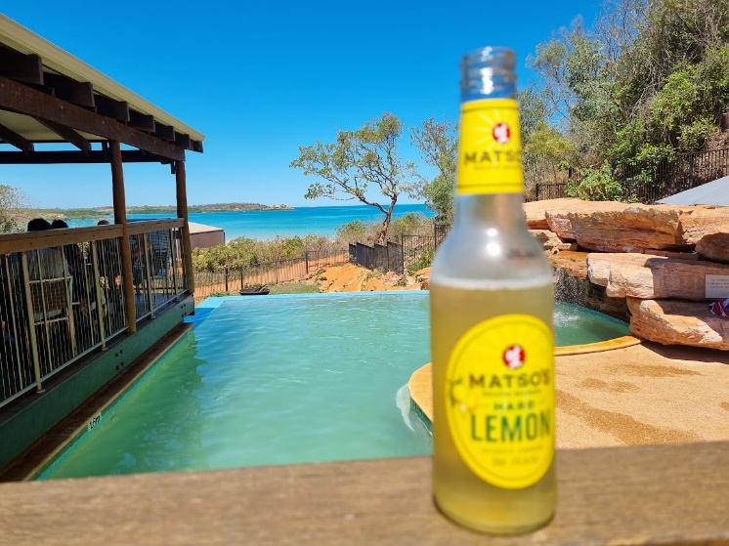

The workshop was divided into 2 days: Day 1 was an unconstrained science discussion about how we could explore some integrated analyses using the six years of Lower Murray data; and Day 2 was a more structured discussion with the purpose of self-reviewing the Flow-MER program in the Lower Murray to seek improvements and future opportunities.

It was an intensive and arduous, but very rewarding, couple of days. We identified what modifications can be made to our monitoring and research to improve our capability to evaluate ecological responses to, and inform, flow delivery in the future.

We also put steps forward to better integrate our project findings across the different research themes, with the aim of publishing these findings in a scientific journal to showcase the amazing work that is coming out of this project.

The age of perch larvae

To evaluate the response of the spawning of flow-cued fishes (i.e. golden perch and silver perch) to flow delivery, including water for the environment, it is essential to determine ‘when’ and ‘where’ spawning occurs.

To find out such information, we dissected fish larvae collected in spring-summer 2020-21. A total of 56 silver perch and five golden perch larvae had their otoliths (‘ear bones’) removed. As you can imagine, this was very fiddly and time-consuming work because they were very small! Rings in otoliths represent daily increments. We then counted these rings to determine the age of each fish to calculate the date of spawning (the ‘when’).

Otolith of a 9 mm silver perch larvae that has 15 daily age rings. Scale bar of 0.05 mm (or 50 µm). Photo credit: SARDI.

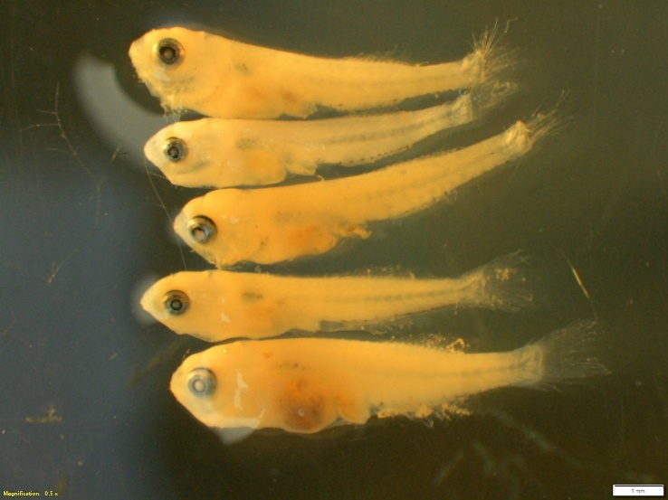

Silver perch under a dissecting microscope. Scale bar of 1 mm. Photo credit: SARDI.

For each otolith, two ‘blind’ reads were performed by two different readers, to eliminate bias. The numbers were then compared between the different readers and, if counts for a particular otolith differed between readers by ≥5%, an agreed age was decided by re-reading the otolith together.

While the data are still preliminary, these silver perch (8–15 mm) and golden perch (5–8 mm) have been estimated to range in age from 11–31 days old and 5–12 days old, respectively.

The chemical signatures in water result from a river’s surrounding landscape and geology. Fish otoliths incorporate these chemical signatures as they grow and therefore their otolith reflects the water in which they have lived in. So, to determine the location of spawning (the ‘where’), strontium chemistry analyses of otolith and water samples are being conducted. From early spring to late summer 2020-21, water samples were collected from a number of locations in the Murray–Darling Basin, by some very helpful staff from SA Water, Goulburn–Murray Water, Water NSW and NSW Department of Primary Industries. These water samples were recently sent to the University of Melbourne for analysis, while otolith samples were prepared at SARDI and sent to the University of Western Australia for analysis.

Given that most silver perch were around two to three weeks old and captured close to the SA-NSW border (just below Lock 6), it will be interesting to identify where spawning occurred.

Eggs, thought to be golden perch or silver perch, that were collected in November–December 2020 were sent away for DNA sequencing to determine which species these eggs belong to. We hope to find out their identities in the coming week!!!

Littoral Vegetation seed bank

The seed bank is an important component of the littoral and floodplain plant community in arid zone rivers as it provides a mechanism for species to persist through unfavourable conditions. It also indicates how resilient the vegetation is as it is a source of propagules for plants to re-establish under favourable conditions and after disturbances, such as drought.

Sediment samples were collected in December 2019 during the first round of monitoring of the

Flow-MER project at each site (downstream of Locks 1, 4 and 6) to assess the seed bank of the littoral zone, to provide a baseline for future comparison and to evaluate the benefits of water for the environment on the resilience of the vegetation.

Sediments being weighted/prepared for trial. Photo credit: SARDI.

Sediments samples collection. Photo credit: SARDI.

Sediments emergence trial set up prior to first watering. Photo credit: SARDI.

Soil samples to depth of 5 cm were taken in the littoral zones at each vegetation monitoring site from normal pool level to 2 m above pool level at 20 cm vertical intervals. The soil was transported to SARDI Aquatic Sciences, dried and stored in the dark until December 2020 when the seed bank was assessed using the seedling emergence technique. This technique involves keeping the soil samples damp and the number and types of seedlings are counted after they have germinated. Seedlings were removed when they could be identified or to relieve crowding in the pots. The trial ran for 16 weeks from January to April 2021.

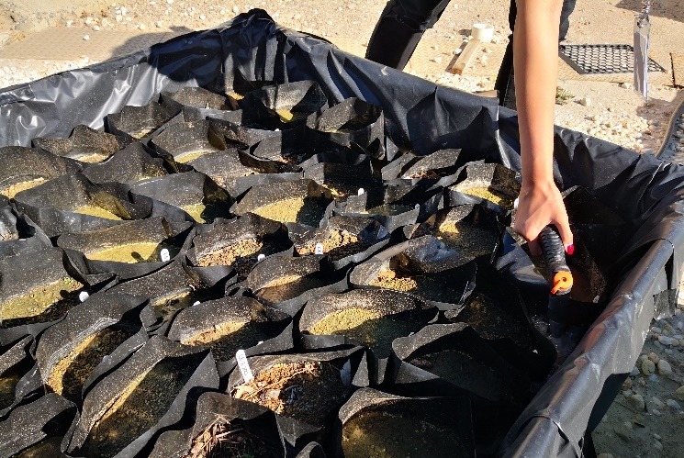

Damp soil and seeds germinating. Photo credit: SARDI.

The highest seed density (top graph) and species richness (bottom graph) was recorded from downstream of Lock 1 and the lowest downstream of Lock 4. Results showed that there is a seed bank in the littoral zone and some species have a resident pool of propagules capable of regenerating after disturbance. However, there were also several exotic pest plants present in the soil seed bank.

These results showed that the seed bank of the Lower Murray is depauperate (<5,500 seeds/m2 and <14 natives species) compared to similar systems such as the Chowilla Floodplain or the Menindee Lakes where seed densities of 50,000 to 100,000 seeds/m2 and 30 to 60 native species have been commonly recorded.



Mean seedling density in littoral zones downstream of locks 1, 4 and 6 (error bars ± 1 standard error).



Native, exotic and total species richness in the littoral zones downstream locks 1, 4 and 6.

***What’s next***

In the next quarter, part of our team will be in the field collecting samples and data for the 2021-22 season, while many scientists will be finalising analyses and reporting for 2020-21.

Upcoming engagement and communication activities include continuing to work on the post-production of the “in field” video where we will showcase the important activities our field team performs. We will also continue to work on our next animation video to explain the Flow-MER Project in the Lower Murray and highlight the important role that water for the environment plays in restoring the riverine ecosystem in this region.

We are excited for another Indigenous Ecology in Action workshop planned for late October, which is to be confirmed soon.

For more information about the work we do, visit our webpage [https://flow-](https://flow-mer.org.au/selected-area-lower-murray/)mer.org.au/selected-area-[lower-murray/](https://flow-mer.org.au/selected-area-lower-murray/) and follow us on social media and <https://twitter.com/FlowMERprogram>

Electrofishing boat, Frank at the Murray River. Photo credit: SARDI.

