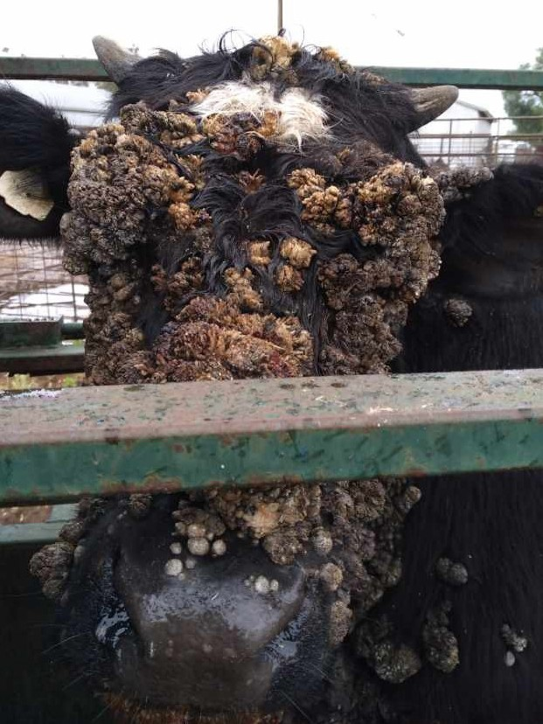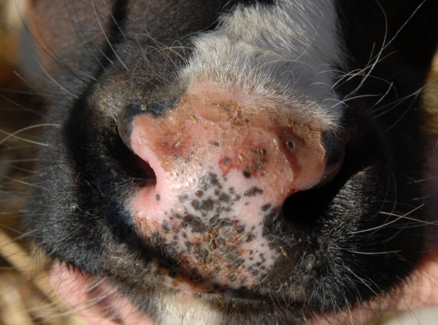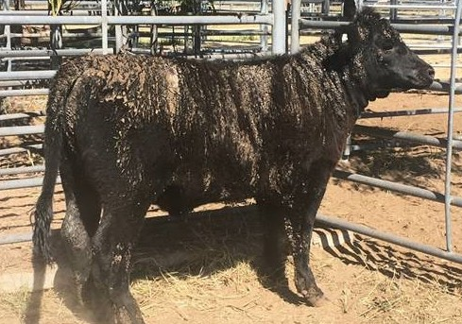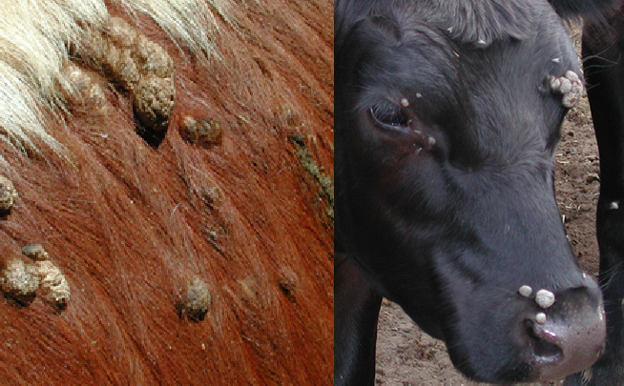

ABIO433.0622

**Differential diagnoses for lumpy skin disease**



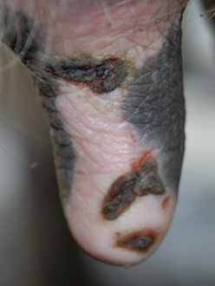NOTE: this list only includes differential diseases endemic to Australia.

|  |  |  |  |
| --- | --- | --- | --- |
| **Differential diagnosis** | **Description of lesions** | **Confirming diagnosis** | **Image** |
| Bovine Herpes Virus 2 (Pseudo-Lumpy Skin Disease/Bovine Herpes Mammillitis) | y Firm, round, raised nodules with flat surface and  depressed centre  y Lesions appear suddenly  y Lesions all over the body, but in Australia lesions are mostly found on teats  y Lesions slough after 1–2 weeks leaving 1–2cm circular alopecia patches resembling ringworm  y Lesions disappear in a few weeks  y By contrast, lumpy skin disease lesions are ulcerative, necrotic and usually cause permanent scarring | y Virology and histology of skin biopsies  Lesions on teat of a cow with Bovine Herpes Virus 2.  (Source: David Beggs, University of Melbourne) | |
| Bovine Papillomavirus (Warts) | y Papillomas of varying form and size  y Located anywhere on the body  y Most frequently seen on head, neck, shoulder and brisket  y Typically affects young cattle <2 years | y Histology of skin biopsies | An unusually severe case of papillomas.  (Source: Jeremy Rogers, PIRSA) Cow with papillomas.  (Source: David Beggs, University of Melbourne) |
| Bovine Papular Stomatitis (Parapoxvirus) | y Raised, red papules  y Erosions and ulcers  y Affects the muzzle, nose, oral mucosa, oesophagus, and rumen  y More common in animals <2 years of age | y Electron microscopy of secretions or  tissue scrapings  y Immunofluorescence or neutralisation of  tissue cultures  y Histopathology of tissue biopsies  y Agar-gel precipitation, immunofluorescence or ELISA to look for viral antibodies  Cow with parapoxvirus.  (Source: David Beggs, University of Melbourne) | |
| Dermatophilosis (Rain Scald) | y Scabs in matted hair  y Alopecia where scabs are pulled/rubbed off  y Affects areas of the body that are wet for  prolonged periods  y “Strawberry” appearance when scabs peeled off | y Microscopic identification of organism in scabs/scrapings/biopsy samples  Cow with rain scald.  (Source: Jeremy Rogers, Department of Primary Industries and Regions) | |

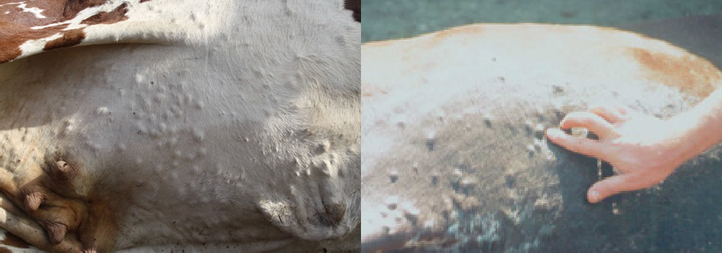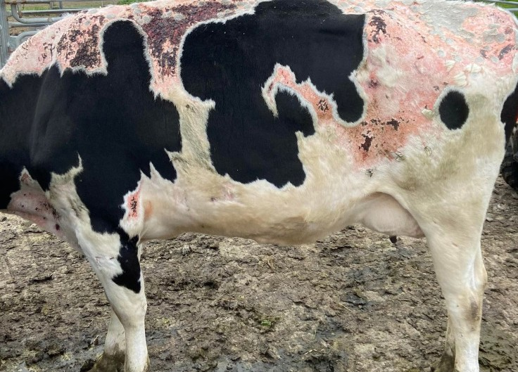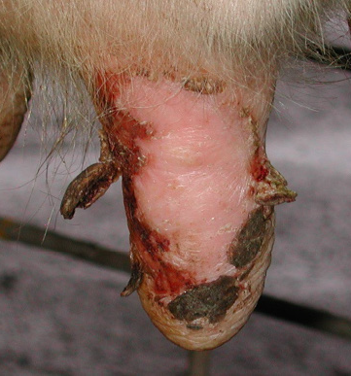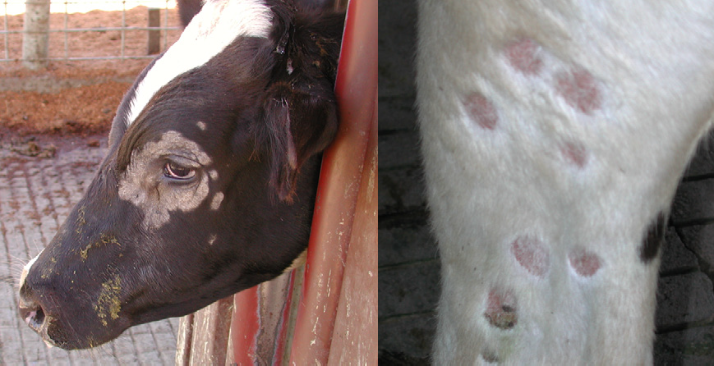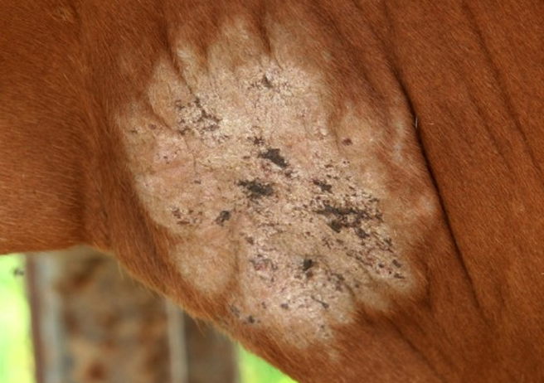Department of Agriculture, Fisheries and Forestry Differential diagnoses for lumpy skin disease

|  |  |  |  |
| --- | --- | --- | --- |
| **Differential diagnosis** | **Description of lesions** | **Confirming diagnosis** | **Image** |
| Ectoparasites  (e.g. mites, ticks) | y Clinical signs will depend on which ectoparasite is affecting the animal | y Will depend on which ectoparasite you  are suspecting  y E.g. diagnosis of mites is generally by microscopic detection of mites in skin scrapings or in nodules excised from the skin  Parasite hypersensitivity  (Source: Constantin Constantinoiu, JCU & QDAF) | |
| Onchocercosis | y Can vary depending on species of Onchocerca  y Nodules are located intradermally and are easy to locate by palpation of the skin  y Depending on the species of Onchocerca, nodules may be located on the brisket, udde or abdominal wall  y Most nodules are 2.5–3.5cm in diameter  y Usually <4 nodules per brisket | y Biopsy of lesions  y Microscopic demonstration of microfilaria  y Generally 1 female and 1+ male worms coiled  together per nodule  Nodules on abdominal wall of cow with onchocercosis.  (Source: Alfons Renz, University of Tübingen) | |
| Photosensitisation | y Non-pigmented, sun-exposed skin most affected (e.g. face, ears, muzzle, udder and along back)  y Skin may be itchy, red, swollen and blistered  y Scabs may develop | y Clinical signs and access to toxic plants  y Blood tests, liver function assessment and post mortem examination  Cow with photosensitisation.  (Source: David Beggs, University of Melbourne) | |
| Pseudocowpox | y Initially appears as small, red, raised sores on teats  and udders  y Progresses to vesicles, scabs and nodules  y May form a ‘ring’ or ‘horseshoe’ of scabs, over the course of several weeks | y PCR test on blood, swab of lesion, or scab  y Clinical signs  Sores on teats of a cow with pseudocowpox.  (Source: David Beggs, University of Melbourne) | |
| Dermatophytosis (ringworm) | y Circular hairless lesions, up to 3cm diameter, may coalesce to form larger patches  y Head and neck most affected  y Skin initially moist and red, progressing to dry,  scaly and grey | y Ringworm sits near the hair follicle so deep skin scrape or biopsy not needed. Rather a hair sample can be placed in a culture – there are even specific agars which will change colour if Ringworm (Dermatophytosis)  is present  y Microscopic demonstration or isolation of Circular hairless lesions on a cow the organism with dermatophytosis.  (Source: David Beggs, University of Melbourne) | |
| Skin allergies (e.g. urticaria) | y Acute-onset of haired, dome-shaped wheals that may crust  y Angioedema in severe cases  y Lesions can appear anywhere on the skin | y History of acute onset of lesions  y Lesions subside after glucocorticoid is administered | |