# National Lumpy Skin Disease Action Plan



© Commonwealth of Australia 2022

**Ownership of intellectual property rights**

Unless otherwise noted, copyright (and any other intellectual property rights) in this publication is owned by the Commonwealth of Australia (referred to as the Commonwealth).

**Creative Commons licence**

All material in this publication is licensed under a [Creative Commons Attribution 4.0 International Licence](https://creativecommons.org/licenses/by/4.0/legalcode) except content supplied by third parties, logos and the Commonwealth Coat of Arms.

Inquiries about the licence and any use of this document should be emailed to [copyright@aff.gov.au](mailto:copyright@aff.gov.au).



**Cataloguing data**

This publication (and any material sourced from it) should be attributed as: DAFF 2022, *National Lumpy Skin Disease Action Plan*, Department of Agriculture, Fisheries and Forestry, Canberra, October. CC BY 4.0.

This publication is available at [agriculture.gov.au/biosecurity-trade/pests-diseases-weeds/animal/lumpy-skin-disease](https://www.agriculture.gov.au/biosecurity-trade/pests-diseases-weeds/animal/lumpy-skin-disease).

Department of Agriculture, Fisheries and Forestry

GPO Box 858 Canberra ACT 2601

Telephone 1800 900 090

Web [agriculture.gov.au](https://www.agriculture.gov.au/)

**Disclaimer**

The Australian Government acting through the Department of Agriculture, Fisheries and Forestry has exercised due care and skill in preparing and compiling the information and data in this publication. Notwithstanding, the Department of Agriculture, Fisheries and Forestry, its employees and advisers disclaim all liability, including liability for negligence and for any loss, damage, injury, expense or cost incurred by any person as a result of accessing, using or relying on any of the information or data in this publication to the maximum extent permitted by law.

**Acknowledgement of Country**

We acknowledge the Traditional Custodians of Australia and their continuing connection to land and sea, waters, environment and community. We pay our respects to the Traditional Custodians of the lands we live and work on, their culture, and their Elders past and present.

## Foreword

**National Lumpy Skin Disease Action Plan**

While Australia’s strong biosecurity system has ensured our country has remained free from lumpy skin disease (LSD), we must remain vigilant, particularly given its recent emergence in our region.

Although Australia has never experienced an outbreak of LSD, an incursion would have a major impact on Australia’s livestock industries and our rural and regional communities.

Our biosecurity system is one of the strongest in the world and is built on strong partnerships between governments, industries, and the community.

But we should constantly strive to make it better.

This National LSD Action Plan has been developed through extensive engagement between stakeholders in industry, state and territory governments, and other organisations.

It includes 8 objectives and 27 activities to enhance Australia’s ability to prevent, detect, prepare for and respond to a possible incursion.

Importantly, it also aims to reduce the risks of LSD by building on our long history of collaboration and engagement in South East Asia.

Biosecurity is everybody’s responsibility and I encourage all levels of government, industry and the Australian public to work collaboratively in managing the risk of biosecurity threats.

Commonwealth of Australia

**Senator the Hon Murray Watt**

Minister for Agriculture, Fisheries and Forestry

Contents

Foreword iii

Introduction 1

Background 2

Summary of objectives and activities 4

Objective 1—International engagement 6

Activities 7

Objective 2—Border biosecurity and trade 9

Activities 10

Objective 3—Diagnostic capability and capacity 12

Activities 13

Objective 4—Surveillance 14

Activities 14

Objective 5—Preparedness and response 16

Activities 17

Objective 6—Awareness and communications 20

Activities 20

Objective 7—Research and innovation 22

Activities 23

Objective 8—Recovery 25

Activities 25

Implementing the plan 26

Approach to implementation 26

Roles and responsibilities 26

Appendix A Stakeholders 27

Industry 27

Government or independent bodies 28

Jurisdictions 28

Appendix B Linkages 29

Appendix C Abbreviations 30

References 31

**Tables**

Table 1 Activities under Objective 1 8

Table 2 Activities under Objective 2 11

Table 3 Activities under Objective 3 13

Table 4 Activities under Objective 4 15

Table 5 Activities under Objective 5 19

Table 6 Activities under Objective 6 21

Table 7 Activities under Objective 7 24

Table 8 Activities under Objective 8 25

## Introduction

Australia’s National Lumpy Skin Disease (LSD) Action Plan (the Action Plan) sets out national priorities for actions to strengthen Australia’s preparedness for a potential incursion of LSD. These actions are critically important to protect Australia’s cattle and other livestock industries from the growing threat of this disease. The Action Plan has been developed in consultation with a broad range of government, industry and other stakeholders (Appendix A).

Global and domestic trends in trade and animal production indicate that Australia requires increasingly strong and resilient systems to effectively manage animal disease risks, including LSD. The Action Plan outlines what systems need to be strengthened or established to support Australia’s cattle industries and effectively manage the risk of LSD. It sets out 8 objectives – International engagement, Border biosecurity and trade, Diagnostic capability and capacity, Surveillance, Preparedness and response, Awareness and communications, Research and innovation, and Recovery.

Government and industry organisations already have strategic animal health plans that broadly cover components included in the Action Plan (Appendix B). The intent is not to duplicate activities, but rather to create links between plans to make the best use of resources.

The Action Plan will be implemented through ongoing collaboration between industry and government parties.

In addition to the industry-government collaboration that supports the Action Plan’s success, its development has followed some key guiding principles:

The Action Plan addresses common national priorities.

* It focuses on national strategic issues that will provide enduring benefit to the management of LSD (and other exotic animal diseases).
* Its objectives and activities have defined, achievable outcomes.
* It is a framework of agreed national priorities to which investment will be directed.

## Background

LSD is a contagious, primarily vector-transmitted disease of cattle and buffalo caused by the LSD virus (LSDV). LSD is a nationally notifiable disease of animals and a reportable disease for the World Organisation for Animal Health (WOAH). LSDV is highly host-specific and causes disease primarily in cattle and buffalo, although it has also been seen in other bovids and giraffes. LSDV does not cause disease in humans.

LSDV is transmitted mechanically by invertebrate vectors including mosquitoes, biting flies, midges and ticks. The virus may be transmitted via milk and semen as well as through direct close contact. It is remarkably stable and can survive in favourable environmental conditions (cool, shade) for many months. It may also be transmitted by contaminated objects (fomites).

Clinical signs of LSD typically include acute pyrexia, depression and characteristic skin nodules. There can be a marked reduction in milk yield and the disease can cause abortion in pregnant animals. Morbidity of the disease may vary between 1-95%, and some infected animals don’t display signs of the disease. Mortality is generally low between 1-5%, but has been reported at up to 75% (Animal Health Australia 2022).

Before 2012, the distribution of LSD was limited to Africa and parts of the Middle East. LSD then spread throughout the Middle East, Turkey, Cyprus, eastern Europe, the Balkans and the Russian Federation. Since 2019, LSD has spread throughout the Asian continent, ranging from India to China, as well as extending through southern Asia where it has been reported in Bangladesh, Taiwan, Vietnam, Bhutan, Hong Kong (Special Administrative Region, People’s Republic of China), Nepal and Myanmar. In 2021, LSD spread further into Cambodia, Thailand and Malaysia. In 2022, cases were reported in Indonesia, Singapore and Pakistan. The disease may continue to spread throughout South East Asia and become a serious threat to Australia.

The most likely way for LSD to enter a new area is by the introduction of infected animals. It is then transmitted further via mechanical vectors such as biting insects. In some circumstances, insects that have fed on infected cattle may travel or be wind-borne for substantial distances. It is believed that LSD-contaminated insects were blown across the Sinai Desert, resulting in the spread of the disease to Israel. The movement of contaminated hides represents another potential means for introduction of LSDV.

Control of LSD overseas typically involves vaccination of susceptible animals and accompanying measures, such as movement restrictions, depopulation of infected and exposed animals, proper disposal of carcasses, cleaning and disinfection of the premises and insect control.

For endemic areas, vaccination against LSD is critical for control. Vaccines helped eradicate the disease during an outbreak in Israel and have been vital in keeping Europe relatively LSD-free. In South Africa, an attenuated LSD vaccine based on the Neethling strain of the virus is used. Vaccination with the Neethling strain is thought to confer immunity for up to 3 years. In Kenya and Egypt, the Romanian strain of sheep and goat pox vaccine has been used successfully for prophylaxis against LSD.

If Australia experienced an incursion, access to economically important international markets, particularly for live cattle and some dairy products, would be compromised. Depending on trading partners’ responses, Australia’s trade in other livestock products could also be affected. The disease may be difficult and costly to control and eradicate.

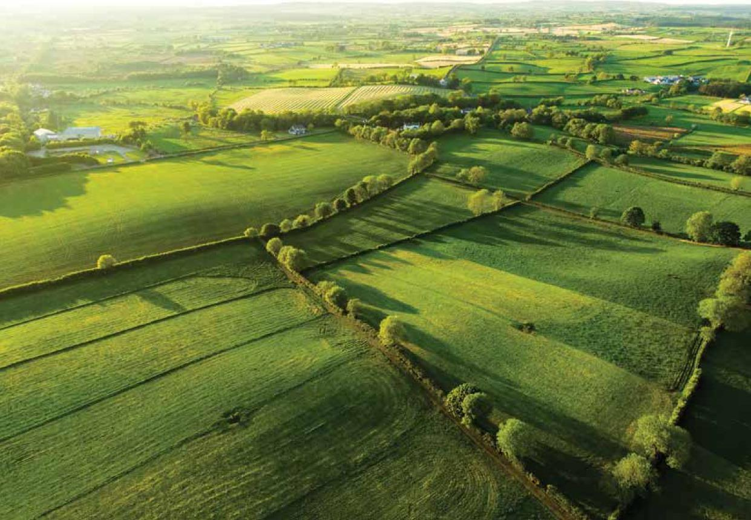

## Summary of objectives and activities

**Objective 1: International engagement.** *Strengthen collaboration and engagement within the region to strategically address the risks of LSD.*

1.1 Support Indonesia’s LSD response

1.2 Build LSD preparedness, technical and diagnostic capability and surveillance in near neighbouring countries

1.3 Strengthen relationships in South East Asia

1.4 Engage in international and regional fora

**Objective 2: Border biosecurity and trade.** *Augment industry-government collaboration and communication on the border biosecurity risks of LSD to Australia and strategically address technical market access barriers.*

2.1 Review import policy and LSD risk pathways

2.2 Develop a strategic approach to minimising export trade disruptions

**Objective 3: Diagnostic capability and capacity.** *Ensure that Australia’s national diagnostic network provides reliable LSD testing capability and capacity.*

3.1 Improve national and regional LSD diagnostic capability and capacity

3.2 Improve the diagnostic testing options at the Australian Centre for Disease Preparedness

3.3 Explore point-of-care LSD testing

**Objective 4: Surveillance.** *Optimise government and industry investment in LSD surveillance.*

4.1.a Develop a national LSD surveillance strategy

4.1.b Develop a wild and free-roaming bovid surveillance strategy

4.1.c Review arthropod vector monitoring programs

4.2 Undertake training and awareness activities

**Objective 5: Preparedness and response.** *Enhance the LSD preparedness and emergency response capacity and capability of industries and governments, and clearly define roles and responsibilities.*

5.1.a Undertake risk mapping of the likelihood of entry, establishment and spread of LSD

5.1.b Develop epidemiological modelling systems for LSD

5.2.a Develop a national LSD vaccination strategy

5.2.b Access an LSD vaccine appropriate for use within Australia

5.2.c Investigate options for the timely supply of LSD vaccines

5.3 Review the national LSD response strategy

5.4 Prepare to manage exported livestock in transit and in preparation for export during an incursion

5.5 Investigate arthropod vector control options

**Objective 6: Awareness and communications.** *Facilitate stronger engagement between governments and industry through a comprehensive and adaptable communication strategy for LSD.*

6.1 Develop a comprehensive and sustained LSD communication plan to raise awareness and understanding of the disease, risk and preparedness activities

6.2 Develop a communication plan for use during an LSD emergency response

**Objective 7: Research and innovation.** *Improve Australia’s LSD preparedness and response through research priorities driven by industry and government needs, and ensure new knowledge is freely accessible.*

7.1 Set national priorities for LSD research, engagement and communication

7.2 Investigate new technology LSD vaccines

7.3 Develop modelling tools to support LSD preparedness and response

**Objective 8: Recovery.** *Mitigate the economic and social effects of an outbreak of LSD by developing options for a recovery strategy.*

8.1 Develop options for an LSD recovery strategy

## Objective 1—International engagement

**Strengthen collaboration and engagement within the region to strategically address the risks of LSD.**

Australia conducts collaborative surveillance, capacity-building, aid and research activities in neighbouring countries in the region. These activities occur in collaboration with overseas government agencies, veterinary associations and private organisations. The aim is to improve the control of animal diseases, including zoonoses, thereby improving livelihoods in partner countries.

Australia actively engages with and supports the efforts of the World Organisation for Animal Health (WOAH) and the Food and Agriculture Organization of the United Nations (FAO). Australia is also a member of the Quads Animal Health Alliance (Quads), which aims to progress evidence-based policy in international animal health and trade issues.

The highly successful Australia Indonesia Partnership for Emerging Infectious Diseases (AIP-EID) ran from 2011 to 2018. It focused on improving Indonesia’s emergency management; built a national animal health information system (iSIKHNAS), which assisted with the effective use of information to support surveillance, veterinary service delivery, policy development and advocacy; and strengthened leadership and management within Indonesia’s Veterinary Service. At that time, LSD was not considered a threat to the region and there was no specific planning for an outbreak. The foundational work of the AIP-EID has since been progressed through the animal health stream of the Australia Indonesia Health Security Partnership which commenced in 2020. This program is a primary conduit of Australian assistance to Indonesia in combatting the LSD incursion. Additional Australian development programs that may play a role in the outbreak response include the Indonesia Australia Red Meat and Cattle Partnership, the Australia Indonesia Partnership on Promoting Rural Incomes through Support for Markets in Agriculture, and the Australian Centre for International Agricultural Research. The department also has established engagement with the FAO Indonesia country office to enable coordination of bilateral and international efforts in support of Indonesia’s outbreak response. Engagement and coordination with relevant Indonesian and Australian industry will also continue to be a significant component in limiting the spread of the disease.

Australia has a long history of collaborating with and supporting its near neighbours Papua New Guinea (PNG) and Timor-Leste with field surveillance and preparedness for significant animal diseases. Both countries border parts of Indonesia and are at risk of an LSD incursion if the disease continues to spread in the Indonesia archipelago.

With the presence of LSD in the region it is crucial that Australia builds on these relationships and takes a lead role in supporting its near neighbouring countries. This will include ongoing engagement through relevant Australian government agencies including the Department of Foreign Affairs and Trade (DFAT), CSIRO Australian Centre for Disease Preparedness (ACDP), and industry groups including Meat and Livestock Australia (MLA). Efforts should be directed towards helping to limit the spread in Indonesia, improving surveillance and monitoring, refining LSD preparedness plans, and helping to develop regional diagnostic and response capacity.

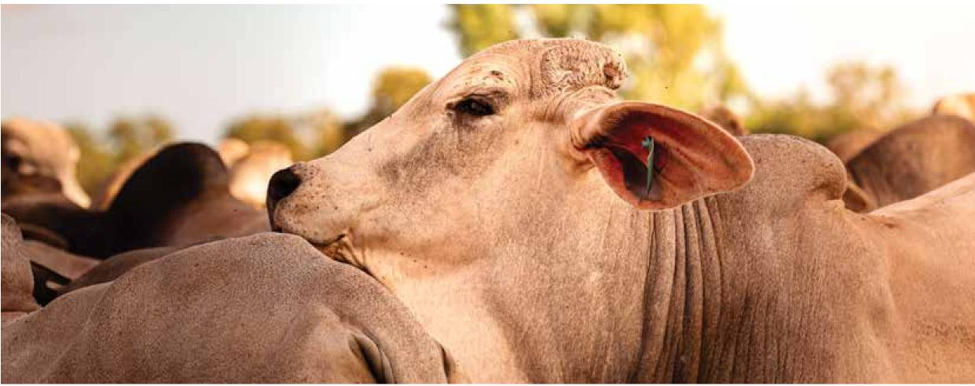

### Activities

#### Activity 1.1 Support Indonesia’s LSD response

This activity aims to ensure Indonesia receives ongoing financial and technical support for their LSD outbreak response to help control and contain the spread of the disease in alignment with the needs identified by the Government of Indonesia. There will be collaborative engagement with aid agencies, the FAO and WOAH to ensure there is a coordinated approach to Indonesia’s support with activities that are complementary and not duplicative.

Indonesia will also be supported to help improve their technical and diagnostic capability, and surveillance. Good biosecurity practices at farm level will also be promoted to limit disease spread, noting this is also beneficial for animal health and welfare. This may also include engagement between the Indonesian and Australian industry groups.

Work has commenced on this activity.

#### Activity 1.2 Build LSD preparedness, technical and diagnostic capability, and surveillance in near neighbouring countries

This activity seeks to build on existing relationships with PNG’s National Agriculture Quarantine and Inspection Authority (NAQIA) and Timor-Leste’s Ministry of Agriculture and Fisheries (MAF) to improve their LSD preparedness, technical and diagnostic capability, and surveillance. There will be further investment in building diagnostic capacity to support early detection of incursions of LSD. There will be a focus on developing culturally and socially appropriate LSD awareness materials to drive community engagement and increase the likelihood of early reporting in these countries. Tools to facilitate early reporting within communities will also be explored and adapted depending on the needs of NAQIA and MAF. Capacity building will be undertaken to support training of animal health workers in disease investigation and sample collection, with a focus on LSD. Coordination of Australian government agencies providing support for near neighbours will be overseen by the Office of the Chief Veterinary Officer (OCVO).

Work has commenced on this activity.

#### Activity 1.3 Strengthen relationships in South East Asia

This activity includes establishing an OCVO presence in northern Australia, led by the Australian Deputy Chief Veterinary Officer (Deputy ACVO). The Deputy ACVO will seek to build relationships in South East Asia and promote engagement around LSD and other important animal health issues.

Work has commenced on this activity.

#### Activity 1.4 Engage in international and regional fora

This activity involves Australia’s ongoing engagement and contribution to international and regional fora on the topic of LSD. This aims to elevate the global agenda on LSD and generate opportunities for collaborative prevention and management activities with international partners. Australia will continue to advocate for membership and involvement in international and regional fora by countries within the region.

Work has commenced on this activity.

Table Activities under Objective 1

| Activity | Lead and key collaborators a |
| --- | --- |
| 1.1 Support Indonesia’s LSD response | *Lead:* DFAT and DAFF  *Collaborators:* MLA, ACDP, Overseas partners |
| 1.2 Build LSD preparedness, technical and diagnostic capability, and surveillance in near neighbouring countries | *Lead:* DAFF  *Collaborators:* Overseas partners |
| 1.3 Strengthen relationships in South East Asia | *Lead:* DFAT and DAFF  *Collaborators:* Relevant state and territory governments, Overseas partners |
| 1.4 Engage in international and regional fora | *Lead:* DAFF  *Collaborators:* Overseas partners |

**a** Note: the ‘activity lead’ is expected to drive the activity (i.e., develop and implement the project plan, source available funding [where required]) and to liaise with key collaborators to achieve the expected benefits and outcome.

## Objective 2—Border biosecurity and trade

**Augment industry-government collaboration and communication on the border biosecurity risks of LSD to Australia and strategically address technical market access barriers.**

Australia manages biosecurity to ensure a very low level of risk. This draws a balance between protecting Australia from pests and diseases and maintaining our ability to trade internationally. To protect Australia, biosecurity measures are applied offshore, at the border and onshore.

LSD is a serious biosecurity threat to Australia’s cattle industry. Therefore, it is imperative that the risks associated with trade in LSD risk materials are managed effectively. Australia’s import policies have been supported by defining country freedom from LSD as freedom from LSD in all susceptible species (both the domestic and wild population). Trade in animals and products containing material derived from species susceptible to LSD requires that countries are assessed by Australia as free from the disease, without vaccination, and therefore eligible for inclusion on the LSD-free country list. This means that if a country has an outbreak of LSD they are removed from the LSD-free country list and import permits for animals and products susceptible to LSD sourced from and/or manufactured in that country are suspended or varied. Alternative risk management measures cannot be substituted unless an assessment of those risk management measures has concluded that they will meet Australia’s legislated appropriate level of protection (ALOP).

LSD is a notifiable disease to WOAH and an infection domestically would result in Australia losing its LSD-free country status.

The trade implications of an outbreak of LSD in Australia are difficult to predict with certainty, as such issues are highly situational and will vary across markets. For example, trading partners will usually have regard to matters such as Australia’s response arrangements, their existing import policies and conditions, as well as their country’s disease status, and reliance on imports for food security. The commodities that are likely to be affected include live cattle exports, red meat, some dairy products, animal by-products (e.g., hides and skins) and genetic materials. Trade in these products could be restricted until new protocols are negotiated with trading partners, or our LSD-free status is regained.

The department has evaluated, and is continuing to evaluate, markets which may be affected by an LSD outbreak in Australia. This includes reviewing our options to re-negotiate trade protocols to incorporate changes to accepted processing practices, or commodity treatments to manage risk and the potential acceptance of zoning depending on the nature of any outbreak and Australia’s eradication response. The department will continue to engage with potentially affected industry sectors on market access activities including where pre-emptive negotiations or other discussions are planned to occur. There is a need for a coordinated departmental approach to these market access strategies to ensure they align with Australia’s import and planned response settings.

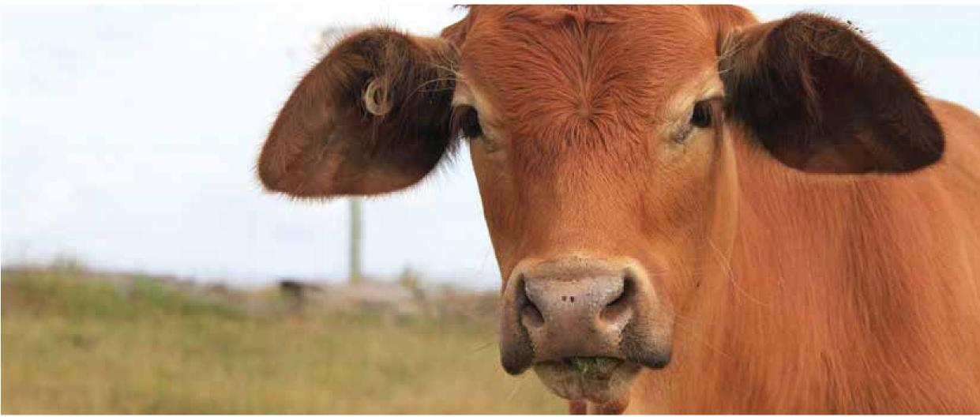

### Activities

#### Activity 2.1 Review import policy and LSD risk pathways

This activity will include undertaking robust science-based risk analyses for the import of products from LSD-affected countries to ensure the risk of LSD is managed and achieves Australia’s appropriate level of protection. LSD risk pathways will also be reviewed and monitored to ensure appropriate risk management measures are implemented where needed.

Increased engagement and understanding by industry and government stakeholders strengthens decision-making processes. Therefore, a program of two-way communication will be established to facilitate greater information exchange and increased transparency around border biosecurity.

Work has commenced on this activity.

#### Activity 2.2 Develop a strategic approach to minimising export trade disruptions

This activity will take a strategic approach to minimising disruptions to trade by analysing which export markets and products would be affected if there is an LSD incursion in Australia. This will include an implementation plan for reviewing and renegotiating export protocols where appropriate, and contingency plans to manage and minimise effects on export supply chains. Given the broad reach of LSD in the region, there may also be discussions around potential future zoning arrangements. The broader trade and biosecurity interests of trading partners are also key considerations under this strategic approach.

Work has commenced on this activity.

Table Activities under Objective 2

| Activity | Lead and key collaborators a |
| --- | --- |
| 2.1 Review import policy and LSD risk pathways | *Lead:* DAFF  *Collaborators:* Peak industry organisations |
| 2.2 Develop a strategic approach to minimising export trade disruptions | *Lead:* DAFF  *Collaborators:* DFAT, ALEC, LiveCorp, MLA, other  industry groups, and state and territory  governments |

**a** Note: the ‘activity lead’ is expected to drive the activity (i.e., develop and implement the project plan, source available funding [where required]) and to liaise with key collaborators to achieve the expected benefits and outcome.

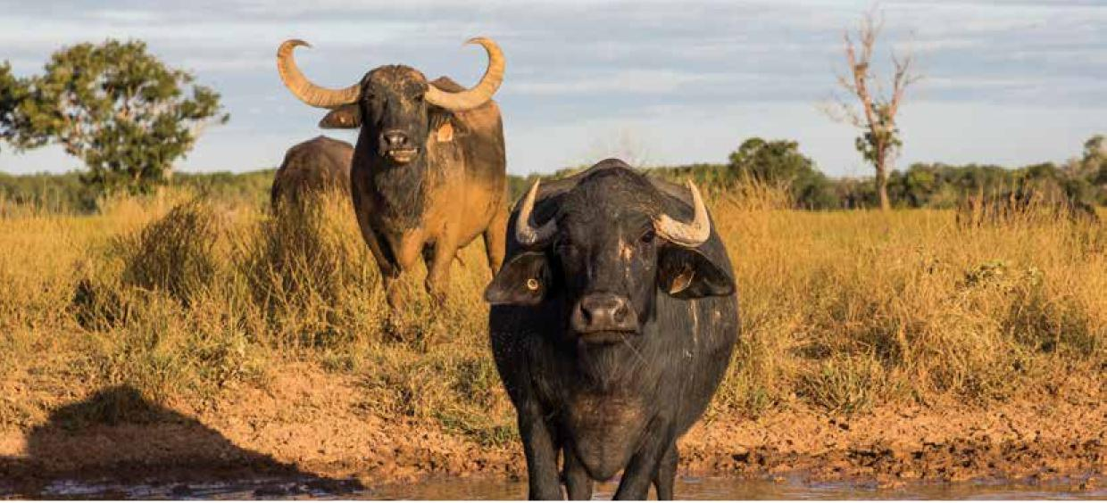

## Objective 3—Diagnostic capability and capacity

**Ensure Australia’s national diagnostic network provides reliable LSD testing capability and capacity.**

Australia’s national diagnostic network for animal diseases has been developed over time to support the many functions of Australia’s animal health management system. These include confirmation or exclusion of exotic diseases, implementing disease management measures, enterprise health accreditation and demonstration of regional or national disease status. The investment in Australia’s diagnostic network and diagnostic methods has been substantial and has resulted in significant strength in testing reliability and capacity.

Australia’s diagnostic network draws on nodes of expertise throughout national and state government laboratories, research laboratories and private service providers. The high standard of diagnostic service is built upon quality research, validation of methods, diagnostic and laboratory standards, and programs to support quality assurance. This also includes the Laboratories for Emergency Animal Disease Diagnosis and Response (LEADDR) network, made up of each state and territory government veterinary laboratories and Australian Centre for Disease Preparedness (ACDP). LEADDR provides an established system by which diagnostic testing standards for exotic diseases can be harmonised across the country. Despite these strong and established elements, there remain challenges associated with the diagnostic testing for LSD. The key issues are as follows:

* LSD is a notifiable disease in all states and territories, so only government endorsed veterinary laboratories or parties approved by the chief veterinary officer of a state or territory are allowed to undertake testing for LSDV.
* ACDP is currently the only laboratory with specific testing capabilities for LSDV.
* Rollout of specific LSDV testing to the state and territory veterinary laboratories has been hindered by ACDP’s inability to import LSDV to develop proficiency testing and quality assurance panels.
* Testing of animals in remote areas is difficult and time consuming. Developing point-of-care tests would be useful to allow those in the field to quickly rule in disease in clinically affected animals. This would enable responders to delimit surveillance areas in the event infected animals are suspected outside of control areas, before confirmatory testing occurs.
* Testing capacity for LSD within the near neighbouring countries of Timor-Leste and PNG is currently severely limited and they are reliant on Australia for testing support.

It is crucial that Australia develops LSD testing capability within state and territory veterinary laboratories to ensure we have sufficient capacity to respond to an LSD incursion.

### Activities

#### Activity 3.1 Improve national and regional LSD diagnostic capability and capacity

This activity will build Australia’s diagnostic capability and capacity for LSD. The activity will see both molecular and serological testing options deployed across the LEADDR network. These will be supported by an LSD proficiency testing program to ensure all laboratories can meet the standards expected of them. The aim is to also build similar testing capability in near neighbouring countries (see Activity 1.2).

Work has commenced on this activity.

#### Activity 3.2 Improve the diagnostic testing options at ACDP

There are a range of diagnostic testing options available for LSD at ACDP. Despite this, the development of new and improved diagnostic tests is important for detecting and managing an LSD incursion in alternative ways and progressing research. This includes testing different sample types, such as vector species, as well as ensuring we are using the most effective tests currently available. This activity aims to increase understanding of the infection process and immune response to LSD infection. This may result in diagnostic tests that can detect disease sooner or with greater accuracy and may assist in vaccine development (see Activity 7.2).

Work has commenced on this activity.

#### Activity 3.3 Explore point-of-care LSD testing

This activity will explore the development and use of novel point-of-care (POC) tests to screen for potential LSD cases during an outbreak situation. These tests could enable on ground responders (including in northern Australia) to quickly delimit infected areas and establish control area boundaries. Currently there is no capability to use POC tests for detecting LSD. There are also legislative and connectivity difficulties for the use of POC tests in some jurisdictions. Advancements made in POC test technology in recent years will allow for the rapid development and deployment of these tests during an emergency response.

Table Activities under Objective 3

| Activity | Lead and key collaborators a |
| --- | --- |
| 3.1 Improve national and regional LSD diagnostic capability and capacity | *Lead:* ACDP and LEADDR  *Collaborators:* DAFF |
| 3.2 Improve the diagnostic testing options at ACDP | *Lead:* ACDP  *Collaborators:* DAFF |
| 3.3 Explore point-of-care LSD testing | *Lead:* ACDP, SCAHLS and AHC  *Collaborators:* DAFF and state and territory governments |

**a** Note: the ‘activity lead’ is expected to drive the activity (i.e., develop and implement the project plan, source available funding [where required]) and to liaise with key collaborators to achieve the expected benefits and outcome.

## Objective 4—Surveillance

**Optimise government and industry investment in LSD surveillance.**

Australia’s disease surveillance includes targeted and general surveillance activities for terrestrial animal diseases for early detection of emergency animal diseases including LSD, delivered under the authority of the state and territory governments (jurisdictions) and the Australian Government. This includes surveillance programs specific to northern Australia. These are delivered through jurisdictional animal health surveillance, the Northern Australia Quarantine Strategy (NAQS) and the Northern Australia Biosecurity Surveillance Network (NABSnet). Surveillance activities in southern jurisdictions can also be improved, to address the increased risk of an LSD incursion now that the disease is in Indonesia.

In the jurisdictions, official government veterinarians establish relationships with private veterinarians and maintain networks of animal health surveillance stakeholders. This facilitates collaboration during investigations of unusual disease incidents and ensures exchange of important surveillance information. There is a legislated obligation that if a notifiable animal disease, including LSD, is suspected it must be reported to the relevant state or territory department of agriculture or primary industries.

Australia also has vector surveillance programs including the National Arbovirus Monitoring Program (NAMP), the screw-worm fly surveillance and preparedness program, jurisdiction-based mosquito surveillance programs, mosquito trapping at seaports and airports, and vector surveillance for international passenger arrivals, cargo, mail, animals and plants or their products entering Australia. These programs are complemented by targeted research undertaken by universities and other scientific organisations. As vectors play a major role in the transmission and spread of LSD, it is timely to review Australia’s arthropod vector surveillance and monitoring programs to determine these programs can be adapted to have a broader reach.

Australia has a large population of feral and free-roaming animals, which includes cattle and water buffalo. Once LSD is in these populations, it may be challenging to control. An improved understanding of the population biology, reproduction, and movements of these animal groups, would help with developing regional control strategies to consider options to reduce the likelihood of establishment and spread.

### Activities

#### Activity 4.1.a Develop a national LSD surveillance strategy

This activity aims to develop a national LSD surveillance strategy that will assist with detecting an LSD incursion as early as possible. To achieve this, a national working group will be established and tasked with reviewing Australia’s animal health surveillance activities relevant to LSD. The working group will first clarify the purpose of the surveillance plan, identifying common needs, objectives, responsibilities, priority areas for investment and make recommendations on how they can be funded sustainably. To help guide the recommendations of the working group, an evaluation of Australia’s surveillance for LSD will be undertaken, including descriptive epidemiological analyses of national surveillance data for early detection and to demonstrate freedom from LSD. This plan should consider surveillance strategies at animal aggregation points such as saleyards, mustering points and abattoirs. Critical to increasing the likelihood of early detection, the group should also consider ways that a communications and awareness strategy could be used to target industry and communities at geographical regions deemed to be at highest risk of an LSD incursion, to boost general surveillance.

#### Activity 4.1.b Develop a wild and free-roaming bovid surveillance strategy

This activity aims to develop a surveillance strategy to identify the locations, numbers and population dynamics of wild and free-roaming bovid populations. Consideration should be given to developing innovative tools to increase the likelihood of capturing meaningful surveillance data when working in remote and geographically isolated locations. Consultation with Traditional Owners should take place to ensure they are fully engaged in the process. The cost-effectiveness of pre-emptive control programs will also be explored.

#### Activity 4.1.c Review arthropod vector monitoring programs

This activity will review Australia’s current arthropod vector monitoring programs (including in near neighbouring countries) and investigate if there are opportunities or the need to adapt these programs to be relevant to LSDV surveillance. Studies on the distribution, vector competency and transmission of LSD in different vector species in near neighbouring countries will also help inform the potential pathways of entry and the epidemiology of LSD in Australia. Understanding the extent of the various relevant vector populations and their seasonal patterns in Australia will be key to disease surveillance efforts and planning in an outbreak response.

#### Activity 4.2 Undertake training and awareness activities

This activity will seek to develop training programs and raise awareness of the increased risk of LSD and other animal disease threats within the Australian livestock population. Activities will be concentrated where they can extract the most benefit, including linking together existing programs and targeting populations that have not traditionally been subject to training and awareness programs. This includes those responsible for biosecurity and surveillance programs, or who will play a part during an emergency animal disease response.

Work has commenced on this activity.

Table Activities under Objective 4

| Activity | Lead and key collaborators a |
| --- | --- |
| 4.1a Develop a national LSD surveillance strategy | *Lead:* AHC and AHA  *Collaborators:* DAFF, CSIRO ACDP, AMIC and peak industry bodies |
| 4.1b Develop a wild and free-roaming bovid surveillance strategy | *Lead:* State and territory governments  *Collaborators:* DAFF NAQS, Northern Territory Cattlemen’s Association and other industry groups |
| 4.1c Review arthropod vector monitoring programs | *Lead:* DAFF and state and territory governments  *Collaborators:* CSIRO, AHA |
| 4.2 Undertake training and awareness activities | *Lead:* DAFF and state and territory governments |

**a** Note: the ‘activity lead’ is expected to drive the activity (i.e., develop and implement the project plan, source available funding [where required]) and to liaise with key collaborators to achieve the expected benefits and outcome.

## Objective 5—Preparedness and response

**Enhance the LSD preparedness and emergency response capacity and capability of industries and governments, and clearly define roles and responsibilities.**

LSD poses a substantial threat to the cattle and buffalo industries. The nature of an LSD outbreak is difficult to predict as it is vector-transmitted and affects both domestic and wild bovid populations. The complex interaction of factors including LSD arthropod vector numbers (influenced by season, weather patterns such as flooding and temperature for breeding); host animal populations easily infected with the virus; and the degree of animal movements likely drives the extent of an outbreak.

Underlying preparedness is essential for effective emergency animal disease responses. Australia needs to know the locations of its cattle and wild bovid populations (see Activity 4.1 b), how the climate and seasons affect those populations, the biology of vectors (see Activity 4.1 c), what resources are required (e.g. vaccines, staffing, tools, equipment), that the outbreak response strategy is contemporary and fit-for-purpose, and that the right funding mechanisms are in place. While there is capacity in each of these areas, several could be strengthened.

It would be timely to consider the utility and enforcement of the National Livestock Identification System (NLIS) as a tool to support mapping national cattle populations and movements, along with other tools that capture livestock movement data. Mapping and modelling wild or free-roaming bovid populations, arthropod vectors and domestic cattle populations within relevant geographic areas and seasonal weather patterns would not only help guide surveillance for early warning, it could also be used to plan ahead for an outbreak response.

Although Australia is well placed with its suite of AUSVETPLAN response strategies and the Emergency Animal Disease Response Agreement (EADRA), they have not been tested by the uncertainties that would occur with an outbreak caused by a vector-transmitted disease of cattle, like LSD. In addition, northern Australia poses significant challenges including remote and hard to access locations, tough environmental conditions, limited resources or surge capacity, abundant vector species and dispersed free-roaming host populations. Outbreak scenarios that capture many of these elements should form the basis of test exercises, where results can then be used to guide key future activities.

Intelligence and modelling can help predict changes in the risks and threat posed by LSD as it continues to spread in the region. It is essential that national preparedness work is commensurate with the level of risk posed to Australia. This will help manage resources in a measured way, so capacity is not quickly overwhelmed. Efforts should be directed towards identifying ‘trigger points’ where certain communications, investment and surveillance interventions should be implemented. At the broadest level, this would include activities such as increasing surveillance if LSD moves into the eastern Indonesian provinces. Prioritising activities will ensure we make the best use of available funds.

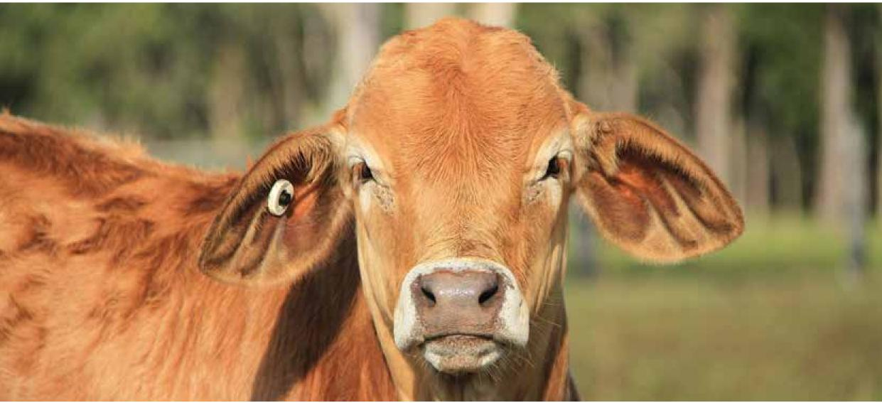

### Activities

#### Activity 5.1.a Undertake risk mapping of the likelihood of entry, establishment and spread of LSD

This activity aims to undertake risk mapping of geographical areas that may have a higher likelihood of entry, establishment and spread of LSD. Further capacity development may incorporate information about arthropod vector populations, weather patterns (including modelling), data on the structure and dynamics of cattle and buffalo populations, as well as distribution and movement dynamics in response to climate and other variables.

Work has commenced on this activity.

#### Activity 5.1.b Develop epidemiological modelling systems for LSD

This activity shall focus on the development of systems for the epidemiological modelling of vector-transmitted disease outbreaks. The system will be used to integrate data from jurisdictional and national datasets. This includes animal positional information from property identification code (PIC) databases as well as livestock movement data. This will allow the modelling of potential response strategies to assist in preparing for potential disease incursions.

#### Activity 5.2.a Develop a national LSD vaccination strategy

This activity will establish a national LSD vaccine working group to develop a national LSD vaccination strategy, including options on how to best apply vaccination during a response and how to identify vaccinated animals. To inform the strategy, modelling can be used to help guide cost-effective vaccine deployment to control disease spread, where practical. The development of new LSD vaccines will continue to be monitored to determine if future changes are required to the LSD chapter in the WOAH Terrestrial Animal Health Code. Over the longer term, input from Activity 7.2 may also guide preferred options identified in the national LSD vaccination strategy.

Work has commenced on this activity.

#### Activity 5.2.b Accessing an LSD vaccine appropriate for use within Australia

Commercially available LSD vaccines will be evaluated to assess their suitability for emergency use in Australia. Applications for an Australian Pesticides and Veterinary Medicines Authority (APVMA) emergency use permit and an import permit will be facilitated to ensure vaccine availability if there is an outbreak.

Work has commenced on this activity.

#### Activity 5.2.c Investigating options for the timely supply of LSD vaccines

This activity aims to investigate options to secure access to LSD vaccines in the event of an outbreak, including the possibility of investment in a LSD vaccine bank modelled on the Australian FMD Vaccine Bank.

#### Activity 5.3 Review the national LSD response strategy

This activity aims to ensure the national LSD response strategy is fit-for-purpose and well aligned with the national LSD vaccination strategy. This will include a thorough evaluation of both the response and vaccination strategies to ensure they are suitable for use Australia-wide. This would focus on the practical application of activities within the AUSVETPLAN Response strategy: Lumpy skin disease (the AUSVETPLAN LSD Response Strategy), or activities that will be necessary following the responses detailed in AUSVETPLAN. This includes the development and administration of programs relating to animal carcass management, property decontamination and the coordination of interjurisdictional or interagency support. Discussion exercises and outbreak scenarios will test response capability, factoring in some of the challenges that would be faced during an outbreak in northern Australia including vector and feral animal control, animal identification, monitoring, and traceability. This can also consider issues with animal welfare arising from market disruption, movement controls, and culling. The additional burden of diagnostic testing requirements to demonstrate freedom should also be investigated, where zoning or compartmentalisation may be used to allow trade to continue during an emergency response. Outcomes will be used to further refine the AUSVETPLAN LSD Response Strategy as well as other components of Australia’s LSD preparedness.

Work has commenced on this activity.

#### Activity 5.4 Prepare to manage exported livestock in transit and in preparation for export during an incursion

This activity would involve the development of contingency plans (including preparedness, logistics, biosecurity and welfare) for Australian livestock consignments which are within the export process, including those that are loading or those that have departed but not yet arrived in their destination country. Scenario planning may be used to model potential trade disruptions and contingency plans developed in collaboration with producers, live exporters, and state and territory governments.

#### Activity 5.5 Investigate arthropod vector control options

This activity will review Australia’s current arthropod vector control options (including in near neighbouring countries) and investigate if there are opportunities to improve these or put in place plans to prevent the spread of disease. This will also include assessment of available tools to control LSD vectors, to inform prevention and response activities.

Table Activities under Objective 5

| Activity | Lead and key collaborators a |
| --- | --- |
| 5.1.a Undertake risk mapping of the likelihood of entry, establishment and spread of LSD | *Lead:* DAFF  *Collaborators:* State and territory governments, AHC, other partners |
| 5.1.b Develop epidemiological modelling systems for LSD | *Lead:* DAFF  *Collaborators:* State and territory governments, AHC, other partners |
| 5.2.a Develop a national LSD vaccination strategy | *Lead:* AHC and AHA  *Collaborators:* CSIRO, CCA, AHC (inc. VEAG), other partners |
| 5.2.b Accessing an LSD vaccine appropriate for use within Australia | *Lead:* DAFF |
| 5.2.c Investigating options for the timely supply of LSD vaccines | *Lead:* DAFF and AHA  *Collaborators:* State and territory governments, peak industry bodies |
| 5.3 Review the national LSD response strategy | *Lead:* AHA, AHC and DAFF (inc. TRG)  *Collaborators:* Peak industry bodies |
| 5.4 Prepare to manage exported livestock in transit and in preparation for export during an incursion | *Lead:* DAFF  *Collaborators:* AHC, LiveCorp, MLA, live animal exporters |
| 5.5 Investigate arthropod vector control options | *Lead:* DAFF  *Collaborators:* State and territory governments |

**a** Note: the ‘activity lead’ is expected to drive the activity (i.e., develop and implement the project plan, source available funding [where required]) and to liaise with key collaborators to achieve the expected benefits and outcome.

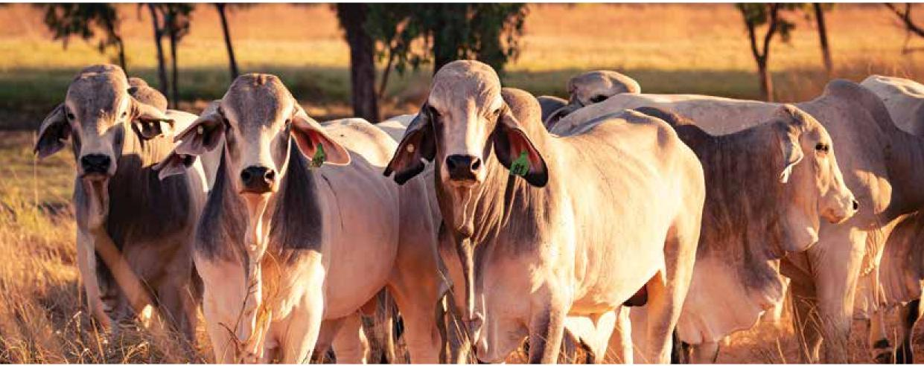

## Objective 6—Awareness and communications

**Facilitate stronger engagement between governments, industry and communities through a comprehensive and adaptable communication strategy for LSD.**

A comprehensive and adaptable communication strategy is required to support this Action Plan.

When LSD was first detected in Indonesia, the Commonwealth commenced communication activities to raise awareness of the disease, and to encourage vigilance and reporting.

A longer-term communication plan is now under development, that will take into account broader concerns, such as food safety, as well as information about relevant projects under this Action Plan, working groups and stakeholder collaboration. This plan will continue to be updated as required.

A national LSD communication response plan is also under development to prepare for an incursion. This plan would need to be finalised through the Consultative Committee on Emergency Animal Diseases (CCEAD) at the time of an incursion, as it will need to support the national response based on the disease situation, and will require endorsement by the National Management Group. If funding is required to support communication and engagement activities, this will need to be approved through the national cost-sharing arrangements (as per EADRA).

This LSD communication response plan will focus on providing consistent national messages about the disease situation, government response activities, and information for audiences on what they need to do in terms of protecting their property, and assisting/complying with response activities. The plan will be developed by the National Biosecurity Communication and Engagement Network (NBCEN) in consultation with affected industry groups (EADRA signatories). State and territory governments remain responsible for communication to industry and the public at the jurisdictional and local level. DAFF is responsible for communication activities targeted at importers and exporters, incoming passengers, and trading partners.

### Activities

#### Activity 6.1 Develop a comprehensive and sustained LSD communication plan to raise awareness and understanding of the disease, risk and preparedness activities

This activity will develop a comprehensive and sustained LSD communication plan to raise awareness and understanding of the disease, risk and preparedness activities.

Work has commenced on this activity.

#### Activity 6.2 Develop a communication plan for use during an LSD emergency response

This activity will develop a communication plan that could be used during an incursion of LSD.

Table Activities under Objective 6

| Activity | Lead and key collaborators a |
| --- | --- |
| 6.1 Develop a comprehensive and sustained LSD communication plan to raise awareness and understanding of the disease, risk and preparedness activities | *Lead:* NBCEN, industry peak bodies  *Collaborators:* DAFF |
| 6.2 Draft a communication plan for use during an LSD emergency response | *Lead:* NBCEN |

**a** Note: the ‘activity lead’ is expected to drive the activity (i.e., develop and implement the project plan, source available funding [where required]) and to liaise with key collaborators to achieve the expected benefits and outcome.

## Objective 7—Research and innovation

**Improve Australia’s LSD preparedness and response through research priorities driven by industry and government needs, and ensure new knowledge is freely accessible.**

Animal health research is well supported and funded by Australia’s government agencies and industry. In addition, there is an array of opportunities for collaborative work with international organisations. The department is already engaged in collaborative LSD-related research to improve understanding of the vector spread pathways of LSD in South East Asia, and is actively engaged in discussions about LSD vaccine research using new vaccine technologies. It is important to maintain this momentum and ensure resources are directed towards the critical gaps in our knowledge and capacity.

The most effective vaccine currently available overseas includes attenuated-live LSD virus. In addition, the vaccine can cause mild disease in some animals. For these reasons, alternative options need be considered. Opportunities to investigate emerging technologies that are under development to create new vaccines for LSD needs to be explored.

LSD is spreading into new regions with different arthropod populations and climatic conditions, so work is needed to better understand the disease’s epidemiology and what the implications are for Australia and the region. Research should also be directed towards developing the right modelling tools to improve our epidemiological understanding, and to be able to quickly assess potential changes in the risk profile of LSD. The Australian Animal DISease (AADIS) model is an example of an epidemiological model that can simulate the spread and control of an animal disease in the Australian context. Although AADIS has been adapted for several livestock diseases including foot-and-mouth disease, African swine fever, and bluetongue virus, there are no similar simulation models for LSD. LSD has a multilayered epidemiology, with serious implications for becoming widespread in Australia, so investment is needed in innovative tools, including AADIS, to help predict appropriate controls.

Australia should be proactive with its LSD-related research to identify existing gaps in Australia’s LSD knowledge and preparedness. Future research should focus on creating solutions for identified gaps.

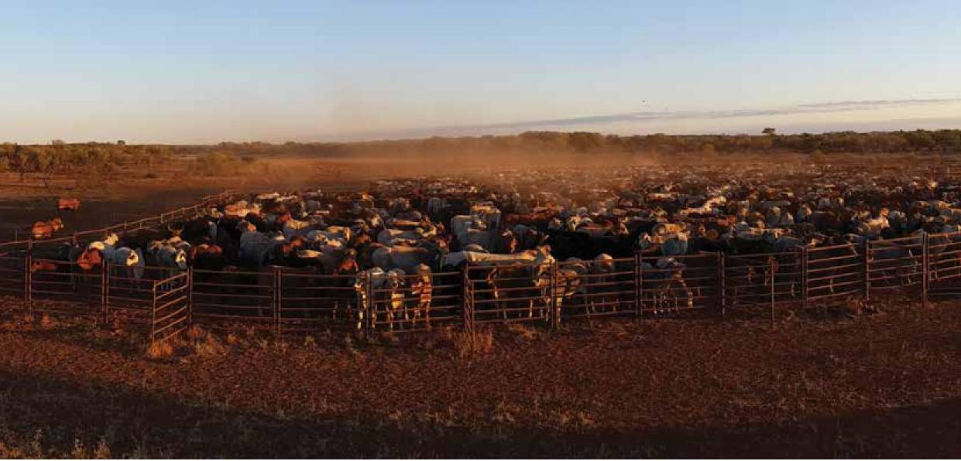

### Activities

#### Activity 7.1 Set national priorities for LSD research, engagement and communication

This activity will seek to bring together industry, government and other stakeholders to identify, prioritise and undertake important LSD-related research and preparedness activities. Stakeholders will collaboratively work to find solutions for problems identified through national workshops and exercises. Although many activities can be easily progressed through Australian networks, engagement with international partners and experts will also be required. Activities may include vector competence, distribution and transmissibility studies, as well as the development of new surveillance approaches.

#### Activity 7.2 Investigate new technology LSD vaccines

This activity will seek research interest in developing alternative vaccine technologies that can be deployed both in Australia and internationally to control the further spread of LSD. This includes the need for research to better understand the principles of immunity to LSD virus, allowing for the identification of more appropriate vaccines. The development of other subunit, mRNA or genetically modified organism-based vaccines would increase the range of options and potentially the safety of the LSD vaccines. This activity will be progressed in parallel with Activities 5.2.a, b and c, which will involve accessing and preparing to use currently available vaccines.

#### Activity 7.3 Develop modelling tools to support LSD preparedness and response

This activity will seek investment in other modelling tools to hone Australia’s LSD preparedness and response (in addition to epidemiological modelling tools developed under Activity 5.1.b). The modelling will help identify geographic regions, populations and production systems that might be at greater risk from LSD incursions; support studies on LSD’s economic effects, including how to minimise these; evaluate surveillance, testing and control strategies; and guide surveillance activities and training exercises.

Table Activities under Objective 7

| Activity | Lead and key collaborators a |
| --- | --- |
| 7.1 Set national priorities for LSD research, engagement and communication | *Lead:* DAFF, AHA (e.g. through the National Animal Biosecurity Research, Development and Extension Strategy) and AHC |
| 7.2 Investigate new technology LSD vaccines | *Lead:* ACDP, EMAI  *Collaborators:* DAFF and state and territory governments |
| 7.3 Develop modelling tools to support LSD preparedness and response | *Lead:* DAFF, CEBRA  *Collaborators:* State and territory governments |

**a** Note: the ‘activity lead’ is expected to drive the activity (i.e., develop and implement the project plan, source available funding [where required]) and to liaise with key collaborators to achieve the expected benefits and outcome.

## Objective 8—Recovery

**Mitigate the economic and social effects of an outbreak of LSD by developing options for a recovery strategy.**

There are significant long-term implications when dealing with an EAD outbreak and response. It is therefore critical to take a broad approach and ensure that planning considers the arrangements for recovery. Disasters, like an LSD outbreak, will not affect everyone in the same way. We need to identify recovery strategy policy options which are scalable and meet the needs of business, individuals, and communities in the event of an outbreak.

### Activities

#### Activity 8.1 Develop options for an LSD recovery strategy

This activity will develop options for a LSD recovery strategy in consultation with other APS agencies as appropriate, to assist in overall preparedness in the event of an LSD outbreak.

Table Activities under Objective 8

| Activity | Lead and key collaborators a |
| --- | --- |
| 8.1 Develop options for an LSD recovery strategy | *Lead:*DAFF in consultation with other Australian  Government agencies as appropriate |

**a** Note: the ‘activity lead’ is expected to drive the activity (i.e., develop and implement the project plan, source available funding [where required]) and to liaise with key collaborators to achieve the expected benefits and outcome.

## Implementing the plan

### Approach to implementation

The Action Plan has been developed in partnership between Australian governments, industry groups, non-governmental organisations and other stakeholders (Appendix A).

Implementation of the plan will continue this collaborative approach. There are 3 key areas that will support implementation:

1. Shared ownership and collaboration
2. Sustainable resourcing
3. Strong and efficient coordination and reporting mechanisms.

These key areas will be used to develop the implementation, communication and engagement, and monitoring and evaluation plans.

Once activities are underway, reviews will play a key role in monitoring progress and allowing for flexibility to adapt if priorities or circumstances change. For example, other EAD events can cause substantial shifts in priorities.

### Roles and responsibilities

Representatives from the Commonwealth, state and territory governments and industry peak bodies will share responsibility for the implementation of the plan. An industry-government steering committee, led by the Commonwealth, will help guide implementation of the plan and to represent industry and governments’ shared interests. DAFF will support the steering committee, coordinate implementation of the plan and assist in the reporting of actions to stakeholders.

Representatives from the department will provide central coordination for the plan by liaising with industry and governments, activity leads and collaborators, as required, to progress the subsequent implementation, communication and engagement, and monitoring and evaluation plans.

It will be the responsibility of the activity leads to drive their nominated activities. This includes liaising with collaborators, developing and implementing the activities’ project plan, and sourcing available funding, where required.

Implementation will require collaboration with others in the animal health community, and along the supply chain including universities, laboratories, animal health consultants and veterinarians, and other scientific organisations and associated industries. It is the responsibility of everyone to champion the plan and to report on its progress.

All activities in the plan will be collaborative, cultivate ownership and will aim to realise benefit for all those working within the cattle industry.

## Appendix A Stakeholders

Key stakeholders to be involved in the Action Plan finalisation and implementation

### Industry

* Industry EADRA signatories
* Australian Dairy Farmers Limited
* Australian Lot Feeders’ Association
* Cattle Council of Australia
* Goat Industry Council of Australia
* Sheep Producers Australia Limited
* Wool Producers Australia Limited
* Industry groups (non-EADRA signatories)
* AgForce
* Australian Buffalo Industry Council (ABIC)
* Australian Cattle Veterinarians
* Australian Dairy Industry Council
* Australian Dairy Products Federation (ADPF)
* Australian Livestock and Property Agents
* Australian Livestock and Rural Transporters Association
* Australian Livestock Export Corporation Limited (LiveCorp)
* Australian Livestock Exporters’ Council (ALEC)
* Australian Livestock Markets Association
* Australian Meat Industry Council
* Australian Meat Processor Corporation
* Australian Red Meat Advisory Council Limited (RMAC)
* Australian Registered Cattle Breeders Association
* Australian Veterinary Association
* Dairy Australia
* Kimberley Pilbara Cattlemen’s Association
* Meat and Livestock Australia (MLA)
* MINTRAC (National Meat Industry Training Advisory Council Limited)
* National Farmers Federation (NFF)
* Northern Territory Buffalo Industry Council
* Northern Territory Cattlemen’s Association
* Northern Territory Livestock Exporters Association
* Pastoralists and Graziers Association of Western Australia (PGA)

### Government or independent bodies

* Animal Health Australia
* Animal Health Committee
* Australian Government Department of Agriculture, Fisheries and Forestry
* Australian Government Department of Foreign Affairs and Trade
* CSIRO Australian Centre for Disease Preparedness
* Laboratories for Emergency Animal Disease Diagnosis and Response (LEADDR) network
* National Biosecurity Communication and Engagement Network (NBCEN)
* National Biosecurity Committee
* Subcommittee on Animal Health Laboratory Standards

### Jurisdictions

* Australian Capital Territory
* New South Wales, Department of Primary Industries
* Northern Territory, Department of Industry, Tourism and Trade
* Queensland, Department of Agriculture and Fisheries
* South Australia, Department of Primary Industries and Regions
* Tasmania, Department of Primary Industries, Parks, Water, and the Environment
* Victoria, Department of Economic Development, Jobs, Transport and Resources
* Western Australia, Department of Primary Industries and Regional Development.

## Appendix B Linkages

* [Intergovernmental Agreement on Biosecurity](https://www.agriculture.gov.au/biosecurity-trade/policy/partnerships/nbc/intergovernmental-agreement-on-biosecurity) (IGAB)– an agreement that aims to strengthen partnerships between the Australian, state and territory governments and improve the national biosecurity system by identifying roles and responsibilities and outlining collaboration priorities.
* [Commonwealth Biosecurity 2030 Roadmap](https://www.agriculture.gov.au/biosecurity-trade/policy/commonwealth-biosecurity-2030) – provides a clear and practical roadmap to direct and guide projects, initiatives and investments associated with the Australian Government’s biosecurity remit. Annual action plans will be developed to guide its delivery and ensure transparency.
* [National Biosecurity Strategy](https://www.biosecurity.gov.au/about/national-biosecurity-committee/nbs) (under development) – will align current and future efforts of key stakeholders across the system in a common purpose, enhancing the long-held commitment to shared responsibility with a clear and transparent commitment to action and investment.
* [Australian Veterinary Emergency Plan](https://animalhealthaustralia.com.au/ausvetplan/) (AUSVETPLAN) – the nationally-agreed approach for the response to emergency animal disease incidents in Australia. The plan is captured in a series of manuals and supporting documents.
* [Emergency Animal Disease Response Agreement](https://animalhealthaustralia.com.au/eadra/) (EADRA) – this agreement brings together the Australian, state and territory governments and livestock industry groups to collectively and significantly increase Australia’s capacity to prepare for—and respond to—emergency animal disease (EAD) incursions
* [AnimalPLAN](https://www.agriculture.gov.au/agriculture-land/animal/health/animal-plan) – Australia’s first national action plan for terrestrial agricultural animal health which consolidates themes from over 30 existing strategies, plans and frameworks and outlines priority animal health activities.
* [National Animal Health Diagnostic Business Plan](https://www.agriculture.gov.au/agriculture-land/animal/health/committees/ahc/animal-health-policies) (NAHDBP) 2021-2026 – a national plan to further develop and strengthen the animal health diagnostics component of Australia’s animal health system. The NAHDBP will guide the delivery of nationally coordinated activities to maintain and continually improve our national diagnostic capability and capacity.
* [National Animal Health Surveillance Business Plan](https://www.agriculture.gov.au/agriculture-land/animal/health/surveillance-diagnostics) (NAHSBP) 2021-2026 – a national plan to further develop Australia’s animal disease surveillance systems. The NAHSBP is intended to guide the delivery of surveillance activities in accordance with nationally agreed objectives and priorities.

## Appendix C Abbreviations

| Abbreviation | Meaning |
| --- | --- |
| AADIS | The Australian Animal DISease model |
| ABIC | Australian Buffalo Industry Council |
| ACDP | Australian Centre for Disease Preparedness |
| ADPF | Australian Dairy Products Federation |
| ALEC | Australian Livestock Exporters’ Council |
| ALOP | Appropriate level of protection |
| APVMA | Australian Pesticides and Veterinary Medicines Authority |
| AUSVETPLAN | Australian Veterinary Emergency Plan |
| DAFF | Australian Government Department of Agriculture, Fisheries and Forestry |
| DFAT | Australian Government Department of Foreign Affairs and Trade |
| EADRA | Emergency Animal Disease Response Agreement |
| FAO | Food and Agriculture Organization of the United Nations |
| IGAB | The Intergovernmental Agreement on Biosecurity |
| iSIKHNAS | Indonesia’s national animal health information system |
| LEADDR | Laboratories for Emergency Animal Disease Diagnosis and Response |
| LiveCorp | Australian Livestock Export Corporation Limited |
| LSD | Lumpy skin disease |
| LSDV | Lumpy skin disease virus |
| MAF | Ministry of Agriculture and Fisheries (Timor-Leste) |
| MINTRAC | National Meat Industry Training Advisory Council Limited |
| MLA | Meat and Livestock Australia |
| mRNA | Messenger ribonucleic acid |
| NABSnet | Northern Australia Biosecurity Surveillance Network |
| NAHDBP | The National Animal Health Diagnostic Business Plan |
| NAHSBP | The National Animal Health Surveillance Business Plan |
| NAMP | National Arbovirus Monitoring Program |
| NAQIA | National Agriculture Quarantine and Inspection Authority (Papua New Guinea) |
| NAQS | Northern Australia Quarantine Strategy |
| NBCEN | National Biosecurity Communication and Engagement Network |
| NFF | National Farmers Federation |
| NLIS | National livestock identification system |
| WOAH | World Organization for Animal Health |
| PGA | Pastoralists and Graziers Association of Western Australia |
| PNG | Papua New Guinea |
| POC | Point-of-care |
| RMAC | Australian Red Meat Advisory Council Limited |

## References

Animal Health Australia 2022, [Response strategy: Lumpy skin disease](https://animalhealthaustralia.com.au/ausvetplan/) (version 5.0), Australian Veterinary Emergency Plan (AUSVETPLAN), edition 5, Canberra.