# Strategic Steering Group – Member Biographies

## Dr Chris Rodwell – Transition Advocate, Chair

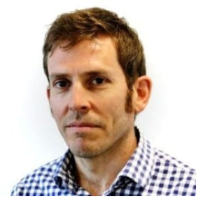Dr Chris Rodwell has had significant international and national experience in livestock systems specialising in agricultural exports and trade, disease preparedness, animal welfare and biosecurity.

He has worked at international, national and state level in government and is based in his home state of WA.

He has led and shaped primary system change in a number of agricultural areas including live export, biosecurity and farm support services. He has developed strategies from the ground up and also implemented them so they make meaningful impact on the ground.

Before his appointment as independent Transition Advocate, he was engaged by the CSIRO to help create a future-focused vision and implementation plan for Australia’s national biocontainment laboratory in Geelong and it’s 300 staff.

Prior to this, he helped establish a new national farm advisory service in NZ and develop its initial strategic direction; to help producers navigate increasing environmental and climate regulation sustainably and profitably. He was also in charge of live exports, animal welfare science standards, NZ’s Chief Technical Officer for Biosecurity with statutory accountability for setting the nations biosecurity import standards, and helped establish a new state veterinary function to address endemic livestock diseases of high production impact.

He believes strategies should be useful, evidence-backed and guide choices for investment and ideas.

## Ms Bindi Murray - Sheep and wool producer

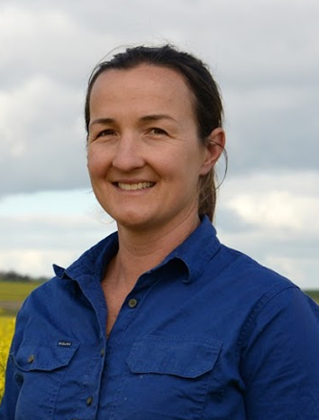Ms Murray is a commercial farmer and sheep producer based in Woodanilling, Western Australia, running approx. 7500 Merino ewes. The enterprise supplies local processors as well as the live export market. Aside from on farm experience, she also brings skills and experience in international markets, industry systems, government and industry relations, RD&A, and industry strategy and risk management. Her focus is on the development of scientific advances for the sheep industry and their adoption to increase production and profitability. She believes in developing strong relationships, working with producers, supply chain and the government, while developing knowledge of the supply chain as a whole for better impact.

Ms Murray worked in sheep genetics research and agricultural policy after completing her Honours in Animal Science. She is a member of the Australian Institute of Company Directors (AICD) and has graduated form the AICD Company Directors course as well as the Rabobank Executive Development Program.

Ms Murray is Chair of Sheep Producers Australia and currently holds Non-Executive Director roles in the Red Meat Advisory Council and Sheep Industry Health and Welfare Trust. She is involved in industry R&D through her position on the MLA Red Meat Panel, AWI industry Consultative Committee and previous role on the Live Export R&D Advisory Committee. She has previous experience as a Director of the WA Meat Industry Authority, Live Export Reference Group and Sheep Alliance of WA.

## Ms Erin Gorter - Rural industry consultant

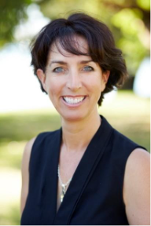Ms Gorter is a rural industry consultant, a non-executive Director of Australian Grain Technologies and the Grower Group Alliance.

Ms Gorter serves on the Council for Australian Arab Relations and is Chair of the Mt Burdett Rural and Regional Advancement Foundation committee.

Ms Gorter was integrally involved in the WA QLamb Alliance, as former Chair and has extensive experience with grower groups as the former Executive Officer of Evergreen Farming and Southern Dirt.

Ms Gorter is a graduate of the Australian Institute for Company Directors program, the Australian Rural Leadership Program, and the Curtin Business School Ignition program.

Ms Gorter has served on the Grower Group Alliance Board as Vice Chair from December 2018 and appointed by the Board as Chair from 10 December 2024.

## Mr Ashley Herbert - Agribusiness consultant

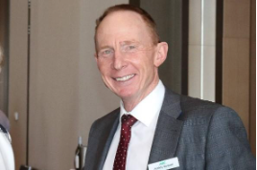Mr Herbert is a highly regarded farm management consultant who has been providing professional services to Western Australian mixed farming businesses for 32 years.

Mr Herbert is recognised for his specialist skills in sheep production and his commitment to helping his clients make good business decisions that balance the physical capability, financial performance and risk profile of their business.

Mr Herbert is a director on the Rural Business Development Corporation (RBDC) board, member of the Future drought Fund Advisory Committee and is a graduate of the Australian Institute for Company Directors program