**Long Term Intervention Monitoring Project**

**Lachlan River System Selected Area**

**Project Progress Report**

**Report period: *1 September to 31st December 2014***

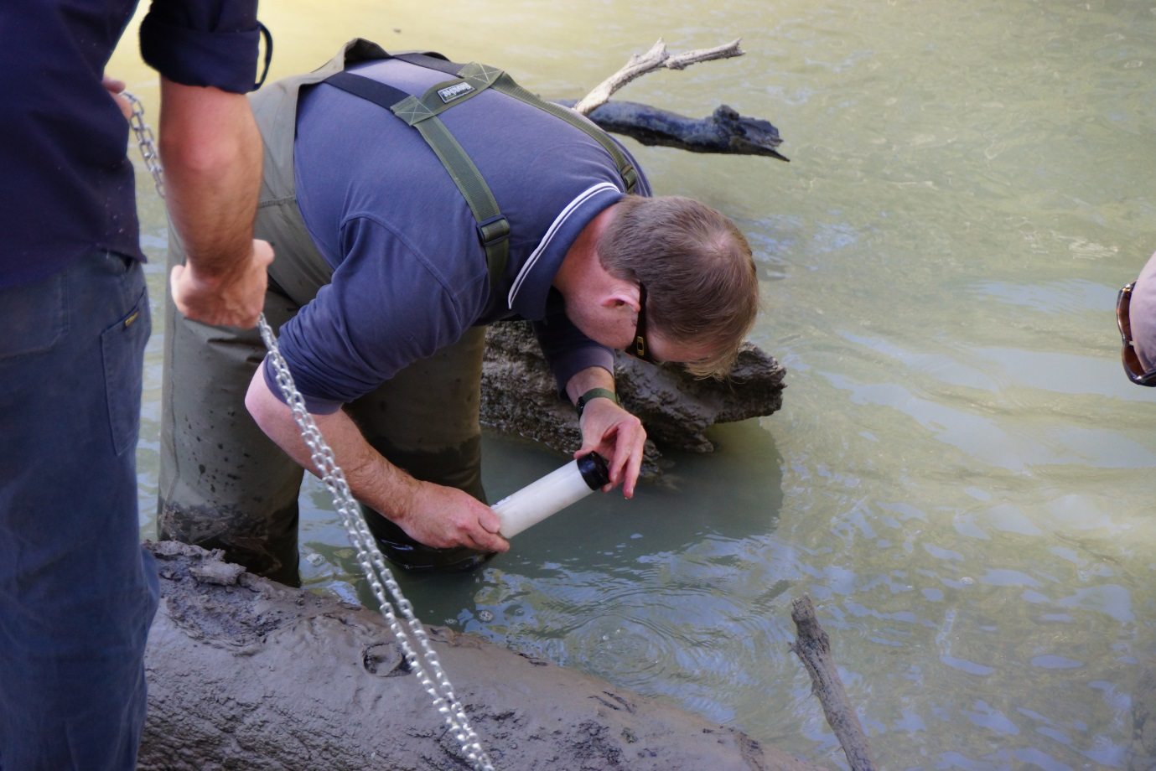

Installation of water quality monitoring equipment at Whealbah Bridge on the Lachlan River.

Inquiries regarding this document should be addressed to:

Dr Fiona Dyer  
Phone: 02 6201 2452  
e-mail: Fiona.Dyer@canberra.edu.au

**Document history and status**

|  |  |  |  |  |
| --- | --- | --- | --- | --- |
| Version | Date Issued | Reviewed by | Approved by | Revision Type |
| Draft 1 | 12 December 2014 | Ben Broadhurst | Fiona Dyer | Internal |
| FINAL | 16 December 2014 |  | Fiona Dyer | FINAL |

**Distribution of copies**

|  |  |  |
| --- | --- | --- |
| Version | Type | Issued to |
| FINAL | Electronic | Commonwealth Environmental Water Office |

**Copyright**© Copyright Commonwealth of Australia, 2014



‘Long term intervention monitoring project, Lachlan River system selected area, progress report 1 September to 31st December 2014’ is licensed by the Commonwealth of Australia for use under a Creative Commons By Attribution 3.0 Australia licence with the exception of the Coat of Arms of the Commonwealth of Australia, the logo of the agency responsible for publishing the report, content supplied by third parties, and any images depicting people. For licence conditions see: <http://creativecommons.org/licenses/by/3.0/au/>

**Disclaimer**

The views and opinions expressed in this publication are those of the authors and do not necessarily reflect those of the Australian Government or the Minister for the Environment. While reasonable efforts have been made to ensure that the contents of this publication are factually correct, the Commonwealth does not accept responsibility for the accuracy or completeness of the contents, and shall not be liable for any loss or damage that may be occasioned directly or indirectly through the use of, or reliance on, the contents of this publication.

1. Objectives of Commonwealth environmental water use in the   
   Lachlan River system during 2014-15

**Primary objective:** Commonwealth environmental water will contribute to the preservation of the integrity of small to medium unregulated flows through the Lachlan River system through spring-summer to provide natural cues for native fish

**Secondary objectives:** It is anticipated that this action will contribute to improved habitat access, fish condition, recruitment opportunities, larval survival, and will provide a more natural flow variability by restoring a portion of small to medium freshes.

**Commonwealth Water delivered as at 30 September 2014:** 5,000 ML combined with NSW water of 821 ML

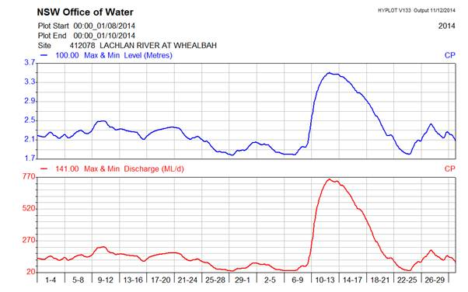

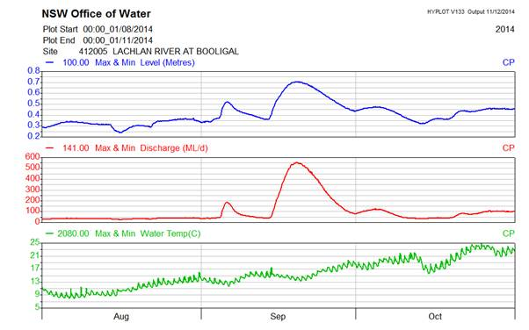

1. Summary on progress against core monitoring and evaluation activities

|  |  |  |
| --- | --- | --- |
| ACTIVITIES | PROGRESS TO DATE | UPCOMING ACTIVITIES |
| *Monitoring activities* | | |
| Ecosystem type | * Initial data collected | * Processing of data and verification of ANAE type for sites |
| Fish (river) | * No sampling required | * Sampling in Autumn 2015 |
| Fish (larvae) | * Sampling commenced 15/10 and finished 12/12 | * Processing of samples collected during field program |
| Waterbird breeding (optional) | * No sampling required | * None |
| Water quality and stream metabolism | * Sampling sites established 25/8 | * Processing of field data. |
| Vegetation diversity | * Sampling commenced 3/11 and finished 5/12 | * Processing of field data |
| Frogs (optional) | * No sampling required | * None |
| *Evaluation activities* | | |
| Monitoring data entry | * Database not yet available | * n/a |
| *Communication and engagement* | | |
| Selected Area Working Group | * Meeting held 10/7/14 | * Meeting schedule to be established for 2014 and quarterly meetings held |
| Other Stakeholder Engagement | * Land access protocols developed for all sites being accessed for sampling | * Provision of information to landholders |

**Note:** for the Long-Term Intervention Monitoring Project, Lachlan River system selected area:

* **Appendix A** provides additional information about the project for the Lachlan system and its context in terms of ecological monitoring and evaluation within the Murray-Darling Basin
* **Appendix B** provides a map showing the location of hydrological zones that will be monitored
* **Appendix C** provides a summary of monitoring to be undertaken under the project from 2014-2019.

1. Field observations
   1. Larval Fish Sampling

Following the fish spawning flow, fortnightly sampling of Larval fish was conducted between mid-October and mid-December at three sites on the lower Lachlan River (Wallanthry, Hunthawang and Lanes Bridge). Field observations of retrieved nets and traps confirmed that larval fish were present at all sites and among the species to have spawned were Murray cod and Australian smelt. Processing of the samples will commence in the new year.

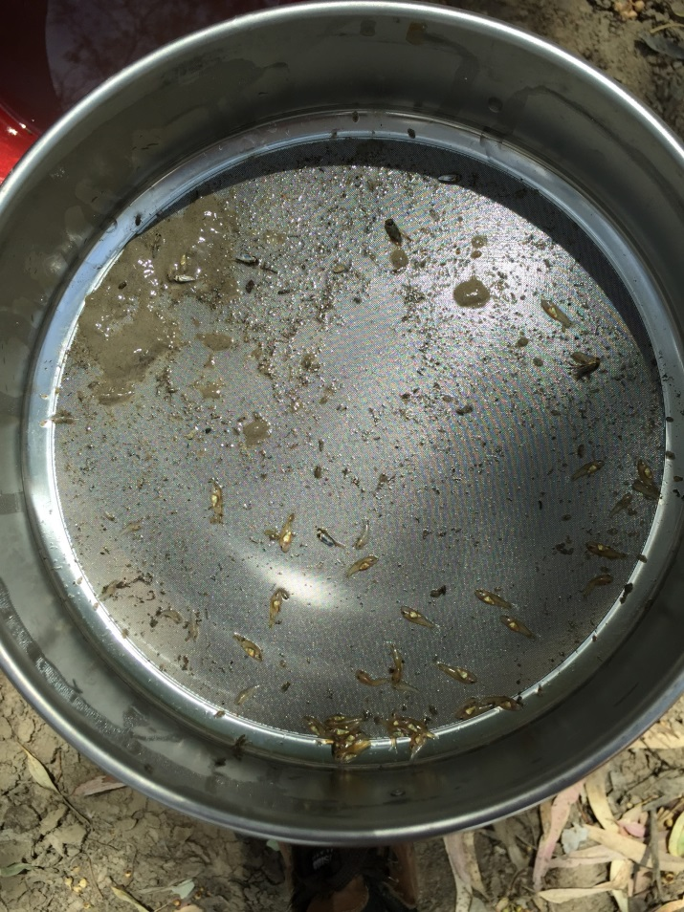

Figure 1.Larval fish captured in a light trap at Hunthawang on the lower Lachlan River.

* 1. Vegetation Monitoring

Vegetation monitoring was conducted between 3 November and 5 December. This involved the establishment of permanent plots and transects at a series of sites between the Great Cumbung Swamp and Lake Brewster. The field team was led by Fiona Dyer and comprised staff from the University of Canberra, Central Tablelands LLS, NSW Office of Environment and Heritage, NSW Department of Primary Industries (Office of Water) and the Commonwealth Environmental Water Office.

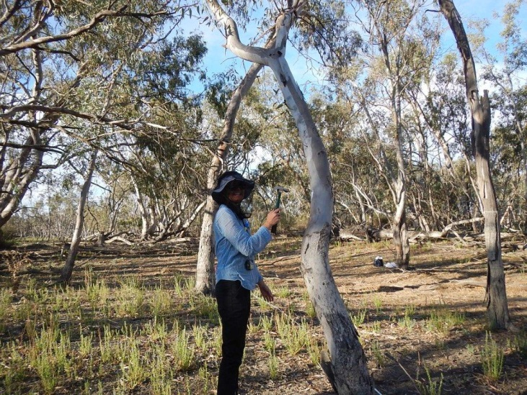 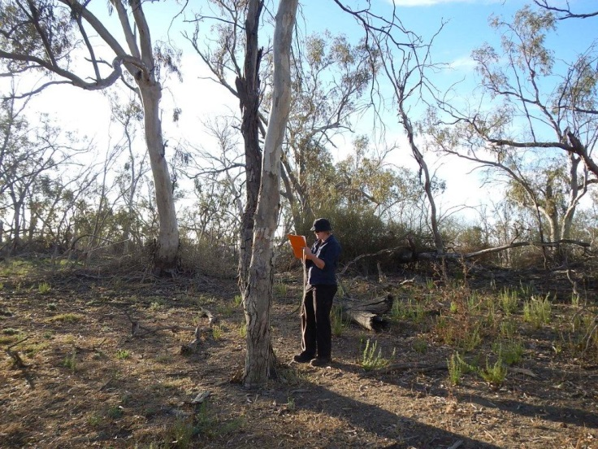

Figure 1. Vegetation monitoring at Lake Tarwong by CEWO staff.

All sites were dry during the November monitoring and many properties were starting to de-stock as projections are for a very dry summer. Groundcover was low at most sites, with wetland transects having very little cover in the lower lying areas. The last week of sampling took place in early December and 8mm of rain had been received in the Booligal/Bullogal area. This wasn’t sufficient to put water in Merrowie Creek or produce a vegetation response, but clay pans were wet making site access challenging.

The Black box was observed to be flowering at almost all sites and some recruitment of Black Box was observed at Lake Ita (inlet channel) sites, but was under serious grazing pressure (predominantly from goats).

Appendix A: The Long-Term Intervention Monitoring Project for the Lachlan River system and its context in terms of ecological monitoring and evaluation within the Murray-Darling Basin.

The Long Term Intervention Monitoring (LTIM) Project for the Lachlan river system selected area is funded by the Commonwealth Environmental Water Office. The project is being delivered by a consortium of service providers lead by University of Canberra and includes NSW Office of Environment and Heritage, NSW Department of Primary Industries (Fisheries), Central Tablelands Local Land Services, NSW Department of Primary Industries (Office of Water), University of New South Wales and Charles Sturt University.

The LTIM project is based on a clear and robust program logic, as detailed in the [Long-Term Intervention Monitoring Project Logic and Rationale Document](http://www.environment.gov.au/water/cewo/publications/long-term-intervention-monitoring-project-logic-and-rationale-document). That document sets out the scientific and technical foundations of long-term intervention monitoring and is being applied to areas where LTIM projects are being undertaken. It also provides links between Basin Plan objectives and targets to the monitoring of outcomes from Commonwealth environmental watering actions. For more information, see [Monitoring and evaluation for the use of Commonwealth environmental water](http://www.environment.gov.au/topics/water/commonwealth-environmental-water-office/monitoring-and-evaluation).

Many different agencies play a role in the reporting on environmental outcomes, consistent with the Basin Plan (see figure 1 below). The Murray Darling Basin Authority is responsible for reporting on achievements against the environmental objectives of the Basin Plan at a basin-scale, which are broadly focussed on flows and water quality, fish, vegetation and birds across the whole of the Basin. State Governments are responsible for reporting on achievements against the environmental objectives of the Basin Plan at an asset-scale i.e. rivers, wetlands, floodplains. The Commonwealth Environmental Water Holder is responsible for reporting on the contribution of Commonwealth environmental water to the environmental objectives of the Basin Plan (at multiple-scales).

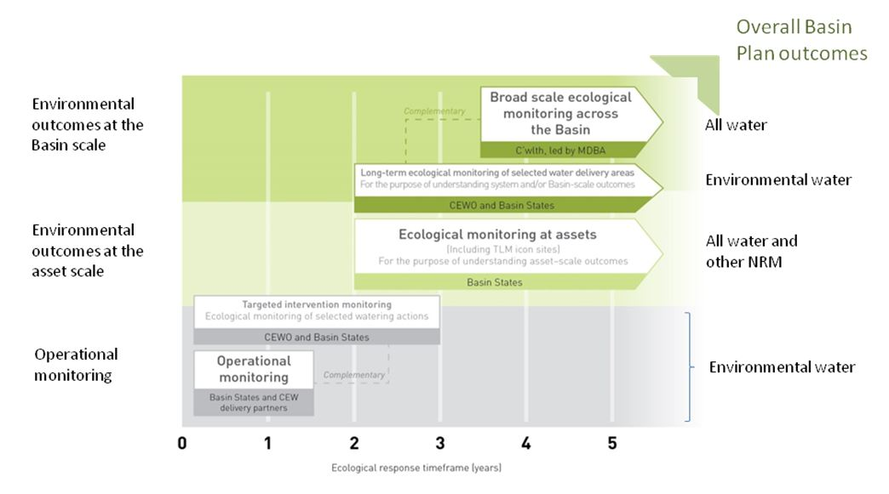

Figure 1. A summary of roles various agencies play a in the reporting on environmental outcomes, consistent with the Basin Plan.

Appendix B: Map showing location of hydrological zones of the Lachlan system for the Long-Term Intervention Monitoring Project.

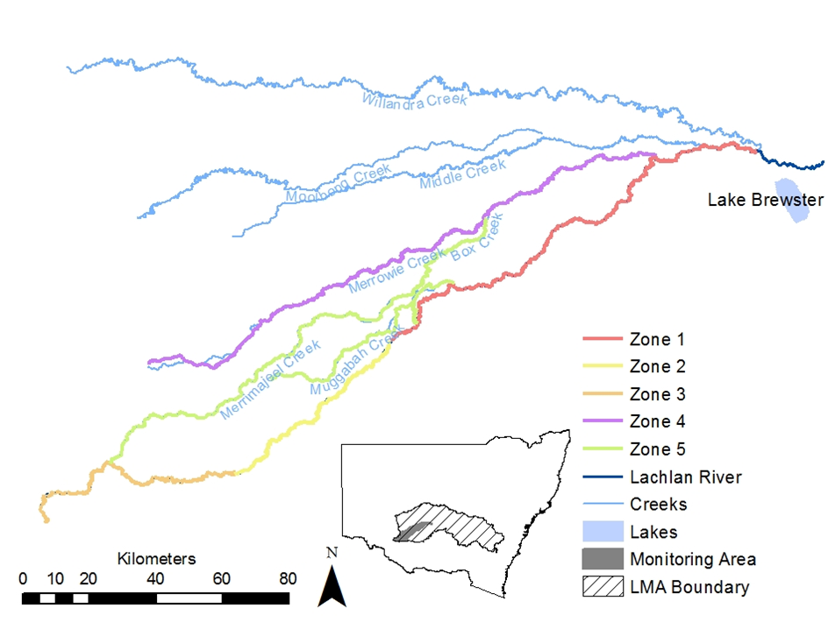

Appendix C: Summary of monitoring to be undertaken in the Lachlan system for the Long Term Intervention Monitoring Project from 2014-2019

The five year monitoring schedule has been based around the expected watering options and is focussed on the monitoring of Basin Indicators. Monitoring effort is consistent across the five years with the exception of monitoring Waterbird Breeding and Frogs which are options that can be implemented on the basis of a request from the CEWO.

|  |  |  |  |  |  |  |
| --- | --- | --- | --- | --- | --- | --- |
| indicator | ZONE | Evaluation of responses to Commonwealth environmental watering in the Lachlan system (✓where appropriate) | Data will contribute to evaluation of responses to Commonwealth environmental watering at whole of Basin-scale (✓where appropriate) | monitoring frequency | sites | expected schedule |
| Ecosystem type | All | ✓ | ✓ | Once only | All sites for other indicators | Establishment of ANAE type at the start of the LTIM Project. Expected August-December 2014 |
| Riverine fish | 1 | ✓ | ✓ | ANNUAL | Basin Evaluation: 10 fixed sites within Zone 1 | Annual sampling between March and May |
| Larval fish | 1 | ✓ | ✓ | ANNUAL | 3 fixed riverine sites in Zone 1 | Annual sampling 5 times during breeding season (September to February) |
| Stream metabolism | 1 | ✓ | ✓ | CONTINUOUS  REGULAR | Four fixed sites matched to riverine fish sampling sites in Zone 1 | Continuous monitoring of dissolved oxygen and, temperature.  6 weekly sampling of nutrients and water quality attributes. |
| Hydrology (River) | 1 | ✓ | ✓ | CONTINUOUS | Gauging sites |  |
| Vegetation diversity and condition | All | ✓ |  | ANNUAL & EVENT BASED | 12 fixed sites | Before and after watering (expected to be April/May and 3 months after first fill) |
| Waterbird breeding (Option) | 1 | ✓ |  | EVENT-BASED (on request from the CEWO) | One fixed site – Booligal wetland | Fortnightly surveys of bird breeding triggered by breeding events in Booligal wetland.  Assumes 3 breeding events in 5 years. |
| Frogs (Option) | All | ✓ |  | EVENT-BASED (on request from the CEWO) | 15 sites comprising 2 to 8 wetland sites and 2 to 7 riverine sites depending on watering targets | 3 sampling events between August and February (one sample in each of winter, spring and summer). |
| Hydrology (wetland – Option) |  | ✓ |  | EVENT-BASED (in conjunction with Waterbird Breeding or Frog monitoring) | Cameras at 6 roving wetland sites | Cameras installed prior to targeted watering each year and downloaded after the watering event has passed |