**Long Term Intervention Monitoring Project**

**Lachlan River System Selected Area**

**Project Progress Report**

**Report period: *1 October to 31 December 2015***

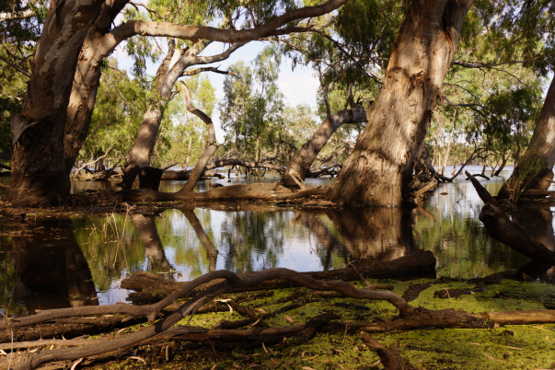

Inquiries regarding this document should be addressed to:

Dr Fiona Dyer  
Phone: 02 6201 2452  
e-mail: Fiona.Dyer@canberra.edu.au

This document was prepared by Fiona Dyer with contributions from Skye Wassens, Ben Broadhurst and Carmen Amos.

Cover Photo: Moon Moon swamp, October 28 2015 (photo by Laura Caffrey, University of Canberra)

**Document history and status**

|  |  |  |  |  |
| --- | --- | --- | --- | --- |
| Version | Date Issued | Reviewed by | Approved by | Revision Type |
| Draft 1 | 16 December 2015 |  | Fiona Dyer | Internal |
| FINAL | 29 February 2016 | Ebony Coote, CEWO | Fiona Dyer | External |

**Distribution of copies**

|  |  |  |
| --- | --- | --- |
| Version | Type | Issued to |
| FINAL | Electronic | Commonwealth Environmental Water Office |

**Copyright**© Copyright Commonwealth of Australia, 2015



‘Long term intervention monitoring project, Lachlan River system selected area, progress report’ is licensed by the Commonwealth of Australia for use under a Creative Commons By Attribution 3.0 Australia licence with the exception of the Coat of Arms of the Commonwealth of Australia, the logo of the agency responsible for publishing the report, content supplied by third parties, and any images depicting people. For licence conditions see: <http://creativecommons.org/licenses/by/3.0/au/>

**Disclaimer**

The views and opinions expressed in this publication are those of the authors and do not necessarily reflect those of the Australian Government or the Minister for the Environment. While reasonable efforts have been made to ensure that the contents of this publication are factually correct, the Commonwealth does not accept responsibility for the accuracy or completeness of the contents, and shall not be liable for any loss or damage that may be occasioned directly or indirectly through the use of, or reliance on, the contents of this publication.

1. Objectives of Commonwealth environmental water use in the   
   Lachlan River system during 2015-16
   1. Commonwealth environmental water use

As at 31 December 2015, 34 523 ML of Commonwealth environmental water had been delivered to the Lower Lachlan River system across three watering actions. These actions were designed to contribute to supporting native riparian, wetland and floodplain vegetation diversity and condition, provide habitat to support survival, maintain condition of, and provide reproduction opportunities for native fish (e.g. Murray cod and golden perch) waterbirds (e.g. straw necked ibis) and other aquatic vertebrate species (e.g. Murray River turtle). The three actions were:

1. 24 058ML of Commonwealth environmental water into Lachlan River, targeting the Great Cumbung Swamp. This action is expected to consolidate the benefits of inundation that occurred in 2013 and support the survival and growth of wetland vegetation and habitat values for waterbirds and other water dependent species.
2. 1087 ML of Commonwealth environmental water to Merrimajeel Creek targeting Murrumbidgil Swamp. 1497 ML of Commonwealth environmental water to Merrimajeel Creek to support waterbird habitat at the Blockbank.
3. 9378 ML of Commonwealth environmental water to the Lachlan River, targeting flow cued native fish outcomes, specifically golden perch, but also to contribute to non-flow cued native fish outcomes for species such as Murray cod.

The specific objectives for these watering actions were:

|  |  |  |
| --- | --- | --- |
| Action | Primary Objective | Secondary Objective |
| 1 | To protect, maintain and improve riparian, wetland and floodplain vegetation diversity and condition | To improve hydrological connectivity, contribute to ecosystem function, support vegetation condition (river red gum, lignum and aquatic macrophytes) and ecosystem resilience. |
| 2 | To contribute to hydrological connectivity in the Booligal wetlands and   1. protect the extent and condition of native riparian and vegetation communities, 2. potentially maintain base flows into Booligal Swamp to support waterbird breeding to completion | To support the ongoing recovery and resilience of Murrumbidgil Swamp if dry conditions continue, by providing drought refuge. |
| 3 | To support habitat requirements to native fish and other water dependent vertebrates.  Provide opportunities for native fish movement, spawning and recruitment | Trial the augmentation of flows to generate a golden and/or silver perch movement and spawning response.  Protect and maintain the health of existing extent of riparian and wetlands native vegetation. |

* 1. Planned environmental water: translucent releases

Significant rainfall within the catchment in the first half of 2015 produced medium-large volumes of unregulated inflow to the Lachlan River, particularly from the Belubula and Boorowa Rivers. Inflows from 1 January to 26 August 2015 totalled 268 GL which consequently triggered the delivery of translucent releases, as required under the Lachlan Regulated River Water Sharing Plan. Dam levels were such that translucent releases were targeted at between 3,500 ML/day and 5,156 ML/day with a combination of passing flow and dam releases delivering the water to the Lower Lachlan river system. This translucent event contributed to approximately 72 GL of flow passing Lake Brewster weir in August-September 2015.

1. Summary on progress against core monitoring and evaluation activities

|  |  |  |
| --- | --- | --- |
| ACTIVITIES | PROGRESS TO DATE | UPCOMING ACTIVITIES |
| *Monitoring activities* | | |
| Ecosystem type | * Data collection complete and suggested Australian National Aquatic Ecosystems (ANAE) types for all sites included in the Monitoring and Data Management System (MDMS). | * No more data collection required |
| Fish (river) | * 2014-15 Annual Report Completed | * Sampling in 2016 |
| Fish (larvae) | * 2014-15 Annual Report Completed * All 2015-16 field sampling completed | * Processing of field samples: identification of larvae collected |
| Waterbird breeding (optional) | * No sampling required * Preparation of a proposal to analyse conditions in 2015 to determine why bird breeding did not progress | * Data analysis if required |
| Water quality and stream metabolism | * 2014-15 Annual Evaluation Report completed * Loggers deployed for 2015-16 watering * Checking, calibrating and downloading logger data completed | * Checking, calibrating and downloading logger data in 2016 * Analysis of data. |
| Vegetation diversity | * 2014-15 Annual Evaluation Report completed * Spring sampling completed * Field data partially processed | * Complete processing of field samples * Analysis of data |
| Frogs (optional) | * October and December frog monitoring completed | * Additional sites monitored in January * Analysis of data |
| *Evaluation activities* | | |
| Monitoring data entry | * All data from 2014-15 uploaded to MDMS | * Data to be uploaded once QA/QC steps completed |
| *Communication and engagement* | | |
| Selected Area Working Group | * Meeting held 10th December | * February meeting |
| Project team teleconference | * None | * Teleconference to be held in March |
| Other Stakeholder Engagement | * Quarterly report #5 provided to landholders with positive feedback. | * Quarterly progress report #6 to be provided to landholders and other stakeholders |

**Note:** for the Long-Term Intervention Monitoring Project, Lachlan River system selected area:

* **Appendix A** provides additional information about the project for the Lachlan system and its context in terms of ecological monitoring and evaluation within the Murray-Darling Basin
* **Appendix B** provides a map showing the location of hydrological zones that will be monitored
* **Appendix C** provides a summary of monitoring to be undertaken under the project from 2014-2019.

1. Observations
   1. Hydrology

The combination of environmental watering actions, translucent releases (planned watering activities) and rainfall in the catchment produced significant flows in the Lower Lachlan River in the second half of 2015. Flows reached 3,500 ML/day at Whealbah in mid to late September (Figure 1). The peak flow was a consequence of translucent releases and rainfall and a considerable rise in water level also occurred along the river (Figures 1 and 2). The flows targeting fish recruitment in November/December peaked at just over 2000 ML/day in early December at Whealbah (Figure 1) and just under 1600 ML/day at Booligal (Figure 3 when river temperatures had consistently been above 23o C since late October (Figure 2).

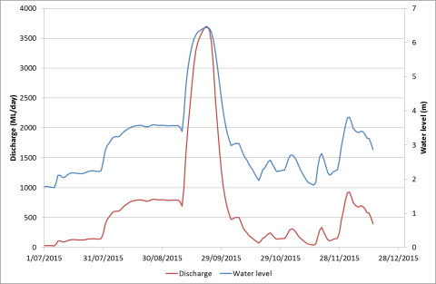

Figure 1. Flow and water level data from the Lachlan River at Whealbah. Data from NSW Waterinfo (Data from NSW Waterinfo (http://realtimedata.water.nsw.gov.au/) for station 412078, Lachlan River at Whealbah

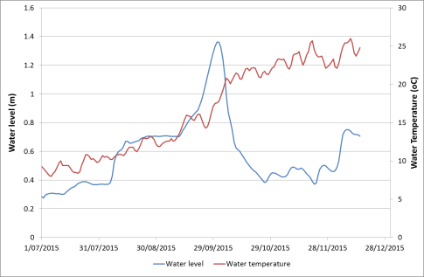

Figure 2. Water level and temperature from the Lachlan River at Booligal. Data from NSW Waterinfo (http://realtimedata.water.nsw.gov.au/) for station 412005, Lachlan River at Booligal

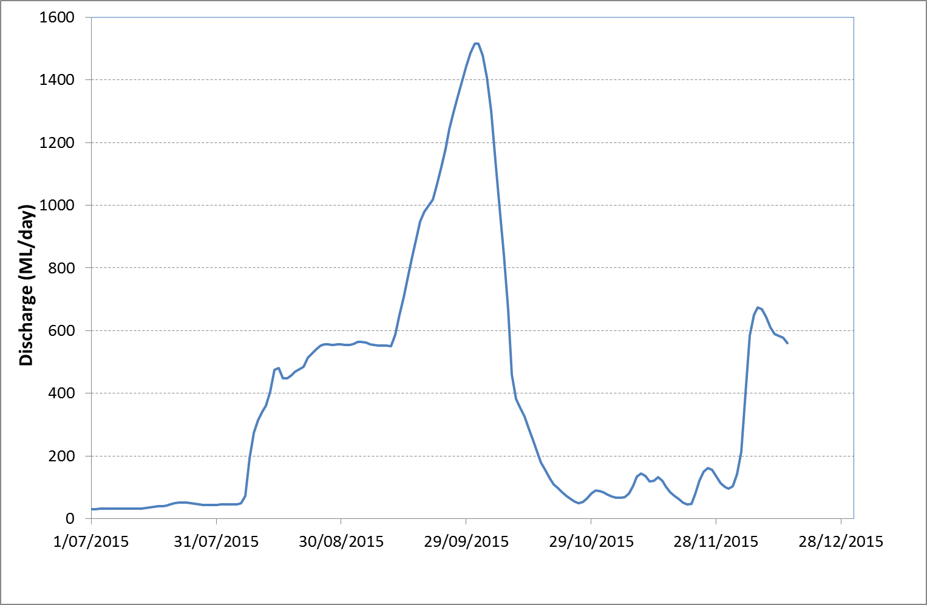

Figure . Flow data from the Lachlan River at Booligal. Data from NSW Waterinfo (http://realtimedata.water.nsw.gov.au/) for station 412005, Lachlan River at Booligal

* 1. Vegetation monitoring

Vegetation monitoring was conducted between 26 October and 30 November. Rain interrupted sampling and two trips were completed. Water was present in a number of the wetlands and billabongs including Hazelwood Billabong, Whealbah Billabong, Moon Moon swamp, Booligal wetlands, Murrumbidgil Swamp and the Cumbung swamp sites of Nooran and Clear Lake. Approximately 70% of the groundcover species have been identified with a few amphibious and aquatic species evident within the mix. Redgums within Murrumbidgil swamp were observed to be flowering (early) and some trees close to channels were covered in abundant large flowers.

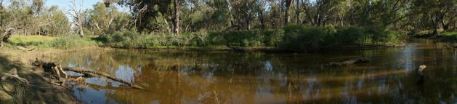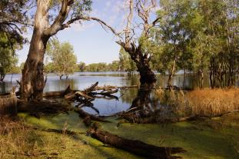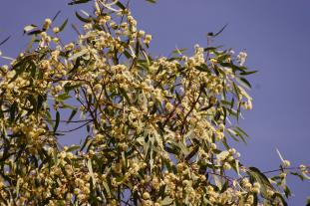

Figure 4. Hazelwood Billabong (top), Moon Moon swamp (bottom left) and redgum flowers at Murrumbidgil Swamp (bottom right) from the field sampling in October/November). Photos Fiona Dyer and Laura Caffrey

Large numbers of birds were observed while the vegetation monitoring was being conducted. Yellow billed spoonbills, ducks, sacred kingfishers and straw necked ibis were seen regularly around the wetlands and swamps (see Figure 4).

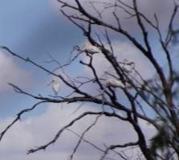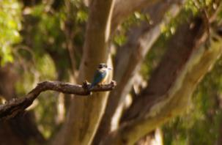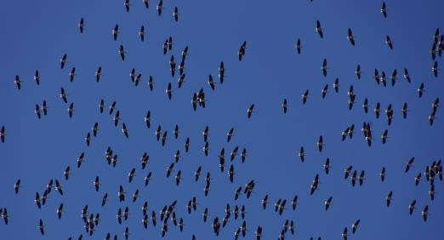

Figure 5. Birds observed during the vegetation sampling in October/November 2015. Yellow billed spoonbills at Whealbah lagoon (top left), Sacred Kingfisher at Moon Moon Swamp (top right) and Straw-necked ibis above Murrumbidgil Swamp (bottom). Photos Laura Caffrey and Fiona Dyer

* 1. Larval Fish monitoring

The larval fish monitoring was conducted between mid-October and mid-December at three sites near Hillston on the Lachlan River. Sixty percent of the larval samples have been processed. Large numbers of Murray cod larvae were caught in the first sampling in October with less caught in subsequent sampling trips. This suggests that Murray cod spawned early this year compared with the 2014-15 sampling. The sampling team were catching the larvae of small bodied fish in the later (second half of November and early December) sampling dates. No Golden perch have been observed in the samples and only a small number of carp and gambusia larvae have been collected in the sampling so far, but it is noted that there are still samples to be processed and identified.

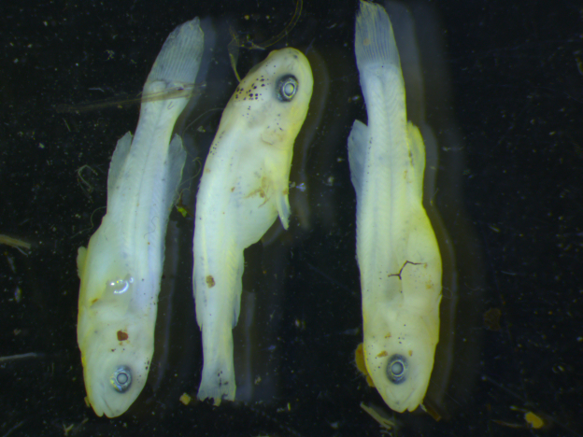

Figure 6. Larval Murray cod caught in a light trap from the Lachlan River (photo Ben Broadhurst)

* 1. Frogs

Initial frog surveys were conducted between 12and 16 October at fourteen sites across the Lower Lachlan river system. At the time of sampling all sites had moderate to high water levels, apart from Murrumbidgil Swamp which had only shallow pools. Four species were detected in the formal sampling: Spotted Marsh frog (*Limnodynates tasmaniensis)*, Giant Banjo frog (*Limnodynastes interioris)*, Plains froglet (*Crinia parinsignifera)* and Peron’s Tree frog (*Litoria peronii)*. The Spotted Marsh Frog, *L. tasmaniensis* was the most common and prolific species, identified at all 14 sites. The other active species detected, *L. interioris*, *C. parinsignifera* and *L. peronii* were also relatively widespread (detected at 8, 7 & 6 sites, respectively).

Although not part of the formal sampling, further observations were made in late October with Common Spadefoot Toad (*Nebatrachus sudelli)* juveniles and *L. tasmaniensis* juveniles identified at Alma crossing, and *N. sudelli* metamorphs and juveniles within Muggebah road, Box Yards road crossing area.

Recent breeding activity was evident with *Limnodynastes* species tadpoles in their early stages of development detected at 10 of the 14 sites. The presence of metamorphs and juveniles suggests successful recruitment in response to the recent delivery of water to the system.

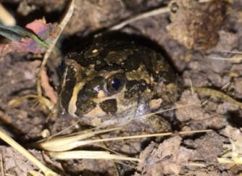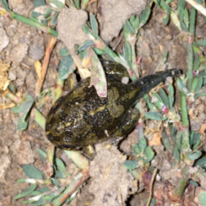

Figure 7. Nebatrachus sudelli juvenile and metamorph observed near Alma Road in late October. Photos Carmen Amos (NSW OEH).

Appendix A: The Long-Term Intervention Monitoring Project for the Lachlan River system and its context in terms of ecological monitoring and evaluation within the Murray-Darling Basin.

The Long Term Intervention Monitoring (LTIM) Project for the Lachlan river system selected area is funded by the Commonwealth Environmental Water Office. The project is being delivered by a consortium of service providers lead by University of Canberra and includes NSW Office of Environment and Heritage, NSW Department of Primary Industries (Fisheries), Central Tablelands Local Land Services, NSW Department of Primary Industries (Office of Water), University of New South Wales and Charles Sturt University.

The LTIM project is based on a clear and robust program logic, as detailed in the [Long-Term Intervention Monitoring Project Logic and Rationale Document](http://www.environment.gov.au/water/cewo/publications/long-term-intervention-monitoring-project-logic-and-rationale-document). That document sets out the scientific and technical foundations of long-term intervention monitoring and is being applied to areas where LTIM projects are being undertaken. It also provides links between Basin Plan objectives and targets to the monitoring of outcomes from Commonwealth environmental watering actions. For more information, see [Monitoring and evaluation for the use of Commonwealth environmental water](http://www.environment.gov.au/topics/water/commonwealth-environmental-water-office/monitoring-and-evaluation).

Many different agencies play a role in the reporting on environmental outcomes, consistent with the Basin Plan (see figure 1 below). The Murray Darling Basin Authority is responsible for reporting on achievements against the environmental objectives of the Basin Plan at a basin-scale, which are broadly focussed on flows and water quality, fish, vegetation and birds across the whole of the Basin. State Governments are responsible for reporting on achievements against the environmental objectives of the Basin Plan at an asset-scale i.e. rivers, wetlands, floodplains. The Commonwealth Environmental Water Holder is responsible for reporting on the contribution of Commonwealth environmental water to the environmental objectives of the Basin Plan (at multiple-scales).

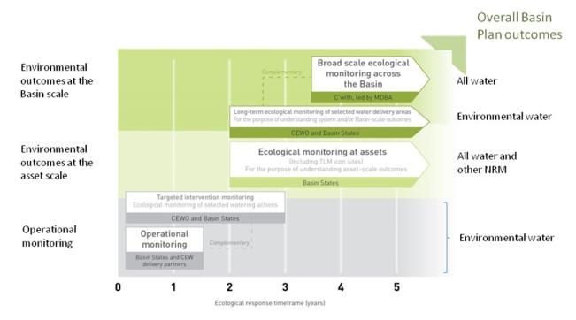

Figure 1. A summary of roles various agencies play a in the reporting on environmental outcomes, consistent with the Basin Plan.

Appendix B: Map showing location of hydrological zones of the Lachlan system for the Long-Term Intervention Monitoring Project.

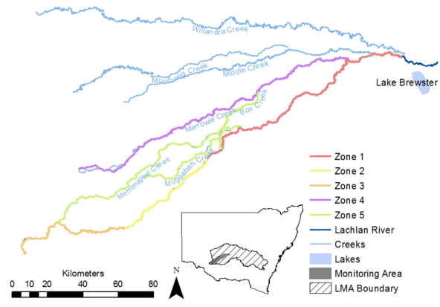

Appendix C: Summary of monitoring to be undertaken in the Lachlan system for the Long Term Intervention Monitoring Project from 2014-2019

The five year monitoring schedule has been based around the expected watering options and is focussed on the monitoring of Basin Indicators. Monitoring effort is consistent across the five years with the exception of monitoring Waterbird Breeding and Frogs which are options that can be implemented on the basis of a request from the CEWO.

|  |  |  |  |  |  |  |
| --- | --- | --- | --- | --- | --- | --- |
| indicator | ZONE | Evaluation of responses to Commonwealth environmental watering in the Lachlan system (where appropriate) | Data will contribute to evaluation of responses to Commonwealth environmental watering at whole of Basin-scale (where appropriate) | monitoring frequency | sites | expected schedule |
| Ecosystem type | All | ✓ | ✓ | Once only | All sites for other indicators | Establishment of ANAE type at the start of the LTIM Project. Expected August-December 2014 |
| Riverine fish | 1 | ✓ | ✓ | ANNUAL | Basin Evaluation: 10 fixed sites within Zone 1 | Annual sampling between March and May |
| Larval fish | 1 | ✓ | ✓ | ANNUAL | 3 fixed riverine sites in Zone 1 | Annual sampling 5 times during breeding season (September to February) |
| Stream metabolism | 1 | ✓ | ✓ | CONTINUOUS  REGULAR | Four fixed sites matched to riverine fish sampling sites in Zone 1 | Continuous monitoring of dissolved oxygen and, temperature.  6 weekly sampling of nutrients and water quality attributes. |
| Hydrology (River) | 1 | ✓ | ✓ | CONTINUOUS | Gauging sites |  |
| Vegetation diversity and condition | All | ✓ |  | ANNUAL & EVENT BASED | 12 fixed sites | Before and after watering (expected to be April/May and 3 months after first fill) |
| Waterbird breeding (Option) | 1 | ✓ |  | EVENT-BASED (on request from the CEWO) | One fixed site – Booligal wetland | Fortnightly surveys of bird breeding triggered by breeding events in Booligal wetland.  Assumes 3 breeding events in 5 years. |
| Frogs (Option) | All | ✓ |  | EVENT-BASED (on request from the CEWO) | 15 sites comprising 2 to 8 wetland sites and 2 to 7 riverine sites depending on watering targets | 3 sampling events between August and February (one sample in each of winter, spring and summer). |
| Hydrology (wetland – Option) |  | ✓ |  | EVENT-BASED (in conjunction with Waterbird Breeding or Frog monitoring) | Cameras at 6 roving wetland sites | Cameras installed prior to targeted watering each year and downloaded after the watering event has passed |