Long Term Intervention Monitoring Project
Lachlan River System Selected Area
Observations Report
Report period: 1 October 2016 to 31 December 2016

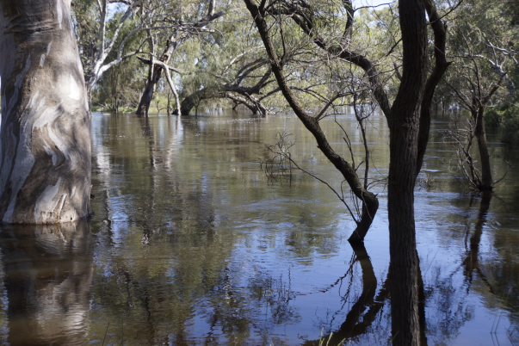

Inquiries regarding this document should be addressed to:
Dr Fiona Dyer
Phone: 02 6201 2452
e-mail: Fiona.Dyer@canberra.edu.au

This document was prepared by Fiona Dyer with input from Kate Brandis and Mitch Lyons (UNSW), Ben Broadhurst (University of Canberra).
Cover Photo: Lachlan River at Whealbah. Photo: Fiona Dyer (University of Canberra)
Document history and status
Version | Date Issued | Reviewed by | Approved by | Revision Type
Draft 1 | 15 December 2016 |  | Fiona Dyer | Internal
FINAL

Distribution of copies
Version | Type | Issued to
FINAL | Electronic | Commonwealth Environmental Water Office

Copyright
© Copyright Commonwealth of Australia, 2016

‘Long term intervention monitoring project, Lachlan River system selected area, progress report’ is licensed by the Commonwealth of Australia for use under a Creative Commons By Attribution 3.0 Australia licence with the exception of the Coat of Arms of the Commonwealth of Australia, the logo of the agency responsible for publishing the report, content supplied by third parties, and any images depicting people. For licence conditions see: http://creativecommons.org/licenses/by/3.0/au/
Disclaimer
The views and opinions expressed in this publication are those of the authors and do not necessarily reflect those of the Australian Government or the Minister for the Environment. While reasonable efforts have been made to ensure that the contents of this publication are factually correct, the Commonwealth does not accept responsibility for the accuracy or completeness of the contents, and shall not be liable for any loss or damage that may be occasioned directly or indirectly through the use of, or reliance on, the contents of this publication.

- Conditions in the Lachlan River system 2016-17
Above average rainfall across the catchment in mid-2016 (May to July) resulted in saturated conditions in the catchment and large volumes of unregulated inflows to the Lachlan River. While rainfall in August was slightly below average, record breaking rainfall in September and well above rainfall in October (Figure 1), produced widespread flooding across the catchment.
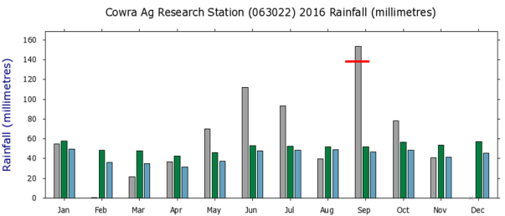
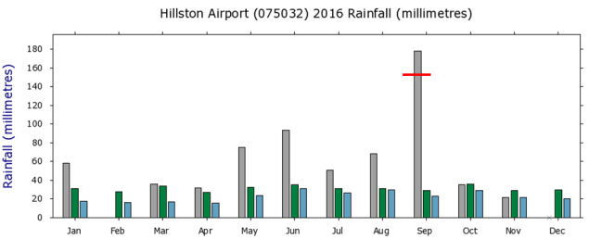
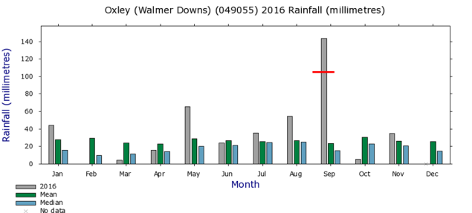
Figure 1. Rainfall at Cowra, Hillston and Oxley from 2016 compared with the long term mean and median rainfall. The red bar across the September rainfall denotes the previous maximum rainfall for the month of September. Data and figures from the Bureau of Meteorology, Climate Data Online.

- Summary on progress against core monitoring and evaluation activities

ACTIVITIES | PROGRESS TO DATE | UPCOMING ACTIVITIES
Monitoring activities
Ecosystem type | - Data collection complete and suggested Australian National Aquatic Ecosystems (ANAE) types for all sites included in the Monitoring and Data Management System (MDMS). | - No more data collection required
Fish (river) | - No activity | - Fish community sampling
Fish (larvae) | - Larval sampling completed | - Processing of larval samples
Waterbird breeding (optional) | - Waterbird monitoring completed | - Data analysis and evaluation
Water quality and stream metabolism | - Water quality samples collected  - Temporary loggers installed as long term loggers inaccessible because of flooding | - Checking, calibrating and downloading logger data once loggers become accessible
Vegetation diversity | - Half of the vegetation monitoring sites sampled at maximum water level | - Remaining vegetation monitoring sites to be sampled at or near maximum water level  - Vegetation QA/QC
Frogs (optional) | - None | - None
Evaluation activities
Monitoring data entry | - Data entry completed for 2015-16  - Data being collated for 2016-17 data entry to MDMS | - Update ageing data from bony herring if appropriate
Communication and engagement
Selected Area Working Group | - Specific working group meeting not held but working group members have met in October and November in relation to the waterbird breeding event with additional conversations held around Blackwater and the use of Commonwealth environmental water and there has been no need to replicate the conversation. | - Q1 2017 meeting in February/March
Project team teleconference | - None | - None
Other Stakeholder Engagement | - Quarterly report #9 finalised in November | - Quarterly progress report #10 to be provided to landholders and other stakeholders

Note: for the Long-Term Intervention Monitoring Project, Lachlan River system selected area:

- Appendix A provides additional information about the project for the Lachlan system and its context in terms of ecological monitoring and evaluation within the Murray-Darling Basin
- Appendix B provides a map showing the location of hydrological zones that will be monitored
- Appendix C provides a summary of monitoring to be undertaken under the project from 2014-2019.

- Observations
  - Hydrology
The inflows from the Lachlan River and tributaries (such as Mandagery Creek, Belubula River and Boorowa River) combined with a high volume in storage meant that Wyangala Dam was operated to maintain airspace throughout much of September and into October. This was on top of the earlier delivery of translucent releases under the Lachlan Regulated River Water Sharing Plan (for more information on translucent releases see http://www.water.nsw.gov.au/water-management/water-sharing/environmental-rules/rivers#flows). This combination of circumstances resulted in high to very high flows in the Lower Lachlan River from mid-July to the end of November.
The flood flows peaked at the gauge upstream of Willandra weir at just under 21,000 ML/day on the 16th October (Figure 2). While the flow record for the gauge upstream of Willandra Weir is incomplete (and missing the 1990 floods), this is the highest recorded flow at the site since records began in 1941. Further downstream, the flood peak at Whealbah was just under 6 000 ML/day and the fourth highest recorded flows since records began in 1968.

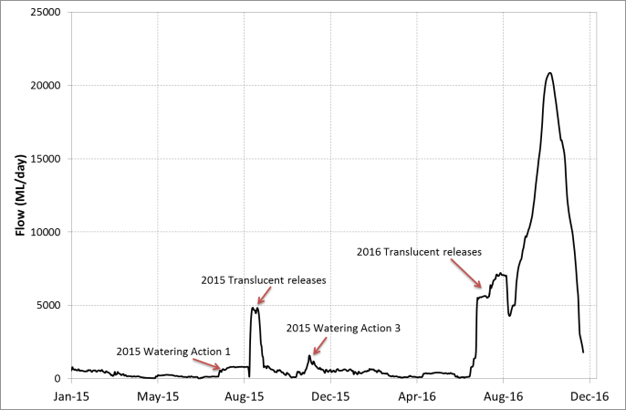
Figure 2. Flow at the gauge Upstream of Willandra weir (412038) showing the 2015 watering actions and the 2016 flood flow.

  - Waterbird breeding
Significant rainfall within the catchment during mid 2016 produced large volumes of unregulated inflow to the Lachlan River, triggering the delivery of translucent releases as required under the Lachlan Regulated River Water Sharing Plan. The translucent flows inundated significant areas of the Booligal wetlands and the Great Cumbung Swamp. Thousands of straw necked ibis were observed in the Booligal area, exhibiting nest preparation behaviour (trampling of lignum and other nesting vegetation) in mid-August. Breeding was confirmed on the 26th August with around 4000 birds on nests in the Lignum and eggs observed in nests on private land on the Upper Merrimajeel Creek.
Nest monitoring by the UNSW team began in mid-September with ground surveys continuing fortnightly until the end of November. The ground surveys were augmented by aerial survey and UAV (drone) image capture.
UAV image capture was done on the 12th October. Image capture was successful with both video and still photos collected. Still photos were used to create an orthomosaic of the entire colony site from which total nests were counted and vegetation layers derived. A total of 101,360 nests were marked for the 12th Oct. 2016 (Figure 3).
Figure 3. Orthomosaic compiled from UAV imagery (background) with colony boundary (purple line) and nests (red point data) marked.

At its peak the colony exceeded 200,000 birds. Reproductive success is expected to be high, with large numbers of fledged juveniles observed, low predation rates, and no significant abandonment of nests.
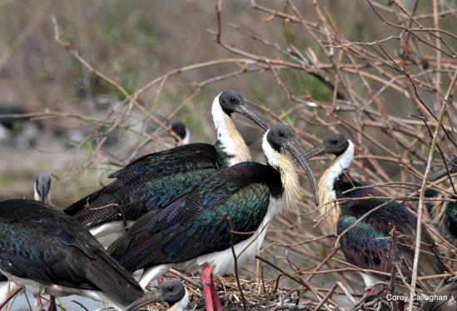
Figure 4. Straw-necked ibis in breeding plumage. Photo. C. Callaghan (UNSW)

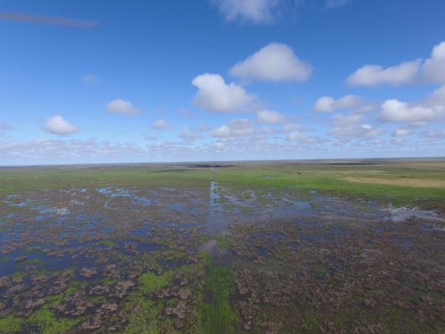
Figure 5. Aerial view of colony area from UAV 12th Oct. 2016. Photo: M. Lyons (UNSW)

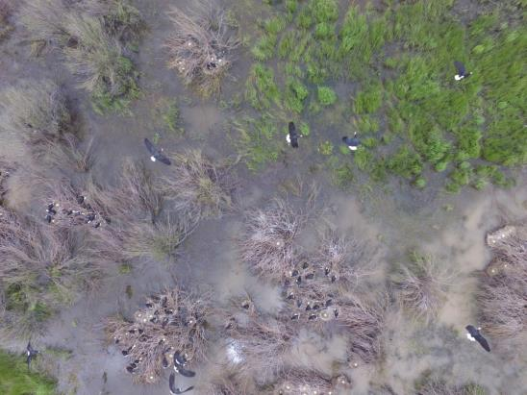
Figure 6. Image of straw-necked ibis on nests captured by UAV. Photo: M. Lyons (UNSW)

  - Larval fish monitoring
Despite the floodwater and associated logistical challenges, the larval fish team has been able to set drift nets at each site fortnightly since mid-October. During the first two trips (just prior and right on the peak discharges), drift net catches consisted largely of chironomids and micro-crustaceans (predominantly cladocera). Fish have been a rare catch apart from one net at one site (Wallanthery), which yielded a large number (>100) of carp. So far laboratory processing has not detected any native fish eggs or larvae. It is suspected that very low dissolved oxygen levels (<2 mg/L) experienced during high flows may have inhibited native fish spawning. A return to lower discharges and higher dissolved oxygen levels will hopefully result in successful spawning of natives in the lower Lachlan River.
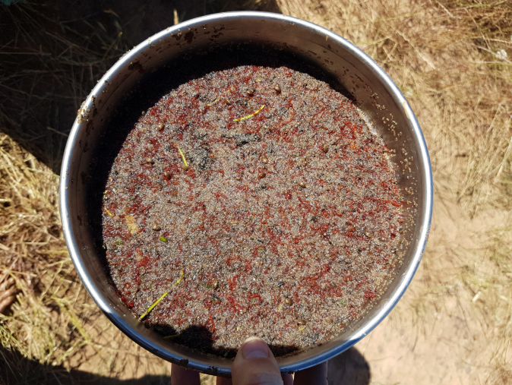
Figure 7. Microcrustacean and chironomid catch from a drift net in the Lachlan River 19th October 2016. Photo: Ben Broadhurst (University of Canberra).

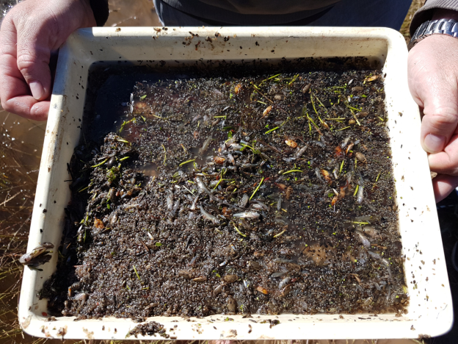
Figure 8. Partial catch from a drift net at Wallanthery showing carp larvae, juvenile carp and abundant micro and macroinvertebrates. Photo: Ben Broadhurst (University of Canberra) 19th October 2016

  - Vegetation monitoring
Flooding of the Lower Lachlan catchment from mid-2016 means that all of the vegetation monitoring sites were under water in spring, our normal time for monitoring. This has affected site access and the monitoring schedule. In spite of the access challenges, 6 of the monitoring sites were visited in October and November.
All of the sites visited were under water and water depths ranged from 0.05 to 2 m deep. The vegetation at the sites was observed to be responding with aquatic vegetation particularly noticeable at sites that had less than 0.4 m depth of water. Species such as nardoo (Marsillea drummondii Figure 9), water ribbons (Triglochin sp) spike rush (Eleocharis sp) and slender monkey flower (Mimulus gracilis) were observed at several sites, many of which have not been oserved in the catchment during first two years of monitoring.
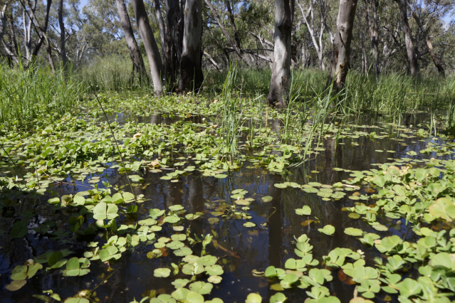
Figure 9. Inundated vegetation plot at Whealbah with Nardoo in the foreground and Eleocharis and Poa in the background. Photo: Fiona Dyer (University of Canberra) 31st October 2016

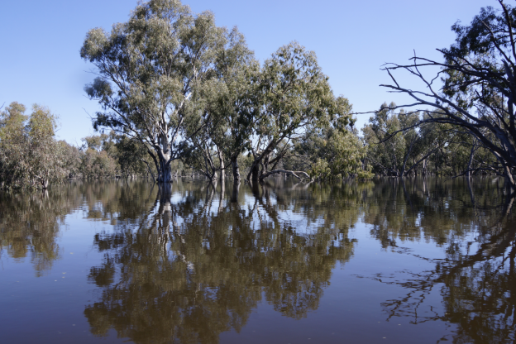
Figure 10. Inundation of Moon Moon swamp. Photo: Fiona Dyer (University of Canberra) 31st October 2016
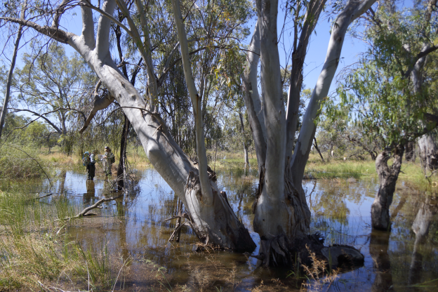
Figure 11. Surveying flooded vegetation plot at the Ville. Photo: Alica Tschierschke (University of Canberra) 16th November 2016

Appendix A: The Long-Term Intervention Monitoring Project for the Lachlan River system and its context in terms of ecological monitoring and evaluation within the Murray-Darling Basin.

The Long Term Intervention Monitoring (LTIM) Project for the Lachlan river system selected area is funded by the Commonwealth Environmental Water Office. The project is being delivered by a consortium of service providers lead by University of Canberra and includes NSW Office of Environment and Heritage, NSW Department of Primary Industries (Fisheries), Central Tablelands Local Land Services, NSW Department of Primary Industries (Office of Water), University of New South Wales and Charles Sturt University.
The LTIM project is based on a clear and robust program logic, as detailed in the Long-Term Intervention Monitoring Project Logic and Rationale Document. That document sets out the scientific and technical foundations of long-term intervention monitoring and is being applied to areas where LTIM projects are being undertaken. It also provides links between Basin Plan objectives and targets to the monitoring of outcomes from Commonwealth environmental watering actions. For more information, see Monitoring and evaluation for the use of Commonwealth environmental water.
Many different agencies play a role in the reporting on environmental outcomes, consistent with the Basin Plan (see figure 1 below). The Murray Darling Basin Authority is responsible for reporting on achievements against the environmental objectives of the Basin Plan at a basin-scale, which are broadly focussed on flows and water quality, fish, vegetation and birds across the whole of the Basin. State Governments are responsible for reporting on achievements against the environmental objectives of the Basin Plan at an asset-scale i.e. rivers, wetlands, floodplains. The Commonwealth Environmental Water Holder is responsible for reporting on the contribution of Commonwealth environmental water to the environmental objectives of the Basin Plan (at multiple-scales).
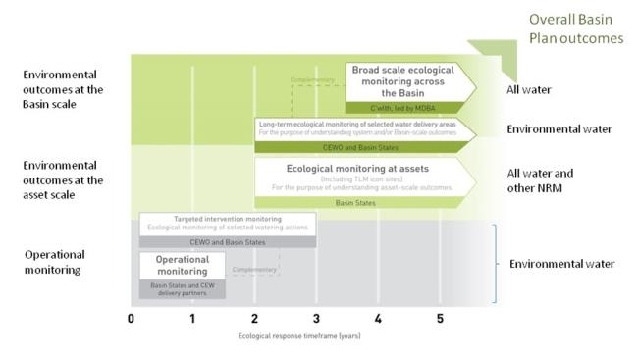
Figure 12. A summary of roles various agencies play a in the reporting on environmental outcomes, consistent with the Basin Plan.

Appendix B: Hydrological zones of the lower Lachlan for the Long-Term Intervention Monitoring Project.
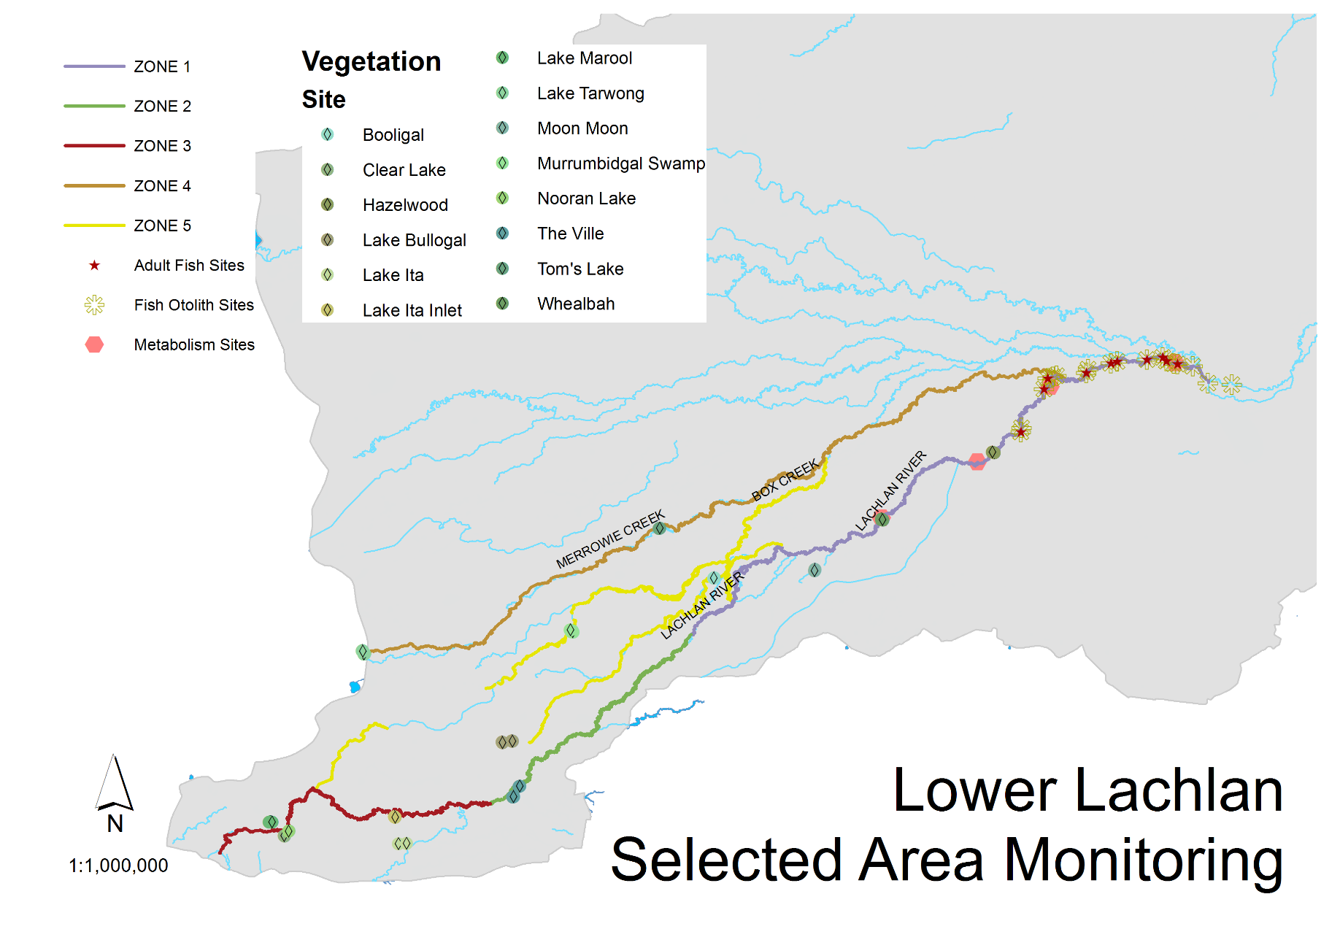
Figure 13. Lower Lachlan LTIM monitoring sites, hydrological zones and NSW gauging stations
Appendix C: Summary of monitoring to be undertaken in the Lachlan system for the Long Term Intervention Monitoring Project from 2014-2019
The five year monitoring schedule has been based around the expected watering options and is focussed on the monitoring of Basin Indicators. Monitoring effort is consistent across the five years with the exception of monitoring Waterbird Breeding and Frogs which are options that can be implemented on the basis of a request from the CEWO.

indicator | ZONE | Evaluation of responses to Commonwealth environmental watering in the Lachlan system (where appropriate) | Data will contribute to evaluation of responses to Commonwealth environmental watering at whole of Basin-scale (where appropriate) | monitoring frequency | sites | expected schedule
Ecosystem type | All | ✓ | ✓ | Once only | All sites for other indicators | Establishment of ANAE type at the start of the LTIM Project. Expected August-December 2014
Riverine fish | 1 | ✓ | ✓ | ANNUAL | Basin Evaluation: 10 fixed sites within Zone 1 | Annual sampling between March and May
Larval fish | 1 | ✓ | ✓ | ANNUAL | 3 fixed riverine sites in Zone 1 | Annual sampling 5 times during breeding season (September to February)
Stream metabolism | 1 | ✓ | ✓ | CONTINUOUS  REGULAR | Four fixed sites matched to riverine fish sampling sites in Zone 1 | Continuous monitoring of dissolved oxygen and, temperature.  6 weekly sampling of nutrients and water quality attributes.
Hydrology (River) | 1 | ✓ | ✓ | CONTINUOUS | Gauging sites
Vegetation diversity and condition | All | ✓ |  | ANNUAL & EVENT BASED | 12 fixed sites | Before and after watering (expected to be April/May and 3 months after first fill)
Waterbird breeding (Option) | 1 | ✓ |  | EVENT-BASED (on request from the CEWO) | One fixed site – Booligal wetland | Fortnightly surveys of bird breeding triggered by breeding events in Booligal wetland. Assumes 3 breeding events in 5 years.
Frogs (Option) | All | ✓ |  | EVENT-BASED (on request from the CEWO) | 15 sites comprising 2 to 8 wetland sites and 2 to 7 riverine sites depending on watering targets | 3 sampling events between August and February (one sample in each of winter, spring and summer).
Hydrology (wetland – Option) |  | ✓ |  | EVENT-BASED (in conjunction with Waterbird Breeding or Frog monitoring) | Cameras at 6 roving wetland sites | Cameras installed prior to targeted watering each year and downloaded after the watering event has passed

