**Long Term Intervention Monitoring Project**

**Lachlan River System Selected Area**

**Project Progress Report**

**Report period: *1 April to 30th June 2015***

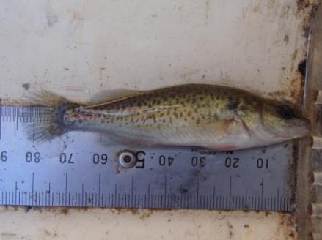

Inquiries regarding this document should be addressed to:

Dr Fiona Dyer  
Phone: 02 6201 2452  
e-mail: Fiona.Dyer@canberra.edu.au

This document was prepared by Ben Broadhurst and Fiona Dyer with contributions from Professor Ross Thompson (UC); Dr Patrick Driver (NSW-Office of Water); Dr Sharon Bowen and Mr Paul Packard (NSW Office of Environment and Heritage); Dr Jason Thiem and Mr Martin Asmus (NSW Department of Primary Industries, Fisheries); and Dr Joanne Lenehan (Central Tablelands LLS).

**Document history and status**

|  |  |  |  |  |
| --- | --- | --- | --- | --- |
| Version | Date Issued | Reviewed by | Approved by | Revision Type |
| Draft 1 | 14 July 2015 | Ben Broadhurst | Fiona Dyer | Internal |
| FINAL | 22 July 2015 | Ebony Coote | Fiona Dyer | External |
| FINAL2 | 17 September 2015 | Ebony Coote | Fiona Dyer | External |

**Distribution of copies**

|  |  |  |
| --- | --- | --- |
| Version | Type | Issued to |
| FINAL | Electronic | Commonwealth Environmental Water Office |

**Copyright**© Copyright Commonwealth of Australia, 2015



‘Long term intervention monitoring project, Lachlan River system selected area, progress report 1 April to 30th June 2015’ is licensed by the Commonwealth of Australia for use under a Creative Commons By Attribution 3.0 Australia licence with the exception of the Coat of Arms of the Commonwealth of Australia, the logo of the agency responsible for publishing the report, content supplied by third parties, and any images depicting people. For licence conditions see: <http://creativecommons.org/licenses/by/3.0/au/>

**Disclaimer**

The views and opinions expressed in this publication are those of the authors and do not necessarily reflect those of the Australian Government or the Minister for the Environment. While reasonable efforts have been made to ensure that the contents of this publication are factually correct, the Commonwealth does not accept responsibility for the accuracy or completeness of the contents, and shall not be liable for any loss or damage that may be occasioned directly or indirectly through the use of, or reliance on, the contents of this publication.

1. Objectives of Commonwealth environmental water use in the   
   Lachlan River system during 2014-15

**Primary objective:** Commonwealth environmental water will contribute to the preservation of the integrity of small to medium unregulated flows through the Lachlan River system through spring-summer to provide natural cues for native fish

**Secondary objectives:** It is anticipated that this action will contribute to improved habitat access, fish condition, recruitment opportunities, larval survival, and will provide more natural flow variability by restoring a portion of small to medium freshes.

**Commonwealth Water delivered as at 30 September 2014:** 5,000 ML combined with NSW water of 821 ML. As further natural trigger events did not occur, no further watering has been undertaken since the September 2014 flows.

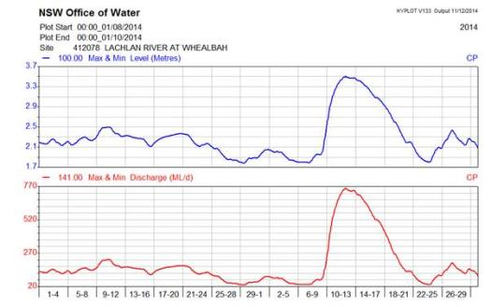

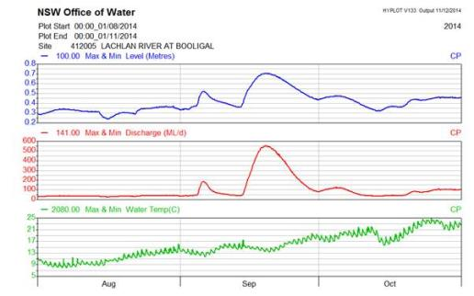

1. Summary on progress against core monitoring and evaluation activities

|  |  |  |
| --- | --- | --- |
| ACTIVITIES | PROGRESS TO DATE | UPCOMING ACTIVITIES |
| *Monitoring activities* | | |
| Ecosystem type | * Initial data collected. Processing of data and verification of ANAE types for sites | * Uploading ANAE types into MDMS |
| Fish (river) | * Adult fish sampling completed for 2015 | * Analysis of adult fish data * Processing of otoliths |
| Fish (larvae) | * Samples processed, identified and measured. | * Analysis of larval fish catch to be undertaken * Preparations for 2015 field collection period |
| Waterbird breeding (optional) | * No sampling required | * None |
| Water quality and stream metabolism | * Data from all sites downloaded during late May. Data processing has commenced. | * Processing of field data, reporting and uploading to MDMS. |
| Vegetation diversity | * Field data from Q4 2014 processed * Vegetation monitoring occurred between 19/5/2015 and 29/5/2015. * All field samples have been processed with a set of unknown vegetation samples preserved for expert identification | * Identification of unknown samples * Analysis of field data and reporting |
| Frogs (optional) | * No sampling required | * None |
| *Evaluation activities* | | |
| Monitoring data entry | * Initial data provided for database establishment | * Enter data into database when available |
| *Communication and engagement* | | |
| Selected Area Working Group | * Meeting held on 14th April | * July meeting |
| Project team teleconference | * No meeting required | * Teleconference to be held late July |
| Other Stakeholder Engagement | * Jo Lenehan had a meeting with local fishing committee | * Zoomobile visit 30-Aug |

**Note:** for the Long-Term Intervention Monitoring Project, Lachlan River system selected area:

* **Appendix A** provides additional information about the project for the Lachlan system and its context in terms of ecological monitoring and evaluation within the Murray-Darling Basin
* **Appendix B** provides a map showing the location of hydrological zones that will be monitored
* **Appendix C** provides a summary of monitoring to be undertaken under the project from 2014-2019.

1. Observations
   1. Larval Fish Sampling

Larval fish have been processed and data analysis has commenced. The larval fish catch in the lower Lachlan river was dominated by Murray cod (424 individuals), Flatheaded gudgeon (42 individuals) and Australian Smelt (40 individuals). Other native species captured were Carp gudgeon (9 individuals) and Eel-tailed catfish (2 individuals – see Figure 1). Eastern gambusia (16 individuals) and European carp (1 individual) larvae were the only exotic species detected in 2014.

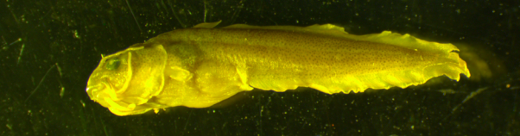

Figure 1. Larval Eel-tailed catfish captured in November 2014 in a drift net at Hunthawang on the lower Lachlan River.

Honours student at the Institute for Applied ecology at the University of Canberra Emily Belton recently completed her honours thesis on diet and prey selectivity of larval Murray cod in an upland and lowland river. Emily used the lower Lachlan river (specifically Murray cod larvae captured during LTIM sampling) as her lowland site. Below is an excerpt from Emily’s thesis abstract.

Poor survival in the early life stages is suggested to be the dominant driver behind fish community degradation. This study examined the diet and prey selectivity of Murray cod larvae in a lowland river (lower Lachlan River) and an upland river (the upper Murrumbidgee River) in the Murray-Darling Basin. Gut content analysis was used to examine diet composition of larvae collected using drift nets and light traps. Prey availability was determined by sampling the pelagic (up in the water column) and epibenthic (near the stream bed) microinvertebrate community and then comparing these findings to the diet composition of larval Murray cod to calculate prey selectivity. Cyclopoid copepods (type of small crustacean) were more important in the diet of larval Murray cod in the lower Lachlan River, while macrothricid cladocerans (type of water flea), chironomid (non-biting midges) larvae and decapod (freshwater shrimp) larvae were the most important prey items in the upper Murrumbidgee River. Microinvertebrates in epibenthic habitat were found to occur in considerably higher densities and have a distinct community composition compared with the pelagic community. This was consistent for the lower Lachlan River and the upper Murrumbidgee River, though the community composition differed between the two rivers which may indicate localised environmental conditions influenced community structure. Although prey availability and diet composition differed between the lower Lachlan River and upper Murrumbidgee River, Murray cod were found to exhibit selective feeding for large copepods in both study areas. Differences in larval Murray cod diet found between upland and lowland environments in this study and differences from previous studies suggest that larval Murray Cod are capable of exploiting a large range of prey items. Abundances of suitable prey items were found to be adequate in both systems despite no large overbank flows in the period leading up to the field sampling. These findings support the notion that low summer flows in the main channel provide suitable conditions for the survival and recruitment of some larval fish species.

* 1. Adult Fish Sampling

Category 1 fish sampling was undertaken in the Lachlan River in March and April 2015. Ten species of fish were captured including three alien and seven native species (Table 1). Data entry is complete and analysis and reporting is underway. Additional otolith collection trips targeting large-bodied species were undertaken in May and June 2015. Adequate sample sizes were achieved for all size classes of Murray cod, Bony herring, Golden perch and Carp gudgeon and ageing is underway.

Table 1. List of species captured during category 1 adult fish sampling of the lower Lachlan River selected area.

|  |  |  |
| --- | --- | --- |
| Group | Species name | Common name |
| Decapods | *Atyid* spp | freshwater shrimp |
| *Cherax destructor* | yabbie |
| *Macrobrachium australiense* | freshwater prawn |
| Turtles | *Emydura macquarii* | Murray River turtle |
| *Chelodina longicollis* | Eastern long-necked turtle |
| Fish | *Carassius auratus* | goldfish |
| *Craterocephalus stercusmuscarum fulvus* | un-specked hardyhead |
| *Cyprinus carpio* | common carp |
| *Gambusia holbrooki* | gambusia |
| *Hypseleotris* spp | carp gudgeon |
| *Macquaria ambigua* | golden perch |
| *Maccullochella peelii* | Murray cod |
| *Nematalosa erebi* | bony herring |
| *Retropinna semoni* | Australian smelt |
| *Tandanus tandanus* | freshwater catfish |

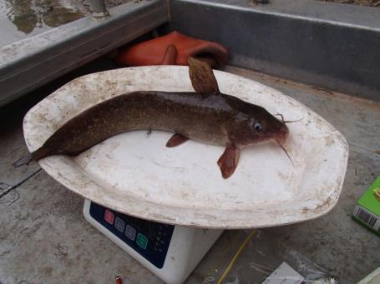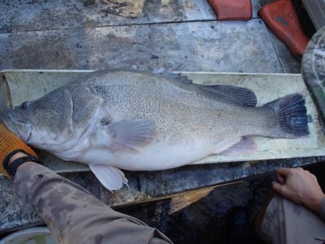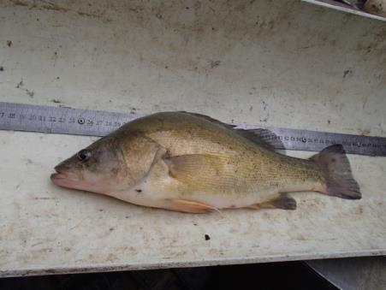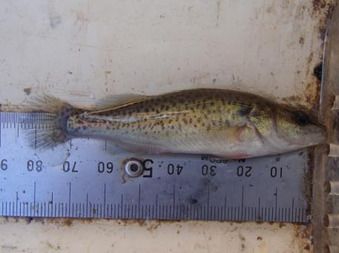

Figure . Adult fish captured whilst sampling the lower Lachlan River. Clockwise from top left: Eel-tailed catfish, large adult Murray cod, Golden perch and young-of-year Murray cod.

* 1. Vegetation Monitoring

Vegetation monitoring was conducted between 19 and 29th May 2015 at the core vegetation monitoring sites. Groundcover samples collected reveal a predominance of rain respondent species. Some parts of the region had received up to 50 mm of rain in April and the groundcover was most likely a response to this rain.

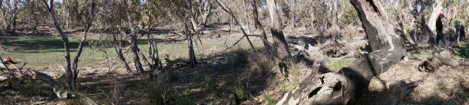

Figure . Murrumbidgal swamp during May 2015.

The blackbox was observed to be flowering at several sites and most of the mature river red gums had buds present.

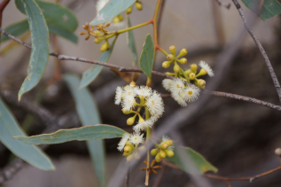 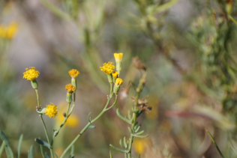

Figure . Left: Black Box flowering from Booligal swamp. Groundsell (Senecio sp) flowering from Murrumbidgal swamp

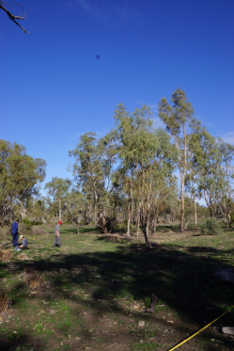 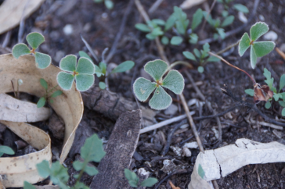

Figure . Monitoring vegetation in the Great Cumbung Swamp (near Clear Lake). Left: site photo. Right Common nardoo ([Marsilea](http://plantnet.rbgsyd.nsw.gov.au/cgi-bin/NSWfl.pl?page=nswfl&lvl=gn&name=Marsilea) drummondii)

* 1. Stream metabolism

Stream metabolism data is currently being analysed. Preliminary assessments of the data suggest that respiration and primary production measures are possible for >90% of the days of sampling, which is an excellent result. Batching this data and summarising the results will take place in July.

* 1. Communication and engagement

Jo Lenehan attended the Hillston RSL fishing club and Hillston Hook Line and Sinker organising committee meeting on 19 May 2015. The committee voted in favour of a proposal to work with the LTIM team to create an information pack including LTIM communication material, environmental water information, fisheries info and regulatory changes, and current research. The proposal included a $1000 sponsorship from the LLS for prizes, information packs and the Zoomobile visit. The Zoomobile is confirmed for Sunday 30 August with four sessions in the morning. Jo will work with the committee on publicity and format and the Zoomobile will custom a Healthy Waterways conservation presentation. LTIM will have a stand and posters on the monitoring and Martin Asmus will be present with the NSW DPI Fish display trailer. There is an opportunity to talk about preliminary data observations and results, and to brand the information bags.

Appendix A: The Long-Term Intervention Monitoring Project for the Lachlan River system and its context in terms of ecological monitoring and evaluation within the Murray-Darling Basin.

The Long Term Intervention Monitoring (LTIM) Project for the Lachlan river system selected area is funded by the Commonwealth Environmental Water Office. The project is being delivered by a consortium of service providers lead by University of Canberra and includes NSW Office of Environment and Heritage, NSW Department of Primary Industries (Fisheries), Central Tablelands Local Land Services, NSW Department of Primary Industries (Office of Water), University of New South Wales and Charles Sturt University.

The LTIM project is based on a clear and robust program logic, as detailed in the [Long-Term Intervention Monitoring Project Logic and Rationale Document](http://www.environment.gov.au/water/cewo/publications/long-term-intervention-monitoring-project-logic-and-rationale-document). That document sets out the scientific and technical foundations of long-term intervention monitoring and is being applied to areas where LTIM projects are being undertaken. It also provides links between Basin Plan objectives and targets to the monitoring of outcomes from Commonwealth environmental watering actions. For more information, see [Monitoring and evaluation for the use of Commonwealth environmental water](http://www.environment.gov.au/topics/water/commonwealth-environmental-water-office/monitoring-and-evaluation).

Many different agencies play a role in the reporting on environmental outcomes, consistent with the Basin Plan (see figure 1 below). The Murray Darling Basin Authority is responsible for reporting on achievements against the environmental objectives of the Basin Plan at a basin-scale, which are broadly focussed on flows and water quality, fish, vegetation and birds across the whole of the Basin. State Governments are responsible for reporting on achievements against the environmental objectives of the Basin Plan at an asset-scale i.e. rivers, wetlands, floodplains. The Commonwealth Environmental Water Holder is responsible for reporting on the contribution of Commonwealth environmental water to the environmental objectives of the Basin Plan (at multiple-scales).

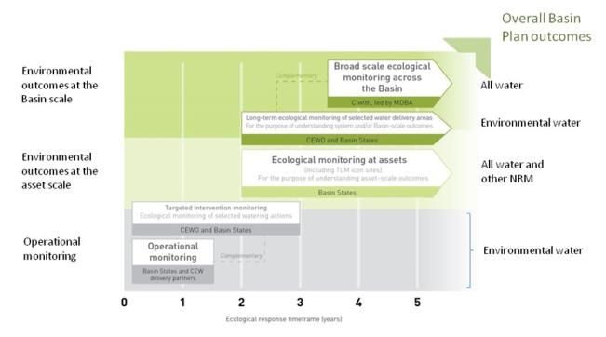

Figure 1. A summary of roles various agencies play a in the reporting on environmental outcomes, consistent with the Basin Plan.

Appendix B: Map showing location of hydrological zones of the Lachlan system for the Long-Term Intervention Monitoring Project.

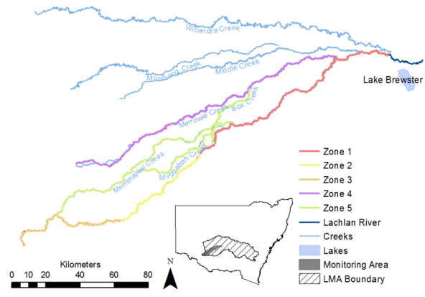

Appendix C: Summary of monitoring to be undertaken in the Lachlan system for the Long Term Intervention Monitoring Project from 2014-2019

The five year monitoring schedule has been based around the expected watering options and is focussed on the monitoring of Basin Indicators. Monitoring effort is consistent across the five years with the exception of monitoring Waterbird Breeding and Frogs which are options that can be implemented on the basis of a request from the CEWO.

|  |  |  |  |  |  |  |
| --- | --- | --- | --- | --- | --- | --- |
| indicator | ZONE | Evaluation of responses to Commonwealth environmental watering in the Lachlan system (✓where appropriate) | Data will contribute to evaluation of responses to Commonwealth environmental watering at whole of Basin-scale (✓where appropriate) | monitoring frequency | sites | expected schedule |
| Ecosystem type | All | ✓ | ✓ | Once only | All sites for other indicators | Establishment of ANAE type at the start of the LTIM Project. Expected August-December 2014 |
| Riverine fish | 1 | ✓ | ✓ | ANNUAL | Basin Evaluation: 10 fixed sites within Zone 1 | Annual sampling between March and May |
| Larval fish | 1 | ✓ | ✓ | ANNUAL | 3 fixed riverine sites in Zone 1 | Annual sampling 5 times during breeding season (September to February) |
| Stream metabolism | 1 | ✓ | ✓ | CONTINUOUS  REGULAR | Four fixed sites matched to riverine fish sampling sites in Zone 1 | Continuous monitoring of dissolved oxygen and, temperature.  6 weekly sampling of nutrients and water quality attributes. |
| Hydrology (River) | 1 | ✓ | ✓ | CONTINUOUS | Gauging sites |  |
| Vegetation diversity and condition | All | ✓ |  | ANNUAL & EVENT BASED | 12 fixed sites | Before and after watering (expected to be April/May and 3 months after first fill) |
| Waterbird breeding (Option) | 1 | ✓ |  | EVENT-BASED (on request from the CEWO) | One fixed site – Booligal wetland | Fortnightly surveys of bird breeding triggered by breeding events in Booligal wetland.  Assumes 3 breeding events in 5 years. |
| Frogs (Option) | All | ✓ |  | EVENT-BASED (on request from the CEWO) | 15 sites comprising 2 to 8 wetland sites and 2 to 7 riverine sites depending on watering targets | 3 sampling events between August and February (one sample in each of winter, spring and summer). |
| Hydrology (wetland – Option) |  | ✓ |  | EVENT-BASED (in conjunction with Waterbird Breeding or Frog monitoring) | Cameras at 6 roving wetland sites | Cameras installed prior to targeted watering each year and downloaded after the watering event has passed |