**Long Term Intervention Monitoring Project**

**Lachlan River System Selected Area**

**Project Progress Report**

**Report period: *1 April to 30 June 2016***

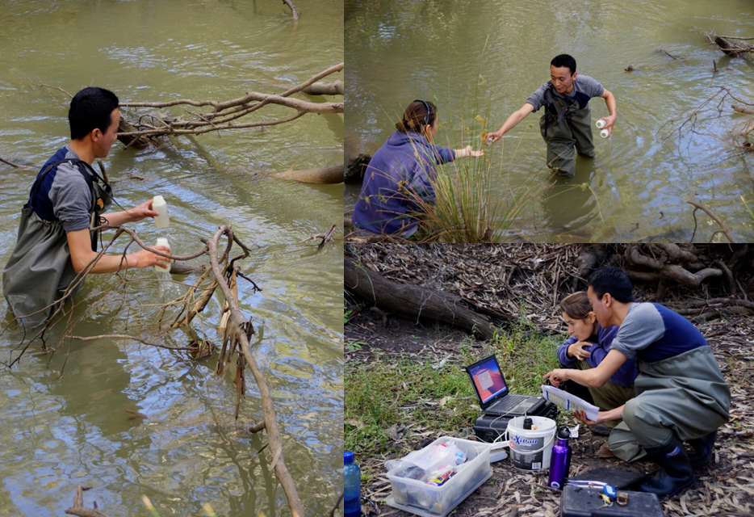

Inquiries regarding this document should be addressed to:

Dr Fiona Dyer  
Phone: 02 6201 2452  
e-mail: Fiona.Dyer@canberra.edu.au

This document was prepared by Fiona Dyer with contributions from Jason Thiem.

Cover Photo: Collecting water samples and calibrating loggers at Lane’s Bridge. Photo: Fiona Dyer (University of Canberra)

**Document history and status**

|  |  |  |  |  |
| --- | --- | --- | --- | --- |
| Version | Date Issued | Reviewed by | Approved by | Revision Type |
| Draft 1 | 20 June 2016 |  | Fiona Dyer | Internal |
| FINAL | 15 August 2016 | Ebony Coote | Fiona Dyer | External |

**Distribution of copies**

|  |  |  |
| --- | --- | --- |
| Version | Type | Issued to |
| FINAL | Electronic | Commonwealth Environmental Water Office |

**Copyright**© Copyright Commonwealth of Australia, 2016



‘Long term intervention monitoring project, Lachlan River system selected area, progress report’ is licensed by the Commonwealth of Australia for use under a Creative Commons By Attribution 3.0 Australia licence with the exception of the Coat of Arms of the Commonwealth of Australia, the logo of the agency responsible for publishing the report, content supplied by third parties, and any images depicting people. For licence conditions see: <http://creativecommons.org/licenses/by/3.0/au/>

**Disclaimer**

The views and opinions expressed in this publication are those of the authors and do not necessarily reflect those of the Australian Government or the Minister for the Environment. While reasonable efforts have been made to ensure that the contents of this publication are factually correct, the Commonwealth does not accept responsibility for the accuracy or completeness of the contents, and shall not be liable for any loss or damage that may be occasioned directly or indirectly through the use of, or reliance on, the contents of this publication.

1. Objectives of Commonwealth environmental water use in the   
   Lachlan River system during 2015-16
   1. Commonwealth environmental water use

As at 30 June 2016, 36 021 ML of Commonwealth environmental water had been delivered to the Lower Lachlan River system across three watering actions (Figure 1). These actions were designed to contribute to supporting native riparian, wetland and floodplain vegetation diversity and condition; and to provide habitat to support survival, maintain condition of, and provide reproduction opportunities for native fish (e.g. Murray cod and Golden perch), waterbirds (e.g. straw necked ibis), and other aquatic vertebrate species (e.g. Murray River turtle). The three actions were:

1. 24 058 ML of Commonwealth environmental water into Lachlan River, targeting the Great Cumbung Swamp. This action is expected to consolidate the benefits of inundation that occurred in 2013 and support the survival and growth of wetland vegetation and habitat values for waterbirds and other water dependent species.
2. 1087 ML of Commonwealth environmental water to Merrimajeel Creek targeting Murrumbidgil Swamp. 1497 ML of Commonwealth environmental water to Merrimajeel creek to support waterbird habitat at the Blockbank
3. 9378 ML of Commonwealth environmental water to the Lachlan River, targeting flow cued native fish outcomes, specifically Golden perch, but also to contribute to non-flow cued native fish outcomes for species such as Murray cod.

The specific objectives for these watering actions were:

|  |  |  |
| --- | --- | --- |
| Action | Primary Objective | Secondary Objective |
| 1 | To protect, maintain and improve riparian, wetland and floodplain vegetation diversity and condition | To improve hydrological connectivity, contribute to ecosystem function, support vegetation condition (river red gum, lignum and aquatic macrophytes) and ecosystem resilience. |
| 2 | To contribute to hydrological connectivity in the Booligal wetlands and   1. protect the extent and condition of native riparian and vegetation communities, 2. potentially maintain base flows into Booligal Swamp to support waterbird breeding to completion | To support the ongoing recovery and resilience of Murrumbidgil Swamp if dry conditions continue, by providing drought refuge. |
| 3 | To support habitat requirements to native fish and other water dependent vertebrates.  Provide opportunities for native fish movement, spawning and recruitment | Trial the augmentation of flows to generate a Golden and/or silver perch movement and spawning response.  Protect and maintain the health of existing extent of riparian, floodplain and wetland native vegetation communities. |

1. Other environmental water use in the Lachlan River system during 2015-16
   1. Planned environmental water: translucent releases

Significant rainfall within the catchment in the first half of 2015 produced medium-large volumes of unregulated inflow to the Lachlan River, particularly from the Belubula and Boorowa Rivers. Inflows from 1 January to 26 August 2015 totalled 268 000 ML which consequently triggered the delivery of translucent releases, as required under the Lachlan Regulated River Water Sharing Plan. Dam levels were such that translucent releases were targeted at between 3,500 ML/day and 5,156 ML/day with a combination of passing flow and dam releases delivering the water to the Lower Lachlan river system (Figure 1). This translucent event contributed to approximately 72 000 ML of flow passing Lake Brewster weir in August-September 2015.

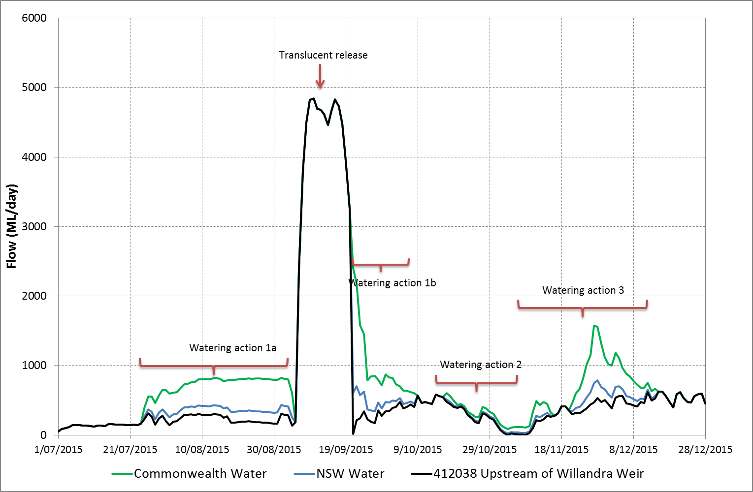

Figure 1. Flow at the gauge Upstream of Willandra weir (412038) illustrating the pattern of Commonwealth (green) and NSW (blue) environmental water delivery. Normal river flows (including licensed delivery of water) is shown in black. Watering action 1 was interrupted by translucent releases.

1. Summary on progress against core monitoring and evaluation activities

|  |  |  |
| --- | --- | --- |
| ACTIVITIES | PROGRESS TO DATE | UPCOMING ACTIVITIES |
| *Monitoring activities* | | |
| Ecosystem type | * Data collection complete and suggested Australian National Aquatic Ecosystems (ANAE) types for all sites included in the Monitoring and Data Management System (MDMS). | * No more data collection required |
| Fish (river) | * 2016 Sampling completed * Field samples processed | * Analysis of data |
| Fish (larvae) | * Processing of field samples * QA/QC | * Analysis of data |
| Waterbird breeding (optional) | * No sampling required | * N/A |
| Water quality and stream metabolism | * Checking, calibrating and downloading logger data completed | * QA/QC * Analysis of data |
| Vegetation diversity | * Autumn vegetation sampling completed * Processing of field samples | * QA/QC * Analysis of data |
| Frogs (optional) | * Frog monitoring completed | * Analysis of data |
| *Evaluation activities* | | |
| Monitoring data entry | * Data entry commenced | * Data to be uploaded once QA/QC steps completed |
| *Communication and engagement* | | |
| Selected Area Working Group | * Meeting held 27th June | * Meeting to be held in August to comment on draft report. |
| Project team teleconference | * None | * Teleconference to be held once sampling completed |
| Other Stakeholder Engagement | * Quarterly report #7 finalised in May. | * Quarterly progress report #8 to be provided to landholders and other stakeholders |

**Note:** for the Long-Term Intervention Monitoring Project, Lachlan River system selected area:

* **Appendix A** provides additional information about the project for the Lachlan system and its context in terms of ecological monitoring and evaluation within the Murray-Darling Basin
* **Appendix B** provides a map showing the location of hydrological zones that will be monitored
* **Appendix C** provides a summary of monitoring to be undertaken under the project from 2014-2019.

1. Observations
   1. Hydrology and water temperature

The combination of environmental watering actions, translucent releases (planned watering activities) and rainfall in the catchment produced significant flows in the Lower Lachlan River in the second half of 2015. Flows reached almost 5000 ML/day upstream of Willandra Weir in mid September (Figure 2). The peak flow was caused by a combination of translucent releases and rainfall and produced a considerable rise in water level along the river.

Water temperatures in the river rose rapidly in early October, following the translucent releases. The rapid increase was in association with unusually high air temperatures in the region.

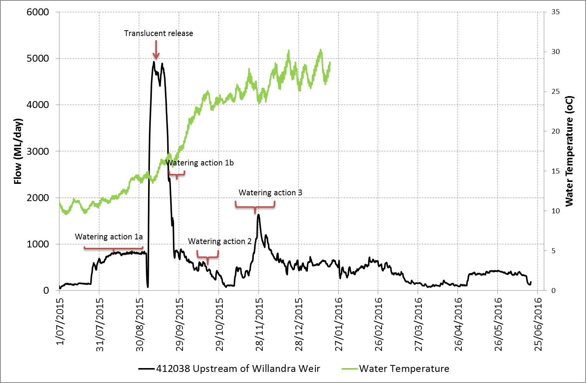

Figure 2. Flow and temperature data from the Lachlan River upstream of Willandra weir. Data from NSW Waterinfo (Data from NSW Waterinfo (http://realtimedata.water.nsw.gov.au/) for station 412038, Lachlan River upstream of Willandra weir. Note that stream temperatures are not available after 20/1/2016.

* 1. Vegetation monitoring

Vegetation monitoring was conducted between 2nd May and 10th June over 3 sampling trips. Rainfall in the catchment coincided with the vegetation sampling. The second and third sampling trips revealed a flush of plants which had responded to rain across the catchment. These were germinants and were often able to be identified to genus only. They comprised a range of plants from genera such as *Senecio, Sisymbrium, Tetragonia* and *Zygophyllum*.

Many of the wetland sites that had been inundated solely with the translucent releases in September 2015 were dry by May-June 2016, the exception being Whealbah Billabong which still held water (Figure 3).

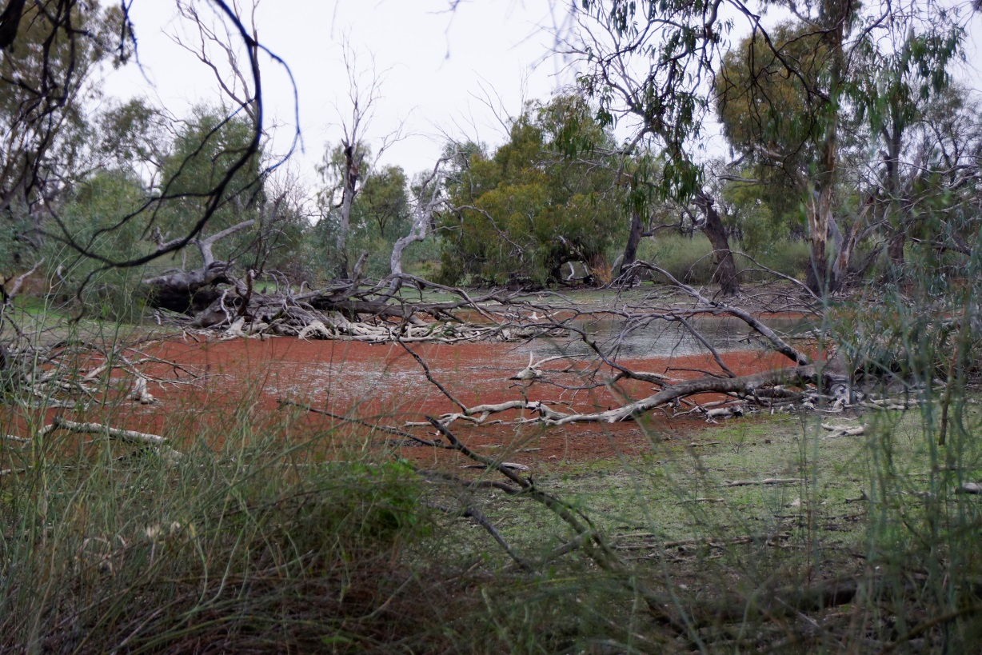

Figure 3. Whealbah billabong holding water during May 2016. The billabong was filled during the translucent releases in 2015.

Nooran Lake and Clear Lake in the Great Cumbung Swamp, which had received both Commonwealth environmental water and water from the translucent flows also retained water.

A response to the inundation of the wetlands by translucent flows in 2015-16 was observed with red gums germinating at a number of sites including Moon Moon swamp (Figure 4). Lignum was observed to be growing vigorously at all sites that had received environmental water (including Commonwealth environmental water, translucent flows or both).

Canopy cover at most sites appeared to be higher than previous sampling trips with both red gums and black box seeming to have improved in condition. Data analysis will confirm if these observations are significant. Interestingly River red gums were observed to be flowering (unseasonally) at Moon Moon swamp during the vegetation sampling (Figure 5). The reasons for this are not clear.

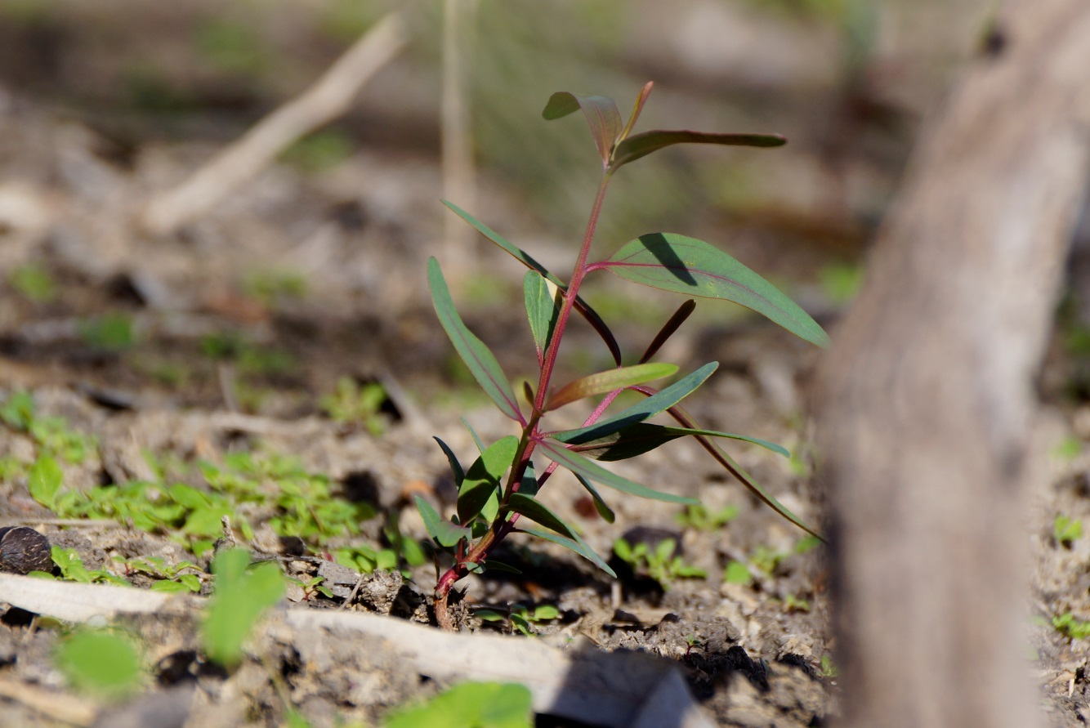

Figure 4. River red gum germinant on the bed of Moon Moon swamp following the 2015 inundation by translucent flows.

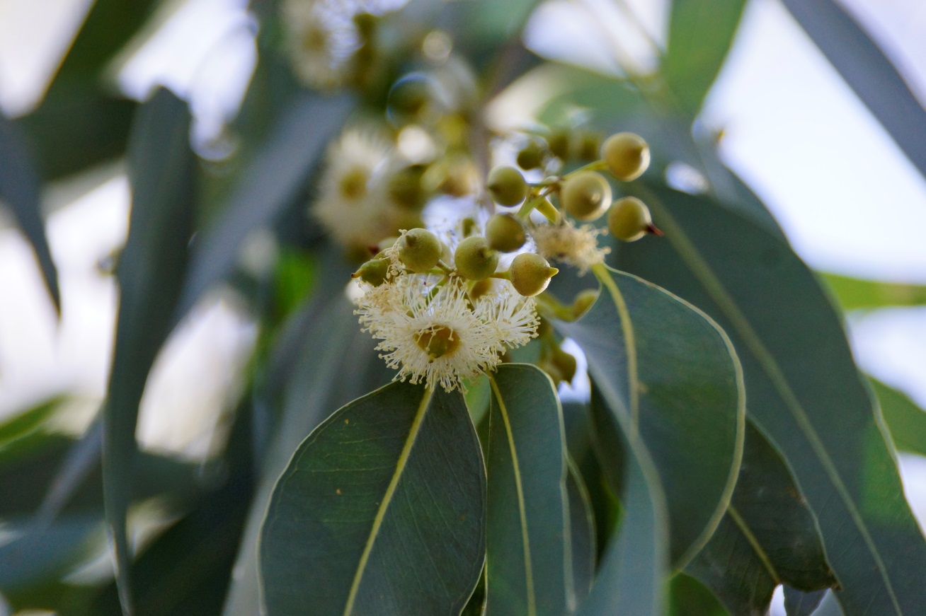

Figure 5. River red gums flowering at Moon Moon swamp, May 2016.

* 1. Fish monitoring:
     1. Larval fish identification

Larval fish were sampled fortnightly between mid-October and mid-December 2015 using drift nets and light traps set at three sites, Wallanthery, Hunthawang and Lanes Bridge. The timing of sampling aimed to follow the delivery of Commonwealth environmental water and coincide with the known spawning windows of six ‘representative’ target species. Analysis of the larval fish samples collected during sampling has been completed. The larvae of four native species (Murray cod, flat headed gudgeon, Australian smelt and carp gudgeon) and two alien fish species (eastern gambusia and common carp) were captured during the 2015 sampling. None of these species are known to require particular flow conditions to spawn.

* + 1. Golden perch recruitment

One of the objectives of the 2015-16 watering actions was to trial the augmentation of flows to generate a Golden and/or silver perch movement and spawning response. Larval fish monitoring conducted under the LTIM project did not detect Golden perch eggs or larvae and LTIM fish community monitoring in March 2016 did not detect any young of year Golden perch.

Additional NSW DPI Fisheries funded monitoring targeting Golden perch was conducted to determine if spawning of Golden Perch occurred in Spring/Summer 2015. This monitoring included additional sampling of larval fish (increased monitoring frequency and intensity) and targeted sampling of juvenile Golden perch in April 2016. The additional monitoring effort revealed:

* No eggs or larvae
* No young-of-year were captured in the LTIM focal zone. A total of 5 juvenile Golden perch were captured during the targeted sampling for juvenile Golden perch in April. Ageing determined that all were older than 1 year (i.e. spawned in late 2014) and had calcein marks on their otoliths indicating hatchery origin.

Thus it appears that Golden perch did not spawn in response to the flows delivered in late 2015.

* 1. Additional research

Two PhD students have started at the University of Canberra in association with the lower Lachlan LTIM project.

Will Higgisson will be investigating floodplain and wetland vegetation and the role of fragmentation on species composition, persistence and resilience. He has begun his research by joining us in vegetation sampling and is currently conducting some seed bank studies using samples collected from the core vegetation monitoring sites.

Foyez Shams will be also be investigating the role of fragmentation and his research will be focussed on understanding the genetic character of key fish species within the Lachlan catchment and how hydrologic fragmentation affects the structure of the populations.

Appendix A: The Long-Term Intervention Monitoring Project for the Lachlan River system and its context in terms of ecological monitoring and evaluation within the Murray-Darling Basin.

The Long Term Intervention Monitoring (LTIM) Project for the Lachlan river system selected area is funded by the Commonwealth Environmental Water Office. The project is being delivered by a consortium of service providers lead by University of Canberra and includes NSW Office of Environment and Heritage, NSW Department of Primary Industries - Fisheries, NSW Department of Primary Industries – Water, University of New South Wales and Charles Sturt University.

The LTIM project is based on a clear and robust program logic, as detailed in the [Long-Term Intervention Monitoring Project Logic and Rationale Document](http://www.environment.gov.au/water/cewo/publications/long-term-intervention-monitoring-project-logic-and-rationale-document). That document sets out the scientific and technical foundations of long-term intervention monitoring and is being applied to areas where LTIM projects are being undertaken. It also provides links between Basin Plan objectives and targets to the monitoring of outcomes from Commonwealth environmental watering actions. For more information, see [Monitoring and evaluation for the use of Commonwealth environmental water](http://www.environment.gov.au/topics/water/commonwealth-environmental-water-office/monitoring-and-evaluation).

Many different agencies play a role in the reporting on environmental outcomes, consistent with the Basin Plan (see figure 1 below). The Murray Darling Basin Authority is responsible for reporting on achievements against the environmental objectives of the Basin Plan at a basin-scale, which are broadly focussed on flows and water quality, fish, vegetation and birds across the whole of the Basin. State Governments are responsible for reporting on achievements against the environmental objectives of the Basin Plan at an asset-scale i.e. rivers, wetlands, floodplains. The Commonwealth Environmental Water Holder is responsible for reporting on the contribution of Commonwealth environmental water to the environmental objectives of the Basin Plan (at multiple-scales).

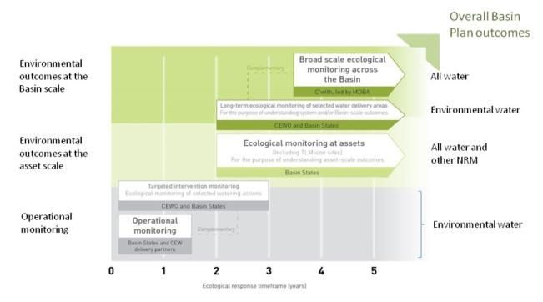

Figure 1. A summary of roles various agencies play a in the reporting on environmental outcomes, consistent with the Basin Plan.

Appendix B: Map showing location of hydrological zones of the Lachlan system for the Long-Term Intervention Monitoring Project.

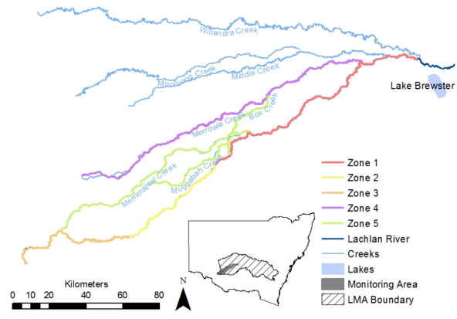

Appendix C: Summary of monitoring to be undertaken in the Lachlan system for the Long Term Intervention Monitoring Project from 2014-2019

The five year monitoring schedule has been based around the expected watering options and is focussed on the monitoring of Basin Indicators. Monitoring effort is consistent across the five years with the exception of monitoring Waterbird Breeding and Frogs which are options that can be implemented on the basis of a request from the CEWO.

|  |  |  |  |  |  |  |
| --- | --- | --- | --- | --- | --- | --- |
| indicator | ZONE | Evaluation of responses to Commonwealth environmental watering in the Lachlan system (where appropriate) | Data will contribute to evaluation of responses to Commonwealth environmental watering at whole of Basin-scale (where appropriate) | monitoring frequency | sites | expected schedule |
| Ecosystem type | All | ✓ | ✓ | Once only | All sites for other indicators | Establishment of ANAE type at the start of the LTIM Project. Expected August-December 2014 |
| Riverine fish | 1 | ✓ | ✓ | ANNUAL | Basin Evaluation: 10 fixed sites within Zone 1 | Annual sampling between March and May |
| Larval fish | 1 | ✓ | ✓ | ANNUAL | 3 fixed riverine sites in Zone 1 | Annual sampling 5 times during breeding season (September to February) |
| Stream metabolism | 1 | ✓ | ✓ | CONTINUOUS  REGULAR | Four fixed sites matched to riverine fish sampling sites in Zone 1 | Continuous monitoring of dissolved oxygen and, temperature.  6 weekly sampling of nutrients and water quality attributes. |
| Hydrology (River) | 1 | ✓ | ✓ | CONTINUOUS | Gauging sites |  |
| Vegetation diversity and condition | All | ✓ |  | ANNUAL & EVENT BASED | 12 fixed sites | Before and after watering (expected to be April/May and 3 months after first fill) |
| Waterbird breeding (Option) | 1 | ✓ |  | EVENT-BASED (on request from the CEWO) | One fixed site – Booligal wetland | Fortnightly surveys of bird breeding triggered by breeding events in Booligal wetland.  Assumes 3 breeding events in 5 years. |
| Frogs (Option) | All | ✓ |  | EVENT-BASED (on request from the CEWO) | 15 sites comprising 2 to 8 wetland sites and 2 to 7 riverine sites depending on watering targets | 3 sampling events between August and February (one sample in each of winter, spring and summer). |
| Hydrology (wetland – Option) |  | ✓ |  | EVENT-BASED (in conjunction with Waterbird Breeding or Frog monitoring) | Cameras at 6 roving wetland sites | Cameras installed prior to targeted watering each year and downloaded after the watering event has passed |