**Long Term Intervention Monitoring Project**

**Lachlan River System Selected Area**

**Observations Report**

**Report period: *1 April 2017 to 30 June 2017***

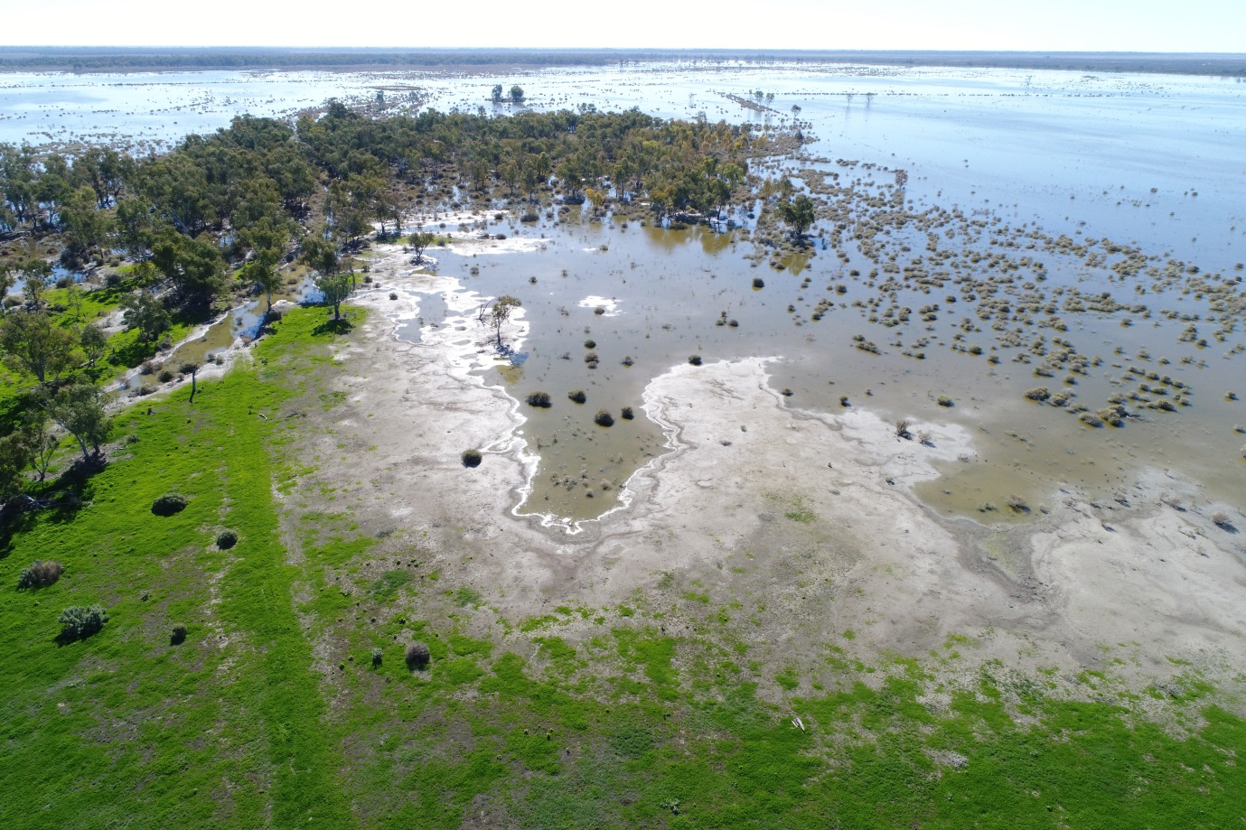

Inquiries regarding this document should be addressed to:

Dr Fiona Dyer  
Phone: 02 6201 2452  
e-mail: Fiona.Dyer@canberra.edu.au

This document was prepared by Fiona Dyer with input from Alica Tschierschke and Rhian Clear.

Cover Photo: Lake Ita June 2nd 2017. Photo: Alica Tschierschke (University of Canberra)

**Document history and status**

|  |  |  |  |  |
| --- | --- | --- | --- | --- |
| Version | Date Issued | Reviewed by | Approved by | Revision Type |
| Draft 1 | 23/6/2017 | Fiona Dyer | Fiona Dyer | Internal |
| FINAL |  |  |  |  |

**Distribution of copies**

|  |  |  |
| --- | --- | --- |
| Version | Type | Issued to |
| FINAL | Electronic | Commonwealth Environmental Water Office |

**Copyright**© Copyright Commonwealth of Australia, 2016



‘Long term intervention monitoring project, Lachlan River system selected area, progress report’ is licensed by the Commonwealth of Australia for use under a Creative Commons By Attribution 3.0 Australia licence with the exception of the Coat of Arms of the Commonwealth of Australia, the logo of the agency responsible for publishing the report, content supplied by third parties, and any images depicting people. For licence conditions see: <http://creativecommons.org/licenses/by/3.0/au/>

**Disclaimer**

The views and opinions expressed in this publication are those of the authors and do not necessarily reflect those of the Australian Government or the Minister for the Environment. While reasonable efforts have been made to ensure that the contents of this publication are factually correct, the Commonwealth does not accept responsibility for the accuracy or completeness of the contents, and shall not be liable for any loss or damage that may be occasioned directly or indirectly through the use of, or reliance on, the contents of this publication.

1. Conditions in the lower Lachlan River system 2016-17

The second half of 2016 was unusually wet across the catchment and record breaking spring rains resulted in widespread flooding of the catchment. The flooding filled wetlands, swamps and depressions across the catchment and the water level peaked in the Great Cumbung Swamp at the end of December 2016. In contrast, the first quarter of 2017 was particularly dry with well below average rainfall recorded throughout the catchment (Figure 1). The second quarter of 2017 has seen highly variable rainfall, with some significant local rainfall events in autumn (Figure 1). At the time of reporting, June had been particularly dry. Most of the wetlands still retain water and the soils have not started to dry out and crack. This means that any local rainfall ponds on the surface and tops up wetlands.

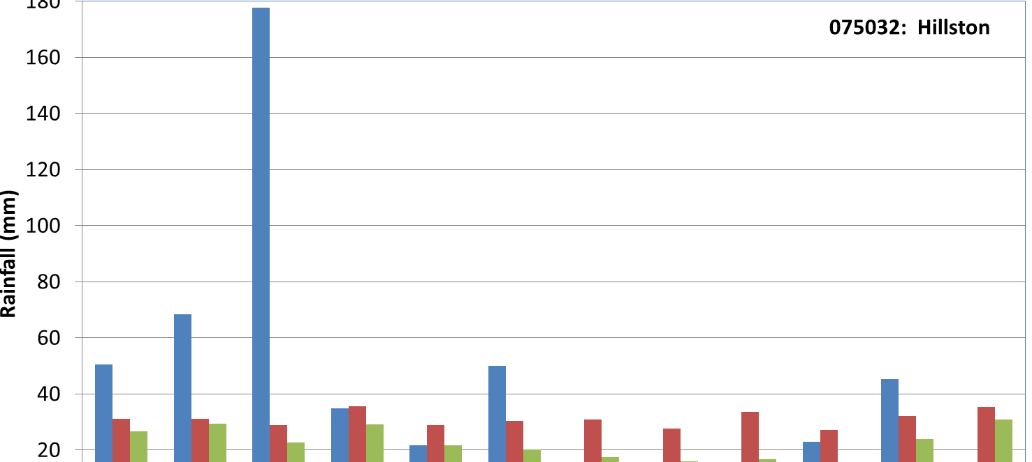

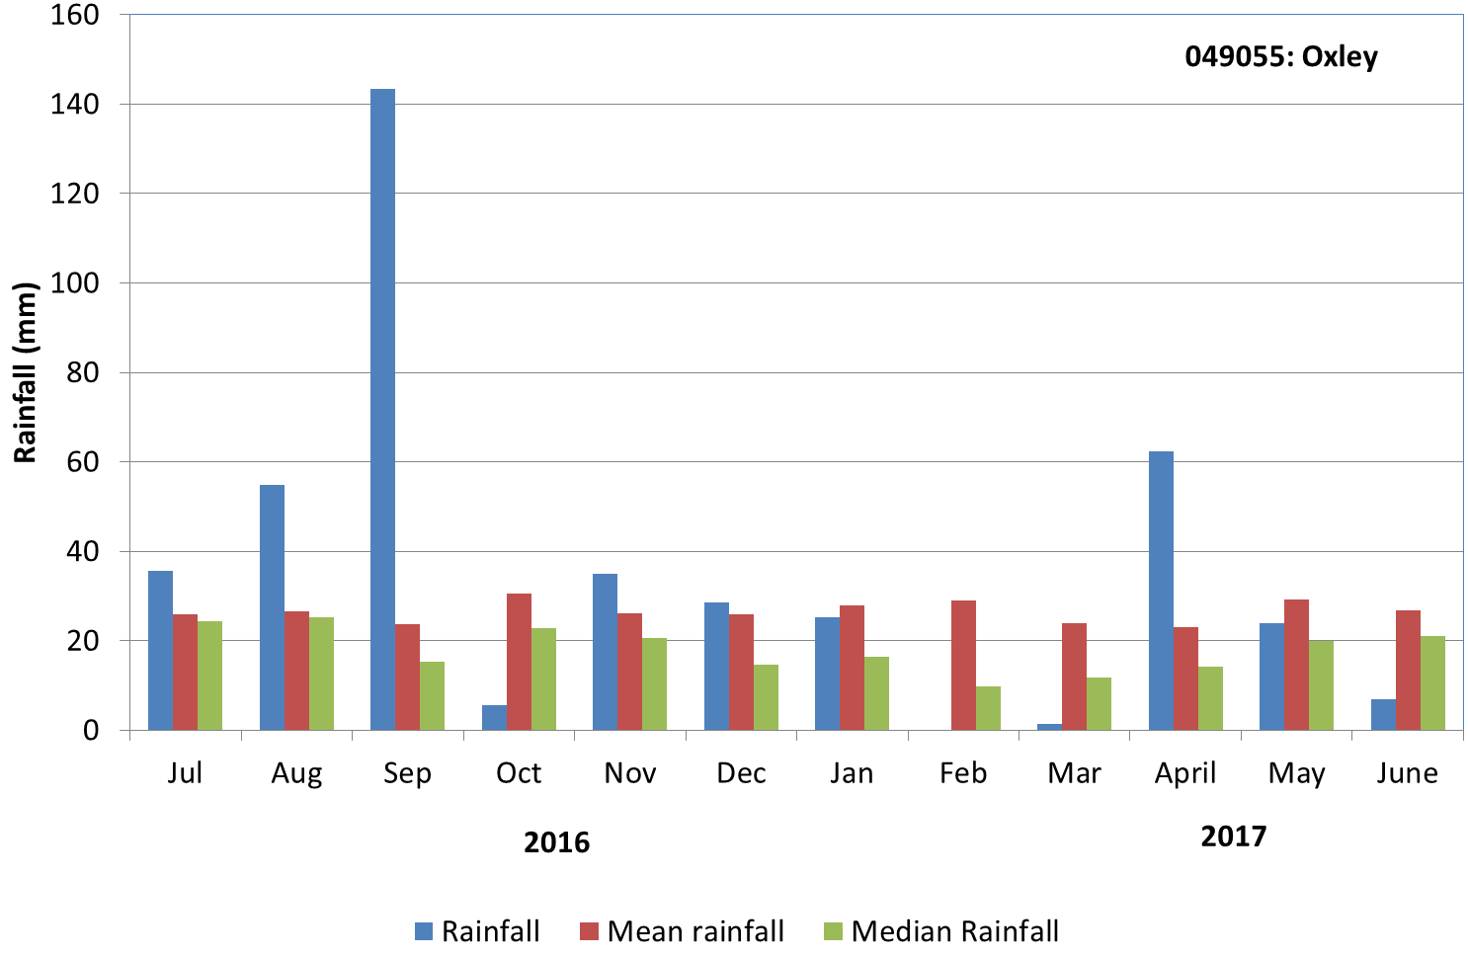

Figure . Rainfall at Hillston and Oxley from July 2016 to June 2017 compared with the long-term mean and median rainfall. Data sourced from the Bureau of Meteorology, Climate Data Online

1. Objectives of Commonwealth environmental water use in the Lachlan River system during 2016-17
   1. Commonwealth and NSW environmental water use

As at 30 June 2017, a combination of 29,492ML of Commonwealth environmental water and 5,250 ML NSW Adaptive Environmental Water has been used in the Lachlan River system in two joint actions. These were:

1. 33,418ML (28,168 ML of Commonwealth environmental water and 5,250 of NSW Adaptive Environmental Water) between 3 November and 2 January 2017 targeting improvements in dissolved oxygen levels and provision of in-channel refuge in the mid Lachlan River; and
2. 1,324 ML Commonwealth environmental water between 21 January 2017 and 13 March 2017 supporting water levels at the second bird breeding colony in the Booligal Wetlands.

Planned environmental water also contributed to both actions (see below).

* 1. Planned environmental water: translucent releases, Water Quality Allowance and Environmental Water Allowance

The flood conditions within the river system in 2017 also triggered the delivery of translucent releases, as required under the Lachlan Regulated River Water Sharing Plan (<http://www.water.nsw.gov.au/water-management/water-sharing/plans_commenced/water-source/lachlan>) as well as the release of water from Wyangala Dam to maintain airspace during the height of the flood.

Planned environmental water managed by the NSW Office of Environment and Heritage also contributed to the above actions:

1. 15 000 ML of Water Quality Allowance (WQA) targeting improvements in dissolved oxygen levels and provision of in-channel refuge in the mid Lachlan River; and
2. 3,571 ML of Environmental Water Allowance (EWA) supporting water levels at the second bird breeding colony in the Booligal Wetlands.
3. Summary on progress against core monitoring and evaluation activities

|  |  |  |
| --- | --- | --- |
| ACTIVITIES | PROGRESS TO DATE | UPCOMING ACTIVITIES |
| *Monitoring activities* | | |
| Ecosystem type | * Data collection complete and suggested Australian National Aquatic Ecosystems (ANAE) types for all sites included in the Monitoring and Data Management System (MDMS). | * No more data collection required |
| Fish (river) | * Fish community sampling has been completed * Sample processed | * Data analysis and evaluation |
| Fish (larvae) | * Processing of larval samples | * Data analysis and evaluation |
| Waterbird breeding (optional) | * Data analysis and evaluation has commenced | * Data analysis and evaluation |
| Water quality and stream metabolism | * Data loggers have been checked, calibrated and downloaded * Loggers have been located, some are damaged and some had recoverable data | * Searching for loggers * QA/QC * Analysis of data |
| Vegetation diversity | * Spring and Autumn field sampling completed * Processing of field samples almost completed | * QA/QC * Data analysis and evaluation |
| Frogs (optional) | * None | * None |
| *Evaluation activities* | | |
| Monitoring data entry |  | * Data uploaded once either MDMS available (larval fish and waterbirds) or QA/QC completed |
| *Communication and engagement* | | |
| Selected Area Working Group | * None | * EWAG meeting in July |
| Project team teleconference | * Teleconferences with individual members of the team in May |  |
| Other Stakeholder Engagement | * Quarterly report 11 was finalised 11 April | * Quarterly report to be provided to landholders and other stakeholders |

**Note:** for the Long-Term Intervention Monitoring Project, Lachlan River system selected area:

* **Appendix A** provides additional information about the project for the Lachlan system and its context in terms of ecological monitoring and evaluation within the Murray-Darling Basin
* **Appendix B** provides a map showing the location of hydrological zones that will be monitored
* **Appendix C** provides a summary of monitoring to be undertaken under the project from 2014-2019.

1. Observations
   1. Hydrology

Flows during the second half of 2016 in the Lachlan River were of a similar magnitude to the floods of 1991, 1974, 1956 and 1950 (Figure 4 and Figure 3). It has taken some time for flows to return to base flows, with flow gradually dropping over the first quarter of 2017 before returning to base flows (Figure 4). The catchment remains wet and the replenishment of local groundwater is evident in slightly higher baseflows in the river than have been observed over the past 2 years of the LTIM project.

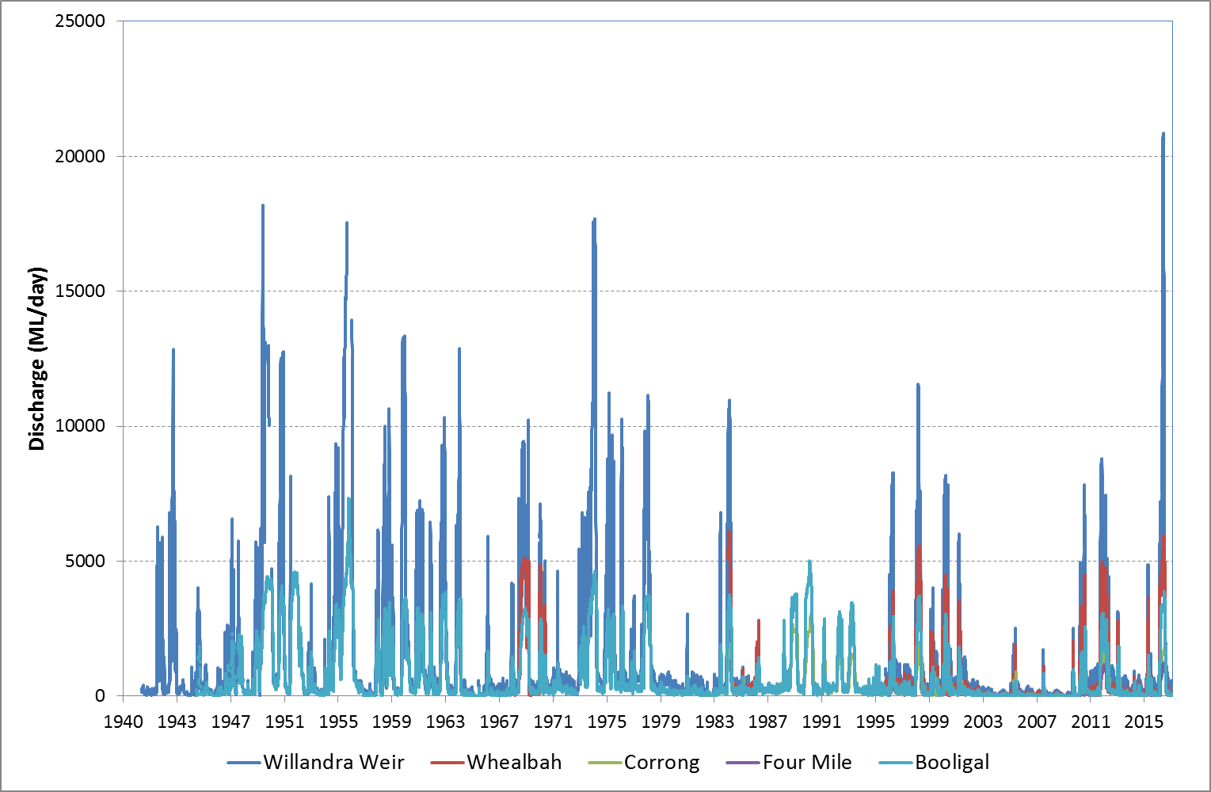

Figure . Flow in the Lachlan River from the gauges at Willandra weir (412038), Whealbah (412078), Booligal (412005), Corrong (412045) and Four Mile (412194) showing the flows since 1940. Data are from NSW Department of Primary Industries (http://www.water.nsw.gov.au/realtime-data).

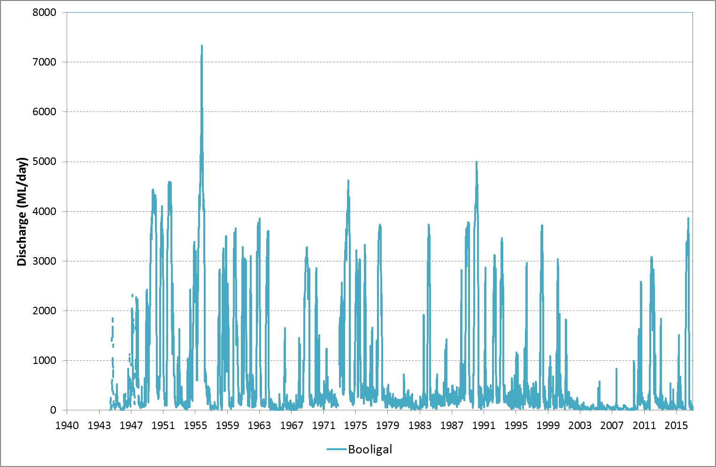

Figure . Flow in the Lachlan River from the gauge at Booligal (412005) showing the flows since 1940. Data are from NSW Department of Primary Industries (http://www.water.nsw.gov.au/realtime-data).

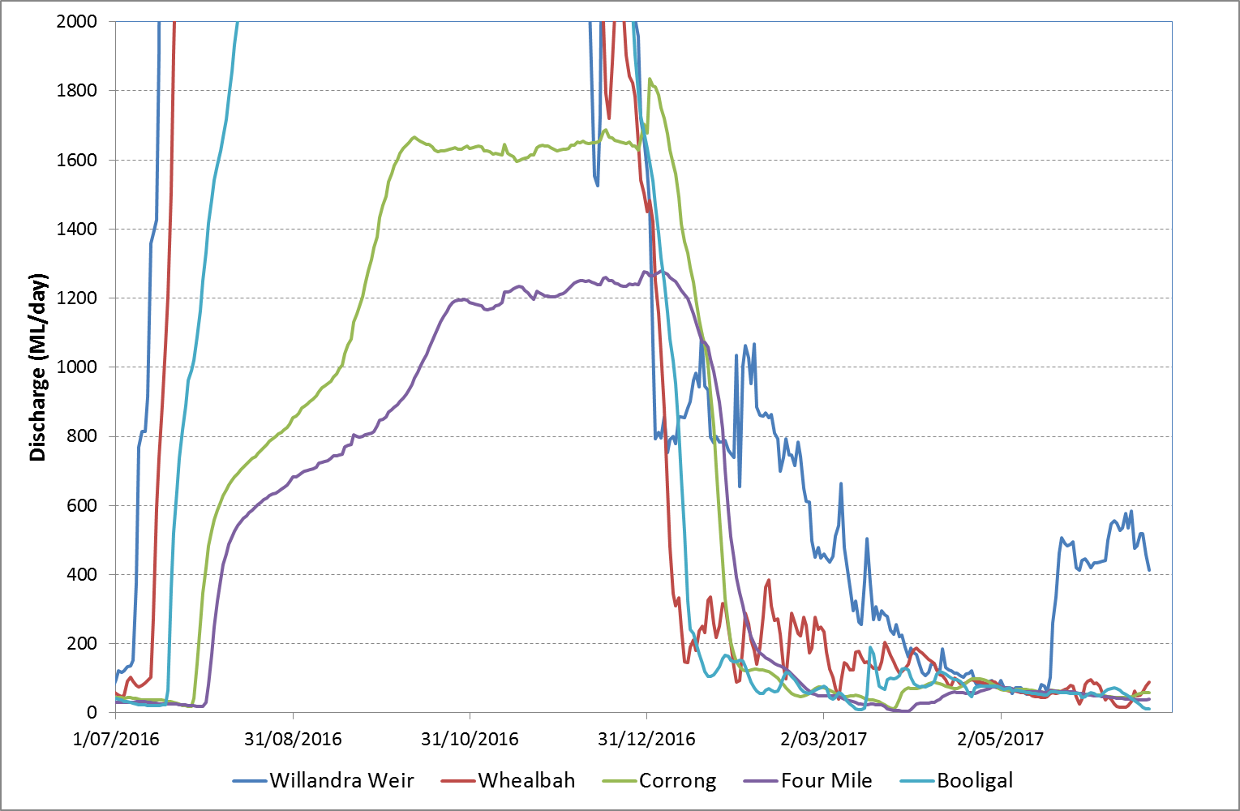

Figure . Flow in the Lachlan River from the gauges at Willandra weir (412038), Whealbah (412078), Booligal (412005), Corrong (412045) and Four Mile (412194) from July 2016 to June 2017. Data are from NSW Department of Primary Industries (<http://www.water.nsw.gov.au/realtime-data>) and have been scaled to show the pattern of flows post-flood.

Many of the wetlands in the catchment still remain inundated. The red gum sections of Lake Tarwong remain completely inundated (Figure 4) with water up to 1.5 m deep in some of the deep channel sections. Moon Moon Swamp still has between 20 and 40cm of water across the main open section of the wetland and scattered puddles of water throughout the redgums (Figure 5). The mounds within the wetlands of Lake Bullogal have recently been exposed and water remains within the channels (Figure 5). The water is up to 1.2 m deep in some of the channels of Lake Bullogal.

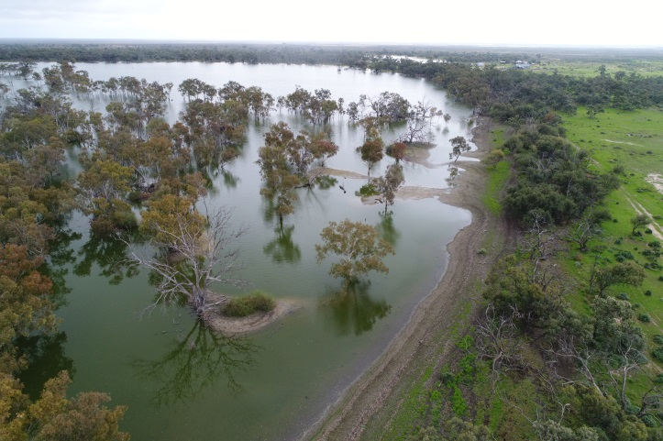 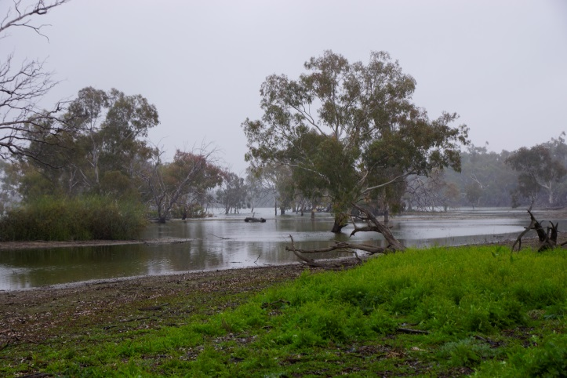

Figure . Lake Tarwong 7th June 2017 from the air (left) and from the ground (right). Images Alica Tschierchke (left) and Fiona Dyer (right)

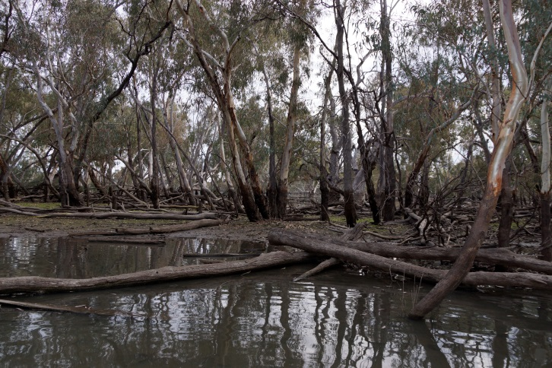 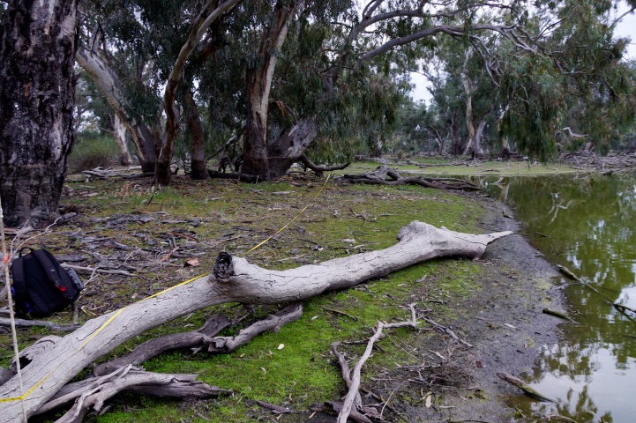

Figure . Wetlands of the lower Lachlan Selected Area in June 2017. Left Moon Moon Swamp. Right Lake Bullogal. Images: Fiona Dyer

* 1. Water Quality

In early June we were able to access sites to look for the Water Quality loggers that had been missing following the flood. We were fortunate enough to find several loggers and one of them had data for the full period of deployment that was able to be recovered. This is a great demonstration of the robustness of miniDot loggers! These data show very low (0.4 mg/L) dissolved oxygen concentrations in mid to late November (after the peak of the flood event) with a slow recovery as flows dropped. The flow at the nearest upstream gauge (Willandra Weir) to our data logger peaked at just over 20,000 ML/day on the 31st October (Figure 8) The logger data also shows a rapid drop in dissolved oxygen concentrations associated with high water temperatures in early February before temperatures began to drop and oxygen concentrations began to increase (Figure 6).

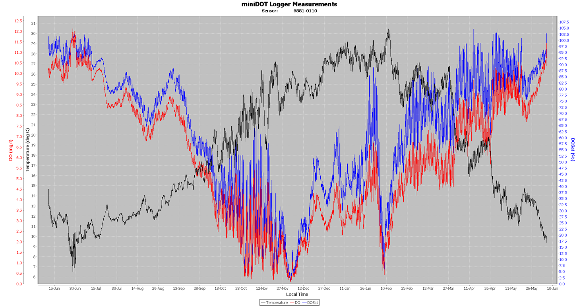

Figure . Dissolved oxygen concentrations (red is mg/L blue as % saturation) and water temperature (black) at Lanes Bridge from the recovered miniDOT logger. Lane’s Bridge is located immediately upstream of Hillston. The flood had peaked in early November (see Figure 8).

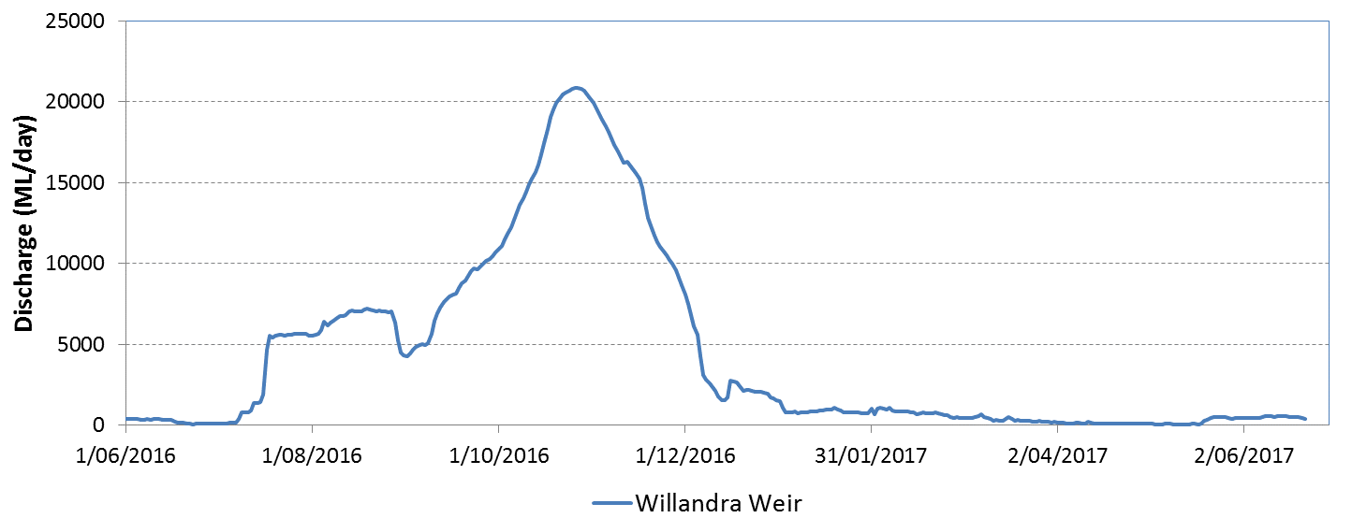

Figure . Flow in the Lachlan River from the gauge at Willandra weir (412038) June 2016 to June 2017. Data are from NSW Department of Primary Industries (<http://www.water.nsw.gov.au/realtime-data>) and show a similar time period to the data in Figure 7.

* 1. Vegetation monitoring

The vegetation response to flooding was still evident in the autumn sampling and given that some sites had only recently been exposed following flooding, a number of recessional species had appeared at sites. At Lake Bullogal a bright green mat had formed on recently explosed and waterlogged soils (Figure 7). This comprised a mixture of species including slender club rush (*Isolepis sp.*), native mint (*Mentha australis*), native mudwort (*Limosella australis*) and matted water starwort (*Callatriche sonderi*) (Figure 8).

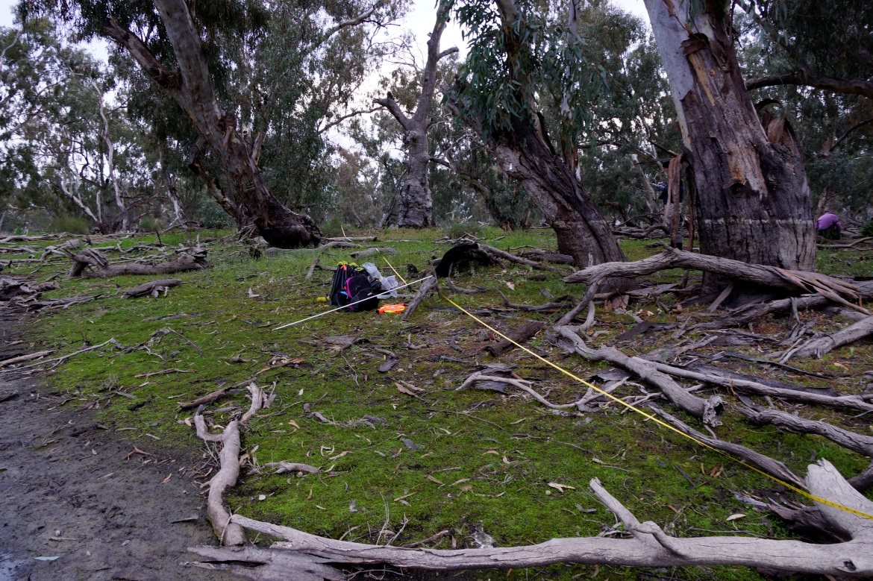

Figure . Vegetation plot at Lake Bullogal 16 June 2017. Photo: Fiona Dyer

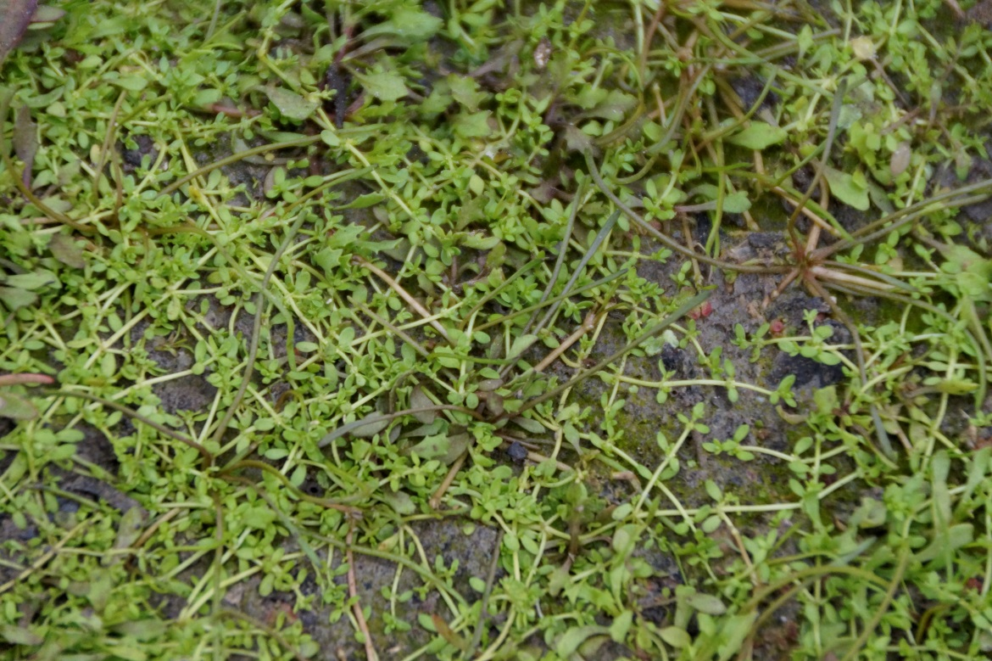

Figure . Matted water starwort (Callatriche sonderi) and native mudwort (Limosella australis) at Lake Bullogal 16 June 2017. Photo: Fiona Dyer

Large numbers of redgum seedlings have been noted on the high water mark of most of the wetlands amidst a relatively dense layer of bark and leaf litter (Figure 9).

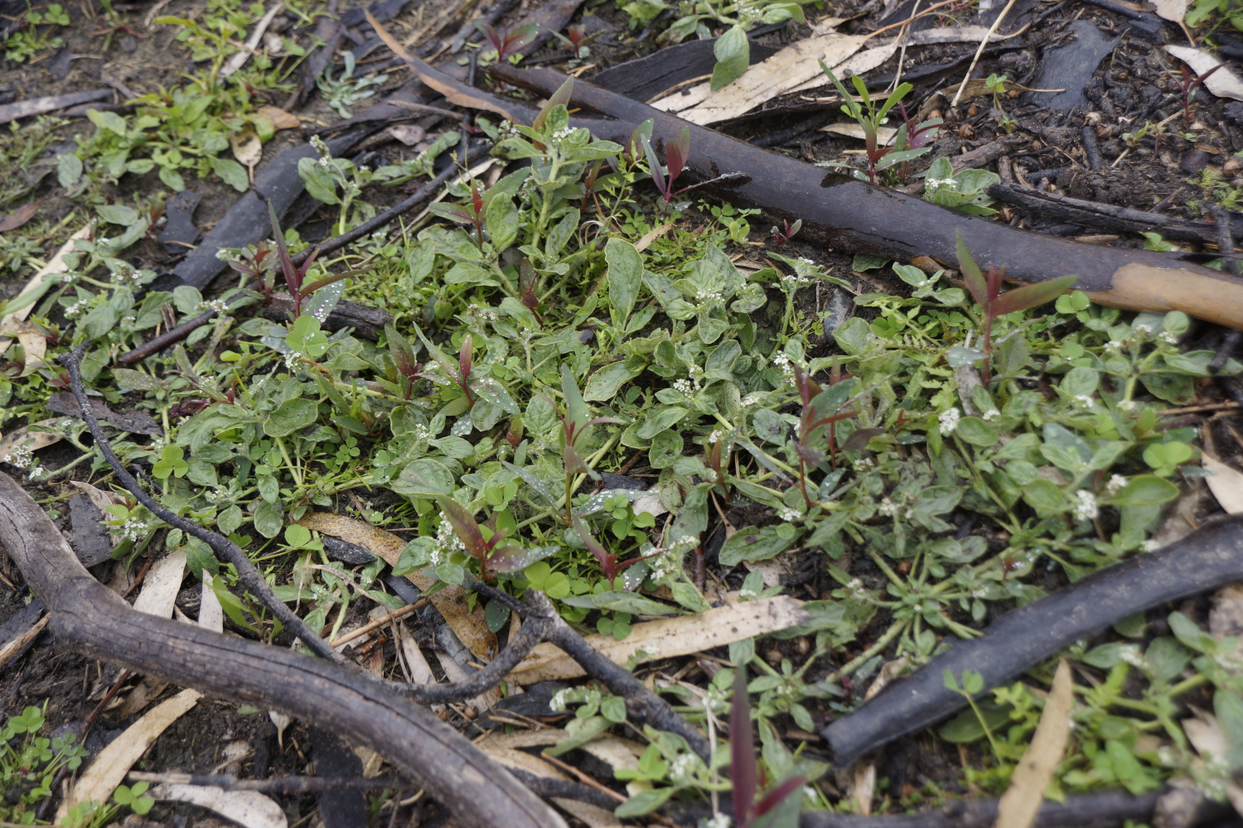

Figure . River redgum seedlings on the margins of Lake Tarwong. Photos: Fiona Dyer

* 1. Other relevant work

Our team have been trialling the use of drones to take relevant field vegetation and site measures. We are particularly interested in the use of drones to provide an accurate estimation of tree metrics such as height and percent cover, but are also interested in understanding flow pathways across the floodplain. Dr Duanne White accompanied us on one of the field trips to record high resolution imagery over a large area near our field sites using a drone. Our field team has used the drone in subsequent trips to record specific site imagery. These images will be used to build a high resolution DEM and extract tree metrics which can then be compared with the field data. The drone proved particularly useful in taking pictures of sites that we were unable to access because of high water levels (see Figure 4 for an image of Lake Tarwong).

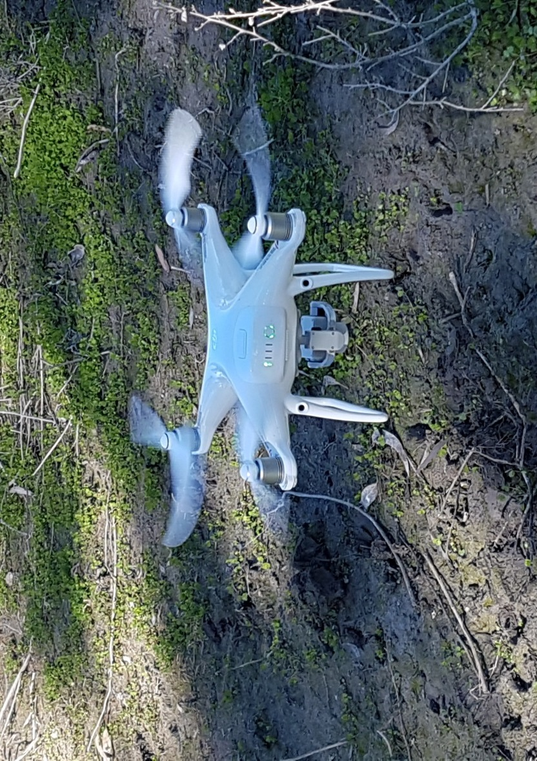

Figure Drone ready to survey vegetation. Photo: Fiona Dyer

Appendix A: The Long-Term Intervention Monitoring Project for the Lachlan River system and its context in terms of ecological monitoring and evaluation within the Murray-Darling Basin.

The Long Term Intervention Monitoring (LTIM) Project for the Lachlan river system selected area is funded by the Commonwealth Environmental Water Office. The project is being delivered by a consortium of service providers lead by University of Canberra and includes NSW Office of Environment and Heritage, NSW Department of Primary Industries (Fisheries), NSW Department of Primary Industries (Office of Water), University of New South Wales and Charles Sturt University.

The LTIM project is based on a clear and robust program logic, as detailed in the [Long-Term Intervention Monitoring Project Logic and Rationale Document](http://www.environment.gov.au/water/cewo/publications/long-term-intervention-monitoring-project-logic-and-rationale-document). That document sets out the scientific and technical foundations of long-term intervention monitoring and is being applied to areas where LTIM projects are being undertaken. It also provides links between Basin Plan objectives and targets to the monitoring of outcomes from Commonwealth environmental watering actions. For more information, see [Monitoring and evaluation for the use of Commonwealth environmental water](http://www.environment.gov.au/topics/water/commonwealth-environmental-water-office/monitoring-and-evaluation).

Many different agencies play a role in the reporting on environmental outcomes, consistent with the Basin Plan (see figure 1 below). The Murray Darling Basin Authority is responsible for reporting on achievements against the environmental objectives of the Basin Plan at a basin-scale, which are broadly focussed on flows and water quality, fish, vegetation and birds across the whole of the Basin. State Governments are responsible for reporting on achievements against the environmental objectives of the Basin Plan at an asset-scale i.e. rivers, wetlands, floodplains. The Commonwealth Environmental Water Holder is responsible for reporting on the contribution of Commonwealth environmental water to the environmental objectives of the Basin Plan (at multiple-scales).

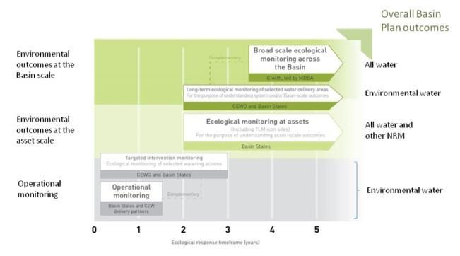

Figure 12. A summary of roles various agencies play a in the reporting on environmental outcomes, consistent with the Basin Plan.

Appendix B: Hydrological zones and monitoring sites of the lower Lachlan for the Long-Term Intervention Monitoring Project.

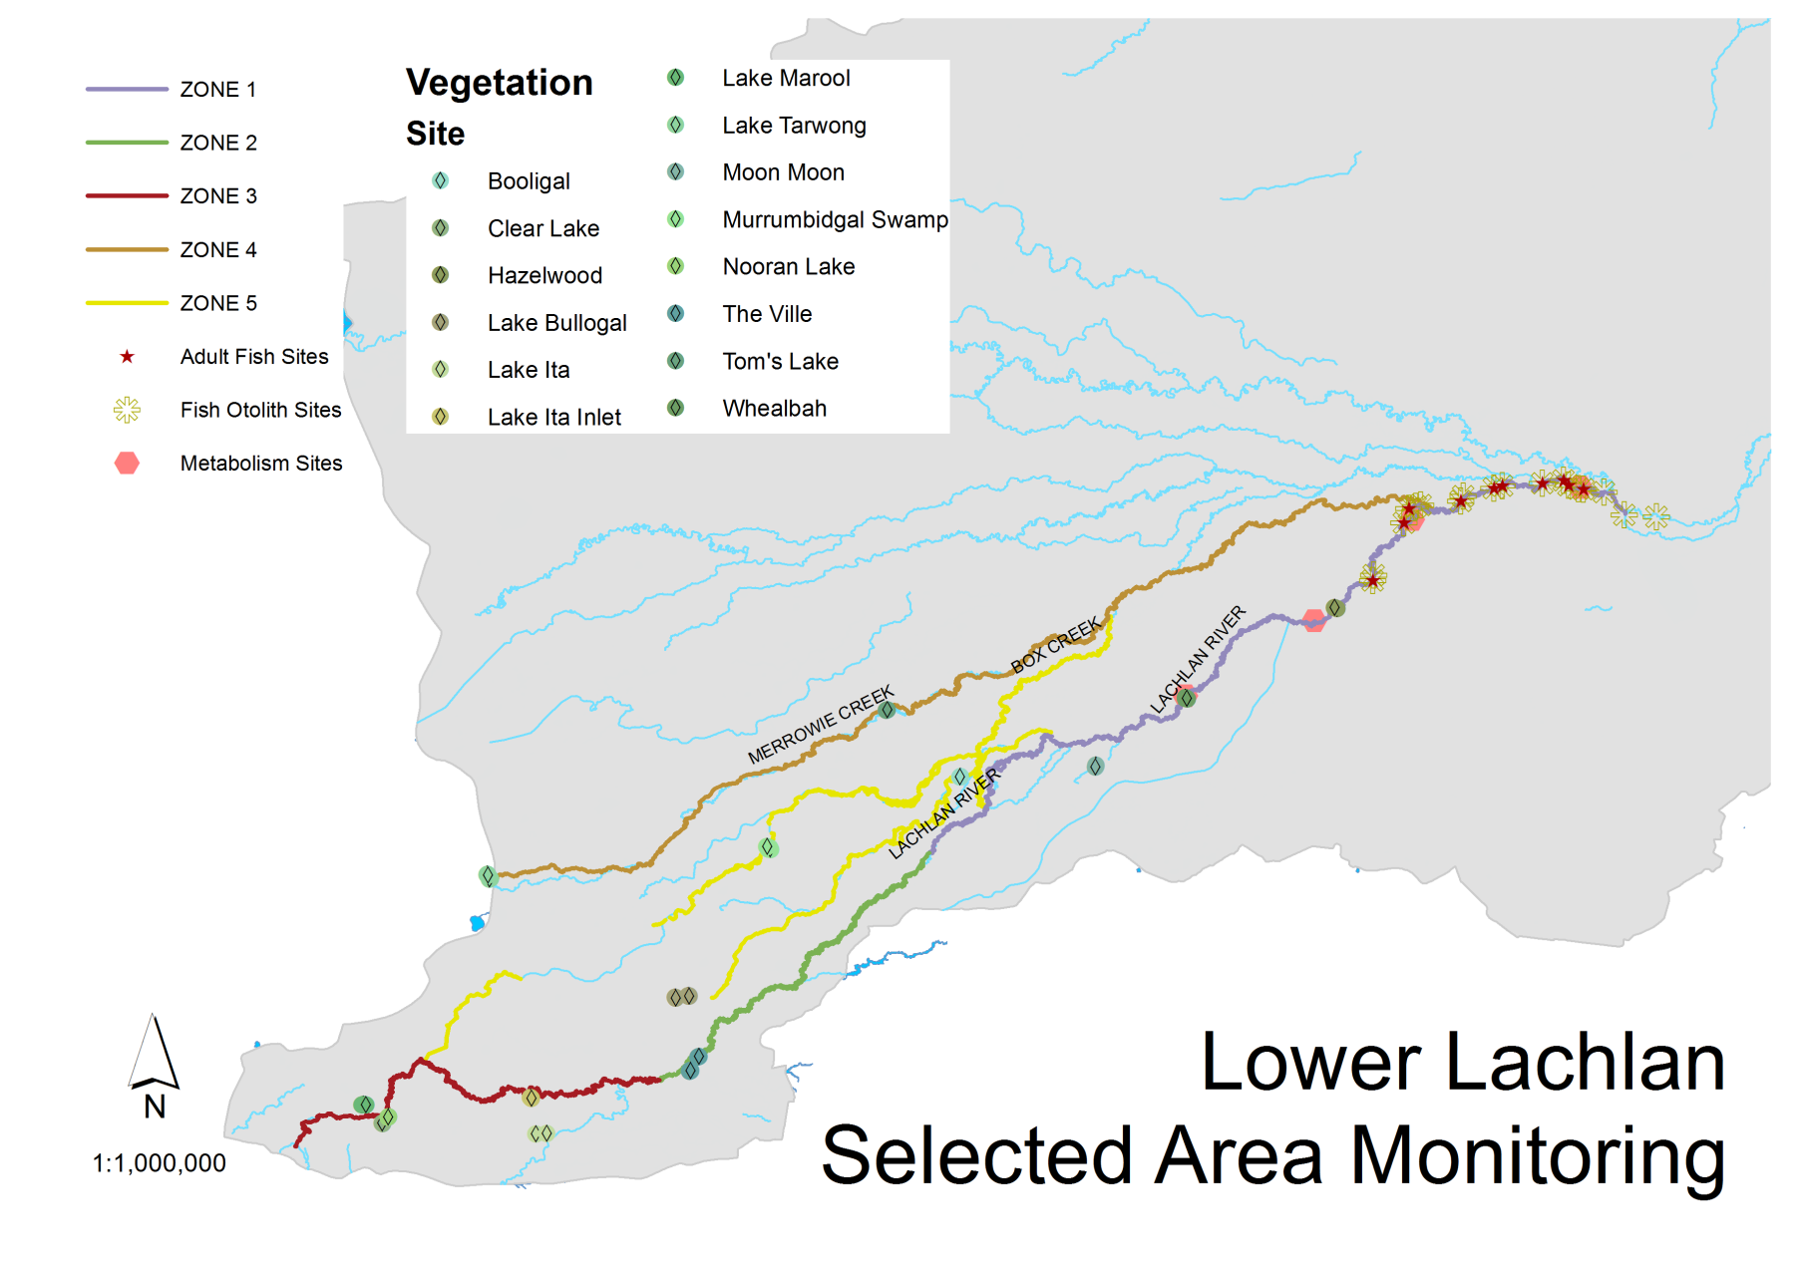

*Figure 13. Lower Lachlan LTIM monitoring sites, hydrological zones and NSW gauging stations*

Appendix C: Summary of monitoring to be undertaken in the Lachlan system for the Long Term Intervention Monitoring Project from 2014-2019

The five year monitoring schedule has been based around the expected watering options and is focussed on the monitoring of Basin Indicators. Monitoring effort is consistent across the five years with the exception of monitoring Waterbird Breeding and Frogs which are options that can be implemented on the basis of a request from the CEWO.

| indicator | ZONE | Evaluation of responses to Commonwealth environmental watering | Data contributes to evaluation of responses to Commonwealth environmental watering at whole of Basin-scale | monitoring frequency | sites | expected schedule |
| --- | --- | --- | --- | --- | --- | --- |
| Ecosystem type | All | ✓ | ✓ | Once only | All sites for other indicators | Establishment of ANAE type at the start of the LTIM Project. Expected August-December 2014 |
| Riverine fish | 1 | ✓ | ✓ | ANNUAL | Basin Evaluation: 10 fixed sites within Zone 1 | Annual sampling between March and May |
| Larval fish | 1 | ✓ | ✓ | ANNUAL | 3 fixed riverine sites in Zone 1 | Annual sampling 5 times during breeding season (September to February) |
| Stream metabolism | 1 | ✓ | ✓ | CONTINUOUS  REGULAR | Four fixed sites matched to riverine fish sampling sites in Zone 1 | Continuous monitoring of dissolved oxygen and temperature.  6 weekly sampling of nutrients and water quality attributes. |
| Hydrology (River) | 1 | ✓ | ✓ | CONTINUOUS | Gauging sites |  |
| Vegetation diversity and condition | All | ✓ |  | ANNUAL & EVENT BASED | 12 fixed sites | Before and after watering (expected to be April/May and 3 months after first fill) |
| Waterbird breeding (Option) | 1 | ✓ |  | EVENT-BASED (on request from the CEWO) | One fixed site – Booligal wetland | Fortnightly surveys of bird breeding triggered by breeding events in Booligal wetland. |
| Frogs (Option) | All | ✓ |  | EVENT-BASED (on request from the CEWO) | 15 sites comprising 2 to 8 wetland sites and 2 to 7 riverine sites depending on watering targets | 3 sampling events between August and February (one sample in each of winter, spring and summer). |
| Hydrology (wetland – Option) |  | ✓ |  | EVENT-BASED (in conjunction with Waterbird Breeding or Frog monitoring) | Cameras at 6 roving wetland sites | Cameras installed prior to targeted watering each year and downloaded after the watering event has passed |