**Long Term Intervention Monitoring Project**

**Lachlan River System Selected Area**

**Project Progress Report**

**Report period: *1 January to 31 March 2016***

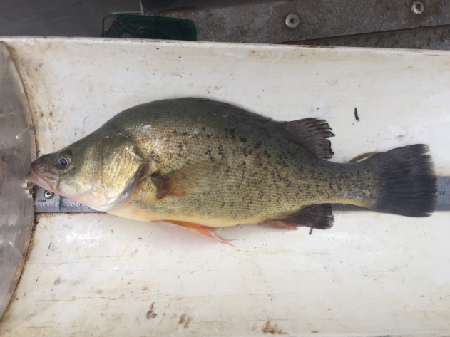

Inquiries regarding this document should be addressed to:

Dr Fiona Dyer  
Phone: 02 6201 2452  
e-mail: Fiona.Dyer@canberra.edu.au

This document was prepared by Fiona Dyer with contributions from Amelia Walcott, Skye Wassens and Jason Thiem.

Cover Photo: Golden perch from the Autumn sampling. Photo: Jason Thiem (NSW DPI)

**Document history and status**

|  |  |  |  |  |
| --- | --- | --- | --- | --- |
| Version | Date Issued | Reviewed by | Approved by | Revision Type |
| Draft 1 | 24 March 2016 |  | Fiona Dyer | Internal |
| FINAL |  |  |  |  |

**Distribution of copies**

|  |  |  |
| --- | --- | --- |
| Version | Type | Issued to |
| FINAL | Electronic | Commonwealth Environmental Water Office |

**Copyright**© Copyright Commonwealth of Australia, 2016



‘Long term intervention monitoring project, Lachlan River system selected area, progress report ’ is licensed by the Commonwealth of Australia for use under a Creative Commons By Attribution 3.0 Australia licence with the exception of the Coat of Arms of the Commonwealth of Australia, the logo of the agency responsible for publishing the report, content supplied by third parties, and any images depicting people. For licence conditions see: <http://creativecommons.org/licenses/by/3.0/au/>

**Disclaimer**

The views and opinions expressed in this publication are those of the authors and do not necessarily reflect those of the Australian Government or the Minister for the Environment. While reasonable efforts have been made to ensure that the contents of this publication are factually correct, the Commonwealth does not accept responsibility for the accuracy or completeness of the contents, and shall not be liable for any loss or damage that may be occasioned directly or indirectly through the use of, or reliance on, the contents of this publication.

1. Objectives of Commonwealth environmental water use in the   
   Lachlan River system during 2015-16
   1. Commonwealth environmental water use

As at 31 March 2016, 36 021 ML of Commonwealth environmental water had been delivered to the Lower Lachlan River system across three watering actions. These actions were designed to contribute to supporting native riparian, wetland and floodplain vegetation diversity and condition; and to provide habitat to support survival, maintain condition of, and provide reproduction opportunities for native fish (e.g. Murray cod and golden perch), waterbirds (e.g. straw necked ibis), and other aquatic vertebrate species (e.g. Murray River turtle). The three actions were:

1. 24 058 ML of Commonwealth environmental water into Lachlan River, targeting the Great Cumbung Swamp. This action is expected to consolidate the benefits of inundation that occurred in 2013 and support the survival and growth of wetland vegetation and habitat values for waterbirds and other water dependent species.
2. 1087 ML of Commonwealth environmental water to Merrimajeel Creek targeting Murrumbidgil Swamp. 1497 ML of Commonwealth environmental water to Merrimajeel creek to support waterbird habitat at the Blockbank.
3. 9378 ML of Commonwealth environmental water to the Lachlan River, targeting flow cued native fish outcomes, specifically golden perch, but also to contribute to non-flow cued native fish outcomes for species such as Murray cod.

The specific objectives for these watering actions were:

|  |  |  |
| --- | --- | --- |
| Action | Primary Objective | Secondary Objective |
| 1 | To protect, maintain and improve riparian, wetland and floodplain vegetation diversity and condition | To improve hydrological connectivity, contribute to ecosystem function, support vegetation condition (river red gum, lignum and aquatic macrophytes) and ecosystem resilience. |
| 2 | To contribute to hydrological connectivity in the Booligal wetlands and   1. protect the extent and condition of native riparian and vegetation communities, 2. potentially maintain base flows into Booligal Swamp to support waterbird breeding to completion | To support the ongoing recovery and resilience of Murrumbidgil Swamp if dry conditions continue, by providing drought refuge. |
| 3 | To support habitat requirements to native fish and other water dependent vertebrates.  Provide opportunities for native fish movement, spawning and recruitment | Trial the augmentation of flows to generate a golden and/or silver perch movement and spawning response.  Protect and maintain the health of existing extent of riparian and wetlands native vegetation. |

* 1. Planned environmental water: translucent releases

Significant rainfall within the catchment in the first half of 2015 produced medium-large volumes of unregulated inflow to the Lachlan River, particularly from the Belubula and Boorowa Rivers. Inflows from 1 January to 26 August 2015 totalled 268 GL which consequently triggered the delivery of translucent releases, as required under the Lachlan Regulated River Water Sharing Plan. Dam levels were such that translucent releases were targeted at between 3,500 ML/day and 5,156 ML/day with a combination of passing flow and dam releases delivering the water to the Lower Lachlan river system. This translucent event contributed to approximately 72 GL of flow passing Lake Brewster weir in August-September 2015.

1. Summary on progress against core monitoring and evaluation activities

|  |  |  |
| --- | --- | --- |
| ACTIVITIES | PROGRESS TO DATE | UPCOMING ACTIVITIES |
| *Monitoring activities* | | |
| Ecosystem type | * Data collection complete and suggested Australian National Aquatic Ecosystems (ANAE) types for all sites included in the Monitoring and Data Management System (MDMS). | * No more data collection required |
| Fish (river) | * 2016 Sampling underway | * Processing of field samples * Data entry |
| Fish (larvae) | * Processing of field samples | * QA/QC * Analysis of data |
| Waterbird breeding (optional) | * No sampling required | * N/A |
| Water quality and stream metabolism | * Checking, calibrating and downloading logger data completed | * Analysis of data * QA/QC |
| Vegetation diversity | * Field data partially processed | * Complete processing of field samples * QA/QC * Autumn vegetation sampling |
| Frogs (optional) | * Frog monitoring completed | * Additional sites monitored in January * Analysis of data |
| *Evaluation activities* | | |
| Monitoring data entry |  | * Data to be uploaded once QA/QC steps completed |
| *Communication and engagement* | | |
| Selected Area Working Group | * Meeting held 7th March | * May/June meeting |
| Project team teleconference | * None | * Teleconference to be held once sampling completed |
| Other Stakeholder Engagement | * Quarterly report #6 finalised in February. | * Quarterly progress report #7 to be provided to landholders and other stakeholders |

**Note:** for the Long-Term Intervention Monitoring Project, Lachlan River system selected area:

* **Appendix A** provides additional information about the project for the Lachlan system and its context in terms of ecological monitoring and evaluation within the Murray-Darling Basin
* **Appendix B** provides a map showing the location of hydrological zones that will be monitored
* **Appendix C** provides a summary of monitoring to be undertaken under the project from 2014-2019.

1. Observations
   1. Hydrology

The combination of environmental watering actions, translucent releases (planned watering activities) and rainfall in the catchment produced significant flows in the Lower Lachlan river in the second half of 2015. Flows reached 3,500 ML/day at Whealbah in mid to late September (Figure 1). The peak flow was a consequence of translucent releases and rainfall and a considerable rise in water level also occurred along the river (Figure 1).

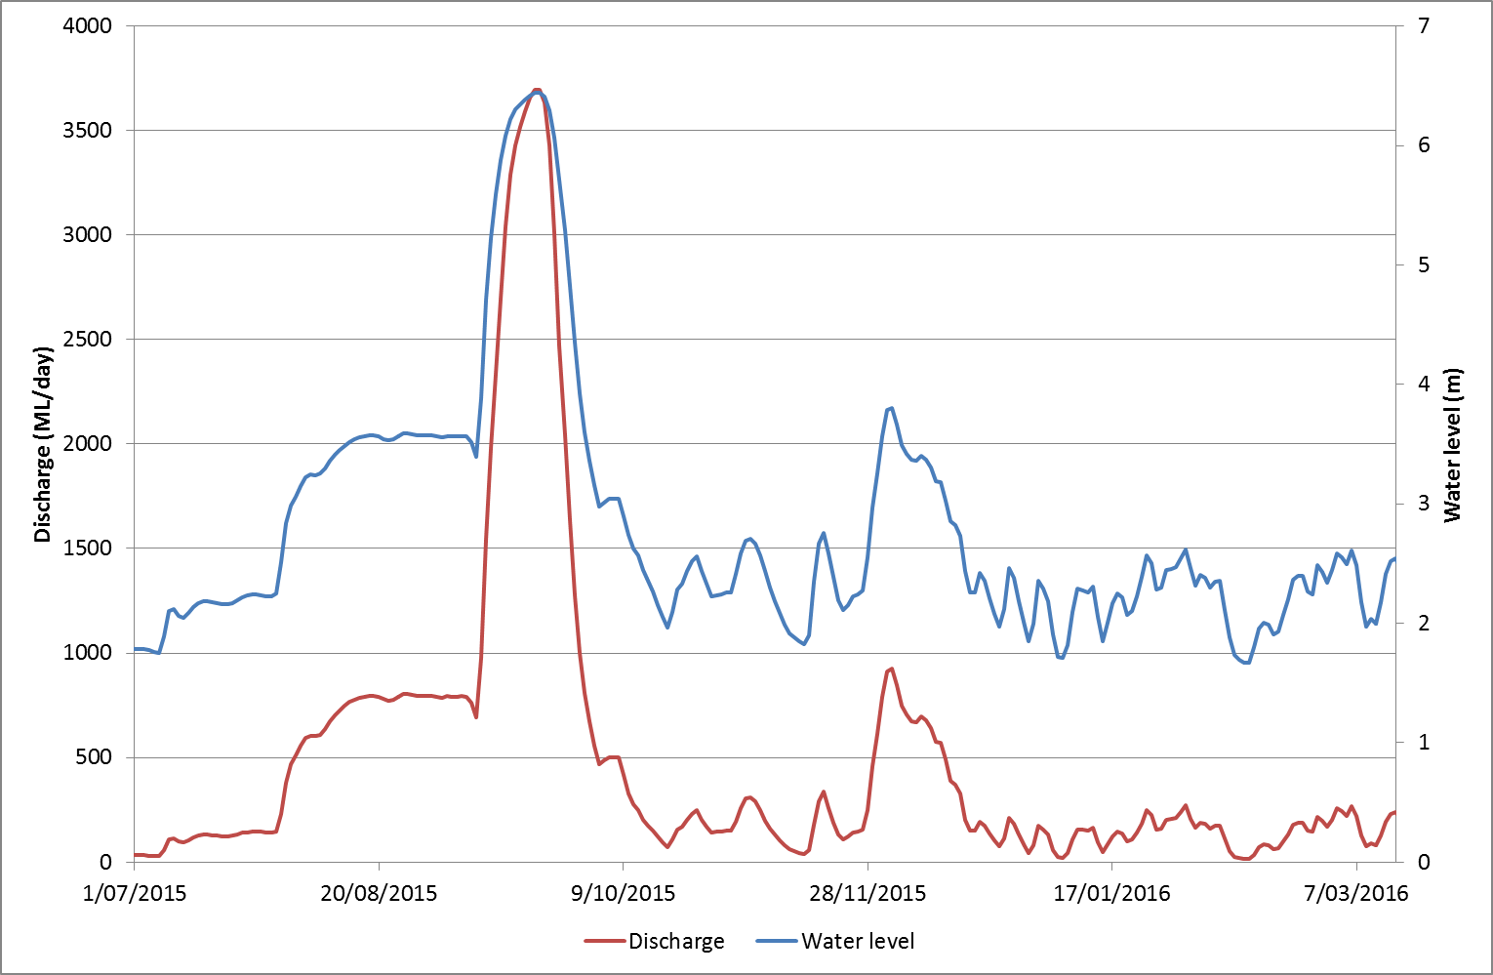

Figure 1. Flow and water level data from the Lachlan River at Whealbah. Data from NSW Waterinfo (Data from NSW Waterinfo (http://realtimedata.water.nsw.gov.au/) for station 412078, Lachlan River at Whealbah

The environmental and planned (translucent releases) watering actions inundated a number of the distributary channels (Figure 2) and resulted in water reaching a number of wetlands. Water persisted in the landscape for several months, but by mid to late January, most of the water had receded or dried up (Figures 3-5).

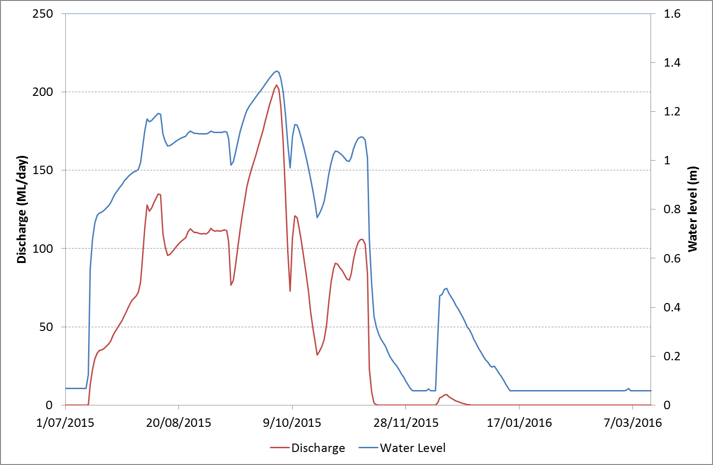

Figure . Flow and water level data from Merrimajeel Creek at Cobb Highway. Data from NSW Waterinfo (Data from NSW Waterinfo (http://realtimedata.water.nsw.gov.au/) for station 412122, Merrimajeel Creek at Cobb Highway

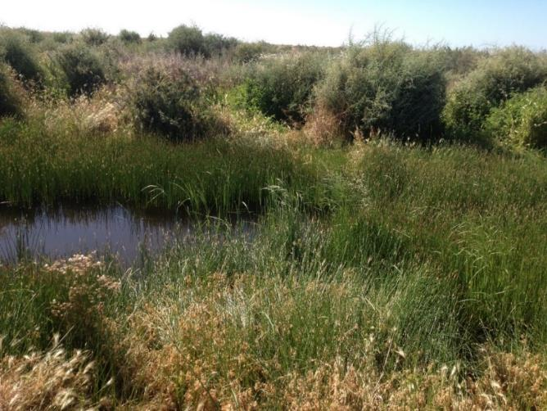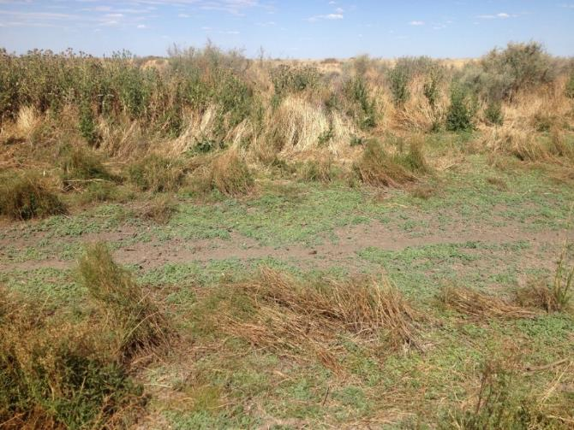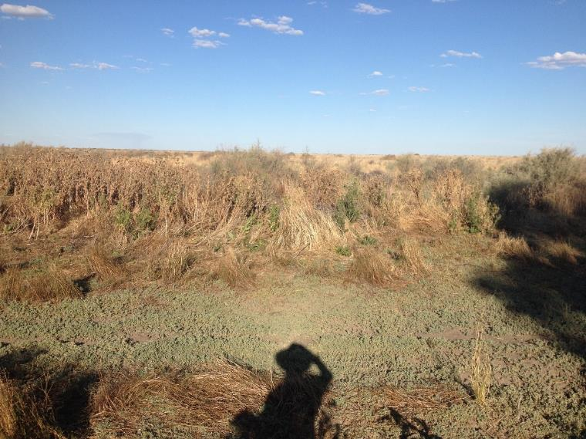

Figure . Frog monitoring photopoint Upstream Merrimajeel. From L-R October 2015, December 2015, January 2016. Photos Amelia Walcott (Charles Sturt University)

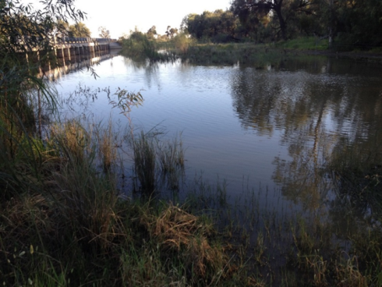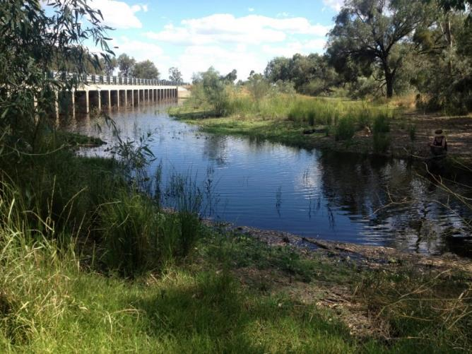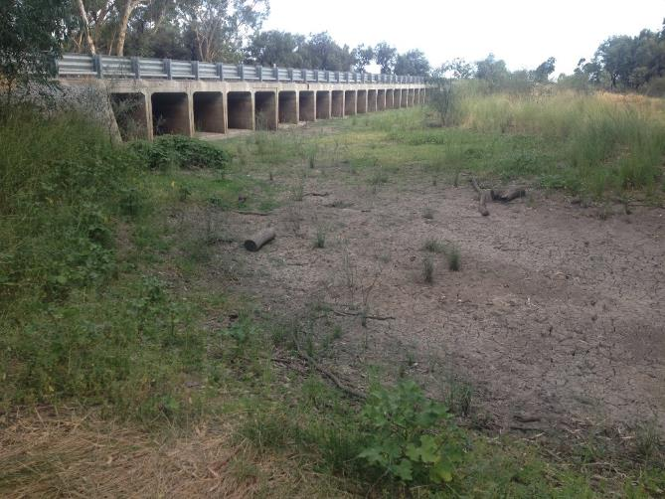

Figure . Frog monitoring photo point Merrimajeel Cobb Highway. From L-R October 2015, December 2015, January 2016. Photos Amelia Walcott (Charles Sturt University)

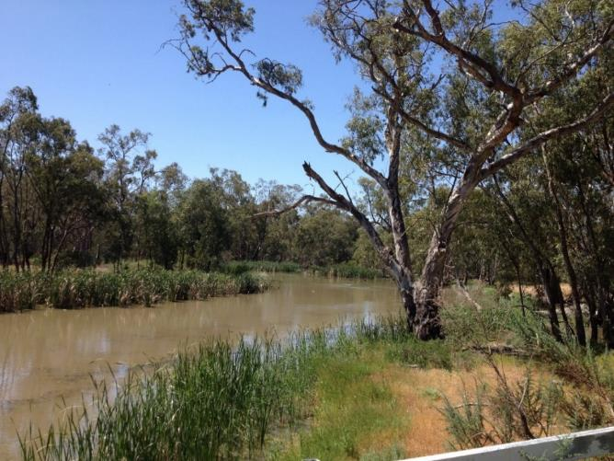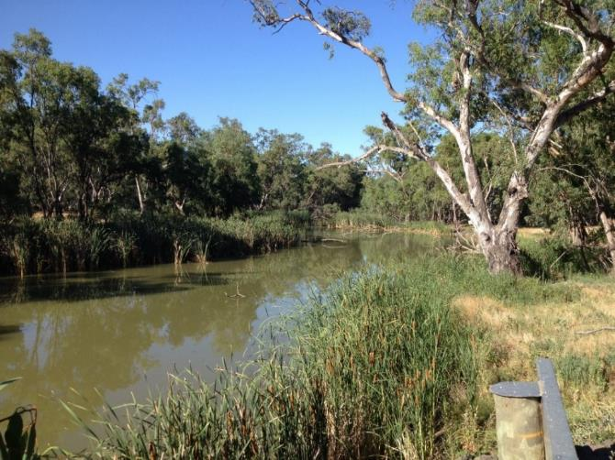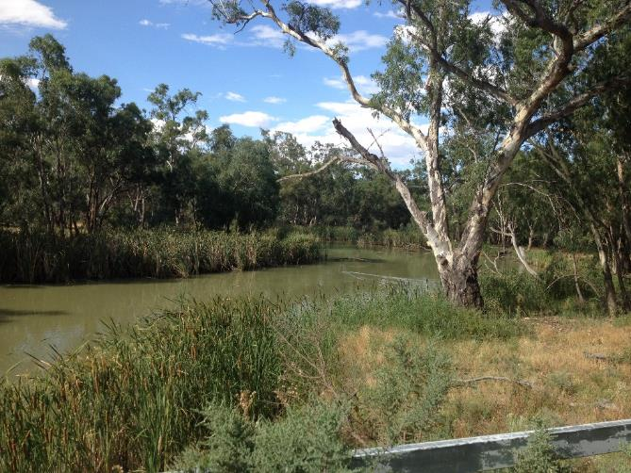

Figure . Frog monitoring photo point Lachlan River at Oxley. From L-R October 2015, December 2015, January 2016. Photos Amelia Walcott (Charles Sturt University)

* 1. Adult fish monitoring

Fish community (Category 1) sampling was undertaken in March 2016 comprising boat-electrofishing and small fyke nets at each of ten sites. A total of ten species of fish were captured including seven native species (Australian smelt, bony herring, carp gudgeon, flathead gudgeon, golden perch, Murray cod and un-specked hardyhead) and three alien species (common carp, goldfish and eastern gambusia). These species were also caught during the 2015 fish community monitoring. One hundred bony herring were retained for annual age determination as a replacement for small bodied fish as per modifications to the standard methods. Data entry is currently underway. Additional monitoring by DPI Fisheries is also specifically targeting Golden Perch recruits to indicate whether a spawning event occurred in Spring/Summer 2015.

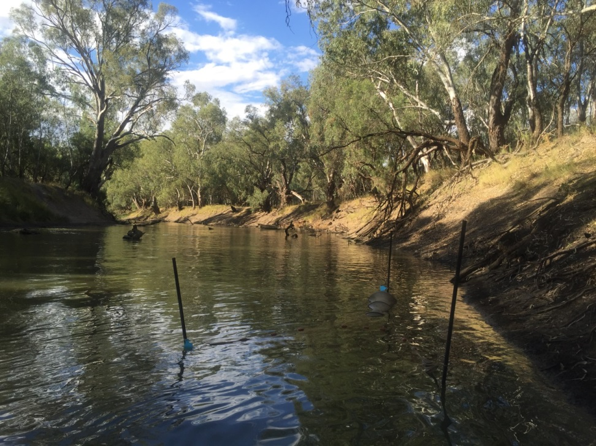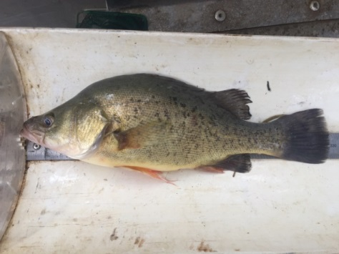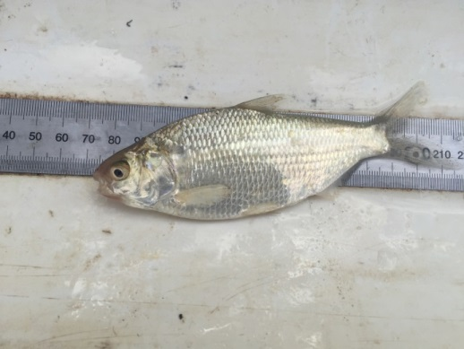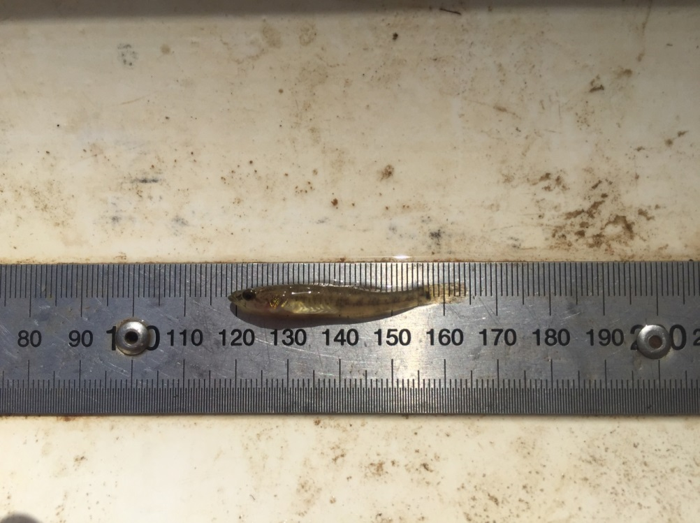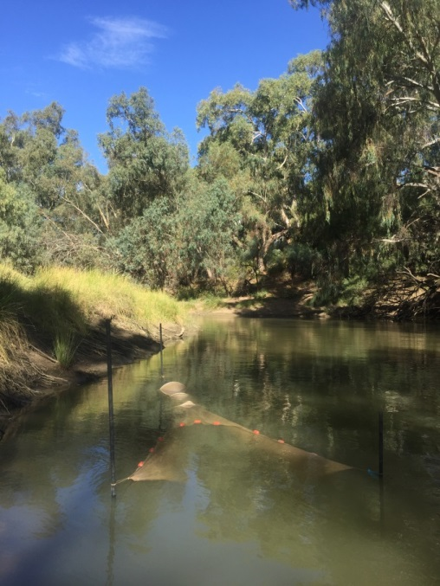

Figure 6. Top: Small fyke nets set on the Lachlan River, 2016. Bottom (from left): Examples of native fish species captured in 2016 on the Lachlan River: golden perch (Macquaria ambigua), flathead gudgeon (Philypnodon grandiceps) and bony herring (Nematalosa erebi). Photos Jason Thiem

* 1. Frogs

Final frog surveys were conducted between 18 and 20 January at fourteen sites across the Lower Lachlan river system. Most sites were either dry or with receding water levels. Only two species were detected: Spotted marsh frog (*Limnodynates tasmaniensis)*  and Peron’s tree frog (*Litoria peronii)*. In keeping with previous surveys’ findings, the Spotted Marsh Frog, *L. tasmaniensis* was by far the most common and prolific species, identified at 10 of the 14 sites. A generalist species with opportunistic breeding behaviour, their relatively high rate of occupancy was unsurprising given their abundant breeding activity in October.

Very few Peron’s Tree Frogs (*L. peronii)* were heard calling at four sites within zone three which retained higher water levels, and standing timber - known associations with their occupancy. The presence of water, coupled with high night time temperatures and humidity associated with an impending storm during surveys likely cued their calling activity.

Very little calling activity was evident during the surveys for both species, likely due to the general lack of available aquatic breeding habitat. Furthermore, no tadpoles were detected at any of the sites.

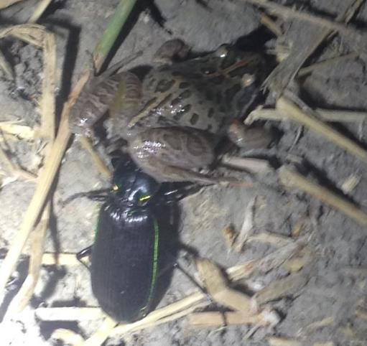

Figure 7. Unusual night survey observations: beetle latched onto a Spotted Marsh Frog. Photo Amelia Walcott (Charles Sturt University).

Appendix A: The Long-Term Intervention Monitoring Project for the Lachlan River system and its context in terms of ecological monitoring and evaluation within the Murray-Darling Basin.

The Long Term Intervention Monitoring (LTIM) Project for the Lachlan river system selected area is funded by the Commonwealth Environmental Water Office. The project is being delivered by a consortium of service providers lead by University of Canberra and includes NSW Office of Environment and Heritage, NSW Department of Primary Industries (Fisheries), NSW Department of Primary Industries (Water), University of New South Wales and Charles Sturt University.

The LTIM project is based on a clear and robust program logic, as detailed in the [Long-Term Intervention Monitoring Project Logic and Rationale Document](http://www.environment.gov.au/water/cewo/publications/long-term-intervention-monitoring-project-logic-and-rationale-document). That document sets out the scientific and technical foundations of long-term intervention monitoring and is being applied to areas where LTIM projects are being undertaken. It also provides links between Basin Plan objectives and targets to the monitoring of outcomes from Commonwealth environmental watering actions. For more information, see [Monitoring and evaluation for the use of Commonwealth environmental water](http://www.environment.gov.au/topics/water/commonwealth-environmental-water-office/monitoring-and-evaluation).

Many different agencies play a role in the reporting on environmental outcomes, consistent with the Basin Plan (see figure 1 below). The Murray Darling Basin Authority is responsible for reporting on achievements against the environmental objectives of the Basin Plan at a basin-scale, which are broadly focussed on flows and water quality, fish, vegetation and birds across the whole of the Basin. State Governments are responsible for reporting on achievements against the environmental objectives of the Basin Plan at an asset-scale i.e. rivers, wetlands, floodplains. The Commonwealth Environmental Water Holder is responsible for reporting on the contribution of Commonwealth environmental water to the environmental objectives of the Basin Plan (at multiple-scales).

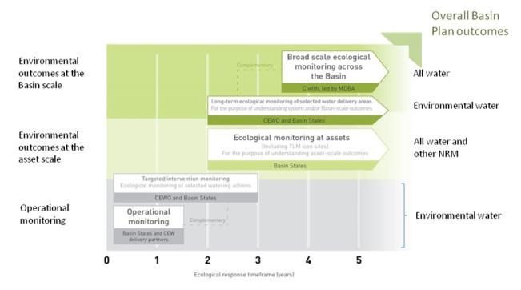

Figure 1. A summary of roles various agencies play a in the reporting on environmental outcomes, consistent with the Basin Plan.

Appendix B: Map showing location of hydrological zones of the Lachlan system for the Long-Term Intervention Monitoring Project.

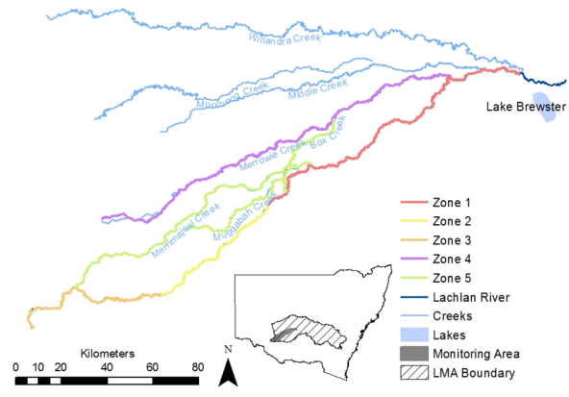

Appendix C: Summary of monitoring to be undertaken in the Lachlan system for the Long Term Intervention Monitoring Project from 2014-2019

The five year monitoring schedule has been based around the expected watering options and is focussed on the monitoring of Basin Indicators. Monitoring effort is consistent across the five years with the exception of monitoring Waterbird Breeding and Frogs which are options that can be implemented on the basis of a request from the CEWO.

|  |  |  |  |  |  |  |
| --- | --- | --- | --- | --- | --- | --- |
| indicator | ZONE | Evaluation of responses to Commonwealth environmental watering in the Lachlan system (where appropriate) | Data will contribute to evaluation of responses to Commonwealth environmental watering at whole of Basin-scale (where appropriate) | monitoring frequency | sites | expected schedule |
| Ecosystem type | All | ✓ | ✓ | Once only | All sites for other indicators | Establishment of ANAE type at the start of the LTIM Project. Expected August-December 2014 |
| Riverine fish | 1 | ✓ | ✓ | ANNUAL | Basin Evaluation: 10 fixed sites within Zone 1 | Annual sampling between March and May |
| Larval fish | 1 | ✓ | ✓ | ANNUAL | 3 fixed riverine sites in Zone 1 | Annual sampling 5 times during breeding season (September to February) |
| Stream metabolism | 1 | ✓ | ✓ | CONTINUOUS  REGULAR | Four fixed sites matched to riverine fish sampling sites in Zone 1 | Continuous monitoring of dissolved oxygen and, temperature.  6 weekly sampling of nutrients and water quality attributes. |
| Hydrology (River) | 1 | ✓ | ✓ | CONTINUOUS | Gauging sites |  |
| Vegetation diversity and condition | All | ✓ |  | ANNUAL & EVENT BASED | 12 fixed sites | Before and after watering (expected to be April/May and 3 months after first fill) |
| Waterbird breeding (Option) | 1 | ✓ |  | EVENT-BASED (on request from the CEWO) | One fixed site – Booligal wetland | Fortnightly surveys of bird breeding triggered by breeding events in Booligal wetland.  Assumes 3 breeding events in 5 years. |
| Frogs (Option) | All | ✓ |  | EVENT-BASED (on request from the CEWO) | 15 sites comprising 2 to 8 wetland sites and 2 to 7 riverine sites depending on watering targets | 3 sampling events between August and February (one sample in each of winter, spring and summer). |
| Hydrology (wetland – Option) |  | ✓ |  | EVENT-BASED (in conjunction with Waterbird Breeding or Frog monitoring) | Cameras at 6 roving wetland sites | Cameras installed prior to targeted watering each year and downloaded after the watering event has passed |