**Long Term Intervention Monitoring Project**

**Lachlan River System Selected Area**

**Observations Report**

**Report period: *1 January 2017 to 31 March 2017***

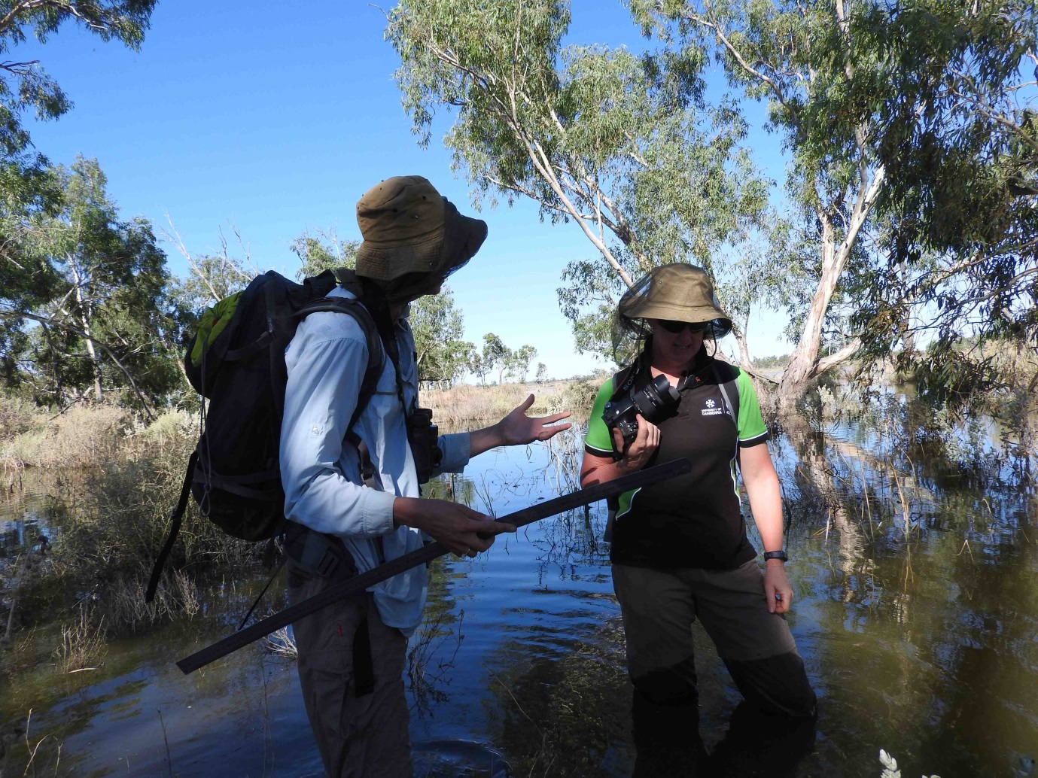

Inquiries regarding this document should be addressed to:

Dr Fiona Dyer  
Phone: 02 6201 2452  
e-mail: Fiona.Dyer@canberra.edu.au

This document was prepared by Fiona Dyer with input from Alica Tschierschke and Rhian Clear.

Cover Photo: Joanne Lenehan and Fiona Dyer discussion the inundation of Lake Ita vegetation plots. Photo: Alica Tschierschke (University of Canberra)

**Document history and status**

|  |  |  |  |  |
| --- | --- | --- | --- | --- |
| Version | Date Issued | Reviewed by | Approved by | Revision Type |
| Draft 1 | 24/3/2017 | Fiona Dyer | Fiona Dyer | Internal |
| FINAL |  |  |  |  |

**Distribution of copies**

|  |  |  |
| --- | --- | --- |
| Version | Type | Issued to |
| FINAL | Electronic | Commonwealth Environmental Water Office |

**Copyright**© Copyright Commonwealth of Australia, 2016



‘Long term intervention monitoring project, Lachlan River system selected area, progress report’ is licensed by the Commonwealth of Australia for use under a Creative Commons By Attribution 3.0 Australia licence with the exception of the Coat of Arms of the Commonwealth of Australia, the logo of the agency responsible for publishing the report, content supplied by third parties, and any images depicting people. For licence conditions see: <http://creativecommons.org/licenses/by/3.0/au/>

**Disclaimer**

The views and opinions expressed in this publication are those of the authors and do not necessarily reflect those of the Australian Government or the Minister for the Environment. While reasonable efforts have been made to ensure that the contents of this publication are factually correct, the Commonwealth does not accept responsibility for the accuracy or completeness of the contents, and shall not be liable for any loss or damage that may be occasioned directly or indirectly through the use of, or reliance on, the contents of this publication.

1. Conditions in the lower Lachlan River system 2016-17

The second half of 2016 was unusually wet across the catchment and record breaking spring rains resulted in widespread flooding of the catchment. The flooding filled wetlands, swamps and depressions across the catchment and the water level peaked in the Great Cumbung Swamp at the end of December 2016. In contrast, the first quarter of 2017 has been particularly dry with well below average rainfall recorded throughout the catchment (Figure 1). The below average rainfall combined with slightly higher than average temperatures has produced dry conditions across the landscape in spite of the ongoing presence of water in wetlands and across floodplains.

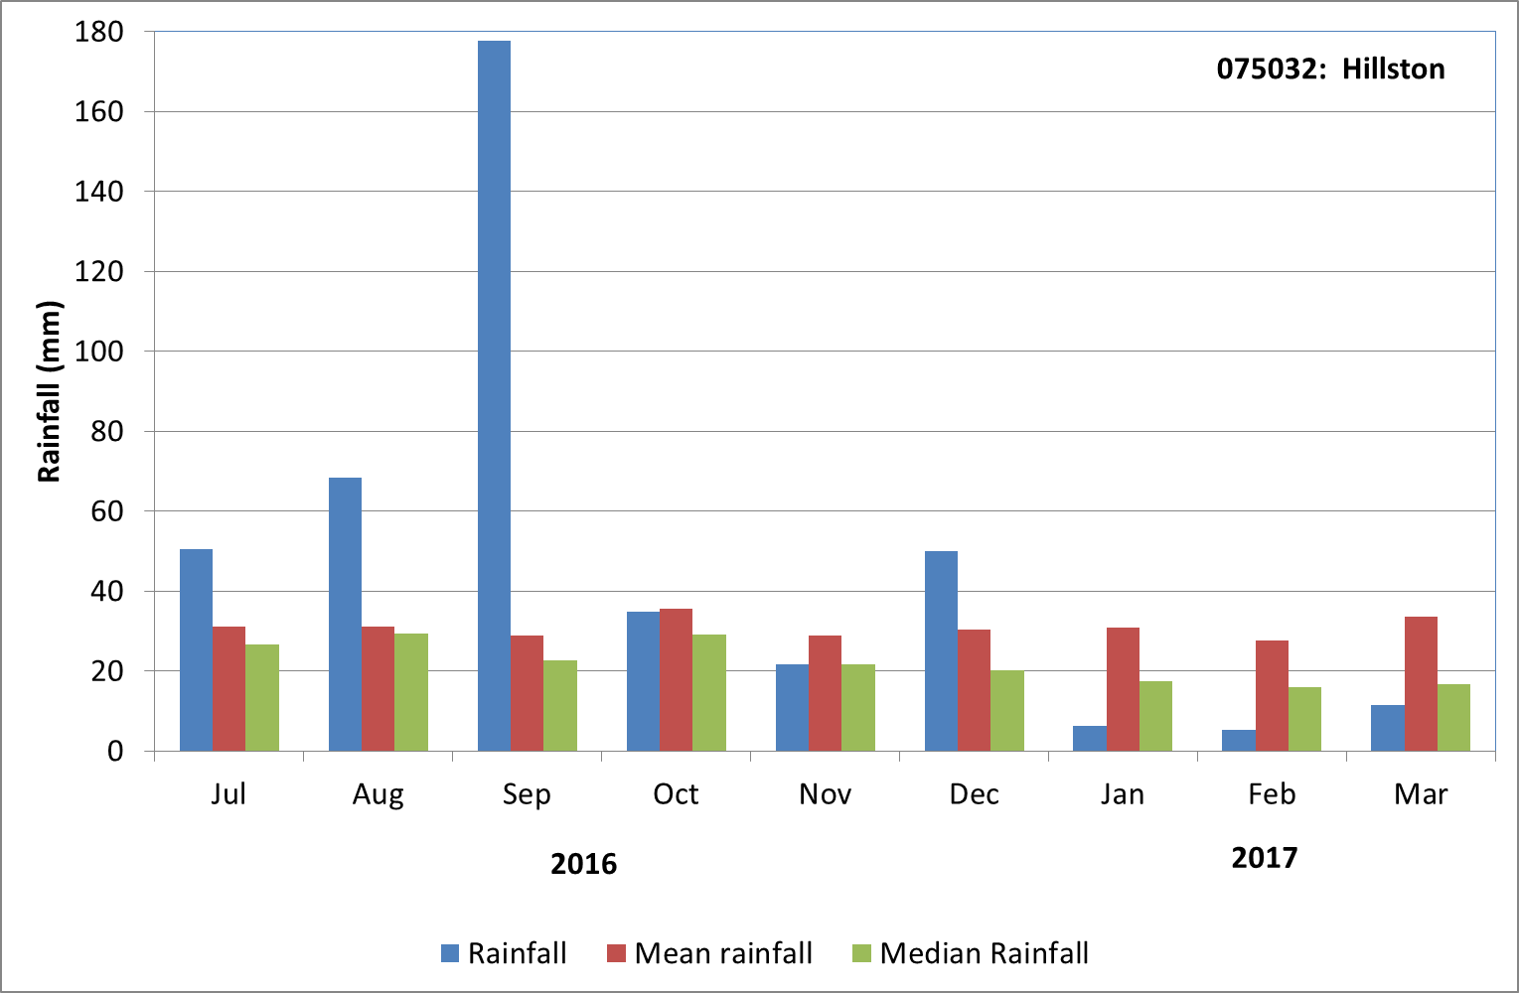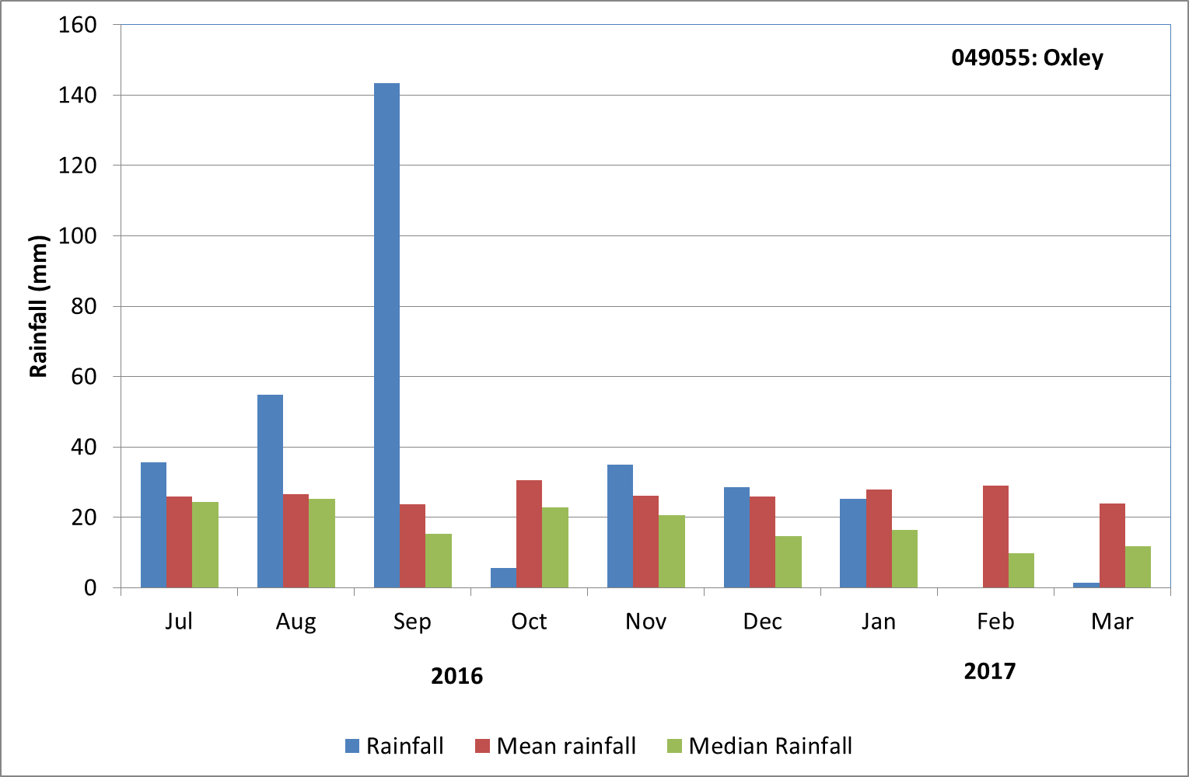

Figure 1. Rainfall at Hillston and Oxley from the second half of 2016 and first quarter of 2017 compared with the long term mean and median rainfall. Data sourced from the Bureau of Meteorology, Climate Data Online

1. Objectives of Commonwealth environmental water use in the Lachlan River system during 2016-17
   1. Commonwealth and NSW environmental water use

As at 30 March 2017, a combination of 28,969 ML of Commonwealth environmental water and 5,250 ML NSW Adaptive Environmental Water has been used in the Lachlan River system in two joint actions. These were:

1. 33,168 ML (27,918 ML of Commonwealth environmental water and 5,250 of NSW Adaptive Environmental Water) targeting improvements in dissolved oxygen levels and provision of in-channel refuge in the mid Lachlan River; and
2. 1,051 ML Commonwealth environmental water supporting water levels at the second bird breeding colony in the Booligal Wetlands.

Planned environmental water also contributed to both actions (see below).

* 1. Planned environmental water: translucent releases, Water Quality Allowance and Environmental Water Allowance

The flood conditions within the river system in 2017 also triggered the delivery of translucent releases, as required under the Lachlan Regulated River Water Sharing Plan (<http://www.water.nsw.gov.au/water-management/water-sharing/plans_commenced/water-source/lachlan>) as well as the release of water from Wyangala Dam to maintain airspace during the height of the flood.

Planned environmental water managed by the NSW Office of Environment and Heritage also contributed to the above actions:

1. 15 000 ML of Water Quality Allowance (WQA) targeting improvements in dissolved oxygen levels and provision of in-channel refuge in the mid Lachlan River; and
2. 3,153 ML of Environmental Water Allowance (EWA) supporting water levels at the second bird breeding colony in the Booligal Wetlands.
3. Summary on progress against core monitoring and evaluation activities

|  |  |  |
| --- | --- | --- |
| ACTIVITIES | PROGRESS TO DATE | UPCOMING ACTIVITIES |
| *Monitoring activities* | | |
| Ecosystem type | * Data collection complete and suggested Australian National Aquatic Ecosystems (ANAE) types for all sites included in the Monitoring and Data Management System (MDMS). | * No more data collection required |
| Fish (river) | * Fish community sampling has been completed | * Processing samples * QA/QC * Data analysis and evaluation |
| Fish (larvae) | * Processing of larval samples | * Data analysis and evaluation |
| Waterbird breeding (optional) | * Data analysis and evaluation has commenced | * Data analysis and evaluation |
| Water quality and stream metabolism | * Data loggers have been checked, calibrated and downloaded * Some loggers are missing and searching has commenced for these | * Searching for loggers * QA/QC * Analysis of data |
| Vegetation diversity | * Most of remaining spring sites assessed * Partial processing of field samples completed | * Remaining Spring sampling * Autumn sampling * Processing of field samples * QA/QC * Data analysis |
| Frogs (optional) | * None | * None |
| *Evaluation activities* | | |
| Monitoring data entry |  | * Data uploaded once either MDMS available (larval fish and waterbirds) or QA/QC completed |
| *Communication and engagement* | | |
| Selected Area Working Group | * Covered by TAG meeting (24/2/2017) and EWAG (15/3/2017) | * Q2 meeting |
| Project team teleconference | * None | * Teleconference to be held in April |
| Other Stakeholder Engagement | * Quarterly report 10 was finalised in February | * Quarterly report to be provided to landholders and other stakeholders |

**Note:** for the Long-Term Intervention Monitoring Project, Lachlan River system selected area:

* **Appendix A** provides additional information about the project for the Lachlan system and its context in terms of ecological monitoring and evaluation within the Murray-Darling Basin
* **Appendix B** provides a map showing the location of hydrological zones that will be monitored
* **Appendix C** provides a summary of monitoring to be undertaken under the project from 2014-2019.

1. Observations
   1. Hydrology

The most recent flood in the Lachlan River is one of the largest on record. Flows peaked at Willandra weir at 20,853 ML/day on 26 October 2016. As the flood passed down the river, peak flows decreased significantly as flows became distributed through the system. At Four Mile (the gauge nearest the Cumbung Swamp) flows peaked at 1275 ML/day on 30 December 2016, but were above 1200 ML/day for 3 months (between 12 November 2016 and 14 January 2017) illustrating the broad hydrograph that typically occurs in floods in the lower river system (Figure 2).

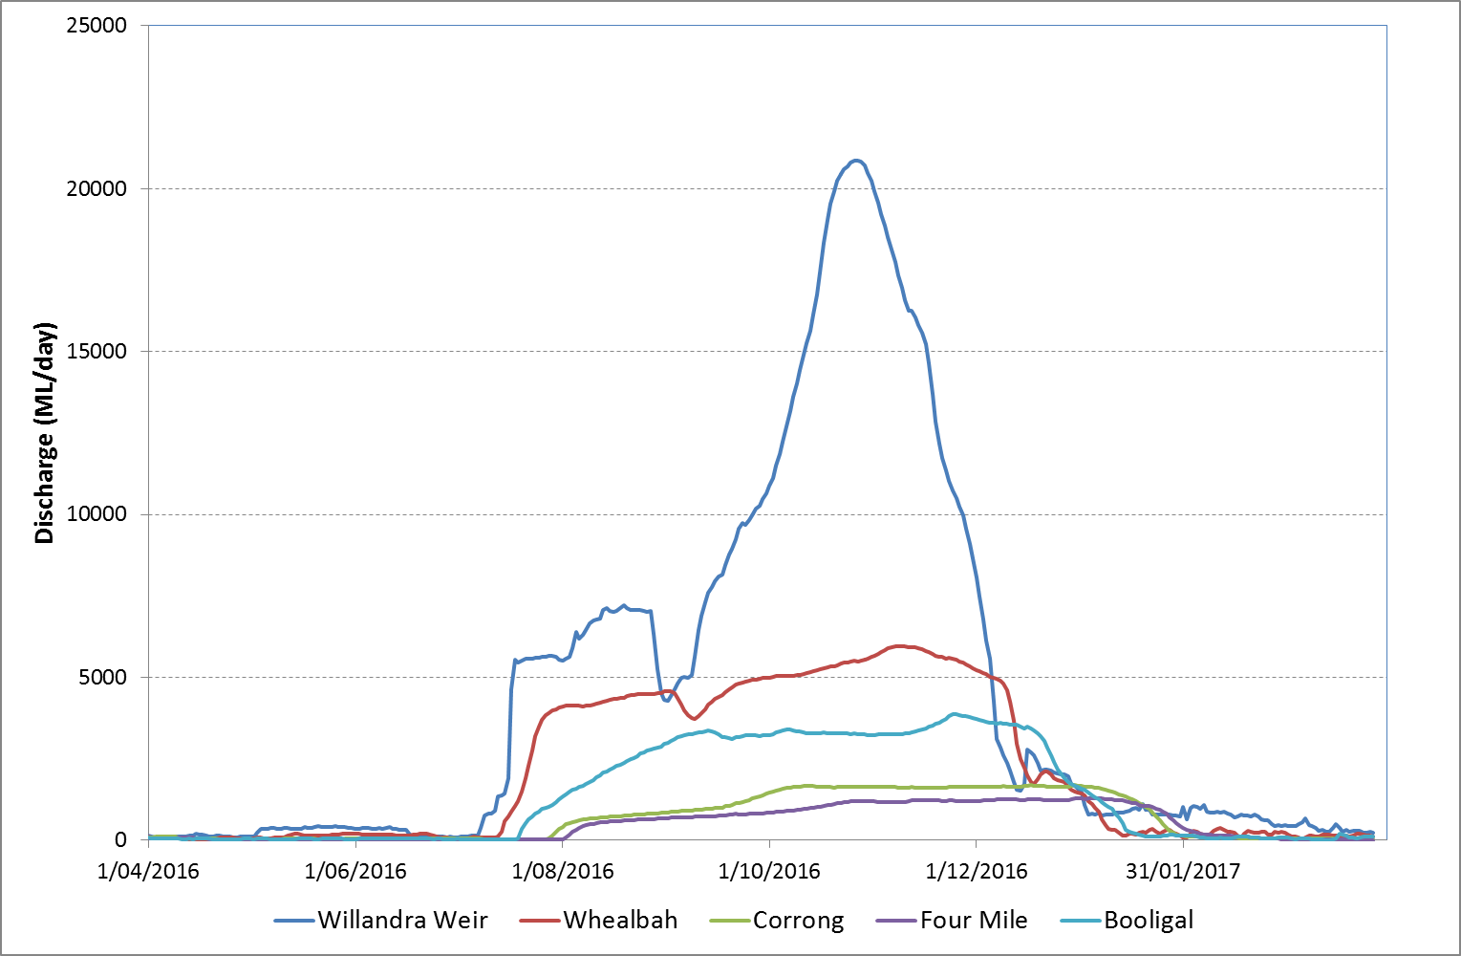

Figure 2. Flow in the Lachlan River from the gauges at Willandra weir (412038), Whealbah (412078), Booligal (412005), Corrong (412045) and Four Mile (412194) showing the passage of the flood through the study reach. Data are from NSW Department of Primary Industries (http://www.water.nsw.gov.au/realtime-data).

* 1. Water Quality

While the water quality loggers were unable to be accessed and serviced during the flood event we were fortunate that one of the loggers remained fully functional for the entire period of the flooding. The data from this logger shows the major drop in the concentration of dissolved oxygen in the river between late September and mid November (Figure 3) with concentrations reaching as low as 0.5 mg/L on 23 November 2016 before recovering to above 4 mg/L in mid December 2016.

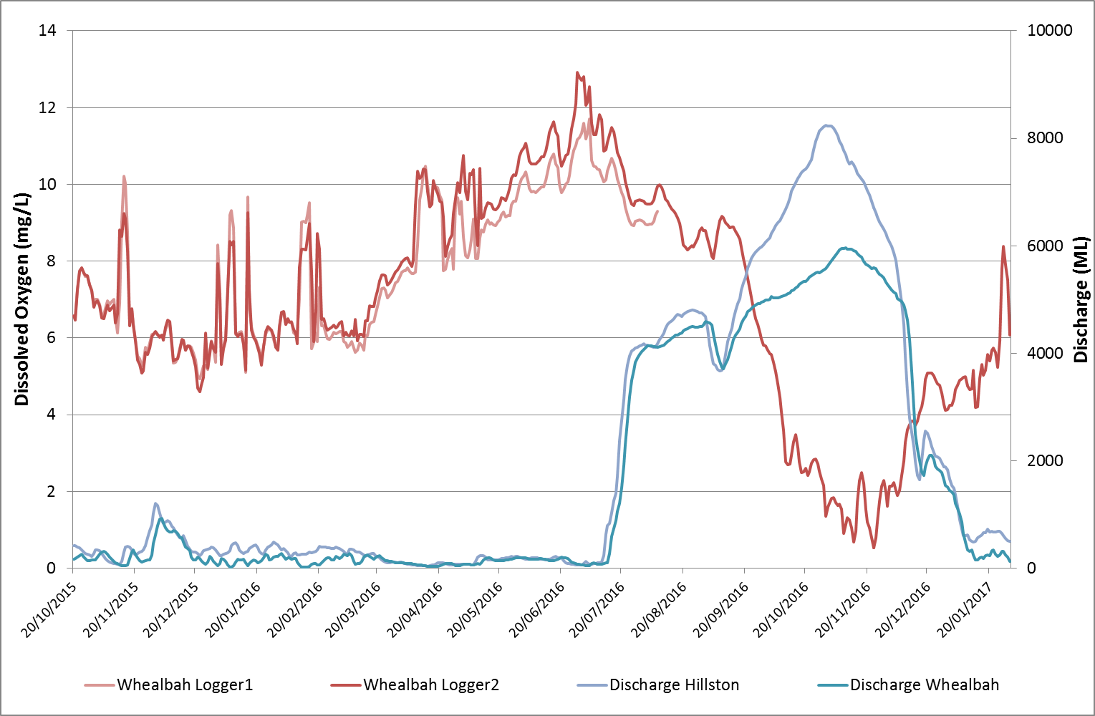

Figure 3. Flow and dissolved oxygen concentrations at Whealbah. Dissolved oxygen concentrations are from LTIM loggers and the flow is from NSW Department of Primary Industries (http://www.water.nsw.gov.au/realtime-data).

* 1. Fish monitoring

Drift nets were set at each site fortnightly for the five sampling events from mid October to mid December 2016 despite the challenges of the floodwaters. These conditions prevented the use of light traps for the entire sampling season. The last sampling event in December was the only one where the river had returned to in-channel flows. The first sampling event was the only one that significant numbers of fish were captured and they all predominantly came from one net at one site (Wallanthery) with almost 900 carp larvae recorded. No fish were captured from the second sampling event and three larval fish were captured from the third sampling event. A total of 10 carp were caught from the last two sampling events, (six and four respectively), and all the fish were juveniles (50-115 mm). No native fish or eggs were detected for all five sampling events for 2016. In the last few sampling events visual observations were made at each site of large numbers of juvenile carp jumping. It is suggested that the very high flows and low dissolved oxygen that occurred during the known spawning window of native fish in this area, produced unfavourable conditions for these species to spawn.

* 1. Vegetation monitoring

The spring vegetation sampling was seriously hampered by the flooding with most monitoring sites underwater for the majority of the spring and many roads were cut preventing access. Sites within the mid to lower part of the Selected Area were visited in February and the vegetation response was marked. All sites had been inundated by between 0.5 and 2 m of water. The response of aquatic vegetation was noted with species such as Species such as nardoo (*Marsillea drummondii)*, water ribbons (*Triglochin sp*) and spike rush (*Eleocharis sp*) appearing at sites.

Vegetation species richness had increased at many of the sites. The most noticeable was within the Black Box community upstream of Lake Ita which had previously displayed one of the lowest numbers of species, with around 10-12 species recorded during past visits. During February, we recorded 44 species (Figure 4).

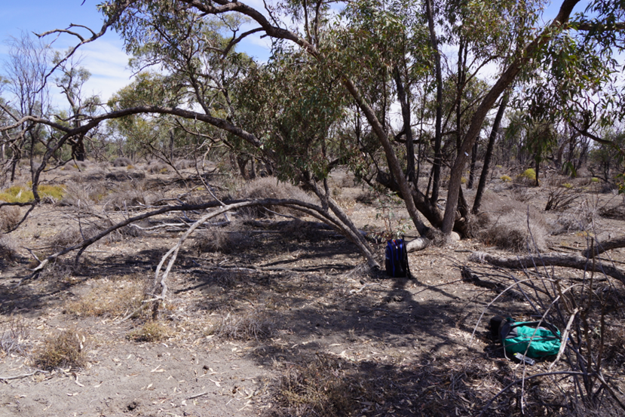

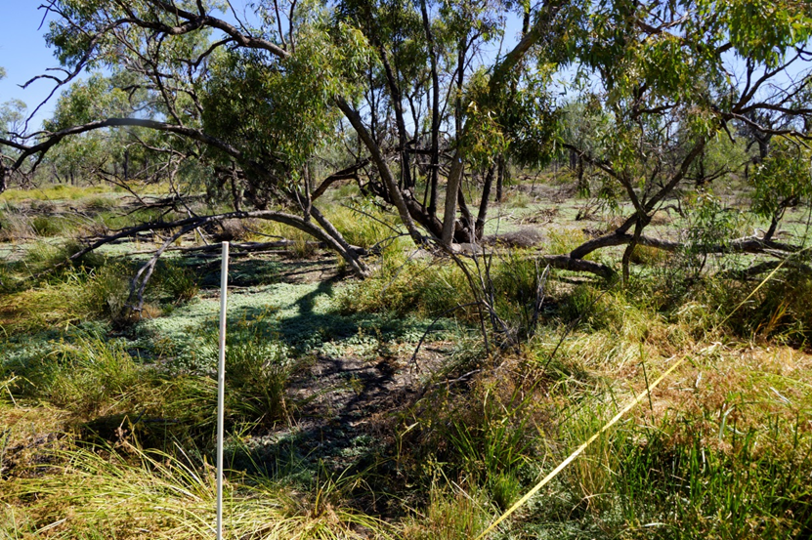

Figure 4. Vegetation plots within the Lake Ita Black Box community. The upper image is taken in spring 2014 and shows low ground cover and few groundcover species present. The lower image was taken in February 2017 and shows a marked change in the number of groundcover species and the proportion of groundcover.

Appendix A: The Long-Term Intervention Monitoring Project for the Lachlan River system and its context in terms of ecological monitoring and evaluation within the Murray-Darling Basin.

The Long Term Intervention Monitoring (LTIM) Project for the Lachlan river system selected area is funded by the Commonwealth Environmental Water Office. The project is being delivered by a consortium of service providers lead by University of Canberra and includes NSW Office of Environment and Heritage, NSW Department of Primary Industries (Fisheries), Central Tablelands Local Land Services, NSW Department of Primary Industries (Office of Water), University of New South Wales and Charles Sturt University.

The LTIM project is based on a clear and robust program logic, as detailed in the [Long-Term Intervention Monitoring Project Logic and Rationale Document](http://www.environment.gov.au/water/cewo/publications/long-term-intervention-monitoring-project-logic-and-rationale-document). That document sets out the scientific and technical foundations of long-term intervention monitoring and is being applied to areas where LTIM projects are being undertaken. It also provides links between Basin Plan objectives and targets to the monitoring of outcomes from Commonwealth environmental watering actions. For more information, see [Monitoring and evaluation for the use of Commonwealth environmental water](http://www.environment.gov.au/topics/water/commonwealth-environmental-water-office/monitoring-and-evaluation).

Many different agencies play a role in the reporting on environmental outcomes, consistent with the Basin Plan (see figure 1 below). The Murray Darling Basin Authority is responsible for reporting on achievements against the environmental objectives of the Basin Plan at a basin-scale, which are broadly focussed on flows and water quality, fish, vegetation and birds across the whole of the Basin. State Governments are responsible for reporting on achievements against the environmental objectives of the Basin Plan at an asset-scale i.e. rivers, wetlands, floodplains. The Commonwealth Environmental Water Holder is responsible for reporting on the contribution of Commonwealth environmental water to the environmental objectives of the Basin Plan (at multiple-scales).

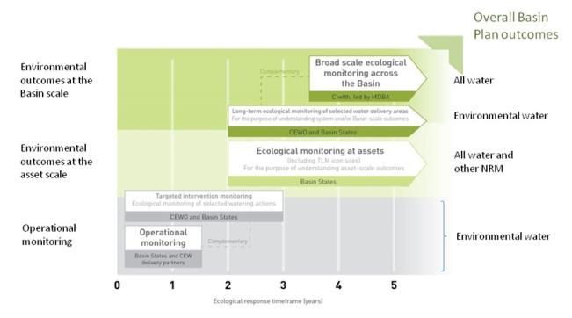

Figure 12. A summary of roles various agencies play a in the reporting on environmental outcomes, consistent with the Basin Plan.

Appendix B: Hydrological zones and monitoring sites of the lower Lachlan for the Long-Term Intervention Monitoring Project.

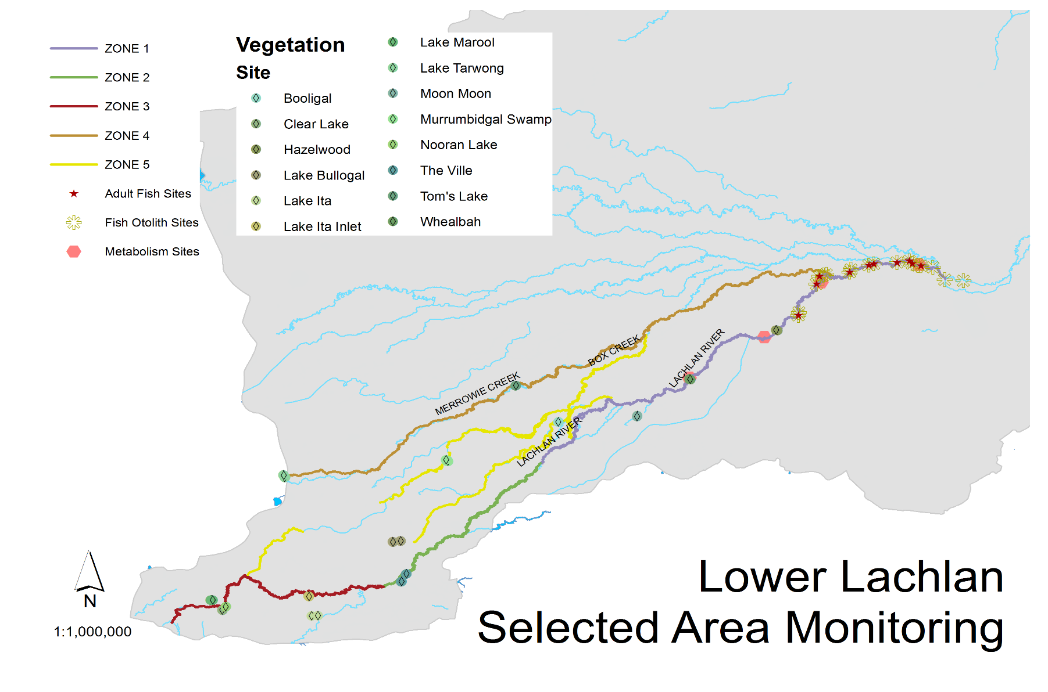

*Figure 13. Lower Lachlan LTIM monitoring sites, hydrological zones and NSW gauging stations*

Appendix C: Summary of monitoring to be undertaken in the Lachlan system for the Long Term Intervention Monitoring Project from 2014-2019

The five year monitoring schedule has been based around the expected watering options and is focussed on the monitoring of Basin Indicators. Monitoring effort is consistent across the five years with the exception of monitoring Waterbird Breeding and Frogs which are options that can be implemented on the basis of a request from the CEWO.

| indicator | ZONE | Evaluation of responses to Commonwealth environmental watering | Data contributes to evaluation of responses to Commonwealth environmental watering at whole of Basin-scale | monitoring frequency | sites | expected schedule |
| --- | --- | --- | --- | --- | --- | --- |
| Ecosystem type | All | ✓ | ✓ | Once only | All sites for other indicators | Establishment of ANAE type at the start of the LTIM Project. Expected August-December 2014 |
| Riverine fish | 1 | ✓ | ✓ | ANNUAL | Basin Evaluation: 10 fixed sites within Zone 1 | Annual sampling between March and May |
| Larval fish | 1 | ✓ | ✓ | ANNUAL | 3 fixed riverine sites in Zone 1 | Annual sampling 5 times during breeding season (September to February) |
| Stream metabolism | 1 | ✓ | ✓ | CONTINUOUS  REGULAR | Four fixed sites matched to riverine fish sampling sites in Zone 1 | Continuous monitoring of dissolved oxygen and temperature.  6 weekly sampling of nutrients and water quality attributes. |
| Hydrology (River) | 1 | ✓ | ✓ | CONTINUOUS | Gauging sites |  |
| Vegetation diversity and condition | All | ✓ |  | ANNUAL & EVENT BASED | 12 fixed sites | Before and after watering (expected to be April/May and 3 months after first fill) |
| Waterbird breeding (Option) | 1 | ✓ |  | EVENT-BASED (on request from the CEWO) | One fixed site – Booligal wetland | Fortnightly surveys of bird breeding triggered by breeding events in Booligal wetland. |
| Frogs (Option) | All | ✓ |  | EVENT-BASED (on request from the CEWO) | 15 sites comprising 2 to 8 wetland sites and 2 to 7 riverine sites depending on watering targets | 3 sampling events between August and February (one sample in each of winter, spring and summer). |
| Hydrology (wetland – Option) |  | ✓ |  | EVENT-BASED (in conjunction with Waterbird Breeding or Frog monitoring) | Cameras at 6 roving wetland sites | Cameras installed prior to targeted watering each year and downloaded after the watering event has passed |