**Long Term Intervention Monitoring Project**

**Lachlan River System Selected Area**

**Project Progress Report**

**Report period: *1 July to 30 September 2015***

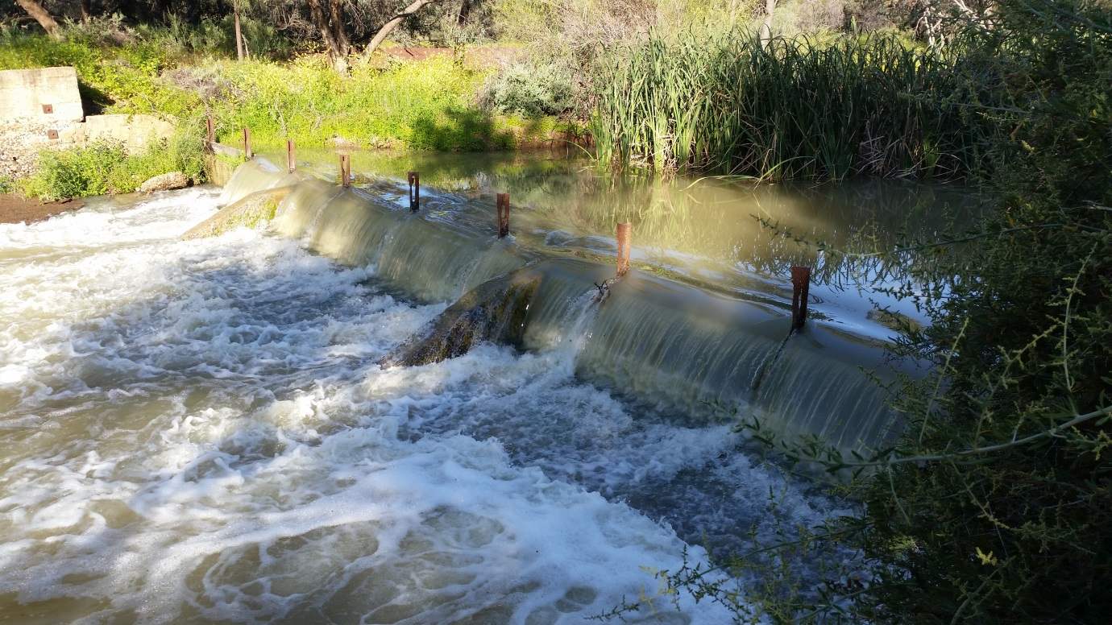

Inquiries regarding this document should be addressed to:

Dr Fiona Dyer  
Phone: 02 6201 2452  
e-mail: Fiona.Dyer@canberra.edu.au

This document was prepared by Ben Broadhurst and Fiona Dyer with contributions from Joanne Lenehan (Central Tablelands LLS).

Cover Photo: Water flowing over Willandra Homestead weir pool 28th September 2015

**Document history and status**

|  |  |  |  |  |
| --- | --- | --- | --- | --- |
| Version | Date Issued | Reviewed by | Approved by | Revision Type |
| Draft 1 | 7 October 2015 | Ben Broadhurst | Fiona Dyer | Internal |
| FINAL |  |  | Fiona Dyer | External |

**Distribution of copies**

|  |  |  |
| --- | --- | --- |
| Version | Type | Issued to |
| FINAL | Electronic | Commonwealth Environmental Water Office |

**Copyright**© Copyright Commonwealth of Australia, 2015



‘Long term intervention monitoring project, Lachlan River system selected area, progress report 1 July to 30 September 2015’ is licensed by the Commonwealth of Australia for use under a Creative Commons By Attribution 3.0 Australia licence with the exception of the Coat of Arms of the Commonwealth of Australia, the logo of the agency responsible for publishing the report, content supplied by third parties, and any images depicting people. For licence conditions see: <http://creativecommons.org/licenses/by/3.0/au/>

**Disclaimer**

The views and opinions expressed in this publication are those of the authors and do not necessarily reflect those of the Australian Government or the Minister for the Environment. While reasonable efforts have been made to ensure that the contents of this publication are factually correct, the Commonwealth does not accept responsibility for the accuracy or completeness of the contents, and shall not be liable for any loss or damage that may be occasioned directly or indirectly through the use of, or reliance on, the contents of this publication.

1. Objectives of Commonwealth environmental water use in the   
   Lachlan River system during 2015-16

As at 30 September 2015, the 2015-16 watering actions in the Lower Lachlan River systems are designed to provide:

1. at least 15 000 ML of Commonwealth environmental water into Lachlan River, targeting the Great Cumbung Swamp. This action is expected to consolidate the benefits of inundation that occurred in 2013 and support the survival and growth of wetland vegetation and habitat values for waterbirds and other water dependent species. An additional 8692 ML was approved for delivery towards this action, as a result of Available Water Determinations in August and September 2015 that increased general security allocations.
2. up to 1500 ML of Commonwealth environmental water to Merrimajeel Creek targeting Murrumbidgil Swamp, and up to 3750 ML per year to potentially support a significant colonially nesting waterbird breeding event in Booligal wetlands to completion.

**Primary objective**: to improve hydrological connectivity, contribute to ecosystem function, support vegetation condition (river red gum, lignum and aquatic macrophytes) and ecosystem resilience.

**Secondary objectives:**

1. to improve hydrological connectivity, contribute to ecosystem function, support vegetation condition (river red gum, lignum and aquatic macrophytes) and ecosystem resilience.
2. to support the ongoing recovery and resilience of Murrumbidgil Swamp if dry conditions continue, by providing drought refuge.

**Commonwealth environmental water delivered as at 30 September 2015:**

1. 21 407 ML combined with 8301 ML of NSW water to the Lachlan River targeting the Great Cumbung Swamp; and
2. 950 ML combined with 500 ML of NSW water to Merrimajeel Creek targeting Murrumbidgil Swamp.

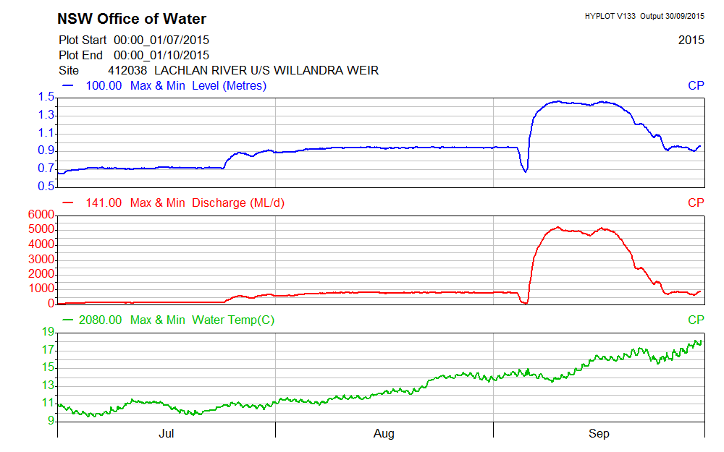

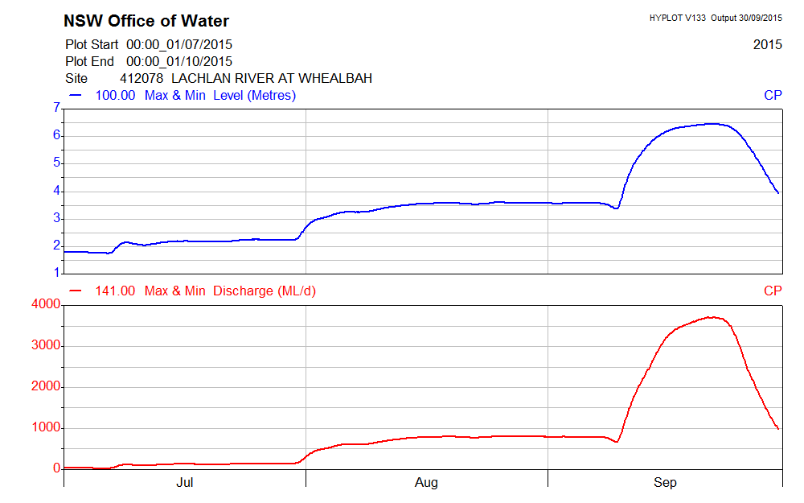

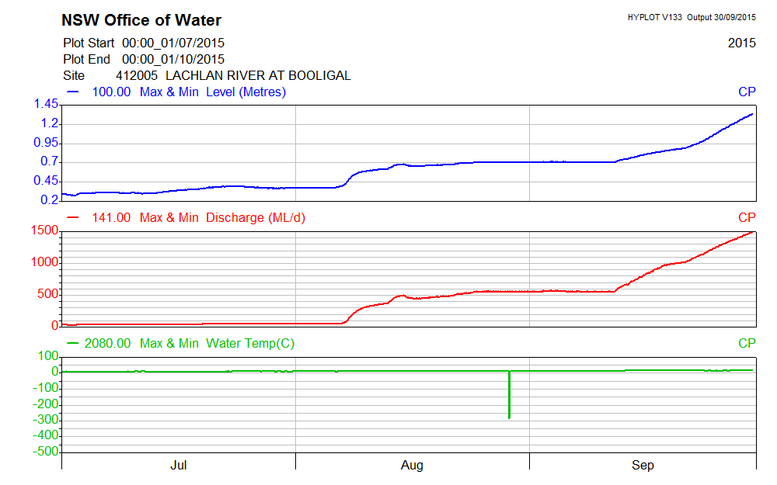

* 1. Planned environmental water: translucent releases

Significant rainfall within the catchment in the first half of 2015 produced medium-large volumes of unregulated inflow to the Lachlan River, particularly from the Belubula and Boorowa Rivers. Inflows from 1 January to 26 August 2015 totalled 268 GL which consequently triggered the delivery of translucent releases, as required under the Lachlan Regulated River Water Sharing Plan. Dam levels were such that translucent releases were targeted at between 3,500 ML/day and 5,156 ML/day with a combination of passing flow and dam releases delivering the water to the Lower Lachlan river system. This event has created additional environmental watering demands and opportunities, which will be developed over coming months.

1. Summary on progress against core monitoring and evaluation activities

|  |  |  |
| --- | --- | --- |
| ACTIVITIES | PROGRESS TO DATE | UPCOMING ACTIVITIES |
| *Monitoring activities* | | |
| Ecosystem type | * Data collection complete and suggested Australian National Aquatic Ecosystems (ANAE) types for all sites included in the Monitoring and Data Management System (MDMS). | * No more data collection required |
| Fish (river) | * Analysis of fish community data completed * Otoliths processed * 2014-15 report submitted | * Revisions to 2014-15 Annual Evaluation Report * Sampling in 2016 |
| Fish (larvae) | * Data analysis completed * 2014-15 report submitted | * Revisions to 2014-15 Annual Evaluation Report * Preparations for 2015 field collection period |
| Waterbird breeding (optional) | * No sampling required | * Preparation of a bird monitoring proposal in case of waterbird breeding in Spring 2015 |
| Water quality and stream metabolism | * Data processing and analysis been completed for 2014-15 data * 2014-15 Annual Evaluation Report submitted * Loggers deployed for 2015-16 watering | * Revisions to 2014-15 Annual Evaluation Report * Checking, calibrating and downloading logger data |
| Vegetation diversity | * Analysis of field data and reporting * 2014-15 report submitted | * Revisions to 2014-15 Annual Evaluation Report * Spring vegetation monitoring to commence on the 26th October |
| Frogs (optional) | * No sampling required | * Optional frog monitoring engaged for 2015. Monitoring to commence in October 2015 |
| *Evaluation activities* | | |
| Monitoring data entry | * Almost all data from 2014-15 uploaded to MDMS | * Nutrient (TN and TP) and chlorophyll data to be uploaded when processed |
| *Communication and engagement* | | |
| Selected Area Working Group | * Meetings held on 23rd July and 7th September 2015 | * December meeting |
| Project team teleconference | * Teleconference held 27/7/15 | * None |
| Other Stakeholder Engagement | * Hook Line and Sinker event in Hillston In Late August * Quarterly report #4 provided to landholders with positive feedback. | * Quarterly progress report #5 to be provided to landholders and other stakeholders |

**Note:** for the Long-Term Intervention Monitoring Project, Lachlan River system selected area:

* **Appendix A** provides additional information about the project for the Lachlan system and its context in terms of ecological monitoring and evaluation within the Murray-Darling Basin
* **Appendix B** provides a map showing the location of hydrological zones that will be monitored
* **Appendix C** provides a summary of monitoring to be undertaken under the project from 2014-2019.

1. Observations

Time-lapse cameras were downloaded from five wetland sites (Whealbah, Tom’s Lake, Murrumbidgil Swamp, Clear Lake and Nooran Lake) in July. The team is satisfied that camera positions will adequately capture inundation events.

* 1. Stream metabolism

Stream metabolism loggers were installed at the four monitored sites in June and July 2015. A download was attempted in August and later in September 2015, but river levels were too high and loggers could not be accessed.

* 1. Communication and engagement

Jo Lenehan and Martin Asmus attended the Hillston RSL fishing club and Hillston Hook Line and Sinker Fishing Festival and Taronga Zoomobile visit in Hillston. LTIM had a stand and posters on the monitoring, and Martin Asmus presented the NSW DPI Fish display trailer. There was an opportunity to talk about preliminary data observations and results, and to brand the information bags.

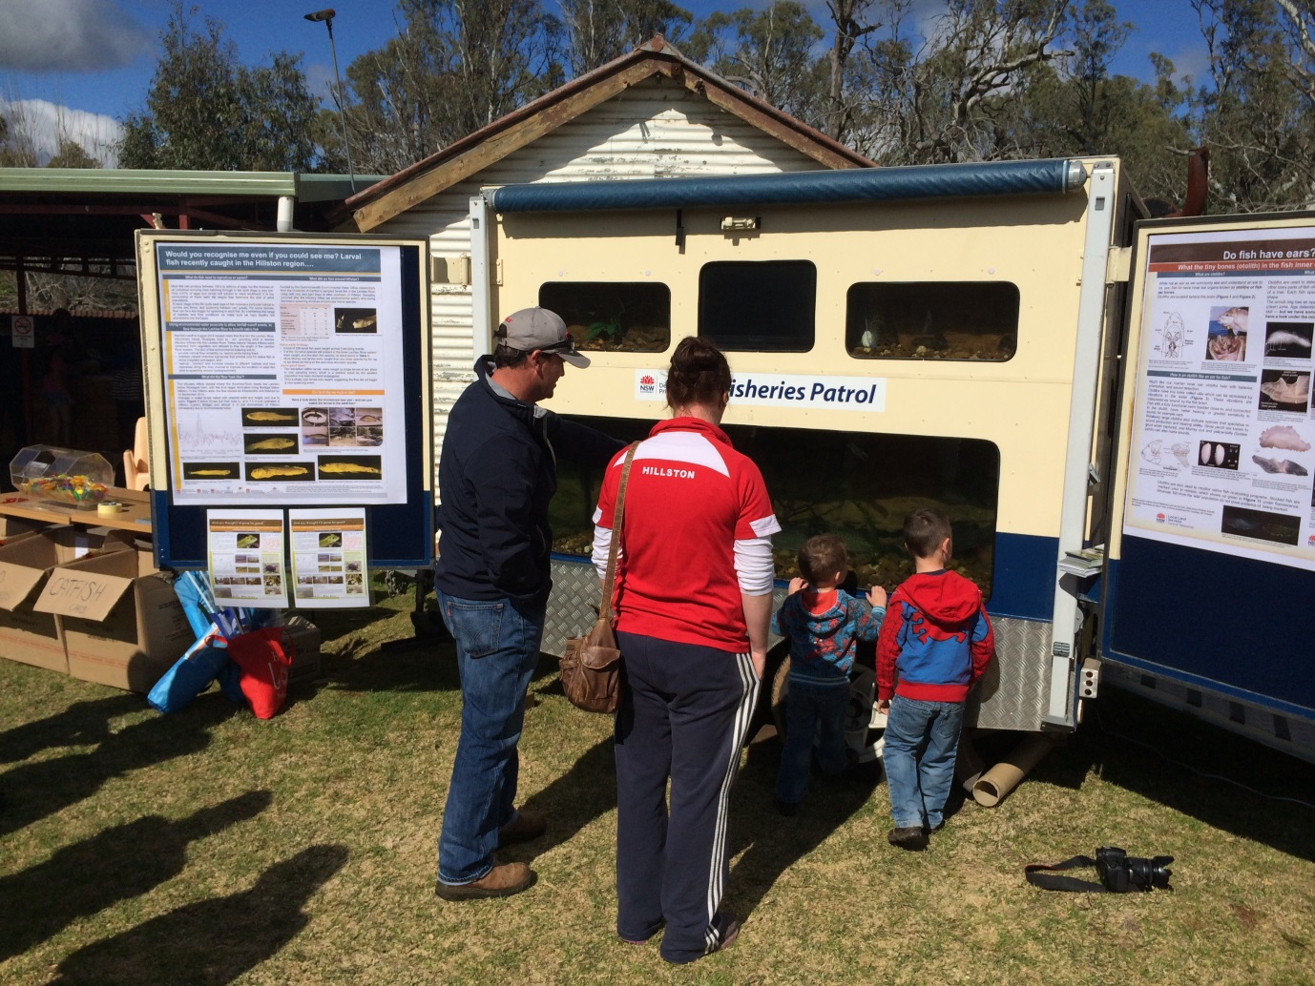

NSW DPI Fish Biologist Martin Asmus showing off NSW DPI fish display trailer and LTIM information posters. Photo courtesy of NSW DPI Fisheries.

* 1. Additional activities in the catchment

The University of Canberra has been running a field trip to Willandra National Park for almost 30 years as part of the second year unit Ecology and Biodiversity. In 2014 and 2015, the students undertook projects investigating small bodied fish and decapods in the weir pool at Willandra homestead. In 2014, flows in Willandra Creek were low and flow ceased at the homestead weir. In 2015, the higher natural flows in the Lachlan River system combined with translucent releases meant that flows in Willandra Creek were higher and water was flowing over the weir and downstream. In 2014, gambusia (*Gambusia holbrookii*) were the only fish collected from the weir pool by the students and in 2015, gambusia and bony herring (*Nematalosa erebi*) were captured in the weir pool and carp gudgeons (*Hypseleotris spp*) were collected downstream of the weir pool. In both years a good population of decapods (including both freshwater prawns, *Macrobrachium australiense* and glass shrimp, *Parataya australiensis*) were caught.

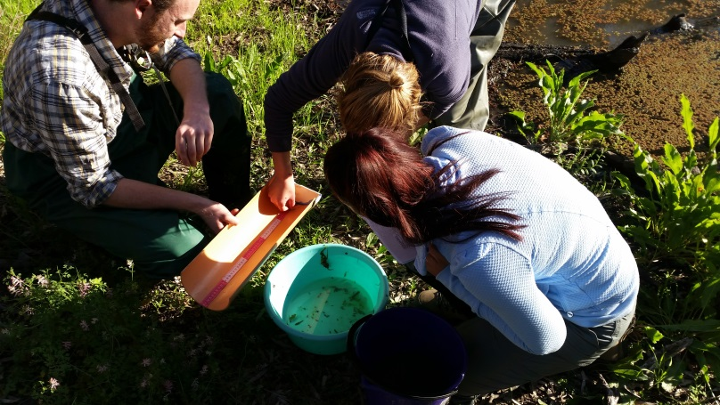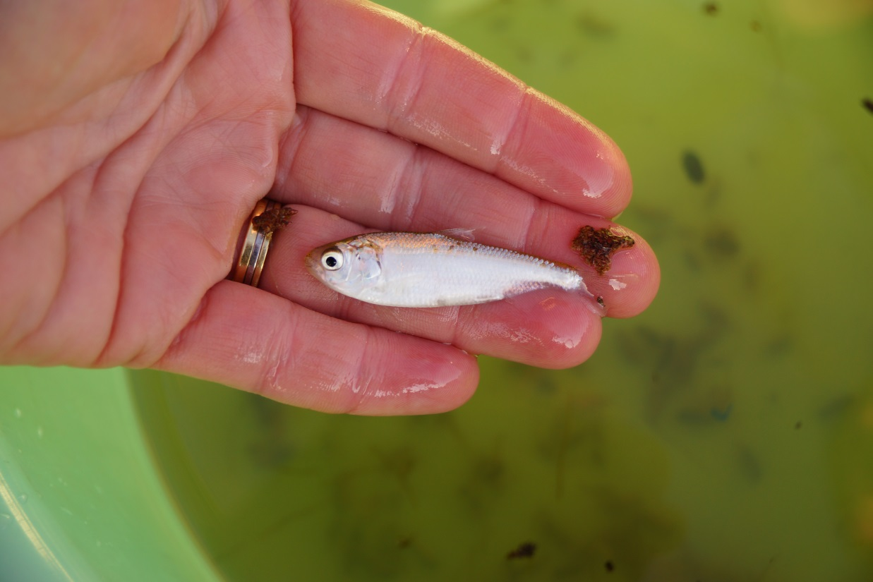

(Left) University of Canberra students measuring fish during field sampling at Willandra homestead weir in September 2015. (Right) Bony herring (*Nematalosa erebi*) caught from the weir pool. Photos Fiona Dyer

Observations from Willandra National Park were that the rains during winter/spring had produced good vegetation growth with staff suggesting it was the ‘best’ season in 15-20 years. Numerous waterbirds were observed on the weir pool including yellow billed spoonbills, cormorants, a pair of black swans and pelicans.

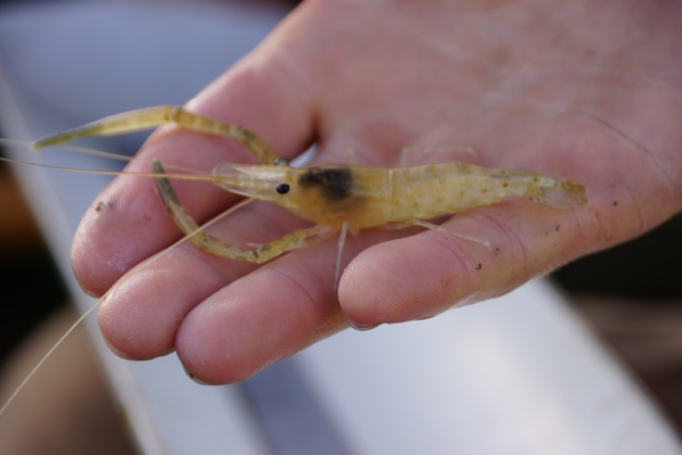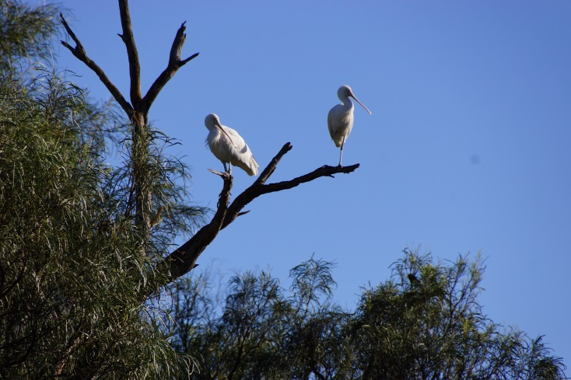

Willandra homestead weir September 2015: (Left) Freshwater prawn (*Macrobrachium australiense)* (Right) Yellow billed spoonbills (*Platalea flavipes*). Photos Fiona Dyer

Appendix A: The Long-Term Intervention Monitoring Project for the Lachlan River system and its context in terms of ecological monitoring and evaluation within the Murray-Darling Basin.

The Long Term Intervention Monitoring (LTIM) Project for the Lachlan river system selected area is funded by the Commonwealth Environmental Water Office. The project is being delivered by a consortium of service providers lead by University of Canberra and includes NSW Office of Environment and Heritage, NSW Department of Primary Industries (Fisheries), Central Tablelands Local Land Services, NSW Department of Primary Industries (Office of Water), University of New South Wales and Charles Sturt University.

The LTIM project is based on a clear and robust program logic, as detailed in the [Long-Term Intervention Monitoring Project Logic and Rationale Document](http://www.environment.gov.au/water/cewo/publications/long-term-intervention-monitoring-project-logic-and-rationale-document). That document sets out the scientific and technical foundations of long-term intervention monitoring and is being applied to areas where LTIM projects are being undertaken. It also provides links between Basin Plan objectives and targets to the monitoring of outcomes from Commonwealth environmental watering actions. For more information, see [Monitoring and evaluation for the use of Commonwealth environmental water](http://www.environment.gov.au/topics/water/commonwealth-environmental-water-office/monitoring-and-evaluation).

Many different agencies play a role in the reporting on environmental outcomes, consistent with the Basin Plan (see figure 1 below). The Murray Darling Basin Authority is responsible for reporting on achievements against the environmental objectives of the Basin Plan at a basin-scale, which are broadly focussed on flows and water quality, fish, vegetation and birds across the whole of the Basin. State Governments are responsible for reporting on achievements against the environmental objectives of the Basin Plan at an asset-scale i.e. rivers, wetlands, floodplains. The Commonwealth Environmental Water Holder is responsible for reporting on the contribution of Commonwealth environmental water to the environmental objectives of the Basin Plan (at multiple-scales).

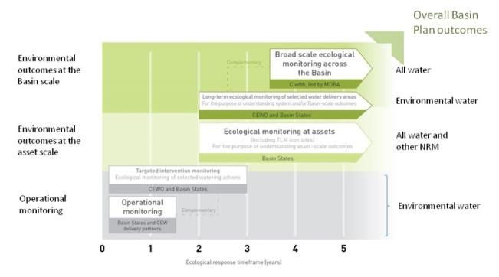

Figure 1. A summary of roles various agencies play a in the reporting on environmental outcomes, consistent with the Basin Plan.

Appendix B: Map showing location of hydrological zones of the Lachlan system for the Long-Term Intervention Monitoring Project.

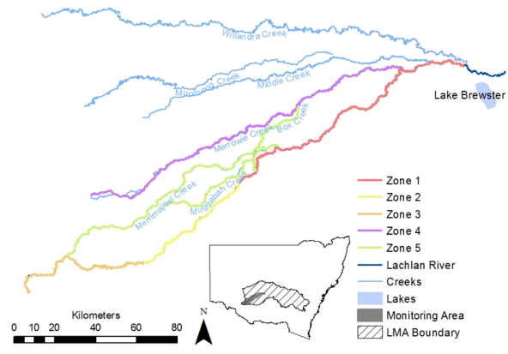

Appendix C: Summary of monitoring to be undertaken in the Lachlan system for the Long Term Intervention Monitoring Project from 2014-2019

The five year monitoring schedule has been based around the expected watering options and is focussed on the monitoring of Basin Indicators. Monitoring effort is consistent across the five years with the exception of monitoring Waterbird Breeding and Frogs which are options that can be implemented on the basis of a request from the CEWO.

|  |  |  |  |  |  |  |
| --- | --- | --- | --- | --- | --- | --- |
| indicator | ZONE | Evaluation of responses to Commonwealth environmental watering in the Lachlan system (where appropriate) | Data will contribute to evaluation of responses to Commonwealth environmental watering at whole of Basin-scale (where appropriate) | monitoring frequency | sites | expected schedule |
| Ecosystem type | All | ✓ | ✓ | Once only | All sites for other indicators | Establishment of ANAE type at the start of the LTIM Project. Expected August-December 2014 |
| Riverine fish | 1 | ✓ | ✓ | ANNUAL | Basin Evaluation: 10 fixed sites within Zone 1 | Annual sampling between March and May |
| Larval fish | 1 | ✓ | ✓ | ANNUAL | 3 fixed riverine sites in Zone 1 | Annual sampling 5 times during breeding season (September to February) |
| Stream metabolism | 1 | ✓ | ✓ | CONTINUOUS  REGULAR | Four fixed sites matched to riverine fish sampling sites in Zone 1 | Continuous monitoring of dissolved oxygen and, temperature.  6 weekly sampling of nutrients and water quality attributes. |
| Hydrology (River) | 1 | ✓ | ✓ | CONTINUOUS | Gauging sites |  |
| Vegetation diversity and condition | All | ✓ |  | ANNUAL & EVENT BASED | 12 fixed sites | Before and after watering (expected to be April/May and 3 months after first fill) |
| Waterbird breeding (Option) | 1 | ✓ |  | EVENT-BASED (on request from the CEWO) | One fixed site – Booligal wetland | Fortnightly surveys of bird breeding triggered by breeding events in Booligal wetland.  Assumes 3 breeding events in 5 years. |
| Frogs (Option) | All | ✓ |  | EVENT-BASED (on request from the CEWO) | 15 sites comprising 2 to 8 wetland sites and 2 to 7 riverine sites depending on watering targets | 3 sampling events between August and February (one sample in each of winter, spring and summer). |
| Hydrology (wetland – Option) |  | ✓ |  | EVENT-BASED (in conjunction with Waterbird Breeding or Frog monitoring) | Cameras at 6 roving wetland sites | Cameras installed prior to targeted watering each year and downloaded after the watering event has passed |