Lachlan River

Long Term Intervention Monitoring Project

Progress Report

1 July 2016 to 30 September 2016

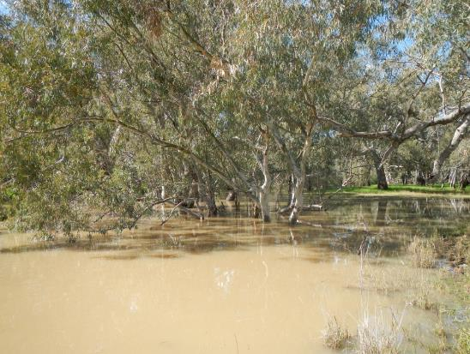

Inquiries regarding this document should be addressed to:

Dr Fiona Dyer  
Phone: 02 6201 2452  
e-mail: Fiona.Dyer@canberra.edu.au

This document was prepared by Fiona Dyer with input from Elizabeth Symes (CEWO), Jennifer Spencer and Joanne Lenehan (OEH) and Kate Brandis (UNSW).

Cover Photo: Lachlan River at Cowl Cowl. Photo: Ugyen Llendhup (University of Canberra)

**Document history and status**

|  |  |  |  |  |
| --- | --- | --- | --- | --- |
| Version | Date Issued | Reviewed by | Approved by | Revision Type |
| Draft 1 | 23 September 2016 | Joanne Lenehan | Fiona Dyer | Internal |
| FINAL | 11 November 2016 | Liz Symes | Fiona Dyer | External |

**Distribution of copies**

|  |  |  |
| --- | --- | --- |
| Version | Type | Issued to |
| FINAL | Electronic | Commonwealth Environmental Water Office |

**Copyright**© Copyright Commonwealth of Australia, 2016



‘Long term intervention monitoring project, Lachlan River system selected area, progress report’ is licensed by the Commonwealth of Australia for use under a Creative Commons By Attribution 3.0 Australia licence with the exception of the Coat of Arms of the Commonwealth of Australia, the logo of the agency responsible for publishing the report, content supplied by third parties, and any images depicting people. For licence conditions see: <http://creativecommons.org/licenses/by/3.0/au/>

**Disclaimer**

The views and opinions expressed in this publication are those of the authors and do not necessarily reflect those of the Australian Government or the Minister for the Environment. While reasonable efforts have been made to ensure that the contents of this publication are factually correct, the Commonwealth does not accept responsibility for the accuracy or completeness of the contents, and shall not be liable for any loss or damage that may be occasioned directly or indirectly through the use of, or reliance on, the contents of this publication.

1. Conditions in the Lachlan River system June - September 2016

Rainfall across the catchment in mid 2016 (May to August) was well above average, producing saturated conditions and large volumes of unregulated inflows to the Lachlan River. In particular, the month of September recorded the highest rainfall at a number of locations (Figure 1). Mean monthly maximum temperatures were below average and mean monthly minimum temperatures above average for the winter period.

Figure 1. September 2016 rainfall at a number of sites in the Lachlan River Catchment in 2016 compared with the old record rainfall. Data from the Bureau of Meteorology.

1. Summary on progress against core monitoring and evaluation activities

|  |  |  |
| --- | --- | --- |
| ACTIVITIES | PROGRESS TO DATE | UPCOMING ACTIVITIES |
| *Monitoring activities* | | |
| Ecosystem type | * Data collection complete and suggested Australian National Aquatic Ecosystems (ANAE) types for all sites included in the Monitoring and Data Management System (MDMS). | * No more data collection required |
| Fish (river) | * 2015-16 data analysis and draft report completed | * None |
| Fish (larvae) | * 2015-16 data analysis and draft report completed | * Larval fish sampling to commence mid October |
| Waterbird breeding (optional) | * Scope provided for monitoring of waterbirds * Waterbird monitoring commenced | * Continuation of waterbird monitoring |
| Water quality and stream metabolism | * 2015-16 data analysis and draft report completed * Water quality samples | * Checking, calibrating and downloading logger data once loggers become accessible |
| Vegetation diversity | * 2015-16 data analysis and draft report completed | * Spring vegetation sampling |
| Frogs (optional) | * 2015-16 data analysis and draft report completed | * None |
| *Evaluation activities* | | |
| Monitoring data entry | * Data entry completed | * Update ageing data from bony herring if appropriate |
| *Communication and engagement* | | |
| Selected Area Working Group | * Specific working group meeting not held but working group members have met twice during September in relation to the waterbird breeding event and there has been no need to replicate the conversation. | * November/December meeting |
| Project team teleconference | * Project team teleconferences held July | * None |
| Other Stakeholder Engagement | * Quarterly report #8 finalised in August * Attendance at the Lachlan Riverine Working Group on 12 August. | * Quarterly progress report #9 to be provided to landholders and other stakeholders |

**Note:** for the Long-Term Intervention Monitoring Project, Lachlan River system selected area:

* **Appendix A** provides a summary of monitoring to be undertaken under the project from 2014-2019.

1. Observations
   1. Hydrology

Inflows triggered the delivery of translucent releases under the Lachlan Regulated River Water Sharing Plan (for more information on translucent releases see <http://www.water.nsw.gov.au/water-management/water-sharing/environmental-rules/rivers#flows>). A combination of translucent releases (planned watering activities), dam operation to maintain airspace and rainfall in the catchment produced significant flows in the Lower Lachlan River since mid July 2016. Translucent flows peaked at just over 7000 ML/day at the gauge upstream of Willandra Weir in mid August and are continuing to rise as the flood passes through the system (Figure 3). By 30 September 2016 flows were 10,654 ML/day at the gauge upstream of Willandra Weir.

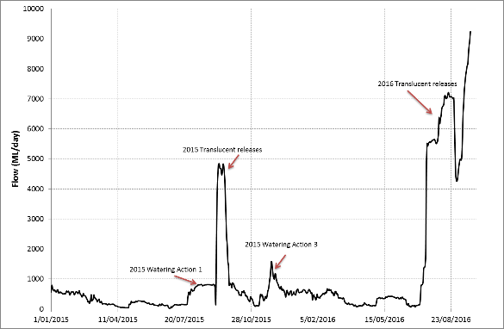

Figure 3. Flow at the gauge upstream of Willandra weir (412038) showing the 2015 watering actions and the current high flows.

* 1. Waterbird breeding

Significant rainfall within the catchment during winter and Spring in 2016 produced large volumes of unregulated inflow to the Lachlan River, triggering the delivery of translucent releases as required under the Lachlan Regulated River Water Sharing Plan. These flows, in combination with widespread rain have inundated significant areas of the Booligal wetlands and the Great Cumbung Swamp. Large numbers of colonial nesting waterbirds were observed in the Booligal area in mid August.

Breeding of straw necked ibis was confirmed on the 26th August, with an estimated 4000 birds on nests in the lignum and eggs observed in nests (Figure 4). The majority of the colony was on private land by the 21st September, the colony was spreading toward the more traditional breeding areas in the Booligal wetland complex. Water levels under the nests were in the order of 0.8-1.3 m. Commonwealth environmental water may be used to extend the duration of watering or mitigate water level fluctuations to ensure breeding success.

In response to the bird breeding event, the LTIM team were asked to implement the optional waterbird monitoring protocol. The University of NSW (UNSW) commenced monitoring with Dr Kate Brandis leading the monitoring activities. On September 16th staff from OEH and UNSW observed straw-necked ibis chicks hatching in several nests in the sections of the colony that had been established first. Monitoring of the colony will continue fortnightly until the December 2016.

On the 16th September, it was estimated that at least 10,000 birds were present in the colony area, with straw necked ibis the main nesting species. White Ibis, Royal Spoonbills and Glossy Ibis were also observed in the area and many more wetland dependent birds observed in the area.

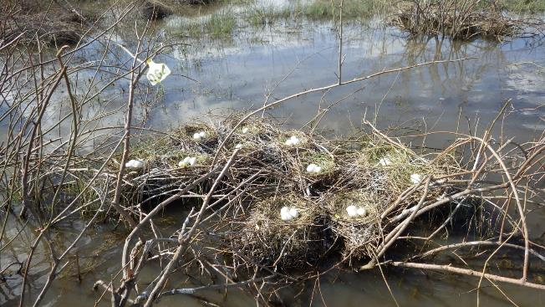Figure 4. Straw necked Ibis eggs at a tagged monitoring site within the nesting colony at the Booligal wetland complex Image: Jennifer Spencer, OEH

* 1. Field observations

Observations from the September 2016 showed the increased volume of flow compared with past field visits. The significant rain across the catchment prevented access to the Whealbah monitoring site due to river height. At Wallanthery, the channel was still a few metres from bank full (Figure 5). Aerial imagery (Figure 8) at Forbes expemplies the widespread inundation that was caused by floodingin the Lachlan system.

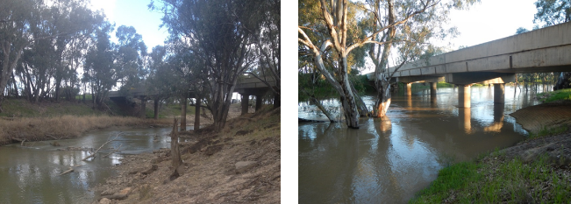

Figure 5. Water quality and larval fish monitoring site at Wallanthery. The image ( left )was taken in February 2014 and the image (right) was taken during September 2016. Images: Fiona Dyer and Ugyen Llendhup, University of Canberra

At Lane’s Bridge, the dominant snag (fallen tree) on the bend was submerged with only a few branches still exposed (Figure 6) and the river was almost over the top of the bank.

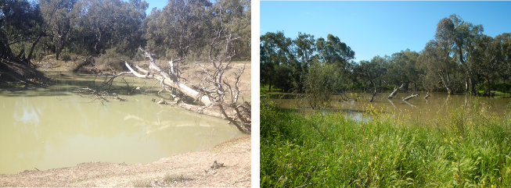

Figure 6. Water quality and larval fish monitoring site at Lane’s Bridge. The image ( left ) was taken in February 2014 and the image ( right) taken in September 2016. Note the snag in the image. Images Fiona Dyer and Ugyen Llendhup, University of Canberra.

While high water levels have prevented access to instream data loggers, spot grab water samples were taken with the help of an extension pole from the water edge (Figure 7). The water samples are being analysed by the laboratory in Canberra for nutrient concentrations. Figure 8 (below) shows a saturated landscape in the Forbes area on 22 September 2016, and is indicative of the widespread saturated catchment conditions that prevailed.

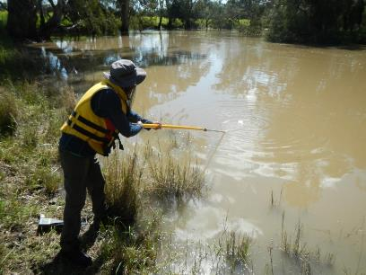

Figure 7. Ugyen Llendhup collecting water samples from the Lachlan River at Cowl Cowl during September 2016. Image Simon Votto, University of Canberra.

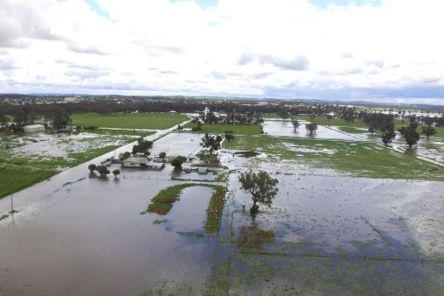

Figure 8. Widespread flooding inundated properties at Forbes, 22 September 2016. Image retrieved from http://www.abc.net.au/news/2016-09-27/forbes-flooding/7879772 on 9/10/2016

The wetter conditions within the catchment has promoted vigorous vegetation growth compared to previous visits (Figure’s 9 and 10)

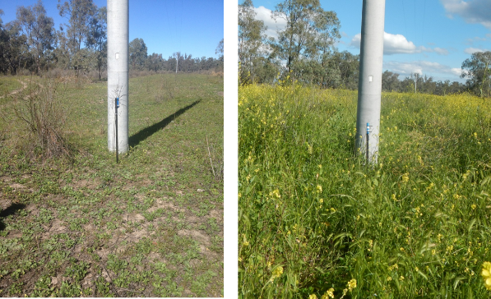

Figure 9. Barometric pressure logger at Lane’s Bridge ( Left) in February 2014, and ( Right) in September 2016. Images, Fiona Dyer and Ugyen Llendhup, University of Canberra

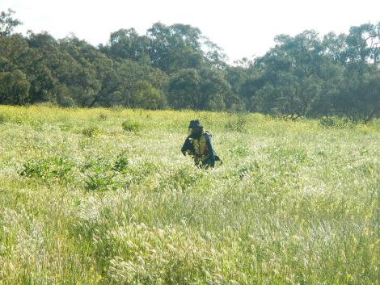

Figure 10. Ugyen Llendhup from the University of Canberra heading to site in September 2016. Images Simon Votto, University of Canberra

Appendix A: Summary of monitoring to be undertaken in the Lachlan system for the Long Term Intervention Monitoring Project from 2014-2019

The five year monitoring schedule will focus on the monitoring of Basin Indicators. Monitoring effort is consistent across the five years with the exception of monitoring Waterbird Breeding and Frogs which are options that can be implemented on the basis of a request from the CEWO.

|  |  |  |  |  |  |
| --- | --- | --- | --- | --- | --- |
| indicator | Evaluation of CEW in the Lachlan system | CEW at whole of Basin-scale | monitoring frequency | sites | expected schedule |
| Ecosystem type | ✓ | ✓ | At commencement | All sites for other indicators | Establishment of ANAE type at the start of the LTIM Project. Expected August-December 2014 |
| Riverine fish | ✓ | ✓ | ANNUAL | Basin Evaluation: 10 fixed sites within Zone 1 | Annual sampling between March and May |
| Larval fish | ✓ | ✓ | ANNUAL | 3 fixed riverine sites in Zone 1 | Annual sampling 5 times during breeding season (September to February) |
| Stream metabolism | ✓ | ✓ | CONTINUOUS  REGULAR | Four fixed sites matched to riverine fish sampling sites in Zone 1 | Continuous monitoring of dissolved oxygen and, temperature.  6 weekly sampling of nutrients and water quality attributes. |
| Hydrology (River) | ✓ | ✓ | CONTINUOUS | Gauging sites |  |
| Vegetation diversity and condition | ✓ |  | ANNUAL & EVENT BASED | 12 fixed sites | Before and after watering (expected to be April/May and 3 months after first fill) |
| Waterbird breeding (Option) | ✓ |  | EVENT-BASED (on request from the CEWO) | One fixed site – Booligal wetland | Fortnightly surveys of bird breeding triggered by breeding events in Booligal wetland.  Assumes 3 breeding events in 5 years. |
| Frogs (Option) | ✓ |  | EVENT-BASED (on request from the CEWO) | 15 sites comprising 2 to 8 wetland sites and 2 to 7 riverine sites depending on watering targets | 3 sampling events between August and February (one sample in each of winter, spring and summer). |
| Hydrology (wetland – Option) | ✓ |  | EVENT-BASED (in conjunction with Waterbird Breeding or Frog monitoring) | Cameras at 6 roving wetland sites | Cameras installed prior to targeted watering each year and downloaded after the watering event has passed |

**Appendix B:** Map showing location of monitoring sites for the Long-Term Intervention Monitoring Project.

