Lachlan River

Long Term Intervention Monitoring Project

Progress Report

1 July 2017 to 30 September 2017

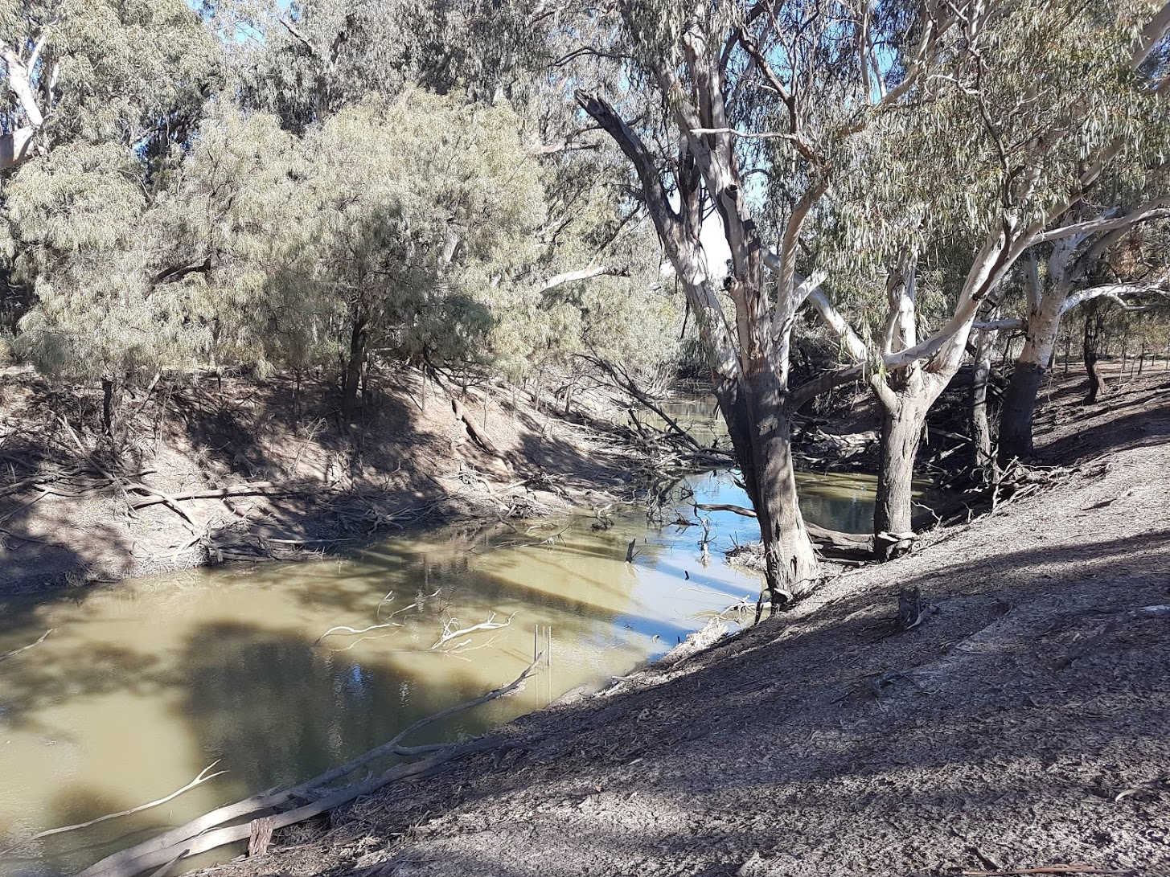

Inquiries regarding this document should be addressed to:

Dr Fiona Dyer  
Phone: 02 6201 2452  
e-mail: Fiona.Dyer@canberra.edu.au

This document was prepared by Ben Broadhurst with input from Ebony Mullin (CEWO) and Fiona Dyer (IAE-UC).

Cover Photo: Lachlan River at Cowl Cowl. Photo: Ugyen Llendhup (University of Canberra)

**Document history and status**

|  |  |  |  |  |
| --- | --- | --- | --- | --- |
| Version | Date Issued | Reviewed by | Approved by | Revision Type |
| Draft 1 | 3 October 2017 | Ben Broadhurst | Fiona Dyer | Internal |
| FINAL | 25 October 2017 | Ebony Mullin/Damian McRae | Fiona Dyer | External |

**Distribution of copies**

|  |  |  |
| --- | --- | --- |
| Version | Type | Issued to |
| FINAL | Electronic | Commonwealth Environmental Water Office |

**Copyright**© Copyright Commonwealth of Australia, 2016



‘Long term intervention monitoring project, Lachlan River system selected area, progress report’ is licensed by the Commonwealth of Australia for use under a Creative Commons By Attribution 3.0 Australia licence with the exception of the Coat of Arms of the Commonwealth of Australia, the logo of the agency responsible for publishing the report, content supplied by third parties, and any images depicting people. For licence conditions see: <http://creativecommons.org/licenses/by/3.0/au/>

**Disclaimer**

The views and opinions expressed in this publication are those of the authors and do not necessarily reflect those of the Australian Government or the Minister for the Environment. While reasonable efforts have been made to ensure that the contents of this publication are factually correct, the Commonwealth does not accept responsibility for the accuracy or completeness of the contents, and shall not be liable for any loss or damage that may be occasioned directly or indirectly through the use of, or reliance on, the contents of this publication.

1. Conditions in the Lachlan River system June - September 2017

The catchment has experienced a warmer and drier than average period from June – September 2017. Monthly rainfall was well below long term averages for all months between June – September (Figure1). Total long-term average rainfall for this period is 126 mm, which is significantly higher than that which fell in 2017 (35.8 mm) (Figure 1). Maximum monthly temperatures were well above average at all stations in the Lachlan River catchment, though minimum monthly temperatures were lower than average (Figure 2).

In late September 2017, the Bureau of Meteorology (BoM) forecast roughly equal chances of wetter or drier conditions from October to December, with above average temperatures.

Figure . Rainfall at Hillston (075032) in the Lachlan River Catchment in June – September 2017 compared with the long term average rainfall. Data from the Bureau of Meteorology.

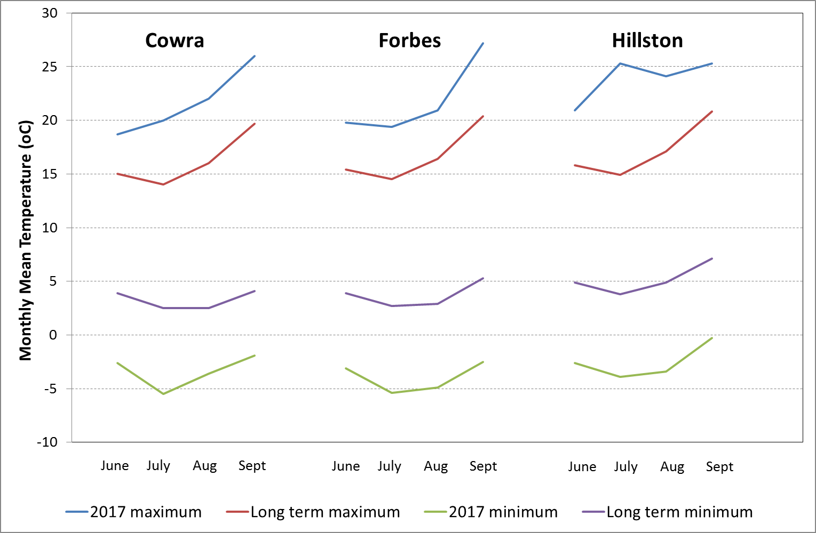

Figure . Winter and early spring mean monthly temperatures at Cowra, Forbes and Hillston in the Lachlan River catchment comparing 2017 temperatures with the long term means. Data from the Bureau of Meteorology.

1. Summary on progress against core monitoring and evaluation activities

|  |  |  |
| --- | --- | --- |
| ACTIVITIES | PROGRESS TO DATE | UPCOMING ACTIVITIES |
| *Monitoring activities* | | |
| Ecosystem type | * Data collection complete and suggested Australian National Aquatic Ecosystems (ANAE) types for all sites included in the Monitoring and Data Management System (MDMS). | * No more data collection required |
| Fish (river) | * 2016-17 data analysis and draft report completed | * None |
| Fish (larvae) | * 2016-17 data analysis and draft report completed | * Larval fish sampling to commence mid October |
| Waterbird breeding (optional) | * Unlikely to be undertaken in 2017 / 2018 | * None |
| Water quality and stream metabolism | * 2016-17 data analysis and draft report completed * Water quality samples | * Checking, calibrating and downloading logger data |
| Vegetation diversity | * 2016-17 data analysis and draft report completed | * Spring vegetation sampling |
| Frogs (optional) | * 2015-16 data analysis and draft report completed | * None |
| *Evaluation activities* | | |
| Monitoring data entry | * Data entry continuing as MDMS updated | * Finalise data entry |
| *Communication and engagement* | | |
| Selected Area Working Group | * Selected Area working group has been replaced by active participation of the LTIM team at the Lachlan EWAG and relevant TAG meetings during the watering year | * October/November/December meeting |
| Project team teleconference | * Project team meeting held in July via phone and at the annual forum | * None |
| Other Stakeholder Engagement | * Quarterly report #12 finalised in August. The observations report still to be finalised. * Attendance at the Lachlan EWAG 25-26 July. | * Quarterly progress report #13 to be provided to landholders and other stakeholders |

**Note:** for the Long-Term Intervention Monitoring Project, Lachlan River system selected area:

* **Appendix A** provides a summary of monitoring to be undertaken under the project from 2014-2019.

1. Observations
   1. Hydrology

Flow in the Lachlan River downstream of Willandra weir throughout winter 2017 has been of a similar magnitude to the winter low flows of 2013 and 2014 but considerably lower than the those of 2015 and 2016 (Figure 3).

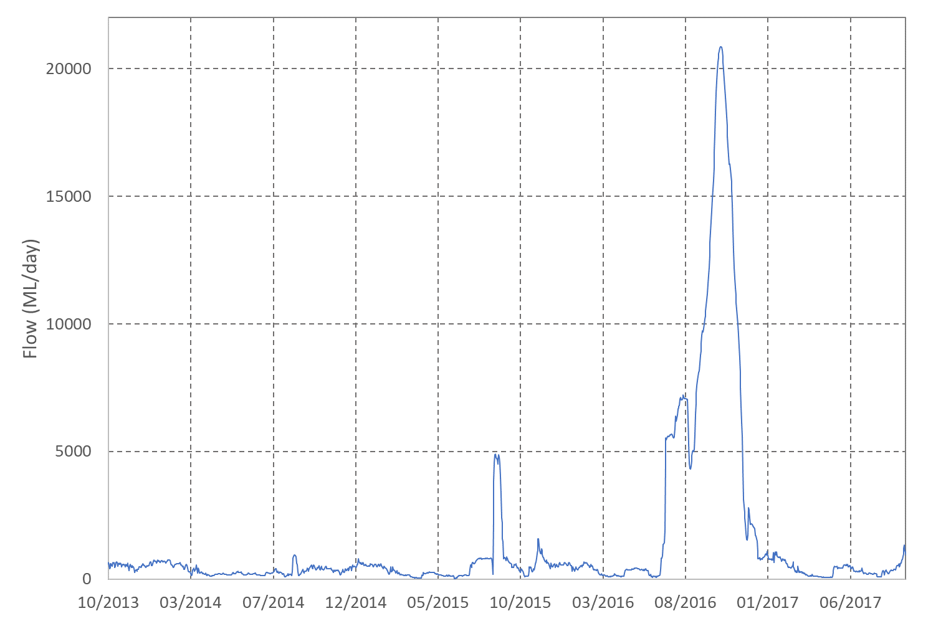

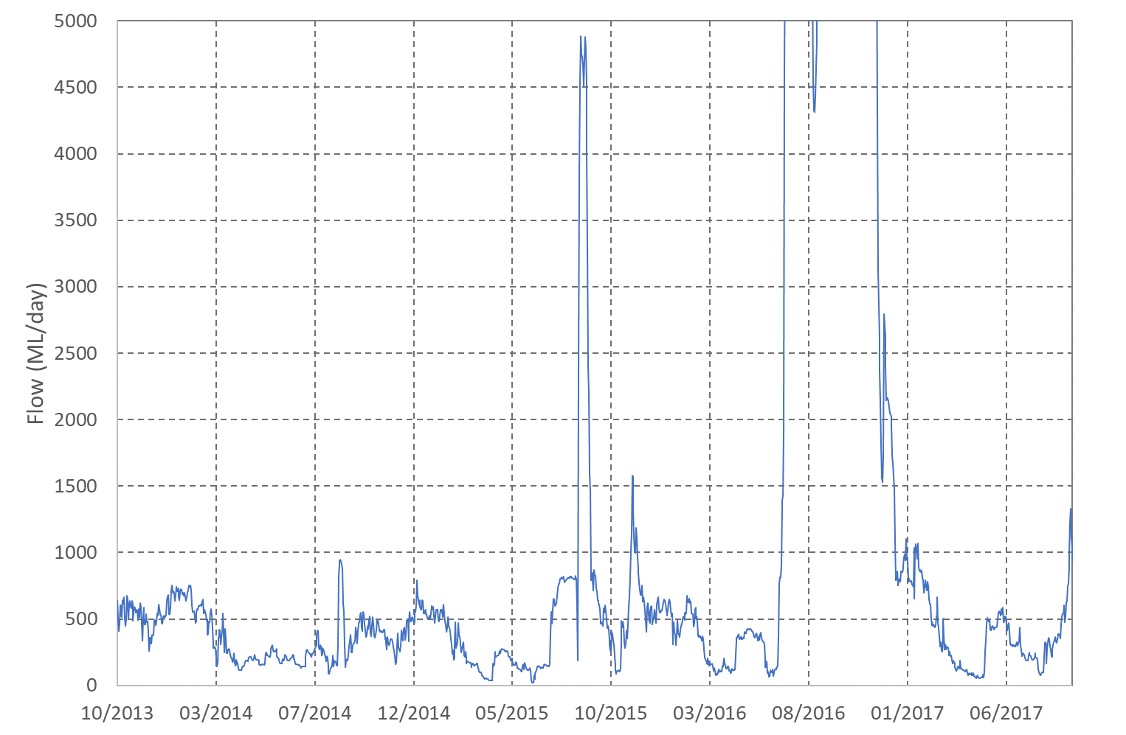

Figure . Flow at the gauge Upstream of Willandra Weir (412038) from October 2013 to September 2017. Data from NSW Department of Primary Industries (http://www.water.nsw.gov.au/realtime-data)

* 1. Field observations

Observations from in June and August 2017 showed the low volume of flow compared with flood levels experienced in late 2016 and early 2017. At Lanes Bridge (larval fish, fish and stream metabolism site), low flows in August revealed low level benches (Figure 5). Low water levels allowed for the retrieval and reployment of instream loggers (Figure 5).

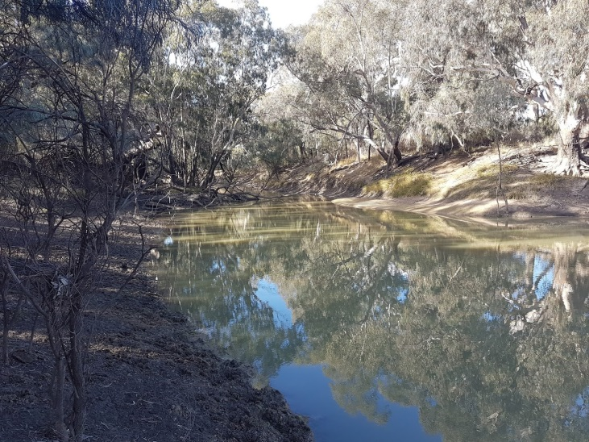 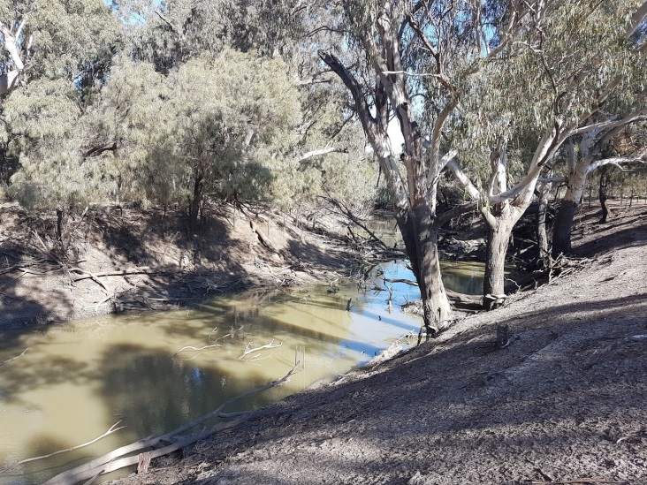

Figure 5. Water quality and larval fish monitoring site at Lanes Bridge (left) showing low level bench (taken in August 2017). Low water level (shown here at Whealbah – right) allowed for retrieval of loggers following the floods . Images: Ben Broadhurst, University of Canberra

Appendix A: The Long-Term Intervention Monitoring Project for the Lachlan River system and its context in terms of ecological monitoring and evaluation within the Murray-Darling Basin.

The Long Term Intervention Monitoring (LTIM) Project for the Lachlan river system selected area is funded by the Commonwealth Environmental Water Office. The project is being delivered by a consortium of service providers lead by University of Canberra and includes NSW Office of Environment and Heritage, NSW Department of Primary Industries (Fisheries), NSW Department of Primary Industries (Office of Water), University of New South Wales and Charles Sturt University.

The LTIM project is based on a clear and robust program logic, as detailed in the [Long-Term Intervention Monitoring Project Logic and Rationale Document](http://www.environment.gov.au/water/cewo/publications/long-term-intervention-monitoring-project-logic-and-rationale-document). That document sets out the scientific and technical foundations of long-term intervention monitoring and is being applied to areas where LTIM projects are being undertaken. It also provides links between Basin Plan objectives and targets to the monitoring of outcomes from Commonwealth environmental watering actions. For more information, see [Monitoring and evaluation for the use of Commonwealth environmental water](http://www.environment.gov.au/topics/water/commonwealth-environmental-water-office/monitoring-and-evaluation).

Many different agencies play a role in the reporting on environmental outcomes, consistent with the Basin Plan (see figure 1 below). The Murray Darling Basin Authority is responsible for reporting on achievements against the environmental objectives of the Basin Plan at a basin-scale, which are broadly focussed on flows and water quality, fish, vegetation and birds across the whole of the Basin. State Governments are responsible for reporting on achievements against the environmental objectives of the Basin Plan at an asset-scale i.e. rivers, wetlands, floodplains. The Commonwealth Environmental Water Holder is responsible for reporting on the contribution of Commonwealth environmental water to the environmental objectives of the Basin Plan (at multiple-scales).

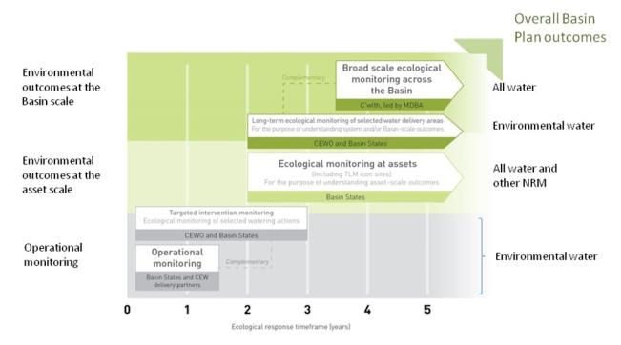

Figure 12. A summary of roles various agencies play a in the reporting on environmental outcomes, consistent with the Basin Plan.

Hydrological zones and monitoring sites of the lower Lachlan for the Long-Term Intervention Monitoring Project.

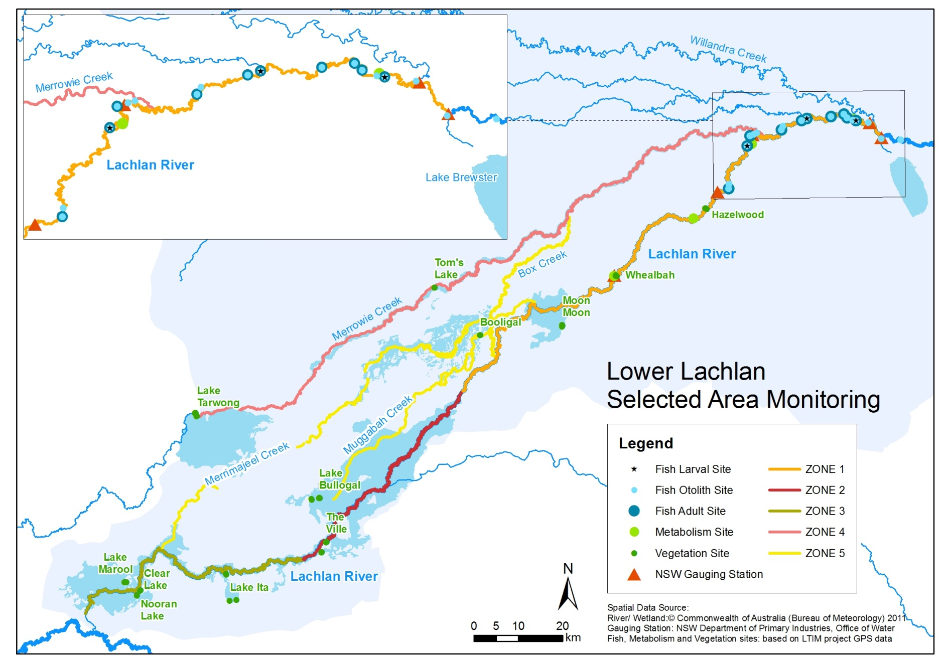

*Figure 13. Lower Lachlan LTIM monitoring sites, hydrological zones and NSW gauging stations*

Monitoring to be undertaken in the Lachlan system for the Long Term Intervention Monitoring Project from 2014-2019

The five year monitoring schedule has been based around the expected watering options and is focussed on the monitoring of Basin Indicators. Monitoring effort is consistent across the five years with the exception of monitoring Waterbird Breeding and Frogs which are options that can be implemented on request from the CEWO.

|  | ZONE | Data contributes to the Evaluation of responses to Commonwealth environmental watering | | monitoring frequency | sites | expected schedule |
| --- | --- | --- | --- | --- | --- | --- |
|  |  | Selected Area | Whole of Basin Scale |  |  |  |
| Ecosystem type | All | ✓ | ✓ | Once only | All sites for other indicators | Establishment of ANAE type at the start of the LTIM Project. Expected August-December 2014 |
| Riverine fish | 1 | ✓ | ✓ | ANNUAL | Basin Evaluation: 10 fixed sites within Zone 1 | Annual sampling between March and May |
| Larval fish | 1 | ✓ | ✓ | ANNUAL | 3 fixed riverine sites in Zone 1 | Annual sampling 5 times during breeding season (September to February) |
| Stream metabolism | 1 | ✓ | ✓ | CONTINUOUS  REGULAR | Four fixed sites matched to riverine fish sampling sites in Zone 1 | Continuous monitoring of dissolved oxygen and temperature.  6 weekly sampling of nutrients and water quality attributes. |
| Hydrology (River) | 1 | ✓ | ✓ | CONTINUOUS | Gauging sites |  |
| Vegetation diversity and condition | All | ✓ |  | ANNUAL & EVENT BASED | 12 fixed sites | Before and after watering (expected to be April/May and 3 months after first fill) |
| Waterbird breeding (Option) | 1 | ✓ |  | EVENT-BASED (on request from the CEWO) | One fixed site – Booligal wetland | Fortnightly surveys of bird breeding triggered by breeding events in Booligal wetland. |
| Frogs (Option) | All | ✓ |  | EVENT-BASED (on request from the CEWO) | 15 sites comprising 2 to 8 wetland sites and 2 to 7 riverine sites depending on watering targets | 3 sampling events between August and February (one sample in each of winter, spring and summer). |
| Hydrology (wetland – Option) |  | ✓ |  | EVENT-BASED (in conjunction with Waterbird Breeding or Frog monitoring) | Cameras at 6 roving wetland sites | Cameras installed prior to targeted watering each year and downloaded after the watering event has passed |