

**Long Term Intervention Monitoring Project**

**Generic Cause and Effect Diagrams**

**Version 1.0**

May 2013

**Prepared by:** TheMurray-Darling Freshwater Research Centre

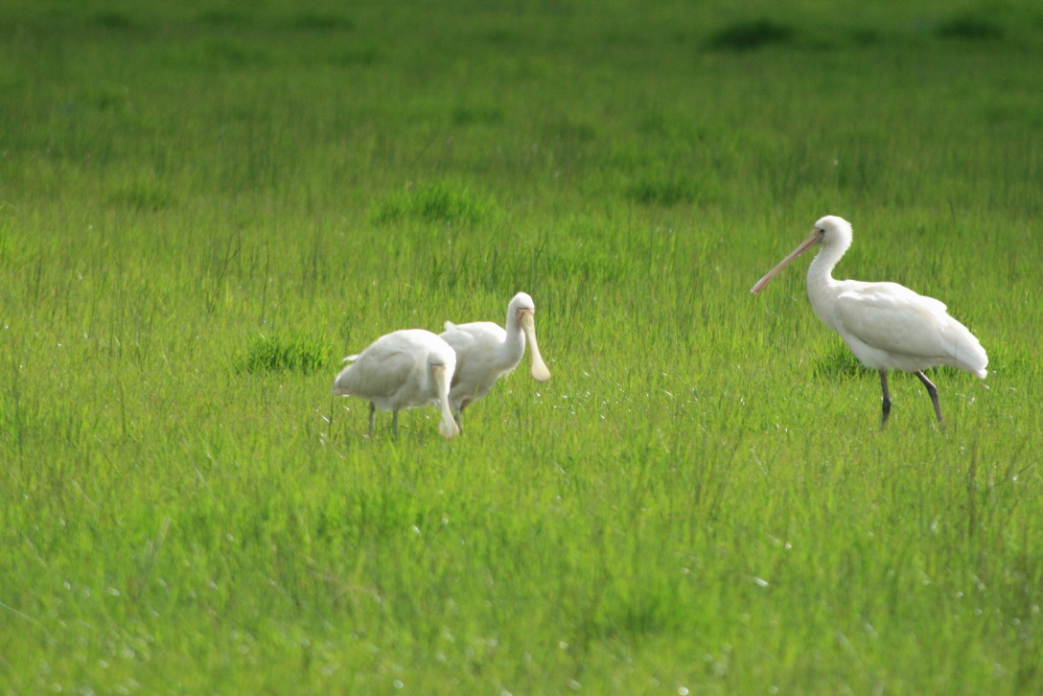



**MDFRC Publication 01.5/2013**



**Insert report title here**

**Long Term Intervention Monitoring Project Generic Cause and Effect Diagrams Version 1.0**

Final Report prepared for the Commonwealth Environmental Water Office by The Murray-Darling Freshwater Research Centre.

Department of Sustainability, Environment, Water, Population and Communities

GPO Box 787

Canberra ACT 2601

Ph: (02) 6274 2657

The views and opinions expressed in this publication are those of the authors and do not necessarily reflect those of the Australian Government or the Minister for Sustainability, Environment, Water, Population and Communities. While reasonable efforts have been made to ensure that the contents of this publication are factually correct, the Commonwealth does not accept responsibility for the accuracy or completeness of the contents, and shall not be liable for any loss or damage that may be occasioned directly or indirectly through the use of, or reliance on, the contents of this publication.

This report was prepared by The Murray-Darling Freshwater Research Centre (MDFRC). The aim of the MDFRC is to provide the scientific knowledge necessary for the management and sustained utilisation of the Murray-Darling Basin water resources. The MDFRC is a joint venture between the Murray-Darling Basin Authority, La Trobe University and CSIRO (through its Division of Land and Water). Additional investment is provided through the Australian Government Department of Sustainability, Environment, Water, Population and Communities.



For further information contact:

**Ben Gawne**

The Murray-Darling Freshwater Research Centre

PO Box 991

Wodonga Vic 3689

Ph: (02) 6024 9650; Fax: (02) 6059 7531

Email: [B.Gawne@latrobe.edu.au](mailto:B.Gawne@latrobe.edu.au)

Web: [www.mdfrc.org.au](http://www.mdfrc.org.au)  
Enquiries: [info@mdfrc.org.au](mailto:info@mdfrc.org.au)

**Report Citation:** MDFRC (2013) Long-term Intervention Monitoring - Generic Cause and Effect Diagrams Final Report prepared for the Commonwealth Environmental Water Office by The Murray-Darling Freshwater Research Centre, MDFRC Publication 01.5/2013, May, 163pp.

**Cover Image:** Yellow-billed Spoonbill *Platalea flavipes*

**Photographer:** Ben Gawne

**MDFRC Disclaimer:**

The material contained in this publication represents the opinion of the author only. Whilst every effort has been made to ensure that the information in this publication is accurate, the author and MDFRC do not accept any liability for any loss or damage howsoever arising whether in contract, tort or otherwise which may be incurred by any person as a result of any reliance or use of any statement in this publication. The author and MDFRC do not give any warranties in relation to the accuracy, completeness and up to date status of the information in this publication.

Where legislation implies any condition or warranty which cannot be excluded restricted or modified such condition or warranty shall be deemed to be included provided that the author’s and MDFRC’s liability for a breach of such term condition or warranty is, at the option of MDFRC, limited to the supply of the services again or the cost of supplying the services again.

Copyright in this publication remains with the Commonwealth. No part may be reproduced or copied in any form or by any means without the prior permission of the Commonwealth**.**

**Document History and Status**

|  |  |  |  |  |
| --- | --- | --- | --- | --- |
| **Version** | **Date Issued** | **Reviewed by** | **Approved by** | **Revision type** |
| Draft | 8 March 2013 | CEWO | Penny Everingham | External |
| Draft | 1 May 2013 | Nina Schuuman | Penny Everingham | External |
| Final | 6 May 2013 | Penny Everingham | Ben Gawne | Internal |

**Distribution of Copies**

|  |  |  |
| --- | --- | --- |
| **Version** | **Quantity** | **Issued to** |
| Final | 1 x Word Doc | Tim Wyndham and Leanne Wilkinson |

**Filename and path:** projects\CEWO\CEWH Long Term Monitoring Project\Final Reports\LTIM Logic and Rationale - Generic Cause Effect Diagrams

**Author(s):** The Murray-Darling Freshwater Research Centre

**Project Manager:** Ben Gawne

**Client:** Commonwealth Environmental Water Office

**Project Title:** Long Term Intervention Monitoring Project

**Document Version:** Final

**Project Number:** M/BUS/435

**Contract Number:** SON339925

**Acknowledgements:**

MDFRC Staff

Rhonda Butcher

Shane Brookes

Peter Cottingham

Jenny Hale

Mike Stewardson

Heather McGinness

# Contents

Prelude 1

1 Landscape ecosystem diversity 4

2 Landscape vegetation diversity 14

3 Vegetation condition and reproduction 21

4 Vegetation recruitment and extent 28

5 Within ecosystem macroinvertebrate diversity 37

6 Landscape fish diversity 41

7 Fish condition 44

8 Fish reproduction 49

9 Fish larval growth and survival 54

10 Landscape waterbird diversity 62

11 Waterbird survival and condition 67

12 Waterbird reproduction 72

13 Waterbird recruitment and fledging 75

14 Other vertebrates reproduction, growth and survival 80

15 Hydrological connectivity 87

16 Biotic dispersal 101

17 Sediment transport 106

18 Primary production 111

19 Decomposition 116

20 Nutrient and carbon cycling 121

21 Refugia and landscape refugia 126

22 Resistance and recovery 133

23 Salinity 139

24 Dissolved oxygen 147

25 PH 150

26 Dissolved organic carbon 155

27 Algal blooms 158

References 163

**KEY – CAUSE AND EFFECT DIAGRAMS**

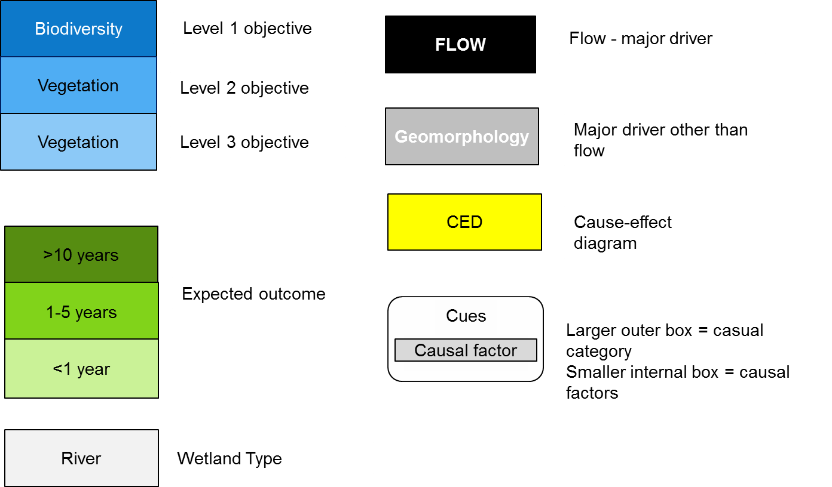

# Prelude

This document contains 27 generic cause and effect diagrams (CEDs) which form the basis of the LTIM Project ecological understanding. This document accompanies, and should be read in conjunction with the LTIM Logic and Rationale document (Gawne et al. 2013).

**Cause and effect diagrams**

The cause and effect diagrams (CEDs) are a simplified representation of the complex relationship between flow and ecological responses in freshwater aquatic systems. The CEDs do not attempt to explain all possible relationships or contain all possible factors that influence the specific objective, but try to simplify reality by containing only the most relevant information (Gross 2003).

Each CED is a box and arrow diagram and a description of the relationship between flow and the nominated expected outcome. The objectives of the LTIM Project CEDs are to:

* Illustrate visually the key influence of flow on ecological variables
* identify important processes and variables
* identify key links between flow, causal factors and expected outcomes
* facilitate selection and justification of monitoring variables
* facilitate evaluation of data from the monitoring program
* clearly communicate the complex influence of flow on the environment to technical and non-technical audiences.

In developing the CEDs and ensuring the balance between simplicity and accurately representing ecological relationships, the following principles were followed:

* the focus is on the influence of flow, omitting all non-flow related influences. In some instances, this required a judgment about whether a minor or indirect influence warranted inclusion in the CED
* alignment with the objectives hierarchy
* utility within adaptive management. The CEDs recognise the complex relationship between flow and expected outcomes but are designed to facilitate the ongoing process of improvement essential to the success of adaptive management.

**The Diagrams**

The general form of all the diagrams (except hydrological connectivity, and nutrients and carbon cycling) is the same with flow at the top of the CED influencing one or more causal categories (habitat, connectivity, processes, disturbance or cues) or subsidiary CEDs (Figure 1). Within each causal category is a list of causal factors. The CEDs are nested within the objectives hierarchy and references to other CEDs are included as yellow boxes.

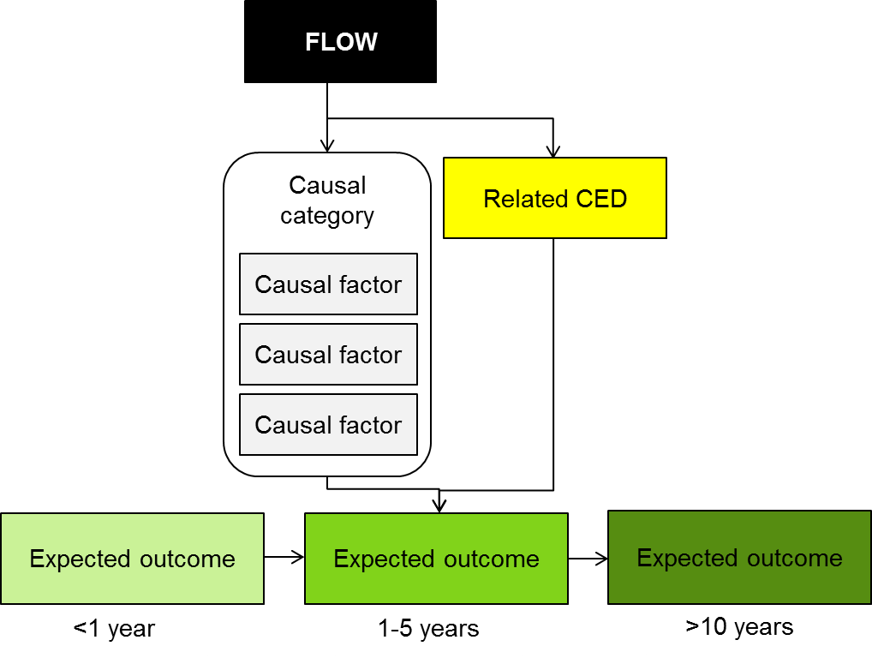

Figure 1. Generic structure of cause-effect diagrams, illustrating the influence of flow on an expected outcome through the action of causal factors that are grouped within a causal category. A related CED is identified within a yellow box. The expected outcome is the major influence on identification of effect indicators while causal factors facilitate identification of causal indicators.

**The Description**

Each CED is associated with a description that provides a concise summary of the evidence supporting the relationships illustrated in the diagram. The summaries are not full literature reviews although they may provide a basis for a formal literature review at a later stage. Where available, the evidence refers to water dependent ecosystems in the Murray-Darling Basin (MDB), however, in a number of areas, there is only limited evidence available and so the international literature has been used. The use of overseas evidence is associated with an increased level of uncertainty in terms of applying the knowledge to the MDB, however, gathering evidence to either reduce the uncertainty or modify the CED are key steps in the adaptive management process. The CEDs are generic and provide a starting point for predicting environmental outcomes in water dependent ecosystems throughout the MDB. In many instances, the application to a specific Selected Area will require modification of the CED. This will be an important part of adaptive management and records of the changes will help identify important differences among regions and ecosystems.

The CEDs have been used to develop expected outcomes for the seven Selected Areas. It is expected that they also be used to inform the development of the detailed Monitoring and Evaluation Plans for the seven Selected Areas.

In a number of instances several related CEDs have been combined into one description where the literature content was inter-related and overlapping.

Importantly, a good cause-effect diagram needs to explicitly state the underlying assumptions and the level of uncertainty associated with the links (King et al. 2003). As the CEDs are further developed, the assumptions will be articulated and the uncertainty expressed.

Overall, the CEDs presented here provide evidence of the relationship between flow and Basin Plan objectives, but perhaps more importantly in the long-term, provide a resource to support the application of our understanding of freshwater ecosystems to the management of environmental water.

# 1 Landscape ecosystem diversity

A system is a set of interacting or interdependent components forming an integrated whole. The components in an ecosystem are the biota (plants, animals, microbes) and the physical environment (air, water, soil). The components interact through the exchange of nutrients and energy; with carbon, in many cases, representing both a nutrient and a source of energy. While the designation of ‘ecosystem’ is often applied to a limited area of land, the nested nature of landscapes means that the term ecosystem can be applied at a variety of scales. A wetland that could be considered a separate ecosystem at one scale may be considered to be a part of an ecosystem at a larger scale. At either scale our understanding is that the ecosystem forms some integrated whole that interacts with other systems.

The Basin Plan seeks to protect or restore ecosystem diversity as part of the broader goal of protecting biodiversity more generally. There are several reasons why ecosystem diversity is important. First, as the definition implies, ecosystems are comprised of interdependent species, including in some instances, species that Australia has committed to protect such as migratory waterbirds. The principles of ecosystem management suggest that ecosystem management has a much higher probability of protecting valued species than individual species management. Second, because ecosystems are comprised of the biota and physical environment (and the physical environment is heterogeneous) we need a diversity of ecosystems in order to provide ecosystem services across the entire landscape. The following section describes how landscape ecosystem diversity (Figure 1) and within ecosystem diversity (Figure 2) are affected by river flow and geomorphology through its influence on habitat, area, disturbance and connectivity.

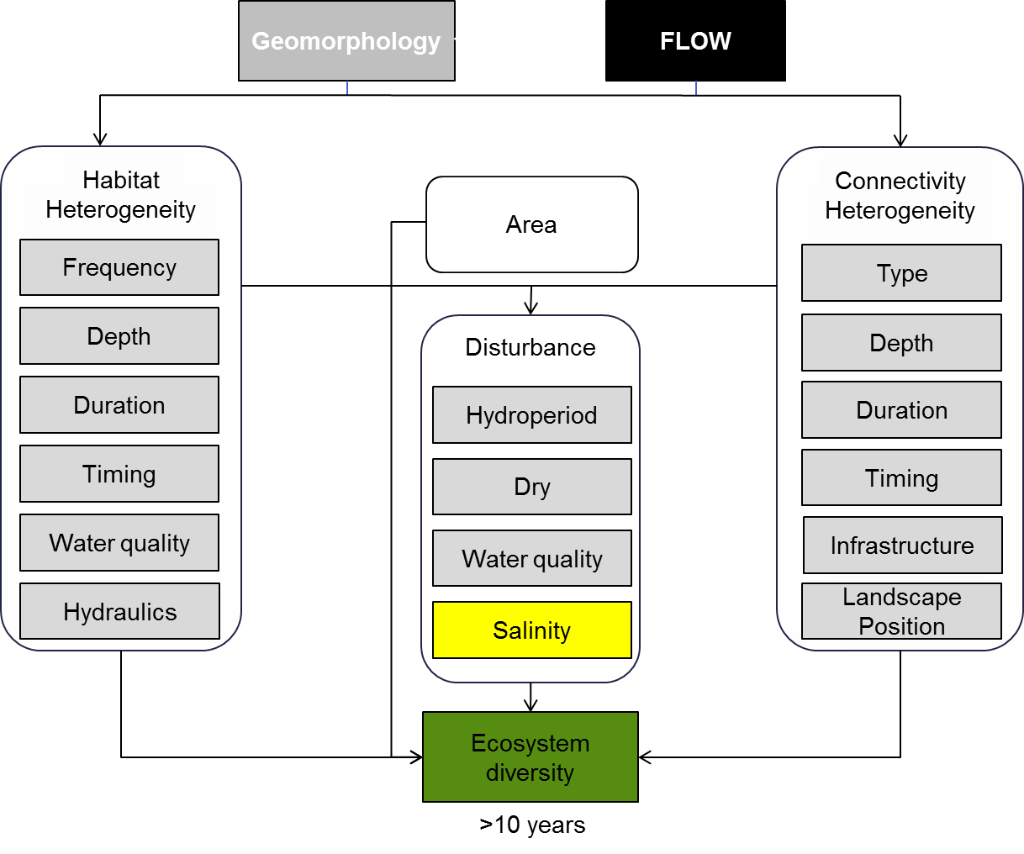

**Figure 1. Cause and effect diagram depicting the influence of flow on landscape ecosystem diversity.**

While the description above may suggest that ecosystem diversity is determined by variation in the physical environment alone, ecosystems are controlled by both the physical environment and the biota that have the capacity to influence the physical environment. There are therefore, a number of interacting factors that sustain ecosystem diversity. An important consideration is that the use of the term ‘system’ has connotations of having a fixed purpose and structure when in fact ecosystems are constantly responding to changes in both the physical environment and biotic interactions.

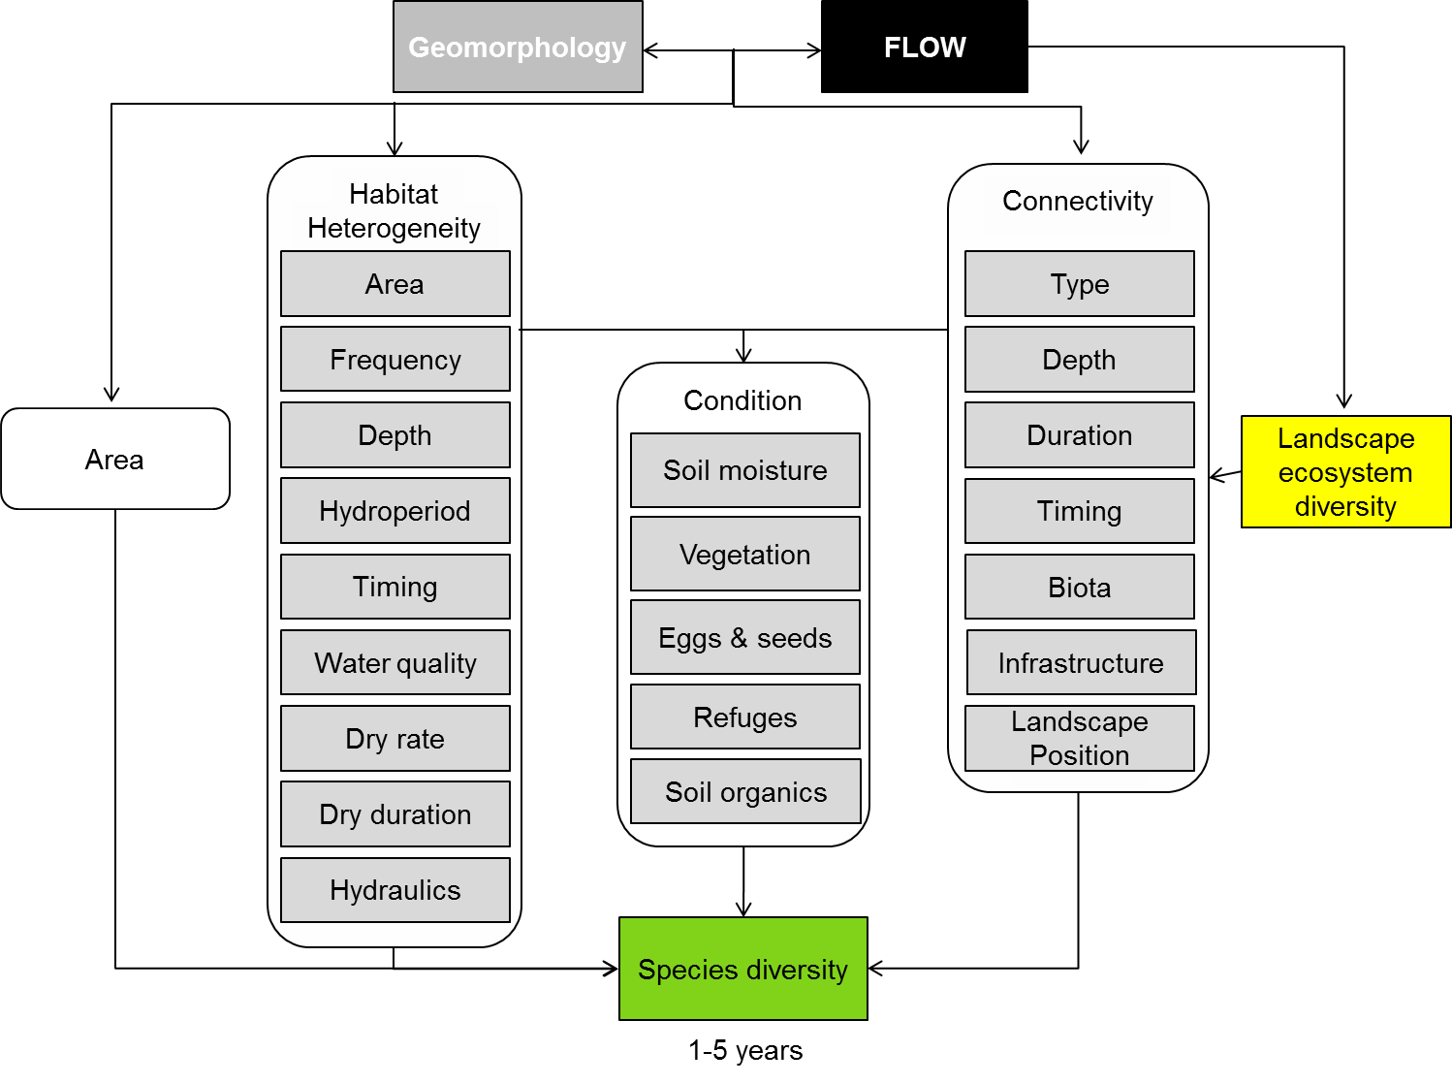**Figure 2. Cause and effect diagram depicting the influence of flow on within ecosystem diversity.**

**Habitat heterogeneity:** Habitat is the environment inhabited by a particular species, or more commonly in freshwater systems, the physical and chemical environment that surrounds, influences and is utilised by individuals within a species. There are a great many physical, chemical and biological characteristics that combine to define a species’ preferred habitat or niche. For example, species can only persist within a certain range of salinities, pH, current speed or depth of water. Variation in these habitat characteristics across the landscape and through time provide opportunities for other species who prefer a different habitat or are better able to compete under those conditions. Ecosystems are characterised by the combination of physical, chemical and biological characteristics (habitats) and variation in habitat both between and within ecosystems is a significant driver of ecosystem diversity.

In freshwater systems, the importance of habitat has been long recognised and so, many models of freshwater systems use physical habitat availability to predict the outcomes of environmental management. Examples include PHABSim (Souchon et al. 2008; Petts 2009) and the Murray Flows Assessment Tool (MFAT) (MDBC 2004; Norton and Andrews 2006) which was a modification of an environmental flow decision support system (Young et al. 2000). The rest of this section will review some of the major habitat characteristics influenced by flow.

Flood frequency has been found to be a significant influence on vegetation communities where it influences species composition distributions (Chesterfield 1986), productivity (Robertson et al. 2001) and condition (Overton et al. 2006). River regulation has been found to decrease flood frequency which may extend the dry period beyond the tolerance of flood dependent species (Bren 1991) or provide an opportunity for more terrestrial species to become established (Stokes et al. 2010; Catford et al. 2011). Decreases in flooding frequency may also lead to accumulations of salt which may act as a disturbance to floodplain vegetation (Overton et al. 2006).

Flood frequency influences the presence of fish (Bunn et al. 2006; Lubinski et al. 2008) through its influence on the presence and quality of refuges. For microinvertebrates that rely on an eggbank to persist through dry periods, extension of the dry phase will reduce the viability of the eggbank and reduce the diversity of the community (Boulton and Jenkins 1998). In a landscape context, this will mean that less frequently inundated wetlands are likely to have a different species composition to more frequently inundated wetlands (Nielsen et al. in press).

Water depth is an important influence on species present within an ecosystem. For vegetation, water depth has been found to be a significant influence on species composition (Howell and Benson 2000; Murphy et al. 2003; Wolters et al. 2005; Elsey‐Quirk et al. 2009) and so a water regime that creates a mosaic of water depths is likely to increase ecosystem diversity. Water depth is important for birds (Taft et al. 2002; González-Gajardo et al. 2009) and fish (Irz et al. 2004; Lubinski et al. 2008), with many birds reliant on shallow water to forage. Fish depth preferences may be influenced by the influence of depth on water quality, wetland permanence or in some cases, bird predation (Gawne and Scholz 2006).

One of the effects of river regulation has been a reduction in the duration of inundation of many ecosystems (Bren 1991; Frazier and Page 2006). At a landscape scale, this may mean that ecosystems that once experienced long periods of inundation may now be lost or under stress. For vegetation, the period of inundation has a significant influence on species composition (Furness and Breen 1980; Casanova and Brock 2000; Pettit et al. 2001; Baker and Wiley 2004). For invertebrates, wetland inundation initiates a gradual change in species composition (Lake et al. 1989; Gawne and Scholz 2006). For fish, reductions in inundation duration may preclude the use of floodplain habitats (King et al. 2003) or undermine the value of ecosystems as refuges (Bunn et al. 2006). Duration of inundation also influences the bird species that utilise wetlands, with ephemeral wetlands supporting a different suite of birds to permanent billabongs (Parkinson et al. 2002).

The timing or season of inundation will also influence the species within an ecosystem. Season of inundation has been found to influence the species of annual plants that emerge (Howell and Benson 2000; White et al. 2012) and their capacity to complete their life cycle (Warwick and Brock 2003). Season is also an important influence on the invertebrate community, primarily through its influence on temperature (Nielsen et al. 1999), and in some instances, due to the effects of temperature on processes and water quality (Watkins et al. 2011). Fish response is also influenced by timing (Nielsen et al. 1999; Górski et al. 2010; White et al. 2012). Once again, temperature is a key influence on species’ dispersal response and reproductive behaviour (Humphries et al. 1999). For fish to take advantage of the habitat and productivity associated with inundation, the season and temperature need to coincide with other dispersal and breeding cues and these are known to vary among species (Humphries et al. 1999; Beesley et al. 2010). In terms of protecting or restoring ecosystem diversity, the key considerations are that inundation at inappropriate times of year may not achieve their objective, but also that within the appropriate seasons, the timing of inundation should be varied to ensure that species with different seasonal requirements are provided with opportunities to complete their life cycles.

Several water quality parameters are known to influence vegetation species occurring in an ecosystem including; nutrients (Kleinebecker et al. 2010), salinity (Nielsen et al. 2003; Overton et al. 2006), turbidity (Blanch et al. 1998; Best et al. 2001; Tremp 2007) and pH (Porter et al. 2007). For invertebrates, key water quality influences include; salinity (Growns et al. 1992; Bonada et al. 2005), nutrients (Growns et al. 1992; Bonada et al. 2005; Kleinebecker et al. 2010), pH (Growns et al. 1992) and dissolved oxygen (Watkins et al. 2011). Similarly, fish community composition has been found to be influenced by salinity (Wedderburn et al. 2008) and dissolved oxygen (McNeil and Closs 2007). Each of these water quality parameters will vary over different spatial and temporal scales in response to in-channel conditions, connection with the main channel and local conditions including connection with regional groundwater. Protecting or restoring ecosystem diversity would require an understanding of the expected range and combinations of water quality characteristics within wetlands.

Hydraulic conditions also have a significant influence on species occurrence within ecosystems. The effects of depth have already been described, but current speed and turbulence also influence the occurrence of species and their distribution. Current speed is acknowledged as being a major influence on macrophytes (Biggs 1996), invertebrates (Lancaster and Downes 2010) and fish (Crook et al. 2001).

**Area:** the species-area relationship is the relationship between the area of an ecosystem or habitat and the number of species found within that area. As the area increases, so does the number of species found and this is one of the most widespread and consistently observed ecological patterns. The size of an ecosystem has been found to influence the number of bird (González-Gajardo et al. 2009), fish (Alimov 2001; Aigo et al. 2008), frog (Parris 2006), invertebrate (Briers and Biggs 2005; Ryberg and Chase 2007), algal and vegetation (Murphy et al. 2003) species. In the case of fish, a relationship has also been found between discharge, which is broadly related to the amount of habitat, and fish diversity (Xenopolous et al. 2005).

A number of hypotheses have been proposed to explain the species-area relationship, including that as the number of individuals increase so does the probability of an increased number of species. Larger areas are more likely to include a greater variety of habitats that will support a greater diversity of species.

**Disturbance:** The cycles of flooding and drying influence habitat and connectivity but they also impose a disturbance regime on biota that, if altered, will affect the species present in the system. This has been observed when the frequency of floods is reduced or when dry phases are lost (Casanova and Brock 2000; Gawne and Scholz 2006).

Floods represent a disturbance for many plant species as they have limited or no tolerance for inundation (Siebentritt et al. 2004). Even some species considered to be flood dependent (e.g. river red gum) have limits to the period of time that they can tolerate inundation (Steinfeld and Kingsford 2013).

Drying is also a disturbance that eliminates aquatic species and as the dry period increases, fewer and fewer flood dependent species persist (Barrett et al. 2010; Nielsen et al. in press).

In some instances, the effects of the disturbance are linked to changes in water quality associated with the drying process including; salinity, temperature and dissolved oxygen (McNeil and Closs 2007; Hladyz et al. 2012).

**Connectivity heterogeneity:** Connectivity is the exchange of water, energy, nutrients and biota among ecosystems in the landscape. Connectivity is increasingly being recognised as a major influence on ecosystem character through both hydrological connectivity that is a major influence on habitat characteristics and its influence on the distributions of species. While from a single species perspective limitations to dispersal may not appear beneficial, from an ecosystem perspective variation in connectivity excludes some species from some systems and this creates opportunities for other species to persist, thereby increasing ecosystem diversity. An example of this occurs between fish and frogs, where fish predation on tadpoles can exclude frogs from some wetlands.

The importance of spatial variation in connection reflects temporal variation in connections that are a key characteristic of floodplain ecosystems. Floods are associated with widespread connectivity that tend to homogenise floodplain ecosystems and the drying phase is then associated with diversification as connectivity is lost and local habitat characteristics influence survival (Angeler et al. 2000; Lewis et al. 2000; Miranda 2005; Thomaz et al. 2007; Balcombe et al. 2012).

This section will focus on the influence of connectivity on the distribution of species. Connectivity is particularly important in dynamic systems like floodplains where biota need to disperse to access areas of high productivity or refuges and the system goes through periods of boom and bust. In general, reduced connectivity is associated with a loss of species (Ward and Tockner 2001; Brinson and Malvárez 2002). Patterns of connectivity have been found to influence invertebrate (Leigh and Sheldon 2009; Obolewski 2011) and vegetation (Keruzoré et al. 2012) distributions. Fish appear to be most strongly influenced by connectivity (Bright et al. 2010; White et al. 2012).

Far less is known about the characteristics of connectivity that influence the dispersal of different groups but there is some limited information. Observations of fish movements through regulators and fish-ways have provided evidence that the type of connection can influence the species that will disperse (Beesley et al. 2010). The duration (Stoffels and Humphries 2003) and timing of connection (Davis et al. 2012) are also emerging as important with different species entering wetlands at different times.

One of the major influences management has wrought on water dependent ecosystems has been the installation of infrastructure including weirs, regulators and levies that significantly alter patterns of connectivity. The importance of longitudinal and lateral connectivity to at least fish has been widely acknowledged through the installation of fish-ways through programs such as the Hume to the Sea fish-way program and the modification of wetland regulators to ensure they are fish ‘friendly’.

Finally, landscape position has an important influence on the capacity of biota to disperse to an ecosystem. Ward and Tockner (2001) found that the diversity of different groups of biota peaked at different distances from the river channel but that overall, diversity peaked at intermediate levels of connectivity. An additional observation was that ecosystem diversity, (that is, the difference in species composition among ecosystems) was greatest in the most fragmented systems (Tockner et al. 1999).

**Knowledge gaps:** Freshwater ecology has had an emphasis on species responses to the physical environment at relatively small spatial and short temporal scales. As a consequence, our understanding of connectivity and the forces that sustain species and ecosystem diversity at larger scales could be considered one large knowledge gap.

**Use of the cause and effect diagram:** This is a generic diagram applicable across both the northern and southern parts of the Basin. Its application to particular circumstances or localities would require additional information and potentially modification of the model.

**References**

Aigo J et al. (2008) Distribution of introduced and native fish in Patagonia (Argentina): patterns and changes in fish assemblages. Reviews in Fish Biology and Fisheries 18:387-408

Alimov A (2001) Studies on biodiversity in the plankton, benthos, and fish communities, and the ecosystems of fresh water bodies differing in productivity. Biology Bulletin of the Russian Academy of Sciences 28:75-83

Angeler D, Alvarez-Cobelas M, Rojo C, Sanchez-Carrilo S (2000) The significance of water inputs to plankton biomass and trophic relationships in a semi-arid freshwater wetland (central Spain). Journal of Plankton Research 22:2075-2093

Baker ME, Wiley MJ (2004) Characterization of woody species distribution in riparian forests of Lower Michigan, USA using map-based models. Wetlands 24:550-561

Balcombe SR, Lobegeiger JS, Marshall SM, Marshall JC, Ly D, Jones DN (2012) Fish body condition and recruitment success reflect antecedent flows in an Australian dryland river. Fisheries Science 78:841-847 doi: 10.1007/s12562-012-0519-z

Barrett R, Nielsen DL, Croome R (2010) ASSOCIATIONS BETWEEN THE PLANT COMMUNITIES OF FLOODPLAIN WETLANDS, WATER REGIME AND WETLAND TYPE. River Research and Applications 26:866-876 doi: 10.1002/rra.1299

Beesley L et al. (2010) Watering floodplain wetlands in the Murray-Darling Basin for native fish. In: Waterlines Series. National Water Commission, Canberra, ACT

Best EPH et al. (2001) Modeling submersed macrophyte growth in relation to underwater light climate: modeling approaches and application potential. Hydrobiologia 444:43-70

Biggs BJF (1996) Hydraulic habitat of plants in streams. Regulated Rivers: Research and Management 12:131-144

Blanch SJ, Ganf GG, Walker KF (1998) Growth and recruitment in Vallisneria americana as related to average irradiance in the water column. Aquatic Botany 61:181-205

Bonada N, ZAMORA‐MUÑOZ C, Rieradevall M, Prat N (2005) Ecological and historical filters constraining spatial caddisfly distribution in Mediterranean rivers. Freshwater Biology 50:781-797

Boulton AJ, Jenkins KM (1998) Flood regimes and invertebrate communities in floodplain wetlands. In: Williams WD (ed) Wetlands in a dry land: Understanding for management. Environment Australia, Biodiversity Group, Canberra, pp 137-146

Bren L (1991) Modelling the influence of River Murray management on the Barmah river red gum forests. Australian Forestry 54:9-15

Briers RA, Biggs J (2005) Spatial patterns in pond invertebrate communities: separating environmental and distance effects. Aquatic Conservation: Marine and Freshwater Ecosystems 15:549-557

Bright EG, Batzer DP, Garnett JA (2010) Variation in Invertebrate and Fish Communities Across Floodplain Ecotones of the Altamaha and Savannah Rivers. Wetlands 30:1117-1128 doi: 10.1007/s13157-010-0116-9

Brinson MM, Malvárez AI (2002) Temperate freshwater wetlands: types, status, and threats. Environmental Conservation 29:115-133

Bunn SE, Thoms M, Hamilton SK, Capon SJ (2006) Flow variability in dryland rivers: Boom, bust and the bits in between. River Research and Applications 22:179-186

Casanova M, Brock M (2000) How do depth, duration and frequency of flooding influence the establishment of wetland plant communities? Plant Ecology 147:237-250

Catford JA, Downes BJ, Gippel CJ, Vesk PA (2011) Flow regulation reduces native plant cover and facilitates exotic invasion in riparian wetlands. Journal of Applied Ecology 48:432-442 doi: 10.1111/j.1365-2664.2010.01945.x

Chesterfield E (1986) Changes in vegetation of the river red gum forest at Barmah, Victoria. Australian Forestry 49:4-15

Crook DA, Robertson AI, King AJ, Humphries P (2001) The influence of spatial scale and habitat arrangement on diel patterns of habitat use by two lowland river fishes. Oecologia 129:525-533

Davis B, Johnston R, Baker R, Sheaves M (2012) Fish Utilisation of Wetland Nurseries with Complex Hydrological Connectivity. Plos One 7 doi: e49107

10.1371/journal.pone.0049107

Elsey‐Quirk T, Middleton BA, Proffitt CE (2009) Seed dispersal and seedling emergence in a created and a natural salt marsh on the Gulf of Mexico coast in southwest Louisiana, USA. Restoration Ecology 17:422-432

Frazier P, Page K (2006) The effect of river regulation on floodplain wetland inundation, Murrumbidgee River, Australia. Marine and Freshwater Research 57:133-141

Furness H, Breen C (1980) The vegetation of seasonally flooded areas of the Pongolo River Floodplain. Bothalia 13:217-230

Gawne B, Scholz O (2006) Synthesis of a new conceptual model to facilitate management of ephemeral deflation basin lakes. Lakes & Reservoirs: Research & Management 11:177-188

González-Gajardo A, Sepúlveda PV, Schlatter R (2009) Waterbird Assemblages and habitat characteristics in wetlands: influence of temporal variability on species-habitat relationships. Waterbirds 32:225-233

Górski K, Winter H, De Leeuw J, Minin A, Nagelkerke L (2010) Fish spawning in a large temperate floodplain: the role of flooding and temperature. Freshwater Biology 55:1509-1519

Growns JE, Davis JA, Cheal F, Schmidt LG, Rosich RS, Bradley SJ (1992) MULTIVARIATE PATTERN-ANALYSIS OF WETLAND INVERTEBRATE COMMUNITIES AND ENVIRONMENTAL VARIABLES IN WESTERN-AUSTRALIA. Australian Journal of Ecology 17:275-288

Hladyz S, Nielsen DL, Suter PJ, Krull ES (2012) Temporal variations in organic carbon utilization by consumers in a lowland river. River Research and Applications 28:513-528 doi: 10.1002/rra.1467

Howell J, Benson D (2000) Predicting potential impacts of environmental flows on weedy riparian vegetation of the Hawkesbury–Nepean River, south‐eastern Australia. Austral Ecology 25:463-475

Humphries P, King AJ, Koehn JD (1999) Fish, flows and flood plains: links between freshwater fishes and their environment in the Murray-Darling River system, Australia. Environmental Biology of Fishes 56:129-151 doi: 10.1023/a:1007536009916

Irz P, Argillier C, Oberdorff T (2004) Native and introduced fish species richness in French lakes: local and regional influences. Global Ecology and Biogeography 13:335-344

Keruzoré AA, Willby NJ, Gilvear DJ (2012) The role of lateral connectivity in the maintenance of macrophyte diversity and production in large rivers. Aquatic Conservation: Marine and Freshwater Ecosystems:n/a-n/a doi: 10.1002/aqc.2288

King A, Humphries P, Lake P (2003) Fish recruitment on floodplains: the roles of patterns of flooding and life history characteristics. Canadian Journal of Fisheries and Aquatic Sciences 60:773-786

Kleinebecker T, Hölzel N, Vogel A (2010) Patterns and gradients of diversity in South Patagonian ombrotrophic peat bogs. Austral Ecology 35:1-12

Lake P, Bayly I, Morton D (1989) The phenology of a temporary pond in western Victoria, Australia, with special reference to invertebrate succession. Archiv für Hydrobiologie 115:171-202

Lancaster J, Downes BJ (2010) Linking the hydraulic world of individual organisms to ecological processes: Putting ecology into ecohydraulics. River Research and Applications 26:385-403

Leigh C, Sheldon F (2009) Hydrological connectivity drives patterns of macroinvertebrate biodiversity in floodplain rivers of the Australian wet dry tropics. Freshwater Biology 54:549-571 doi: 10.1111/j.1365-2427.2008.02130.x

Lewis W, Hamilton S, Lasi M, Rodriguez M, Saunders III J (2000) Ecological determinism on the Orinoco Floodplain. Bioscience 50:681-693

Lubinski BJ, Jackson JR, Eggleton MA (2008) Relationships between floodplain lake fish communities and environmental variables in a large river-floodplain ecosystem. Transactions of the American Fisheries Society 137:895-908 doi: 10.1577/t06-112.1

McNeil DG, Closs GP (2007) Behavioural responses of a south-east Australian floodplain fish community to gradual hypoxia. Freshwater Biology 52:412-420

MDBC (2004) Inside MFAT. In. Murray-Darling Basin Commission, Canberra, ACT

Miranda LE (2005) Fish assemblages in oxbow lakes relative to connectivity with the Mississippi River. Transactions of the American Fisheries Society 134:1480-1489 doi: 10.1577/tos-057.1

Murphy K et al. (2003) Aquatic plant communities and predictors of diversity in a sub-tropical river floodplain: the upper Rio Paraná, Brazil. Aquatic Botany 77:257-276

Nielsen D, Brock M, Rees G, Baldwin DS (2003) Effects of increasing salinity on freshwater ecosystems in Australia. Australian Journal of Botany 51:655-665

Nielsen D, Podnar K, Watts R, Wilson A (in press) Empirical evidence linking increased hydrologic stability with decreased biotic diversity within wetlands. Hydrobiologia:1-16 doi: 10.1007/s10750-011-0989-5

Nielsen DL, Hillman TJ, Smith FJ (1999) Effects of hydrological variation and planktivorous competition on macroinvertebrate community structure in experimental billabongs. Freshwater Biology 42:427-444

Norton JP, Andrews FT (2006) Sensitivity and structure assessment of a software tool to gauge the ecological impact of flow scenarios. Journal of Hydrology 325:325-339 doi: 10.1016/j.jhydrol.2005.10.035

Obolewski K (2011) Macrozoobenthos patterns along environmental gradients and hydrological connectivity of oxbow lakes. Ecological Engineering 37:796-805 doi: 10.1016/j.ecoleng.2010.06.037

Overton I, Jolly ID, Slavich PG, Lewis M, Walker G (2006) Modelling vegetation health from the interaction of saline groundwater and flooding on the Chowilla floodplain, South Australia. Australian Journal of Botany 54:207-220 doi: 10.1071/BT05020

Parkinson A, Mac Nally R, Quinn G (2002) Differential macrohabitat use by birds on the unregulated Ovens River floodplain of southeastern Australia. River Research and Applications 18:495-506

Parris KM (2006) Urban amphibian assemblages as metacommunities. Journal of Animal Ecology 75:757-764

Pettit N, Froend R, Davies P (2001) Identifying the natural flow regime and the relationship with riparian vegetation for two contrasting western Australian rivers. Regulated Rivers: Research & Management 17:201-215

Petts GE (2009) Instream Flow Science For Sustainable River Management1. JAWRA Journal of the American Water Resources Association 45:1071-1086

Porter JL, Kingsford RT, Brock MA (2007) Seed banks in arid wetlands with contrasting flooding, salinity and turbidity regimes. Plant Ecology 188:215-234 doi: 10.1007/s11258-006-9158-8

Robertson AI, Bacon P, Heagney G (2001) The responses of floodplain primary production to flood frequency and timing. Journal of Applied Ecology 38:126-136

Ryberg WA, Chase JM (2007) Predator‐Dependent Species‐Area Relationships. The American Naturalist 170:636-642

Siebentritt MA, Ganf GG, Walker KF (2004) Effects of an enhanced flood on riparian plants of the River Murray, South Australia. In. John Wiley & Sons, Ltd., pp 765-774

Souchon Y et al. (2008) Detecting biological responses to flow management: missed opportunities; future directions. River Research and Applications 24:506-518

Steinfeld CMM, Kingsford RT (2013) DISCONNECTING THE FLOODPLAIN: EARTHWORKS AND THEIR ECOLOGICAL EFFECT ON A DRYLAND FLOODPLAIN IN THE MURRAYDARLING BASIN, AUSTRALIA. River Research and Applications 29:206-218 doi: 10.1002/rra.1583

Stoffels RJ, Humphries P (2003) Ontogenetic variation in the diurnal food and habitat associations of an endemic and an exotic fish in floodplain ponds: consequences for niche partitioning. Environmental Biology of Fishes 66:293-305

Stokes K, Ward K, Colloff M (2010) Alterations in flood frequency increase exotic and native species richness of understorey vegetation in a temperate floodplain eucalypt forest. Plant Ecology 211:219-233 doi: 10.1007/s11258-010-9833-7

Taft OW, Colwell MA, Isola CR, Safran RJ (2002) Waterbird responses to experimental drawdown: implications for the multispecies management of wetland mosaics. Journal of Applied Ecology 39:987-1001

Thomaz SM, Bini LM, Bozelli RL (2007) Floods increase similarity among aquatic habitats in river-floodplain systems. Hydrobiologia 579:1-13 doi: 10.1007/s10750-006-0285-y

Tockner K et al. (1999) The Danube restoration project: Species diversity patterns across connectivity gradients in the floodplain system. Regulated Rivers-Research & Management 15:245-258

Tremp H (2007) Spatial and environmental effects on hydrophytic macrophyte occurrence in the Upper Rhine floodplain (Germany). Hydrobiologia 586:167-177 doi: 10.1007/s10750-007-0617-6

Ward J, Tockner K (2001) Biodiversity: towards a unifying theme for river ecology. Freshwater Biology 46:807-820

Warwick NW, Brock MA (2003) Plant reproduction in temporary wetlands: the effects of seasonal timing, depth, and duration of flooding. Aquatic Botany 77:153-167

Watkins SC, Nielsen D, Quinn GP, Gawne B (2011) The influence of leaf litter on zooplankton in floodplain wetlands: changes resulting from river regulation. Freshwater Biology 56:2432-2447 doi: 10.1111/j.1365-2427.2011.02665.x

Wedderburn SD, Walker KF, Zampatti BP (2008) Salinity may cause fragmentation of hardyhead (Teleostei : Atherinidae) populations in the River Murray, Australia. Marine and Freshwater Research 59:254-258 doi: 10.1071/mf07205

White SM, Ondrackova M, Reichard M (2012) Hydrologic Connectivity Affects Fish Assemblage Structure, Diversity, and Ecological Traits in the Unregulated Gambia River, West Africa. Biotropica 44:521-530 doi: 10.1111/j.1744-7429.2011.00840.x

Wolters M, Garbutt A, Bakker JP (2005) Plant colonization after managed realignment: the relative importance of diaspore dispersal. Journal of Applied Ecology 42:770-777

Xenopolous MA, Lodge J, Alcamo M, Marker K, Schulze K, Van Vuurens DP (2005) Scenarios of freshwater fish extinctions from climate change and water withdrawal. Global Change Biology 11:1557-1564

Young WJ, Lam DCL, Ressel V, Wong IW (2000) Development of an environmental flows decision support system. Environmental Modelling & Software 15:257-265

# 2 Landscape vegetation diversity

In the context of this report, landscape vegetation diversity is the diversity of plant species and vegetation communities present in rivers, wetlands and floodplains through all phases of the flow regime relevant to the particular ecosystem (i.e. dry, base flow, fresh, bank full, overbank). The distribution and abundance of wetland and floodplain vegetation is strongly influenced by hydrology and the availability of water (Brock and Casanova 1997; Blanch et al. 1999; Casanova and Brock 2000; Brock 2011; Roberts and Marston 2011). Changes in flow regimes are therefore likely to significantly impact vegetation assemblages.

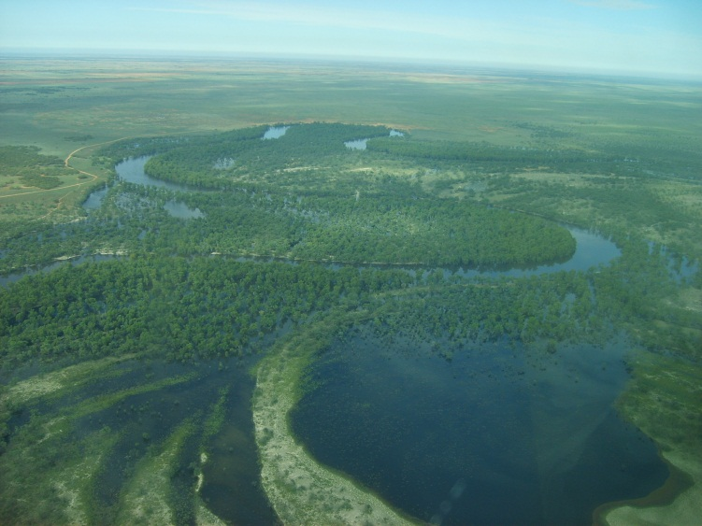

Photo: C. Campbell

Landscapes, however, are not uniform and the way vegetation communities respond to changes in flow regimes will also be influenced by the interaction of the flow regime with the landscape (Thoms et al. 2006). Geomorphological factors, such as; the shape, depth and size of rivers, wetlands and floodplains; the type of sediment present on which plants establish; the relative location of ecosystems within the landscape; and the connection between ecosystems will all influence the range of vegetation communities supported. The range, size and abundance of vegetation communities supported at any given time will also be dependent on the area of specific types of habitat available. It has been demonstrated that vegetation communities and the presence of plant species can vary substantially between wetlands, with many plant species only found in a few wetlands (Alexander et al. 2008). This ‘uniqueness’ of plant species can be partially attributed to differences in water regime and morphology at individual sites. Wetland and floodplain plant biodiversity within the landscape can be promoted and maintained by providing a diversity of wetland types with varying flood regimes within the landscape (Alexander et al. 2008; Barrett et al. 2010). The following section describes how wetland and floodplain vegetation diversity are affected by river flow through influences on connectivity and habitat (Figure 3).

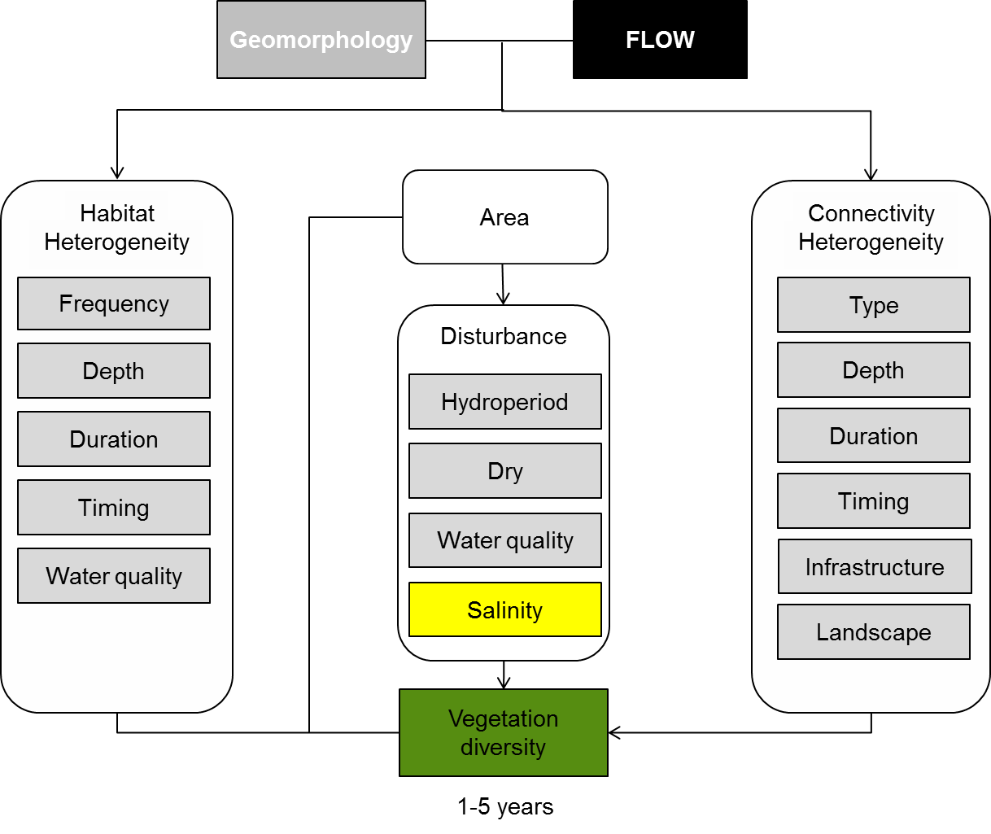

Figure 3: Cause and effect diagram depicting the influence of flow regime and geomorphology on landscape vegetation diversity

**Habitat heterogeneity:** Water regime is a major determinant of wetland plant germination and distribution (Brock and Casanova 1997; Casanova and Brock 2000). Maintaining a mosaic of habitat types within the landscape is likely to lead to high diversity of wetland vegetation communities and plant species, as the habitat requirements of a wide range of species or functional groupings of species is being catered for.

Flow variables, such as frequency, duration, depth and timing all influence the types of habitats that are available. For example, flood frequency has a significant influence on the growth of River Red Gum (*Eucalyptus camaldulensis*) (Rogers and Ralph 2010). While different studies suggest different ranges of frequency required or experienced by River Red Gum trees, the frequency of inundation required is greater than for other types of vegetation communities such as Black Box (*Eucalyptus largiflorens*) (Rogers and Ralph 2010; Roberts and Marston 2011 and references within). There is also some indication that the abundance and possibly presence of particular wetland understorey species or groups of species may be influenced by the frequency of inundation events experienced in wetlands (unpublished data). The role that cumulative environmental watering events play in determining the diversity of wetland vegetation communities requires further investigation.

Variations in the duration of inundation will be required for and favour different types of vegetation communities. For short-lived wetland species which germinate and grow on damp mud following the recession of floodwater, the duration of inundation needs to be such that adequate soil moisture is maintained to enable species to complete their life cycles (Nicol 2004). Spiny Mud Grass (*Pseudoraphis spinescens*), which grows after flooding from rootstock, requires a duration of inundation of seven months on average. Lignum (*Muehlenbeckia florulenta*) appears to achieve vigourous growth after three to seven months inundation, however it will not tolerate continuous flooding. In contrast, the shoots of Spiny Sedge (*Cyperus gymnocaulos*) will only tolerate inundation of two to four weeks (Roberts and Marston 2011 and references within).

As for duration of inundation, different vegetation communities require and occupy different depth zones. Submerged macrophytes, such as Ribbonweed (*Vallisnaria australis)* require water to grow, ideally from 50cm to 1m depending on water temperature and turbidity (Roberts and Marston 2011). A broad range of species occupy the wet-dry ecotone around the waterline, while other species are typically found above the waterline or germinating on exposed mud and will not tolerate continuous inundation (Brock and Casanova 1997).

The timing of both inundation and drying will affect the diversity of vegetation, through changes in the availability of propagules in different seasons as well as cues for germination. Different species may be cued to germinate at different times of year, whether by changes in temperature or day length. Different wetland vegetation assemblages have been recorded in different seasons (Campbell et al. 2012a), however little is known about the specific germination cues for individual plant species. For Lignum, timing is critical; flooding for dispersal and post-flood recession germination needs to be within a few months of seed release which occurs in autumn (Roberts and Marston 2011). Variable water regimes, which result in the presence of inundated, damp and dry habitats in different seasons, are likely to maximise the diversity of vegetation in the long-term and across landscape scales (Campbell et al. 2012; Campbell et al. 2012; Hayward et al. 2012).

Water quality variables, such as salinity, turbidity and temperature, will also influence the availability of different habitat types. Different species have different requirements and tolerances to water quality variables. As mentioned in relation to disturbance, changes in salt concentrations will result in changes in community composition. While an increase in salinity in naturally fresh systems is a detrimental disturbance, the maintenance and protection of naturally saline ecosystems, such as the Lower Lakes and inland saline wetlands is an important consideration in the maintenance of landscape scale diversity. These environments support saline specialist plant species which in turn provide habitat for other organisms (Wedderburn et al. 2007).

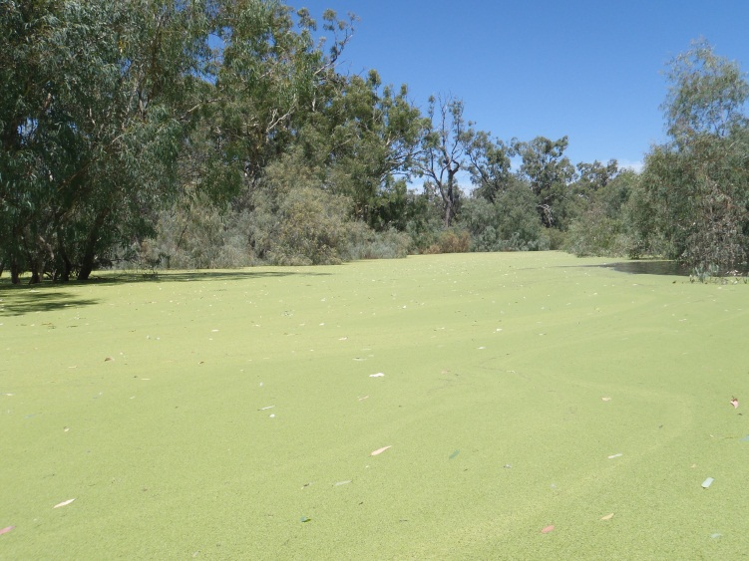

Photo: C. Johns

The availability of various habitats will be influenced by aspects of geomorphology, such as shape, depth, size and sediment type as well as by flow variables such as frequency, duration, depth and timing. The complexity of systems, for example the range of wetlands types, from near-permanent to ephemeral, present within an ecosystem will also influence the availability of habitat types. In order to maintain vegetation diversity on a landscape scale it is important to maintain as many habitat types as possible, through the maintenance of variable watering regimes (Alexander et al. 2008). To successfully achieve management goals such as the protection of biodiversity, it is important to acknowledge the inherent variability of many Australian aquatic ecosystems and the importance of preserving such variation in space and time (Boulton and Brock 1999).

**Disturbance:** Disturbance is a key driver of change in vegetation communities as it opens up new areas of habitat. The understorey vegetation of the Murray Darling Basin (MDB) is adapted to periodic disturbances including flooding that creates bare ground for plants to colonise (as referenced in Nicol and Weedon 2006). The majority of the floodplain understorey species in the MDB are short-lived and will die when flooded; however flooding is required to promote regeneration from seed and provide appropriate soil moisture for growth and recruitment (Cunningham et al. 1992; Nicol 2004). These species are adapted to regular disturbance by floods and will be replaced by drought tolerant species if flooding frequencies are reduced (Nicol and Weedon 2006).

Both the period of inundation (hydroperiod) and period of drying are important components of disturbance. The hydroperiod is required to provide habitat for submerged macrophytes that require the presence of water for growth. The hydroperiod needs to be sufficient to enable growth and the completion of life-cycles to ensure replenishment of seeds and propagules (Nicol 2004; Nielsen and Brock 2009) and to recharge soil moisture (Rogers and Ralph 2010). The drying phase promotes oxygenation, nutrient transformation and consolidation of sediments (Boulton and Brock 1999).

Particular vegetation communities and plant species have varying requirements and tolerances to water quality and salinity (Cramer and Hobbs 2002; Nielsen and Brock 2009 and references within). As such, changes in both of these will influence the survival of particular species and will promote or exclude competition between communities. A shift to more saline conditions (both within the soil and water column) may result in the loss of many wetland and floodplain plant species unadapted to high salt concentrations. However it may lead to an increase in species adapted to saline habitats such as Sea Tassel (*Ruppia* spp.) in aquatic environments or Rounded Noon-flower (*Disphyma crassifolium* ssp. *clavellatum*) in dry floodplain habitats.

Changes in water quality variables such as turbidity, affecting the euphotic depth and availability of light for plant growth (Boulton and Brock 1999; Porter et al. 2007), will also impact on the distribution and hence landscape diversity of aquatic macrophytes. Turbidity may be influenced by runoff and sediment mobilisation, and the destructive action of Carp (*Cyprinus carpio*) (Parkos et al. 2003; Gell et al. 2009). The distribution and hence landscape diversity of aquatic and floodplain vegetation is also likely to be influenced by distrubances such as grazing pressure (selecting for particular species and impacting on recruitment and regeneration) and surrounding landuse impacting on water quality in terms of nutrient loads and chemical inputs.

**Connectivity heterogeneity:** Flow regime, coupled with geomorphological factors such as the shape, depth, size and location of ecosystems, are the drivers behind the connectivity between rivers, wetlands and floodplains. The loss of floodplain to river channel connectivity results in a progressive transition from aquatic ecosystems to terrestrial ecosystems (Kingsford 2000). Flow variables, such as depth and duration, will affect the extent of connection possible between river-to-wetland-to-floodplain. The magnitude of the flow as well as the position of particular ecosystems or habitats within the landscape (i.e. their commence-to-flow level) will create a mosaic of ecosystems of varying depths, inundated for varying lengths of time.

The duration of the connection will also influence the amount of movement or interchange that is possible between different ecosystems within the landscape. In theory, the longer the connection between two locations exists, the more opportunity there will be for the dispersal of propagules, which may lead to increased diversity of particular vegetation communities or plant species within the connected landscape. Similarly, the timing of connection is likely to impact on the development of wetland plant communities. The availability of seeds and other propagules will vary during different seasons (refer to Rogers and Ralph 2010; Roberts and Marston 2011 and references within), thus the timing or season of connection will influence which particular plant species are available to be dispersed through the connected landscape.

The way in which a connection occurs (e.g. the type of connection) is likely to have an impact on observed outcomes (Wallace et al. 2011) including the diversity of vegetation. The type of connection can be natural and vary in its form such that the connection is direct from river to wetland or river to floodplain, or via a different flow path (e.g. river to creekline to wetland all inchannel, or river to wetland via overbank flooding of the floodplain). The extent to which the connection type engages the floodplain will alter the degree to which nutrients and carbon are mobilised and input into the system (Junk et al. 1989; Walker et al. 1995; Kingsford 2000).

The connection type can also be ‘artificial’ or ‘manipulated’ through the use of infrastructure (e.g. controlled releases, manipulation of structures, or pumping). Manipulated connections are likely to impact on nutrient cycling, dispersal and fill patterns. It is currently unknown what impact the type of flow connection is likely to have on biotic and abiotic responses (Wallace et al. 2011).

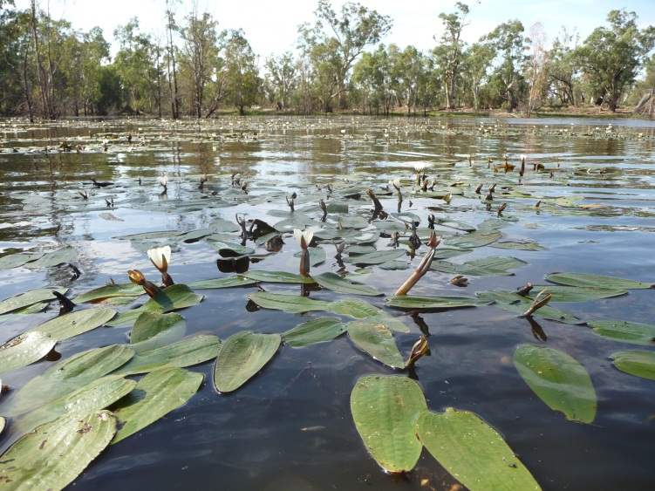

Photo: C. Johns

Where a particular location or ecosystem is situated in the landscape will influence how frequently it is connected, how much area is connected, as well as the duration and depth of the connection. To maintain a landscape mosaic of vegetation communities it is desirable to maintain a mosaic of ecosystems in different hydrological stages. For example, to maintain sites at any given time in varying degrees of inundation from overbank or above full-supply-level, through degrees of drawdown to complete drying for intermittent or ephemeral ecosystems.

**Knowledge gaps:** The influence of connectivity on landscape scale diversity is not well understood. Neither are the processes or cues that determine when and where particular plant species establish across the landscape. Few landscape-scale studies have been undertaken in Australia looking at the influence of flow regime on vegetation diversity.

**Use of the cause and effect diagram:** This is a generic diagram applicable across both the northern and southern parts of the basin.

**References**

Alexander P, Nielsen DL, Nias D (2008) Response of wetland plant communities to inundation within floodplain landscapes. Ecological Management & Restoration 9:187-195 doi: 10.1111/j.1442-8903.2008.00417.x

Barrett R, Nielsen DL, Croome R (2010) Associations between the plant communities of floodplain wetlands, water regime and wetland type. River Research and Applications 26:866-876 doi: 10.1002/rra.1299

Blanch J, Ganf G, Walker K (1999) Tolerance of riverine plants to flooding and exposure indicated by water regime. Regulated Rivers: Research and Management 15:43-62

Boulton AJ, Brock MA (1999) Australian Freshwater Ecology: processes and management. Gleneagles Publishing, Glen Osmond SA

Brock M (2011) Persistence of seed banks in Australian temporary wetlands. Freshwater Biology 56:1312-1327

Brock M, Casanova M (1997) Plant life at the edge of wetlands: ecological responses to wetting and drying patterns. In: Klomp N, Lunt I (eds) Frontiers in Ecology: Building the Links. Elsevier Science, Oxford, pp 181-192

Campbell CJ, Healy S, D'Santos P (2012) Value of environmental watering during drought years: Wetland vegetation response. In. Final report prepared in conjunction with NSW Office of Environmental and Heritage by The Murray-Darling Freshwater Research Centre

Casanova M, Brock M (2000) How do depth, duration and frequency of flooding influence the establishment of wetland plant communities? Plant Ecology 147:237-250

Cramer VA, Hobbs RJ (2002) Ecological consequences of altered hydrological regimes in fragmented ecosystems in southern Australia: Impacts and possible management responses. Austral Ecology 27:546-564

Cunningham GM, Mulham WE, Milthorpe PL, Leigh JH (1992) Plants of western New South Wales. Inkata Press, Marrickville, NSW

Gell P et al. (2009) Anthropogenic acceleration of sediment accretion in lowland floodplain wetlands, Murray–Darling Basin, Australia. Geomorphology 108:122-126 doi: 10.1016/j.geomorph.2007.12.020

Hayward GJ, Campbell CJ, Johns CV (2012) Wetland and floodplain vegetation assemblages. In: Henderson M et al. (eds) The Living Murray Condition Monitoring at Hattah Lakes 2011/12: Part A - Main Report. Final report prepared for the Mallee Catchment Management Authority by The Murray-Darling Freshwater Research Centre

Junk W, Bayley P, Sparks R (1989) The flood pulse concept in river-floodplain systems. In: Dodge D (ed) Proceedings of the International Large River Synposium. Canadian Special Public Fisheries and Aquatic Science, pp 110-127

Kingsford RT (2000) Ecological impacts of dams, water diversions and river management on floodplain wetlands in Australia. Austral Ecology 25:109-127

Nicol J, Weedon J (2006) Understorey vegetation monitoring of the Chowilla River Red Gum watering trials. In. Aquatic Sciences, South Australian Research and Development Institute, Adelaide, SA, p 83

Nicol JM (2004) Vegetation Dynamics of the Menindee Lakes with reference to the seedbank. PhD thesis. The University of Adelaide

Nielsen D, Brock M (2009) Modified water regime and salinity as a consequence of climate change: prospects for wetlands of Southern Australia. Climatic Change 95:523-533 doi: 10.1007/s10584-009-9564-8

Parkos JJ, III, Santucci VJ, Jr., Wahl DH (2003) Effects of adult common carp (Cyprinus carpio) on multiple trophic levels in shallow mesocosms. Canadian Journal of Fisheries and Aquatic Sciences 60:182-192

Porter JL, Kingsford RT, Brock MA (2007) Seed banks in arid wetlands with contrasting flooding, salinity and turbidity regimes. Plant Ecology 188:215-234 doi: 10.1007/s11258-006-9158-8

Roberts J, Marston F (2011) Water regime for wetland and floodplain plants: a source book for the Murray-Darling Basin. National Water Commission, Canberra

Rogers K, Ralph T (2010) Floodplain wetland biota in the Murray-Darling Basin: water habitat requirements. CSIRO Publishing, Collingwood, Victoria

Thoms MC, Beyer PJ, Rogers KH (2006) Variability, complexity and diversity: the geomorphology of river ecosystems in dryland regions. In: Kingsford RT (ed) Ecology of Desert Rivers. Cambridge University Press, Cambridge

Walker K, Sheldon F, Puckridge J (1995) A perspective on dryland river ecosystem. Regulated Rivers: Research and Management 11:85-104

Wallace T et al. (2011) "Natural" versus "Artifical" watering of floodplains and wetlands. In. Draft report prepared for the Murray-Darling Basin Authority by The Murray-Darling Freshwater Research Centre, p 28pp

Wedderburn SD, Walker KF, Zampatti BP (2007) Habitat separation of Craterocephalus (Atherinidae) species and populations in off-channel areas of the lower River Murray, Australia. Ecology of Freshwater Fish 16:442-449 doi: 10.1111/j.1600-0633.2007.00243.x

# 3 Vegetation condition and reproduction

The vegetation community within a freshwater ecosystem is an important determinant of the ecosystem’s function and condition. The vegetation community contributes to the freshwater ecosystem diversity by increasing flow heterogeneity, binding soils and substrate, and reducing erosion and trapping suspended sediments. Plants in freshwater ecosystems contribute either directly or indirectly to water quality parameters such as dissolved oxygen, carbon and nitrogen levels, providing direct and indirect food resources to invertebrates, waterbirds, amphibians, fish and other animals; and providing structure for other biota to live on or around. As the distribution and abundance of vegetation within freshwater ecosystems are influenced by hydrology, any alterations to these cycles are likely to impact on the composition and structure of the ecosystem (Wallace et al. 2007), influencing community and individual condition and reproduction of plants within that community. The following section describes how vegetation condition and reproduction are affected by river flow through its influence on habitat, cues and connectivity and (Figure 4).

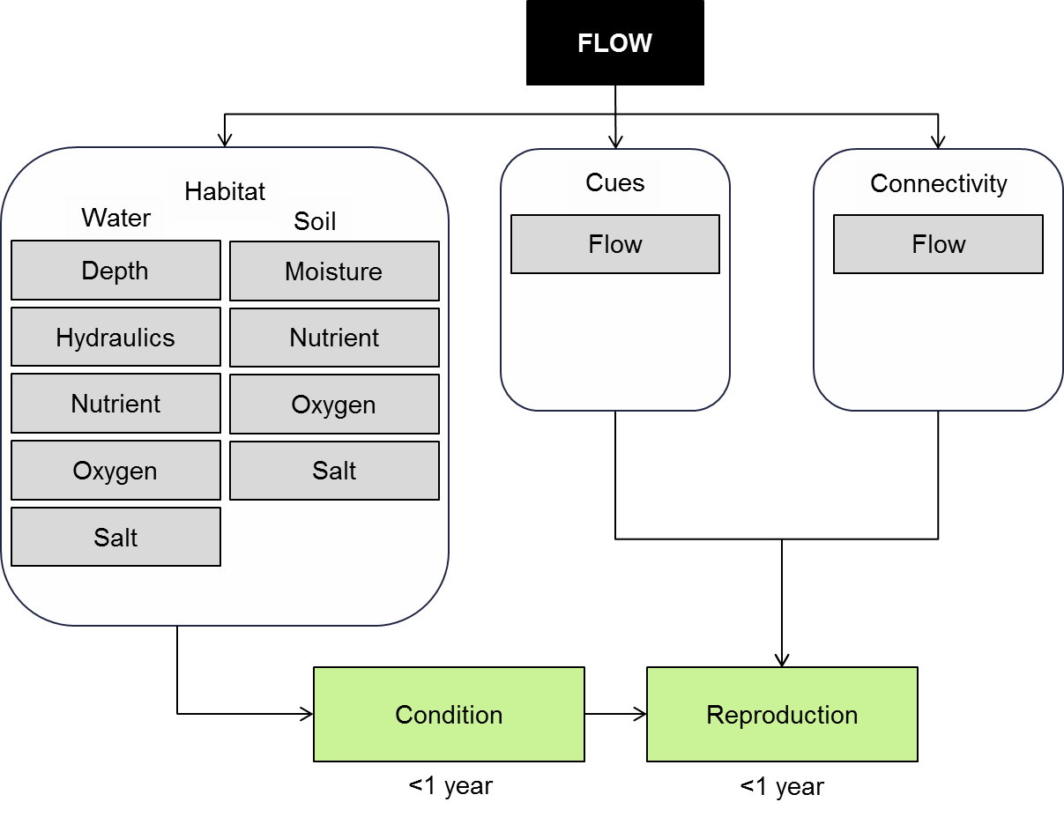

**Figure 4*.* Causeand *e*ffect diagram depicting the influence of flow regime on vegetation condition and reproduction.**

**Habitat:** Flooding of wetlands, rivers and floodplains is a natural process producing a number of environmental benefits. Alternating periods of drought and flooding are responsible for changes in wetland productivity and plant communities (Euliss et al. 2004). Flooding increases soil moisture and contributes silt and nutrients to the flood plain soils stimulating the germination and growth of aquatic plants and the inundation and decomposition of terrestrial plants (Casanova and Brock 2000). As the duration of flooding increases the condition of aquatic plants increases through the uptake of nutrients. These nutrients become re-available during periods of drought when the accumulated plant litter decomposes (Euliss et al. 2004; Boulding and Baldwin 2009). Nutrient enrichment of a water body, particularly in the case of nitrogen and phosphorus, may lead to algal blooms to develop and the abundance of submerged aquatic plants to decrease (Kosten et al. 2009).

The volume, duration, and frequency of flooding influences the abundance and richness of aquatic plant communities (Nielsen and Chick 1997). Communities that grow in ephemeral habitats are more species rich and abundant when subjected to frequent, short, shallow flooding rather than the low frequency of long deep floods (Casanova and Brock 2000). In comparison, submerged aquatic plants such as Vallisneria americana need floods to persist for several years before flowering is initiated and require floods that are of a longer duration and depth (Roberts and Marston 2011).

In more permanently wet or dry systems, both terrestrial and aquatic species may be more abundant over the amphibious plant groups, which respond to wetting/drying cycles (Brock and Casanova 1997; Nielsen et al. in press). Changes in the dominant functional groups and condition of vegetation communities, may be a direct result of lack of water (i.e. submerged species unable to tolerate dry areas), increase in salinity in the soil and/or water, drought conditions, frequency of wetting events and oxygen deficiency in the soil and/or water (Durant et al. 2009).

Alternatively, by altering water regimes, flow regulation can facilitate plant invasion by providing conditions that directly benefit invading species or by reducing competition from native species unsuited to the modified conditions (Catford et al. 2011). During dry periods while moisture is still prevalent in the soil, Eucalyptus camaldulensis can germinate and establish within a creek bed. As seedlings become established, as root systems extend and sapling height increases, seedlings can survive flooding up to six months (Roberts and Marston 2011). This expansion of emergent species and E. camaldulensis saplings can restrict the growth of other emergent, submerged and understorey species.

Wetland and floodplain sediments contain seed banks composed primarily of species produced during previous climate cycles. As water levels decrease during drought, part or all of the sediment is exposed and seeds from terrestrial, amphibious and emergent plants germinate. When wetlands re-flood, amphibious and terrestrial plants are replaced by emergent and submerged macrophytes adapted to more aquatic conditions. Extended dry periods also influence the viability of the seed banks present and can have a substantial impact on the biodiversity the ecosystem can subsequently support (Nielsen et al. in press). However, the seed bank is not long-lived and declines in both species richness, the abundance of seeds germinating begins to decline after 10 years (Leck and Brock 2000; Brock 2011; Nielsen et al. in press).

Desiccation, high temperatures, increased salinity and environmental changes that may often accompany drawdown, may limit the re-establishment of communities from the seed bank. Seed reserves on some species within a freshwater ecosystem may be naturally very low and/or all seeds present germinate in response to a single wetting and therefore, on subsequent wettings, are no longer encountered (Brock et al. 2003). Germination of plants from the seed bank is inhibited by increasing salinity with a substantial decline in germination occurring as salinity rises above 1000 mg L-1 with few species capable of germinating or surviving once salinity approaches 5000 mg L-1 (Nielsen et al. 2003; Brock et al. 2005). Similarly, very few species will germinate from the sediments of wetlands that have become acidic (Ning et al. 2011).

Different rates of velocity flows into wetlands affect the condition and breeding of vegetation communities and their habitats in different ways. Frequent high velocity flows cause sediment scour that impedes the establishment of aquatic vegetation by breaking and uprooting plants but they can promote high bio-diversity by hindering competitive exclusion, while low velocity flows often deposit finer sediments impeding seed development through deep burial (Barrett et al. 2010).

In terms of individual condition, one of the best known influences of flow and habitat on vegetation condition is the response of River red gum. Widespread declines in condition have been observed in response to changes in flow (Mac Nally et al., 2001) or through a combination of changes in flow and rising saline groundwater (Slavich et al., 1999, Overton et al., 2006). The response of River red gum to changes in flooding have enabled identification of River red gum flow requirements that suggest that the frequency and duration of inundation are important, but vary among habitats (Wen et al., 2009).

The condition of individual seeds is also an important influence on vegetation communities as seed viability will influence the response to environmental flows. Observations of seed viability has shown that it declines with the duration of the dry period (Brock 1998, Brock et al., 2003).

**Cues**: Many riparian plants have life cycles adapted to seasonal timing components of natural flow regimes through their ‘emergence phonologies’ – the seasonal sequence of flowering, seed dispersal, germination and seedling growth (Poff et al. 1997). Seasonal adapted reproductive patterns have been reported for macrophytes inhabiting unpredictable wetlands within temperate regions of Australia (Greet et al. 2011).

Flow timing has also been shown to influence productivity of vegetation communities, with riparian forests showing increases in growth during short-duration flooding that occurs in the growing season (Poff et al. 1997) and aquatic macrophyte’s growth was greater following a spring rather than summer flood (Roberston et al. 2001).

Connectivity:

Vegetation condition is affected by hydrological connectivity as the connection between an individual plant’s habitat and the source of water will influence key habitat characteristics including the frequency and duration of inundation. The connectivity between surface water and groundwater may also be a key influence on the condition of trees that rely on groundwater.

Connectivity can influence both sexual and asexual reproduction. The timing of connection has been found to influence flowering among macrophytes with variation among groups. Amphibious species and native annuals flowered only in response to inundation in spring, while emergent macrophytes flowered in spring or summer and introduced annuals flowered only in summer (Greet et al., 2013). The influence of connectivity on overall moisture levels also influences the species that will reproduce with many exotic species reproducing only under dryer conditions (Stokes et al., 2010). Asexual reproduction occurs when part of a plant becomes separated from the parent and is then able to develop into an independent plant. The movement of water can be an important influence on both the fragmentation process and the subsequent dispersal of the propagule to appropriate habitat where it can establish (Santamaria, 2002, Nilsson et al. 2010).

**Knowledge gaps:** Most research into wetland vegetation has focused on over story trees or large shrubs. Very little is known about smaller understorey species, such as sedges, rushes, herbs and forbs, in relation to ideal germination timing, flood timing, flood duration and flood depth (Rogers and Ralph 2011). These understorey species make up a significant component of the diversity observed within wetlands. Little is also known about the potential cues that trigger seeds to germinate or the effects that artificial connection types are likely to have on both biotic and abiotic processes. The maintenance of wetland vegetation diversity requires an understanding of the conditions required for the growth and successful regeneration of wetland vegetation. It also requires an understanding of the links between the conditions required for growth and successful regeneration and the flow variables (such as inundation, drawdown, timing, frequency and duration) that create those conditions.

**Use of the cause and effect diagram:** This generic diagram is applicable across both the northern and southern parts of the Basin. Its application to particular circumstances or species would require additional information and potential modification of the model.

**References**

Barrett R, Nielsen DL, Croome R (2010) Associations between the plant communities of floodplain wetlands, water regime and wetland type. River Research and Applications 26:866-876

Brock, M. A., Nielsen, D. L., Shiel, R. J., Green, J. D. and Langley, J. D. (2003) Drought and aquatic community resilience: The role of eggs and seeds in sediments of temporary wetlands. Freshwater Biology 48, 1207-1218.

Boulding A, Baldwin DS (2009) Assessing the impacts and potential control of terrestrial plant colonization of a reservoir bed during an extreme drawdown event. Lakes & Reservoirs: Research & Management 14:21-30 doi: 10.1111/j.1440-1770.2009.00388.x

Brock, M. A. (1998) Understanding plant germination, establishment and reproduction for wetland vegetation. In 'Wetlands in a dry land: Understanding for management'. (Ed. W. D. Williams) pp. 131-136. (Environment Australia, Biodiversity Group: Canberra)

Brock MA (2011) Persistence of seed banks in Australian temporary wetlands. Freshwater Biology 56:1312-1327 doi: 10.1111/j.1365-2427.2010.02570.x

Brock MA, Casanova MT (1997) Plant life at the edge of wetlands: ecological responses to wetting and drying patterns. In: Klomp N, Lunt I (eds) Frontiers in Ecology: building the links. Elsevier Science Ltd., Oxford, pp 181-192

Brock MA, Nielsen DL, Crosslé K (2005) Changes in biotic communities developing from freshwater wetland sediments under experimental salinity and water regimes. Freshwater Biology 50:1376–1390

Brock MA, Nielsen DL, Shiel RJ, Green JD, Langley JD (2003) Drought and aquatic community resilience: the role of eggs and seeds in sediments of temporary wetlands. Freshwater Biology 48:1207-1218

Casanova M, Brock MA (2000) How do depth, duration and frequency of flooding influence the establishment of wetland plant communities? Plant Ecology 147:237-250

Catford JA, Downes BJ, Gippel CJ, Vesk PA (2011) Flow regulation reduces native plant cover and facilitates exotic invasion in riparian wetlands. Journal of Applied Ecology 48:432-442

Durant R, Nielsen D, Reid C, Durant R, Nielsen D, Reid C (2009) Monitoring of temporarily disconnected River Murray Wetlands Final Report. In. Report prepared for South Australian Murray-Darling Basin Natural Resources Management Board, January

Euliss NHJ et al. (2004) The wetland continuum: a conceptual framework for interpreting biological studies. Wetlands 24:448-458

Figuerola J, Green AJ (2002) Dispersal of aquatic organisms by waterbirds: a review of past research and priorities for future studies. Freshwater Biology 47:483-494 doi: 10.1046/j.1365-2427.2002.00829.x

Gawne, B. and Scholz, O. (2006) Synthesis of a new conceptual model to facilitate management of ephemeral deflation basin lakes. Lakes and Reservoirs: Research and Management 11, 177-188.

Greet, J., Cousens, R. D. and Webb, J. A. (2013) Seasonal timing of inundation affects riparian plant growth and flowering: Implications for riparian vegetation composition. Plant Ecology 214, 87-101

Greet J, Webb JA, Cousens RD (2011) The importance of seasonal flow timing for riparian vegetation dynamics: a systematic review using causal criteria analysis. Freshwater Biology 56:1231-1247

Jansson R, Zinko U, Merritt DM, Nilsson C (2005) Hydrochory increases riparian plant species richness: a comparison between a free-flowing and a regulated river. Journal of Ecology 93:1094-1103 doi: 10.1111/j.1365-2745.2005.01057.x

Kingsford, R. T., Jenkins, K. M. and Porter, J. L. (2004) Imposed hydrological stability on lakes in arid australia and effects on waterbirds. Ecology 85, 2478-2492.

Kosten S et al. (2009) Climate-related differences in the dominance of submerged macrophytes in shallow lakes. Global Change Biology 15:2503-2517 doi: 10.1111/j.1365-2486.2009.01969.x

Leck MA, Brock MA (2000) Ecological and evolutionary trends in wetlands: evidence from seeds and seed banks in New South Wales, Australia and New Jersey, USA. Plant Species Biology 15:97-112

Mac Nally, R., Cunningham, S. C., Baker, P. J., Horner, G. J. and Thomson, J. R. (2011) Dynamics of murray-darling floodplain forests under multiple stressors: The past, present, and future of an australian icon. Water Resources Research 47

Maher, M. and Carpenter, S. M. (1984) Benthic studies of waterfowl breeding habitat in south-western new south wales. Ii chironomid populations. Australian Journal of Marine and Freshwater Research 35, 97-110.

Moggridge HL, Gurnell AM (2010) Hydrological controls on the transport and deposition of plant propagules within riparian zones. River Research and Applications 26:512-527 doi: 10.1002/rra.1273

Nielsen D, Podnar K, Watts R, Wilson A (in press) Empirical evidence linking increased hydrologic stability with decreased biotic diversity within wetlands. Hydrobiologia:1-16 doi: 10.1007/s10750-011-0989-5

Nielsen DL, Brock MA (2009) Modified water regime and salinity as a consequence of climate change: prospects for wetlands of Southern Australia. Climatic Change 95:523-533

Nielsen DL, Brock MA, Crosslé K, Harris K, Healey M, Jarosinski I (2003) The effects of salinity on aquatic plant germination and zooplankton hatching from two wetland sediments. Freshwater Biology 48:2214-2223

Nielsen DL, Chick AJ (1997) Flood-mediated changes in aquatic macrophyte community structure. Marine and Freshwater Research 48:153-157

Nilsson, C., Brown, R. L., Jansson, R. and Merritt, D. M. (2010) The role of hydrochory in structuring riparian and wetland vegetation. Biological Reviews 85, 837-858

Ning NSP, Nielsen DL, Baldwin DS (2011) Assessing the potential for biotic communities to recolonise freshwater wetlands affected by sulfidic sediments. Freshwater Biology 56:2299-2315 doi: 10.1111/j.1365-2427.2011.02657.x

Overton, I., Jolly, I. D., Slavich, P. G., Lewis, M. and Walker, G. (2006) Modelling vegetation health from the interaction of saline groundwater and flooding on the chowilla floodplain, south australia. Australian Journal of Botany 54, 207-220.

Poff NL et al. (1997) The natural flow regime. BioScience 47:769-784

Roberston AL, Bacon P, Heagney G (2001) The responses of floodplain primary production to flood frequency and timing. Journal of Applied Ecology 38:126-136

Roberts J, Marston F (2011) Water regime for wetland and floodplain plants: a source book for the Murray–Darling Basin. In. National Water Commission, Canberra

Rogers K, Ralph TJ (2011) Floodplain Wetland Biota in the Murray-Darling Basin: Water and Habitat Requirements. CSIRO Publishing, Melbourne

Santamaria, L. (2002) Why are most aquatic plants widely distributed? Dispersal, clonal growth and small-scale heterogeneity in a stressful environment. Acta Oecologica-International Journal of Ecology 23, 137-154

Slavich, P. G., Walker, G. R., Jolly, I. D., Hatton, T. J. and Dawes, W. R. (1999) Dynamics of eucalyptus largiflorens growth and water use in response to modified watertable and flooding regimes on a saline floodplain. Agricultural Water Management 39, 245-26

Stokes, K., Ward, K. and Colloff, M. (2010) Alterations in flood frequency increase exotic and native species richness of understorey vegetation in a temperate floodplain eucalypt forest. Plant Ecology 211, 219-233.

Wallace T, Gawne B, McCarthy BJ, Nielsen DL, Vilizzi L (2007) A standardised protocol for assessing the suitability of permanent wetlands for disconnection. In. Report to the Murray-Darling Basin Commission, Murray-Darling Freshwater Research Centre.

Wen, L., Ling, J., Saintilan, N. and Rogers, K. (2009) An investigation of the hydrological requirements of river red gum (eucalyptus camaldulensis) forest, using classification and regression tree modelling. Ecohydrology 2, 143-155.

# 4 Vegetation recruitment and extent

Patterns of dispersal have a profound influence on the diversity of plant communities (Jansson et al. 2005; Brederveld et al. 2011), community dynamics (Hopfensperger and Baldwin 2009), distribution (Santamaría 2002) and the outcomes of restoration initiatives (Hopfensperger and Baldwin 2009; Brederveld et al. 2011).

Plants disperse in a variety of ways as either seeds or fragments that are capable of developing into an independent plant. Together seeds and fragments are called propagules. Propagules may be dispersed by wind (anemochory) or water (hydrochory) or by animals by either sticking to their bodies or by surviving passage through their gut (Figuerola and Green 2002). Different species have different dispersal strategies with some being heavily reliant on flow while others are more reliant on wind (e.g. cumbungi). Flow has the potential to influence dispersal either directly or indirectly through its influence on animals. This description will focus on the direct influences of flow on propagule dispersal as a main component of vegetation recruitment and extent (Figure 5).

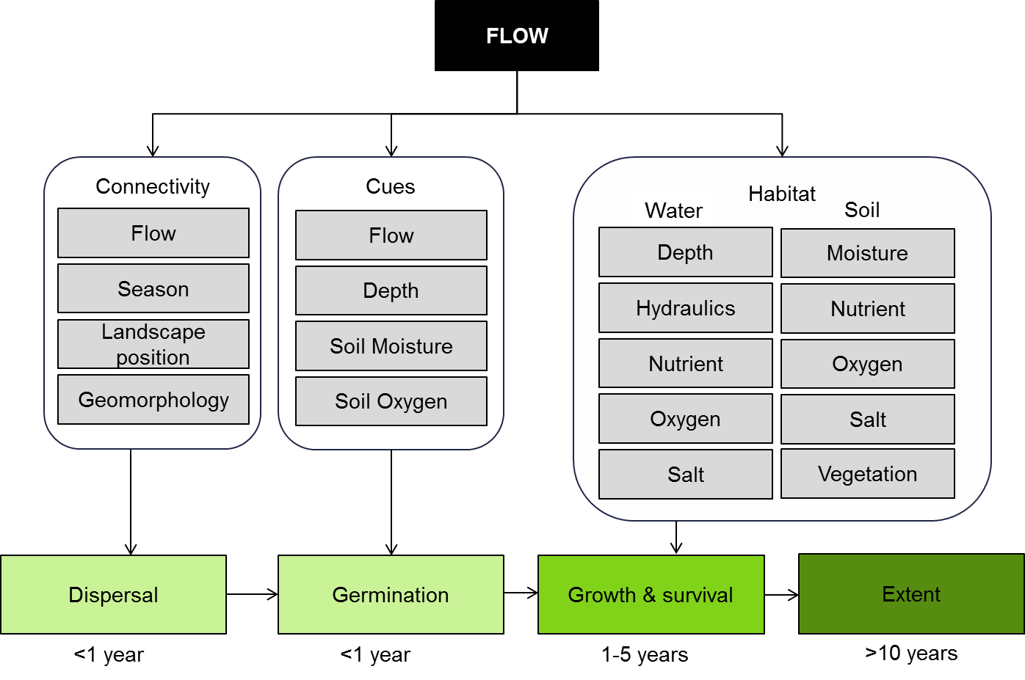

Figure 5. Cause and effect diagram depicting the influence of flow on vegetation recruitment and extent.

**Connectivity:** Flow is one of the major influences on dispersal with velocity determining whether a seed will be entrained (Gurnell et al. 1998) and how far it is carried (Groves et al. 2009). Hydraulic conditions may also influence the distance dispersed and deposition (Merritt and Wohl 2002; Nilsson et al. 2002). Floods are believed to be particularly important (Cellot et al. 1998) due to their ability to disperse propagules large distances (Moggridge and Gurnell 2010). Floods are associated with increases in the arrival of seeds (Jansson et al. 2005). Rising flows tend to entrain propagules (Merritt and Wohl 2002) and move seeds out of storage (Gurnell et al. 2008) while low flow and descending flow promotes settlement (Merritt and Wohl 2002).

Timing of flows is also an important influence (Greet et al. 2011) as different species reproduce at different times of the year and so the timing of the connection will influence dispersal of individual species (Moggridge and Gurnell 2010). For example, the period of peak seed-fall for river red gum is September to November, so floods during this period will favour dispersal, while many annual species reproduce later in the year, for example cumbungi, requiring flows to disperse seeds in summer and autumn (Roberts and Marston 2011). In some instances, the seeds will reside in the seedbank before being entrained by flow (Roberts and Marston 2011), in which case the flow velocity will once again be an important influence. In some instances, the timing of flow will still be important as establishment, once deposited, requires favourable conditions and if flows occur at the wrong time, establishment may be constrained (Stella et al. 2006).

Infrastructure, such as dams, has been found to influence dispersal (Andersson et al. 2000; Merritt and Wohl 2002; Jansson et al. 2005) reducing the dispersal of propagules and, over the long term, influencing the vegetation community composition (Jansson et al. 2005). The presence of vegetation within flow pathways will also influence dispersal by creating areas of low flow and potentially trapping seeds (Soomers et al. 2010).

**Cues:** Seed germination and the establishment of a healthy seedling are fundamental features for the propagation of plant species (Rajjou et al. 2012). Germination is regarded as the most critical stage in the plant life cycle due to its high vulnerability to injury, disease, and environmental stress (Rajjou et al. 2012). Flow alterations have contributed to a decline in the germination of many aquatic and semi-aquatic plant taxa through the modification and/or removal of plant germination cues and a decline in seedbank abundance and viability (Brock and Rogers 1998; Siebentritt et al. 2004). The following section describes how plant germination is affected by river flow through its influences on cues and seed availability.

Climatic conditions (Baskin et al. 1998), soil characteristics (Greenwood and MacFarlane 2006) and hydrology/flow regime (Blanch et al. 2000; Ning et al. 2012) all play an important role in cuing germination. Climatic conditions relating to season, including temperature and light, are regarded as fundamental germination cues (Baskin et al. 1998). Seeds need to respond to seasonal environmental cues to germinate at appropriate times of the year to maximise their chances of establishment (Donohue et al. 2007).

The soil characteristics of soil moisture, oxygen (Bewley 1997) and salinity (Greenwood and MacFarlane 2006) have also all been widely recognised for their important role in germination. Suitable soil moisture and soil oxygen concentrations are required to break seed dormancy (Bewley 1997), whilst excessive salinity concentrations can slow down water uptake by seeds, inhibiting germination and root elongation (Greenwood and MacFarlane 2006).

Hydrological cues, particularly inundation timing, inundation duration and drawdown rates/depth changes, are believed to be the major forces shaping plant germination in wetland habitats (Nielsen and Chick 1997; Blanch et al. 2000; Casanova and Brock 2000; Nicol and Ganf 2000; Ning et al. 2012). A number of studies have reported a reduction in plant diversity in wetlands that have been artificially permanently flooded (Nielsen and Chick 1997), as well as in weir pools with stabilised water levels (Blanch et al. 2000). These studies have all attributed the response to the removal of hydrological germination cues.

In many cases, the alteration and/or removal of germination cues in response to flow alterations has been found to be detrimental to the germination of native species and/or favourable to the germination of weedy species (Greet et al. 2011). Environmental flows offer the potential to reinstate and/or ameliorate the affected germination cues for native taxa; however, the use of such flows remains hampered by a lack of knowledge regarding the specific cue types, combinations and thresholds required for the successful germination of target species. Indeed, most of the knowledge regarding cues for germination relates to terrestrial species and much less is known for aquatic and semi-aquatic taxa, particularly at the species level.

In addition to the alteration and removal of germination cues, the seedbanks in many aquatic ecosystems have become impoverished and/or undergone a reduction in viability. Flow alterations associated with river regulation in particular, are thought to be responsible for reducing seedbank abundance and viability in some systems:

* directly through the effects of a reduced flooding frequency in limiting opportunities for flood-tolerant and responsive taxa to replenish this reserve of seeds (Brock and Rogers 1998; Siebentritt et al. 2004) and/or reducing the viability of the seedbank (Nielsen et al. 2012)
* indirectly through their effects on sediment and water physico-chemistry (e.g. sulfidic sediments (Ning et al. 2012).

Seed bank studies have generally shown that once the period of time a wetland remains dry exceeds 10 years, there is a decline in both the abundance and richness of plants germinating largely due to a reduction in seedbank viability (Leck and Brock 2000; Brock et al. 2003; Brock 2011; Nielsen et al. 2012). Comparatively less remains known about the effects of flow-mediated changes to sediment or water physico-chemistry on the resilience of plant seeds. Nonetheless, the few studies that have been undertaken suggest that such physico-chemical changes may be just as influential on seedbank abundance and viability as flow alterations themselves (Ning et al. 2012).

Following successful germination of plant species, continued growth and survival is required to ensure plants reach maturity. Established plants affect a range of processes and trophic interactions from provision of a range of structural habitats, to nutrient cycling and altering of microclimates and water quality (Warfe and Barmuta 2006; Mokany et al. 2008; Colloff and Baldwin 2010). Environmental conditions have to be suitable for plant growth and survival to be successful in the short and also long term. Suitable environmental conditions for growth and survival will vary between species; however, the provision of suitable habitat for the growth and survival of target plant species will likely lead to an increase in the extent of these species or communities over appropriate time scales. The following section describes how vegetation growth and survival are affected by river flow through its influences on connectivity, cues and habitat which ultimately leads to an increase in extent (Figure 5).

**Habitat:** The habitat available for plant species to grow in will determine the type of vegetation communities present, the growth and survival of those communities and, across longer timeframes, the spatial extent of vegetation communities. Flow influences the available habitat for plant species growth and survival in terms of water regime variables such as water depth, velocity and available soil moisture; and access to adequate and appropriate levels of nutrients, salt and oxygen in both the water column and the soil. Competition with other vegetation supported by the flow regime will also influence the growth and survival of individual plants.

High levels of flow in riverine areas can, in many cases, lead to flooding. The water depth associated with flooding can be either an important disturbance or requirement for plant growth and survival (Banach et al. 2009). The likelihood of a flood disturbance becoming a stress for vegetation depends on the characteristics of the flood, the initial condition of the vegetation and the water requirements of the individual species. Peak performance of a species in response to flow disturbance depends on the species unique adaptations to flood and drought as well as the characteristics of the flow such as depth, duration, velocity and water quality (Rogers and Ralph 2011).

The flood tolerance of species’ determines their distribution along flooding gradients of the river (Brock and Casanova 1997). Amphibious wetland plants tolerate or respond to the fluctuating presence or absence of water, whereas true aquatics cannot tolerate drying and terrestrial plants will not tolerate flooding. Vegetation zones on the floodplain often reflect differences in flooding tolerance and requirements at the individual plant level. Pioneer (or colonising) plants are able to establish in open environments left bare by recent inundation. Species from elevated sites that are rarely flooded mainly belong to later successional stages and may invade lower elevations during times of extended drought. Species from the mid-successional stages occur in the intervening zones (Blom and Voesenek 1996).

The water regime requirements for plant growth and survival vary depending on the individual species. For example, species such as river red gum (*Eucalyptus camaldulensis*) which occur relatively low on the floodplain at the edge of rivers and wetlands, require flooding every one to four years for approximately two to seven months. Whereas, black box (*Eucalyptus largiflorens*), which occurs much higher on the floodplain, requires flooding every three to seven years for three to six months (Roberts and Marston 2011). The way in which particular water-regime variables, such as water depth, affect growth and survival is also closely linked to life-history. Larger tree species, such as river red gum and black box require only intermittent inundation, where the depth of inundation is important through its influence on flood duration (except where flood depth overtops individual plants, which can occur in the earlier stages of growth post-germination). However, true aquatic species that cannot tolerate drying, such as the submerged macrophyte ribbon-weed (*Vallisnaria australis*) requires the presence of water, typically between 50cm to 1m to grow and survive (Roberts and Marston 2011).

Water depth is also directly related to soil moisture/flooding. Floodwaters recharge soil moisture and can be retained in soils for up to one month after inundation (Rogers and Ralph 2010). Soil flooding causes displacement of gases when soil pores are filled with water. This leads to a limitation of oxygen availability for plant roots, soil micro-organisms and chemical processes, and leads to a switch in metabolism from aerobic to the less efficient anaerobic fermentation causing a fast depletion of carbohydrate reserves and eventually death for some species (Banach et al. 2009). Under these conditions, important oxygen-dependent microbial processes, such as nitrification, will no longer take place (Blom and Voesenek 1996). However, many wetland and floodplain plant species have developed strategies to tolerate or respond to inundation. Survival during flood submergence will depend largely on the timing, frequency, depth and duration of the flood events and will vary for individual species. Much of what is known about the water requirements and tolerances of wetland and floodplain plants is summarised by Roberts and Marston (2011) and Rogers and Ralph (2011).

Flooding of soils also facilitates a number of chemical and biological processes likely to be beneficial to plant growth and survival. Re-wetting of sediments can release significant amounts of nutrients such as nitrogen, phosphorus and carbon, influencing microbial activity and the availability of energy to foodwebs (Boulton and Brock 1999). Nutrients such as phosphorus, nitrogen and silica are essential for plant growth. However, in excess, they can encourage the growth of algae (Shafron et al. 1990) which, depending on the type, can be toxic to humans and other animals or may limit the development of other macrophytes. The direct links between chemical and biological processes that occur post-flooding and their impact on vegetation growth and survival is not well understood.

The velocity, or current speed, of flows may also influence vegetation growth and survival. Very high velocities may displace vegetation, such as submerged macrophytes, as well as mobilise sediments affecting water quality factors such as turbidity and euphotic depth (light penetration). Very low velocities, or no flow, may impact on vegetation growth and survival through changes in water quality factors such as temperature and oxygen (Naiman et al. 2005).

Floods and droughts have long-term consequences for biota. Low flows (droughts) have equally important long-term effects on plant growth and survival as high flows (flooding), through fundamental changes to biogeochemical processes and to plant distribution. Conditions deteriorate as drought severity becomes acute. Plant biomass and production decline and palatable plant species are often overgrazed in riparian corridors. This leads to litter quality and nitrogen availability being reduced, fires may become more frequent and terrestrial plant species extensively colonise the river corridor (Stromberg et al. 2007). When flood frequency decreases, trees, particularly river red gum, are likely to exhibit signs of stress and a decline in reproductive ability (Rogers and Ralph 2010). Growth of river red gums is significantly influenced by flow and the frequency of floods. Numerous studies have found accelerated growth of river red gums in association with abundant surface waters (Rogers and Ralph 2010). The ability of vegetation such as river red gums and black box to respond (in terms of growth and survival) to a disturbance event, such as flooding, appears to also be closely related to the health or condition prior to flooding (unpublished data). Trees in poor condition (less than 40% crown condition) having a greater likelihood of mortality post-flooding than trees in better condition (unpublished data).

Altered flow regimes can also affect the competition between plant species, especially with respect to introduced species. The success of non-native species in rivers is facilitated by the alteration of flow regimes and the impacts are manifest across broad taxonomic groups including plants (Stromberg et al. 2007). An individuals’ ability to access adequate soil moisture, nutrients and light to sustain growth and survival will be influenced by the competition it receives for those resources from other surrounding vegetation (Bonser and Reader 1995), both exotic and native.

Where floods are reduced in frequency, salts can accumulate in floodplain soils, reaching particularly high levels if the groundwater also has a high salt content. Salinity influences riparian vegetation patterns, with high salt availability favouring certain species adapted to these conditions, while reducing the germination, productivity and survivorship of others (Stromberg et al. 2007). Salt in both the soil and the water column can affect plants in a number of ways. Even though plants have the ability to exclude salt from the water they absorb out of the soil, if the salinity of the soil water rises this process becomes more difficult and plants are more likely to suffer from stress. At very high levels, salt has toxic effects on many plants. Salinity can also change soil structure and reduce its permeability, reducing the moisture and air available to plant roots (Close and Chandler 1990). Submerged vegetation species are also adapted to particular levels of salt in the water column. Changes in the concentration of salt in the water column will change the habitat type available, favouring species adapted to saline conditions while excluding or limiting those requiring fresh water. In certain areas and circumstances, flow levels and salinity are closely related. When flow or water levels are low, salinity can rise to very high levels, but usually falls to low levels during floods (Nielsen and Brock 2009). Where soil salinity is increased and access to groundwater is limited or saline, the frequency of flows to sustain vegetation growth and survival are likely to increase.

While saline conditions are typically considered unfavourable, naturally saline waterways, such as the Lower Lakes and inland saline wetlands, are an important habitat component within the Murray-Darling Basin (MDB). These habitats support saline specialist plant species such as sea tassel (Ruppia spp) which in turn supports fish species such as the threatened Murray hardyhead (Wedderburn et al. 2007).

The extent or distribution of an individual plant species or vegetation community is the culmination of dispersal, germination and subsequent growth and survival of the individual plants. The vegetation associated with water-dependent ecosystems in the Murray-Darling Basin has been subjected to a wide variety of disturbances (Mac Nally et al. 2011) that have wrought significant changes to the distribution and extent of the great majority of plant species. Efforts to protect and restore water dependent ecosystems in the MDB will require that the extent of native vegetation be expanded. While flow restoration is only one of the disturbances and flow restoration by itself may not be sufficient, flow restoration that supports the dispersal, germination, growth and survival of native vegetation is critical.

**Knowledge gaps:** *Dispersal -*Much of our knowledge of propagule dispersal is reliant on research undertaken overseas. The effects of flow change on dispersal in wetlands of the MDB are poorly understood as are the consequences of changes in dispersal. It seems likely that dispersal will be important in the restoration of many wetlands due to the degraded nature of both their vegetation community and associated seedbanks. Overseas research has demonstrated that dams have a significant influence on dispersal; however, the effects of other connectivity changes such as levies, regulators, pumps and reduced flooding have not been investigated. While it is important we understand the dispersal of native species it will also be important to understand the dispersal of invasive species if we are to avoid situations in which flows facilitate the spread of invasive species to the detriment of native plants and animals.

*Germination -*This is a generic diagram based on an aggregation of knowledge of the effects of flow on a limited number of species at a limited number of sites across the Basin. There are many species of aquatic plants for which there is only limited information available on their germination requirements and even less on their germination in response to flow. Also, whilst flow is acknowledged as a major influence on aquatic plant germination, it is only one of a suite of influences and there are significant knowledge gaps concerning the effect of other factors such as alterations in sediment or water physio-chemistry. Furthermore, much of the extant Australian research undertaken on aquatic plant germination has arisen from general seedbank studies (Nielsen et al. 2003; Ning et al. 2012). Whilst these studies have been beneficial in demonstrating the overall response of aquatic plant communities to various environmental stressors, very few (if any) have successfully determined whether the overall response was being driven by effects on reproduction or seed viability, inhibition of germination cues, and/or mortality soon after germination. Future research should be directed at teasing out some of these underlying causal mechanisms. Such information could help determine for example, whether poor germination rates in many obligate submerged Australian plant species from a wetland seedbank are attributed to an inadequate inundation period for their reproductive organs to form (Warwick and Brock 2003) or from a lack of suitable germination cues. This would inform management of environmental flows.

*Growth and survival -*Much of what is known about the water requirements and tolerances of wetland and floodplain plants is summarised by Roberts and Marston (2011) and Rogers and Ralph (2010). However, this applies to a limited number of species and relatively little information is known about the flooding requirements/tolerance of many plant species. Some information regarding plant species’ water requirements can be inferred from the distribution of species along flood gradients (Rogers and Ralph 2010), but it is not always specific to flow, water depth and duration and may vary for different life-history stages of plant species. The direct links between chemical and biological processes that occur post-flooding and their impact on vegetation growth and survival is not well understood.

**Use of the cause and effect diagram:** This is a generic diagram applicable across both the northern and southern parts of the Basin. Its application to particular circumstances or localities would require additional information and potentially modification of the model.

**References**

Andersson E, Nilsson C, Johansson ME (2000) Effects of river fragmentation on plant dispersal and riparian flora. Regulated Rivers: Research & Management 16:83-89 doi: 10.1002/(sici)1099-1646(200001/02)16:1<83::aid-rrr567>3.0.co;2-t

Banach K et al. (2009) Differences in flooding tolerance between species from two wetland habitats with contrasting hydrology: implications for vegetation development in future floodwater retention areas. Annals of botany 103:341-351

Baskin C, Baskin J, Chester EW (1998) Effect of Seasonal Temperature Changes on Germination Responses of Buried Seeds of Agalinis fasciculate (Scrophulariaceae), and a Comparison with 12 Other Summer Annuals Native to Eastern North America. Plant Species Biology 13:77-84

Bewley JD (1997) Seed germination and dormancy. The plant cell 9:1055

Blanch SJ, Walker KF, Ganf GG (2000) Water Regimes and Littoral Plants in Four Weir Pools of the River Murray, Australia. Regulated Rivers: Research & Management 16:445-456

Blom C, Voesenek L (1996) Flooding: the survival strategies of plants. Trends in Ecology & Evolution 11:290-295

Bonser S, Reader R (1995) Plant competition and herbivory in relation to vegetation biomass. Ecology:2176-2183

Boulton AJ, Brock MA (1999) Australian Freshwater Ecology: processes and management. Gleneagles Publishing, Glen Osmond SA

Brederveld RJ, Jähnig SC, Lorenz AW, Brunzel S, Soons MB (2011) Dispersal as a limiting factor in the colonization of restored mountain streams by plants and macroinvertebrates. Journal of Applied Ecology 48:1241-1250

Brock MA (2011) Persistence of seed banks in Australian temporary wetlands. Freshwater Biology 56:1312-1327 doi: 10.1111/j.1365-2427.2010.02570.x

Brock MA, Nielsen DL, Shiel RJ, Green JD, Langley JD (2003) Drought and aquatic community resilience: the role of eggs and seeds in sediments of temporary wetlands. Freshwater Biology 48:1207-1218

Brock MA, Rogers KH (1998) The regeneration potential of the seed bank of an ephemeral floodplain in South Africa. Aquatic Botany 61:123-135

Casanova M, Brock MA (2000) How do depth, duration and frequency of flooding influence the establishment of wetland plant communities? Plant Ecology 147:237-250

Cellot B, Mouillot F, Henry CP (1998) Flood drift and propagule bank of aquatic macrophytes in a riverine wetland

Journal of Vegetation Science 9:631-640

Close T, Chandler P (1990) Cereal dehydrins: serology, gene mapping and potential functional roles. Functional Plant Biology 17:333-344

Colloff MJ, Baldwin DS (2010) Resilience of floodplain ecosystems in a semi-arid environment. The Rangeland Journal 32:305-314 doi: http://dx.doi.org/10.1071/RJ10015

Donohue K, Griffith C, Kim E, Aguilera A, Polisetty C, Schmitt J (2007) The evolutionary ecology of seed germination of Arabidopsis thaliana: Variable selection on germination timing. Evolution 59:758-770

Figuerola J, Green AJ (2002) Dispersal of aquatic organisms by waterbirds: a review of past research and priorities for future studies. Freshwater Biology 47:483-494 doi: 10.1046/j.1365-2427.2002.00829.x

Greenwood ME, MacFarlane GR (2006) Effects of salinity and temperature on the germination of Phragmites australis, Juncus kraussii, and Juncus acutus: implications for estuarine restoration initiatives. Wetlands 26:854-861

Greet J, Webb JA, Cousens RD (2011) The importance of seasonal flow timing for riparian vegetation dynamics: a systematic review using causal criteria analysis. Freshwater Biology 56:1231-1247

Groves JH, Williams DG, Caley P, Norris RH, Caitcheon G (2009) Modelling of floating seed dispersal in a fluvial environment. River Research and Applications 25:582-592

Gurnell A et al. (1998) Morphological and ecological change on a meander bend: the role of hydrological processes and the application of GIS. Hydrological Processes 12:981-993

Gurnell A, Thompson K, Goodson J, Moggridge H (2008) Propagule deposition along river margins: linking hydrology and ecology. Journal of Ecology 96:553-565

Hopfensperger K, Baldwin A (2009) Spatial and temporal dynamics of floating and drift-line seeds at a tidal freshwater marsh on the Potomac River, USA. In: Herbaceous Plant Ecology. Springer, pp 313-322

Jansson R, Zinko U, Merritt DM, Nilsson C (2005) Hydrochory increases riparian plant species richness: a comparison between a free-flowing and a regulated river. Journal of Ecology 93:1094-1103 doi: 10.1111/j.1365-2745.2005.01057.x

Leck MA, Brock MA (2000) Ecological and evolutionary trends in wetlands: evidence from seeds and seed banks in New South Wales, Australia and New Jersey, USA. Plant Species Biology 15:97-112

Mac Nally R, Cunningham SC, Baker PJ, Horner GJ, Thomson JR (2011) Dynamics of Murray-Darling floodplain forests under multiple stressors: The past, present, and future of an Australian icon. Water Resources Research 47 doi: W00g05

10.1029/2011wr010383

Merritt DM, Wohl EE (2002) Processes governing hydrochory along rivers: hydraulics, hydrology, and dispersal phenology. Ecological Applications 12:1071-1087

Moggridge HL, Gurnell AM (2010) Hydrological controls on the transport and deposition of plant propagules within riparian zones River Research and Applications 26:512-527

Mokany A, Wood JT, Cunningham SA (2008) Effect of shade and shading history on species abundances and ecosystem processes in temporary ponds. Freshwater Biology 53:1917-1928 doi: 10.1111/j.1365-2427.2008.02076.x

Naiman RJ, Decamps H, Mclain ME (2005) Riparia: Ecology, Conservation and Management of Streamside Communities. Elsevier Academic Press, Amsterdam

Nicol JM, Ganf GG (2000) Water regimes, seedling recruitment and establishment in three wetland plant species. Marine and Freshwater Research 51:305-309

Nielsen D, Brock M (2009) Modified water regime and salinity as a consequence of climate change: prospects for wetlands of Southern Australia. Climatic Change 95:523-533 doi: 10.1007/s10584-009-9564-8

Nielsen D, Brock M, Rees G, Baldwin DS (2003) Effects of increasing salinity on freshwater ecosystems in Australia. Australian Journal of Botany 51:655-665

Nielsen D, Chick A (1997) Flood-mediated changes in aquatic macrophyte community structure. Marine and Freshwater Research 48:153-157

Nielsen DL, Podnar K, Watts R, Wilson A (2012) Empirical evidence linking increased hydrologic stability with decreased biotic diversity within wetlands. Hydrobiologia:1-16

Nilsson C, Andersson E, Merritt DM, Johansson ME (2002) Differences in riparian flora between riverbanks and river lakeshores explained by dispersal traits. Ecology 83:2878-2887

Ning NSP, Hladyz S, Gawne B, Maffei S, Price A, Nielsen DL (2012) Morphological, physiological and behavioural response patterns of carp gudgeon Hypseleotris spp. to food deprivation: implications for assessing health. Journal of Fish Biology 80:218-224

Rajjou L et al. (2012) Seed germination and vigor. Annual review of plant biology 63:507-533

Roberts J, Marston F (2011) Water regime for wetland and floodplain plants: a source book for the Murray-Darling Basin. National Water Commission, Canberra

Rogers K, Ralph T (2010) Floodplain wetland biota in the Murray-Darling Basin: water and habitat requirements. CSIRO PUBLISHING

Rogers K, Ralph TJ (2011) Floodplain Wetland Biota in the Murray-Darling Basin: Water and Habitat Requirements. CSIRO Publishing, Melbourne

Santamaría L (2002) Why are most aquatic plants widely distributed? Dispersal, clonal growth and small-scale heterogeneity in a stressful environment. Acta Oecologica 23:137-154

Shafron M, Croome R, Rolls J (1990) Water quality. The Murray:147-165

Siebentritt MA, Ganf GG, Walker KF (2004) Effects of an enhanced flood on riparian plants of the River Murray, South Australia. In. John Wiley & Sons, Ltd., pp 765-774

Soomers H, Winkel D, Du Y, Wassen MJ (2010) The dispersal and deposition of hydrochorous plant seeds in drainage ditches. Freshwater Biology 55:2032-2046

Stella JC, Battles JJ, Orr BK, McBride JR (2006) Synchrony of seed dispersal, hydrology and local climate in a semi-arid river reach in California. Ecosystems 9:1200-1214

Stromberg J, Beauchamp V, Dixon M, Lite S, Paradzick C (2007) Importance of low‐flow and high‐flow characteristics to restoration of riparian vegetation along rivers in arid south‐western United States. Freshwater Biology 52:651-679

Warfe DM, Barmuta LA (2006) Habitat Structural Complexity Mediates Food Web Dynamics in a Freshwater Macrophyte Community. Oecologia 150:141-154

Warwick NW, Brock MA (2003) Plant reproduction in temporary wetlands: the effects of seasonal timing, depth, and duration of flooding. Aquatic Botany 77:153-167

Wedderburn SD, Walker KF, Zampatti BP (2007) Habitat separation of Craterocephalus (Atherinidae) species and populations in off-channel areas of the lower River Murray, Australia. Ecology of Freshwater Fish 16:442-449 doi: 10.1111/j.1600-0633.2007.00243.x

# 5 Within ecosystem macroinvertebrate diversity

Within ecosystem macroinvertebrate diversity is strongly influenced by the hydrological regime of the ecosystem and the key drivers of aquatic ecosystem biodiversity (e.g. Batzerr, 1999; Bedford et al. 2001; Bunn and Arthington 2002; Butcher 2003; Gallardo et al. 2008; Rolls et al. 2012), with depth, duration of inundation, onset of inundation and history of inundation all influencing biota. Riverine floodplain systems support an array of different ecosystem types, including temporary and permanent wetlands, channels, backwaters, shallow lakes, and the main parent river channel. All of these habitats contribute to the high biological diversity seen in these systems as a whole (i.e. gamma diversity, Thomaz et al. 2007) (see also 1 Landscape Ecosystem diversity CED).

Invertebrates are clearly one of the most diverse non-microbial components of aquatic ecosystem biodiversity (Palmer et al. 1997; Bedford et al. 2001).For the purposes of this model, aquatic macroinvertebrates are those which depend permanently or periodically on aquatic ecosystems or other water dependent organism living in ecosystems (Gopal and Junk 2000; Junk et al. 2006). The following cause-effect diagram describes how aquatic macroinvertebrate diversity is affected by flow through its influences on connectivity, condition and habitat (Figure 6).

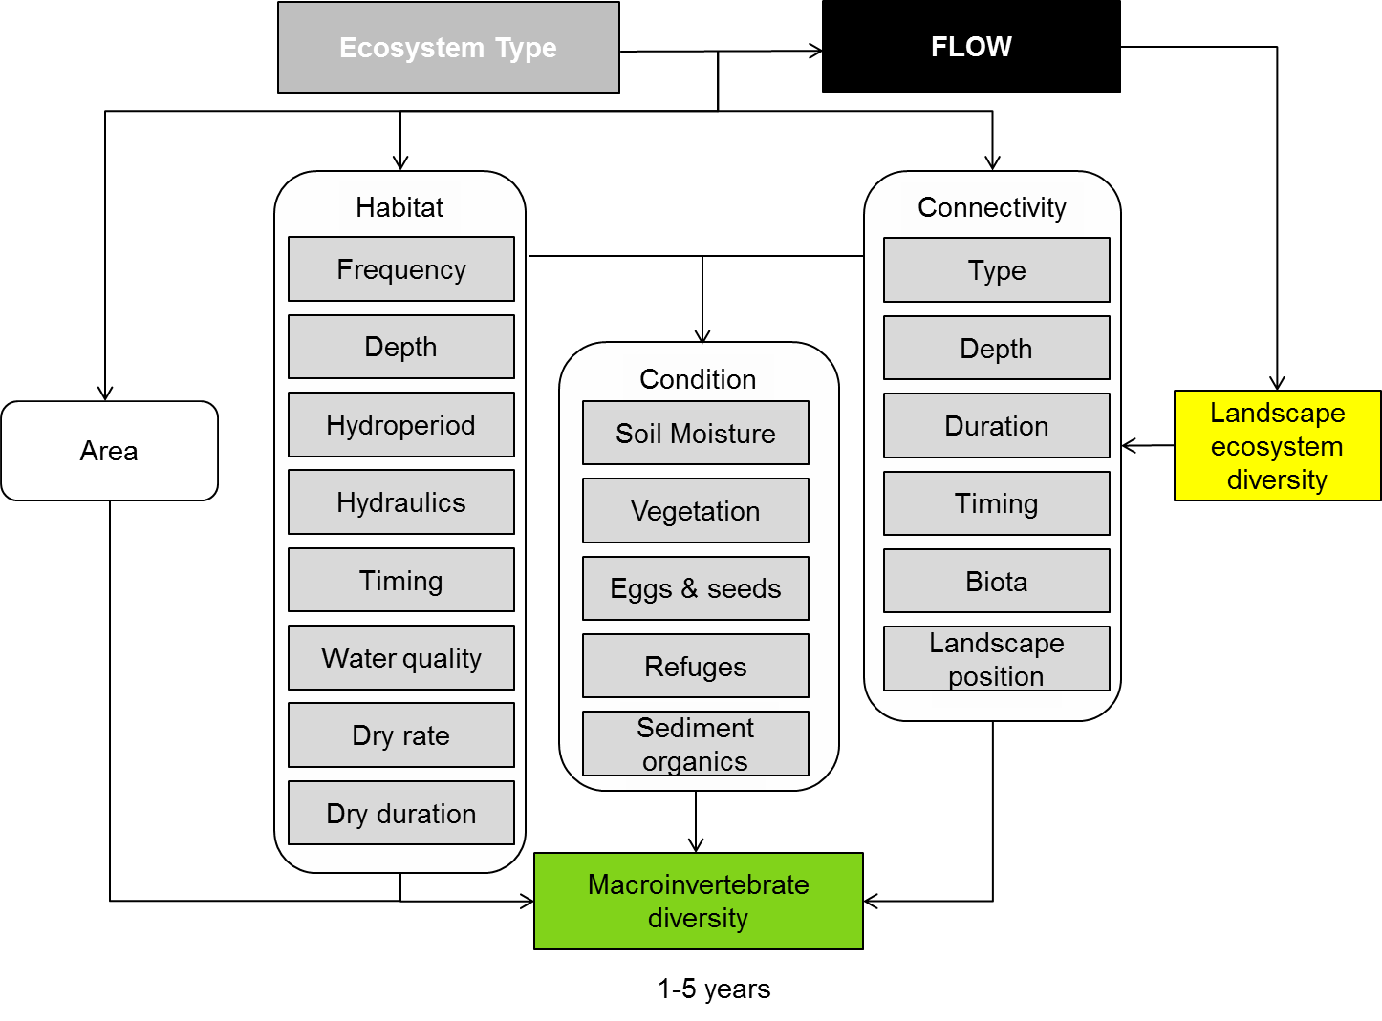

**Figure 6: Cause and effect diagram depicting influence of flow on within ecosystem macroinvertebrate diversity**

**Habitat:** Aquatic ecosystem type, which is largely determined by flow, has a strong influence on within ecosystem macroinvertebrate diversity. Flooding frequency, depth, timing and water quality are important for determining and selecting species which inhabit different ecosystem types. Equally the duration of time that the aquatic ecosystems are dry will also influence macroinvertebrate presence/absence (Fitz and Dobbs 2005; Garcia-Rogers et al. 2011). Macroinvertebrates in temporary streams can be influenced by annual factors which have immediate effects on colonization and abundance (e.g. floods, drought in a year) as well as historical factors including the length of dry period over several years to decades (Fritz and Dobbs 2005). Many species have evolved adaptations such as physiological tolerance and life history modification that enable them to persist in systems which are periodically flooded and dried.

Physiological tolerance most often involves a form of diapause during the stage in the life cycle which coincides with the dry period. Arrested or retarded growth can result as a direct consequence of water loss from the organism's tissues. The animal then becomes dormant when dehydrated but continues growth when water is restored (Williams 1997).

Life history modification is controlled both by internal factors including physiology, behavior and morphology and also factors in the environment such as water loss, temperature, food, photoperiod and other biota. For the most part, the invertebrates of ephemeral aquatic ecosystems in particular exhibit traits of selected species such as high powers of dispersal, rapid growth, short life-span, small size and opportunistic/generalist feeding (Williams 1997).

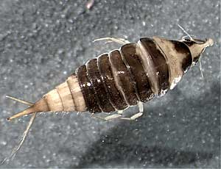 **Condition:** Aquatic habitat and type and degree of connectivity strongly influence condition of aquatic ecosystems which ultimately determines within ecosystem macroinvertebrate diversity. Soil moisture, vegetation (both aquatic and terrestrial) and refuges are all significant aspects of condition affecting macroinvertebrates. Vegetation is particularly important for invertebrate diversity (Boulton and Lloyd 1991; De Szalay and Resh 2000), and wetland vegetation type and extent have been linked to flow regime (Bren 1992). Macrophyte diversity has been correlated with macroinvertebrate species richness (Della Bella et al. 2005) and is an important consideration when determining desired flow patterns. The maintenance of some suitable macroinvertebrate habitats, or refuges, within the landscape may be critical to reestablishment of invertebrate diversity at the ecosystem scale (Robson and Clay 2005). At the ecosystem scale, disturbances such as dry periods or floods typically only affect the populations within a landscape, not an entire species, with impacts lasting in the order of weeks to decades (Keppel et al. 2012; Robson et al. 2012).

Photo C Davey

Other aspects of habitat condition which can influence macroinvertebrate diversity include soil moisture which may determine survival rates of egg and seed banks (Bond et al. 2008), and sediment organics which have been shown to influence macroinvertebrate species richness (Growns et al. 1992).

**Connectivity:** Hydrological connectivity in riverine systems is a key determinant of macroinvertebrate diversity (De Szalay and Resh 2000; Quinn et al. 2000; Bunn and Arthington 2002; Hillman and Quinn 2002). Duration and frequency of inundation, both in terms of temporal and spatial connectivity (e.g. lateral, longitudinal and vertical - see X Hydrological Connectivity CED), influence macroinvertebrate community structure and diversity. During periods of low hydrological connectivity in floodplain systems, isolated aquatic habitats can be structured by local features which induce heterogeneity. Such forces include (from Thomaz et al. 2007):

Photo P McInerney

* water inputs from lateral tributaries and/or seepage leading to localised physical and chemical characteristics that are basin-specific
* wind and animal induced sediment re-suspension, which affects water bodies according to their morphometry
* differences in ecological succession.

These local forces act with different intensities in the floodplain landscape, creating distinctive aquatic habitats and biotic communities (Thomaz et al. 2007).

Dispersal of some species is also dependent on the timing, duration and depth of inundation while landscape position of the wetland and spatio-temporal heterogeneity may be important to others (Boulton and Lloyd 1991; Sheldon et al. 2002).

Invertebrate diversity in aquatic ecosystems can be driven by active transfers such as migration and dispersal and also by passive flood driven transfers (Williams 1997), both of which are dependent on longitudinal and lateral connection to rivers (Douglas et al. 2005). Invertebrate colonisation, especially by opportunistic species, is usually rapid following inundation (Lake et al. 1989).

**Knowledge gaps:** Habitat and hydrological connectivity requirements for macroinvertebrates are, for floodplains and wetlands in particular, relatively poorly understood. Understanding of riverine macroinvertebrate diversity and assessment techniques are more advanced than for floodplain and wetland systems.

**Use of the cause and effect diagram:** This is a generic diagram applicable across both the northern and southern parts of the basin. Its application to particular circumstances or localities would require additional information and potentially modification of the model.

**References**

Batzer DP, Rader RB, Wissinger SA (1999) Invertebrates in freshwater wetlands of North America: ecology and management. Wiley

Bond N, Lake PS, Arthington A (2008) The impacts of drought on freshwater ecosystems: an Australian perspective. Hydrobiologia 600:3-16 doi: 10.1007/s10750-008-9326-z

Boulton AJ, Lloyd LN (1991) Macroinvertebrate assemblages in floodplain habitats of the lower river murray, South Australia. Regulated Rivers: Research & Management 6:183-201 doi: 10.1002/rrr.3450060304

Bren LJ (1992) Tree invasion of an intermittent wetland in relation to changes in the flooding frequency of the River Murray, Australia. Australian Journal of Ecology 17:395-408 doi: 10.1111/j.1442-9993.1992.tb00822.x

Bunn SE, Arthington AH (2002) Basic Principles and Ecological Consequences of Altered Flow Regimes for Aquatic Biodiversity. Environmental Management 30:492-507 doi: 10.1007/s00267-002-2737-0

De Szalay FA, Resh VH (2000) Factors influencing macroinvertebrate colonization of seasonal wetlands: responses to emergent plant cover. Freshwater Biology 45:295-308 doi: 10.1111/j.1365-2427.2000.00623.x

Della Bella V, Bazzanti M, Chiarotti F (2005) Macroinvertebrate diversity and conservation status of Mediterranean ponds in Italy: water permanence and mesohabitat influence. Aquatic Conservation: Marine and Freshwater Ecosystems 15:583-600 doi: 10.1002/aqc.743

Douglas MM, Bunn SE, Davies PM (2005) River and wetland food webs in Australia’s wet–dry tropics: general principles and implications for management. Marine and Freshwater Research 56:329-342 doi: http://dx.doi.org/10.1071/MF04084

Gopal B, Junk WJ (2000) Biodiversity in wetlands: an introduction. In. Backhuys Publishers

Growns JE, Davis JA, Cheal F, Schmidt LG, Rosich RS, Bradley SJ (1992) Multivariate pattern analysis of wetland invertebrate communities and environmental variables in Western Australia. Australian Journal of Ecology 17:275-288 doi: 10.1111/j.1442-9993.1992.tb00809.x

Hillman TJ, Quinn GP (2002) Temporal changes in macroinvertebrate assemblages following experimental flooding in permanent and temporary wetlands in an Australian floodplain forest. River Research and Applications 18:137-154 doi: 10.1002/rra.628

Junk W et al. (2006) The comparative biodiversity of seven globally important wetlands: a synthesis. Aquatic Sciences 68:400-414 doi: 10.1007/s00027-006-0856-z

Lake P, Bayly I, Morton D (1989) The phenology of a temporary pond in western Victoria, Australia, with special reference to invertebrate succession. Archiv für Hydrobiologie 115:171-202

Quinn GP, Hillman TJ, Cook R (2000) The response of macroinvertebrates to inundation in floodplain wetlands: a possible effect of river regulation? Regulated Rivers: Research & Management 16:469-477 doi: 10.1002/1099-1646(200009/10)16:5<469::aid-rrr598>3.0.co;2-1

Robson BJ, Clay CJ (2005) Local and regional macroinvertebrate diversity in the wetlands of a cleared agricultural landscape in south-western Victoria, Australia. Aquatic Conservation: Marine and Freshwater Ecosystems 15:403-414 doi: 10.1002/aqc.675

Sheldon F, Boulton AJ, Puckridge JT (2002) Conservation value of variable connectivity: aquatic invertebrate assemblages of channel and floodplain habitats of a central Australian arid-zone river, Cooper Creek. Biological Conservation 103:13-31 doi: 10.1016/s0006-3207(01)00111-2

Williams DD (1997) Temporary ponds and their invertebrate communities. Aquatic Conservation: Marine and Freshwater Ecosystems 7:105-117 doi: 10.1002/(sici)1099-0755(199706)7:2<105::aid-aqc222>3.0.co;2-k

# 6 Landscape fish diversity

Landscape fish diversity is influenced by a large number factors that operate across a range of spatio-temporal scales. At regional scales, historical and bio-geographical factors are important determinants of the species that are present and thus define the regional pool of species that are available (Jackson et al. 2001; Schweizer and Jager 2011; Stendera et al. 2012) but at smaller scales, including the landscape scale, the quantity (i.e. area), heterogeneity and accessibility (i.e. connectivity) of resources (i.e. food and habitat) are the main drivers of biodiversity (Schlosser 1991; Bunn and Arthington 2002; Ward et al. 2002). In addition, the degree and type of disturbance events may affect biodiversity patterns either directly (e.g. by eliminating sensitive species) or via effects on temporal habitat heterogeneity (Ward 1998; Lake 2000; Stanford et al. 2005). The following cause-effect diagram describes how landscape fish diversity is affected by river flow through its influences on habitat, disturbance and connectivity (Figure 7).

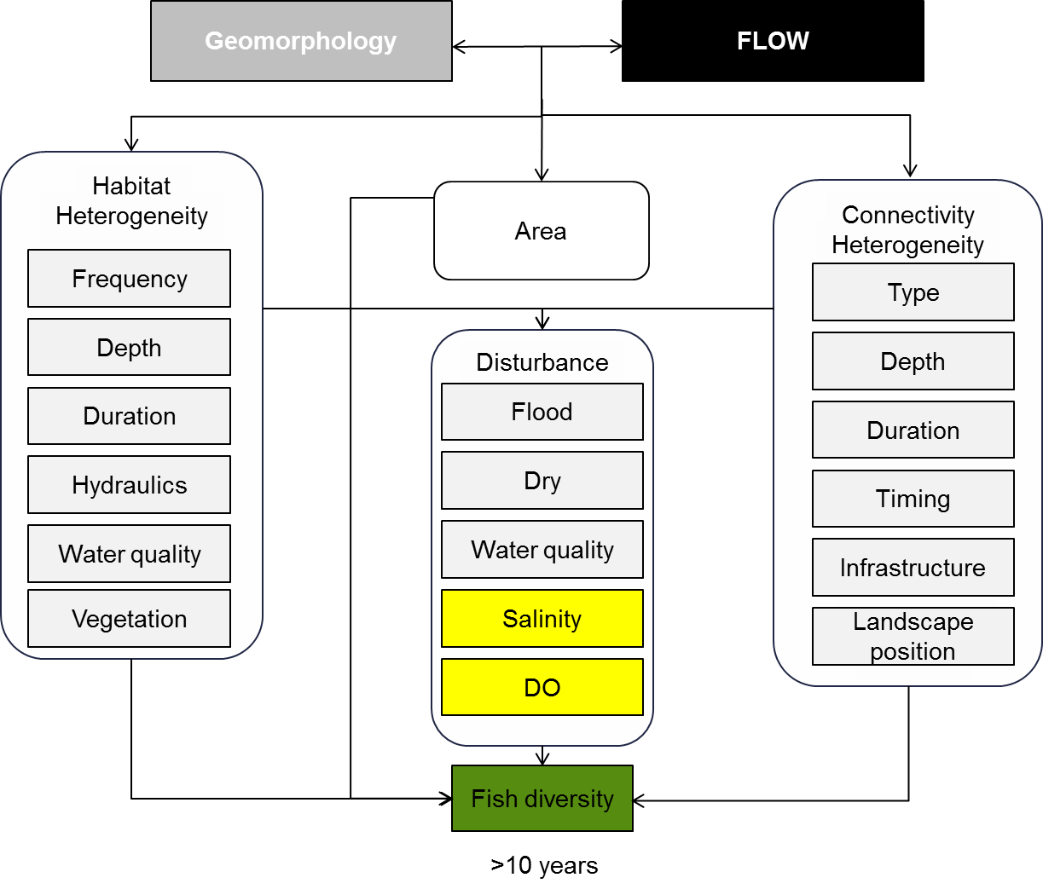

**Figure 7. Cause and effect diagram depicting flow influences on landscape fish diversity**

**Habitat heterogeneity**: Key habitat attributes for fish include hydraulic habitat (i.e. velocity and depth), physical structure (e.g. instream vegetation, substrate) and water quality, in particular, water temperature, dissolved oxygen and salinity (Mathews 1998). Different species and life-stages display clear habitat preferences and thus, high levels of spatial heterogeneity allows for spatial segregation and therefore co-existence of multiple species (Schlosser 1991; Schiemer and Zalewski 1992; Amoros and Bornette 2002; Bunn and Arthington 2002). In riverine systems, the key driver of habitat heterogeneity is the interaction between geomorphology and flow (Copp 1989; Schlosser 1991; Ward 1998; Lake 2000).

**Area:** As is the case for many biotic groups, relationships have been found between fish species richness and the area or volume of habitat (Angermeier and Schlosser 1989; Taylor 1996; Latta et al. 2008; Erös and Schmera 2010). A number of possible explanations have been put forward to explain this relationship and these include:

* the larger the area the more diverse the habitat available (Rosenzweig 1995; Jackson et al. 2001)
* smaller habitats (i.e. small lakes and high order streams) have higher disturbance intensity than larger ones leading to higher extinction rates (Taylor 1996; Jackson et al. 2001)
* larger habitats contain more individuals and therefore more species will be collected with the same relative sampling effort than in smaller (Angermeier and Schlosser 1989; Schlosser 1991).

**Disturbance**: The frequency of disturbance is thought to be a major regulating factor on species diversity (Lake 2000). Flow variability, resulting in periods of high and low flows; create disturbances within the riverine environment (Schlosser 1991; Lake 2000; Ward et al. 2002). In turn, these flow-related disturbance events may impact on fish biodiversity either positively or negatively as a consequence of changes to connectivity, food and habitat availability and water quality (Schlosser 1991; Ward et al. 2002; Stanford et al. 2005).

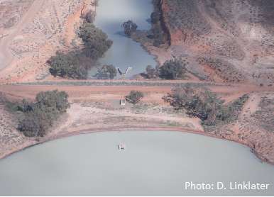**Connectivity heterogeneity**: The ability of fish to move and disperse among habitats within the landscape is critical in maintaining biodiversity (Schlosser 1991; Amoros and Bornette 2002; Bunn and Arthington 2002). Maintaining and/or restoring connectivity between landscape elements is therefore important in preserving biodiversity. In riverine ecosystems, flow is the primary driver of connectivity (Ward et al. 2002) and modifications to flow regimes have altered the nature, timing and duration of connections between habitats within the landscape (Amoros and Bornette 2002; Bunn and Arthington 2002). Loss of connectivity may lead to reduced fish diversity as a consequence of the loss of both migratory species and species that require access to multiple habitats to complete their life-cycles; localised extinctions if access to refuge habitats is not available and lack of recolonisation opportunities if localised extinctions have occurred (Copp 1997; Jackson et al. 2001; Amoros and Bornette 2002; Boisclair et al. 2009; Sullivan and Watzin 2009). In floodplain habitats, the nature and diversity of connections between the river and floodplain water bodies are also drivers of fish diversity (Amoros and Bornette 2002; Ward et al. 2002; Boisclair et al. 2009; Sullivan and Watzin 2009). Strong links have been found between fish diversity and the degree of connectivity between the river and floodplain water bodies (Ward et al. 2002; Boisclair et al. 2009; Sullivan and Watzin 2009) and diversity in connection types is thought to be important as this results in increased habitat diversity on the floodplain (Amoros and Bornette 2002; Bunn and Arthington 2002; Ward et al. 2002).

**Knowledge Gaps**: The specific habitat and connectivity requirements of the majority of fish species which occur within the Murray-Darling Basin are poorly understood. Similarly, species-area relationships have not been tested for fish in any Australian systems.

**Use of the cause and effect diagram**: This is a generic diagram applicable across both the northern and southern parts of the basin. Its application to particular circumstances or localities would require additional information and potentially modification of the model.

**References**

Amoros C, Bornette G (2002) Connectivity and biocomplexity in waterbodies of riverine floodplains. Freshwater Biology 47:761-776

Angermeier PL, Schlosser IJ (1989) Species-area relationship for stream fishes. Ecology:1450-1462

Boisclair D, Bouvier LD, Cottenie K, Doka SE (2009) Aquatic connectivity and fish metacommunities in wetlands of the lower Great Lakes. Canadian Journal of Fisheries and Aquatic Sciences 66:933-948

Bunn SE, Arthington AH (2002) Basic principles and ecological consequences of altered flow regimes for aquatic biodiversity. Environmental Management 30:492-507

Copp G (1997) Microhabitat use of fish larvae and 0+ juveniles in a highly regulated section of the River Great Ouse. Regulated Rivers: Research & Management 13:267-276

Copp GH (1989) The habitat diversity and fish reproductive function of floodplain ecosystems. Environmental Biology of Fishes 26:1-27

Erös T, Schmera D (2010) Spatio‐temporal scaling of biodiversity and the species–time relationship in a stream fish assemblage. Freshwater Biology 55:2391-2400

Jackson DA, Peres-Neto PR, Olden JD (2001) What controls who is where in freshwater fish communities the roles of biotic, abiotic, and spatial factors. Canadian Journal of Fisheries and Aquatic Sciences 58:157-170

Lake P (2000) Disturbance, patchiness, and diversity in streams. Journal of the North American Benthological Society 19:573-592

Latta W, Breck J, Duchon EM (2008) Species-area and latitudinal patterns for Michigan fishes. The American Midland Naturalist 159:349-363

Mathews WJ (1998) Patterns in Freshwater Fish Ecology. Chapman & Hall, New York

Olden JD, Jackson DA, Peres-Neto PR (2001) Spatial isolation and fish communities in drainage lakes. Oecologia 127:575-585

Rosenzweig ML (1995) Species diversity in space and time. Cambridge University Press, Cambridge

Schiemer F, Zalewski M (1992) The importance of riparian ecotones for diversity and productivity of riverine fish communities. Netherlands Journal of Zoology 42

Schlosser IJ (1991) Stream fish ecology: a landscape perspective. BioScience 41:704-712

Schweizer PE, Jager HI (2011) Modeling Regional Variation in Riverine Fish Biodiversity in the Arkansas–White–Red River Basin. Transactions of the American Fisheries Society 140:1227-1239

Stanford JA, Lorang MS, Hauer FR (2005) The shifting habitat mosaic of river ecosystems. . Internationalen Vereinigung für Theoretische und Angewandte Limnologie Verhandlungen 29:123-136

Stendera S et al. (2012) Drivers and stressors of freshwater biodiversity patterns across different ecosystems and scales: a review. Hydrobiologia 696:1-28

Sullivan S, Watzin M (2009) Stream–floodplain connectivity and fish assemblage diversity in the Champlain Valley, Vermont, USA. Journal of Fish Biology 74:1394-1418

Taylor C (1996) Abundance and distribution within a guild of benthic stream fishes: local processes and regional patterns. Freshwater Biology 36:385-396

Ward DL, Eugene Maughan O, Bonar SA, Matter WJ (2002) Effects of temperature, fish length, and exercise on swimming performance of age-0 flannelmouth sucker. Transactions of the American Fisheries Society 131:492-497

Ward J (1998) Riverine landscapes: biodiversity patterns, disturbance regimes, and aquatic conservation. Biological Conservation 83:269-278

# 7 Fish condition

The ‘condition’ of a fish refers to a measure of the fish’s health or well-being. Healthy fish are relatively free from pathogens and have good resistance to environmental factors that may increase mortality or reduce growth and fecundity (Strange 1996). Poor condition is usually associated with poor habitat quality (Lambert and Dutil 2000).

The condition of individual fish can be assessed through observation of factors including: damage to extremities, state of maturity, and the condition of gills and other organs (Strange 1996). Measures of fish condition based on weight at a given length are also considered to be reliable indicators of the energetic condition or energy reserves of fish (Lambert and Dutil 1997), with the assumption that fish in better ’condition’ (nutritional and health status) are more full-bodied and therefore heavier at a given length (Fulton 1911). More thorough observations of condition can include blood, histological, biochemical or toxicological examinations (Strange 1996).

Fish condition can have dramatic effects on a fish’s reproductive potential (Marshall and Frank 1999; Morgan 2004). The egg production of fish in poor condition may decrease through lower potential fecundity, atresia, or even skipped spawning. Larvae produced by fish in poor condition may be smaller and less likely to survive (Marteinsdottir and Begg 2002). A further potential impact of poor condition of spawning fish is that they may be at a greater risk of mortality following spawning (Lambert and Dutil 2000).

For freshwater fish, condition can be influenced by the availability of suitable habitat, connectivity between different habitats (e.g. stream channel and floodplain wetlands); and other processes including food availability, the presence and intensity of disease and competition or predation with other fauna. Flow is a major determinant of each of these factors (habitat, connectivity and ecological processes) and ultimately in the condition of fish in an ecosystem (Figure 8).

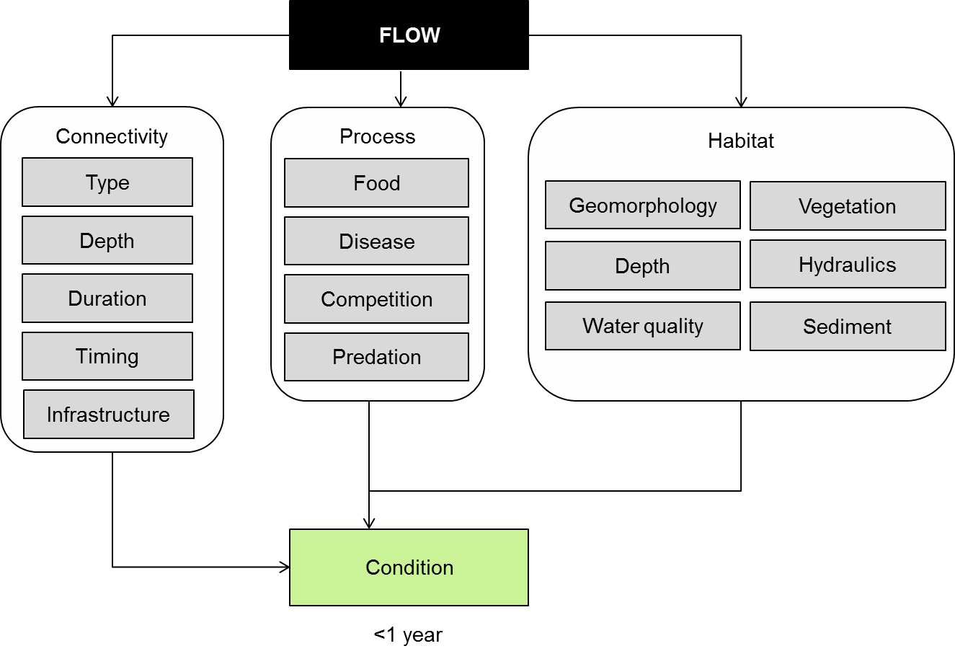

**Figure 8. Cause and effect diagram depicting the influence of flow on fish condition.**

**Connectivity**: The connectivity between a stream channel and its floodplain can have a significant influence on fish condition. Modified stream geomorphology and altered flow regimes affect connectivity by changing the frequency, timing and duration of connections among habitats (Walker 2006; Pratchett et al. 2011). Reduced flooding means highly productive floodplain areas which produce plankton blooms necessary for some fish, are not utilised (Koehn and O'Connor 1990). This influences productivity and habitat availability and ultimately the condition of fish. River regulation through the installation of dams and levees has also created barriers to movement which make it difficult for fish to migrate or relocate to habitat which may be necessary for feeding or breeding (Lintermans 2007). This can in turn lead to a deterioration in fish condition if food and habitat resources are in short supply.

A recent examination of fish condition in wetlands along the Murray River revealed that fish condition was 11.6% higher in the wetlands and 7.8% higher in summer (Beesley et al. 2011). Limitations in lateral connectivity between the river channel and wetlands would restrict access to the wetlands that appear to provide a more productive habitat (Beesley et al. 2012).

**Processes:** Other ecological processes including; food availability, the intensity of competition with and predation by other organisms and disease will influence the condition of fish. Poor nutrition (low food availability or unsuitable types of food) can lead to reductions in the growth rate and condition of individual fish (Tonkin et al. (2008); Ning et al. (2012), which may make them more susceptible to predation or disease. Flow has a major influence on food availability and floods have been associated with improved body condition while periods of low flow are associated with poorer body condition (Balcombe et al. 2012). The response is not always as clear cut, with golden perch in the Moonie River showing no significant change in lipid and only a small increase in biomass in response to a flood driven increase in food (Sternberg et al. 2012).

High predation or competition intensity can influence the condition of fish in a particular habitat. Intense predatory pressure can reduce fish condition through injury from predator attacks and also through depletion of energy resulting from predator avoidance. Likewise, high competition pressure reduces the availability of food and habitat for fish, in turn reducing their capacity to maintain good condition. MacDonald et al. (2012) showed that the presence of eastern gambusia as a competing species influenced the condition (and abundance) of most common wetland fish in Murray-Darling Basin (MDB) wetlands.

Disease can also affect the condition of individual fish, although infection of fish with disease is often secondary to degraded water quality or other environmental stressors (Strange 1996). Studies in insects, fish, amphibians and rodents show that infection occurrence and intensity are more probable and more severe in individuals with an underlying poor condition (Beldomenico and Begon 2010).

**Habitat:** Fish habitat refers to the parts of an environment that fish depend on for feeding, shelter, and reproduction, and is a key determinant of fish condition. Fish habitat requirements vary between fish species and from one life stage of a particular fish species to the next (Koehn and O'Connor 1990; Lintermans 2007). Flow is a major determinant of habitat through its influence on river shape (geomorphology) and water quality that will influence habitat availability (Bunn and Arthington 2002). The following factors may influence habitat suitability as it affects condition for some or all species of fish, in some or all life stages:

* geomorphology: the geomorphology of a water-body will influence the depth, patterns of flow and other habitat characteristics (such as vegetation or water quality) in the water body
* flow velocity: Flow velocity may influence other habitat characteristics such as aquatic vegetation, food availability and water quality
* depth: Some fish prefer the cover of deeper water, whilst others require warmer, shallow waters and the food sources it provides
* vegetation: Many species of freshwater fish use aquatic vegetation for cover from predators, as a food source or as a substrate on which breeding occurs.
* water quality: Water quality influences fish through the physiological responses individual species display to various water quality variables and the tolerance levels of species and individuals to extremes (SKM 2003). Different fish have different water quality preferences and tolerances, and changes in water quality parameters such as temperature, salinity and dissolved oxygen which approach the tolerance limits of a fish will inevitably result in reduced condition. In some cases, changes in water quality (e.g. increased salinity, occurrence of hypoxic blackwater) can result in fish deaths (McNeil and Closs 2007)
* sediment: different types of sediment will support different types of fauna and flora (e.g. plant germination), which may be important to the diet or recruitment of certain fish species. Sediment physico-chemistry may influence the chemistry or water quality in a given water body (e.g. acid sulfate sediments, saline groundwater intrusion), which can influence the condition of fish within.

**Knowledge gaps:** There is little literature available on the body condition of fish in the MDB, and of the direct influences of flow or habitat on condition. The specific influences of predation and competition on fish condition in the MDB is also poorly studied.

**Use of the cause and effect diagram:** This is a generic diagram applicable across both the northern and southern parts of the Basin. Its application to particular circumstances or localities would require additional information and potentially modification of the model.

**References**

Balcombe SR, Lobegeiger JS, Marshall SM, Marshall JC, Ly D, Jones DN (2012) Fish body condition and recruitment success reflect antecedent flows in an Australian dryland river. Fisheries Science 78:841-847 doi: 10.1007/s12562-012-0519-z

Beesley L et al. (2012) Does flooding affect spatiotemporal variation of fish assemblages in temperate floodplain wetlands? Freshwater Biology 57:2230-2246

Beesley L et al. (2011) Watering floodplain wetlands in the Murray–Darling Basin for native fish. Waterlines report, National Water Commission, Canberra

Beldomenico PM, Begon M (2010) Disease spread, susceptibility and infection intensity: vicious circles? Trends in Ecology & Evolution 25:21-27

Bunn SE, Arthington AH (2002) Basic principles and ecological consequences of altered flow regimes for aquatic biodiversity. Environmental Management 30:492-507

Fulton TW (1911) The sovereignty of the sea, London: Edinburgh

Koehn J, O'Connor W (1990) Biological information for management of native freshwater fish in Victoria. Department of Conservation and Environment, Freshwater Fish Management Branch, Arthur Rylah Institute for Environmental Research

Lambert Y, Dutil J-D (1997) Can simple condition indices be used to monitor and quantify seasonal changes in the energy reserves of cod (Gadus morhua)? Canadian Journal of Fisheries and Aquatic Sciences 54:104-112

Lambert Y, Dutil J-D (2000) Energetic consequences of reproduction in Atlantic cod (Gadus morhua) in relation to spawning level of somatic energy reserves. Canadian Journal of Fisheries and Aquatic Sciences 57:815-825

Lintermans M (2007) Fishes of the Murray–Darling Basin: An Introductory Guide. Murray-Darling Basin Commision, Canberra

Macdonald JI, McNeil DG, Crook DA (2012) Asteriscus v. lapillus: comparing the chemistry of two otolith types and their ability to delineate riverine populations of common carp Cyprinus carpio. Journal of Fish Biology 81:1715-1729 doi: 10.1111/j.1095-8649.2012.03443.x

Marshall CT, Frank KT (1999) The effect of interannual variation in growth and condition on haddock recruitment. Canadian Journal of Fisheries and Aquatic Sciences 56:347-355

Marteinsdottir G, Begg GA (2002) Essential relationships incorporating the influence of age, size and condition on variables required for estimation of reproductive potential in Atlantic cod Gadus morhua. Marine Ecology Progress Series 235

McNeil DG, Closs GP (2007) Behavioural responses of a south-east Australian floodplain fish community to gradual hypoxia. Freshwater Biology 52:412-420

Morgan MJ (2004) The relationship between fish condition and the probability of being mature in American plaice (Hippoglossoides platessoides). ICES Journal of Marine Science 61

Ning NSP, Hladyz S, Gawne B, Maffei S, Price A, Nielsen DL (2012) Morphological, physiological and behavioural response patterns of carp gudgeon Hypseleotris spp. to food deprivation: implications for assessing health. Journal of Fish Biology 80:218-224

Pratchett MS et al. (2011) Contribution of climate change to degradation and loss of critical fish habitats in Australian marine and freshwater environments. Marine and Freshwater Research 62:1062-1081

SKM (2003) Review of habitat associations of native fish in the Murray-Darling

Basin. In. Report to the Murray-Darling Basin Commission

Sternberg D, Balcombe SR, Marshall JC, Lobegeiger JS, Arthington AH (2012) Subtle 'boom and bust' response of Macquaria ambigua to flooding in an Australian dryland river. Environmental Biology of Fishes 93:95-104 doi: 10.1007/s10641-011-9895-y

Strange RJ (ed) (1996) Field examination of fishes. American Fisheries Society, Bethesda, Maryland

Tonkin Z, King AJ, Mahoney J (2008) Effects of flooding on recruitment and dispersal of the Southern Pygmy Perch (*Nannoperca australis*) at a Murray River floodplain wetland. Ecological Management and Restoration 9:196-201

Walker KF (2006) Serial weirs, cumulative effects: the Lower River Murray, Australia. In ‘The Ecology of Desert Rivers. Cambridge University Press, Cambridge

# 8 Fish reproduction

Flow can have significant effects on the reproduction of riverine fishes. As depicted in Figure 9, flow affects fish reproduction, which produces larvae, through its impact on: spawning cues; connectivity to spawning habitats; and the suitability of the spawning habitat itself. In addition the spawning output (fecundity) of adult fish is strongly determined by the condition of those fish (left box), however the effect of flow on fish condition is the subject of a separate cause-effect diagram, and is not discussed further here (refer 7 Fish Condition CED).

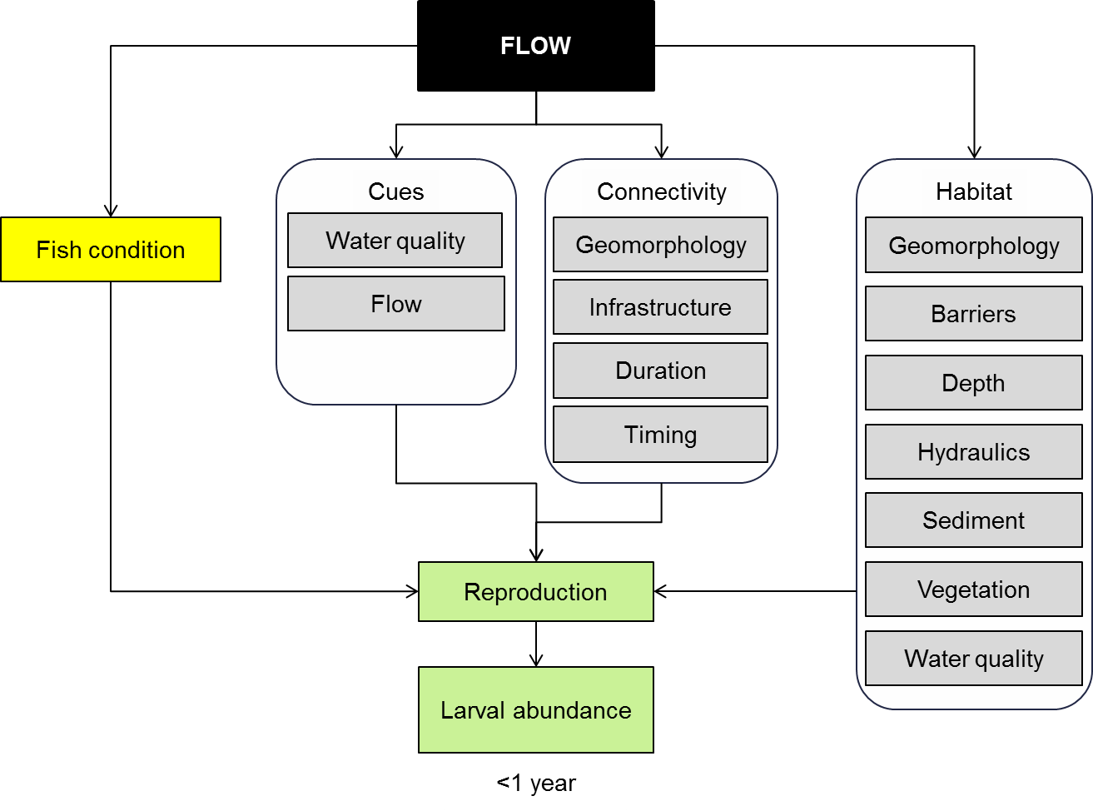

Figure 9. Cause and effect diagram depicting flow influences on fish reproduction

**Cues:** Reproduction cues are environmental stimuli that induce one of two responses associated with spawning:

* movement to spawning habitats
* the process of reproduction itself, including mate determination and courtship (King et al. in press).

The cues that induce these responses include photoperiod, temperature, turbidity, water velocity, and possibly chemical composition of the water, which stimulate the fish’s highly sensitive senses of taste or smell. Only photoperiod is not affected by flow management.

The current understanding of the cues that trigger reproduction movements in river-floodplain networks is extremely poor. We do know that many riverine fishes may have relatively small home ranges and strong site fidelity during base flows (Rodriguez 2002; Crook 2004), but that these behaviours may be altered during floods, when species that have not exhibited significant movement for many months can suddenly exhibit substantial dispersal, which may be linked to reproduction.

Freshwater fishes may be able to distinguish between large natural flows, and smaller and/or unnatural flows using their sense of smell; large flows arising from catchment-scale rainfall pulses may be associated with a distinct chemical signature resulting from catchment runoff on massive scales (DeBose and Nevitt 2008; Vrieze et al. 2010; Stoffels et al. in review).

Riverine fish dispersal may also be triggered by non-chemical cues that are not necessarily caused by catchment-scale runoff. More specifically, changes in water temperature, discharge, velocity and turbidity have all been correlated with dispersal rates of riverine fishes (Fernandes 1997; Swanberg 1997; Rakowitz et al. 2008; Sykes et al. 2009; Tiffan et al. 2009; Nunn et al. 2010). Interestingly, however, all these studies show fish dispersal is triggered by some sort of change in the physical state of the river, and often a change associated with a flow pulse.

Once fish have moved to a spawning site within theriverscape, the same suite of flow-related cues may act upon senses to induce reproduction of certain species (King et al. in press). However, it must be stated that within the MDB it appears that many fishes do not require flow-related cues to reproduce, and that flows may play a more important role in subsequent recruitment (Humphries et al. 1999; Humphries and Lake 2000; King et al. 2003).

**Connectivity:** Available habitats within theriverscape are influenced by flow since river height determines the quantity and quality of ‘aquatic corridors’ through which fish move to spawn. The current understanding of reproduction movements of MDB fishes is very poor, however, it is clear that certain species can undertake significant movements associated with reproduction. Murray cod, *Maccullochella peelii*, for example, can undertake large-scale longitudinal migrations to access spawning habitats, after which they can return to their pre-spawning home-range (Koehn et al. 2009). Similarly, golden perch, *Macquaria ambigua*, and silver perch, *Bidyanus bidyanus*, have been shown to undertake large longitudinal migrations during the spawning season (Reynolds 1983). However, these studies do not show that spawning migrations are necessary for population viability, but that they can occur.

Our understanding of lateral spawning migrations within the MDBriverscape is even poorer. Currently, it appears that no MDB fish species is an obligate floodplain spawner (Humphries et al. 1999; King et al. 2003). However, that does not preclude facultative floodplain reproduction. That is, it may not be absolutely essential for a species to access the floodplain for spawning, but when the floodplain is used it may increase the productivity of a population significantly (Beesley et al. 2012; Stoffels et al. in review).

Flows interact with the geomorphology of ariverscape to shape the degree of connectivity among spawning habitats. Man-made barriers will also interact with flows to affect spawning migrations. The properties of a flow (timing, duration, magnitude, etc.) will affect the access different fishes have to particular habitats, as well as the survivorship of juveniles and adults following reproduction. For example, a reduction in flows while breeding dispersal is taking place may result in fish becoming stranded in sub-optimal habitats. This is particularly true for fish dispersal onto the floodplain, where fish may become stranded in a complex network of wetlands, all of which are susceptible to drying.

**Habitat:** Freshwater fishes may have particular habitat requirements for reproduction. Water quality, for example, can influence spawning in many species. Temperature, in particular, has a very strong influence on spawning (King et al. in press), and so flow pulses provided at certain times of the year may be too cold and reduce spawning.

Several MDB species may utilise either submerged or emergent aquatic vegetation as a spawning substrate. Certain glassfishes (*Ambassis* spp.), rainbowfishes (*Melanotaenia* spp.), hardyheads (*Craterocephalus* spp.), pygmy perches (*Nannoperca* spp.), and carp gudgeons (*Hypseleotris* spp.) can utilize plants as spawning substrates (Allen et al. 2002; Pusey et al. 2004; Lintermans 2007; King et al. in press). It follows that flows that enhance the health of aquatic plant communities will also benefit freshwater fishes.

Sediment characteristics of the benthos are of great importance to freshwater fish spawning. Several species require hard substrates, such as rock, gravel or hollow logs, for spawning (King et al. in press). An excellent example is provided by the two-spined blackfish, *Gadopsis marmoratus* ( O’Connor and Zampatti 2006); this species swims under flat boulders and lays its eggs on the lower surface. Sedimentation of the substrate is a major threat to the viability of this species (Jackson 1978; O'Connor and Zampatti 2006), as well as the river blackfish, *G. marmoratus* (Jackson 1978). Sedimentation is heavily influenced by external pressures such as land use and riparian clearing, however, if river segments do not experience large flow pulses that scour the river bed then hard substrate availability will decline.

Hydraulics such as current and velocity can have a significant bearing on the spawning success of native fishes. In particular, nest building species such as Murray cod (Humphries 2005), and freshwater catfish, *Tandanus tandanus* (Merrick and Midgley 1981), may suffer reductions in spawning success if large, high velocity flows occur during their nesting period. On the other hand pelagic broadcast spawners like golden perch may seek out higher water velocity for spawning (King et al. in press). Maintenance of geomorphological heterogeneity in the longer term will provide the diversity of hydraulic habitat—including depth—preferred for the complete native fish community of the MDB.

**Knowledge gaps**: There is much work to be done to improve our understanding of how flows affect fish spawning, however, two broad questions may be of high priority:

(1) Do flows activate cues that are necessary to stimulate the spawning of fishes, and if so, exactly what are they ie. chemical, thermal, or other?

(2) How does lateral and longitudinal connectivity, mediated by flows, affect the dispersal of fishes to spawning habitats? By extension, what are the key spawning habitats of native fishes?

**Use of the cause and effect diagram**: This is a generic diagram applicable across both the northern and southern parts of the basin. Its application to particular circumstances or localities would require additional information and potentially modification of the model.

**References**

Allen GR, Midgley SH, Allen M (2002) Field Guide to the Freshwater Fish of Australia. CSIRO Publishing, Collingwood

Beesley L et al. (2012) Does flooding affect spatiotemporal variation of fish assemblages in temperate floodplain wetlands? Freshwater Biology 57:2230-2246 doi: 10.1111/j.1365-2427.2012.02865.x

Crook DA (2004) Is the home range concept compatible with the movements of two species of lowland river fish? Journal of Animal Ecology 73:353-366 doi: 10.1111/j.0021-8790.2004.00802.x

DeBose JL, Nevitt GA (2008) The use of odors at different spatial scales: Comparing birds with fish. Journal of Chemical Ecology 34:867-881 doi: 10.1007/s10886-008-9493-4

Fernandes CC (1997) Lateral migration of fishes in Amazon floodplains. Ecology of Freshwater Fish 6:36-44 doi: 10.1111/j.1600-0633.1997.tb00140.x

Humphries P (2005) Spawning time and early life history of Murray cod, Maccullochella peelii (Mitchell) in an Australian river. Environmental Biology of Fishes 72:393-407 doi: 10.1007/s10641-004-2596-z

Humphries P, King AJ, Koehn JD (1999) Fish, flows and flood plains: links between freshwater fishes and their environment in the Murray-Darling River system, Australia. Environmental Biology of Fishes 56:129-151 doi: 10.1023/a:1007536009916

Humphries P, Lake PS (2000) Fish larvae and the management of regulated rivers. Regulated Rivers-Research & Management 16:421-432 doi: 10.1002/1099-1646(200009/10)16:5<421::aid-rrr594>3.0.co;2-4

Jackson PD (1978) Spawning and early development of river blackfish, *Gadopsis marmoratus* Richardson (Gadpsiformes, Gadposidae), in McKenzie River, Victoria. Australian Journal of Marine and Freshwater Research 29:293-298

King AJ, Humphries P, Lake PS (2003) Fish recruitment on floodplains: the roles of patterns of flooding and life history characteristics. Canadian Journal of Fisheries and Aquatic Sciences 60:773-786 doi: 10.1139/f03-057

King AJ, Humphries P, McCasker NG (in press) Reproduction and early life history. In: Humphries P, Walker KF (eds) Ecology of Australian Freshwater Fish. CSIRO Publishing, Collingwood, VIC

Koehn JD, McKenzie JA, O'Mahony DJ, Nicol SJ, O'Connor JP, O'Connor WG (2009) Movements of Murray cod (Maccullochella peelii peelii) in a large Australian lowland river. Ecology of Freshwater Fish 18:594-602 doi: 10.1111/j.1600-0633.2009.00375.x

Lintermans M (2007) Fishes of the Murray-Darling Basin: An Introductory Guide. The Murray-Darling Basin Commission, Canberra

Merrick JR, Midgley SH (1981) Spawning behaviour of the freshwater catfish, *Tandanus tandanus* (Plotosidae). Australian Journal of Marine and Freshwater Research 32:1003-1006

Nunn AD, Copp GH, Vilizzi L, Carter MG (2010) Seasonal and diel patterns in the migrations of fishes between a river and a floodplain tributary. Ecology of Freshwater Fish 19:153-162 doi: 10.1111/j.1600-0633.2009.00399.x

O'Connor JP, Zampatti BP (2006) Spawning season and site location of Gadopsis bispinosus Sanger (Pisces : Gadopsidae) in a montane stream of southeastern Australia. Transactions of the Royal Society of South Australia 130:227-232

Pusey B, Kennard M, Arthington AH (2004) Freshwater Fishes of North-Eastern Australia. CSIRO Publishing, Collingwood, VIC, Australia

Rakowitz G, Berger B, Kubecka J, Keckeis H (2008) Functional role of environmental stimuli for the spawning migration in Danube nase Chondrostoma nasus (L.). Ecology of Freshwater Fish 17:502-514 doi: 10.1111/j.1600-0633.2008.00302.x

Reynolds LF (1983) Migration patterns of five fish species in the Murray-Darling River system. Australian Journal of Marine and Freshwater Research 34:857-871

Rodriguez MA (2002) Restricted movement in stream fish: The paradigm is incomplete, not lost. Ecology 83:1-13

Stoffels RJ, Clarke KR, Rehwinkel RA, McCarthy BJ (In review) Response of a floodplain fish community to river-floodplain connectivity: natural versus managed reconnection.

Swanberg TR (1997) Movements of and habitat use by fluvial bull trout in the Blackfoot River, Montana. Transactions of the American Fisheries Society 126:735-746 doi: 10.1577/1548-8659(1997)126<0735:moahub>2.3.co;2

Sykes GE, Johnson CJ, Shrimpton JM (2009) Temperature and Flow Effects on Migration Timing of Chinook Salmon Smolts. Transactions of the American Fisheries Society 138:1252-1265 doi: 10.1577/t08-180.1

Tiffan KF, Kock TJ, Haskell CA, Connor WP, Steinhorst RK (2009) Water Velocity, Turbulence, and Migration Rate of Subyearling Fall Chinook Salmon in the Free-Flowing and Impounded Snake River. Transactions of the American Fisheries Society 138:373-384 doi: 10.1577/t08-051.1

Vrieze LA, Bjerselius R, Sorensen PW (2010) Importance of the olfactory sense to migratory sea lampreys Petromyzon marinus seeking riverine spawning habitat. Journal of Fish Biology 76:949-964 doi: 10.1111/j.1095-8649.2010.02548.x

# 9 Fish larval growth and survival

Understanding how the flow regime influences the growth and survival of larval fish is critical for managing native fish populations (King et al. 2010). This is true for the Murray-Darling Basin (MDB) where there is limited information available to date. The cause-effect diagram (CED) shown in Figure 10 describes the potential pathways for how flows influence larval fish growth and survival in the MDB. The CED proposes that flow influences larval growth and survival through its effect on: interspecific processes; habitat connectivity; and habitat suitability.

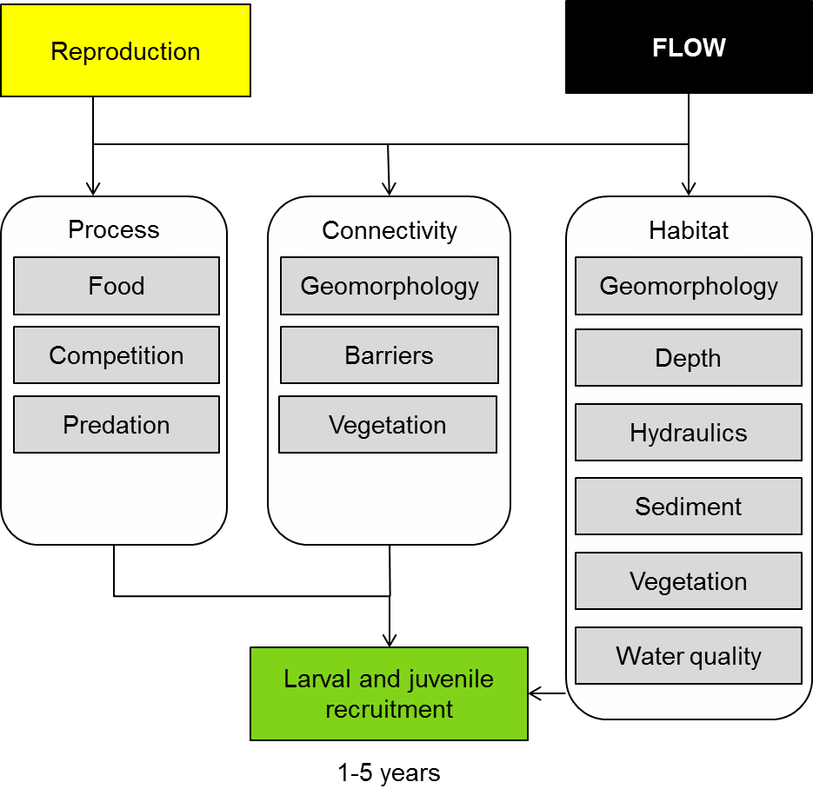

Figure 10. Cause and effect diagram depicting the influence of flow on fish larval growth and survival.

**Processes**: When we discuss processes, we are referring to the ecological processes that arise from interactions among species. The process can be food production in which another species can be prey (food species), predation in which the subject of the model is consumed or competition in which two similar species compete for resources.

The larval stage of a fish’s life history is a critical stage for feeding or energy acquisition. Relative to later life-history stages, food availability plays a particularly important role in determining growth and survival of larvae due to:

* low energy reserves
* small gape size of larval fishes (Neill et al. 1994). Their small gape means larval fish require high densities of appropriately-sized prey in the form of zooplankton (Humphries et al. 1999).

Larval fish that fail to feed sufficiently suffer higher mortality rates due to starvation as well as loss of fitness leading to increased susceptibility to predators (King 2004), and perhaps disease.

Both high and low flows purportedly increase larval fish recruitment (Humphries et al. 1999). High, overbank flows may increase the availability of nutrients, thereby increasing production rates of zooplankton and other prey items for larval fishes, which in turn leads to increased recruitment (Junk et al. 1989; Winemiller 2004). Within the MDB, however, there is little published evidence to support this (Humphries et al. 1999; King et al. 2003; King 2004). High flows may also enable larval fishes to access higher prey densities on the floodplain, but again, the importance of prey in floodplain habitats to larval fish recruitment within the MDB is poorly understood (King et al. 2003). Beesley et al. (2012) recently showed that flooding of wetlands improves recruitment of *Hypseleotris*, a small native fish, however, the significance of wetland recruitment to overall population viability is unknown (Winemiller 2004; Closs et al. 2006). However, flow pulses do not necessarily have to inundate the floodplain to improve fish growth. Tonkin et al. (2011) recently showed that within-channel flow pulses may increase the growth of smelt, a small-bodied MDB fish.

Humphries et al. (1999) proposed that the larvae of certain species of fish may recruit better during extended periods of low flow. Low flows may result in higher concentrations of zooplankton within slow-flowing pools, as well as reduce disturbance to fish nests and flushing rates of larvae, which may be poor swimmers (Humphries 2005; Dudley and Platania 2007; Tonkin et al. 2011).

There are two types of competition in ecological communities: exploitation and interference competition. Exploitation competition occurs when one species depletes the resources (food, for example) of another species enough to indirectly affect its productivity. Interference competition occurs when one species directly and physically displaces another species. Exploitation competition in larval fishes is essentially a matter of food availability, which has been discussed above. However, it is worth mentioning that survival in riverine fishes can be density dependent, and sustained low flows in certain years may reduce survivorship by increasing competition for food within and between species (Heggenes et al. 1999; Jensen and Johnsen 1999; Parra et al. 2011). In a recent example from the MDB, Ho et al. (2012) demonstrated that spring flooding of wetlands may give a native species (*Hypseleotris*) a competitive edge over an alien pest species (mosquitofish). Unfortunately, is known concerning flow and competition in fishes comes from research overseas, and the understanding of flow and fish competition within the MDB is very poor.

Flows may affect interference competition in MDB larval fishes. For example, high, overbank floods generally promote the spawning of carp (Brown et al. 2005; Jones and Stuart 2009; Conallin et al. 2012), whose larvae and juveniles may be sufficiently abundant to physically displace juveniles of native fishes. This is speculation, however, and the effects of flow on competition between larval fishes is poorly understood.

Flow rates, coupled with catchment geomorphology, directly affects water levels in floodplain river systems. In turn, water levels may determine the amount of suitable habitat functioning as predation refuges for larval fish. Low flows may reduce the avilability of slackwater and/or backwater habitats which may be a predation refuge for juvenile fishes (Humphries et al. 1999; Humphries and Lake 2000; Tockner et al. 2000; Winemiller 2004; Zeug and Winemiller 2008).

Floodplain wetlands may be particularly productive for certain small-bodied native fishes of the MDB (e.g. smelt and carp-gudgeons), not only due to potentially higher food production rates (Junk et al. 1989; Winemiller et al. 2000; Winemiller 2004; Zeug and Winemiller 2008), but also due to the the availability of refuges from predators such as native percichthyids (e.g. golden perch and Murray cod (King et al. 2003; Stoffels and Humphries 2003)). If fishes are to access the floodplain they require flows large enough to establish lateral hydrological connectivity between channel and floodplain habitats.

**Connectivity:** River-floodplain ecosystems are comprised of a vast number of different habitats (channel, oxbow lake, paleochannel, etc.) that differ in their productivity to the larvae and juveniles of different species. However, larvae and juveniles cannot use these habitats if they cannot access them and, moreover, larvae and juveniles that have experienced enhanced growth in nursery habitats cannot contribute to population viability and subsequent generations if they are left stranded in those habitats and cannot disperse from nurseries to adult habitats. Thus connectivity among habitats within the riverscape is vital to the viability of fish populations (Tockner et al. 2000; Amoros and Bornette 2002; Fullerton et al. 2010). Flows mediate the hydrological connectivity between these habitats. Flow timing, magnitude, frequency and method of delivery are just four properties of the flow regime that will inlfuence the functional significance of hydrological connectivity in riverscapes.

The importance of flow- connectivity to larval and juvenile accessto feeding and refuge habitats has been discussed above ( see Interspecific Processes). Here we very briefly highlight the importance of flows in maintaining connectivity through their effect on geomorphology and barriers to dispersal.

Over multi-decadal time-scales river flows have shaped the geomorphology of the riverscape; its permanent and temporary aquatic habitats, both within the main channel and on the floodplain, and the nature of all the connecting channels between these habitats. It follows that connectivity within the riverscape is heavily shaped by flow regimes over very long time-scales (Tockner et al. 2000; Winemiller et al. 2000; Amoros and Bornette 2002; Fullerton et al. 2010). Loss of medium to large flows, and flow heterogeneity through time, will gradually deplete connectivity among critical habitat units witihn theriverscape (Amoros and Bornette 2002).

At a very broad level, barriers to the movement of larvae and juveniles can be natural (e.g. dry channels between floodplain and river habitats) or man-made (e.g. weirs). The passage of fish through or over natural and man-made barriers is affected by flows.

Natural barriers to dispersal can occur longitudinally and laterally. Examples of longitudinal barriers include shallow riffles, log-jams, and dry reaches between pools. Examples of natural lateral barriers include natural floodplain levees, bars that delineate slackwater and edge habitats from the main channel, and dry floodplain channels—and the dry floodplain itself—that restrict movement of larvae and juveniles laterally in the riverscape. Flow is the primary determinant of how easily fish negotiate these natural barriers in theriverscape (Amoros and Bornette 2002). Moreover, the properties of flow delivery—e.g. timing, magnitude—will be critical in shaping the success of natural barriers in limiting fish recruitment (Aarts et al. 2004; Fullerton et al. 2010).

Our understanding of how flows can be managed to improve the ability of larval and juvenile fish to negotiate man-made barriers is extremely poor. However, it is possible that flows could be managed to improve the efficacy of juvenile movement past man-made barriers. For example, high movement rates of fishes usually coincide with particular cues associated with flow pulses (Schlosser 1998; David and Closs 2002; Koster and Crook 2008; Nunn et al. 2010). Hence juvenile fish may be encouraged to negotiate man-made barriers with appropriate flow allocations. The management of flows to cue dispersal is an area in need of more research.

**Habitat:** As mentioned above,riverscapes are comprised of a great diversity of habitats, which all differ in their value to larval and juvenile fishes. Flow not only mediates connectivity between these habitats, but it also creates these habitats on short and long time scales (Tockner et al. 2000; Amoros and Bornette 2002).

We discussed earlier the importance of flow regimes in shaping the geomorphological features of riverscapes that maintain connectivity among habitats in the riverscape. Multi-decadal flow regimes also influence riverscape habitat diversity that has, in turn, formed a template for the evolution of riverine biodiversity (Ward and Stanford 1995; Winemiller et al. 2000). For example, any given floodplain is comprised of oxbow lakes of diverse ages, and the age of an oxbow lake interacts with flow to affect the structure and quality of habitat within that lake. Older oxbow lakes have, over many years, filled with sediment to some degree, are often further away from the current channel, and have gentle littoral gradients that support macrophyte assemblages (Winemiller et al. 2000). By contrast, younger oxbows are closer to the current channel and have steep littoral gradients that do not support as much macrophyte coverage. In turn, these oxbow ages then affect water quality—in addition to habitat structure—and consequently the composition of juvenile and larval fishes that occupy them (Winemiller et al. 2000). Other habitats on the floodplain important to larval and juvenile fishes are also shaped by flow regime, such as deflation lakes, anabranches, paleochannels and lateral connecting channels. Each of these floodplain habitats may have different values to the larvae and juveniles of different fish species, thus the maintenance of the medium to large flows that maintain floodplain geomorphology will also help to maintain fish recruitment, hence fish diversity (Ward and Stanford 1995; Aarts et al. 2004).

Importantly, the long-term flow regime is what creates geomorphological (habitat) heterogeneity within the channel, too, such as channel depth, slackwater heterogeneity, and channel sediment scouring/depositional patterns (Ward and Stanford 1995; Tockner et al. 2000; Amoros and Bornette 2002; Tockner and Stanford 2002; Aarts et al. 2004). Thus long-term flow regime shapes riverine geomorphology, hence the physcial habitat template that then interacts with flow at shorter time scales to shape the habitat structure that affects recruitment of larval and juvenile fishes.

While flow regimes on long time scales shape geomorphology, at shorter time scales flow interacts with geomorphology of the riverscape to shape macrophyte community structure, which in turn may influence recrutiment of larval and juvenile fishes. ‘We say flow ‘interacts’ with geomorphology to generate macrophyte community structure because neither flow nor geomorphology *by themselves* create aquatic habitat diversity. For example, on the floodplain macrophyte beds may form only in wetlands of certain shape and age (Winemiller et al. 2000), but those macrophytes cannot establish, let alone remain viable at longer time scales, without receiving water.

Unfortunately, we have an extremely poor understanding of how macrophytes affect the recruitment of juvenile fishes within the MDB. Macrophytes may increase fish recruitment in several ways, such as through the provision of refuge from predators, critical feeding substrates and refuge from high water velocities. The functional significance of macrophytes to freshwater fishes of the MDB is a major knowledge gap.

Flows may directly influence water quality within floodplain river systems in various ways. Variables such as dissolved oxygen (DO), temperature, salinity and pH can all have large effects on fish growth and survival (Fry 1971). For each of these water quality variables, there will be a threshold value beyond which the juveniles of a fish species can no longer survive—the lethal level—but there will also be a range of values that significantly, and perhaps strongly, impair the growth and survivorship of individuals. DO, for example, can have many and varied detrimental effects on the growth and survival of juvenile fishes, even when DO is well above lethal levels (Chabot and Claireaux 2008). DO is an important driver of MDB fish production. For example, if an overbank flood occurs following a return-time that is unnaturally long, hypoxic blackwater flows may occur (Hladyz et al. 2011), resulting in substantial fish deaths or prolonged sub-lethal impairments to recruitment. Hypoxia could then be exacerbated if flows occur in the warmest months, late in the summer. On the floodplain, wetlands may turn hypoxic if flooding frequency is not high enough (Winemiller et al. 2000).

Flow management also influences water temperature, which also has a large effect on fish recruitment (Neill et al. 1994). Within the MDB the release of water cold water from large dams has been a source of great concern for its impact on native freshwater fish for some time (Todd et al. 2005). Larval fish communities immediately downstream of coldwater releases may potentially experience high mortalities through thermal shock. A recent population modelling study undertaken by Todd et al. (2005) suggests that cold water releases on post-spawning survival are a signficant threat to Murray Cod populations.

Flow velocity may influence larval fish in several ways. The ability for drifiting larvae to settle in suitable areas may be minimised when they are exposed to higher than natural water velocities, due to irrigation releases (Jones and Stuart 2004; Dudley and Platania 2007) or poor management of environemntal water. In contrast, larval fish may be susceptible to stranding, in areas such as anabranch and irrigation channels, when regulator gates are shut (e.g. at the end of the irrigation season) (Jones and Stuart 2004; Koehn and Harrington 2005).

**Knowledge gaps**: Recruitment of larval riverine fishes into the juvenile stage—let alone later adults stages—is very poorly understood. This is true internationally, but particularly true in Australia. Much more research is required under all of the above sub-headings, but three questions are considered the highist priority:

(1) How do flows affect the availability of micro- and macro-invertebrates to larval and juvenile fishes, and how does flow-mediated food supply, in turn, affect growth and survival of fishes during early life stages?

(2) How do flows affect the distribution of food in theriverscape (e.g. floodplain versus channel), and how does hydrological connectivity among different foraging habitats affect growth and survival?

(3) How important is flow in shaping the geomporphology of river reaches, and how important is geomorphological variation at multiple scales to fish recruitment?

**Use of the cause and effect diagram**: This is a generic diagram applicable across both the northern and southern parts of the basin. Its application to particular circumstances or localities would require additional information and potentially modification of the model.

**References**

Aarts BGW, Van den Brink FWB, Nienhuis PH (2004) Habitat loss as the main cause of the slow recovery of fish faunas of regulated large rivers in Europe: The transversal floodplain gradient. River Research and Applications 20:3-23 doi: 10.1002/rra.720

Amoros C, Bornette G (2002) Connectivity and biocomplexity in waterbodies of riverine floodplains. Freshwater Biology 47:761-776 doi: 10.1046/j.1365-2427.2002.00905.x

Beesley L et al. (2012) Does flooding affect spatiotemporal variation of fish assemblages in temperate floodplain wetlands? Freshwater Biology 57:2230-2246 doi: 10.1111/j.1365-2427.2012.02865.x

Brown P, Sivakumaran KP, Stoessel D, Giles A (2005) Population biology of carp (Cyprinus carpio L.) in the mid-Murray river and Barmah Forest Wetlands, Australia. Marine and Freshwater Research 56:1151-1164 doi: 10.1071/mf05023

Chabot D, Claireaux G (2008) Environmental hypoxia as a metabolic constraint on fish: The case of Atlantic cod, Gadus morhua. Marine Pollution Bulletin 57:287-294 doi: 10.1016/j.marpolbul.2008.04.001

Closs GP, Balcombe SR, Driver P, McNeil DG, Shirley MJ (2006) The importance of floodplain wetlands to Murray-Darling fish: What's there? What do we know? What do we need to know? In: Phillips B (ed) Native Fish and Wetlands in the Murray-Darling Basin: Action Plan, Knowledge Gaps and Supporting Papers. Murray-Darling Basin Commission, Canberra, ACT, pp 14-28

Conallin AJ, Smith BB, Thwaites LA, Walker KF, Gillanders BM (2012) Environmental Water Allocations in regulated lowland rivers may encourage offstream movements and spawning by common carp, Cyprinus carpio: implications for wetland rehabilitation. Marine and Freshwater Research 63:865-877 doi: 10.1071/mf12044

David BO, Closs GP (2002) Behavior of a stream-dwelling fish before, during, and after high-discharge events. Transactions of the American Fisheries Society 131:762-771 doi: 10.1577/1548-8659(2002)131<0762:boasdf>2.0.co;2

Dudley RK, Platania SP (2007) Flow regulation and fragmentation imperil pelagic-spawnfng riverine fishes. Ecological Applications 17:2074-2086 doi: 10.1890/06-1252.1

Fry FEJ (1971) The effect of environmental factors on the physiology of fish. In: Hoar WS, Randall DJ (eds) Fish Physiology: Environmental Relations and Behaviour. Academic Press, New York, pp 1-98

Fullerton AH et al. (2010) Hydrological connectivity for riverine fish: measurement challenges and research opportunities. Freshwater Biology 55:2215-2237 doi: 10.1111/j.1365-2427.2010.02448.x

Heggenes J, Bagliniere JL, Cunjak RA (1999) Spatial niche variability for young Atlantic salmon (Salmo salar) and brown trout (S-trutta) in heterogeneous streams. Ecology of Freshwater Fish 8:1-21 doi: 10.1111/j.1600-0633.1999.tb00048.x

Hladyz S, Watkins SC, Whitworth KL, Baldwin DS (2011) Flows and hypoxic blackwater events in managed ephemeral river channels. Journal of Hydrology 401:117-125 doi: 10.1016/j.jhydrol.2011.02.014

Ho SS, Bond NR, Thompson RM (2012) Does seasonal flooding give a native species an edge over a global invader? Freshwater Biology 58:159-170

Humphries P (2005) Spawning time and early life history of Murray cod, Maccullochella peelii (Mitchell) in an Australian river. Environmental Biology of Fishes 72:393-407 doi: 10.1007/s10641-004-2596-z

Humphries P, King AJ, Koehn JD (1999) Fish, flows and flood plains: links between freshwater fishes and their environment in the Murray-Darling River system, Australia. Environmental Biology of Fishes 56:129-151 doi: 10.1023/a:1007536009916

Humphries P, Lake PS (2000) Fish larvae and the management of regulated rivers. Regulated Rivers-Research & Management 16:421-432 doi: 10.1002/1099-1646(200009/10)16:5<421::aid-rrr594>3.0.co;2-4

Jensen AJ, Johnsen BO (1999) The functional relationship between peak spring floods and survival and growth of juvenile Atlantic Salmon (Salmo salar) and Brown Trout (Salmo trutta). Functional Ecology 13:778-785 doi: 10.1046/j.1365-2435.1999.00358.x

Jones M, Stuart I (2004) Impact of flow regulation structures on fish in the Barmah-Millewa Forest. Final Report to the Barmah-Millewa forum. In. Freshwater Ecology, Arthur Rylah Institute for Environmental Research, Department of Sustainability and Environment, Victoria

Jones MJ, Stuart IG (2009) Lateral movement of common carp (Cyprinus carpio L.) in a large lowland river and floodplain. Ecology of Freshwater Fish 18:72-82 doi: 10.1111/j.1600-0633.2008.00324.x

Junk WJ, Bayley PB, Sparks RE (1989) The flood-pulse concept in river-floodplain systems. In: Dodge DP (ed) Proceedings of the International Large River Symposium. Canadian Special Publications in Fisheries and Aquatic Sciences, pp 110-127

King AJ (2004) Density and distribution of potential prey for larval fish in the main channel of a floodplain river: Pelagic versus epibenthic meiofauna. River Research and Applications 20:883-897 doi: Doi 10.1002/Rra.805

King AJ, Humphries P, Lake PS (2003) Fish recruitment on floodplains: the roles of patterns of flooding and life history characteristics. Canadian Journal of Fisheries and Aquatic Sciences 60:773-786 doi: 10.1139/f03-057

King AJ, Ward KA, O'Connor P, Green D, Tonkin Z, Mahoney J (2010) Adaptive management of an environmental watering event to enhance native fish spawning and recruitment. Freshwater Biology 55:17-31 doi: 10.1111/j.1365-2427.2009.02178.x

Koehn JD, Harrington DJ (2005) Collection and distribution of the early life stages of the Murray cod (Maccullochella peelii peelii) in a regulated river. Australian Journal of Zoology 53:137-144 doi: Doi 10.1071/Zo04086

Koster WM, Crook DA (2008) Diurnal and nocturnal movements of river blackfish (Gadopsis marmoratus) in a south-eastern Australian upland stream. Ecology of Freshwater Fish 17:146-154 doi: 10.1111/j.1600-0633.2007.00269.x

Neill WH, Miller JM, Vanderveer HW, Winemiller KO (1994) Ecophysiology of marine fish recruitment: A conceptual framework for understanding interannual variability. Netherlands Journal of Sea Research 32:135-152

Nunn AD, Copp GH, Vilizzi L, Carter MG (2010) Seasonal and diel patterns in the migrations of fishes between a river and a floodplain tributary. Ecology of Freshwater Fish 19:153-162 doi: 10.1111/j.1600-0633.2009.00399.x

Parra I, Almodovar A, Ayllon D, Nicola GG, Elvira B (2011) Ontogenetic variation in density-dependent growth of brown trout through habitat competition. Freshwater Biology 56:530-540 doi: 10.1111/j.1365-2427.2010.02520.x

Schlosser IJ (1998) Fish recruitment, dispersal, and trophic interactions in a heterogeneous lotic environment. Oecologia 113:260-268 doi: 10.1007/s004420050377

Stoffels RJ, Humphries P (2003) Ontogenetic variation in the diurnal food and habitat associations of an endemic and an exotic fish in floodplain ponds: consequences for niche partitioning. Environmental Biology of Fishes 66:293-305

Tockner K, Malard F, Ward JV (2000) An extension of the flood pulse concept. Hydrological Processes 14:2861-2883 doi: 10.1002/1099-1085(200011/12)14:16/17<2861::aid-hyp124>3.0.co;2-f

Tockner K, Stanford JA (2002) Riverine flood plains: present state and future trends. Environmental Conservation 29:308-330 doi: 10.1017/s037689290200022x

Todd CR, Ryan T, Nicol SJ, Bearlin AR (2005) The impact of cold water releases on the critical period of post-spawning survival and its implications for Murray Cod (*Maccullochella Peelii Peeli*): A case study of the Mitta Mitta River, Southeastern Australia. River Research and Applications 21:1035-1052

Tonkin ZD, King AJ, Robertson AI, Ramsey DSL (2011) Early fish growth varies in response to components of the flow regime in a temperate floodplain river. Freshwater Biology 56:1769-1782 doi: 10.1111/j.1365-2427.2011.02612.x

Ward JV, Stanford JA (1995) Ecological connectivity in alluvial river ecosystems and its disruption by flow regulation. Regulated Rivers-Research & Management 11:105-119 doi: 10.1002/rrr.3450110109

Winemiller KO (2004) Floodplain river foodwebs: Generalisations and implications for fisheries management. In: Welcomme RL, Petr T (eds) Proceedings of the Second International Symposium on the Management of Large Rivers for Fisheries. Food and Agriculture Organization of the UN and Mekong River Commission, Phnom Penh, pp 285-312

Winemiller KO, Tarim S, Shormann D, Cotner JB (2000) Fish assemblage structure in relation to environmental variation among Brazos River oxbow lakes. Transactions of the American Fisheries Society 129:451-468 doi: 10.1577/1548-8659(2000)129<0451:fasirt>2.0.co;2

Zeug SC, Winemiller KO (2008) Relationships between hydrology, spatial heterogeneity, and fish recruitment dynamics in a temperate floodplain river. River Research and Applications 24:90-102 doi: 10.1002/rra.1061

# 10 Landscape waterbird diversity

Australian waterbirds are a highly valued group whose protection is the subject of international treaties such as JAMBA and CAMBA and are included in the criteria for nomination of Ramsar wetlands. Waterbirds have adapted to cope with highly variable habitat availability in time and space. Their ecology, as a consequence, differs in some aspects from waterbirds in other parts of the world (Kingsford and Norman 2002). For example, breeding is closely correlated with rainfall and can occur at any time of year (Frith 1965), which contrasts to waterbirds in the northern hemisphere (Kingsford and Norman 2002). While we have learned a considerable amount about the influence of flow on waterbird abundance and a limited number of species, the combination of the unique characteristics of Australian waterbirds and relatively little information concerning the major determinants of waterbird diversity mean that there remains significant uncertainty about the major drivers of waterbird diversity at the landscape scale.

What is clear is that the ability of many Australian waterbird species to maintain viable populations in a variable environment (e.g. through long-distance dispersal, habitat and diet shifts) has been reduced due to the exploitation of water resources and associated loss of habitat (Kingsford and Norman 2002). The following section describes how landscape waterbird diversity is affected by river flow through its influences on habitat, connectivity and disturbance (Figure 11).

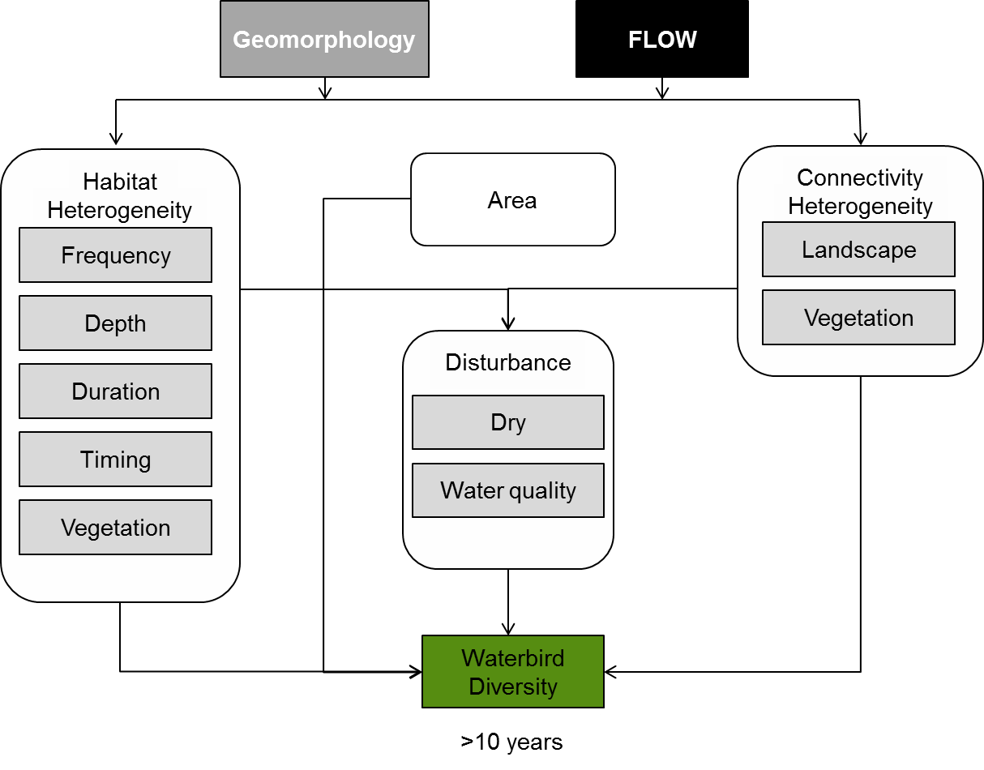

**Figure 11. Cause and effect diagram depicting the influence of flow and geomorphology on landscape bird diversity.**

**Habitat:** Habitat diversity is an important determinant of waterbird diversity for three reasons:

* many species require different habitats for breeding, foraging, roosting and surviving harsh times
* different species have different habitat requirements (see Rogers and Ralph (2011)) for summaries of bird habitat requirements), so maintaining a mosaic of wetlands with different water depths (Colwell and Taft 2000; Kingsford et al. 2004) duration of inundation and vegetation is required to support diverse waterbird communities (Guadagnin et al. 2005)
* the flooding and drying cycles of Australian rivers means that the value of specific wetlands will change through time as they fill and dry. Shallow wetlands may provide good foraging habitat during the flood peak, but will soon dry and lose their value. However, at flood peak, deeper wetlands may provide good habitat for birds such as cormorants, but as the wetland dries and its shape and vegetation changes, the bird community will change (Gawne and Scholz 2006).

Water depth is an important waterbird habitat characteristic with community composition varying with wetland depth: deeper water is favoured by diving and fish-eating birds (Scott 1997) and shallow wetlands generally support a greater diversity and abundance of waterbirds including waders and ducks (Colwell and Taft 2000). This is because shallow areas are foraging habitat for many species and are also believed to be more productive (Colwell and Taft 2000; Kingsford et al. 2004). Depth is also an important breeding cue with rapid falls in water level leading to nest abandonment in some instances (Brandis et al. 2011).

One of the key determinants of waterbird diversity at the Basin scale is the opportunity to breed. The frequency, duration and timing of flooding of wetland habitat influences the production of food resources and is important for waterbird breeding success and population persistence between breeding events (Arthur et al. 2011). Suitable breeding habitat must be made available at frequent intervals relative to species longevity (so that individual birds can breed before they die) and breeding habitat must remain suitable for long enough to enable fledging to occur (Brandis et al. 2011). The timing of floods influences the lag time between flooding and nesting for species such as darters, cormorants, herons, egrets and spoonbills (Briggs and Thornton 1999).

Wetland vegetation provides nesting, rearing and refuge areas for waterbirds, as well as being a direct food source for herbivorous species such as black swans and coots (Scott 1997). Floodplain trees are particularly important for nesting of species including darters, spoonbills, cormorants, herons and egrets (Briggs and Thornton 1999), while macrophytes such as typha, phragmites and spiny rush provide nesting habitat for Australasian grebes, swans, eurasian coot, purple swamphens and straw-necked ibis (Rogers and Ralph 2010). As a consequence, vegetation condition and diversity will influence the diversity of the bird community.

**Area**: The species-area relationship predicts that the more habitat available the more species will be present. Habitat availability is known to be a major influence on waterbird communities. Areas of extensive floodplain have been found to have a higher diversity of wetland habitats during times of flood and support high abundances of waterbirds at the catchment scale (Roshier et al. 2002). At an individual wetland scale, wetland size has also been found to be positively correlated with waterbird diversity (Colwell and Taft 2000). These results are similar to findings from overseas where the area of available habitat (Guadagnin et al. 2005), wetland size (Guadagnin et al. 2005; González-Gajardo et al. 2009) and length of shore-line (González-Gajardo et al. 2009) have all been found to influence waterbird diversity.

**Disturbance**: The disturbance regime is an important ecosystem characteristic that influences biodiversity and any change to a system’s disturbance regime is likely to have a significant effect on community composition (Kingsford et al. 2004). In the Murray-Darling Basin, water dependent ecosystems are characterised by periods of boom and bust over both annual and decadal time-frames.

More permanent, regulated waterbodies may be important refuges during these times. The dry phase is however, essential to the hydrological variability that drives the ecology of floodplains within the Murray-Darling Basin (Kingsford et al. 2004; Gawne and Scholz 2006; Briggs et al. 2010). Waterbird density and diversity is positively correlated with hydrological variability (Kingsford et al. 2004) and ephemeral floodplain lakes provide abundant food resources for waterbirds that feed on invertebrates and plants, including grey teal, pink-eared duck and egrets (Scott 1997). In order to cope with this variability, some species switch diet during dry periods from plants to insects (e.g. Australian wood duck), others may move from fresh to saline areas (e.g. chestnut teal, grey teal) (Kingsford and Norman 2002).

Over decadal time scales, dry periods are ‘press’ or ‘ramp’ disturbances (Lake 2003) that influence the distribution of waterbirds by reducing the area of wetland habitat available for feeding, nesting and refuge. Significant declines in waterbird abundance and diversity have been documented throughout the Murray-Darling Basin, particularly for highly regulated wetlands (Kingsford et al. 2012) (Kingsford and Thomas 1995). This suggests that while waterbirds are well adapted to dealing with extended dry periods, that our management of the system may make persistence through extended droughts more difficult, thereby affecting resilience.

**Connectivity**: For waterbirds in other countries, connectivity among wetlands is recognised as being an important determinant of wetland use by waterbirds (Amezaga et al. 2002); however, in Australia where waterbirds are known to move large distances, the influence of landscape pattern is less well understood. During times of high rainfall and flood, wetland habitat in Australia is extensive and waterbirds can disperse large distances to exploit temporary aquatic habitats for food, refuge and breeding (Kingsford and Norman 2002). Successful waterbird dispersal is influenced by the interaction between the distance a species can fly and the distance between suitable habitats such that changes to the spatial distribution of wetlands may affect species persistence (Kingsford and Norman 2002). There is also some information to suggest that dispersal patterns of some species vary in response to the landscape (Roshier et al. 2002), although the significance of these differences is not well understood.

Connectivity also has the capacity to influence waterbirds indirectly through its influence on food resources. Connections among wetlands are known to influence the composition of fish, frog and invertebrate communities. As a consequence, maintaining a mosaic of wetlands with different connections is likely to maintain a mosaic of diverse food resources to support waterbirds.

**Knowledge gaps**: The ecology of many species of waterbirds remains a significant knowledge gap (Kingsford and Norman 2002). Broad-scale movement of Australian waterbirds is also poorly understood, including the triggers for movement and the interaction between individual species and their habitats (Roshier et al. 2002). In particular, species population structure and dynamics, including measures of juvenile and adult survival rates and drivers, are major knowledge gaps that together with lack of knowledge of dispersal and movement patterns (over both space and time) significantly hinder our ability to understand and manage waterbird populations and communities. One pertinent question for waterbird conservation in Australia is how do climate change, habitat loss and flow modification interact with waterbird population declines? (Kingsford and Norman 2002).

**Use of the cause and effect diagram**: This is a generic diagram applicable across both the northern and southern parts of the basin. Its application to particular circumstances or localities would require additional information and potentially modification of the model.

**References**

Amezaga JM, Santamaría L, Green AJ (2002) Biotic wetland connectivity—supporting a new approach for wetland policy. Acta Oecologica 23:213-222 doi: http://dx.doi.org/10.1016/S1146-609X(02)01152-9

Brandis K, Kingsford R, Ren S, Ramp D (2011) Crisis water management and Ibis breeding at Narran Lakes in arid Australia. Environmental Management 48:489-498

Briggs S, Hodgson P, Ewin P (2010) Changes in populations of waterbirds on a wetland following water storage. Wetlands (Australia) 13:36-48

Briggs S, Thornton S (1999) Management of water regimes in River Red Gum *Eucalyptus camaldulensis* wetlands for waterbird breeding. Australian Zoologist 31:187-197

Colwell M, Taft O (2000) Waterbird communities in managed wetlands of varying water depth. Waterbirds 23:45-55

Frith H (1965) Ecology of the Freckled Duck *Stictonetta naevosa* (Gould). Wildlife Research 10 125-139

Gawne B, Scholz O (2006) Synthesis of a new conceptual model to facilitate management of ephemeral deflation basin lakes. Lakes & Reservoirs: Research & Management 11:177-188

González-Gajardo A, Sepúlveda PV, Schlatter R (2009) Waterbird Assemblages and habitat characteristics in wetlands: influence of temporal variability on species-habitat relationships. Waterbirds 32:225-233

Guadagnin DL, Peter ÂS, Perello LFC, Maltchik L (2005) Spatial and temporal patterns of waterbird assemblages in fragmented wetlands of southern Brazil. Waterbirds 28:261-272

Kingsford R, Jenkins K, Porter J (2004) Imposed hydrological stability on lakes in arid Australia and effects on waterbirds. Ecology 85:2478-2492

Kingsford R, Norman F (2002) Australian waterbirds - products of the continent's ecology. Emu 102:47-69

Kingsford R, Porter J, Halse S (2012) National waterbird assessment. Waterlines Report Series No. 74, March 2012. In. National Water Commission, Canberra, ACT

Kingsford R, Thomas R (1995) The Macquarie Marshes in arid Australia and their waterbirds: a 50-year history of decline. Environmental Management 19:867-878

Lake P (2003) Ecological effects of perturbation by drought in flowing waters. Freshwater Biology 48:1161-1172

Rogers K, Ralph T (2010) Floodplain wetland biota in the Murray-Darling Basin: water habitat requirements. CSIRO Publishing, Collingwood, Victoria

Rogers K, Ralph TJ (2011) Floodplain Wetland Biota in the Murray-Darling Basin: Water and Habitat Requirements. CSIRO Publishing, Melbourne

Roshier D, Robertson A, Kingsford R (2002) Responses of waterbirds to flooding in an arid region of Australia and implications for conservation. Biological Conservation 106:399-411

Scott A (1997) Relationships between waterbird ecology and river flows in the Murray-Darling Basin. In. CSIRO Land and Water, pp 1-41

# 11 Waterbird survival and condition

Sustaining waterbird populations requires that individuals survive to have breeding opportunities and also attain adequate condition to successfully fledge chicks. Accordingly, as survival and condition are strongly influenced by the hydrological regime, so too are waterbird populations. The frequency of flooding required to maintain food resources and habitats, promote recruitment and aid the survival of waterbird population is dependent on the mortality of individuals (Kingsford and Norman 2002; Rogers and Ralph 2010; Arthur 2011). More specifically, Rogers and Ralph (2010) estimate that, in the Murray-Darling Basin, at least two large floods should occur within the wild waterbirds lifetime, or four large breeding events within the captive longevity of waterbirds to account for waterbird population losses due to poor condition or predation. However, the age-structured model developed by Arthur (2011) of a generic egret, suggests a much higher frequency of breeding is required. Large populations of egrets are expected to require the occurrence of large breeding every one to two years to maintain the population (Arthur 2011). This inconsistency is largely due to the rarity of waterbird population studies in Australia (except for ducks) that detail survival/mortality rates (Arthur 2011).

Droughts may result in poor condition and high mortality rates through the loss of food resources and reduced habitat (Scott 1997). These high mortality rates reduce waterbird abundance, however, the impacts of drought are exacerbated as negative breeding responses also result. This is because waterbirds often require flooding as a cue to breed along with an adequate food supply to allow birds to achieve pre-breeding condition (Scott 1997). Waterbird populations should then flourish from the increased condition and survival of individuals. The following section describes how the survival and condition of waterbirds are affected by river flow through its influences on the connectivity, process and quality of the waterbirds habitat (Figure 12).

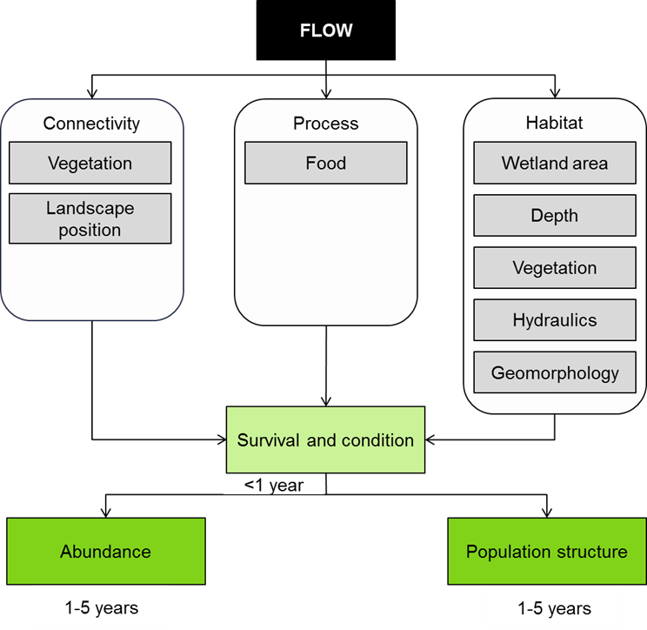

**Figure 12. Cause and effect diagram depicting the influence of flow on waterbird survival and condition.**

**Connectivity**: Australian waterbirds are highly mobile with habitat and food resources often driving their movements. Some waterbird species take advantage of wetland connectivity which results from high rainfall and floods (Kingsford and Norman 2002). This connectivity can be extensive enough to enable continental-scale movements, allowing waterbirds to disperse large distances to exploit temporary aquatic habitats for food, refuge and breeding (Kingsford and Norman 2002). However, knowledge of the timing and the extent of movement by many species is underdeveloped (Kingsford and Norman 2002). While generally floods provide a boom in food availability, food availability between floods is also important for sustaining bird condition and minimising mortality.

Prolonged droughts can force waterbirds to move great distances in search of drought refuges (Scott 1997). These refuges are important for the survival of individuals; by providing critical food resources enabling them to endure until environmental conditions improve (Scott 1997). In the past, some wetlands of the Murray-Darling Basin have been drained for agriculture, urbanisation or flood mitigation reducing the number of drought refuges (Scott 1997; Kingsford and Norman 2002). Many wetlands are currently permanently inundated for water storage which may counteract this previous loss (Briggs 1990; Scott 1997; Briggs and Thornton 1999; Kingsford and Norman 2002). However, the quality of water storages and irrigated crops for waterbird habitat is disputable (Kingsford and Norman 2002; Richardson and Taylor 2003). Despite their availability, they may not provide the diversity or abundance of food resources required to support a variety of waterbird species over time (Kingsford and Norman 2002).This uncertainty of food resources is intensified when changes to flooding regimes kill floodplain vegetation (Kingsford and Norman 2002).

Drought can also discourage movements of some species to small water bodies. This is because small wetlands and billabongs can become less suitable for waterbird feeding and breeding as they dry or become isolated from the main river channel (Scott 1997). Construction of levees on floodplains for crop irrigation or for town flood mitigation can also isolate small water bodies reducing their suitability for waterbird feeding (Scott 1997). Ultimately, the influence of flow on wetland connectivity can play a crucial role in the survival and condition of waterbirds.

**Process:** The probability of survival and the capacity for waterbirds to breed is strongly influenced by their condition.Waterbird condition is reliant on the availability and quality of food resources.Since many waterbirds specialise in particular food types, different geomorphologic habitats and hydrological regimes are likely to have diverse outcomes for each waterbird species. Access to these feeding locations is also important, particularly in severe drought.

There is currently only limited information on the relationship between food availability and waterbird condition. Observations of cycles of wetting and drying have observed that extended periods of inundation have been associated with changes in the abundance of plant and invertebrates and increases in the numbers of fish and this leads to a bird community dominated by piscivorous fish (Kingsford et al., 2004). Flooding has also been associated with large increases in invertebrate abundance which is associated with increases in bird abundance (Maher and Carpenter, 1984, Gawne and Scholz, 2006). In light of these observations and the possible links between food availability and bird mortality (Arthur 2011), it appears likely that the process of food production is a key influence on waterbird survival and condition.

**Habitat**: The loss and degradation of habitat affects food availability and so is possibly the greatest influence on condition and survival (Kingsford and Norman 2002). Flow regimes influence the amount of foraging habitat available for waterbirds. For example, piscivorous species such as cormorants, darters, and terns require ongoing access to small-bodied fish (Scott 1997). Some herbivorous species such as dabbling ducks, black swans and coots may profit from permanent wetlands where aquatic macrophyte communities are well established (Scott 1997). However, permanent flooding results in wetland becoming less diverse(Nielsen and Chick 1997; Barrett et al. 2010; Nielsen et al. in press); which may disadvantage other herbivorous species like magpie geese, plumed whistling ducks and maned ducks which graze predominantly on seed heads, buds, leaves and other plant material of both wetlands and dry-land vegetation(Scott 1997). A large number of species feed on invertebrates and other small animals (e.g. frogs) such as some ducks, ibis, egrets, spoonbills, herons, etc. These species may share food resources but have a diverse range of feeding sites, from mud flats (wading birds) to the main river channel (blue-billed duck and musk duck) (Scott 1997). Even when sharing the same wetland each species may collect different food items, or may collect the same food item from different parts of the habitat (Scott 1997). As food source preferences are species specific, so too are hydrological requirements and habitat geomorphology.

Flood characteristics (i.e. timing, recession, duration) impact bird condition and survival through their influence on food availability and the provision of roosting sites. These characteristics can affect the persistence and/or establishment of vegetation structure and condition within wetlands (Brandis 2010). Roosting sites in particular, are important for survival as they provide waterbirds with shelter and refuge from predators (Hattori and Satoshi 2001). Again a species specific interaction is seen with preferred vegetation for roosting sites. For instance, wetland vegetation such as reed beds, provides roosting sites and a direct food source for herbivorous species such as black swans and coots (Scott 1997), whereas littoral trees and shrubs are often utilised for roosting by herons and egrets (Hattori and Satoshi 2001). Plant structural diversity and vegetation richness is crucial for a diverse waterbird community (Hattori and Satoshi 2001; Leslie 2001; Overton et al. 2009), therefore the hydrological regime most suited for survival and condition of waterbirds is likely to be one that takes into account both the maintenance of vegetative habitat and other waterbird requirements.

Habitat geomorphology is important to foraging as it affects the quantity and the availability of the food resource. Geomorphic requirements (e.g. depth and size) vary among species (Bolduca and Aftonb 2007) and are strongly correlated to the availability of food resources (Mažeika et al. 2006). For example, kingfishers tend to forage only in small streams with clear, relatively shallow water as larger deeper streams generally have fewer small sized fish, greater amounts of aquatic vegetation and can be more turbid (Mažeika et al. 2006). The preference of the piscivorous belted kingfisher (*Ceryle alcyon*) for this stream geomorphology was seen to improve foraging success (Mažeika et al. 2006). As geomorphology influences foraging success, accordingly condition and survival too are affected.

The hydraulics of flooding also affects waterbird foraging habitat. Current velocity affects water clarity and visibility while foraging, particularly where substrate sediment is composed of silt (Maccarone and Parsons 1994; Maccarone and Brzorad 2005). Trophic guilds have also presented preferences for different current velocities; presumably either due to the abundance of prey in these areas or the ability of the bird to forage there. For instance, diving piscivorous waterbirds have been seen to utilise stronger currents more often, whereas benthic foragers frequently foraged in areas with little or no current (Holm and Burger 2002). Research by (Holm and Burger 2002) however, revealed several exceptions to this pattern (Holm and Burger 2002). Still, the importance of flow to food availability and thus condition and survival of waterbirds is highlighted.

Other non-flow related factors affecting survival of water birds include waterfowl hunting, pollution, and the introduction of exotic flora and fauna. Clearing of vegetation (lignum) and floodplain trees (river red rum, coolabah and blackbox) along rivers is also a problem in many parts of the Murray-Darling Basin. Grazing of wetlands also degrades waterbird habitats and causes a decline in the abundance of more palatable species and can prevent the regeneration of river red gums (Scott 1997).

**Knowledge gaps**: Waterbird population studies in Australia detailing age structure, age-specific mortality rates and recruitment information are very rare. Filling these knowledge gaps would contribute significantly to assisting the waterbird population persistence within the MDB (Overton et al. 2009; Arthur 2011).

Also, as discussed, the timing and extent of the movements of many waterbirds is not well understood (Kingsford and Norman 2002) and how environmental flows could be used to influence this. The use of satellite tracking of a substantial number of individuals may inform this, however, such studies may be biased by costs and small sample size (Kingsford and Norman 2002).

**Use of the cause and effect diagram**: This is a generic diagram applicable across both the northern and southern parts of the basin. Its application to particular circumstances or localities would require additional information and potentially modification of the model.

**References**

Arthur AD (2011) Using an age-structured population model to define management requirements for conservation of egrets in the Murray–Darling Basin, Australia. Emu 111:191-196 doi: http://dx.doi.org/10.1071/MU10060

Barrett R, Nielsen DL, Croome R (2010) Associations between the plant communities of floodplain wetlands, water regime and wetland type. River Research and Applications 26

Bolduca F, Aftonb AD (2007) Monitoring waterbird abundance in wetlands: The importance of controlling results for variation in water depth. Ecological Modelling 216:402-408

Brandis K (2010) Colonial waterbird breeding in Australia: wetlands, water requirements and environmental flows. PhD, University of New South Wales

Briggs S (1990) Waterbirds. In: MacKay N, Eastburn D (eds) The Murray. Murray-Darling Basin Commission, Canberra

Briggs S, Thornton S (1999) Management of water regimes in River Red Gum Eucalyptus camaldulensis wetlands for waterbird breeding. Australian Zoologist 31:187-197

Hattori A, Satoshi M (2001) Habitat use and diversity of waterbirds in a coastal lagoon around Lake Biwa, Japan. Ecological Research 16:543-553

Holm KJ, Burger AE (2002) Foraging Behavior and Resource Partitioning by Diving Birds During Winter in Areas of Strong Tidal Currents. Waterbirds 25:312-325

Kingsford R, Norman F (2002) Australian waterbirds - products of the continent's ecology. Emu 102:47-69

Leslie DJ (2001) Effect of river management on colonially-nesting waterbirds in the Barmah-Millewa forest, south-eastern Australia. Regulated Rivers: Research & Management 17:21-36 doi: 10.1002/1099-1646(200101/02)17:1<21::aid-rrr589>3.0.co;2-v

Maccarone AD, Brzorad JN (2005) Foraging Microhabitat Selection by Wading Birds in a Tidal Estuary, with Implications for conservation. Waterbirds 28:383-391

Maccarone AD, Parsons KC (1994) Factors Affecting The Use of a Freshwater and an Estuarine Foraging Site by Egrets and Ibises during the Breeding Season in New York City

Colonial Waterbirds 17:60-68

Mažeika S, Sullivan P, Watzin MC, Hession WC (2006) Differences in the Reproductive Ecology of Belted Kingfishers (Ceryle alcyon) Across Streams with Varying Geomorphology and Habitat Quality. Waterbirds 29:258-270

Nielsen D, Podnar K, Watts R, Wilson A (in press) Empirical evidence linking increased hydrologic stability with decreased biotic diversity within wetlands. Hydrobiologia:1-16

Nielsen DL, Chick AJ (1997) Flood-mediated changes in aquatic macrophyte community structure. Marine and Freshwater Research 48:153-157

Overton IC, Colloff M, Doody TM, Henderson B, Cuddy S (2009) Ecological outcomes of flow regimes in the Murray-Darling Basin. Water for a Healthy Country

Reid J, Kingsford R, Jaensch R (2009) Waterbird Surveys in the Channel Country Floodplain Wetlands, Autumn 2009. Report by Australian National University, Canberra, University of New South Wales, Sydney, and Wetlands International, Oceania, Brisbane, for the Australian Government Department of Environment, Water, Heritage and the Arts

Richardson AJ, Taylor IR (2003) Are rice fields in south-eastern Australia an adequate substitute for natural wetlands as foraging areas for egrets? Waterbirds 26:353-363

Rogers K (2010) Waterbirds. In: Rogers K, Ralph T (eds) Floodplain wetland biota in the Murray-Darling basin: water and habitat requirements. CSIRO Publishing, Collingwood, Victoria, pp 83-204

Rogers K, Ralph T (2010) Floodplain wetland biota in the Murray-Darling Basin: water and habitat requirements. CSIRO PUBLISHING

Scott A (1997) Relationships between waterbird ecology and river flows in the Murray-Darling Basin. In. CSIRO Land and Water, pp 1-41

# 12 Waterbird reproduction

This cause-effect diagram (CED) describes the influence of flow on waterbird reproduction. Waterbird reproduction is often used as an indicator of environmental health due to its links to wetland productivity, however as birds are highly mobile their absence does not necessarily indicate unsuitable habitat (Baldwin et al. 2005). River flows and season affect waterbird reproduction directly by providing cues for reproduction behaviour and by affecting the condition of the birds and their breeding habitats (Figure 13). Environmental flow management is likely to have a significant influence on waterbird populations through the influence on flooding, which if improperly managed can result in a decline in the frequency of waterbird breeding (Leslie 2001; Arthur 2011). The following description refers to waterbird reproduction, which in this context encompasses breeding and hatching. Waterbird recruitment and fledging are described in separate CEDs, as is waterbird survival and condition.

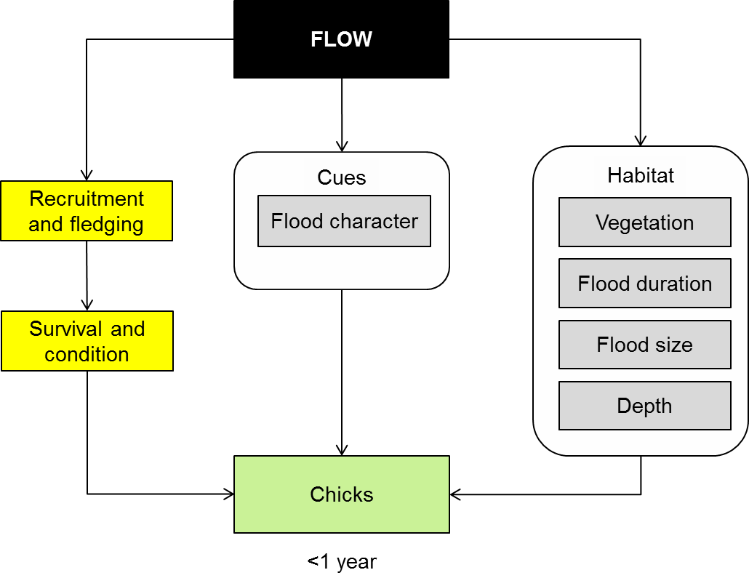

Figure 13. Cause-effect diagram depicting flow influences on waterbird cues and habitat.

**Cues:** Waterbird reproduction can be cued by season (temperature and photoperiod), rainfall, flooding, or interactions between these, depending on the species – however in Australia most waterbirds are cued to breed by flooding (Briggs 1990; Scott 1997; Rogers 2010). Breeding success in many species is particularly sensitive to flood depth (Briggs 1990; Kingsford and Auld 2005) and premature lowering of water levels may cause abandonment of nests (Briggs et al. 1997; Scott 1997; Leslie 2001; Kingsford and Auld 2005; Brandis 2010; Brandis et al. 2011). This may be related to reduction in availability or quality of food resources, increased predation, loss of suitable habitat, or a combination of these.

Some waterbird species require an extended flooding period for successful breeding (Leslie 2001). For example the great egret requires a minimum flood duration of about 6-7 months, with an ideal flood duration of 12 months (Rogers 2010). This time allows for attainment of pre-breeding condition (nutritional and hormonal requirements), pairing, nesting, incubation and fledging (Briggs 1990; Brandis 2010; Rogers 2010). It is also essential to manage the time between floods, as prolonged droughts may not allow opportunity for waterbirds to reproduce within their lifetimes (Leslie 2001). Thus breeding opportunities are limited to the number of floods.

Timing of flooding is also important for waterbird breeding, as optimal breeding occurs when flooding coincides with favourable seasonal conditions (Chesterfield et al. 1984; Briggs, 1990; Scott, 1997). Many waterbirds tend to breed during the warmer months. Seasonal cues help to ensure that breeding coincides with plentiful food resources and minimised exposure to adverse weather conditions (Briggs 1990; Brandis 2010; Rogers 2010). Some species, such as the Musk Duck and the Blue-billed Duck, breed in response to season alone (Briggs 1990).

In summary, waterbird breeding can be stimulated by season, flooding, or a combination of the two (Briggs 1990). However the effect of these cues is likely to be due to their characteristics (Season- temperature, photoperiod; Flooding- timing, duration, depth, extent, rate of recession, frequency and inter-flood dry period). These factors also influence breeding success largely by affecting the condition of the waterbirds themselves and their habitat (Rogers 2010).

**Habitat:** Rivers, wetlands and floodplains provide essential reproduction habitat. Waterbirds require breeding sites that will provide both suitable nesting habitat and reliable food resources. Wetland vegetation provides nesting, rearing and refuge areas for waterbirds, as well as being a direct food source for herbivorous species such as black swans and coots (Scott 1997). Floating and submerged macrophytes are essential breeding habitat for the whiskered tern, swans and coots (Reid et al. 2009). Rushes, reed beds and lignum beds are used by swamphen, moorhen, duck, ibis, spoonbills, and herons (Reid et al, 2009), and large riparian trees (dead and alive), particularly river red gums, are important for nesting habitat of darters, spoonbills, cormorants, herons and egrets (Briggs and Thornton 1999). This highlights the importance of managing for a diversity of nesting habitats to meet the reproduction requirements of a diverse waterbird community (Leslie 2001; Reid et al. 2009).

The quality of waterbird breeding habitat is related directly to hydrological regime, as flooding is required for the provision and maintenance of vegetation structure and condition (Brandis 2010). The hydrological regime most suited to the maintenance of vegetative habitat may be quite different to that required for waterbird reproduction, however the provision of water to maintaining the health of nesting vegetation maybe just as important for breeding.

Flood duration, water depth and the rate of rise and fall are hydrological effectors of food and nesting availability (Herring 2005; Rogers and Ralph 2010). As the nests of many species are often established over water or on ephemeral islands, depth may be a crucial factor affecting breeding (Marchant and Higgins 1990; Rogers and Ralph 2010). However minimal information is available about the specific depth of water required for breeding success (Rogers and Ralph 2010). Even so, due to the relationship between flood depth and duration, it is likely that floods with a greater depth and duration will have enhanced breeding success (Rogers and Ralph 2010).

Some waterbirds are fastidious with their food and habitat requirements for reproduction. Notably, waterbird reproduction can also be constrained by the spatial scale of nesting habitats and previous memory attachment to sites (i.e. some species habitually breed in certain locations) (Reid et al. 2009). With this acute selectivity of waterbirds to their nesting habitat, combinations of perfect flow conditions and ideal habitat elements may still not equate to predicted breeding responses (Reid et al. 2009).

**Knowledge gaps**: The conditions and habitats required for successful waterbird reproduction for some guilds are generally well understood in some locations. However, whether this varies between different floodplains is less explicit. We also currently know very little about the exact mechanisms that drive successful breeding events and what survival rates are actually being achieved (Reid et al. 2009). Age structure, age-specific mortality rates, and recruitment information would contribute significantly to understanding and management of waterbird population persistence within the MDB (Reid et al. 2009).

**Use of the cause and effect diagram**: This is a generic diagram applicable across both the northern and southern parts of the basin.

**References**

Arthur AD (2011) Using an age-structured population model to define management requirements for conservation of egrets in the Murray–Darling Basin, Australia. Emu 111:191-196 doi: http://dx.doi.org/10.1071/MU10060

Baldwin DS, Nielsen DL, Bowen PM, Williams J (2005) Recommended Methods for Monitoring Floodplains and Wetlands. MDBC Publication No. 72/04

Brandis K (2010) Colonial waterbird breeding in Australia: wetlands, water requirements and environmental flows. PhD, University of New South Wales

Brandis K, Kingsford R, Ren S, Ramp D (2011) Crisis water management and Ibis breeding at Narran Lakes in arid Australia. Environmental Management 48:489-498

Briggs S (1990) Waterbirds. In: MacKay N, Eastburn D (eds) The Murray. Murray-Darling Basin Commission, Canberra

Briggs S, Thornton S (1999) Management of water regimes in River Red Gum *Eucalyptus camaldulensis* wetlands for waterbird breeding. Australian Zoologist 31:187-197

Briggs SV, Lawler WG, Thornton SA (1997) Relationships Between Hydrological Control of River Red Gum Wetlands and Waterbird Breeding. Emu 97:31-42 doi: http://dx.doi.org/10.1071/MU97003

Herring M (2005) Threatened species and farming. Brolga: Management of breeding wetlands in northern Victoria. ESAI sub-project 5118

Kingsford RT, Auld KM (2005) Waterbird breeding and environmental flow management in the Macquarie Marshes, arid Australia. River Research and Applications 21:187-200 doi: 10.1002/rra.840

Leslie DJ (2001) Effect of river management on colonially-nesting waterbirds in the Barmah-Millewa forest, south-eastern Australia. Regulated Rivers: Research & Management 17:21-36 doi: 10.1002/1099-1646(200101/02)17:1<21::aid-rrr589>3.0.co;2-v

Marchant S, Higgins PJ (eds) (1990) Handbook of Australian, New Zealand and Antarctic Birds. Oxford University Press, Melbourne

Reid J, Kingsford R, Jaensch R (2009) Waterbird Surveys in the Channel Country Floodplain Wetlands, Autumn 2009. Report by Australian National University, Canberra, University of New South Wales, Sydney, and Wetlands International, Oceania, Brisbane, for the Australian Government Department of Environment, Water, Heritage and the Arts

Rogers K (2010) Waterbirds. In: Rogers K, Ralph T (eds) Floodplain wetland biota in the Murray-Darling basin: water and habitat requirements. CSIRO Publishing, Collingwood, Victoria, pp 83-204

Rogers K, Ralph T (2010) Floodplain wetland biota in the Murray-Darling Basin: water and habitat requirements. CSIRO PUBLISHING

Scott A (1997a) Relationships between waterbird ecology and river flows in the Murray-Darling Basin. In. CSIRO Land and Water, pp 1-41

# 13 Waterbird recruitment and fledging

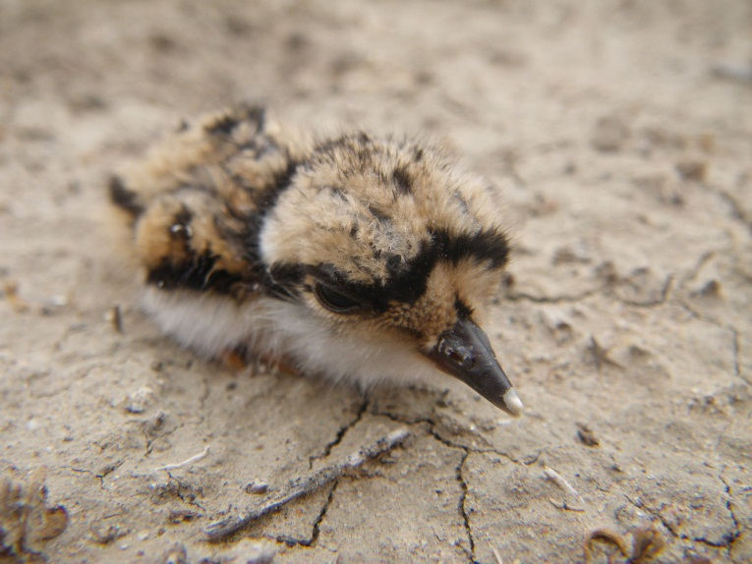Chick recruitment and fledging is used as a measure of productivity; an important element in the study of avian demography (Nisbet et al. 1990). Fledging may be interpreted differently between authors and depending on species of waterbird. For example, in a study of breeding success of four egret species in Australia, young birds were considered fledged when able to fly from branch to branch or to a nearby tree (Maddock and Baxter 1991). It is likely that the most important factor in successful fledging of clutches is food availability (Maddock and Baxter 1991). At key waterbird breeding sites in the Murray-Darling Basin, food availability is strongly predicated by characteristics of flood events (e.g. timing, duration, spatial extent, depth) (Scott 1997). Adult waterbirds confronted by loss of foraging habitat due to sudden drop in flood waters may be cued to abandon nests *en masse*, thereby terminating potential chick fledging (Kingsford and Auld 2005).

Dotterel chick, Darling Anabranch NSW, October 2012

The body of work on waterbird ecology in relation to the ecological health of wetlands in Australia, and particularly within the Murray-Darling Basin, is growing (Kingsford et al. 2004; Kingsford and Auld 2005; Overton et al. 2009; Brandis and Kingsford 2010; Rogers and Ralph 2010); however, specific studies of chick fledging and subsequent survival in Australia are scant (Maddock and Baxter 1991; Arthur 2011; Brandis et al. 2011) and more work is required to understand and manage flow related threats to successful waterbird chick fledging.

In the context of the Murray-Darling Basin, the cause and effect diagram shown in Figure 14 proposes that flow influences waterbird chick fledging through:

* ecological cues
* process (food availability)
* habitat availability.

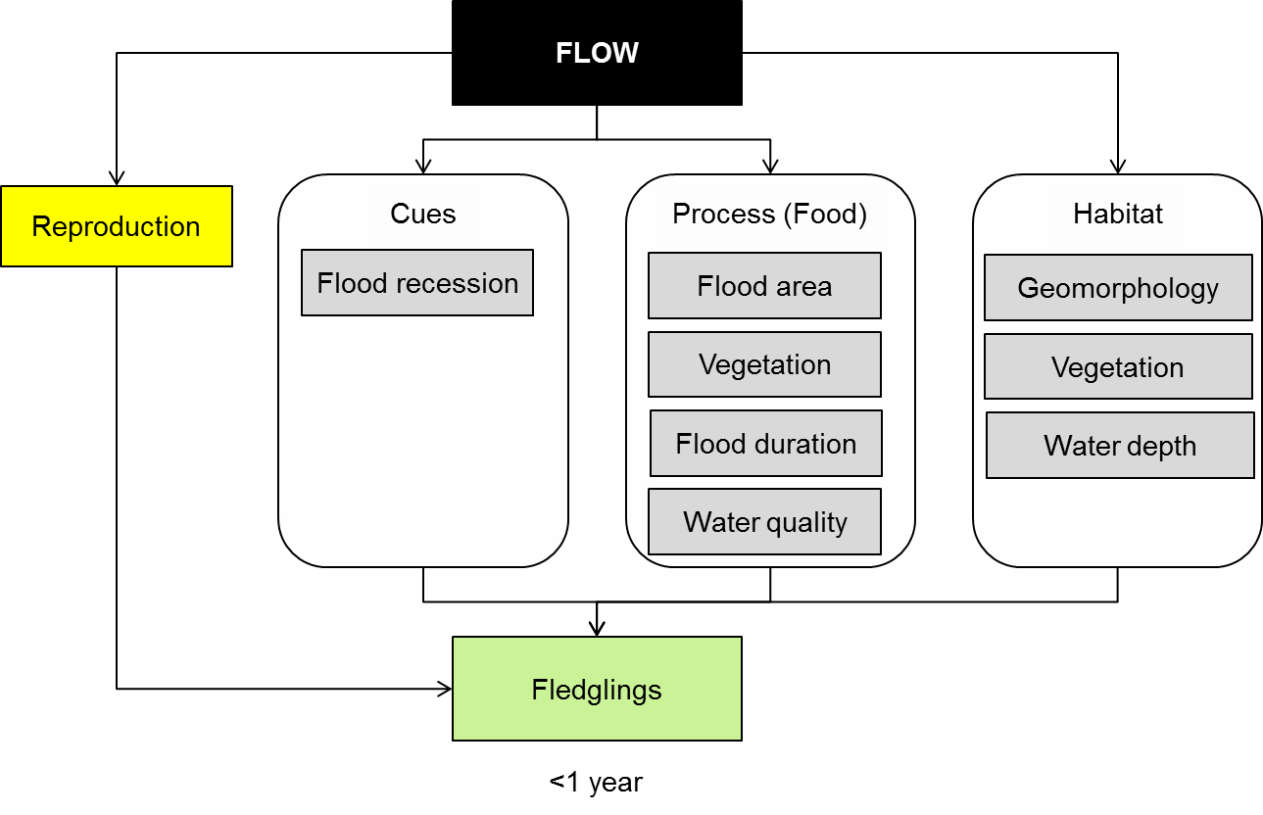

**Figure 14. Cause and effect diagram depicting influence of flow on waterbird recruitment and fledging.**

**Cues:** Flood recession - Having achieved hatching of eggs, the major threat to breeding success then is abandonment of the nest or brood by the parent bird/s, preventing fledging. Flood recession, either natural or managed, can act as a cue for nest abandonment by colonially nesting waterbirds (Carrick 1962; Briggs et al. 1997; Scott 1997; Kingsford and Auld 2005; Brandis et al. 2011). Scott (1997), suggests that falling water levels are perceived by waterbirds as an indicator of declining food reserves and it is this impending food scarcity that drives the nest abandonment behaviour.

**Process (Food):** *Flood area and duration -* Breeding habitat needs to be inundated in sufficient area and over sufficient time to allow the accumulation of food resources for waterbird breeding through to successful chick fledging (Leslie 2001; Kingsford and Auld 2005; Arthur et al. 2012). Arthur et al.(2012) observed that the number of nests at Murray-Darling Basin study sites (Barmah-Millewa Forest, Macquarie Marshes and Lake Merreti) increased with the area of floodplain inundated and inferred that food availability for breeding and successful fledging of broods is correlated with inundation area. Using chick fledging as an indicator of breeding success, evidence suggests that the larger the flood the more successful the breeding event (Kingsford and Auld 2005; Arthur et al. 2012). Scott (1997) also notes that high volume floods inundating larger areas support chick fledging when a greater abundance of food is available over a longer time period. As chicks approach fledging and independent feeding behaviours are learned, food supply must be plentiful enough to maintain the parent birds and support foraging chicks whose foraging skills are not yet at peak efficiency (Arthur 2011).

A Canadian study has looked at population regulation in foraging waterbirds based on territory defence or food availability (Butler 1994) finding ‘it is possible that density-dependent effects may have gone undetected because they are not immediate or direct. For example, density-dependent effects on chick growth and quality might be manifested by increased mortality after chicks leave their nests …’. Density dependant effects such as low per-capita food availability can be linked to flood magnitude and duration.

Flood duration to support fledging of chicks has been studied and recommended periods of up to 10 months are known for a range of waterbird species (Briggs et al. 1997).

*Vegetation -* Most Australian waterbirds obtain their food items in or on the edges of water bodies (Scott 1997). Aquatic and fringing plants are diet items for herbivorous waterbirds (i.e. swans and coots) and create habitat for the invertebrates and other small animals eaten by waterbirds from other feeding guilds. Characteristics of flooding such as source, timing and velocity can impact upon the establishment and/or persistence of vegetation within wetlands post-inundation. Absence or paucity of aquatic and fringing vegetation prior to and at the time of fledging may limit food availability for adults and fledglings, thereby undermining fledging success.

*Water quality -* As with vegetation abundance, diversity and distribution; surface water quality can directly influence the success of chick fledging via impacts upon food availability. Salinisation of wetlands leads to clearer waters, which may allow greater macrophyte growth and associated strong communities of zooplankton and other invertebrates, with lower abundances of aquatic vertebrates (i.e. fish and frogs) (Scott 1997) which are key prey items for some waterbird species. Saline and freshwater lakes may support breeding success including fledging for different species of waterbird. Further, the transition from fresh to salinised water conditions associated with drying of a wetland may render the wetland unsuitable for the completion of a successful breeding event through the impact on food resources; making water quality part of the suite of factors driving nest abandonment upon sudden flood water recession.

Piscivorous waterbirds relying on fish stocks within a wetland to sustain them and their brood may be adversely affected by water quality issues including hypoxic blackwater events or algal blooms if the impact is to reduce availability of suitable prey items (i.e. fish and other biota moving out of an area to avoid poor water quality, or succumbing to inadequate oxygen levels or toxins in the water column).

Conversely, during adverse water quality conditions avoidance behaviour by freshwater invertebrate and vertebrate animals may increase waterbird food availability in the short term as organisms move to the edges and shallows to seek oxygen at the water/air interface.

**Habitat:**

*Geomorphology* - Over time, flow will impact on geomorphology of wetlands. Changes in geomorphology may affect flooding duration, depth and extent at key bird breeding wetlands which in turn, may influence the spatial and temporal availability of nesting habitat (Leslie 2001; Overton et al. 2009) and foraging grounds.

*Vegetation -* As discussed in the ‘Food’ section above, suitable and adequate foraging area is a key habitat requirement to ensure successful fledging. Maintenance of nesting habitat for the duration of the fledging stage is also a requirement. Habitat utilised by waterbirds for nesting varies with species and includes floating macrophytes, emergent macrophytes, lignum, living trees and dead trees (Scott 1997; Leslie 2001).

*Water depth -* In 1997, Scott (1997) commented that actual water depth is not an important habitat variable in determining the successful fledging of chicks (except in the case of fish-eating waterbirds), adding however, that water depth is indirectly an indicator of the extent of flooding and the likely duration of inundation. In a study of ibis breeding at Narran Lakes in 2008, Brandis (2011) found that water depth was a significant variable in deciding breeding success. Brandis (2011) postulates that the ibis’ response to water depth may be a determining factor in nest abandonment, or may be indicative of a surrogate cue such as reduced wetland area and therefore reduced food availability, and increased threat from land predators.

Imposed hydrological stability (constant depth) at regulated wetlands may have the effect of reducing the diversity of biota at all trophic levels while maintaining plentiful fish stocks to the advantage of piscivores such as cormorants, darters and Australian pelicans (Scott 1997).

Continuous prolonged flooding of river red gum should be avoided to prevent premature death of trees which serve as nesting habitats (Briggs and Thornton 1999). Some colonial waterbirds will nest only in live trees (Scott 1997; Leslie 2001).

**Knowledge gaps:** While falling water levels are recognised as a cue to nest abandonment, which can cause fledging failure, the significance of such details as rate of fall, timing of fall, threshold water depth and threshold area of inundation are not well known. Further, it is likely that different species react differently to changes in flow; a clearer understanding of species specific requirements would facilitate management action in support of targeted waterbird species at individual breeding sites.

**Use of the cause and effect diagram**: This is a generic diagram applicable across both the northern and southern parts of the basin.

**References**

Arthur A, Reid JW, Kingsford R, McGinness H, Ward K, Harper M (2012) Breeding Flow Thresholds of Colonial Breeding Waterbirds in the Murray-Darling Basin, Australia. Wetlands 32:257-265 doi: 10.1007/s13157-011-0235-y

Arthur AD (2011) Using an age-structured population model to define management requirements for conservation of egrets in the Murray–Darling Basin, Australia. Emu 111:191-196 doi: http://dx.doi.org/10.1071/MU10060

Brandis K, Kingsford R (2010) Management of environmental flows for colonial waterbird breeding in Australia. Colonial waterbird breeding in Australia: wetlands, water requirements and environmental flows:134

Brandis K, Kingsford R, Ren S, Ramp D (2011) Crisis water management and Ibis breeding at Narran Lakes in arid Australia. Environmental Management 48:489-498

Briggs S, Thornton S (1999) Management of water regimes in River Red Gum *Eucalyptus camaldulensis* wetlands for waterbird breeding. Australian Zoologist 31:187-197

Briggs SV, Lawler WG, Thornton SA (1997) Relationships Between Hydrological Control of River Red Gum Wetlands and Waterbird Breeding. Emu 97:31-42 doi: http://dx.doi.org/10.1071/MU97003

Butler RW (1994) Population Regulation of Wading Ciconiiform Birds. Colonial Waterbirds 17:189-199 doi: 10.2307/1521300

Carrick R (1962) Breeding, movements and conservation of Ibises (Threskiornithidae) in Australia. CSIRO Wildlife Research 7:71-88 doi: http://dx.doi.org/10.1071/CWR9620071

Kingsford R, Jenkins K, Porter J (2004) Imposed hydrological stability on lakes in arid Australia and effects on waterbirds. Ecology 85:2478-2492

Kingsford RT, Auld KM (2005) Waterbird breeding and environmental flow management in the Macquarie Marshes, arid Australia. River Research and Applications 21:187-200 doi: 10.1002/rra.840

Leslie DJ (2001) Effect of river management on colonially-nesting waterbirds in the Barmah-Millewa forest, south-eastern Australia. Regulated Rivers: Research & Management 17:21-36 doi: 10.1002/1099-1646(200101/02)17:1<21::aid-rrr589>3.0.co;2-v

Maddock M, Baxter GS (1991) Breeding Success of Egrets Related to Rainfall: A Six-Year Australian Study. Colonial Waterbirds 14:133-139 doi: 10.2307/1521502

Nisbet ICT, Burger J, Safina C, Gochfeld M (1990) Estimating Fledging Success and Productivity in Roseate Terns (Sterna dougallii). Colonial Waterbirds 13:85-91 doi: 10.2307/1521572

Overton IC, Colloff M, Doody TM, Henderson B, Cuddy S (2009) Ecological outcomes of flow regimes in the Murray-Darling Basin. Water for a Healthy Country

Rogers K, Ralph T (2010) Floodplain wetland biota in the Murray-Darling Basin: water and habitat requirements. CSIRO PUBLISHING

Scott A (1997) Relationships between waterbird ecology and river flows in the Murray-Darling Basin. In. CSIRO Land and Water, pp 1-41

# 14 Other vertebrates reproduction, growth and survival

**Other vertebrates reproduction**

The Basin Plan seeks to protect or restore the diversity of the Basin’s water dependent ecosystems. In addition to waterbirds and fish there are a number of animal species listed as threatened or endangered that would be expected to respond to environmental watering actions. These include:

* frogs
* turtles
* bush birds such as a crowned babbler
* birds of prey such as a white breasted sea-eagle
* bats such as small footed myotis
* other small mammals such as brush tailed phascogale and *y*ellow-footed antechinus.

This section describes the relationship between flow and reproduction (Figure 15), and flow and growth and survival in these groups (Figure 16). Rather than attempt to describe the relationship for all of these groups, the description focuses on frogs and turtles.

The Murray-Darling Basin (MDB) supports 29 frog species (Wassens 2011) and four species of turtle. All of these species are reliant on water to persist and, in general, river regulation has had a significant effect on habitat availability and dispersal. This is not true for all frog species as some are capable of persisting in wetlands sustained by rainfall. Many frog and turtle species have undergone significant declines in abundance, although in some instances, flow modification is not considered to be the major threat. In these cases, flow modification may interact with land use and predation by introduced predators to threaten their persistence.

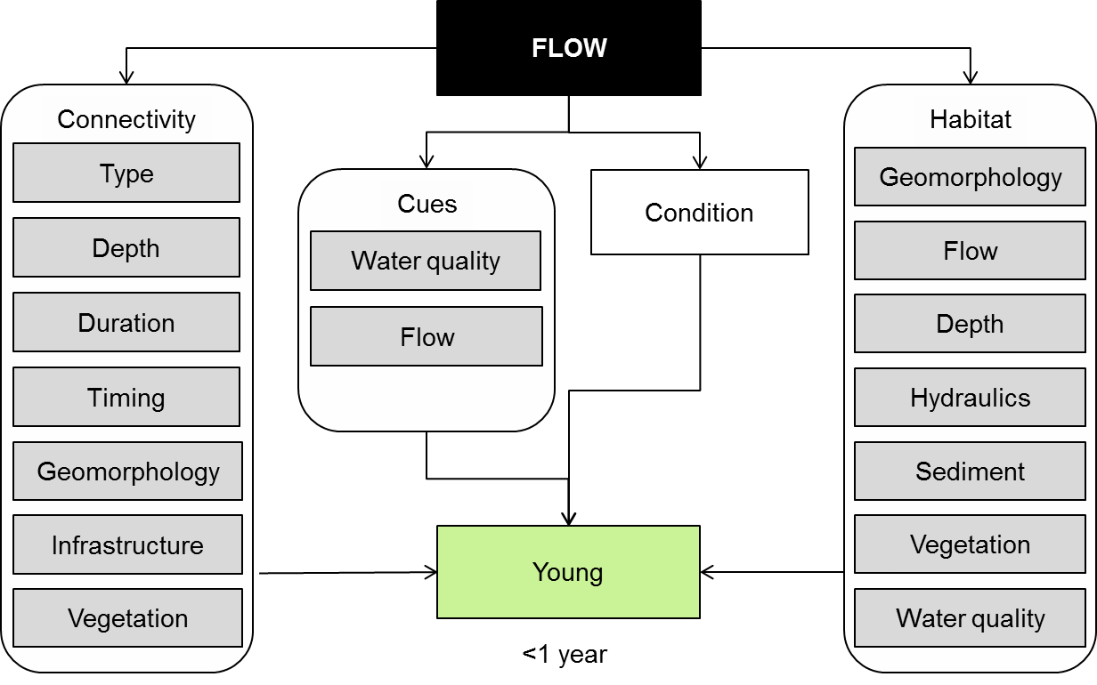

Figure 15. Cause and effect diagram depicting the influence of flow on other vertebrate reproduction.

Water is critical for frog breeding. Cues for reproduction include rainfall or floods. A survey of 67 species of frog in eastern NSW found 46 species had clearly defined calling periods in the warmer spring and summer months (Lemckert and Mahony 2008). This means that for many species, the timing of inundation may influence these species capacity to breed during wetland inundation.

Once conditions are suitable, males and females will move to breeding sites where males will start calling to attract mates. In many instances, these movements occur across land, so connectivity, particularly vegetation condition between wetlands, is an important influence (Westgate et al. 2012) as is the landscape mosaic of wetlands (Hamer and Mahony 2007; Heard et al. 2012).

Fecundity is influenced in many species by the size of the female (Lauck 2005; Reading 2007; Tomasevic et al. 2008). In some species there is also variation in the size of eggs related to season (Cadeddu and Castellano 2012) and antecedent conditions (Tomasevic et al. 2008). Turtles mate and then lay eggs in a nest. The long-necked tortoise lays from six to 23 eggs on a river or wetland bank in spring or summer. Clutch size and the number of clutches per year is influenced by food availability in the period leading up to mating and so is flow dependent (Kennett and Georges 1990). The broad-shelled river tortoise is believed to lay eggs in autumn that subsequently hatch in spring (Cogger 1996). To date there is no evidence that turtles and tortoise use any cue other than season to initiate breeding, although poor body condition is believed to limit reproductive activity and output.

**Other vertebrate growth and survival**

There is limited information available on the growth and survival of vertebrates such as frogs and turtles. For frogs, much of the information of their requirements is based on records of their presence in wetlands (Lauck 2005). The growth and survival of frogs is most usefully divided into the tadpole and post-metamorphosis phase. For tadpoles, the key influence on their growth and survival is hydroperiod (Herrmann et al. 2005; Werner et al. 2007; Wilson et al. 2013), both because of its influence on the time available for them to complete the larval phase of their life, but also because of the influence that cycles of flooding and drying have on predators, vegetation and productivity (Gawne and Scholz 2006).

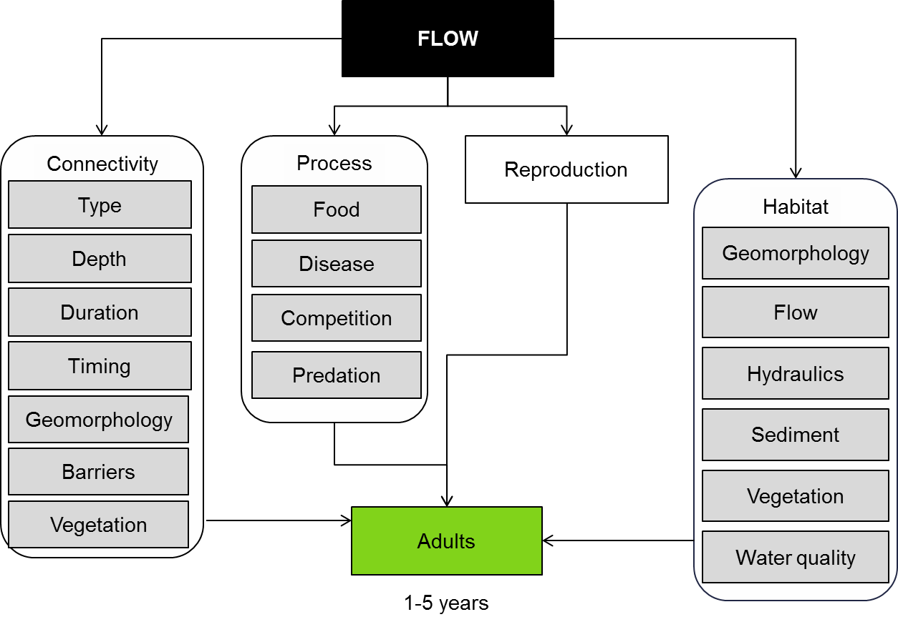

Figure 16. Cause and effect diagram depicting the influence of flow on other vertebrate growth and survival.

The time taken from hatching to metamorphosis varies among species (Wassens 2011) and with temperature (Williamson and Bull 1996). Some species such as the water-holding frog and the desert tree frog mature within one to two months, while at the other end of the spectrum, southern bell frogs mature over three to five months and the eastern banjo frog and giant banjo frog may take up to six months (Wassens 2011). This means that in order to successfully complete the tadpole phase, the duration of inundation needs to exceed the time required for development and the timing of inundation needs to align with the species’ temperature requirements.

As noted earlier, cycles of drying and flooding influence predator abundance, vegetation and primary productivity and these are all key influences on tadpole growth and survival. Predation is widely acknowledged to be a major influence on tadpole survival (Teplitsky et al. 2003; Werner et al. 2007) with predation by invasive species believed responsible for declines of some species (Gillespie and Hines 1999; Mahony 1999).

Vegetation is also widely recognised as an important influence on tadpole survival and growth (Gillespie 2002; Vignoli et al. 2007; Werner et al. 2007). Aquatic vegetation within the wetland may provide refuge from predators and an additional source of food (Wassens et al. 2010). Riparian vegetation may also shade the wetland which has been found to reduce tadpole survival (Lauck 2005; Werner et al. 2007).

Food availability is also a major influence on tadpole survival and growth (Gillespie 2002; Lauck 2005). Tadpole diets vary among species (Wassens 2011), but cycles of wetting and drying influence the rates of both primary and secondary production (Gawne and Scholz 2006) thereby influencing food availability. Further evidence for the importance of food comes from observations of competition influencing growth and survival among tadpoles (Bardsley and Beebee 1998; Greenberg 2001; Gillespie 2002; Brodman et al. 2003).

Finally, tadpole growth and survival is influenced by water quality with salinity (Smith et al. 2007) silica, hardness, pH, alkalinity, turbidity and ammonia all having been found to have an influence (Boyer and Grue 1995; Brodman et al. 2003; Vignoli et al. 2007). Very few tadpoles appear to survive to metamorphosis (Greenberg 2001; Ryan and Winne 2001) and survival appears to be related to their growth rate (Bardsley and Beebee 2001) and size at metamorphosis (Williamson and Bull 1996).

Once metamorphosed, the distribution of frogs and turtles is influenced by the availability of habitat, connectivity and processes. Habitat characteristics vary among species, but some of the key characteristics include flow characteristics such as the length of time the wetland holds water (hydroperiod) and whether the wetland is permanent (Wassens 2011) or ephemeral (Pyke and White 1999). Vegetation is a major habitat characteristic with many species dependent on vegetation to persist (Hazell 2003; Wassens et al. 2010; Wilson et al. 2013). Vegetation modifies the micro-climate reducing temperature, increasing humidity and providing protection from predators. Other habitat characteristics that may be important include depth, water quality and current speed (Mahony 1999).

Each of the three species of turtle has slightly different habitat requirements. The Murray turtle (*Emydura macquarii)* is associated primarily with riverine habitats with flowing water and associated backwater habitats where the main habitat characteristics include current speed, persistence during dry periods and turbidity (Chessman 1988). The long-necked tortoise (*Chelodina longicollis* ) prefers ephemeral wetlands such as anabranches, billabongs and swamps (Chessman 1988). By contrast, the broad-shelled river tortoise (*Chelodina expansa)* appears to be a generalist, occupying a wide variety of wetland types, but occurs in higher numbers in deeper wetlands close to the main river channel (Chessman 1988).

Connectivity is also important for the persistence of other vertebrates. For frogs, who are critically dependent on water in a highly variable and unpredictable landscape, this requires that they are able to deal with extinctions at individual wetlands. It appears that a key strategy to deal with this is to persist as a meta-population, that is, a number of isolated populations that regularly exchange individuals (Heard et al. 2012). For this strategy to work, frogs must be able to disperse among wetlands. For this reason, floods (Wassens et al. 2008) and the distance to nearby populations (Heard et al. 2012) influence the presence of frogs in wetlands.

For turtles, different types of connectivity are important for the different species. For the long-necked tortoise that prefers ephemeral wetlands, connectivity is important as they need to move back to refuges as their preferred habitat dries and into their preferred habitat when it fills (Kennett and Georges 1990; Roe and Georges 2008). For the short-necked tortoise, lateral connectivity between backwaters and the main channel is important and for males, longitudinal connectivity appears to be important with individuals moving up to 25km (Bower et al. 2012).

While connectivity is important for both frogs and turtles, there is only limited understanding of the critical connectivity characteristics that may influence dispersal. Being cold-blooded it is likely that timing of connection will affect dispersal as cooler temperatures may mean the animals are not as active. It is less clear the extent to which the type, duration and depth of connection will influence dispersal as frogs and turtles are capable of crossing land; however, these characteristics do influence fish access and may therefore influence predation within a wetland. Barriers are also likely to influence dispersal during both wet and dry phases as frogs and turtles colonise wetlands or retreat into refuges respectively.

Ecological processes are key influences on the growth and survival of other vertebrates. For frogs, predation is known to be a key influence on survival, including the introduced gambusia (Mahony 1999; Pyke and White 1999) and foxes (Gillespie and Hines 1999). Frogs are also influenced by disease, with declines in many populations being attributed to chytrid fungus infection (Gillespie and Hines 1999). Food availability may also be important for both tadpoles and adults, but very little information is available (Gillespie and Hines 1999).

For turtles, predation by introduced predators such as foxes is believed to be one of the major threats to their persistence; (Spencer and Thompson 2005), although the degree to which this is influenced by flow is unknown. The main three species of turtle are omnivores, consuming a mix of vegetable and animal material including carrion(Chessman 1986), but the amount of food is believed to influence both body condition and dispersal (Kennett and Georges 1990). Kennet and Georges (1990) observed that competition for food appeared to reduce body condition when dry conditions forced large number of turtles into a limited number of refuges.

**Knowledge gaps:** Compared to fish, the ecology of other vertebrates are less well studied in the Murray-Darling Basin and as a result there are large knowledge gaps, dependent on the species examined.

**Use of the cause and effect diagram:** This is a generic diagram applicable across both the northern and southern parts of the basin.

**References**

Bardsley L, Beebee TJC (1998) INTERSPECIFIC COMPETITION BETWEEN BUFO LARVAE UNDER CONDITIONS OF COMMUNITY TRANSITION. Ecology 79:1751-1759 doi: 10.1890/0012-9658(1998)079[1751:icbblu]2.0.co;2

Bardsley L, Beebee TJC (2001) STRENGTH AND MECHANISMS OF COMPETITION BETWEEN COMMON AND ENDANGERED ANURANS. Ecological Applications 11:453-463 doi: 10.1890/1051-0761(2001)011[0453:samocb]2.0.co;2

Bower DS, Hutchinson M, Georges A (2012) Movement and habitat use of Australia's largest snake-necked turtle: implications for water management. Journal of Zoology 287:76-80 doi: 10.1111/j.1469-7998.2011.00891.x

Boyer R, Grue CE (1995) THE NEED FOR WATER-QUALITY CRITERIA FOR FROGS. Environmental Health Perspectives 103:352-357 doi: 10.2307/3432288

Brodman R et al. (2003) Multivariate Analyses of the Influences of Water Chemistry and Habitat Parameters on the Abundances of Pond-Breeding Amphibians. Journal of Freshwater Ecology 18:425-436 doi: 10.1080/02705060.2003.9663978

Cadeddu G, Castellano S (2012) Factors affecting variation in the reproductive investment of female treefrogs, Hyla intermedia. Zoology 115:372-378 doi: 10.1016/j.zool.2012.04.006

Chessman BC (1986) DIET OF THE MURRAY TURTLE, EMYDURA-MACQUARII (GRAY) (TESTUDINES, CHELIDAE). Australian Wildlife Research 13:65-69

Chessman BC (1988) SEASONAL AND DIEL ACTIVITY OF FRESH-WATER TURTLES IN THE MURRAY VALLEY, VICTORIA AND NEW SOUTH-WALES. Australian Wildlife Research 15:267-276

Cogger HG (1996) Reptiles & Amphibians of Australia, 5 edn. Reed Books, Melbourne

Gawne B, Scholz O (2006) Synthesis of a new conceptual model to facilitate management of ephemeral deflation basin lakes. Lakes & Reservoirs: Research & Management 11:177-188

Gillespie G, Hines H (1999) Status of temperate riverine frogs in south-eastern Australia. Declines and disappearances of Australian frogs:109-130

Gillespie GR (2002) Impacts of sediment loads, tadpole density, and food type on the growth and development of tadpoles of the spotted tree frog Litoria spenceri: an in-stream experiment. Biological Conservation 106:141-150 doi: 10.1016/s0006-3207(01)00127-6

Greenberg CH (2001) Spatio-temporal dynamics of pond use and recruitment in Florida gopher frogs (Rana capito aesopus). Journal of Herpetology 35:74-85 doi: 10.2307/1566026

Hamer AJ, Mahony MJ (2007) Life history of an endangered amphibian challenges the declining species paradigm. Australian Journal of Zoology 55:79-88 doi: 10.1071/zo06093

Hazell D (2003) Frog ecology in modified Australian landscapes: a review. Wildlife Research 30:193-205 doi: 10.1071/wr02075

Heard GW, Scroggie MP, Malone BS (2012) Classical metapopulation theory as a useful paradigm for the conservation of an endangered amphibian. Biological Conservation 148:156-166 doi: 10.1016/j.biocon.2012.01.018

Herrmann HL, Babbitt KJ, Baber MJ, Congalton RG (2005) Effects of landscape characteristics on amphibian distribution in a forest-dominated landscape. Biological Conservation 123:139-149 doi: 10.1016/j.biocon.2004.05.025

Kennett RM, Georges A (1990) Habitat utilization and its relationship to growth and reproduction of the eastern long-necked turtle, Chelodina longicollis (Testudinata: Chelidae), from Australia. Herpetologica:22-33

Lauck B (2005) Life history of the frog Crinia signifera in Tasmania, Australia. Australian Journal of Zoology 53:21-27 doi: 10.1071/zo04028

Lemckert F, Mahony M (2008) CORE CALLING PERIODS OF THE FROGS OF TEMPERATE NEW SOUTH WALES, AUSTRALIA. Herpetological Conservation and Biology 3:71-76

Mahony M (1999) Review of the declines and disappearances within the bell frog species group (Litoria aurea species group) In. Australia.'' Declines and Disappearances of Australian Frogs, Canberra, pp 81-93

Pyke GH, White A (1999) Dynamics of co-occurring frog species in three ponds utilized by the endangered Green and Golden Bell Frog Litoria aurea. Australian Zoologist 31:230-239

Reading CJ (2007) Linking global warming to amphibian declines through its effects on female body condition and survivorship. Oecologia 151:125-131 doi: 10.1007/s00442-006-0558-1

Roe JH, Georges A (2008) Terrestrial activity, movements and spatial ecology of an Australian freshwater turtle, Chelodina longicollis, in a temporally dynamic wetland system. Austral Ecology 33:1045-1056 doi: 10.1111/j.1442-9993.2008.01877.x

Ryan TJ, Winne CT (2001) Effects of hydroperiod on metamorphosis in Rana sphenocephala. American Midland Naturalist 145:46-53 doi: 10.1674/0003-0031(2001)145[0046:eohomi]2.0.co;2

Smith MJ et al. (2007) Associations between anuran tadpoles and salinity in a landscape mosaic of wetlands impacted by secondary salinisation. Freshwater Biology 52:75-84 doi: 10.1111/j.1365-2427.2006.01672.x

Spencer RJ, Thompson MB (2005) Experimental analysis of the impact of foxes on freshwater turtle populations. Conservation Biology 19:845-854

Teplitsky C, Plenet S, Joly P (2003) Tadpoles' responses to risk of fish introduction. Oecologia 134:270-277 doi: 10.1007/s00442-002-1106-2

Tomasevic N, Cvetkovic D, Miaud C, Aleksic I, Crnobrnja-Isailovic J (2008) INTERANNUAL VARIATION IN LIFE HISTORY TRAITS BETWEEN NEIGHBOURING POPULATIONS OF THE WIDESPREAD AMPHIBIAN BUFO BUFO. Revue D Ecologie-La Terre Et La Vie 63:371-381

Vignoli L, Bologna MA, Luiselli L (2007) Seasonal patterns of activity and community structure in an amphibian assemblage at a pond network with variable hydrology. Acta Oecologica-International Journal of Ecology 31:185-192 doi: 10.1016/j.actao.2006.09.006

Wassens S (2011) Frogs. In: Rogers K, Ralph TJ (eds) Floodplain wetland biota in the Murray-Darling Basin: Water and Habitat Requirements. CSIRO Publishing, Collingwood, Vic, pp 253-272

Wassens S, Hall A, Osborne W, Watts RJ (2010) Habitat characteristics predict occupancy patterns of the endangered amphibian Litoria raniformis in flow-regulated flood plain wetlands. Austral Ecology 35:944-955 doi: 10.1111/j.1442-9993.2010.02106.x

Wassens S, Watts RJ, Jansen A, Roshier D (2008) Movement patterns of southern bell frogs (Litoria raniformis) in response to flooding. Wildlife Research 35:50-58 doi: 10.1071/wr07095

Werner EE, Skelly DK, Relyea RA, Yurewicz KL (2007) Amphibian species richness across environmental gradients. Oikos 116:1697-1712 doi: 10.1111/j.2007.0030-1299.15935.x

Westgate MJ, Driscoll DA, Lindenmayer DB (2012) Limited influence of stream networks on the terrestrial movements of three wetland-dependent frog species. Biological Conservation 153:169-176 doi: 10.1016/j.biocon.2012.04.030

Williamson I, Bull CM (1996) Population ecology of the Australian frog Crinia signifera: Adults and juveniles. Wildlife Research 23:249-266

Wilson JN, Bekessy S, Parris KM, Gordon A, Heard GW, Wintle BA (2013) Impacts of climate change and urban development on the spotted marsh frog (Limnodynastes tasmaniensis). Austral Ecology 38:11-22 doi: 10.1111/j.1442-9993.2012.02365.x

# 15 Hydrological connectivity

There are multiple definitions for connectivity, and hydrological connectivity in particular (Ali and Roy 2009). Hydrologists lack consensus on what connectivity is, how to identify and measure it, and how to relate it to existing research (Bracken and Croke 2007; Ali and Roy 2009; Phillips et al. 2011). Ali and Roy (2009) reviewed 100 recent papers and defined four broad categories of definitions of varying preciseness. Hydrologic connectivity can thus be defined from (i) components of the water regime e.g.(Pringle 2003), (ii) landscape features e.g.(Hooke 2003; Bracken and Croke 2007), (iii) spatial patterns of hydrological properties e.g. (Western et al. 2002) cited in Ali and Roy (2009), and (iv) flow processes (Ali and Roy 2009).

In terms of hydrology and geomorphology, connectivity can be further split into three broad types (Bracken and Croke 2007):

1. **Landscape connectivity**, which relates to the physical coupling of landforms (e.g. hill slope to channel) within a drainage basin
2. **Hydrological connectivity**, which refers to the passage of water from one part of the landscape to another and is expected to generate some catchment run-off response
3. **Sedimentological connectivity**, which relates to the physical transfer of sediments and attached pollutants through the drainage basin and may vary considerably with, amongst others, in particle size.

Landscape connectivity is relevant at the watering area scale and at the Basin wide scale for certain taxa that have large distributions (i.e. waterbirds); however the focus of this cause-effect diagram (CED) is on hydrological connectivity, with a predominantly ecological context. Sedimentological connectivity is dealt with under a separate sediment transport cause-effect diagram. There is a high degree of overlap with several other cause-effect diagrams, notably the function cause-effect diagrams, and these should be referred to for greater detail.

One of the original and most widely used definitions of hydrological connectivity is that of Pringle (2001), which uses an ecological context to refer to water mediated transfer of matter, energy and/or organisms within or between elements of the hydrologic regime. The Basin Plan defines connectivity as referring to the connections between natural habitats, such as a river channel, adjacent wetland areas and along the length of rivers, including connections above ground (surface water) or below ground (groundwater) (MDBA 2012).

Connectivity in aquatic ecosystems is multidimensional and highly variable, with hydrological connectivity having four dimensions: lateral (riverine – floodplain), longitudinal (headwaters-estuarine), vertical (riverine – groundwater) and temporal connectivity (Ward and Stanford 1995; Poff et al. 1997; Amoros and Bornette 2002; Pringle 2003). Given an ecological context, hydrological connectivity relates to water mediated movement of biota (refer biotic dispersal cause-effect diagram), energy (refer nutrient and carbon cycling cause-effect diagram) and materials (refer sediment transport cause-effect diagram) through the landscape (Pringle 2001; Pringle 2003) and is a well-established principle in the maintenance of spatially structured populations (Bracken and Croke 2007).

Hydrological connectivity is influenced by floods, rainfall and run-off with all three influencing the transport of terrestrial material through the landscape. The amount of material (biotic and abiotic) transported and or deposited is related to the degree of connectivity, which is a function of both the energy generated by runoff and how this is dissipated and the level of connectedness (how far it reaches). The key flow elements of hydrological connectivity include duration, frequency, magnitude, timing and sequence of inundation (Figure 17). Fluvial morphology interacts with flow characteristics to determine the level of connectivity, including:

* commence to fill levels for water entering floodplains and wetlands
* provision of hydraulic habitat in channel and on floodplains
* transport, deposition, and reworking of sediments in channel and on floodplains
* vertical connectivity (also influenced by sediment type).

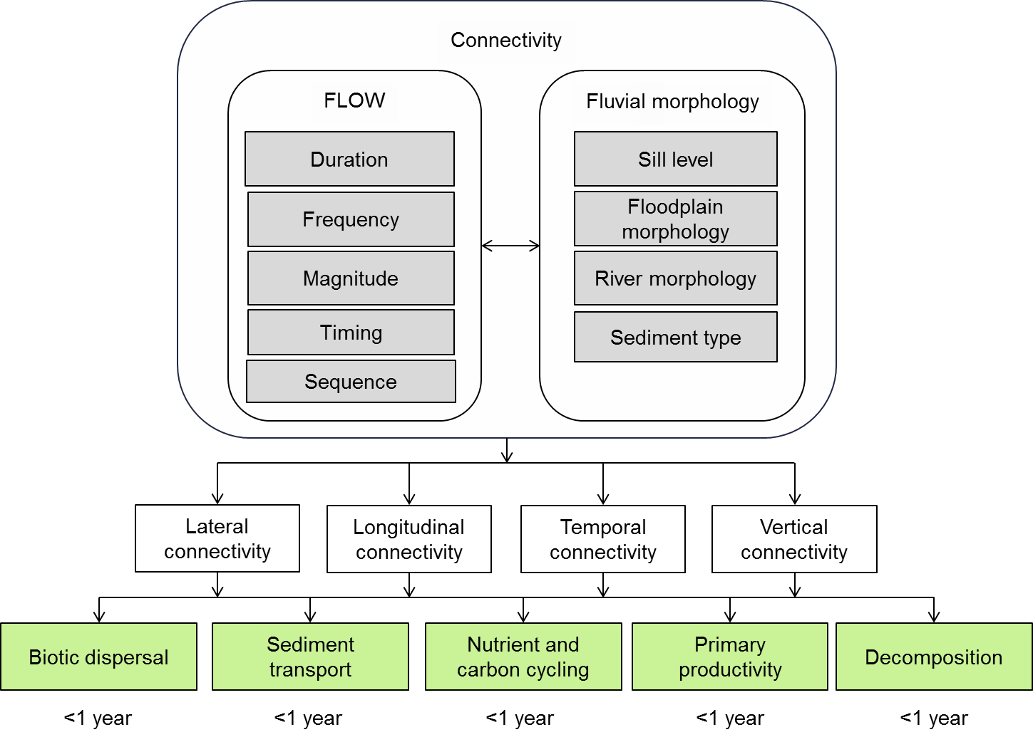

Figure 17. Cause and effect diagram depicting the hydrological connectivity influences of flow and fluvial morphology.

Hydrological connectivity is well established in riverine ecosystem management, and our understanding of this complex process has evolved along with the development of conceptual models such as the River Continuum Concept (Vannote et al. 1980), the Flood Pulse Concept (Junk et al. 1989), the Riverine Productivity Model (Thorp and Delong 1994) and Riverine Ecosystem Synthesis (Thorp et al. 2006). In Australian dryland river systems, unpredictable flows (Walker et al. 1995) are a key feature that drives ecological responses; spatial and temporal complexity in hydrological connectivity is a feature of many Australian river systems (Puckridge et al. 1998; Kingsford 2000).

**Flow:** Variation in the degree of hydrological connectivity will promote heterogeneity in physical habitat for biota, which in turn promotes diversity. Evidence to support this has been found from a range of studies and taxa. For example, Sheldon and Thoms (2006) found that there were strong associations between measures of flow variability and the macroinvertebrate assemblage composition within rivers, suggesting that flow variability, and therefore, variable levels of habitat connectivity, were possible determinants of broad-scale macroinvertebrate assemblage composition. Another example was a study of fish populations of the Coongie Lakes in South Australia, where fish populations were found to use wetlands with varying degrees of hydrological connectivity, and any reduction in the frequency of inundation could result in decreased fish diversity because of the sequential loss of less mobile species (Puckridge et al. 2010).

Bunn and Arthington (2002) identified four basic principles and ecological consequences of altered hydrology, with the impacts evident across broad taxonomic groups including riverine plants, invertebrates, and fish:

1. Flow is a major determinant of physical habitat in streams, which in turn is a major determinant of biotic composition
2. Aquatic species have evolved life history strategies primarily in direct response to the natural flow regimes
3. Maintenance of natural patterns of longitudinal and lateral connectivity is essential to the viability of populations of many riverine species
4. The invasion and success of exotic and introduced species in rivers is facilitated by the alteration of flow regimes.

Lloyd et al. (2003) found strong evidence that flow modification could result in ecological effects, but that the relationship between the degree of flow modification and ecological or geomorphological change was complex. Relationships between flow modification and ecological effect were rarely linear; even small changes to hydrological connectivity can have large ecological impacts (Lloyd et al. 2003). Lloyd et al. (2003) found evidence for all four of the principles put forward by Bunn and Arthington (2002) although studies relating to the second principle were limited at the time.

The following provides some brief examples of how elements of the flow regime can affect connectivity and ecosystem response.

*Duration* of inundation relates to the time that surface water is present and can range from days to months in wetlands (Roberts et al. 2000). Duration can also relate to the length of dry phases, with duration effectively existing as a gradient from rarely inundated/connected to permanently inundated/connected. Duration of connecting flows will dictate species-specific responses in dispersal, breeding and recruitment, as well as foraging for resources.

For example waterbird breeding and fledging on floodplain ecosystems will, for many species, be linked to the duration of inundation (lateral connectivity), with rates of rise and fall influencing the success of recruitment, timing of fledging and also the risk of nest abandonment. Wetlands with altered area and duration of inundation tend to have lower values for waterbird breeding, adult abundance, species richness, and number of species (Kingsford and Thomas 1995; Leslie 1995; Briggs et al. 1997) cited in Lloyd et al. (2003).

The duration of inundation is critical for obligate aquatic species, as it influences life cycle stages such as growth, reproduction and recruitment. For example, extended inundation and change from intermittent inundation to permanent inundation can lead to death of long live vegetation such as River Red Gum, a common sight throughout the Murray Darling Basin e.g. (Thorton and Briggs 2010). The duration of inundation is also assumed to be important for fish, although the relationship between most flow components (duration, frequency and timing) and the benefit to native fish in wetland habitat is considered to be poorly understood (Closs et al. 2006; Beesley et al. 2012).

*Frequency* relates to all flow regime events (cease to flow, freshes, bankfull, flooding, and dry periods) and basically describes the number of events occurring over time. Aquatic biota responds to frequency of inundation in a number of ways. For example most annual and short lived plants are typically only inundated once in their lifespan, whereas perennial aquatic and woody floodplain species can be inundated numerous times but with varying inter-flood intervals (Roberts et al. 2000). Flood frequency has a strong role in determining vegetation structure, for example floodplain forests, most notably of River Red Gum, are more frequently inundated than woodland (Roberts and Marston 2011). Whilst River Red Gum woodland exists it is not as extensive as River Red Gum forest: Black Box and Coollibah are the most extensive floodplain woodlands in the Murray Darling Basin (Roberts and Marston 2011). Frequency of inundation is important in structuring long-term vigour and survival of perennial vegetation (Roberts and Marston 2011).

*Magnitude* relates to the volume or size of the flow event. Lateral connectivity is weakened through drying and drought as the frequency and magnitude of inundation is reduced. Magnitude is directly related to the four main flow types delivered in environmental watering with bank full and overbank flows being the ‘larger’ events. The magnitude of overbank flows will dictate the extent of floodplain inundation and is important in sustaining long lived vegetation such as that of Black Box woodlands, and increasing biodiversity through increased heterogeneity (i.e. inundation of greater number of different habitats). Large infrequent floods have the capacity to maximise connectedness but also have the capacity to reshape the floodplain environment.

*Timing* of hydrological connectivity is another aspect of connectivity which can have both positive and negative consequences. In the case of blackwater events the unseasonal inundation of floodplains during summer months (often associated with peak irrigation periods) can result in the return of organic-rich, oxygen-depleted water to the river system which can have significant impacts on downstream ecosystems (Baldwin D et al. 2011).

*Sequence* of flow events is also a driving factor in determining ecological response and in maintaining fluvial morphology. Many species of vegetation, for example, require a minimum dry period between inundation (Roberts and Marston 2011). Natural sequence of flooding in unmodified systems such as the Cooper Creek system indicate that the sequence of inundation can influence fish community structure and reduce or limit invasive fish colonisation (Puckridge et al. 2010). The sequence of large flow events can have significant influence on reshaping of in channel sediments and reworking of floodplain topography.

Major geomorphic events such as lateral channel migration, and avulsions, which can either, create new channels or cut off meanders, are determined by the sequence and magnitude of flow events.

**Fluvial morphology:** Landscape setting and the configuration of a catchment shape geomorphic processes over a range of spatial and temporal scales, which ultimately determine the pattern and rates of water, sediment and nutrient movement or flux. Catchment topography dictates the gradients and path of the network of potential hydrological connections (Phillips et al. 2011). The relative rates of hydrological processes and variation in the energy required to drive these processes directly influence connectivity (Phillips et al. (2011) and references therein). Rates of water and sediment movement and nutrient flux in turn influence the biophysical processes that determine habitat viability, quality and quantity (Brierley et al. 2006).Fluvial action such as erosion, and subsequent sediment transport and deposition is the predominant agent of landscape evolution and is the primary natural disturbance regime responsible for sustaining a high level of landscape diversity in riverine systems (Ward et al. 2002).

As mentioned above hydrological connectivity is complex on both spatial and temporal scales and reflects the operation of different processes at different positions in a catchment (Brierley et al. 2006). The types of lateral, longitudinal and vertical connections that influence slope-channel-floodplain relationships and longitudinal and vertical transfer of flow, the processes they influence, and suggested measures of linkage are described in .

Fluvial morphology influences hydrological connectivity by affecting physical connections between the river channel and floodplains, such as in terms of commence to flow levels, and the physical dimensions of connecting flow paths and waterways. However it is important to note that geomorphic outcomes will not always provide positive biological outcomes (Borg et al. 2007). While diversity in hydrological connectivity can increase habitats (e.g. hydraulic habitats) required for life cycles of different species, it can also produce ecological disturbances, even within the same waterbody (Amoros and Bornette 2002). For example, Stewardson and Gippel (2003) identified that connectivity can cause hydrological disturbance affecting the following physical phenomena:

* drying and inundation
* light attenuation
* mixing and advection of dissolved gases and solutes
* transport of inorganic sediments and organic matter
* direct effects on organisms including drag and abrasion.

Periodic disturbance associated with variable lateral and longitudinal connectivity creates topographic heterogeneity (Opperman et al. 2010), whereby small differences in topography and soils or substrate in the beds of river channels or floodplain surfaces can lead to significant differences in hydroperiod and the disturbance regime (Naiman et al. 2005; Opperman et al. 2010). Variation in fluvial morphology combined with dynamic flows results in aquatic ecosystems with a shifting mosaic of diverse habitat patches, which in turn supports a range of species, age classes, and physical structure, or high biodiversity (Ward et al. 2002). Studies illustrating the role of hydrological disturbance and cyclic geomorphic perturbation in regulating community structure include Townsend (1989), Lake (1995), Poff and Allan (1995), and Lake (2000) to name a few. Key processes in providing habitat patches include channel scour and the production of landforms produced by instability, such as bare sand and gravel bars and undercut banks (Gippel 2009). River morphology changes in response to flow variation, sediment supply and size and boundary conditions, or the relative resistance of the channel to change due to presence and type of vegetation, bank material characteristics, woody debris, and base level (downstream control on the bed level of the river) (Gippel 2009).

**Connectivity:** Lateral Connectivity relates to connectivity between the river channel and floodplain and associated wetlands. Three basic elements of connectivity are required for sustaining and preserving ecologically functioning floodplains: (i) lateral hydrological connectivity between the river and floodplain, (ii) a variable flow regime which incorporates a range of flow levels, and (iii) adequate geographical extent of inundation to allow key processes to occur (Opperman et al. 2010). Connectivity is a central concept in functional aquatic ecosystems (Bunn and Arthington 2002) and is a driver of floodplain diversity and productivity, with the periodic inundation of floodplains closely linked to floodplain productivity (Junk et al. 1989; Walker et al. 1995; Kingsford et al. 1998; Kingsford et al. 1999; Sheldon et al. 2002; Balcombe et al. 2005; Douglas et al. 2005) and high-energy flows driving geomorphic processes such as erosion and deposition, which in turn influences habitat heterogeneity and biodiversity (Salo et al. 1986) cited in Opperman et al.(2010); Ward et al. (1998); Bunn and Arthington (2002).

Water abstraction, alterations in flood frequency, duration and extent, and seasonal reversal of flows are the main impacts on flow regime in Australian rivers (Lloyd et al. 2003). In south eastern Australia rivers there has been a loss of short-term variation and an increased predictability of flows (Growns and Marsh 2000; Lloyd et al. 2003) both of which influence lateral hydrological connectivity. Lateral hydrological connectivity has also been strongly influenced by the construction earthworks built on floodplains (Kingsford 2000; Steinfeld and Kingsford 2011), which ultimately can lead to changes to the fluvial morphology and spatial distribution of flows (Thoms et al. 2005; Steinfeld and Kingsford 2011).

Table 1: Forms of landscape linkage/connectivity and potential measures of their (dis)connectivity (modified from Brieley et al. 2006). Important flow characteristics are shown in bold.

|  |  |  |  |
| --- | --- | --- | --- |
| **Type of linkage (connectivity)/Scale** | **Process** | **Measures used to assess strength of linkage** | **Controls** |
| **Within landscape compartment** | | | |
| Landform scale analysis (alluvial lateral connectivity) | Formation and reworking of floodplains. Sediment transport and deposition in channels. | Characterise sediment storage and reworking on the valley floor. Appraisal of the mechanisms and rates of floodplain formation and reworking and sediment transport capacity of channels | Valley confinement and slope. Sediment supply and **the magnitude-frequency of flows.** |
| Surface-subsurface (vertical connectivity) | Surface-subsurface exchange of water, sediment and nutrients. Infiltration and filtering. **Maintenance of base flow.** | Characterise sediment and water exchange between surface waters and ground water compartments. Determine the presence, distribution and role of blankets that impede exchange between surface and subsurface compartments and their potential to be reworked. | Bed material texture. Sediment transport regime of the channel. Recurrence of channel **flushing flows (sequence, frequency).** Groundwater mechanisms. |
| **Between landscape compartment** | | | |
| Upstream-downstream (longitudinal connectivity) | The transfer of flow through a system. The efficiency of supply, transfer and storage of sediments of variable calibre. | Appraise the pattern and role of barriers and boosters to connectivity (i.e. e flows). How readily can these barriers be reworked (i.e. the threshold conditions and recurrence interval under which they are likely to be breached)? Estimation of the ration of transport capacity for a given range of events relative to sediment availability involves the examination of the degree of channel bed aggradation or degradation the distribution of bedrock steps along the longitudinal profile and the degree of channel and valley confinement | Base level. Sediment transport regime of the system (i.e. sediment supply or sediment transport limited). |
| Tributary-trunk (longitudinal connectivity) | The transfer of flow through a system. They supply, transfer and storage of sediments of variable calibre. | Appraise the patterns of tributary (dis)connectivity by examining how often and over what length of river course tributaries are joined of disconnected from the trunk stream. Are buffers absent/present? Examine impact that tributary contributions have on the trunk stream at the confluence (e.g. aggradation or degradation). | Shape of catchment (i.e. its elongation ratio). Drainage pattern and density. |
| Channel-floodplain (lateral connectivity) | Channel adjustment on the valley floor. Floodplain formation and reworking. | Appraise the character and volume of materials stored on valley floors, and the contemporary flux (i.e. floodplain accretion or reworking). Determine whether the reach operates as a sediment source, transfer or accumulation zone. What is the channel size and shape? What is the degree of channel aggradation or degradation relative to floodplain height? What is the floodplain inundation frequency? Is there any evidence of channel migration, avulsion, expansion or contraction? | Bed and bank material texture. Sediment transport regime of the channel relative to the floodplain. The **magnitude of inundation and frequency of overbank events** that drive mechanisms of channel adjustment and floodplain formation and reworking. |
| **Sub catchment scale** | | | |
| Valley segment – valley segment | The **pattern and** **sequence** of sediment source, transfer and accumulation zones along the valley floor | Examine the pattern of upstream-downstream connectivity through the sub catchment as a whole. What is the sequence of valley settings (i.e. Confined, partly confined or laterally unconfined valleys)? Are these sediment source, transfer or accumulation zones? Appraise the pattern and role of barriers and boosters (i.e. e-flows for longitudinal connectivity). Interpret the capacity for downstream propagation of sediment release from primary sediment stores, and their likely off-site impacts. Assess whether this is a transport limited or a supply limited system. | Valley confinement, valley slope, valley morphology which area controlled by underlying geology and landscape evolution. |
| Land system assemblage | Areas of relatively uniform topography measured in terms of relief, landform morphology, valley confinement and geology. Summarise slope–valley floor configuration. | Appraise tributary–trunk, slope–valley floor and channel–floodplain in the sub catchment as a whole. The role of buffers to sediment conveyance is examined. | Hillslope morphology, valley floor confinement, valley slope, valley morphology which are controlled by underlying geology and landscape evolution |
| **Catchment scale** | | | |
| Catchment configuration | How valley segments and land systems fit together and are connected across a catchment to explain across catchment variability in patterns of (dis)connectivity and flux. | Measure the effective catchment area. Appraise how sub catchments fit together at the catchment scale through integration of sub catchment-scale relationships. Frame this in terms of analysis of how catchment shape, elongation ratio, etc. impact upon sediment conveyance, storage, etc. Determine the position of the most downstream blockage that impedes sediment output from the system. Predict the sensitivity of the landscape to change, where change will occur and be propagated from, and likely geomorphic responses | Sub catchment variability in patterns of valley segments and land systems which are controlled by underlying geology and landscape evolution. |

*Longitudinal Connectivity* relates to the transport of materials, dispersal of organisms and flow of energy from the upper catchment to the lower. Different flows types also affect variation in the degree of spatial and temporal connectivity. For example, connectivity associated with base flow and flow freshes can influence the water quality of refuges, provide limited sediment transport and allow limited dispersal, all of which affects the quality of refuges for aquatic biota. Longitudinal connectivity is particularly important for fish dispersal, reproduction and long-term population dynamics (Fullerton et al. 2010). A range of range of migration strategies (i.e. migration within freshwater, freshwater to estuarine, sea to freshwater) are exhibited by Australian native species, with barriers to longitudinal connectivity a significant threat to fish populations. Many fish species migrate long distances within inland river systems e.g. Murray Cod, Koehn et al. (2009) and base flows and freshes are believed to be important elements in maintaining connectivity for such migrations.

*Temporal Connectivity-*the temporal dimension of connectivity is crucial and operates across all three spatial dimensions of connectivity (Ward 1989; Kondolf et al. 2006; Boulton et al. 2010). Temporal changes in connectivity underpin most river ecosystem processes, varying according to the organism(s) or process of interest, ranging from the time required to elicit a behavioural response through to the time required for evolutionary change (Ward 1989). For example, the timing and duration of streambed desiccation in intermittent streams affects the function of biofilms. Timoner et al. (2012) found that autotrophic biomass decreased by 80% with the drying of the streambed, but recovered rapidly after the resumption of flow. Heterotrophs were more resistant to water stress, notably in hyporheic biofilms where bacterial cell density decreased only by 20% (Timoner et al. 2012) .The temporal dimension is also central to recovery from hydrological disturbance.

*Vertical Connectivity* relates to the connection between surface water and groundwater and is considered a very important dimension of hydrological connectivity, due to the dependence of some surface ecosystems on groundwater or the exchange of biota (Stanford and Ward 1988). The hyporheic zone is the site of significant exchange of water, nutrients and organic matter. Determinants affecting rates of change include responses to variation in flow, bed topography and porosity (Boulton et al. 1998). Upwelling and downwelling transports water, dissolved oxygen and organic matter to microbes and invertebrates with highly variable gradients (e.g. redox, uptake of dissolved organic carbon, and nitrification) existing at all scales and temporally (Boulton et al. 1998). Boulton et al. (1998) state that across all scales, the functional importance of the hyporheic zone relates to its activity and degree of connection with surface waters. The interactions which occur in the hyporheic zone are highly influential in surface water functions, affecting stream primary productivity and nutrient cycling (Mulholland and Webster 2010) cited in Boulton et al.(2010).

**Knowledge Gaps:** Understanding of hydrological connectivity is limited in Australia due to the high degree of spatial and temporal complexity. For example, there is only a poor understanding of how hydrological connectivity affects the structure and functioning of food webs (Reid et al. 2012), and even the role of connectivity in riverine fish ecology (Fullerton et al. 2010; Beesley et al. 2012). Variability in the sequence and degree of connectedness is also poorly understood. Knowledge gaps include the relationships between spatial structure of streams, scale of dependence of connectivity, the complexity of life histories of obligate aquatic species (fish) and quantifying anthropogenic influence on connectivity and aligning management goals (Fullerton et al. 2010).

Grove et al. (2012) state that the influence of environmental flows on floodplain geomorphology is unclear and that additional research into this field is required. Notably the effect of reduced suspended sediment loads in water released from dams on floodplain geomorphology is poorly understood.

**Use of the cause and effect diagram:** These are generic diagrams applicable across both the northern and southern parts of the basin. There applications to particular circumstances or species would require additional information and potentially modification of the cause-effect diagram

**References**

Ali GA, Roy AG (2009) Revisiting Hydrologic Sampling Strategies for an Accurate Assessment of Hydrologic Connectivity in Humid Temperate Systems. Geography Compass 3:350-374 doi: 10.1111/j.1749-8198.2008.00180.x

Amoros C, Bornette G (2002) Connectivity and biocomplexity in waterbodies of riverine floodplains. Freshwater Biology 47:761-776

Balcombe SR, Bunn S, McKenzie‐Smith FJ, Davies P (2005) Variability of fish diets between dry and flood periods in an arid zone floodplain river. Journal of Fish Biology 67:1552-1567

Baldwin D, Williams J, Whitworth K (2011) Understanding blackwater generated from the Koondrook-Perricoota Forest. In: MDFRC Publication 17/2011 (ed) Final report Prepared for the Murray-Darling Basin Authority by the Murray Darling Freshwater Research Centre

Beesley L et al. (2012) Does flooding affect spatiotemporal variation of fish assemblages in temperate floodplain wetlands? Freshwater Biology 57:2230-2246

Borg D, Rutherfurd I, Stewardson M (2007) The geomorphic and ecological effectiveness of habitat rehabilitation works: Continuous measurement of scour and fill around large logs in sand-bed streams. Geomorphology 89:205-216

Boulton AJ, Datry T, Kasahara T, Mutz M, Stanford JA (2010) Ecology and management of the hyporheic zone: stream–groundwater interactions of running waters and their floodplains.

Boulton AJ, Findlay S, Marmonier P, Stanley EH, Valett HM (1998) The functional significance of the hyporheic zone in streams and rivers. Annual Review of Ecology and Systematics:59-81

Bracken LJ, Croke J (2007) The concept of hydrological connectivity and its contribution to understanding runoff‐dominated geomorphic systems. Hydrological Processes 21:1749-1763

Brierley G, Fryirs K, Jain V (2006) Landscape connectivity: the geographic basis of geomorphic applications. Area 38:165-174

Briggs S, Lawler W, Thornton S (1997) Relationships between hydrological control of River Red Gum wetlands and waterbird breeding. Emu 97:31-42

Bunn SE, Arthington AH (2002) Basic principles and ecological consequences of altered flow regimes for aquatic biodiversity. Environmental Management 30:492-507

Closs GP, Balcombe SR, Driver P, McNeil DG, Shirley MJ (2006) The importance of floodplain wetlands to Murray-Darling fish: What's there? What do we know? What do we need to know? In: Phillips B (ed) Native Fish and Wetlands in the Murray-Darling Basin: Action Plan, Knowledge Gaps and Supporting Papers. Murray-Darling Basin Commission, Canberra, ACT, pp 14-28

Douglas MM, Bunn SE, Davies PM (2005) River and wetland food webs in Australia's wet–dry tropics: general principles and implications for management. Marine and Freshwater Research 56:329-342

Fullerton A et al. (2010) Hydrological connectivity for riverine fish: measurement challenges and research opportunities. Freshwater Biology 55:2215-2237

Gippel CJ (2009) Bowmans Creek Diversity Environmental Assessment: Flood Hydrology and Geomorphology. Fluvial Systems PTY Ltd, Stockton NSW

Grove JR, Webb JA, Marren PM, Stewardson MJ, Wealands SR (2012) High and dry: comparing literature review approaches to reveal the data that informs the geomorphic management of regulated river floodplains. Wetlands 32:215-224

Growns J, Marsh N (2000) Characterisation of flow in regulated and unregulated streams in Eastern Australia. Cooperative centre for Freshwater Ecology, Canberra, ACT

Hooke J (2003) Coarse sediment connectivity in river channel systems: a conceptual framework and methodology. Geomorphology 56:79-94

Junk WJ, Bayley PB, Sparks RE (1989) The flood pulse concept in river-floodplain systems. Canadian special publication of fisheries and aquatic sciences 106:110-127

Kingsford R, Curtin A, Porter J (1999) Water flows on Cooper Creek in arid Australia determine ‘boom’and ‘bust’periods for waterbirds. Biological Conservation 88:231-248

Kingsford RT (2000) Ecological impacts of dams, water diversions and river management on floodplain wetlands in Australia. Austral Ecology 25:109-127

Kingsford RT, Boulton AJ, Puckridge JT (1998) Challenges in managing dryland rivers crossing political boundaries: lessons from Cooper Creek and the Paroo River, central Australia. Aquatic Conservation: Marine and Freshwater Ecosystems 8:361-378

Kingsford RT, Thomas RF (1995) The Macquarie Marshes in arid Australia and their waterbirds: a 50-year history of decline. Environmental Management 19:867-878

Koehn JD, McKenzie JA, O'Mahony DJ, Nicol SJ, O'Connor JP, O'Connor WG (2009) Movements of Murray cod (Maccullochella peelii peelii) in a large Australian lowland river. Ecology of Freshwater Fish 18:594-602 doi: 10.1111/j.1600-0633.2009.00375.x

Kondolf GM et al. (2006) Process-based ecological river restoration: visualizing three-dimensional connectivity and dynamic vectors to recover lost linkages. Ecology and Society 11:5

Lake P (1995) Of floods and droughts: River and stream ecosystems of Australia. In: Elssevier Oxford (ed) River and Stream Ecosystems, pp 659-694

Lake P (2000) Disturbance, patchiness, and diversity in streams. Journal of the North American Benthological Society 19:573-592

Leslie DJ (1995) Moira Lake: A case study of deterioration of a Murray River natural resource. In: Forestry Science. University of Melbourne, Melbourne

Lloyd Q et al. (2003) Does flow modification cause geomorphological and ecological response in rivers? A literature review from an Australian perspective. . In: Technical report 1/2004. CRC for Freshwater Ecology

MDBA (2012) Proposed Basin Plan - a revised draft May 2012. Murray Darling Basin Authority

Mulholland PJ, Webster JR (2010) Nutrient dynamics in streams and the role of J-NABS. Journal of the North American Benthological Society 29:100-117

Naiman RJ, Decamps H, Mclain ME (2005) Riparia: Ecology, Conservation and Management of Streamside Communities. Elsevier Academic Press, Amsterdam

Opperman JJ, Luster R, McKenney BA, Roberts M, Meadows AW (2010) Ecologically Functional Floodplains: Connectivity, Flow Regime, and Scale1. JAWRA Journal of the American Water Resources Association 46:211-226

Phillips R, Spence C, Pomeroy J (2011) Connectivity and runoff dynamics in heterogeneous basins. Hydrological Processes 25:3061-3075

Poff NL, Allan JD (1995) Functional organization of stream fish assemblages in relation to hydrological variability. Ecology 76:606-627

Poff NL et al. (1997) The natural flow regime. BioScience 47:769-784

Pringle C (2003) What is hydrologic connectivity and why is it ecologically important? Hydrological Processes 17:2685-2689

Pringle CM (2001) Hydrologic connectivity and the management of biological reserves: a global perspective. Ecological Applications 11:981-998

Puckridge J, Sheldon F, Walker KF, Boulton A (1998) Flow variability and the ecology of large rivers. Marine and Freshwater Research 49:55-72

Puckridge JT, Costelloe JF, Reid JRW (2010) Ecological responses to variable water regimes in arid-zone wetlands: Coongie Lakes, Australia. Marine and Freshwater Research 61:832-841

Reid M, Delong M, Thoms M (2012) The influence of hydrological connectivity on food web structure in floodplain lakes. River Research and Applications 28:827-844

Roberts J, Marston F (2011) Water regime for wetland and floodplain plants: a source book for the Murray-Darling Basin. National Water Commission, Canberra

Roberts J, Young B, Marston F (2000) Estimating the water requirements for plants of floodplain wetlands: A guide. Occasional Paper 04/00

Salo J et al. (1986) River dynamics and the diversity of Amazon lowland forest. Nature 322:254-258

Sheldon F, Boulton AJ, Puckridge JT (2002) Conservation value of variable connectivity: aquatic invertebrate assemblages of channel and floodplain habitats of a central Australian arid-zone river, Cooper Creek. Biological Conservation 103:13-31

Sheldon F, Thoms MC (2006) Relationships between flow variability and macroinvertebrate assemblage composition: data from four Australian dryland rivers. River Research and Applications 22:219-238

Stanford J, Ward J (1988) The hyporheic habitat of river ecosystems.

Steinfeld C, Kingsford R (2011) Disconnecting the Floodplain: Earthworks and their Ecological Effect on a Dryland Floodplain in the Murray-Darling Basin, Australia. River Research and Applications

Stewardson MJ, Gippel CJ (2003) Incorporating flow variability into environmental flow regimes using the flow events method. River Research and Applications 19:459-472

Thoms MC, Southwell M, McGinness HM (2005) Floodplain–river ecosystems: Fragmentation and water resources development. Geomorphology 71:126-138

Thorp JH, Delong MD (1994) The riverine productivity model: an heuristic view of carbon sources and organic processing in large river ecosystems. Oikos 70:305-308

Thorp JH, Thoms MC, Delong MD (2006) The riverine ecosystem synthesis: biocomplexity in river networks across space and time. River Research and Applications 22:123-147

Thorton S, Briggs S (2010) A survey of hydrological changes to wetlands of the Murrumbidgee River. Wetlands (Australia) 13:1-13

Timoner X, Acuña V, Von Schiller D, Sabater S (2012) Functional responses of stream biofilms to flow cessation, desiccation and rewetting. Freshwater Biology 57:1565-1578

Townsend CR (1989) The patch dynamics concept of stream community ecology. Journal of the North American Benthological Society:36-50

Vannote RL, Minshall GW, Cummins KW, Sedell JR, Cushing CE (1980) The river continuum concept. Canadian Journal of Fisheries and Aquatic Sciences 37:130-137

Walker KF, Sheldon F, Puckridge JT (1995) A perspective on dryland river ecosystems. Regulated Rivers: Research & Management 11:85-104

Ward DL, Eugene Maughan O, Bonar SA, Matter WJ (2002) Effects of temperature, fish length, and exercise on swimming performance of age-0 flannelmouth sucker. Transactions of the American Fisheries Society 131:492-497

Ward J (1989) The four-dimensional nature of lotic ecosystems. Journal of the North American Benthological Society:2-8

Ward J (1998) Riverine landscapes: biodiversity patterns, disturbance regimes, and aquatic conservation. Biological Conservation 83:269-278

Ward JV, Stanford J (1995) Ecological connectivity in alluvial river ecosystems and its disruption by flow regulation. Regulated Rivers: Research & Management 11:105-119

Western AW, Grayson RB, Blöschl G (2002) Scaling of soil moisture: A hydrologic perspective. Annual Review of Earth and Planetary Sciences 30:149-180

# 16 Biotic dispersal

Dispersal is the movement of biota from one habitat patch to another. Individuals disperse in an attempt to optimise their fitness but their movement may influence population abundance, resilience or distribution. Patterns of movement vary widely among species depending on their life history, dispersal capacity and changes in their environment. Patterns of movement also vary within a population in response to individual circumstances and their experience of a heterogenous environment.

Dispersal is particularly important in the water dependent ecosystems of the Murray-Darling Basin (MDB) that are characterised by variable and unpredictable flows, and periods of boom and bust. The variation in flow over multiple time-frames means that species need to move to either avoid disturbances or to take advantage of abundant resources or breeding opportunities.

This CED describes the influence of flow on dispersal with a focus on fish, as their dispersal is most heavily influenced by flow. Fish passage is also one of the most common subjects of environmental watering decisions concerning connectivity and dispersal. The following section will describe how flow influences fish disperal through condition, cues and connectivity (Figure 18). Vegetation dispersal is discussed in a separate CED called vegetation recruitment and extent.

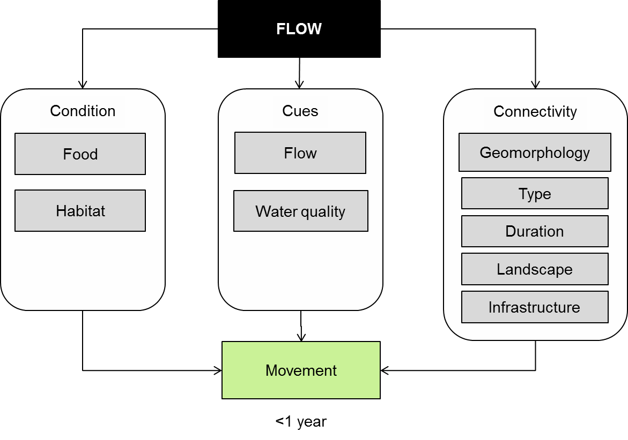

**Figure 18. Cause and effect diagram depicting the influence of flow on biotic dispersal.**

**Fish dispersal:** Most of our current knowledge of fish dispersal in the MDB concerns the larger native species and carp. The large natives appear to follow the restricted movement model in which the majority of individuals spend much of their time in a home range but there are usually some individuals who are mobile (Rodriguez 2002). Periodically, individuals will disperse from their home range to either reproduce (Koehn et al. 2009) or identify an alternate home range (Koster and Crook 2008). This model appears to apply to adult Murray cod (Jones and Stuart 2007), trout cod (Ebner et al. 2009), golden perch (Crook 2004b; Crook 2004a) and river blackfish (Koster and Crook 2008). While carp also appear to have a home range (Crook 2004b; Jones and Stuart 2007) they appear more mobile than natives and have less specific habitat requirements (Jones and Stuart 2007). For some species, including Murray cod, trout cod, golden perch, silver perch and bony herring, their movements occur along the river (Baumgartner et al. 2008) making longitudinal connectivity important. For other species such as river blackfish and carp or golden perch, the movements may be lateral onto floodplains or into wetlands (Jones and Stuart 2007; Koster and Crook 2008; Conallin et al. 2011).

While the restricted movement model appears to apply to adult large native fish, dispersal is also important for some species to complete their life cycle. Very little is known about the habitat requirements of the juveniles of large bodied natives but it is possible that dispersal may be an important part of the life cycle of some of these species. One example of where movement appears important is the eel-tailed catfish that may spend the first year of its life in a wetland before moving into the river channel and then after it matures, moving back to a wetland to reproduce (Stoffels et al. In review). A further example may be golden perch who presumably at some point in their life need to find an area to use as a home range (Crook 2004a). In addition, golden perch juveniles have been recorded in ephemeral wetlands (Ebner et al. 2009) and if these individuals are to contribute to the adult population, they will need to disperse back to the river. The extent to which large native fish use floodplains and wetlands remains an area of significant uncertainty (King et al. 2003).

The extent to which the restricted movement model applies to small fish is also uncertain. Evidence to date suggests that small natives such as carp gudgeon, smelt and the invasive gambusia will readily move into wetlands during base flow conditions (Conallin et al. 2011) and in response to increased discharge (Beesley et al. 2010; Lyon et al. 2010).

**Condition:** Dispersal of water dependent biota is influenced by the condition of the individuals and their habitats, the cues available and the connectivity between habitats. In the case of fish, there has been little work done on the influence of condition on fish movement in Australia but work overseas has found that conditon influences the distance moved (Schrank and Rahel 2006), the rates of mortality among adults and larvae dispersal (Duong et al. 2011; Markle 2011). In long-necked turtles, habitat condition and food availability have been found to influence dispersal (Roe and Georges 2007; Roe et al. 2009). For waterbirds, dispersal is often associated with food availability (Roshier and Watson).

**Cues:** Cues are a stimulus to move and can be provided by a range of factors including flow, daylight, temperature or specific tastes or smells. Both increases and decreases in flow are believed to be cues for fish movement (Jones and Stuart 2007; Koster and Crook 2008; Lyon et al. 2010). It is not clear whether the change in flow is the actual cue or whether it is some associated chemical signal that provides the cue. There are abundant examples among both marine and freshwater fish that chemical cues are important . Other changes in water quality are also believed to act as cues, including declines in dissolved oxygen and temperature (Nunn et al. 2010). For frogs, cues include rainfall and season (Hauselberger and Alford 2005) and inundation (Wassens et al. 2008).

**Connectivity:** Geomorphology provides the physical template that interacts with flow to influence the characteristics of the hydrological connection. Key connectivity characteristics for fish include the type of connection. For dispersal along rivers, undershot weirs are associated with much higher rates of mortality than overshot weirs (Baumgartner et al. 2006) and fish ladders facilitate fish movement (Stuart et al. 2008; Broadhurst et al. 2012; Keller et al. 2012). Lateral dispersal is also influenced by the type of connection, with pipes and pumps limiting dispersal (Beesley et al. 2010).

The duration of connection is also important with longer connections being associated with more species and individuals being able to disperse (Stoffels et al. In review). This can have unfortunate consequences when connecting channels are controlled by regulators, as increased numbers of fish and turtles may end up stranded behind the regulator (Jones and Stuart 2007).

A site’s location within the landscape will also influence a fish’s capacity to disperse to that site (Grant et al. 2007). As a consequence, landscape position will influence the recolonisation of sites (Albanese et al. 2009; Crook et al. 2010) which is important in frequently disturbed systems and may limit the distribution of species such as pygmy perch (Tonkin et al. 2008). Landscape position has also been found to be an important determinant of frog(Hamer and Mahony 2010; Heard et al. 2010) and turtle distributions (Chessman 1988).

**Knowledge gaps:** Developments in radio-tagging, otolith microchemistry and genetics have enabled significant advances in our understanding of fish dispersal; however, the significance of movements to populations remains uncertain. In addition, the cues that initiate dispersal are relatively poorly understood. Finally, dispersal among small native fish remains poorly understood.

**Use of the cause and effect diagram**: This is a generic diagram applicable across both the northern and southern parts of the Basin. Its application to particular circumstances or localities would require additional information and potentially modification of the model.

**References**

Albanese B, Angermeier PL, Peterson J (2009) Does mobility explain variation in colonisation and population recovery among stream fishes? Freshwater Biology 54:1444-1460

Baumgartner LJ, Boys CA, Zampatti BP, Stuart I (2008) Assessmenty of fish passage though fishways at Lock 7, 9 and 10. In: Barret J (ed) The Sea to Hume: Restoring Fish Passage in the Murray River. Murray-Darling Basin Authority, Canberra, pp 45-58

Baumgartner LJ, Reynoldson N, Gilligan DM (2006) Mortality of larval Murray cod (Maccullochella peelii peelii) and golden perch (Macquaria ambigua) associated with passage through two types of low-head weirs. Marine and Freshwater Research 57:187-191 doi: 10.1071/mf05098

Beesley L et al. (2010) Watering floodplain wetlands in the Murray-Darling Basin for native fish. In: Waterlines Series. National Water Commission, Canberra, ACT

Broadhurst BT, Ebner BC, Clear RC (2012) A rock-ramp fishway expands nursery grounds of the endangered Macquarie perch (Macquaria australasica). Australian Journal of Zoology 60:91-100 doi: 10.1071/zo12002

Chessman BC (1988) SEASONAL AND DIEL ACTIVITY OF FRESH-WATER TURTLES IN THE MURRAY VALLEY, VICTORIA AND NEW SOUTH-WALES. Australian Wildlife Research 15:267-276

Conallin AJ, Hillyard KA, Walker KF, Gillanders BM, Smith BB (2011) Offstream movements of fish during drought in a regulated lowland river. River Research and Applications 27:1237-1252 doi: 10.1002/rra.1419

Crook DA (2004a) Is the home range concept compatible with the movements of two species of lowland river fish? Journal of Animal Ecology 73:353-366 doi: 10.1111/j.0021-8790.2004.00802.x

Crook DA (2004b) Movements associated with home-range establishment by two species of lowland river fish. Canadian Journal of Fisheries and Aquatic Sciences 61:2183-2193 doi: 10.1139/f04-151

Crook DA, Reich P, Bond NR, McMaster D, Koehn JD, Lake PS (2010) Using biological information to support proactive strategies for managing freshwater fish during drought. Marine and Freshwater Research 61:379-387 doi: 10.1071/mf09209

Duong TY et al. (2011) Relative larval loss among females during dispersal of Lake Sturgeon (Acipenser fulvescens). Environmental Biology of Fishes 91:459-469 doi: 10.1007/s10641-011-9804-4

Ebner B, Johnston L, Lintermans M (2009) Radio-tagging and tracking of translocated trout cod (Maccullochella macquariensis: Percichthyidae) in an upland river. Marine & Freshwater Research 60:346-355

Grant EC, Lowe W, Fagan WF (2007) Living in the branches: population dynamics and ecological processes in dendritic networks. Ecology Letters 10:165-175

Hamer AJ, Mahony MJ (2010) Rapid Turnover in Site Occupancy of a Pond-breeding Frog Demonstrates the Need for Landscape-level Management. Wetlands 30:287-299 doi: 10.1007/s13157-010-0029-7

Hauselberger KF, Alford RA (2005) Effects of season and weather on calling in the Australian microhylid frogs Austrochaperina robusta and Cophixalus ornatus. Herpetologica 61:349-363 doi: 10.1655/04-03.1

Heard G, Scroggie M, Clemann N (2010) Guidelines for managing the endangered Growling Grass Frog in urbanising landscapes. Arthur Rylah Institute for Environmental Research Technical Report Series

Jones MJ, Stuart IG (2007) Movements and habitat use of common carp (Cyprinus carpio) and Murray cod (Maccullochella peelii peelii) juveniles in a large lowland Australian river. Ecology of Freshwater Fish 16:210-220 doi: 10.1111/j.1600-0633.2006.00213.x

Keller RJ, Peterken CJ, Berghuis AP (2012) Design and assessment of weirs for fish passage under drowned conditions. Ecological Engineering 48:61-69 doi: 10.1016/j.ecoleng.2011.06.037

King AJ, Humphries P, Lake PS (2003) Fish recruitment on floodplains: the roles of patterns of flooding and life history characteristics. Canadian Journal of Fisheries and Aquatic Sciences 60:773-786 doi: 10.1139/f03-057

Koehn JD, McKenzie JA, O'Mahony DJ, Nicol SJ, O'Connor JP, O'Connor WG (2009) Movements of Murray cod (Maccullochella peelii peelii) in a large Australian lowland river. Ecology of Freshwater Fish 18:594-602 doi: 10.1111/j.1600-0633.2009.00375.x

Koster WM, Crook DA (2008) Diurnal and nocturnal movements of river blackfish (Gadopsis marmoratus) in a south-eastern Australian upland stream. Ecology of Freshwater Fish 17:146-154 doi: 10.1111/j.1600-0633.2007.00269.x

Lyon J, Stuart I, Ramsey D, O'Mahony J (2010) The effect of water level on lateral movements of fish between river and off-channel habitats and implications for management. Marine and Freshwater Research 61:271-278 doi: 10.1071/mf08246

Markle DF (2011) SIZE-STRUCTURED SPATIAL PATTERNS AS A MEASURE OF LARVAL DISPERSAL AND EMIGRATION. Western North American Naturalist 71:456-471

Nunn AD, Copp GH, Vilizzi L, Carter MG (2010) Seasonal and diel patterns in the migrations of fishes between a river and a floodplain tributary. Ecology of Freshwater Fish 19:153-162 doi: 10.1111/j.1600-0633.2009.00399.x

Rodriguez MA (2002) Restricted movement in stream fish: The paradigm is incomplete, not lost. Ecology 83:1-13

Roe JH, Brinton AC, Georges A (2009) Temporal and spatial variation in landscape connectivity for a freshwater turtle in a temporally dynamic wetland system. Ecological Applications 19:1288-1299 doi: 10.1890/08-0101.1

Roe JH, Georges A (2007) Heterogeneous wetland complexes, buffer zones, and travel corridors: Landscape management for freshwater reptiles. Biological Conservation 135:67-76 doi: 10.1016/j.biocon.2006.09.019

Roshier D, Watson DM Report 1o. 6.

Schrank AJ, Rahel FJ (2006) Factors influencing summer movement patterns of Bonneville cutthroat trout (Oncorhynchus clarkii utah). Canadian Journal of Fisheries and Aquatic Sciences 63:660-669 doi: 10.1139/f05-250

Stoffels RJ, Clarke KR, Rehwinkel RA, McCarthy BJ (In review) Response of a floodplain fish community to river-floodplain connectivity: natural versus managed reconnection.

Stuart IG, Zampatti BP, Baumgartner LJ (2008) Can a low-gradient vertical-slot fishway provide passage for a lowland river fish community? Marine and Freshwater Research 59:332-346 doi: 10.1071/mf07141

Tonkin Z, King AJ, Mahoney J (2008) Effects of flooding on recruitment and dispersal of the Southern Pygmy Perch (*Nannoperca australis*) at a Murray River floodplain wetland. Ecological Management and Restoration 9:196-201

Wassens S, Watts RJ, Jansen A, Roshier D (2008) Movement patterns of southern bell frogs (Litoria raniformis) in response to flooding. Wildlife Research 35:50-58 doi: 10.1071/wr07095

# 17 Sediment transport

Sediment transport arises from erosion and deposition of sediment that affects the shape of the river channel, wetland or floodplain. The shape of the water-body then interacts with the flow regime to influence key habitat characteristics. For example, erosion of fine sediments is important to the maintenance of gravel or cobble river-beds which are important habitats for macroinvertebrates. Conversely, sediment deposition will influence the depth of pools (Prosser et al. 2001) within the river channel or wetlands which will influence the pool or wetlands habitat value to fish and macrophytes.

Sediment transport also influences nutrient transport (Prosser et al. 2001) as nutrients such as carbon, nitrogen and phosphorus are attached to or incorporated into sediment particles. Sediments act as both a source and sink for nutrients and contaminants such as heavy metals and agri-chemicals. The amount of suspended sediment influences turbidity which affects both the rate and type of primary production with some species of macrophyte being limited by turbidity (Blanch et al. 1998).

One of the major drivers of sediment transport in rivers is the input of sediment from the surrounding catchment and river banks. Floodplain development has led to a significant increase in sediment inputs to rivers in the Murray-Darling Basin (MDB) (Scott 2001; Olley and Wasson 2002; Bond and Lake 2005). Despite the importance of these processes to sediment transport, they are largely beyond the influence of water managers and so this cause and effect diagram focuses on in-stream influences on sediment transport. The following section describes how sediment transport is affected by river flow through its influences on connectivity, morphology and vegetation (Figure 19).

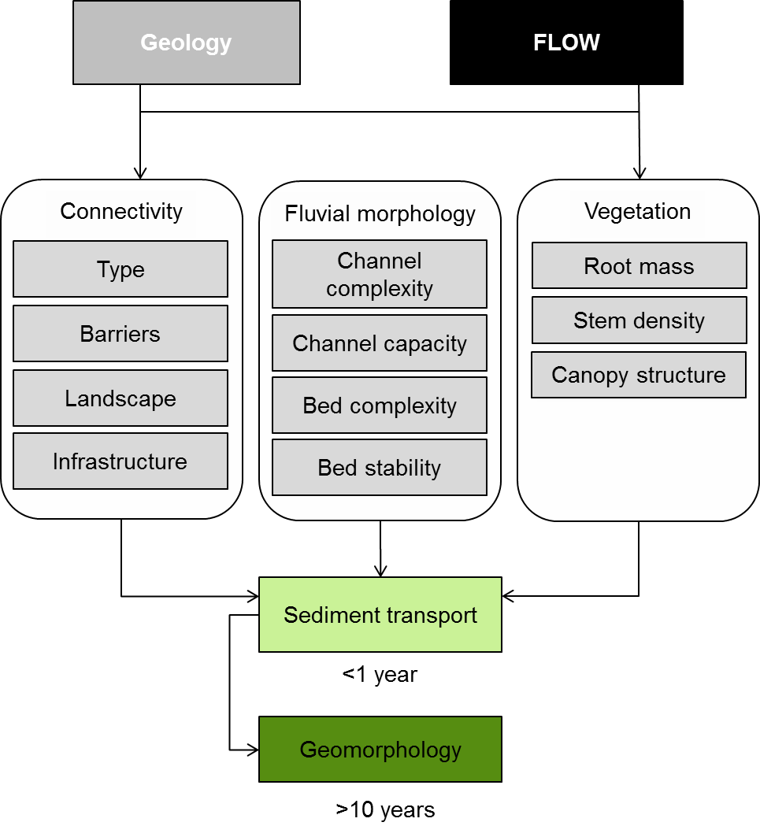

**Figure 19. Cause and effect diagram depicting the influence of flow regime and geology on sediment transport**

**Connectivity:** Barriers and infrastructure for water resource development has required the construction of a large number of weirs\dams and levies that have significantly altered connectivity (Steinfeld and Kingsford 2013) and this has had an effect on sediment transport. For example, sediment loads immediately downstream of dams are considerably reduced due to sediment storage within the dam (Stewardson and Jin 2009) and this influence can extend many kilometres downstream. The reduced sediment transport means that the water has a greater potential to erode the bed and banks which can lead to channel enlargement and bed degradation. This leads to wider channels and in some instances a change in sediment composition, reduced bed and channel complexity (Stewardson and Jin 2009).

Historically, flooding was associated with both erosion and deposition of sediment on floodplains (Wallbrink et al. 1998; Thoms et al. 2007). River regulation has reduced this lateral connectivity and affected the associated transport and storage of sediment (Olive and Olley 1997). The effects are complicated because the change in flow regime interacts with changes in land use such that although floods are less common, generally there is less vegetation to stabilise sediments and reduce current speeds that would otherwise promote deposition.

**Fluvial morphology:**Channel geomorphology is the physical shape of the channel, wetland or floodplain and it ultimately determines flow velocity, which is a major factor in sediment transport. Changes in discharge are associated with changes in sediment transport. Generally, as flow increases, the shape of the channel and floodplain influences the areas of high and low current velocity and therefore the capacity to erode and carry sediment. Suspended sediment is under stable flows in slack-water areas along the channel margin and in pools during periods of low flow or on the floodplain during floods. If stable flow conditions are maintained for extended periods of time, considerable fine sediment will be deposited in slow flowing areas, such as slack-waters and pools.

Stable flow conditions have also been reported to cause the erosion of benches and banks although the mechanisms for this are unclear. It is common to see a break in the bank angle, or ‘notch’, at a stage equivalent to elevated summer flow releases with a steeper bank angle below this level. Stable flows are also associated with increased channel stability, the removal of bars and the accumulation of fine sediments on the bed in slack-water zones. These changes in sediment transport will adversely affect benthic habitats.

As discharge increases, erosion increases and the sites of deposition move. The greater the increase in flow the greater the increase in erosion and so the rate of morphological change also increases, which in turn affects flow. As a consequence, bankfull discharge and flooding are considered important flows due to their influence on geomorphology and ultimately habitat availability. The interaction between flow and geomorphology is however, complex. In channel features such as benches are created by bankfull and flood flows that interact with the channel form, to create areas of low flow or reverse flow. These areas are sites of sediment deposition that slowly accumulates to form an in-channel bench that will influence the surrounding hydraulic environment (Vietz et al. 2006) and habitat (Arthington et al. 2010).

River regulation may also lead to channel enlargement through widening or bed degradation. These geomorphological changes increase channel capacity and reduce flood magnitudes and frequencies, reducing the frequency of floodplain-channel connection with the associated degradation of floodplain habitats.

**Vegetation:**Flow and geomorphology interact to create habitat for plants, but once established, the plants further influence sediment transport by stabilising sediments and promoting further sediment deposition by slowing water flow (Sandercock et al. 2007; Gurnell et al. 2012). Sediment stabilisation is achieved through the proliferation of roots through the sediment that bind sediment particles (Murray and Paola 2003; Clarke et al. 2004). Flow reduction is influenced by the amount of resistance provided by the plants which is influenced by the density of stems (Barkow and James 1992; Madsen et al. 2001; Larsen et al. 2009) and the structure of the leaves or canopy (Sand-Jensen 1998).

There are two broad situations in which vegetation is of significance in environmental flow management. The first is consideration of riparian and floodplain areas where vegetation has been removed or is in poor condition. In these circumstances, there is an increased likelihood of sediment erosion (Saynor and Erskine 2006; Sandercock et al. 2007; Jansen and Nanson 2010) and little capacity to predict the consequences.

The second situation is where either stable flows or the elimination of high flows has slowed the downstream transport of sediment enough to provide opportunities for plants to become established within what was previously the river channel (Erskine et al. 1999; Bejarano and Sordo-Ward 2011). Vegetation encroachment in channels will have complex outcomes, but is likely to reduce channel capacity or promote channel migration.

**Knowledge gaps:** Very little is known about what levels of sediment transport are desirable or the environmental consequences of too much or too little sediment transport during different flow events. There is also very little known about the influence of flow regulation on sediment transport and what the longer term effects of this will be on the system.

**Use of the cause and effect diagram:** This is a generic diagram applicable across both the northern and southern parts of the Basin. Its application to particular circumstances or localities would require additional information and potentially modification of the model.

**References**

Arthington AH, Olden JD, Balcombe SR, Thoms MC (2010) Multi-scale environmental factors explain fish losses and refuge quality in drying waterholes of Cooper Creek, an Australian arid-zone river. Marine and Freshwater Research 61:842-856 doi: 10.1071/mf09096

Barkow J, James W (1992) Effects of submerged aquatic macrophytes on nutrient dynamics, sedimentation, and resuspension. In: Jeppesen E, Sondergaard M, Sondergaard M, Christofferesen K (eds) The structuring role of submerged macrophytes in lakes. Springer, New York, pp 24-45

Bejarano MD, Sordo-Ward A (2011) Riparian woodland encroachment following flow regulation: a comparative study of Mediterranean and Boreal streams. Knowledge and Management of Aquatic Ecosystems doi: 20

10.1051/kmae/2011059

Blanch SG, Ganf GG, Walker KF (1998) Growth and recruitment in *Vallisneria americana* as related to average irradiance in the water column. Aquatic Botany 61:181-205

Bond NR, Lake PS (2005) Ecological restoration and large-scale ecological disturbance: The effects of drought on the response by fish to a habitat restoration experiment. Restoration Ecology 13:39-48 doi: 10.1111/j.1526-100X.2005.00006.x

Clarke A, Lake PS, O'Dowd DJ (2004) Ecological impacts on aquatic macroinvertebrates following upland stream invasion by a ponded pasture grass (Glyceria maxima) in southern Australia. Marine and Freshwater Research 55:709-713 doi: 10.1071/mf04043

Erskine WD, Terrazzolo N, Warner RF (1999) River rehabilitation from the hydrogeomorphic impacts of a large hydro-electric power project: Snowy River, Australia. Regulated Rivers-Research & Management 15:3-24 doi: 10.1002/(sici)1099-1646(199901/06)15:1/3<3::aid-rrr532>3.3.co;2-i

Gurnell AM, Bertoldi W, Corenblit D (2012) Changing river channels: The roles of hydrological processes, plants and pioneer fluvial landforms in humid temperate, mixed load, gravel bed rivers. Earth-Science Reviews 111:129-141 doi: 10.1016/j.earscirev.2011.11.005

Jansen JD, Nanson GC (2010) Functional relationships between vegetation, channel morphology, and flow efficiency in an alluvial (anabranching) river. Journal of Geophysical Research-Earth Surface 115 doi: F04030

10.1029/2010jf001657

Larsen LG, Harvey JW, Crimaldi JP (2009) Predicting bed shear stress and its role in sediment dynamics and restoration potential of the Everglades and other vegetated flow systems. Ecological Engineering 35:1773-1785 doi: 10.1016/j.ecoleng.2009.09.002

Madsen JD, Chambers PA, James WF, Koch EW, Westlake DF (2001) The interaction between water movement, sediment dynamics and submersed macrophytes. Hydrobiologia 444:71-84 doi: 10.1023/a:1017520800568

Murray AB, Paola C (2003) Modelling the effect of vegetation on channel pattern in bedload rivers. Earth Surface Processes and Landforms 28:131-143 doi: 10.1002/esp.428

Olive LJ, Olley JM (1997) River regulation and sediment transport in a semi-arid river: the Murrumbidgee River, NSW, Australia. IAHS publication 245:283-290

Olley JM, Wasson R (2002) Changes in the flux of sediment in the Upper Murrumbidgee catchment, Southeastern Australia, since European settlement. HYDROLOGICAL PROCESSES 17:3307-3320

Prosser I, Rutherford I, Olley J, Young W, Wallbrink P, Moran C (2001) Large-scale patterns of erosion and sediment transport in river networks, with examples from Australia. Marine and Freshwater Research 52:81-99

Sand-Jensen K (1998) Influence of submerged macrophytes on sediment composition and near-bed flow in lowland streams. Freshwater Biology 39:663-680

Sandercock PJ, Hooke JM, Mant JM (2007) Vegetation tin dryland river channels and its interaction with fluvial processes. Progress in Physical Geography 31:107-129 doi: 10.1177/0309133307076106

Saynor MJ, Erskine WD (2006) Spatial and temporal variations in bank erosion on sand-bed streams in the seasonally wet tropics of northern Australia. Earth Surface Processes and Landforms 31:1080-1099 doi: 10.1002/esp.1310

Scott A (2001) Water erosion in the Murray-Darling Basin: Learning from the past. In: CSIRO Land and Water Technical Report. CSIRO Land and Water, Canberra, ACT, p 135

Steinfeld CMM, Kingsford RT (2013) Disconnecting the floodplain: Earthworks and their ecological effect on a dryland floodplain in the Murray-Darling Basin, Australia. River Research and Applications 29:206-218 doi: 10.1002/rra.1583

Stewardson MJ, Jin W (2009) Geomorphology. In: Overton I, Colloff M, Doody T, Henderson B, Cuddy S (eds) Ecological Outcomes of flow regimes in the Murray-Darling Basin. CSIRO, Canberra ACT, pp 215-226

Thoms MC, Parsons M, Foster J (2007) The use of multivariate statistics to elucidate patterns of floodplain sedimentation at different spatial scales. EARTH SURFACE PROCESSES AND LANDFORMS 32

Vietz G, Stewardson MJ, Finlayson BL (2006) Flows that form: the hydromorphology of concave-bank bench formation in the Ovens River, Australia. Sediment Dynamics and the Hydromorphology of Fluvial Systems

Wallbrink PJ, Murray AS, Olley JM, Olive LJ (1998) Determining sources and transit times of suspended sediment in the Murrumbidgee River, New South Wales, Australia, using fallout Cs-137 and Pb-210. Water Resources Research 34:879-887

# 18 Primary production

Primary productivity is the formation of organic matter by plants (macrophytes and algae). Algae and macrophytes perform important roles in aquatic ecosystems providing a source of food (Bunn et al. 2003; Zeug and Winemiller 2008; Hladyz et al. 2012), and habitat for invertebrates and fish (Humphries 1996; Warfe and Barmuta 2006). The organic matter produced by plants and consumed by invertebrates and fish is then consumed by larger fish, birds and humans which means that primary producers provide the base of aquatic ecosystem food webs.

The following cause and effect diagram describes potential pathways for how flows can influence primary production (Figure 20). Primary productivity in ecosystems influences not only plant biomass but consumer species richness, abundance and nutrient cycling (Mokany et al. 2008). The diagram separates two important aspects of the flow – primary productivity relationship:

* Flow effects on the composition, condition and extent of the plant community; and
* Flow effects on rate of primary productivity.

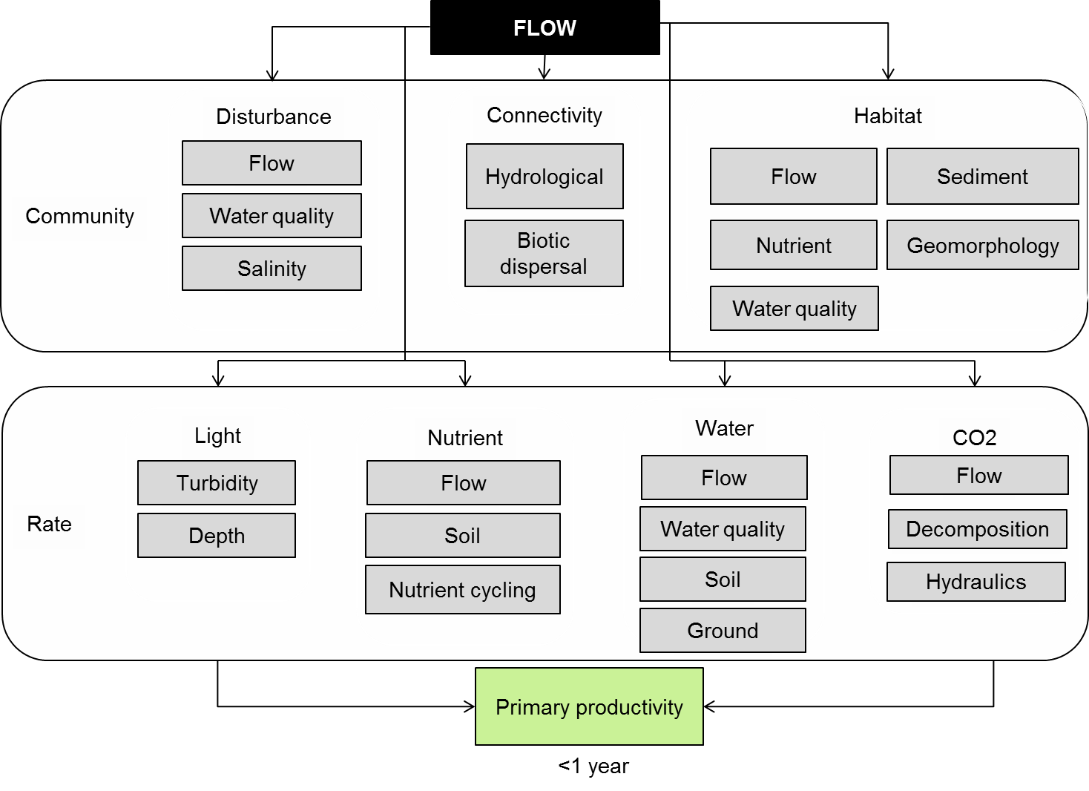

Figure 20. Cause and effect diagram depicting the influence of flow on primary production.

**Community:** The plant community composition and extent can have a profound effect on primary productivity. Robertson et al. (2001) reviewed the available information on primary productivity from different plant communities in Australian floodplain aquatic ecosystems. For example, wood production rates for river red gum riparian and floodplain forests were estimated at between 85 and 360 gCm2/year (Bacon et al. 1993). By comparison, primary productivity from phytoplankton within the water column, even under algal bloom conditions, is estimated to be in the order of just 3 gCm2/year (Robertson et al. 1996). The community composition of emergent wetland plants can affect primary productivity, with some species, such as *Typha orientalis*, capable of high rates of primary production (up to 38 gDWm2/year, while other species such as *Baumea articulata* have lower rates of production (Froend and McComb 1994).

The effect of flow on aquatic ecosystem plant communities is therefore one mechanism by which flows can influence primary productivity. These flow influenced factors are represented in the upper box in Figure 1 and briefly described below.

*Disturbance -* The frequency and magnitude of disturbance in aquatic ecosystems is a regulating factor on species diversity and community composition (Lake 2000). Flow variability (i.e. periods of high, low and no flow) creates disturbance in aquatic ecosystems, which in turn influences vegetation communities. Biofilms, for example, are heavily influenced by flow related disturbance (Burns and Ryder 2001). Biofilms are a mixture of algae, bacteria and fungi that grow on submerged substrates such as wood. Biofilms provide a major energy source for aquatic food webs by contributing organic material to the river (Burns and Ryder 2001). Although relatively low in biomass compared to aquatic macrophytes, their high turnover rates contribute significantly to instream productivity and they are an important food resource for grazing invertebrates. Under constant flows, biofilms can thicken and become less productive. An increase in velocity can scour biofilms leading to the release of nutrients and an increase in productivity. Similarly, a reduction in discharge can lead to the drying and death of biofilms which, when flows increase, once again leads to the release of nutrients and development of a more productive biofilm. Newly established biofilms tend to be more productive than older thicker biofilms (Burns and Ryder 2001).

Salinity and other aspects of water quality (such as acidification as a result of activation of acid sulphate soils) are also types of disturbances that can affect plant communities. As mentioned above, plant species have varying tolerances to salinity and acidity, and composition will change in response to these variables.

*Connectivity* in aquatic ecosystems is related both to the movement of water (hydrological connectivity) and the dispersal of biota (biological connectivity). These are both described in detail in separate CEDs (insert cross-reference). In terms of aquatic plant community composition, both hydrological and biological connectivity are important. Hydrological connectivity has four dimensions: lateral (riverine – floodplain), longitudinal (headwaters-estuarine), vertical (riverine – groundwater) and temporal connectivity (Poff et al. 1997). This can facilitate the dispersal of propagules (seeds, spores and vegetative propagules) within the water, along rivers and between rivers, wetlands and floodplains (Santamaria 2002). Aquatic plants are also dispersed through biological means, with waterbirds recognised as important carriers of seeds, algae and other propagules) between wetland ecosystems (Figuerola and Green 2002).

*Habitat* water regimes in aquatic systems are the major determinant of plant community composition and distribution (Roberts et al. 2000). Aquatic plant species zonation occurs predominantly in response to water depth, with different species and associations occupying niches from the shallow littoral zone to deeper water (Boulton and Brock 1999). Frequency of flooding, as with depth, also influences community composition, with the inter-flood (dry) interval critical for the survival of some species intolerant of constant water logging and aerobic sediments (Roberts et al. 2000). Both depth and frequency of inundation are strongly influenced by the shape of the landscape and geomorphic processes.

Velocity and its variation through time influence habitat availability for both algae and macrophytes (Blanch et al. 1999; Blanch et al. 2000). Velocity influences the volume of water available for floating algae to grow. Velocity also influences the area of river bed, wood and macrophyte on which attached algae (biofilm) can grow.

Water quality can also effect plant community composition through a number of mechanisms. Suspended sediment concentrations affect underwater light availability and the ability for submerged plants to grow. Plants species have different tolerances and responses to salinity, pH and nutrient concentrations. For example, the introduced cape water lily (*Nymphaea caerulea*) is tolerant of acidic conditions and often dominates in aquatic ecosystems influenced by acid sulphate soils (Sammut et al. 2010). Similarly *Typha orientalis* has been shown to be competitively advantaged in systems with nutrient enrichment (Froend and McComb 1994).

**Rates:** The rate of primary production in aquatic ecosystems is spatially and temporally variable. Although there are a myriad of factors, which can affect rates of primary production, this discussion is limited to those that are influenced by flow. This is represented in the bottom box in and described briefly below.

*Light* within the water column of aquatic ecosystemsis strongly influenced by turbidity, which is influenced by river flows and run-off. Flow influences turbidity and consequently the light regime by increasing the amount of suspended particles in the water column. Turbidity reduces the depth to which sunlight penetrates into water and the higher the turbidity, the greater this effect (Davies-Colley and Smith 2001). Primary production is light limited (Kromkamp et al. 1995) and a substantial amount of the variation in primary production within the water column of aquatic systems can be explained by turbidity (Bunn et al. 2003). The depth to which light penetrates is the photic depth of the waterbody, which is the depth below which there is insufficient light for plants/algae to photosynthesise. Rates of primary production in turbid deeper areas can be a magnitude lower than in shallow edge areas (Bunn and Davies 1990). It should be noted that primary productivity of emergent plants is not influenced by flow – turbidity relationships.

*Nutrients* in particular the macro-nutrients of nitrogen and phosphorus are important regulators of growth and primary productivity in aquatic ecosystems (Boulton and Brock 1999). Water inflows to aquatic ecosystems transport nutrients and facilitate the exchange of dissolved nutrients for uptake and use in photosynthesis. Aquatic plants may uptake nutrients from either the water column or the sediment, depending on species adaptations, and so sediment nutrient concentrations and loads are also important in regulating primary productivity in systems dominated by emergent macrophytes. In general, increased nutrients, result in increased rates of primary production (Boulton and Brock 1999). The relationship between nutrients and flow is provided in a separate CED (insert cross reference).

*Water*and flow influence primary production through changes in water quality, nutrient availability and the movement of sediments. The productivity of aquatic systems relies on water from river flows and groundwater from a large underlying aquifer, which are highly connected. Increased sedimentation will change the light regime and lead to potential increases in chemical such as salts. Increasing salt will reduce the amount of primary production by decreasing plant growth (Nielsen et al. 2003). The amount of water will also influence the availability of groundwater. Riparian trees utilise ground water are susceptible to changes in the quality and quantity of ground water (Johns et al. 2009)

*CO2*is essential to photosynthesis and primary production and is taken up mostly by the leaves of aquatic plants. For plants with their leaves in the air, CO2 is not limited. However, for submerged aquatic macrophytes and algae, CO2 must be sourced from the water column. The rate of supply of CO2 in the water column is influenced by diffusion from eh air and from decomposition of organic matter and respiration of plants and animals within the water column. Flooding can increase the availability of inorganic carbon in the water column, facilitating primary productivity (Roberts et al. 2000).

**Knowledge gaps**: This CED is generic, based on an aggregation of knowledge of the effects of flow on a limited number of species at a limited number of sites across the MDB. There are many species of aquatic plant for which there is only limited information available on their habitat requirements and even less on their productivity in response to flow. While flow is acknowledged as a major influence on aquatic plants and biofilms, it is only one of a suite of influences and there are significant knowledge gaps concerning the influence of other influences such as grazing, water quality or invasive species and their interaction with flow.

The majority of research on biofilms has been on the algal component. Further research needs to be undertaken on how flow influences the other structural components (fungi and bacteria)

**Use of the cause and effect diagram**: This is a generic diagram applicable across both the northern and southern parts of the basin. Its application to particular circumstances or species would require additional information and potentially modification of the cause-effect diagram.

**References**

Blanch SJ, Ganf G, Walker KF (1999) Growth and resource allocation in response to flooding in the emergent sedge Bolboschoenus medianus. Aquatic Botany 63:145-160 doi: 10.1016/s0304-3770(98)00109-0

Blanch SJ, Walker KF, Ganf GG (2000) Water Regimes and Littoral Plants in Four Weir Pools of the River Murray, Australia. Regulated Rivers: Research & Management 16:445-456

Boulton AJ, Brock MA (1999) Australian freshwater ecology: processess and management. Gleneagles Publishing, Glen Osmond

Bunn SE, Davies PM (1990) Why is the streamfauna of south-western Australia so impoverished? Hydrobiologia 194:169-176

Bunn SE, Davies PM, Winning M (2003) Sources of organic carbon supporting the food web of an arid zone floodplain river. Freshwater Biology 48:619-635

Burns A, Ryder DS (2001) Potential for biofilms as biological indicators in Australian riverine systems. Ecological Management & Restoration 2:53-64 doi: 10.1046/j.1442-8903.2001.00069.x

Davies-Colley RJ, Smith DG (2001) TURBIDITY SUSPENI)ED SEDIMENT, AND WATER CLARITY: A REVIEW1. JAWRA Journal of the American Water Resources Association 37:1085-1101 doi: 10.1111/j.1752-1688.2001.tb03624.x

Hladyz S, Nielsen DL, Suter PJ, Krull ES (2012) Temporal variations in organic carbon utilization by consumers in a lowland river. River Research and Applications 28:513-528 doi: 10.1002/rra.1467

Humphries P (1996) Aquatic macrophytes, macroinvertebrate associations and water levels in a lowland Tasmanian river. Hydrobiologia 321:219-233 doi: 10.1007/bf00143752

Johns C et al. (2009) Literature review and identification of research priorities to address retaining floodwater on floodplains and flow enhancement hypotheses relevant to native tree species. . In. Report prepared for the Murray-Darling Basin Authority by The Murray-Darling Freshwater Research Centre. 70pp

Kromkamp J, Peene J, Rijswijk P, Sandee A, Goosen N (1995) Nutrients, light and primary production by phytoplankton and microphytobenthos in the eutrophic, turbid Westerschelde estuary (The Netherlands). Hydrobiologia 311:9-19 doi: 10.1007/bf00008567

Mokany A, Wood JT, Cunningham SA (2008) Effect of shade and shading history on species abundances and ecosystem processes in temporary ponds. Freshwater Biology 53:1917-1928 doi: 10.1111/j.1365-2427.2008.02076.x

Nielsen DL, Brock MA, Rees GN, Baldwin DS (2003) Effects of increasing salinity on freshwater ecosystems in Australia. Australian Journal of Botany 51:655-665

Warfe DM, Barmuta LA (2006) Habitat Structural Complexity Mediates Food Web Dynamics in a Freshwater Macrophyte Community. Oecologia 150:141-154

Zeug SC, Winemiller KO (2008) Evidence supporting the importance of terretrial carbon in a large-river food web. Ecology 89:1733-1743

# 19 Decomposition

Decomposition is the breakdown of complex organic material into smaller carbon-based compounds, culminating in mineralisation to carbon dioxide and methane (Tank et al. 2010). Decomposition requires a source of organic carbon, available electron acceptors (oxygen or, under anaerobic conditions, alternate oxidants such as nitrate, iron(III) or sulfate) and moisture. Decomposition can occur abiotically (Austin and Vivanco 2006; Smith et al. 2010) but is primarily driven by biota (Vossbrinck et al. 1979), particularly bacteria, fungi and invertebrate shredders (Hieber and Gessner 2002), which derive energy from the decomposition process. Energy can then be transferred up the food chain as larger organisms consume the biota that directly consume organic material.

The following cause and effect diagram shows factors that directly influence decomposition in aquatic environments and describes potential pathways for how flow can influence these (Figure 21). The interactions between flow and decomposition are complex; however, outlined the key factors that are likely to be altered by flows. Hydrological connectivity, primary production and sediment transport are described in separate CEDs.

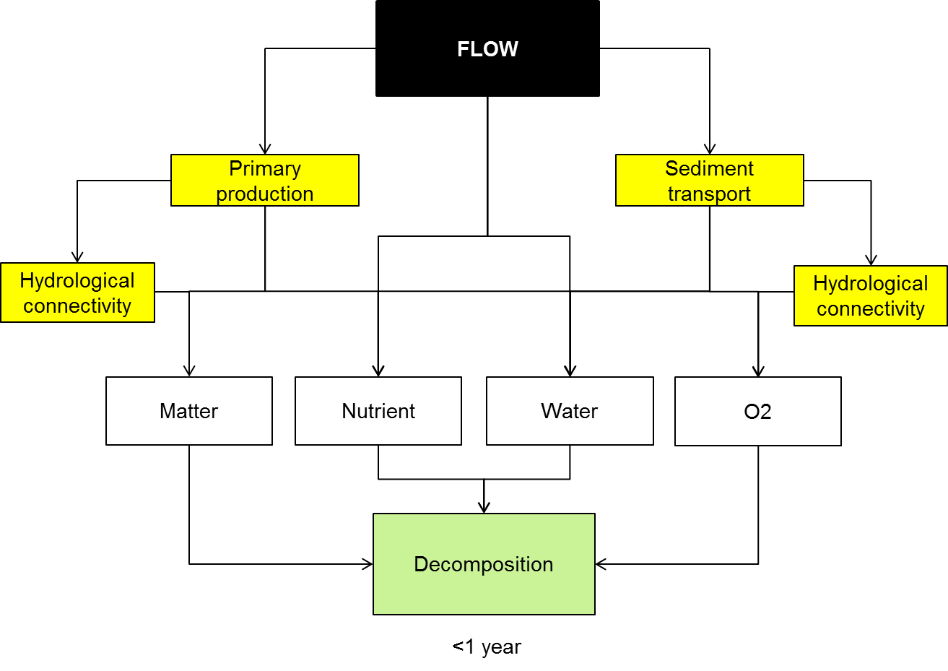

**Figure 21. Cause and effect diagram depicting the influence of flow on decomposition.**

**Organic matter:** A source of organic matter is required to drive decomposition. Autochthonous organic matter is formed within the waterway by algal and macrophyte primary productivity. Allochthonous organic matter is formed in the riparian and floodplain zone by photosynthesis of terrestrial or wetland plants. The rate of primary productivity in either environment is therefore the initial control on the amount of organic material available for future decomposition. The impacts of flow on primary productivity are considered in a separate cause and effect diagram.

Flow determines the transport of allochthonous organic matter (as particulate or dissolved material) into the water body (for example, during floodplain inundation (Junk et al. (1989)) and also influences the location of autochthonous and allochthonous organic matter decomposition (Webster et al. 1999). Flow contributes to physical degradation of organic material by abrasion (Wipfli et al. 2007), releases organic matter from the soil matrix (Findlay and Sinsabaugh 1999) and controls habitat quality for macro-invertebrates (Gore et al. 2001) that consume or shred organic material (Graça 2001). Photodegradation will be promoted by low, shallow flows but inhibited by highly coloured or turbid water (Amon and Benner 1996).

Flow may also influence organic matter quality by influencing the type of organic matter formed by primary productivity and by influencing decomposition processes. Groundwater inputs stimulated by the impacts of flow on local groundwater tables may also contribute dissolved organic matter to the aquatic system (Webster and Meyer 1997; Baker et al. 2000).

**Nutrient:** Decomposers generally require a source of available macro- (nitrogen, phosphorus) and micro-nutrients to sustain the decomposition process, therefore decomposition may become nutrient-limited in some environments (Zweifel et al. 1995). Flow influences nutrient transport, both in dissolved and particulate-bound forms (Tockner et al. 2000; Heffernan and Sponseller 2004). The influence of flow on nutrients is described in a separate cause-effect diagram.

**Water:** Decomposition requires a source of moisture so will be limited in dry floodplain environments and dry channels, particularly during drought periods (Austin et al. 2004; Baldwin et al. 2012), although the relative importance of photodegradation may increase during these periods (Smith et al. 2010). Flows over floodplains will promote decomposition not only during the period of inundation but also for the duration of the persistence of moisture in the soil profile.

Interactions between flow and shallow groundwater tables may also influence decomposition by providing a source of moisture to the base of incised ephemeral channels or other groundwater outflow points.

**Oxygen:** Organic matter decomposition requires an oxidant and generally proceeds most rapidly when oxygen is available as an electron acceptor (Kristensen et al. 1995), although some studies have shown that anaerobic oxidation can be equally rapid (O'Connell et al. 2000). The dominant microbial community that drives the decomposition process will also be affected by the oxygen concentration (O'Connell et al. 2000). Increased flows promote high oxygen concentrations by increasing the rate of water column re-aeration and hindering stratification, which can otherwise lead to anoxia in bottom waters. However, in some instances increased flows may lead to oxygen depletion by mobilising reactive anaerobic sediment (e.g. rich in Fe2+, or S2-; Bush et al. (2004)).

Oxygen concentration will also be influenced by flow seasonality. As water temperatue increases, oxygen solubility decreases, thereby lowering the maximum potential oxygen concentration. The rate of decomposition also increases as temperature increases and, under high organic loading, this can deplete oxygen from the water column more rapidly than it can be replenished (Howitt et al. 2007). Once oxygen has been depleted, the rate of decomposition depends on the availability of alternate electron acceptors.

Watering actions may influence local groundwater tables and interactions with saline groundwater may increase the availability of sulfate as an alternate electron acceptor. Decomposition via the sulfate reduction pathway leads to the formation of toxic reduced sulfur compounds (Whitworth and Baldwin 2011).

Nitrate is the second major alternate electron acceptor that may be influenced by flow management (Cornwell et al. 1999; Burgin and Hamilton 2007). Flooding tends to mobilise nutrients, including nitrate, and may therefore increase the importance of denitrification as a decomposition pathway.

**Decomposer habitat:** Although decomposers exist in a broad range of aquatic environments, alteration to flow may impact on the activities of some groups. Microbiota living in sediments, biofilms or macrophyte beds may be disturbed by high flows. Larger biota that consume or shred organic material also require appropriate habitat, according to their life form . The impact of flow on macroinvertebrates and fish is considered in separate cause-effect diagrams.

Sediment mobilised in high flows may smother biofilms or aquatic macrophyte communities, reducing both primary production and decomposition rates.

**Flow seasonality and temperature:** Flow seasonality and water depth influence water column temperature. As temperature increases, the rate of carbon leaching and decomposition increase (Howitt et al. 2007). Altered flow seasonality may also affect the type of carbon formed during primary production. Seasonal variations in litterfall may also result in variations in the average age of litter inundated with flood pulses in different seasons, which can in turn influence the composition and bioavailability of leachates (Baldwin 1999). Recent literature also suggests that the precise timing of wet and dry phases in intermittent systems may be crucial for determining decomposition rates (Bruder et al. 2011).

**Knowledge gaps:** Little literature exists that directly links flow to decomposition. This mini-review is based primarily on the indirect effects of flow on decomposition, by means of a consideration of the likely impacts of flow on processes that in turn impact on decomposition.

**Use of the cause and effect diagram:** This is a generic diagram applicable across both the northern and southern parts of the basin.

**References**

Amon RMW, Benner R (1996) Photochemical and microbial consumption of dissolved organic carbon and dissolved oxygen in the Amazon River system. Geochimica et Cosmochimica Acta 60:1783-1792

Austin AT, Vivanco L (2006) Plant litter decomposition in a semi-arid ecosystem controlled by photodegradation. Nature 442:555-558 doi: http://www.nature.com/nature/journal/v442/n7102/suppinfo/nature05038_S1.html

Austin AT et al. (2004) Water pulses and biogeochemical cycles in arid and semiarid ecosystems. Oecologia 141:221-235 doi: 10.1007/s00442-004-1519-1

Baker MA, Valett HM, Dahm CN (2000) Organic carbon supply and metabolism in a shallow groundwater ecosystem. Ecology 81:3133-3148 doi: 10.1890/0012-9658(2000)081[3133:ocsami]2.0.co;2

Baldwin DS (1999) Dissolved organic matter and phosphorus leached from fresh and 'terrestrially' aged river red gum leaves: implications for assessing river-floodplain interactions. Freshwater Biology 41:675-685

Baldwin DS et al. (2012) Provisioning of bioavailable carbon between the wet and dry phases in a semi-arid floodplain. Oecologia doi: 10.1007/s00442-012-2512-8

Bruder A, Chauvet E, Gessner MO (2011) Litter diversity, fungal decomposers and litter decomposition under simulated stream intermittency. Functional Ecology 25:1269-1277 doi: 10.1111/j.1365-2435.2011.01903.x

Burgin AJ, Hamilton SK (2007) Have we overemphasized the role of denitrification in aquatic ecosystems? A review of nitrate removal pathways. Frontiers in Ecology and the Environment 5:89-96 doi: doi: 10.1890/1540-9295(2007)5%5B89:HWOTRO%5D2.0.CO;2

Bush RT, Sullivan LA, Fyfe D, Johnston S (2004) Redistribution of monosulfidic black oozes by floodwaters in a coastal acid sulfate soil floodplain. Australian Journal of Soil Research 42:603-607 doi: 10.1071/sr03073

Cornwell J, Kemp WM, Kana T (1999) Denitrification in coastal ecosystems: methods, environmental controls, and ecosystem level controls, a review. Aquatic Ecology 33:41-54 doi: 10.1023/a:1009921414151

Findlay S, Sinsabaugh RL (1999) Unravelling the sources and bioavailability of dissolved organic matter in lotic aquatic ecosystems. Marine and Freshwater Research 50:781-790.

Gore JA, Layzer JB, Mead J (2001) Macroinvertebrate instream flow studies after 20 years: a role in stream management and restoration. Regulated Rivers: Research & Management 17:527-542 doi: 10.1002/rrr.650

Graça MAS (2001) The role of invertebrates on leaf litter decomposition in streams – a review. International Review of Hydrobiology 86:383-393 doi: 10.1002/1522-2632(200107)86:4/5<383::aid-iroh383>3.0.co;2-d

Heffernan JB, Sponseller RA (2004) Nutrient mobilization and processing in Sonoran Desert riparian soils following artificial re-wetting. Biogeochemistry 70:117-134

Hieber M, Gessner MO (2002) Contribution of stream detrivores, fungi, and bacteria to leaf breakdown based on biomass estimates. Ecology 83:1026-1038 doi: 10.1890/0012-9658(2002)083[1026:cosdfa]2.0.co;2

Howitt JA, Baldwin DS, Rees GN, Williams JL (2007) Modelling blackwater: predicting water quality during flooding of lowland river forests. Ecological Modelling 203:229-242

Junk WJ, Bayley PB, Sparks RE (1989) The flood pulse concept in river-floodplain systems. In: Dodge DP (ed) Proceedings of the International Large River Symposium. Canadian Special Publications of Fisheries and Aquatic Sciences, pp 110-127

Kristensen E, Ahmed SI, Devol AH (1995) Aerobic and anaerobic decomposition of organic matter in marine sediment: Which is fastest? Limnology and Oceanography 40:1430-1437

O'Connell M, Baldwin DS, Robertson AI, Rees G (2000) Release and bioavailability of dissolved organic matter from floodplain litter: influence of origin and oxygen levels. Freshwater Biology 45:333-342

Smith WK, Gao W, Steltzer H, Wallenstein MD, Tree R (2010) Moisture availability influences the effect of ultraviolet-B radiation on leaf litter decomposition. Global Change Biology 16:484-495

Tank JL, Rosi-Marshall EJ, Griffiths NA, Entrekin SA, Stephen ML (2010) A review of allochthonous organic matter dynamics and metabolism in streams. Journal of the North American Benthological Society 29:118-146 doi: 10.1899/08-170.1

Tockner K, Malard F, Ward JV (2000) An extension of the flood pulse concept. Hydrological Processes 14:2861-2883 doi: 10.1002/1099-1085(200011/12)14:16/17<2861::aid-hyp124>3.0.co;2-f

Vossbrinck CR, Coleman DC, Woolley TA (1979) Abiotic and biotic factors in litter decomposition in a semiarid grassland. Ecology 60:265-271

Webster JR et al. (1999) What happens to allochthonous material that falls into streams? A synthesis of new and published information from Coweeta. Freshwater Biology 41:687-705

Webster JR, Meyer JL (1997) Organic matter budgets for streams: a synthesis. Journal of the North American Benthological Society 16:141-161

Whitworth KL, Baldwin DS (2011) Reduced sulfur accumulation in salinised sediments. Environmental Chemistry 8:198-206 doi: http://dx.doi.org/10.1071/EN10103

Wipfli MS, Richardson JS, Naiman RJ (2007) Ecological linkages between headwaters and downstream ecosystems: Transport of organic matter, invertebrates, and wood down headwater channels. Journal of the American Water Resources Association 43:72-85 doi: 10.1111/j.1752-1688.2007.00007.x

Zweifel UL, Wikner J, Hagstrom A, Lundberg E, Norrman B (1995) Dynamics of dissolved organic carbon in a coastal ecosystem. Limnology and Oceanography 40:299-305

# 20 Nutrient and carbon cycling

The macro nutrients nitrogen (N) and phosphorus (P) are important regulators of growth of aquatic organisms and therfore are important in the functioning of river systems. The following cause-effect diagram (CED) describes how nutrients are affected by river flow through its influences on nutrients (Figure 22). Primary production, decomposition, sediment transport and hydrological connectivity are described in separate CEDs.

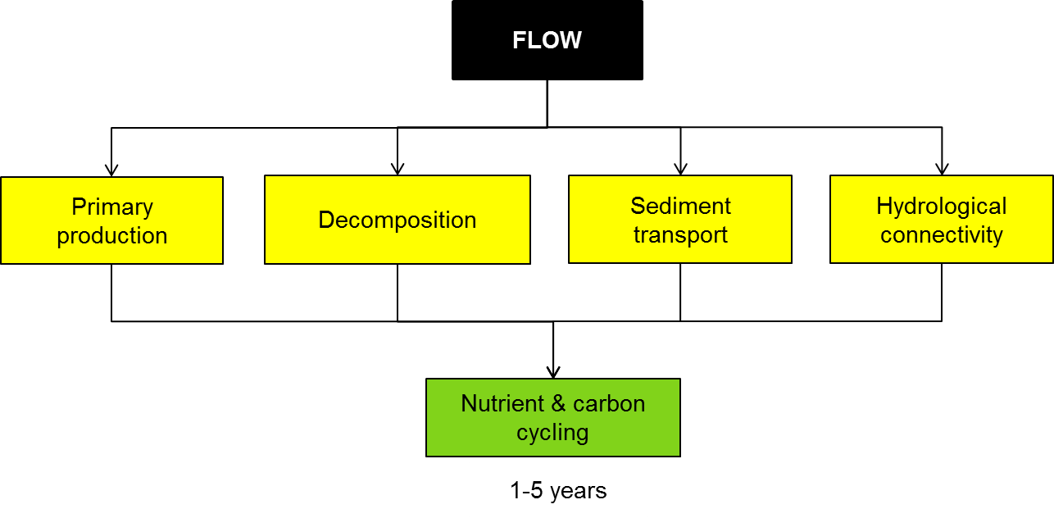

Figure 22. Cause and effect diagram depicting the influence of flow on nutrient and carbon cycling.

**The relationship between nutrients and flow:** The movements of nutrients in lowland river systems is quite complex with multiple pathways for the movement of nutrients between uplands, riparian zones, wetlands and river channels (Figure 23). The extent and importance of each pathway will vary in time and in space.

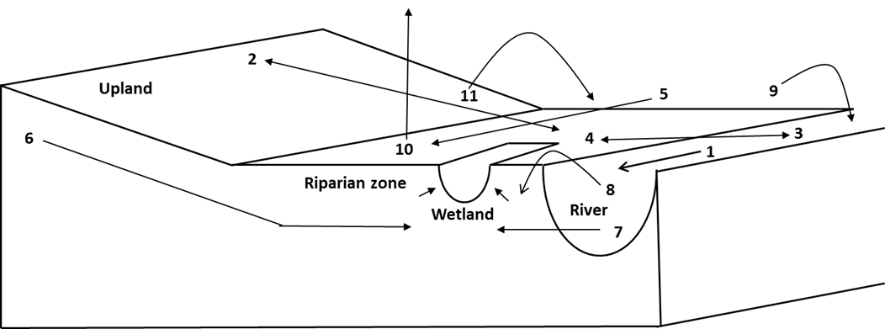

Figure 23. Schematic diagram showing the key pathways that nutrients may take within catchments.

The key flux pathways include:

Surface Fluxes:

1. Longitudinal flow within the river channel (see below) including errosional proceeses;
2. Bi-directional overland fluxes between the uplands to the riparian zone;
3. Fluxes from the river channel to the riparian zone (often associated with flooding);
4. Flood recession with flood water coming off the floodplain back into the river; and
5. Fluxes from upstream riparian zones – i.e. flood waters moving along the riparian zone

Subsurface Flows:

1. Subsurface flows from the uplands. Upland subsurface flows can be intercepted by low points on the riparian zone or can enter the river channel;
2. Subsurface flows from the river channel to the riparian zone – again these subsurface flows can be intercepted by low points in the riparian zone; and
3. Overbank floodwater penetrating through the soil profile to the underlying groundwater.

Aerial Fluxes:

1. Aerial deposition of material fixed on the floodplain into the adjacent water course (this encompasses, but is not necessarily limited to, leaf fall);
2. Gaseous fluxes from the riparian zone to the atmosphere; and
3. Aerial deposition from the uplands to the riparian zone (e.g. dust).

Most of these pathways will either be directly or indirecly influenced by flow. Some but not all of these pathways will be dependent on flows. Two important interactions between nutrients and flow are longditudinal flow within the river channel (1 in 23) and the mobilisation of nutrients during floods (3, 4 and 5 in 23).

**In Channel processes - Nutrient Transport:** Conceptually nutrients in the aquatic environment can be viewed as residing in one of four pools (i) dissolved in the water column, (ii) associated with suspended sediments, or (iii) bed sediments or (iv) incorporated into to the biota. These ‘pools’ are shown diagrammatically in 24. The arrows in the diagram indicate the exchanges between each of these ‘pools’. Upstream inputs (arrow A) into a water body (river reach or lake) can add nutrients into any of the four defined pools. Water and sediment chemistries and biological activity then control the exchange between each of the pools in the water body. Adsorption and desorption exchanges occur between the dissolved pool and the sediment bound pools (arrows B and C). Nutrients are also released from the sediment pools to the dissolved pool by the mineralisation of organic matter present both in the bed and suspended sediments. Nutrients are incorporated into the biological pool from the dissolved pool through the growth of algae, bacteria and aquatic plants (arrow E). For simplicity, organisms further along the food chain have been omitted from the diagram. The release of nutrients from the biological pool back to the dissolved pool occurs either through direct excretion (arrow E) or mineralization during decomposition following the death of the organism (arrows F through C and G through B). Exchange between the bed sediment and the suspended sediment pools occurs through the processes of sedimentation and re-suspension (arrow D). Finally, in the case of nitrogen there can be exchange out of the water column through denitrification (the conversion of reduced forms of nitrogen to dinitrogen gas) or into the water column through nitrogen fixation.

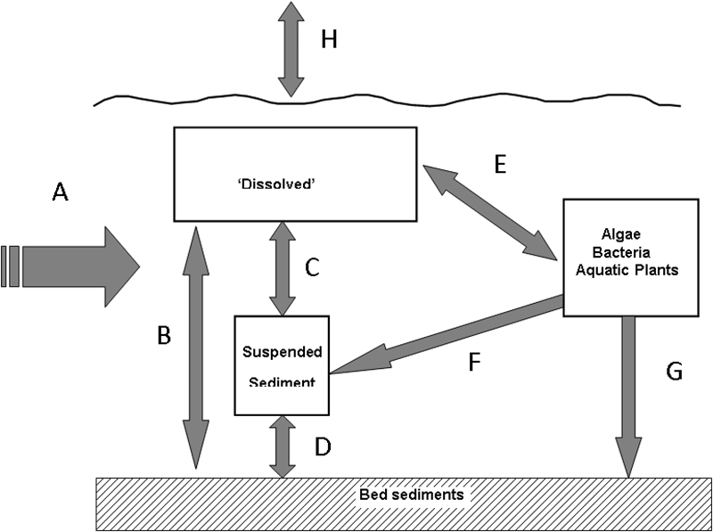

Figure 24. Exchanges nutrients may follow within river channels.

**Over bank flows and nutrients:** Overbank flows can have a number of effects on nutrient dynamics both from the river to the floodplain or from the floodplain back to the river:

**Source of nutrients to the river channel:** On flooding (flux pathway 2), dry riparian soil can immediately release a pulse of nutrients (N and occasionally P) into the overlying water column; a phenomenon known as the Birch effect (Birch 1960; Baldwin and Mitchell 2000). After prolonged inundation of riparian soil, anoxia can occur which then favours the microbially mediated reductive dissolution of iron minerals and concomitant release of any adsorbed phosphorus (Boström and Pettersson 1982; Caraco et al. 1989; Mitchell and Baldwin 1998). A proportion of the nutrient pulse can be transferred to the river channel on flood recession (flux pathway 3) either as dissolved nutrients or fixed into organic matter (e.g. phytoplankton).

**Deposition of particulate nutrients from floodwater:** As well as being sources of particulate and dissolved nutrients, the riparian zone can also be a sink. During floods (flux pathway 2), incoming floodwater can deposit particulate nutrients onto the riparian zone from upstream sources (Junk et al. 1989). Dissolved nutrients can be fixed into biomass or adsorbed onto sediments during the flood and hence enter riparian biogeochemical cycles (Baldwin and Mitchell 2000).

However the effects of flooding on nutrient dynamics may be much more subtle than direct transport for example iron minerals have a high affinity for phosphorus and are important in a soils ability to sequester inorganic P. As iron mineral phases age they become more crystalline and the number of sites on the mineral surface that can adsorb phosphate declines (e.g. (Baldwin 1996). Therefore as iron rich riparian soils age they potentially have less of an ability to sequester phosphate. During flooding, following the onset of anoxia, microbially mediated reductive dissolution of redox active mineral phases like iron occurs. While this results in the release of phosphate in the short term, it also allows renewal of the iron phases. When reduced dissolved iron (Fe2+) encounters an oxic environment, is Fe2+ is oxidised to Fe3+ which rapidly precipitates out of solution as amorphous iron oxyhydroxide (FeOOH). Amorphous oxyhydroxides have an enhanced capacity to sequester phosphate compared to more crystalline forms. Hence periodic flooding of riparian zones can increase the soils ability to adsorb P, therefore enhancing its ability to buffer phosphate coming from upslope.

**Knowledge gaps:**Despite decades of research, there are still many unknowns regarding nutrient dynamics, particularly in lowland river systems. These include:

* Shifting Baselines. Although it has been assumed that changes in land use and river regulation has changed the way that nutrients cycle in the environment, there has be no attempt to qualitative or quantitatively assess what those changes have been and what the subsequent impact on the aquatic environment have been
* Changes in hydrology. The effects of wetting and drying on nutrient dynamics in floodplains is still not well understood (Baldwin and Mitchell 2000) – especially the processes underlying observed effects
* Organic nutrients: Despite the fact that organic nitrogen and phosphorus species can account for the majority of N and P in both the water column and in the sediment the ecological significance of these compounds is still unclear. In particular the pathways for transformation of these compounds into forms more readily utilised by biota are still unclear
* Carbon sequestration. Although nutrients and soil moisture have been identified as important determinants on whether or not carbon undergoes mineralisation (creating greenhouse gases) or humification (carbon sequestration) in soils (Prescott 2010) the inter-relationship between flows, nutrients and soil and sediment carbon is still for the most part unknown.

**Use of the cause and effect diagram:** These are generic diagrams applicable across both the northern and southern parts of the basin. There applications to particular circumstances would require additional information and potentially modification of the model.

**References**

Baldwin DS (1996) Effects of exposure to air and subsequent drying on the phosphate sorption characteristics of sediments from a eutrophic reservoir. Limnology and Oceanography 41:1725-1732

Baldwin DS, Mitchell AM (2000) The effects of drying and re-flooding on sediment and soil nutrient dynamics of lowland river-floodplain systems; a synthesis. Regulated Rivers:Research and Management 16:457-467

Birch HF (1960) Nitrification in soils after different periods of dryness. Plant and Soil 12:81-96 doi: 10.1007/bf01377763

Boström B, Pettersson K (1982) Different patterns of phosphorus release from lake sediments in laboratory experiments. Hydrobiologia 91-92:415-429 doi: 10.1007/bf00940131

Caraco NF, Cole JJ, Likens GE (1989) Evidence for sulphate-controlled phosphorus release from sediments of aquatic systems. Nature 341:316-318

Junk WJ, Bayley PB, Sparks RE (1989) The flood pulse concept in river-floodplain systems. In: Dodge DP (ed) Proceedings of the International Large River Symposium. Canadian Special Publications of Fisheries and Aquatic Sciences, pp 110-127

Mitchell A, Baldwin DS (1998) Effects of Desiccation/Oxidation on the Potential for Bacterially Mediated P Release from Sediments. Limnology and Oceanography 43:481-487 doi: 10.2307/2839097

Prescott CE (2010) Litter decomposition: what controls it and how can we alter it to sequester more carbon in forest soils? Biogeochemistry 101:133-149

# 21 Refugia and landscape refugia

Riverscapes of the Murray-Darling Basin (MDB) experience highly variable flow regimes, with periods of flooding when dispersal rates among spatial units may be high, through to periods of drought when dispersal rates of many aquatic organisms may be extremely low. The resistance and resilience of populations to drought is determined by (a) properties of the riverscape and (b) properties of the populations themselves. Refuges are an important property of the riverscape that determine resistance and resilience to drought. However, refuges are also important to population viability during non-drought periods too, such us during hypoxic blackwater flows or other bouts of extreme physicochemical harshness (extremes of pH or salinity, for example). Essentially, **refuges** are spatial units within the riverscape that retain the appropriate quantity and quality of water to support some subset of the animal and plant community, during periods of harshness within the broader riverscape. The individuals within refuges are those that will repopulate the riverscape following periods of harshness, and are therefore pivotal to the resilience of the MDB; using metapopulation terminology, they are **sources of colonists** within the riverscape (Hanski 1999; Magoulick and Kobza 2003). By extension, refuges themselves are pivotal spatial units that promote resilience within the MDB.

A cause-effect diagram of how flow affects individual refugia within riverscapes is presented in Figure 25 and how flow affects landscape refugia is presented in Figure 26. The cause-effect diagram assumes flow interacts with geomorphology to shape the structure and dynamics of refuges.

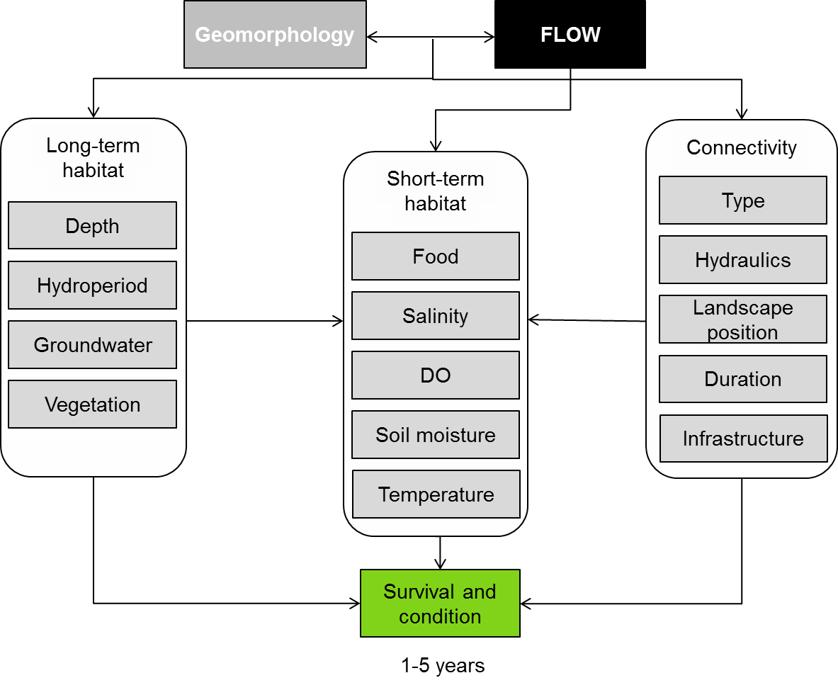

**Figure 25. Cause and effect diagram depicting influence of flow on individual refugia.**

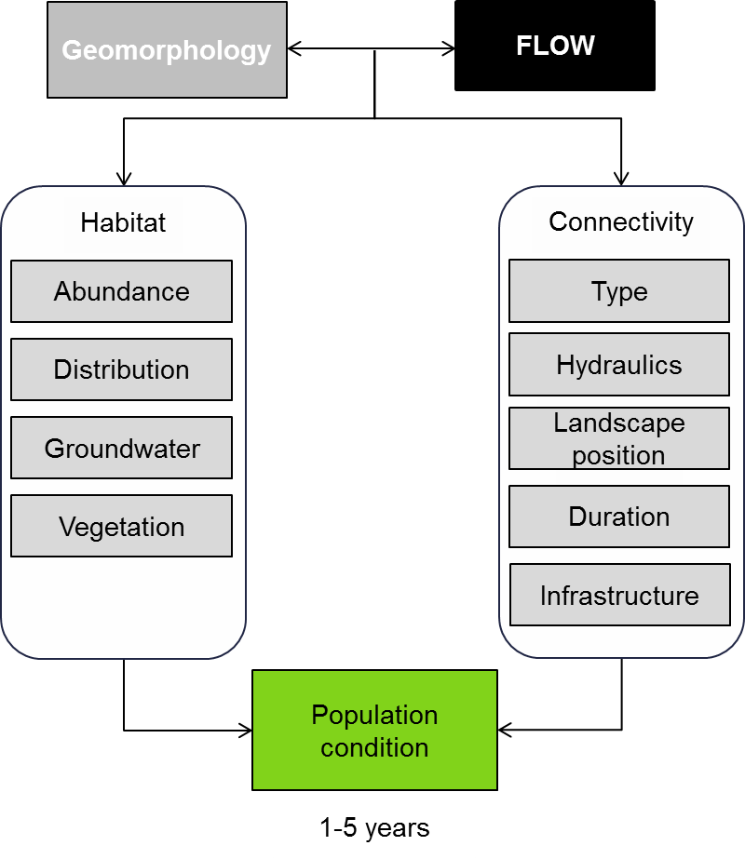

**Figure 26. Cause and effect diagram depicting influence of flow on landscape refugia.**

We have assumed refuges are defined by three classes of variables:

1. the spatial structure of the refuges, or the geometry of the refuge arrangement in the riverscape
2. the degree of connectivity among refuges
3. the quality of the habitat within individual refuges.

Within each of these classes we have listed some variables, shaped by flow, that we feel are particularly important to population resistance and resilience.

**Spatial structure of refuges:** *Inter-refuge distance -* Refer to Figure 2; inter-refuge distance is the minimum distance between a refuge of interest and another refuge within the riverine network. The inter-refuge distance of Refuge 1 in Figure 2 is the minimum of distances A + B or A + C. Theoretically, the smaller the mean inter-refuge distance, the greater the resilience of animal populations within the riverscape (Hanski 1999). Ideally, flows would be managed so the average inter-refuge distance did not decline to levels that significantly erode the resilience of flora and fauna to flow (Lowe et al. 2006; Davey and Kelly 2007). Flow variables such as ‘method of delivery’ will affect inter-refuge distance. For example, if we choose to allocate flows to a very low number of sites on the MDB floodplain, thereby increasing inter-refuge distance, we propose that resilience will erode.

*Refuge density -* Refer to Figure 2; refuge density at some spatial scale is the number of significant refuges per unit area (e.g. 1 per 100 km2). Where the refuges lie within the river channel, refuge density is simply the average inter-refuge distance. However, on floodplains, refuge density is not some function of mean inter-refuge density, as shown in Figure 2, Boxes A and B. Average inter-refuge distance between floodplain refuges in Box A is approximately the same as that between refuges in Box B, but refuge density in Box A is clearly higher than density in Box B. Riverscapes with low refuge density should have less resilience than those with high refuge density. Flow variables such as ‘pulse height’ will affect the surface area of floodplain inundated and therefore result in higher refuge density and higher resilience (Davey and Kelly 2007; Vermaat et al. 2008; Arthington et al. 2010; Pires et al. 2010; Chester and Robson 2011).

*Shape diversity -* The shape of spatial units or patches has long been of fundamental importance to population resilience in landscape ecology (Hanski 1999). Similarly, in the ecology of riverscapes, the shape diversity of waterbodies will be important to community resilience (Pires et al. 2010). The MDB riverscape comprises waterbodies of enormous diversity; large channels, paleochannels, oxbow lakes, deflation lakes, etc. These all vary in their depth, surface area, lateral shape (dendritic, circular, etc.) and bathymetry. Shape diversity in the riverscape promotes the diversity of ecological communities (Matthews 1998; Arthington et al. 2010; Pires et al. 2010) and, by extension, the resilience of those riverscapes. For example, large carnivorous fishes often don’t persist in small refuges during drought (Schlosser 1982); however, they do persist during the drought in large, deep refuges. Their presence in such refuges may drive certain small-bodied prey species to be locally extinct, however they can persist during droughts in smaller refuges without large carnivores (Schlosser 1982). Flow variables such as pulse height will inundate a greater diversity of refuge shapes, thereby promoting resilience.

**Connectivity:** *Channel density -* Refer to Figure 27; channel density is the number of channels that connect a refuge with neighbouring refuges. Box A and Box C both contain four refuges; however, the average channel density in Box A is three channels per refuge, while average channel density in Box C is only two channels per refuge. A higher channel density may increase the probability of organisms successfully dispersing from one refuge to the other as conditions change, thereby promoting community resilience. Long-term patterns of flow management that maintain channel complexity on the floodplain will maintain or increase channel density.



**Figure 27. Conceptual model demonstrating certain aspects of refuge spatial structure and connectivity that shape resilience of communities within ariverscape.**

*Channel hydrology* - Channel hydrology is pivotal to the dispersal of organisms within the riverscape and therefore the resilience of communities to flow variability. Three variables may be particularly important; timing, duration and method of delivery (Datry 2012; Steward et al. 2012). The timing of flows that reconnect units within the riverscape may have a large influence over the dispersal rates of species and how those rates vary among species. For example, flows allocated in colder months may result in less movement through the riverscape than those allocated in warmer months.

Due to the species-specific timing of dispersal response, duration of connection flows affects the composition of the community moving through the landscape (Stoffels et al. In review). Certain species, such as carp, may move on and off the floodplain extremely quickly, while others, such as catfish, may have a delayed dispersal response. A diversity of connection durations may promote the resilience of communities in river-floodplain systems.

Method of delivery refers to how channels connecting refuges within the riverscape are inundated. Pumped reconnection events may select for certain species, while natural reconnection events and those induced by opening regulators may be less selective. Method of delivery will affect the composition of species within refuges and hence the resilience of the riverscape community as a whole.

*Channel water quality -* The quality of the water within the channels of a riverscape should affect the dispersal rates of organisms (Fry 1971). For example, if channels have not been inundated in some time, inundation may result in a period of localised channel hypoxia (Hladyz et al. 2011), restricting passage of certain species. In such situations longer connection durations may promote dispersal of a higher diversity of species between refuges, thereby increasing resilience in the long-term.

**Refuge quality:** *Water quality -* is defined by variables such as temperature, dissolved oxygen, salinity and pH. Refuges within the riverscape can vary immensely in their water quality (Schlosser 1982; Capone and Kushlan 1991; Lake 2003; Magoulick and Kobza 2003; Higgins and Wilde 2005; Cucherousset et al. 2007; Chester and Robson 2011). Species vary significantly in their tolerances of water quality variables, which in turn means that the water quality of refuges will affect the composition of the communities within them, hence the spatial patterns of diversity within the riverscape and resilience of that riverscape to change (Pires et al. 2010; Schooley and Branch 2011). One way that managed flows may affect water quality is through the frequency of inundation events. If inundation events of refuges on the floodplain are not of sufficient frequency, water quality within floodplain refuges may become so harsh that numerous species are driven locally extinct in those refuges. A diversity of inundation frequencies may promote the greatest diversity of communities among refuges.

*Habitat diversity -* The diversity of habitat types within refuges will affect the species that a refuge can support. For example, refuges containing macrophyte beds and other structurally-complex structures (e.g. fine, woody debris) may support certain species that would otherwise be vulnerable to predation (Bond and Lake 2005). Higher habitat diversity within and among refuges should promote resilience of ecological communities within the riverscape. Long-term regimes of water delivery will affect the composition of macrophytes, for example, that a refuge can support, through its effect on seed banks, among other things.

**Major knowledge gaps:** Much of our understanding of how refuges should be managed and their effects on population viability is actually theoretical (Fagan 2002; Grant et al. 2007), so there is much research to be done to determine how flow interacts with geomorphology in riverscapes to affect population viability.

Some example questions include:

* How does the allocation of water to refuges affect the viability of populations in the medium- to long-term?
* How many refuges are required to maintain some minimum level of biodiversity?
* How does the spatial structure of managed refuges affect biodiversity response following resumption of flows?
* How does the method of water delivery (timing, duration, infrastructure utilised) affect the colonisation of refuges or persistence of fauna in refuges?

**Use of the cause and effect diagram:** This is a generic diagram applicable across both the northern and southern parts of the basin.

**References**

Arthington AH, Olden JD, Balcombe SR, Thoms MC (2010) Multi-scale environmental factors explain fish losses and refuge quality in drying waterholes of Cooper Creek, an Australian arid-zone river. Marine and Freshwater Research 61:842-856 doi: 10.1071/mf09096

Bond NR, Lake PS (2005) Ecological restoration and large-scale ecological disturbance: The effects of drought on the response by fish to a habitat restoration experiment. Restoration Ecology 13:39-48 doi: 10.1111/j.1526-100X.2005.00006.x

Capone TA, Kushlan JA (1991) Fish community structure in dry-season stream pools. Ecology 72:983-992 doi: 10.2307/1940598

Chester ET, Robson BJ (2011) Drought refuges, spatial scale and recolonisation by invertebrates in non-perennial streams. Freshwater Biology 56:2094-2104 doi: 10.1111/j.1365-2427.2011.02644.x

Cucherousset J, Paillisson JM, Carpentier A, Chapman LJ (2007) Fish emigration from temporary wetlands during drought: the role of physiological tolerance. Fundamental and Applied Limnology 168:169-178 doi: 10.1127/1863-9135/2007/0168-0169

Datry T (2012) Benthic and hyporheic invertebrate assemblages along a flow intermittence gradient: effects of duration of dry events. Freshwater Biology 57:563-574 doi: 10.1111/j.1365-2427.2011.02725.x

Davey AJH, Kelly DJ (2007) Fish community responses to drying disturbances in an intermittent stream: a landscape perspective. Freshwater Biology 52:1719-1733 doi: 10.1111/j.1365-2427.2007.01800.x

Fagan WF (2002) Connectivity, fragmentation, and extinction risk in dendritic metapopulations. Ecology 83:3243-3249 doi: 10.2307/3072074

Fry FEJ (1971) The effect of environmental factors on the physiology of fish. In: Hoar WS, Randall DJ (eds) Fish Physiology: Environmental Relations and Behaviour. Academic Press, New York, pp 1-98

Grant EHC, Lowe WH, Fagan WF (2007) Living in the branches: population dynamics and ecological processes in dendritic networks. Ecology Letters 10:165-175 doi: 10.1111/j.1461-0248.2006.01007.x

Hanski I (1999) Metapopulation Ecology. Oxford University Press, New York

Higgins CL, Wilde GR (2005) The role of salinity in structuring fish assemblages in a prairie stream system. Hydrobiologia 549:197-203 doi: 10.1007/s10750-005-0844-7

Hladyz S, Watkins SC, Whitworth KL, Baldwin DS (2011) Flows and hypoxic blackwater events in managed ephemeral river channels. Journal of Hydrology 401:117-125 doi: 10.1016/j.jhydrol.2011.02.014

Lake PS (2003) Ecological effects of perturbation by drought in flowing waters. Freshwater Biology 48:1161-1172

Lowe WH, Likens GE, Power ME (2006) Linking scales in stream ecology. Bioscience 56:591-597 doi: 10.1641/0006-3568(2006)56[591:lsise]2.0.co;2

Magoulick DD, Kobza RM (2003) The role of refugia for fishes during drought: a review and synthesis. Freshwater Biology 48:1186-1198

Matthews WJ (1998) Patterns in Freshwater Fish Ecology. Chapman and Hall, New York

Pires DF, Pires AM, Collares-Pereira MJ, Magalhaes MF (2010) Variation in fish assemblages across dry-season pools in a Mediterranean stream: effects of pool morphology, physicochemical factors and spatial context. Ecology of Freshwater Fish 19:74-86 doi: 10.1111/j.1600-0633.2009.00391.x

Schlosser IJ (1982) Fish community structure and function along two habitat gradients in a headwater stream. Ecological Monographs 52:395-414 doi: 10.2307/2937352

Schooley RL, Branch LC (2011) Habitat quality of source patches and connectivity in fragmented landscapes. Biodiversity and Conservation 20:1611-1623 doi: 10.1007/s10531-011-0049-5

Steward AL, von Schiller D, Tockner K, Marshall JC, Bunn SE (2012) When the river runs dry: human and ecological values of dry riverbeds. Frontiers in Ecology and the Environment 10:202-209 doi: 10.1890/110136

Vermaat JE, Vigneau N, Omtzigt N (2008) Viability of meta-populations of wetland birds in a fragmented landscape: testing the key-patch approach. Biodiversity and Conservation 17:2263-2273 doi: 10.1007/s10531-008-9401-9

# 22 Resistance and recovery

This cause-effect diagram describes the relationship between flow resilience and recovery as it relates to biotic condition (Figure 28 and Figure 29). Resilience and resistance are two terms often used in the management of ecosystems in the face of stressors. Resilience can be defined as the capacity of a system to respond to disturbance (resist, recover and adapt) while undergoing change so as to still retain essentially the same function, structure and feedbacks and therefore identity (Gawne 2012).The concept of resistance, as a component of resilience, in floodplain ecosystems may be explained as the capacity to resist changes associated with fluctuations between wet and dry phases without loss of overall ecosystem functionality and provision of services (Colloff and Baldwin 2010). Implicit in this concept is the importance of biotic resistance to abiotic perturbation such as flood, drought, fire, salinity, acidity and blackwater. In other words, the resilience of an ecosystem is dependent in part on the resistance of its components to changes in environmental stressors and conditions.

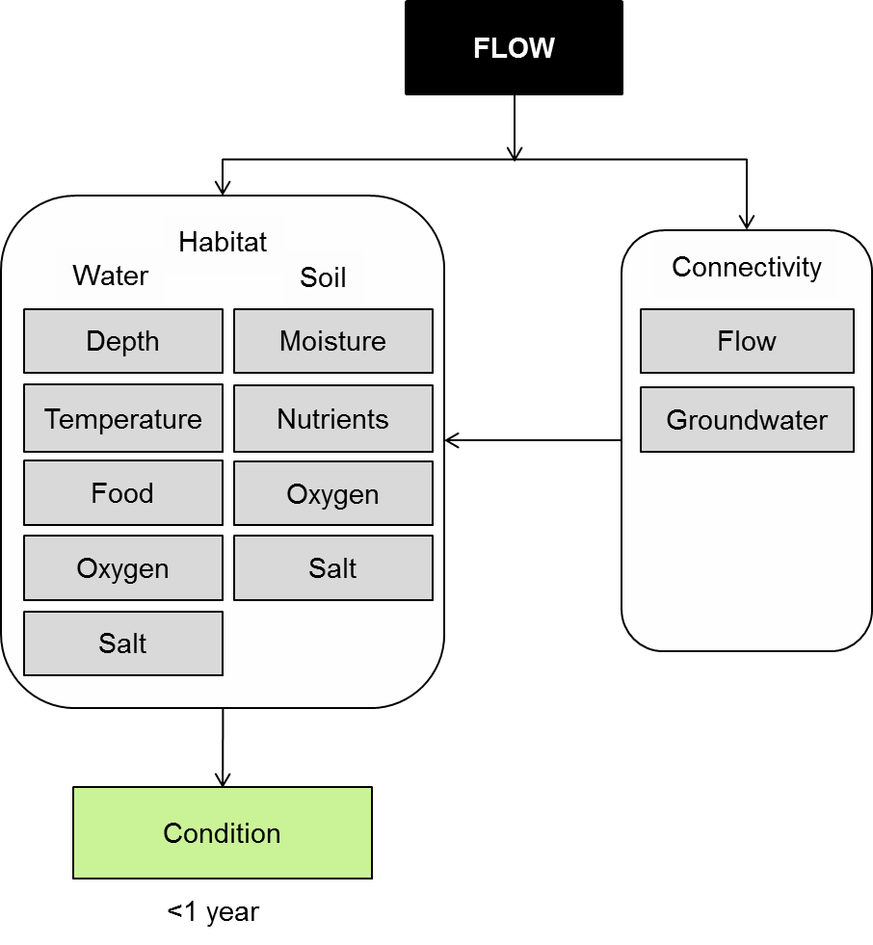

Figure 28. Cause-effect diagram depicting the effect of flow on ecosystem resistance.

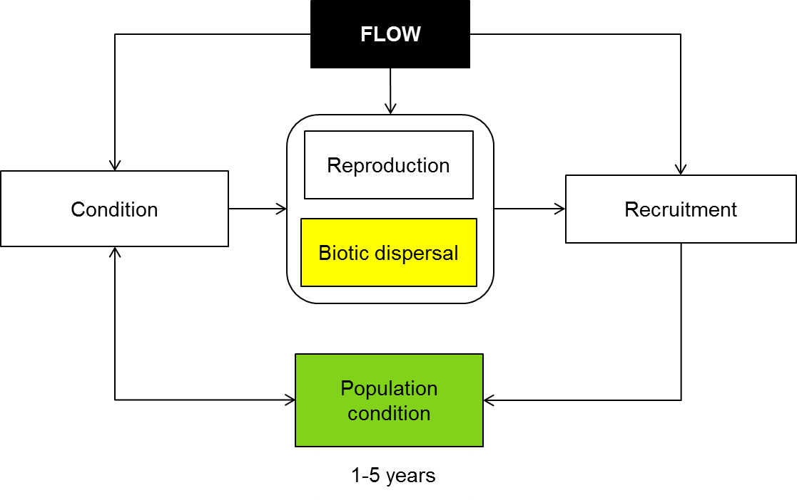

Figure 29. Cause-effect diagram depicting the effect of flow on ecosystem recovery.

It is proposed that the less resistant the component biota of an ecosystem is to environmental fluctuation then the greater the potential the ecosystem will move to an alternate state i.e. a new state of resilience with altered functionality (Colloff and Baldwin 2010). In this context, floodplain ecosystems of the Murray-Darling are considered more resilient than those with less extreme abiotic disturbance (e.g. coral reefs) because they are composed of biota that have evolved physiological, behavioural and dispersal characteristics to persist within a highly variable environment. Nevertheless, marked changes in the magnitude of environmental stressors are likely to compromise ecosystem function as species are lost or decline in condition. Once a driver such as permanent inundation or very long drying exceeds a particular threshold, the system may move to an alternate state (Figure 30) (Scheffer and Carpenter 2003; Wallace et al. 2011; Scheffer et al. 2012). It is thought that the ability of individuals, communities or ecosystems to resist this continuous disturbance, and not move into a ‘catastrophic’ alternate state from which they can’t recover, is closely related to their condition.



Figure 30. Conceptual model of the dynamic regime in which floodplains are always drying or flooding and the potential for excessive pressure to cause a transition to an alternate state (taken from Wallace et al. 2011).

The status of component biota with respect to their relative contribution to the ecosystem is also important (Baldwin et al. In Press). For lower order components, for example those involved in primary production, pollination and decomposition, the effect on ecosystem functionality of reduced condition or species loss may be compensated by niche overlap. For ecosystem engineers (Wright and Jones 2006) such as river red gums, for which there is minimal niche overlap, a reduction in condition, size structure or abundance may have a significant effect on ecosystem function. As resistance thresholds for key flora and fauna are exceeded, there is increased potential for the system as a whole to move to a more resilient, less desirable stable state characterised by reduced species diversity, altered functionality and reduced provision of ecosystem services.

Resistance strategies for native floodplain biota have evolved in association with a pre-regulated hydrological system. The extent to which floodplain biota are affected by alterations in hydrology is dependent on species-level strategies of resistance such as physiological tolerance, behavioural plasticity and dispersal strategy. The cause-effect diagram (Figure 29) shows potential pathways for how system hydrology can influence biotic and population condition. This model infers that ecological condition of biota may be used to indicate the level of physiological stress (i.e. the extent to which resistance is being compromised) and therefore as a measure of how suitable a particular hydrological regime is for the maintenance of a desirable resilient floodplain ecosystem.

**Habitat and Condition:** The type and quality of available habitat will influence the condition of individual species or ecosystems and hence their ability to resist disturbances such as flooding and drought. It is thought that the ability of individuals, communities or ecosystems to resist this continuous disturbance, and not move into a ‘catastrophic’ alternate state from which they can’t recover (Figure 3), is closely related to their condition and hence the condition of the habitat that supports them.

In terms of maintaining the condition of aquatic and floodplain ecosystems, habitat can be considered in two broad categories: the habitat provided through conditions in the soil and the habitat provided through conditions in the water column. For aquatic organisms (requiring the presence of water) factors such as water depth, temperature, available food, oxygen and salt concentrations will all impact on species and community condition. The condition of the habitat provided in the soil will be influenced by factors such as soil moisture content, and nutrient, oxygen and salt availability (refer to cause-effect diagrams relating to ‘vegetation condition and reproduction’, ‘macroinvertebrate adult aquatic and terrestrial’, and ‘fish condition’ for discussions on the effect and interactions of flow and habitat on species and community condition).

An example of how condition can affect the ability of biota to resist flow disturbance comes from floodplain trees. The ability of river red gum (*Eucalyptus camaldulensis*) trees to respond favourably, in terms of increased crown condition (MDBA 2012), to flooding following an extended period of drought is closely related to the condition of the tree prior to flooding (unpublished data). river red gum already in ‘poor’ condition (less than 40% crown condition) were less likely to respond favourably post-flooding and had a greater chance of dying than trees with greater than c.a. 40% crown condition (unpublished data). Tree condition is related to factors such as soil moisture content (linked to rainfall and time since last inundation), access to groundwater and the concentration of salt within the groundwater and soil (Jolly and Walker 1996; Overton et al. 2006; Roberts and Marston 2011 and references within).

However the condition of ecosystems is not solely dependent of the condition of constituent species but relies on abiotic factors as well. Abiotic parameters like nutrient status, water availability, light, pH, salinity, oxygen concentration and temperature impact on a relatively small suite of physiological processes that drive growth, reproduction and development (Colloff and Baldwin 2010). In well connected (functioning) ecosystems there are many feedback mechanisms as well as species that function as ‘ecosystem engineers’ (Wright and Jones 2006; Colloff and Baldwin 2010) that influence the resilience of species and ecosystems. Long-lived tree species, through physical and chemical means, affect a whole range of processes and trophic interactions from provision of habitat, sediment accumulation, erosion mitigation and soil stabilisation to altering microclimates (Colloff and Baldwin 2010).

In terms of feedback mechanisms high soil moisture leads to a healthy cover of vegetation and abundant litter to the soil. High soil carbon concentrations from the breakdown of this litter leads to better retention of water in the soil (Colloff and Baldwin 2010), which is likely to lead to healthier vegetation during dry phases. Recent work at Yanga has highlighted the importance of both the wet and dry phases to the resistance of floodplain ecosystems, through the reciprocal provisioning of carbon (Baldwin et al. In Press). Carbon fixed during the dry phase is important for driving biogeochemical transformations upon the next wet phase, however the carbon fixed during the wet phase (in the form of aquatic macrophytes) is also an important source of energy for the dry phase (Baldwin et al. In Press). Maintaining the processes that sustain feedback mechanisms, support ‘ecosystem engineers’ like long-lived tree species, as well as maintaining energy transfer between the fluctuating wet and dry phases, is likely to improve the condition of wetland, river and floodplain ecosystems and improve the resistance of these systems to disturbances such as flooding and drought (Colloff and Baldwin 2010).

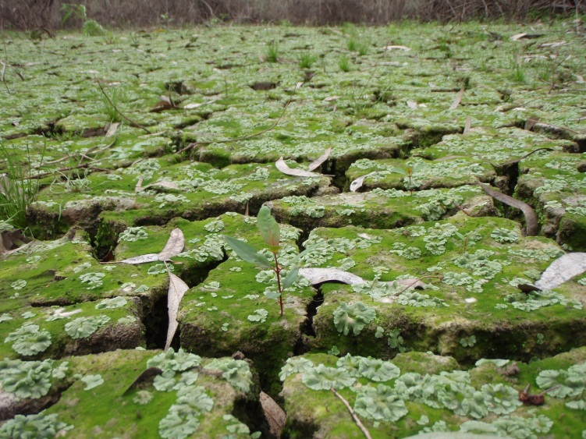

Photo: M. Henderson

**Connectivity**: Historical connectivity has, through evolutionary process, engineered the resistance strategies of extant floodplain biota. Resistance strategies include physiological tolerance, behavioural plasticity and dispersal mechanisms. Excessive disruption to the rates of rise and fall, timing, duration, extent or frequency of connectivity may exceed resistance thresholds of affected biota.

The importance of the connectivity between the lowland rivers of the Murray-Daring basin and their floodplains is captured in the Flood Pulse Concept (Junk et al. 1989) and more recently in the Reciprocal Provisioning Concept (Baldwin et al. In Press). These concepts reason the importance of two-way transfer of carbon and nutrients between terrestrial and aquatic pools and the key role of flooding regime as a determinant of productivity and ecosystem maintenance. Implicit is that the abatement of environmental stressors likely to exceed resistance thresholds is achievable through the provision of flow characteristics appropriate for the maintenance of soil and water habitats.

Connectivity may also be important as a dispersal vector for biota whose resistance strategies include maintenance in refuge pools during times of extended flood and drought prior to dispersal into suitable habitats upon the return of suitable environmental conditions (Jenkins and Boulton 2003) (see also CEDs relating to Resilience-Refugia and Connectivity-Biotic Dispersal). ‘Boom and bust’ cycles typical of Australian floodplain ecosystems are characterised by a period of intense productivity and dispersal followed by a period of habitat contraction and fragmentation (Bunn et al. 2006). Changes in hydrological connectivity may affect dispersal capacity, maintenance of spatiotemporal extent and genetic exchange.

Groundwater can also be considered an agent of connectivity. Groundwater is known to play an important role in the maintenance of key ecosystem biota such as river red gums and black box at Chowilla in South Australia (Mensforth et al. 1994; Overton et al. 2006). Groundwater recharge is affected by rainfall and/or flooding where flooding may be necessary to freshen otherwise saline groundwater aquifers (Holland et al. 2006). There is also a more direct link between surface and groundwater resources for the maintenance of biota that rely on both. River Red Gum are known to not only opportunistically utilise surface and ground water sources but to redistribute water throughout the soil profile (groundwater to surface soils and surface water to deeper root zone) using their root systems (Burgess et al. 1998; Burgess et al. 2001; Holland et al. 2006). This hydraulic redistribution resistance strategy has implications, not only for the maintenance of floodplain trees but also for the maintenance of understorey, soil condition and the fauna that depend on them.

**Knowledge gaps:** Most of the understanding of resistance, resilience and recovery in inland aquatic ecosystems is theoretical; there have been very few research projects that specifically have addressed the question of resistance, resilience and recovery in aquatic ecosystems. This is in part due to the question of resistance, resilience and recovery to what? To address the question first needs an understanding of the stressor of interest and the systems response when that stress is imposed, which requires a thorough understanding of the systems condition prior to the stress; as well as the systems response once the stress has been removed. It also requires some predictive capacity of when the stress will be imposed – which, for climatic stresses such as drought, may be difficult to predict; other stressors, such as change in land-use, may never be reversed. There is also the question of choice of indictors (resistance and resilience of what to the stress). Candidate indicators must possess feature or features that make them critical in the functioning of the ecosystem in question. However, these issues are not insurmountable. There is a real and specific need for hypothesis based research programs to address the questions of resistance and resilience of aquatic ecosystems to specific stressors.

**Use of the cause and effect diagram:** These are generic diagrams applicable across both the northern and southern parts of the basin. There applications to particular circumstances or species would require additional information and potentially modification of the cause-effect diagram.

**References**

Baldwin DS et al. (In Press) Provisioning of bioavailable carbon between the wet and dry phases in a semi-arid floodplain. Oecologia

Bunn SE, Thoms MC, Hamilton SK, Capon SJ (2006) Flow variability in dryland rivers: boom, bust and the bits in between. River Research and Applications 22:179-186 doi: 10.1002/rra.904

Burgess SSO, Adams MA, Turner NC, Ong CK (1998) The redistribution of soil water by tree root systems. Oecologia 115:306-311 doi: 10.1007/s004420050521

Burgess SSO, Adams MA, Turner NC, White DA, Ong CK (2001) Tree roots: conduits for deep recharge of soil water. Oecologia 126:158-165 doi: 10.1007/s004420000501

Colloff MJ, Baldwin DS (2010) Resilience of floodplain ecosystems in a semi-arid environment. The Rangeland Journal 32:305-314 doi: http://dx.doi.org/10.1071/RJ10015

Holland KL, Tyerman SD, Mensforth LJ, Walker GR (2006) Tree water sources over shallow, saline groundwater in the lower River Murray, south-eastern Australia: implications for groundwater recharge mechanisms. Australian Journal of Botany 54:193-205 doi: http://dx.doi.org/10.1071/BT05019

Jenkins KM, Boulton AJ (2003) Connectivity in a dryland river: short-term aquatic microinvertebrate recruitment following floodplain inundation. Ecology 84:2708-2723 doi: 10.1890/02-0326

Jolly ID, Walker GR (1996) Is the field water use of *Eucalyptus largiflorens* F. Muell. affected by short-term flooding? Australian Journal of Ecology 21:173-183

Junk WJ, Bayley PB, Sparks RE (1989) The Flood Pulse Concept in River-Floodplain Systems. Can Spec Publ Fish Aquatic Sci 106:110-127

MDBA (2012) Ground-based survey methods for The Living Murray assessment of condition of river red gum and black box populations. In, Version edn. Murray-Darling Basin Authority, Canberra, p 58

Mensforth L, Thorburn P, Tyerman S, Walker G (1994) Sources of water used by riparian Eucalyptus camaldulensis overlying highly saline groundwater. Oecologia 100:21-28 doi: 10.1007/bf00317126

Overton IC, Jolly ID, Slavich PG, Lewis MM, Walker GR (2006) Modelling vegetation health from the interaction of saline groundwater and flooding on the Chowilla floodplain, South Australia. Australian Journal of Botany 54:207-220 doi: http://dx.doi.org/10.1071/BT05020

Roberts J, Marston F (2011) Water regime for wetland and floodplain plants: a source book for the Murray-Darling Basin. National Water Commission, Canberra

Scheffer M, Carpenter SR (2003) Catastrophic regime shifts in ecosystems: linking theory to observation. Trends in Ecology &amp; Evolution 18:648-656 doi: 10.1016/j.tree.2003.09.002

Scheffer M et al. (2012) Anticipating Critical Transitions. Science 338:344-348 doi: 10.1126/science.1225244

Wallace T et al. (2011) "Natural" versus "Artifical" watering of floodplains and wetlands. In. Draft report prepared for the Murray-Darling Basin Authority by The Murray-Darling Freshwater Research Centre, p 28pp

Wright JP, Jones CG (2006) The Concept of Organisms as Ecosystem Engineers Ten Years On: Progress, Limitations, and Challenges. BioScience 56:203-209 doi: 10.1641/0006-3568(2006)056[0203:tcooae]2.0.co;2

# 23 Salinity

Salt, in a variety of forms, is a natural occurring component of the Australian landscape and has been deposited from a variety of sources over millions of years. The cycles of wetting and drying have been associated with a salinity regime to which biota have become adapted. Salt enters aquatic systems from groundwater, terrestrial material via the weathering of rocks or from the atmosphere, and is transported with wind and rain (Williams 1987; Baldwin 1996). Development of the Basin’s land and water resources has influenced the movement of water and salt through the landscape. These include vegetation removal and managing the river resource, altering the natural flow regime. The effects of management include 1) increases in average salinity levels in some systems, and 2) higher peak salinities in soils and water bodies.

Rising salinities are recognised as one of the most challenging environmental problems to freshwater ecosystems and it is estimated that by 2020, the Murray River’s salinity will exceed drinking water standards for nearly 150 days a year (Lovett et al. 2007). The following cause and effect diagram describes how salinity is modulated by the key influences of catchment, connectivity; channel conduits; and in-stream process (Figure 31).

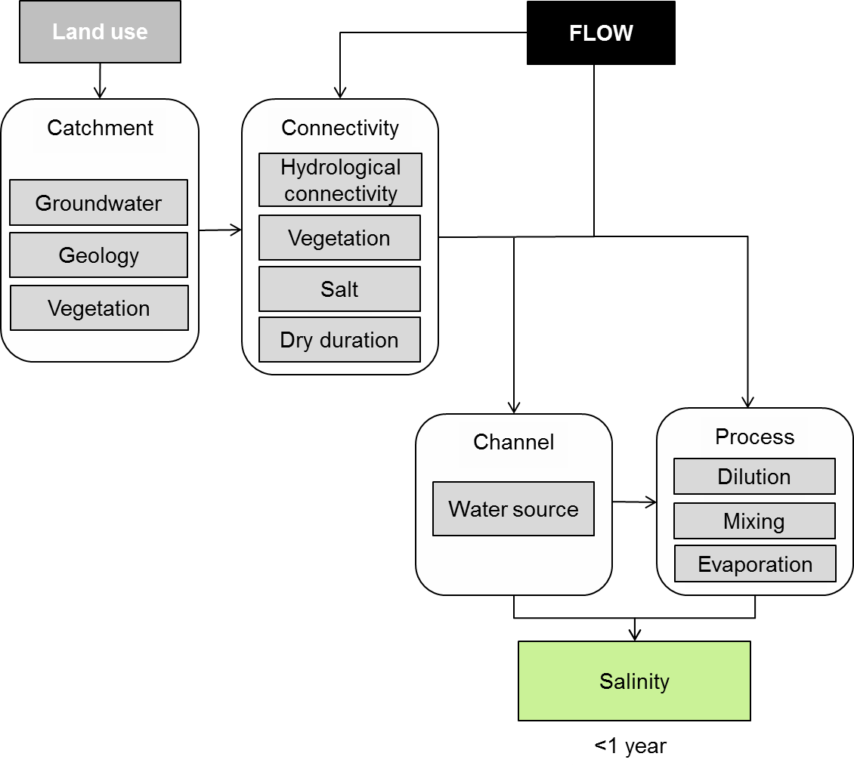

**Figure 31. Cause and effect diagram depicting flow influences on salinity*.***

**Catchment:** Groundwater is located beneath the earth’s surface being stored in aquifers (porous rock and soils) with the top portion of the aquifer called the water table. Groundwater is fed from surface waters (rivers and rain) when infiltration is possible and stops when it reaches impervious layers. Geological types however, characterize a range of aquifer types. For example, unconfined aquifers lack a ‘confining’ low permeable geology above them so water passes easily through them. They are characteristically near the surface and often follow the surface topography of the land and can form natural springs and wetlands. Alternatively, confined aquifers are deeper and are better sealed from the surface by a less permeable geology. They can be fed from recharge sources a great distance away where infiltration occurs more readily. These artesian aquifers do not necessarily follow the topography of the surface lands.

The significance to the cause and effect diagram is two-fold, 1) different geologies translate to differences in water yield, recharge rates and accessibility or potential to be connected to surface water systems and the transport of salt between the two systems, and 2) many ecosystems are either groundwater dependent or dependent some of the time.

Salt can be stored and transported through groundwater systems, with large regional groundwater systems making the greatest contribution to stream salinity in the drier basin lowlands (Van Dijk et al. 2008). They cover about a third of the Murray-Darling drainage area (LeBlanc et al. 2011). Saline groundwater is also naturally rich in sulfate that contaminates soils and sediments especially where it concentrates through evaporation. The concentration of sulfate further increases the potential for acidification. Groundwater is vulnerable to salt contamination from catchment land use and modifications. Practices such as irrigation, vegetation clearance, the presence of dams and weirs and mining operations can influence salt concentrations in groundwater. These are issues of connectivity and will be addressed below.

**Connectivity:** Connectivity is the major avenue by which salt enters water dependent ecosystems. The Basin’s floodplain-river system contains a myriad of water bodies and adjacent lowland floodplains with lateral and longitudinal hydrological connections. These occur at a variety of heights on the floodplain. Regulating the main channel volumes directly affects river height and therefore the extent of lateral connections with anabranches, wetlands and floodplains. Furthermore, the duration and magnitude of connection will directly affect how salt is transported or retained in the system as detailed in Figure 32.

**(A) Non-modified water regime**

**Threshold**

**High**

**Low**

**Mean Salinity**

**Water level**

**Salinity**

**Time**



**B) Modified water regime**

**Figure 32. The relationship between flow and salinity in (A) non-modified and (B) modified water regimes. Solid blue line indicates the variation in water level over time. Solid black line indicates the variation in the mean salinity over time. Red dashed line indicates biotic threshold level above which *the* loss of biota may occur or strategies to either avoid or tolerate increased salinity occur. Green dashed line indicates mean salinity over time (Reproduced from Nielsen et al. 2003).**

Under a modified or regulated water regime, many high flow events are removed from the system which can allow a shift in the balance between salt accumulation and removal leading to salt accumulation over time.

*Hydrological, vegetation and salt movement*wetlands act as salt ‘sinks’ because they are often the lowest point on the floodplain. Surface water connection through floods will pick up salt that has been discharged into wetlands or concentrated in floodplain soils and potentially export this back to the river. When groundwater discharges to wetlands it may lead to the development of saline lakes or swamps unless it can discharge to rivers for export from the system. Similarly, wetlands can increase in salt content over time when the frequency and magnitude of hydraulic connection decreases with consequences to biota when salinity tolerances are approached (Figure 32).

River regulation often means that floodplains and wetlands are flushed less frequently, but water carrying salt is still delivered into these systems increasing the concentration of salt in the sediments and this will influence biota such as aquatic plants and animals (Bailey and James 2000). Under natural conditions, salt in surface soils is transported down to groundwater aquifers and then transported to areas of groundwater discharge. Clearing of native vegetation and irrigation practices has led to the raising of salty water-tables in the soil profile that then evaporate leaving concentrated salts at the surface (LeBlanc et al. 2011) (Figure 33). Shallow water tables can also increase river salinity through groundwater seepage. The removal of vegetation contributes to increases in surface runoff that can increase erosion and the increased movement of terrestrial surface salts to aquatic systems.

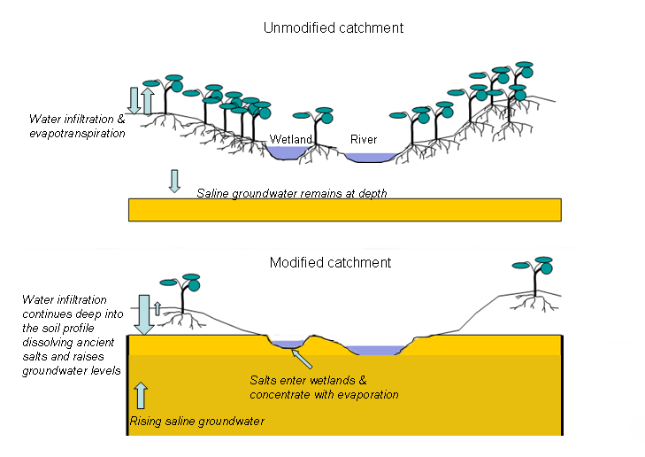

**Figure 33*.* Movement of salt within the landscape. Top *-* unmodified catchment, Bottom *-* modified catchment (Watson et al. 2008).**

While a modified catchment can increase groundwater salinity, groundwater can also become saline if extraction from aquifers exceeds natural recharge rates. Saline groundwater moves into aquifer zones that previously contained only fresh water (NWC 2012).

*Dry Duration*increased dry periods reduce the frequency of flushes to the system and lead to the accumulation of salt in the landscape. These dry periods can be caused by reductions in storm activity and river regulation. Under natural flow regimes these salts would have been removed by the flushing associated with overbank flows. Coupled with less frequent high flows characteristic of a managed system, a new relationship between salt and the environment emerges and salts in sediments gradually increase over time (Figure 34).

One consequence of this salt accumulation is that return floodwater from first inundations will transport greater loads of salt than would occur after more frequent flooding events (James et al. 2003). If these rare floods are also smaller, then salt concentrations in rivers are likely to be much higher as a consequence. Where water is delivered as a pulse, first run-off transports an initial ‘slug’ of highly saline water in the leading edge (Nielsen et al. 2003).



**Dry period**

**Figure 34. The relationship between wetting and dry cycle on the accumulation of salts in wetlands. Solid line indicates the variation in water level over time with intermittent dry periods. In this model, salinity levels are reset but at higher than previous levels post flushing (over time*,* due to theincrease in dry duration relative to a modified river regime). Large-dashed line indicates mean salinity over time. Solid rectangle indicates the accumulation of salts in the sediment as a consequence of reduced flushing. Threshold is a nominal level of biotic tolerance. (Nielsen et al. 2003)**.

Long dry periods reduce the quality and quantity of wetlands available for species that can actively move into them for refuge. These periods reduce wetlands in volume and their evaporation typically increases and become selective for more tolerant species.

**Channel:** Within the channel, the major influence on salinity is the source of water. If water is being delivered from upstream and the salinity is low then this will help keep salinity levels low. If the water however, is sourced from saline aquifer, then salinity will be higher.

**Process:** The salinity at a site is influenced by local processes such as dilution, mixing and evaporation which can lead to local interactive effects between salt and other processes. During periods of low or cease-to-flow, differences in salt concentration within a water body can lead to stratification which limits mixing and solute transport in the water column. This occurs through salty groundwater intrusion and can be further reinforced by thermal gradients generated during summer (Nielsen et al. 2003). In some circumstances the barrier prevents oxygen moving to areas of high oxygen demand, resulting in oxygen depleted sediments. This in turn impacts on microbial processes and nutrient cycling. It stands to reason that flowing water enhances mixing through a more turbulent water delivery and the dilution of saline gradients will usually occur fairly rapidly. Dilution with water delivery also serves to dilute localised saline pools but the extent of which will be a function of the salinity difference between localised salinity and that of the incoming water as well as their respective volumes.

Saline waters are known for their decreased ability to dissolve oxygen in fresh water and at very high salinities (30 000 EC or 20 000 mg L-1) available dissolved oxygen is insufficient for most aquatic invertebrates, causing respiratory failure (Williams 1998). Salinity can also change the physical and chemical properties of water including:

* pH
* contribute to the formation of sulfidic sediments
* solubility of ions
* reduction and oxygenation potentials
* flocculation of particles and disruption of chemical equilibria
* shifts in nutrient availability
* favour particular microbial processes over others
* influence nutrient releases into the water column (Dunlop et al. 2005; Lovett et al. 2007).

Salinity mediated flocculation blankets sediments, affecting habitat availability for periphyton and other groups. The precipitation of suspended particles increases light penetration thereby expanding the euphotic zone and favouring algal growth. The effects of salinity on nutrient cycles, stratification and light penetration may combine to enhance conditions for blue green algae that also have high salt tolerances (Watson et al. 2008).

Waterlogging also can exacerbate the effects of salinity. Extended inundation of floodplains results in the depletion of soil oxygen which decreases energy production, solute movement and stomatal conductance of plants. When saline water interacts with these conditions, a plant’s salinity tolerance will be compromised as a consequence of increased accumulation of salts in shoots (Barrett-Lennard 2003). Evaporation, as mentioned above, leads to salt concentration over time and so prolonged periods without flushing or dilution leads to salty deposits or scalds on the landscape.

These changes in salinity have consequences for native animals and plants that have particular salinity tolerances. In simple terms, biota have individual preferences for salinity levels and this varies between biotic groups. Generally, as salinity increases there will be little or no effect (e.g. reduced fecundity and fitness) until a threshold is reached above which longer term exposure will result in species disappearance and/or mortality of whole communities (Watson et al. 2008). Early life stages however, can be particularly sensitive to moderately small elevations in salinity. This is particularly evident with freshwater fish with Murray cod and trout cod found critically sensitive to moderate levels of salinity for the first two weeks post hatching (Chotipuntu 2003).

**Knowledge Gaps:** Perhaps the most challenging gap in knowledge arises from how salt physically and chemically interacts with other processes and chemicals under conditions of no or low flow and the complex responses of aquatic biota. Simple laboratory experiments can determine simplistic cause and effect models under controlled conditions but predicting landscape scale or ecosystem scale cause and effect responses remains extremely difficult (Lovett et al. 2007). Central to this is 1) an understanding of hydrologic connectivity and the processes that drive it and 2) the appropriate ecological knowledge around biological communities; both of which require more research.

There is currently a poor understanding of the connectivity of groundwater with surface water systems and their dependent environments (Watson 2010; NWC 2012). Predictive knowledge for lateral surface connectivity between floodplains and river systems is also still in development. For example, an assessment of the extent of floodplain inundation that will occur against a given river flow volume at large reach scales (640 km) have recently been trialled (Frazier and Page 2009) but these approaches are not well developed across the Basin.

Sulfidic sediments cause negative outcomes for freshwater systems (e.g. acidification) and can form when sediments are exposed to more highly saline water for a period of time and are subsequently dried and exposed to air through the presence of specific bacteria. More information is needed on the prevalence of these bacterial communities across the Basin. As most of the sulfidic story has been understood from wetland studies, an understanding of river hydrology and sulfidic sediment transformations in rivers remains unknown (Baldwin and Capon 2011).

Finally, the impacts to the environment and its inhabitants from salt movement and resilience to its presence and pressures from climate requires thrifty investigations. It is imperative to establish base line or benchmark condition surveys and, where conditions still exist, to provide reference community data.

**Use of the cause and effect diagram:** This is a generic diagram applicable across both the northern and southern parts of the basin.

**References**

Bailey PC, James KR (2000) Riverine and Wetland Salinity Impacts - Assessment of R & D Needs. Land and Water Resources Research and Development Corporation, Occasional Paper No. 25/99.

Baldwin DS (1996) Salinity in Australian Rivers. Australasian Science 17:15-17

Baldwin DS, Capon SJ (2011) Sulfic Sediments in inland waterways, Waterlines Report. National Water Commission, Canberra

Barrett-Lennard E (2003) The interaction between waterlogging and salinity in higher plants: causes, consequences and implications. Plant and Soil 253:35-54

Chotipuntu P (2003) Salinity Sensitivity in Early Life Stages of an Australian Freshwater Fish, Murray Cod (Maccullochella Peelii Peelii Mitchell 1838). University of Canberra

Dunlop J, McGregor G, Horrigan N (2005) Potential Impacts of Salinity and Turbidity in Riverine Ecosystems: Characterisation of impacts and a discussion of regional target setting for riverine ecosystems In: Queensland. Aquatic Ecosystem Health Unit Water Quality and Monitoring. Natural Resource Sciences Queensland Department of Natural Resources and Mines.

Frazier P, Page K (2009) A reach‐scale remote sensing technique to relate wetland inundation to river flow. River Research and Applications 25:836-849

James KR, Cant B, Ryan T (2003) Responses of freshwater biota to rising salinity levels and implications for saline water management: a review. Australian Journal of Botany 51:703-713

LeBlanc M et al. (2011) Groundwater change in the Murray basin from log-term in-situ monitoring and GRACE estimates In: : Climate Change Effects on Groundwater Resources: A Global Synthesis of Findings and Recommendations. IAH - International Contributions to Hydrogeology, CRC Press - 414

Lovett S, Price P, Edgar B (2007) Salt, Nutrient, Sediment and Interactions:. In: Findings from the National River Contaminants Program. Land & Water Australia

Nielsen D, Brock M, Rees G, Baldwin DS (2003) Effects of increasing salinity on freshwater ecosystems in Australia. Australian Journal of Botany 51:655-665

NWC (2012) Groundwater Essentials. National Water Condition, Canberra

Van Dijk A, Gilfedder M, Austin J (2008) Influences of climate, terrain and land cover on stream salinity in southeastern Australia, and implications for management through reforestation. Hydrological Processes 22:3275-3284

Watson G (2010) Feasibility Assessment of Ecological Outcomes (indicators) proposed for the Basin Plan Monitoring and Evaluation Program. In. Final Report prepared for the Murray-Darling Basin Authority by The Murray-Darling Freshwater Research Centre, p 17

Watson G, Nielsen DL, Gawne B (2008) The Effects of Salinity on Aquatic Ecosystems of the Murray-Darling Basin: A report prepared for the Murray-Darling Basin Commission by the Murray-Darling Freshwater Research Centre.

Williams DD (1987) The ecology of temporary waters. Croom Helm/Timber Press, London, Sydney/Portland

Williams WD (1998) Salinity as a determinant of the structure of biological communities in salt lakes. Hydrobiologia 381:191-201

# 24 Dissolved oxygen

Changes in dissolved oxygen can have a profound effect on aquatic animals. There have been widespread problems associated with low oxygen levels due to high input of organic matter into a waterway (Salles et al. 2006; Whitworth et al. 2012). There are however, situations in which high levels of oxygen (supersaturation) can also cause problems.

Australian native fish and other large aquatic organisms require at least 2mg L−1 of oxygen in the water to survive, but may begin to suffer at levels below 4–5mgO2 L−1(Gehrke 1988) For example, flooding of the Barmah-Millewa Forest in 2000 and 2010 resulted in ‘blackwater’ returning to the river, causing a significant degradation of water quality leading to fish and crustacean deaths (Baldwin et al. 2001; King et al. 2012).

The amount of oxygen dissolved in water is influenced by the water temperature with increasing temperatures being associated with lower levels of dissolved oxygen. The maximum amount of oxygen that can be dissolved in water (saturated oxygen concentration) is calculated using the formula:

Saturated oxygen = 13.41e(−0.01905T) mgL−1.

The following section describes how dissolved oxygen is affected by river flow through its influence on habitat (Figure 35). Primary production, decomposition and hydrological connectivity also influence dissolved oxygen and are contained in separate cause and effect diagrams

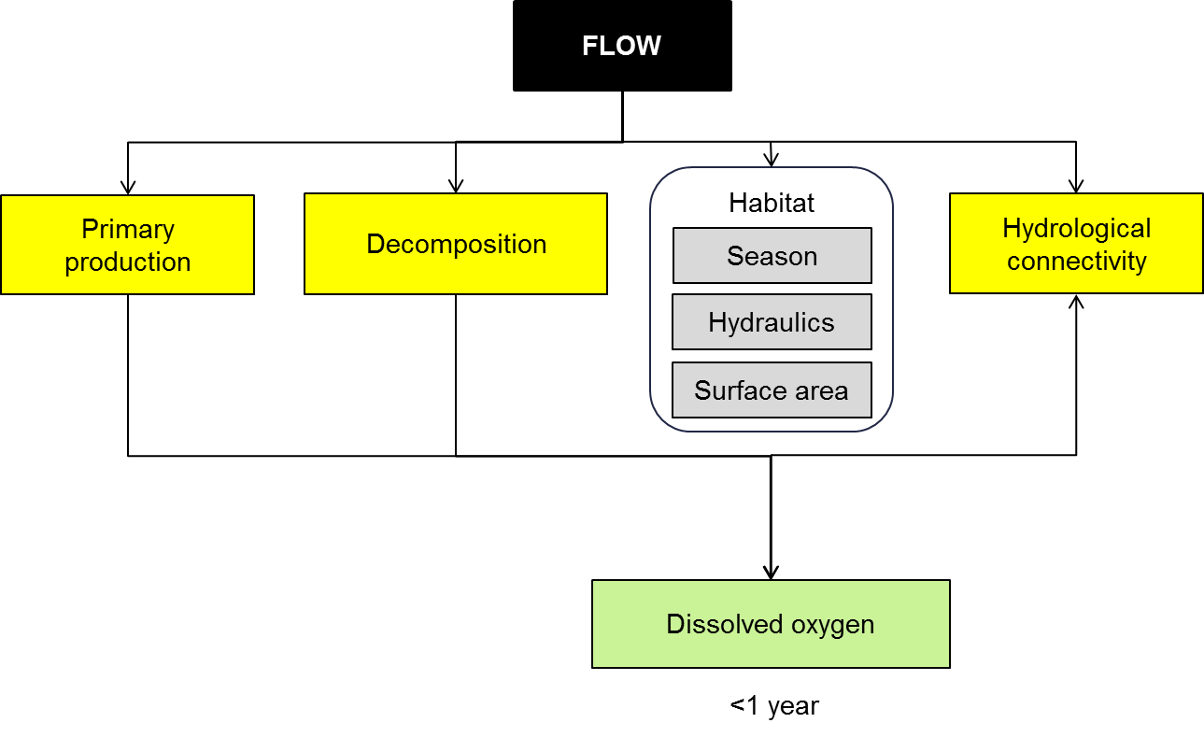

**Figure 35. Cause and effect diagram depicting flow influences on dissolved oxygen.**

**Habitat:** The other factors that influence Dissolved Oxygen (DO) concentrations relate to the supply and consumption of DO of which there are three broad factors. The first of these is re-aeration which is the exchange of oxygen between the water and the air. Re-aeration is influenced by the relative movement of air past water, so it will be affected by wind speed (Odum and Wilson 1962). From a water perspective, the velocity and turbulence of the water will influence re-aeration (Melching and Flores 1999; Morse et al. 2007). The effect of re-aeration on dissolved oxygen will also be influenced by the ratio of the area available for re-aeration (channel width) compared to the depth of the water body (Melching and Flores 1999). Efforts to ameliorate low oxygen levels often focus on increasing the amount of surface area available for re-aeration or the turbulence of the water (Kerr et al. 2013).

Primary production contributes oxygen to the water column. The photosynthetic process undertaken by macrophytes and algae consumes carbon dioxide and produces oxygen that diffuses out of the plants and into the water column (Odum and Wilson 1962; Young and Huryn 1996). In some rare situations, high rates of photosynthesis can lead to oxygen supersaturation (Cloern 1996).

Most management focus has been on the role of decomposition processes in creating hypoxic blackwater events (Hladyz et al. 2011; King et al. 2012; Whitworth et al. 2012). These events occur when large amounts of organic matter are inundated by warm water which leads to the development of a productive microbial community that consumes oxygen faster than it can be replaced (Howitt et al. 2007; Whitworth et al. 2012). A number of factors interact to cause a major reduction in DO, including the amount of organic matter inundated, the bioavailability of the organic matter and the temperature which is influenced by the timing of the flood (Howitt et al. 2007; Whitworth et al. 2012).

Environmental flows have been used to ameliorate low DO levels through dilution, but other options, including flooding to reduce floodplain litter loads and flow management to create refuges, have been discussed as strategies that may be worth trialing (Kerr et al. 2013).

**Knowledge gaps:** The processes that influence dissolved oxygen are relatively well known; however, there are knowledge gaps concerning blackwater events such as the sources of organic matter and the rate at which it is processed by microbes that require further investigation. There is also a need to understand spatial variation in dissolved oxygen and how flow may be used to create or sustain refuges for fish during hypoxic blackwater events.

**Use of the cause and effect diagram**: This is a generic diagram applicable across both the northern and southern parts of the Basin. Its application to particular circumstances or localities would require additional information and potentially modification of the model.

**References**

Baldwin D, Howitt J, Edwards M (2001) Blackwater event. Austasia Aquaculture 15:21

Cloern JE (1996) Phytoplankton bloom dynamics in coastal ecosystems: A review with some general lessons from sustained investigation of San Francisco Bay, California. Reviews of Geophysics 34:127-168 doi: 10.1029/96rg00986

Gehrke PC (1988) RESPONSE-SURFACE ANALYSIS OF TELEOST CARDIORESPIRATORY RESPONSES TO TEMPERATURE AND DISSOLVED-OXYGEN. Comparative Biochemistry and Physiology a-Physiology 89:587-592 doi: 10.1016/0300-9629(88)90837-7

Hladyz S, Watkins SC, Whitworth KL, Baldwin DS (2011) Flows and hypoxic blackwater events in managed ephemeral river channels. Journal of Hydrology 401:117-125 doi: 10.1016/j.jhydrol.2011.02.014

Howitt JA, Baldwin DS, Rees GN, Williams JL (2007) Modelling blackwater: predicting water quality during flooding of lowland river forests. Ecological Modelling 203:229-242

Kerr JL, Baldwin DS, Whitworth KL (2013) Options for managing hypoxic blackwater events in river systems: A review. Journal of Environmental Management 114:139-147 doi: 10.1016/j.jenvman.2012.10.013

King AJ, Tonkin Z, Lieshcke J (2012) Short-term effects of a prolonged blackwater event on aquatic fauna in the Murray River, Australia: considerations for future events. Marine and Freshwater Research 63:576-586 doi: 10.1071/mf11275

Melching CS, Flores HE (1999) Reaeration equations derived from US Geological Survey database. Journal of Environmental Engineering 125:407-414

Morse N, Bowden W, Hackman A, Pruden C, Steiner E, Berger E (2007) Using sound pressure to estimate reaeration in streams. Journal of the North American Benthological Society 26:28-37

Odum H, Wilson F (1962) Further studies on reaeration and metabolism of Texas bays, 1958–1960. In: Publication of the Institute of Marine Sciences. University of Texas, pp 23–55

Salles P, Bredeweg B, Araújo S (2006) Qualitative models about stream ecosystem recovery: Exploratory studies. Ecological Modelling 194:80-89

Whitworth KL, Baldwin DS, Kerr JL (2012) Drought, floods and water quality: drivers of a severe hypoxic blackwater event in a major river system (the southern Murray-Darling Basin, Australia). Journal of Hydrology

Young R, Huryn A (1996) Interannual variation in discharge controls ecosystem metabolism along a grassland river continuum. Canadian Journal of Fisheries and Aquatic Sciences 53:2199-2211

# 25 PH

pH is a measure of the activity of hydrogen ions which is a measure of the hydrogen ion concentration. pH ranges from a value of 1 - which represents a highly acidic solution, through to 7 - which is neutral, and through to 14 - which represents a highly basic solution. Water in healthy water dependent ecosystems generally varies from 6 to 8. The pH in aquatic ecosystems is the product of a range of chemical reactions, functions and processes; including hydrological connection with groundwater and the floodplain, photosynthesis and decomposition. The following section describes how pH is affected by river flow through its influences on the catchment, connectivity, channel and process (Figure 36).

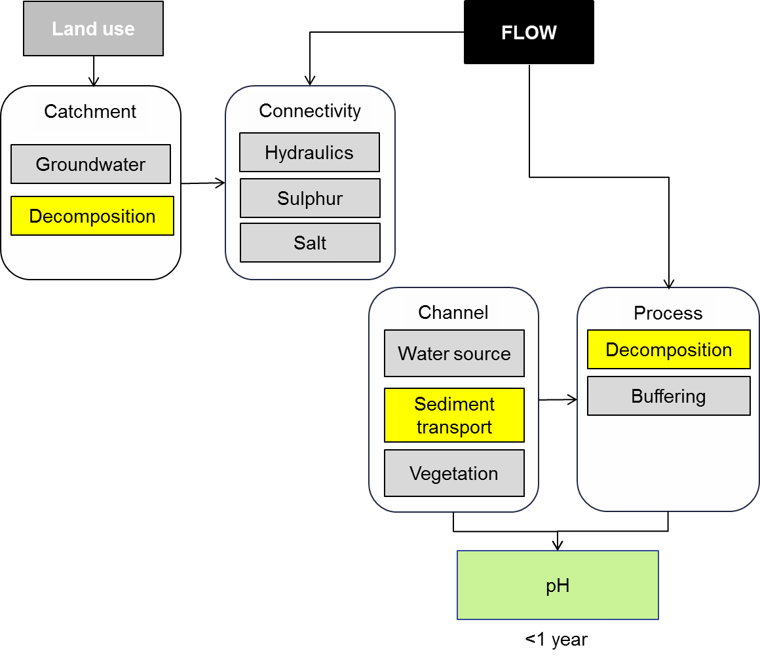

**Figure 36. Cause and effect diagram depicting flow and land use influences on pH.**

The pH of a water-body will affect aquatic biota either directly or indirectly. Direct effects arise from interactions of protons or hydroxide ions with animal and plant tissue. Most animals and plants can only tolerate a limited pH range. Acidification that results in pH falling below 5 will have adverse effects on algae, macrophytes and many invertebrates (Lacoul et al. 2011). Similarly, increases in pH (alkalization) above 9 are likely to adversely affect fish and invertebrates (Berezina 2001).

Indirect effects occur when changes in pH influence the bioavailability of toxicants such as metals and ammonia and in some instances, herbicide or pesticide residues. Reductions in pH may lead to heavy metals (such as cadmium and lead) and metalloids (such as arsenic) becoming more available in the environment (Appleyard et al. 2004; Burton et al. 2008; Corkhill et al. 2008; Simpson et al. 2010). These toxins may then be incorporated into animal or plant tissue and potentially into the food chain.

The effects of increases in pH are thought to be mainly through indirect effects. One of the key indirect effects is through its effects on ammonia that is acutely and/or chronically toxic to many aquatic organisms (Randall and Wright 1989; Hickey and Martin 1999; Mummert et al. 2003). Ammonia is present as both uncharged ammonia (NH3) and the ammonium ion (NH4+) in the environmental pH range, but high pH increases the proportion of ammonia that is present in the NH3 form which is more toxic to aquatic organisms (Dejours et al. 1989; Randall and Tsui 2006). High pH is also said to inhibit ammonia excretion (Wicks et al. 2002). Evidence of blood alkalosis and ammonia accumulation has been observed in fish exposed to alkaline conditions (Randall and Brauner 1991). The other indirect effect associated with an increase in pH arises from changes in the toxicity of agricultural chemicals (Edginton et al. 2003; Chen et al. 2004; Edginton et al. 2004).

Changes in pH may also have direct effects on people. The degradation of the environmental values of aquatic ecosystems due to major pH changes may limit their uses. The effects may include loss of amenity (preventing aquatic ecosystems being used for recreation), the generation of foul odours (including toxic hydrogen sulfide) and impaired drinking water quality (Hicks and Lamontagne 2006; Kinsela et al. 2007; Ljung et al. 2010).

**Land use:** A range of land use practices, including the application of nitrogen fertilisers (Rice and Herman 2012) and mining (Neculita et al. 2007; Liang and Thomson 2010; Rice and Herman 2012), can lead to either soil acidification or acid mine drainage water, both of which have the capacity to influence wetland or river pH.

Land use change and associated vegetation clearing has led to rising saline groundwater tables and associated mobilisation of salt in surface water flows. These processes have led to the salinisation of many inland aquatic ecosystems. As saline groundwater naturally discharges to inland aquatic ecosystems, it is often the main source of salt entering these systems. The sulfur it contains, which is derived from ancient seawater brought inland with rain (Dogramaci et al. 2001), provides the basis for acid-sulfate soils (Ward et al. 2002).

**Connectivity:** River regulation has altered the hydrology and hydrogeology of many inland ecosystems leading to the accumulation of both salt, with its associated sulfur, and organic matter in wetland sediments. When inundated, a specialised group of bacteria utilise the organic matter and sulfate to grow, but in the process produce sulfide and metal sulfide minerals, which, when exposed to air, are converted to sulfuric acid. This series of chemical reactions has severely degraded wetlands like Bottle Bend in NSW (McCarthy et al. 2006) and threatened many other wetlands in the Murray-Darling Basin (Hall et al. 2006). However, because many aquatic ecosystems have a high capacity to neutralise acid, not all of those containing sulfidic materials will acidify if the sediment is exposed to oxygen.

**River channel:** Sulfur rich salts and organic matter can also accumulate in river beds where they form monosulfidic black oozes (Bush et al. 2004; Cheetham et al. 2012). After an extended period of low flow, high flows can resuspend these oozes. This leads to rapid oxidation of the material that consumes oxygen and, in extreme cases, can remove all of the oxygen from the water column resulting in the death of aquatic organisms. This process has been observed in coastal wetlands (Ward et al. 2010) and also in the Edward-Wakool system (Cheetham et al. 2012).

Significant increases in pH can also be linked back to sulfate accumulation in wetlands. In regions dominated by carbonate geology, pH is regulated by the interaction between carbon dioxide and carbonate alkalinity (Baldwin et al. 2013). In cases where sulfate reduction takes place, the process of calcium carbonate precipitation that would otherwise buffer the pH does not occur and pH rises. Sulfate reduction occurs in these systems when specialised bacteria utilise sulfur in the same way animals use oxygen and when sulfur is reduced it increases alkalinity. This has recently been observed in south-eastern South Australia (Baldwin et al. 2013).

**Role of environmental flows:** In each of the situations outlined above, flow influences the change in pH, but may not be the primary driver. In the first situation where land use is the major driver of pH, careful management of hydrological connectivity may help ensure that contaminants do not move into rivers and wetlands.

For acid sulfate soils (ASS) in wetlands, one option is to use environmental flows to prevent the build-up of harmful levels of ASS. This requires either ensuring large stores of ASS are not allowed to accumulate in an aquatic ecosystem or that conditions do not favour sulfide formation. Flow management that maintains a freshwater lens between saline groundwater and the aquatic ecosystem, or promotes the export of salt and sulfur from the system may help. In terms of avoiding the formation of sulfide, restoration of more natural flow regimes with frequent periods of wetting and drying will both limit the accumulation of sulfidic materials and promote decomposition of organic matter thereby reducing the environmental hazard.

Management of monosulfidic black oozes in river channels could be based on similar principles of promoting the export of sulfur and promoting decomposition through increases in flow variability and restoration of fresh flows. One additional consideration is the allocation of environmental flows in systems where monosulfidic black oozes are known to have accumulated. In this situation it will be important to avoid disturbing the sediments until there is enough water to dilute the material and temperatures are low enough to limit microbial activity.

In situations where pH increases due to sulfate reduction, the same principles applied to management of ASS would apply.

**Knowledge gaps:** Generally the pH in the southern eastern Australia lies between 6 and 8.5. However, in the last few years extremes of pH have been observed. A large number of wetlands adjacent to the western reaches of the Murray River have been found to contain significant amounts of sulfidic sediments (acid sulfate soils). When exposed to air, the sulfide in the sediments is oxidised to sulfate, and in the processes produces acid. pH levels as low as 2 (which places it between battery acid and vinegar on the pH scale) have been measured at wetlands like Bottle Bend lagoon. These acidic waters have been observed flowing into the Murray River. On the other hand, extremely high pH levels (9 – 10.5) have been observed in wetlands in the south east of South Australia. While the cause of these high levels of pH as still uncertain, it has been suggested (paradoxically) that the processes underlying the formation of sulfidic sediments in the wetlands of the Murray River are also responsible for the high pH levels observed in south East South Australia. It is thought that the difference between the two extremes is caused by difference in the way water moves in these systems and different underlying geology. However, much still needs to be done to understand this paradox, and th identify if other areas of south eastern Australia is susceptible to extremes of pH.

**Use of the cause and effect diagram:** This is a generic diagram applicable across both the northern and southern parts of the Basin. Its application to particular circumstances or localities would require additional information and potentially modification of the model.

**References**

Appleyard S, Wong S, Willis-Jones B, Angeloni J, Watkins R (2004) Groundwater acidification caused by urban development in Perth, Western Australia: source, distribution, and implications for management. Australian Journal of Soil Research 42:579-585 doi: 10.1071/sr03074

Baldwin DS, L WK, Silvester EJ, Reid RJ, Brookes JD (2013) Investigating the cause of high pH in wetlands of the south-east of South Australia. The Murray-Darling Freshwater Research Centre

Department of Environmental Management & Ecology Latrobe University

Water Research Centre, School of Earth and Environmental Science, University of Adelaide.

Berezina NA (2001) Influence of ambient pH on freshwater invertebrates under experimental conditions. Russian Journal of Ecology 32:343-351 doi: 10.1023/a:1011978311733

Burton ED, Bush RT, Sullivan LA, Johnston SG, Hocking RK (2008) Mobility of arsenic and selected metals during re-flooding of iron- and organic-rich acid-sulfate soil. Chemical Geology 253:64-73 doi: 10.1016/j.chemgeo.2008.04.006

Bush RT, Fyfe D, Sullivan LA (2004) Occurrence and abundance of monosulfidic black ooze in coastal acid sulfate soil landscapes. Australian Journal of Soil Research 42:609-616 doi: 10.1071/sr03077

Cheetham MD, Wong VNL, Bush RT, Sullivan LA, Ward NJ, Zawadzki A (2012) Mobilisation, alteration, and redistribution of monosulfidic sediments in inland river systems. Journal of Environmental Management 112:330-339 doi: 10.1016/j.jenvman.2012.08.015

Chen CY, Hathaway KM, Folt CL (2004) Multiple stress effects of Vision (R) herbicide, pH, and food on zooplankton and larval amphibian species from forest wetlands. Environmental Toxicology and Chemistry 23:823-831 doi: 10.1897/03-108

Corkhill CL, Wincott PL, Lloyd JR, Vaughan DJ (2008) The oxidative dissolution of arsenopyrite (FeAsS) and enargite (Cu3AsS4) by Leptospirillum ferrooxidans. Geochimica Et Cosmochimica Acta 72:5616-5633 doi: 10.1016/j.gca.2008.09.008

Dejours P, Armand J, Beekenkamp H (1989) THE TOXICITY OF AMMONIA IS A FUNCTION OF WATER PH - A STUDY IN THE SALAMANDER PLEURODELES-WALTL. Comptes Rendus De L Academie Des Sciences Serie Iii-Sciences De La Vie-Life Sciences 308:55-60

Dogramaci SS, Herczeg AL, Schiff SL, Bone Y (2001) Controls on delta S-34 and delta O-18 of dissolved sulfate in aquifers of the Murray Basin, Australia and their use as indicators of flow processes. Applied Geochemistry 16:475-488 doi: 10.1016/s0883-2927(00)00052-4

Edginton AN, Sheridan PM, Stephenson GR, Thompson DG, Boermans HJ (2004) Comparative effects of pH and Vision (R) herbicide on two life stages of four anuran amphibian species. Environmental Toxicology and Chemistry 23:815-822 doi: 10.1897/03-115

Edginton AN, Stephenson GR, Sheridan PM, Thompson DG, Boermans HJ (2003) Effect of pH and release((R)) on two life stages of four anuran amphibians. Environmental Toxicology and Chemistry 22:2673-2678 doi: 10.1897/02-484

Hall K, Baldwin DS, Rees G, Richardson A (2006) Distribution of inland wetlands with sulfidic sediments in the Murray–Darling Basin, Australia. Science of the Total Environment 370:235-244

Hickey CW, Martin ML (1999) Chronic toxicity of ammonia to the freshwater bivalve Sphaerium novaezelandiae. Archives of Environmental Contamination and Toxicology 36:38-46

Hicks W, Lamontagne S (2006) A Guide to Sulfur Gas Emissions from Wetlands and Disposal Basins: Implications for Salinity Management In: CSIRO Land and water Scientific report, Canberra, ACT

Kinsela AS, Reynolds JK, Melville MD (2007) Agricultural acid sulfate soils: a potential source of volatile sulfur compounds? Environmental Chemistry 4:18-25 doi: 10.1071/en06071

Lacoul P, Freedman B, Clair T (2011) Effects of acidification on aquatic biota in Atlantic Canada. Environmental Reviews 19:429-460 doi: 10.1139/a11-016

Liang HC, Thomson BM (2010) Minerals and Mine Drainage. Water Environment Research 82:1485-1533 doi: 10.2175/106143010x12756668801491

Ljung K, Maley F, Cook A (2010) Canal estate development in an acid sulfate soil Implications for human metal exposure. Landscape and Urban Planning 97:123-131 doi: 10.1016/j.landurbplan.2010.05.003

McCarthy B, Conallin AJ, D'Santos P (2006) Acidification, salinisation and fish kills at an inland wetland in south-eastern Australia following partial drying. Ecological Management & Restoration 7:218-223

Mummert AK, Neves RJ, Newcomb TJ, Cherry DS (2003) Sensitivity of juvenile freshwater mussels (Lampsilis fasciola, Villosa iris) to total and un-ionized ammonia. Environmental Toxicology and Chemistry 22:2545-2553 doi: 10.1897/02-341

Neculita CM, Zagury GJ, Bussiere B (2007) Passive treatment of acid mine drainage in bioreactors using sulfate-reducing bacteria: Critical review and research needs. Journal of Environmental Quality 36:1-16 doi: 10.2134/jeq2006.0066

Randall D, Brauner C (1991) EFFECTS OF ENVIRONMENTAL-FACTORS ON EXERCISE IN FISH. Journal of Experimental Biology 160:113-126

Randall DJ, Tsui TKN (2006) Tribute to R.G. Boutilier: Acid-base transfer across fish gills. Journal of Experimental Biology 209:1179-1184 doi: 10.1242/jeb.02100

Randall DJ, Wright PA (1989) THE INTERACTION BETWEEN CARBON-DIOXIDE AND AMMONIA EXCRETION AND WATER PH IN FISH. Canadian Journal of Zoology-Revue Canadienne De Zoologie 67:2936-2942

Rice KC, Herman JS (2012) Acidification of Earth: An assessment across mechanisms and scales. Applied Geochemistry 27:1-14 doi: 10.1016/j.apgeochem.2011.09.001

Simpson SL, Fitzpatrick RW, Shand P, Angel BM, Spadaro DA, Mosley L (2010) Climate-driven mobilisation of acid and metals from acid sulfate soils. Marine and Freshwater Research 61:129-138 doi: 10.1071/mf09066

Ward NJ et al. (2010) Monosulfidic black ooze accumulations in sediments of the Geographe Bay area, Western Australia. Marine Pollution Bulletin 60:2130-2136 doi: 10.1016/j.marpolbul.2010.07.029

Ward NJ, Sullivan LA, Bush RT (2002) Sulfide oxidation and acidification of acid sulfate soil materials treated with CaCO3 and seawater-neutralised bauxite refinery residue. Australian Journal of Soil Research 40:1057-1067 doi: 10.1071/sr01119

Wicks B, Joensen R, Tang Q, Randall D (2002) Swimming and ammonia toxicity in salmonids: the effect of sub lethal ammonia exposure on the swimming performance of coho salmon and the acute toxicity of ammonia in swimming and resting rainbow trout. Aquatic Toxicology 59:55-69

# 26 Dissolved organic carbon

Dissolved organic carbon (DOC) describes a broad and diverse suite of compounds derived from both primary production and decomposition (Meyer and Edwards 1990). DOC is important in freshwater ecosystems because it represents a significant component of the organic matter within the system (Gawne et al. 2007) and this organic matter fuels metabolism and growth of microorganisms (Meyer and Edwards 1990).

Under most flow conditions, concentrations of DOC average between 5 – 10 mg L-1; however, under some circumstances, DOC concentrations can increase dramatically with significant effects on the microbial community and through their increased metabolic activity, dissolved oxygen. These events are known as hypoxic blackwater events and they have been observed in rivers around the world including Brazil (Hamilton et al. 1997), USA (Fontenot et al. 2001; Valett et al. 2005) and Australia (McKinnon and Shepheard 1995; Baldwin et al. 2001; Hladyz et al. 2011).

The following section describes how DOC is affected by river flow and land use through its influence on catchment, connectivity, channel and process (Figure 37). Primary production and decomposition are another major land use influence and are contained in separate cause and effect diagrams.

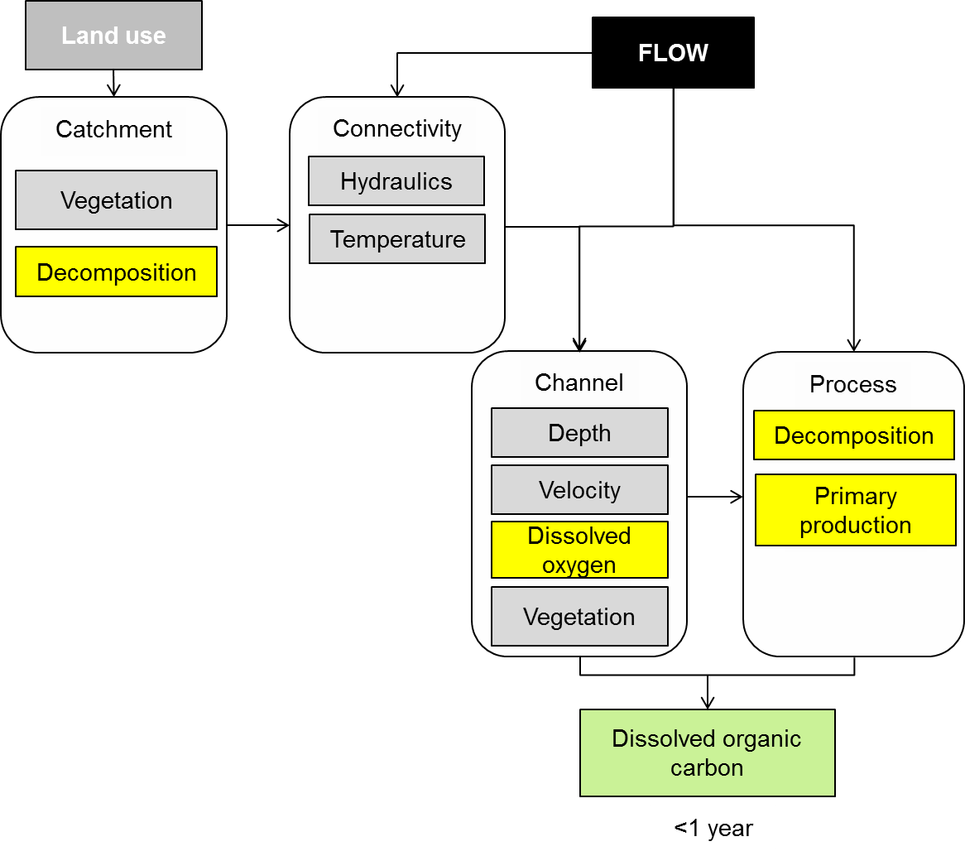

Figure 37. Cause and effect diagram depicting the influence of flow on dissolved organic carbon.

**Process and Channel:** Hypoxic blackwater events occur when warm water inundates floodplains or wetlands where there is a large amount of organic matter (Kerr et al. 2012). While they are known to occur naturally, river regulation has exacerbated the severity of events and the frequency of these severe events (Whitworth et al. 2012). River regulation has reduced the frequency of flooding, increasing the period of time that organic material can accumulate.

The dissolved organic carbon fuelling hypoxic blackwater events is mostly derived from plant detritus (Hladyz et al. 2011) with one of the major sources being leaf litter (O'Connell et al. 2000). The majority of the organic matter is rapidly released into the water column (O'Connell et al. 2000) where it is transformed by microbial, chemical and photochemical processes (Meyer and Edwards 1990; Moran and Zepp 1997; Bano et al. 1998; Robertson et al. 1999; Howitt et al. 2004).

**Connectivity:** Increased temperatures stimulate the rate of microbial consumption of organic matter (Howitt et al. 2004) and this, in turn, increases the rate of oxygen consumption by the bacteria at times when the warmer temperatures also reduce the amount of oxygen dissolved in the water. Dissolved oxygen may exceed the rate of diffusion from the atmosphere (Koetsier et al. 1997; O'Connell et al. 2000).

**Knowledge gaps:** There continues to be some uncertainty about both the source of dissolved organic matter that drives hypoxic blackwater events and its bioavailability. There are also significant knowledge gaps on the potential for environmental flows to manage DOC to reduce the risks associated with hypoxic blackwater events.

**Use of the cause and effect diagram:** This is a generic diagram applicable across both the northern and southern parts of the Basin. Its application to particular circumstances or localities would require additional information and potentially modification of the model.

**References**

Baldwin D, Howitt J, Edwards M (2001) Blackwater event. Austasia Aquaculture 15:21

Bano N, Moran MA, Hodson RE (1998) Photochemical formation of labile organic matter from two components of dissolved organic carbon in a freshwater wetland. Aquatic Microbial Ecology 16:95-102

Fontenot Q, Rutherford D, Kelso W (2001) Effects of environmental hypoxia associated with the annual flood pulse on the distribution of larval sunfish and shad in the Atchafalaya River Basin, Louisiana. Transactions of the American Fisheries Society 130:107-116

Gawne B et al. (2007) Patterns of primary and heterotrophic productivity in an arid lowland river. River Research and Applications 23:1070-1087

Hamilton SK, Sippel SJ, Calheiros DF, Melack JM (1997) An anoxic event and other biogeochemical effects of the Pantanal wetland on the Paraguay River. Limnology and Oceanography 42:257-272

Hladyz S, Watkins SC, Whitworth KL, Baldwin DS (2011) Flows and hypoxic blackwater events in managed ephemeral river channels. Journal of Hydrology 401:117-125 doi: 10.1016/j.jhydrol.2011.02.014

Howitt JA, Baldwin DS, Rees GN, Hart BT (2004) Facilitated heterogeneous photodegradation of dissolved organic matter by particulate iron. Environmental Chemistry 1:197-205

Kerr JL, Baldwin DS, Whitworth KL (2012) Options for managing hypoxic blackwater events in river systems: A review. Journal of Environmental Management

Koetsier IP, McArthur JV, Leff LG (1997) Spatial and temporal response of stream bacteria to sources of dissolved organic carbon in a blackwater stream

system. Freshwater Biology 37:79-89

McKinnon L, Shepheard N (1995) Factors contributing to a fish kill in Broken Creek. The Victorian Naturalist 112:93-99

Meyer JL, Edwards RT (1990) Ecosystem metabolism and turnover of organic carbon along a blackwater river continuum. Ecology:668-677

Moran MA, Zepp RG (1997) Role of photoreactions in the formation of biologically labile compounds from dissolved organic matter. Limnology and Oceanography 42:1307-1316

O'Connell M, Baldwin DS, Robertson AI, Rees G (2000) Release and bioavailability of dissolved organic matter from floodplain litter: influence of origin and oxygen levels. Freshwater Biology 45:333-342

Robertson A, Bunn S, Walker K, Boon P (1999) Sources, sinks and transformations of organic carbon in Australian floodplain rivers. Marine and Freshwater Research 50:813-829

Valett H et al. (2005) Biogeochemical and metabolic responses to the flood pulse in a semiarid floodplain. Ecology 86:220-234

Whitworth KL, Baldwin DS, Kerr JL (2012) Drought, floods and water quality: drivers of a severe hypoxic blackwater event in a major river system (the southern Murray-Darling Basin, Australia). Journal of Hydrology

# 27 Algal blooms

Algal blooms, in particular blue-green algal blooms, are a global phenomenon that are of concern from both a human and environmental perspective. Several species of blue-green algae including *Microcystis aeruginosa, Anabaena circinalis* and *Cylindrospermopsis raciborskii* produce toxins that have significant health effects on people and livestock (Baker and Humpage 1994; Fitzgerald et al. 1999; Steffensen et al. 1999). From an environmental perspective there is less evidence of detrimental effects from toxins, but very severe blooms of any algal type can affect dissolved oxygen levels with adverse outcomes for fish and invertebrates.

Algal blooms are relevant to environmental flow management for two reasons. First, environmental flows can be used to disperse or disrupt algal blooms (Webster et al. 2000). Second, in some situations, floodplain inundation may increase the likelihood of an algal bloom (Bormans et al. 2004; Power et al. 2008).

Algal blooms came to prominence in Australia in 1991 when a 1000km long bloom affected the Darling River (Davis and Koop 2006). The bloom focussed national attention on bloom management and for the next five years there was considerable effort expended in understanding the causes and developing appropriate management responses. The following section describes how algal blooms are affected by river flow through its influences on the channel, connectivity and habitat (Figure 38).

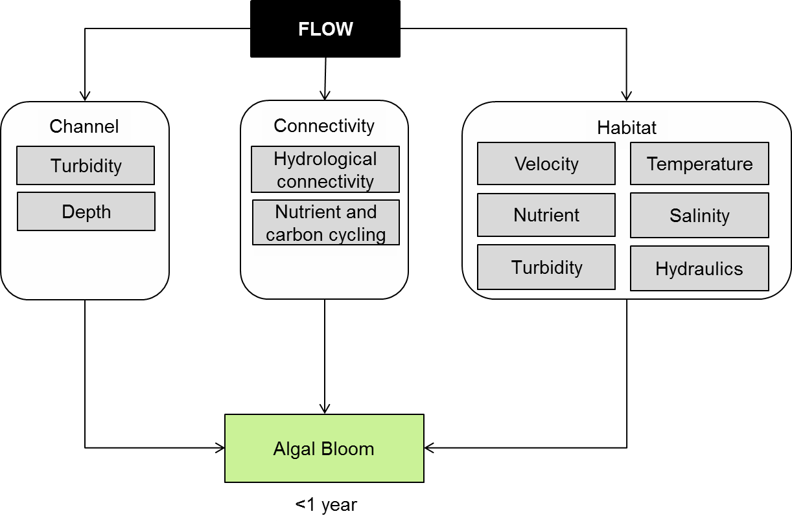

**Figure 38. Cause and effect diagram depicting flow influence on algal blooms.**

**Channel:** Algae are like all plants and require sunlight to grow. Within a channel or wetland environment, two of the major influences on the amount of light are water depth (Webster et al. 2000; Guven and Howard 2011) and water clarity (turbidity) (Geddes 1988; Hotzel and Croome 1994; Bormans et al. 2004).

Water depth may have two influences; the first is that blue-green algae species such as *Anabaena* produce resting stages (akinetes) that persist in sediments. The germination of akinetes may be more likely in shallow water due to either re-suspension or light penetrating to the sediments (Baker 1999). Depth may also influence rates of growth as depth may influence stratification and also the amount of time that algal cells spend in the high light environment at the surface (Thompson et al. 2002; O'brien et al. 2009).

**Connectivity:** Hydrological connectivity is an important influence on blue-green algae with floods being a period of high flow and high turbidity that will suppress algal blooms (Bormans et al. 2004) although blooms of other algae are possible (Cook and Holland 2012). In contrast, periods of low flow and connectivity promote stratification (Bormans and Condie 1998; Davis and Koop 2006). Dams also influence blue-green algal blooms by creating ideal conditions for blooms that may then be transported downstream (Baldwin et al. 2010).

Nutrient cycling is also an important driver of blue-green algal blooms. Nutrients within a river reach are imported from upstream or from floodplains, often associated with sediment particles (Harris 2001). Under low flow conditions, thermal stratification occurs and deoxygenation of sediments may follow and this triggers the release of nutrients from sediments (Jones and Poplawski 1998; Baldwin and Williams 2007). The release of nutrients then influences the magnitude of the bloom (Bormans et al. 2004; Davis and Koop 2006).

**Habitat:** Algal blooms occur when a number of specific habitat conditions coincide. Flow has emerged as one of the major influences on bloom formation (Maier et al. 2001; Mitrovic et al. 2003; Guven and Howard 2011). Flow is important for its influence on hydraulic conditions. Higher flows are associated with turbulence that keeps the water column mixed and moves algal cells into and out of the surface zone of high light. Flow also influences the residence time that algae spend within a reach. The longer the residence time, the greater opportunity the algae have to grow (Harris 2001; Reid and Hamilton 2007). Perhaps the most important influence of flow is that low flows increase the likelihood of stratification. Stratification enables blue-green algae to remain in the warm sun-lit surface waters (Bormans and Condie 1998; Webster et al. 2000; Maier et al. 2001). Once the water-body has stratified, blue-green algae are able to remain within the surface layer or in some cases regulate their buoyancy to exploit light and nutrients(Bormans et al. 1999; Brookes et al. 2000; Mitrovic et al. 2001; Guven and Howard 2011).

One of the key habitat characteristics is light (Sherman et al. 1998). Like all plants, algae require light to grow and blooms require abundant light in order to form (Guven and Howard 2006). For this reason, turbidity influences bloom formation by reducing the amount of available light (Geddes 1988). Temperature is also an important influence on algal growth rates (Robards and Zohary 1987; Costelloe et al. 2005), although blooms of microcystis have been recorded at temperatures as low as 13oC (Hotzel and Croome 1994; Mitrovic et al. 2001).

Overseas experience with algal blooms have identified nutrients as a major influence on the likelihood of bloom formation (Bulgakov and Levich 1999). In the Australian context, nutrient concentrations appear less important, although they may influence the magnitude of the bloom (Davis and Koop 2006).

Most blue-green algae appear to be able to tolerate quite high salinities, although there appears to be some variation among species (Orr et al. 2004; Tonk et al. 2007). Salinity does appear to influence both toxin production (Hobson et al. 1999) and the production of algal resting stages (akinetes) (Baker and Bellifemine 2000). Finally, salinity levels also influence turbidity such that increasing salinity levels reduces turbidity and this may improve the light environment for blue-green algae (Donnelly et al. 1997; Grace et al. 1997).

**Knowledge Gaps:** The dynamics of algal blooms are reasonably well understood in a generic sense, although the formation of blooms in specific areas may require investigation to identify local thresholds of flow. In 2010, there was a cyanobacterial bloom along most of the Murray River that was initiated in the Hume Dam (Baldwin et al. 2010).The factors that enabled the bloom to persist along the river remain poorly understood and may warrant further investigation.

**Use of the cause and effect diagram**: This is a generic diagram applicable across both the northern and southern parts of the Basin. Its application to particular circumstances or localities would require additional information and potentially modification of the model.

**References**

Baker P, Bellifemine D (2000) Environmental influences on akinte germination of *Anabaena circinalis* and implications for management of cyanobacetrial blooms. Hydrobiologia 427:65-73

Baker P, Humpage A (1994) Toxicity associated with commonly occurring cyanobacteria in surface waters of the Murray-darling Basin, Australia. Australian Journal of Marine and Freshwater Research 45:773-786

Baldwin DS, Williams J (2007) Differential release of nitrogen and phosphorus from anoxic sediments. Chemistry and Ecology 23:243-249

Baldwin DS, Wilson J, Gigney H, Boulding A (2010) INFLUENCE OF EXTREME DRAWDOWN ON WATER QUALITY DOWNSTREAM OF A LARGE WATER STORAGE RESERVOIR. River Research and Applications 26:194-206 doi: 10.1002/rra.1255

Bormans M, Condie SA (1998) Modelling the distribution of *Anabaena* and *Melosira* in a stratified river weir pool. Hydrobiologia 364:3-13

Bormans M, Ford P, Fabbro L, Hancock M (2004) Onset and persistence of cyanobacterial blooms in a large impounded tropical river, Australia. Marine and Freshwater Research 55:1-16

Bormans M, Sherman BS, Webster IT (1999) Is buoyancy regulation in cyanobacteria an adaptation to exploit separation of light and nutrients. Marine and Freshwater Research 50:897-906

Brookes J, Ganf G, Oliver R (2000) Heterogeneity of cyanobacterial gas-vesicle volume and metabolic activity. Journal of Plankton Research 22:1579-1589

Bulgakov NG, Levich AP (1999) The nitrogen:phosphorus ratio as a factor regulating phytoplankton community structure. Archiv fur Hydrobiologie 146:3-22

Cook PLM, Holland DP (2012) Long term nutrient loads and chlorophyll dynamics in a large temperate Australian lagoon system affected by recurring blooms of cyanobacteria. Biogeochemistry 107:261-274 doi: 10.1007/s10533-010-9551-1

Costelloe JF, Powling J, Reid JRW, Shiel RJ, Hudson P (2005) Algal diversity and assemblages in arid zone rivers of the Lake Eyrie Basin, Australia. River Research and Applications 21:337-349

Davis JR, Koop K (2006) Eutrophication in Australian rivers, reservoirs and estuaries - a southern hemisphere perspective on the science and its implications. Hydrobiologia 559:23-76 doi: 10.1007/s10750-005-4429-2

Donnelly TH, Grace MR, Hart BT (1997) Algal blooms in the Darling-Barwon River, Australia. Water Air and Soil Pollution 99:487-496 doi: 10.1023/a:1018351709174

Fitzgerald D, Cunliffe D, Burch M (1999) Development of health alerts for cyanobacteria and related toxins in drinking water in South Australia. Environmental Toxicology 14:203-209

Geddes MC (1988) The role of turbidity in the limnology of Lake Alexandrina, River Murray, South Australia; comparisons between clear and turbid phases. Australian Journal of Marine and Freshwater Research 39:201-209

Grace MR, Hislop TM, Hart BT, Beckett R (1997) Effect of saline groundwater on the aggregation and settling of suspended particles in a turbid Australian river. Colloids and Surfaces a-Physicochemical and Engineering Aspects 120:123-141 doi: 10.1016/s0927-7757(96)03863-0

Guven B, Howard A (2006) Modelling the growth and movement of cyanobacteria in river systems. Science of the Total Environment 368:898-908 doi: 10.1016/j.scitotenv.2006.03.035

Guven B, Howard A (2011) Sensitivity Analysis of a Cyanobacterial Growth and Movement Model under Two Different Flow Regimes. Environmental Modeling & Assessment 16:577-589 doi: 10.1007/s10666-011-9266-2

Harris G (2001) Biogeochemistry of nitrogen and phosphorus in Australian catchments, rivers and estuaries: Effects of land use and flow regulation and comaprisons with global patterns. Marine & Freshwater Research 52:139-149

Hobson P, BUrch M, Fallowfield H (1999) Effect of total dissolved solids and irradiance on growth and toxin production by *Nodularia spumigena*. Journal of Applied Phycology 11:551-558

Hotzel G, Croome R (1994) Long-term phytoplankton monitoring of the Darling River at Burtundy, New South Wales: Incidence and significance of cyanobacterial blooms. Australian Journal of Marine and Freshwater Research 45:747-759

Jones G, Poplawski W (1998) Understanding and management of cyanobacterial blooms in sub-tropical reservoirs of Queensland, Australia. Water Science and Technology 37:161-168

Maier H, Burch M, Bormans M (2001) Flow management strategies to control blooms of the cyanobacterium, Anabaena circinalis, in the River Murray at Morgan, South Australia. REGULATED RIVERS-RESEARCH & MANAGEMENT 17:637-650

Mitrovic S, Bowling L, Buckney R (2001) Responses of phytoplankton to *in-situ* nutrient enrichment; Potential influences on species dominance in a river. International Review of Hydrobiology 86:285-298

Mitrovic S, Oliver R, Rees C, Bowling L, Buckney R (2003) Critical flow velocities for the growth and dominance of *Anabaena circinalis* in some turbid freshwater rivers. Freshwater Biology 48:164-174

O'brien k, Burford M, Brookes J (2009) Effects of light history on primary productivity in a phytoplankton community dominated by the toxic cyanobacterium <i>Cylindrospermopsis raciborskii</i>. Freshwater Biology 54:272-282

Orr PT, Jones GJ, Douglas GB (2004) Response of cultured Microcystis aeruginosa from the Swan River, Australia, to elevated salt concentration and consequences for bloom and toxin management in estuaries. Marine and Freshwater Research 55:277-283 doi: 10.1071/mf03164

Power ME, Parker MS, Dietrich WE (2008) Seasonal reassembly of a river food web: Floods, droughts, and impacts of fish. Ecological Monographs 78:263-282 doi: 10.1890/06-0902.1

Reid NJ, Hamilton SK (2007) Controls on algal abundance in a eutrophic river with varying degrees of impoundment (Kalamazoo River, Michigan, USA). Lake and Reservoir Management 23:219-230

Robards R, Zohary T (1987) Temperature effects on photosynthetic capacity, respirat9ion, and growth rates of bloom-forming cyanobacteria. New Zealand Journal of Marine and Freshwater Research 21:391-399

Sherman BS, Webster IT, Jones GJ, Oliver RL (1998) Transitions between *Aulacoseira* and *Anabaena* dominance in a turbid river weir pool. Limnology and Oceanography 43:1902-1915

Steffensen D, Burch M, Nicholson B, Drikas M, Baker P (1999) Management of toxic blue-green algae (cyanobacteria) in Australia. Environmental Toxicology 14:183-195

Thompson P, Waite A, McMahon K (2002) Dynamics of a cyanobacterial bloom in a hypereutrophic, stratified weir pool. Marine and Freshwater Research 54:27-38

Tonk L, Bosch K, Visser PM, Huisman J (2007) Salt tolerance of the harmful cyanobacterium Microcystis aeruginosa. Aquatic Microbial Ecology 46:117-123 doi: 10.3354/ame046117

Webster I, Sherman B, Bormans M, Jones G (2000) Management strategies for cyanobacterial blooms in an impounded lowland river. Regulated Rivers: Research and Management 16:513-525

# References

Gross J E (2003) Developing Conceptual Models for Monitoring Programs. National Park Service US Department of the Interior. Available from URL: <http://science.nature.nps.gov/im/monitor/docs/Conceptual_Modelling.pdf>.

King A, Brooks J, Quinn G, Sharpe A and McKay S (2003) Monitoring Programs for Environmental Flows in Australia **—** A Literature Review.Department of Sustainability and Environment, Sinclair Knight Merz and the CRC Freshwater Ecology.