# Attachment 2: Instructions for registration of businesses under Article 9 of GACC Decree 248 to fill

**online single window application form**

**Step 1:** The website to the form can be found through the following [link](https://app.singlewindow.cn/userserver/user/userEtpsRegister/choseRgtWay?service=https%3A%2F%2Fswapp.singlewindow.cn%2Fdeskserver%2Fj_spring_cas_security_check) -<https://app.singlewindow.cn/userserver/user/userEtpsRegister/choseRgtWay?service=https%3A%2F%2Fswapp.singlewindow.cn%2Fdeskserver%2Fj_spring_cas_security_check> . This link will take you to the below page. Click on the blue globe for overseas establishment registration as shown by the red arrow.

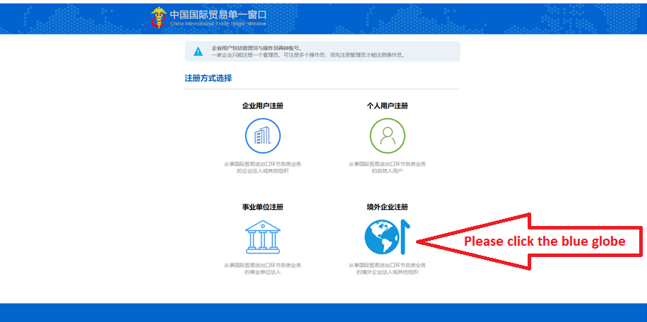

**Step 2:**After clicking on the blue globe, a [new page](https://app.singlewindow.cn/userserver/user/abroad/index) will appear (refer below). This is the online application form.

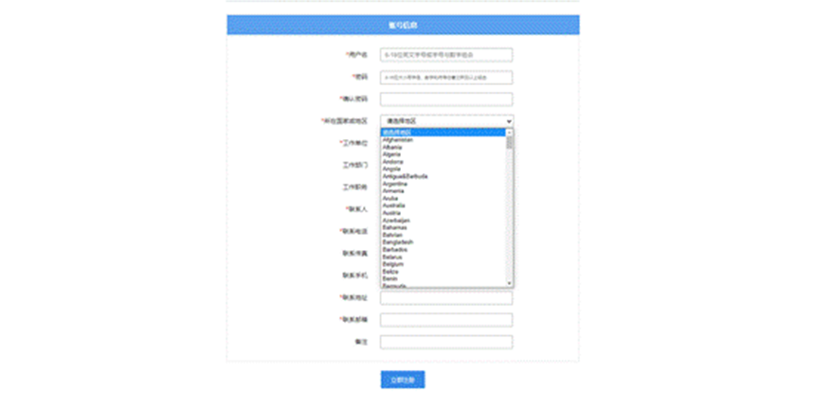

**Step 3:** Fill in the form (below is the unofficial translation of the form)

**境外账号注册Overseas account registration**

**账号信息Account information**

**\***用户名Username(6-18 digits of English letters, or letters combined with numbers）[Control]

**\***密码Password(6 to16 digits of lower-or higher-case letters with numbers and symbols)[Control]

**\***确认密码Password confirmation [Control]

**\***所在国家或地区Located country or region[Control]

**\***工作单位Work organisation[Control]

工作部门Work division in the organisation [Control]

工作职务Work position[Control]

**\***联系人Contact person [Control]

**\***联系电话Contact phone[Control]

联系传真Contact fax[Control]

联系手机Contact mobile phone[Control]

**\***联系地址Contact address[Control]

**\***联系邮箱Contact email [Control]

备注Remark [Control]

立即注册Submit the form immediately

Page Break

**Step 4:** Once registered successfully you will be automatically directed to the below [logon platform](https://app.singlewindow.cn/cas/login?service=https%3A%2F%2Fapp.singlewindow.cn%2Fuserserver%2Fj_spring_cas_security_check) (<https://app.singlewindow.cn/cas/login?service=https%3A%2F%2Fapp.singlewindow.cn%2Fuserserver%2Fj_spring_cas_security_check>)

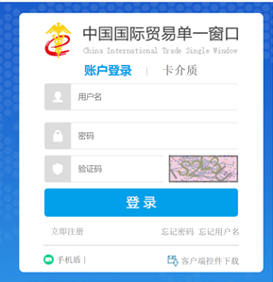

**Step 5:** Fill out login platform details. Below in an unofficial translation of [the logon platform](https://app.singlewindow.cn/cas/login?service=https%3A%2F%2Fapp.singlewindow.cn%2Fuserserver%2Fj_spring_cas_security_check)

|  |  |  |
| --- | --- | --- |
| **中国国际贸易单一窗口 China International Trade Single Window** | | |
| 用户名 Username | | |
| 密码 Password | | |
| 验证码 Verification code (If the code on the right side cannot be seen clearly, please click it to change for a new code) | |  |
| 登录Logon | | |
| 立即注册Register immediately | 忘记密码Forgot password? | 忘记用户名Forgot username? |
| 手机盾 Mobile phone shield | | 客户端控件加载 Client control APP download |

Once login is completed, there are no more steps for users and you are successfully registered. GACC may use the logon platform to request users to provide extra information or provide further guidance on next steps at a later date.