Attachment 1 - countries and products affected by occurrence of high pathogenicity avian influenza
Market | Product | Certificate Template | Endorsement Number | Current Status
Argentina | Processed pet food | M584 | N/A | Certification available for all Australian product that has been produced on or after 13 June 2025.
Bangladesh | Poultry meat, meat products and edible offal | EX174 | N/A | Affects certification for all Australian product.
Brunei | Turkey meat | EX174 | 143 | Certification available for all Australian product that has been produced on or after 13 June 2025.
Canada | Ostrich and emu meat and offal | MECEX | 4970 | Affects certification for all Australian product
 | Rendered poultry meals (no restrictions on end use, shipped directly to Canada | M450 | 4819 | Certification available for ingredients derived from poultry and avian animals sourced outside the Control Area.
 | Rendered poultry meals (no restrictions on end use, transhipped through the USA) | M450 | 4820 | Certification available for ingredients derived from poultry and avian animals sourced outside the Control Area.
 | Rendered poultry meals (restricted end use, shipped directly to Canada) | M450 | 5105 | Certification available for ingredients derived from poultry and avian animals sourced outside the Control Area.
 | Rendered poultry meals (restricted end use, transhipped through the USA) | M450 | 5106 | Certification available for ingredients derived from poultry and avian animals sourced outside the Control Area.
China | Processed animal protein of poultry origin used as feed material | M482 | N/A | Affects certification for all Australian product.
Egypt | Raw pet meat and processed pet food | E242A | 3703 | Affects certification for all Australian product
EU | Animal by-products to be used for trade samples or purposes outside the food chain | M448 | N/A | Affects certification for all Australian product containing poultry.
 | Inedible rendered fats and oils (for use in the feed chain) | M250 | N/A | Affects certification for all Australian product containing poultry.
 | Ratite meat | Z946 | N/A | Affects certification for all Australian product.
 | Raw materials for the manufacture of petfood | M094  M277  M276  M283 | N/A | Affects certification for all Australian product containing poultry.
 | Retail-ready pet meat | Z734 | N/A | Affects certification for all Australian product containing poultry.
 | Untreated blood products, excluding blood from horses, mules and donkeys for the manufacture of technical products | Z733  Z733A | N/A | Affects certification for all Australian product containing poultry.
French Polynesia | Dry processed pet food containing rendered co-products of terrestrial and aquatic origin | E242  E242A |  | Certification available for product sourced outside of Victoria.
 | Dry processed pet food containing rendered co-products of terrestrial origin | E242  E242A |  | Certification available for product sourced outside of Victoria.
 | Feed containing terrestrial animal ingredients intended for feeding all animals (excluding ruminants) for human consumption | EX214C | N/A | Certification available.
 | Ostrich and emu meat and offal | Z91 | N/A | Certification available for product sourced outside of Victoria.
 | Poultry meat and meat products | Z91 | N/A | Certification available for product sourced outside of Victoria.
Great Britain | Animal by-products to be used for trade samples or purposes outside the food chain | IGBE | N/A | Affects certification for all Australian product containing poultry.
 | Inedible rendered fats and oils (for use in the feed chain) | IGBJ | N/A | Affects certification for all Australian product containing poultry.
 | Raw materials for the manufacture of petfood | IGBB | N/A | Affects certification for all Australian product containing poultry.
 | Untreated blood products, excluding blood from horses, mules and donkeys for the manufacture of technical products | IGBC | N/A | Affects certification for all Australian product containing poultry.
Hong Kong | Combined beef and poultry meat products | Z933 | 3678 | Certification available for product sourced outside of Hong Kong’s specified AI suspension areas (see Table 1 of MAA2507).
 | Table eggs | EX46EG | 3945 | Certification available for product sourced outside of Hong Kong’s specified AI suspension areas (see Table 1 of MAA2507).
 | Ostrich and emu carcasses and emu offal with departmental inspector supervision of ante and post-mortem inspection | Z87A | 2172 | Certification available for product sourced outside of Hong Kong’s specified AI suspension areas (see Table 1 of MAA2507).
 | Ostrich and emu meat products with departmental inspector supervision of ante and post-mortem inspection | Z87C | 2172 | Certification available for product sourced outside of Hong Kong’s specified AI suspension areas (see Table 1 of MAA2507).
 | Ostrich and emu meat with departmental inspector supervision of ante and postmortem inspection | Z87B | 2172 | Certification available for product sourced outside of Hong Kong’s specified AI suspension areas (see Table 1 of MAA2507).
 | Poultry carcases and offal with departmental inspector supervision of ante and post-mortem inspection | EX195A | 2172 | Certification available for product sourced outside of Hong Kong’s specified AI suspension areas (see Table 1 of MAA2507).
 | Poultry meat products with departmental inspector supervision of ante-mortem and post-mortem inspection | EX195C | 2172 | Certification available for product sourced outside of Hong Kong’s specified AI suspension areas (see Table 1 of MAA2507).
 | Poultry meat with departmental inspector supervision of ante-mortem and post-mortem inspection | EX195B | 2172 | Certification available for product sourced outside of Hong Kong’s specified AI suspension areas (see Table 1 of MAA2507).
 | Poultry meat. Meat products and edible offal without department inspector supervision of ante and postmortem inspection | EX174 | 2172 | Certification available for product sourced outside of Hong Kong’s specified AI suspension areas (see Table 1 of MAA2507).
Israel | Co-products for the manufacture of non-pharmaceutical items | E242  E242A | 3837 | For product containing poultry, certification is available for products processed in establishments 30km outside the control areas shown at attachment 2 until 13 September 2025, after which certification will be available for all Australian product produced on or after 13 September 2025. Product must meet conditions on a valid import permit.
 | Dry-salted skins and hides | M079 | N/A | Certification available for all Australian product that has been produced on or after 13 June 2025.
 | Fresh frozen hides and skins | M079A | N/A | Certification available for all Australian product that has been produced on or after 13 June 2025.
 | Technical and pharmaceutical products | M238  M238A | 3719 | For product containing poultry, certification is available for products processed in establishments 30km outside the control areas shown at attachment 2 until 13 September 2025, after which certification will be available for all Australian product produced on or after 13 September 2025. Product must meet conditions on a valid import permit.
Japan | Blood and blood products of avian origin | Z934 | 4863 | Certification available for products sourced outside Victoria, NSW and the ACT.
 | Canned poultry meat products | Z144K | E002, A160 | Affects certification for all Australian product.
 | Chilled or frozen raw or partially processed pet meat (including jerky) containing poultry ingredient | M100 | N/A | Affects certification for all Australian product.
 | Combined product (excluding canned) containing beef and poultry meat, meat products and offal | Z144P | SANCRT - E001, E002, E003, A150, A160, B306 | Affects certification for all Australian product.
 | Processed eggs | EX46EG | 5210 | Affects certification for all Australian product.
 | Heat treated pet food that contains poultry | M100 | N/A | Affects certification for all Australian product.
 | Mixed poultry and porcine origin rendered meals and digests intended for use in the production of pet food | M100 | 5026 | Affects certification for all Australian product containing poultry.
 | Ostrich or emu meat, meat products and offal | Z144I | SANCRT - E002, A150, A160, B306 | Affects certification for all Australian product.
 | Ostrich or emu skins | E153 | 2931 | Affects certification for all Australian product.
 | Poultry meat, meat products and offal | Z144J | SANCRT - X001, X002, E002, A160 | Affects certification for all Australian product.
 | Poultry origin rendered meals and digests intended for use in the production of pet food | M100 | 5025 | Affects certification for all Australian product.
Kiribati | Table eggs | EX46EG | 6477 | Certification available for all Australian product that has been produced on or after 13 June 2025.
 | Poultry carcases and offal with departmental inspector supervision of ante and postmortem inspection | EX195A | 3018 | Certification available for all Australian product that has been produced on or after 13 June 2025.
 | Poultry meat products with departmental inspector supervision of ante and postmortem inspection | EX195C | 3018 | Certification available for all Australian product that has been produced on or after 13 June 2025.
 | Poultry meat with departmental inspector supervision of ante and postmortem inspection | EX195B | 3018 | Certification available for all Australian product that has been produced on or after 13 June 2025.
 | Poultry meat, meat products and offal without departmental inspector supervision of ante and postmortem inspection | EX174 | 3018 | Certification available for all Australian product that has been produced on or after 13 June 2025.
Macau | Poultry meat, meat products  and offal | EX174 | 498 | Certification available for all Australian product that has been produced on or after 13 June 2025.
Malaysia | Ostrich and emu meat | Z87A | 271 | Affects certification for all Australian product.
 | Ostrich and emu meat products | Z87C | 271 | Affects certification for all Australian product.
 | Ostrich and emu meat, meat products, carcases and offal | Z87A | 271 | Affects certification for all Australian product.
 | Poultry meat, meat products and edible offal | Z83 | 3216 | Affects certification for all Australian product.
 | Processed pet food | E242  E242A | 7465 | Certification available for poultry products manufactured from outside the Control Areas.
Marshall Islands | Poultry meat, meat products and edible offal | EX174 | N/A | Affects certification for all Australian product.
Mauritius | Poultry meat, poultry meat products, and edible offal, ostrich and emu meat and ostrich and emu meat products | Z911 | 3670 | Affects certification for all Australian product.
Mexico | Rendered edible animal fats and oils including tallow | M594 | 5631 | Affects certification for all Australian product containing poultry.
 | Salted skins and hides of ratites | M477 | 5228 | Affects certification for all Australian product.
Myanmar | Poultry meat and meat products | EX174 | 498 | Affects certification for all Australian product.
Namibia | Ostrich skins and hides | E153  Z450 | 2907 | Certification available for all Australian product that has been produced on or after 13 June 2025.
 | Poultry meat, meat products and offal | Z369 | N/A | Certification available for product sourced from 15km outside of the control areas shown in Attachment 2 until 13 December 2025, after which certification will be available for all Australian product produced on or after 13 December 2025.
Nauru | Poultry meat, meat products and offal | EX174 |  | Certification available for products sourced outside Control Areas.
 | Table and processed eggs | EX46EG | 5326, 5327 | Certification available for eggs sourced outside Control Areas.
New Caledonia | Canned and dried processed petfood | EX214 | N/A | Certification available for products sourced outside Control Areas.
 | Table and processed eggs | Z930 | N/A | Certification available for eggs sourced from outside Victoria (please refer to MAA2518 for eligible laying dates).
 | Ostrich and emu meat, meat products and offal | Z930 | N/A | Certification available for product sourced from outside Victoria (please refer to MAA2518 for eligible slaughter dates).
 | Poultry and poultry products | EX203 | N/A | Certification available for product sourced from outside Victoria (please refer to MAA2518 for eligible slaughter dates).
 | Poultry meal | EX214  EX214B | N/A | Certification available.
 | Poultry meat and poultry meat products | Z930 | N/A | Certification available for product sourced from outside Victoria (please refer to MAA2518 for eligible slaughter dates). Certification available for cooked products if treatment requirements are met.
 | Rendered products for use in animal food | EX214 | N/A | Certification available.
New Zealand | Processed eggs | N/A - Veterinary declaration | N/A | Certification available for all Australian product that has been produced on or after 13 June 2025.
Palau | Poultry meat, meat products and offal | EX174 | 317 | Certification available for all Australian product that has been produced on or after 13 June 2025.
Papua New Guinea | Table and processed eggs | EX46EG |  | Affects certification for all Australian product.
 | Heat-treated poultry meat | EX174 | 3073 | Certification available for heat treated product from all Australia as of 30 June 2025. For product slaughtered/sourced prior to this date check previous control areas (shown in Attachment 2) to ensure product meets importing country requirements.
 | Non-mammalian meal including stock feeds containing non-mammalian rendered products | E242 E242A | 3749 | Certification available for heat treated product from all Australia as of 30 June 2025. For product slaughtered/sourced prior to this date check previous control areas (shown in Attachment 2) to ensure product meets importing country requirements.
 | Poultry meat and meat products | EX174 | 3078 | Certification available for mechanically deboned meat (MDM) or mechanically separated meat (MSM) product from all Australia as of 30 June 2025. For product slaughtered/sourced prior to this date check previous control areas (shown in Attachment 2) to ensure product meets importing country requirements.
Philippines | Ostrich or emu carcasses and offal | Z87A | 309 | Affects certification for all Australian product.
 | Ostrich or emu meat | Z87B | 309 | Affects certification for all Australian product.
 | Ostrich or emu meat products | Z87C | 309 | Affects certification for all Australian product.
 | Poultry meat, meat products and offal | PHEXMP | 4781 | Affects certification for all Australian product.
Russia | Skins and hides | EX324S | N/A | Affects certification for all Australian product containing poultry or avian product.
Samoa | Poultry meat, meat products and offal | EX174 | 2940 | Affects certification for all Australian product.
Singapore | Chilled poultry meat and meat products | EX174 | 3667 | Certification available from all Australia as of 3 July 2025. For product slaughtered/sourced prior to this date check previous control areas (shown in Attachment 2) to ensure product meets importing country requirements.
 | Egg products that are not heat treated in accordance with Article 10.4.23 of the Terrestrial Animal Code (WOAH) | EX46EG | 4657 | Certification available from all Australia as of 3 July 2025. For product slaughtered/sourced prior to this date check previous control areas (shown in Attachment 2) to ensure product meets importing country requirements.
 | Eggs for research purposes | E242 | N/A | Certification available from all Australia as of 3 July 2025. For product slaughtered/sourced prior to this date check previous control areas (shown in Attachment 2) to ensure product meets importing country requirements.
 | Frozen or chilled ostrich or emu carcases and offal | Z87A | 189 | Certification available from all Australia as of 3 July 2025. For product slaughtered/sourced prior to this date check previous control areas (shown in Attachment 2) to ensure product meets importing country requirements.
 | Frozen or chilled ostrich or emu meat | Z87B | 189 | Certification available from all Australia as of 3 July 2025. For product slaughtered/sourced prior to this date check previous control areas (shown in Attachment 2) to ensure product meets importing country requirements.
 | Frozen or chilled ostrich or emu meat products | Z87C | 189 | Certification available from all Australia as of 3 July 2025. For product slaughtered/sourced prior to this date check previous control areas (shown in Attachment 2) to ensure product meets importing country requirements.
 | Frozen poultry meat and meat products | EX174 | 182 | Certification available from all Australia as of 3 July 2025. For product slaughtered/sourced prior to this date check previous control areas (shown in Attachment 2) to ensure product meets importing country requirements.
 | Raw pet meat and processed animal food (excluding canned pet food and dry pet food) | M074 | 3751 | Certification available from all Australia as of 3 July 2025. For product slaughtered/sourced prior to this date check previous control areas (shown in Attachment 2) to ensure product meets importing country requirements.
Solomon Islands | Table Eggs | EX46EG | N/A | Certification available.
 | Poultry meat, meat products and offal | EX174 | 4771 | Certification available for product sourced from 10km outside the control areas shown in attachment 2 until 13 September 2025, after which certification will be available for all Australian product produced on or after 13 September 2025Attachment 2. Product must meet conditions on a valid import permit.
South Africa | Fertiliser containing processed animal protein | E242  E242A | 3759 | Certification available for all Australian product that has been produced on or after 13 June 2025.
 | Ostrich skins | E153 | N/A | Certification available for product sourced from 20km outside the control areas shown in attachment 2 until 13 December 2025, after which certification will be available for all Australian product produced on or after 13 December 2025. Product must meet conditions on a valid import permit.
 | Poultry meat, meat products (including mechanically recovered poultry meat and chicken feet) and offal | Z9 | N/A | Certification available for all Australian product that has been produced on or after 4 July 2025.
 | Processed animal protein | E242  E242A | 3757 | Certification available for all Australian product that has been produced on or after 13 June 2025.
South Korea | Blown ratite egg shells | E242  E242A | 3827 | Affects certification for all Australian product.
 | Table eggs | EX46EG | 5268 | Affects certification for all Australian product.
 | Fully refined ratite oil | EX331  EX331A | 5533 | Affects certification for all Australian product.
 | Heat treated poultry meat and poultry meat products | Z84A | N/A | Certification available for heat treated products sourced and processed from 5km outside the control areas shown in Attachment 2.
 | Poultry meat, meat products and offal | Z84 | N/A | Affects certification for all Australian product.
 | Processed, semi processed pet food and pet meat (excluding sterilised products) | M548 | N/A | Certification available for heat treated products for product containing poultry.
 | Salted ratite hide | E153  Z450 | 2918 | Affects certification for all Australian product.
 | Sterilised petfood products | M547 | N/A | Certification available
Sri Lanka | Egg powder | EX46EG | 6455 | Certification available for eggs sourced outside of VIC.
 | Poultry carcases and offal produced with Departmental supervision of ante-mortem and post-mortem inspection | EX195A | 1032 | Affects certification for all frozen Australian product.
 | Poultry meat produced with Departmental supervision of anti-mortem and postmortem inspection | EX195B | 1032 | Affects certification for all frozen Australian product.
 | Poultry meat products produced with Departmental supervision of ante-mortem and post-mortem inspection | EX195C | 1032 | Affects certification for all frozen Australian product.
 | Poultry produced with company ante-mortem and post-mortem inspection | EX174 | 1032 | Affects certification for all frozen Australian product.
Taiwan | Dried animal products of poultry origin (for example feathers) not intended for human or animal consumption | E242  E242A | 3828 | Certification available for poultry products sourced outside of VIC, NSW and ACT.
 | Processed eggs | EX46TW | 5171 | Certification available for poultry products sourced outside of VIC, NSW and ACT.  Exporters should note egg MAA 2024-30 when considering if egg products can be exported to Taiwan.
 | Meat meal, bone meal, meat-and-bone meal, bone meal and plasma protein powder from mixed animals (cattle, sheep, goats, pigs, and deer (Artiodactyla animals), chickens, ducks, geese and turkeys (Aves animals)) | M074B | 7310 | Certification available for poultry products sourced outside of VIC, NSW and ACT.
 | Ostrich and emu carcasses and offal | Z87A | 289 | Certification available for poultry products sourced outside of VIC, NSW and ACT.
 | Ostrich and emu meat | Z87B | 289 | Certification available for poultry products sourced outside of VIC, NSW and ACT.
 | Petfood (raw, dry and semi-moist processed) that contains poultry ingredients | M074A | 3777 | Certification available for poultry products sourced outside of VIC, NSW and ACT.
 | Poultry soup jelly | EX188M | N/A | Certification available for poultry products sourced outside of VIC, NSW and ACT.
 | Table eggs | EX46TW | 5170 | Certification available for poultry products sourced outside of VIC, NSW and ACT.  Exporters should note egg MAA 2024-30 when considering if egg products can be exported to Taiwan.
Thailand | Inedible tallow | M336 | 5075 | Certification available for poultry products sourced from outside the Control Areas. No sourcing restrictions for other species.
 | Ostrich and emu carcases and emu offal | Z87A | 3021 | Affects certification for all Australian product.
 | Ostrich and emu meat | Z87B | 3021 | Affects certification for all Australian product.
 | Ostrich and emu meat products | Z87C | 3021 | Affects certification for all Australian product.
 | Ostrich and emu skins | E153 | N/A | Affects certification for all Australian product.
 | Raw inedible turkey meat | M100 | 5211 | Affects certification for all Australian product.
Timor Leste | Poultry, poultry meat products and edible offal | EX174 | 3077 | Affects certification for all Australian product.
Tonga | Table eggs | EX46EG |  | Certification available for eggs sourced outside Control Areas
 | Poultry meat, poultry meat products and edible offal | EX174 | 2269 | Certification available for products sourced outside Control Areas.
United Arab Emirates | Table and processed eggs | EX46EG | 5116 | Certification available for all Australian product that has been produced on or after 13 June 2025.
 | Poultry meat, meat products and offal | EX195U | 209 | Certification available for all Australian product that has been produced on or after 13 June 2025.
 | Skins and hides | Z450D | 5116 | Certification available for all Australian product that has been produced on or after 13 June 2025.
United States of America | Bovine-origin petfood and pet treats that do not contain 'processed animal protein ' | M525 | 5109 | Certification available for all Australian product that has been produced on or after 13 June 2025.
 | Non-bovine blood from slaughtered Australian animals | M523 | N/A | Certification available for all Australian product that has been produced on or after 13 June 2025.
 | Non-bovine-origin petfood and pet treats that do not contain 'processed animal protein' | M524 | 5108 | Certification available for all Australian product that has been produced on or after 13 June 2025.
 | Ratite meat, meat products and edible offal | USEXM | 2936 | Certification available for all Australian product that has been produced on or after 13 June 2025.
 | Raw animal by-product from animals other than wild game animals for export to the US for inclusion in manufactured pet food for the EU | M470 | 5109 | Certification available for all Australian product that has been produced on or after 13 June 2025.
 | Raw animal by-product from Kangaroo for export to the US for inclusion in manufactured petfood for the EU | M471 | N/A | Certification available for all Australian product that has been produced on or after 13 June 2025.
 | Raw animal by-product from wild game animals (other than kangaroo only product) for export to the US for inclusion in manufactured pet food for the EU | M471 | 5109 | Certification available for all Australian product that has been produced on or after 13 June 2025.
 | Raw material exported to the US for further processing into technical and pharmaceutical products for re-export to Mexico | M525 | 5200 | Certification available for all Australian product that has been produced on or after 13 June 2025.
 | Raw pet meat (containing bovine material) | M525 | 5109 | Certification available for all Australian product that has been produced on or after 13 June 2025.
 | Raw pet meat (not containing bovine material) | M524 | 5108 | Certification available for all Australian product that has been produced on or after 13 June 2025.
 | Technical and pharmaceutical material for processing in the US, then re-export to the EU | M546 | 5109 | Certification available for all Australian product that has been produced on or after 13 June 2025.
 | Technical products containing bovine material excluding blood vells and gullets | M525 | 5109 | Certification available for all Australian product that has been produced on or after 13 June 2025.
 | Technical products not containing bovine material excluding blood, vells and gullets | M524 | 5108 | Certification available for all Australian product that has been produced on or after 13 June 2025.
 | Untreated bovine and foetal bovine blood from slaughtered Australian and/or New Zealand animals exported to the US for re-export to the EU | M498 M498B | N/A | Certification available for all Australian product that has been produced on or after 13 June 2025.
Vanuatu | Table eggs | EX46EG | 5186 | Certification available for all Australian product that has been produced on or after 13 June 2025.
 | Poultry meat, meat products and offal | EX174 | 4772 | Certification available for all Australian product that has been produced on or after 13 June 2025.
Vietnam | Animal by-products (containing ruminant material) for animal feed production | M072 | 4890 | Certification available for heat treated product sourced from outside of Control Areas.
 | Animal by-products (excluding ruminant material) for animal feed production | M073 | 4890 | Certification available for heat treated product sourced from outside of Control Areas.
 | Bovine edible offal | M521 | 5191 | Certification available for animals sourced from outside the Control Areas.
 | Caprine edible offal | M541 | 5194 | Certification available for animals sourced from outside the Control Areas.
 | Table eggs | EX46EG | 3946 | Affects certification for all Australian product.
 | Ovine edible offal | M540 | 5193 | Certification available for animals sourced from outside the Control Areas.
 | Porcine edible offal | M542 | 5117 | Certification available for animals sourced from outside the Control Areas.
 | Poultry edible offal | M522 | 5192 | Affects certification for all Australian product.
 | Poultry meat and poultry meat products | EX174 | 3082 | Affects certification for all Australian product.
 | Washed feathers | E242  E242A | 3800 | Certification available for heat treated product sourced from outside of Control Areas.
Zimbabwe | Ostrich hides | E153 | N/A | Certification available for product sourced from outside the control areas shown in Attachment 2 until 13 December 2025, after which certification will be available for all Australian product produced on or after 13 December 2025. Product must meet conditions on a valid import permit.
 | Ostrich hides transhipping South Africa | E153 | N/A | Certification available for product sourced from 20km outside the control areas shown in Attachment 2 until 13 December 2025, after which certification will be available for all Australian product produced on or after 13 December 2025. Product must meet conditions on a valid import permit.

The information provided above is current at the time of writing and is intended for use as guidance only and should not be taken as definitive or exhaustive. The Commonwealth endeavours to keep information current and accurate, however, it may be subject to change without notice. Exporters are encouraged to verify these details with their importers prior to undertaking production/exports. The Commonwealth will not accept liability for any loss resulting from reliance on information contained in this notice

Attachment 2 – Maps of 2024 and 2025 HPAI outbreaks
Region | Date Outbreak Resolved | Key | Map
Terang, VIC | 4 Nov 2024 | Map as at 25 June 2024.  Red shade: Restricted areas  Purple shade: Control areas  Red diamonds: Infected premises | 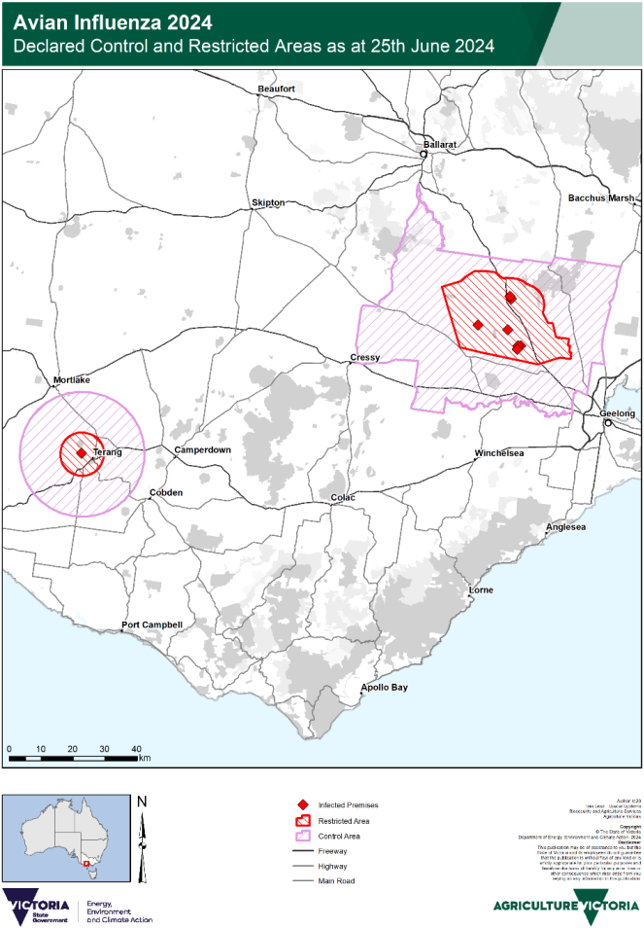
Meredith & Lethbridge, VIC | 30 Dec 2024

Region | Date Outbreak Resolved | Key | Map
Freemans Reach, Glossodia, North Richmond, & Cornwallis, NSW | 23 Jan 2025 | Map as at 12 July 2024.  Red shade: Restricted areas  Orange shade: Control areas  Red diamonds: Infected premises | 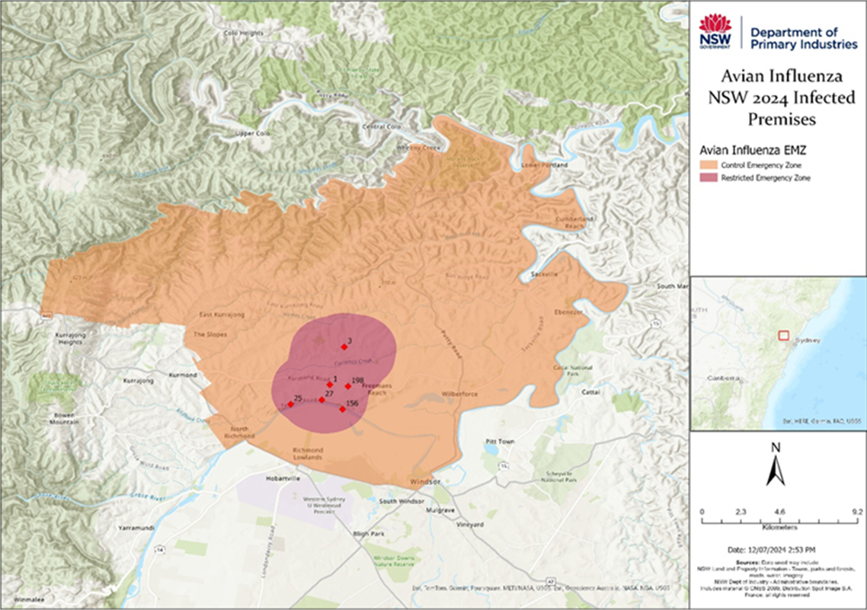

Region | Date Outbreak Resolved | Key | Map
NSW Bordering Belconnen | 31 Oct 2024 | Map as at 27 June 2024.  Red shade: Restricted areas  Orange shade: Control areas  Note: There are no infected premises in this area, as it was established given the proximity to the infected premises in the ACT in the below image. | 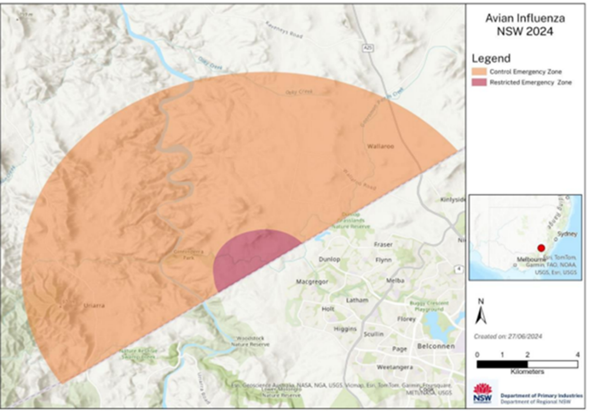

Region | Date Outbreak Resolved | Key | Map
Belconnen, ACT | 31 Oct 2024 | Map as at 28 June 2024.  Red shade: Restricted areas  Orange shade: Control areas  Note: There are no infected premises in this area, as it was established given the proximity to the infected premises in the ACT in the below image. | 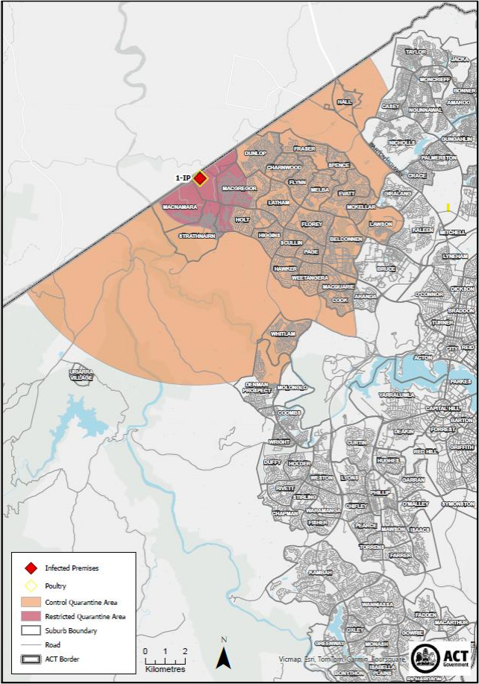

Region | Date Outbreak Resolved | Key | Map
Euroa, VIC | 13 June 2025 | Map as at 28 April 2025.  Red shade: Restricted area  Yellow shade: Control area | 