Attachment 3: Registration information for China international trade single window system
The Single Window is owned and administered by the General Administration of Customs of the People’s Republic of China (GACC) and the department does not have oversight of the information submitted.
The department has developed registration information that is general in nature and should not be taken as definitive or exhaustive. The instructions are current to the version of the Single Window System available as at 29 November 2021 and may be subject to change.
Based on the GACC guidance of Decree 248, the System of China Import Food Enterprise Registration (CIFER) can be accessed through the following link: https://cifer.singlewindow.cn
The above link is in both English and Chinese. Please choose the language before login. Registration is based on the physical location of the facility. Each location needs to be registered separately. Brand owners using contract manufacturers should not register but ensure each contract manufacturer completes the self-registration process. Contract manufacturers only need to self-register once. Freight forwarders providing transitory storage services do not need to apply.

STEP 1
This link will take you to the webpage below. Note the language options in the top right-hand corner.


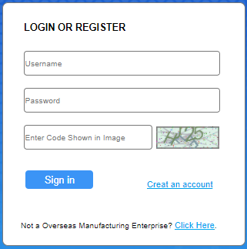
If you have already created an account with the China International Trade Single Window System, enter your username and password in the fields below and progress to Step 2.

If you have not created an account with the China International Trade Single Window System, click on the ‘create an account’ link (circled).
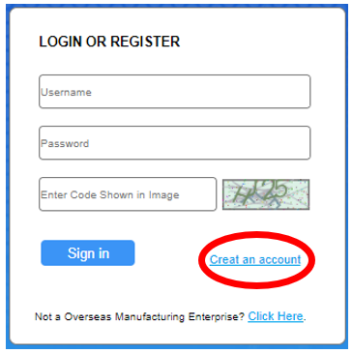

You will then be directed to the following webpage form where you will need to fill out the applicable details. Note that only the fields marked with a red Asterix/star are mandatory however you will need to complete the field for registration number as highlighted in the picture below.
Usernames are required to be between 6-18 characters. A mixture of letters and numbers can be used. Passwords need to be 8-16 characters with at least one upper and lower case letter, a number and a symbol.
Note:
- The country abbreviation for Australia in the ‘located Country (Region)’ field is AUS.
- The form will have a field which requests the ‘Register Number’, which the department understands is where you should enter your registration number approved by the competent authority in the country in which you are located or your GACC number, i.e. your 'department establishment number' or 'food business or notification number issued by state, territory or local government' or 'another unique identifying number for your business; for example, your Australian Business Number (ABN) or Australian Company Number (CAN).

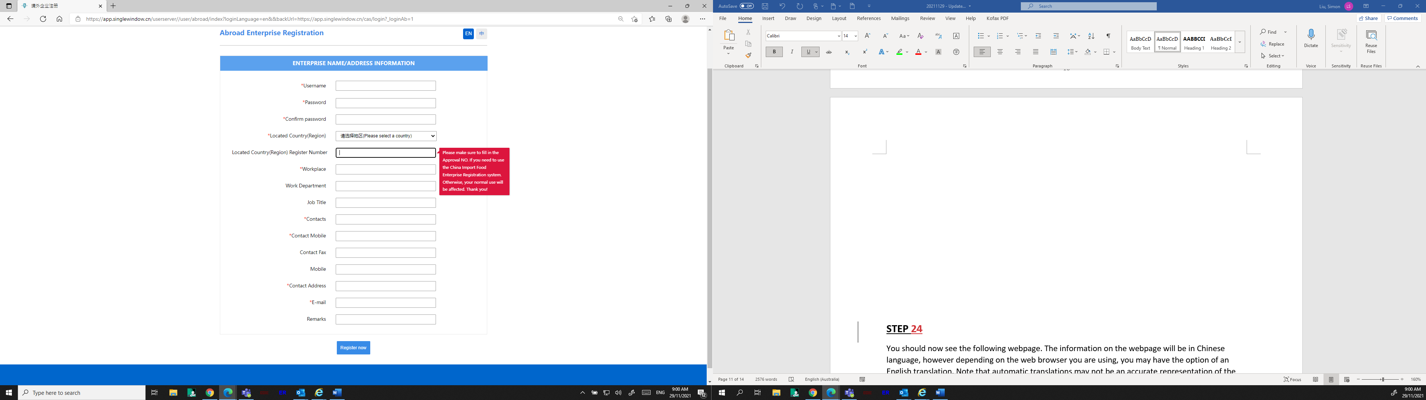

STEP 2
You should now see the following webpage. GACC has translated most menus and fields into English. Proceed with your application for registration using the menus in English on the left of the picture.
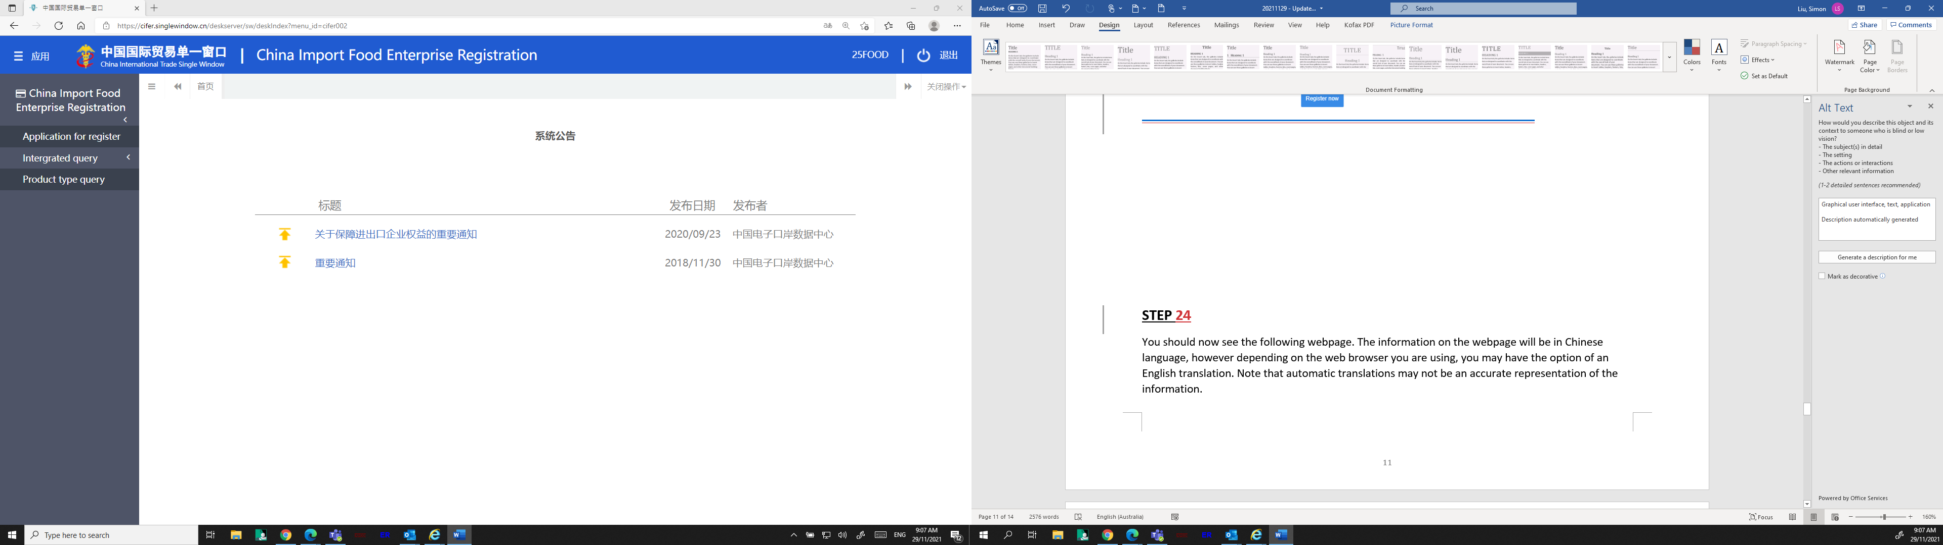
STEP 3
The following webpage will appear, which shows a comprehensive list of food product categories. Note that the commodities listed are divided into two categories:
- Foods requiring recommendation by the competent authority of the located country/region for registration with GACC (that is meat, dairy, seafood and Article 7 foods) *Note: GACC is developing a new application process for these food groups, please refer to Section 4
- Foods which require self-registration with GACC (Article 9 foods)

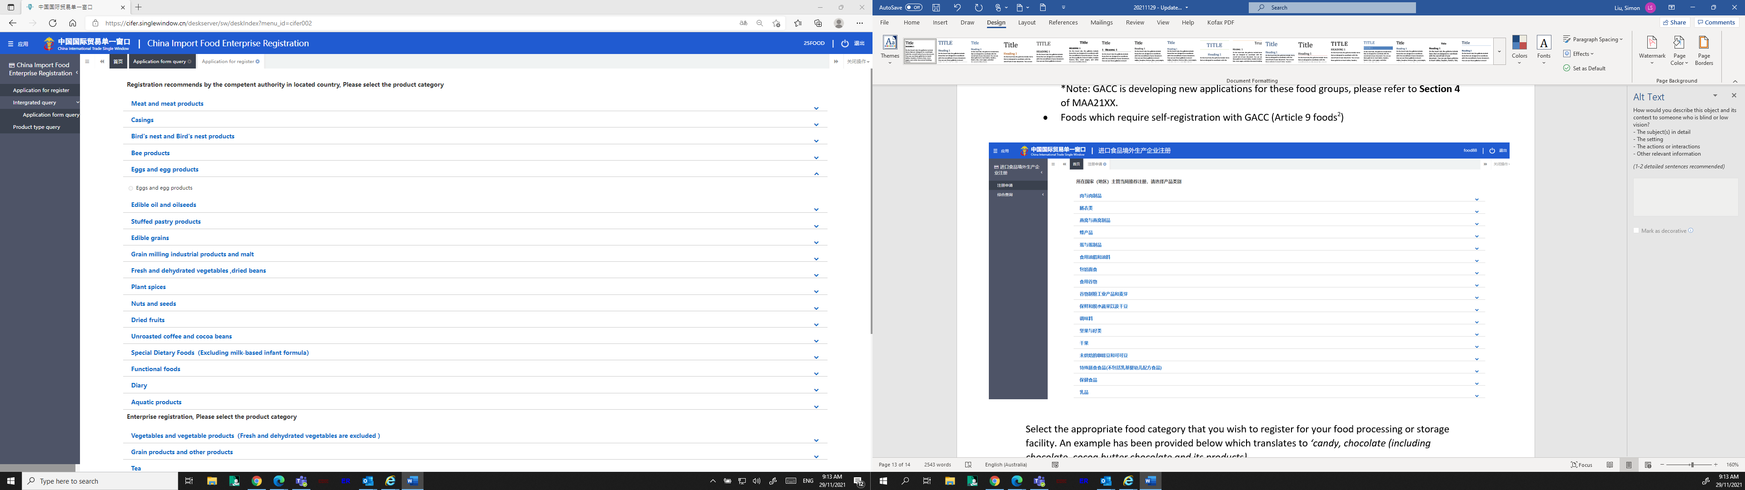
Facilities can also search their product HS code on the Single Window by clicking the ‘Product type query’ tab on the left-hand side. You can use this function to see if your product is considered an Article 7 or Article 9 product by viewing the status of the ‘Officially recommended’ in the right-hand column. The department understands products that have ‘yes’ listed, are considered Article 7 products, and products that have ‘no’ listed, are considered Article 9 products. You can also search using the ‘product name’; however, this function is only available in Chinese language.
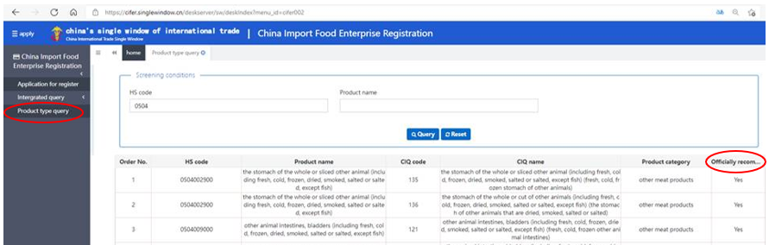

STEP 4
Select the appropriate food category that you wish to register for your food processing or storage facility. An example has been provided below for the ‘Confectionary, Chocolate’ category.
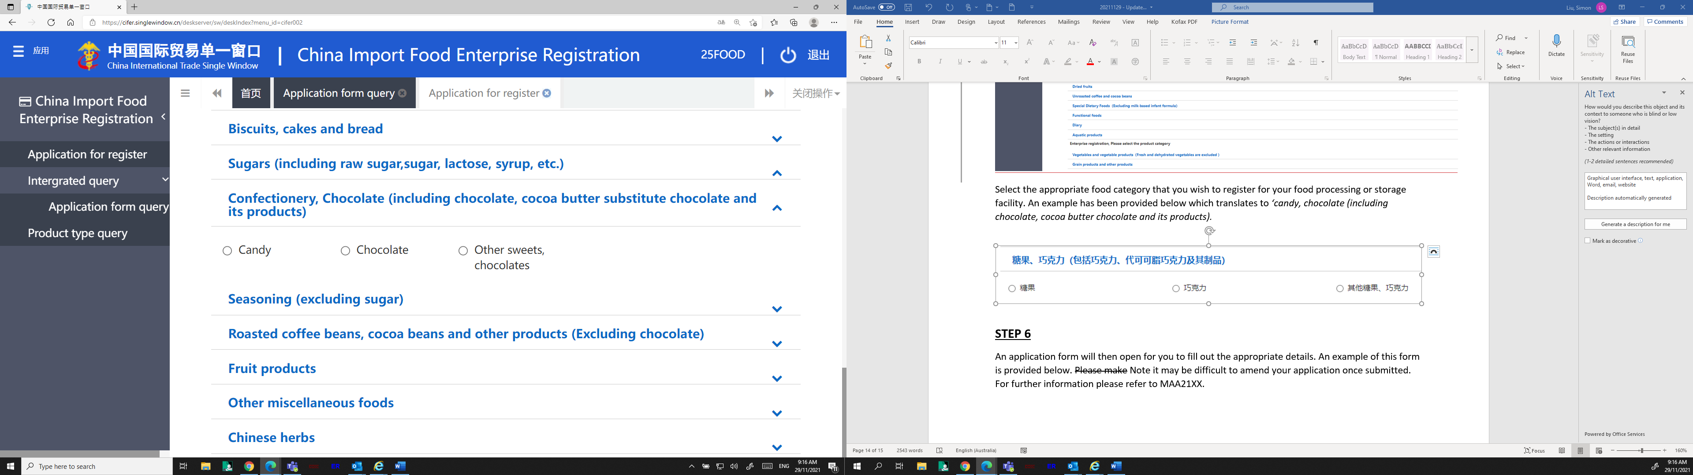

STEP 5
An application form will then open for you to fill out the appropriate details. An example of this form is provided below. Note it may be difficult to amend your application once submitted.
As the self-registration process with GACC is a commercial activity, the department encourages food storage and processing facilities to seek advice from their importer or agent in China should they require further information.
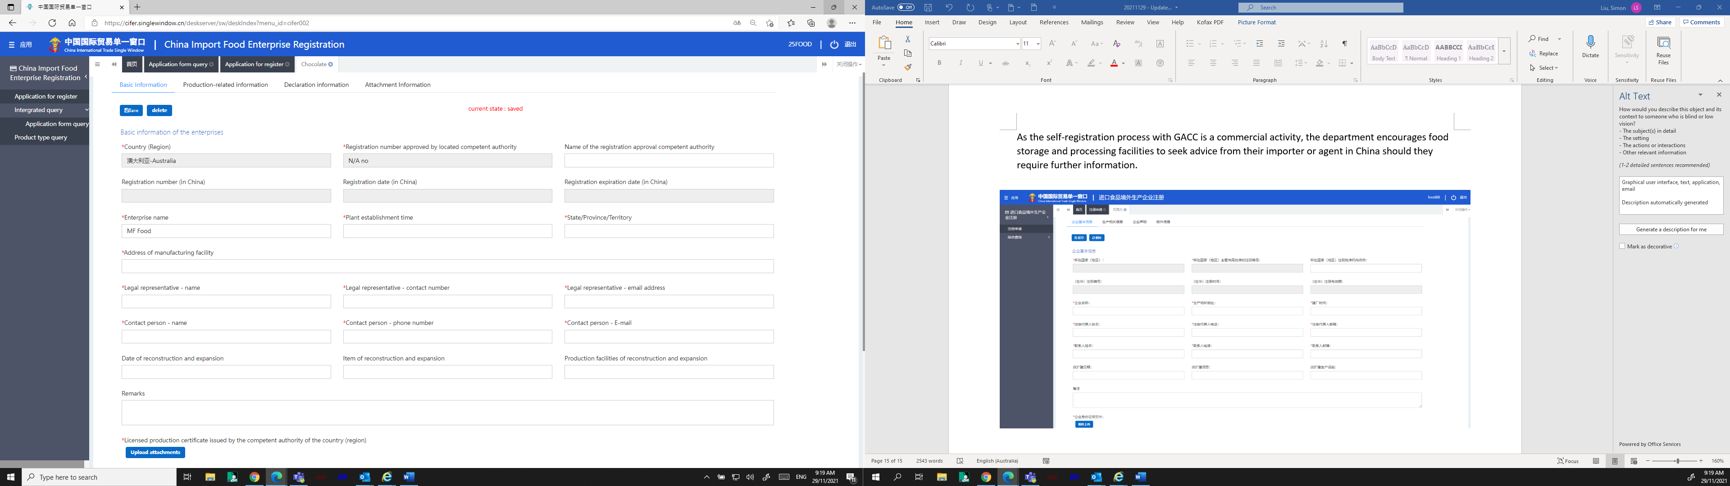

Article 7 foods include casings, bee products, eggs and egg products, edible fats and oils, stuffed wheaten food, edible grains, milled grain products and malt, fresh-kept/ preserved and dehydrated vegetables and dry beans, condiments and seasonings, nuts and seeds, dry fruits, unroasted coffee and cocoa beans, food for special dietary uses, health/ functional foods.
Article 9 foods include all food categories that are not meat, dairy or seafood and are not an Article 7 food.

