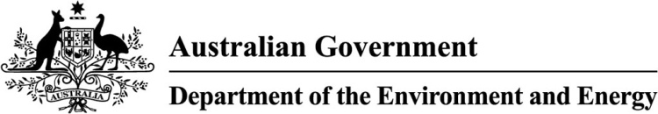

Assessing the condition of the Macquarie Marshes Ramsar site

The Macquarie Marshes Ramsar site was listed in 1986 under the Convention on Wetlands of International Importance (Ramsar Convention). The site is located in central northern New South Wales, north west of Warren, and is comprised of the Macquarie Marshes Nature Reserve, the privately owned Wilgara wetland and the privately owned U-Block. The Macquarie Marshes lie within the traditional country of the Wailwan Aboriginal people.

The broader Macquarie Marshes wetland system (the marshes) contains a wide range of vegetation types, which have evolved in response to the variable flows that result from rainfall and runoff from the upstream catchment. These vegetation types include river red gum woodland, water couch grasslands, extensive beds of common reed, coolibah, black box, lignum, cumbungi and river cooba.

The range of vegetation types provide habitat for many species of waterbirds, as well as a diverse array of other wildlife including: 233 bird species; 29 species of native mammal; 15 frog species, 60 reptile species and 11 native fish species. The marshes are known for their large-scale colonial waterbird breeding events and as refuge for international migratory shorebird species.

As a party to the Ramsar Convention, Australia is expected to promote the conservation and wise use of our wetlands, and to manage its Ramsar sites to maintain the ecological character of each site.

Notifying a change in the ecological character of the Macquarie Marshes   
Ramsar wetland

In 2009, the Australian Government made a notification to the Ramsar Secretariat of a change in the ecological character of the Macquarie Marshes Ramsar site, under Article 3.2 of the convention. The primary cause of this decline was identified as river regulation, although it was noted that the site had been affected by the millennium drought.

Following this notification, the site was placed on the Ramsar Article 3.2 List. This list of sites, that have had a change in ecological character, is considered every three years at the Ramsar Conference of the Parties where countries must report on their sites.

**Below is a detailed illustration showing the areas comprising the Macquarie Marshes Ramsar site.**

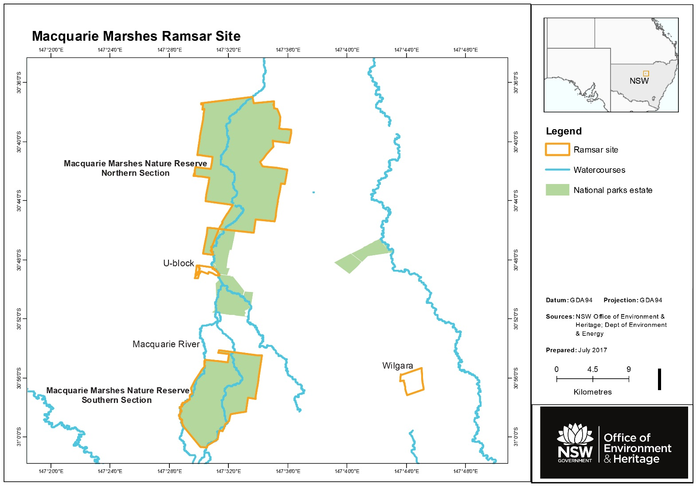

Article 3.2 Response strategy for the Macquarie Marshes Ramsar site

In accordance with Australia’s Article 3.2 notification guidelines, a response strategy was developed in 2012 by the NSW Office of Environment and Heritage (OEH), and approved by the Australian Government. It was issued in March 2013, and is being implemented by OEH. The strategy includes the use of NSW environmental water which is coordinated with the release of Commonwealth environmental water.

Following five years of implementation, the strategy and the management actions undertaken in the Macquarie Marshes Ramsar site will be reviewed to consider their effectiveness, and the condition of the site’s critical ecological components, process and services.

This review - a *Technical Report on the Response of the Macquarie Marshes Ramsar Site Following Environmental Watering and Other Management Actions* has been commissioned by the Department of the Environment and Energy, in consultation with OEH to assess progress to date under the strategy.

Technical report

The Australian Government has engaged a team from Griffith University’s Australian Rivers Institute to report on the monitoring activity, environmental watering outcomes and scientific research in the Macquarie Marshes.

The team will assess information against the objectives of the 2013 Macquarie Marshes Response Strategy to determine the extent to which the ecological character of the Macquarie Marshes Ramsar site is, or is not, recovering.

A steering committee chaired by the   
Australian Government with members from NSW OEH and Griffith University will provide technical and administrative support for the project. A range of stakeholders, including traditional owners and site managers (private landholders and National Parks and Wildlife Service), will be invited to participate in the project.

**For more information on the marshes project** **please email:** **wetlandsmail@environment.gov.au**

What has been observed to date – conditions in the Macquarie Marshes

Wetland vegetation condition and extent in the Macquarie Marshes has improved since 2009 through the effective use of environmental water to extend natural flooding events.

The combined effect of floods and environmental water has supported large colonial nesting waterbird breeding events in the Macquarie Marshes, including on the Ramsar site, and stimulated some recovery of reed beds, river red gum woodlands and water couch meadows.

Between spring 2012 and autumn 2016, hot and dry conditions prevailed in the Macquarie catchment which slowed the ecological recovery of the Macquarie Marshes system. However, the delivery of combined Commonwealth and NSW environmental water to the Macquarie River and Macquarie Marshes has supported the inundation of core wetland areas and semi-permanent vegetation, improving habitat and ecosystem health.

© Commonwealth of Australia, 2017.

This fact sheet is licensed by Commonwealth of Australia under a Creative Commons Attribution 4.0 International licence.

The views and opinions expressed in this publication are those of the authors and do not necessarily reflect those of the Australian Government or the Minister for the Environment and Energy.