# Macquarie River and Marshes watering event update #1

This is the first update on the 2018–19 environmental watering event in the Macquarie River and Macquarie Marshes. Water for the environment started being delivered from Burrendong Dam in late July and is now flowing down the Macquarie River and into the Marshes. This water will help support native fish, wetland vegetation and waterbirds, providing improved habitat and health. Water is being provided by NSW and the Commonwealth. These updates are to share the event with the community.

## About the Macquarie River and Macquarie Marshes

The Macquarie River runs north-west through the Macquarie Marshes and connects with the Barwon River downstream of Walgett. The iconic Macquarie Marshes include internationally significant Ramsar wetlands. The Marshes are one of the largest remaining semi-permanent wetland systems in inland Australia and one of the biggest colonial waterbird breeding sites in Australia.

The Macquarie River and Marshes are an important breeding ground for native fish, frogs and other aquatic life and provide breeding habitat and food for a range of waterbirds, including egrets, spoonbills and ducks. Water for the environment has been allocated to the Macquarie River and Marshes over recent decades.

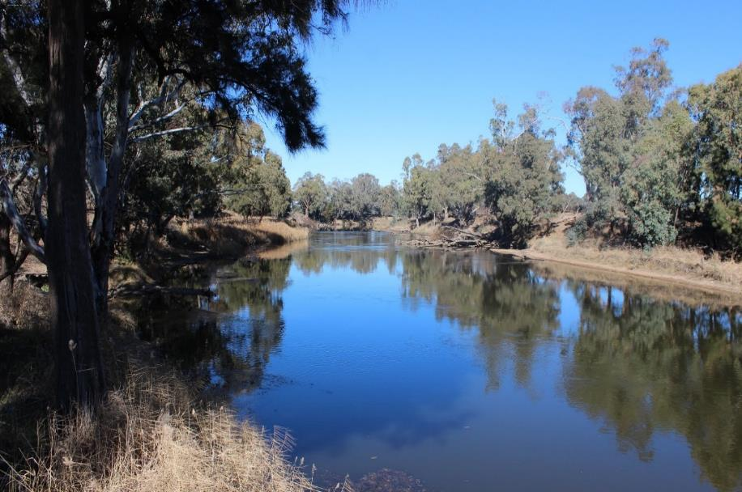

## Why deliver water for the environment into the Macquarie now

In 2016 when all water users accounts received their full allocation, a 3-year watering strategy was developed to improve the health and resilience of around 19,000 ha of the Macquarie Marshes including reed-beds, water couch, mixed marsh and river red gum forests. This is about 10% of the area of the Marshes.

Delivery of water for the environment in 2018–19 will target these areas to maintain their health and resilience, and to help them survive dry years. The delivery will support habitat and food sources for frogs, turtles, and waterbirds. The flow will also benefit native fish such as Murray cod and freshwater catfish and provide low flow connectivity to the Barwon River. If conditions remain very dry, this may be the only flow to the Barwon in coming months.

**Objectives for this event**

|  |  |  |  |
| --- | --- | --- | --- |
| C:\Users\korodat\Desktop\Environmental water icons - OEH Black icons - png format\OEH_Black_icons_Large\66_waterplant2.png | Water ~19,000 ha of mixed marsh, lignum, water couch and river red gum | C:\Users\korodat\Desktop\Environmental water icons - OEH Black icons - png format\OEH_Black_icons_Large\11_fish2.png | Provide increased movement, feeding and spawning opportunities for native fish. |
| C:\Users\korodat\Desktop\Environmental water icons - OEH Black icons - png format\OEH_Black_icons_Large\60_waterbird5.png | Water important breeding and foraging habitat for waterbirds. | C:\Users\korodat\Desktop\Environmental water icons - OEH Black icons - png format\OEH_Black_icons_Large\04_connectivity2.png | Increase the connections between the Macquarie River, Marshes and Barwon River |

**Map of the target area for this water delivery**

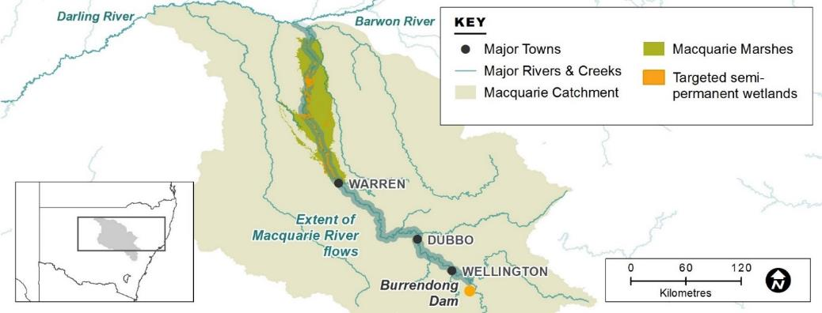

## Water delivery details

Delivery of environmental water from Burrendong Dam began in late July and is expected to continue until late November 2018. The volume of environmental water used will be within the [temporary restriction of 70 per cent of carryover allocations](https://www.industry.nsw.gov.au/__data/assets/pdf_file/0011/170885/WAS-Macquarie-180817.pdf) announced by the NSW Department of Industry – Water on 17 August 2018.

Deliveries will be closely monitored and adjusted if necessary. The delivery will also be managed to ensure water achieves the environmental outcomes efficiently.

**What the water delivery will look like**

The delivery will provide multiple benefits in the Macquarie River and Marshes, described in the hydrograph below. A hydrograph shows how much water (in megalitres per day) is moving past a particular point in a river. Marebone Weir is the site where the water enters the Marshes. The shape of the hydrograph (highs and lows) is important as different parts of the flow provide for the different needs of the river, fish and vegetation.

**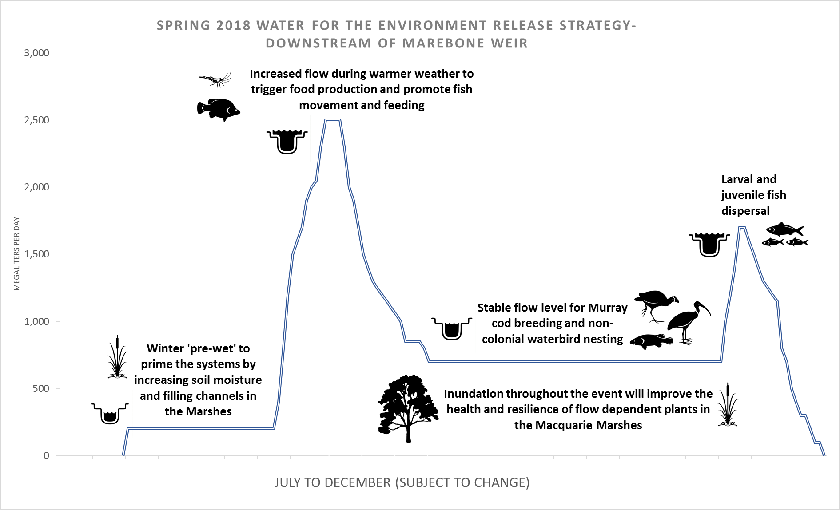**

## Event update

Environmental water delivered from Burrendong Dam reached Marebone Weir on 24 July 2018, providing multiple benefits as it made its way through the system. Water began flowing through the Macquarie Marshes and into the northern Marshes at the start of August. This first part of the flow helped to pre-wet the system, filling channels and increasing soil moisture in the Marshes. The priming flow finished on 24 August.

The main spring flow is now being delivered with the flow peak currently moving through the southern Marshes. Delivery into the east Marsh (Gum Cowal/Terrigal system) also commenced on the 1st of September. This peak in flow rate, or ‘flow pulse’ is helping to maximise the area of the Marshes that receives water, and to provide more food and movement opportunities for native fish. Water will also help recharge shallow groundwater systems, which will help vegetation to survive through dry times.

## Ecological monitoring

A range of monitoring activities are planned for the flow. Remote cameras are recording the level of inundation in the Macquarie Marshes and photo points used along the Macquarie River to compare changes over time. For the first-time sound recording equipment has been set up to record frog and bird calls. This new information will provide knowledge of how these animals respond to flooding. Annual bird and frog surveys will be completed in the Macquarie Marshes to measure diversity, abundance, breeding and recruitment. Fish population surveys will occur along the Macquarie River with further information being provided in a future up-date.

**How the Marshes look during a wet compared to a dry year**

|  |  |
| --- | --- |
|  | |
| Monkeygar mixed marsh – 2016 | Monkeygar mixed marsh – 2018 |
|  | |
| Monkeygar water couch – 2016 | Monkeygar water couch – 2018 |

## Government and community working together

Government and the community are working together to care for our rivers and wetlands. The NSW Office of Environment & Heritage and the Commonwealth Environmental Water Office work with the Macquarie Cudgegong Environmental Flow Reference Group to plan and manage the delivery of water for the environment in the Macquarie River catchment. The Reference Group includes members from local interest groups from community and government, and provides advice on planning, management and monitoring of water for the environment in the Macquarie catchment*.* We will also work with other agencies, such as the Natural Resource Access Regulator and the Murray-Darling Basin Authority, that have roles in compliance. Regular updates will be provided to the community as the flow moves through the system.

## Contacts

|  |  |
| --- | --- |
| **NSW OEH Senior Wetlands & Rivers Conservation Officer:** | **CEWO Local Engagement Officers:** |
| **Paul Keyte**  02 6883 5342 or 0429 616 390  [paul.keyte@environment.nsw.gov.au](mailto:paul.keyte@environment.nsw.gov.au) | **Neal Foster**  0437 141 495  **Jason Wilson**  0418 210 389 |
| **NSW OEH website**  <http://www.environment.nsw.gov.au/topics/water/water-for-the-environment/about-water-for-the-environment> | **CEWO media line** [media@environment.gov.au](mailto:media@environment.gov.au)   02 6275 9880 |