# Macquarie River and Marshes watering event Spring 2018 update #2

This is the second update on the 2018–19 watering event in the Macquarie River and Macquarie Marshes. Water for the environment delivery commenced late July from Burrendong Dam and is flowing down the Macquarie River and into the Marshes. The environmental benefits are becoming visible with waterbirds arriving, frogs calling and

wetland plants starting to grow. 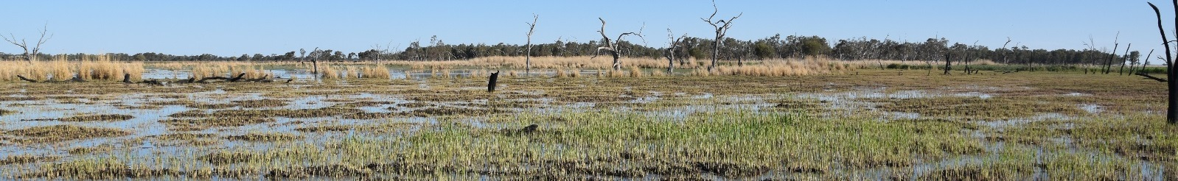

## WATERING Event Objectives

The event is targeting wetland areas of the Macquarie Marshes to maintain their health and resilience. Water delivery will support habitat and food sources for frogs, turtles, and waterbirds. The flow will also benefit native fish such as Murray cod and freshwater catfish and may provide connection to the Barwon River.

Delivery of environmental water from Burrendong Dam began in late July and is expected to continue until November.

## WATERING Event update

Approximately 70,500 megalitres of the 165,000 megalitres allocated for the event has been delivered so far. Water has moved slower than anticipated through the Marshes, which is likely the result of the dry conditions. The event is now a low stable flow to continue to spread inundation in the Marshes while keeping Murray cod nesting sites inundated along the mid-Macquarie River (refer to the hydrograph of page 2).

**Flow progress**

*Southern Marshes-* several wetlands have been inundated including Buckiinguy Swamp, Monkey Swamp, Monkeygar Swamp, lagoons in the southern Macquarie Marshes Nature Reserve and Mole Marsh including the U-Block and Nature Reserve Ramsar areas. Flows through Buckiinguy Swamp have inundated the Old Macquarie River Channel.

*Eastern Marshe*s- the flow has moved through the Gum Cowal with the lead of the flow moving down the Terrigal Creek, filling several lagoons. The water has recently reached Gibson’s Way.

*Northern Marshes-* the water has inundated Sinclair’s and Louden’s Lagoons and partially filled the extensive North Marsh reedbed. Flows have reached the Ginghet Creek from the Bora Creek and are currently filling large patches of lignum and river red gum woodlands.

**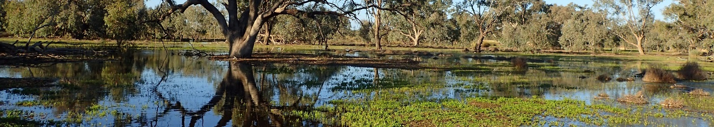***Lower Macquarie River-* North of the Marshes the water has reached the Miltara gauge on the lower Macquarie River and will continue flowing down the system. Connection with the Barwon River will depend on several factors, including rainfall during the flow, the level of authorised water take and seepage into the dry channel.

**Macquarie event hydrograph**

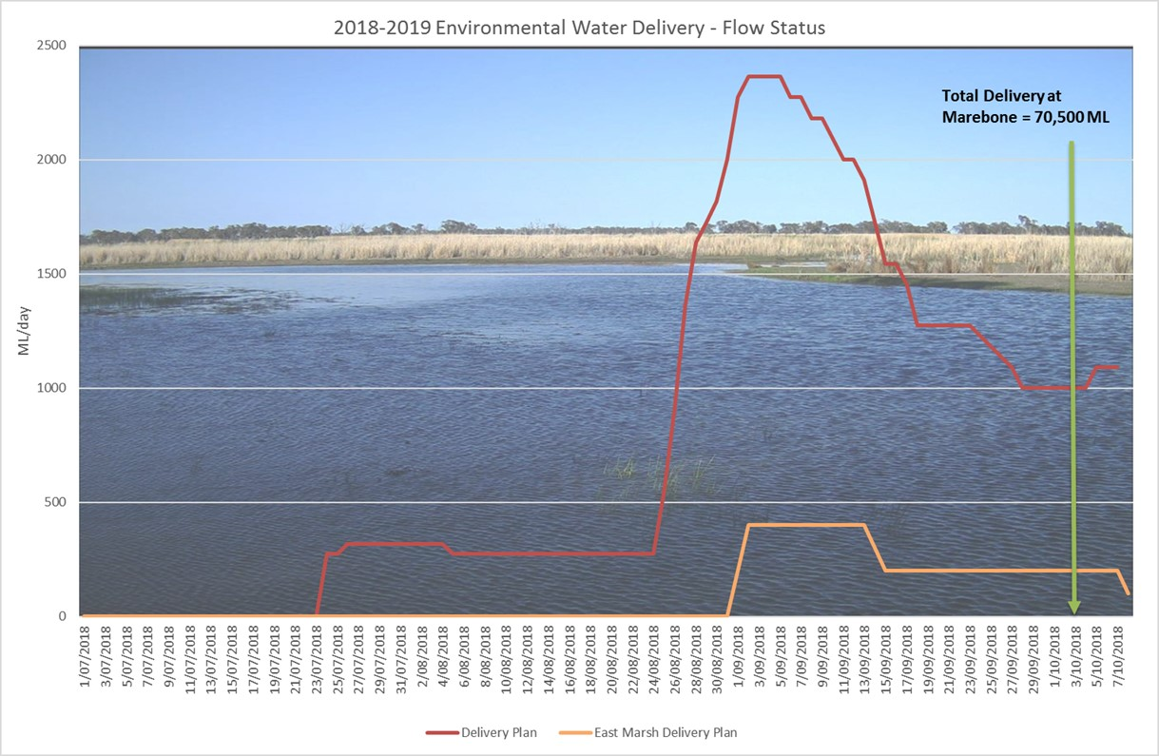

## Ecological monitoring

OEH (NSW Office of Environment and Heritage) staff are regularly monitoring flow movement and the spread of water into the Marshes. Waterbirds have begun to arrive at various locations across the Marshes including brolgas, terns, egrets, ducks and ibis. The annual Marshes OEH bird surveys will be undertaken in mid-October to identify and measure the abundance of all the bird species taking advantage of the wet marsh areas.

Water plants are beginning to emerge including water primrose, common spike-rush and swamp buttercup.

OEH frog surveys in late September detected five species of frogs. Despite low temperatures in some areas, breeding was occurring at some sites including egg masses and a small number of tadpoles. The next surveys are scheduled in November and with the warmer temperatures it is anticipated there will be more breeding and additional frog species.

NSW Department of Industry-Fisheries monitoring of fish populations is scheduled for later in 2018-19.

## Contacts

|  |  |
| --- | --- |
| **NSW OEH Senior Wetlands & Rivers Conservation Officer:** | **CEWO Local Engagement Officers:** |
| **Paul Keyte**  02 6883 5342 or 0429 616 390  [paul.keyte@environment.nsw.gov.au](mailto:paul.keyte@environment.nsw.gov.au) | **Neal Foster**  0437 141 495  **Jason Wilson**  0418 210 389 |
| **NSW OEH website**  <http://www.environment.nsw.gov.au/topics/water/water-for-the-environment/about-water-for-the-environment> | **CEWO media line** [media@environment.gov.au](mailto:media@environment.gov.au)   02 6275 9880 |