# Macquarie River and Marshes watering event Spring 2018 update #3

This is the third update on the 2018–19 watering event in the Macquarie River and Macquarie Marshes. The delivery of water for the environment that commenced in late July from Burrendong Dam continues, with water flowing down the Macquarie River and into the Marshes. Water for the environment has now made it through the Marshes, all the way along the lower Macquarie River and has connected to the Barwon River.

## WATERING Event update

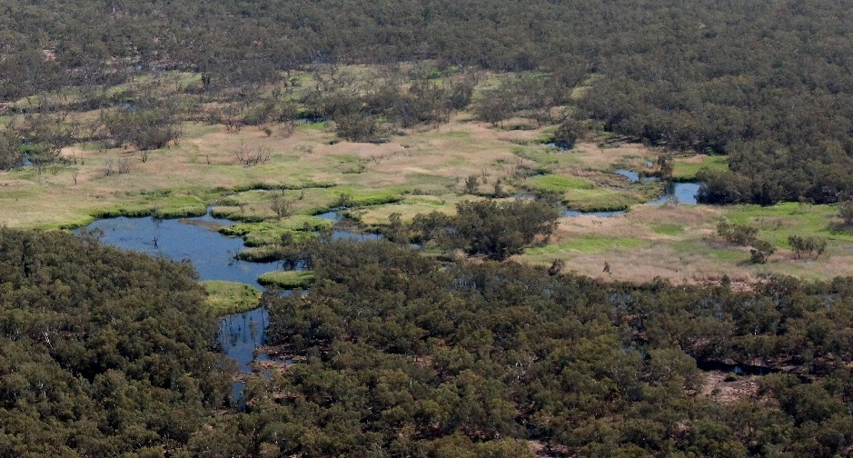At the start of December, approximately 123,000 megalitres (ML) of water for the environment had been delivered from Burrendong Dam to the Macquarie River and Marshes. The delivery is planned to finish during the second week of December. Flow rates have reduced from the third week of November as the watering event comes to its completion.

The flow rate over November was kept stable to ensure nesting sites for Murray cod remain covered in the mid-Macquarie River. This stable flow also aimed to prolong the presence of water (duration) to create conditions that favour the growth of wetland plants which need wet conditions to support a part of their life-cycle.

Supporting our native fish stocks and semi-permanent wetland vegetation through this current drought means they are better placed to withstand any further dry conditions and will enhance their ability to recover when wetter conditions return.

**Connection to the Barwon River**

Water for the environment continues to move through the Marshes and arrived in the lower Macquarie River (downstream of the marshes) on 25 September. Over the next 27 days, the flow re-wet the dry lower Macquarie River bed before it reached the Barwon River around 22 October 2018. Flow continues to enter the Barwon River at a low rate, with a peak of 100 ML/day being recorded in late November. Flow is now receding, although it is expected to continue to mid-December.

|  |  |
| --- | --- |
| G:\Environment\Environmental Water\CEWH\Photos\2018\20181106 - Macquarie Marshes - NSloane\selection\IMG_993579e_exiting_Northern Reedbeds_Macquarie_River_NSloane.JPG  **Barwon River** | G:\Environment\Environmental Water\CEWH\Photos\2018\20181030 - Macquarie Flight_NSloane\IMG_9821100e_Macquarie_Barwon_Confluence_NSloane.JPG  **Macquarie River** |
| *Water coming out of the Northern Marsh reedbed and re-entering the Macquarie River* | *The junction of the Macquarie and Barwon rivers (looking downstream)* |
|  |  |

*Satellite images of the Macquarie-Barwon connection October 2018 (Source: Sentinel Hub Playground).*

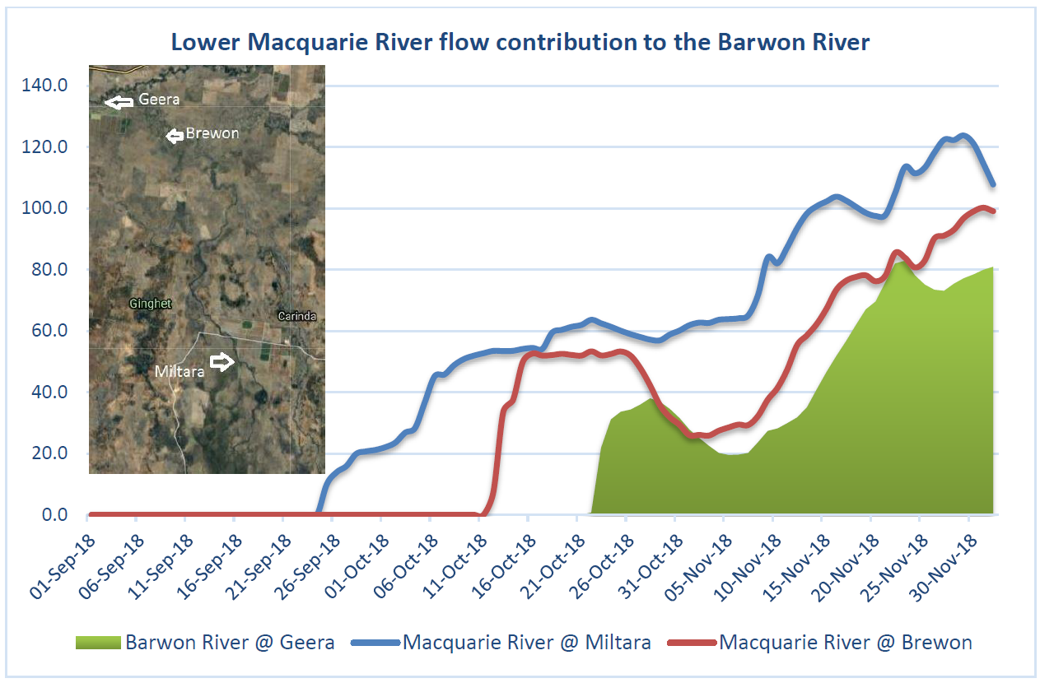

*Flows at Miltara, Brewon and Geera gauges. Inset: Location of Miltara, Brewon and Geera flow gauges.*

During the 53 days of flow connection, an average of 50 ML/day has entered the Barwon River. Prior to these small inflows, the Barwon River downstream of Walgett had stopped flowing for over three months. The flows have improved water quality by reducing salinity levels in the Barwon River at Geera from over 10,500 µS/cm (not suitable for human consumption or irrigation) to 608 µS/cm (can be used for human and livestock consumption and irrigation).Flows to the Barwon are a small proportion of the total delivered to the Marshes. However, the portion of water that has left the marshes and reached the Barwon River is quite high, being 64% of the flow recorded at Miltara. This inflow has reconnected and topped up the 175 pools identified along the 130 kilometre stretch of river between the Macquarie junction and the Brewarrina Weir. These deeper pools provide refuge in these dry periods for native fish. This topping up of pools will improve their water quality and lengthen the time they can persist as we move into the warmer summer months. Locals around Brewarrina may also see some benefits of water flowing into the Brewarrina weir pool.

## Ecological MONITORING

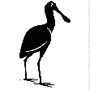WATERBIRDS

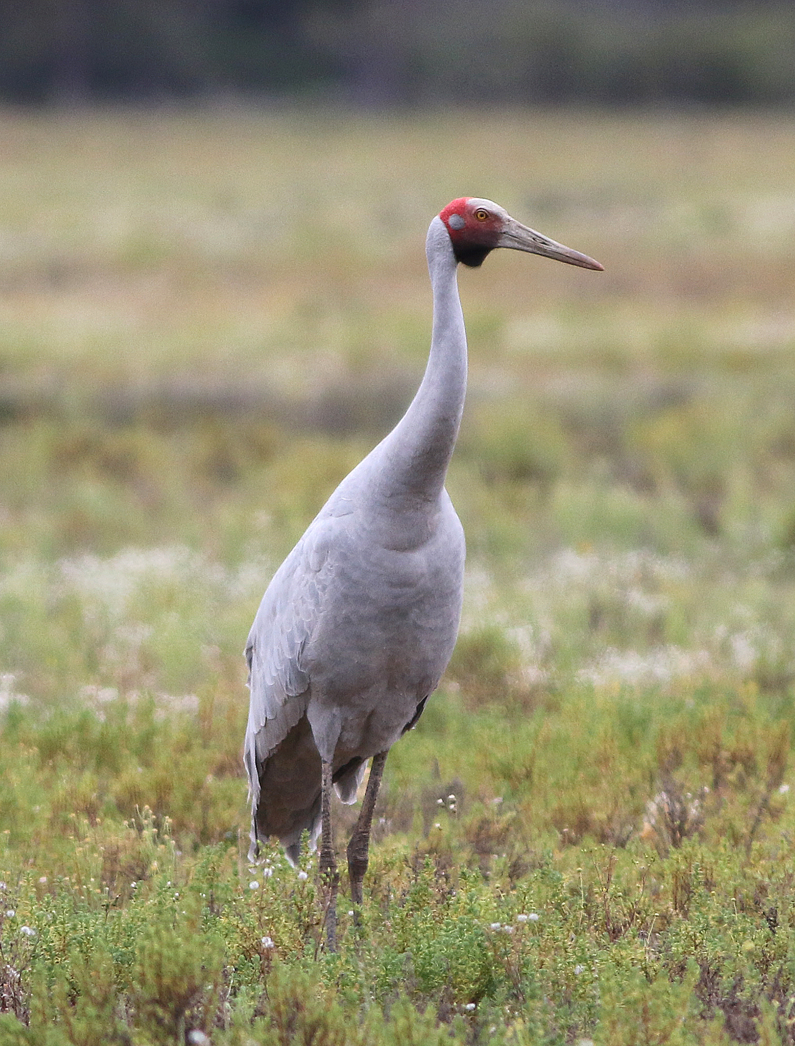

*Photo credit: Lachlan Copeland*

**FEATURE: Brolga (*grus rubicunda)***

Brolgas are large cranes that commonly inhabit large open wetlands, grassy plains, coastal mudflats and irrigated croplands. They feed on both vegetable and animal matter, with their diet including plant tubers insects, molluscs, amphibians and even mice.

Brolgas mate for life and perform elaborate courtship displays that involve dancing, leaping, wing-flapping, bowing, head-bobbing and calling. Birds may dance alone or in groups in stunning displays.  Both adults incubate the eggs and care for the young birds.

This watering event has supported important habitat and provided food for a range of waterbirds. In October, the NSW Office of Environment and Heritage undertook its annual spring waterbird survey. A total of 40 different waterbird species were recorded in the Marshes during the survey. This was slightly lower than the average of 43 waterbird species recorded since this survey commenced 2012. The nationally endangered Australasian bittern, migratory Latham’s snipe and a large flock (>40) of NSW-listed brolga were among those recorded. Overall waterbird abundance was low compared to previous surveys, with birds concentrated in areas inundated by the flows. Large flocks of grey teal and Pacific black ducks (over 1,500 birds), groups of stilts, spoonbills and egrets were observed at inundated sites.

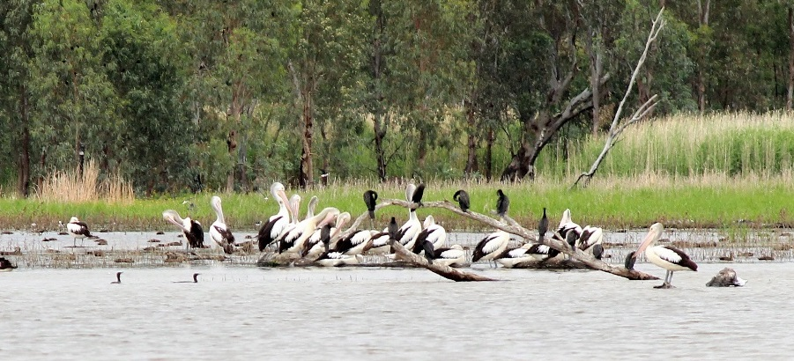

Following the 2016 flood and 2017 environmental water operations, it is considered the condition of the mid Macquarie River and Macquarie Marshes system has improved since the very dry years of 2013 to mid-2016. An objective of this environmental watering event has been to secure this progress by maintaining the health and resilience of the marshes semi-permanent wetland vegetation communities (approximately 10%).

Healthy vegetation is important for supporting a diverse range of waterbirds. For example, lignum and reeds are used to form platforms that colonial waterbirds like ibis and Royal spoonbills nest on during wetter times. Healthy river red gum provides roosting habitat for many species, including egrets and heron.

Maintaining breeding and feeding habitat using water for the environment during a dry period ensures these areas are available and able to support waterbird breeding events when next natural flooding occurs.

|  |  |
| --- | --- |
| *G:\Environment\Environmental Water\CEWH\Photos\2018\20181106 - Macquarie Marshes - NSloane\selection\IMG_987419e_Wilgara_NSloane.JPG*  *Vegetation in the Eastern Marshes, including lignum, cooba and river red gum.* | *A path with grass and trees  Description generated with very high confidence*  *Reedbeds in the Monkeygar swamp, which provides nesting habitat for colonial waterbirds.* |

## Contacts

|  |  |
| --- | --- |
| **NSW OEH Senior Wetlands & Rivers Conservation Officer:** | **CEWO Local Engagement Officers:** |
| **Paul Keyte**  02 6883 5342 or 0429 616 390  [paul.keyte@environment.nsw.gov.au](mailto:paul.keyte@environment.nsw.gov.au) | **Jason Wilson**  0418 210 389 |
| **NSW OEH website**  <http://www.environment.nsw.gov.au/topics/water/water-for-the-environment/about-water-for-the-environment> | **CEWO media line** [media@environment.gov.au](mailto:media@environment.gov.au)   02 6275 9880  **CEWO website**  <http://www.environment.gov.au/water/cewo/catchment/macquarie/catchment-updates> |