# Khapra beetle warning

### Keep khapra beetle out of Australia!

### What is khapra beetle?

Khapra beetle is a major threat to Australia’s grains industry. It destroys grain quality making it unfit for consumption. An outbreak could cost $15.5 billion over 20 years. Eating or handling products infested with khapra beetle can cause stomach, breathing and skin irritation problems.

Khapra beetle adults (1.6-3mm) and larvae (1.6-4.5mm)

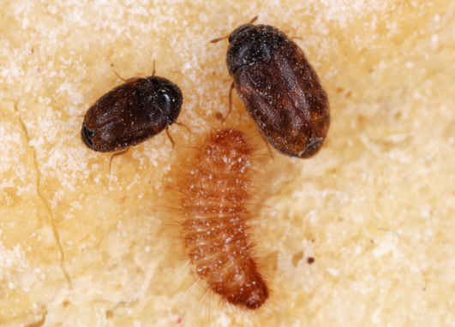

Adult khapra beetle

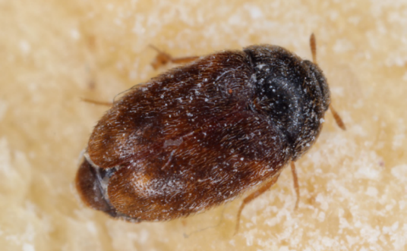

Adult khapra beetle

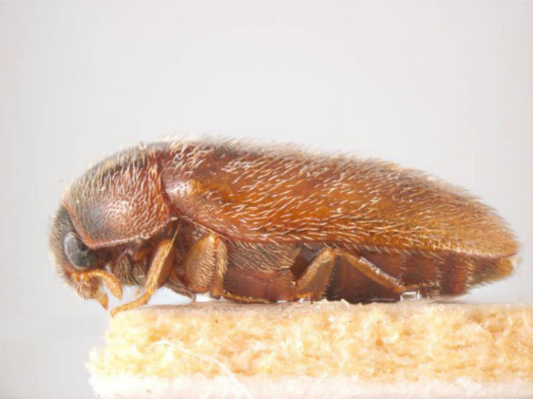

#### Do your part as an international traveller or online shopper

The following plant products are not permitted into Australia when brought in by international travellers or sent through mail, as they could be carrying khapra beetle. Some exclusions apply for certain products. For further information, visit [**agriculture.gov.au/bicon**](http://www.agriculture.gov.au/bicon).

### Don’t bring or mail the following products

Rice

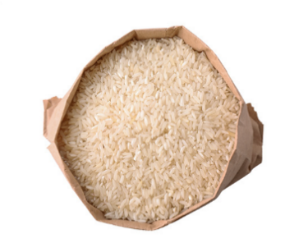

Pulses

Wheat

Powdered seeds and grains

Nuts

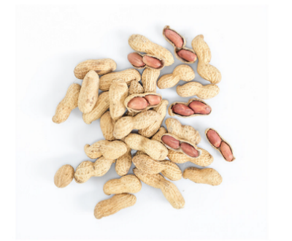

Beans

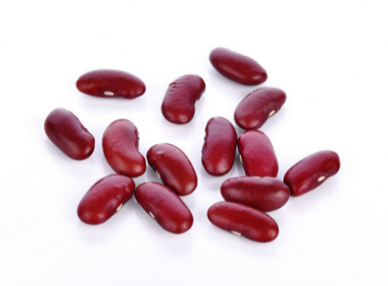

Dried chilli

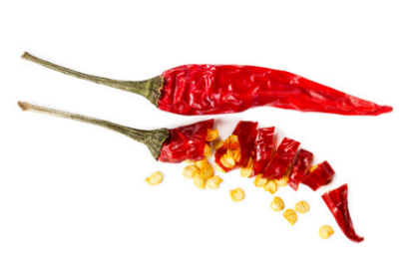

Seeds

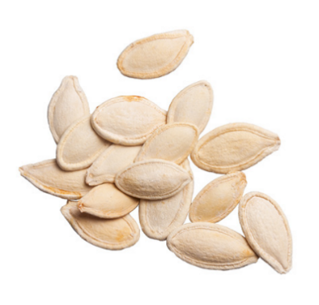

Do buy these products from Australian suppliers who have either sourced their products locally or imported them through commercial channels.

Serious penalties apply if you breach Australia’s biosecurity laws. You may be given an infringement notice. Your visa may also be cancelled and, if so, you will be refused entry into Australia and could face a three-year ban.

Learn more at: [agriculture.gov.au/khapra-urgent-actions](http://www.agriculture.gov.au/khapra-urgent-actions)