# Keep khapra beetle out of Australia!

These plant products can be infested with khapra beetle and are not permitted into Australia through international mail.

Khapra beetle is not present in Australia. It is a highly invasive pest that poses a major threat to Australia’s grains industry.

International mail articles arriving in Australia that contain any of these high-risk plant products will be immediately destroyed.  
  
Some exclusions apply for certain products. For further information, visit [**agriculture.gov.au/bicon**](https://bicon.agriculture.gov.au/BiconWeb4.0/).

### DO NOT buy these products online from overseas.

### Tell family and friends NOT to send these products to you.

Beans

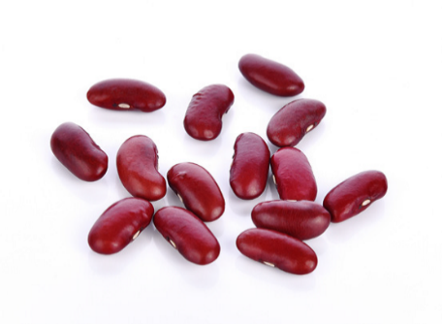

Rice

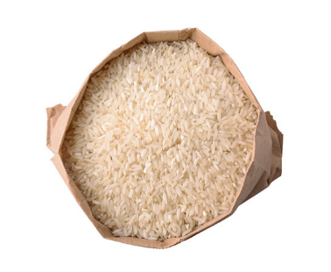

Nuts

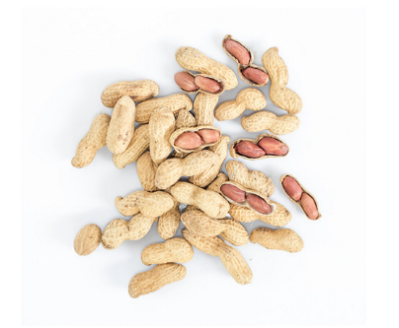

Wheat

Dried chilli



Seeds

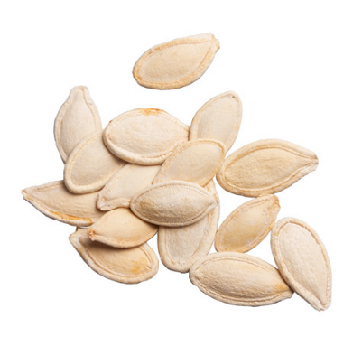

Pulses

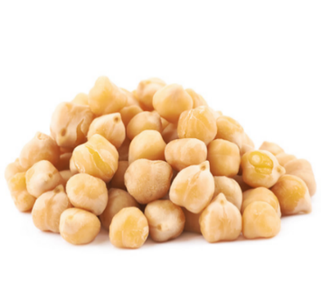

Powdered seeds and grains

Learn more at: [agriculture.gov.au/khapra-urgent-actions](http://www.agriculture.gov.au/khapra-urgent-actions).