Making the Connection: Designing, delivering and monitoring flows between catchments

A case study in the Macquarie and Barwon Rivers April – June 2017

Davis, S., Asmus, M.W and Stocks, J.R.

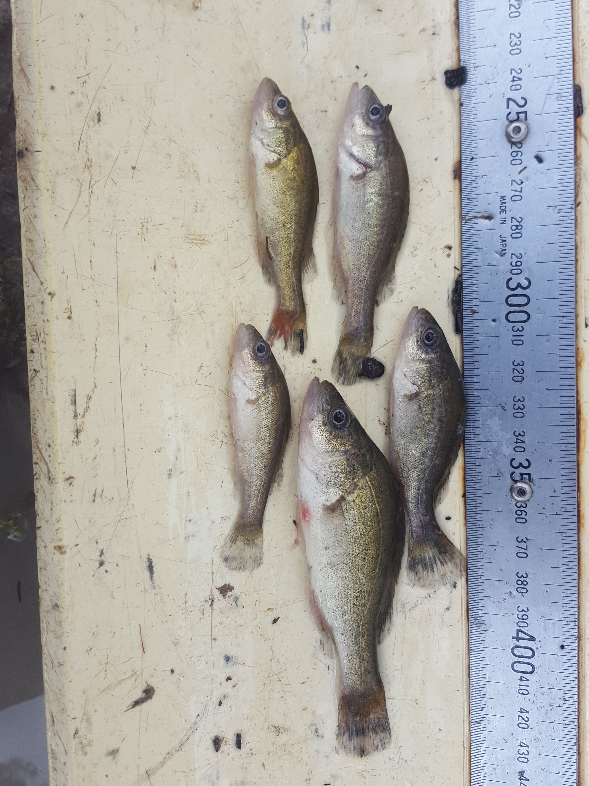

Published by the NSW Department of Primary Industries

*Making the Connection: Designing, Delivering and Monitoring flows between catchments*

Commonwealth of Australia- Reference No**. 3600000828**

First published December 2017

ISSN 2204-8669*

**More information**

Sam Davis, Martin Asmus and Jerom Stocks, Department of Primary Industries, PO BOX 865, Dubbo, NSW 2230, Australia

www.dpi.nsw.gov.au

**Acknowledgments**

Funding for this project was provided by The Commonwealth Environmental Water Office.



*Cover image: Timothy McGarry*

© State of New South Wales through the Department of Industry, Skills and Regional Development, 2017. You may copy, distribute and otherwise freely deal with this publication for any purpose, provided that you attribute the NSW Department of Primary Industries as the owner.

Disclaimer: The information contained in this publication is based on knowledge and understanding at the time of writing (December 2017). However, because of advances in knowledge, users are reminded of the need to ensure that information upon which they rely is up to date and to check currency of the information with the appropriate officer of the Department of Primary Industries or the user’s independent adviser.

*Before July 2004, this report series was published by NSW Fisheries as the ‘NSW Fisheries Final Report Series’ with ISSN 1440-3544. Then, following the formation of the NSW Department of Primary Industries it was published as the ‘NSW Department of Primary Industries – Fisheries Final Report Series’ with ISSN 1449-9967. It was then published by Industry & Investment NSW as the ‘Industry & Investment NSW – Fisheries Final Report Series’ with ISSN 1837-2112. It is now published as the ‘Fisheries Final Report Series’ with ISSN 2204-866

Table of Contents

List of tables iii

List of figures iii

Acknowledgments v

Non-technical summary 1

1.0 Introduction 3

2.0 Event Operations 4

Historical flow connectivity 4

Event planning 6

Flow event 6

Event timeline 6

Flow pathways 7

3.0 Methods 10

3.1 Field Sampling 10

Site Selection 10

Standardised fish assemblage sampling 10

Directional fyke netting 10

3.2 Data Analysis 11

Fish community composition 11

Abundance of recruits 12

Directional fyke netting 12

Otolith processing and daily aging 12

Recruitment and hydrography 12

4.0 Results 13

Standardised fish assemblage sampling 13

Directional fyke netting 14

Fish community composition 15

Abundance of recruits 17

Recruitment and Hydrology 17

Movement and Connectivity 20

Water Quality 20

6.0 Discussion 22

7.0 Conclusions and recommendations 26

References 27

Appendices 29

Appendix 1 – Sample site photographs (Round 1, April 2017) 29

Appendix 2 – Sample site coordinates 33

Appendix 3 – Water quality measurement at 0.2m depth for each sampling site during each round of sampling. Shaded values indicate water quality measurements outside ANZECC guidelines. 34

Appendix 4 – Water quality measurement at 0.2m depth for each sampling site during each round of fyke net sampling. Shaded values indicate water quality measurements outside ANZECC guidelines. 35

Appendix 5 - Barriers to fish movement, photos of captured species and sampling methodology 36

# List of tables

Table 1. Macquarie-Barwon River connectivity during a dry phase sequence (Pre-development 1939 – 1949). 5

Table 2. Macquarie-Barwon River connectivity (2007 – 2017). Connection events resulting in YOY Golden perch detection in the lower Macquarie River are indicated by small fish symbol. 5

Table 3. Fish species detected during standardised fishing and fyke netting operations undertaken in the Macquarie River during April – June 2017. 13

Table 4. Total catch by site and sampling round (Pre and Post water delivery) from standardised fishing (SRA protocol) undertaken in the Macquarie River during April – June 2017. Sites are arranged upstream to downstream (top to bottom). 14

Table 5. Total catch by site from directional fyke netting undertaken in the lower Macquarie River region. 15

Table 6. Results of PERMANOVA test examining fish community composition with zone and sampling event as factors. 17

Table 7. Results of ANOVA examining the abundance of recruits with zone, species and sampling event as factors. 17

Table 8. Results of ANOVA examining abundance of a) common carp, b) spangled perch, c) golden perch &, d) bony bream caught in directional fyke nets with fyke direction (upstream/downstream), site & mesh as factors in the model. 21

# List of figures

Figure 1. Tributary trigger and subsequent multi-peaked event that contributed to fish dispersal and movement 6

Figure 2. Event flow paths, camera locations & stream gauging points, Macquarie system downstream of Marebone Weir. 8

Figure 3. Macquarie River main channel flow heights (m) recorded via river gauges, reconyx cameras and staff gauges during the 2017 flow event.. 9

Figure 4. Location of sample sites in the Lower Macquarie River focus reach. 9

Figure 5. A paired set of small mesh (3mm) fyke nets (R.Price) 11

Figure 6. Cumulative frequency histograms of Golden perch from combined sampling methods (electrofishing and netting) within two zones over two sampling rounds. 14

Figure 7. Hyrtl's tandan captured as part of targeted fyke netting operations in the lower Macquarie River 15

Figure 8. Non-metric multi-dimensional scaling (nMDS) plot illustrating dissimilarity in community composition between sampling events. 16

Figure 9. Non-metric multi-dimensional scaling (nMDS) plot illustrating dissimilarity in community composition between sampling zones. 16

Figure 10. Daily aged otolith of a 55 mm (Total Length) golden perch. Estimated age 116 days. 18

Figure 11. Length-at-age data for young-of-year golden perch with linear growth function fitted. 18

Figure 12. Frequency of back-calculated hatch dates for daily aged juvenile golden perch sampled from the lower Macquarie River over three years from eight sampling events. 19

# Acknowledgments

We thank New South Wales Fisheries personnel who provided technical advice and assistance, particularly Tim McGarry, Dean Gilligan, Tom Butterfield, Peter Graham, Rodney Price and Matt Miles for the fieldwork and fish sampling component. A special mention also to Tony Townsend for his assistance with event planning and design

Tim Hosking and Paul Keyte from NSW Office of Environment and Heritage provided invaluable assistance with flow planning and operationalisation and provision of event height-flow data.

We must also thank property owners who allowed access to the sampling sites.

This study was funded by the Commonwealth Environmental Water Office, and the water was provided by the Commonwealth. Thanks go to Nerida Sloane, Hayley Behnke, Lindsay White and Adrian Clements for their support. Specimens were collected under animal research authority No 98/14 granted by the Primary Industries (Fisheries Animal Care and Ethics Committee and scientific collection permit P01/0059(A).

Finally, gratitude is expressed to the Macquarie Cudgegong Environmental Flows Reference Group who provided in-principle support and endorsement for the Lower Macquarie River connectivity flow.

# Non-technical summary

*Making the connection: Designing, delivering and monitoring flows between catchments.*

|  |  |
| --- | --- |
| **Principal investigators:** | Sam Davis, Martin Asmus and Jerom Stocks |

|  |  |
| --- | --- |
| **Address:** | NSW Department of Primary Industries - Fisheries  PO BOX 865  Dubbo, NSW 2230  Tel: 02 6881 1284. Fax: 02 6881 1295 |

**EXECUTIVE SUMMARY:**

In autumn 2017, a managed environmental flow event of 27,583 megalitres of Commonwealth Licenced Annual Environmental Water aimed to connect the Lower Macquarie River system for a minimum of 10 days to the Barwon River upstream of Brewarrina in the Murray Darling Basin, Australia. The primary objective of the flow was to facilitate the upstream movement of juvenile flow dependent river channel specialist group of species from the Barwon River along migrational pathways into the Macquarie catchment. Targeted native fish species included golden perch (*Macquaria ambigua*), silver perch (*Bidyanus bidyanus*) and spangled perch (*Leiopotherapon unicolor*).

Monitoring the ecological response of native fish involved a combination of standardised electrofishing at 11 sites from Marebone to the lower Macquarie River (before and after flow delivery) and directional fyke-netting at targeted site locations (during the peak of the event).

Golden perch juveniles (<100mm TL) were detected in small numbers at lower Macquarie River sites prior to the water delivery and increased in numbers following the full connection with the Barwon River. Directional fyke netting detected juvenile golden perch migrating in an upstream direction along with other channel specialists such as spangled perch. Golden perch were also found to be migrating upstream using smaller anabranch systems.

The lower Macquarie River downstream of Marebone Weir contains a significant number of man-made barriers to fish passage which are likely to be impacting on migration of all size classes and species of native fish. Whilst there is some benefit from connection events under current conditions, future efforts are required to mitigate these barriers along flow pathways to optimise outcomes of environmental water management.

Conclusions and recommendations for environmental water managers follow:

1. This project highlights the benefit of environmental water releases creating connectivity between the Macquarie River and Barwon River particularly in synchrony with flow events occurring in the Barwon River.
2. Movement of native fish species, particularly golden perch and spangled perch was shown to be facilitated by flow and connection between the Macquarie River and Barwon River.
3. Hyrtl’s tandan, a medium bodied river channel specialist more commonly found in the Paroo/Barwon/Darling River system, was detected at the most downstream site (*Glenacre*). This single record represents the first capture of the species by DPI Fisheries in the Macquarie River.
4. Future watering events with a connectivity objective require identified release triggers to be defined in annual watering plans for ease of flow operationalisation and management. The detection of a suite of native fish of different size classes in the lower Macquarie indicated that the prescribed depth of flow (0.5m) was likely to be adequate to achieve the objectives.
5. Connectivity events between the Macquarie and Barwon rivers should be considered into the future by environmental water managers.
6. Identified and potential barriers to fish movement within the mid-lower Macquarie River (and associated wetland system) need to be investigated and remediation works prioritised and funding sources identified. Fishways should be operated as a matter of course to support connectivity.
7. Part of the adaptive framework in the Macquarie is to be able to support ‘wildcard’ flow events, use new information to inform science-based decision-making and then set future priorities for management, research and intervention. Having arrangements in place to be responsive is important.
8. The project highlights the significance of a good working relationship between managers, water holders and scientific agencies.
9. Some suggestions for the design of monitoring and research are provided, including the consideration of inclusion of the Marthaguy Creek and Castlereagh River, are included.
10. Adequate legislative protection of environmental flow events from extraction in both the regulated and unregulated Macquarie water sources is required. Protecting the integrity of flows is also emerging as a key factor to the success of connectivity watering events and facilitating this should be a focus in current planning and legislative frameworks throughout the Basin.

**KEYWORDS:**

Abundance, Diversity, Environmental flows, Golden perch, Connectivity, Recruitment, Macquarie River, Barwon River, Migration

# 

# 1.0 Introduction

Connections between major rivers represent important links for the movement of fish, transfer of energy, riverine biodiversity and providing a diverse aquatic habitat. The design and provision of environmental flows to facilitate these processes is complex and many factors need to be considered; size, timing and the target species.

Studies investigating population dynamics of golden perch within the southern connected Murray-Darling Basin have shown that integrating variability in within-channel flows in conjunction with appropriate water temperature can promote golden perch spawning (Koster *et al* 2016, Zampatti *et al* 2015) and that providing greater access to floodplain nursery habitats will improve some species ability to persist during years of little or no flow (Rolls and Wilson 2010).

Golden perch are a highly mobile species (Reynolds 1983), studies such as Zampatti *et al* (2015) have demonstrated that larval, juvenile and adult golden perch move passively and actively over 100-1000s km throughout the southern connected Basin, and that specific spawning events may influence golden perch dynamics across large spatial scales reinforcing the importance of hydrological and biological connectivity between systems. Similarly, research within the northern rivers of far-western Queensland (and northern NSW) highlights the importance of variable flows (Kerezsy et al 2011), water temperature, access to nursery habitat, availability of resources (Rolls et al 2013) and connectivity to the broader catchment (Rolls and Wilson 2010) as crucial to the recruitment and persistence of golden perch. Allocation and delivery of environmental flows provides the opportunity to deliberately deliver the behavioural cues for movement (Rayner *et al* 2009).

Intensive monitoring of fish assemblages in the Macquarie River over the past 4 years from 2014 to 2017 has indicated that whilst adults of most fish species expected have been recorded, juveniles of the River Channel Specialist group (including golden perch, silver perch, spangled perch and Hyrtl’s tandan) have been not been detected in DPI Fisheries surveys in the lower Macquarie region since 2010. This suggests that they may not have successfully spawned or recruited within the Macquarie system during the monitoring period, despite opportunity to do so. In a study of golden perch in the Southern Murray-Darling Basin in 2013-14, it was observed that spawning occurred primarily from October-December and coincided with both the rising and descending limbs of within channel and overbank flows and water temperatures ≥17°C (Zampatti *et al* 2015). Since 2014, there have been at least 3 occasions where these criteria have been met in the Macquarie River with no breeding response or recruitment detected in the River Channel Specialists group (Stocks *et al* 2015, NSW DPI Fisheries unpublished data). A possible hypothesis may be that a proportion of resident Macquarie fish populations of the River Channel Specialist group are being serviced by emigrants from the Barwon-Darling, Marthaguy and Castlereagh populations through movement opportunities when the river systems become connected. Long-term DPI Fisheries data (DPI Fisheries unpublished data) supports this theory. For example, standardised sampling undertaken in the lower Macquarie River/mid-Barwon River between 1994 and 2012 indicating the presence of young-of-year golden perch typically in years where uncontrolled overbank flows and connectivity between catchments has been a feature.

Within the 2016-17 Environmental Watering Plan (OEH) and the *Portfolio Management Plan: Macquarie River Valley 2016-17* (CEWO), the Macquarie Cudgegong Environmental Flows Reference Group formulated a series of recommendations that accounted for dry, moderate and wet condition scenarios. A recommended action was that if suitable tributary flows occurred in either spring 2016 or autumn 2017, a portion of the available water was allocated to create a 30 gigalitre flow pulse. The aim of this pulse would be to provide a protected fresh in the mid-Macquarie River for breeding of generalists and in-channel specialist native fish and then flow into the Macquarie Marshes.

Higher than average winter rainfall resulted in significant increases in resource availability and water to be discharged from the Flood Mitigation Zone from Burrendong Dam (commonly called a ‘dam-spill’ event). This resulted in major inflows into the Macquarie Marshes and subsequent connectivity to the Barwon River over the summer months. A significant rainfall event in March fulfilled the pre-determined requirements for the planned fish dispersal flow which was subsequently delivered. Later in the month, Severe Tropical Cyclone Debbie had weakened to a tropical low which resulted in widespread and torrential rainfall across South East Queensland. Many tributaries that flow into the Barwon-Darling River experienced high flows or flooding which contributed to a fresh event. The opportunity to connect a pre-charged Macquarie system and facilitate the potential movement of a previously sampled cohort of juvenile golden perch in the Barwon River was identified. With suitable tributary inflows contributing, the devised environmental delivery of a flow pulse and system re-connection was endorsed and delivered.

This report details the monitoring of the ecological response of fish to the augmentation of a natural rainfall driven flow event in March to May 2017 with several sources of environmental water. This included contributions of Commonwealth environmental water to connect the Lower Macquarie River system to the Barwon River to provide an opportunity for native fish movement.

The broad objectives of the study were;

1. Undertake electrofishing surveys in the Lower Macquarie River to establish information on the fish community (species present, abundance, population structure) of the system before and after the flow connection event.
2. Undertake directional fyke netting at select sites in the Lower Macquarie River during the flow connection event to determine fish movement responses.
3. Assess reproduction and recruitment outcomes for representative species from different reproductive ‘guilds’ in the Lower Macquarie River.
4. Assess water quality at the fish community sampling sites using standard protocols and metrics. Along with flow and availability of suitable food, water quality is an important factor influencing native fish condition, and spawning and recruitment success.

# 2.0 Event Operations

### Historical flow connectivity

In order to ascertain a baseline for event duration and return intervals of connection flows in the Lower Macquarie, an examination was undertaken of the actual hydrological data ([**http://waterinfo.nsw.gov.au**](http://waterinfo.nsw.gov.au)) at the Carinda (Bells Bridge) gauge (421012), commencing from 1939 (pre-development). For the purpose of defining a connection event, flows exceeding a threshold of 100 ML/day at the gauge were considered effective for providing adequate volume of water (minimum depth of 0.5 metres) to facilitate fish passage for a range of species and size classes.

Analysis of historical data revealed that prior to the construction of major dams on the Cudgegong and Macquarie Rivers, in the driest recorded sequence prior to development, the Macquarie connected to the Barwon River in 9 out of 11 years (82% of years) (Table 1). Most of the connection events were typically of 40 – 250 days duration, with the longest event lasting well over a year.

In comparison, analysis of more recent hydrological data (2007 – 2017) from the Carinda gauge (421012) indicated that over the past 11 years, connectivity has been reduced to 5 out of 11 years (45% of years) (Table 2). Small to medium events of less than 100 days rarely featured and dam spills are now critical to achieving a majority of the connectivity events.

Table 1. Macquarie-Barwon River connectivity during a dry phase sequence (Pre-development 1939 – 1949).

|  |  |  |  |
| --- | --- | --- | --- |
| Year | Days connected* | Timing | Seasonality |
| 1939 | **199 days** | 27/06/1939 to 12/01/1940 | Winter-Spring-Summer |
| 1940 | ***Nil connection via Macquarie*** | | |
| 1941 | **42 days**  **51 days** | 5/01/1941 to 16/02/1941 25/07/1941 to 14/09/1941 | Summer  Winter-Spring |
| 1942 | **238 days** | 5/07/1942 to 28/2/1943 | Winter-Spring-Summer |
| 1943 | **208 days** | 14/06/1943 to 8/01/1944 | Winter-Spring-Summer |
| 1944 | **5 days** | 18/09/1944 to 22/09/1944 | Spring |
| 1945 | **136 days** | 6/6/1945 to 20/10/1945 | Winter-Spring |
| 1946 | ***Nil connection via Macquarie*** | | |
| 1947  1948 | **47 days**  **396 days** | 28/3/1947 to 13/5/1947  8/9/1947 to 9/10/1948 | Autumn  Spring-Summer-Autumn-Winter |
| 1949 | **95 days** | 14/7/1949 to 17/10/1949 | Winter-Spring |

\***Connection considered as occurring when flow was recorded as >100 ML/day at the Carinda Gauge**

Table 2. Macquarie-Barwon River connectivity (2007 – 2017). Connection events resulting in YOY Golden perch detection in the lower Macquarie River are indicated by small fish symbol.

|  |  |  |  |  |  |
| --- | --- | --- | --- | --- | --- |
| Year | Days connected | Timing | | Seasonality | |
| 2007 | ***Nil connection via Macquarie*** | | | | |
| 2008 | ***Nil connection via Macquarie*** | | | | |
| 2009 | ***Nil connection via Macquarie*** | | | | |
| 2010 2011 | **3 days**  **214 days** *Dam spill*  **131 days** | | 2/1/2010 - 4/1/2010  1/9/2010 - 3/4/2011  4/9/2011 - 13/1/2012 | | Summer  Spring-Summer-Autumn  Spring-Summer |
| 2012 | **359 days** *Dam spill* | | 30/1/2012 - 24/1/2013 | | Summer-Autumn-Winter-Spring |
| 2013 | ***Nil connection via Macquarie*** | | | | |
| 2014 | ***Nil connection via Macquarie*** | | | | |
| 2015 | ***Nil connection via Macquarie*** | | | | |
| 2016 | **200 days** *Dam spill* | | 4/8/2016 to 20/2/2017 | | Winter-Spring-Summer |
| 2017 | **10 + 8 days** *managed flow* | | 4/5/2017 to 29/5/2017 | | Autumn |

### 

### Event planning

The timing of the event was designed to coincide with a rainfall-fed large fresh in the Barwon River that was likely to cue fish movement. This flow peaked at 4503 ML/day, when water temperature was 20°C on 23/4/2017 at the Geera gauge (422027), just downstream of the confluence of the Macquarie-Barwon Rivers.

For the purpose of managing the flow event, connectivity was defined as achieving a consistent depth of flow of at least 0.5 metres, for duration of ten consecutive days or more in the lower Macquarie River system through to the confluence with the Barwon River. A peak flow target of 2000 ML/day arriving at Marebone Weir was set, tailing off to 500 ML/day to run the Oxley Break into the Bulgeraga Creek for a minimum of 12 days in order to achieve the above objectives. The total event duration was scheduled for 30 days, with the lead of the flow to be directed down the Northern Marsh Bypass Channel in order to minimise flow travel time.

### Flow event

Significant local rainfall events in March 2017 created a ‘natural’ trigger resulting in a 27 day multi-peaked event which continued downriver to reach Marebone Weir and beyond (Figure 1). To support in-channel processes and maintain connection between the Barwon and Macquarie Rivers this flow was augmented with a combination of held environmental water. This included contributions of Commonwealth environmental water to connect the Lower Macquarie River system to the Barwon River to provide an opportunity for native fish movement, specifically a previously detected cohort of young-of-year golden perch (Sharpe and Stuart 2017, In Preparation).

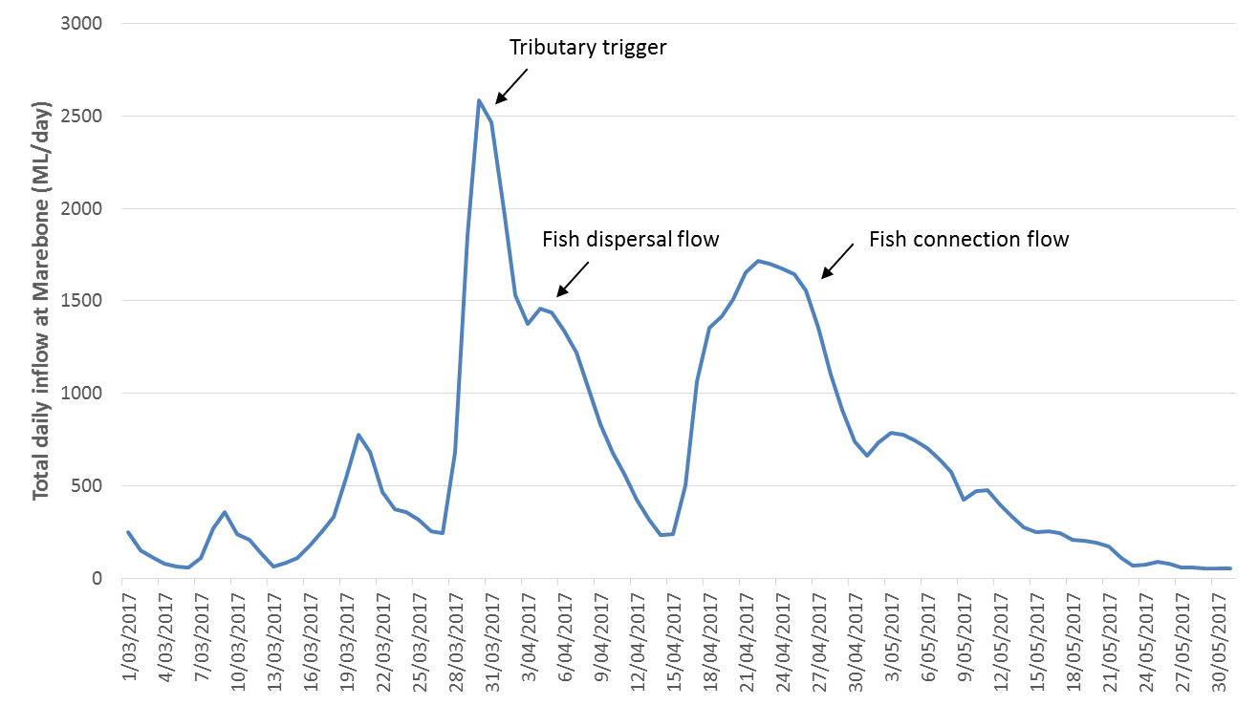

Figure 1. Tributary trigger and subsequent multi-peaked event that contributed to fish dispersal and movement (flow data sourced from <http://realtimedata.water.nsw.gov.au/water.stm>)

### Event timeline

Significant local rainfall events of 90.4 mm on 13-14th March and 132mm over 21-30th March (measured at Dubbo Airport, BOM weather station) caused a natural rise in the river via tributary contributions and overland run-off.

Flow augmentation then occurred for six days with a combination of 2648 ML of Commonwealth Licenced Annual Environmental Water, 448 ML of NSW Licensed Water and 3385 ML of Planned Environmental Water (Translucent & Active sub-allowances) released from Burrendong Dam. This flow was designed to support in-channel processes and a fish return flow event to support redistribution of young of year fish as per the Macquarie Cudgegong Annual Environmental Watering Plan for 2016-17.

This resulted in a 27 day multi-peaked event with an initial small peak of 1531 megalitres per day (ML/d) on 14/03/2017 at Baroona Gauge (421127) downstream of Dubbo (rise and fall over 5 days with maximum 0.48 m height change) then dropping to a short 2 day recession before reaching a second peak of 4333 ML/d on 27/03/2017 (rise and fall over 20 days with maximum 1.24 m height change). This event continued downriver to reach Marebone Weir and beyond (peak of 2477 ML/d at Marebone D/S gauge (421090) on 30/3/17 with a maximum height change of 3.56m from pre-event baseflow).

Following the dispersal flow, 27,583 ML of Commonwealth environmental water was delivered over approximately 30 days to provide a second flow pulse to achieve connection with the Barwon River. Deliveries commenced at Marebone Weir on 16 April 2017 and ceased on 15 May 2017 achieving connection through the system between Burrendong Dam and the Barwon River. Water continued to flow at a low rate out of the Marshes into the lower Macquarie at Bells Bridge through to the end of June.

**13-14th March 2017**: Rainfall event in mid-Macquarie River area

**21-30th March 2017**: Secondary rainfall event

**27th March 2017:** Commenced flow augmentation release from Burrendong Dam

**8th April 2017:** Additional flow released from Burrendong Dam to facilitate the Lower Macquarie fish connection flow

**12th April 2017:** Flow arrived at Miltara Gauge (421135) in the Lower Macquarie River system via the Northern Macquarie Marshes Bypass Channel.

**16th April 2017:** Fish connection flow arrived at Marebone Weir @ 230 ML/day. Delivery of the connection pulse began arriving at Marebone Weir.

**23rd April 2017**: Flow peak of 1715 ML/day arrives at Marebone Weir

**24th April 2017**: Northern Macquarie Marshes Bypass Channel closed

**30th April 2017**: Connection flow arrives at Macquarie-Barwon River confluence

**5th May 2017**: Release concluded from Burrendong Dam

**15th May 2017**: Tail of event passes Marebone Weir with a total 27,583 ML of Commonwealth Licenced Annual Environmental Water delivered over a period of 29 days

**26th May 2017**: Conclusion of managed event @ Carinda gauge (Bells Bridge, 421012)

### Flow pathways

Downstream of Marebone Weir, the majority of the flow was directed down the mainstem Macquarie River (Figure 2). The remainder of the flow was directed via Oxley Break and through the Bora system to the eastern side of Northern Marshes via natural flow-paths. The Northern Macquarie Marshes Bypass channel was opened for part of the event (from 10th -24th April 2017) to allow a volume of water through to avoid a significant lag in flow and prevent de-coupling the regulated water release component from the natural flow priming event. The recession on the hydrograph for Miltara (Figure 3) in late April indicates where the flow directed through the Northern Marsh then combined with the flows directed down the Northern Marsh Bypass Channel.

In order to accurately record the flow event, an additional gauging station was installed at Brewon Bridge by Water NSW to provide hydrological data during the delivery to the Barwon River from the Macquarie River during May to July 2017 (WaterNSW, 2017).

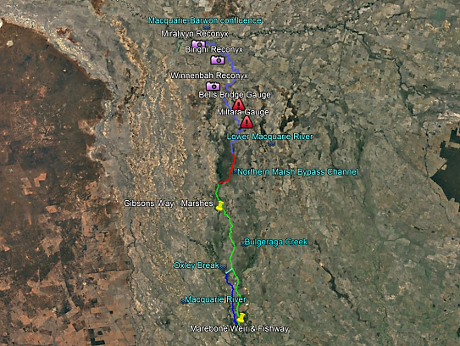

Figure 2. Event flow paths, camera locations & stream gauging points, Macquarie system downstream of Marebone Weir.

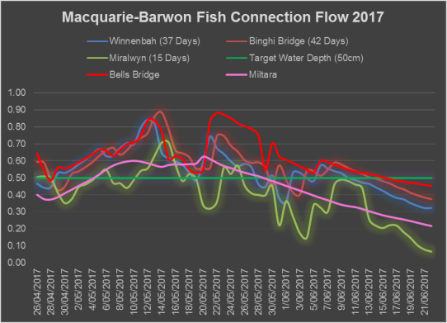

Figure 3. Macquarie River main channel flow heights (m) recorded via river gauges, reconyx cameras and staff gauges during the 2017 flow event. (Note: this data shows relative height only, i.e. changes in water height, and are not tied to any ADH reference point). (Source: NSW OEH).

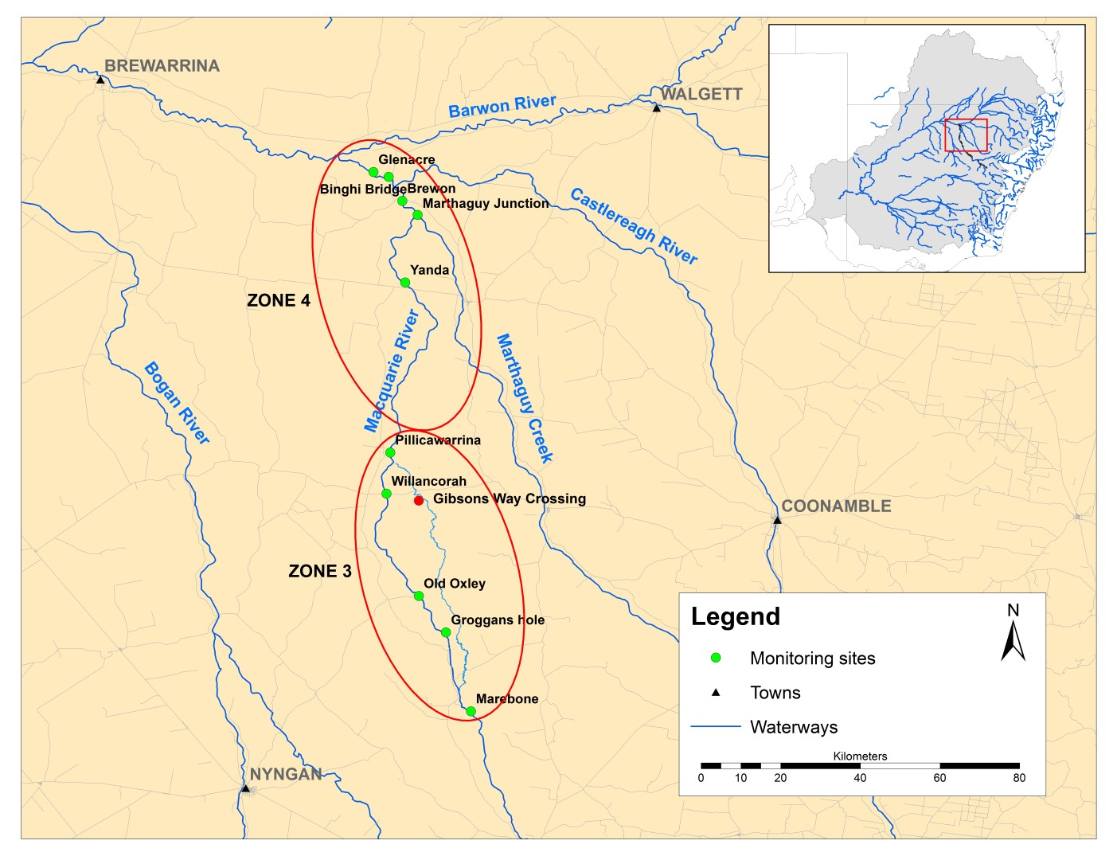

Figure 4. Location of sample sites in the Lower Macquarie River focus reach. (Note: Sample site coordinates are provided in Appendix 2)

# 3.0 Methods

## 3.1 Field Sampling

### Site Selection

Given the scope and broad aims of this project, established temporal sites previously sampled as part of previous and on-going intervention monitoring were chosen for fish assemblage sampling (see Stocks *et al* 2015, NSW DPI BPEOM project-unpublished data). The 10 sampling sites selected for this project corresponded to those within Zones 3 and 4 of the lower Macquarie River (Figure 4, Appendix 2).

Additional to standardised fish assemblage sampling, targetted fyke netting was proposed at four sites within Zones 3 and 4 (Figure 4, Appendix 2). An additional site, Gibsons Way Crossing (-30.89341, 147.57080) within the Bulgeraga Creek was opportunistically sampled during netting operations as flows were found to be moving through this system and was identified as a possible movement pathway for native fish.

### Standardised fish assemblage sampling

Prior to environmental water delivery, standardised fish sampling was undertaken at 10 sites (Figure 4, Zones 3 and 4) between 12April and 23 April 2017. Post water delivery sampling was undertaken at the same 10 sites between 30 May and 3 June 2017.

Sampling protocols used were those developed for the Murray Darling Basin Authority’s Sustainable Rivers Audit (SRA) – Fish Theme (MDBA 2008, Davies *et al* 2010). These are based on standardised boat and/or backpack electrofishing, in addition to 10 un-baited concertina type shrimp traps. A boat electrofishing system (2.5kW Smith-Root model GPP) was used at those sites where a boat could be navigated. Twelve boat electrofishing operations, each consisting of 90 seconds of electrofishing (power on) were done at each electrofishing site. A backpack electrofishing system (Smith-Root model LR24) was used at those sites too shallow to be navigated by boat. Eight backpack electrofishing operations, each consisting of 150 seconds of electrofishing (power on) were done at these sites. In addition to standardised sampling protocol, 5 baited opera-house nets were also set for the duration of sampling at each site in order to quantify decapods and crustaceans (crayfish, shrimps and crabs as part of a NSW initiative to collect baseline data on freshwater macro-crustacean species).

The proportion of boat or backpack / bank electrofishing shots was dependent on the size of the waterbody and habitats present. Electrofishing was conducted in each of the main habitat types present at a site in proportion to its relative extent. During each electrofishing sampling shot, stunned fish are netted and placed in an aerated live-well (boat fishing) or bucket (backpack fishing). On completion of each shot, captured fish are identified to species, length measured to nearest mm, individual fish greater than 100 mm long are weighed to nearest gram, visually checked for parasites, signs of disease or wounds and released at their point of capture.

Water quality parameters (temperature (°C), pH, dissolved oxygen (mg/L), conductivity (µs/cm), turbidity (NTU) and secchi depth (m)) were recorded using a Horiba U52 water quality meter at each site on the date of sampling. Water quality was assessed at 0.2m below the water surface.

### Directional fyke netting

Directional fyke netting was undertaken at key sites (throughout zones 3 and 4) between 8May and 13 May 2017 with the aim of detecting movement of fish into or out of the system. An additional site at Gibsons Way on the Bulgeraga Creek was also opportunistically sampled. At each site a paired set of large (25mm mesh) and small (3mm mesh), double-wing fyke nets was set overnight. Nets were set parallel to the bank and set in an upstream and downstream direction (Figure 5). Each site was sampled three (3) times (3 replicate sets) over the six (6) day period during the peak of the flow delivery. Site and net location (left/right bank) was randomised to minimise bias. Nets were retrieved the following morning, captured fish identified, measured (nearest mm), weighed (nearest g; if > 100mm TL), checked for visual parasites or wounds and released unharmed. At each sampling site net direction (upstream/downstream facing) and net set/retrieval times was recorded for use in data analyses.

Water quality parameters (temperature (°C), pH, dissolved oxygen (mg/L), conductivity (µs/cm), turbidity (NTU) and secchi depth (m)) were recorded using a Horiba U52 water quality meter at each site on the date of sampling. Water quality was assessed at 0.2m below the water surface.

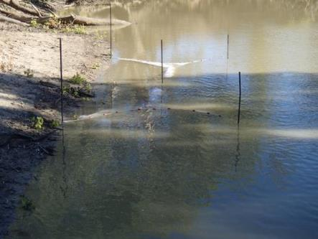

Figure 5. A paired set of small mesh (3mm) fyke nets (R.Price)

## 3.2 Data Analysis

### Fish community composition

The catch from each electrofishing operation and bait traps for each sampling event per site was pooled for data analysis. Multivariate analyses of the fish assemblage composition were performed in PRIMER 7.0 (Plymouth Marine Laboratory). To compare spatial and temporal variation in the fish community composition, species abundances were transformed to the fourth root with the addition of a ‘dummy’ variable after shade plot inspection. Similarities between fish assemblages for each sample were calculated using a Bray–Curtis similarity matrix. Non-metric multi-dimensional scaling (nMDS, PRIMER v7) ordination plots were constructed for visual comparisons of dissimilarity between community composition for factors of zone and sampling event (pre vs post connection flow) based on the Bray–Curtis similarity matrix.

Permutational analysis of variance (ANOVA)/multivariate ANOVA (MANOVA) (PERMANOVA, PRIMER v7) was used to test for any significant differences in the fish community composition between zones and sampling event.

### Abundance of recruits

The abundance of new recruits collected during each sampling event was analysed for factors of zones and sampling event using parametric univariate ANOVA after square root transformation. For golden perch, bony bream and common carp, an individual was considered to be a recruit if the body length was less than that of a 1 year old of the same species. The recruitment length cut-offs were derived from existing length-at-age data from scientific literature (bony bream= 67mm (Cadwallader, 1977), golden perch = 75mm (Mallen-Cooper and Stuart, 2003), spangled perch = 68mm (Leggett and Merrick) goldfish = 127mm (Lorenzoni et al 2007) and common carp = 155mm (Vilizzi & Walker, 1999).

### Directional fyke netting

The catch of abundant species (golden perch, bony bream, spangled perch and common carp) caught in upstream and downstream facing directional fyke nets set during the connection flow were compared using parametric univariate ANOVA after square root transformation. Directional fyke nets were set at 4 sites, however, only sites at which the species being analysed was captured were used in the analyses.

### Otolith processing and daily aging

Young-of-year (YOY) golden perch were retained during sampling for daily age determination and the construction of length-at-age growth functions. We employed the methodology described in Stocks *et al*. (2014) to examine and enumerate daily growth rings in otoliths of juvenile golden perch. The sagittal otoliths (sagittae) were extracted and mounted on a microscope slide using crystalbond mounting adhesive (Structure Probe Inc., West Chester, Pennsylvania, USA). Otoliths were polished by hand to the core from the dorsal and ventral margins otolith margins on 9 μm lapping film until daily growth increments became visible. A camera (Q-Imaging, MicroPublisher 5.0 RTV, Canada) attached to a compound microscope collected an image of each otolith examined (Figure 10). Multiple images were collected throughout the polishing process and the images re-stitched prior to aging due to the varying ring visibility with section thickness between primordium and otolith margins. Sectioned otoliths were viewed under a compound microscope using transmitted light at 100× magnification. Daily rings were counted radially from the primordium to outer otolith edge (see Figure 9) using ImageJ, a digital image analysis program (http://rsb.info.nih.gov/ij/). A 20% re-read of randomly chosen otoliths was used to calculate a coefficient of variation for the two reads using the equation described in Campana (2001).

### Recruitment and hydrography

A random sample of approximately 20 golden perch individuals covering the YOY size range were aged. Multiple growth functions were fitted to golden perch length-at-age, however, a linear regression model provided the best fit.

Due to resource and time constraints not all YOY golden perch were aged, rather the ages of YOY golden perch were estimated from length measurements using the species growth model equation. Estimates of fish age were not extrapolated beyond the largest fish aged when constructing the growth functions.

The frequency of back-calculated hatch dates of young-of-year golden perch collected during each round of standardised sampling (SRA protocol) was plotted with water temperature and river discharge to identify if hatch/spawning dates coincided with a specific feature of the hydrograph.

# 4.0 Results

### Standardised fish assemblage sampling

A total of 4671 individual fish from 9 fish species were sampled across the two sampling events (Pre-flow delivery and post-flow delivery, Tables 3 and 4). Of these, three species and 4320 fish (92.5%) were introduced (goldfish, common carp, eastern gambusia), with this proportion remaining consistent across sampling events (pre 91.3% and post 93.3%). Bony bream was the most abundant native species contributing to 4.0% overall (pre 4.5% and post 3.6%) while golden perch were the second most abundant, albeit at only 1.9% overall (pre 1.7%, post 2.1%).

Total numbers (all species combined) were greater in Zone 4 (59.3%) in comparison to Zone 3 (40.7%) and also when compared across sampling events.

Across sampling events, native species richness was similar between zones and within sites, although Zone 4 sites were consistently more diverse. No sites recorded all six native species detected during sampling (Table 4). Bony bream were the most widely distributed native species, present at all sites within the two zones. Golden perch were similarly dispersed throughout the focus reach, being detected at the majority of sites, including the upper (Marebone) and lowest site (Glenacre). Murray cod (*Maccullochella peelii*) were in very low numbers and only detected at the upper two sites in Zone 3. Spangled perch were detected throughout both zones with a greater abundance sampled within zone 4 during both events (pre- and post-water delivery). No recruits of Murray cod or spangled perch were detected.

Young-of-year (YOY) golden perch (<75mm TL) were detected in small numbers at lower Macquarie River sites (zone 4) prior to water delivery and increased in numbers considerably following the re-connection with the Barwon River (Figure 6). Very few adult golden perch were detected at sites within either zone prior to the watering event, however, the proportion of adults increased following water delivery, most noticeably in the lower sites (Zone 4).

Standardised sampling did not detect the following native species known to occur within the lower Macquarie River; Australian smelt (*Retropinna semoni*), freshwater catfish (*Tandanus tandanus),* un-specked hardyhead (*Craterocephalus stercusmuscarum*), flat-headed gudgeon (*Philypnodon grandiceps*).

Table 3. Fish species detected during standardised fishing and fyke netting operations undertaken in the Macquarie River during April – June 2017.



Table 4. Total catch by site and sampling round (Pre and Post water delivery) from standardised fishing (SRA protocol) undertaken in the Macquarie River during April – June 2017. Sites are arranged upstream to downstream (top to bottom).



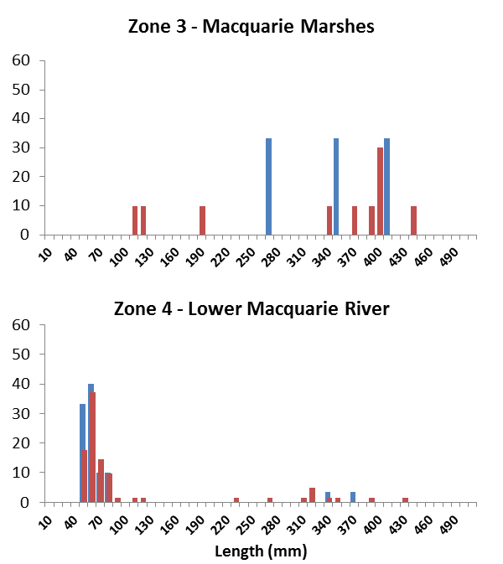

Figure 6. Cumulative frequency histograms of Golden perch from combined sampling methods (electrofishing and netting) within two zones over two sampling rounds. (Blue histogram - Pre water delivery, Red histogram – Post water delivery). X-axis shows total length. Young-of-year (YOY) length cut-off (<75mm TL) is shown as a dashed line

### Directional fyke netting

A total of 1435 individual fish from 9 fish species were sampled from the five sites during netting operations (Table 5). Consistent with results from standardised electrofishing, introduced species (goldfish, eastern gambusia, common carp,) dominated the total catch (although by a smaller percentage) contributing 64% of the total abundance. Carp gudgeon and bony bream were the most abundant native species contributing 20.1% and 11.8% respectively.

With the exception of Murray-Darling rainbowfish and Hyrtl’s tandan (due to the capture of only single individuals of each) all species detected were recorded in upstream and downstream facing fyke nets. Spangled perch were the only species to show a significant upstream migration trend, however, only at a single site (see Movement and Connectivity section below). Golden perch were caught at 3 of the 5 sites with juveniles (53mm and 61mm) and adult perch (321 mm and 320 mm) detected heading upstream at the most downstream site (*Glenacre*). The highest abundance of YOY golden perch were detected at the Yanda site (n=8, 68-112mm), all heading in an upstream direction. No juveniles or adult golden perch or spangled perch were detected at sites upstream of Yanda (Old Oxley and Willancorah) with introduced species dominating these sites.

Hyrtl’s tandan, a medium bodied river channel specialist more commonly found in the Paroo/Barwon/Darling River system, were detected at the most downstream site (*Glenacre*, Figure 7).

Table 5. Total catch by site from directional fyke netting undertaken in the lower Macquarie River region. (Note: Gibsons Way crossing was opportunistically sampled and was located on the Bulgeraga Creek not the Macquarie River).



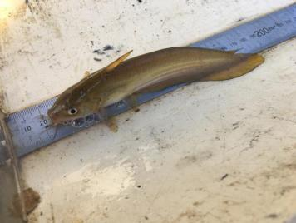

Figure 7. Hyrtl's tandan captured as part of targeted fyke netting operations in the lower Macquarie River

### Fish community composition

Multivariate analyses of the fish community composition indicated no significant difference between pre and post connection flow sampling (Figure 8, Table 6). However a significant difference in the fish community composition was identified between the two sampling zones (Figure 9, Table 6).

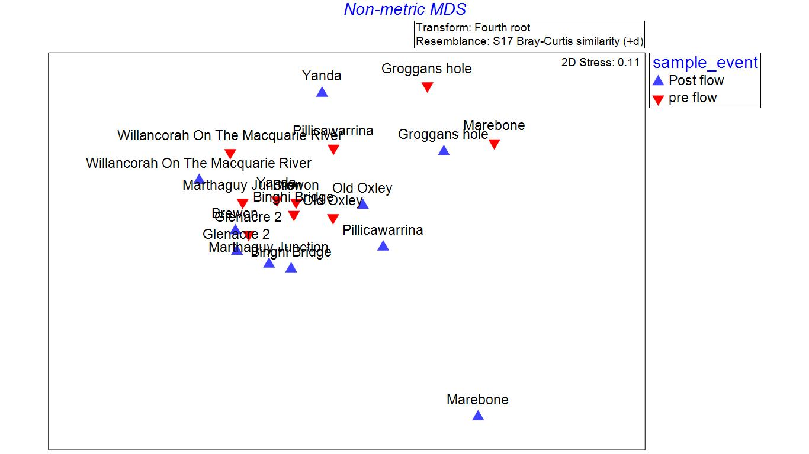

Figure 8. Non-metric multi-dimensional scaling (nMDS) plot illustrating dissimilarity in community composition between sampling events.

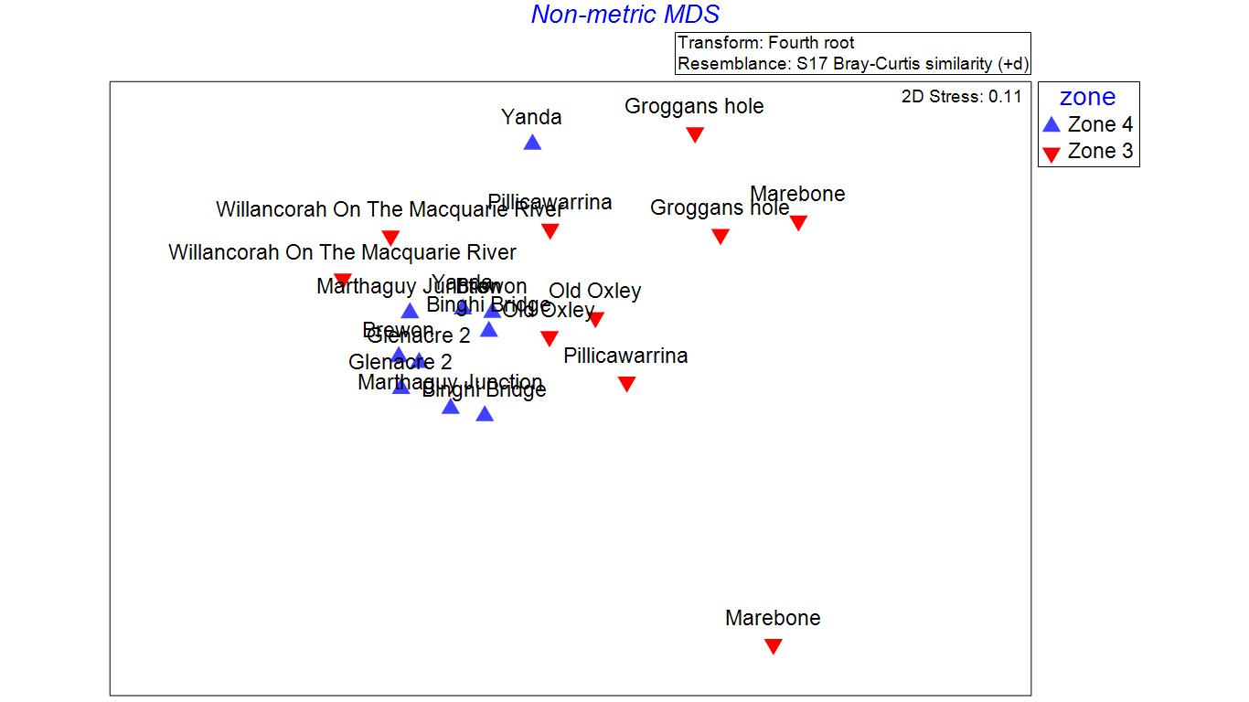

Figure 9. Non-metric multi-dimensional scaling (nMDS) plot illustrating dissimilarity in community composition between sampling zones.

Table 6. Results of PERMANOVA test examining fish community composition with zone and sampling event as factors.

|  |  |  |  |  |  |  |
| --- | --- | --- | --- | --- | --- | --- |
| Source | df | SS | MS | Pseudo-F | P(perm) | Unique perms |
| Sample event | 1 | 789.55 | 789.55 | 2.0426 | 0.082 | 999 |
| Zone | 1 | 1992.2 | 1992.2 | 5.1539 | **0.004** | 999 |
| Event x Zone | 1 | 393.5 | 393.5 | 1.018 | 0.426 | 999 |
| Residuals | 16 | 6184.6 | 386.54 |  |  |  |
| Total | 19 | 9359.9 |  |  |  |  |

### Abundance of recruits

No significant difference was observed between the abundance of new recruits in pre and post connection flow sampling. However, significantly higher abundances for some species, golden perch for example, were observed in Zone 4 as compared to Zone 3 (Table 7).

Table 7. Results of ANOVA examining the abundance of recruits with zone, species and sampling event as factors.

|  |  |  |  |  |  |
| --- | --- | --- | --- | --- | --- |
| **Source** | **df** | **Sum Sq** | **Mean Sq** | **F value** | **Pr(>f)** |
| Sample event | 1 | 0.38 | 0.38 | 0.25 | 0.619 |
| Zone | 1 | 81.94 | 81.94 | 54.415 | **<0.05\*** |
| Species | 2 | 172.32 | 86.16 | 57.217 | **<0.05\*** |
| Sample event x Species | 2 | 0.06 | 0.03 | 0.02 | 0.98 |
| Sample event x Zone | 1 | 0.44 | 0.44 | 0.294 | 0.59 |
| Zone x Species | 2 | 63.6 | 31.8 | 21.12 | **<0.05\*** |
| Sample event x Zone x Species | 2 | 0.12 | 0.06 | 0.039 | 0.962 |
| Residuals | 48 | 72.28 | 1.51 |  |  |

### Recruitment and Hydrology

In total 18 YOY golden perch were daily aged to construct the length at age growth model (Figure 10). The largest fish aged was 86 mm TL and estimated at 160 days old; the smallest fish was 47 mm and aged 98 days old. The growth function can be represented by the equation:

*Age (days) = (total length – 6.2166)/0.443*

Estimated daily age and sample date were used to determine the date of birth (DOB) of YOY golden perch. All YOY sampled during standardised pre and post connection flow sampling had back-calculated hatch dates between October 27th 2016 & February 21st 2017 on the receding tail of a large natural flow event within the Macquarie and Barwon River when water temperatures were between 22-32°C (Figure 11).

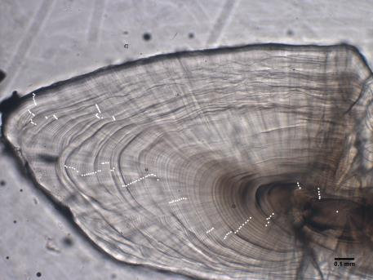

Figure 10. Daily aged otolith of a 55 mm (Total Length) golden perch. Estimated age is 116 days.

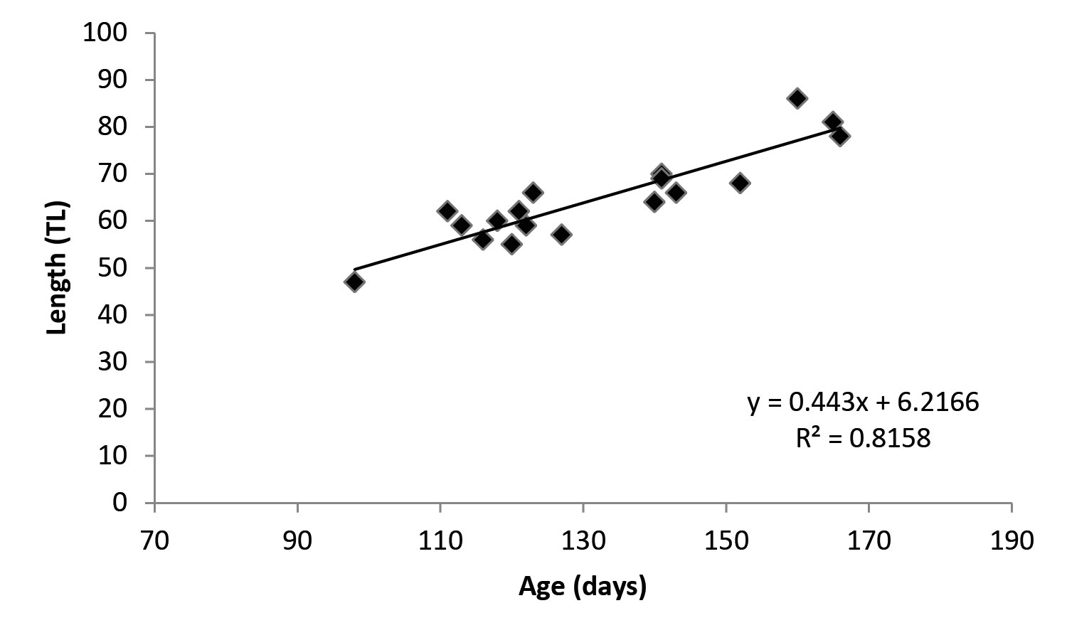

Figure 11. Length-at-age data for young-of-year golden perch with linear growth function fitted.

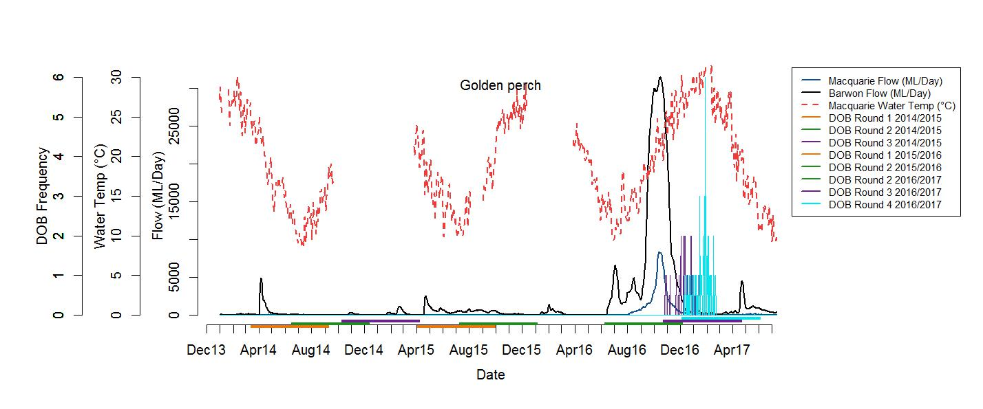

Figure 12. Frequency of back-calculated hatch dates for daily aged juvenile golden perch sampled from the lower Macquarie River over three years from eight sampling events.

*Note: Hydrology and water temperature are displayed (hydrograph data: Geera & Carinda Gauging Station; water temperature: Carinda Gauging Station). Coloured bars indicate the ‘focus period’ for each sample. The ‘focus period’ extends to earliest date to which a hatch date could be assigned to fish from each sampling event, based upon the maximum size/age to which daily aging was possible. A larger focus period could likely be assigned to golden perch however no juvenile recruits >180 days old/86 mm TL were sampled during the present study.*

### Movement and Connectivity

ANOVA results indicated the orientation of directional fyke nets set during the connection flow only significantly affected catch rates of spangled perch (Table 8). Pairwise comparison of the three way interaction term for spangled perch revealed a significantly greater abundance of spangled perch caught in large mesh fyke nets at Yanda orientated downstream as compared to those facing upstream. For bony bream, golden perch and spangled perch the catch from direction fyke nets only varied between the two mesh sizes. For common carp, site had a significant effect on the total catches of directional fyke nets.

### Water Quality

In general, water quality parameters measured throughout the lower Macquarie River fell within the relevant Australia and New Zealand Environment and Conservation Council (ANZECC) guidelines for NSW lowland rivers (ANZECC and ARMCANZ 2000). However, at a number of locations, water quality parameters were outside the ANZECC trigger values (Appendix 3 and 4).

Table 8. Results of ANOVA examining abundance of a) common carp, b) spangled perch, c) golden perch &, d) bony bream caught in directional fyke nets with fyke direction (upstream/downstream), site & mesh as factors in the model.

1. Common carp

|  |  |  |  |  |  |
| --- | --- | --- | --- | --- | --- |
| **Source** | **df** | **Sum Sq** | **Mean Sq** | **F value** | **Pr(>f)** |
| Fyke direction | 1 | 0.13 | 0.13 | 0.488 | 0.4899 |
| Site | 3 | 3.255 | 1.0851 | 4.072 | **<0.05\*** |
| Mesh | 1 | 0.55 | 0.5502 | 2.065 | 0.1604 |
| Direction x Site | 3 | 0.035 | 0.0117 | 0.044 | 0.9876 |
| Direction x Mesh | 1 | 0.086 | 0.0861 | 0.323 | 0.5736 |
| Site x Mesh | 3 | 0.389 | 0.1296 | 0.487 | 0.694 |
| Direction x Site x Mesh | 3 | 0.551 | 0.1838 | 0.69 | 0.565 |
| Residuals | 32 | 8.527 | 0.2665 |  |  |

1. Spangled perch

|  |  |  |  |  |  |
| --- | --- | --- | --- | --- | --- |
| **Source** | **df** | **Sum Sq** | **Mean Sq** | **F value** | **Pr(>f)** |
| Fyke direction | 1 | 3.129 | 3.129 | 18.054 | **<0.001\*** |
| Site | 1 | 1.113 | 1.113 | 6.425 | **<0.05\*** |
| Mesh | 1 | 3.561 | 3.561 | 20.549 | **<0.001\*** |
| Direction x Site | 1 | 1.74 | 1.74 | 10.038 | **<0.01\*** |
| Direction x Mesh | 1 | 1.442 | 1.442 | 8.319 | **<0.05\*** |
| Site x Mesh | 1 | 0.828 | 0.828 | 4.775 | **<0.05\*** |
| Direction x Site x Mesh | 1 | 1.377 | 1.377 | 7.945 | **<0.05\*** |
| Residuals | 16 | 2.773 | 0.173 |  |  |

1. Golden perch

|  |  |  |  |  |  |
| --- | --- | --- | --- | --- | --- |
| **Source** | **df** | **Sum Sq** | **Mean Sq** | **F value** | **Pr(>f)** |
| Fyke direction | 1 | 0.3028 | 0.3028 | 1.982 | 0.1783 |
| Site | 1 | 0.0163 | 0.0163 | 0.107 | 0.7482 |
| Mesh | 1 | 0.8229 | 0.8229 | 5.386 | **<0.05\*** |
| Direction x Site | 1 | 0.4841 | 0.4841 | 3.169 | 0.094 |
| Direction x Mesh | 1 | 0.5801 | 0.5801 | 3.797 | 0.0691 |
| Site x Mesh | 1 | 0.1149 | 0.1149 | 0.752 | 0.3986 |
| Direction x Site x Mesh | 1 | 0.2347 | 0.2347 | 1.532 | 0.233 |
| Residuals | 16 | 2.4444 | 0.1528 |  |  |

1. Bony Bream

|  |  |  |  |  |  |
| --- | --- | --- | --- | --- | --- |
| **Source** | **df** | **Sum Sq** | **Mean Sq** | **F value** | **Pr(>f)** |
| Fyke direction | 1 | 0.05 | 0.05 | 0.018 | 0.8958 |
| Site | 1 | 4.63 | 4.63 | 1.54 | 0.2325 |
| Mesh | 1 | 20.19 | 20.19 | 6.722 | **<0.05\*** |
| Direction x Site | 1 | 0.88 | 0.88 | 0.292 | 0.5963 |
| Direction x Mesh | 1 | 0 | 0 | 0 | 0.985 |
| Site x Mesh | 1 | 8.05 | 8.05 | 2.68 | 0.1211 |
| Direction x Site x Mesh | 1 | 1.44 | 1.44 | 0.48 | 0.4985 |
| Residuals | 16 | 48.05 | 3.003 |  |  |

# 

# 6.0 Discussion

This project focussed on the short-term ecological response to two managed environmental watering actions in the Macquarie-Castlereagh valley; the first being a within valley connection along the system and secondly, the augmenting of that flow to reconnect the Macquarie to the Barwon River. The main aim was to facilitate the upstream movement of juvenile flow dependent, periodic species, specifically, golden perch (*Macquaria ambigua*), silver perch (*Bidyanus bidyanus*) and spangled perch (*Leiopotherapon unicolor*) from the Barwon River along migrational pathways into the Macquarie catchment. The results of this study have implications for the long-term management of the Macquarie River system.

Juvenile golden perch and other species had limited opportunity to move into the lower Macquarie (from the Barwon River) during the brief connection period between the systems in early May 2017. However, following the delivery of environmental water (resulting in a change in flow and hydraulic variability) a significant difference was observed between the two sampling zones, presumably driven by the greater abundance of all species (native and introduced) at sites in the lower zone in comparison to the total catch at sites in the upstream zone (zone 3). Importantly, golden perch responded the most favourably of all native species to the environmental flow delivery with numbers of young-of-year and adults increasing following water delivery, predominantly within zone 4. Spangled perch and bony bream were detected in similar numbers between water delivery events and within zones.

Golden perch juveniles spawned in the Barwon-Darling system with hatch dates later than December 2016 (Figure 12) were unlikely to be sufficiently physically developed enough to have moved into the Macquarie system prior to the connection event. This may indicate that different birthdate cohorts of juveniles are highly attuned to respond to and utilise flow events opportunistically when their stage of physical development allows. In the absence of natal origin information, the possibility that the juveniles may have been spawned in the Macquarie-Castlereagh system and had moved downstream and were on a return journey upstream cannot be discounted. However, the lack of detection of juveniles in previous sampling efforts makes this scenario less likely. It also must be noted that in the absence of the connectivity flow, it is certain that no fish would have been sampled at some sites as they would have been without water entirely. From this we can surmise that the event provided temporary habitat and additional movement opportunities and partially redressed the connectivity deficit.

Directional fyke netting during the flow delivery detected juvenile golden perch migrating in an upstream direction along with other channel specialists such as spangled perch (*Leiopotherapon unicolor*). Golden perch were also found to be migrating upstream using smaller anabranch systems such as the Bulgeraga Creek. The significant differences observed between zones in overall total abundance and abundance of golden perch recruits, suggests that several in-stream structures may be restricting upstream movement and connectively to the broader catchment and warrants further investigation. Significantly, fyke netting at the lower *Glenacre* site detected Hyrtl’s tandan, a medium-bodied species more commonly found in the Paroo, Warrego, Condamine and Barwon River system (McDowall 1996). This single record represents the first capture of the species by DPI Fisheries in the Macquarie River. Previously, they had been recorded in studies conducted by others in the lower Macquarie River (University of NSW, unpublished data) and nearby in the lower Bogan River following higher flows in the Barwon River during 2011-12 (DPI Fisheries unpublished data).

The Marebone site was an obvious outlier during post connection flow sampling possibly driven by the fact that it was the only site to detect Murray cod and Murray-Darling rainbowfish in the first sampling event. Follow-up surveys failed to detect the two species and a smaller total number of fish were sampled at the site following the e-flow delivery. Murray cod have rarely been detected in the lower reach of the Macquarie River, possibly due to the lack of low-flow refugia during dry periods (Rayner *et al* 2009). Additionally, the Marebone weir fishway may not have been operating optimally during this period (see Fish passage section below).

Limited evidence of native fish recruitment was observed within the lower Macquarie River zones, with low numbers of recruits detected for golden perch, bony bream and spangled perch. Strong recruitment was observed for goldfish and to a lesser extent common carp. Total abundance of all recruits (native and introduced species) was significantly higher in zone 4, potentially due to the inundation of the Macquarie marshes (acting as a nursery) or instream barriers preventing upstream movement and recolonization of upstream reaches.

The modification of the hydrological regime in the lower Macquarie River has impacted on the native fish assemblage reducing the diversity and abundance of some species and/or certain life stages (Rayner *et al* 2009). The native fish population in the lower Macquarie River remains in a ‘poor’ state with results from this study consistent with previous surveys (SRA, Davies *et al* 2008, 2010, MDBA 2011, Rayner *et al* 2009, Jenkins *et al* 2004). Native species richness is low in comparison to historical ‘reference condition’ for the Lowland Macquarie River zone (Davies *et al* 2008) and introduced species dominated fish abundance and biomass. In order to facilitate recovery, critical population thresholds of native fish need to be maintained and opportunities for dispersal are required through connectivity so natural range and distribution do not continue to decline.

#### Daily aging and natal origin

It is unlikely that juvenile golden perch were recruited in the lower Macquarie given the small adult population size and although they may have originated from upstream of Marebone, results from previous studies (Stocks et al 2015) and ongoing monitoring (DPI Fisheries unpublished data) has failed to detect golden perch recruits. It appears that golden perch recruited on the receding tail of the large flow event within the Barwon River. Larval fish monitoring undertaken by an independent fish ecologist (CPS Enviro P/L) within the Darling/Barwon Rivers during the high-flow event in October-November 2016 detected drifting larval golden perch at several locations from Walgett to below Bourke.

Through the otolith analysis, the maximum age of juvenile golden perch indicated that the birthplace of the juvenile cohorts detected in the study was the Barwon-Darling River itself or potentially any of the tributaries entering the Barwon-Darling upstream of Bourke. The Bourke Weir presents a significant barrier to migration of all species and size classes of fish, with movement opportunities over the weir estimated to occur during flow events of 10,000 ML/day or greater. Larval and early juvenile drift of golden perch in the main channel of the Darling River has been previously determined to occur for at least 38 days from spawning (Sharpe, 2011). Given the earliest hatch-date was calculated to be October 27th 2016, individuals born around or after this date downstream or drifting downstream of the weir would not have the physical development and swimming ability to take advantage of the weir drown-out event that ceased around 18th November 2016. Tributaries that displayed an event that would have notionally supported a golden perch spawning event within the early hatch-date timeframes include the Culgoa, Bogan, Macquarie, Marthaguy, Castlereagh, Namoi, Weir, Moonie, Dumaresq and Mehi Rivers. Stocking efforts of golden perch at sites in the Barwon River and Namoi catchment also occurred in early 2017, so it is possible that some of the juveniles detected in the lower Macquarie may have been hatchery-bred fish from a number of sources (Craig Watson – Fisheries Manager NSW DPI, pers. comm.).

Local future research work could potentially examine the role of the connected Marthaguy and Castlereagh systems as other contributors to populations of Macquarie fish. Further research is required to determine natal origin of the individual fish that were collected during sampling through otolith isotopic analysis. This will assist in determining potential source populations of particular species and equip water managers with better information for flow requirements and connections required to support meta-populations of native fish.

#### Refining connection event parameters and triggers

Based on findings calculating the known age of juvenile collected golden perch, the youngest fish detected in this study were 47 mm in length and aged at 98 days when collected. Assuming these YOY fish were emigrants from outside the Macquarie, as a guide, with juvenile migration being the prime objective, managed or augmented connection events could be designed to occur no earlier than a specified number of days post an identified fresh/spawning event in the Northern Basin. In the absence of further analysis revealing catchment of origin, the assumption that the earliest a connection event could take place post spawning fresh could be 100 days, if juvenile golden perch movement was the primary objective. This event would be ideally in conjunction with a secondary natural fresh within the water source to cue movement.

In order to facilitate movement opportunities for adults, connection events between catchments could be set at any time, but preferably in conjunction with a natural fresh event in either the contributing or receiving stream (or ideally both) to cue movement. Length of event could be set at a minimum +25 days of actual connectivity, but ideally between 40 -100 days. This is based on local historical connection information and would restore a portion of medium length events and provide adequate opportunity for fish movement that has not been present under the current regime for the past decade at least. The detection of a suite of native fish of different size classes indicated that the prescribed depth of flow (0.5m) was likely to be adequate to achieve the objectives.

#### Fish Passage

A number of unrecorded barriers to fish passage (Appendix 5, Plates 1 & 2) and fish passage issues were identified along the flow pathways of the connection event. It was determined that at the event flow heights, a gravel causeway adjacent to Brewon Bridge and a multi-pipe culvert crossing at Miralwyn were not presenting an obstruction to fish movement. However, if flows were higher, the velocity through the pipe culvert is likely to cause issues. A low-head weir on the Macquarie River upstream of Gibson Way (Appendix 5, Plate 3) is likely to obstruct fish passage during low flows. It is also noted that the tilt gates at the Marebone Weir fishway that creates an attractant flow were not open during the event. Any flows being passed through the sluice gates of the main weir would create an attractant flow away from the fishway entrance and the success of fish locating the fishway entry slot and successfully moving upstream would be greatly compromised. The Marebone weir is an undershot structure and if the gates are not lifted clear of the water, the structure creates hydraulic conditions that cause a change in hydrostatic pressure which can be harmful to fish (Baumgartner *et al* 2006). Adult, juvenile or larval fish passing downstream through any partially opened sluice gate were at high risk of injury or death. Numerous other recorded man-made barriers exist in other areas of the lower Macquarie including the upper sections of the Bulgeraga Creek (affecting both upstream and downstream passage) and the along the Breakaway Channel (upstream passage) that may obstruct fish movement in future flow delivery pathways under a range of flow conditions. It is acknowledged that these barriers may have influence on the significantly higher abundances for some species that were observed in Zone 4 as compared to Zone 3.

We recognise that fish passage is likely to be a major influence on the ability of River Specialists to effectively undergo large scale migrational movement into and along the Macquarie and solutions should be pursued aggressively. Immediate steps should be taken to remediate priority barriers in the lower Macquarie along key flow/fish migration pathways to establish uncompromised fish passage. A timeframe should be provided for mitigation of state-owned assets managed by Water NSW and NSW National Parks along the Bulgeraga Creek and Breakaway Channel that are obstructing fish migration. Funding sources should be identified to assist with mitigating the privately owned structures. Correct operation of Marebone Vertical Slot Fishway to maintain an attractant flow through the fishway tilt gates is required to optimise future fish passage outcomes at the site during all water deliveries. If flows are required to be regulated through the weir, a formal request that any undershot lift/sluice type gates are raised fully clear of the flow at all times during environmental watering events and at other times where possible to prevent fish mortality should be requested, with an acknowledgment receipt from the operator in writing. Furthermore, a request to Water NSW to formalise operating protocols for Marebone Vertical Slot Fishway and other relevant structures, such as Gum Cowal Regulator in consultation with DPI Fisheries and the Environmental Watering Advisory Group to ensure fish movement outcomes associated with flow management in the Lower Macquarie are optimised.

#### Flow protection

Protecting the integrity of flows as they pass through a system is emerging as a key factor determining connection success and facilitating this should be a focus in planning and legislative frameworks throughout the Basin. Clauses contained within both the regulated and unregulated Macquarie Water Sharing require review and revision to ensure that subsequent events are afforded the highest protection as they pass through and between water source areas.

Water extraction from the Macquarie River downstream of Miltara directly impacted and greatly influenced the shape of the hydrograph and the depth of flow at times during the event. Extraction appears to have lowered the flow heights on several occasions, causing the depth to fall below the critical target of 0.5 m at the Miralwyn staff gauging point and reconyx site. The consequences of this are that migrating fish may be less inclined to move, as attractant provided by flow is diminished and are potentially more vulnerable to predation, as the water column is reduced and the flow pathway contracts. Additionally, migrating fish are also at risk of being directly impacted by low or high capacity pumps extracting water during environmental flow delivery. A study undertaken in the Namoi River by Baumgartner et al (2009) demonstrated that irrigation pumps (low and high volume capacity) were capable of permanently removing fish from the system (entraining them within irrigation infrastructure) and that passage though these pumps resulted in the size-specific injury and mortality of several species.

Whilst we recognise there were some major challenges in operationalising this particular flow event, it is important that water managers and researchers are prepared to incorporate innovation and flexibility into annual watering plans and monitoring programs. Part of the adaptive framework in the Macquarie is to be able to support ‘wildcard’ flow events, use new information to inform science-based decision-making and then set future priorities for management, research and intervention.

# 7.0 Conclusions and recommendations

Conclusions for environmental water managers:

* This project highlights the benefit of environmental water releases creating connectivity between the Macquarie River and Barwon River particularly in synchrony with flow events occurring in the Barwon River.
* Movement of native species, particularly golden perch and spangled perch was shown to be facilitated by flow and connection between the Macquarie River and Barwon River.
* A Hyrtl’s tandan, a medium bodied river channel specialist more commonly found in the Paroo/Barwon/Darling River system, was detected at the most downstream site (*Glenacre*). This single record represents the first capture of the species by DPI Fisheries in the Macquarie River.
* Project highlights the significance of a good working relationship between managers, water holders and scientific agencies.
* Future watering events with a connectivity objective require identified release triggers to be defined in annual watering plans for ease of flow operationalisation and management.
* Adequate legislative protection of environmental flow events from extraction in both the regulated and unregulated Macquarie water sources is required.
* Identified and potential barriers to fish movement within the mid-lower Macquarie River (and associated wetland system) need to be investigated and remediation works prioritised and funding sources identified.

Conclusions regarding science:

* Analysis of otolith microchemistry may provide more certainty about which river system juveniles recruited from; i.e. do flow events that create connectivity between the Barwon and Macquarie River allow for the emigration of juveniles into the Macquarie River?
* Integration of a fish movement telemetry component to any future planned connection events (again, in synchrony with flow events occurring in the Barwon River) may give insights as to how and when adult native fish (e.g. golden perch) move between systems and under what hydrologic conditions. Additionally, within catchment movement constraints caused by barriers to fish movement could also be investigated via telemetry.
* Sampling design for future watering events should consider the addition of sampling sites within the Marthaguy Creek and Castlereagh River in order to quantify and examine the role in which these connected systems contribute to fish populations in the Macquarie River.
* Increased replication of sites for any future directional fyke netting is recommended in order to reduce the amount of variability in catch data.

# References

ANZECC & ARMCANZ 2000. Australia and New Zealand guidelines for fresh and marine water quality. Volume 1, The guidelines / Australian and New Zealand Environment and Conservation Council, Agriculture and Resource Management Council of Australia and New Zealand.

BAUMGARTNER, L.J., REYNOLDSON, N., & GILLIGAN, D.M. 2006. Mortality of larval Murray cod (*Maccullochella peelii peelii*) and golden perch (*Macquaria ambigua*) associated with passage through two types of low-head weirs. *Marine and Freshwater Research*, **57**, 187-191

BAUMGARTNER, L.J., REYNOLDSON, N., CAMERON, L. and STANGER, J.G. 2009. Effects of irrigation pumps on riverine fish. *Fisheries Management and Ecology*, 16, 429-437.

CADWALLADER, P. L. 1977. JO Lantry’s 1949-50 Murray River Investigations. Fisheries and Wildlife Division, Victoria.

CAMPANA, S. E. 2001. Accuracy, precision and quality control in age determination, including a review of the use and abuse of age validation methods. *Journal of Fish Biology,* 59**,** 197-242.

DAVIES, P. E. 2008. *Sustainable Rivers Audit: SRA Report 1, June 2008: A Report on the Ecological Health of Rivers in the Murray-Darling Basin, 2004-2007*, Murray-Darling Basin Commission.

DAVIES, P. E., HARRIS, J. H., HILLMAN, T. J. & WALKER, K. F. 2010. The Sustainable Rivers Audit: assessing river ecosystem health in the Murray-Darling Basin, Australia. *Marine and Freshwater Research,* 61**,** 764-777.

JENKINS, K.M., ASMUS, M.W., RYDER, D.S. and WOLFENDEN B.J. 2004. Fish, Water Quality and Macroinvertebrates in the Macquarie Marshes in Winter and Spring 2003. Report to the MMMC, DEC and DIPNR, University of New England, Armidale.

KOSTER, W.M., DAWSON, D.R., LIU, C., MOLONEY, P.D., CROOK, D.A. and THOMSON, J.R. 2016. Influence of streamflow on spawning-related movemnts of golden perch Macquaria ambigua in south-eastern Australia. Journal of Fish Biology, 90, 93-108.

KERESZY, A., BALCOMBE, S.R., ARTHINGTON, A.H. and BUNN, S.E. 2011. Continuous recruitment underpins fish persistence in the arid rivers of far-western Queensland, Australia. *Marine and Freshwater Research*, 62, 1178-1190.

LEGGETT, R. and MERRICK, J.R. 1987. Australian native fishes for aquariums. JR Merrick Publications.

LORENZONI, M., CORBOLI, M., GHETTI, L., PEDICILLO, C. and CAROSI, A. 2007. Growth and reproduction of the goldfish *Carrasius auratus*: a case study from Italy. In Biological Invaders in inland waters: Profiles, distribution and threats (pp.259-273). Springer Netherlands.

MCDOWALL, R. 1996. Freshwater fishes of South-Eastern Australia. Reed Books, Australia.

MDBA 2011. Sustainable Rivers Audit 2: The ecological health of rivers in the Murray–Darling Basin at the end of the Millennium Drought (2008–2010). Summary.

MDBC 2008. Murray–Darling Basin Rivers: Ecosystem Health Check, 2004–2007. A summary report based on the Independent Sustainable Rivers Audit Group’s SRA Report 1: A Report on the Ecological Health of Rivers in the Murray–Darling Basin, 2004–2007, submitted to the Murray–Darling Basin Ministerial Council in May 2008.

MALLEN-COOPER, M. & STUART, I. 2003. Age, growth and non-flood recruitment of two potamodromous fishes in a large semi-arid/temperate river system. *River research and applications,* 19**,** 697-719.

O’CONNOR ,J.P., MAHONY, D.J. and MAHONY, J.M. 2005. Movements of *Macquaria ambigua*, in the Murray River, south-eastern Australia. *Journal of Fish Biology*, 66, 392-403.

RAYNER, T. S., JENKINS, K. M. & KINGSFORD, R. T. 2009. Small environmental flows, drought and the role of refugia for freshwater fish in the Macquarie Marshes, arid Australia. *Ecohydrology,* 2**,** 440-453.

RAYNER, T. S., KINGSFORD, R. T., SUTHERS, I. M. & CRUZ, D. O. 2014. Regulated recruitment: native and alien fish responses to widespread floodplain inundation in the Macquarie Marshes, arid Australia. *Ecohydrology***,** DOI: 10.1002/eco.1496.

REYNOLDS, L. F. 1983. Migration patterns of five fish species in the Murray-Darling River system. *Marine and Freshwater Research,* 34**,** 857-871.

ROLLS, R. J. and WILSON, G.G. 2010. Spatial and temporal patterns in fish assmblages following an artifically extended floodplain inundation event, Northen Murray-Darling Basin. Environmental Management, 45, 822-833.

ROLLS, R. J., GROWNS, I.O., KHAN, T.A., WILSON, G.G., ELLISON, T.L., PRIOR, A. and WARING, C.C 2013. Fish recruitment in rivers with modified discharge depends on the interacting effects of flow and thermal regimes. Freshwater Biology

SHARPE, C. 2011. Spawning and recruitment ecology of golden perch (*Macquaria ambigua* Richardson 1845) in the Murray and Darling Rivers. Ph.D. Thesis, Griffith University

SHARPE, C. AND STUART, I. (2017).  Planning, implementing, monitoring and protecting environmental flows to sustain native fish populations in the Darling River 2016-17.  CPS Enviro report to The Commonwealth Environmental Water Office (In Preparation).

STOCKS, J.R., GRAY, C.A. and TAYLOR, M.D. (2014) Synchrony and variation across latitudinal gradients: The role of climate and oceanographic processes in the growth of a herbivorous fish. *Journal of Sea Research*, 90, 23–32.

STOCKS, J.R., SCOTT, K., RODGERS, M.P., WALSH, C.T., VAN DER MEULEN, D. and GILLIGAN, D. 2015. Short-term monitoring of a fish communities response to an environmental flow in the mid and lower Macquarie River: 2014/2015 watering year, Commonwealth of Australia, 2015.

VILIZZI, L. & WALKER, K. F. 1999. Age and growth of the common carp, Cyprinus carpio, in the River Murray, Australia: validation, consistency of age interpretation, and growth models. *Environmental Biology of Fishes,* 54**,** 77-106.

WATER NSW. 2017. Lower Macquarie Catchment Temporary Water Monitoring 2017

ZAMPATTI, B., WILSON, P., BAUMGARTNER, L. J., KOSTER, W., LIVORE, J., MCCASKER, N., THIEM, J., TONKIN, Z & YE, Q. 2015. Reproduction and recruitment of golden perch (*Macquaria ambigua ambigua*) in the southern Murray-Darling Basin 2013-2014: an exploration of river-scale response, connectivity and population dynamics. *SARDI Research Report Series No. 820.* SARDI.

# Appendices

## Appendix 1 – Sample site photographs (Round 1, April 2017)

**Plate 1:** Marebone (Zone 3)

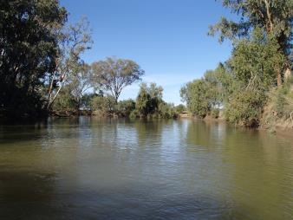

**Plate 2:** Groggans Hole (Zone 3)

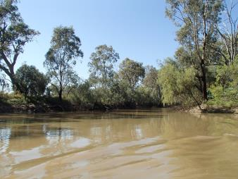

**Plate 3:** Old Oxley (Zone 3)

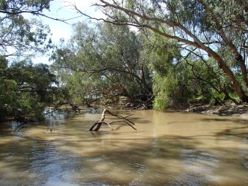

**Plate 4:** Willancorah (Zone 3)

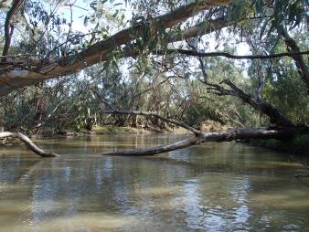

**Plate 5:** Pillicawarrina (Zone 3)

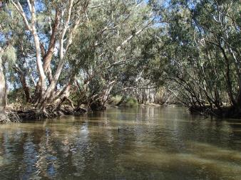

**Plate 6:** Yanda (Zone 4)

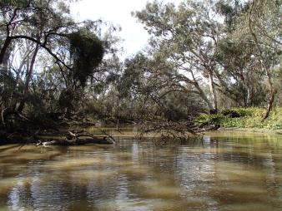

**Plate 7:** Marthaguy Junction (Zone 4)

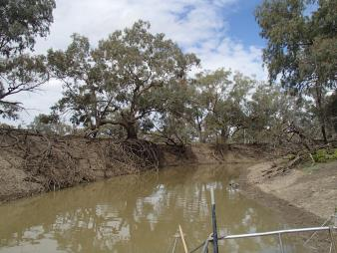

**Plate 8:** Brewon (Zone 4)

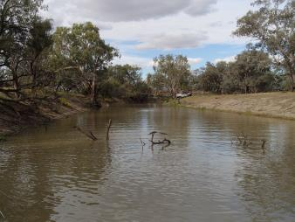

**Plate 9:** Binghi Bridge (Zone 4)

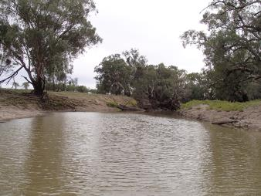

**Plate 10:** Glenacre (Zone 4)

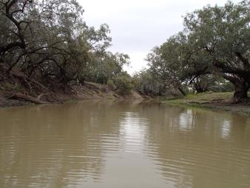

## 

## Appendix 2 – Sample site coordinates

|  |  |  |  |  |  |
| --- | --- | --- | --- | --- | --- |
| **Site** | **Zone** | **Latitude** | **Longitude** | **Fish Assemblage** | **Fyke netting** |
| **Marebone** | 3 | -31.38698 | 147.69669 | ✓ |  |
| **Groggans hole** | 3 | -31.20874 | 147.64015 | ✓ |  |
| **Old Oxley** | 3 | -31.12648 | 147.57880 | ✓ | ✓ |
| **Willancorah** | 3 | -30.89562 | 147.50593 | ✓ | ✓ |
| **Pillicawarrina** | 3 | -30.80293 | 147.51441 | ✓ |  |
| **Yanda** | 4 | -30.41871 | 147.54800 | ✓ | ✓ |
| **Marthaguy Junction** | 4 | -30.26629 | 147.57599 | ✓ |  |
| **Brewon** | 4 | -30.23448 | 147.54159 | ✓ |  |
| **Binghi Bridge** | 4 | -30.18031 | 147.51074 | ✓ |  |
| **Glenacre** | 4 | -30.16950 | 147.47635 | ✓ | ✓ |
| **Gibsons Way Crossing** | 4 | -30.89341 | 147.57080 |  | ✓ |

Note: Gibsons Way Crossing (Bulgeraga Creek), was opportunistically selected and sampled and not part of the original sampling strategy.

## 

## Appendix 3 – Water quality measurement at 0.2m depth for each sampling site during each round of sampling. Shaded values indicate water quality measurements outside ANZECC guidelines.



## Appendix 4 – Water quality measurement at 0.2m depth for each sampling site during each round of fyke net sampling. Shaded values indicate water quality measurements outside ANZECC guidelines.

|  |  |  |  |  |  |  |  |
| --- | --- | --- | --- | --- | --- | --- | --- |
|  |  |  | Fyke Netting | | | | |
| Site Name | Zone | Date | Water temp. (°C) | pH | Conductivity (mS.cm-1) | Dissolved Oxygen (mg/L) | Turbidity (NTU) |
| Old Oxley | 3 | 9/05/2017 | 13.39 | 7.69 | 0.360 | 8.49 | 120 |
|  |  | 10/05/2017 | 14.08 | 7.65 | 0.360 | 6.72 | 139 |
|  |  | 12/05/2017 | 15.48 | 7.92 | 0.365 | 9.25 | 132 |
| Willancorah | 3 | 9/05/2017 | 14.93 | 8.01 | 0.366 | 10.62 | 114 |
|  |  | 10/05/2017 | 12.96 | 7.83 | 0.375 | 10.90 | 130 |
|  |  | 12/05/2017 | 13.83 | 8.07 | 0.380 | 9.61 | 109 |
| Yanda | 4 | 8/05/2017 | 15.52 | 6.89 | 0.637 | 11.28 | 164 |
|  |  | 11/05/2017 | 15.40 | 8.05 | 0.593 | 10.20 | 123 |
|  |  | 13/05/2017 | 15.68 | 8.23 | 0.578 | 5.58 | 123 |
| Glenacre | 4 | 8/05/2017 | 16.90 | 7.35 | 0.632 | 8.62 | 268 |
|  |  | 11/05/2017 | 15.94 | 8.18 | 0.648 | 8.31 | 209 |
|  |  | 13/05/2017 | 15.93 | 8.16 | 0.638 | 8.29 | 232 |
| Gibsons Way Crossing | 3 | 10/05/2017 | 14.08 | 8.24 | 0.366 | 10.20 | 266 |

## Appendix 5 - Barriers to fish movement, photos of captured species and sampling methodology

**Plate 1:** Gravel causeway adjacent to Brewon Bridge (Tim Hosking)

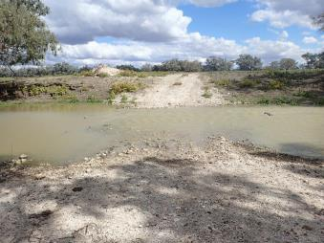

**Plate 2:** Miralwyn Road pipe culvert road crossing(Tim Hosking)

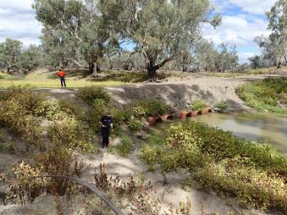

**Plate 3:** Small mesh fyke net set below low head weir at Willancorah, Macquarie River(Peter Graham)

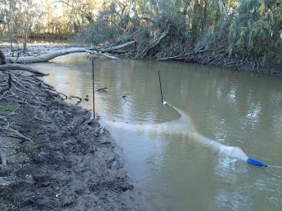

**Plate 4:** Adult golden perch, Macquarie River(Rod Price)

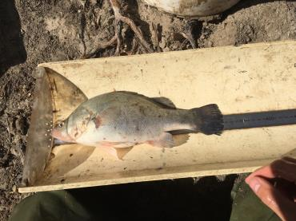

**Plate 5:** Juvenile and young-of-year golden perch, Macquarie River(Rod Price)

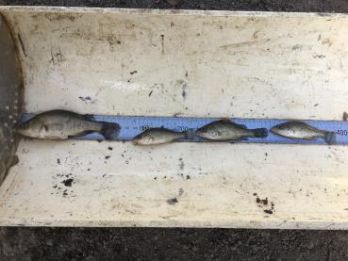

**Plate 6:** Spangled perch, Macquarie River(Rod Price)

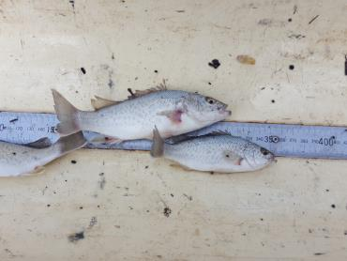

**Plate 7:** Bony bream, Macquarie River(Rod Price)

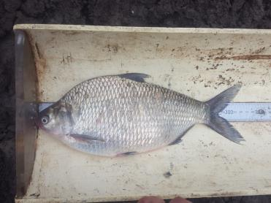

**Plate 8:** The confluence of the Macquarie River (left side of image) and Barwon River (Sam Davis)

