# 

# Country Specific Guideline for Malaysia

# Part 2 of 3: Sabah

This guideline has been prepared by the Australian Government and the Malaysian Government. It is intended to assist businesses importing regulated timber products from Malaysia into Australia in understanding the regulatory framework in Malaysia in order for them to carry out their due diligence obligations under the Illegal Logging Prohibition Regulation 2012, which supports the Illegal Logging Prohibition Act 2012.

This version (V1.3) of the Country Specific Guideline for Malaysia was co-endorsed by the Australian Government and Malaysian Government on 12 May 2020.

Table of Contents

1 What is required under Australia’s Illegal Logging Laws? 4

2 How to use the Country Specific Guideline (CSG) 5

2.1 Development of the CSG 6

3 Scope of the CSG for Malaysia 7

3.1 Timber harvested outside of Malaysia 7

4 Overview of Forest Management in Malaysia 8

5 Timber products exported to Australia 9

6 Law and regulations governing harvesting 11

6.1 Legal requirements for timber harvesting 11

6.2 Approval of harvesting area 11

6.3 Alienated land 11

6.4 Harvesting licence 11

6.5 Annual Work Plan and Comprehensive Harvest Plan (CHP) 11

6.6 Control of harvesting operations 12

6.7 Prohibition and restrictions of harvesting of certain species 12

6.8 Statutory charges 12

6.9 Special provisions for indigenous people 14

6.10 Production and manufacture of rubberwood products 14

7 Relevant laws relating to legal timber 16

7.1 Timber harvesting 16

7.2 Timber processing 17

7.3 Export of timber and timber products 17

7.4 Import of timber and timber products 19

7.5 Trade in CITES-listed timber species 19

8 Identifying legal products 19

9 Legality of manufactured timber products 20

9.1 Traceability of domestic sources 20

9.2 Traceability of import sources 20

10 Who should I contact for further information 21

11 Attachments - List of sample documents 22

Attachment 2.1 Sustainable Forest Management Licence (SFMLA)/Long Term Licence Agreement (LTL) issued by SFD 23

Attachment 2.2 Form I Licence issued by SFD 24

Attachment 2.3 Form IIB Licence issued by SFD 25

Attachment 2.4 List of Prohibited Species in PFE or Natural Forest Management (NFM) Area (Unless Specified) 26

Attachment 2.5 Timber Disposal Permit issued by SFD 28

Attachment 2.6 Removal Pass issued by SFD 29

Attachment 2.7 Exporter Registration Certificate issued by SFD 30

Attachment 2.8 Export Licence issued by SFD 32

Attachment 2.9 Customs Export Declaration Form (K2) 33

Attachment 2.10 Import Licence issued by SFD 34

Attachment 2.11 Importer Registration Certificate issued by SFD 35

Attachment 2.12 Customs Import Declaration Form (K1) 37

Attachment 2.13 Export/Import/Re-Export CITES Permit issued by MTIB 38

Attachment 2.14 Sawmill Licence issued by SFD 39

## What is required under Australia’s Illegal Logging Laws?

Australia’s Illegal Logging Prohibition Regulation 2012 (the Regulation) prescribes due diligence for businesses importing ‘regulated timber products’ and for Australian processors of domestic raw logs. Under the Regulation, importers and processors have to undertake due diligence to minimise the risk of sourcing illegally logged timber.

The due diligence requirements for importers include the following steps:

**Step 1**: Establish and maintain a due diligence system.

**Step 2**: Gather information about the timber in the product that is being imported.

**Step 3**: Assess the risk (using one of the three methods outlined in the Regulation).

**Step 4**: Risk mitigation (if required).

**Step 5**: Keep records.

Further information about the Regulation and the due diligence requirements is available at the Australian Government Department of Agriculture, Water and the Environment website ([www.agriculture.gov.au/illegallogging](http://www.agriculture.gov.au/illegallogging)).

## How to use the Country Specific Guideline (CSG)

The forestry and timber industry in Malaysia is governed by laws, regulations and institutional arrangements in the three regions; Peninsular, Sabah and Sarawak. Therefore, the CSG is divided into three separate parts:

Part 1: Peninsular

Part 2: Sabah

Part 3: Sarawak

This three-part CSG is intended to assist an importer of regulated timber products from Malaysia to Australia to comply with the due diligence requirements of the Regulation.

An importer must gather information about the product in accordance with section 10 of the Regulation, this includes gathering information or evidence contained in this CSG.

Information listed in this CSG is not an exhaustive list of evidence or documentation required to satisfy the due diligence requirements under the Regulation.

The information gathered by applying this CSG, along with any other information gathered in accordance with the Regulation, needs to be assessed in accordance with the processes outlined in section 12 of the Regulation (including considering any other information the importer knows, or ought reasonably to know, but is not contained in the CSG), to identify the risk that a regulated timber product is, is made from, or contains illegally logged timber. All data included in this document is the most current as available at time of publishing.

### 2.1 Development of the CSG

The development of the CSG was undertaken by a working group which comprised members from the following Ministries, departments, agencies and councils, and trade associations.

|  |
| --- |
| Ministries |
| Ministry of Primary Industries and Commodities (MPIC)  Ministry of Water, Land and Natural Resources (KATS)  [Formerly known as Ministry of Natural Resources and Environment (NRE)]  Ministry of International Trade and Industry (MITI)  Ministry of Urban Development and Natural Resources (MUDeNR), Sarawak  [Formerly known as Ministry of Resource Planning and Environment, Sarawak] |
| Departments, Agencies and Councils |
| Forestry Department Peninsular Malaysia (FDPM);  Sabah Forestry Department (SFD);  Forest Department Sarawak (FDS);  Malaysian Investment Development Authority (MIDA);  Malaysian Timber Industry Board (MTIB);  Sarawak Timber Industry Development Corporation (STIDC);  Malaysian Timber Council (MTC);  Malaysian Timber Certification Council (MTCC);  Sarawak Forestry Corporation (SFC); and  Harwood Timber Sdn. Bhd. (HTSB). |
| Trade Associations |
| Malaysian Panel-Products Manufacturers’ Association (MPMA);  Malaysian Wood Industries Association (MWIA);  Malaysian Furniture Council (MFC);  Association of Malaysian Bumiputera Timber and Furniture Entrepreneurs (PEKA);  The Timber Exporters’ Association of Malaysia (TEAM);  Malaysian Wood Moulding and Joinery Council (MWMJC);  Malaysia Pulp and Paper Manufacturers Association (MPPMA);  Sarawak Timber Association (STA);  Sabah Timber Industries Association (STIA); and  Timber Association of Sabah (TAS). |

The CSG has been subjected to several consultations with relevant stakeholders groups in Malaysia at national and regional levels.

Malaysia and Australia have agreed in bilateral discussions that the CSG forms the basis for compliance with the due diligence requirements as set out in the Regulation.

## Scope of the CSG for Malaysia

This CSG provides detailed information on the control of pathways for timber harvested and then processed/ manufactured in Malaysia and informs Australian importers of what is considered legal timber. It is also only applicable for timber products with a Malaysian origin of harvest, directly exported from Malaysia to Australia.

### 3.1 Timber harvested outside of Malaysia

There may be timber, forest products or products which contain timber, wholly or in-part, which was harvested in another country, before it was imported into Malaysia. Any product that contains timber that was harvested, processed, manufactured, or exported outside of Malaysia is out of scope of the CSG.

While these products are not in-scope of this CSG, the information contained in this document may assist importers in conducting due diligence using either the timber legality framework or the regulated risk factors pathways detailed in section 11 and section 13 respectively of the Regulation.

## Overview of Forest Management in Malaysia

Malaysia is a tropical country that covers an area of about 33 million hectares consisting of 3 regions: Peninsular Malaysia, the state of Sabah and Sarawak. Malaysia regards its natural forest resources as an important and valuable resource that contributes significantly towards the country’s economy and environmental well-being. As such, Malaysia is committed to ensure at least 50% of her land area remain as forest and adhered to the Principle of Sustainable Forest Management (SFM). In addition, Malaysia encourages SFM through forest certifications which among others include the Malaysian Timber Certification Scheme (MTCS), Programme for the Endorsement of Forest Certification (PEFC) and other internationally recognised schemes. These schemes continuously support the trade in timber and timber products that use wood originating from sustainable and legal sources that take into account the environmental, social and economic aspects of SFM.

Generally, there are 3 categories of forest: Permanent Reserved Forest (PRF)/ Permanent Forest Estates (PFE), state land forest and alienated land. The management of the forestry sector is governed under the National Forestry Policy and laws which has stringent forest laws and regulation to monitor and enforce forest related activities.

In Peninsular Malaysia, the Forestry Department Peninsular Malaysia (FDPM) and respective state forestry departments are responsible for the management of PRF. The state forestry departments have control over the removal of timber from state land and alienated land forest. This is regulated by the National Forestry Act 1984 and guided by the National Forestry Policy 1978 (revised 1992). The Malaysian Timber Industry Board (MTIB) is the licensing authority for Peninsular Malaysia in issuing export and import licence for timber and timber products.

In Sabah, the Sabah Forestry Department (SFD) is responsible for forest management, control of harvesting operations, royalty payment requirements as well as issuance of export and import licence in line with the Forest Enactment 1968, Forest Rules 1969, Forest Timber Enactment 2015 and Forest (Timber) (Registration) Regulations 2017.

In Sarawak, the Forest Department Sarawak (FDS) and the Sarawak Forestry Corporation (SFC) are responsible for forest management. This is regulated by the Forests Ordinance, 2015 (Cap. 71). Sarawak Timber Industry Development Corporation (STIDC) is the licensing authority to issue export and import licences for timber and timber products in Sarawak.

MTIB, SFD and STIDC are the respective licensing authorities for Peninsular, Sabah and Sarawak for issuing export and import licences for timber and timber products, as provided for under Schedule 2 of the Customs (Prohibition of Exports) Order 2017 and Customs (Prohibition of Imports) Order 2017. For timber products listed by the *Convention of International Trade in Endangered Species of Wild Fauna and Flora* (CITES), a CITES export or re-export permit issued by MTIB for Peninsular and Sabah, and FDS for Sarawak, can be considered as having fulfilled the applicable national and CITES requirements.

## Timber products exported to Australia

Australia is one of Malaysia’s most important markets for timber and timber products. Table 2.1 provides a list of regulated timber products. These span across four Customs HS codes: namely 44, 47, 48 and 94. For the full list of regulated timber products subject to due diligence requirements refer to [Schedule 1 to the *Illegal Logging Prohibition Regulation 2012*](https://www.legislation.gov.au/Details/F2018C00885).

Table 2.1 - List of Regulated Timber Products exported from Malaysia to Australia (HS Code)

| Chapters | Headings | Description |
| --- | --- | --- |
| 44 – Wood and articles of wood | 4407 | Wood sawn or chipped lengthwise |
| 4408 | Sheets for veneering |
| 4409 | Wood, continuously shaped, not assembled |
| 4410 | Particleboard |
| 4411 | Fibreboard |
| 4412 | Plywood, veneered panels and similar laminated wood |
| 4413 | Densified wood |
| 4414 | Wooden frames |
| 4418 | Builders’ joinery and carpentry, assembled wood panel |
| 47 – Pulp of wood or of other fibrous cellulosic material | 4701 | Mechanical wood pulp |
| 4702 | Chemical wood pulp, dissolving grades |
| 4703 | Chemical pulp, soda or sulphate |
| 4704 | Chemical wood pulp, sulphite |
| 48 – Paper and paperboard; articles of paper pulp, of paper or of paperboard | 4801 | Newsprint, in rolls or sheets |
| 4802 | Uncoated paper and paperboard |
| 4809 | Carbon paper, self copy paper |
| 4811 | Paper, paperboard |
| 4813 | Cigarette paper |
| 4817 | Envelopes, letter cards, plain postcards and correspondence cards |
| 4818 | Toilet paper, handkerchiefs, cleansing tissues towels tablecloths, serviettes, napkins for babies, tampons bed sheets, sanitary or hospital articles |
| 4819 | Cartons, boxes, cases, bags and other packaging |
| 4820 | Registers, account books, note books, order books, receipt books, letter pads, memorandum pads, diaries, and similar articles, exercise books |
| 4823 | Other paper, paperboard |
| 94 – Furniture & prefabricated buildings | 9401  9403 | Furniture |
| 9406 | Prefabricated buildings |

## Law and regulations governing harvesting

### 6.1 Legal requirements for timber harvesting

Timber harvesting in PFE, state land and alienated land is regulated by the following regulations:

1. Forest Enactment, 1968; and
2. Forest Rules, 1969.

### 6.2 Approval of harvesting area

In order for an organisation or company to obtain the right to harvest, it must fulfil the following requirements:

1. An organisation or company shall obtain an approval of harvesting rights for the specified area.
2. The area under the license for harvesting shall not include areas with Native Customary Rights.

### 6.3 Alienated land

For alienated land, an organisation or company must fulfil the following requirements:

1. The organisation or company shall have a valid land title or a letter of confirmation on the status of the land application from the Assistant Collector of Land Revenue.
2. The organisation or company shall have receipt of payment of land premium.

### 6.4 Harvesting licence

Prior to issuing a harvesting licence, the following requirements must be fulfilled:

1. The organisation or company shall obtain a letter of approval from the Natural Resources Office (NRO) for issuing a harvesting licence.
2. The organisation or company shall have a valid harvesting licence or coupe permit.

Harvesting licence can be in a form of **Sustainable Forest Management Licence Agreement** (SFMLA) or **Long Term Licence Agreement** (LTL) (see Attachment 2.1), **Form I Licence** (see Attachment 2.2), or **Form IIB** in the case of timber from alienated land (see Attachment 2.3).

### 6.5 Annual Work Plan and Comprehensive Harvest Plan (CHP)

PFE are subject to the following requirements:

1. The licensee (SFMLA/LTL) shall have an approved Annual Work Plan (AWP) containing maps and description of the areas and types of operations to be carried out during the year and approved by SFD.
2. The licensee shall have a Comprehensive Harvesting Plan (CHP) containing the total and net production areas; harvesting volumes, diameter, limits, species and protected areas approved by SFD.
3. CHP shall comply with the Reduced Impact Logging (RIL) Operation Guide Book requirements for harvesting and operations (roads, skid trails and log landings density and location, harvestable tree marking and stream buffer zones identification).
4. The CHP shall be developed by a registered CHP contractor.

### 6.6 Control of harvesting operations

There are various controls over timber harvesting operations in Sabah depending on the land status. For timber extracted from a licence involving PFE, state land and alienated land, all licensees must adhere to the following conditions as stipulated in the licence conditions:

1. A licensee must register a Property Hammer Mark (PHM), with the PHM stamped at the end of each log produced.
2. A licensee must incise each extracted log with a serial number.
3. A logging contractor must be registered with the SFD prior to commencing operations.

For an area involving PFE and state land, only a licenced area is allowed for timber harvesting. For alienated land, timber can be felled for land clearance for agricultural purposes as the land is alienated land, but no timber can be removed without royalty payment and with proper markings and thereafter issuance of Form IIB licence.

For timber extracted from Forest Reserves, additional harvesting control is imposed on the employment of Reduced Impact Logging (RIL). The operation will be guided by the approved Comprehensive Harvesting Plan (CHP) which guide on meeting road alignment and construction, directional felling and the mapping of trees to be harvested.

Other harvesting operation controls include:

1. The requirement to prepare daily harvesting records.
2. Submission of Quarterly Logging Progress Report and Closing Inspection Report.
3. Prohibition of timber harvesting in steep slopes (25° and above) and buffer zones as stipulated in the licence conditions.

### 6.7 Prohibition and restrictions of harvesting of certain species

The **conditions of harvesting licence** stipulate several protected species of timber that are prohibited from being harvested in PFE or Natural Forest Management Areas (see Attachment 2.4).

### 6.8 Statutory charges

#### 6.8.1 Harvesting charges

1. Royalty payment

The requirement of royalty payment for all harvested timber is covered under Section 24CoftheForest Enactment 1968, and Rule 12 (1) of theForest Rules 1969, that all logs to be transported to the final destination must be royalty paid first prior to leaving the licenced area or approved royalty assessment area.

The licensee must apply for royalty assessment for their logs to the District Forestry Officer (DFO) and shall include supporting documents such as a Log Summary and Log List showing the timber species, log dimension and volume. The DFO will conduct field inspections and will verify the company’s log list based on the Guideline for Measurement of Timber for Royalty Assessment and assess royalty payment based on the applicable royalty rates of timber.

Prior to the royalty assessment the following are checked:

1. Logs bear a Property Hammer Mark.
2. Logs bear a Forestry Department Inspection Mark.
3. All logs have a species symbol and serial number incised at both ends of the logs, and the logs’ details and volume correspond to the company’s log list and log summary volume.

Upon satisfaction of these procedural requirements, the company will pay royalty based on the assessment made by the DFO and a receipt of royalty payment will be issued.

Royalty paid logs will have the following documents or markings:

1. Logs bear a Property Hammer Mark.
2. Logs bear a Forestry Department Inspection Mark.
3. Logs bear a Forestry Department Revenue Hammer Mark.
4. All logs have a species symbol and serial number incised at both ends of the logs.
5. Timber Disposal Permit (TDP) (see Attachment 2.5) which provide all the details of logs including: the license where the logs were extracted from; the serial number; log specifications by species; diameter and length; date of scaling; and reference of the royalty payment receipt.
6. Movement of Logs

Movement of timber is regulated by Rule 15(1) of the Forest Rules 1969, whereby all timber to be transported out must be accompanied by a **Removal Pass** (RP) (see Attachment 2.6) upon payment of royalty to the Government, or a Transit Pass for the transportation of logs from the extraction area to the royalty assessment area. In addition, all logging trucks must also be registered with the SFD.

Prior to the transportation of logs to the final destination, the following are checked by the SFD:

1. Logs bear a Property Hammer Mark.
2. Logs bear a Forestry Department Inspection Mark.
3. Logs bear a Forestry Department Revenue Hammer Mark.
4. All logs have a species symbol and serial number incised at both ends of the logs.
5. All royalty paid logs are supported by TDP, which provide all the details of logs including the license where the logs were extracted from, the serial number, the logs’ dimensions, and reference of the royalty payment receipt.

A RP (one per truck) will be issued upon satisfaction of all the above. The RP will indicate TDP numbers covered by the RP and the name of the receiving mill in the final destination.

Upon reaching the mill, logs and truck records and the/RP are recorded in the log Arrival Book kept at the mill by the SFD, and the used RP is stamped as “Used Removal Pass”.

#### 6.8.2 Export royalty

An exporter of round logs, timber and timber products, listed inTable 2.2 must pay the relevant export royalty as provided for in the Forest Rules, 1969.

Table 2.2: List of royalty payable timber and timber products

| No. | Wood Items | Customs HS Code |
| --- | --- | --- |
| 1. | Logs (including baulks and roughly squared) except those planted from alienated lands. | 4403 |
| 2. | Railways or tramway sleepers | 4406 |
| 3. | Sawn timber | 4407 |
| 4. | Veneer sheets | 4408 |
| 5. | Moulding | 4409 |
| 6. | Particleboard, Chipboard | 4410 |
| 7. | Plywood, veneered panel and similar laminated wood, blockboard | 4412 |

### 6.9 Special provisions for indigenous people

Community benefits and rights to occupy land and native users’ right to forest resources are recognised, subject to the following requirements:

1. Meeting legislative requirements covering customary rights relevant to forest harvesting activities including requirements covering the sharing of benefits and tenure rights.
2. Meeting legislative requirements covering “free, prior and informed consent” in connection with the transfer of forest management rights and customary rights to the organisation in charge of the harvesting operation.
3. Meeting legislative requirements that regulate the rights of indigenous people in relation to forestry activities. Other aspects that may need to be considered are land tenure, the right to use certain forest related resources or practice traditional activities on forest lands.

### 6.10 Production and manufacture of rubberwood products

Rubberwood *(Hevea brasiliensis)* is produced from logs harvested from rubber plantations (state land and alienated land) and PFE (Industrial Tree Plantation Zone of the SFMLA). Rubber trees are planted for latex production, in the case of state land and alienated land, and for both latex and timber production in the case of SFMLA. The trees are usually felled when their life span for the production of latex (approximately 15 to 20 years) is no longer economical and replanting is necessary.

The harvesting of rubberwood logs from alienated land only requires the consent of the rubber smallholding or estate owner. SFMLA production of rubberwood logs however, is subject to the same requirements as those imposed on any other timber products from PFE. Irrespective of the source of rubberwood logs, all logs are subject the issuing of RP from the SFD to ascertain their legality. Rubberwood logs produced from alienated land in Sabah are royalty exempted if processed domestically, while rubberwood logs produced from PFE (Industrial Tree Plantation Zone of SFMLA) are subject to royalty payment.

## Relevant laws relating to legal timber

Apart from the Forest Enactment, 1968 and the Forest Rules, 1969, other relevant laws in Sabah that govern or are applicable to timber legality are:

1. Land Ordinance (Sabah Cap. 68);
2. Wildlife Conservation Enactment 1977 (Section 38);
3. Environment Protection Enactment 2002;
4. Environment Protection (Environment Impact Assessment) Order, 2012;
5. Industrial Co-ordination Act 1975;
6. Custom Act 1967;
7. The Customs (Prohibition of Exports) Order 2017;
8. The Customs (Prohibition of Imports) Order 2017;
9. International Trade In Endangered Species Act 2008 (Act 686);
10. Fees Enactment 1981 [The Fees (Forestry Department) Service of Inspection and Certification Order, 1999].

Legal timber is also produced or harvested from either state land or alienated land, which are also governed by the Land Ordinance (Sabah Cap. 68). Before an organisation or company can proceed with timber harvesting on state land, an organisation or company should obtain a letter of approval from Natural Resources Office (NRO) which issues approval prior to the issuance of harvesting licence and Lands and Surveys Department for a Temporary Occupation Lease (TOL). For alienated land, an organisation or company must have a letter confirming the status of land and a valid land title issued by the Registrar of Titles. A harvesting licence is issued by the SFD upon satisfaction of all requirements.

Under the Wildlife Conservation Enactment 1977 (Section 38), it is a requirement that the licensee of any area must first notify the Director of Wildlife Department one month prior to harvesting.

For wood manufacturing mills, mills shall not operate without a manufacturing licence issued by the Ministry of Trade and Industry (MITI), unless otherwise exempted under Section II of the Industrial Co-ordination Act 1975*.*

Timber exports are regulated by the Customs Act 1967, the Customs (Prohibition of Exports) Order 2017.

Under the International Trade In Endangered Species Act 2008 (Act 686), all forest produce listed under [Appendix I and II of CITES](https://www.cites.org/eng/app/appendices.php) which are to be exported outside the country must obtain a CITES export permit from the Management Authority (MA) prior to export.

The Fees Enactment 1981 [The Fees (Forestry Department) Service of Inspection and Certification Order, 1999] requires that imports of logs, veneer and sawn timber be inspected by the SFD upon arrival, and are subject to payment of an inspection fee prior to sending to domestic mills for further processing.

### 7.1 Timber harvesting

Relevant laws relating to timber harvesting include:

1. Forest Enactment 1968 (Section 15, 24,28(A);
2. Forest Rules 1969, Rule 12 (3);
3. RIL Operation Guide Book-Code of Practice For Harvesting in Sabah;
4. Environment Protection Enactment 2002; and
5. Wildlife Protection Enactment 1997 (Section 38).

### 7.2 Timber processing

#### 7.2.1 Timber and timber products (including furniture, pulp and paper products)

Relevant laws relating to timber and timber products include:

1. Forest Enactment 1968, Section 42 (e);
2. Forest Rules 1969, Rule 19(1);
3. Industrial Co-ordination Act 1975 (Act 156); and
4. Licensing Guidelines for the Wood-Based Industry in Sabah-Version 2, 2012.

### 7.3 Export of timber and timber products

#### 7.3.1 Timber and timber products under Customs HS code 44 and 94

Any company or person engaged in the export of timber and timber products falling under these codes must be registered by SFD. Registered companies or persons are issued with a **registration certificate** (see Attachment 2.7). Registered companies or persons are allowed to export timber and timber products with an **export licence** (see Attachment 2.8) issued by SFD, upon satisfaction of all timber and timber products export requirements.

Laws related to the export of these products include:

1. Customs Act 1967 (Act 235), Customs (Prohibition of Exports) Order 2017;
2. Forest Enactment, 1968; and
3. Forest Rules, 1969.
4. Forest (Timber) Enactment 2015.
5. Forest (Timber) (Registration) Regulations 2017.

The Second Schedule of the Customs (Prohibition of Exports) Order 2017 lists timber and timber products that require an export licence from SFD prior to export. The list of products that require an export license is as shown in Table 2.3.

#### 7.3.2 Timber and timber products under Customs HS code 47 and 48 (pulp and paper products)

Exporters of products under HS Codes 47 and 48 must make an appropriate declaration using **Customs Export Declaration Form (K2)** (see Attachment 2.9) and submit it to the Customs Department for final export clearance.

Laws related to the export of these products include:

1. Customs Act 1967 (Act 235), Customs (Prohibition of Exports) Order 2017;
2. Forest Enactment, 1968; and
3. Forest Rules, 1969.
4. Forest (Timber) Enactment 2015.
5. Forest (Timber) (Registration) Regulations 2017.

Table 2.3: List of products that require export licence

| No. | Wood Items | Customs HS Code |
| --- | --- | --- |
| 1. | Wood in chip or particle | 4401.21 000, 4401.22 000 |
| 2. | Wood charcoal | 4402.90 000 |
| 3. | Logs (including baulks and roughly squared) | 4403 |
| 4. | Hoopwood | 4404 |
| 5. | Wood wool ; Wood flour | 4405.00 |
| 6. | Railways or tramway sleepers | 4406 |
| 7. | Sawn timber | 4407 |
| 8. | Veneer sheets | 4408 |
| 9. | Moulding | 4409 |
| 10. | Particleboard | 4410 |
| 11. | Fibreboard | 4411 |
| 12. | Plywood, veneered panel and similar laminated wood | 4412 |
| 13. | Densified wood | 4413.00 000 |
| 14. | Wooden frames | 4414.00 000 |
| 15. | Cask, barrels, vats, tub and other coopers products, of wood, including staves | 4416.00 000 |
| 16. | Tool, broom and brush bodies and handles, of wood | 4417.00 000 |
| 17. | Builders joinery and carpentry, of wood | 4418 |
| 18. | Tableware and kitchenware, of wood | 4419.00 000 |
| 19. | Articles of wooden furniture | 4420.90.200 |
| 20. | Other articles of wood | 4421 |
| 21. | Seats of bamboo or rattan and other seats, with wooden frames | 9401.51 000, 9401.61 000  9401.69 000 |
| 22. | Wooden furniture | 9403.30 000, 9403.40 000  9403.50 000, 9403.60 100  9403.60 200, 9403.60 900 |
| 23. | Prefabricated buildings, of wood | 9406.00 200 |

### 7.4 Import of timber and timber products

All products listed in the Customs (Prohibition of Imports) Order 2017 require an **Import Licence** (see Attachment 2.10) from SFD prior to their importation into Sabah. Any company or person engaged in the importation of timber and timber products listed under the Customs (Prohibition of Imports) Order 2017, must be registered by SFD (see Attachment 2.11). Registered companies or persons are allowed to import timber and timber products with an import licence issued by SFD, upon satisfaction of all timber and timber products import requirements. For the importation of logs, it is a requirement that prior written approval from the Chief Conservator of Forests be obtained before an import licence may be issued.

For other timber products, an importer is required to make appropriate declaration using **Customs Import Declaration Form (K1)** (see Attachment 2.12**)** and seek clearance from the Customs Department prior to importation.

### 7.5 Trade in CITES-listed timber species

Currently, MTIB as the Management Authority of the CITES for timber products in Sabah, is responsible for issuing **export, import and re-export permits** (see Attachment 2.13) for any timber species listed under CITES.

Laws related to trade in CITES listed timber species include:

1. Customs Act 1967 (Act 235), Customs (Prohibition of Exports) Order 2017; and
2. International Trade in Endangered Species Act 2008 (Act 686).

## Identifying legal products

The export of all forest products must be covered by an **export licence** (see Attachment 2.8) issued by the SFD and issued with a **Customs Export Declaration Form (K2)** (see Attachment 2.9).

As a procedural requirement, all exports must be inspected and verified that the exported timber is legal and has fulfilled the various legal requirements in the supply chain including royalty payment. Upon satisfying all requirements, the SFD issues export licence. The export licence amongst others shows exporter’s registration certificate number and the registration certificate’s validity, export licence validity, export approval reference number, type of product, volume, royalty payment and payment receipt number unless exempted. The final export endorsement will be made by the RMCD.

For CITES-listed products, a **CITES export or re-export permit** (see Attachment 2.13) issued by MTIB may be considered as having fulfilled the applicable national and CITES requirements.

## Legality of manufactured timber products

### 9.1 Traceability of domestic sources

Compliance with legal requirements at critical points in the supply chain are checked by the SFD and supported by documents as evidence of compliance. It is also mandatory that all timber to be manufactured domestically irrespective of their source can only be processed in a mill licensed by the SFD. All wood manufacturers are required to obtain a **sawmill license** (see Attachment 2.14) under Rule 19 (1), of the Forest Rules 1969.

Any timber arriving at the mill gate (including royalty exempted timber, such as rubberwood and planted timber from alienated lands) must also be accompanied by a RP and timber details are recorded in a Log/Timber Arrival Book.

### 9.2 Traceability of import sources

Customs (Prohibition of Imports) Order 2017 provides the authority to SFD to exercise control over the list of products as given in Table 2.4 below. Importers of these products must obtain an import licence, as described in Section 7.4.

Table 2.4: List of products that require import licence

| No. | Wood Items | Customs HS Code |
| --- | --- | --- |
| 1. | Logs; wood in the rough, whether or not stripped of its bark or merely roughed down; wood roughly squared or half-squared but not further manufactured; and baulks | 4403 |
| 2. | Poles and piles of Mangroves (*Rhizophora spp*) | 4403.99 515 |
| 3. | Plywood, veneered panel and similar laminated wood | 4412 |

It is mandatory that all importers of timber and timber products be registered as importers with the SFD, so that traceability is assured. All imports of logs, veneer and sawn timber must also be inspected by the SFD under the Fees Enactment, 1981 [The Fees (Forestry Department) Service of Inspection and Certification Order, 1999]. As with other timber sourced domestically, all imported timbers movement from the Port of Discharge must also be covered by Removal Pass to mills licenced by the SFD. Details of imported timber are recorded in a Log/Timber Arrival Book.

## Who should I contact for further information

|  |  |
| --- | --- |
| Logo |  |
| Australian Government  Department of Agriculture, Water and the Environment  GPO Box 858  Canberra ACT 2601 Phone: +61 (0) 2 6272 3933  Web: [www.agriculture.gov.au/illegallogging](http://www.agriculture.gov.au/illegallogging)  Email: [illegallogging@agriculture.gov.au](mailto:illegallogging@agriculture.gov.au) | Malaysian Government  Sabah Forestry Department  Locked Bag 68  90009 Sandakan  Sabah, Malaysia  Phone: +6089-660811/242500  Fax: +6089-671303/672579  Web: [www.forest.sabah.gov.my](http://www.forest.sabah.gov.my)  Email: [mcsg.sabah@sabah.gov.my](mailto:mcsg.sabah@sabah.gov.my) |

Disclaimer

While reasonable efforts have been made to ensure that the contents of this guideline and the associated quick reference guide are factually correct, the Commonwealth of Australia does not accept responsibility for the accuracy or completeness of the contents and expressly disclaims liability for any loss or damage, however caused, that may be occasioned directly or indirectly through the use of, or reliance on, the contents of this guideline or associated quick reference guide.

This guideline and its associated quick reference guide is made available on the understanding that the Commonwealth of Australia is not providing professional advice. Before relying on this guideline or its associated quick reference guide, readers should obtain appropriate professional advice suitable to their particular circumstances.

Readers should also confirm that this is the most up-to-date available guideline by referring to the Department of Agriculture, Water and the Environment website.

## Attachments - List of sample documents

| No. | Name of Sample Document | Attachment |
| --- | --- | --- |
| 1. | Sustainable Forest Management Licence (SFMLA)/Long Term Licence Agreement (LTL) issued by SFD | 2.1 |
| 2. | Form I Licence issued by SFD | 2.2 |
| 3. | Form IIB Licence issued by SFD | 2.3 |
| 4. | List of Prohibited Species in PFE or Natural Forest Management Area | 2.4 |
| 5. | Timber Disposal Permit issued by SFD | 2.5 |
| 6. | Removal Pass issued by SFD | 2.6 |
| 7. | Exporter Registration Certificate issued by SFD | 2.7 |
| 8. | Export Licence issued by SFD | 2.8 |
| 9. | Customs Export Declaration Form (K2) | 2.9 |
| 10. | Importer Registration Certificate issued by SFD | 2.10 |
| 11. | Import Licence issued by SFD | 2.11 |
| 12. | Customs Import Declaration Form (K1) | 2.12 |
| 13. | CITES Export Permit issued by MTIB | 2.13 |
| 14. | Sawmill licence issued by SFD | 2.14 |

1. Sustainable Forest Management Licence (SFMLA)/Long Term Licence Agreement (LTL) issued by SFD

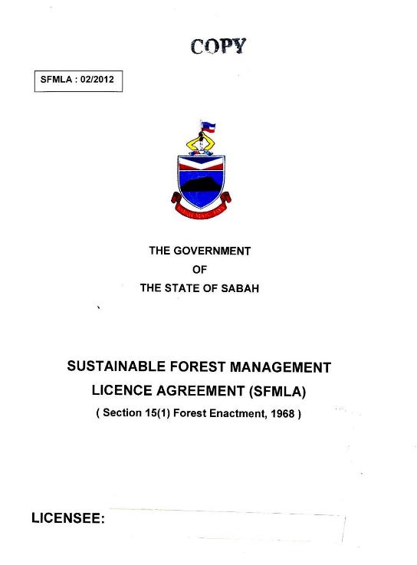

Key ID Features

SAMPLE

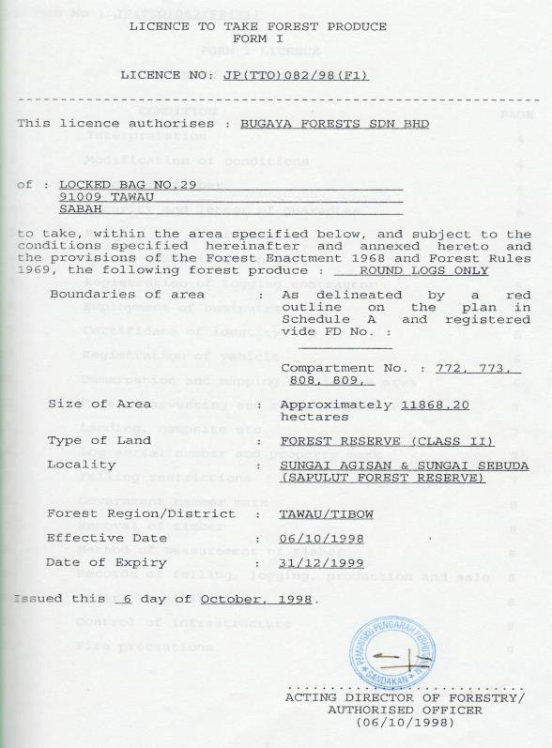Attachment 2.2 Form I Licence issued by SFD

SAMPLE

# 

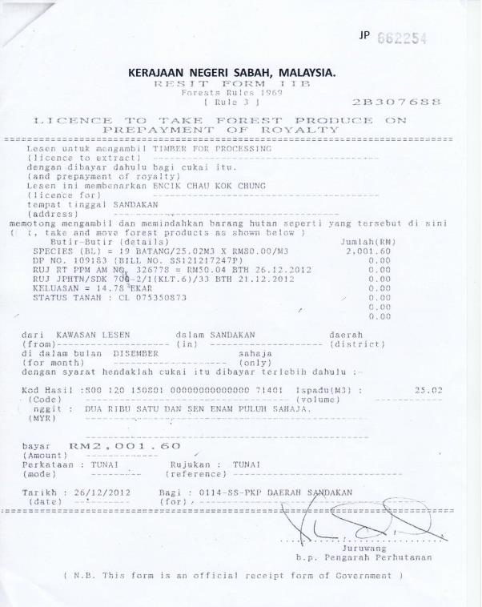Attachment 2.3 Form IIB Licence issued by SFD

Key ID Features

Key ID Features

SAMPLE

SAMPLE

Key ID Features – Export No.

Attachment 2.4 List of Prohibited Species in PFE or Natural Forest Management (NFM) Area (Unless Specified)

| Scientific Name | Local Name | Purpose |
| --- | --- | --- |
| Shorea macrophylla, Shorea gysbertinana, Shorea pinangah | All Tengkawang/Kawang species | Fruit |
| All *Mangifera* species | All Asam family-Mangga or Macang Hutan | Fruit |
| All *Durio* species | Durian | Fruit |
| Triomma spp., Daryodes spp. and Santiria spp., except Canarium spp. | All Kedondong species | Fruit |
| All Drancontomelon spp. | Sengkuang | Fruit |
| All Lansium spp. | Langsat | Fruit |
| All Bacaurea spp. | Tampoi, Rambai and Belimbing Hutan | Fruit |
| All Artocarpus spp. | Terap, Buruni, Pulutan/Cempedak | Fruit |
| All Nephelium spp. | Meritam and Rambutan | Fruit |
| All Paranephelium spp. | Mata Kuching | Fruit |
| Gonystylus bancanus | Ramin | Conservation |
| All Aquilaria spp. | Gaharu | Conservation (prohibited in Forest Reserves and state land, unless specified) |
| All Koompassia spp. | Mengaris/Tualang | Depository of wild honey |
| Eusideroxyln zwageri | Belian | Conservation |
| Protoxylon malagangai | Belian Malagangai | Conservation |
| Intsia palembanica and Sympetalandra borneensis | All Merbau species including Merbau Lalat | Conservation |
| All Litocarpus spp. | Mempening | Conservation |
| All Castanopsis spp. | Berangan | Conservation |
| All mangrove species | All mangrove species | Conservation-unless for use by Natives and Charcoal factories |
| Any trees marked by the Director for retention | Any trees marked by the Director for retention | Conservation and seeds (mother trees) |
|  | Any trees from the genera stipulated in Schedule I - Forest Rules 1969, if the diameter is less than the specified limit except if marked by the Conservator of Forests for felling. | Conservation |
|  | All trees below 60cm dbh or above 120cm dbh unless authorized by the Conservator of Forests for felling. | Conservation |

Attachment 2.5 Timber Disposal Permit issued by SFD

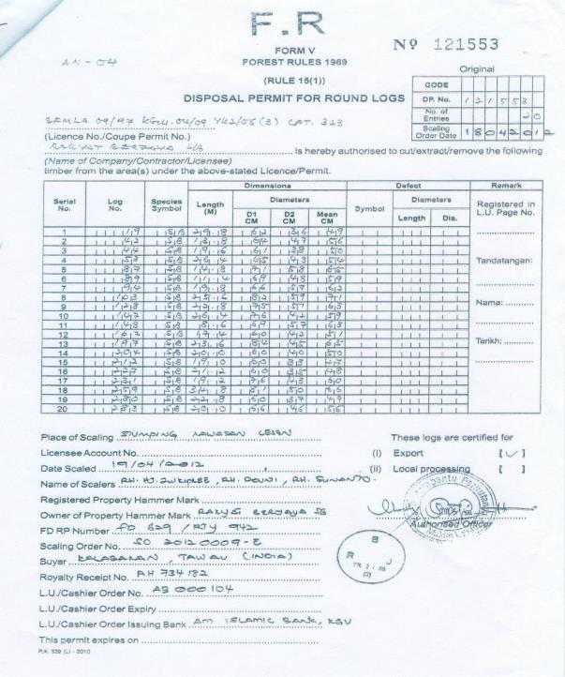

Key ID Features

Key ID Features

SAMPLE

Attachment 2.6 Removal Pass issued by SFD

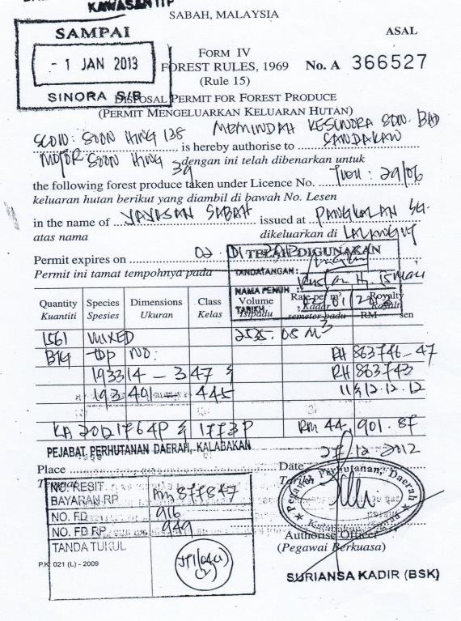

SAMPLE

Key ID Features

Attachment 2.7 Exporter Registration Certificate issued by SFD

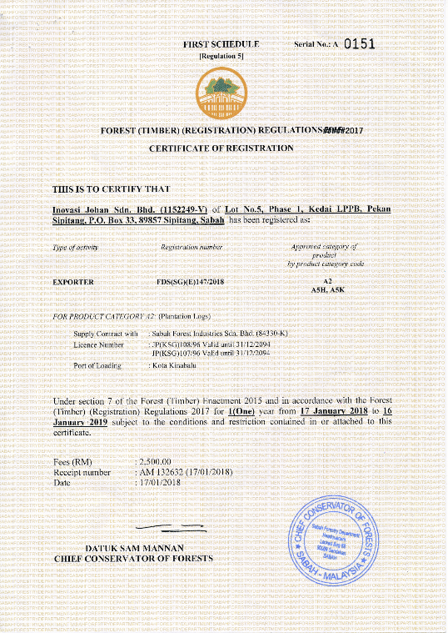

Key ID Features

SAMPLE

Key ID Features

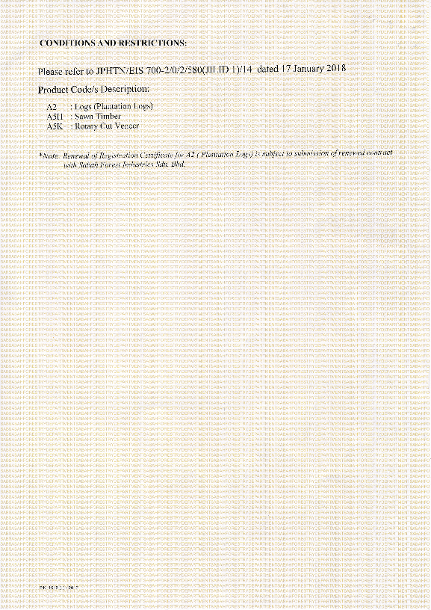

SAMPLE

Attachment 2.8 Export Licence issued by SFD

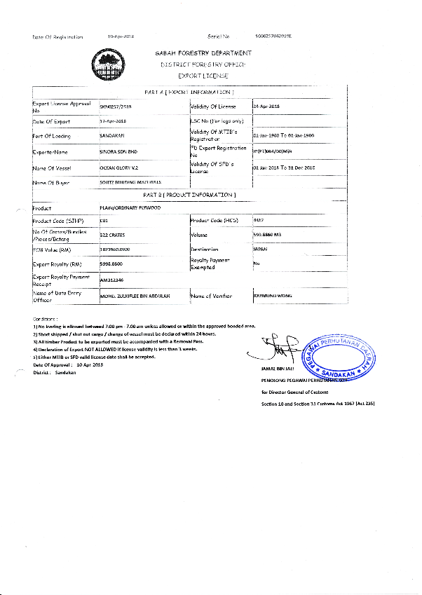

Key ID Features

SAMPLE

Key ID Features

Key ID Features

Attachment 2.9 Customs Export Declaration Form (K2)

Sample of Customs Export Declaration Form (K2) issued by MTIB.

The image shows key visual cues on the government issued export declaration form. A circle identifies the Registration Number box as a key ID feature

SAMPLE

Key ID Features

Attachment 2.10 Import Licence issued by SFD

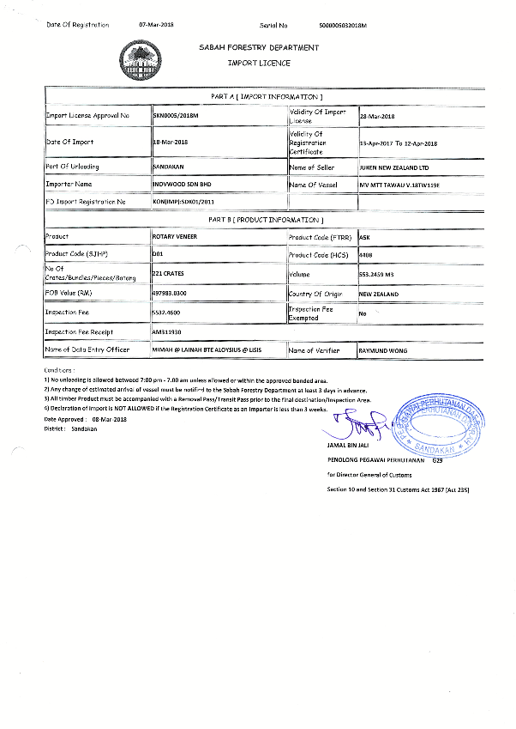

Key ID Features

Key ID Features

Key ID Features

SAMPLE

Attachment 2.11 Importer Registration Certificate issued by SFD

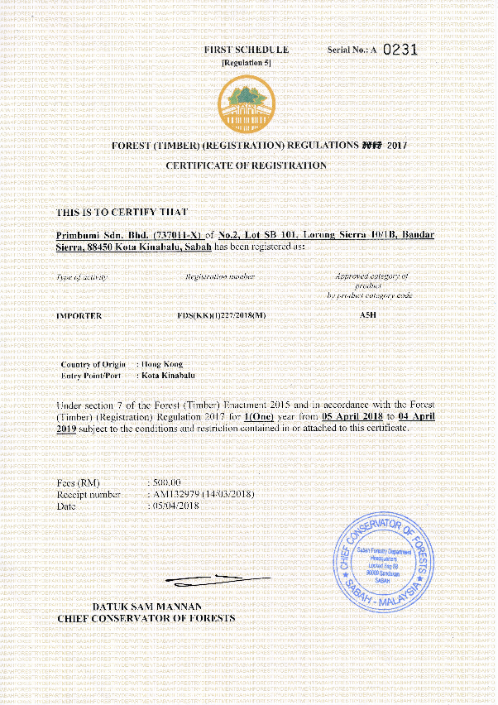

Key ID Features

Key ID Features

SAMPLE

Import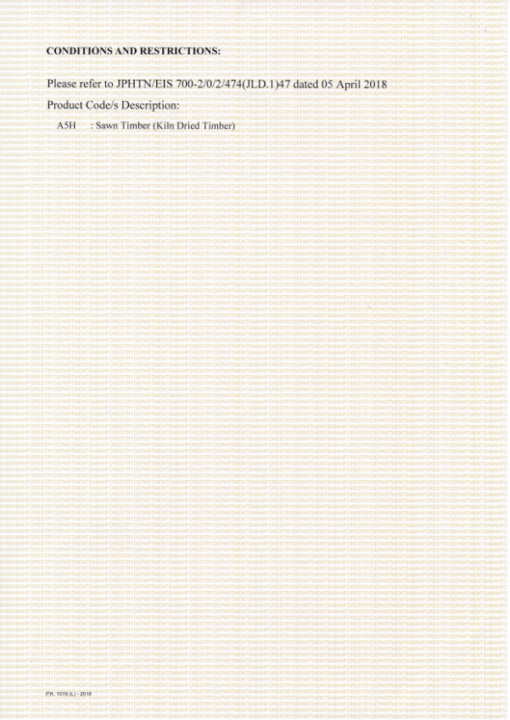

SAMPLE

Attachment 2.12 Customs Import Declaration Form (K1)

Sample of customs import declaration form (K1) issued by the Royal Customs Department - front page.

The sample outlines the key ID feature, the Registration number, in the top right hand corner of the document.

Key ID Features

Key ID Features

SAMPLE

Attachment 2.13 Export/Import/Re-Export CITES Permit issued by MTIB

The document is a sample page of the export, import, re-exirt CITES permit issued by MTIB. 
The Permit number (011228) at the top right-hand corner of the page is circled and labelled as a Key ID Feature. A signature box further down the page is circled and labelled "key ID feature - CITES number wil be on the CITES Stamp".

Key ID Features

Key ID Features - CITES number will be on the CITES Stamp

SAMPLE

Attachment 2.14 Sawmill Licence issued by SFD

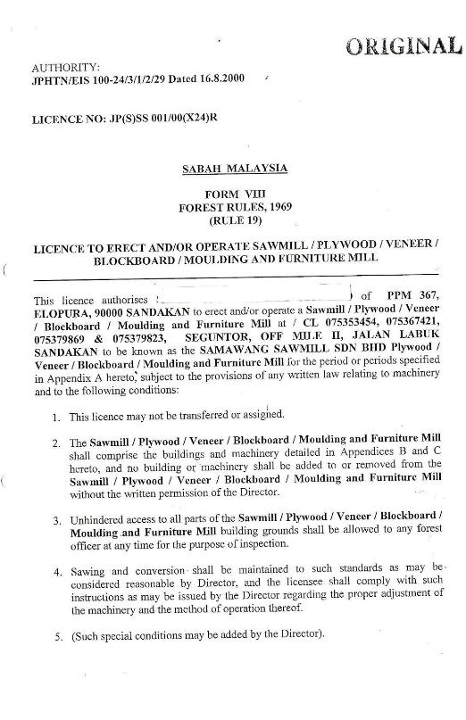

Key ID Features

SAMPLE

Key ID Features

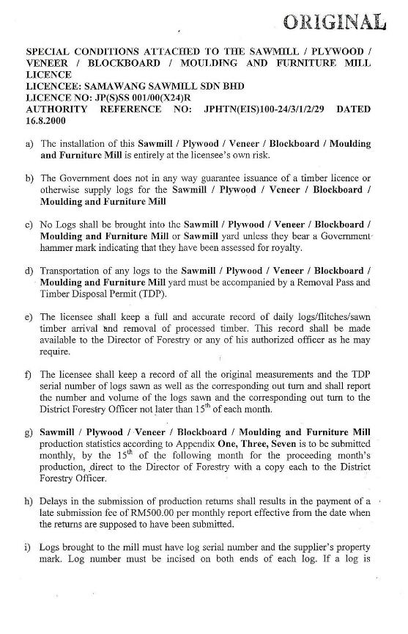

SAMPLE

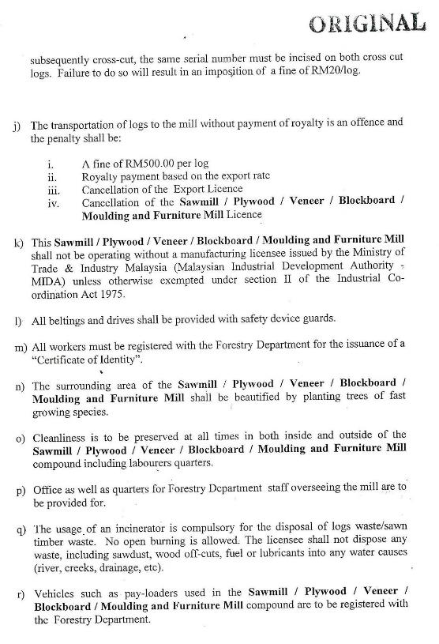

SAMPLE

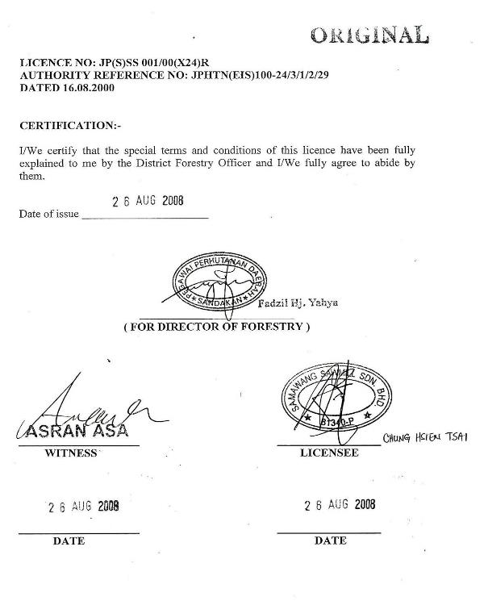

SAMPLE