# THe mallowa CREEK & wetlands watering event update #2

This is the second update on the 2018–19 watering event in the Mallowa. The delivery of water for the environment commenced in mid-September and continues with water flowing down the Mehi River and into the Mallowa Creek and wetlands. Watering Event updates are also available for the Gwydir Wetlands and Macquarie Marshes.

## Event update

Like other wetlands in the Gwydir system, the Mallowa experiences wet and dry phases. Following a dry period last year, water for the environment commenced flowing into Mallowa Creek in early spring 2018. These flows will maintain the health of Mallowa Creek and wetlands and provide drought refuge habitat for native animals. They are also expected to support native fish populations along the Mehi River upstream of the Mallowa Creek offtake.

As of 9 December 2018, approximately 11,245 ML had been delivered to the Mallowa wetlands. Recently the environmental flows in the Mallowa have connected through the western Mallowa areas into the Moomin Creek. As a result, flow rates will be reduced to maintain core areas.

During the second half of January, delivery rates may increase again to deliver a further 5,000ML to top up the Mallowa wetlands before deliveries cease. Target delivery rates are expected to be between 150 - 175 ML/day. Larger flows than this will break away from the main channel and increase losses. Further delivery of environmental water will also provide benefits to local landholders by assisting to top up stock and domestic water supplies. It is hoped that this flow may join with irrigation water deliveries scheduled to move down the Moomin Creek during January improving connection between the two creeks.

## Ecological monitoring

Water for the environment has filled most of the wetlands and creek sections of the Mallowa. These wetlands have been targeted for environmental watering since 2012. Over this time the health of vegetation in the Mallowa wetlands has improved. However, the wetlands did not receive environmental water in 2017–18, during a dry year, increasing the environmental need for water in 2018–19.

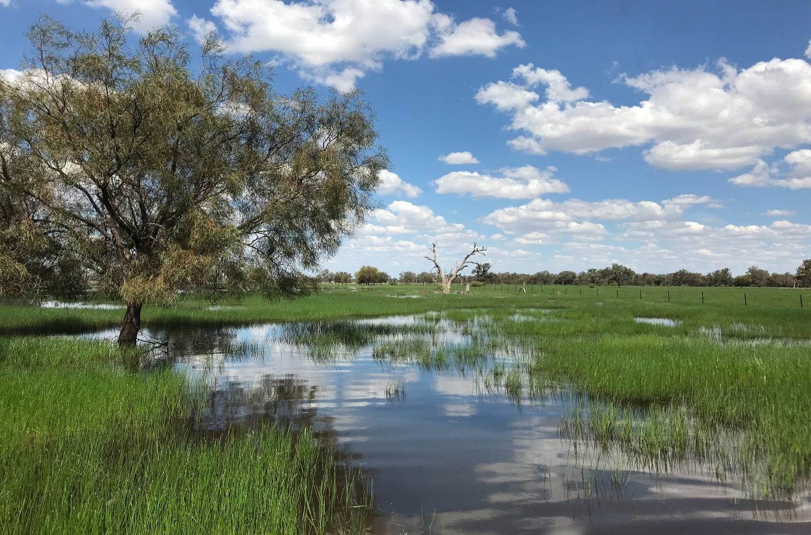

**Environmental flows spreading across part of the Mallowa Wetlands improving the condition of wetland vegetation.**

Healthy vegetation is important for supporting a diverse range of waterbirds. For example, marshy habitat (as shown above) provides feeding habitat for migratory species such as sandpipers, terns and snipe. Maintaining breeding and feeding habitat using water for the environment will help to improve waterbird diversity and abundance as well as the success of breeding events when they occur naturally.

November bird surveys undertaken by field staff from Office of Environment and Heritage (OEH) and the Commonwealth’s Long Term Intervention Monitoring Project (LTIM) identified 31 waterbird species across Mallowa wetlands. Species recorded included small waders such as Latham’s snipe as well as sharp-tailed and marsh sandpipers which are listed under international migratory bird agreements.  The nationally listed eastern great and cattle egrets as well as brolga (which are listed as vulnerable in NSW) were also observed. Local Mallowa landholders have also made several recent sightings of black-necked stork (jabiru).

In addition to a range of waterbirds, around 60 woodland bird species were seen in the Mallowa wetlands. Species sighted included raptors, and the vulnerable grey-crown babbler. Glossy-black cockatoo and the Australian bustard have also been previously found in the Mallowa by landholders during the year. The substantial number of bird species found in and around the Mallowa Creek and wetlands highlights the role they play in supporting a wide range of waterbird species.

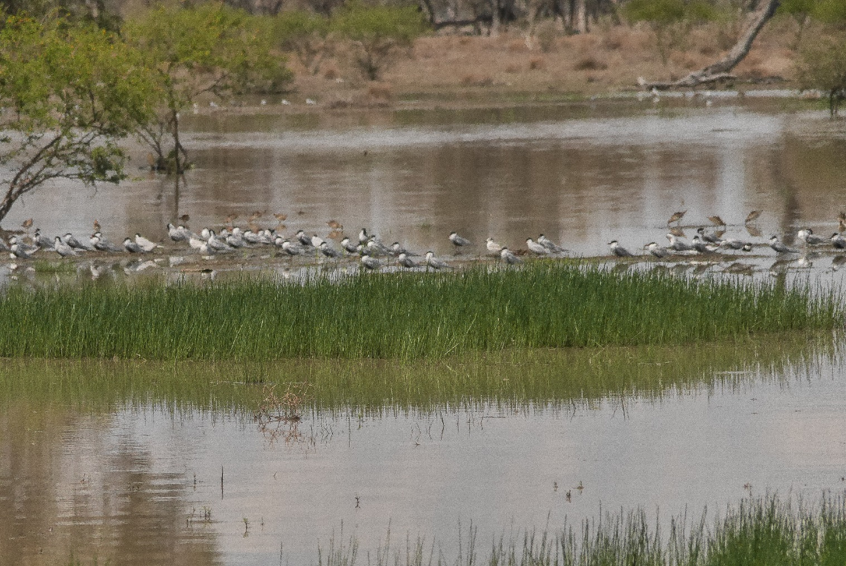

**Whiskered terns, Sharp-tailed sandpipers and Latham’s Snipe foraging on one of the Wetlands areas along Mallowa Creek.**

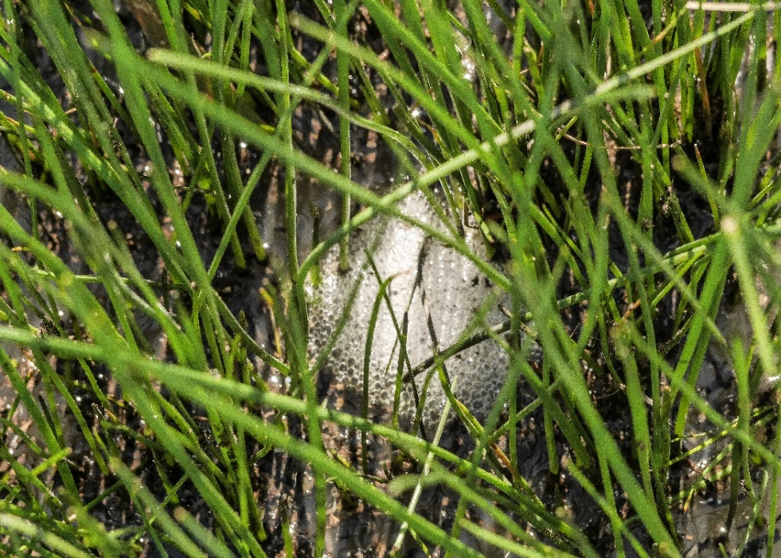Field staff acknowledge and greatly appreciates the cooperation and assistance of landholders during the bird surveys.

Since the commencement of watering, calls of spotted marsh frog, eastern-sign bearing froglets, and salmon striped frogs have been heard in the Mallowa Wetland, and freshly laid eggs have been observed.

**Frog eggs amongst wetland vegetation in one of the Mallowa wetlands**

Remote sensing using satellite images is an important tool in determining the extent of wetland vegetation watered across the Mallowa wetlands. The dark green colouring shown in the following images shows the response of wetland vegetation communities to the delivery of water for the environment.

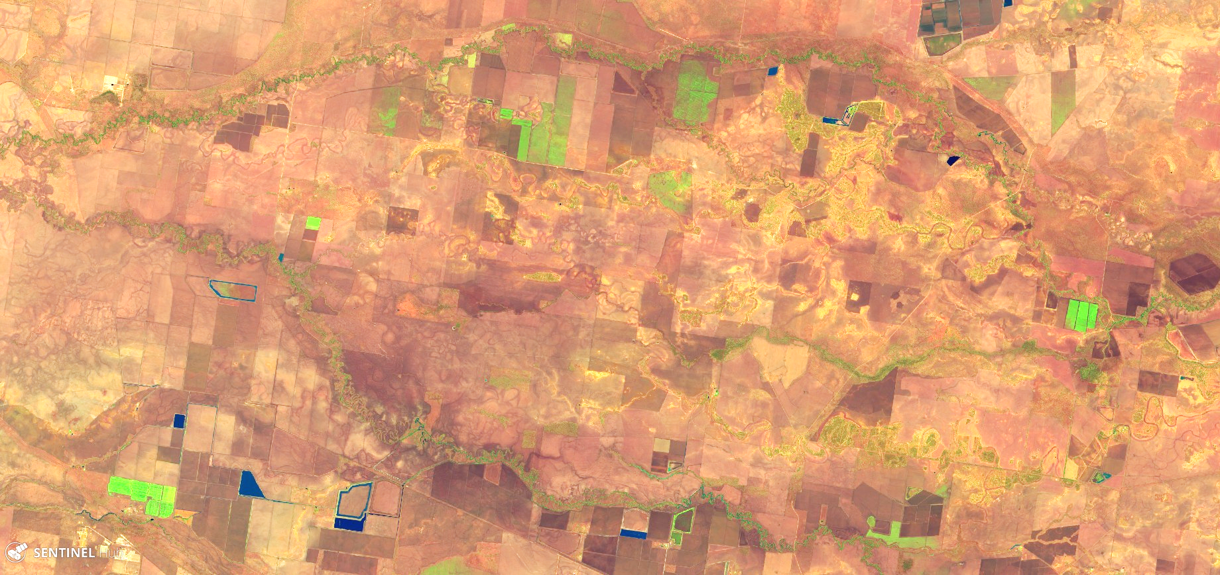

**15 September 2018**

**Moomin Creek**

**Mallowa Creek and wetlands River**

**Mehi River**

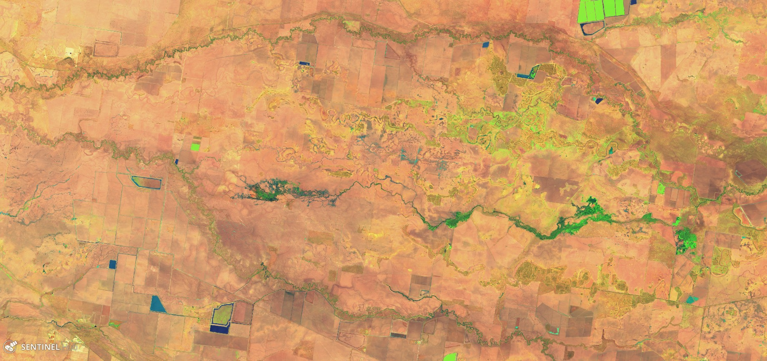

**24 November 2018**

**Mehi River**

**Moomin Creek**

**Mallowa Creek and wetlands River**

OEH has undertaken monitoring of vegetation and waterbirds since 2012 and frogs from 2015. Since 2014–15 monitoring of flows, fish populations and movement, water quality, vegetation diversity, waterbird diversity and macroinvertebrates has been undertaken as part of the LTIM. For more information about this project visit: <http://www.environment.gov.au/water/cewo/catchment/gwydir/monitoring>

These monitoring programs help inform future planning for environmental water, meet basin objectives and monitor long term trends.

## community and Government working together

Government and the community are working together to care for our rivers and wetlands. OEH staff work with interested landholders along the Mallowa system to ensure water for the environment achieves maximum benefits.

Peter Guyer is one of the many Mallowa landholders who highly values the Mallowa Creek and its wetlands for both productive values and for the important ecological values the Mallowa provides. Birds including waterbirds have long been a passion for Peter and his family and they enjoy seeing the many waterbird species benefitting from environmental flows in the Mallowa on their family farm ‘Valetta’.

Peter’s work over many years as part of the Mallowa Water Users Association (MWUA) in getting funding from Wetland Recovery and Border-Rivers Gwydir CMA to engage experts to survey and 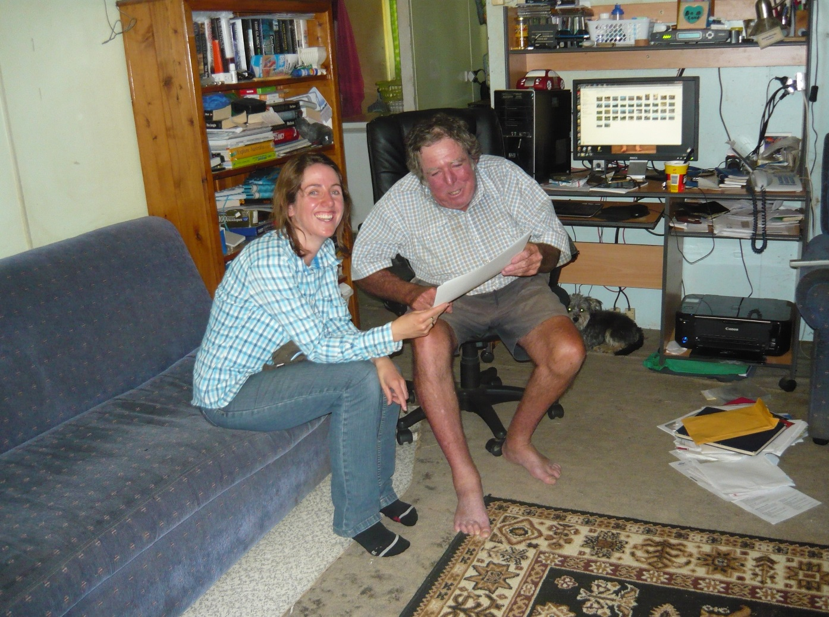prepare reports on the environmental values and the water requirements of the Mallowa, combined with tireless long-term advocating for the need for environmental water for the Mallowa, has been vital.

From 2010 Peter was the key landholder who, along with other Mallowa landholders, worked with Commonwealth and regional OEH staff to make possible the delivery of Commonwealth environmental water for the Mallowa.  This long-term work and commitment from Peter and the MWUA finally bore fruit in 2012 with Commonwealth environmental water being available for delivery to the Mallowa.

**Peter Guyer with Clare D’Arcy (CEWO) in March 2013 celebrating and reviewing images of inundation from the first environmental water deliveries made into the Mallowa in 2012/2013 water year.**

## Contacts

|  |  |
| --- | --- |
| **NSW OEH:** | **CEWO Local Engagement Officer:** |
| **Daryl Albertson Senior Wetlands & Rivers Conservation Officer**  0407 071 985  [daryl.albertson@environment.nsw.gov.au](mailto:daryl.albertson@environment.nsw.gov.au)  **Jane Humphries Wetlands & Rivers Conservation Officer**  0448 442 434  [jane.humphries@environment.nsw.gov.au](mailto:daryl.albertson@environment.nsw.gov.au) | **Jason Wilson**  0418 210 389  [jason.wilson@environment.gov.au](mailto:jason.wilson@environment.gov.au) |
| **CEWO media line** [media@environment.gov.au](mailto:media@environment.gov.au)   02 6275 9880 |
| **NSW OEH website**  <http://www.environment.nsw.gov.au/topics/water/water-for-the-environment/about-water-for-the-environment> | |