# mallowa wetlands watering event update #1

This is the first community update on the 2018–19 delivery of water for the environment in the Mallowa Wetlands, in the Gwydir catchment in northern NSW. Water for the environment is being provided to improve the health of wetlands. The water release started from Copeton Dam in mid-September.

## About the mallowa wetlands

|  |  |
| --- | --- |
| Mallowa Creek breaks off the Mehi River approximately 50km downstream of Moree. The Mallowa Creek and wetlands support a mix of wetland vegetation communities. These wetland communities attract many waterbirds when they are wet. These wetlands have been a priority for the delivery of water for the environment since 2012, using NSW and Commonwealth water for the environment.  The Mallowa wetlands also provide feeding habitat for a range of waterbird species, including threatened, vulnerable and migratory species, and large wading birds like spoonbills and Ibis which are frequently found foraging in the Mallowa Wetlands when wet. In addition, the wetlands provide habitat for a range of native species such as fish, frogs and turtles. | D:\Environmental Water\CEWH\Photos\Archive\Photos for Graphic Designers\Images for Common Use\9. Gwydir\Images with no  metadata\Mallowa\Mallowa wetlands_Valetta_5.JPG  **Large wading waterbirds on a section of Mallowa Wetlands Spring 2013** |

## Why deliver water for the environment into the mallowa wetlands now?

Many wetlands in inland NSW experience natural wet and dry phases. Storage and use of water upstream, changes to rivers and creeks, and infrastructure can increase the frequency and length of dry periods. This can reduce the ability for wetlands to bounce back in wetter times. Our planning includes watering during some dry years, to help maintain wetland areas as well as providing drought refuge habitat for native animals.

The last time larger flows entered Mallowa Creek was early 2017, when natural flows triggered a delivery of water for the environment into the system of around 7,500 megalitres. This provided inundation of the creek and core wetland areas, creating foraging habitat for waterbirds.

Water for the environment that is currently being delivered will meet the water requirements of more than 2,000 hectares of remaining wetland vegetation and enhance the condition of waterbird feeding habitat. Water for the environment is also currently being delivered into the Gingham and Lower Gwydir wetlands. Further information is at: [www.environment.gov.au/water/cewo/catchment/gwydir/water-use](http://www.environment.gov.au/water/cewo/catchment/gwydir/water-use) .

**Objectives for this watering of the Mallowa Creek and wetlands**

|  |  |
| --- | --- |
| C:\Users\korodat\Desktop\Environmental water icons - OEH Black icons - png format\OEH_Black_icons_Large\66_waterplant2.png | Vegetation - improve the condition and resilience of wetland vegetation habitat, supporting waterbird diversity and populations and other native animals. |
| C:\Users\korodat\Desktop\Environmental water icons - OEH Black icons - png format\OEH_Black_icons_Large\60_waterbird5.png | Waterbirds - improve the condition of waterbird feeding habitat following extended dry conditions. |
| C:\Users\korodat\Desktop\Environmental water icons - OEH Black icons - png format\OEH_Black_icons_Large\11_fish2.png | Fish - support native fish populations, such as golden perch, Murray cod and freshwater catfish in the Mehi River en route to the Mallowa. |

**Map of water for the environment delivery in the Gwydir Valley in 2018-19**

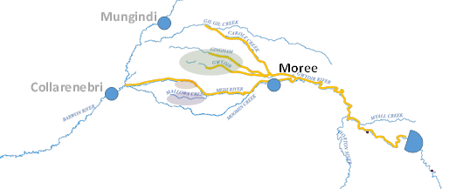

Barwon River

Gwydir River

Mallowa Wetlands

Gwydir Wetlands

Water for the environment delivered into the Mallowa Creek and wetlands provides broader benefits. Prior to this delivery of water into the Mallowa, the Mehi River below Moree had not flowed since May 2018. Similarly, very little flow had entered Mallowa Creek in the 18 months leading up to the current delivery of water for the environment. Some landholders along the Mallowa Creek and wetlands now have access to water for household and stock use.

## Water delivery details

Up to 20,000ML of Commonwealth water for the environment will be delivered into the Mallowa Creek during the 2018 – 19 water year. This water will improve the health of wetland vegetation along the length of the system. These flows also support native fish populations along the Mehi River upstream of the Mallowa Creek offtake.

Deliveries will be closely monitored and adjusted if necessary. The delivery will also be managed to ensure water achieves the environmental outcomes efficiently.

**What the water delivery will look like**

|  |  |
| --- | --- |
| Delivery of water for the environment has been planned to occur in two stages, with an initial delivery of 10,000ML between September and December 2018. The second stage of Mallowa event will deliver a further 10,000ML to the Mallowa. The targeted volume of water will reach the wetlands over about 10 weeks.  As part of the initial delivery, flows into Mallowa Creek gradually increased from mid-September to a maximum flow of around 200ML/d. By the end of October flows will start falling, with stage one being completed by early December.  The timing of the second stage of water delivery will be decided after taking account of winter crop harvest, and whether the water could be more efficiently used if delivered after the hottest months. | C:\Users\A24500\AppData\Local\Microsoft\Windows\Temporary Internet Files\Content.Outlook\P84KKHF0\Valetta_Composite.png  **27 September – water just arriving in a section of Mallowa Wetlands**  **16 October - Showing flows spreading in a section of the Mallowa Wetlands and the vegetation growing** |

## Event update

As of 16 October, around 3,360ML has been delivered to the Mallowa Creek and wetlands. During the start-up phase of Stage 1, flow rates were more variable than expected mainly due to dry conditions. While variable, flow rates for the event generally stayed within the target range of 75 - 150ML/day for the first 4-week period. Past experience suggests that flow rates above 200ML/day into Mallowa Creek may result in flows breaking away from the main channel and thereby increasing losses. With this in mind, the upper target delivery rate is 200ML/day.

## Ecological monitoring

A range of monitoring activities are planned for the flow event. Remote sensing using satellite images will be used to look at the amount of wetland vegetation watered throughout the Mallowa Creek and wetlands. An example of the response of wetland vegetation communities to the delivery of water for the environment in the Mallowa is shown in photos above.

Regular site visits will be undertaken as well as observation using remote sensing data. In the last few weeks, calls of spotted marsh frog, eastern-sign bearing froglets, and salmon striped frogs have been heard in the Mallowa Wetland, and freshly laid eggs have been observed. The Office of Environment and Heritage (OEH) has undertaken monitoring in the Mallowa of vegetation and waterbirds since 2012 and frogs from 2015. This allows comparison of this event to past events to inform future planning, meet basin objectives and monitor long term trends.

Since 2014–15 monitoring of flows, fish populations and movement, water quality, vegetation diversity, waterbird diversity and macroinvertebrates has been undertaken as part of Commonwealth Long Term Intervention Monitoring Project (LTIM). For more information about this project visit <http://www.environment.gov.au/water/cewo/catchment/gwydir/monitoring>

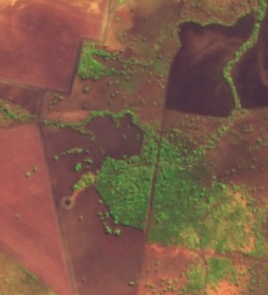

**Mallowa Creek**

Direction of flow

**11 August**

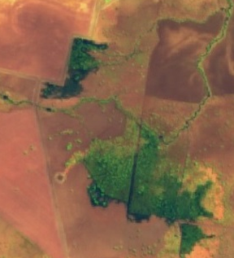

**Mallowa Creek**

Direction of flow

**30 September**

**Vegetation responses to current environmental flows in a section of Mallowa Wetlands (Source:** <https://apps.sentinel-hub.com/sentinel-playground/>

## Government and community working together

Government and the community are working together to care for our rivers and wetlands. The NSW Office of Environment and Heritage (OEH) and the Commonwealth Environmental Water Office (CEWO) work with the Gwydir Environmental Contingency Allowance Operational Advisory Committee (ECAOAC) to plan and manage the delivery of water for the environment in the Gwydir catchment. The Gwydir catchment includes the Mallowa Creek and wetlands. This committee includes members from local community and landholder groups, and industry, science and governmental organisations. The ECAOAC provides advice on planning, management and monitoring of water for the environment in the Gwydir catchment*.* OEH staff work with interested landholders along the Mallowa system. OEH and CEWO also work with other agencies, such as the Natural Resource Access Regulator and the Murray-Darling Basin Authority, that have roles in planning, monitoring and compliance.

Approximately three updates will be produced to share the event with the community. Any feedback would be welcomed.

## Contacts

|  |  |
| --- | --- |
| **NSW OEH:** | **CEWO Local Engagement Officers:** |
| **Daryl Albertson Senior Wetlands & Rivers Conservation Officer**  0407 071 985  [daryl.albertson@environment.nsw.gov.au](mailto:daryl.albertson@environment.nsw.gov.au)  **Jane Humphries Wetlands & Rivers Conservation Officer**  0448 442 434  [jane.humphries@environment.nsw.gov.au](mailto:daryl.albertson@environment.nsw.gov.au) | **Neal Foster**  0437 141 495  [neal.foster@environment.gov.au](mailto:daryl.albertson@environment.nsw.gov.au)  **Jason Wilson**  0418 210 389  [jason.wilson@environment.gov.au](mailto:jason.wilson@environment.gov.au) |
| **NSW OEH website**  <http://www.environment.nsw.gov.au/topics/water/water-for-the-environment/about-water-for-the-environment> | **CEWO media line** [media@environment.gov.au](mailto:media@environment.gov.au)   02 6275 9880 |