# MANAGING THE COMMONWEALTH ENVIRONMENTAL WATER PORTFOLIO

The Australian Government created the Commonwealth Environmental Water Holder through the *Water Act 2007*:

*“The functions of the Commonwealth Environmental Water Holder are to be performed for the purpose of protecting or restoring the environmental assets of the Murray-Darling Basin ... so as to give effect to relevant international agreements.”*

The Commonwealth’s water holdings are the result of government purchases of entitlements and investment in more efficient water infrastructure, as part of a suite of national water reforms in the Murray Darling Basin.

## PLANNING AND DECISIONS ARE DRIVEN BY THE NEED TO MAXIMISE ENVIRONMENTAL OUTCOMES

Murray-Darling river flows have always been variable. Therefore, native plants and animals in the Basin’s rivers, wetlands and floodplains rely on having variable wet and dry periods to thrive and survive.

The Commonwealth’s water portfolio is actively managed to allow the flexibility to adapt to seasonal, operational and management conditions (see example at Figure 1). This is particularly important because conditions differ across catchments (particularly unregulated catchments).

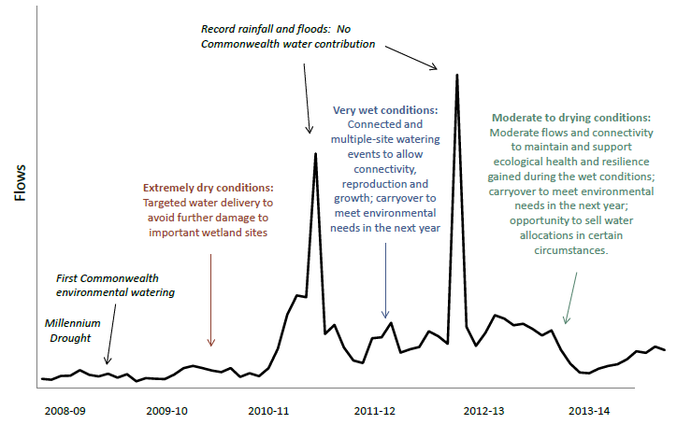

**MANAGING THE COMMONWEALTH ENVIRONMENTAL WATER**

**Figure 1** Portfolio management actions in response to changing conditions during first five years of Commonwealth Environmental Water Office operations (an illustrative example only of the Commonwealth’s actions across a range of Murray-Darling Basin catchments).

...to protect and restore rivers, wetlands and other environmental assets in the Murray-Darling Basin Commonwealth Environmental Water Office

By way of response, the Commonwealth Environmental Water Holder can deliver water over the course of the watering year; can carryover for future years to meet future environmental needs; or can trade (sell or purchase water).

## ROBUST PLANNING, SCIENTIFIC AND LOCAL STAKEHOLDER INPUT UNDERPIN DECISIONS

Robust evidence-based planning allows the Commonwealth Environmental Water Holder to manage the environmental water portfolio in a holistic manner, ensuring maximum environmental return. The Commonwealth Environmental Water Office plans based on two key factors:

1. Demand according to environmental conditions: Watering needs of plants and animals are determined, based on scientific and local stakeholder input. Extended dry conditions commonly result in high demand for water whilst multiple wet years or successful environmental watering events typically result in low demand.
2. Water availability to meet environmental demands: The scope of watering actions and the environmental outcomes that can be achieved can be limited by availability of water. Environmental needs can be met from a range of sources, and Commonwealth environmental water is delivered in conjunction with natural flows, consumptive water, and other sources of environmental water.

By considering these factors together, the Commonwealth Environmental Water Office can determine an overall purpose, ranging from ‘avoiding damage’ to the environment through to ‘improving’ ecological condition (Figure 3). These two factors also help to determine the mix of portfolio management options that might be most suitable for maximising environmental outcomes in different conditions (Figure 4).

## FROM PLANNING TO DECISION MAKING

Following the planning process outlined above, a number of factors specific to local conditions within catchments influences decision-making around water delivery, carryover and trade (Figure 2).

Figure 2 Factors informing planning and decision-making for Commonwealth environmental water include 
• environmental demands and opportunities at specific sites 
• anticipated environmental demands in coming years 
• forecast climatic conditions and current dam storage levels 
• physical and operational constraints to water delivery 
• environmental and operational risks 
• cost versus benefit assessment of each option 
• water account rules and carryover limits 
• long-term yield of entitlements and wise levels of carryover, given uncertainty about future environmental needs  and water market conditions. 


**Figure 2** Factors informing planning and decision-making for Commonwealth environmental water.

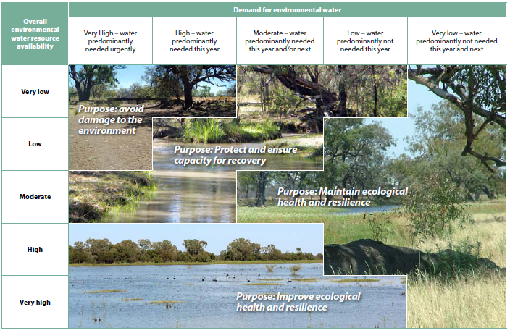

**Figure 3** Environmental demand and water availability influence the purpose of Commonwealth environmental water management.

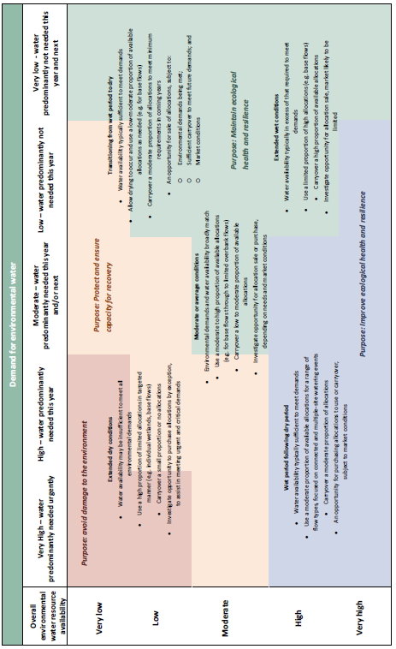

**Figure 4** Examples of how environmental demand and water availability shape planning for the mix of portfolio management options for maximising environmental outcomes in different conditions (note the portfolio management actions in each scenario represent generic examples and the specific approach taken in individual catchments and conditions will vary).