Fish and flows | aQUATIC HABITAT rEHABILITATION
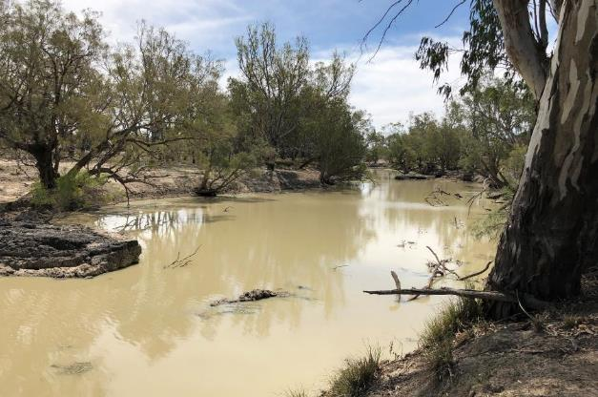

Mapping the Barwon River – Mungindi to Walgett
Aquatic habitat mapping to inform water management
Report prepared for the Commonwealth Environmental Water Office (Project 3600002146)

Murray DARLING Unit



Published by the NSW Department of Primary Industries
Mapping the Barwon River - Mungindi to Walgett: Aquatic Habitat Mapping to Inform Water Management
First published May 2020
More information
[Sam Davis, Rodney Price, / Murray Darling Unit / Dubbo]
www.dpi.nsw.gov.au
Acknowledgments
This project was funded by the Commonwealth Environmental Water Office, and was undertaken by the NSW Department of Primary Industries on behalf of the Commonwealth Environmental Water Office. NSW Department of Primary Industries’ Aquatic Habitat Rehabilitation Unit managed the project including research and report preparation. Personnel involved in completion of the project were: Rodney Price, Bron Powell, Matt Miles, Sam Davis and Anthony Townsend.
© State of New South Wales through the Department of Planning, Industry and Environment, 2020. You may copy, distribute and otherwise freely deal with this publication for any purpose, provided that you attribute the NSW Department of Primary Industries as the owner.
Disclaimer: The information contained in this publication is based on knowledge and understanding at the time of writing (May 2020). However, because of advances in knowledge, users are reminded of the need to ensure that information upon which they rely is up to date and to check currency of the information with the appropriate officer of the Department of Primary Industries or the user’s independent adviser.

Executive Summary
The purpose of this report is to inform the Commonwealth Environmental Water Office (CEWO) on environmental flow requirements for native fish in the Barwon River. Fish habitat was mapped along a 286 km stretch of river, from Mungindi to Walgett. This included inundation heights for fish habitat features – such as large woody habitat (LWH) and in-channel benches. This information, in addition to existing information on flow requirements for native fish can be used to inform the protection of critical flows or in some cases releases of water for the environment. Hydrographs can be designed based on this information to inundate a certain amount of habitat, providing measurable outcomes for supporting and increasing fish populations in the Barwon River.
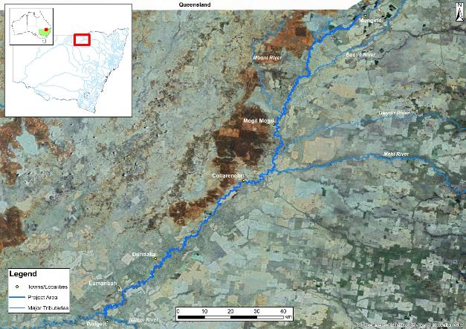
Figure 1. Project area showing major tributaries features. Source: NSW DPI
Native fish species of the Murray-Darling Basin have adapted to the highly variable conditions in its aquatic ecosystems. Many of the fish species native to the Basin have specific flow requirements adapted to these conditions. The biological rhythms of fish are often linked to flow so that opportunities for spawning, growth and dispersal are synchronised to maximise recruitment. With the development of the Basin’s river systems and subsequent regulation, many of the natural flow regimes have been altered and fish communities have suffered significant declines.
Under the 2012 Murray-Darling Basin Plan, opportunities exist for fish communities to recover from impacts associated with river regulation. Flows can be developed, delivered or protected to enhance spawning, recruitment, and movement outcomes for native fish. Flows can also be used to increase productivity in the system to improve the condition of native fish and overall river health, as well as connectivity between aquatic habitats. Information in this report informs the CEWO of flow requirements for fish species in the Barwon River.
The relationship between river height and habitat availability is an important part of flow needs for fish. Higher flows provide increased access to favourable breeding habitats and inundate benches and connected wetlands, increasing the availability of carbon in the system and driving productivity and increasing food availability. Increases in river height can also connect the river to other watercourses and wetlands (lateral connection), increasing fish distribution and improving genetic diversity. It can also increase system productivity and provide favourable conditions for spawning for some species including the iconic golden perch (Macquaria ambigua). The relationship between river flow height and habitat availability is therefore essential in determining the magnitude of flow needed to promote fish spawning and recruitment, or the addition of new individuals to the population of a species (Gaillard et al. 2008).
Native fish species of the Murray-Darling Basin have developed a range of spawning and recruitment behaviours, consequently, it is highly unlikely a single flow regime would provide equal benefits for the fish community of a system (Baumgartner et al. 2013; NSW DPI, 2013a). The exact flow requirements to deliver healthy and robust native fish communities are unknown (Bunn and Arthington, 2002). What can be assumed is that native fish have adapted to cope and thrive with the high level of natural flow variability experienced in the project area and as such the system should be managed to maintain a level of variability.
To enhance native fish outcomes, fish species can be classified into functional groups based on flow related attributes (Baumgartner et al. 2013). This has been recognised as a method for simplifying flow requirements for fish allowing more effective management of environmental flow delivery and/or flow protection from extraction (Baumgartner et al. 2013; Mallen-Cooper and Zampatti, 2015).
During the Northern Basin Fish and Flows project, (then) NSW Department of Primary Industries (DPI) Fisheries developed four functional groups of native fish (including two sub groups) combining elements of the reproductive spawning-movement and eco-hydraulic guilds (Mallen-Cooper and Zampatti, 2015; NSW DPI, 2015; Ellis et al. 2016; NSW DPI). The functional groups identified for species in the Barwon River were adapted from the Northern Basin Fish and Flows report with consideration of more recent work by Kerr et al. (2017) for defining stable low flow spawning fish. Functional groups were established in consultation with experts to assist in the development of specific long-term environmental watering requirements and flow related management actions (NSW DPI, 2015). The elements considered in development of these groups in the Northern Basin Fish and Flows project (NSW DPI, 2015) included:
- Cues for migration (dispersal and recolonization) and spawning (temperature and/or flow).
- Spatial scales of spawning and dispersal movements (10’s – 100’s of m; 100’s of m – 10’s of km; 10’s – 100’s of km).
- Reproductive mode and fecundity (e.g. broadcast spawning, nesting species, adhesive eggs).
- Spawning habitats in still/slow-flowing water or in fast-flowing habitats.
- Egg hatch time (short 1 – 3 days; medium 3 – 10 days; long > 10 days) and egg morphology.
- Scale of larval drift and recruitment.

Four groups, plus two sub groups were developed. These were as follows:
Group 1: Flow-dependent specialists
Group 2: In-channel specialists
Group 2A: Flow-dependent
Group 2B: Flow-independent
Group 3: Floodplain specialists
Group 4: Generalists

These functional groups were used to identify critical flow requirements which was coupled with the detailed habitat inundation information to be used to develop EWRs for fish in the Barwon River.

In the habitat mapping undertaken on the Barwon River between Mungindi and Walgett, commence to inundate heights were recorded and analysed for LWH, in-channel benches, and entry points to connected wetlands. This information indicates the flows (Megalitres (ML)/day) required to inundate these features. The project area was separated into six management reaches based on the nearest WaterNSW river gauge and patterns in the river channel. The management reaches used for this project are outlined in Table 1.
Table 1. Management reaches in the Barwon-Darling (Mungindi to Walgett) for flow analysis.
Management reach | Reach description | Reference gauge | Reach length (km) | LWH | Benches | Connected wetland entry points
Mungindi | Mungindi Weir to Comilaroi Weir | Barwon River @ Mungindi (416001) | 26.3 | 1,386 | 186 | 74
Presbury | Comilaroi Weir to Junction of Barwon and Boomi Rivers | Barwon U/S Presbruy  (416050) | 34.2 | 1,681 | 370 | 48
Mogil Mogil | Junction of Barwon and Boomi Rivers to Collarenebri Weir Pool | Barwon @ Mogil Mogil (422004) | 81.5 | 3,907 | 277 | 61
Collarenebri | Collarenebri Weir Pool | Barwon @ Collarenebri (422003) | 18.3 | 642 | 44 | 4
Tara | Collarenebri Weir to Walgett Weir pool | Barwon @ Tara (422025) | 106.2 | 4,108 | 608 | 27
Walgett | Walgett Weir Pool | Barwon @ Dangar Bridge (422001) | 22.1 | 867 | 122 | 30

Flow analysis revealed that overbank flows over 59,800 ML/day would be required to inundate all features across the project area; however large quantities of habitat would be inundated across all management reaches with small (154-4,040 ML/day) and large (303-18,500 ML/day) pulse events. These thresholds generally align with those outlined in the draft Barwon-Darling Long-Term Water Plan (DPIE, 2019), however the lower thresholds for small and large fresh events can be somewhat lower reflecting the influence of habitat feature availability as a factor in defining thresholds in this study. Management of water for the environment in combination with natural flow events could assist in enhancing critical events, namely connection or pool replenishment flow during dry times and small pulse events. There is limited capacity for held environmental water to significantly influence larger events such as large pulse and overbank flows.
Five flow events have been developed to represent the flow requirements of native fish in the Barwon River between Walgett and Mungindi. These requirements focus on important or threatened native fish populations occurring in the catchment as well as general system health.
The requirements aim to provide longitudinal connectivity, cues for life-cycle responses, improved habitat availability, increased primary productivity and enhanced fish condition and survival in the Barwon River.
Achievement of specified Environmental Water Requirements (EWRs) is expected to provide significant native fish outcomes. However, attaining these EWRs will require using water for the environment to supplement natural flows. To enable this to occur will require water for the environment to be protected from downstream extraction and changes to existing operational arrangements. NSW, Queensland and Commonwealth Governments are working on mechanisms to enhance the way environmental water is managed across the Northern Murray Darling Basin.
The flow magnitudes outlined in the EWRs are ideal amounts, some also have lower rates suggested that may still achieve favourable environmental outcomes. The use of lower magnitudes has a particular focus on timing and duration. Under some conditions, held environmental water may be required to provide critical refugia replenishment or provide flows for spawning and recruitment where absence of these flow conditions may compromise wild fish populations.
Ecological objectives have been developed to assist in defining the EWRs. These objectives have been tailored to native fish species reliant on flow events for specific life-cycle requirements, by providing improved spawning and recruitment opportunities. Attainment of these EWRs is also expected to enhance the maintenance and condition of all native fish by providing spawning and recruitment opportunities for those species that are less reliant on flows. Flow components such as rapid flow increases and draw down should be avoided during critical periods for native nesting fish species that have demersal eggs, such as Murray Cod.
Enhanced in-channel specialists spawning
Ecological objective
Provide flow regimes that enhance spawning opportunities for in-channel specialist native fish species, focusing on Murray cod and freshwater catfish
Improve the inundation and availability of key habitat features along the Barwon River for in-channel specialists (flow dependent – Murray cod), particularly LWH.
Improve the inundation and availability of key habitat features along the Barwon River for in-channel specialists (flow independent – freshwater catfish), particularly benches/cobble beds, and connected wetland entry points.
Improve the longitudinal connectivity along the Barwon River, enhancing localised movement opportunities for native fish.
Environmental water requirement
A stable flow event of 1,360 ML/day at the Mogil Mogil gauge and 1,780 ML/day at the Tara gauge for a minimum of 20 consecutive days (or ideally >20 days) from August to November, preferably every year but can be every second year, with a maximum inter-flow period of two years to enhance spawning outcomes for in-channel specialists (flow dependent – Murray cod) species. The effectiveness of outcomes may be compromised, with a timing shift from September to March enhancing spawning outcomes for in-channel specialists (flow independent – freshwater catfish) species. The duration and frequency should still be maintained. A slow recession should be maintained to avoid desiccation of nests and nest abandonment.
Site specific flow indicators
This magnitude of flow at Mogil Mogil Gauge would drown out Presbury Weir providing passage past this structure. Habitat feature inundation would increase with over 55.6% of LWH and 20% of benches and 21.7% of wetland entry points becoming inundated. The requirement specified at the Tara gauge would increase habitat feature inundation with over 90% of LWH, 95.4% of benches and 70.4% of wetland entry points becoming inundated.
Rationale
Small in-channel pulse events at the Mogil Mogil and Tara gauges would provide benefits for all functional groups of fish through improved habitat availability. Flows of 1,780 ML/day at the Tara gauge, are important for enhancing spawning outcomes for Murray cod and would inundate a significant proportion of habitat features thought to be related to spawning outcomes for these species, including 90% of LWH. Research has suggested a strong association between Murray cod and complex woody habitat (Koehn and Nicol, 2014). Increased availability of these habitats from this higher flow target would provide more opportunities for spawning.
This flow target would also have significant benefits for freshwater catfish with over 95% of benches in the Tara Management Reach inundated. This could result in increased availability of breeding sites and nesting materials (gravel and cobbles).
The availability of these core habitat features provided by the small pulse events would allow regular maintenance and condition opportunities for all fish communities, as well as opportunities for short to moderate movements in the system through improved longitudinal connectivity. The proposed frequency of the events is especially important for short-lived fish, including those described as stable low flow spawning fish (SLFSF) by Kerr et al. (2017), as they need regular flow events to complete important life-cycle stages.
The minimum duration of 20 days is linked to the natural hydrology and the hatch time for eggs of the target species to ensure a stable flow when eggs are on the nest. Rapid changes in height and flow rate are to be avoided to maximise spawning outcomes. The minimum of 20 days allows for sufficient time for in channel specialists (Murray cod) to select a nest, spawn, allow time for the eggs to develop and larvae to disperse (NSW DPI, 2015b).The ideal length of this event is >20 days to provide regular access to spawning habitat and movement opportunities for spawning outcomes. It is considered appropriate for the event to occur during the prescribed spawning window for target species.
Held environmental water delivered from Glenlyon, Pindari and/or Copeton dams (Border Rivers and Gwydir catchments) could be used to shape the hydrograph adding to natural flow to reach the threshold or providing a stable recession while not impacting on water temperature. The held environmental water component of the flow would have to be actively managed across the Unregulated Barwon-Darling Water Sharing Plan area.
Through implementation of their Water Reform Action Plan, the NSW government is committed to improving the way environmental water in the NSW Northern Murray-Darling Basin is managed, including an active management framework to provide assurance of the protection of environmental flows along the length of un-regulated river systems and beyond the boundaries of water sharing plans.
Enhanced native fish condition, movement and recruitment
Ecological objective
Provide flow regimes that enhance system productivity and recruitment outcomes for native fish, including in-channel specialist species, focussing on Murray cod (flow dependent), generalist species, flow specialists and floodplain specialists.
Improve the inundation and availability of key habitat features that contribute to productivity outcomes along the Barwon River, particularly benches, and wetland entry points.
Improve the longitudinal connectivity along the Barwon River, enhancing localised pre and/or post spawning movement opportunities for native fish.
Environmental water requirement
Optimum flow event of 3,180 ML/day at Mogil Mogil and 2,140 ML/day at Tara gauge for a minimum of five consecutive days from any time of year, preferably every year but can be every second year, with a maximum inter-flow period of two years. The flow target could be adjusted to a minimum of 2,650 ML/day at Mogil Mogil and 1,050 ML/day at Tara gauge, while still achieving some of the objectives under resource constrained conditions, although the effectiveness of outcomes may be compromised. Ideally, these large pulse events would occur before and after the flow for In-channel Specialist spawning. A large pulse before the spawning flow would prime the system increasing productivity, fish condition and provide opportunities to move to preferred spawning habitats. Post spawning large pulse events increase productivity providing increased food availability for larval fish, the increase in flow also improves larval drift increasing the flow of genetics.
Site specific flow indicators
A flow of 3,180 ML/day at the Mogil Mogil gauge would drown out Mungindi and Presbury weirs providing passage past these structures. Habitat feature inundation would increase with over 64% of LWH, 52% of benches and 26% of wetland entry points in the Management Reach becoming inundated. A flow of 2,140 ML/day at the Tara gauge would increase inundation of habitat features with 92.1% of LWH, 97.5% of benches and 85.2% of wetland entry points in this management reach becoming inundated.
Rationale
Large in-channel pulse events at the Mogil Mogil and Tara gauges would provide benefits for all functional groups of fish through improved habitat availability and system productivity. In particular, flows of 3,180 ML/day at Mogil Mogil would drown-out Mungindi and Presbury weirs providing improved longitudinal connectivity.
Flows of 2,140 ML/day at Tara would inundate a high portion (>80%) of all habitat features. The reduced flow targets could provide some similar outcomes, but the effectiveness may be compromised.
The availability of these core habitat features provided by the large pulse event would also improve the condition of emergent aquatic macrophytes such as cumbungi, phragmites and juncus/sedge, helping contribute to regular maintenance and condition opportunities for all fish communities, as well as opportunities for short to moderate movements in the system through improved longitudinal connectivity. The proposed frequency of the events is especially important for short-lived fish, including those described as SLFSF species by Kerr et al. (2017), as they need regular flow events to complete important life-cycle stages. A large portion of the in-channel food resources in lowland river systems comes from organic material on the floodplain (Vannote et al. 1980; Oliver and Merrick, 2006). Inundating areas out of the main channel increases availability of these resources and increases in-channel productivity while increasing the condition and growing area for macrophytes. Inundation of benches mobilises carbon which stimulates river productivity. Wetland inundation provides a stimulus for plant germination and the emergence of invertebrates from resting life stages, many of which can become abundant within days of inundation (Kerr et al. 2017).
This flow can be used to prime the system for spawning events when delivered in late winter to early spring or can be used to increase food availability and connectivity for larval and juvenile fish in mid-summer to mid-autumn. Late winter/early spring flows are intended primarily to support pre-spawning conditioning for all functional groups through inundation of in-channel benches and aquatic habitat. Mid-summer to autumn peaks are intended to provide inundation of in-channel benches and habitat to increase productivity and support larval and juvenile drift.
The main outcomes for this EWR are recruitment, productivity, and movement opportunities for dispersal. It is therefore considered appropriate for the event to occur during the pre and post-spawning timeframes for the majority of native fish species, taking into consideration any water quality issues such as water temperature.
Refuge replenishment and connection
Ecological objective
The ecological objective of this flow is to maintain critical water quality and quantity in refuge pools to avoid fish kills during sustained dry periods. This will also provide intermittent connection between refuge habitats. Maintaining refugia allows key ecosystem functions including cycling of nutrients and provision of carbon for productive food webs (MDBA, 2018).
Environmental water requirement
There is no recommended flow magnitude for replenishment of refugia and temporary connection, as it varies depending on the nature of the drying event. In some cases, water may need to be delivered at a low rate at the start of the flow to avoid adverse impacts to water quality in refuge pools when rerunning the river. This event is delivered during critical dry periods to replenish refuge pools and provide a short period of connectivity between habitats. Natural flows can be supplemented to more efficiently achieve longitudinal connection. In the absence of natural events, this flow can be delivered from regulated tributaries of the Barwon Darling. Flows were delivered from Glenylon and Copeton Dams in 2018 and 2019 for this purpose (the Northern Connectivity Event in 2018 and the Northern Fish Flow in 2019). Information gained from the delivery of these events should inform the magnitude and shape of the hydrograph for future events. As a rule, the longer the period of zero flow the greater the reduction in flow between gauges, meaning earlier delivery would be more efficient and prevent water quality in refugia becoming intolerable.
Site specific flow indicators
Replenishment and connection of refuge pools. Distance of river to be reconnected will depend on the nature of the drying event and in flows, or lack of, from tributaries.
Large pulse events for flow dependent specialists
Ecological objective
Maintain large pulse events for spawning and recruitment of flow dependent specialists.
Provide significant longitudinal connection and an increased level of lateral connection inundating low-lying wetland entry points and low-level floodplains.
Providing spawning and recruitment opportunities for floodplain specialists.
Environmental water requirement
This flow would generally not require delivery but protection of the integrity of natural events within the flow class. Natural flow events could be supplemented with held environmental water from tributaries. This is particularly important after long periods of no flow or extended period with no large pulse.
A pulse event peaking at 8,180 ML/day at Mogil Mogil and 6,500 ML/day at Tara for a minimum of 20 consecutive days from September to March, preferably every year but can be every second year, with a maximum inter-flow period of two years to enhance migration, spawning and recruitment outcomes for flow specialists and floodplain specialists. The flow target could be adjusted to a minimum of 3,700 ML/day at Tara while still achieving some of the objectives, although the effectiveness of outcomes may be compromised, with a timing shift from September to March enhancing spawning outcomes for in-channel specialists (flow independent – freshwater catfish) species. The duration and frequency should still be maintained.
Site specific flow indicators
A flow of 8,180 ML/day at Mogil Mogil gauge would drown out Munginidi, Comilaroi and Presbury weirs providing fish passage past these structures. Habitat feature inundation would increase with over 90% of LWH and benches and 85% of wetland entry points becoming inundated. A flow of 6,500 ML/day at Tara gauge would drown out Banaraway Weir providing fish passage past this structure and increased inundation of habitat features with 100% of habitat features recorded in that area becoming inundated.
Maintain integrity of bankfull and overbank flows for flow dependent specialist and floodplain specialists
There is minimal potential for held environmental water to impact on this flow class. However, protection should be advocated to maintain its integrity along the whole project area due to the number of connection points to wetland areas including anabranches and billabongs. Additional mapping could take place to identify particularly valuable wetlands. Local Land Services could assist in promoting protection and rehabilitation of wetland areas including fencing and stock exclusion. Establishing the height required to inundate entry points to significant areas of wetland requires further analysis of where the connection points lead too. The occurrence interval for these events varies significantly for the target species, longer lived flow dependent specialist species such as golden perch and silver perch do not require as frequent recurrence intervals as short-lived floodplain specialist species such as olive perchlet.
Activities to address the lack of natural inundation of off stream wetlands may need to be considered in some areas. This could be done by pumping water from the main channel which has been used in areas of the Southern Murray-Darling Basin (see VEWH, 2019; NSW DPIE-EES, 2019) at a number of scales with varying levels of success. This is also being considered in parts of the Northern Basin including upstream of Mungindi in the Lower Macintyre.

Recommendations for future management in the Barwon River
The Barwon River habitat mapping project has considerably advanced information and thinking for water management in the Barwon River related to fish and river outcomes and enhanced the existing information for the already mapped stretch of the Barwon Darling from Walgett to Wilcannia. However, knowledge gaps still exist that require attention to enhance the development of future environmental water requirements. The outcomes of water management in the Barwon River would be greatly enhanced by the development and implementation of complementary aquatic habitat rehabilitation and adaptive monitoring programs. The recommendations outlined in this report are the views of the Department of Planning, Industry and Environment (DPIE) Fisheries and are not considered to be the sole responsibility of the CEWO but may be supported or progressed with other State and Federal government agencies.
Management Actions
To improve native fish populations and river health in the Barwon River and throughout the Border Rivers, future management of water for the environment should consider management actions including:

Developing a fish management strategy for the Barwon River Catchment
Critical riverine components of habitat and connectivity need to be considered in management planning and implementation, and whilst aspects of these components are integrated with flow management, additional complementary actions will also be needed to achieve the most effective and efficient outcomes.

These actions should include targeted habitat rehabilitation such as riparian management, including native revegetation, aquatic planting, and weed control; resnagging; erosion control; fish passage/connectivity remediation; reducing the impact of extraction through offtakes on fish; and; alien fish management. The development of reach scale plans would benefit from and be guided by fine-scale habitat mapping activities, which would also collect information on the condition of aquatic and riparian habitat and provide a prioritised and coordinated strategy that maximises water management for improved river health.
The habitat mapping data can be used to provide direction on how to proceed with aquatic habitat restoration and protection initiatives. This information can be used by natural resource managers to prioritise areas for action increasing the benefits of environmental flow deliveries in the project area. For example, habitat mapping data could be used to improve the condition of riparian vegetation by showing where there are significant weed issues and where there is revegetation of native riparian species, allowing natural resource managers to make more informed decision when directing their resources.
The Barwon River is at the whim of upstream catchments. The conservation and enhancement of these areas would have significance benefits to the fish communities of the main channel Barwon River. Unimpeded access to these catchments and their diverse habitats is essential to the recovery of native fish population in the Barwon Darling, making fish passage the highest priority for complementary actions in the project area.
The development of a fish management strategy for the Barwon River catchment would also need to consider and manage for potential negative impacts associated with managing water for the environment. In the Barwon River catchment this may include the proliferation of alien fish species and the occurrence of water quality impacts such as black water events. black water events are intensified when periods of drought are punctuated by floodplain inundating flows that return organic matter to the river channel. Using relevant flow related information of all fish species to form functional groups and develop flow regimes will ensure that the effects of both alien and native fish are considered, allowing water requirements to be developed that do not provide an unnecessary advantage to alien fish over native fish.

Coupling flows with connectivity
Increasing connectivity between Mungindi and Walgett, as well as into tributaries coupled with targeted flow events would have a significant benefit for native fish. Addressing fish passage at barriers in the project area by providing or supplementing flows to drown out lower structures (Mungindi, Comilaroi, Presbury and Banaraway weirs) and constructing fishways on larger structures would improve the resilience of the fish community in the area.

Continued and sustained cross-disciplinary and inter-jurisdictional collaboration on information and knowledge of ecological relationships in the Barwon River and adjoining catchments
Current activities across the Murray-Darling Basin related to water management provide opportunities to effectively establish and foster linkages between relevant community, academic and government experts. The Mapping the Barwon project gathered a range of relevant knowledge, expertise and information related to fish and flow relationships in the Barwon River. While much of this information is readily accessible, other material occurs in variable formats and is held by a number of different institutions and agencies. The formation of a formal water management group for the Barwon River, promoting a collaborative and open approach to management of existing and future watering activities, including a shared commitment to identifying and addressing knowledge gaps would be of great benefit to water management in the project area.

Research and Monitoring
To improve native fish populations and river health in the Barwon River and throughout the Border Rivers, future management of water for the environment should consider research and monitoring options such as:

Undertaking further habitat mapping to connect mapped areas in the Border Rivers, Gwydir and Barwon Darling River and secure additional data source
Significant gaps still exist in our understanding of habitat features and their relationship to river flow across the Northern Basin. Complementing the habitat mapping database from this project a previous project completed on the Dumaresq and Barwon/Darling Rivers and projects completed on the Gwydir and Mehi with further mapping planned on the Macintyre River downstream of the Dumaresq River confluence, the Severn River downstream of Pindari and the remainder of the Mehi could connected the data sets. This information, coupled with fish community details and water management activities, would allow critical flow thresholds to be identified in relation to inundation values, structure drown out requirements, and bankfull capacity volumes, helping to develop specific water requirements and strengthen water management actions from Roseneath on the Dumaresq River and start of the Mehi River to Wilcannia on the Darling River.
Priority reaches:
  - Severn River - Pindari Dam to the Dumaresq River confluence (~180 km)
  - Macintyre River - Dumaresq River confluence to Mungindi (~340 km)
  - Mehi River - Gundare to Barwon River (~235 km)
To complement habitat mapping data, LiDAR could be used to assess wetland area associated with entry points. This would allow a wetland area to be attached to each entry/exit point recorded during on ground mapping. Further analysis could also be complete of these wetlands using satellite imagery to map vegetation extent.

Committing to a long-term, adaptive management plan driven by monitoring and evaluation
The hydrological and hydraulic variation required to restore key elements for fish in the Barwon River will differ across functional groups, and whilst some benefits will be experienced cross groups from different flow regimes, a long-term commitment to adaptive management to flow and aquatic habitat management is required to maximise outcomes. Management plans that consider flow, habitat and connectivity need to include objectives for each functional group to ensure benefits are experienced across all native fish communities over relevant spatial and temporal scales. The development and implementation of a rigorous monitoring program is essential to help validate program assumptions and measure the success of flow delivery/protection and water requirements against the program objectives.
It is important to establish long-term monitoring in project area that can supplement other monitoring programs in tributaries and downstream in the Darling River. This will ensure that outcomes from managing water for the environment across a range of different valley types are captured and used to guide management decisions. In addition to this, it is essential that monitoring information and research outcomes are communicated and readily accessible to advance knowledge and management actions across related systems where applicable.

Contents
Executive Summary i
Recommendations for future management in the Barwon River vi
Contents ix
List of Figures xi
List of Tables xiii
Introduction 1
Project scope and objectives 1
Project objectives 1
Study area 1
Hydrology 1
Water infrastructure 4
Fish species in the Barwon River 6
Fish functional groups in the Barwon River 10
Methodology 14
Habitat mapping 14
Refugia 16
Management Reaches 16
Flow relationships 19
Habitat mapping results 20
Riparian vegetation condition 20
Exotic plant species 21
Aquatic habitat 22
Large Woody Habitat 22
Rootballs 24
Refugia 31
Benches 38
Connected wetlands 46
Aquatic macrophytes 54
Cobble beds 62
Fish passage 70
Flow relationship results 75
Summary of project area flow components 76
Recommendations and future directions 96
Flows for native fish 96
Recommendations for future management in the Barwon River 103
Conclusion 107
References 108
Appendix 116
Appendix A: Stream cross sections for the six gauges in the project area 116
Appendix B: Habitat feature inundation with the 2019 fish flow 122
Appendix C: Pumpsites 128

Contents
Executive Summary i
Recommendations for future management in the Barwon River vi
Contents ix
List of Figures xi
List of Tables xiii
Introduction 1
Project scope and objectives 1
Project objectives 1
Study area 1
Hydrology 1
Water infrastructure 4
Fish species in the Barwon River 6
Fish functional groups in the Barwon River 10
Methodology 14
Habitat mapping 14
Refugia 16
Management Reaches 16
Flow relationships 19
Habitat mapping results 20
Riparian vegetation condition 20
Exotic plant species 21
Aquatic habitat 22
Large Woody Habitat 22
Rootballs 24
Refugia 31
Benches 38
Connected wetlands 46
Aquatic macrophytes 54
Cobble beds 62
Fish passage 70
Flow relationship results 75
Summary of project area flow components 76
Recommendations and future directions 96
Flows for native fish 96
Recommendations for future management in the Barwon River 103
Conclusion 107
References 108
Appendix 116
Appendix A: Stream cross sections for the six gauges in the project area 116
Appendix B: Habitat feature inundation with the 2019 fish flow 122
Appendix C: Pumpsites 128

List of Figures
Figure 1. Project area showing major tributaries features. Source: NSW DPI i
Figure 2. Extent of the Barwon River project area (highlighted in yellow) in relation to the Barwon-Darling Water Resource Plan Area (CLWD, 2017) 1
Figure 3. Project area showing major tributaries features. Source: NSW DPI 1
Figure 4. Barwon River profile, with project area outlined in green (MDBA, 2019). 5
Figure 5. Fish community status for the Northern Basin, highlighting condition of fish communities, and the location of carp hotspots (NSW DPI, 2015). 9
Figure 6: The influence of flows on the different stages within the life-cycle of a fish (adapted from MDBA, 2014). 10
Figure 7: Flow plot analysis of the Barwon River during field work component. Grey shading represents when field work took place. 14
Figure 8: Structural complexity classes used to describe LWH during field work. 16
Figure 9: Management Reaches between Mungindi and Walgett. 18
Figure 10: Schematic of methods used to calculate CTI heights of key habitat features along the Barwon River. 19
Figure 11: Example of rootball habitat recorded in the project area. 24
Figure 12: Location of rootballs recorded in the Mungindi management reach. 25
Figure 13. Location of rootballs recorded in the Presbury management reach. 26
Figure 14. Location of rootballs recorded in the Mogil Mogil management reach. 27
Figure 15. Location of rootballs recorded in the Collarenebri management reach. 28
Figure 16. Location of rootballs recorded in the Tara management reach. 29
Figure 17. Location of rootballs recorded in the Walgett management reach. 30
Figure 18: Location of refuge pools recorded in the Mungindi management reach. 32
Figure 19: Location of refuge pools recorded in the Presbury management reach. 33
Figure 20: Location of refuge pools recorded in the Mogil Mogil management reach. 34
Figure 21: Location of refuge pools recorded in the Collarenebri management reach. 35
Figure 22: Location of refuge pools recorded in the Tara management reach. 36
Figure 23: Location of refuge pools recorded in the Walgett management reach. 37
Figure 24: Examples of silt (top) and rock (bottom) benches recorded in the project area. 39
Figure 25: Location of benches recorded in the Mungindi management reach. 40
Figure 26. Location of benches recorded in the Presbury management reach. 41
Figure 27. Location of benches recorded in the Mogil Mogil management reach. 42
Figure 28. Location of benches recorded in the Collarenebri management reach. 43
Figure 29. Location of benches recorded in the Tara management reach. 44
Figure 30. Location of benches recorded in the Walgett management reach. 45
Figure 31: Example of a wetland entry point recorded in the project area. 47
Figure 32: Location of connected wetland entry points recorded in the Mungindi management reach. 48
Figure 33: Location of connected wetland entry points recorded in the Presbury management reach. 49
Figure 34: Location of connected wetland entry points recorded in the Mogil Mogil management reach. 50
Figure 35: Location of connected wetland entry points recorded in the Collarenebri management reach. 51
Figure 36: Location of connected wetland entry points recorded in the Tara management reach. 52
Figure 37: Location of connected wetland entry points recorded in the Walgett management reach. 53
Figure 38: An example of submerged (curly pondweed) and emergent (water primrose) macrophytes recorded in the project area. 55
Figure 39: Location of macrophytes that were recorded in the Mungindi management reach. 56
Figure 40: Location of macrophytes that were recorded in the Presbury management reach. 57
Figure 41: Location of macrophytes that were recorded in the Mogil Mogil management reach. 58
Figure 42: Location of macrophytes that were recorded in the Collarenebri management reach. 59
Figure 43: Location of macrophytes that were recorded in the Tara management reach. 60
Figure 44: Location of macrophytes that were recorded in the Walgett management reach. 61
Figure 45: Example of a partially submerged cobble bed near Walgett. 63
Figure 46: Location of cobble beds recorded in the Mungindi management reach. 64
Figure 47: Location of cobble beds recorded in the Presbury management reach. 65
Figure 48: Location of cobble beds recorded in the Mogil Mogil Management Reach. 66
Figure 49: Location of cobble beds recorded in the Collarenebri Management Reach. 67
Figure 50: Location of cobble beds recorded in the Tara management reach. 68
Figure 51: Location of cobble beds recorded in the Walgett management reach. 69
Figure 52: Fish passage barriers recorded in the project area. 71
Figure 53: Fish passage barriers in the project area and flows in the Barwon River during the last 20 years. The green dotted line highlights the drown out value for each weir, indicating when fish passage would have been available. 74
Figure 54: Components of the in-channel flow regime (adapted from Ellis et al. 2016). 76
Figure 55. Hydrological connectivity and flows (MDBA, 2014). 97
Figure 56: Cross section for Barwon @ Mungindi gauge. 116
Figure 57: Cross section for Barwon @ upstream Presbury gauge. 117
Figure 58: Cross section for Barwon @ Mogil Mogil. 118
Figure 59: Cross section for Barwon @ Collarenebri. 119
Figure 60: Cross section for Barwon @ Tara. 120
Figure 61: Cross section for Barwon @ Dangar Bridge. 121
Figure 62: Habitat inundation in the Mungindi Management Reach during the 2019 fish flow. 122
Figure 63: Habitat inundation in the Presbury Management Reach during the 2019 fish flow. 123
Figure 64: Habitat inundation in the Mogil Mogil Management Reach during the 2019 fish flow. 124
Figure 65: Habitat inundation in the Collarenebri Management Reach during the 2019 fish flow. 125
Figure 66: Habitat inundation in the Tara Management Reach during the 2019 fish flow. 126
Figure 67: Habitat inundation in the Dangar Bridge Management Reach during the 2019 fish flow. 127
Figure 68: Location and size of pumpsites in the project area 129

List of Tables
Table 1. Management reaches in the Barwon-Darling (Mungindi to Walgett) for flow analysis. i
Table 2: Commonwealth (as of 30/11/2019) and NSW State Government (as of 23/02/2020) environmental water holdings in the Barwon Darling River (DPIE Water, 2020; CEWO, 2019a). 3
Table 3: Fish and significant crustacean and mollusc species expected to occur in the project area, their status, and life history requirements related to flow (Jones, 2007; Lintermans, 2009; Ponder et al. 2016; NSW DPI, 2018b; NSW DPIE 2019a). 8
Table 4: Fish guild groupings for species in the Barwon River (adapted from NSW DPI, 2015). 12
Table 5: Typical features recorded on PDAs during habitat mapping. 15
Table 6: List of exotic plant species recorded in the project area. 21
Table 7: Number and percentage of each LWH complexity group in the Mungindi management reach. 23
Table 8: Number and percentage of each LWH complexity group in the Presburys management reach. 23
Table 9: Number and percentage of each LWH complexity group in the Mogil Mogil management reach. 23
Table 10: Number and percentage of each LWH complexity group in the Collarenebri management reach. 23
Table 11: Number and percentage of each LWH complexity group in the Tara management reach. 23
Table 12: Number and percentage of each LWH complexity group in the Walgett management reach. 23
Table 13: Number of rootballs identified in each management reach 24
Table 14: Number, extent and average depth of refugia identified in each management reach 31
Table 15: Number and extent of benches identified in each management reach 38
Table 16: Number of connected wetlands identified in each management reach 46
Table 17: Number and extent (m²) of aquatic macrophyte species identified in each management reach 54
Table 18: Number and extent (m²) of cobble bars identified in each management reach 62
Table 19: Definition of the six flow regime components identified for this study (adapted from Ellis et al. 2016; NSW DPI, 2017a). 77
Table 20: Summary of flow components, stage height and mean daily flow range for Mungindi management reach. 79
Table 21: Summary of flow components, stage height and mean daily flow range for Presbury management reach. 82
Table 22: Summary of flow components, stage height and mean daily flow range for Mogil Mogil management reach. 85
Table 23: Summary of flow components, stage height and mean daily flow range for Collarenebri management reach. 88
Table 24: Summary of flow components, stage height and mean daily flow range for Tara management reach. 91
Table 25: Summary of flow components, stage height and mean daily flow range for Dangar Bridge management reach. 94

Introduction
Aquatic habitat is an important element of the riverine environment and consists of stream features such as bed substrates, hydrology, pools, riffles, floodplains, instream and bank vegetation (macrophytes and riparian vegetation), large woody habitat (LWH), bank overhangs and rocky outcrops (Rutherford et al. 2000). These features along with billabongs, paleo-channels and off stream wetlands provide spawning, feeding, shelter and recruitment sites essential for the survival of aquatic biota, including native fish. The degradation of native riparian vegetation, the removal of LWH and the installation of and operation of instream structures that are barriers to fish passage are all listed as Key Threatening Processes under the NSW Fisheries Management Act (FM Act) 1994.
Although there is limited capacity to deliver water for the environment to the Barwon River (Walgett to Mungindi) (the project area), the Commonwealth Environmental Water Office (CEWO) has the capacity to target deliveries in upstream catchments such as the Dumaresq, Macintyre and Severn Rivers (Border Rivers), Gwydir/Mehi (Gwydir), Namoi and Peel rivers. Delivery to the Barwon is typically only used in exceptional circumstances such as the drought conditions over the past two years. Improved ecological conditions in the tributaries that CEWO has a greater capacity to deliver in, are likely to have benefits to the fish community in the project area and a portion of the flows is likely to reach the project area.
The catchment supports a relatively rich native fish fauna. Twelve native fish species have been recorded, including threatened species or populations such as Murray cod, silver perch, olive perchlet, freshwater catfish and species of community and recreational importance such as golden perch (NSW DPI, 2015). The area also has a number of important crustacea and mollusc species, including the critically endangered Darling River snail (Notopala sublineata), and up to three species of freshwater mussel (Alathyria jacksoni, Velesunio ambiguous and V. wilsonii which have significant cultural, spiritual and community importance for the Aboriginal people of the Barwon-Darling and Murray-Darling Basin more broadly (Jones, 2007; WCMA, 2009; Sheldon 2017; NSW DPI 2018c; NSW DPIE, 2019a). Assessments by (then) NSW Department of Primary Industries (DPI) Fisheries (2016) and the Sustainable Rivers Audit (Davies et al. 2012) concluded that overall the Barwon River fish community is in moderate to good health, ranking it among the best catchments in the Basin for native fish and providing a strong platform for further improvement if appropriate management actions are implemented.
The Northern Basin Review suggests to further improve environmental outcomes in the Barwon‒Darling, targeted recovery combined with management and protection of environmental flows would make the most of recovered water (MDBA, 2016). Environmental assets and associated objectives and outcomes for the Barwon River have been identified in the Basin-wide Watering Strategy (BWS), an assessment of in-stream environmental water requirements by the MDBA (2012), and state-based investigations to inform Water Resource Plans (WRPs) and Long-Term Watering Plans (LTWPs). Based on these strategies and studies, the CEWO has identified key demands and outcomes being targeted by managing water for the environment in the Barwon River. For native fish this includes increasing the frequency of pulses and bankfull events (CEWO, 2016).
To ensure these ecological outcomes are achieved with the most effective and efficient use of water for the environment in the Barwon Rivers it is critical that management decisions are guided by the best available information, including environmental water requirements for fish and hydrological thresholds for habitat conditions.
NSW Department of Planning Industry and Environment (NSW DPIE Fisheries) has in the past completed work on the flow requirements of native fish in the Northern Murray-Darling Basin to achieve key life history stages (NSW DPI, 2015).
This information is based on the latest science, literature and expert opinion for the Northern Basin, and can be used to guide management decisions to achieve fish outcomes from improved water management. However, in all valleys there is a need to relate these biological needs to system-specific ecological information that enhances management actions and ecological outcomes. This includes flow thresholds and other metrics (river height, flow rate, duration, volume) required to inundate key habitat features in the system that contribute to native fish, connectivity and productivity outcomes such as benches, wetland entry points, aquatic macrophytes, and LWH.
Habitat mapping has already been completed on the Barwon Darling from Walgett to Wilcannia in 2015 under the Northern Basin Fish and Flows project (NSW DPI, 2015), the Dumaresq River in 2017 (NSW DPI, 2018a) and various reaches of the Gwydir in 2019. This made the project area a high priority for mapping to further provide support for decision making in relation to water for the environment in the Barwon Darling system. Further mapping is now planned in the Lower Macintyre which will connect with the reach mapped through this project. Calculating hydrological thresholds for LWH, benches and wetland entry points based on detailed habitat mapping will significantly improve the CEWO’s ability to make decisions for water for the environment that meets environmental objectives under the BWS.

Drought Conditions in the Murray Darling Basin (Summer 2019/20)
The conditions in the project area during the writing of this report are at a serious point with much of the Northern Basin in critical drought. Across most of the project area, flows in the past two years have been solely attributed to water for the environment deliveries from the Border Rivers and the Gwydir, constituting previously unseen conditions at many gauges dating back to the 1980s.These conditions and the likely increase in occurrence with climate change make this report as a whole and the recommendations for refuge replenishment flows, particularly valuable for water management in the project area.
As a result of the severe drought conditions in the Murray Darling Basin and the increasing likelihood of wide spread fish kills the NSW Department of Planning Industry and Environment – Fisheries established the Native Fish Drought Response Framework (NSW DPI 2019).The Framework includes the establishment of Valley Technical Advisory Groups (VTAG) which have helped to the provide information for on ground interventions including fish rescues, pool aeration and refuge pool monitoring (NSW DPI 2019). A VTAG has been established for the Barwon Darling and has thus far helped identify refuge pools and a monitoring regime.
Additionally, the Barwon-Darling Watercourse Water Resource Plan contains measures for addressing drought and extreme dry periods under 5.8 Measures in Response to Extreme Events.

Project scope and objectives

Project objectives
The primary objectives of the project are to:
- Calculate commence-to-inundate flow thresholds of select habitat features where feasible, including benches, wetlands entry/exit points and LWH.
- Document the stream bed morphology, including the location, length and depth of pools that may act as drought refugia, the instream habitat features (benches, wetland entry/exit points, aquatic macrophytes, substrate), and LWH loading;
- Document the riparian features of the Barwon River between Mungindi and Walgett, focusing on native vegetation, weed infestation and existing management activities;
- Identify and map threats and processes that may influence the extent and condition of aquatic and riparian habitat features; and
- Make recommendations to improve water for the environment management actions in the Barwon River, and to protect and improve stream health, threatened species habitat enhancement, weed control and other habitat features.

Study area
The Barwon River is formed at the confluence of the Macintyre and Weir Rivers, 25 kilometres upstream of Mungindi, NSW (Figure 2 & Figure 3). The catchment areas of these rivers are the Darling Downs of south-east Queensland and the lower slopes of the New England Tablelands in north-east NSW (Bioregional Assessments, 2019). The Barwon River flows south-west through Collarenebri and Walgett, then heads west to Brewarrina. Its confluence with the Culgoa River marks the start of the Darling River.

The study area is the reach from Mungindi (Mungindi Weir) to Walgett (Walgett Weir), a distance of 286 kilometres. The area receives inflows from major tributaries including the Boomi, Little Weir, Moonie, Gwydir, Mehi and Namoi rivers. River channel capacity increases considerably downstream of Collarenebri with inflows from upstream tributaries.

The Barwon River is a part of the Lower Darling Endangered Ecological Community (EEC) listed under the FM Act (NSW DPI, 2007). The EEC is characterised by variable and unpredictable patterns of high and low flows. The EEC provides a variety of habitats for fish and invertebrates including pools, runs, riffles, backwaters and billabongs, in-stream woody habitats and aquatic plants (NSW DPI, 2007). One of the major causes of degradation to the EEC is the modification of natural flows as a result of river regulation (NSW DPI, 2007).
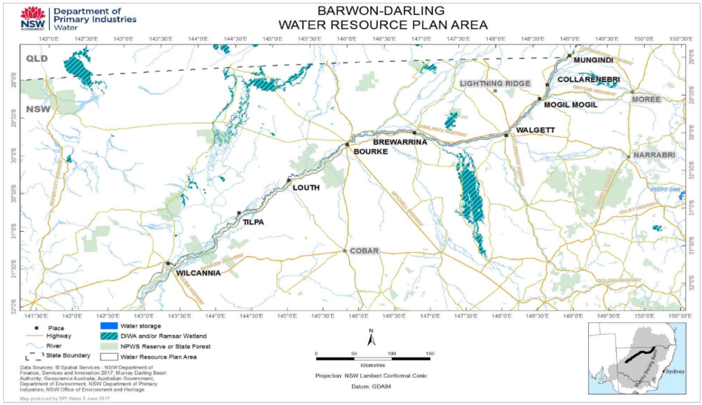
Figure 2. Extent of the Barwon River project area (highlighted in yellow) in relation to the Barwon-Darling Water Resource Plan Area (CLWD, 2017)

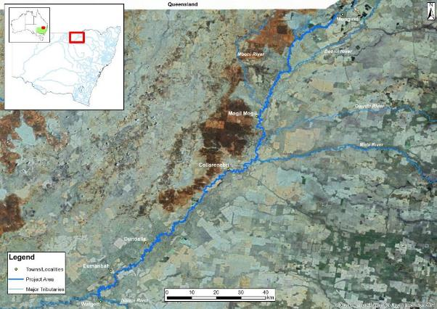
Figure 3. Project area showing major tributaries features. Source: NSW DPI

Hydrology
The project area is one of low rainfall, with mean annual rainfall in Mungindi 506mm (BOM, 2018). Rainfall is predominantly recorded in the hotter months and is highly variable, which has a considerable impact on flows in the system (BOM 2018). In the first half of 2017-18, most of the Northern Basin was experiencing below average to very much below average rainfall conditions, resulting in very low to no flows across all systems (BOM, 2018). At the same time, some areas were experiencing record high temperatures during spring and early summer, which exacerbated no flow conditions (CEWO, 2019b). In 2019, dry conditions continued with a dry winter recorded making three consecutive winters with below average rainfall followed by a dry spring (WaterNSW, 2019). Despite record low inflows, flow was seen in the project area as a result of the Northern Fish Flow with water delivered from the Borders Rivers and Gwydir catchments (Wrathall, 2019).
The system experiences highly variable and unreliable flows, as a result of variable rainfall and highly regulated tributaries (Border and Mehi rivers) and unregulated intermittent systems (the Moonie and Weir rivers). The Mehi system has undergone increased connection to the Barwon River since construction of Tareelaroi Regulator and works to lower the exit from the Gwydir River have decreased the flows required to inundate the system. Originally the bulk of flows in the Gwydir system would dissipate in the Gingham and Big Leather watercourses (DECCW, 2011).
Water in the project area is managed under the Water Sharing Plan for the Barwon Darling Unregulated and Alluvial Water Sources 2012. Table 2 shows the estimated Commonwealth environmental water holdings under the water sharing plan and water held by the NSW State Government. The flows entering the system from the Border Rivers are managed under the Water Sharing Plan for the New South Wales Border Rivers Regulated River Water Source 2009 and flows from Glenlyon Dam are managed under the Border Rivers Resource Operations Plan 2008.
These flows make up a significant portion of flows in the project area and can be impacted by water management in Queensland. The Border Rivers Commission implements the agreement made between the governments of NSW and Qld in relation to water sharing and infrastructure. The agreement in NSW was ratified by the New South Wales-Queensland Border Rivers Act 1947 and in Qld by the New South Wales-Queensland Border Rivers Act 1946. Flows will also be impacted by the Queensland Border Rivers-Moonie Water Resource Plan which was accredited in September 2019.
Flows in the Gwydir catchment are managed under Water Sharing Plan for the Gwydir Regulated River Water Source 2016 and the Namoi is managed under the Water Sharing Plan for the Upper and Lower Namoi Regulated River Water Sources 2016. All other unregulated tributaries are managed under the Water Sharing Plan for the Intersecting Streams Unregulated and Alluvial Water Resources 2011. Most water sharing plans have commenced yet a number have been extended including the Border Rivers Regulated River.
Six Water NSW gauges on the Barwon River record flow height and magnitude. Flows recorded by these gauges are influenced by regulation from tributaries, including highly regulated systems that have significantly altered flows. Although the Barwon River is not directly regulated by a large storage, inflows from tributaries are impacted by large storages and regulating structures further up in the adjoining catchments.

Security | Registered entitlements | Long term average annual yield (ML) | Estimated current Commonwealth water account balance (ML) | NSW State Government Holdings
Unregulated (A Class) | 73 | 73 | N/A | 189
Unregulated (B Class) | 16,060 | 16,060 | N/A | 51
Unregulated (C Class) | 12,498 | 12,498 | N/A | N/A
Unregulated River | N/A | N/A | N/A | 1,488
Total | 28,631 | 28,631 | 0 | 1,628
Table 2: Commonwealth (as of 30/11/2019) and NSW State Government (as of 23/02/2020) environmental water holdings in the Barwon Darling River (DPIE Water, 2020; CEWO, 2019a).
*For unregulated entitlements, no ‘carryover’ or ‘water account balance’ is reported. ‘New allocations’ and ‘available water transferred for delivered directly’ are accounted at the time of take.

Water infrastructure
In the project area, seven fixed crest weirs restrict flow but do not have regulating infrastructure. Tributary inflows to the project area are highly regulated with major storages in Border Rivers, Gwydir and Namoi catchments. Storages in the Border Rivers include Pindari, Glenlyon and Coolmunda Dam. Flows are re-regulated downstream of these storages at Boggabilla Weir on the Macintyre River. In the Gwydir Catchment flows are regulated by Copeton Dam and re-regulated downstream by Tareelaroi Weir, Boolooroo Weir, Tyreel Regulator, Combadello Weir, Gundare Regulator and Mallowa Creek Regulator. In the Namoi Catchment flows are regulated by major storages Keepit and Chaffey Dams and minor storages Quipolly and Dungowan Dams. Flows are re-regulated downstream of these storages by Mollee, Gunidgera and Weeta weirs.

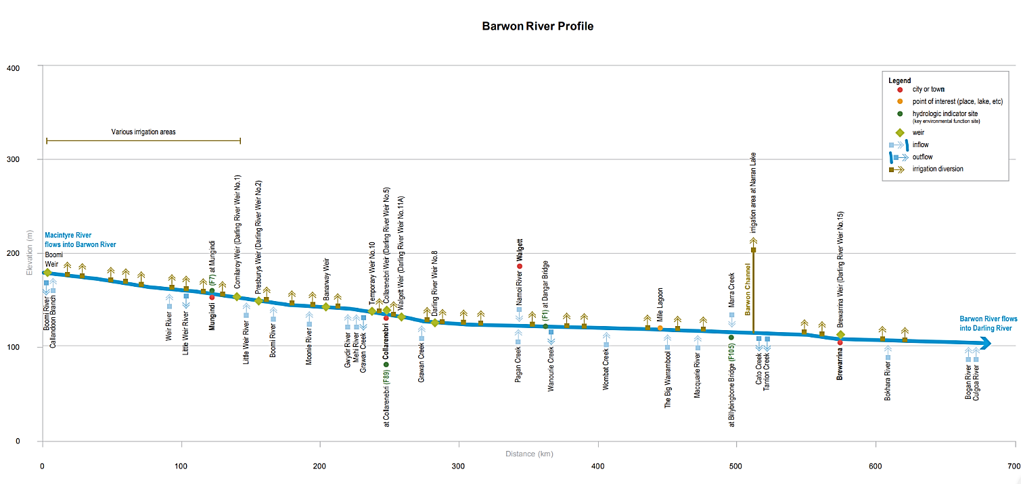
Figure 4. Barwon River profile, with project area outlined in green (MDBA, 2019).

Fish species in the Barwon River
The fish community of the Barwon River between Mungindi and Walgett includes 12 native species and three alien species that have been recorded or are expected to occur in the project area (Linterman 2007; Table 3). These species range in size at adult life stage from 5 mm to over 1 m. Four of the fish species and one mollusc species recorded or expected to occur in the Barwon River are listed as threatened under the Environmental Protection and Biodiversity Conservation Act (EPBC Act) 1999 and/or the FM Act.
The fish community of the Barwon River is in moderate to good health, similar to the rest of the Barwon Darling River (Figure 5). Despite this condition, many factors have contributed to the deterioration of native fish in the Barwon, including barriers to fish passage, changes to water flow, degradation of in-stream habitat and riparian vegetation, poor land management, and alien fish species (NSW DPI, 2007). While the majority of the fish community of the Barwon is in a moderate to good condition, this provides a strong platform for fish recovery, including improving the distribution, abundance and population structure of key species if management actions are developed and implemented appropriately.
Native fish species in the Barwon River are dominated by bony herring and spangled perch, with numbers of golden perch, Murray cod, Australian smelt, Murray–Darling rainbowfish and unspecked hardyhead also present (Davies et al. 2012). Boys et al. (2005) found that there is a significant variation in the fish assemblage in the project area downstream of Collarenebri (to Brewarrina), which is attributed to a higher prevalence of alien fish (carp and gambusia), and a lower abundance of golden perch and Murray cod compared to areas further downstream. The fish assemblage in this area was dominated by carp and a lack of native fish species (Boys et al. 2005). The area between Presbury and Collarenebri was found to have fewer fish but a higher portion of native fish, constituting a more healthy fish assemblage (Boys et al. 2005).
Three alien species also occur in the Barwon River: gambusia, carp and goldfish (Lintermans, 2009). Carp are present in the majority of lowland rivers and creeks of the Barwon Darling system. NSW DPI carp recruitment hotspot modelling (NSW DPI, 2015) also identifies a number of hotspots in the upper Barwon River (Figure 5). Three species present in the project area: silver perch, Murray cod, and golden perch are known to undertake large-scale migrations, while others make short migrations to spawning sites (Butcher, 2007; Humphries and Walker, 2013). Many of these migrations are believed to be triggered in response to increases in flow, including small pulses (<15 cm) and large pulses (>2m), however other factors including physiological (e.g. sexual maturation), behavioural (e.g. homing), environmental (e.g. weather) and biotic (interactions with other organisms) play an important role (Lucas and Baras, 2000; Mallen-Cooper 2000; Humphries and Walker, 2013).
Golden perch have been recorded to migrate over large distances in excess of 1,000 km, however only a small proportion of fish undertake such extensive migrations and many return to a ‘home range’ (Reynolds, 1983; O’Connor et al. 2005; Marshall et al 2016). Murray cod may undertake pre-spawning migration upstream to a spawning area before rapidly returning back downstream often to their home territory (Moffat and Voller, 2002; Humphries and Walker, 2013). Murray cod migration in the area upstream of the project area tend to only move between pools, moving upstream to a spawning site, with few undertaking large scale migrations (Butler 2018, pers. com), this also likely to be the case in the project area. Conversely, golden perch undertake large scale migrations often over hundreds of kilometres (Lintermans, 2009). Migration behaviour referred to in Table 4 refers solely to movement in relation to spawning and reproduction and does not consider other movements that some species may make.

The majority of species in the project area appear to have a preference for spawning between late August and March, which appears to be a trend across a number of catchments in the Northern Basin (NSW DPI, 2015; Table 3). Some species exhibit more opportunistic spawning behaviour and will spawn during the winter months if conditions are favourable. For example, golden perch have long been presumed to spawn between October and April; however these species have also been found to have spawned in May in response to heightened water levels in Lake Malta (part of the Menindee Lakes system), with it suggested that increases in latitude may increase the window for spawning (Ebner et al. 2009).
Three species in the project area, Murray cod, freshwater catfish and carp gudgeon exhibit nesting behaviour and provide parental care. These species require stable flows during the nesting period which can vary from 2 to 14 days depending on the species (NSW DPI, 2015b). River level fluctuations during the nesting period can lead to nest abandonment of the nest and desiccation of the eggs.

Table 3: Fish and significant crustacean and mollusc species expected to occur in the project area, their status, and life history requirements related to flow (Jones, 2007; Lintermans, 2009; Ponder et al. 2016; NSW DPI, 2018b; NSW DPIE 2019a).
Common name | Scientific name | Type | Status | Spawning method | Hatch time (days) | Migratory species | Spawning season | Larval drift
Murray cod | Maccullochella peelii | Large bodied native | Vulnerable (EPBC Act), however, appear to be common in the project area | Nesting with parental care | 14 | Yes | Aug – Nov | Yes
Golden perch | Macquaria ambigua | Medium bodied native | Common | Batch spawning, pelagic eggs | 3 | Yes | Oct – April, additionally recorded spawning during winter | Yes
Freshwater catfish | Tandanus tandanus | Medium bodied native | Endangered MDB population (FM Act) | Nesting with parental care | 7 | Yes | Sept – March | Yes
Silver perch | Bidyanus bidyanus | Medium bodied native | Vulnerable (FM Act)  Critically endangered (EPBC Act) | Batch spawn, pelagic eggs | 5 | Yes | Oct – April | Yes
Spangled perch | Leiopotherapon unicolor | Medium bodied native | Common | Serial, non-sticky demersal eggs | 2 | Yes | Nov – Feb | Yes
Bony bream | Nematalosa erebi | Medium bodied native | Common | Serial, pelagic eggs | 7 | Yes | Oct – Feb | Yes
Hyrtl’s tandan | Neosilurus hyrtlii | Medium bodied native | Locally rare | Unknown, could be presumed to be similar to Freshwater Catfish involving nesting and parental care. | 3 | Yes | Sept-March | Yes
Australian Ssmelt | Retropinna semoni | Small bodied native | Common | Batch spawning, sticky demersal, | 10 | Yes | Sept – Feb | Yes
Carp gudgeon | Hypseleotris klunzingeri | Small bodied native | Common | Nesting parental care | 2 | Yes | Sept – April | No
Murray Darling rainbowfish | Melanotaenia fluviatilis | Small bodied native | Common | Batch, sticky demersal eggs | 7 | Yes | Sept – Feb | Yes
Olive perchlet | Ambassis agassizii | Small bodied native | Endangered western population (FM Act) | Serial, sticky demersal eggs | 7 | No | Oct – Dec | ?
Unspecked Hardyhead | Craterocephalus fulvus | Small bodied native | Common | Batch, sticky demersal eggs | 7 | Yes | Sept – April | No
Darling river snail | Notopala sublineata | Aquatic snail | Critically endangered (FM Act) | Live barer | 0 | No |  | No
Yabby | Cherax destructor | Crayfish | Common | Parental care, eggs are attached to the underside of the female before hatching. | 21 | No | Sept-April | No
Freshwater mussel | Alathyria jacksoni  Velesunio ambiguous  Velesunio wilsonii | Mollusc | Common, however expected to be suffering population declines due to drought and associated extended cease to flow periods | Larvae brooded on adult females gills before being released and spending a period as a parasite on fish gills. | 0 | No | Unknown | Yes
Carp | Cyprinus carpio | Alien Species | Common exotic | Serial, sticky demersal eggs | 6 | Yes | Sept – March | Yes
Gambusia | Gambusia holbrooki | Alien Species | Common exotic | Batch spawning, live young | n/a | Yes | Sept – May | ?
Goldfish | Carassius auratus | Alien Species | Common exotic | Serial, sticky demersal eggs | 7 | Yes | Oct – Jan | No
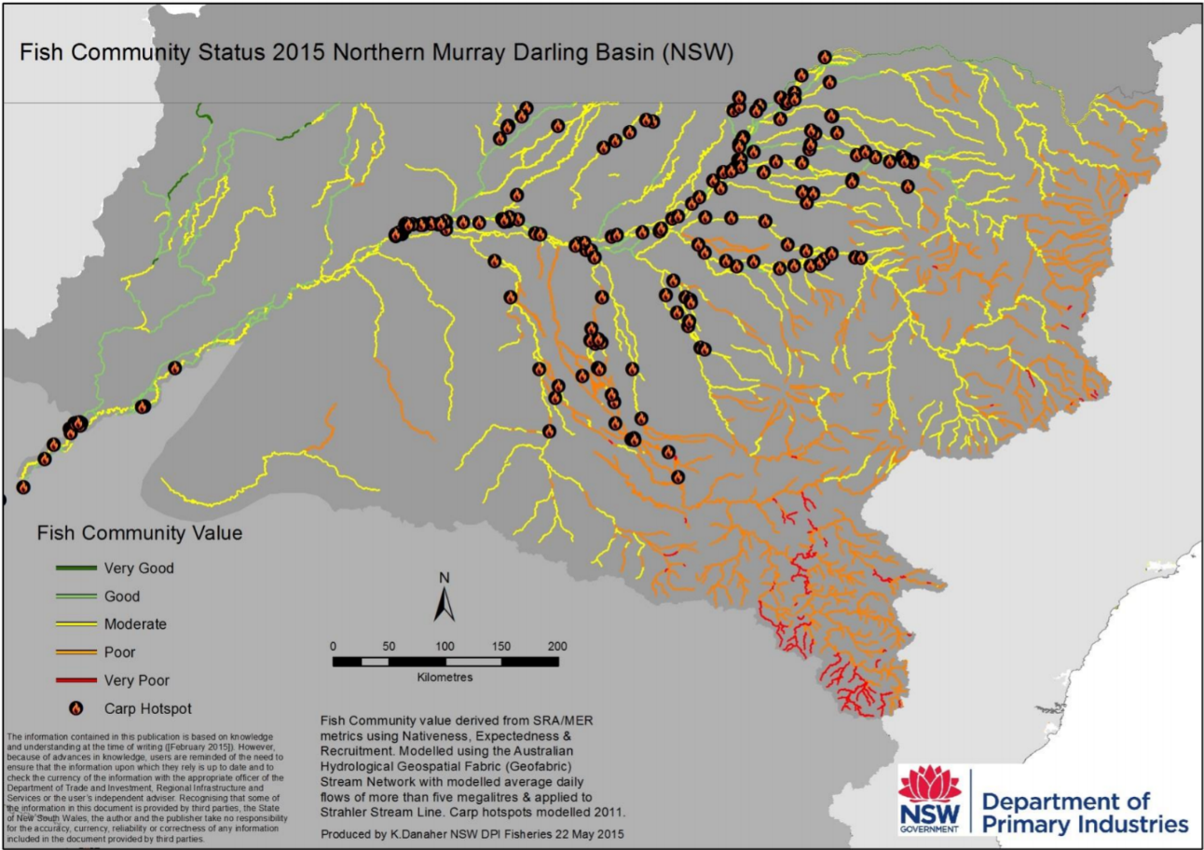
Figure 5. Fish community status for the Northern Basin, highlighting condition of fish communities, and the location of carp hotspots (NSW DPI, 2015).

Fish functional groups in the Barwon River
Native fish in the Murray-Darling Basin have evolved in a highly variable system that is characterised by extreme environmental conditions with diverse wetting and drying cycles (Humphries et al. 1999; Baumgartner et al. 2013). As a result, native fish species of the Murray-Darling Basin have developed a range of spawning and recruitment behaviours, consequently, it is highly unlikely a single flow regime would provide equal benefits for the fish community of a system (Baumgartner et al. 2013; NSW DPI, 2013a). Flows influence fish differently throughout their life history (Figure 6). The exact flow requirements to deliver healthy and robust native fish communities are unknown (Bunn and Arthington, 2002). What can be assumed is that native fish have adapted to cope and thrive with the high level of natural flow variability experienced in the project area and as such the system should be managed to maintain a level of variability.
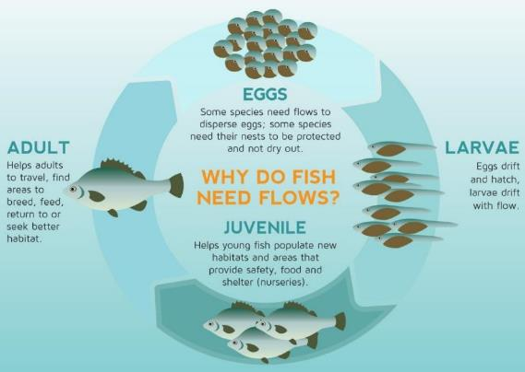
Figure 6: The influence of flows on the different stages within the life-cycle of a fish (adapted from MDBA, 2014).
To enhance native fish outcomes, fish species can be classified into functional groups based on flow related attributes (Baumgartner et al. 2013). This has been recognised as a method for simplifying flow requirements for fish allowing more effective management of environmental flow delivery and/or flow protection from extraction (Baumgartner et al. 2013; Mallen-Cooper and Zampatti, 2015).
During the Northern Basin Fish and Flows project, (then) NSW DPI Fisheries developed four functional groups of native fish (including two sub groups) combining elements of the reproductive spawning-movement and eco-hydraulic guilds (Mallen-Cooper and Zampatti, 2015; NSW DPI, 2015; Ellis et al. 2016; NSW DPI). The degree of benefit of an environmental flow depends on the species with the main drivers being the timing, volume and duration of the flow (Baumgartner et al. 2013). Taking into account the environmental water requirements of a functional group allows flows to be developed that target specific groups of species with similar flow requirements.
The functional groups identified for species in the Barwon River were adapted from the Northern Basin Fish and Flows report with consideration of more recent work by Kerr et al. (2017) and DNRME (2018) for defining stable low flow spawning fish (Table 4).Functional groups were established in consultation with experts to assist in the development of specific long-term environmental watering requirements and flow related management actions (NSW DPI, 2015). The elements considered in development of these groups in the Northern Basin Fish and Flows project (NSW DPI, 2015) included:
- Cues for migration (dispersal and recolonization) and spawning (temperature and/or flow).
- Spatial scales of spawning and dispersal movements (10’s – 100’s of m; 100’s of m – 10’s of km; 10’s – 100’s of km).
- Reproductive mode and fecundity (e.g. broadcast spawning, nesting species, adhesive eggs).
- Spawning habitats in still/slow-flowing water or in fast-flowing habitats.
- Egg hatch time (short 1 – 3 days; medium 3 – 10 days; long > 10 days) and egg morphology.
- Scale of larval drift and recruitment.
Knowledge gaps need to be acknowledged when using the functional groups approach with assumptions and limitations considered when using this information, as well as noting that the fish functional groups should be reviewed and revised as needed when new information becomes available. As mentioned above the more recent work by Kerr et al. (2017) and DNRME (2018) have help inform iterations for the functional groups.

Table 4: Fish guild groupings for species in the Barwon River (adapted from NSW DPI, 2015).
Functional Group | Species | Attributes and implications for flow management
Group 1: Flow-dependent specialists | Golden perch  Silver perch  Spangled perch  Hyrtl’s tandan | - Flow pulses are needed to generate a spawning response.  - Adult fish prepare for spawning in response to increasing water temperatures usually between spring and autumn, with research in the Northern Basin suggesting that the first post-winter flow pulse may be important for pre-spawning condition and migration in some northern systems (Marshall, et al. 2016), but timing is not predictable, with otoliths from golden perch captured in Menindee showing recruitment from a winter spawning event (Ebner et al. 2009).  - Adult fish can undertake moderate to large scale migrations (100s of m to over 1000 km) in response to increased flows and temperature but can delay spawning if conditions are not suitable, with species being medium to long-lived and not necessarily requiring annual spawning and recruitment events.  - Flow events do not have to be large pulses, with small, sharp rises in flow (as little as <15 cm) also providing benefits and eliciting responses from species; however movement responses may be greater with larger (>2m) increases in flow (Marshall et al. 2016).  - Eggs are either buoyant and pelagic or non-sticky and demersal with a short hatch time of up to 5 days, relying on flows for dispersal.  - Larvae drift downstream over long distances for up to 20 days post spawning in perennial and intermittent systems (potentially shorter in highly intermittent systems with smaller flow pulses), with recruitment relying on flows for dispersal and conditioning.
Group 2:  In-channel specialists  (Group 2A: Flow-dependent)  (Group 2B: Flow-independent) | Murray cod (2A)  Freshwater catfish (2B) | - Adult fish are believed to prepare for spawning in response to increasing water temperature however other favourable conditions may trigger spawning events.  - Group 2A adult fish can undertake short to large scale migrations (10s of metres to 100s of kilometres) for spawning.  - Group 2B species can undertake short to moderate scale migrations (10s of metres to 10s of kilometres) for spawning.  - Group 2A species have a predictable spawning period from mid-winter to the end of spring, involving movement to increasing temperature and flow. Species are long-lived and do not necessarily require annual spawning and recruitment events, but may take many years for noticeable population improvements due to low fecundity.  - Group 2B species have a spawning period from spring to autumn, but most commonly between spring and summer, which is independent of flow. Species are medium to long-lived and do not necessarily require annual spawning and recruitment events, but may take many years for noticeable population improvements due to low fecundity.  - Nesting species, or have specific spawning substrate requirements (freshwater catfish), with increases in flow helping to maximise breeding opportunities by inundating additional spawning habitat.  - Eggs are demersal with a relatively long hatch time of up to 14 days, requiring stable flow events during this period to avoid nest abandonment, desiccation or premature dispersal.  - These species may have active or passive larval drift over short to moderate scales for up to 10 days, with recruitment generally relying on flows for dispersal and conditioning.
Group 3: Floodplain specialists | Olive perchlet* | - Adult fish are believed to prepare for spawning in response to increasing water temperature however other favourable conditions may trigger spawning events.  - Adult fish undertake short scale migrations (10s of metres to 100s of metres) for spawning, potentially to off-channel habitats, where spawning takes place in still or slow-moving environments.  - Relatively short-lived and have low fecundities, requiring regular spawning and recruitment events, with spawning between spring and autumn.  - Have specific spawning substrate requirements (aquatic macrophytes), with increases in flow helping to maximise breeding opportunities by inundating additional spawning habitat, especially off-channel, which may also be reliant on water clarity (low turbidity).  - Eggs are sticky and demersal, with an estimated hatch time of up to 9 days.  - Recruitment and dispersal rely critically on flows that reconnect the channel to the nursery habitat including floodplain areas, with large flow events required post spawning.
Group 4: Generalists | Australian smelt  Bony herring  Carp gudgeon  Murray-Darling rainbowfish  Unspecked hardyhead | - These species are generally more resilient to extended low flow conditions having developed more flexible spawning strategies, and as such may be poor indicators of environmental flow effectiveness (MDBA, 2015); however, these species provide an important component of productivity in a system and food source for medium and large bodied species.  - Adult fish are believed to prepare for spawning in response to increasing water temperature.  - Adult fish move short distances (10s of metres to 100s of metres) over a wide range of hydrological conditions and are known to recruit under low flows all year round; however, spawning is most common between spring and summer. Species are short to medium-lived requiring regular spawning and recruitment events but may take many years for noticeable population improvements due to low fecundity.  - These species may spawn more than once during the year, with low to moderate flow events that inundate in-channel habitat, enhancing spawning conditions, providing the greatest benefits to these species.  - Eggs are sticky and demersal with a hatch time of up to 10 days.  - Larval drift is exhibited by the majority of species (except carp gudgeon and unspecked hardyhead) over short to moderate scales, with the recruitment of these species reliant on flows for dispersal and conditioning.  - This group largely encompasses species described by Kerr et al. (2015) to be stable low flow spawning fish. For these species stable flow during the spawning and development phase is critical. Kerr et al. (2015) recommends river level height fluctuations not to exceed 5cm for 3 weeks during these phases.
*Olive perchlet are described as low flow spawning fish by Kerr et al. (2017) so will also likely respond to different stable low flow conditions if favourable habitat (dense macrophytes) are present.

Methodology

Habitat mapping
Habitat mapping was undertaken by NSW DPIE Fisheries staff and used methods developed and implemented for similar projects in the Macquarie River (Industry and Investment, 2010), Horton River (NSW DPI, 2013b), Little River systems (NSW DPI, 2014b), Barwon-Darling Rivers (NSW DPI, 2015), Lachlan River (NSW DPI, 2016), Cudgegong River (NSW DPI, 2018b) and Dumaresq River (NSW DPI, 2018a).
Project staff completed four field trips to collect the project data between 15– 19/10/2018, 29/10-02/11/2018 and 12-16/11/2018. Flow height variability is accounted for by calculating the daily flow height above no flow at the nearest gauge, with a commence to inundate height determined for individual habitat features (i.e. LWH, benches, wetland entry exit, etc.). See page 21 for more information.
Where necessary, landholder permission was obtained to travel through and leave vehicles parked on their properties to access the river at the daily start and finish points. Subsequent opportunistic landholder liaison occurred by mapping staff as fieldwork progressed through the study area.

Figure 7: Flow plot analysis of the Barwon River during field work component. Grey shading represents when field work took place.
Two methods of field data collection were used:
• GPS-equipped GIS interface for features above the water surface.
• Wi-Fi enabled sonar for submerged features (i.e. LWH and refuge pools).
These two data compilation devices enabled the collection of all information necessary to record habitat features and their condition in both aquatic and riparian areas along the Barwon River corridor in the project area.
Two ‘Trimble Nomad’ Personal Digital Assistants (PDA) with GPS and GIS interface software, were used to record all relevant features visible above the water surface using the three spatial feature classes of point, line and polygon (Table 5).
To improve data collection efficiencies and standards, unique scripting codes were written by NSW DPI technicians to provide prescribed data entry drop-down menus specific to project requirements. This enabled all essential attributes for each recorded feature to be entered into the spatial database at the time of data collection.
Table 5: Typical features recorded on PDAs during habitat mapping.
Point Features | Line Features | Polygon Features
LWH - alignment, complexity, width, length, height  Rootballs – height | Fence lines | Exotic riparian vegetation – type and extent
Pumpsites: pipe diameter |  | Aquatic vegetation – type and extent
Wetland/ Anabranch: height of entry/exit points |  | Erosion
Barrier to fish passage- barrier type, headloss |  | Stock management
Substrate type and extent  General points of interest (e.g. boat launch sites, recreation) |  | Instream features– benches with height; refuge habitat with extent and depth; riffles

There is an ecological basis for differentiating LWH based on size and complexity (Boys, 2007). More complex LWH provide greater protection to aquatic fauna from predators and flow, are more useful as breeding sites and have a greater influence on the creation and maintenance of refuge habitat (Boys pers. comm. 2017; Figure 8).
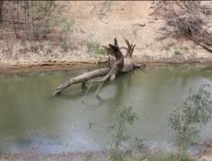
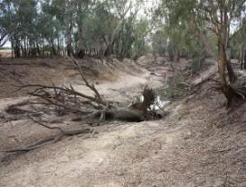
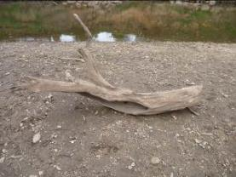
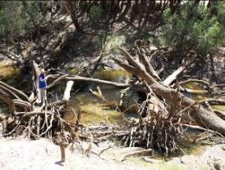
Grade 3: Woody habitat stand – one or more trunks with multiple branchings
Grade 1: Woody habitat stand - single trunk or branch
Grade 2: Woody habitat stand – trunk or branch with one or two branchings.
Grade 4: Woody habitat stand – highly complex complete tree with multiple branchings, or accumulation of separate branchings

Figure 8: Structural complexity classes used to describe LWH during field work.

Refugia
Aquatic refugia (refuge pools) were recorded in the field by observing stream geomorphology, when a pool was presumed to be deep enough to be considered a refuge the depth was measured using a Bluetooth-equipped sonar operated from the bank using a handline and smartphone. This was then verified using GIS, flow data and sonar records to check the bed depth up and downstream of a potential refuge pool site. This process removed any errors that were encountered from the increased depth during high flow periods, allowing the variable flow conditions encountered during the assessment to be considered in the refuge identification process.

Management Reaches
Features were separated into six management reaches according to the nearest gauging station. Figure 9 shows the management reaches between Mungindi and Walgett. The extent of the management reaches is as follows:
- Mungindi - Mungindi Weir to Comilaroy Weir, 26.3 km
- Presbury - Comilaroy Weir to Junction of Barwon and Boomi Rivers, 34.2 km
- Mogil Mogil - Junction of Barwon and Boomi Rivers to Collarenebri Weir Poo 81.5 kml
- Collarenebri - Collarenebri Weir Pool 18.3 km
- Tara - Collarenebri Weir to Walgett Weir Pool 106.2 km
- Walgett - Walgett Weir Pool, 22.1 km

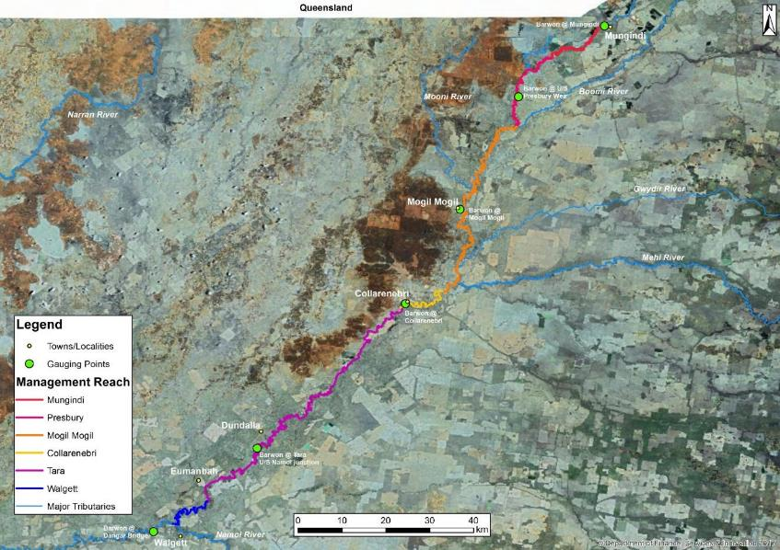
Figure 9: Management Reaches between Mungindi and Walgett.

Flow relationships
To determine the inundation dynamics of LWH, benches and connected wetlands in the study area, the commence-to-inundate height (CTIh) was recorded during the habitat mapping component using methods established by Boys (2007) and Southwell (2008; Figure 10).
The method involved the use of a Haglof Vertex Laser VL400 hypsometer, which uses ultrasonic signals to obtain the range of the habitat feature from the instrument (r) and combines this with the angle of measurement obtained from a tilt sensor (a) to trigonometrically calculate the height of the feature above or below the instrument eye level (h₁), taking into consideration the height of the instrument above water level (o) to determine the height above water level (h₂).

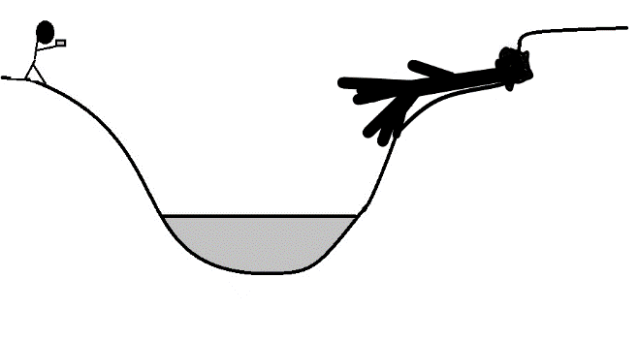
h₁
a
h₂
sh
Legend
r - range from instrument
a – angle of measurement
o – height of instrument above water level
h₁ – height above instrument eye level
h₂ – height above water level
sh – stage height
CTI h – commence to inundate height
o
r
CTI h
Figure 10: Schematic of methods used to calculate CTI heights of key habitat features along the Barwon River.
LWH were recorded at the discretion of the observer, taking into account the geomorphology and knowledge of flow levels through the section of river; if a LWH was deemed too high to be inundated it was not recorded. The stage height (sh) of the river on the day of mapping was obtained from the relevant NSW gauging stations. The inundation height was then turned into an inundation level by using the known height/discharge curve for the nearest gauging station (Southwell, 2008).
It should be noted that due to the large distances encompassed in each of the management reaches, there is likely to be a decrease in confidence of accuracy in the inundation volume that is proportional to the distance from the relevant flow gauging station. Another potentially impacting factor on calculating inundation volumes is the presence of weir pools of varying extents in each management reach, which may influence results due to persistently elevated water levels. As a result the two larger weir pools Collarenebri and Walgett are contained in stand alone reaches.

Habitat mapping results

Riparian vegetation condition
Riparian vegetation plays a key role in determining instream conditions with far reaching impacts on light penetration, water temperature and quality as well as habitat and food availability (Zalewski et al. 2001). Riparian vegetation also helps to buffer streams from catchment processes (Humphries and Walker, 2013), with fish abundance often associated with overhanging vegetation cover (Koehn, 2009). The presence of gaps in riparian vegetation has the potential to greatly impact fish populations with the loss of these processes and functions.
Based on the parameters used for the rapid appraisal of riparian condition method, gaps greater than 50 m in length were recorded. Surprisingly, there were no gaps greater than 50 m in length of missing native riparian vegetation recorded.

Exotic plant species
Exotic plant species compete with native vegetation, substantially changing the composition of riparian dynamics, impacting instream conditions and the fish communities present (NSW DPI, 2017b). Infestations of exotic plant species were noted throughout the project area, and eight species were recorded (Table 6). As large sections of the river were mapped from the bed, only areas for riparian species, giant reed and weeping willow, are considered to be accurate. These two species covered a total area of 5,551.5m². Weeping willow was the most prolific covering an area of 5,459.25 m²across four sites. No exotic aquatic plants were recorded during the fieldwork.
Table 6: List of exotic plant species recorded in the project area.
Common name | Scientific name
African boxthorn | Lycium ferocissimum
Canegrass/ giant reed | Arundo donax
Lippia | Phyla canescens
Mesquite | Prosopis spp.
Opuntia spp. | Opuntia spp.
Prickly pear | Opuntia stricta
Purple trumpet creeper | Campsis radicans
Willow - weeping | Salix babylonica

Aquatic habitat

Large Woody Habitat
LWH is a major ecological and structural element of waterways, providing hiding and resting places for fish out the main flow of the river, and spawning sites and territorial markers for several native fish species (O'Connor, 1992; Lake, 1995; Crook and Robertson, 1999; NSW DPI, 2007; Koehn and Nichol, 2014). LWH also assist in developing scour pools and prevent erosion through bank stabilisation (Gippel, 1995; Brooks et al. 2004; NSW DPI, 2007). As instream wood breaks down it also provides food for benthic algae, invertebrates and microorganisms that form a large part of the food web for fish species (Treadwell, 1999; NSW DPI, 2007).
In the 286 km reach of the Barwon River 12,591 LWH were recorded, with an average loading of 29.02 LWH/km. The total number of LWH in each reach varied significantly with the Tara Management Reach recording 4,108, Mogil Mogil 3,907, Presburys 1,681, Mungindi 1,386 LWH, Walgett 867 and Collarenebri 642. At base flow and below, the availability of woody habitat was 7,231 with an average loading of 25.28 LWH/km across the whole project area.
Most of the LWH recorded were simple complexity grade 1 and 2, with only a small amount being more complex grade 3 and 4, indicating that there is still room for improvement to maximise the benefits LWH provides in the system (Table 7-Table 12).
Table 7: Number and percentage of each LWH complexity group in the Mungindi management reach.
Complexity | Number | Percentage (%)
1 | 811 | 58.51
2 | 440 | 31.75
3 | 100 | 7.22
4 | 35 | 2.53
Table 8: Number and percentage of each LWH complexity group in the Presbury management reach.
Complexity | Number | Percentage (%)
1 | 903 | 53.79
2 | 531 | 31.59
3 | 159 | 9.46
4 | 88 | 5.23
Table 9: Number and percentage of each LWH complexity group in the Mogil Mogil management reach.
Complexity | Number | Percentage (%)
1 | 2410 | 58.51
2 | 1149 | 31.75
3 | 297 | 7.22
4 | 51 | 2.53
Table 10: Number and percentage of each LWH complexity group in the Collarenebri management reach.
Complexity | Number | Percentage (%)
1 | 346 | 53.89
2 | 237 | 36.92
3 | 54 | 8.41
4 | 5 | 0.78
Table 11: Number and percentage of each LWH complexity group in the Tara management reach.
Complexity | Number | Percentage (%)
1 | 1638 | 39.87
2 | 1681 | 40.92
3 | 588 | 14.31
4 | 201 | 4.89
Table 12: Number and percentage of each LWH complexity group in the Walgett management reach.
Complexity | Number | Percentage (%)
1 | 309 | 35.64
2 | 380 | 43.83
3 | 163 | 18.80
4 | 15 | 1.73

Rootballs
Similar to LWH, rootballs provide important habitat to a range of terrestrial and aquatic species. Bank overhangs are often associated with rootballs and provide important cover and have been found to be used by Murray cod as breeding sites upstream of the project area in the Dumaresq River (Gavin Butler pers comm; Figure 11 and Figure 12). A total of 1,255 rootballs were recorded across the project area, Tara Management Reach was particularly deficient (Table 13).
Table 13: Number of rootballs identified in each management reach
Reach | Reach Length (km’s) | Number | Average per km
Mungindi | 26.3 | 128 | 4.9
Presbury | 34.2 | 118 | 3.5
Mogil Mogil | 81.5 | 383 | 4.7
Collarenebri | 18.3 | 229 | 12.5
Tara | 106.2 | 312 | 2.9
Walgett | 22.1 | 85 | 3.8

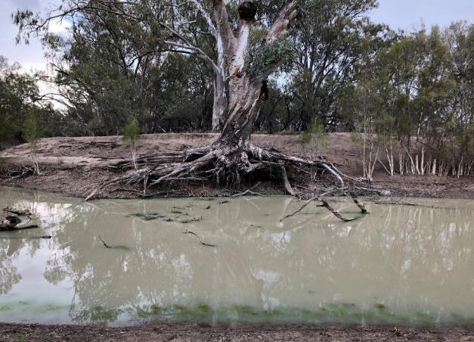
Figure 11: Example of rootball habitat recorded in the project area.

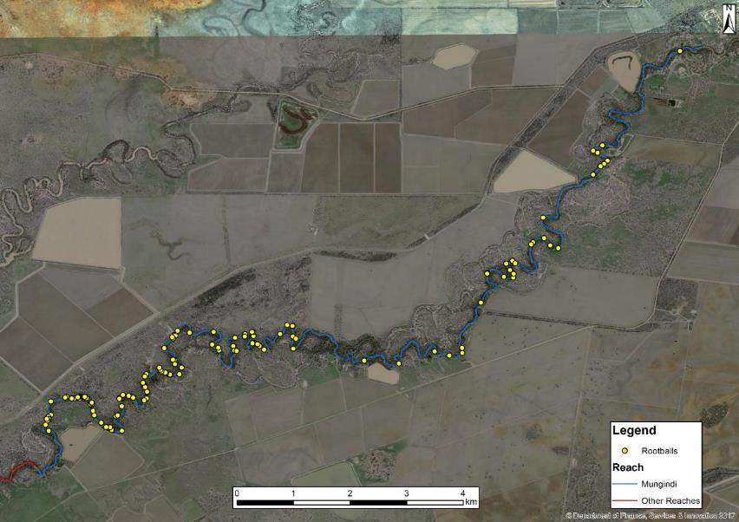
Figure 12: Location of rootballs recorded in the Mungindi management reach.
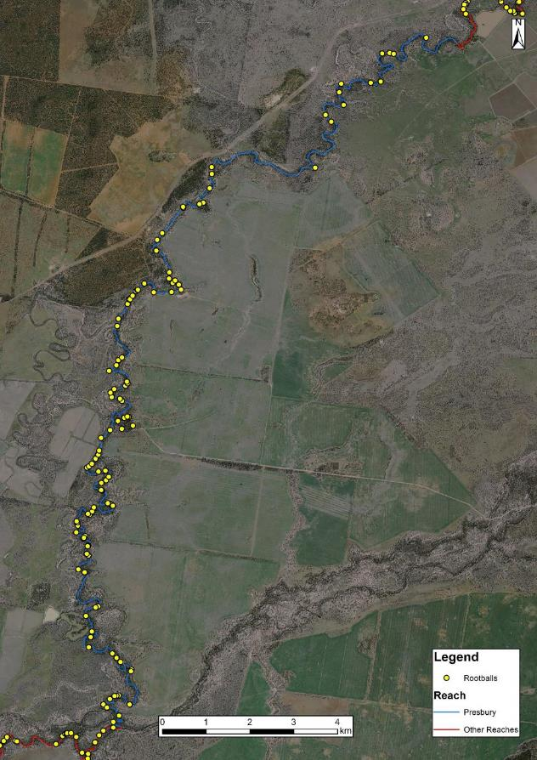
Figure 13. Location of rootballs recorded in the Presbury management reach.
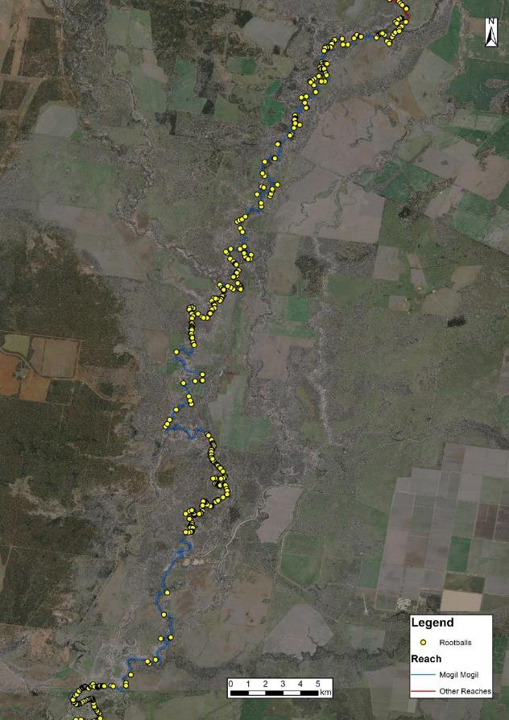
Figure 14. Location of rootballs recorded in the Mogil Mogil management reach.
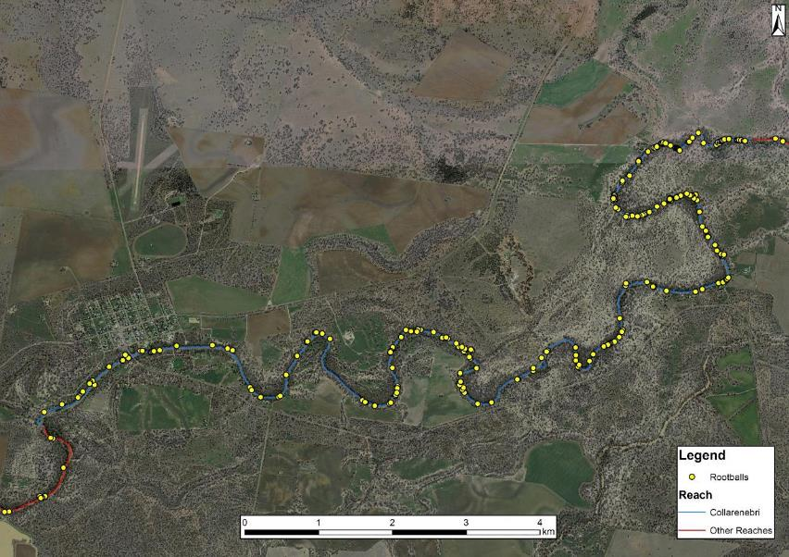
Figure 15. Location of rootballs recorded in the Collarenebri management reach.
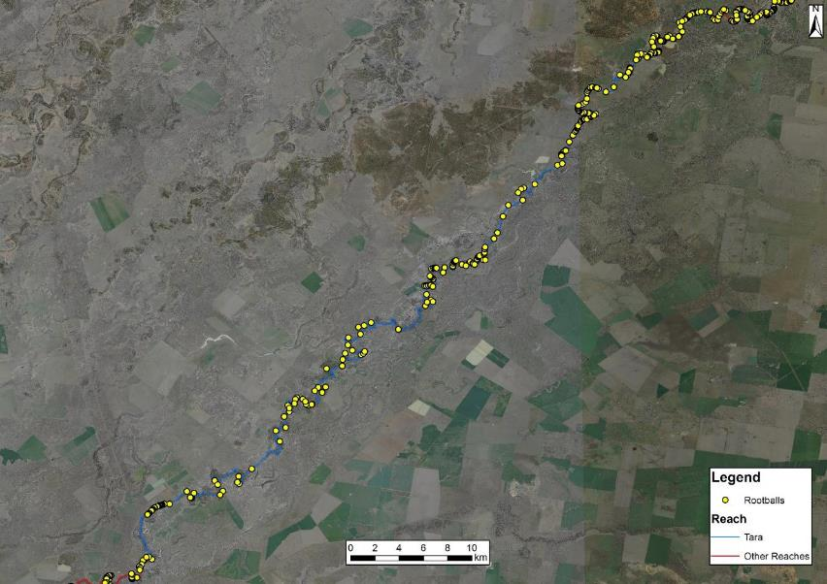
Figure 16. Location of rootballs recorded in the Tara management reach.
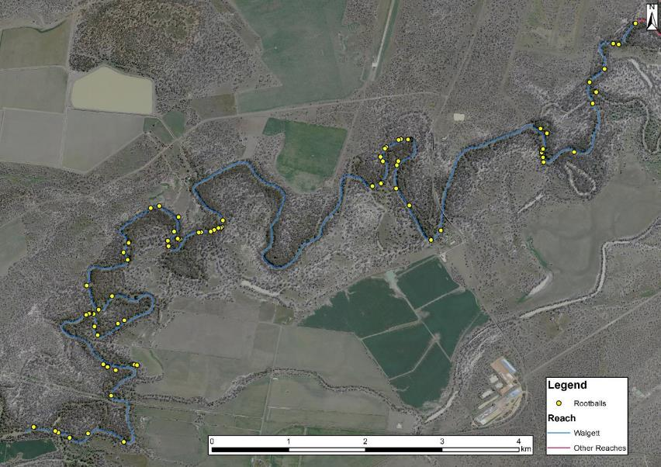
Figure 17. Location of rootballs recorded in the Walgett management reach.

Refugia
For this project, refugia were defined as areas of water greater than 3 m in depth during low flow conditions. There were 131 potential drought refuge sites recorded across the project area up to 7.5 m deep (Figure 15 and Figure 18-Figure 23). The average depth recorded for drought refugia was 3.72 m. The locations of drought refugia were distributed across the project area, with several areas of higher density particularly in the Mogil Mogil (Figure 20) and Collarenebri management reaches (Figure 21). The Mungindi management reach was particularly deficient in refugia (Figure 18). Refuges are particularly critical in times of drought and understanding their location and extent allows targeted management actions, such as the flows delivered from Glenlyon and Copeton Dams in 2018 and 2019. Being able to target water quality monitoring at these refuge sites during dry spells would help the CEWO (and partner agencies) predict the likelihood of fish kills and critical times for drought replenishment flows. Refuge data from previous habitat mapping projects has played a key role in the NSW Native Fish Drought Response Framework as it has been used directly for targeting actions including the installation of aerators in identified refugia.

Table 14: Number, extent and average depth of refugia identified in each management reach
Reach | Number | Extent (ha) | Average per km | Average depth (m)
Mungindi | 1 | 0.22 | 0.03 | 3.4
Presbury | 2 | 0.084 | 0.06 | 3.3
Mogil Mogil | 40 | 6.7 | 0.49 | 3.6
Collarenebri | 43 | 15.2 | 2.4 | 3.8
Tara | 26 | 7.1 | 0.2 | 3.5
Walgett | 19 | 3.2 | 0.9 | 3.7

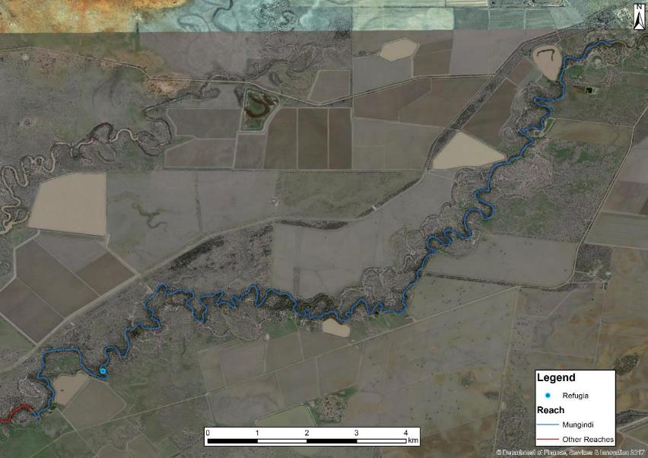
Figure 18: Location of refuge pools recorded in the Mungindi management reach.

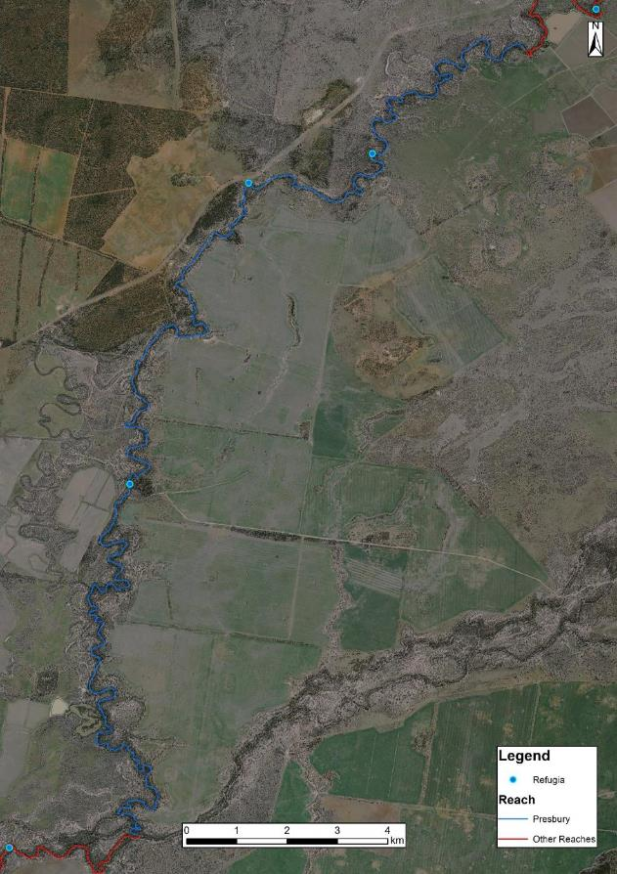
Figure 19: Location of refuge pools recorded in the Presbury management reach.

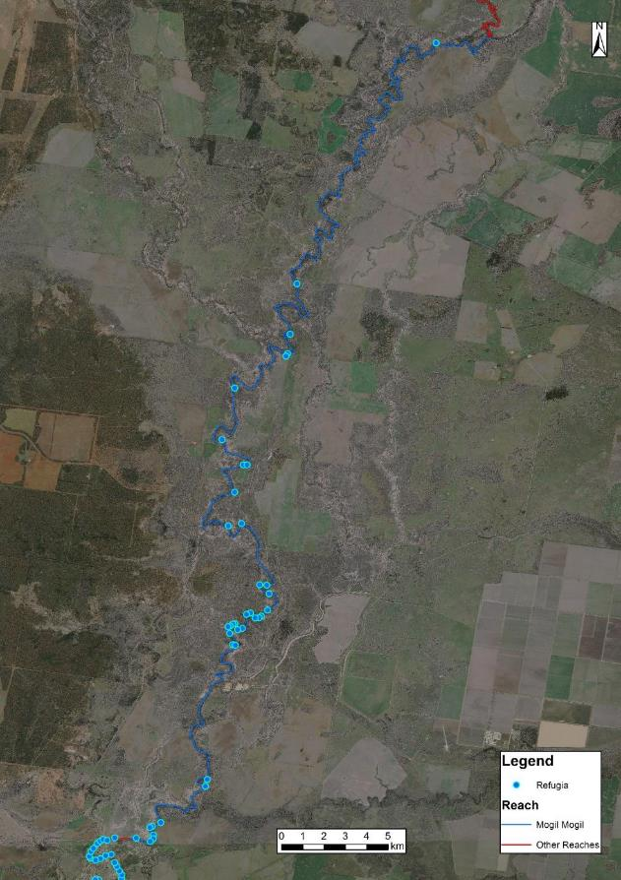
Figure 20: Location of refuge pools recorded in the Mogil Mogil management reach.

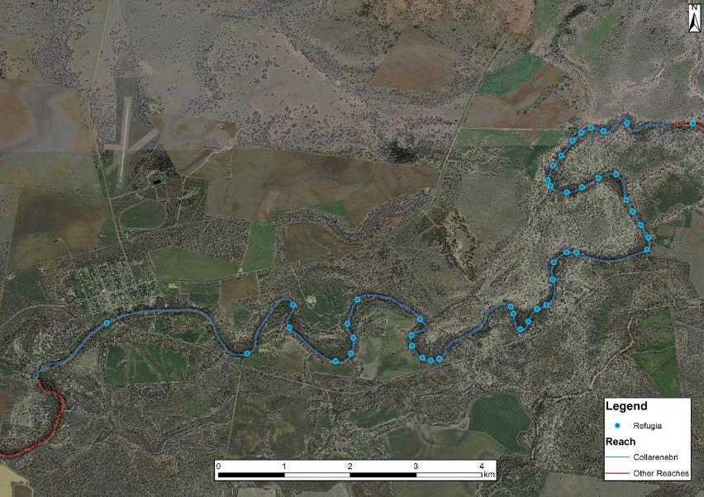
Figure 21: Location of refuge pools recorded in the Collarenebri management reach.
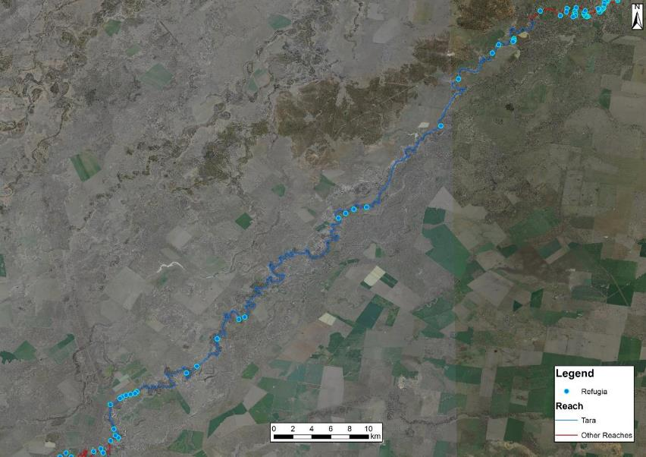
Figure 22: Location of refuge pools recorded in the Tara management reach.
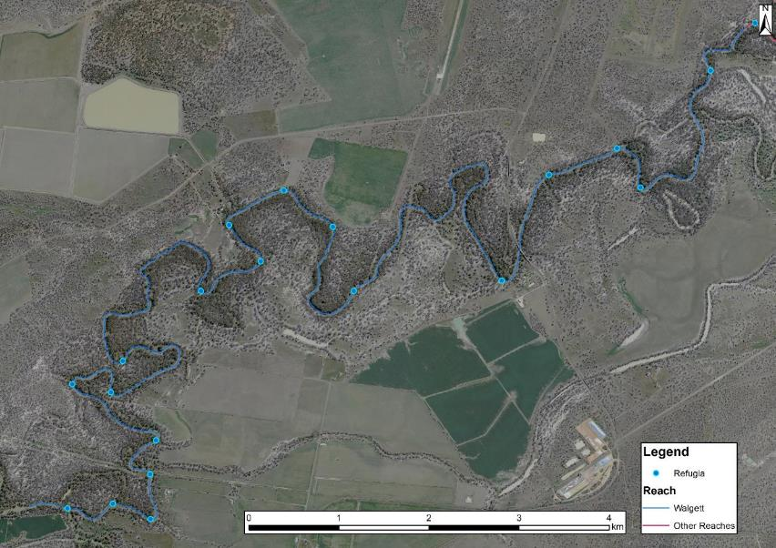
Figure 23: Location of refuge pools recorded in the Walgett management reach.

Benches
Benches are identified as areas of relatively flat sections within the main channel that play an important function in the aquatic environment by enhancing the diversity of habitat and contributing to productivity processes (NSW DPI, 2015; Figure 24). They are an actively accreting fine-grained bank attached feature within the river channel that influence flow and provide variation in water depth (Vietz et al. 2007). Benches play an important role in riverine ecology providing areas of varying levels that facilitate the accumulation of debris, sediment and nutrients, allowing the cycling of carbon, nutrients and food in the system (Southwell, 2008; Foster and Cooke, 2011).
There were 1,607 benches recorded in the project area covering a total of 79.6 ha. Benches were relatively evenly spread across the project area (Table 15 and Figure 25-Figure 30) although a particular deficiency can be noted in the Collarenebri management reach, which is likely attributed to inundation by the two weir pools in this area. The majority of benches were made up of consolidated silt, while a small number consisted of gravel, cobble or rock. These features are particularly valuable for freshwater catfish which use these substrates for constructing nests.

Table 15: Number and extent of benches identified in each management reach
Reach | Number | Extent (ha) | Extent (ha) per km
Mungindi | 186 | 4.2 | 0.16
Presbury | 370 | 8.6 | 0.25
Mogil Mogil | 277 | 14.5 | 0.18
Collarenebri | 44 | 4.8 | 0.26
Tara | 608 | 34.2 | 0.32
Walgett | 122 | 13 | 0.59

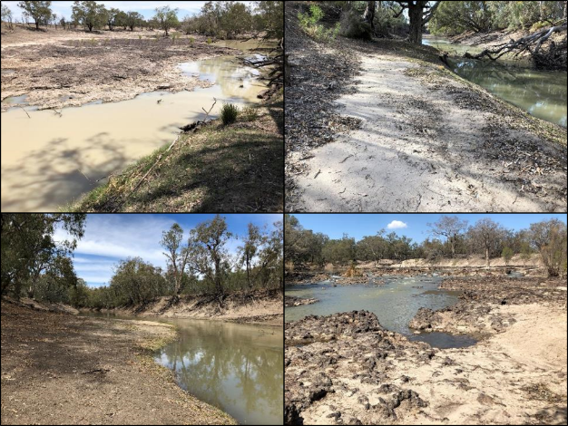
Figure 24: Examples of silt (top) and rock (bottom) benches recorded in the project area.

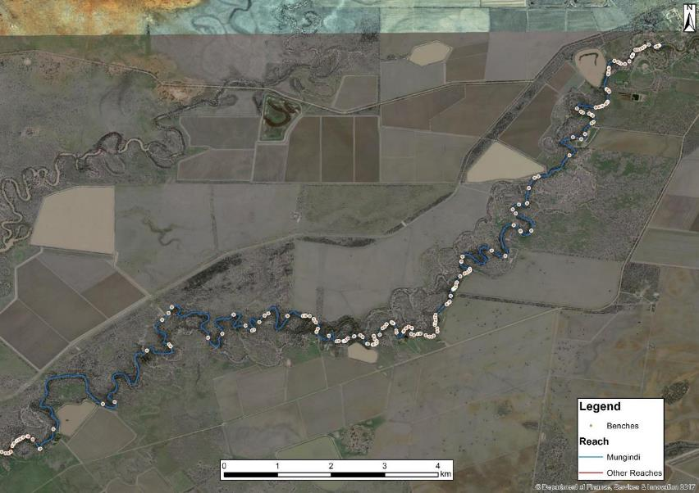
Figure 25: Location of benches recorded in the Mungindi management reach.

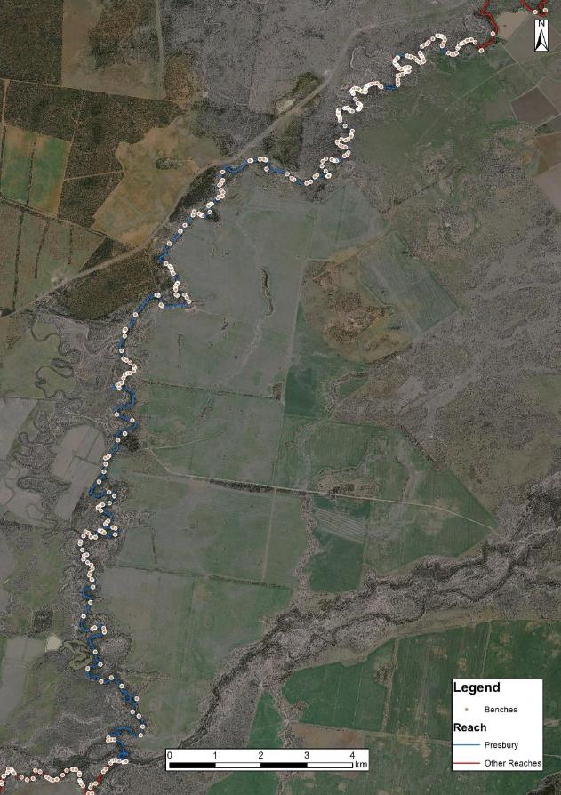
Figure 26. Location of benches recorded in the Presbury management reach.

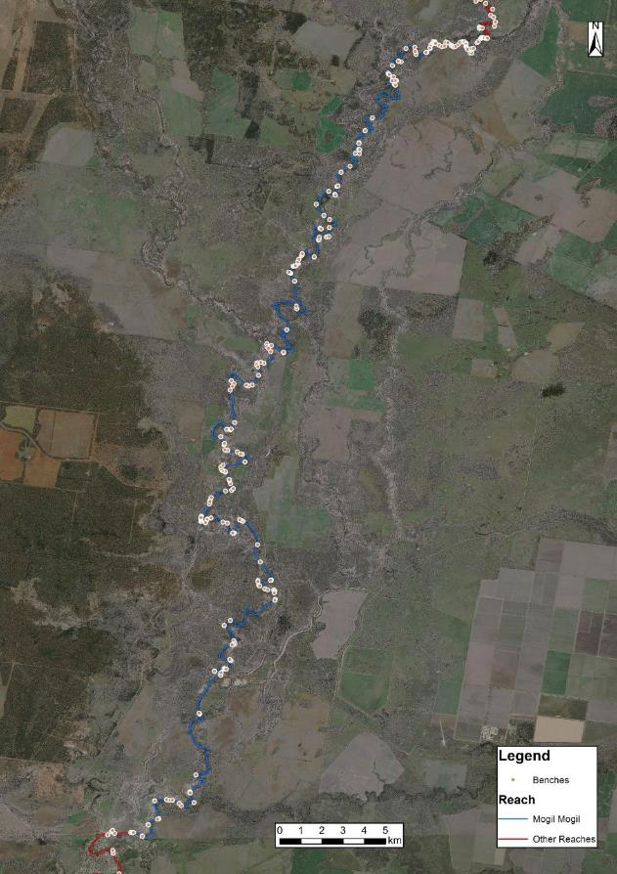
Figure 27. Location of benches recorded in the Mogil Mogil management reach.
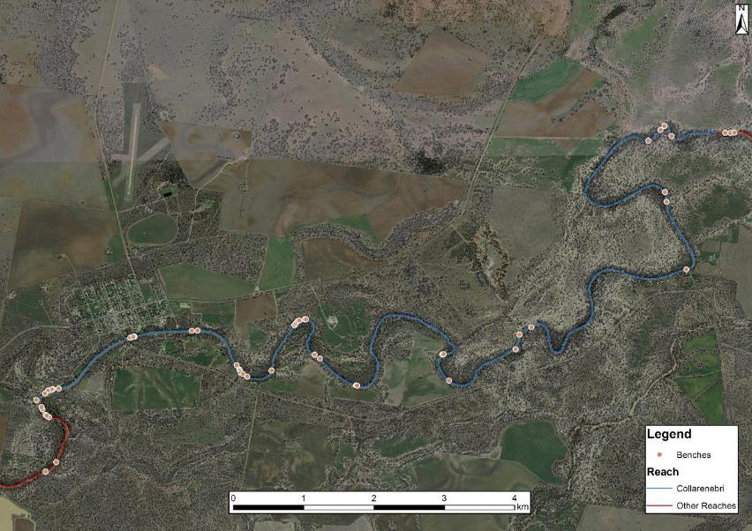
Figure 28. Location of benches recorded in the Collarenebri management reach.
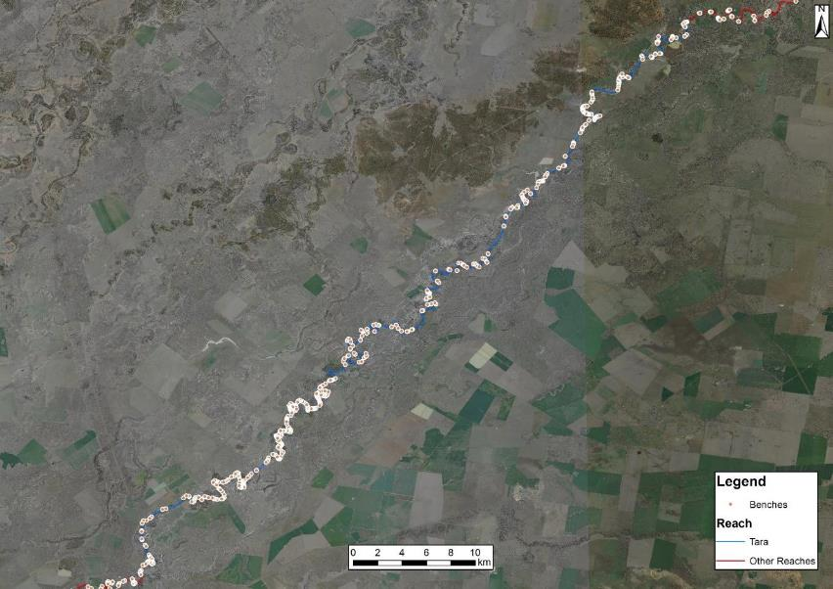
Figure 29. Location of benches recorded in the Tara management reach.
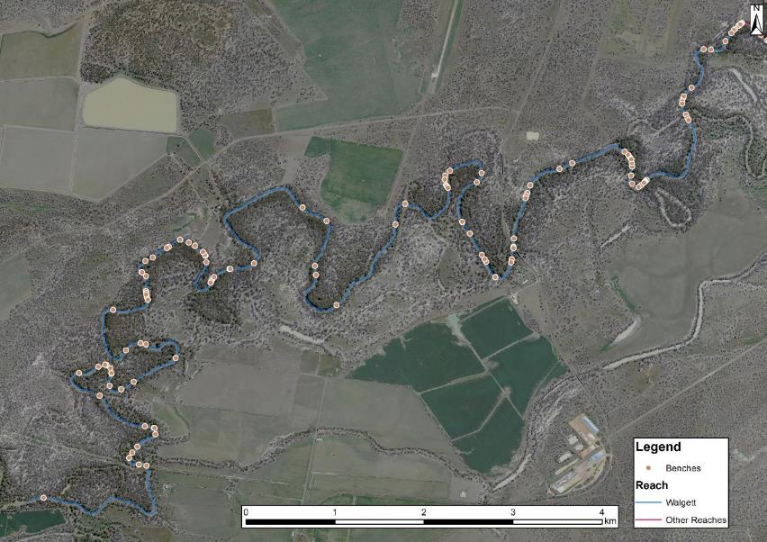
Figure 30. Location of benches recorded in the Walgett management reach.

Connected wetlands
Floodplain wetlands provide critical aquatic and riparian habitat for flood-reliant and flood tolerant flora and fauna, including important freshwater fish species such as olive perchlet, silver perch and golden perch (Rogers and Ralph, 2010; Saintilan and Overton, 2010). Wetland areas and associated smaller systems provide many imperative ecosystem functions, including filtering sediments, releasing nutrients and providing important breeding and nursery habitats for native fish (Beesley et al. 2012; Górski et al. 2013). Rolls and Wilson (2010) consistently found young of year golden perch and bony bream in floodplain wetlands, suggesting that they may be used as nursery habitats by flow dependent specialists (functional group 1) and generalists (functional group 4) species. Many connected wetlands in the project area have reduced inundation frequency since river regulation and hence the benefits to fish and the critical ecological role they play may have been diminished.
A total of 247 wetland entry points recorded in the project area. While relatively well spread across the project area, wetland entry points (Figure 31) appear to be more dense in some areas (Table 16 and Figure 32-Figure 37)This is likely associated with surrounding topography, with flatter areas providing lower banks for the river to exit the main channel.
While there was no quantification of the wetland area attached to the entry and exit points recorded it can be presumed that areas of off stream habitat will be inundated and there will be significant benefit to all native fish species, particularly floodplain specialist species. Future gains in spatial data (LiDAR) may assist in determining wetland area associated with these inundation points.
Table 16: Number of connected wetlands identified in each management reach
Reach | Number
Mungindi | 74
Presbury | 48
Mogil Mogil | 61
Collarenebri | 4
Tara | 27
Walgett | 30

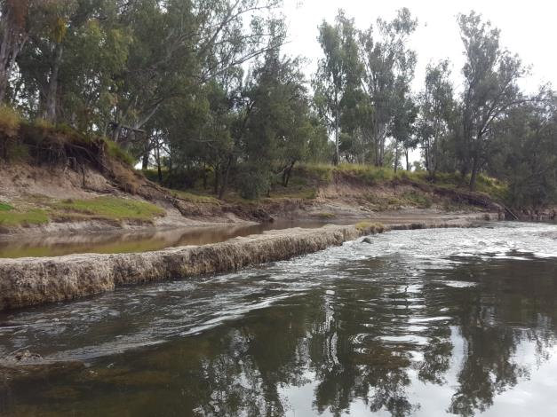
Figure 31: Example of a wetland entry point recorded in the project area.

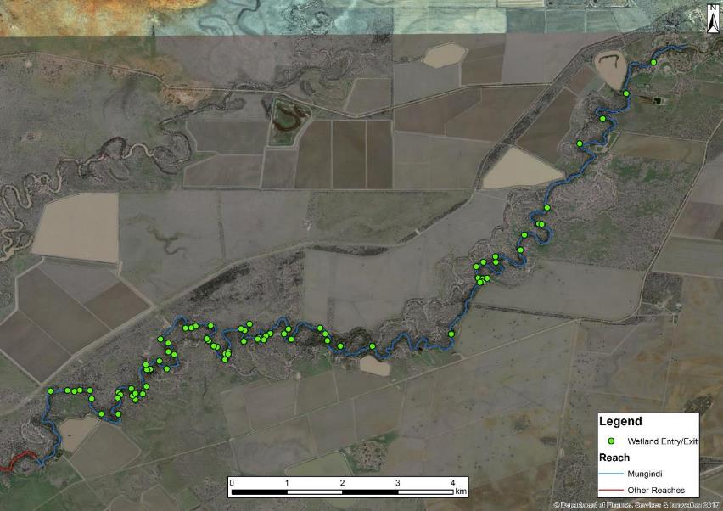
Figure 32: Location of connected wetland entry points recorded in the Mungindi management reach.

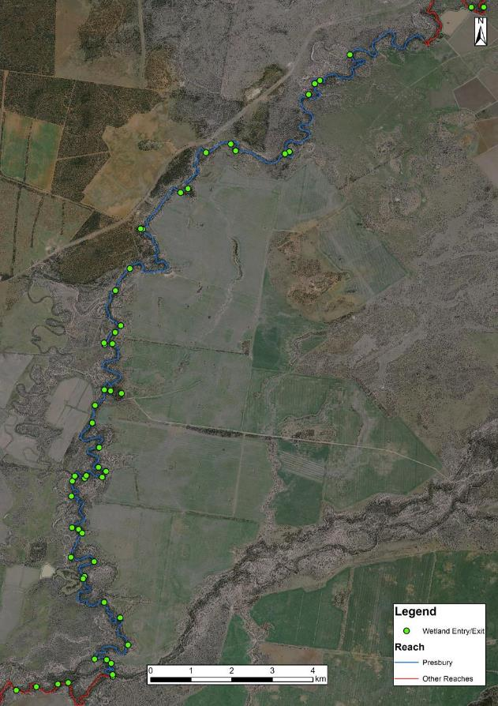
Figure 33: Location of connected wetland entry points recorded in the Presbury management reach.
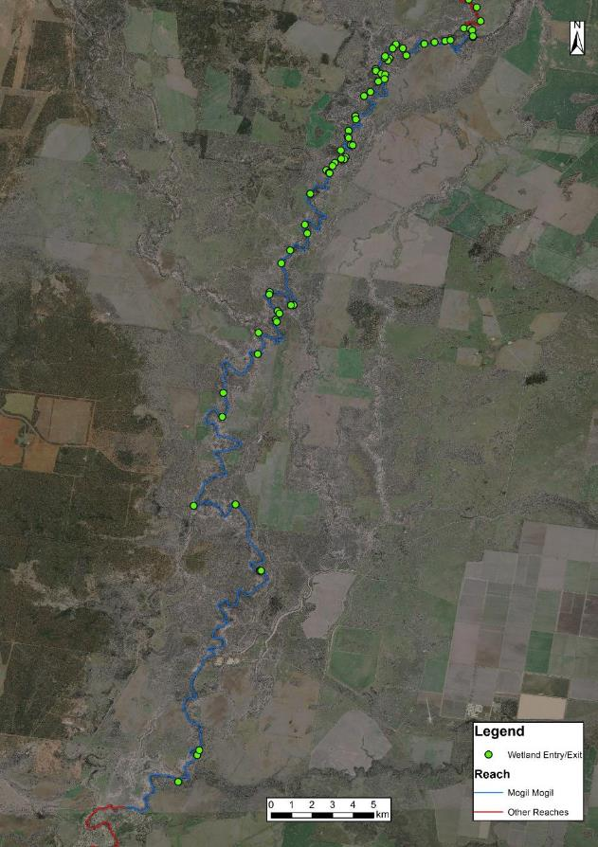
Figure 34: Location of connected wetland entry points recorded in the Mogil Mogil management reach.

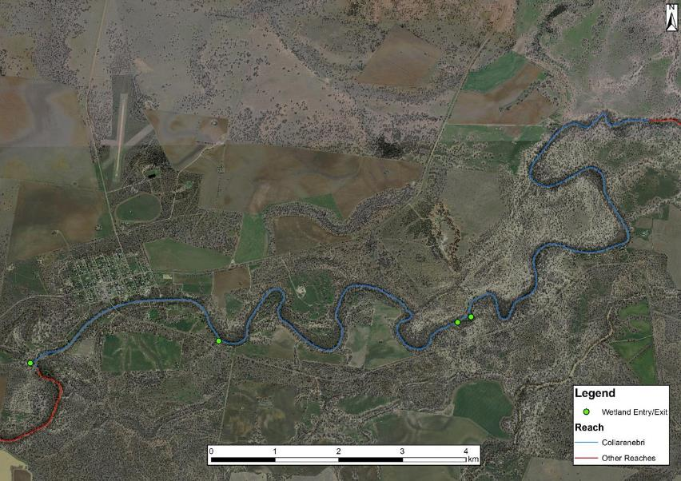
Figure 35: Location of connected wetland entry points recorded in the Collarenebri management reach.
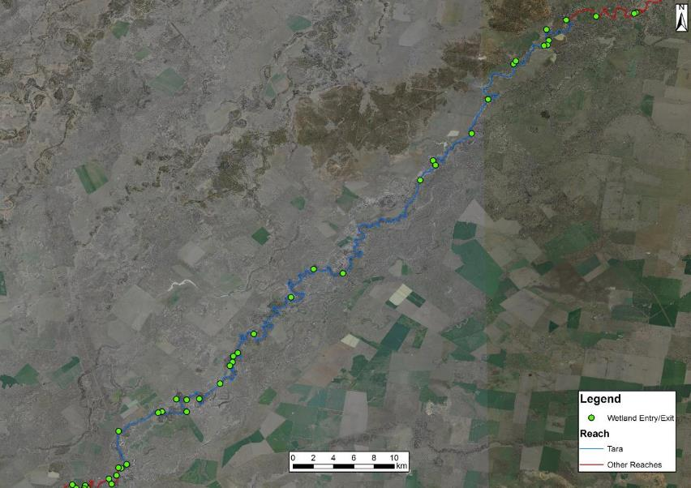
Figure 36: Location of connected wetland entry points recorded in the Tara management reach.
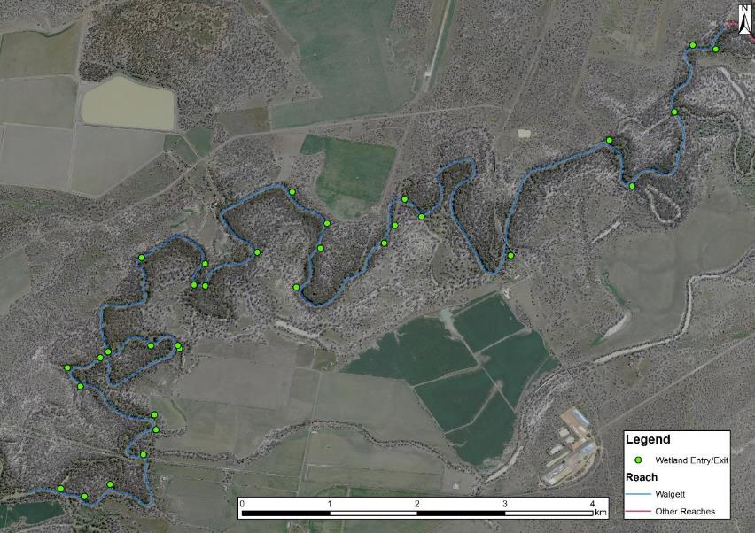
Figure 37: Location of connected wetland entry points recorded in the Walgett management reach.

Aquatic macrophytes
Macrophytes provide physical structure used by freshwater fish for shelter, refuge and as nesting and spawning sites (Petr, 2000; Thomaz and Cunha, 2010). Macrophytes also provide a direct and indirect food source, such as rich foraging microhabitats, as they are inhabited by numerous species of macro-invertebrates (Delariva et al. 1994; Petr, 2000; Casatti et al. 2003). One threatened species, olive perchlet is commonly associated with submerged macrophytes and the loss of these habitats is believed to be a contributing factor to the decline of the species in NSW (NSW DPI, 2014a).
Examples of submerged and emergent macrophytes recorded during field work can be seen in Figure 38. Macrophytes were recorded in all reaches to varying extents. Aquatic macrophytes covered a total area of 14 ha. Macrophytes were most prolific and diverse in the Collarenebri management reach. Numerous gaps in macrophyte presence were evident in the project area, in particular few macrophytes were recorded in the Mungindi management reach, lower section of the Presbury management reach, upper section of the Mogil Mogil management reach and the Walgett management reach (Table 17 and Figure 39-Figure 44). Various species of aquatic macrophytes were recorded, including emergent, floating attached and submerged. Water primrose was the dominant aquatic macrophyte species in the project area covering 6.5 ha.
The following macrophyte species were recorded in the project area:
- Azolla
- Cumbungi
- Curly pondweed
- Floating pondweed
- Juncus/sedge
- Phragmites
- Ribbonweed
- Water milfoil
- Water primrose

Table 17: Extent (m²) of aquatic macrophyte species identified in each management reach
Species | Mungindi | Presbury | Mogil Mogil | Collarenebri | Tara | Walgett | Total Area  (m²)
Azolla | 216 | 15 | 24 934 | 4 372 | 24 495 | 674 | 54 706
Cumbungi | 3 | - | 52 | 37 | 2 | - | 94
Curly Pondweed | - | 57 | - | - | 1 513 | - | 1 570
Floating pondweed | - | - | - | - | 52 | 10 | 62
Juncus/sedge | 66 | 1 | 29 | - | 1 000 | 83 | 1 179
Phragmites | 100 | 1 192 | 2 493 | 1 942 | 3 312 | - | 9 039
Ribbon weed | - | - | - | 459 | 329 | 50 | 838
Water milfoil | - | - | - | - | 65 | 14 | 79
Water primrose | 21 | 250 | 14 477 | 6 206 | 44 493 | 1 043 | 66 490
Total Area  (m²) # | 406 | 1 515 | 41 985 | 13 016 | 75 261 | 1 874 | 134 057
# 1 Ha. = 10 000 m²

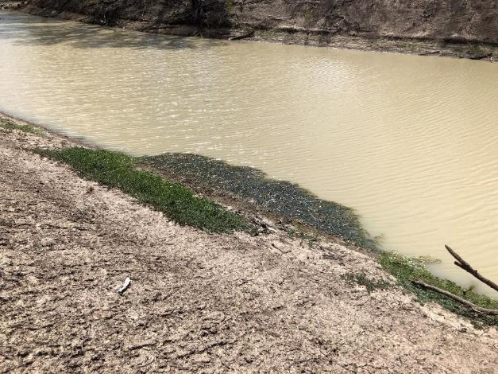
Figure 38: An example of submerged (curly pondweed) and emergent (water primrose) macrophytes recorded in the project area.

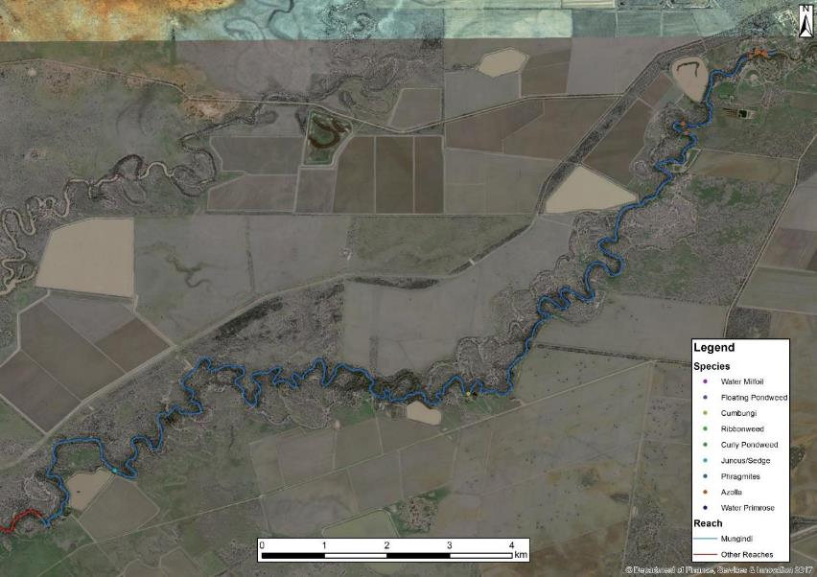
Figure 39: Location of macrophytes that were recorded in the Mungindi management reach.

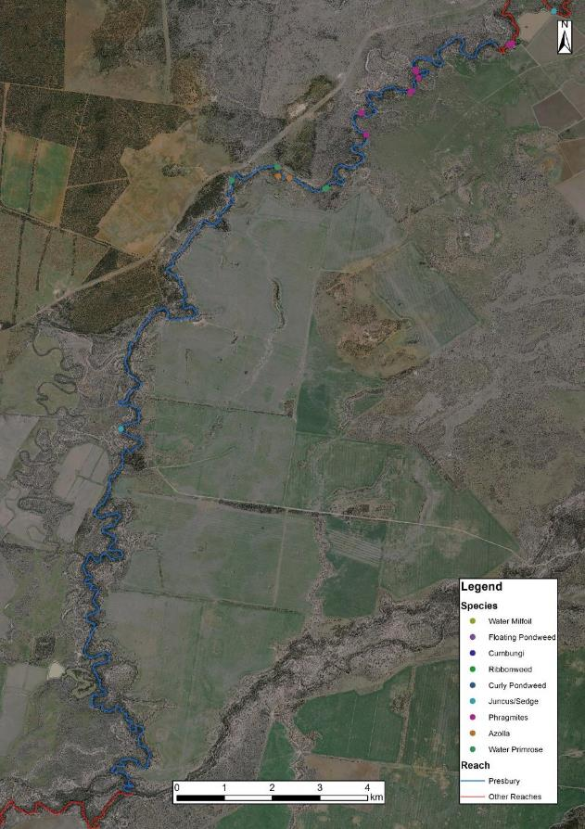
Figure 40: Location of macrophytes that were recorded in the Presbury management reach.

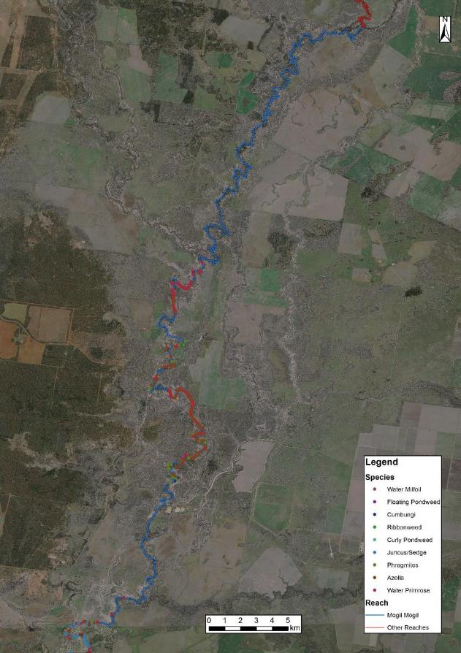
Figure 41: Location of macrophytes that were recorded in the Mogil Mogil management reach.

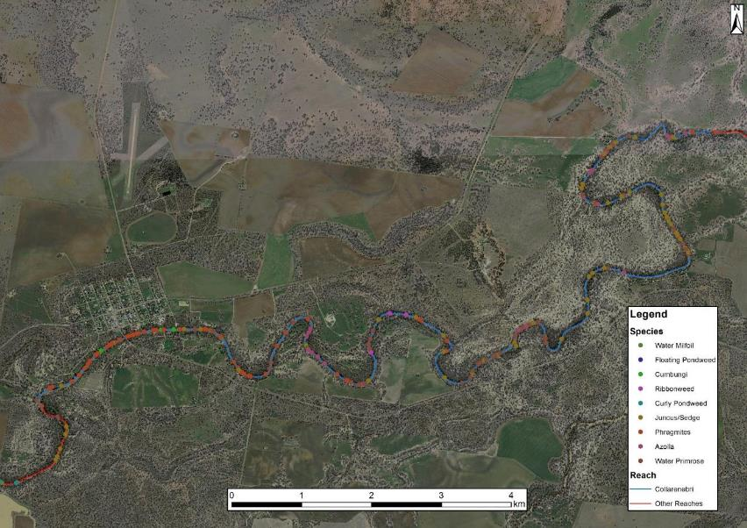
Figure 42: Location of macrophytes that were recorded in the Collarenebri management reach.
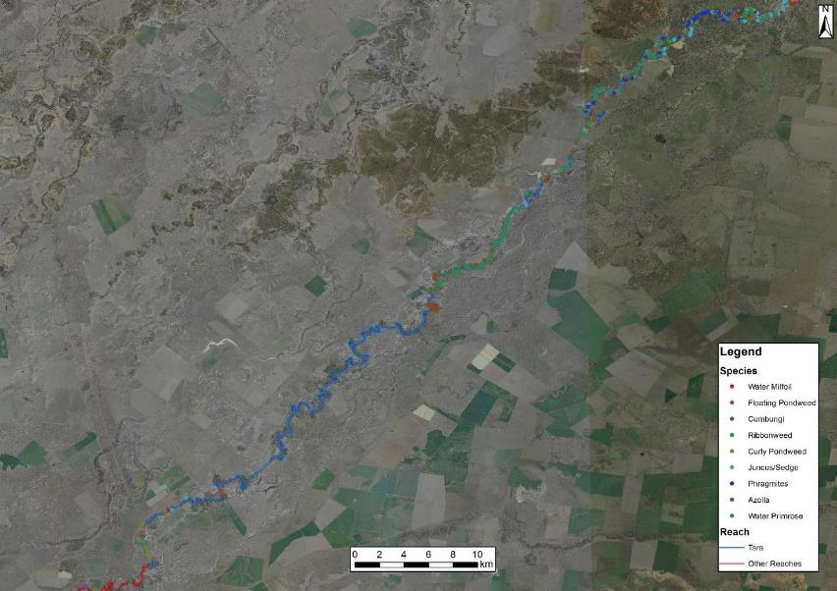
Figure 43: Location of macrophytes that were recorded in the Tara management reach.
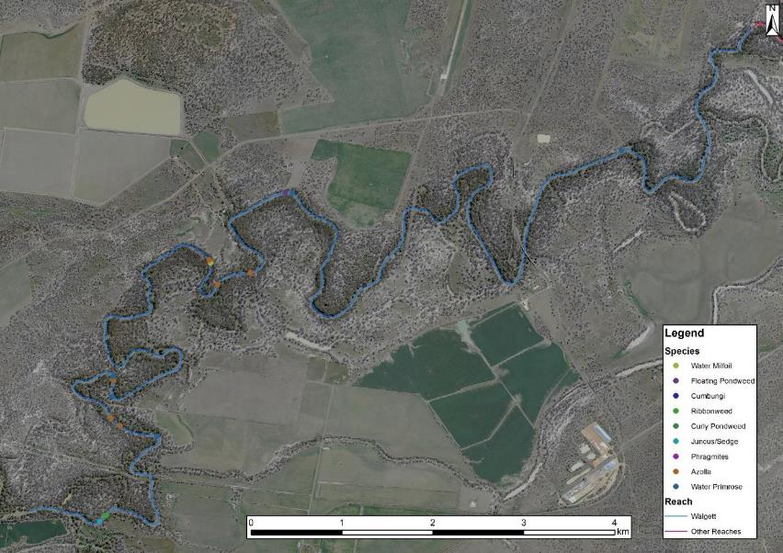
Figure 44: Location of macrophytes that were recorded in the Walgett management reach.

Cobble beds
Boulders, rocks and cobbles provide habitats and spawning sites for a number of freshwater fish species (Humphries and Walker, 2013). In the project area, cobble beds are of particular value as they provide the endangered freshwater catfish (Murray-Darling population) with material for constructing nests, where they lay and guard their eggs (Dyer et al. 2002). In the project area, cobble beds were rare in comparison to the other river systems mapped in NSW. Despite a possible reduction in prevalence due to deposition of fine sediment, it is presumed that cobble beds would be a naturally rare feature due to the nature of the surrounding geology.
Figure 45 shows a cobble bed that is partially submerged, with higher flows this cobble bed could be used by freshwater catfish to build nest. Cobble beds were sparsely recorded across the project area, with no cobble beds recorded in the Presbury, Collarenebri and Walgett management reaches (Table 18 and Figure 46-Figure 51). The highest density was recorded in the Tara management reach.
Table 18: Number and extent (m²) of cobble bars identified in each management reach
Reach | Number | Extent
Mungindi | 1 | 332
Presbury | -
Mogil Mogil | - | 1 822
Collarenebri | 3 | -
Tara | 16 | 26 960
Walgett | - | -
# 1 Ha. = 10 000 m²

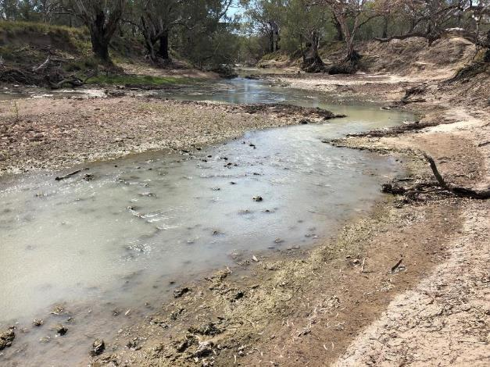
Figure 45: Example of a partially submerged cobble bed near Walgett.

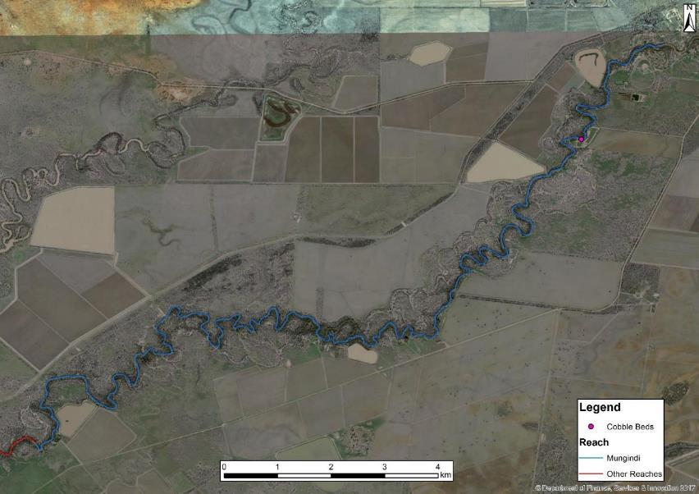
Figure 46: Location of cobble beds recorded in the Mungindi management reach.

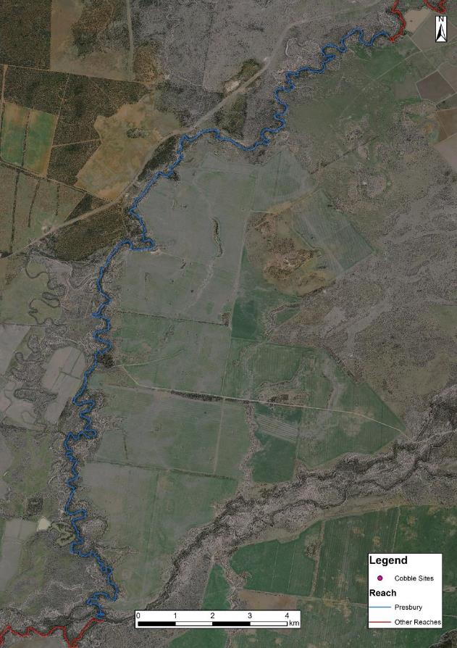
Figure 47: Location of cobble beds recorded in the Presbury management reach.

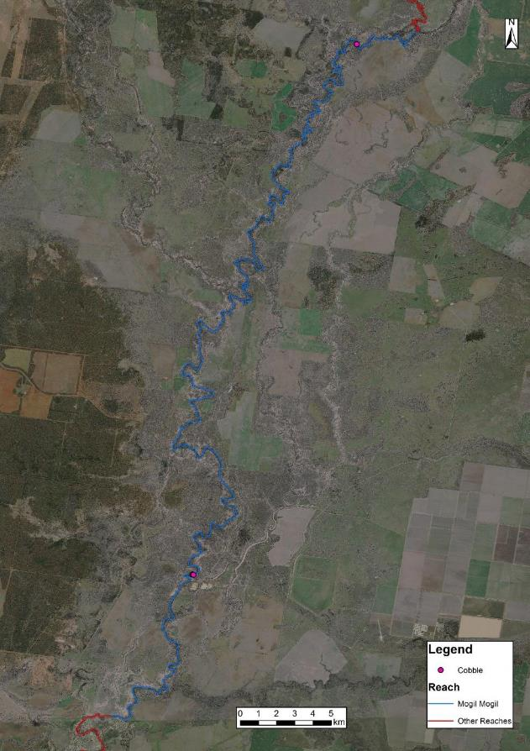
Figure 48: Location of cobble beds recorded in the Mogil Mogil Management Reach.

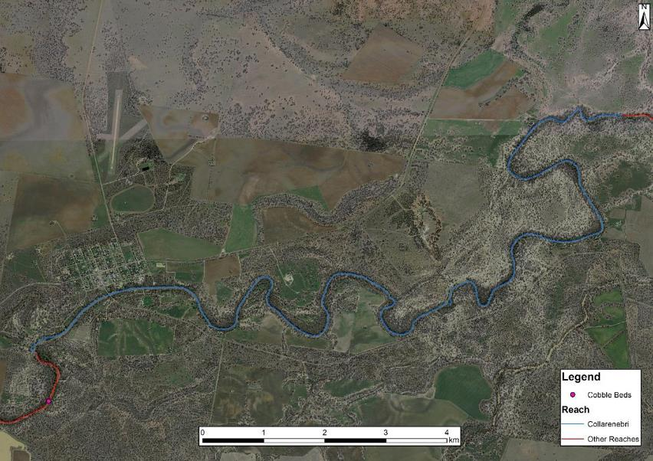
Figure 49: Location of cobble beds recorded in the Collarenebri Management Reach.
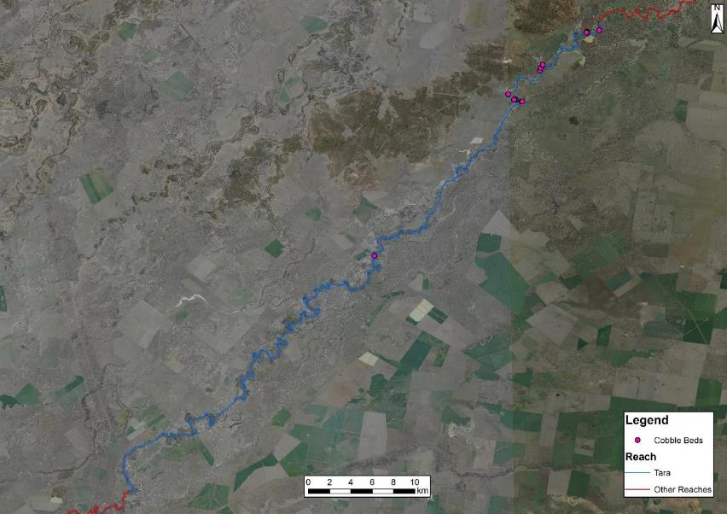
Figure 50: Location of cobble beds recorded in the Tara management reach.
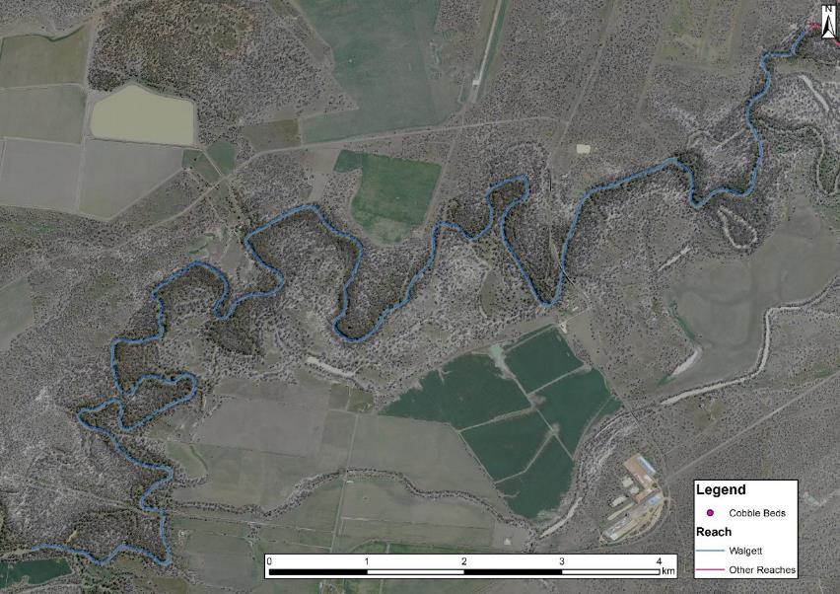
Figure 51: Location of cobble beds recorded in the Walgett management reach.

Fish passage
Australian native fish have evolved to be reliant on a variety of habitat types to complete their life cycle. One of these habitat requirements is the need to move both short and long distances between varying aquatic environments (Thorncraft and Harris, 2000; Fairfull and Witheridge, 2003; Barrett, 2008). While fish migrations are commonly associated with breeding events, other reasons for native fish species needing to disperse include the search for food, shelter, avoidance of predation and competition pressures (Humphries and Walker, 2013). Unfortunately, riverine connectivity has been severely disrupted within Australia by the creation of instream barriers to fish that limit habitat and resource availability and diminish the opportunities for species to adapt to changing environmental conditions (Pethebridge et al. 1998).
The installation and operation of instream structures and the alteration of natural flow regimes have been recognised as a Key Threatening Process under the FM Act 1994 and the NSW Biodiversity Conservation Act 2016. One threatened species in the project area, silver perch, can undergo significant migrations and the presence of barriers has been listed as a cause of their decline (Fisheries Scientific Committee, 2000). Another factor associated with such structures is the presence of weir pools, which has been suggested by the Fisheries Scientific Committee (2000) to contribute to egg mortality for the species with the reduction of water movement.
Seven barriers were recorded in the project area isolating fish populations between them (Figure 52). In some cases, it may possible for held environmental water to supplement or protect natural events to ‘drown-out’ barriers and provide passage, however held environmental water will only provide small contributions to these events. The remediation of these barriers is proposed in the Northern Basin Toolkit measures and would provide access to 445 km of habitat, not including increased access to major tributaries.

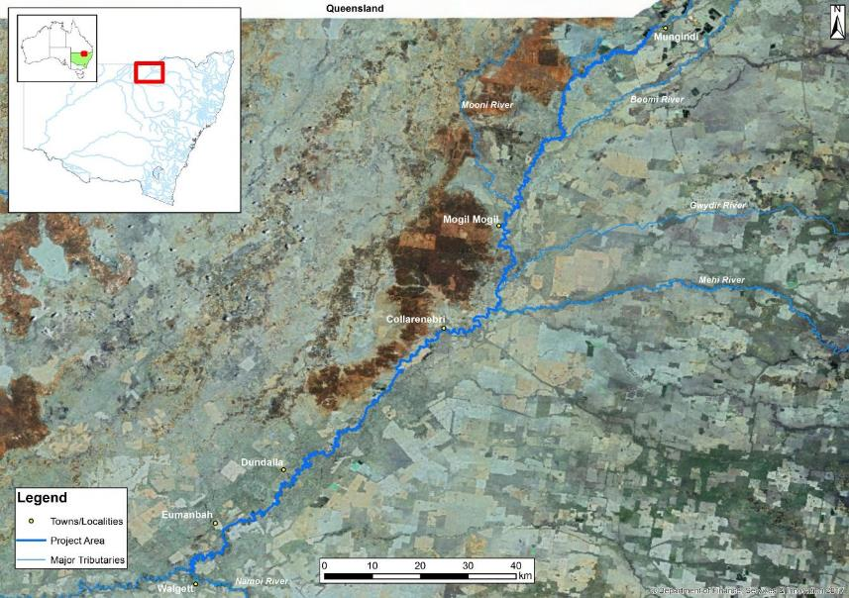
Comilaroi Weir
5,000 ML/day drown out
Walgett Weir
14,000 ML/day drown out
Calmundi Weir
18,000 ML/day drown out
Collarenebri Weir
18,000 ML/day drown out
Banarway Weir
6,500 ML/day drown out
Presbury Weir
1,250 ML/day drown out
Mungindi Weir 2,500 ML/day drown out

Figure 52: Fish passage barriers recorded in the project area.

Mungindi Weir is a fixed crest sheet pile rock faced fill weir. The structure is 4 m high. The weir is a barrier to fish passage at flows less than 2,500 ML/day or 93.8 % of the time (over the past 20 years). There is approximately 154 km of unimpeded fish habitat upstream.
Comilaroi Weir (No.1) is a concrete fixed crest weir. The structure is 4 m high. The weir is a barrier to fish passage at flows less than 5,000 ML/day or 95.7% of the time (over the past 20 years). There is approximately 26 km of unimpeded fish habitat upstream.
Presburys Weir (No.2) is a fixed crest concrete and rock fill weir. The structure is 2.1 m high. The weir is a barrier to fish passage at flows less than 1,250 ML/day or 89.6 % of the time. There is approximately 21 km of unimpeded fish habitat upstream.
Banarway Weir is a fixed crest concrete weir. The structure is 1.9 m high. The weir is a barrier to fish passage at flows less than 6,500 ML/day or 93.8% of the time (over the past 20 years). There is approximately 60 km of unimpeded fish habitat upstream.
Collarenebri Weir (No. 5) is a concrete fixed crest. The structure is 1.5 m high. The structure pools water approximately 46 km upstream. The weir is a barrier to fish passage at flows less than 18,000 ML/day or 98 % of the time (over the past 20 years). Potential increase in habitat area of 82 km if fish passage is remediated at the site. Collarenebri Weir is considered a high priority for remediation (NSW DPI, 2006).
Calmundi Weir (No.8) is a concrete fixed crest weir. The structure is 1.5 m high. The structure pools water approximately 36 km upstream. The weir is a barrier to fish passage at flows less than 18,000 ML/day or 98 % of the time (over the past 20 years). There is approximately 45 km of unimpeded fish habitat upstream.
Another structure located between Calmundi and Walgett weirs, Woorawadin Weir (No.10), was a low-level rock structure that was removed in 2013 after failing.
Walgett Weir (11A) is a rockfill structure with a steel piling cut-off wall. The structure is 3.6 m high. The weir is a barrier to fish passage at flows less than 14,000 ML/day or 95.1% of the time (over the past 20 years). There is approximately 89 km of unimpeded fish habitat upstream. Walgett Weir will have a fishway constructed as obligated under the FM Act 1994, under the provision relating to weir alteration as the weir is planned to be raised by a meter.

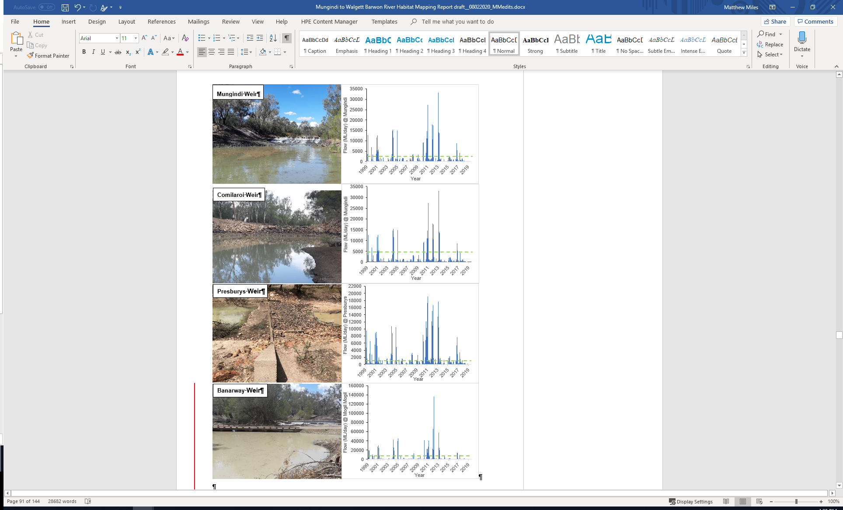
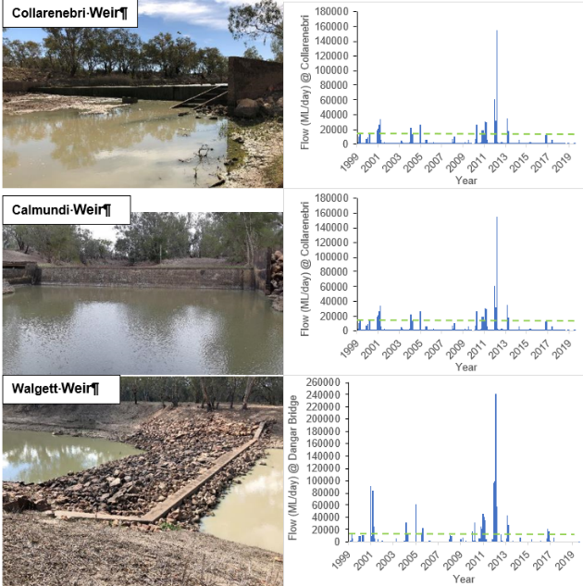
Figure 53: Fish passage barriers in the project area and flows in the Barwon River during the last 20 years. The green dotted line highlights the drown out value for each weir, indicating when fish passage would have been available.

Flow relationship results
The use of functional groups of freshwater fish in the Basin and detailed habitat mapping information can assist with managing water for the environment to deliver native fish benefits and develop specific EWRs When developing EWRs there are a number of basic principles related to the biological and ecological criteria for native fish and inland waterways that need to be considered:
- Natural flow regimes - one of the important principles considered in the development of conceptual flow models for fish in the Basin is that the natural flow regimes provide a strong foundation for the rehabilitation of flows; however the impacts of river regulation, including connectivity, access to habitat, and changes to geomorphology, need to be considered and incorporated into specific planning objectives (Mallen-Cooper and Zampatti, 2015).
- Water quality parameters - the importance of water quality, not just water quantity, also needs to be considered when developing and delivering water requirements, with water temperature driving life history responses from the majority of native species, whilst clarity, dissolved oxygen and productivity (related to chemical, nutrient and plankton composition) also play an important role in maximising benefits to species (Jenkins and Boulton, 2003; Górski et al. 2013; Zampatti and Leigh, 2013; Mallen-Cooper and Zampatti, 2015). The influence of water quality parameters on guiding flows for fish will result in management actions primarily occurring in the warmer spring and summer months; however the importance of replenishing critical refugia, supporting base flows all year round and late-winter high flow events still need to be considered given their benefits to water quality maintenance and productivity (Robertson et al. 2001).
- Fundamental riverine elements – the influence of flow, habitat and connectivity on the dynamics and response of fish populations are inseparable and need to be intimately considered in flow management decisions and actions (Mallen-Cooper and Zampatti, 2015). These three key factors will influence the need for still water or flowing environments, the spatial scale that connectivity and hydraulic complexity needs to be maintained, and the variation in flow needed for habitat access and completion of life history aspects (Mallen-Cooper and Zampatti, 2015). Consideration has been given to determining appropriate flow-height and flow-velocity relationships in the Barwon River that account for connectivity and hydraulic requirements of native fish using the overarching principles below to guide the identification of flow rates:
- Minimum depth for small bodied and moderate bodied fish movement is 0.3m above Cease to Flow (Gippel 2013; O’Connor et al 2015)
- Minimum depth for large bodied fish movement is 0.5m above cease to flow (Fairfull and Witheridge 2003; Gippel 2013; O’Connor et al 2015)
- Optimal transition of small fresh to large fresh events for the flow specialist spawning and movement response is 2m above Cease to Flow and/or velocity greater than or equal to 0.3-0.4m/s (Mallen-Cooper and Zampatti 2015; Marshall et al 2016).
Thresholds for each flow component (very low flow, base flow, small pulse, large pulse, bankfull and overbank) were determined using data from Water NSW gauges. It should be noted that the thresholds developed for flow components using these guiding principles may be further refined as part of future hydrological analysis; however, for the purpose of this project they have been adopted to investigate the habitat inundation relationships for each flow component. Using this information, flow relationships were assessed for LWH, benches and entry points to connected wetlands. The height recorded for each feature was used to calculate the inundation level in ML/day. Cumulative frequency was calculated for each feature type for each management reach.

Summary of project area flow components
Differing flow events may be separated into several ecologically significant components, with each of these providing a diverse range of ecosystem services (Figure 54 and Table 19). To provide water managers with a greater understanding of what specific flows may achieve in the project area, detailed flow/height relationships were determined (Table 20, Table 25). Cross-sections and flow data for each gauge were used to approximate flow regime components in conjunction with bank heights that were recorded in the field using the hypsometer. These were used to assist in identifying hydrological components for each management reach.
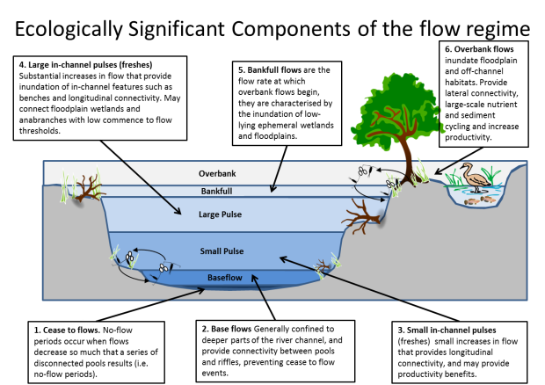
Figure 54: Components of the in-channel flow regime (adapted from Ellis et al. 2016).

Table 19: Definition of the six flow regime components identified for this study (adapted from Ellis et al. 2016; NSW DPI, 2017a).
Flow regime component |  | Definition
Very low flow and cease to flow | No-flow periods occasionally occur in intermittent streams where flows decrease so much that a series of disconnected pools eventuates. High food availability for predatory species at higher trophic levels may occur initially during cease to flow periods and very low flows, with limited refuge habitat for prey. Ultimately, however, food supply and water quality would be expected to decrease in isolated pools as water levels contract. No-flow periods have been associated with poor body condition; particularly for species at lower trophic levels (Balcombe et. al. 2012). Cease to flow and very low flow periods can play an important role in these streams by promoting growth of biofilms and productivity. Rates of wetting and drying are important. Cease to flow can also be useful in controlling carp populations, and would generally occur annually in highly intermittent systems.
Baseflow | Confined to deeper low-lying part of the channel, and would typically inundate geomorphic units such as pools and riffle areas between pools. Base flows (and cease to flows) also allow for the accumulation of allochthonous carbon and vegetation on benches and dry river channel sediments, which then contribute to ecosystem productivity during subsequent flow events. They would generally occur on an ongoing basis in perennial systems. They may be important in maintaining aquatic habitat for fish, plants and invertebrates when low inflow conditions prevail; retain longitudinal connectivity for small-bodied fish and maintain reasonable water quality. Base flows maintain drought refuges during dry periods and contribute to nutrient dilution during wet periods or after a flood event. Base flows may also support winter conditioning and oxygenation through riffle habitats, and historically may have benefited small-bodied native species in terminal wetlands. Stable Low Flow Spawning Fish as described by Kerr et al. 2017 rely on stable base flows for completing important life-cycle stages, they even thrive in some cases from very low and flows as described above. Base flows are commonly maintained by seepage from groundwater and low surface flows (MDBA, 2014).
Small pulse | Generally short increases in flow that provide longitudinal connectivity, and may provide productivity benefits by replenishing soil water for riparian vegetation, inundating low-lying benches and cycling nutrients between different parts of the river channel. Small pulses would generally be considered to be relatively slow flowing (e.g. less than 0.3m/s). They can contribute to the maintenance of refugia and key aquatic habitat such as snags and aquatic vegetation, which supports diverse heterotrophic biofilm generation, with high nutritional value to higher organisms (Wallace et al. 2014). Small within-channel pulses would have generally occurred annually throughout the majority of the Basin, and potentially two to three times in a year for perennial systems.
Large pulse | More substantial increases in flow that provide greater inundation of in-channel features such as benches and longitudinal connectivity and may connect floodplain wetlands and anabranches with low commence to flow thresholds. Large within channel pulse are distinct from small pulses in that they provide fast flowing in channel habitats (e.g. velocity greater than 0.3m/s). Large in-channel pulses enhance productivity and nutrient exchange, promote dispersal and recruitment for all species and can trigger spawning in flow dependent species (i.e. golden perch and silver perch). These flow events are also important for maintaining refuges and minimising geomorphological impacts of regulation (e.g. sedimentation). The shape of these events should reflect the natural rates of flow increase or decrease corresponding to position in the catchment. Maintaining natural rates of change in water level may be important for nesting species such as Murray cod and freshwater catfish, as water level fluctuations that are out of sync with natural patterns and climatic cues can have adverse impacts (e.g. rapid decreases in water levels over short time periods leading to nest abandonment). Large in-channel pulses would have generally occurred annually across most of the Basin, and up to two to three times a year in some systems.
Bankfull flow | The flow rate at which overbank flows begin, or maximum regulated flow releases. Bankfull flows generate similar ecological benefits to large in-channel pulses, potentially at a greater magnitude depending on channel geomorphology. They are characterised by the inundation of low-lying ephemeral wetlands and floodplains. As with large in-channel pulses, the shape of these events should reflect the natural rates of flow increase or decrease corresponding to position in the catchment.
Overbank event | Inundate floodplain and off-channel habitats and are important in providing lateral connectivity, large-scale nutrient and sediment cycling and an increase in productivity. Overbank events can enhance breeding opportunities for many species by creating additional spawning habitat and floodplain productivity benefits which contribute to increased condition and recruitment. Overbank events generally would have occurred between 1 - 25 years (depending on the magnitude of the event) for both intermittent and perennial systems. These events are generally unregulated, although there may be scenarios where water for the environment management activities could augment in-channel flows to create overbank events in which case the shape of these events should reflect the natural rates of flow increase or decrease corresponding to position in the catchment.

Mungindi management reach
Greater than 50% of LWH is inundated during very low flow conditions, specifically when there is no flow recorded at the gauge. There is little further inundation base flows and small pulses. Large pulses, however, inundate up to 91.5% with flows of 8,080ML/day. Overbank flows of 59,900 ML/day are required to inundate 100%.
The number and area of benches inundated during very low flows is minor however does reach just over 20% at the higher end of this flow class. Base flows have a slightly higher level of inundation, most notable is the increase in the number of benches inundated (>60%), however this is not reflected as much in the bench area that becomes inundated. This suggests a large presence of small low-lying benches in this management reach. Inundation increases with small pulses of 2,350 ML/day to 75.8% of benches or 47.4% of bench area. Large pulse flows of 7,040 ML/day are required to inundate 100% of benches.
The number of wetland entry points begins to increase, though remaining low from very low flows to small pulses reaching 14.9% with flows of 2,350 ML/day. Notably, two wetland entry points are inundated with very low flows of 88 and 288 ML/day. A major increase in wetland entry point inundation is evident with large pulses, with up to 87.8% of entry points inundated with flows of 8,080 ML/day. Bankfull flows inundated up to 95.8% with flows of 13,300 ML day with the remainder inundated by overbank flows of 59,800 ML/day.

Table 20: Summary of flow components, stage height and mean daily flow range for Mungindi management reach.
m (gauge) | ML/day | Large Woody Habitat |  |  | Benches |  |  |  |  | Wetland Entry/Exit |  |  | Flow Component
 |  | Frequency | Cumulative Frequency (n) | Cumulative Frequency (%) | Frequency | Cumulative Frequency (n) | Cumulative Frequency (%) | Cumulative Frequency (m²) | Cumulative Frequency (%) | Frequency | Cumulative Frequency (n) | Cumulative Frequency (%)
3.1 | 0 | 710 | 710 | 51.2 | 1 | 1 | 0.5 | 24.7 | 0.1 | 0 | 0 | 0 | Very low flow
3.2 | 88 | 0 | 710 | 51.2 | 38 | 39 | 21.0 | 5524.1 | 13.0 | 1 | 1 | 1.4
3.3 | 288 | 1 | 711 | 51.3 | 5 | 44 | 23.7 | 6489.8 | 15.3 | 1 | 2 | 2.7
3.4 | 541 | 15 | 726 | 52.4 | 14 | 58 | 31.2 | 8198.2 | 19.3 | 0 | 2 | 2.7 | Base flow
3.5 | 855 | 14 | 740 | 53.4 | 31 | 89 | 47.8 | 11720.0 | 27.6 | 1 | 3 | 4.1
3.6 | 1210 | 30 | 770 | 55.6 | 26 | 115 | 61.8 | 14809.2 | 34.9 | 3 | 6 | 8.1
3.7 | 1590 | 31 | 801 | 57.8 | 8 | 123 | 66.1 | 15711.6 | 37.0 | 1 | 7 | 9.5 | Small pulse
3.8 | 1970 | 28 | 829 | 59.8 | 8 | 131 | 70.4 | 18045.6 | 42.5 | 1 | 8 | 10.8
3.9 | 2350 | 21 | 850 | 61.3 | 10 | 141 | 75.8 | 20109.1 | 47.4 | 3 | 11 | 14.9
4 | 2720 | 17 | 867 | 62.6 | 4 | 145 | 78.0 | 21285.8 | 50.2 | 3 | 14 | 18.9 | Large pulse
4.1 | 3090 | 18 | 885 | 63.9 | 7 | 152 | 81.7 | 24206.9 | 57.1 | 2 | 16 | 21.6
4.2 | 3430 | 17 | 902 | 65.1 | 4 | 156 | 83.9 | 25104.2 | 59.2 | 6 | 22 | 29.7
4.3 | 3710 | 24 | 926 | 66.8 | 7 | 163 | 87.6 | 27134.7 | 64.0 | 4 | 26 | 35.1
4.4 | 3990 | 24 | 950 | 68.5 | 3 | 166 | 89.2 | 27515.4 | 64.9 | 1 | 27 | 36.5
4.5 | 4260 | 20 | 970 | 70.0 | 8 | 174 | 93.5 | 30247.9 | 71.3 | 3 | 30 | 40.5
4.6 | 4460 | 15 | 985 | 71.1 | 6 | 180 | 96.8 | 35899.2 | 84.6 | 4 | 34 | 45.9
4.7 | 4650 | 20 | 1005 | 72.5 | 1 | 181 | 97.3 | 36165.0 | 85.2 | 3 | 37 | 50.0
4.8 | 4840 | 16 | 1021 | 73.7 | 1 | 182 | 97.8 | 36757.1 | 86.6 | 4 | 41 | 55.4
4.9 | 5020 | 25 | 1046 | 75.5 | 1 | 183 | 98.4 | 37154.5 | 87.6 | 2 | 43 | 58.1
5 | 5200 | 13 | 1059 | 76.4 | 0 | 183 | 98.4 | 37154.5 | 87.6 | 1 | 44 | 59.5
5.1 | 5420 | 11 | 1070 | 77.2 | 0 | 183 | 98.4 | 37154.5 | 87.6 | 3 | 47 | 63.5
5.2 | 5630 | 30 | 1100 | 79.4 | 0 | 183 | 98.4 | 37154.5 | 87.6 | 4 | 51 | 68.9
5.3 | 5840 | 25 | 1125 | 81.2 | 0 | 183 | 98.4 | 37154.5 | 87.6 | 1 | 52 | 70.3
5.4 | 6050 | 10 | 1135 | 81.9 | 1 | 184 | 98.9 | 37561.0 | 88.5 | 4 | 56 | 75.7
5.5 | 6260 | 19 | 1154 | 83.3 | 0 | 184 | 98.9 | 37561.0 | 88.5 | 2 | 58 | 78.4
5.6 | 6520 | 16 | 1170 | 84.4 | 1 | 185 | 99.5 | 37870.6 | 89.3 | 1 | 59 | 79.7
5.7 | 6780 | 21 | 1191 | 85.9 | 0 | 185 | 99.5 | 37870.6 | 89.3 | 2 | 61 | 82.4
5.8 | 7040 | 14 | 1205 | 86.9 | 1 | 186 | 100 | 42423.5 | 100 | 3 | 64 | 86.5
5.9 | 7300 | 19 | 1224 | 88.3 | 0 | 186 | 100 | 42423.5 | 100 | 0 | 64 | 86.5
6 | 7560 | 11 | 1235 | 89.1 | 0 | 186 | 100 | 42423.5 | 100 | 1 | 65 | 87.8
6.1 | 7820 | 11 | 1246 | 89.9 | 0 | 186 | 100 | 42423.5 | 100 | 0 | 65 | 87.8
6.2 | 8080 | 22 | 1268 | 91.5 | 0 | 186 | 100 | 42423.5 | 100 | 0 | 65 | 87.8
6.3 | 8630 | 15 | 1283 | 92.6 | 0 | 186 | 100 | 42423.5 | 100 | 1 | 66 | 89.2 | Bank full
6.4 | 9240 | 13 | 1296 | 93.5 | 0 | 186 | 100 | 42423.5 | 100 | 2 | 68 | 91.9
6.5 | 9860 | 6 | 1302 | 93.9 | 0 | 186 | 100 | 42423.5 | 100 | 1 | 69 | 93.2
6.6 | 10500 | 11 | 1313 | 94.7 | 0 | 186 | 100 | 42423.5 | 100 | 0 | 69 | 93.2
6.7 | 11200 | 12 | 1325 | 95.6 | 0 | 186 | 100 | 42423.5 | 100 | 0 | 69 | 93.2
6.8 | 11900 | 8 | 1333 | 96.2 | 0 | 186 | 100 | 42423.5 | 100 | 1 | 70 | 94.6
6.9 | 12600 | 10 | 1343 | 96.9 | 0 | 186 | 100 | 42423.5 | 100 | 1 | 71 | 95.9
7 | 13300 | 5 | 1348 | 97.3 | 0 | 186 | 100 | 42423.5 | 100 | 0 | 71 | 95.9
7.1 | 14100 | 5 | 1353 | 97.6 | 0 | 186 | 100 | 42423.5 | 100 | 1 | 72 | 97.3 | Overbank
7.2 | 15000 | 4 | 1357 | 97.9 | 0 | 186 | 100 | 42423.5 | 100 | 0 | 72 | 97.3
7.3 | 16500 | 8 | 1365 | 98.5 | 0 | 186 | 100 | 42423.5 | 100 | 2 | 74 | 100
7.4 | 18200 | 0 | 1365 | 98.5 | 0 | 186 | 100 | 42423.5 | 100 | 0 | 74 | 100
7.5 | 19900 | 8 | 1373 | 99.1 | 0 | 186 | 100 | 42423.5 | 100 | 0 | 74 | 100
7.6 | 23800 | 1 | 1374 | 99.1 | 0 | 186 | 100 | 42423.5 | 100 | 0 | 74 | 100
7.7 | 29100 | 2 | 1376 | 99.3 | 0 | 186 | 100 | 42423.5 | 100 | 0 | 74 | 100
7.8 | 38300 | 10 | 1386 | 100 | 0 | 186 | 100 | 42423.5 | 100 | 0 | 74 | 100
7.9 | 59800 | 0 | 1386 | 100 | 0 | 186 | 100 | 42423.5 | 100 | 0 | 74 | 100

Presbury management reach
During zero flow events 56.4% of LWH is inundated and up to 65.2% with very low flows up to 281 ML/day. Little further inundation occurs with base flows or small pulses. Large pulses inundated up to 97.3% with flows of 5,010 ML/day. The remainder are inundated with bankfull flows of 7,410 ML/day.
Over 80% of benches and bench area is inundated with very low flows of 281 ML/day. This suggests a high proportion of low-lying benches similar to Mungindi, however the percentage of number and area are closer suggesting larger low-lying benches than the Mungindi Reach. Further minor increases in both bench number and area occur with base flows and small pulses. Large pulse flows of 3,180 ML/day, inundated the remaining benches.
Very low flows inundated up to 6.3% of wetland entry points with flows of 281 ML/day. Base flows exhibit inundation of a further minor portion. A greater influence is seen with small pulses which inundate up to 27.1% with flows of 1,340 ML/day. The remainder of entry points are inundated with large pulses of 3,330 ML/day.

Table 21: Summary of flow components, stage height and mean daily flow range for Presbury management reach.
m (gauge) | ML/day | Large Woody Habitat |  |  | Benches |  |  |  |  | Wetland Entry/Exit |  |  | Flow Component
 |  | Frequency | Cumulative Frequency (n) | Cumulative Frequency (%) | Frequency | Cumulative Frequency (n) | Cumulative Frequency (%) | Cumulative Frequency (m²) | Cumulative Frequency (%) | Frequency | Cumulative Frequency (n) | Cumulative Frequency (%)
0 | 0 | 856 | 856 | 50.9 | 0 | 0 | 0 | 0 | 0 | 0 | 0 | 0.0 | Very low flow
0.2 | 0.825 | 22 | 878 | 52.2 | 310 | 310 | 83.8 | 69998.9 | 81.9 | 2 | 2 | 4.7
0.3 | 92.2 | 24 | 902 | 53.7 | 3 | 313 | 84.6 | 70654.1 | 82.7 | 1 | 3 | 6.7
0.4 | 281 | 88 | 990 | 58.9 | 11 | 324 | 87.6 | 72474.7 | 84.8 | 0 | 3 | 6.3
0.5 | 519 | 32 | 1022 | 60.8 | 8 | 332 | 89.7 | 74300.5 | 86.9 | 0 | 3 | 6.3 | Base flow
0.6 | 733 | 36 | 1058 | 62.9 | 7 | 339 | 91.6 | 75794.3 | 88.7 | 1 | 4 | 8.3
0.7 | 915 | 22 | 1080 | 64.2 | 5 | 344 | 93 | 76562.4 | 89.6 | 1 | 5 | 10.4
0.8 | 1080 | 21 | 1101 | 65.5 | 2 | 346 | 93.5 | 77297.8 | 90.5 | 3 | 8 | 16.7 | Small pulse
0.9 | 1210 | 33 | 1134 | 67.5 | 5 | 351 | 94.9 | 78653.2 | 92 | 3 | 11 | 22.9
1 | 1340 | 25 | 1159 | 68.9 | 1 | 352 | 95.1 | 78901.6 | 92.3 | 2 | 13 | 27.1
1.1 | 1460 | 29 | 1188 | 70.7 | 4 | 356 | 96.2 | 79635.7 | 93.2 | 1 | 14 | 29.2 | Large pulse
1.2 | 1580 | 23 | 1211 | 72.0 | 2 | 358 | 96.8 | 80260 | 93.9 | 5 | 19 | 39.6
1.3 | 1680 | 35 | 1246 | 74.1 | 4 | 362 | 97.8 | 82302.3 | 96.3 | 3 | 22 | 45.8
1.4 | 1800 | 67 | 1313 | 78.1 | 1 | 363 | 98.1 | 83036.6 | 97.2 | 1 | 23 | 47.9
1.5 | 1910 | 16 | 1329 | 79.1 | 3 | 366 | 98.9 | 83587 | 97.8 | 0 | 23 | 47.9
1.6 | 2020 | 12 | 1341 | 79.8 | 1 | 367 | 99.2 | 84037.6 | 98.3 | 1 | 24 | 50.0
1.7 | 2130 | 22 | 1363 | 81.1 | 1 | 368 | 99.5 | 84378.5 | 98.7 | 2 | 26 | 54.2
1.8 | 2240 | 11 | 1374 | 81.7 | 1 | 369 | 99.7 | 85012 | 99.5 | 1 | 27 | 56.3
1.9 | 2350 | 20 | 1394 | 82.9 | 0 | 369 | 99.7 | 85012 | 99.5 | 2 | 29 | 60.4
2 | 2460 | 19 | 1413 | 84.1 | 0 | 369 | 99.7 | 85012 | 99.5 | 1 | 30 | 62.5
2.1 | 2590 | 16 | 1429 | 85.0 | 0 | 369 | 99.7 | 85012 | 99.5 | 1 | 31 | 64.6
2.2 | 2740 | 11 | 1440 | 85.7 | 0 | 369 | 99.7 | 85012 | 99.5 | 1 | 32 | 66.7
2.3 | 2880 | 19 | 1459 | 86.8 | 0 | 369 | 99.7 | 85012 | 99.5 | 1 | 33 | 68.8
2.4 | 3030 | 45 | 1504 | 89.5 | 0 | 369 | 99.7 | 85012 | 99.5 | 1 | 34 | 70.8
2.5 | 3180 | 12 | 1516 | 90.2 | 1 | 370 | 100 | 85456 | 100 | 2 | 36 | 75
2.6 | 3330 | 9 | 1525 | 90.7 | 0 | 370 | 100 | 85456 | 100 | 0 | 36 | 75
2.7 | 3480 | 10 | 1535 | 91.3 | 0 | 370 | 100 | 85456 | 100 | 1 | 37 | 77.1
2.8 | 3650 | 11 | 1546 | 92.0 | 0 | 370 | 100 | 85456 | 100 | 1 | 38 | 79.2
2.9 | 3810 | 15 | 1561 | 92.9 | 0 | 370 | 100 | 85456 | 100 | 1 | 39 | 81.3
3 | 3980 | 6 | 1567 | 93.2 | 0 | 370 | 100 | 85456 | 100 | 0 | 39 | 81.3
3.1 | 4150 | 7 | 1574 | 93.6 | 0 | 370 | 100 | 85456 | 100 | 1 | 40 | 83.3
3.2 | 4330 | 5 | 1579 | 93.9 | 0 | 370 | 100 | 85456 | 100 | 0 | 40 | 83.3
3.3 | 4560 | 13 | 1592 | 94.7 | 0 | 370 | 100 | 85456 | 100 | 1 | 41 | 85.4
3.4 | 4780 | 22 | 1614 | 96.0 | 0 | 370 | 100 | 85456 | 100 | 0 | 41 | 85.4
3.5 | 5010 | 10 | 1624 | 96.6 | 0 | 370 | 100 | 85456 | 100 | 0 | 41 | 85.4
3.6 | 5250 | 5 | 1629 | 96.9 | 0 | 370 | 100 | 85456 | 100 | 0 | 41 | 85.4 | Bank full
3.7 | 5480 | 4 | 1633 | 97.1 | 0 | 370 | 100 | 85456 | 100 | 0 | 41 | 85.4
3.8 | 5730 | 6 | 1639 | 97.5 | 0 | 370 | 100 | 85456 | 100 | 0 | 41 | 85.4
3.9 | 6000 | 5 | 1644 | 97.8 | 0 | 370 | 100 | 85456 | 100 | 1 | 42 | 87.5
4 | 6270 | 5 | 1649 | 98.1 | 0 | 370 | 100 | 85456 | 100 | 0 | 42 | 87.5
4.1 | 6550 | 6 | 1655 | 98.5 | 0 | 370 | 100 | 85456 | 100 | 0 | 42 | 87.5
4.2 | 6830 | 2 | 1657 | 98.6 | 0 | 370 | 100 | 85456 | 100 | 1 | 43 | 89.6
4.3 | 7120 | 3 | 1660 | 98.8 | 0 | 370 | 100 | 85456 | 100 | 2 | 45 | 93.8
4.4 | 7410 | 20 | 1680 | 99.9 | 0 | 370 | 100 | 85456 | 100 | 3 | 48 | 100
4.5 | 7730 | 0 | 1680 | 99.9 | 0 | 370 | 100 | 85456 | 100 | 0 | 48 | 100
4.6 | 8080 | 1 | 1681 | 100.0 | 0 | 370 | 100 | 85456 | 100 | 0 | 48 | 100
4.7 | 8450 | 0 | 1681 | 100.0 | 0 | 370 | 100 | 85456 | 100 | 0 | 48 | 100
4.8 | 8820 | 0 | 1681 | 100.0 | 0 | 370 | 100 | 85456 | 100 | 0 | 48 | 100
4.9 | 9200 | 0 | 1681 | 100 | 0 | 370 | 100 | 85456 | 100 | 0 | 48 | 100 | Overbank
5 | 9590 | 0 | 1681 | 100 | 0 | 370 | 100 | 85456 | 100 | 0 | 48 | 100
5.1 | 9990 | 0 | 1681 | 100 | 0 | 370 | 100 | 85456 | 100 | 0 | 48 | 100
5.2 | 10700 | 0 | 1681 | 100 | 0 | 370 | 100 | 85456 | 100 | 0 | 48 | 100
5.3 | 11500 | 0 | 1681 | 100 | 0 | 370 | 100 | 85456 | 100 | 0 | 48 | 100
5.4 | 12400 | 0 | 1681 | 100 | 0 | 370 | 100 | 85456 | 100 | 0 | 48 | 100
5.5 | 13200 | 0 | 1681 | 100 | 0 | 370 | 100 | 85456 | 100 | 0 | 48 | 100
5.6 | 14300 | 0 | 1681 | 100 | 0 | 370 | 100 | 85456 | 100 | 0 | 48 | 100

Mogil Mogil management reach
During zero flow events 54.2% of LWH is inundated with little further inundation under very low flows, base flows or small pulses up to 1,870 ML/day. There is a steady increase in LWH inundation with large pulses with flows of 16,100 ML/day required to inundate 100%.
2.5% of benches or 0.7% of bench areas is inundated with very low flows of 326 ML/day. Inundation shows a marked increase with base flows with 15.2% of benches or 9% of bench area inundated with flows of 1,110 ML/day. Inundation further increases with small pulses, with 27.4% of benches or 22% of bench area inundated with small pulses of 1,870 ML/day. The remainder of benches are inundated with large pulses of 12,100 ML/day.
Up to 15.5% of wetland entry points are inundated with very low flows of 325 ML/day. Just under, an additional 5% are inundated with base flows, while only one more entry point is inundated with small pulses of 1,360 ML/day. The remainder of wetland entry points are inundated with large pulses of 15,100 ML/day.

Table 22: Summary of flow components, stage height and mean daily flow range for Mogil Mogil management reach.
m (gauge) | ML/day | Large Woody Habitat |  |  | Benches |  |  |  |  | Wetland Entry/Exit |  |  | Flow Component
 |  | Frequency | Cumulative Frequency (n) | Cumulative Frequency (%) | Frequency | Cumulative Frequency (n) | Cumulative Frequency (%) | Cumulative Frequency (m²) | Cumulative Frequency (%) | Frequency | Cumulative Frequency (n) | Cumulative Frequency (%)
1.65 | 0.01 | 2113 | 2113 | 54.2 | 0 | 0 | 0 | 0 | 0 | 1 | 1 | 1.7 | Very low flow
1.7 | 54.6 | 0 | 2113 | 54.2 | 0 | 0 | 0 | 0 | 0 | 7 | 8 | 13.8
1.8 | 326 | 3 | 2116 | 54.3 | 7 | 7 | 2.5 | 1023.2 | 0.7 | 1 | 9 | 15.5
1.9 | 582 | 2 | 2118 | 54.3 | 13 | 20 | 7.2 | 5713.8 | 3.9 | 1 | 10 | 17.2 | Base flow
2 | 855 | 6 | 2124 | 54.4 | 8 | 28 | 10.1 | 8127.6 | 5.6 | 1 | 11 | 18.6
2.1 | 1110 | 19 | 2143 | 54.9 | 14 | 42 | 15.2 | 13169.4 | 9 | 1 | 12 | 20.3
2.2 | 1360 | 28 | 2171 | 55.6 | 13 | 55 | 20 | 16092.4 | 11 | 1 | 13 | 21.7 | Small pulse
2.3 | 1620 | 24 | 2195 | 56.2 | 11 | 66 | 23.8 | 20166.6 | 13.8 | 0 | 13 | 21.7
2.4 | 1870 | 27 | 2222 | 56.9 | 10 | 76 | 27.4 | 31647.7 | 22 | 0 | 13 | 21.7
2.5 | 2130 | 38 | 2260 | 57.8 | 14 | 90 | 32.5 | 38053.9 | 26.1 | 1 | 14 | 23.0 | Large pulse
2.6 | 2390 | 25 | 2285 | 58.5 | 11 | 101 | 36.5 | 40908.8 | 28.1 | 0 | 14 | 23.0
2.7 | 2650 | 149 | 2434 | 62.3 | 17 | 118 | 42.6 | 52599 | 36.1 | 0 | 14 | 23.0
2.8 | 2910 | 31 | 2465 | 63.1 | 13 | 131 | 47.3 | 60298.4 | 41.4 | 0 | 14 | 23.0
2.9 | 3180 | 55 | 2520 | 64.5 | 13 | 144 | 52 | 64485.6 | 44.3 | 2 | 16 | 26.2
3 | 3440 | 45 | 2565 | 65.7 | 15 | 159 | 57.4 | 71700 | 49.2 | 0 | 16 | 26.2
3.1 | 3700 | 41 | 2606 | 66.7 | 7 | 166 | 59.9 | 75250.2 | 51.7 | 1 | 17 | 27.9
3.2 | 3950 | 98 | 2704 | 69.2 | 13 | 179 | 64.6 | 79363.5 | 54.5 | 3 | 20 | 32.8
3.3 | 4210 | 24 | 2728 | 69.8 | 2 | 181 | 65.3 | 79674 | 54.7 | 2 | 22 | 36.1
3.4 | 4460 | 26 | 2754 | 70.5 | 5 | 186 | 67.1 | 81692 | 56.1 | 1 | 23 | 37.7
3.5 | 4720 | 47 | 2801 | 71.7 | 7 | 193 | 69.7 | 85753 | 58.9 | 1 | 24 | 39.3
3.6 | 4970 | 40 | 2841 | 72.7 | 8 | 201 | 72.6 | 92821 | 63.7 | 2 | 26 | 42.6
3.7 | 5230 | 131 | 2972 | 76.1 | 10 | 211 | 76.2 | 97995 | 67.3 | 4 | 30 | 49.2
3.8 | 5490 | 37 | 3009 | 77.0 | 7 | 218 | 78.7 | 102893 | 70.6 | 3 | 33 | 54.1
3.9 | 5740 | 51 | 3060 | 78.3 | 4 | 222 | 80.1 | 105872 | 72.7 | 2 | 35 | 57.4
4 | 6000 | 37 | 3097 | 79.3 | 4 | 226 | 81.5884477 | 107793 | 74 | 1 | 36 | 59.0
4.1 | 6270 | 40 | 3137 | 80.3 | 5 | 231 | 83.3935018 | 111926 | 76.8 | 2 | 38 | 62.3
4.2 | 6540 | 85 | 3222 | 82.5 | 4 | 235 | 84.8375451 | 114541 | 78.6 | 2 | 40 | 65.6
4.3 | 6810 | 40 | 3262 | 83.5 | 3 | 238 | 85.9205776 | 115063 | 79 | 3 | 43 | 70.5
4.4 | 7090 | 32 | 3294 | 84.3 | 3 | 241 | 87.0036101 | 116219 | 79.8 | 1 | 44 | 72.1
4.5 | 7360 | 48 | 3342 | 85.5 | 1 | 242 | 87.3646209 | 118935 | 81.6 | 0 | 44 | 72.1
4.6 | 7630 | 42 | 3384 | 86.6 | 1 | 243 | 87.7256318 | 119879 | 82.3 | 0 | 44 | 72.1
4.7 | 7910 | 119 | 3503 | 89.7 | 8 | 251 | 90.6137184 | 123108 | 84.5 | 2 | 46 | 75.4
4.8 | 8180 | 28 | 3531 | 90.4 | 6 | 257 | 92.7797834 | 126818 | 87.1 | 6 | 52 | 85.2
4.9 | 8450 | 49 | 3580 | 91.6 | 2 | 259 | 93.5018051 | 128126 | 88 | 2 | 54 | 88.5
5 | 8730 | 31 | 3611 | 92.4 | 4 | 263 | 94.9458484 | 128808 | 88.4 | 1 | 55 | 90.2
5.1 | 9090 | 35 | 3646 | 93.3 | 1 | 264 | 95.3068592 | 128984 | 88.5 | 0 | 55 | 90.2
5.2 | 9450 | 51 | 3697 | 94.6 | 1 | 265 | 95.66787 | 129822 | 89.1 | 0 | 55 | 90.2
5.3 | 9820 | 27 | 3724 | 95.3 | 1 | 266 | 96.0288809 | 130581 | 89.6 | 3 | 58 | 95.1
5.4 | 10200 | 22 | 3746 | 95.9 | 4 | 270 | 97.4729242 | 134036 | 92 | 0 | 58 | 95.1
5.5 | 10600 | 22 | 3768 | 96.4 | 3 | 273 | 98.5559567 | 141170 | 96.9 | 0 | 58 | 95.1
5.6 | 10900 | 15 | 3783 | 96.8 | 1 | 274 | 98.9169675 | 142531 | 97.8 | 0 | 58 | 95.1
5.7 | 11300 | 50 | 3833 | 98.1 | 0 | 274 | 98.9169675 | 142531 | 97.8 | 0 | 58 | 95.1
5.8 | 11700 | 9 | 3842 | 98.3 | 2 | 276 | 99.6389892 | 145423 | 99.8 | 0 | 58 | 95.1
5.9 | 12100 | 11 | 3853 | 98.6 | 1 | 277 | 100 | 145670 | 100 | 0 | 58 | 95.1
6 | 12500 | 16 | 3869 | 99.0 | 0 | 277 | 100 | 145670 | 100 | 1 | 59 | 96.7
6.1 | 13000 | 7 | 3876 | 99.2 | 0 | 277 | 100 | 145670 | 100 | 0 | 59 | 96.7
6.2 | 13500 | 18 | 3894 | 99.7 | 0 | 277 | 100 | 145670 | 100 | 1 | 60 | 98.4
6.3 | 14000 | 4 | 3898 | 99.8 | 0 | 277 | 100 | 145670 | 100 | 0 | 60 | 98.4
6.4 | 14500 | 1 | 3899 | 99.8 | 0 | 277 | 100 | 145670 | 100 | 0 | 60 | 98.4
6.5 | 15100 | 2 | 3901 | 99.8 | 0 | 277 | 100 | 145670 | 100 | 1 | 61 | 100
6.6 | 15600 | 1 | 3902 | 99.9 | 0 | 277 | 100 | 145670 | 100 | 0 | 61 | 100
6.7 | 16100 | 5 | 3907 | 100 | 0 | 277 | 100 | 145670 | 100 | 0 | 61 | 100
6.8 | 16700 | 0 | 3907 | 100 | 0 | 277 | 100 | 145670 | 100 | 0 | 61 | 100
6.9 | 17200 | 0 | 3907 | 100 | 0 | 277 | 100 | 145670 | 100 | 0 | 61 | 100
7 | 17800 | 0 | 3907 | 100 | 0 | 277 | 100 | 145670 | 100 | 0 | 61 | 100
7.1 | 18600 | 0 | 3907 | 100 | 0 | 277 | 100 | 145670 | 100 | 0 | 61 | 100

Collarenebri management reach
During zero flow events 72.4% of LWH is inundated with no additional inundation during very low flows. Little further inundation occurs with base flows or small pulses. 95.8% of LWH is inundated with large pulses of 18,500 ML/day. The small fraction of remaining LWH is inundated with bankfull flows of 30,000 ML/day. The rate of inundation at zero flows reflects the impacts of the weir pools in this management reach.
No benches are inundated with very low flows, although 20.5% or 19.8% of bench area is inundated with base flows of 1,450 ML/day. Small pulses inundated up to 31.8% of benches or 53% of bench area. The large increase in bench area compared to the number indicates the presence of very large bench/es being inundated by this flow class. The remaining benches are inundated by large pulses of 18,000 ML/day.
Very few (4) wetland entry points were present in this reach, one of which is inundated at zero flow. The remaining three are inundated by a large pulse of 15,600 ML/day. One of these exit points represents Grawan Creek which is a major distributary stream that re-enters downstream. Grawan Creek would only be inundated with larger events and it could be assumed that a large portion of the water that enters this system would replenish parts of that system and not re-enter the Barwon.
Table 23: Summary of flow components, stage height and mean daily flow range for Collarenebri management reach.
m (gauge) | ML/day | Large Woody Habitat |  |  | Benches |  |  |  |  | Wetland Entry/Exit |  |  | Flow Component
 |  | Frequency | Cumulative Frequency (n) | Cumulative Frequency (%) | Frequency | Cumulative Frequency (n) | Cumulative Frequency (%) | Cumulative Frequency (m²) | Cumulative Frequency (%) | Frequency | Cumulative Frequency (n) | Cumulative Frequency (%)
1.53 | 0 | 459 | 459 | 72.4 | 0 | 0 | 0 | 0 | 0 | 1 | 1 | 25 | Very low flow
1.6 | 0.271 | 0 | 459 | 72.4 | 0 | 0 | 0 | 0 | 0 | 0 | 1 | 25
1.7 | 54.6 | 0 | 459 | 72.4 | 0 | 0 | 0 | 0 | 0 | 0 | 1 | 25
1.8 | 373 | 4 | 463 | 72.8 | 2 | 2 | 4.5 | 4589.4 | 9.5 | 0 | 1 | 25 | Base flow
1.9 | 881 | 2 | 465 | 72.4 | 3 | 5 | 11.4 | 5810.9 | 12.0 | 0 | 1 | 25
2 | 1450 | 3 | 468 | 72.9 | 4 | 9 | 20.5 | 9575.2 | 19.8 | 0 | 1 | 25
2.1 | 2160 | 0 | 468 | 72.9 | 3 | 12 | 27.3 | 19271.3 | 39.8 | 0 | 1 | 25 | Small pulse
2.2 | 3030 | 1 | 469 | 73.1 | 1 | 13 | 29.5 | 19778.7 | 40.8 | 0 | 1 | 25
2.3 | 4040 | 3 | 472 | 73.5 | 1 | 14 | 31.8 | 25683.8 | 53.0 | 0 | 1 | 25
2.4 | 5210 | 1 | 473 | 73.7 | 3 | 17 | 38.6 | 33247.3 | 68.6 | 0 | 1 | 25 | Large pulse
2.5 | 6130 | 20 | 493 | 76.8 | 2 | 19 | 43.2 | 34109.8 | 70.4 | 0 | 1 | 25
2.6 | 6810 | 1 | 494 | 76.9 | 1 | 20 | 45.5 | 34867.4 | 72.0 | 0 | 1 | 25
2.7 | 7500 | 6 | 500 | 77.9 | 1 | 21 | 47.7 | 35272.7 | 72.8 | 0 | 1 | 25
2.8 | 8200 | 2 | 502 | 78.2 | 0 | 21 | 47.7 | 35272.7 | 72.8 | 1 | 2 | 50
2.9 | 8900 | 1 | 503 | 78.3 | 3 | 24 | 54.5 | 37862.5 | 78.2 | 0 | 2 | 50
3 | 9600 | 8 | 511 | 79.6 | 5 | 29 | 65.9 | 40757.8 | 84.1 | 0 | 2 | 50
3.1 | 10100 | 7 | 518 | 80.7 | 1 | 30 | 68.2 | 41572.8 | 85.8 | 1 | 3 | 75
3.2 | 10700 | 2 | 520 | 81.0 | 1 | 31 | 70.5 | 41666.6 | 86.0 | 0 | 3 | 75
3.3 | 11200 | 5 | 525 | 81.8 | 0 | 31 | 70.5 | 41666.6 | 86.0 | 0 | 3 | 75
3.4 | 11700 | 3 | 528 | 82.2 | 3 | 34 | 77.3 | 42580.0 | 87.9 | 0 | 3 | 75
3.5 | 12200 | 18 | 546 | 85.0 | 1 | 35 | 79.5 | 43455.0 | 89.7 | 0 | 3 | 75
3.6 | 12600 | 3 | 549 | 85.5 | 1 | 36 | 81.8 | 43709.3 | 90.2 | 0 | 3 | 75
3.7 | 13100 | 8 | 557 | 86.8 | 1 | 37 | 84.1 | 43860.3 | 90.5 | 0 | 3 | 75
3.8 | 13500 | 5 | 562 | 87.5 | 0 | 37 | 84.1 | 43860.3 | 90.5 | 0 | 3 | 75
3.9 | 13900 | 4 | 566 | 88.2 | 2 | 39 | 88.6 | 46040.0 | 95.0 | 0 | 3 | 75
4 | 14400 | 8 | 574 | 89.4 | 1 | 40 | 90.9 | 46691.3 | 96.4 | 0 | 3 | 75
4.1 | 14800 | 3 | 577 | 89.9 | 3 | 43 | 97.7 | 47313.4 | 97.7 | 0 | 3 | 75
4.2 | 15200 | 5 | 582 | 90.7 | 0 | 43 | 97.7 | 47313.4 | 97.7 | 0 | 3 | 75
4.3 | 15600 | 4 | 586 | 91.3 | 0 | 43 | 97.7 | 47313.4 | 97.7 | 1 | 4 | 100
4.4 | 16000 | 1 | 587 | 91.4 | 0 | 43 | 97.7 | 47313.4 | 97.7 | 0 | 4 | 100
4.5 | 16400 | 7 | 594 | 92.5 | 0 | 43 | 97.7 | 47313.4 | 97.7 | 0 | 4 | 100
4.6 | 16800 | 7 | 601 | 93.6 | 0 | 43 | 97.7 | 47313.4 | 97.7 | 0 | 4 | 100
4.7 | 17200 | 4 | 605 | 94.2 | 0 | 43 | 97.7 | 47313.4 | 97.7 | 0 | 4 | 100
4.8 | 17600 | 0 | 605 | 94.2 | 0 | 43 | 97.7 | 47313.4 | 97.7 | 0 | 4 | 100
4.9 | 18000 | 3 | 608 | 94.7 | 1 | 44 | 100 | 48441.8068 | 100 | 0 | 4 | 100
5 | 18500 | 7 | 615 | 95.8 | 0 | 44 | 100 | 48441.8068 | 100 | 0 | 4 | 100
5.1 | 19100 | 3 | 618 | 96.3 | 0 | 44 | 100 | 48441.8068 | 100 | 0 | 4 | 100 | Bank full
5.2 | 19600 | 1 | 619 | 96.4 | 0 | 44 | 100 | 48441.8068 | 100 | 0 | 4 | 100
5.3 | 20200 | 1 | 620 | 96.6 | 0 | 44 | 100 | 48441.8068 | 100 | 0 | 4 | 100
5.4 | 20900 | 1 | 621 | 96.7 | 0 | 44 | 100 | 48441.8068 | 100 | 0 | 4 | 100
5.5 | 21600 | 5 | 626 | 97.5 | 0 | 44 | 100 | 48441.8068 | 100 | 0 | 4 | 100
5.6 | 22300 | 1 | 627 | 97.7 | 0 | 44 | 100 | 48441.8068 | 100 | 0 | 4 | 100
5.7 | 23000 | 3 | 630 | 98.1 | 0 | 44 | 100 | 48441.8068 | 100 | 0 | 4 | 100
5.8 | 23800 | 2 | 632 | 98.4 | 0 | 44 | 100 | 48441.8068 | 100 | 0 | 4 | 100
5.9 | 24700 | 0 | 632 | 98.4 | 0 | 44 | 100 | 48441.8068 | 100 | 0 | 4 | 100
6 | 25600 | 2 | 634 | 98.8 | 0 | 44 | 100 | 48441.8068 | 100 | 0 | 4 | 100
6.1 | 26400 | 0 | 634 | 98.8 | 0 | 44 | 100 | 48441.8068 | 100 | 0 | 4 | 100
6.2 | 27300 | 0 | 634 | 98.8 | 0 | 44 | 100 | 48441.8068 | 100 | 0 | 4 | 100
6.3 | 28200 | 0 | 634 | 98.8 | 0 | 44 | 100 | 48441.8068 | 100 | 0 | 4 | 100
6.4 | 29100 | 2 | 636 | 99.1 | 0 | 44 | 100 | 48441.8068 | 100 | 0 | 4 | 100
6.5 | 30000 | 6 | 642 | 100 | 0 | 44 | 100 | 48441.8068 | 100 | 0 | 4 | 100
6.6 | 31800 | 0 | 642 | 100 | 0 | 44 | 100 | 48441.8068 | 100 | 0 | 4 | 100 | Overbank
6.7 | 33800 | 0 | 642 | 100 | 0 | 44 | 100 | 48441.8068 | 100 | 0 | 4 | 100
6.8 | 35800 | 0 | 642 | 100 | 0 | 44 | 100 | 48441.8068 | 100 | 0 | 4 | 100
6.9 | 37800 | 0 | 642 | 100 | 0 | 44 | 100 | 48441.8068 | 100 | 0 | 4 | 100
7 | 40000 | 0 | 642 | 100 | 0 | 44 | 100 | 48441.8068 | 100 | 0 | 4 | 100

Tara management reach
During zero flow events 58.7% of LWH is inundated and up to 62.1 with very low flows of 49.1 ML/day. Only minor increases in LWH inundation occur with base flows and small pulses up to 249 ML/day. The remainder of LWH requires large pulses of 5,350 ML/day to be inundated.
Up to 58.7% of benches or 49% of bench area is inundated with base flows of 49.1 ML/day. There is a minor increase in bench inundation with base flows and further minor inundation up to 70.9% of benches or 63.5% of bench are, with small pulses of 249 ML/day. Large pulses of 4,450 ML/day are required to inundate 100% of benches.
One wetland entry point is inundated with very low flows of 8.18 ML/day and a further one with base flows of 114 ML/day. A further three, making up 19.25%, are inundated with small pulses of 249 ML/day. A large pulse of 5,140 ML/day is required to inundate 100% of wetland entry points in the Tara management reach.

Table 24: Summary of flow components, stage height and mean daily flow range for Tara management reach.
m (gauge) | ML/day | Large Woody Habitat |  |  | Benches |  |  |  |  | Wetland Entry/Exit |  |  | Flow Component
 |  | Frequency | Cumulative Frequency (n) | Cumulative Frequency (%) | Frequency | Cumulative Frequency (n) | Cumulative Frequency (%) | Cumulative Frequency (m²) | Cumulative Frequency (%) | Frequency | Cumulative Frequency (n) | Cumulative Frequency (%)
0.9 | 0 | 2397 | 2397 | 58.7 | 0 | 0 | 0 | 0 | 0.0 | 0 | 0 | 0 | Very low flow
1 | 8.18 | 33 | 2430 | 59.5 | 311 | 311 | 51.2 | 139501.449 | 40.4 | 1 | 1 | 3.8
1.1 | 25.1 | 68 | 2498 | 61.1 | 28 | 339 | 55.8 | 157380.834 | 45.6 | 0 | 1 | 3.8
1.2 | 49.1 | 44 | 2542 | 62.1 | 18 | 357 | 58.7 | 169184.128 | 49 | 0 | 1 | 3.8
1.3 | 78.9 | 111 | 2653 | 64.6 | 11 | 368 | 60.5 | 174118.861 | 50.5 | 0 | 1 | 3.8 | Base flow
1.4 | 114 | 49 | 2702 | 65.8 | 20 | 388 | 63.8 | 185798.954 | 53.8 | 1 | 2 | 7.7
1.5 | 154 | 48 | 2750 | 66.9 | 16 | 404 | 66.4 | 195061.153 | 56.5 | 2 | 4 | 15.4 | Small pulse
1.6 | 199 | 32 | 2782 | 67.7 | 18 | 422 | 69.4 | 212928.946 | 61.7 | 1 | 5 | 19.2
1.7 | 249 | 38 | 2820 | 68.6 | 9 | 431 | 70.9 | 219134.365 | 63.5 | 0 | 5 | 19.2
1.8 | 303 | 69 | 2889 | 70.3 | 21 | 452 | 74.3 | 234933.906 | 68.1 | 0 | 5 | 18.5 | Large pulse
1.9 | 361 | 98 | 2987 | 72.7 | 19 | 471 | 77.5 | 248331.037 | 72 | 2 | 7 | 25.9
2 | 423 | 39 | 3026 | 73.7 | 8 | 479 | 78.8 | 262450.772 | 76.1 | 0 | 7 | 25.9
2.1 | 489 | 48 | 3074 | 74.8 | 6 | 485 | 79.8 | 264794.818 | 76.7 | 0 | 7 | 25.9
2.2 | 559 | 45 | 3119 | 75.9 | 11 | 496 | 81.6 | 269674.849 | 78.2 | 2 | 9 | 33.3
2.3 | 633 | 80 | 3199 | 77.9 | 9 | 505 | 83.1 | 276973.281 | 80.3 | 0 | 9 | 33.3
2.4 | 710 | 38 | 3237 | 78.8 | 11 | 516 | 84.9 | 286987.797 | 83.2 | 0 | 9 | 33.3
2.5 | 791 | 40 | 3277 | 79.8 | 12 | 528 | 86.8 | 298855.041 | 86.6 | 0 | 9 | 33.3
2.6 | 875 | 36 | 3313 | 80.6 | 10 | 538 | 88.5 | 305484.193 | 88.5 | 2 | 11 | 40.7
2.7 | 962 | 42 | 3355 | 81.7 | 6 | 544 | 89.5 | 309610.351 | 89.7 | 1 | 12 | 44.4
2.8 | 1050 | 53 | 3408 | 83 | 7 | 551 | 90.6 | 312367.579 | 90.5 | 1 | 13 | 48.1
2.9 | 1150 | 77 | 3485 | 84.8 | 3 | 554 | 91.1 | 313564.337 | 90.9 | 1 | 14 | 51.9
3 | 1250 | 31 | 3516 | 85.6 | 3 | 557 | 91.6 | 314620.04 | 91.2 | 1 | 15 | 55.6
3.1 | 1350 | 28 | 3544 | 86.3 | 7 | 564 | 92.8 | 318487.053 | 92.3 | 1 | 16 | 59.3
3.2 | 1450 | 43 | 3587 | 87.3 | 6 | 570 | 93.8 | 321094.054 | 93.1 | 0 | 16 | 59.3
3.3 | 1560 | 54 | 3641 | 88.6 | 4 | 574 | 94.4 | 323615.678 | 93.8 | 1 | 17 | 63
3.4 | 1670 | 33 | 3674 | 89.4 | 5 | 579 | 95.2 | 327165.976 | 94.8 | 1 | 18 | 66.7
3.5 | 1780 | 29 | 3703 | 90.1 | 1 | 580 | 95.4 | 327921.118 | 95 | 1 | 19 | 70.4
3.6 | 1900 | 27 | 3730 | 90.8 | 6 | 586 | 96.4 | 331812.587 | 96.2 | 1 | 20 | 74.1
3.7 | 2020 | 17 | 3747 | 91.2 | 2 | 588 | 96.7 | 332998.131 | 96.5 | 1 | 21 | 77.8
3.8 | 2140 | 35 | 3782 | 92.1 | 5 | 593 | 97.5 | 337034.249 | 97.7 | 2 | 23 | 85.2
3.9 | 2260 | 32 | 3814 | 92.8 | 0 | 593 | 97.5 | 337034.249 | 97.7 | 0 | 23 | 85.2
4 | 2390 | 26 | 3840 | 93.5 | 1 | 594 | 97.7 | 337539.918 | 97.8 | 0 | 23 | 85.2
4.1 | 2520 | 37 | 3877 | 94.4 | 2 | 596 | 98.0 | 338799.092 | 98.2 | 1 | 24 | 88.9
4.2 | 2650 | 24 | 3901 | 95.0 | 1 | 597 | 98.2 | 339090.326 | 98.3 | 0 | 24 | 88.9
4.3 | 2790 | 48 | 3949 | 96.1 | 2 | 599 | 98.5 | 339638.356 | 98.4 | 0 | 24 | 88.9
4.4 | 2930 | 22 | 3971 | 96.7 | 5 | 604 | 99.3 | 342089.709 | 99.1 | 0 | 24 | 88.9
4.5 | 3070 | 18 | 3989 | 97.1 | 0 | 604 | 99.3 | 342089.709 | 99.1 | 1 | 25 | 92.6
4.6 | 3210 | 6 | 3995 | 97.2 | 0 | 604 | 99.3 | 342089.709 | 99.1 | 0 | 25 | 92.6
4.7 | 3360 | 9 | 4004 | 97.5 | 0 | 604 | 99.3 | 342089.709 | 99.1 | 1 | 26 | 96.3
4.8 | 3510 | 13 | 4017 | 97.8 | 1 | 605 | 99.5 | 343019.259 | 99.4 | 0 | 26 | 96.3
4.9 | 3660 | 17 | 4034 | 98.2 | 1 | 606 | 99.7 | 343567.528 | 99.6 | 0 | 26 | 96.3
5 | 3810 | 5 | 4039 | 98.3 | 0 | 606 | 99.7 | 343567.528 | 99.6 | 0 | 26 | 96.3
5.1 | 3970 | 10 | 4049 | 98.6 | 1 | 607 | 99.8 | 344321.908 | 99.8 | 0 | 26 | 96.3
5.2 | 4130 | 8 | 4057 | 98.8 | 0 | 607 | 99.8 | 344321.908 | 99.8 | 0 | 26 | 96.3
5.3 | 4290 | 6 | 4063 | 98.9 | 0 | 607 | 99.8 | 344321.908 | 99.8 | 0 | 26 | 96.3
5.4 | 4450 | 11 | 4074 | 99.2 | 1 | 608 | 100 | 345072.047 | 100 | 0 | 26 | 96.3
5.5 | 4620 | 6 | 4080 | 99.3 | 0 | 608 | 100 | 345072.047 | 100 | 0 | 26 | 96.3
5.6 | 4790 | 2 | 4082 | 99.4 | 0 | 608 | 100 | 345072.047 | 100 | 0 | 26 | 96.3
5.7 | 4960 | 8 | 4090 | 99.6 | 0 | 608 | 100 | 345072.047 | 100 | 0 | 26 | 96.3
5.8 | 5140 | 4 | 4094 | 99.7 | 0 | 608 | 100 | 345072.047 | 100 | 1 | 27 | 100
5.9 | 5350 | 14 | 4108 | 100 | 0 | 608 | 100 | 345072.047 | 100 | 0 | 27 | 100
6 | 5570 | 0 | 4108 | 100 | 0 | 608 | 100 | 345072.047 | 100 | 0 | 27 | 100
6.1 | 5800 | 0 | 4108 | 100 | 0 | 608 | 100 | 345072.047 | 100 | 0 | 27 | 100
6.2 | 6030 | 0 | 4108 | 100 | 0 | 608 | 100 | 345072.047 | 100 | 0 | 27 | 100
6.3 | 6260 | 0 | 4108 | 100 | 0 | 608 | 100 | 345072.047 | 100 | 0 | 27 | 100
6.4 | 6500 | 0 | 4108 | 100 | 0 | 608 | 100 | 345072.047 | 100 | 0 | 27 | 100

Dangar Bridge management reach
10.8% of LWH is inundated with very low flows of 70.8 ML/day. Further minor increases in inundation of LWH occur with base flows inundating up to 28.8% with flows of 199 ML/day. Small pulse flows of 370 ML/day inundate up to 41.6% of LWH. The remainder are inundated with large pulse flows of 3,500 ML/day.
Up to 77% of benches are inundated with very low flows of 70.8 ML/day, however this only represents 24.8% of bench area. This suggested a large number of small low- lying benches similar to those recorded in the Mungindi management reach. Only minor additional increases occur with base flows and small pulses. Large pulse flows of 2,230 ML/day are required to inundate 100% of benches.
One wetland entry point is inundated with very low flows and a further three with base flows of up to 199 ML/day. No additional flows are inundated with small pulses of up to 370 ML/day. Large pulse flows of 7,760 ML/day are required to inundate 100% of wetland entry points.

Table 25: Summary of flow components, stage height and mean daily flow range for Dangar Bridge management reach.
m (gauge) | ML/day | Large Woody Habitat |  |  | Benches |  |  |  |  | Wetland Entry/Exit |  |  | Flow Component
 |  | Frequency | Cumulative Frequency (n) | Cumulative Frequency (%) | Frequency | Cumulative Frequency (n) | Cumulative Frequency (%) | Cumulative Frequency (m²) | Cumulative Frequency (%) | Frequency | Cumulative Frequency (n) | Cumulative Frequency (%)
1 | 0.958 | 617 | 617 | 71.2 | 0 | 0 | 0 | 0 | 0 | 1 | 1 | 3.7 | Very low flow
1.1 | 15.7 | 7 | 624 | 72.0 | 85 | 85 | 69.7 | 27718.8988 | 21.5 | 0 | 1 | 3.6
1.2 | 40.2 | 12 | 636 | 73.4 | 6 | 91 | 74.6 | 30789.2272 | 23.9 | 0 | 1 | 3.6
1.3 | 70.8 | 8 | 644 | 74.3 | 3 | 94 | 77.0 | 32045.1093 | 24.8 | 0 | 1 | 3.6
1.4 | 107 | 34 | 678 | 78.2 | 2 | 96 | 78.7 | 33608.3752 | 26.1 | 0 | 1 | 3.6 | Base flow
1.5 | 150 | 3 | 681 | 78.5 | 0 | 96 | 78.7 | 33608.3752 | 26.1 | 2 | 3 | 10.7
1.6 | 199 | 8 | 689 | 79.5 | 0 | 96 | 78.7 | 33608.3752 | 26.1 | 1 | 4 | 13.8
1.7 | 251 | 8 | 697 | 80.4 | 1 | 97 | 79.5 | 33762.7638 | 26.2 | 0 | 4 | 13.8 | Small pulse
1.8 | 309 | 10 | 707 | 81.5 | 1 | 98 | 80.3 | 34063.0461 | 26.4 | 0 | 4 | 13.8
1.9 | 370 | 14 | 721 | 83.2 | 1 | 99 | 81.1 | 34210.1353 | 26.5 | 0 | 4 | 13.8
2 | 435 | 8 | 729 | 84.1 | 0 | 99 | 81.1 | 34210.1353 | 26.5 | 2 | 6 | 20 | Large pulse
2.1 | 504 | 5 | 734 | 84.7 | 1 | 100 | 82.0 | 34497.844 | 26.8 | 1 | 7 | 23.3
2.2 | 582 | 9 | 743 | 85.7 | 1 | 101 | 82.8 | 35131.7939 | 27.2 | 3 | 10 | 33.3
2.3 | 664 | 8 | 751 | 86.6 | 2 | 103 | 84.4 | 35878.6227 | 27.8 | 0 | 10 | 33.3
2.4 | 750 | 25 | 776 | 89.5 | 2 | 105 | 86.1 | 36602.9857 | 28.4 | 1 | 11 | 36.7
2.5 | 841 | 2 | 778 | 89.7 | 2 | 107 | 87.7 | 37283.9592 | 28.9 | 0 | 11 | 36.7
2.6 | 935 | 10 | 788 | 90.9 | 0 | 107 | 87.7 | 37283.9592 | 28.9 | 1 | 12 | 40
2.7 | 1030 | 7 | 795 | 91.7 | 1 | 108 | 88.5 | 40130.7246 | 31.1 | 3 | 15 | 50
2.8 | 1140 | 2 | 797 | 91.9 | 3 | 111 | 91.0 | 42467.735 | 32.9 | 2 | 17 | 56.7
2.9 | 1240 | 12 | 809 | 93.3 | 1 | 112 | 91.8 | 42564.3716 | 33.0 | 0 | 17 | 56.7
3 | 1350 | 3 | 812 | 93.7 | 2 | 114 | 93.4 | 44103.2217 | 34.2 | 0 | 17 | 56.7
3.1 | 1470 | 4 | 816 | 94.1 | 2 | 116 | 95.1 | 45620.6673 | 35.4 | 0 | 17 | 56.7
3.2 | 1580 | 5 | 821 | 94.7 | 1 | 117 | 95.9 | 45935.8342 | 35.6 | 0 | 17 | 56.7
3.3 | 1700 | 2 | 823 | 94.9 | 1 | 118 | 96.7 | 47135.0997 | 36.6 | 0 | 17 | 56.7
3.4 | 1830 | 9 | 832 | 96.0 | 2 | 120 | 98.4 | 97808.8615 | 75.8 | 0 | 17 | 56.7
3.5 | 1960 | 6 | 838 | 96.7 | 1 | 121 | 99.2 | 110742.807 | 85.9 | 0 | 17 | 56.7
3.6 | 2090 | 2 | 840 | 96.9 | 0 | 121 | 99.2 | 110742.807 | 85.9 | 0 | 17 | 56.7
3.7 | 2230 | 1 | 841 | 97.0 | 1 | 122 | 100 | 128955.041 | 100 | 2 | 19 | 63.3
3.8 | 2390 | 2 | 843 | 97.2 | 0 | 122 | 100 | 128955.041 | 100 | 0 | 19 | 63.3
3.9 | 2560 | 3 | 846 | 97.6 | 0 | 122 | 100 | 128955.041 | 100 | 2 | 21 | 70
4 | 2740 | 4 | 850 | 98.0 | 0 | 122 | 100 | 128955.041 | 100 | 0 | 21 | 70
4.1 | 2920 | 2 | 852 | 98.3 | 0 | 122 | 100 | 128955.041 | 100 | 0 | 21 | 70
4.2 | 3110 | 4 | 856 | 98.7 | 0 | 122 | 100 | 128955.041 | 100 | 2 | 23 | 76.7
4.3 | 3300 | 0 | 856 | 98.7 | 0 | 122 | 100 | 128955.041 | 100 | 0 | 23 | 76.7
4.4 | 3500 | 11 | 867 | 100 | 0 | 122 | 100 | 128955.041 | 100 | 1 | 24 | 80
4.5 | 3700 | 0 | 867 | 100 | 0 | 122 | 100 | 128955.041 | 100 | 0 | 24 | 80
4.6 | 3920 | 0 | 867 | 100 | 0 | 122 | 100 | 128955.041 | 100 | 1 | 25 | 83.3
4.7 | 4130 | 0 | 867 | 100 | 0 | 122 | 100 | 128955.041 | 100 | 0 | 25 | 83.3
4.8 | 4350 | 0 | 867 | 100 | 0 | 122 | 100 | 128955.041 | 100 | 1 | 26 | 86.7
4.9 | 4580 | 0 | 867 | 100 | 0 | 122 | 100 | 128955.041 | 100 | 0 | 26 | 86.7
5 | 4820 | 0 | 867 | 100 | 0 | 122 | 100 | 128955.041 | 100 | 1 | 27 | 90
5.1 | 5060 | 0 | 867 | 100 | 0 | 122 | 100 | 128955.041 | 100 | 1 | 28 | 93.3
5.2 | 5300 | 0 | 867 | 100 | 0 | 122 | 100 | 128955.041 | 100 | 0 | 28 | 93.3
5.3 | 5550 | 0 | 867 | 100 | 0 | 122 | 100 | 128955.041 | 100 | 0 | 28 | 93.3
5.4 | 5810 | 0 | 867 | 100 | 0 | 122 | 100 | 128955.041 | 100 | 0 | 28 | 93.3
5.5 | 6070 | 0 | 867 | 100 | 0 | 122 | 100 | 128955.041 | 100 | 0 | 28 | 93.3
5.6 | 6340 | 0 | 867 | 100 | 0 | 122 | 100 | 128955.041 | 100 | 1 | 29 | 96.7
5.7 | 6610 | 0 | 867 | 100 | 0 | 122 | 100 | 128955.041 | 100 | 0 | 29 | 96.7
5.8 | 6890 | 0 | 867 | 100 | 0 | 122 | 100 | 128955.041 | 100 | 0 | 29 | 96.7
5.9 | 7180 | 0 | 867 | 100 | 0 | 122 | 100 | 128955.041 | 100 | 0 | 29 | 96.7
6 | 7470 | 0 | 867 | 100 | 0 | 122 | 100 | 128955.041 | 100 | 1 | 30 | 100
6.1 | 7760 | 0 | 867 | 100 | 0 | 122 | 100 | 128955.041 | 100 | 0 | 30 | 100
6.2 | 8070 | 0 | 867 | 100 | 0 | 122 | 100 | 128955.041 | 100 | 0 | 30 | 100
6.3 | 8370 | 0 | 867 | 100 | 0 | 122 | 100 | 128955.041 | 100 | 0 | 30 | 100
6.4 | 8690 | 0 | 867 | 100 | 0 | 122 | 100 | 128955.041 | 100 | 0 | 30 | 100
6.5 | 9010 | 0 | 867 | 100 | 0 | 122 | 100 | 128955.041 | 100 | 0 | 30 | 100

Recommendations and future directions

Flows for native fish
The analysis conducted on the Barwon River as part of the Mapping the Barwon project, focuses on the flow relationships of in-channel habitat features and the fish communities of the reach, including the most abundant native species and modelled threatened species distribution for the reach. This analysis allows the knowledge of key native fish in the Barwon River, including their flow requirements during critical life history stages, and the detailed habitat inundation information to be used to develop EWRs for fish in the Barwon River.
The proposed fish specific EWRs focus on in-channel flow requirements based on an understanding of flow-ecology relationships for fish and habitat inundation in the Barwon River to provide greater opportunity for spawning, recruitment, maintenance, and condition outcomes for native fish. The implementation of these EWRs would achieve significant native fish outcomes, especially for the target species of the fish community and fish with specific life-cycle requirements for flow events, including in-channel specialists, by providing improved spawning and recruitment opportunities. The EWRs would also enhance the maintenance and condition of all native fish functional groups.
A number of flow targets have been described for EWRs that will achieve beneficial outcomes for native fish. It is hoped that this will help guide management actions in the project area by recognising the potential value of all water in the system that will contribute to the ecological objectives, including planned environmental water, Commonwealth environmental holdings and natural flows, which could be supplemented to contribute to greater inundation of key habitat features.
The recommended EWRs are targeted at various levels of longitudinal and lateral connection (see Figure 55). Longitudinal connectivity can be achieved or enhanced by in- channel flows including base flows but may require high flow levels where barriers exists. Lateral connection generally requires bankfull and overbank flows which inundate off stream wetlands and distributary streams. Minor increases in lateral connection can be achieved with smaller flows that inundate connected wetlands, benches and low lying floodplains, however ecologically significant lateral connection requires higher flows especially overbank events. The Basin Plan attempts to achieve improvements in the longitudinal and lateral connectivity.
Stable low flow specialist species as described by Kerr et al. (2015) do not require pulse events, rather require flow to be sustained at a level that does not significantly fluctuate (>5cm) during the spawning and development phase (~3 weeks). There is no proposed flow for these species however flow may be targeted at maintaining stable river levels for these species by filling ‘gaps in the hydrograph from water extraction.

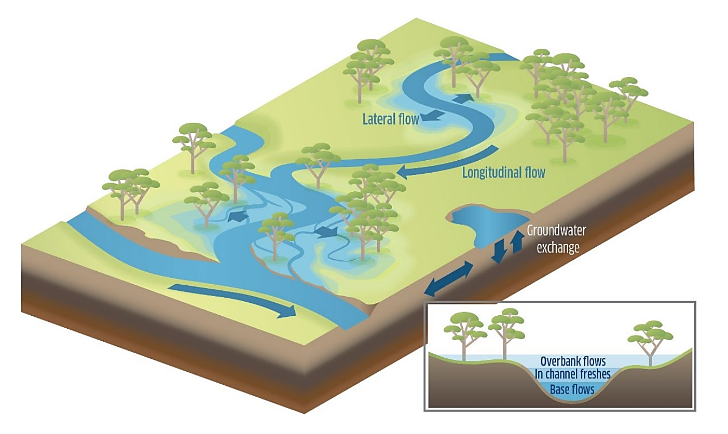
Figure 55. Hydrological connectivity and flows (MDBA, 2014).
As part of these management activities, consideration should also be given to the requirements for timing of flow events. With many native fish species currently understood to have temperature cues for spawning, the impacts of cold-water pollution should be considered when delivering flows as cold-water releases may interrupt natural temperature cues for movement and spawning. This does not directly impact the project area as cold-water pollution is diluted by the time it reaches this area, however the impacts on populations upstream needs to be considered. Where possible, supplementing natural flows can increase inundation of habitat features and mitigate impacts of cold-water pollution by dissipating the temperature variation of the water being released.
All EWRs described below have been set at Tara and Mogil Mogil gauges due to the significant influence of weir pools in other reaches. The potential for large natural events or delivery down the Mehi River have resulted in the inclusion of gauges up and downstream.
Enhanced in-channel specialists spawning
Ecological objective
Provide flow regimes that enhance spawning opportunities for in-channel specialist native fish species, focussing on Murray cod and freshwater catfish.
Improve the inundation and availability of key habitat features along the Barwon River for in-channel specialists (flow dependent – Murray cod), particularly LWH and root balls.
Improve the inundation and availability of key habitat features along the Barwon River for in-channel specialists (flow independent – freshwater catfish), particularly benches/cobble bed, and wetland entry points.
Improve the longitudinal connectivity along the Barwon River, enhancing localised movement opportunities for native fish.

Environmental water requirement
A stable flow event of 1,360 ML/day at Mogil Mogil and 1,780 ML/day at Tara for a minimum of 20 consecutive days (or ideally >20 days) from August to November, preferably every year but can be every second year, with a maximum inter-flow period of two years to enhance spawning outcomes for in-channel specialists (flow dependent – Murray cod) species. The effectiveness of outcomes may be compromised, with a timing shift from September to March enhancing spawning outcomes for in-channel specialists (flow independent – freshwater catfish) species. The duration and frequency should still be maintained. A slow recession should be maintained to avoid stranding nests and nest abandonment.
Site specific flow indicators
This magnitude of flow at Mogil Mogil Gauge would drown out Presbury Weir (provided there is >1,250 ML/day flow at the weir) providing fish passage past this structure. Habitat feature inundate would increase with over 55.6% of LWH and 20% of benches and 21.7% of wetland entry points becoming inundated. This magnitude flow at Tara gauge would inundate over 90% of LWH, 95.4% of benches and 70.4% of wetland entry points.
Rationale
Small in-channel pulse events at the Mogil Mogil and Tara gauges would provide benefits for all functional groups of fish through improved habitat availability. Flows of 1,780 ML/day at Tara, which are targeted for enhancing spawning outcomes for Murray cod, would inundate a significant proportion of habitat features thought to be related to spawning outcomes for these species, including 90% of LWH. Research throughout parts of the Murray cod’s range has suggested a strong association between the species and complex woody habitat (Koehn and Nicol, 2014). With the increase in availability of these habitats from this higher flow target there would be more opportunities for spawning.
This flow target would also have significant benefits for freshwater catfish with over 95% of benches becoming inundated, which could result increased availability of breeding sites and nesting materials (gravel and cobbles).
The availability of these core habitat features provided by the small pulse events would allow regular maintenance and condition opportunities for all fish communities, as well as opportunities for short to moderate movements in the system through improved longitudinal connectivity. The proposed frequency of the events is especially important for short-lived fish, including those described as stable low flow spawning fish (SLFSF) by Kerr et al. (2017), as they need regular flow events to complete important life-cycle stages.
The minimum duration of 20 days is linked to pre-development natural hydrological patterns and the hatch time for eggs of the target species to ensure a stable flow when eggs are on the nest, with rapid changes in height and flow rate, either up or down, to be avoided to maximise spawning outcomes. The minimum of 20 days allows for sufficient time for in-channel specialists (Murray cod) to select a nest, spawn, allow time for the eggs to develop and larvae to disperse (NSW DPI, 2015b).The ideal length of this event is >20 days with the main outcome for the event being regular access to spawning habitat and movement opportunities for spawning outcomes, and it is therefore considered appropriate for the event to occur during the prescribed spawning window for target species.
Held environmental water delivered from Glenlyon, Pindari and/or Copeton dams could be used to shape the hydrograph adding to natural flow to reach the threshold or providing a stable recession while not impacting on water temperature. To maximise environmental outcomes, the held environmental water component of these types of flows would have to be actively managed once it leaves the regulated water sharing plan area from which it was delivered. Active management allows protection of held environmental water from extraction after it leaves the regulated system where it was delivered (DPIE, 2019b). Held environmental water was actively managed in 2019 for the Northern Fish Flow, which consisted of held environmental water being delivered from the Border Rivers out of Glenlyon Dam and the Gwydir system out of Copeton Dam, the flows travelled down these systems before connecting with the Barwon River (CEWO, 2019b).
Enhanced native fish condition, movement and recruitment
Ecological objective
Provide flow regimes that enhance system productivity and recruitment outcomes for native fish, including in-channel specialist species, focussing on Murray cod (flow dependent), generalist species, flow specialists and floodplain specialists.
Improve the inundation and availability of key habitat features that contribute to productivity outcomes along the Barwon River, particularly benches, and wetland entry points.
Improve the longitudinal connectivity along the Barwon River, enhancing localised pre and/or post spawning movement opportunities for native fish.
Can promote spawning in flow dependent species such as golden perch and endangered silver perch (Ellis et al. 2016).
Environmental water requirement
Optimum flow event of 3,180 ML/day at Mogil Mogil and 2,140 at Tara Gauge for a minimum of five consecutive days from anytime of year, preferably every year but can be every second year, with a maximum inter-flow period of two years. A large pulse before the spawning flow would prime the system increasing productivity, fish condition and provide opportunities to move to preferred spawning habitat. Post spawning large pulse events increase productivity providing increased food availability for larval fish. The increase in flow also improves conditions for larval drift. The flow target could be adjusted to a minimum of 2,650 ML/day at Mogil Mogil and 1,050 ML/day at Tara gauge while still achieving some of the objectives under resource constrained conditions, although the effectiveness of outcomes may be compromised. Ideally these large pulse events would occur before and after the in-channel specialist spawning flows.
Site specific flow indicators
A flow of the ideal flow magnitude proposed above at Mogil Mogil would drown out Mungindi and Presbury weirs providing fish passage past these structures. Habitat feature inundation would increase with over 64% of LWH, 52% of benches and 26% of wetland entry points in the management reach becoming inundated A flow of the above proposed ideal magnitude at Tara would inundate 92.1% of LWH, 97.5% of benches and 85.2% of wetland entry points.
A flow of the reduced magnitude proposed above at Mogil Mogil would still drownout Mugindi and Presbury weirs. The reduced flow magnitude at Mogil Mogil would inundate 62.3% of LWH, 36.1% of bench area and 23% of wetland entry points. At Tara the reduced flow magnitude would inundate 83% of LWH, 90.6% of bench area and 48.1% of wetland entry points.
Rationale
Large in-channel pulse events at the Mogil Mogil and Tara gauges would provide benefits for all functional groups of fish through improved habitat availability and system productivity. In particular, flows of 3,180 ML/day at Mogil Mogil would drownout Mungindi and Presbury weirs providing improved longitudinal connectivity. Flows of 2,140 ML/day at Tara would inundate a high portion (>80%) of all habitat features. The reduced flow targets could provide some similar outcomes, but the effectiveness may be compromised.

The availability of these core habitat features provided by the large pulse event would also improve the condition of emergent aquatic macrophytes such as cumbungi, phragmites and juncus/sedge, helping contribute to regular maintenance and condition opportunities for all fish communities, as well as opportunities for short to moderate movements in the system through improved longitudinal connectivity. The proposed frequency of the events is especially important for short-lived fish, including those described as SLFSF species by Kerr et al. (2017), as they need regular flow events to complete important life-cycle stages.
A large portion of the in-channel food resources in lowland river systems comes from organic material on the floodplain (Vannote et al. 1980; Oliver and Merrick, 2006). Inundating areas out of the main channel increases availability of these resources and increases in channel productivity while increasing the condition and growing area for macrophytes. Inundation of benches mobilises carbon which stimulates river productivity. Wetland inundation provides a stimulus for plant germination and the emergence of invertebrates from resting life stages, many of which can become abundant within days of inundation (Kerr et al. 2017).
Although not the primary environmental objective, these flows may also provide some opportunities for spawning and recruitment outcomes for generalists, flow dependent specialists, in-channel specialists and floodplain specialists that are more opportunistic and quicker to respond to the shorter duration event. Species that might respond include bony bream, golden perch, spangled perch and the threatened silver perch and olive perchlet.
The proposed duration of five days can be adjusted as needed, depending on hydrological and antecedent conditions. The duration aligns with the pre development duration for these magnitude flows at Walgett as assessed in the Northern Basin Fish and Flows project (NSW DPI, 2015). Flow duration is directly linked to productivity with diversity of instream communities decreasing with decreased floodplain inundation (Zeiringer et al. 2018). Due to the lowland nature of the project area flows generally consist of a more gradual rise and fall than systems in the slopes upland areas, as a result fish species in this area are adapted to these types of events. Events of a shorter duration provide limited time for fish to move but may provide a window of time when passing a particular barrier is possible or provide an opportunity to move to a more substantial refuge pool. Ideally this flow would occur leading up to and following the instream specialist spawning flow. Very low flow and cease to flow events should be avoided between these events where possible to maintain connection through the system and support native fish recruitment.
This flow can be used to prime the system for spawning events when delivered in late winter to early spring or can be used to increase food availability and connectivity for larval and juvenile fish in mid-summer to mid-autumn. Late winter/early spring flows are intended primarily to support pre-spawning conditioning for all functional groups through inundation of in-channel benches and aquatic habitat. Mid-summer to autumn peaks are intended to provide inundation of in-channel benches and habitat to increase productivity and support larval and juvenile drift.
The main outcomes for this EWR recruitment, productivity, and movement opportunities for dispersal, and it is therefore considered appropriate for the event to occur during the pre and post-spawning timeframes for the majority of species, taking into consideration any water quality issues such as water temperature.

Refuge replenishment and connection
Ecological objective
The ecological objective of this flow is to maintain critical water quality and quantity in refuge pools to avoid fish kills during sustained dry periods. This will also provide intermittent connection between refuge habitats. Maintaining refugia allows key ecosystem functions including cycling of nutrients and provision of carbon for productive food webs (MDBA, 2018).
Environmental water requirement
There is no recommended flow for this EWR as it varies depending on the nature of the dry event. In some cases, water may have to be delivered at a low rate at the start of the flow to avoid adverse impacts to water quality in refuge pools when rerunning the river. This event is delivered during critical dry periods to replenish refuge pools and provide a short period of connectivity between habitats. Natural flows can be supplemented to more efficiently achieve lateral connection.
In the absence of natural events, this flow can be delivered from regulated tributaries of the Barwon Darling. Events similar to this have been delivered in 2018 and 2019. The longer the period of zero flow the greater the reduction in flow between gauges, meaning earlier delivery would be more efficient.
Magnitude will depend on the amount of time and length of channel that has been dry. Extended dry periods will require more water to ‘restart’ the river with water infiltrating into the soil and ground water aquifers. This will require further analysis of environmental flows in 2018 and 2019 to establish the reductions in flows that occurred between gauges for different periods of drying. This could then be used to inform future delivery.
Site specific flow indicators
Replenishment and connection of refuge pools. Distance of river to be reconnected will depend on the nature of the drying event and in flows, or lack of, from tributaries.
Large fresh events for flow dependent specialists
Ecological objective
Maintain large pulse events for spawning and recruitment of flow dependent specialists. This flow provides significant longitudinal connection and provide an increased level of lateral connection inundating some wetland entry points and low-level floodplains providing spawning and recruitment opportunities for some floodplain specialists.
Environmental water requirement
This flow would generally not require delivery but protection of the integrity of natural events within the flow class. Natural flow events could be supplemented with held environmental water from tributaries. This is particularly important after long periods of no flow or extended period with no large pulses.
A large pulse event peaking at 8,180 ML/day at Mogil Mogil and 6,500 ML/day at Tara gauge for a minimum of 20 consecutive days from September to March, preferably every year but can be every second year, with a maximum inter-flow period of two years to enhance migration, spawning and recruitment outcomes for flow specialists and floodplain specialists.

The flow target could be adjusted to a minimum of 3,700 ML/day @Tara while still achieving some of the objectives, although the effectiveness of outcomes may be compromised, with a timing shift from September to March enhancing spawning outcomes for in-channel specialists (flow independent – freshwater catfish) species. The duration and frequency should still be maintained.
Supplementing natural flows to reach heights of a sufficient magnitude is problematic as infrastructure becomes inundated and other third-party impacts become apparent. Complementary water delivery actions for floodplain specialists may be needed in some situations. In the absence of overbank flows, delivery of water to replenish floodplain wetlands may be required via pumping from the main channel do avoid drying of these habitats and subsequent localised extinctions. The floodplain specialist species, olive perchlet, has been found in the project area, and is of particular conservation significance, with protection of their population a priority.
Site specific flow indicators
This magnitude of flow at Mogil Mogil gauge would drown out Munginidi, Comilaroi and Presbury weirs providing fish passage past these structures. Habitat feature inundation would increase with over 90% of LWH and benches and 85% of wetland entry points becoming inundated. This magnitude of flow at Tara gauge would drown out Banaraway Weir providing fish passage past this structure and inundation of 100% of habitat features recorded in that area.
Maintain integrity of bankfull and overbank flows for flow dependent specialist and floodplain specialists
There is minimal potential for the CEWO to impact on this flow class. However, protection should be advocated with other water management agencies to maintain its integrity in areas with connection points to significant wetland areas. Establishing at what height significant wetland areas become inundated would be very valuable. This would require further analysis of where the connection points lead too, potential methods are further discussed in the following section. The protection, monitoring and management of these events is not considered to be the responsibility of the CEWO, however is a responsibility of a number of inter disciplinary agencies.
The occurrence interval for these events varies significantly for the target species, longer lived flow dependent specialist species such as golden perch and silver perch do not require as frequent recurrence intervals as short-lived floodplain specialist species such as olive perchlet that can suffer localised extinctions if these events do not occur for an extended period of time.
Activities to address the lack of natural inundation of off stream wetlands may need to be considered in some areas. This could be done by pumping water from the main channel, a method which has been used in areas of the Southern Basin at a number of scales with varying levels of success (see VEWH, 2019; NSW DPIE-EES, 2019).

Recommendations for future management in the Barwon River
The Barwon River habitat mapping project has considerably advanced information and thinking for water management in the Barwon River related to fish and river outcomes and enhanced the existing information for the already mapped stretch of the Barwon Darling from Walgett to Wilcannia. However, knowledge gaps still exist that require attention to enhance the development of future environmental water requirements. The outcomes of water management in the Barwon River would be greatly enhanced by the development and implementation of complementary aquatic habitat rehabilitation and adaptive monitoring programs. The recommendations outlined in the section below are the views of the DPIE Fisheries and are not considered to be the sole responsibility of the CEWO but may be supported or progressed with other State and Federal government agencies.
Management Actions
To improve native fish populations and river health in the Barwon River and throughout the Border Rivers, future management of water for the environment should consider management actions including:

Developing a fish management strategy for the Barwon River Catchment
In addition to addressing key knowledge gaps related to water for the environment it is also important to acknowledge that flow management actions in isolation may not achieve the desired objectives and outcomes for river health and native fish populations in the Barwon River. The critical riverine components of habitat and connectivity will also need to be considered in management planning and implementation, and whilst aspects of these components are integrated with flow management, additional complementary actions will also be needed to achieve the most effective and efficient outcomes.
These actions should include targeted habitat rehabilitation such as riparian management, including native revegetation, aquatic planting, and weed control; re-snagging; erosion control; fish passage/connectivity remediation; reducing the impact of extraction through offtakes on fish; and; alien fish management. The development of reach scale plans would benefit from and be guided by fine-scale habitat mapping activities, which would also collect information on the condition of aquatic and riparian habitat and provide a prioritised and coordinated strategy that maximises water management for improved river health.
The habitat mapping data can be used to provide direction on how to proceed with aquatic habitat restoration and protection initiatives. This information can be used by natural resource managers to prioritise areas for action increasing the benefits of environmental flow deliveries in the project area. For example, habitat mapping data could be used to improve the condition of riparian vegetation by showing where there are significant weed issues and where there is revegetation of native riparian species, allowing natural resource managers to make more informed decision when directing their resources.
The Barwon River is at the whim of upstream catchments. The conservation and enhancement of these areas would have significance benefits to the fish communities of the main channel Barwon River. Unimpeded access to these catchments and their diverse habitats is essential to the recovery of native fish population in the Barwon Darling, making fish passage the highest priority for complementary actions in the project area.
The development of a fish management strategy for the Barwon River catchment would also need to consider and manage for potential negative impacts associated with managing water for the environment. In the Barwon River catchment this may include the proliferation of alien fish species and the occurrence of water quality impacts such as black water events. black water events are intensified when periods of drought are punctuated by floodplain inundating flows that return organic matter to the river channel. Using relevant flow related information of all fish species to form functional groups and develop flow regimes will ensure that the effects of both alien and native fish are considered, allowing water requirements to be developed that do not provide an unnecessary advantage to alien fish over native fish.

Due to the distance of the Barwon River from any large storages, there is no direct impact from thermal pollution on fish populations in the project area, however this is a consideration for upstream reaches (Dumaresq and Severn Rivers) where fish may be impacted by releases of cold water from flows being delivered to the project area. The impacts of cold-water pollution are exacerbated downstream of major impoundments when water is delivered during warmer periods, with cold water releases from the bottom of dams severely reducing the natural warmer water temperatures. This is a factor requiring careful consideration when delivering replenishment flows during spring and summer when a number of species prefer to spawn.

Coupling flows with connectivity
Increasing connectivity between Mungindi and Walgett, as well as into tributaries coupled with targeted flow events would have a significant benefit for native fish. Addressing fish passage at barriers in the project area by providing or supplementing flows to drown out lower structures (Mungindi, Comilaroi, Presbury and Banaraway weirs) and constructing fishways on larger structures would improve the resilience of the fish community in the area.

Continued and sustained cross-disciplinary and inter-jurisdictional collaboration on information and knowledge of ecological relationships in the Barwon River and adjoining catchments
Current activities across the Murray-Darling Basin related to water management provide opportunities to effectively establish and foster linkages between relevant community, academic and government experts. The Mapping the Barwon project gathered a range of relevant knowledge, expertise and information related to fish and flow relationships in the Barwon River. While much of this information is readily accessible, other material occurs in variable formats and is held by a number of different institutions and agencies.
To support the proposed long-term adaptive management plan and Barwon River fish management strategy, it would also be useful to review existing management and research needs, including data sharing arrangements and management actions relating to fish and flow information in the Barwon River. This could form the basis of a formal water management group for the Barwon River, promoting a collaborative and open approach to management of existing and future watering activities, including a shared commitment to identifying and addressing knowledge gaps.
Research and Monitoring
To improve native fish populations and river health in the Barwon River and throughout the Border Rivers, future management of water for the environment should consider research and monitoring options such as:

Undertaking further habitat mapping to connect mapped areas in the Border Rivers, Gwydir and Barwon Darling River and secure additional data source
Significant gaps still exist in our understanding of habitat features and their relationship to river flow across the Northern Basin. Complementing the habitat mapping database from this project a previous project completed on the Dumaresq and Barwon/Darling Rivers and projects completed on the Gwydir and Mehi with further mapping on the Macintyre River downstream of the Dumaresq River confluence, the Severn River downstream of Pindari and the remainder of the Mehi could connected the data sets. This information, coupled with fish community details and water management activities, would allow critical flow thresholds to be identified in relation to inundation values, structure drown out requirements, and bankfull capacity volumes, helping to develop specific water requirements and strengthen water management actions from Roseneath on the Dumaresq River and start of the Mehi River to Wilcannia on the Darling River.
Priority reaches:
  - Severn River - Pindari Dam to the Dumaresq River confluence (~180 km)
  - Macintyre River - Dumaresq River confluence to Mungindi (~340 km)
  - Mehi River - Gundare to Barwon River (~235 km)
To complement habitat mapping data, LiDAR could be used to assess wetland area associated with entry points. This would allow a wetland area to be attached to each entry/exit point recorded during on ground mapping. Further analysis could also be complete of these wetlands using satellite imagery to map vegetation extent.

Committing to a long-term, adaptive management plan driven by monitoring and evaluation
The hydrological and hydraulic variation required to restore key elements for fish in the Barwon River will differ across functional groups, and whilst some benefits will be experienced cross groups from different flow regimes, a long-term commitment to adaptive management to flow and aquatic habitat management is required to maximise outcomes. Management plans that consider flow, habitat and connectivity need to include objectives for each functional group to ensure benefits are experienced across all native fish communities over relevant spatial and temporal scales. The development and implementation of a rigorous monitoring program is essential to help validate program assumptions and measure the success of flow delivery/protection and water requirements against the program objectives.
Information about the use of habitat by fish and their response to certain flow delivery scenarios will allow management plans to be evaluated and flow hydrographs to be adapted to ensure that outcomes are optimised, whilst providing confidence in stakeholders that decision making is being informed by biological information. It is important to establish long-term monitoring in project area that can supplement other monitoring programs in tributaries and downstream in the Darling River. This will ensure that outcomes from managing water for the environment across a range of different valley types are captured and used to guide management decisions. In addition to this, it is essential that monitoring information and research outcomes are communicated and readily accessible to advance knowledge and management actions across related systems where applicable.

Conclusion
The Mapping the Barwon project has improved the understanding of habitat inundation and the implications for environmental water requirements for the fish functional groups in the Barwon River. Prioritised reach scale assessment for the Barwon River has helped describe flow related attributes of the area, including hydrological conditions, fish barriers and connectivity issues, aquatic habitat condition, and fish community status, improving and consolidating the understanding of hydrological and ecological information for the system.
The degradation of key habitat features on the Barwon River has been exacerbated by the modification of natural flows, having a significant effect on the status of native fish populations in the system. A large portion of the fish community in the Barwon River is in a moderate to good condition similar to the rest of the Barwon Darling. The identification of the areas, in a moderate condition, presents excellent potential for population recovery if management decisions are developed and implemented based on best available science in a holistic adaptive framework.
Upstream river regulation and extraction in the project area has had a significant impact on the natural flow regime in the Barwon River, with major storages Glenlyon and Pindari dams reducing flows entering from the Macintyre. Copeton Dam has reduced flows in the Gywdir and subsequently connection events however alteration of the entry to the Mehi has meant increased connection events from this system (DECCW, 2011). Keepit Dam reduces flows entering the just upstream of Walgett Weir from the Namoi River. The structures mentioned above, as well as extraction have impacted the frequency, duration and magnitude of flow events in the Barwon River, influencing the hydrological, hydraulic and ecological conditions that native aquatic biota.
The habitat data recorded during habitat mapping can be used by natural resource managers and landholders to direct resources for protection and rehabilitation of riparian and instream habitats. These actions can complement the benefits from the management of water for the environment, providing a greater benefit to the fish communities in the project area. The dataset may also have potential benefits for land managers with information on erosion, areas of stock damage, weeds and other features that may be of interest.
Information from the Fish and Flows in the Northern Basin project (NSW DPI, 2015b) and review of the most current literature has helped to refine fish functional groups specific to conditions of the Barwon River based on biological, hydrological and hydraulic similarities related to spawning, recruitment and movement. The formation of fish functional groups for the Barwon has enabled overarching conceptual flow models to be developed that identify the importance of certain flow characteristics and hydrological variability for groups of species. This information can be used to guide the development of the environmental watering requirements that can be used by water managers to improve outcomes for certain species in certain functional groups. The information will also guide management of water for the environment for a system over long-term planning frameworks to maximise water use and environmental benefits.

References
Barrett, J. (Ed.). (2008). The Sea to Hume Dam: Restoring Fish Passage in the Murray River. Murray-Darling Basin Commission, Canberra.
Baumgartner, L., Conallin, J., Campbell, B., Gee, R., Robinson, W. and Mallen-Cooper, M. (2013). Using Flow Guilds of Freshwater Fish in an Adaptive Management Framework to Simplify Environmental Flow Delivery for Semi-Arid Riverine Systems. Fish and Fisheries. 15: 410-427.
Beesley, L., King, A., Amstaetter, F., Koehn, J., Gawne, B., Price, A., Nielson, D., Vilizzi, D. and Meredith, S. (2012). Does Flooding affect Spatiotemporal Variation of Fish Assemblages in Temperate Floodplain Wetlands? Freshwater Biology. 57, 2230-2246.
Bioregional Assessments. (2019). Surface Waters Systems: Condamine-Balonne River Basin. https://www.bioregionalassessments.gov.au/assessments/11-context-statement-maranoa-balonne-condamine-subregion/1151-surface-water-systems
Bureau of Meteorology. (2018). Climate Statistics for Australia: Summary Statistics Mungindi Post Office. http://www.bom.gov.au/climate/averages/tables/cw_052020.shtml
Boys, C. (2007). Fish-habitat Associations in a Large Dryland River of the Murray-Darling Basin, Australia. PhD Thesis, University of Canberra, Canberra. 320 pp
Boys, C. and Rayner, T. (2017). Pump and Diversion Screening: The Sleeping Giant of Australian River Restoration. Proceedings of the Murray Darling Basin Native Fish Forum 2017.
Boys, C., Esslemont, G. and Thoms, M. (2005). Fish Habitat Assessment and Protection in the Barwon-Darling and Paroo Rivers. NSW Department of Primary Industries. Nelson Bay, NSW, Australia.
Brooks, A., Gehrke, P., Jansen, J. and Abbe, T. (2004). Experimental Reintroduction of Woody Debris on the Williams River, NSW: Geomorphic and Ecological Responses. River Research and Applications. 20, 513-536.
Bunn, S. and Arthington, A. (2002). Basic Principles and Ecological Consequences of Altered Flow Regimes for Aquatic Biodiversity. Environmental Management. 30: 492- 507.
Butcher, A. (2007). Characteristics of Fish Fauna of the Macintyre and Dumaresq Rivers and Macintyre Brook. A Report to the Queensland Murray-Darling Committee.
Casatti, L., Mendes, H. and Ferreira, K. (2003). Aquatic Macrophytes as Feeding Sites for Small Fishes in the Rosana Reservoir, Paranapanema River, South-eastern Brazil. Brazilian Journal of Biology. 63, 213- 222.
Crown Lands and Water Division. (2017). Barwon-Darling Water Resource Plan: Surface Water Resource Description. https://www.industry.nsw.gov.au/__data/assets/pdf_file/0010/152938/Barwon-Darling.pdf
Commonwealth Environmental Water Office. (2016). Restoring and Protecting the Unregulated Rivers of the Northern Basin 2016-17.
https://www.environment.gov.au/water/cewo/publications/restoring-protecting-northern-basin-2016-17
Commonwealth Environmental Water Office. (2019a). Environmental Water Holdings. http://www.environment.gov.au/water/cewo/about/water-holdings
Commonwealth Environmental Water Office. (2019b). Northern Fish Flow – Factsheet. https://www.environment.gov.au/water/cewo/publications/northern-fish-flow-fact-sheet
Crook, D. and Robertson, A. (1999). Relationships Between Riverine Fish and Woody Debris: Implications for Lowland Rivers. Marine and Freshwater Research. 50, 941-953.
Davies, P.E., Stewardson, M.J., Hillman, T.J., Roberts, J.R. and Thoms, M.C. (2012). Sustainable Rivers Audit 2: The Ecological Health of the Rivers in the Murray-Darling Basin at the end of the Millenium Drought (2008–10). Prepared by the Independent Sustainable Rivers Audit Group for the Murray-Darling Basin (ISRAG). MDBA Publication No. 72/12. Murray Darling Basin Authority, Canberra.
Department of Environment, Climate Change and Water. (2011). Gwydir Wetlands Adaptive Environmental Management Plan: Synthesis of Information Projects and Actions. Department of Environment, Climate Change and Water NSW. DECCW 2011/0027.
Department of Natural Resource, Mines and Energy. (2018). Stable Low-flow Spawning Fish: Phase II: Assessment of spawning habitat and establishment of lower threshold for stable low-flows in the Condamine-Balonne and Border Rivers WP areas. State of Queensland, Toowoomba.
Department of Planning, Industry and Environment. (2019). Barwon-Darling Long Term Water Plan Part A Draft for exhibition
Delariva, R., Agostinho, A., Nakatani, K. and Baumgartner, G. (1994). Ichthyofauna Associated to Aquatic Macrophytes in the Upper Paraná River Floodplain. Rev. Unimar, 16, 41-60.
Dyer, F., Thoms, M. and Olley, J. (2002). The Structure, Function and Management Implications of Fluvial Sedimentary Systems. International Association Hydrological Sciences Press. Centre for Ecology and Hydrology, Wallingford, Oxfordshire, UK.
Ebner, B., Scholz, O. and Gawne, B. (2009). Golden Perch Macquaria ambigua are Flexible Spawners in the Darling River, Australia. New Zealand Journal of Marine and Freshwater Research. 43, 571-578.
Ellis, I., Cheshire, K., Townsend, A., Copeland, C. Danaher, K. and Webb, L. (2016). Fish and Flows in the Murray River Catchment - A Review of Environmental Water Requirements for Native Fish in the Murray River Catchment. NSW Department of Primary Industries, Queanbeyan.
Fairfull S. and Witheridge, G. (2003). Why do Fish Need to Cross the Road? Fish Passage Requirements for Waterway Crossings. NSW Fisheries, Cronulla, 16pp.
Fisheries Scientific Committee. (2000). Fisheries Scientific Committee Final Determination: Silver Perch. NSW Fisheries, Pyrmont.
Foster, N. and Cooke, R. (2011). Barwon-Darling IQQM Analysis – Critical Flow Thresholds for Environmental Values Identified within the Barwon-Darling Water Sharing Plan. NSW Department of Primary Industries, Tamworth.
Gaillard, J., Coulson, T. and Festa-Bianchet, M. (2008). Recruitment. In Encyclopedia of Ecology. Elsevier, Amsterdam, The Netherlands.
Gippel, C. (1995). Environmental Hydraulics of Large Woody Debris in Streams and Rivers. Journal of Environmental Engineering. 121, 388-395.
Gippel, C.J. (2013). Assessment of the hydraulics of the Little Murray River Weir Pool under alternative operating scenarios. Fluvial Systems Pty Ltd, Stockton. Goulburn-Murray Water, Shepparton, January.
Gorski, K., Buijse, A., Winter, H. and Nagelkerke, L. (2013). Geomorphology and Flooding Shape Fish Distribution in a Large- Scale Temperate Floodplain. River Research and Applications. 29. 1226-1236
Humphries, P., King, A. and Koehn, J. (1999). Fish, Flows and Floodplains: Links between Freshwater Fishes and Their Environment in the Murray-Darling River System, Australia. Environmental Biology of Fishes. 56, 129-151.
Humphries, P. and Walker, K. (2013). Ecology of Australian Freshwater Fish. CSIRO Publishing, Collingwood, Victoria, Australia.
Industry and Investment NSW. (2010). Road Crossing Barrier Summaries, Little River Sub Catchment. Prepared for the Central West Catchment Management Authority. Industry and Investment NSW, Dubbo, NSW.
Jenkins, K. and Boulton, A. (2003) Connectivity in a Dryland River: Short-term Aquatic Macroinvertebrate Recruitment Following Floodplain Inundation. Ecology. 84. 27m08-2723.
Jones, H. (2007). The Influence of Hydrology on Freshwater Mussel (Bivalvia: Hyriidae) Distributions in a Semi-Arid River System, the Barwon-Darling River and Intersecting Streams. In Dickman, C., Lunney, D. and Burgin, S. (eds). (2007). Animals of Arid Australia – Out on Their Own? Royal Zoological Society of New South Wales, Mosman, New South Wales.
Kerr, J., Prior, A. and Fawcett, J. (2017). Stable Low-flow Spawning Fish – Assessment of Generic Model Parameters used to Assess Risk to Stable Low-flow Spawning Fish Species in Condamine-Balonne, Border Rivers and Moonie Water Resource Plans. Department of Natural Resources and Mines, Toowoomba.
Koehn, J. (2009). Multi-scale Habitat Selection by Murray Cod Maccullochella Peeli Peeli in Two Lowland Rivers. Journal of Fish Biology. 75, 113-129.
Koehn, J. and Nichol, S. (2014). Comparative Habitat use by Large Riverine Fishes. Marine and Freshwater Research. 65, 164-174.
Lake, P. (1995). Of Floods and Droughts: River and Stream Ecosystems of Australia. In Cushing, E., Cummins, K. and Minshall, G. E. (eds). River and Stream Ecosystems. p. 659-94. Elsevier, New York.
Lintermans, M. (2009). Fishes of the Murray-Darling Basin: An Introductory Guide. Murray Darling Basin Authority, Canberra.
Lucas, M. and Baras, E. (2000). Methods for Studying Spatial Behaviour of Freshwater Fishes in the Natural Environment. Fish and Fisheries. 1, 283-316.
Mallen-Cooper, M. and Zampatti, B. (2015). Background Paper: Use of Life History Conceptual Models of Fish in Flow Management in the Murray-Darling Basin. Murray-Darling Basin Authority, Canberra.
Marshall, J., Menke, N., Crook, D., Lobegeiger, J., Balcombe, S., Huey, J., Fawcett, J., Bond, N., Starkey, A., Sternberg, D., Linke, S., and Arthington, A. (2016). Go with the flow: the movement behaviour of fish from isolated waterhole refugia during connection flow events in an intermittent dryland river. Freshwater Biology. doi:10.1111/fwb.12707.
Moffat, D. and Voller, J. (2002). Fish and Fish Habitat of the Queensland Murray-Darling Basin. Department of Primary Industries, 98pp.
Murray-Darling Basin Authority (2019). Geographic profil maps for basin catchments: Barwon-Darling. Murray-Darling Basin Authority, Canberra. https://www.mdba.gov.au/publications/mdba-reports/geographic-profile-maps-basin-catchments
Murray-Darling Basin Authority (2012). Assessment of Environmental Water Requirements for the proposed Basin Plan: Barwon-Darling River upstream of Menindee Lakes. Murray-Darling Basin Authority, Canberra.
Murray-Darling Basin Authority. (2014). Basin-wide Environmental Watering Strategy. Murray–Darling Basin Authority, Canberra.
Murray-Darling Basin Authority. (2015). Barwon-Darling. Murray-Darling Basin Authority, Canberra. http://www.mdba.gov.au/about-basin/how-river-runs/barwon-darling-catchment
Murray-Darling Basin Authority. (2016). Northern Basin Review: Understanding the Economic, Social and Environmental Outcomes from Water Recovery in the Northern Basin. https://www.mdba.gov.au/sites/default/files/pubs/Northern-basin-review-report-FINAL.pdf
Murray-Darling Basin Authority. (2018). Ecological Needs of Low Flows in the Baron-Darling. Technical Report. Murray-Darling Basin Authority, Canberra. https://www.mdba.gov.au/sites/default/files/pubs/ecological-needs-low-flows-barwon-darling.pdf
Murray-Darling Basin Authority. (2019). Barwon-Darling.
https://www.mdba.gov.au/discover-basin/catchments/barwon-darling
Norris, A. (2015). Fish loss via irrigation offtake in the Condamine Catchment. Department of Agriculture and Fisheries.
NSW Department of Planning, Industry and Environment. (2019a). Barwon-Darling Long-Term Watering Plan Part A. https://www.environment.nsw.gov.au/-/media/OEH/Corporate-Site/Documents/Water/Water-for-the-environment/barwon-darling-long-term-water-plan-part-a-190478.pdf. NSW Department of Planning, Industry and Environment, Sydney.
NSW Department of Planning, Industry and Environment. (2019b). Barwon-Darling Watercourse Water Resource Plan. INT19/141942
NSW Department of Planning, Industry and Environment – Environment, Energy and Science (2019). Private Wetland Watering in the Murray Valley. https://www.environment.nsw.gov.au/topics/water/water-for-the-environment/murray-and-lower-darling/private-wetland-watering
NSW Department of Planning Industry and Environment – Water. (2020). Environmental Water Register. https://ewp.water.dpi.nsw.gov.au/ewr/main/erShSearchEWL
NSW Department of Primary Industries. (2006). Reducing the Impacts of Weirs on Aquatic Habitat – New South Wales Detailed Weir Review. Western CMA region. Report to the New South Wales Environmental Trust. NSW Department of Primary Industries, Flemington, NSW.
NSW Department of Primary Industries. (2007). Endangered Ecological Communities in NSW – Lowland Darling River Aquatic Ecological Community. Primefact 173.NSW DPI. https://www.dpi.nsw.gov.au/__data/assets/pdf_file/0003/634557/Lowland-Darling-River-aquatic-ecological-community.pdf
NSW Department of Primary Industries. (2013a). ‘Flow for Fish Recruitment in the Barwon-Darling River’. Unpublished Final Report prepared for the Murray-Darling Basin Authority, NSW Department of Primary Industries, Armidale.
NSW Department of Primary Industries (2013b). Bringing Back the Fish on the Horton. Final Report prepared for the Border Rivers Gwydir Catchment Management Authority. NSW Department of Primary Industries, Dubbo.
NSW Department of Primary Industries. (2014a) Prime Fact: Olive Perchlet (Western Population) – Ambassis agassizi. http://www.dpi.nsw.gov.au/__data/assets/pdf_file/0003/426594/PUB12-10-Primefact-176-Western-Olive-Perchlet-Ambassis-agassizii.pdf
NSW Department of Primary Industries. (2014b). Protecting the Purple Patch - Investment Recommendations for Buckinbah and Hanover Creeks. Habitat mapping and prioritisation report prepared for Little River Landcare Group Inc. NSW Department of Primary Industries, Dubbo.
NSW Department of Primary Industries. (2015). Fish and Flows in the Northern Basin: Responses of Fish to Changes in Flow in the Northern Murray-Darling Basin – Reach Scale Report. Final report prepared for the Murray-Darling Basin Authority. NSW Department of Primary Industries, Tamworth.
NSW Department of Primary Industries. (2016). NSW Fish Community Status – final report. NSW Department of Primary Industries. In press Fisheries Final Report Series.
NSW Department of Primary Industries. (2017) a. Barwon-Darling Watercourse Water Resource Plan (Surface Water SW12), Status and Issues Paper
NSW Department of Primary Industries. (2017) b. Improving Fish Habitats. Accessed at http://www.dpi.nsw.gov.au/fishing/habitat/rehabilitating/habitats#Restoring-riparian-vegetation
NSW Department of Primary Industries. (2018) a. Mapping the Dumaresq Aquatic Habitat Mapping to Inform Water Management. Report prepared for the Commonwealth Environmental Water Office. NSW Department of Primary Industries, Dubbo.
NSW Department of Primary Industries. (2018) b. Inundation Heights for Key Habitat Features and Management Recommendations for Cudgegong River Between Windamere Dam and Burrendong Dam Habitat Mapping and Prioritisation. Report prepared for Central Tablelands Local Land Service. NSW Department of Primary Industries, Dubbo
NSW Department of Primary Industries. (2018) c. Primefact: Darling River Snail. https://www.dpi.nsw.gov.au/fishing/threatened-species/what-current/critically/river-snail/river-snail
NSW Department of Primary Industries (2019). NSW Native Fish Drought Response 2019/20. https://www.dpi.nsw.gov.au/__data/assets/pdf_file/0006/1188348/NSW-native-fish-drought-response.pdf
O’Connor, J. (1992). Quantification of Submerged Wood in a Lowland Australian Stream System. Freshwater Biology. 27. 387-395.
O’Connor, J., O’Mahony, D. and O’Mahony, J. (2005) Movement of Macquaria ambigua, in the Murray River, South Eastern Australia. Ecology of Freshwater Fish. 15, 419-427.
O’Connor, J., Mallen-Cooper, M. and Stuart, I. (2015). Performance, Operation and Maintenance Guidelines for Fishways and Fish Passage Works. Arthur Rylah Institute for Environmental Research Technical Report No. 262 for the Water and Catchments Group, Department of Environment, Land, Water and Planning. Arthur Rylah Institute for Environmental Research, Department of Environment, Land, Water and Planning, Heidelberg, Victoria.
Oliver, R. and Merrick, C. (2006). Partitioning of River Metabolism Identifies Phytoplankton as a Major Contributor in the Regulated Murray River (Australia). Freshwater Biology. 51: 1131-1148.
Pethebridge, R., Lugg, A. and Harris, J. (1998). Obstructions to Fish Passage in NSW South Coast Streams. NSW Fisheries, Final Report Series No. 4 for CRC for Freshwater Ecology, NSW Fisheries Research Institute, Cronulla.
Petr, T. (2000). Interactions between Fish and Aquatic Macrophytes in Inland Waters: A Review. FAO Fisheries Technical Paper. Toowoomba Queensland.
Ponder, W., Hallan, A., Shea, M. and Clarke, S. (2016). Australian Freshwater Molluscs. http://keys.lucidcentral.org/keys/v3/freshwater_molluscs/
Reynolds, L. (1983). Migration Patterns of Five Fish Species in the Murray-Darling River System. Australian Journal of Marine and Freshwater Research. 34, 857-871.
Robertson, A.I., Bacon, P. and Heagney, G. (2001) The response of floodplain primary production to flood frequency and timing Journal of Applied Ecology 38: 126-136
Rogers, K. and Ralph, T. (2010) Floodplain Wetland Biota in the Murray Darling Basin Water and Habitat Requirements. CSIRO Publishing, Collingwood, Victoria, Australia.
Rolls, R. and Wilson, G. (2010). Spatial and Temporal Patterns in Fish Assemblages Following an Artificially Extended Floodplain Inundation Event, Northern Murray-Darling Basin, Australia. Environmental Management. 45, 867-880
Rutherford, I., Jerie, K. and Marsh, N. (2000). A Process for Rehabilitating Australian Streams. CD ROM. Cooperative Research Centre for Catchment Hydrology, Land and Water Australia 2000.
Saintilan, N. and Overton, I. (2010). Ecosystem Response Modelling in the Murray Darling Basin. CSIRO Publishing, Collingwood, Victoria, Australia
Sheldon, F. (2017). Characterising the Ecological Effects of Changes in the ‘Low-Flow Hdrology’ of the Barwon-Darling River. Advice to the Commonwealth Environmental Water Office. Griffith University and Commonwealth Environmental Water Office. https://www.environment.gov.au/system/files/resources/bb774e1f-d7fa-4825-8851-cb5e5f1b3f51/files/characterising-eco-effects-changes-low-flow-barwon-darling.pdf
Southwell, M. (2008). Floodplains as Dynamic Mosaics: Sediment and Nutrient Patches in a Large Lowland Riverine Landscape. PhD Thesis, University of Canberra, Canberra, Australia.
Thomaz, S. and Cunha, E. (2010). The Role of Macrophytes in Habitat Structuring in Aquatic Ecosystems: Methods of Measurement, causes and Consequences on Animal Assemblages’ Composition and Biodiversity. Acta Limnologica Brasiliensia. 22 (2).
Thorncraft, G. and Harris, J. (2000). Fish Passage and Fishways in NSW: A Status Report. Cooperative Research Centre for Freshwater Ecology Technical Report 1/2000, Canberra, ACT.
Treadwell, S. (1999). Managing Snags and Large Woody Debris. In Lovett, S. and Price, P. (eds). Riparian Land Management Guidelines: Volume Two: On-ground Management Tools and Techniques. P.15-22. Land and Water Resources Research and Development Corporation, Canberra.
Vannote, R., Minshall, G., Cummins, K., Sedell, J. and Cushing, C. (1980). The River Continuum Concept. Canadian Journal of Fisheries and Aquatic Sciences. 37, 130-137.
Victorian Environmental Water Holder (2019) Hattah Lakes.
http://www.vewh.vic.gov.au/rivers-and-wetlands/northern-region/hattah-lakes. Victorian Environmental Water Holder, Melbourne.
Vietz, G., Rutherford, I., Stewardson, M. and Finlayson, B. (2007). Managing River Flow for Geomorphic Form: Erosion and Accretion of River Benches. 5th Australian Stream Management Conference; Australian rivers: Making a difference. Charles Sturt University.
Wallace, T., Daly, R., Aldridge, K., Cox, J., Gibbs, M., Nicol, J., Oliver, R., Walker, K., Ye, Q, and Zampatti, B. (2014). River Murray Channel: Environmental Water Requirements: Ecological Objectives and Targets. Adelaide, South Australia, Goyder Institute for Water Research.
WaterNSW. (2019). Annual Operations Plan: Barwon-Darling 2019-20. https://www.waternsw.com.au/__data/assets/pdf_file/0010/150013/Barwon-Darling-Annual-Operations-Plan-Water-Year-2019-20.pdf
Western Catchment Management Authority (2009). The Barwon-Darling River Aboriginal life along the River. State of New South Wales through the Western Catchment Management Authority, New South Wales. http://archive.lls.nsw.gov.au/__data/assets/pdf_file/0003/496704/archive-barwon-darling-river-aboriginal-life-along-the-river.pdf
Wrathall, M. (2019). Barwon-Darling and Lower Darling Drought Update. https://www.industry.nsw.gov.au/__data/assets/pdf_file/0007/283273/Barwon-Darling-and-Lower-Darling-Drought-Overview.pdf
Zalewski, M., Thorpe, J. and Naiman, R. (2001). Fish and Riparian Ecotones – A Hypothesis. Ecohydrology and Hydrobiology. 1, 11-24.
Zeiringer, B., Seliger, C., Greimel, F. and Stefan S. (2018). River Hydrology, Flow Alteration, and Environmental Flow. Riverine Ecosystems Management. 8 , 67-89

Appendix

Appendix A: Stream cross sections for the six gauges in the project area
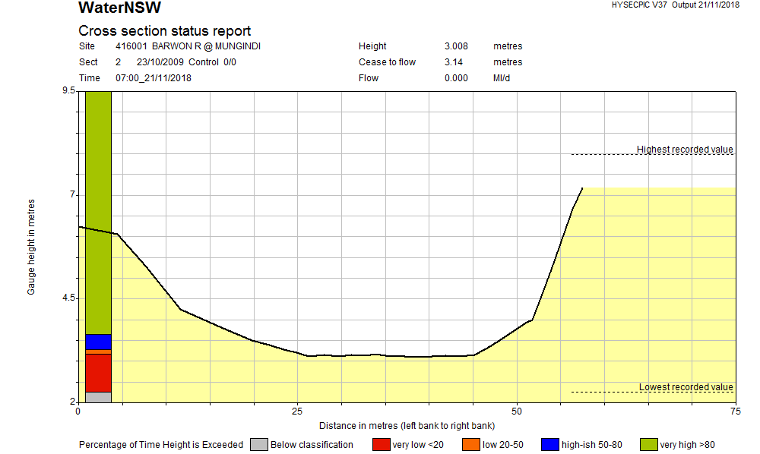
Figure 56: Cross section for Barwon @ Mungindi gauge.
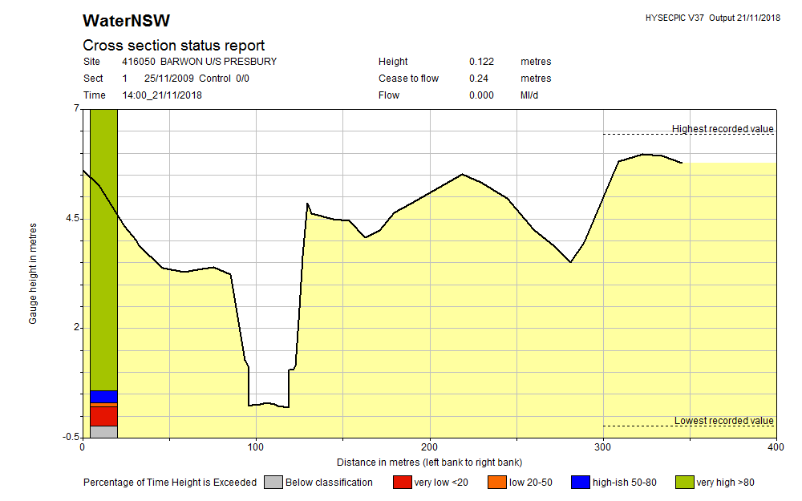
Figure 57: Cross section for Barwon @ upstream Presbury gauge.
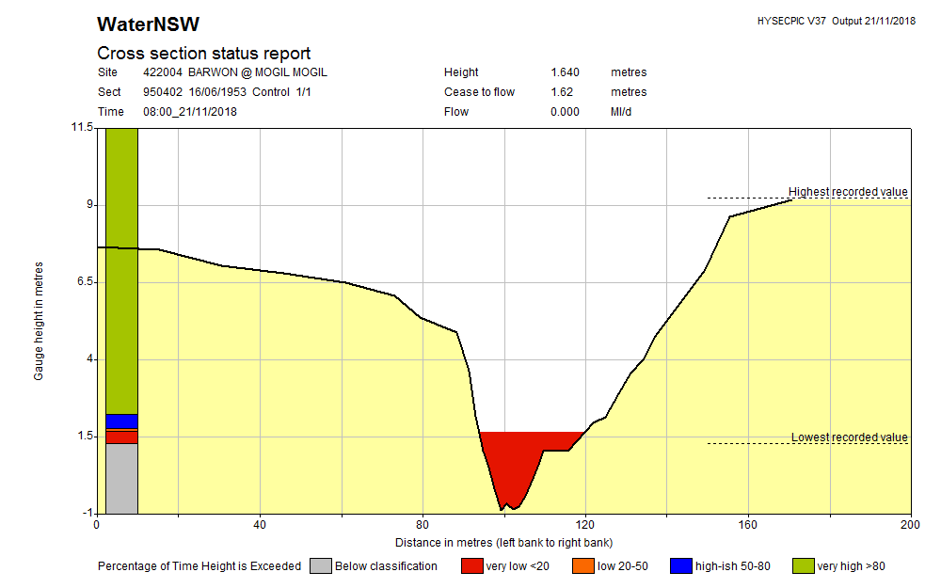
Figure 58: Cross section for Barwon @ Mogil Mogil.
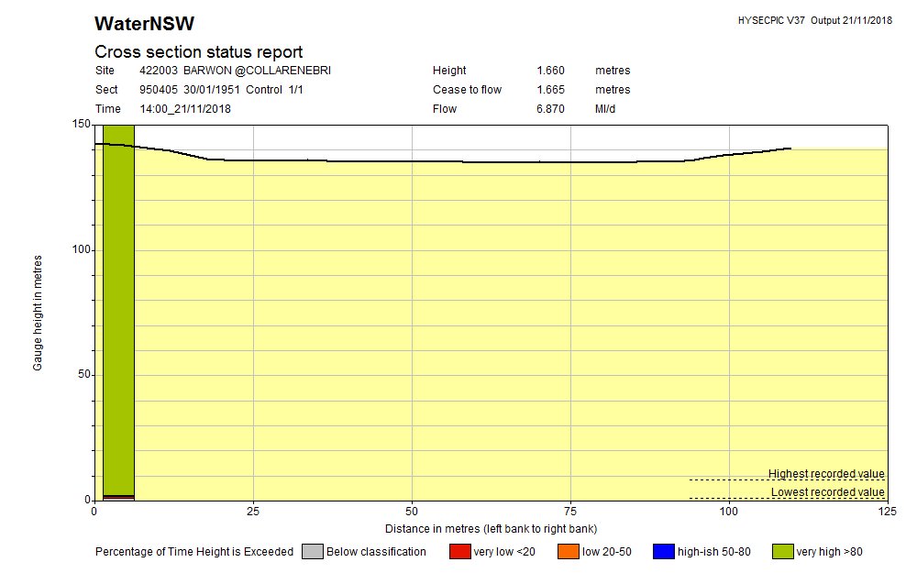
Figure 59: Cross section for Barwon @ Collarenebri.
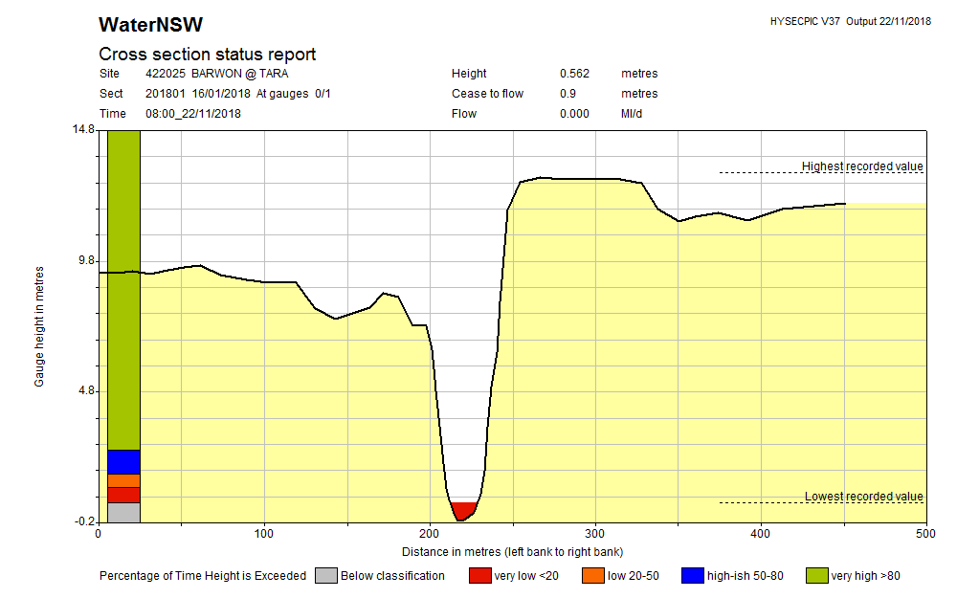
Figure 60: Cross section for Barwon @ Tara.
Figure 61: Cross section for Barwon @ Dangar Bridge.
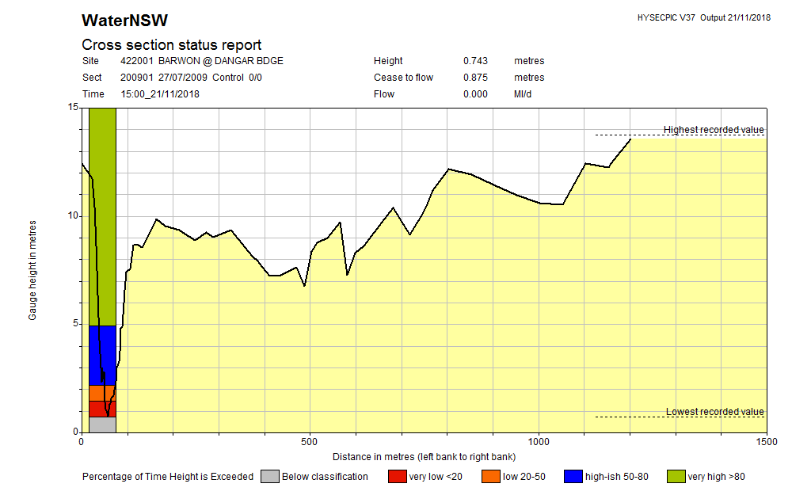
Figure 61: Cross section for Barwon @ Dangar Bridge.

Appendix B: Habitat feature inundation with the 2019 fish flow

Figure 62: Habitat inundation in the Mungindi Management Reach during the 2019 fish flow.

Figure 63: Habitat inundation in the Presbury Management Reach during the 2019 fish flow.

Figure 64: Habitat inundation in the Mogil Mogil Management Reach during the 2019 fish flow.

Figure 65: Habitat inundation in the Collarenebri Management Reach during the 2019 fish flow.

Figure 66: Habitat inundation in the Tara Management Reach during the 2019 fish flow.

Figure 67: Habitat inundation in the Dangar Bridge Management Reach during the 2019 fish flow.

Appendix C: Pumpsites
The project area supports major agriculture industries including grazing and irrigated crops (particularly cotton) (MDBA, 2019). Both requiring various levels of water extraction. Currently, potentially millions of native fish are lost from rivers every year, being extracted by pumps and diverted into channels, significantly compromising native fish communities (Boys and Rayner, 2017). Pumps have the potential to draw fish during water abstraction and can physically harm or kill them (Baumgartner et al. 2009). Studies in the Condamine Catchment in Queensland have recorded over 12,000 native fish being removed from two 300 mm pumps over a 9-hour period (Norris, 2015).
There were 115 pumpsites were recorded in the project area. Smaller pumpsites (<250 mm) were relatively evenly spread across the project area, while larger pumpsites more sparsely distributed with the greatest density around Mungindi. Pumpsites were categorised into three size categories <100 mm, 100 mm to 250 mm and >250 mm. Smaller pumps (<100 mm) are generally used for stock and domestic purposes and larger pumps for irrigation and town water supply. Stock and domestic extraction for grazing properties is less exhaustive on flows but can impact on refuge pools during critical cease to flow periods.
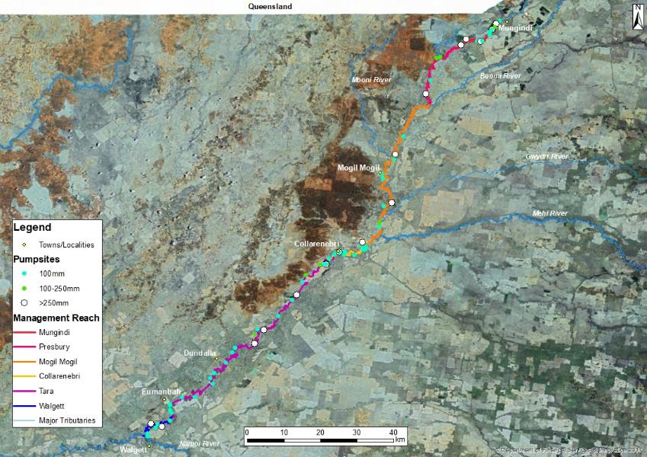
Figure 68: Location and size of pumpsites in the project area

