# Agriculture, fisheries and forestry export snapshot 2022 – March 2023

2022 was a record year for Australian agricultural exports. Exports to most markets were up, including big increases to Southeast Asia, the Middle East and North Africa. China remained Australia’s most valuable single market.

## Record Australian agricultural exports in 2022

* Australia exported a record $78.1 billion of agricultural products in 2022.
  + Compared to the 2018-2021 average, the value of exports to all major markets increased.
  + The largest increases were to countries in the ASEAN[1] (+$7b) and MENA[2] (+$4b) regions.
  + Exports to the EU, predominately canola seeds, also rose substantially (+$3.7b).
  + China was Australia’s largest single export market in 2022 ($15.1b).

Figure 1 - Australian agricultural, fisheries and forestry exports

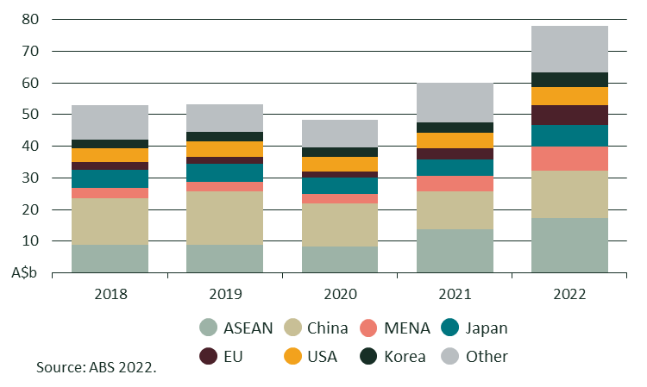

## Increased exports to the Middle East and North Africa

* In 2022, a record 9.8% of the value of Australian agricultural, fisheries and forestry exports went to the MENA region. Record exports were driven by:
  + Bumper Australian grain and oilseed crops and disruptions to northern hemisphere supplies (drought and conflict).
  + Barley exports continuing to flow to Saudi Arabia.
  + Strong demand and prices for red meat in the UAE and Saudi Arabia.
  + Ongoing growth of Australian cotton exports to Türkiye.

Figure 2 - Australian agricultural, fisheries and forestry exports to the Middle East and North Africa

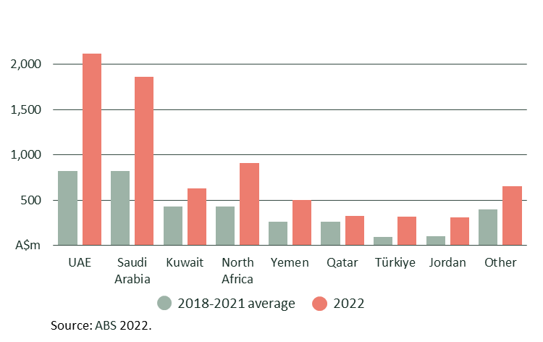

## Crop exports continued to lead the way in 2022

* 2022 was a big year for Australian crop exports, with both high export volumes and strong global prices.
* Canola, sorghum, cotton, wheat, lentils and barley all had record exports. Total export value, volume and prices were all above the previous three-year average.
* Ongoing herd rebuilding reduced the volume of red meat and live cattle exports. High prices kept the value of beef and sheepmeat exports above average, however, live feeder cattle exports were well down (-39%).
* The export unit price of inedible tallow, a key ingredient in some types of biofuel, rose sharply due to surging global oil prices following Russia’s invasion of Ukraine.
* Not all sectors had a bumper year. Finding new high-value markets continued to be a challenge for wine and rock lobster exporters. Table grape exports were also down following difficult seasons in 2020-21 and 2021-22.
* Producers across all sectors faced very high input prices, particularly [fertiliser](https://www.agriculture.gov.au/sites/default/files/documents/september-2022-snapshot-global-fertiliser-trade.pdf), [diesel](https://iea.blob.core.windows.net/assets/347aa45b-333c-49f5-9eff-172dac31d0a5/-15NOV2022_OilMarketReport.pdf) and [machinery](https://www.agriculture.gov.au/sites/default/files/documents/snapshot-of-australian-machinery-imports.pdf). Access to [agricultural labour](https://www.agriculture.gov.au/abares/research-topics/labour) also continued to be a challenge.

**Figure 3: Selected Australian commodity exports, change in value, volume and average export price $/t1 between 2019-2021 and 2022**

Figure 3: Selected Australian commodity exports, change in value, volume and average export price $/t between 2019-20212 and 2022.


1. Association of Southeast Asian Nations
2. Middle East and North Africa