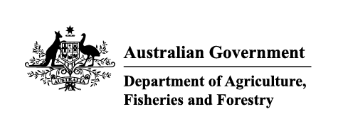

Instrument revoking a holding order under section 15(2) of the Imported Food Control Act 1992
The listed holding orders, having satisfied the circumstances under which the orders will be revoked, are revoked under section 15(2) of the Imported Food Control Act 1992 (the Act).
The circumstances being that the Secretary or delegate is satisfied that the basis for the order no longer applies.
Holding order number | Date revoked
18101 | 02/03/2026
19942 | 02/03/2026
20120 | 02/03/2026
20179 | 03/03/2026
19459 | 04/03/2026
15323 | 10/03/2026
15693 | 10/03/2026
17067 | 10/03/2026
17126 | 10/03/2026
17503 | 10/03/2026
17839 | 10/03/2026
18063 | 10/03/2026
18168 | 10/03/2026
18274 | 10/03/2026
18409 | 10/03/2026
18436 | 10/03/2026
18493 | 10/03/2026
18529 | 10/03/2026
18592 | 10/03/2026
18617 | 10/03/2026
18686 | 10/03/2026
18854 | 10/03/2026
18964 | 10/03/2026
18972 | 10/03/2026
18991 | 10/03/2026
18992 | 10/03/2026
18993 | 10/03/2026
18994 | 10/03/2026
18995 | 10/03/2026
18996 | 10/03/2026
18998 | 10/03/2026
18999 | 10/03/2026
19002 | 10/03/2026
19007 | 10/03/2026
19022 | 10/03/2026
19023 | 10/03/2026
19024 | 10/03/2026
19034 | 10/03/2026
19036 | 10/03/2026
19044 | 10/03/2026
19045 | 10/03/2026
19046 | 10/03/2026
19049 | 10/03/2026
19052 | 10/03/2026
19053 | 10/03/2026
19054 | 10/03/2026
18460 | 11/03/2026
19970 | 11/03/2026
19913 | 17/03/2026
18362 | 18/03/2026
18521 | 18/03/2026
19687 | 18/03/2026
20092 | 18/03/2026
17572 | 24/03/2026
20034 | 24/03/2026
20043 | 24/03/2026
19994 | 31/03/2026

Delegate position number | Date
100091 | 23/04/2026
Delegate of the secretary for the purposes of section 15(2) of the Act.

