# United Arab Emirates food and agriculture snapshot – March 2022

The United Arab Emirates is a dynamic and globalised market with opportunities for agricultural exporters. There are many wealthy citizens, expatriates, and tourists, who are increasingly seeking premium and specialised food products including organic food.

## UAE market overview

* The United Arab Emirates (UAE) has a population of 9.9 million and real GDP growth is forecasted to be 3% in 2022. Rising incomes, changing consumer preferences and a strong tourist sector is fuelling demand for premium, organic and specialised foods.
* A large expatriate population is helping drive demand for western style food. Hyper/supermarkets are widespread and supply a diverse range of food.
* Dubai has developed Jebel Ali, the largest cargo port in the Middle East, and a range of free trade zones to attract manufacturing and service industries.
* The UAE is a commercial hub for regional food and agriculture supply. In 2020, the UAE re-exported $7.5 billion of food and agriculture products, predominately to other Middle Eastern countries.
* On 17 March 2022, Australia and the UAE agreed to commence negotiation of a Comprehensive Economic Partnership Agreement.

## UAE food and agriculture imports

* In 2020, the UAE imported $24 billion of agriculture, fisheries and forestry (AFF) products. The UAE imports 85% of the food it consumes.
* In 2021, Australia exported $1.06 billion of AFF products to the UAE, predominately meat and crop products. This was 57.4% higher than 2020.
* The UAE is a large global market for processed foods and drinks ($5.1b), fruits and vegetables ($4.8b), meat & live animals ($2.6b), dairy products ($2.4b) and grains ($2.2b).

**Figure 1 UAE food and agricultural product imports from the World in 2020**

**Figure 2 Australia food and agricultural product exports to the UAE (2017 to 2021)**

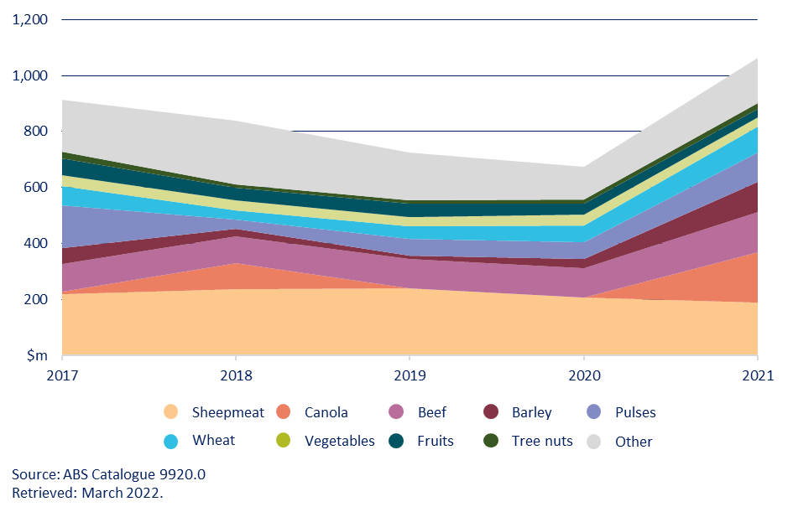

## Outlook for Australian food and agricultural exports to the UAE

* Negotiation and implementation of the Comprehensive Economic Partnership Agreement between Australia and the UAE should support expanded market opportunities for food and agriculture.
* In 2018, the UAE Government published the National Strategy for Food Security which aims to improve food security by facilitating global food trade and diversifying food import sources.
* Food and beverage products identified with high growth potential include ready-to-eat meals, processed food, health food, organic food, soft drinks and flavoured water.
* A Memorandum of Understanding to establish electronic certification has been agreed between Australia and the Dubai Municipality that will facilitate food and agriculture trade to and through the Port of Dubai.
* The UAE consumers view Australian food as premium products with reliable traceability. Australia’s strong regulatory frameworks and reliability of supply supports growing demand for organic and vegan food products by wealthy young citizens and expats.