Market survey - Labelling of plant-based protein products and dairy alternatives

© Commonwealth of Australia 2025
Ownership of intellectual property rights
Unless otherwise noted, copyright (and any other intellectual property rights) in this publication is owned by the Commonwealth of Australia (referred to as the Commonwealth).
Creative Commons licence
All material in this publication is licensed under a Creative Commons Attribution 4.0 International Licence except content supplied by third parties, logos and the Commonwealth Coat of Arms.

Cataloguing data
This publication (and any material sourced from it) should be attributed as: DAFF 2025, Our food future: trends and opportunities, Department of Agriculture, Fisheries and Forestry, Canberra,. CC BY 4.0.
This publication is available at agriculture.gov.au/agriculture-land/farm-food-drought/food/plant-based-alternative-product-labelling.
Department of Agriculture, Fisheries and Forestry
GPO Box 858 Canberra ACT 2601
Telephone 1800 900 090
Web agriculture.gov.au
Disclaimer
The Australian Government acting through the Department of Agriculture, Fisheries and Forestry has exercised due care and skill in preparing and compiling the information and data in this publication. Notwithstanding, the Department of Agriculture, Fisheries and Forestry, its employees and advisers disclaim all liability, including liability for negligence and for any loss, damage, injury, expense or cost incurred by any person as a result of accessing, using or relying on any of the information or data in this publication to the maximum extent permitted by law.
Acknowledgements
The authors thank interview and survey participants for their input. Thanks also to Harold Inglewood and Jerzy Kaminski for their support during the project and in preparing this report.
Acknowledgement of Country
We acknowledge the continuous connection of First Nations Traditional Owners and Custodians to the lands, seas and waters of Australia. We recognise their care for and cultivation of Country. We pay respect to Elders past and present, and recognise their knowledge and contribution to the productivity, innovation and sustainability of Australia’s agriculture, fisheries and forestry industries.
Contents
Purpose of market survey 1
Data collection methodology Error! Bookmark not defined.
Scope 1
Data collection process 1
Data collation 2
Summary of product data collected 3
Summary of key labelling characteristics 5
Limitations 12
Conclusion 12
Tables
Table 1 Number of products by product category and where product information was collected 3
Table 2 Location of plant-based product categories in relation to animal-based equivalent at in-store collection sites 3
Table 3 Summary of meat terminology used on plant-based protein products 5
Table 4 Summary of meat terminology used on plant-based egg products 5
Table 5 Summary of dairy terminology used on plant-based cheese products 6
Table 6 Summary of dairy terminology used on plant-based milk products 6
Table 7 Summary of dairy terminology on plant-based yoghurt products 6
Table 8 Summary of qualifiers used on plant-based protein products 6
Table 9 Summary of qualifiers used on plant-based egg products 7
Table 10 Summary of qualifiers used on plant-based cheese products 7
Table 11 Summary of qualifiers used on plant-based milk products 8
Table 12 Summary of qualifiers used on plant-based yoghurt products 8
Table 13 Location of utility/meat terms and qualifiers found on plant-based protein products 8
Table 14 Location of utility/meat terms and qualifiers found on plant-based egg products 9
Table 15 Location of dairy terms and qualifiers found on plant-based cheese products 9
Table 16 Location of dairy terms and qualifiers found on plant-based milk products 10
Table 17 Location of dairy terms and qualifiers found on plant-based yoghurt products 10
Table 18 Summary of animal depictions on plant-based products by category 10
Table 19 Summary of health and nutrition claims on plant-based products by product category 11

Figures
Figure 1 Breakdown of products by category 4
Figure 2 Breakdown of plant-based proteins by type 4

Purpose of market survey
FSANZ undertook a market scan to collect product image and label information for plant-based protein and dairy alternative products available in Australian retail stores and to collect information on where these product categories are typically located in-store.
The information collected was used to inform the consumer survey and to summarise key labelling characteristics.

Scope
All plant-based protein and dairy alternative products that have undergone a high level of processing, aimed to imitate the flavour and/or texture of meat, fish, eggs or dairy products were considered in-scope. This included:
- fresh and frozen plant-based protein products such as plant-based chicken, beef, mince, processed meat imitations and plant-based seafood
- fresh and shelf stable plant-based milk
- plant-based cheese
- plant-based yoghurt
- plant-based eggs.
Out-of-scope products included:
- plant-based whole foods such as lentils, legumes, seeds and nuts
- common vegan and vegetarian products such as tofu, tempeh and falafels
- novel products produced using new and innovative technologies such as cell cultured meat and precision fermented dairy.

Data collection process
An initial scan of retailer and manufacturer websites was undertaken to determine a list of brands and products currently available to Australian consumers. The list was used to inform the data collection process and to ensure a reasonable number of products were captured in the market scan.
Product images and label information were sourced from:
- selected Australian supermarket in the Australian Capital Territory (ACT)
- selected Australian health food stores in the ACT
- Coles and Woolworths online retail websites
- Online manufacturers’ websites.
The original brand and product list was expanded to include additional products identified during the market scan.

In-store collection
In-store data collection was undertaken by FSANZ between late-April and late-May 2024 from the following stores located in the ACT:
- Woolworths – Majura Park and Woden
- Coles – Dickson and Woden
- Aldi – Majura Park
- Supabarn – Red Hill, Casey and Kingston
- IGA – Ainslie and Nicholls
- The Spence Grocer
- SupaExpress – Campbell
- Health stores – Go Vita Woden, Healthy Life Gungahlin and Mountain Creek Wholefoods Griffith
All sides of the products packaging containing information were photographed using FSANZ’s custom built Vision App. The location of the product categories within each store, relative to their protein or dairy equivalent was also captured.
Product images were uploaded to Peruse and checked to ensure all images were uploaded properly and that all sides of the packaging were clearly visible and legible to enable full data collection. Missing photos or blurry images were re-captured.
This process resulted in the collection of images for 447 products.

Online scan
Where a product from the original list could not be found in-store, images were collected from retailer and/or manufacturer websites where possible.
Products were included if there was at least 1 current clearly visible image of the front of the products packaging available. However, all sides of the packaging containing information were captured where available.
This process resulted in the collection of images for 163 products.

Data collation
Front of pack information from each product was manually entered into 2 templates. One for plant-based proteins (including eggs), and 1 for plant-based dairy alternatives (milk, cheese and yoghurts).
The key labelling characteristics captured in each template included:
- summary product information such as product category, brand, name and product type
- meat and dairy terminology
- ingredient qualifiers
- location and size of meat and dairy terminology and qualifiers
- claims
- animal imagery including type of image and size

Summary of product data collected
The market survey collected data for 610 plant-based protein, egg and dairy alternative products. 73% of product data were collected through in-store collections and 27% of product data were collected through online scans (see Table 1).
Table 1 Number of products by product category and where product information was collected
Product category | Brands n=ª | Number of products: In-store | Number of products: On-line | Total number of products
Plant-based protein | 39 | 147 | 83 | 230
Plant-based eggs | 4 | 2 | 2 | 4
Plant-based cheese | 24 | 103 | 45 | 148
Plant-based milk | 32 | 143 | 22 | 165
Plant-based yoghurt | 7 | 52 | 11 | 63
Total | 106 | 447 | 163 | 610
ªsome brands have products in more than 1 product category
The location of the plant-based categories for products collected in-store varied according to its animal-based equivalent. No patterns were identified between store sizes. However, plant-based product categories were more often co-located with the animal based equivalent then not, across all product categories (see Table 2). Co-located is defined as next to or within the same refrigerator, freezer or shelf space as the animal-based equivalent.
Table 2 Location of plant-based product categories in relation to animal-based equivalent at in-store collection sites
Category | Co-located with animal-based equivalent | Not co-located with animal-based equivalent
Plant-based protein – (refrigerated) | 9 | 2
Plant-based protein - (frozen) | 11 | 3
Plant-based eggs | 0 | 2
Plant-based cheese | 9 | 3
Plant-based milk - (refrigerated) | 11 | 2
Plant-based milk - (shelf-stable) | 12 | 3
Plant-based yoghurt | 12 | 1
Of the 610 products collected, 230 were categorised as plant-based proteins, 4 as plant-based eggs, 148 as plant-based cheeses, 165 as plant-based milks and 63 as plant-based yoghurts (see Figure 1). Plant-based proteins were further categorised by type due to the variation of products available in the category as shown in Figure 2.
⁺ Note: counts reflect the number of store locations visited for each product category, and where the plant-based product categories were located in relation to its animal-based equivalent, not the individual number of products
Figure 1 Breakdown of products by category (n = 610)
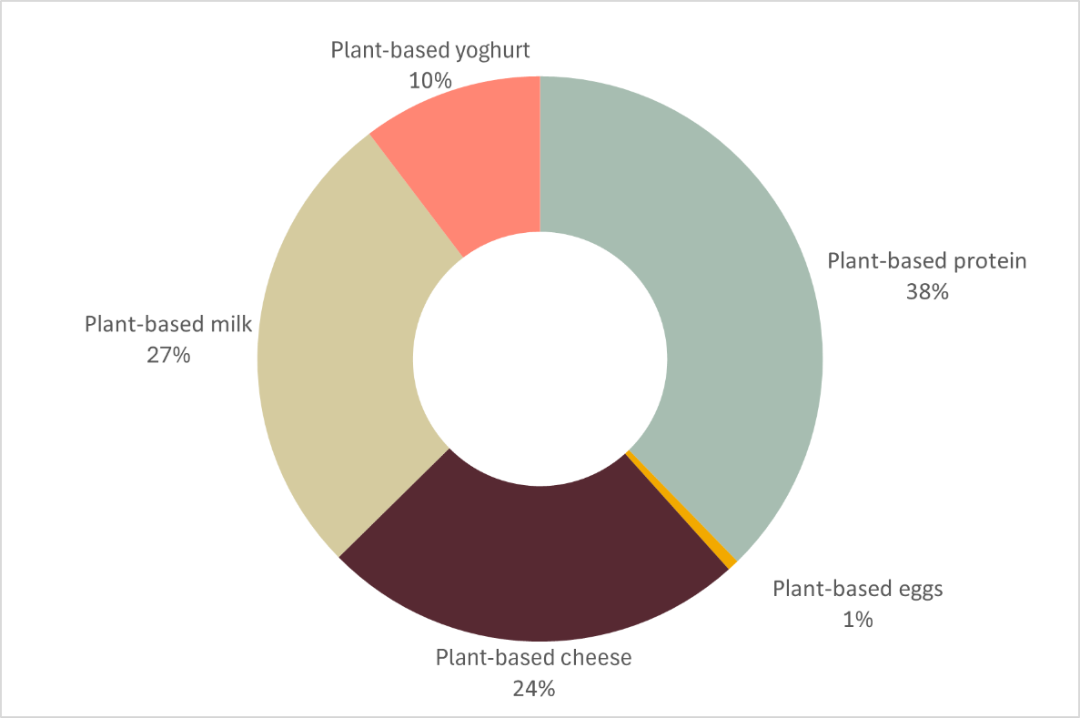
Figure 2 Breakdown of plant-based proteins by type (n = 230)
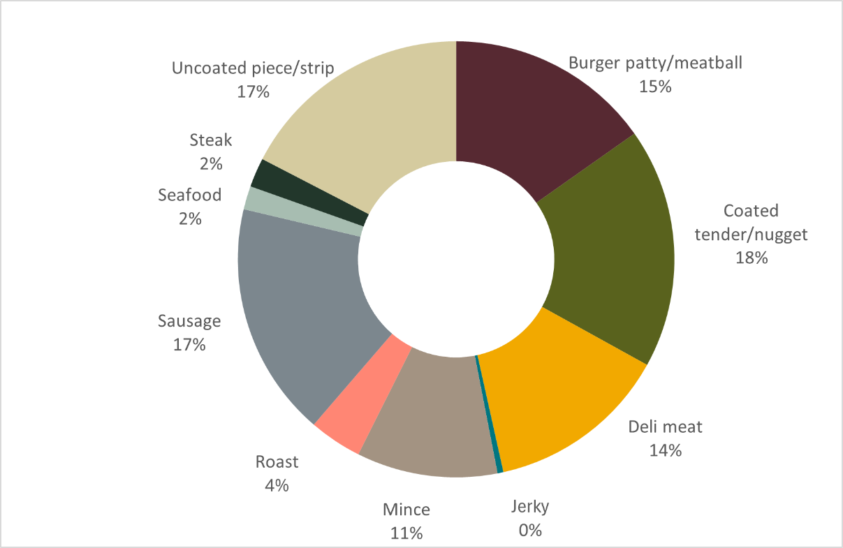

Summary of key labelling characteristics

Use of meat and dairy terminology
The proportion of products using at least 1 meat or dairy term, along with the type of meat and dairy terms used varied between product categories. More information on the number and types of meat and dairy terms used can be found below.

Plant-based proteins
Of the 230 plant-based proteins included in the market survey, 216 or 93.9% used a utility term to describe the product format, with sausage (31), burger (28) and mince (21) being the most used terms. While 139 or 60.4% of products used at least 1 meat term, including at least 1 of the following: common meat term, specific meat term, meat term with suffix or mis-spelt word. Of these, common meat terms were the most frequently used term representing 79 or 34.3% of products, with meat (28) and chicken (20) being the most used terms.
Table 3 Summary of meat terminology used on plant-based protein products
Terminology | Products (n=) | Proportion (%) | Most common terms
Utility term | 216 | 93.9 | sausage (31), burger (28), mince (21)
Common meat term | 79 | 34.3 | meat (28), chicken (20)
Specific meat term | 1 | 0.4 | Hungarian
Meat term with suffix | 30 | 13.0 | chicken-style or chicken style (15)
Mis-spelt word | 43 | 18.7 | chick'n (16), meet (7), vEEF (7)

Plant-based eggs
All 4 or 100% of the plant-based eggs included in the market survey used a utility term to describe the product format. While, no products used a common term, specific term, term with suffix or mis-spelt word.
Table 4 Summary of meat terminology used on plant-based egg products
Terminology | Products (n) | Proportion (%) | Most common terms
Utility term | 4 | 100 | egg
Common term | 0 | 0 | n/a
Specific term | 0 | 0 | n/a
Term with suffix | 0 | 0 | n/a
Mis-spelt word | 0 | 0 | n/a

Plant-based cheese
Of the 148 plant-based cheese products included in the market survey, 138 or 93.2% used at least 1 dairy term. Of these, common dairy terms were the most frequently used term representing 94 or 63.5% of products, with cheese (94) being the most used term. This was followed by specific dairy terms representing 79 or 53.4% of products with cheddar (13), mozzarella (11) and cream cheese (10) being the most used terms.
Table 5 Summary of dairy terminology used on plant-based cheese products
Terminology | Products (n) | Proportion (%) | Most common terms
Common dairy terms | 94 | 63.5 | cheese (94)
Specific dairy terms | 79 | 53.4 | cheddar (13), mozzarella (11), cream cheese (10)
Dairy term with suffix | 44 | 29.7 | cheddar style (8), cheddar flavour (5), mozzarella style (5), goat style (5)
Mis-spelt word | 10 | 6.8 | ch-easy (3), sheese (2), parmesano (2)

Plant-based milk
Of the 165 plant-based milk products included in the market survey, 148 or 89.7% used at least 1 dairy term. Of these, common dairy terms are the most frequently used term representing 136 or 82.4% of products, with milk (136) being the most used term. Less than 5% of products used a dairy term with suffix or a mis-spelt word. While no products were found to use specific dairy terms.
Table 6 Summary of dairy terminology used on plant-based milk products
Terminology | Products (n) | Proportion (%) | Most common terms
Common dairy terms | 136 | 82.4 | milk (136)
Specific dairy terms | 0 | 0.0 | n/a
Dairy term with suffix | 8 | 4.8 | milky (8)
Mis-spelt words | 6 | 3.6 | m*lk (3), m!lk (3)

Plant-based yoghurt
All 63 plant-based yoghurts included in the market survey used at least 1 dairy term. All products used yoghurt as a common dairy term, while 12 or 19% of products used ‘Greek style’ as a specific dairy term. Less than 5% of products used a dairy term with suffix, while no products were found to use a mis-spelt word.
Table 7 Summary of dairy terminology on plant-based yoghurt products
Terminology | Products (n) | Proportion (%) | Most common terms
Common dairy terms | 63 | 100.0 | yoghurt (63)
Specific dairy terms | 12 | 19.0 | Greek style (12)
Dairy term with suffix | 2 | 3.2 | Yoghurt alternative (2)
Mis-spelt words | 0 | 0 | n/a

Use of qualifiers
All products included in the market survey used 1 or more qualifiers.

Plant-based proteins
All 230 plant-based protein products included in the market survey used at least 1 qualifier, with plant-based (164), vegan (114), meat-free (53) and vegetarian (45) being the most common qualifiers used. 178 products or 77.4% used more than 1 qualifier.
Table 8 Summary of qualifiers used on plant-based protein products
No. of qualifiers | Products (n) | Proportion (%) | Most common qualifier terms
1 only | 52 | 22.6 | plant-based (42), meat-free (7), vegan (3)
1 or more | 230 | 100 | plant-based (164), vegan (114), meat-free (53), vegetarian (45)
2 or more | 178 | 77.4 | plant-based (122), vegan (111), meat-free (46), vegetarian (45)
3 or more | 106 | 46.1 | vegan (75), plant-based (71), meat-free (37), vegetarian (34)
4 or more | 45 | 19.6 | vegan (36), plant-based (27), meat-free (26)
5 or more | 3 | 1.3 | vegan (3), plant-based (2), meat-free (2)

Plant-based egg
All 4 plant-based egg products included in the market survey used 2 or more qualifiers, with plant-based (2), vegan (2) and egg-free (2) being the most common terms used.
Table 9 Summary of qualifiers used on plant-based egg products
No. of qualifiers | Products (n) | Proportion (%) | Most common qualifier terms
1 only | 0 | 0 | n/a
1 or more | 4 | 100 | plant-based (2), vegan (2), egg-free (2)
2 or more | 4 | 100 | plant-based (2), vegan (2), egg-free (2)
3 or more | 2 | 50 | egg-free (2)

Plant-based cheese
All 148 plant-based cheese products included in the market survey used at least 1 qualifier, with dairy-free (95), plant-based (77), vegan (73) and cashew (32) being the most common qualifiers used. 111 products or 75% used more than 1 qualifier.
Table 10 Summary of qualifiers used on plant-based cheese products
No. of qualifiers | Products (n) | Proportion (%) | Most common qualifier terms
1 only | 37 | 25.0 | vegan (11), dairy free (11), macadamia (7)
1 or more | 148 | 100.0 | dairy free (95), plant based (77), vegan (73), cashew (32)
2 or more | 111 | 75.0 | dairy free (84), plant based (74), vegan (62), cashew (29)
3 or more | 78 | 52.7 | dairy free (72), plant based (62), vegan (44), vegan friendly (20)
4 or more | 43 | 29.1 | dairy free (43), plant based (40), vegan (27), vegan friendly (16)
5 or more | 19 | 12.8 | dairy free (19), plant based (18), vegan friendly (10), less dairy (10), plant based dairy simulant (10)
6 or more | 8 | 5.4 | dairy free (8), plant based (8), cheddar flavour (5)

Plant-based milk
All 165 plant-based milk products included in the market survey used at least 1 qualifier, with oat (56), almond (56) and soy (31) being the most common qualifiers used. 66 products or 40.0% used more than 1 qualifier.
Table 11 Summary of qualifiers used on plant-based milk products
No. of qualifiers | Products (n) | Proportion (%) | Most common qualifier terms
1 only | 99 | 60.0 | almond (37), oat (34), soy (16)
1 or more | 165 | 100.0 | oat (56), almond (56), soy (31)
2 or more | 66 | 40.0 | oat (22), plant based (19), almond (19), vegan (16), dairy free (15)
3 or more | 20 | 12.1 | dairy free (11), oat (10), vegan (10)
4 or more | 2 | 1.2 | 100% animal free (2), dairy free (2), alternative dairy (2)

Plant-based yoghurt
All 63 plant-based yoghurt products included in the market survey used at least 1 qualifier, with dairy-free (54), coconut (43) and plant-based (23) being the most common qualifiers used. 54 products or 85.7% used more than 1 qualifier.
Table 12 Summary of qualifiers used on plant-based yoghurt products
No. of qualifiers | Products (n) | Proportion (%) | Most common qualifier terms
1 only | 9 | 14.3 | soy (6), oat (3)
1 or more | 63 | 100.0 | dairy free (54), coconut (43), plant based (23)
2 or more | 54 | 85.7 | dairy free (54), coconut (43), plant based (23)
3 or more | 31 | 49.2 | coconut (31), dairy free (31), plant based (23)
4 or more | 8 | 12.7 | coconut (8), plant based (8), dairy free (8), vegan (8)

Location and size of meat and dairy terms and qualifiers
The most common location of the meat and dairy terms was with the product name. While the most common location of the qualifiers varied between the product name and general packaging

Plant-based proteins
Of the 225 plant-based protein products using utility or meat terms, 222 products or 98.7% had a utility term or meat term located with the product name. This was followed by the products general packaging (71) and the brand (30).
Of the 230 plant-based protein products using qualifiers, 196 products or 85.2% had a qualifier located with the products name. This was followed by the products general packaging (147) and brand (127).
Table 13 Location of utility/meat terms and qualifiers found on plant-based protein products
 | Meat terms |  | Qualifiers
Location | Products (n) | Proportion (%) | Products (n) | Proportion (%)
Brand | 30 | 13.3 | 127 | 55.2
General packaging | 71 | 31.6 | 147 | 63.9
Name | 222 | 98.7 | 196 | 85.2
No products used more utility or meat terms than qualifiers, while 152 products or 66.1% had a meat or utility term that was larger than the largest qualifier.

Plant-based egg
All 4 plant-based egg products had a utility term or meat term located with the product name. This was followed by the products general packaging (2 products or 50%).
All 4 plant-based egg products had a qualifier located with the products general packaging. This was followed by the products name (3) and brand (1).
Table 14 Location of utility/meat terms and qualifiers found on plant-based egg products
 | Meat terms |  | Qualifiers
Location | Products (n) | Proportion (%) | Products (n) | Proportion (%)
Brand | 0 | 0 | 1 | 25
General packaging | 2 | 50 | 4 | 100
Name | 4 | 100 | 3 | 75
No products used more utility or meat terms than qualifiers, while 1 product or 25% had a utility term that was larger than the largest qualifier.

Plant-based cheese
Of the 138 plant-based cheese products using a dairy term, 109 products or 79.0% had a dairy term located with the product name. This was followed by the products general packaging (34) and the brand (21).
Of the 148 plant-based cheese products using qualifiers, 110 products or 74.3% had a qualifier located with the products general packaging. This was followed by the products name (84) and brand (64).
Table 15 Location of dairy terms and qualifiers found on plant-based cheese products
 | Dairy terms |  | Qualifiers
Location | Products (n) | Proportion (%) | Products (n) | Proportion (%)
Brand | 21 | 15.2 | 64 | 43.2
General packaging | 34 | 24.6 | 110 | 74.3
Name | 109 | 79.0 | 84 | 56.8
No products used more dairy terms than qualifiers, while 51 products or 34.5% had a dairy term that was larger than the largest qualifier.

Plant-based milk
Of the 148 plant-based milk products using a dairy term, 110 products or 74.3% had a dairy term located with the product name. This was followed by the products general packaging (40) and the brand (7).
Of the 165 plant-based milk products using qualifiers, 156 products or 94.5% had a qualifier located with the product name. This was followed by the products general packaging (102) and brand (13).
Table 16 Location of dairy terms and qualifiers found on plant-based milk products
 | Dairy terms |  | Qualifiers
Location | Products (n) | Proportion (%) | Products (n) | Proportion (%)
Brand | 7 | 4.7 | 13 | 7.9
General packaging | 40 | 27.0 | 102 | 61.8
Name | 110 | 74.3 | 156 | 94.5
No products used more dairy terms than qualifiers, while 18 products or 10.9% had a dairy term that was larger than the largest qualifier.

Plant-based yoghurt
Of the 63 plant-based yoghurt products using a dairy term, 61 products or 96.8% had a dairy term located with the product name. This was followed by the products general packaging (2).
Of the 63 plant-based yoghurt products using qualifiers, all products or 100% had a qualifier located with the products name. This was followed by the products general packaging (52 products or 82.5%).
Table 17 Location of dairy terms and qualifiers found on plant-based yoghurt products
 | Dairy terms |  | Qualifiers
Location | Products (n) | Proportion (%) | Products (n) | Proportion (%)
Brand | 0 | 0.0 | 0 | 0.0
General packaging | 2 | 3.2 | 52 | 82.5
Name | 61 | 96.8 | 63 | 100.0
No products used more dairy terms than qualifiers, while 1 product or 1.6% had a dairy term that was larger than the largest qualifier.

Use of animal depictions
4.1% or 25 products contained animal depictions. If present, plant-based proteins typically contained cow (5), chicken (3) and fish (1) imagery, while all plant-based cheese and yoghurt contained cow imagery (16). No animal depictions were found on plant-based eggs or plant-based milk. All images were in the form of icons, rather than realistic depictions.
Table 18 Summary of animal depictions on plant-based products by category
Category | Total products (n) | Products (n) | Proportion (%) | Type of image
Plant-based protein | 230 | 9 | 3.9 | Icon
Plant-based eggs | 4 | 0 | 0 | n/a
Plant-based dairy alternatives | 376 | 16 | 4.3 | Icon
Plant-based cheese | 148 | 13 | 8.8 | Icon
Plant-based milk | 165 | 0 | 0 | n/a
Plant-based yoghurt | 63 | 3 | 4.8 | Icon
Summary - All categories | 610 | 25 | 4.1 | Icon

Use of health and nutrition claims
The proportion of products with at least 1 health and nutrition related claims varied between product categories. While comparative health claims were only found on plant-based milks.

Plant-based proteins
Of the 230 plant-based protein products collected in the market survey, 180 products or 78.3% used at least 1 claim. The most common claims used were protein per serve (52), no artificial colours and flavours (39) and high in protein (31). No comparative health claims were found.

Plant-based egg
All 4 plant-based egg products or 100% used at least 1 claim. The most common claims used were source of protein. No comparative health claims were found.

Plant-based cheese
Of the 148 plant-based cheese products included in the market survey, 66 products or 44.6% used at least 1 claim. The most common claims used were dairy free (44), gluten free (37) and vegan friendly (17). No comparative health claims were found.

Plant-based milk
Of the 165 plant-based milk products included in the market survey, 95 products or 57.6% used at least 1 claim. The most common claims used were no added sugar (20), high in calcium (19) and source of protein (10).
Four comparative nutrition content claims were also found on plant-based milks. Of these, 1 product claimed it had 25% more protein than the original version, and 3 products claimed they were lite/light compared to their regular fat counterpart. Information on what the claim was being compared to was provided on either the side or back of pack for all 4 products.

Plant-based yoghurt
All 63 plant-based yoghurt products included in the market survey used at least 1 claim. The most common claims used were dairy free (54), gluten free (15), source of calcium (12) and protein per serve (11). No comparative health claims were found.
Table 19 Summary of health and nutrition claims on plant-based products by product category
Product category | Total products (n) | Products with health and nutrition claims n (%) | Total claims (n=) | Most common claims
Plant-based protein | 230 | 180 (78.3) | 430 | protein per serve (52), no artificial colours and flavours (39), high in protein (31)
Plant-based eggs | 4 | 4 (100.0) | 8 | source of protein (2)
Plant-based cheese | 148 | 66 (44.6) | 179 | dairy free (44), gluten free (37) and vegan friendly (17)
Plant-based milk | 165 | 95 (57.6) | 188 | no added sugar (20), high in calcium (19) and source of protein (10).
Plant-based yoghurt | 63 | 63 (100.0) | 167 | dairy free (54), gluten free (15), source of calcium (12) and protein per serve (11)
Total | 610 | 408 (66.9) | 972

Limitations
The market scan only represents products available at a point in time, with products expected to turn over regularly.
The market scan is also unlikely to include all plant-based protein and dairy alternative products available to Australian consumers as not all food outlets have been assessed. However, some of the limitations of undertaking an in-store scan have been overcome by supplementing with on-line data.

Conclusion
The market survey provides a point in time understanding of the plant-based protein and plant-based dairy alternative products available in retail stores in the ACT and online and their key front-of-pack labelling characteristics. The results were used to inform the design of the consumer research, including choice of labelling elements tested and development of mock product images.

