Maritime and Aircraft Reporting System (MARS) User Guide for International Vessels Arriving in Australian Territory
© Commonwealth of Australia 2026
Ownership of intellectual property rights
Unless otherwise noted, copyright (and any other intellectual property rights) in this publication is owned by the Commonwealth of Australia (referred to as the Commonwealth).
Creative Commons licence
All material in this publication is licensed under a Creative Commons Attribution 4.0 International Licence except content supplied by third parties, logos and the Commonwealth Coat of Arms.

Cataloguing data
This publication (and any material sourced from it) should be attributed as: DAFF 2026, Maritime and Aircraft Reporting System (MARS) User Guide for International Vessels Arriving in Australian Territory, Department of Agriculture, Fisheries and Forestry, Canberra. CC BY 4.0.
This publication is available at www.agriculture.gov.au/biosecurity-trade/aircraft-vessels-military/vessels/mars/communications-training-materials.
Department of Agriculture, Fisheries and Forestry
GPO Box 858 Canberra ACT 2601
Telephone 1800 900 090
Web agriculture.gov.au
Disclaimer
The Australian Government acting through the Department of Agriculture, Fisheries and Forestry has exercised due care and skill in preparing and compiling the information and data in this publication. Notwithstanding, the Department of Agriculture, Fisheries and Forestry, its employees and advisers disclaim all liability, including liability for negligence and for any loss, damage, injury, expense, or cost incurred by any person as a result of accessing, using or relying on any of the information or data in this publication to the maximum extent permitted by law.
Acknowledgement of Country
We acknowledge the continuous connection of First Nations Traditional Owners and Custodians to the lands, seas and waters of Australia. We recognise their care for and cultivation of Country. We pay respect to Elders past and present, and recognise their knowledge and contribution to the productivity, innovation and sustainability of Australia’s agriculture, fisheries and forestry industries.

Contents
1 Users vi
1.1 Scope vi
1.2 Need help with vessel reporting or using MARS vi
2 What is MARS 7
2.1 Definitions 7
2.2 The voyage 7
2.3 Billing and invoicing 7
3 Biosecurity obligations 8
3.1 Vessel operator responsibilities 8
3.2 Shipping agent responsibilities 8
4 Biosecurity reporting 9
4.1 Pre-arrival reporting timeframe 9
4.2 Where in Australian territory can vessels arrive? 9
5 Biosecurity legislation and Australian territory 10
5.1 Australian territory 10
5.2 Christmas and Cocos (Keeling) Islands 11
5.3 Norfolk Island 11
5.4 Australian external territories not considered Australian Territory (AETNCAT) 11
6 Legal details and privacy notices 12
6.1 Biosecurity Act 2015 and confidentiality of information 12
6.2 Already registered with a MARS account 12
6.3 Creating a bookmark for regular MARS access 12
6.4 Creating a desktop shortcut for regular MARS access 12
6.5 MARS access overview – first time users 13
6.6 Vessel master users 13
6.7 Tips for searching for information in MARS 13
7 MARS 2-stage registration flowchart 14
8 First time user registration 15
8.1 Step 1 – Online portal registration 15
8.2 MARS access registration 17
8.3 Step 2 – MARS registration 18
9 MARS home screen 22
9.1 Account maintenance 22
10 Shipping agency administrator access 27
10.1 Approving agents and vessels to use MARS 27
10.2 MARS vessel master registration 31
10.3 MARS vessel master approval 32
10.4 Providing access to a Vessel Representative already associated with another vessel 35
10.5 MARS New Agency and Administrator Registration 36
10.6 Updating agency details 37
10.7 Updating agency user details 38
10.8 Accessing MARS as a Port Authority, Government Health or ABF Maritime officer user 39
10.9 Portal registration 39
11 Pre-Arrival Reporting (PAR) 41
11.2 Completing a manual application using a MARS offline form as an XML data file 42
11.3 Completing a manual PAR in MARS 43
11.4 Sanitation 46
11.5 Human Health 47
11.6 Biofouling 48
11.7 Biosecurity 48
11.8 Declaration and submission 54
11.9 Livestock statement 55
12 Ballast Water Reporting 59
12.1 Upload a Ballast Water Report from a MARS Offline Form, XML data file 60
12.2 Completing a manual Ballast Water Report in MARS 60
12.3 Cloning a ballast water report 67
13 Australian sourced ballast water 69
14 Non-First Point of Entry Port (NFP) Applications 71
14.1 NFP Activity Type 72
14.2 Cargo Details 72
15 Human Health Update 75
16 MARS service requests 76
16.1 Disembarking Crew service requests 76
16.2 Ship Sanitation Certificate service requests 78
16.3 Waste removal requests 78
16.4 Release From Biosecurity Control service requests 79
17 MARS Search Information 81
17.1 Visit Search 81
17.2 Report, application or service request search 82
17.3 The status of an application 83
17.4 Accessing vessel information 83
17.5 Accessing voyage information 85
18 MARS Documents and Certificates 87
18.1 Biosecurity Status Documents (BSD’s) 87
18.2 Ship Sanitation Certificates (SSC’s) 88
18.3 Seasonal Pest Questionnaires 90
18.4 MARS Offline Forms 92
18.5 Pratique 94
18.6 Determined Ports 94
18.7 The Vessel Compliance Scheme 95
18.8 Offshore Installations 95
18.9 Vessels exposed to offshore installations 95
18.10 Pre-Arrival Reporting for Australian External Territories 96
18.11 Sovereign Immunity 96
18.12 Biosecurity waste bins used by vessels at all intended ports of call 97
18.13 Treatment of biosecurity waste coming off the vessel 98
18.14 Increased gangway watch of disembarking crew 98
18.15 Changes to the health of crew, passengers, or visitors 99
18.16 What to expect during an inspection 99
18.17 Home Screen - Menu Bar 99
19 Registration – Setting up billing, fees, and charges 101
20 Appendices 103
20.1 Glossary 103
20.2 Common Buttons and Indicators 103
20.3 Version history 104
20.4 References 104

Users
This guide is provided for the following MARS users:
- Commercial vessel masters/operators or nominated responsible officer
- Shipping agents and agency administrators
- Port Authorities
- Australian Government Health agencies
- Australian Border Force (ABF) maritime officers
- Tug operators.

Scope
This user guide is not intended for use by non-commercial vessel operators.

Need help with vessel reporting or using MARS
The department’s National Maritime Centre (NMC) is the single point of contact to deliver real-time information and support for all stakeholders involved in reporting arrival in Australian territory and managing vessel and human health biosecurity risk.
- Phone within Australia: 1300 004 605
- Phone outside of Australia: +61 8 8201 6185
- Out of hours emergency contact: 1300 004 605
- Email: maritimenc@aff.gov.au

The Vessel Contacts webpage provides key biosecurity offices, email addresses and on-call contact details for each seaport location throughout the Australian territory.

What is MARS
The department provides the Maritime and Aircraft Reporting System (MARS) Maritime online portal for commercial vessel masters and shipping agents to submit mandatory pre‑arrival documents for all international commercial vessels preparing to enter Australian territory.
MARS has functionality to view information related to the status of a vessel. MARS must be used by international vessel masters and shipping agents to submit mandatory pre-arrival reporting and update with changes.
- Pre-arrival information, and changes to a vessel's biosecurity status throughout a voyage while in Australian waters, or where any information was not originally notified on the PAR or where any information has changed.
- Vessel reporting obligations are met once pre-arrival report (PAR) information is submitted in MARS by either the vessel master or nominated shipping agent for the voyage. And any changes in circumstances are reported.

MARS Maritime manages voyages, the granting of pratique, creates inspection records, displays vessel arrivals, creates biosecurity directions, records biosecurity officer inspection outcomes and raises service charges, all of which are validated by biosecurity officers.

Definitions
Appendix A defines a range of terms used in this document and throughout MARS.

The voyage
In MARS Maritime, the voyage number is the unique identifier. It is important to use the correct voyage number, as MARS uses the voyage number to link information such as the PAR, ballast water and Non-First Point of Entry requests. MARS only accepts alphanumeric characters (letters A–Z and numbers 0–9).

Billing and invoicing
MARS provides accurate and timely billing and allows users to make changes throughout a voyage. For each voyage, masters or their nominated agents can assign up to three agents: a port agent, a billing agent, and a crew agent.
MARS billing features:
- There is a single invoice per visit, per port.
- The vessel operator or agent supplies the billing information during the lodgement of pre-arrival information and/or a service request.
- Users can view a summary of invoices, including charges and payment status for each invoice.
- Invoices are triggered within 24 hours of a vessel departing from a port.
- The choice of specific agency setup structure can be tailored, depending on individual business needs. Refer to Registration – Setting up billing, fees, and charges.

Biosecurity obligations

Vessel operator responsibilities
Vessels and aircraft become subject to biosecurity control when entering Australian territory, section 191 of the Biosecurity Act 2015 (Act).
The operator of a vessel is obligated to accurately report information in compliance with section 193 of the Act which states: “the operator of the vessel must give a report if it is intended that the vessel is entering Australian territory.”
The report, a Pre-Arrival Report (PAR), must include information prescribed in the Biosecurity Regulation 2016 (Regulation). Section 48 (6) (b) of the Regulation states the pre-arrival reporting timeframe for reporting arrival into Australian territory: All vessels arriving in Australian territory are required by law to give notice (report) impending arrival.
Any changes in circumstances during the voyage in Australian waters while subject to biosecurity control must also be reported to the department as soon as practicable. Section 51A of the Biosecurity Regulation 2016 places responsibility on the vessel operator to provide updated information, where necessary, after they have submitted the PAR. For example, changes to human health, crew disembarkation details, or the detection of insects or animals after the PAR was submitted.

Shipping agent responsibilities
Where a vessel operator uses a shipping agent, the agent is responsible for lodgement of accurate and timely pre-arrival reporting (PAR).
The agent must ensure that this information is a true and correct representation of the reports provided by the vessel operator. That any changes are confirmed with the vessel operator and reported information is accurate and up to date.
Obligation reminder
Vessel masters and shipping agents must:
- Read and understand the Biosecurity Status Document (BSD) directions and conditions and keep a copy of the current document on board the vessel for the duration of the voyage in Australia.
- Report that any changes in circumstances during the voyage in Australian waters, particularly changes to the human health of travellers, must be submitted via MARS or reported to the National Maritime Centre (NMC) as soon as practicable.
- Understand that a failure to report accurately or comply with a requirement under the Act may result in penalties, including infringement notices, civil penalties, or criminal prosecutions.

Biosecurity reporting
Pre-arrival information, and changes, for vessels must be reported in a method approved by the Director of Biosecurity.
- For commercial vessels, reporting obligations are met once vessel pre-arrival information is submitted in MARS. Electronic offline forms can be used where there is limited internet connectivity, but they do not constitute the approved form until the PAR is submitted in MARS.
- For non-commercial vessels, reporting obligations are met once vessel pre-arrival information is submitted using the non-commercial vessel pre-arrival report web portal.

Pre-arrival reporting ensures that the biosecurity risk of each vessel entering Australian waters is assessed and managed. If a vessel does not meet reporting standards, a biosecurity officer will issue new directions or corrective actions through MARS.

Any changes in circumstances during the voyage in Australian waters must be reported as soon as practicable.
In addition to department requirements, Australian state and territory governments also have biosecurity requirements.

Pre-arrival reporting timeframe
The Biosecurity Regulation 2016 identifies that:
- Commercial vessel pre-arrival reporting must be reported 96 to 12 hours prior to arrival in Australian territory.
- Non-commercial vessel pre-arrival reporting must be reported 90 days to 12 hours prior to arrival in Australian territory.

Where in Australian territory can vessels arrive?
Vessels may only arrive at specified Australian ports where the port determined as a First Point of Entry (FPOE) for a particular vessel type, under s229 of the Act.
- Commercial vessel Australian territory first points of entry are First points of entry and non-first points of entry – information for arriving vessels and goods.
- Non-commercial vessel Australian territory first points of entry are non-commercial vessel arrival biosecurity reporting - yachts and private superyachts.

Biosecurity legislation and Australian territory
Vessels entering Australian territory must comply with their requirements under biosecurity legislation.
Section 193 of the Act states that the operator of the vessel must give a report if it is intended that the vessel is entering Australian territory.
The report must include information prescribed in the Biosecurity Regulation 2016. Section 48 (6) (b) of the Regulation states the pre-arrival reporting timeframe for reporting arrival into Australian territory and details the information (abbreviated) that must be provided in the PAR.
- Information identifying the vessel
- The name of the person in charge of the vessel and all other travellers
- The intended voyage and past 24-month history
- The shipping agent/s (if any) engaged to manage the voyage
- Human health of the travellers
- Any intended traveller disembarkations
- Any goods on board and previous history
- Vessel hull cleaning and biofouling management history
- Live or plants that have died on the voyage
- Any animals or insects on board
- If fertiliser, stock feed or dry bulk goods have been carried by the vessel
- Biofouling management including cleaning and treatments
- Details of any ship sanitation certificate in force
- Waste management arrangements.
- The intended discharge of ballast water in Australian territorial seas.

Australian territory
The jurisdiction of Australia and external territories generally extends off the Australian coast to 12 Nautical Miles (NM).
All international vessels, including barges and dredges, which are sailed, motored, or towed through the 12NM limit and enter Australian territory are subject to biosecurity control, pre-arrival reporting, pratique, assessment, and inspection at a first point of entry on arrival.
Vessel operators must meet biosecurity requirements (under the Act) when visiting the Australian mainland or its External Territories:
- Australia
- Christmas Island
- Cocos (Keeling) Islands
- Norfolk Island
- the airspace and the coastal sea of these areas which generally extends to 12 NM (approx. 25kms).
Learn more about the Biosecurity legislation and Australian territory.
All vessel operators are required to submit separate and additional Pre-Arrival Reports for travel between mainland Australian and the territories of Christmas, Cocos (Keeling) and Norfolk Islands.

Christmas and Cocos (Keeling) Islands
Vessels travelling to and from Christmas Island and Cocos (Keeling) Islands and the Australian mainland are required to undertake the pratique process. That means that vessels operators travelling between the mainland, and Christmas and Cocos (Keeling) Islands must submit a PAR.

Norfolk Island
Vessels travelling to and from Norfolk Island and the mainland are exempt from the pratique process as per the Biosecurity (Human Health) Regulation 2016 with pratique conditions on the Biosecurity Status Document (BSD) stating ’Vessels travelling between mainland Australia and Norfolk Island are exempt from the pratique process (Biosecurity (Human Health) Regulation 2016 Ch6)’. That means that vessels operators travelling between the mainland and Norfolk Island must submit a PAR, but the granting of pratique is exempt.

Australian external territories not considered Australian Territory (AETNCAT)
For vessels travelling to these territories, vessels continue to be subject to biosecurity control under the Biosecurity Act 2015 unless otherwise specified and must submit pre-arrival reports. AETNCAT ports are:
- Ashmore Reef and Cartier Island
- Coral Sea Island Territory including Willis Island
- Macdonald Islands
- Heard Island
- Australian Antarctic Territory.
All vessel masters and agents representing commercial vessels, including cruise vessels, travelling between the Australian mainland and the Australian External territories, and between the external territories, are required to pre-arrival report.
PAR examples:
- A vessel visiting an AETNCAT location from mainland Australia is leaving Australian waters.
- A vessel operator returning to an Australian mainland port from an AETNCAT location is considered a new voyage and masters are required to lodge a new PAR.

Legal details and privacy notices
Appendix C contains the MARS and corresponding offline forms legal details (Important Information About This Report), a Declaration Statement and a Privacy Notice at each PAR submission.
It is important to understand the obligations and privacy arrangements. Each time a user logs into MARS, the user agrees to the terms and conditions based on the allocated role of each user.

Biosecurity Act 2015 and confidentiality of information
The department provides the authorisation to access information (in MARS) for permissible purposes to manage potential biosecurity risk under section 580 of the Act. MARS users have obligations to manage protected information and to only access MARS as part of permissible purposes to manage:
- biosecurity risks.
- the risk of contagion of a listed human disease.
- the risk of listed human diseases entering Australian territory or a part of Australian territory, or emerging, establishing themselves or spreading in Australian territory or a part of Australian territory.
- risks relating to ballast water.
- biosecurity emergencies and human biosecurity emergencies.
- to give effect to Australia’s international rights and obligations, including under the International Health Regulations, the SPS Agreement and the Biodiversity Convention.

Already registered with a MARS account
Where users already have a current MARS account, use the MARS link to begin using MARS.

Creating a bookmark for regular MARS access
- Copy the above MARS link and paste it into the internet search address bar, then select Enter.
- Select the Favourites icon (star) and then ‘Add to Favourites’.
- Change the name of the link to ‘MARS’.
- Select OK.

Creating a desktop shortcut for regular MARS access
- Copy the above MARS link.
- On the desktop, right click and then choose New, then Shortcut.
- Paste the MARS link into the shortcut, click next.
- Change the name of the shortcut to ‘MARS’.
- Select ‘Finish’.

MARS access overview – first time users
Vessel masters and agents must register to use MARS for the biosecurity clearance of maritime vessels. In order to use MARS, a one-off registration process is required. First-time registration is a two-step process.
- All vessel masters and shipping agents must first register for a Department of Agriculture, Fisheries and Forestry (DAFF) Security Account which consists of a User ID and password before any department online services or applications like MARS can be accessed.
- Once a User ID is registered, users can request access to MARS. MARS access is requested through signing on to the customer portal on the department’s website with the User ID.

Vessel master users
After approval, MARS links the master’s User ID to the selected vessel. The User ID and password remain with the Master and must be used to request MARS access again when the Master is assigned to a new vessel.
A Master’s User ID can only be associated with one vessel at any given time.

Tips for searching for information in MARS
A vessel Master can search for information about the vessel that they are currently associated with. When the Master signs into MARS using their User ID and Password this vessel association is established.
On the MARS home screen, the following notification appears: Welcome Vessel Master. You are currently associated with vessel [Vessel Name IMO] for instance VEA 9314454. Select the vessel name Hyperlink.
The Vessel Details screen is displayed. The information below summarises the key information that is available to the vessel master and shipping agents in MARS:

MARS 2-stage registration flowchart
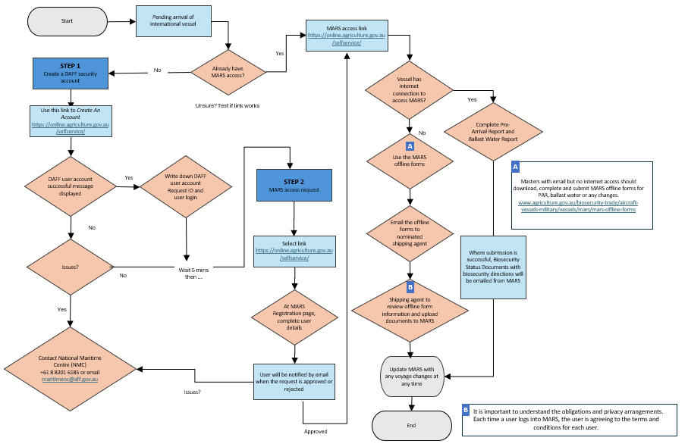
Image: Flowchart demonstrating the 2-stage registration process for MARS access.

First time user registration
First-time registration is a two-step process. Before requesting access to MARS, users must be registered for the department’s online IT web portal, setting up a user account. The web portal hosts all the department’s online systems.

Step 1 – Online portal registration
Access the web portal by entering the following MARS URL link into the web browser’s address bar: https://online.agriculture.gov.au/selfservice/. The Welcome login screen is displayed. To create a new Security Account, select the Create an account link.
The User Registration screen is displayed. Complete all mandatory fields. This window includes challenge questions and answers that are used where a password is forgotten and needs to be reset.
Use an individual work email or personal email address when registering. Do not use the Agency shared email address.
The table below contains specific information for each field. It is important that the guidelines in the table are followed to avoid unnecessary delays in user registration.
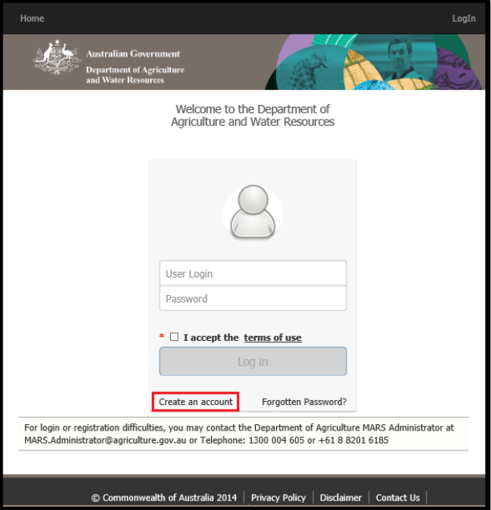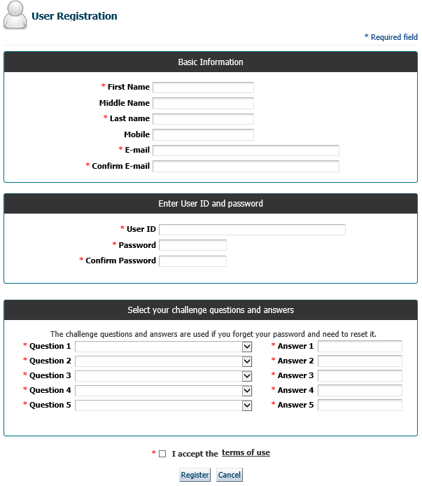
The details entered here create an online Security Account for the user.
Field | Content
First Name | The user’s first name is entered here.
Middle Name | Optional field.
Last Name | The user’s last name.
Mobile | It is recommended that the vessel’s telephone number or the Shipping Company’s telephone number is entered with the international dialling codes.
E-mail | Enter a valid email address to receive confirmation of the registration.
Confirm E-mail | Re-enter the email address.
The email address used here is linked to the User ID and cannot be used more than once for registration. It is advisable that the user use a personal email rather than the vessel’s generic email.
User ID | Users must create a User ID. The User ID remains with the master and must not be passed on to the subsequent Masters.  User IDs are not case sensitive and must consist of 5 or more characters. The User ID must not contain any spaces. Certain special characters can be used. Permissible Special Characters are (@ % . / _ - )  An example of an appropriate User ID: Joe.Smith
Password | Passwords are case sensitive and must consist of 10 or more alpha-numeric characters. Passwords must contain a combination of the following characters:  - One uppercase letter, and  - One lowercase letter, and  - One digit.  Passwords do not expire; however, it is good practice to change passwords every 30 days.
Confirm Password | Re-enter the password.
Incorrectly entered passwords will lock the user’s account for 1 hour after 5 unsuccessful attempts have been made.
Challenge Questions | A minimum of 5 challenge questions must be selected. The same challenge question may not be selected more than once. Answers to the challenge questions are not case sensitive. It is recommended to use a single word for the answer to the challenge question.
Complete all mandatory fields to continue and tick the box to accept the terms of use.
Select the Register button to register the User ID and password with the department. When the registration details have been submitted, a message is displayed stating that the user account was created successfully. Account activation can take a few minutes.
Copy down the Request ID and the User Login. These details are required if the Help desk is contacted to resolve registration issues.
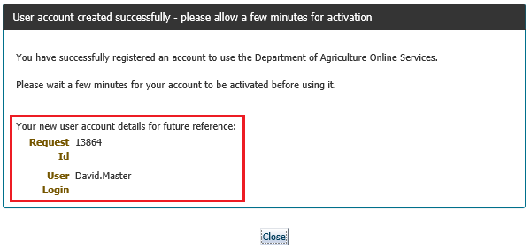

Select the Close button to return to the Log In screen. After a few minutes, enter the User ID and password and select Log In to access the customer portal.
What is next: Users that have successfully created a Security Account with User Id and Password will have to access the department’s customer portal. However, at this stage, users do not have MARS access. The next step is to request MARS access as a Vessel Officer.

MARS access registration
The second step is to request MARS access as a Vessel Officer, agency representative or Administrator of a shipping agency.
Field | Content
Administrator of a New Agency | This role carries certain responsibilities, so the person in each Agency/organisation is responsible and should be selected accordingly.  This role approves access for other Agency Representatives and Vessel Officers. This role has full access to vessel data and the associated agency data in MARS.
Representative of an existing Agency | Agency Representatives approved by the Agency Administrator will have full access to vessel data and the associated agency data in MARS.
Vessel Officer (masters or delegates) | Vessel Officers can submit pre-arrival information and view  information for their vessel. They must report directly into MARS or use offline forms so that their nominated agency can enter this information into MARS on their behalf.

In the Registration page, complete the user details and then Select submit. The user is notified by email when the request is approved or rejected. Access approval may take up to 24 hours.

As an Agency Administrator, users first need to complete the agency details. Complete all mandatory fields. Follow the recommended naming conventions:

Field | Content
Agency Name | To ensure that agencies are clearly distinguished in MARS based on their home port, the department suggests the following agency naming convention:  [Agency Name] [Agency Home Port]  Examples:  INCHCAPE (ISS) PORT  ADELAIDE WILHELMSEN (WSS)  GLADSTONE
Most MARS access requests are sent to and approved by the vessel’s port Agent or the NMC. If the Agent isn’t known or cannot be found during the request or the vessel will arrive in Australia within 48 hours, then the department will action the master’s access request.

Step 2 – MARS registration
- Access the department’s customer portal through the following link: https://online.agriculture.gov.au/selfservice
- Enter the User ID and password.
- Read and accept the terms of use, and select Log In.
- Expand the Request Access section of the customer portal and select the correct user role as per the above table.
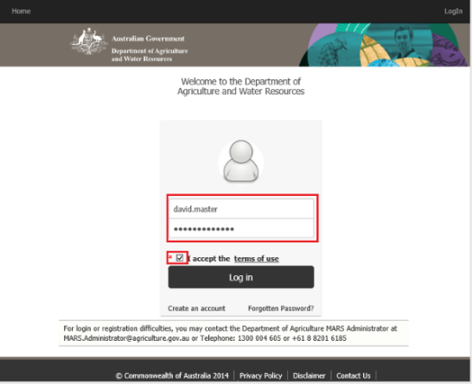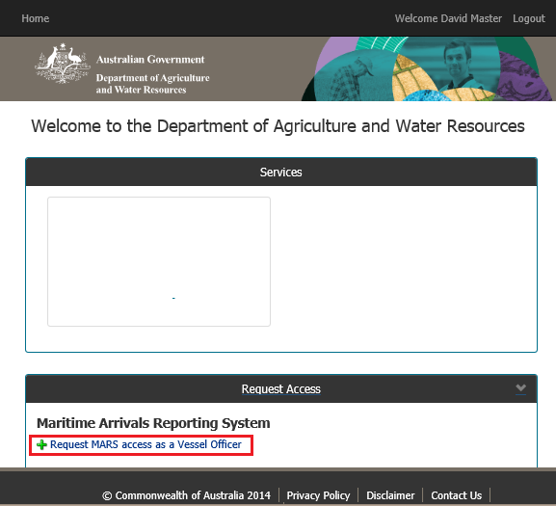
OR
- Complete all mandatory fields. Detailed descriptions of the field contents are in the table below.
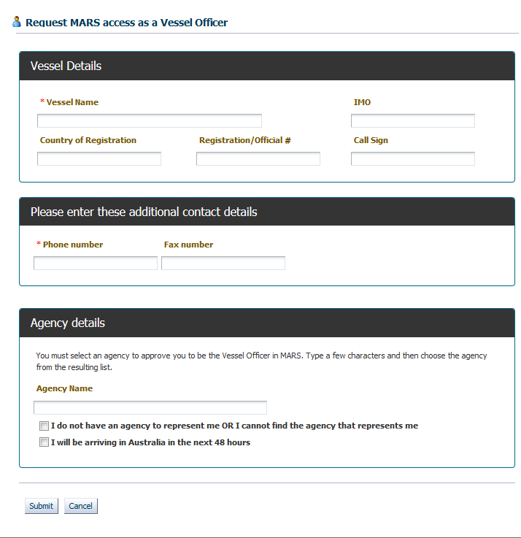
Field | Content
Vessel name | Enter the official full vessel name taken from the Ship’s Particulars.
IMO | Enter the IMO for the vessel. Only official IMO Identification numbers are accepted. The IMO must be a 7-digit numeric identifier.
Call Sign | Enter the Call Sign for the vessel.
Vessel Type | Select from a drop-down list of vessel types.
Registration/Official# | This is an optional field and mainly used for craft without an IMO number or call sign.
Country of Registry | Enter at least the first three letters of the country name and select an option from the drop-down list.
At least one of the IMO or the Country of Registry or the Registration/Official# or Call Sign must be provided.
Vessel Email | This is an important field for the vessel operator to provide an e-mail address which MARS and biosecurity officers use to communicate biosecurity directions, as attachments, with the vessel.  Leave this field blank if the vessel is unable to receive e-mails with attachments.
Phone Number | This is the telephone number of the vessel or the shipping company responsible for the vessel. Include all international dialling codes.
Fax Number | The fax number is optional. If included ensure the international dialing code is included.
Agency Name | Type the first three letters of the Agency name and then select the correct Agency from the drop dowm list.
 | Tick this box where the Agency name is not listed or not associated with an Agency or do not know the name of the Agency representing the vessel at the first port of entry to Australia.
  I do not have an Agency to represent me OR I cannot find the Agency that represents me
If this box is ticked the request for MARS access is sent to the department for approval.
I am arriving in Australia in the next 48 hours | Tick this box if the vessel is arriving within the next 48 hours at an Australian port.
If this box is ticked the request for MARS access is sent to the department for approval.
- Select Submit. The access request is sent to the Agency nominated in the request. The message below is displayed if the request was submitted successfully.
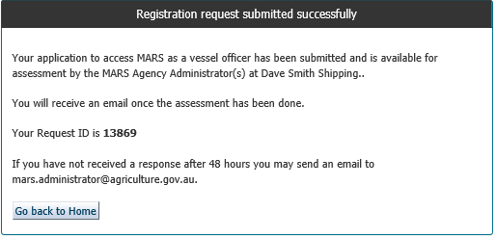
- Vessel access requests are either approved or rejected. The master will receive an email explaining the reasons for rejection or an approval notice.
- For first time MARS access, log into the department’s customer portal with the User ID and password.
- If the access request was approved the MARS icon is available under the Services heading.
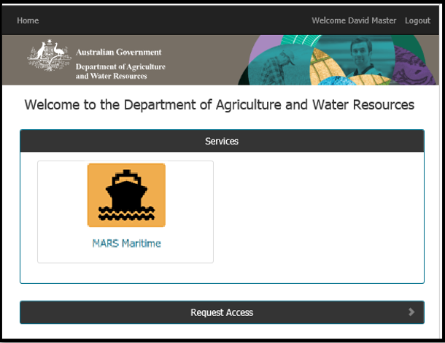

Once a user is approved for MARS access by the NMC, the MARS Maritime icon is visible when the user has signed-in to the department’s customer portal. Only after access is approved will the MARS Maritime icon be accessible.
Selecting this icon 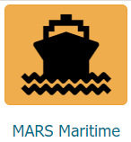opens the MARS application.
Once a user has created and been approved for MARS access, the following icons and menus are visible on the MARS home screen.
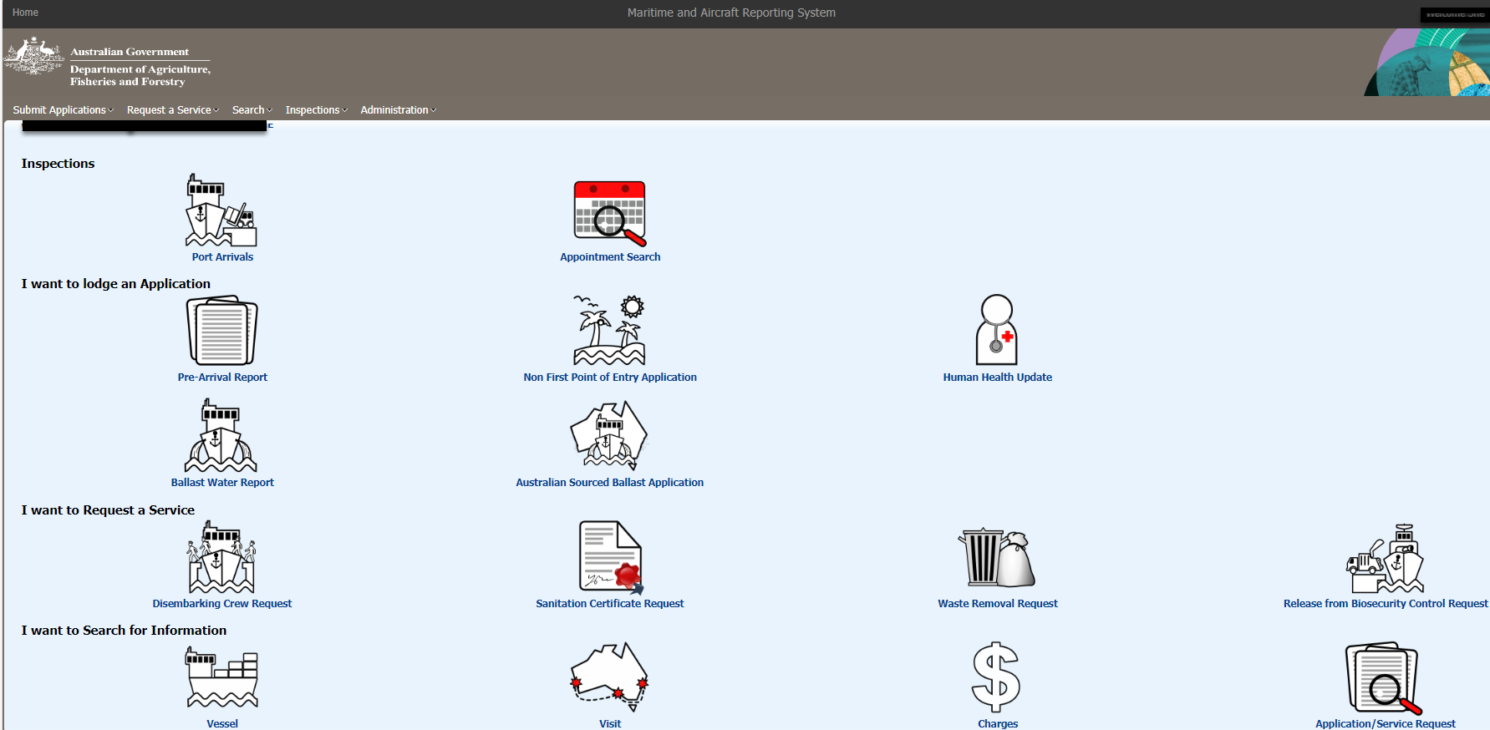

MARS home screen
The MARS home screen has four main sections:
1. MARS Home Screen - Toolbar Home
Selecting Home returns the user to the home page of the department’s customer portal. From here a user can access MARS, access their profile, and request MARS access.
2. Maritime and Aircraft Reporting System
Selecting this hyperlink returns the users to the MARS home screen. The MARS environment the user is logged in to is displayed in brackets.
3. Welcome [User ID]
Selecting this hyperlink takes a user to the Security Account profile screen where the user’s profile and password details can be viewed and updated.
4. Logout
Select the logout button to exit the customer portal and return to the department’s website.

Account maintenance
All external users are able to manage their own Security Account details and passwords. This includes
re-setting a forgotten password, changing a password, and updating security account profile details.

Resetting a forgotten password
If a user forgets their password, they can reset it by following the steps in this section of the User Guide. To reset a password the user must have access to their User ID and the answers to the challenge questions that were configured during the initial security account registration process.
1. Access the department’s customer portal through the link.
2. The Welcome screen is displayed. Select the Forgotten Password link.
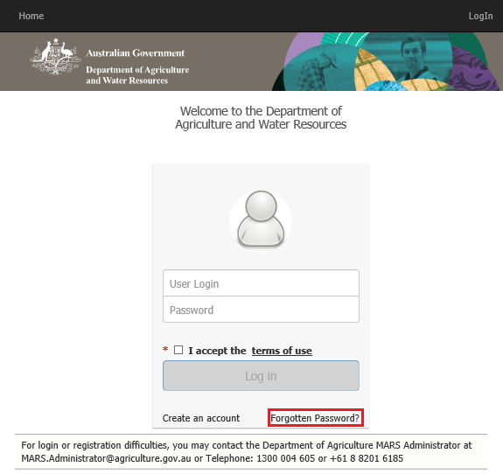
- Enter the User Login (User Id), and Select Next.
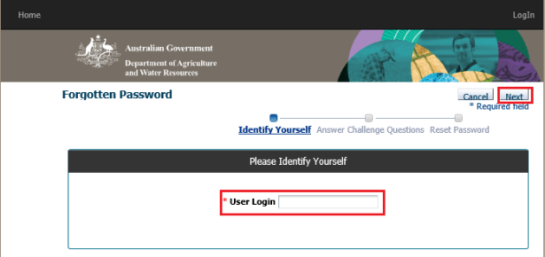
- Answer the challenge questions with the answers that were set during the Security Account registration process. Select Next to continue.
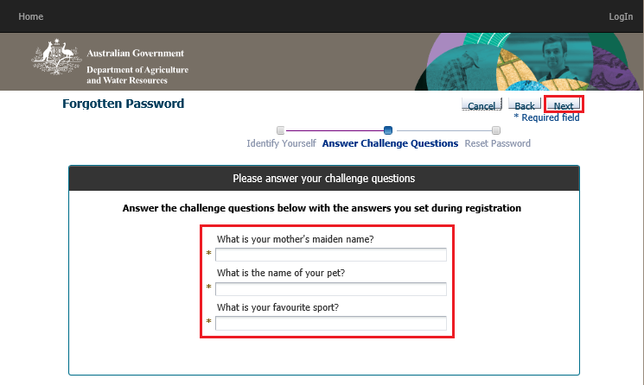
- Enter the new password. Select the Save button.
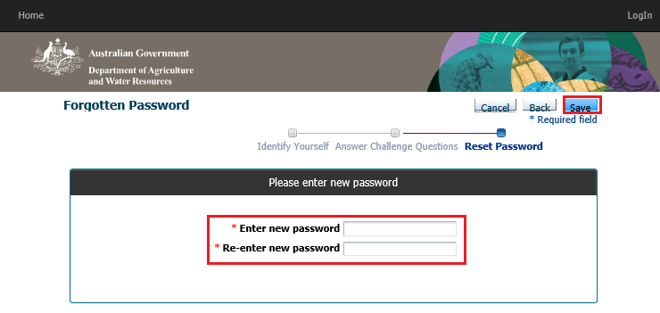
- If the process was successful, the Success screen is displayed.
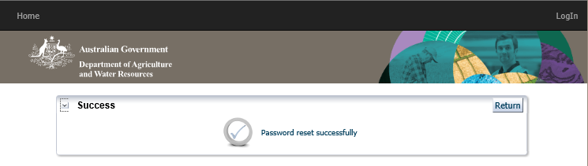

Changing a password
Password changes are not enforced by the department. However, it is good practice to change a password from time to time. The steps below outline the password change process.
- Access the department’s customer portal through the link.
- The Welcome screen is displayed.
- Enter the User ID and password, read and accept the terms of use, and select Log In.
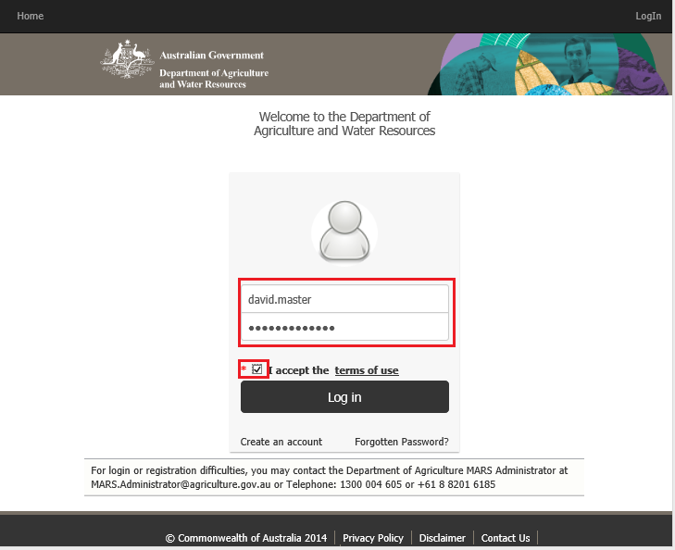
- The department’s customer portal home page is displayed. Select the Welcome [User ID] link at the top right of the page and select Change Password.
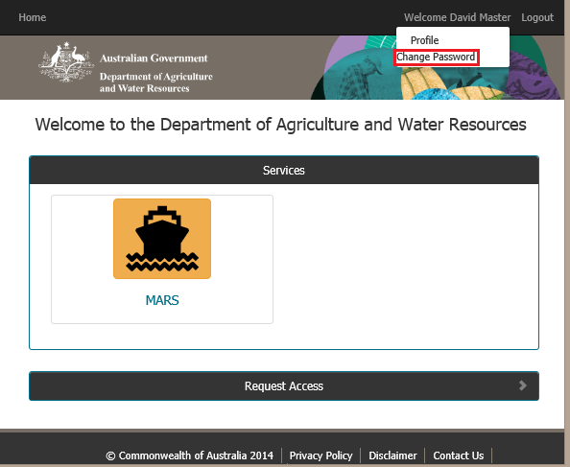
- Enter the current password and then the new password. Select Save.
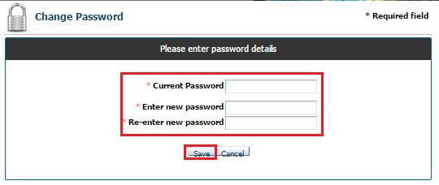

Security Account Profile Update
A user is able to update the Security Account details through the My Profile screen accessed from the Welcome [User ID] link in the department’s customer portal when signed in.
1. Access the department’s customer portal through the link.
2. The Welcome screen is displayed.
3. Enter the User ID and password.
4. Read and accept the terms of use and click Log In.

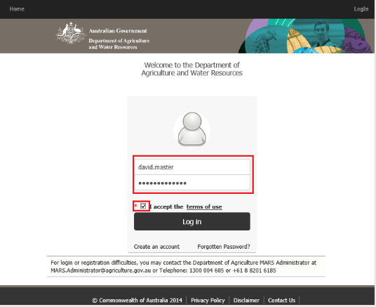
- Select the Welcome [User Name] link at the top right of the page and select Profile from the drop-down menu.
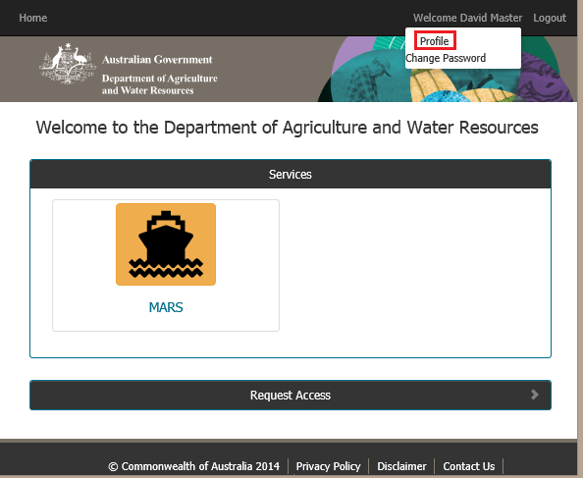
- Update the profile details as required and Select the Update button.
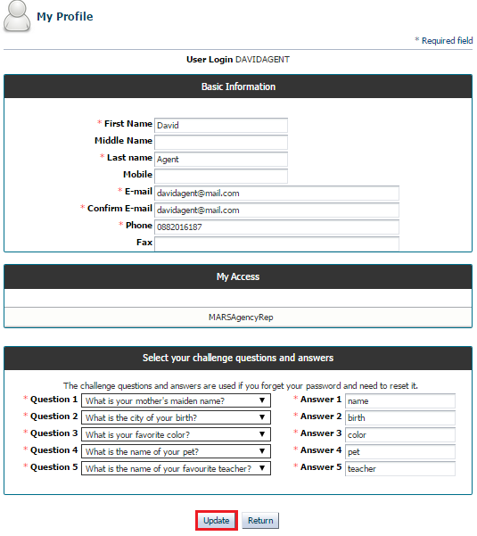
- The user profile has now been updated with the changes.

Shipping agency administrator access

Approving agents and vessels to use MARS
MARS Agency Administrators are responsible for approving MARS access requests from other agents within their organisation, and for vessel officers when requested to represent them.
Agency Administrators may either pro-actively monitor their access request tasks in MARS or require all agents/Vessel Officers to inform them of pending access requests via email. Administrators may also elect to configure other agents as Agency Administrators during the approval process.
Before an Agent can request access to MARS as an ‘Agency Representative’ the following criteria
must be met.

- They must have a departmental Security Account; and
- Their Agency must be an existing Agency already registered in MARS; and
- There must be a MARS Agency Administrator that can approve their request.
When these three initial conditions are met, the prospective Agency representative can then log in to the department’s customer portal, select their Agency from a list, and apply to register as an Agency
Representative for the selected Agency. A task is created for an agency administrator of the
selected Agency to consider the application. Agency Administrators can approve or reject
applications.

Agents may register as representatives of multiple Agencies. Prior to accessing, MARS the Agent
is required to select the Agency they are representing during that session. Agents are required to log
off from MARS and log back in if they want to select a different Agency to represent.

The steps below are used to register as the representative of an existing Agency. Prior to requesting MARS access the Agency representative must already have created a departmental Security Account and have a User ID and password. Access the department’s customer portal through the link.
- Enter the User ID and password.
- Read and accept the terms of use, and select Log In.
- Expand the Request Access section of the main landing page and select ‘Register as a Representative of an Existing Agency’.
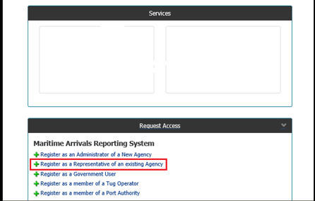
The first section of the registration process requires the selection of a registered Agency.
Field | Content
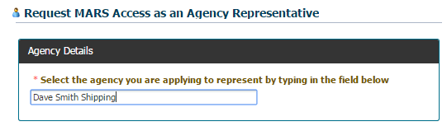
Enter the first three letters of the Agency name. The correct Agency can then be selected from the list of Agencies provided
If the Agency is not listed it means that the Agency has either not been registered in MARS or the Agency name was entered incorrectly.
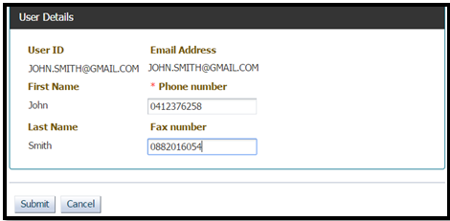
Phone number | The telphone number must include the Australian state dialling code
Select Submit. The access request is sent to the nominated Agency’s MARS Administrator. A message is displayed stating that the registration request was submitted successfully. Make a note of the Request ID.
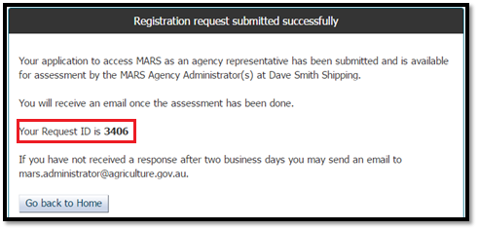
On completion of the assessment by the Agency MARS Administrator an email notification is sent stating whether the registration is approved or rejected, with a rejection reason/s if applicable.
Once the access request is approved, the MARS and My Inbox icons is available when the user is logged in.
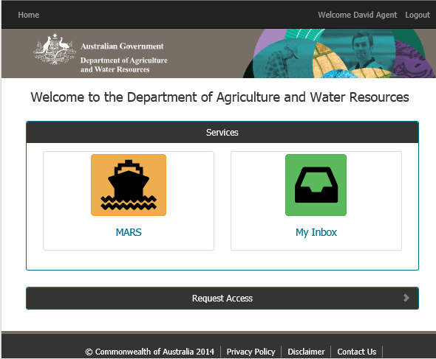
Once an Agency and an Agency MARS Administrator have been registered in MARS the task of approving access for subsequent Agents is with the Agency MARS Administrator. The administrator must verify that the requestor is an Agent with their organisation and only approve legitimate requests. Approved Agents have full access to the Agency’s vessel and Agency data in MARS. The request task is available for action by all Agents registered as Agency MARS Administrators.
The approval process is managed through the My Inbox icon in the department’s customer portal.
The following steps outline the process an Agency MARS Administrator must follow to action an Agent’s MARS access request.
- Access the department’s customer portal through the following link: https://online.agriculture.gov.au/selfservice
- Enter the User ID and password.
- Read and accept the terms of use, and click Log In.
- Select the My Inbox icon to display the available tasks requiring action.
- The Inbox opens in a new browser tab. All access approval requests for the Agency is listed in My Inbox.
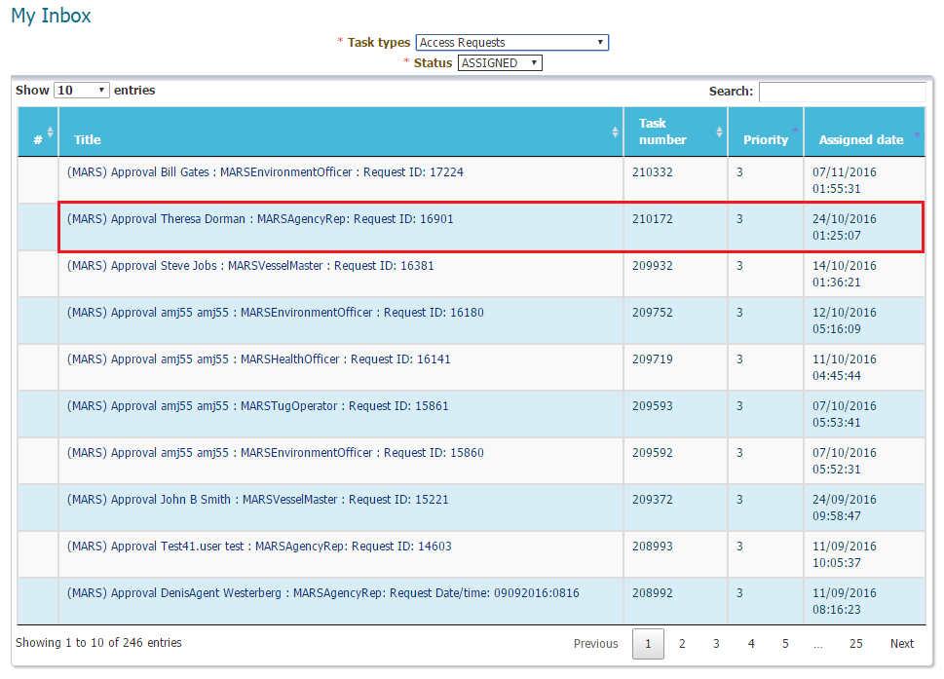
- Select the task that requires approval. A new screen opens. The request details is displayed. Verify the user details. If the user needs to be an Agency MARS Administrator select the checkbox to make this user an additional Administrator. There must always be at least one Agency MARS Administrator registered in MARS.
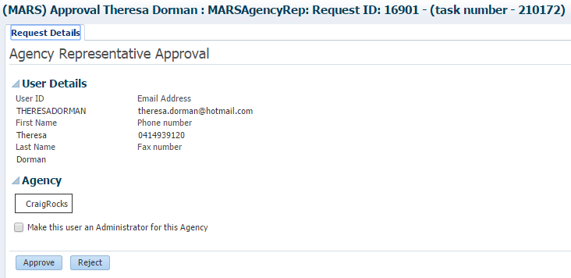
Access requests may either be Approved or Rejected by the Administrator.
User Details | Approval Process
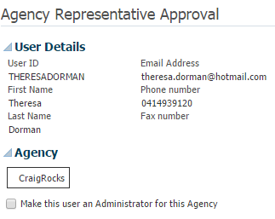 | - User details are read only and cannot be edited by the administrator.  - Verify the User Details to ensure this is a legitimate access request.  - If the request is legitimate Approve the request.  - If the request is not legitimate, Reject the request and provide reasons for the rejection in the dialog box.
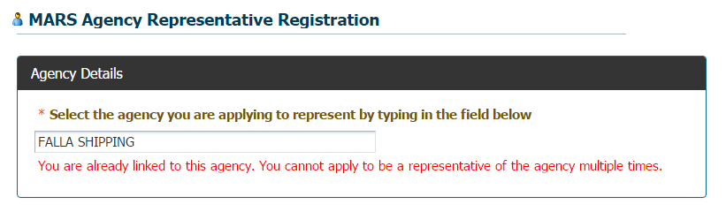 | - A user cannot be associated with the same Agency more than once. This is to ensure there are no duplicate user accounts.  - When a user is already associated with the Agency the access request cannot be generated. The Agent gets a warning message when they go to register if they are already associate with that Agency.  - For a forgotten user ID, search the Agency and User Details screen in MARS will enable the Administrator to forward the correct User ID to the requestor in the rejection notes.  - The requestor may then re-set their password. There is no security risk in giving the user the User ID since the challenge questions required to re-set the password are only known to the correct user.
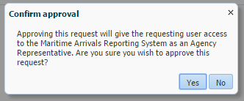 | - If the approver has any doubt about the legitimacy of a registration request the request must be rejected and reasons for rejection entered in the dialog box.  - When a request is approved the terms and conditions are displayed. Click Yes to send the Approval email to the requestor.
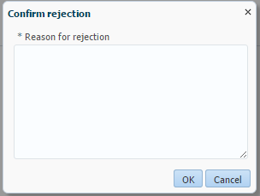 | - When a request is rejected, a reason for the rejection must be added. This reason is sent in the body of the e-mail to the requestor.  - The rejection text must give a clear explanation to the requestor as well as provide follow up steps to take to remedy the issues if applicable. Click OK to send the Rejection e-mail to the requestor.

MARS vessel master registration
This section provides a brief overview for the Agent of the vessel representative (Master) registration process. The Master is responsible for requesting MARS access and the vessel’s Agent is responsible for approving or rejecting the request. The Master is required to register a personal Security Account just like any other external user.
All Masters must have access to the department’s customer portal in order to submit pre-arrival reports on-line using MARS. Without registering a Security Account, the Master will only be able to submit pre-arrival reports via Offline Forms which are emailed to the vessel Agent.
Once the Master has access to the department’s customer portal the next step is to request MARS access. Once approved by the vessel’s Agent the Master can submit pre-arrival documentation directly into MARS.
The table below outlines the information that must be provided by the Master during the registration process. When an Agent receives a request, the details provided must match those in the table below.
Field | Content
Vessel Name | Enter the official full vessel name taken from the Ship’s Particulars.
IMO | Enter the IMO for the vessel. Only official IMO Identification numbers is accepted. The IMO must be a 7 digit numeric identifier.
Country of Registry | Enter at least the first three letters of the country name and select an option from the drop down list.
Registration/Official# | This is a optional field and mainly used for craft without an IMO number or call sign.
Call Sign | Enter the Call Sign for the vessel.
Vessel Name | Enter the official full vessel name taken from the Ship’s Particulars.
At least one of the IMO or the Country of Registry or the Registration/Official# or Call Sign must be provided.
Phone Number | This is the telephone number of the vessel or the shipping company responsible for the vessel. Include all international dialling codes.
Fax Number | The fax number is optional. If included ensure the international dialing code is included.
Agency Name | Type the first three letters of the Agency name and then select the correct Agency from the drop dowm list.
 | Users to tick this box where the Agency name cannot be found or where Agency is not known or do not know the name of the Agency representing the vessel at the first port of entry to Australia.
  I do not have an Agency to represent me OR I cannot find the Agency that represents me
If this box is ticked the request for MARS access is sent to the department for approval.
I am arriving in Australia in the next 48 hours | Tick this box if the vessel is arriving within the next 48 hours at an Australian port.
If this box is ticked the request for MARS access is sent to the department for approval.

MARS vessel master approval
If a Master wants access to MARS to submit pre-arrival documentation, post arrival service requests or human health updates the Master must have access to MARS. This is achieved through the Department Security Account registration and the approval of the MARS Vessel Access request.
The first time a Master requests MARS access it is for the vessel associated with the Agency that is representing that vessel at its first port for that voyage. This is so that the Agency can approve the Master’s access request. For subsequent voyages the Master can select a different Agency as part of the application submission process.
Approval for a Master’s MARS access is managed by any registered Agency Representative. Agency staff must vet the Vessel representative’s access request and either approve it or reject it.
There are, however, circumstances where the department must approve a vessel’s MARS access request:
- The vessel has no Agency relationship.
- Arrival in Australia is imminent.
- Vessel selected by the Master already has a vessel officer assigned.
- User is already linked to another vessel.
- Approval task assigned to Agency Representative has expired.
Approval for vessel MARS access request approval can be managed by all registered Agents in the Agency . Agency staff must vet the vessel’s access request and either approve it or reject it.
- Access the department’s customer portal through the following link:
https://online.agriculture.gov.au/selfservice
- Agent signs in with their online User ID and password
- From the main screen Select the My Inbox icon.
- My Inbox opens in a new browser tab. All the access approval requests for the Agency is listed.
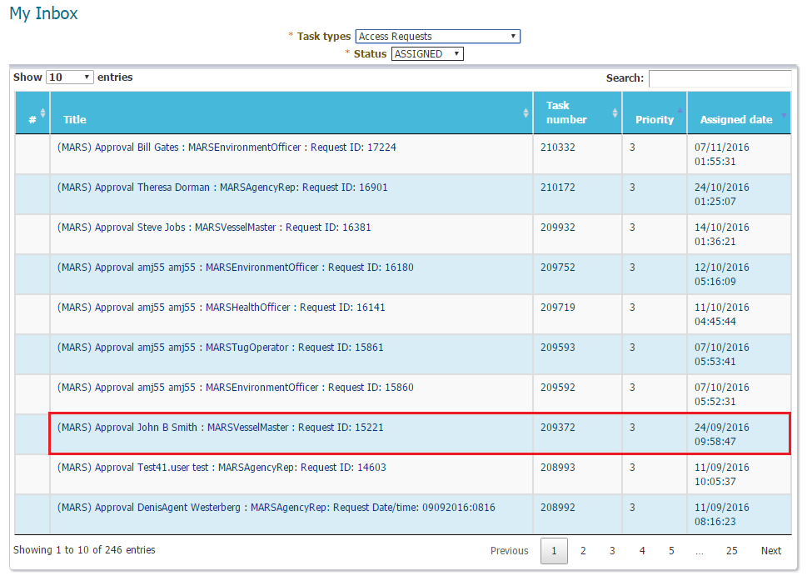
- Select the task that requires approval. The request details is displayed. Verify the User and the Vessel Details.
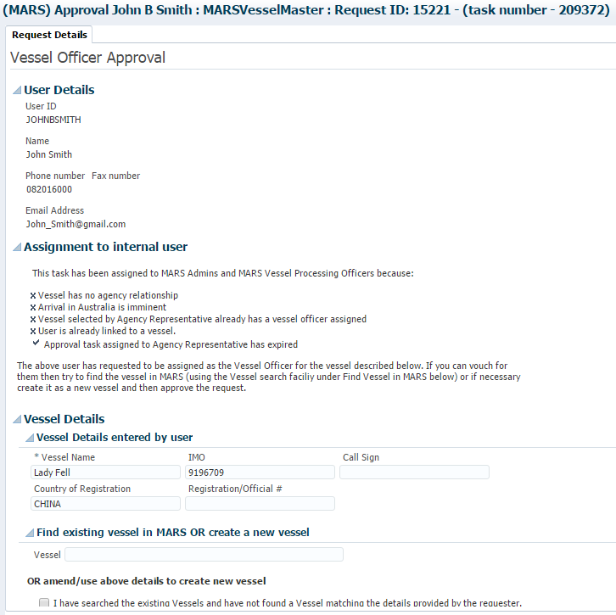
User Details | What to verify
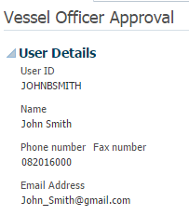 | The user details must be verified to ensure compliance. The vessel details are important to maintain data integrity, avoid multiple user accounts for the same vessel and for correct display in MARS when the Master signs on.  - The name must be the Vessel Master’s. If this isn’t correct, the request must be rejected as above and the user advised in the rejection reason to create a new Security Account with the correct details.  - The email address must be the Master’s email address.
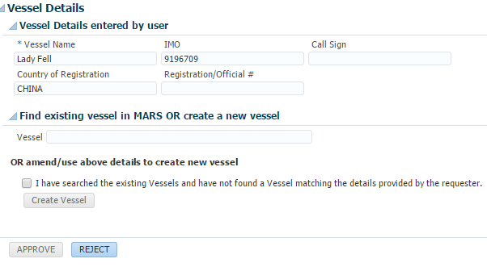 | The vessel details entered by the Master must be verified. Always complete a MARS search using the IMO number to ensure duplicate vessel entries aren’t made or existing vessel details aren’t overwritten with incorrect information.  1. Verify the vessel details entered by searching for the vessel in MARS. If the vessel exists is MARS and there are no changes to the vessel details approve the request.  2. If the vessel’s details in MARS differ from the details supplied by the Master use vessel search engines on the internet to corroborate the changes. If the Agent cannot make a reasonable decision based on the information available reject the request and enter the reasons in the dialog box.  3. If the vessel is not found in MARS check the box to confirm a vessel search was completed in MARS and Select Create Vessel.
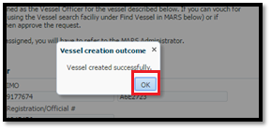 | When a new vessel is created in MARS using the Create Vessel button in the Request Approvals screen the dialogue box on the left is displayed. Select OK to enable the Approve button.
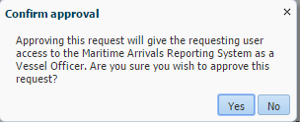 | When a request is approved the terms and conditions are displayed. Select Yes to send the Approval email to the requestor.
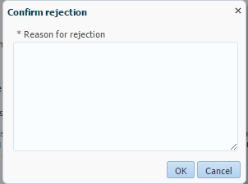 | When a request is rejected, a reason for the rejection must be added. This reason is sent in the body of the e-mail to the requestor.  The rejection text must give a clear explanation to the requestor as well as provide follow up steps to take to remedy the issues if applicable. Select OK to send the Rejection e-mail to the requestor.

Providing access to a Vessel Representative already associated with another vessel
There may be situations where a vessel representative is already associated with a vessel in MARS. If they then request to be associated with another vessel the access request must be forwarded to the NMC for approval.
Note that the statement “This vessel already has a vessel officer assigned” is displayed under the vessel name search. The request cannot be approved and must be referred to a MARS Administrator for approval by selecting the “Refer to MARS Admin” button.

MARS New Agency and Administrator Registration
All Port, Billing and Crew Agencies must be registered in MARS. The initial registration of a new Agency will result in the registration of the ‘Agency MARS Administrator’. Upon submission of the Agency registration request, a task is created for a departmental MARS Administrator to assess whether the registration should be approved.

On completion of the assessment by the department’s MARS Administrator an email notification is sent to the nominated Agency MARS Administrator stating whether the registration is approved or rejected, with a rejection reason/s if applicable.
Follow these steps for new Agencies not already registered in MARS.

- Access the department’s customer portal through the link:
- Enter the User ID and password.
- Read and accept the terms of use, and select Log In.
- From the Request Access section of the department’s customer portal select “Register as an Administrator of a New Agency”.
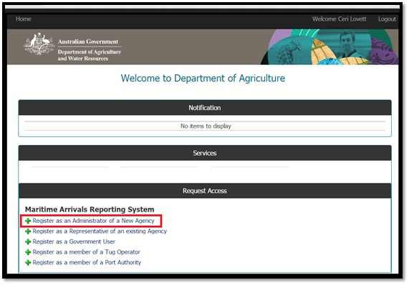
- The first section of the Registration process requires the Agency details. Complete all mandatory fields. Follow the guidelines in the table below.
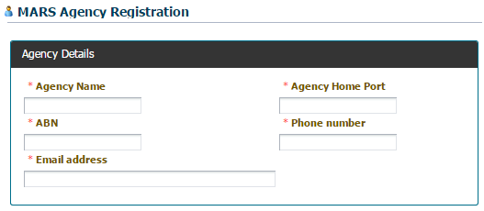

Field | Content
To ensure Agencies are clearly distinguished in MARS based on their home port the department requires the following Agency naming convention: [Agency Name (Abbreviation if in use)]-[Agency Home Port] e.g. Inchcape (ISS) – Port Adelaide.
Agency Name | Enter the Agency’s name with the local port name as described above.
Agency Home Port | This is the home port for the Agency. Particularly important when the Agency services multiple ports. This port should match the port in the Agency name registered above.
Email address | The BSD is emailed to this email address
Phone Number | The phone number must include the Australian state dialling code.
Agency Address | Enter the address details for the Agency.

- The second part of the Registration process is to complete the registering Agent’s details. This person is the first Agency MARS Administrator.
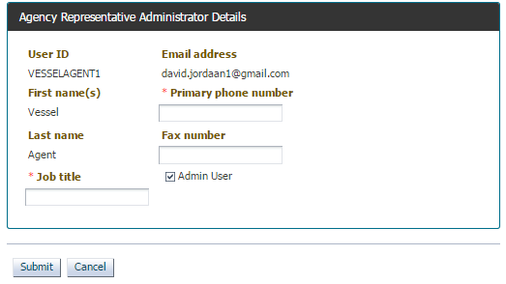
Field | Content
Primary Phone number | The phone number must include the Australian state dialling code.
 | This box is read only and is checked by default when the first Agency user registers.
- Select Submit. The access request is sent to the department for approval.
- Once approval is granted, the MARS icon will be displayed when the user is logged in.
- If the request was successful, the user receives an email advising that MARS access has been approved. The MARS Maritime icon will then be displayed when the user logs in.
- Rejected – If the request was unsuccessful, the user will receive an e-mail explaining why the request is rejected. In this case, users will not see the MARS Maritime icon at log in.

Updating agency details
Once an Agency is registered in MARS, Agency MARS Administrators can update the Agency details such as the Agency name, Agency address and contact details, Agency email address etc.
- Access the department’s customer portal through the link:
- Enter the User Id and password.
- Select the MARS Maritime icon.
- On the MARS home screen select the Agency Name hyperlink.
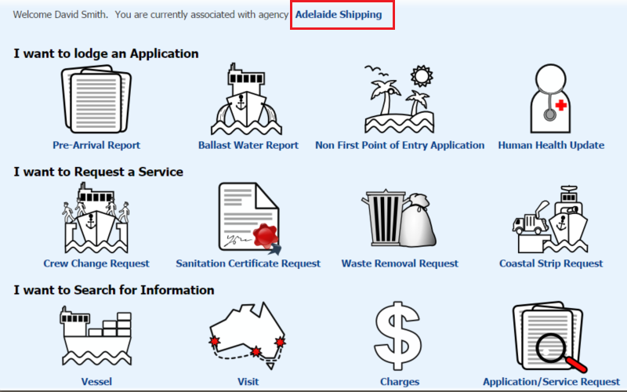
- The Agency and Representative Details screen is displayed. Select the Edit button to edit and update Agency information. Select Submit to save any changes, or select Cancel to exit the screen without saving updates.
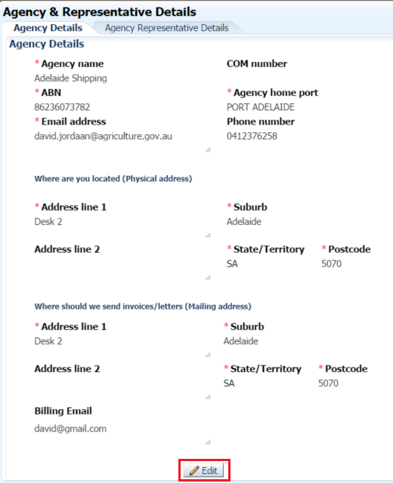

Updating agency user details
Once an Agency has registered users, Agency MARS Administrators can remove users and make a normal user an Agency MARS Administrator.
- Select the Agency Representative Details tab. The details of all MARS users associated with the Agency are displayed.
- To remove a user, select the red cross Action button next to the user’s name.
- To make a user an Admin User, select the Edit button and select the check box.
- Select Update to save the user details.
Important Note: When authorising an Agency Representative and/or Vessel Officer to access and use MARS, users must verify that the requestor is a shipping agent engaged by an organisation, or otherwise that the Vessel Officer is authorised to represent that vessel. Users must only approve legitimate requests, as per the terms and conditions of the Agency Administrator role.
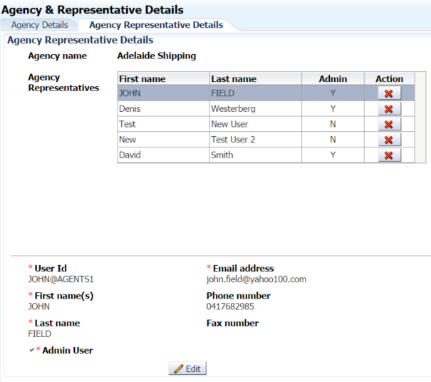

Accessing MARS as a Port Authority, Government Health or ABF Maritime officer user
To use MARS, a one-off registration process is required. Accessing MARS is a simple two-step process, as detailed below. MARS is tailored so users only see the information they require. Registering as a Port Authority allows users to view the following vessel information:
- Vessel and voyage details.
- Applications received including pre-arrival reporting.

Before requesting access to MARS, users must be registered for the department’s online IT web portal, setting up a user account. The web portal hosts all the department’s online systems.

Portal registration
Access the web portal by entering the following MARS URL link into the web browser’s address bar: https://online.agriculture.gov.au/selfservice/
The Welcome login screen is displayed. To create a new Security Account, select the Create an account link. The User Registration screen is displayed. Use an individual work email or personal email address when registering. Complete all mandatory fields. This window includes challenge questions and answers that are used if users forget their password and need to reset it).

Complete all mandatory fields. Select the box to Accept the Terms of Use. Select the Register button to register the User ID and password with the department. When the registration details have been submitted, a message is displayed stating that the user account is successfully created. Account activation can take a few minutes. Select the Close button to return to the Log In screen. Enter the User ID and password and select Log In to access the online portal.

Select the appropriate user access from one of the options below and complete the details then Submit the request. The access request is sent to the department’s NMC for assessment.

Government users include ABF maritime officers and Department of Health officers.
Users receive an email with a link to MARS once access is granted by the NMC. The MARS icon is displayed at login.

Pre-Arrival Reporting (PAR)
Vessel masters entering Australian territory must submit a request through MARS to enter a First Point of Entry. The Pre-Arrival Report (PAR) is completed by a vessel master or agent to notify the department of a vessel’s impending arrival at a First Port of Entry.
The PAR allows the master to report pre-arrival information to the department. The PAR questions seek information about the vessel, the itinerary, sanitation status, human health risks and biosecurity risks on board for each voyage.
The PAR can be accessed either from the Submit Applications drop down menu or by selecting the
Pre-Arrival Report shortcut on the MARS home screen. Reports must either be completed manually in MARS by direct data entry or by uploading a saved XML data file. Both options are described in the steps below.
Masters may elect to submit a PAR directly to their port Agent using the department’s Offline Forms available on the department’s website https://www.agriculture.gov.au/biosecurity-trade/aircraft-vessels-military/vessels/mars/mars-offline-forms.
- Open the Pre-Arrival Report from the MARS home screen. To complete an application each tab must be completed in order of appearance.

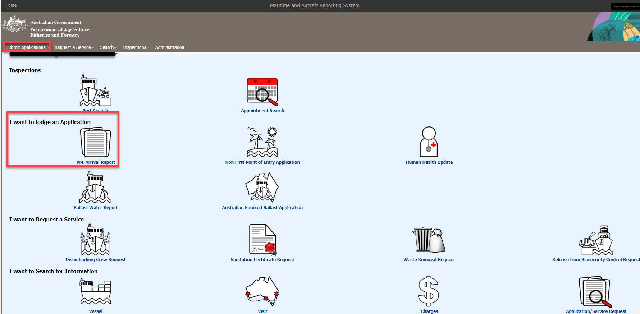

Important Information About This Report
Legal references of the relevant sections of the Act and subordinate legislation that relate to the application. While there are no fields that require completing on this tab, users must be aware of biosecurity requirements and reporting obligations.

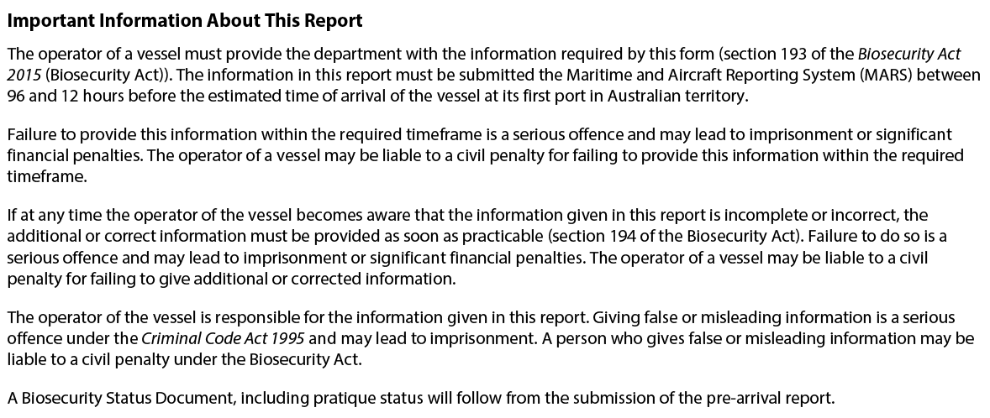

Upload File or Select Vessel

The ‘Upload File or Select Vessel’ tab provides the user with the option to complete a PAR using data from a saved XML Data file.
XML Data files are created by the Pre-Arrival Report PDF Offline Form.

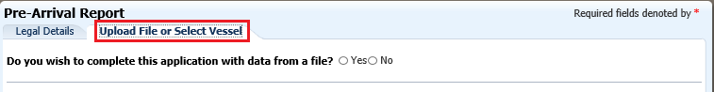

To save time in completing a PAR a Master may complete the PAR Offline Form and then save the file for future use. The Offline Form is saved as an xml file. This xml file is the only file type that can be used in MARS where the option is given to select data from a file.
Upload a PAR to MARS from a Saved XML Data file.

- To complete a PAR using data from an XML file answer ‘Yes’ to the question ‘Do you wish to complete this application with data from a file?’ Select the ‘Browse’ button and navigate to the location where the file is saved on the computer. Once the file is selected the data is automatically uploaded to MARS.
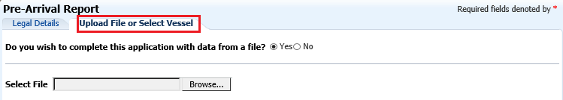
- Select through each of the tabs in sequential order to verify that there are no validation errors and that the correct Agency or Agencies is nominated in the Voyage Details tab.
For more detailed descriptions of each tab in the PAR refer to the sections below.

Completing a manual application using a MARS offline form as an XML data file
To complete a PAR using data from an XML file answer ‘Yes’ to the question ‘Do you wish to complete this application with data from a file?’ Select the ‘Browse’ button and navigate to the location where the file is saved on the computer. Once the file is selected the data is automatically uploaded to MARS.
Select through each of the tabs in sequential order to verify that there aren’t any validation errors and that the correct Agency or Agencies have been nominated in the Voyage Details tab.

Completing a manual PAR in MARS

If the vessel operator wants to create a new PAR and not use an XML data file, select ‘No’ to the question ‘Do you wish to complete this application with data from a file?’ and complete a new PAR using the MARS interface.

The Master can only submit a PAR for the vessel associated with their User ID. If the vessel displayed is not the vessel the Master wants to submit a PAR for then the Master must refer to the MARS Vessel Registration section of this User Guide on how to register the vessel.

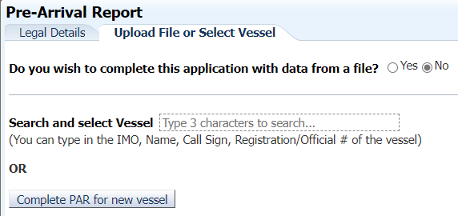
After selecting one of the two options in the screen shot above, the Vessel Particulars tab is displayed and all the vessel details are completed as configured in MARS.

Users must complete the PAR in one session. If the session times out, MARS does not save the information, and the user must start again. MARS has a number of tabs where information must be completed in order to submit the PAR. Each of the screens contains both mandatory * and optional fields.

Vessel Particulars Tab

The Vessel Particulars tab contains both mandatory and optional fields. Complete all mandatory * fields before moving to the next tabs.

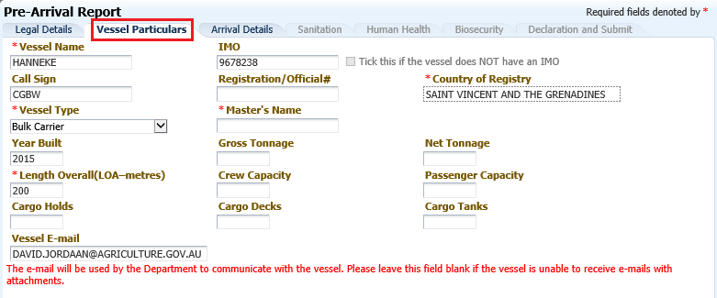

Arrival Details Tab
This screen allows the user to enter voyage related details including the vessel’s itinerary while in Australia. It also allows the user to nominate the port Agency details. This screen contains both mandatory * and optional fields.
Data entry fields are type assisted. At least 3 letters of the full Agency or port name must be entered before a drop down list appears. If the responsible Agency does not appear contact the Agent.
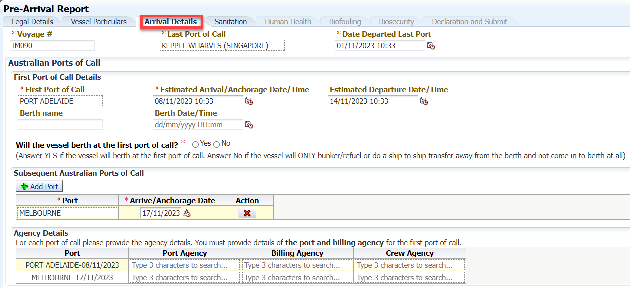
Field | Content
Voyage# * | The voyage number is a unique identifier for each voyage a vessel undertakes to Australia. The voyage number must match the number on the PAR, Ballast Water, Human Health Update or NFP application for the current voyage. Alpha-numeric characters and dashes  (-) are accepted. Spaces are not allowed.
Last Port of Call Name * | Enter the last international port the vessel visited before arriving in Australian territory.
Date Departed Last Port * | Enter the date of the last interntional port.
First Port of Call * | Enter the first Australian port the vessel will visit.
Estimated Arrival/Anchorage Date/Time * | Use the calendar icon to select the date/time the vessel intends to arrive/anchor and select ‘OK’.
Estimated Departure Date/Time | Use the calendar icon to select the date/time the vessel intends to depart the port and select ‘OK’.
Berth name | Enter the name of the berth where the vessel intends to arrive.
Berth Date/Time | Use the calendar icon to select the date/time the vessel will berth and select ‘OK’.
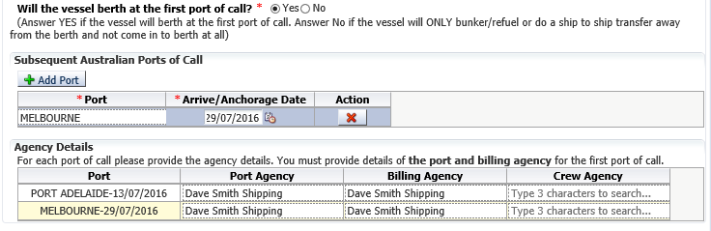
* | Answer ‘Yes’ if the vessel isrth at the first port of call in Australia. Answer ‘No’ if the vessel is only bunkering/refueling or conducting ship to ship transfer away from the berth and not coming in to berth at all.
 | Select the Add Port button to enable the data entry fields. Use this button to add all the subsequent ports the vessel intends to visit in Australia during the current voyage.
Port * | Enter the subsequent Australian Port the vessel intends to visit.
Arrive/Anchorage Date * | Use the calendar icon to select the estimated date the vessel intends to arrive/anchor.
 | Use this button to delete any subsequent ports that were added in error.
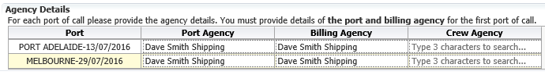
Port | This field automatically pre-populates with information entered by the user in the ‘First Port of Call’ and ‘Subsequent Australian Ports of Call’ fields.
Entering the Port Agency for each Australian Port is mandatory. If the Billing and Crew Agency fields are not completed, MARS assumes that the Port Agency is also the Billing and Crew Agency for that port.
After a PAR is submitted, the port, billing and crew agencies all receive a MARS automated email stating they have been nominated as the port, billing, and crew agents for that vessel’s voyage. This is each agent’s opportunity to contact the NMC and change any details that are needed.
Port Agency | For each port enter the Port Agency that will represent the vessel at the port.  Any invoices for the listed port (except crew change activities) are billed to this Agency.
Billing Agency | For each port enter the Agency nominated by the Master of the vessel to facilitate payment of accounts at the listed port.  Any invoices for the listed port (except crew change activities) is billed to this Agency.
Crew Agency | For each port enter the Agency nominated by the Master of the vessel to facilitate crew disembarkations at the listed port. Any crew disembarkation activities at the listed port is billed to this Agency.

Sanitation
Report the vessel’s Ship Sanitation Certificate (SSC) details. Masters can attach a copy of the SSC to the application. If a new SSC is necessary, the inspection can be requested in this screen.
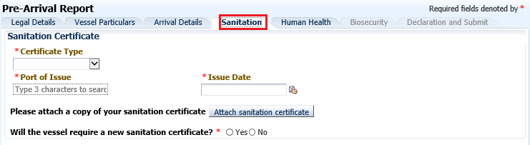
Field | Content
Certificate Type * | The certificate type can be selected by selecting the down arrow and choosing the appropriate type. Four options are displayed:  Control Certificate  Extension Certificate  Exemption Certificate  Not applicable  If the vessel does not have a sanitation certificate the Master should select the ‘Not applicable’ option. Selecting this option will automatically remove some of the mandatory sanitation screen fields.  If the vessel has a Control Certificate in place an additional field will auto-populate. The Master must consult the original Control Certificate to note the reason the certificate was issued for.The Master must provide ‘Control Details’ by select the down arrow and selecting the most applicable option:Documentation; Human Health; Rodents vector; Other; Mosquito Vector.
It is very important the Master ensures the vessel complies with the conditions stated on the Control Certificate to manage the associated risks. Breaches may apply for not following the instructions on the Control Certificate.
Port of Issue * | Enter the port where the Ship Sanitation Certificate was issued.
Issue Date * | Enter the date the Ship Sanitation Certificate was issued.
Attaching a sanitation certificate | To attach a sanitation certificate, select the Attach sanitation certificate button. Select the ‘Browse’ button and navigate to the location where the certificate is saved.  Once the certificate is attached, additional documents can be added by selecting the ‘Update’ button and repeating the steps above. Additional documents need to be attached if the original certificate was not scanned into one document. Attached documents can be viewed by selecting the ‘View sanitation certificate’ hyperlink.
Will the vessel require a new sanitation certificate? | Answer ‘Yes’ if the vessel requires a Ship Sanitation Certificate to be issued when it arrives in Australia. This automatically queues a Ship Sanitation Certificate Inspection for the vessel. Answer ‘No’ if the vessel has a current and valid certificate.
In Australia Ship Sanitation Certificates may only be issued at a Determined Port. Consult the department’s website for a list of Determined Ports. Ship sanitation certification - DAFF (agriculture.gov.au) and/or Australia’s Federal Register of Legislation for the ship sanitation scheme.

Human Health
Effective human health practices are essential to protect Australia from serious listed human diseases that can arrive with international travellers.
After lodging the PAR, the master or agent must report any changes in crew or passenger health during the voyage.
Users must use the Human Health Update to report human health issues post arrival for the next port to be visited; and to update the Department of Health about the human health risks on board international commercial vessels.
Where illness on board the vessel is reported, the vessel master must answer additional questions to assess the public health risk associated with the vessel prior to arrival at each port visit.
Biosecurity officers assess the Human Health Update. Where there are no identified risk factors, users receive a Biosecurity Status Document(BSD) by email which communicates the department’s biosecurity conditions. The BSD is emailed to the agent. The vessel’s email address must be included in the Vessel Details section of the PAR for the master to receive a copy of the BSD.
All questions about each individual’s human health must be answered. All health questions are mandatory. Questions change in MARS from time to time, depending on current human health risks.

Biofouling
The questions in this section are used to determine the vessel’s biosecurity status. When a question is answered more fields will appear that require additional information. The table below details the requirements of each question.
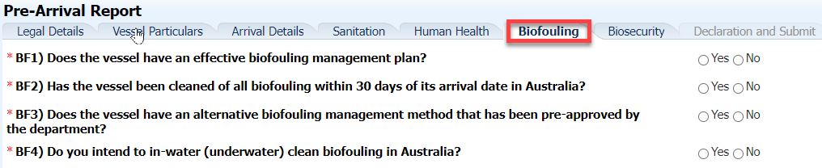
Field | Content
Does the vessel have an effective biofouling management plan? * | Yes or no answer
Has the vessel been cleaned of all biofouling within 30 days of its arrival date in Australia? * | Yes or no answer
Does the vessel have an alternative biofouling management method that has been pre-approved by the department? * | If the users answers ‘No’ additional fields are displayed.
Do you intend to in-water (underwater) clean biofouling in Australia? * | Yes or no answer

Biosecurity
The questions in this section are used to determine the vessel’s biosecurity status. When a question is answered more fields will appear that require additional information. The table below details the requirements of each question.
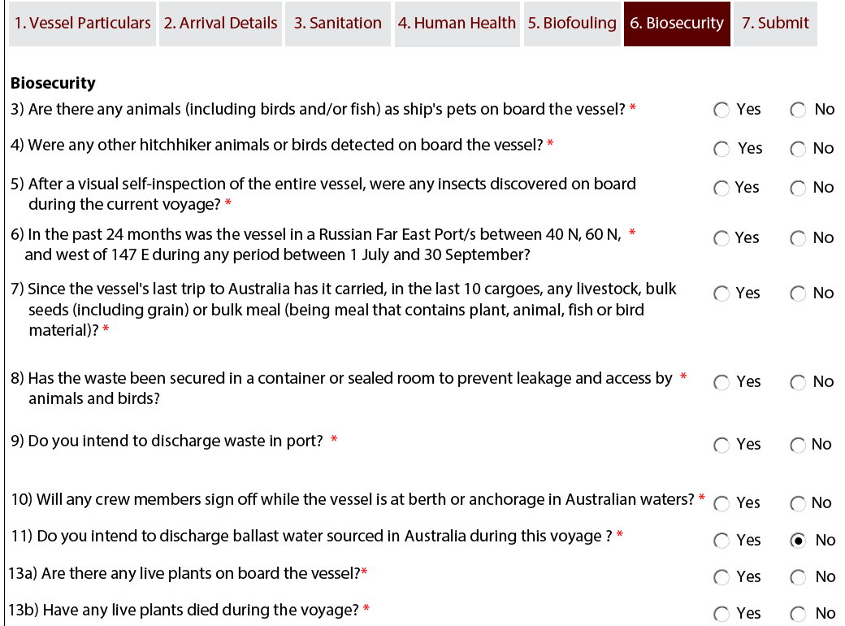
Field | Content
Are there any animals on board? | Answer ‘Yes’ to this question if the vessel has any ship’s pets on board.
 | Select the Add Row button to enable the data entry fields. This section is specifically for vessel pet/s. If the vessel does have any pet/s on board, Select the Add Row button to display the additional fields. Add a new row for each type of pet’s.
Type of Animal * | Options are Bird, Cat, Dog, Other. Select the type of pet animal from the list.
Number of Animals * | Enter the number of pet animals.
Description (Including health condition) | Enter a detailed description of the pet including identifying markings. Also include the health status of the pet/s.
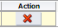 | Use this button to delete any rows that were added.
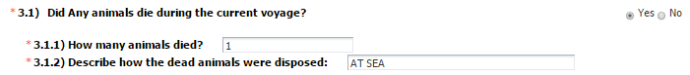Answer ‘Yes’ to this question if any of the ship’s pets have died during the current voyage
How many animals died? * | Enter the total number of all the animals that died.
Describe how the dead animals were disposed * | Enter the details of how the dead animals were disposed of. If the animals are still on board include the details in this section.
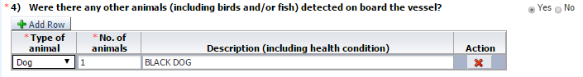
Answer ‘Yes’ to this question if there were any animals on board the vessel during the current voyage. This question does not pertain to livestock or animals being carried as cargo. Animals carried as cargo (goods) must be reported.
 | Select the Add Row button to enable the data entry fields. This section is specifically for animals other than vessel pets and include stray animals or birds which have flown onto and remained on the vessel during the voyage. If the vessel does have any animals on board, Select the Add Row button to display the additional fields. Add a new row for each type of animal.
Type of Animal * | Options are Bird, Cat, Dog, Other. Select the type of animal from the pick list.
Number of Animals * | Enter the number of animals.
Description (Including health condition) | Enter a detailded description of the animal including identifying markings. Also include the health status of the animal.
 | Use this button do delete any rows that were added.
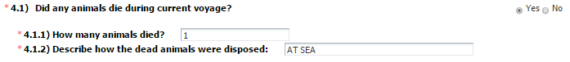
Answer ‘Yes’ to this question if any of the animals died during the current voyage.
How many animals died? * | Enter the total number of all the animals that died.
Describe how the dead animals were disposed * | Enter the details of how the dead animals were disposed of. If the animals are still on board include the details in this section.
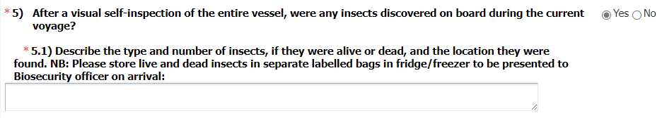
Answer ‘Yes’ to this question if any insects were discovered on board the vessel during the current voyage.
Describe the insects and their location when discovered * | Detailed description of the insects and where they were discovered must be entered in this field.
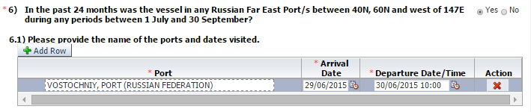
Answer ‘Yes’ to this question if the vessel travelled to any Far East Russian ports between the specified latitudes and longitudes and during the dates specified in the previous 24 months.
 | Select the Add Row button to enable the data entry fields. Add a row for each port that was visited.
Port * | Enter the Far East Russian port name.
Arrival Date* | Enter the date the vessel arrived at the Far East Russian port.
Departure date and Time * | Enter the date and time that the vessel departed from the Far East Russian port.
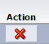 | Delete any rows that were added.
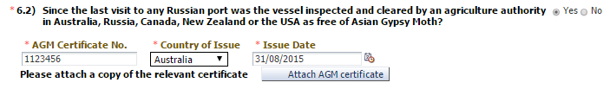
Answer ‘Yes’ to this question if the vessel was inspected in any of the named countries and received an AGM freedom certificate from the local government authorities.
AGM Certificate Number * | Enter the reference number of the AGM certificate.
Country of Issue * | From the drop down box select theAGM certificate issuing country.
Issue Date * | Enter the date the AGM certificate was issued.
AGM certificates must be attached to the PAR by selecting the ‘Attach AGM certificate’ button.The Master must select the ‘Choose File’ button and navigate to the location where the certificate is saved.
Once the certificate is attached, additional documents can be added by selecting the ‘Update’ button and following the above directions. Additional documents must be attached if the original certificate was not scanned into one document.
Attached documents can be viewed by selecting the ‘View AGM certificate’ hyperlink.
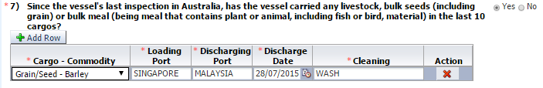
Answer ‘Yes’ to this question if the vessel had carried any commodities as cargo (goods) listed in the question.
 | Select the Add Row button to enable the data entry fields. Add a row for each commodity. If the same commodity was loaded and/or discharged at multiple ports add additional rows to reflect this.
Cargo or Commodity * | Select the commodity the vessel carried from the drop down list. Add a new row if multiple commodities were carried.
Loading Port * | Enter the port where the cargo was loaded onto the vessel.
Discharging Port * | Enter the port where the cargo was discharged.
Discharge Date * | Enter the cargo discharge date.
Cleaning * | Enter the details of the cleaning that was done to remove any residual cargo from the vessel.
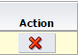 | Delete any rows that were added.
Answer ‘No’ to this question if the vessel has any issues with regard to maintaining waste securely on board. Especially if the waste facilities are inadequate in dealing with the amount of waste being generated.
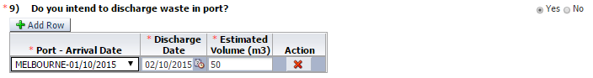
Answer ‘Yes’ to this question if the vessel intends to discharge waste during its current Australian territory voyage.
In Australia vessel waste must only be discharged at certain First Points of Entry. Consult the department’s website for a list of First Points of Entry.
 | Select the Add Row button to enable the data entry fields. Add a row for each port where the vessel is discharging waste.
Port and Arrival Date * | The drop down box only contains the port and date of arrival that was reported in the Arrival Details. If the port is not available for selection the port arrival details must be updated first. Select the port where the waste discharge is intended to take place.
Discharge Date * | Enter the date the waste discharge is likely to occur.
Estimated Volume (m³) * | Enter the estimated volume of waste to be discharged.
 | Delete any rows that were added.
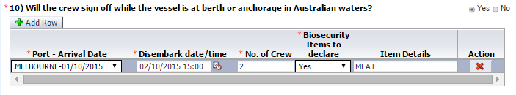
 | Select the Add Row button to enable the data entry fields. Add a row for each port where crew is signing off. If multiple crew sign off at different times or with different biosecurity items to declare add multiple rows.
Port and Arrival Date * | The drop down box only contains the port and date of arrival that was reported in the Arrival Details tab. If the port is not available for selection the port arrival details must updated first. Select the port where the crew will sign off.
Disembark Date and Time * | Enter the date and time the crew is leaving the vessel.
Number of Crew * | Enter the number of crew that is leaving the vessel.
Biosecurity Items to Declare | Select ‘Yes’ or ‘No’ depending on whether the crew have items to declare. If unsure about the biosecurity status of an item select ‘Yes’ and enter the details in the next field.
Item Details | Enter the details of the items that are removed from the vessel.
 | Delete any rows that were added.
Answer ‘Yes’ to this question if the vessel intends to discharge ballast water in Australia during the current voyage.
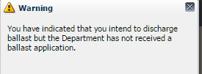 | If a Master or shipping agent has not submitted a ballast water discharge application to the department then a warning message is displayed.
Vessels intending to discharge ballast water in Australia must submit a Ballast Water report. No ballast must be discharged without written permission from the department.
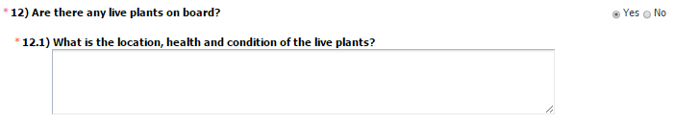
Answer ‘Yes’ to this question if the vessel:
- has any live plants on-board.
- had any live plants that died during the voyage.
A general statement as to the location, health and condition of the plants is required here.
For cruise vessels, detailed information must still be supplied on the Live Plant Vessel log. When a cruise vessel declares plants on board on the PAR, the Live plants conveyance log is sent to the vessel operator email address supplied in the PAR through an automated process in MARS.
The live plants log must be emailed to the NMC once per voyage. The original document must be retained onboard with the vessel’s log for inspection by a biosecurity officer.

Declaration and submission
The completed Pre-Arrival Report can now be submitted. The person submitting the PAR must read the legal notice and acknowledge that the information supplied is true and correct prior to submission. Breaches may apply for any omissions or miss-declarations in the PAR.
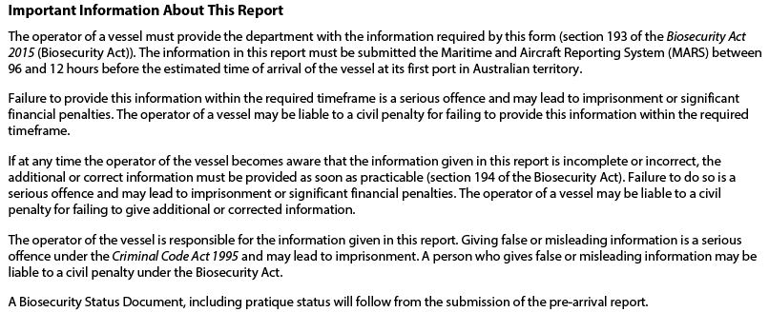
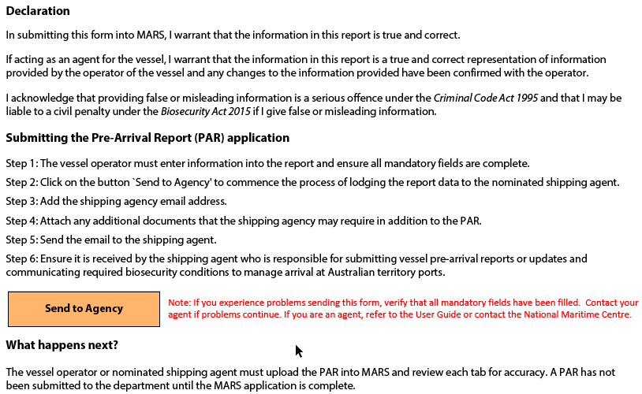
Field | Content
In submitting this form into MARS, users warrant that the information in this report is true and correct.
If acting as an agent for the vessel, I warrant that the information in this report is a true and correct representation of information
provided by the operator of the vessel and any changes to the information provided have been confirmed with the operator.
 | By selecting the Submit button the PAR is uploaded into MARS for assessment. Once the assessment is completed the vessel and Port Agency will receive a Biosecurity Status Document (BSD) with the directions that are applicable to the vessel’s current voyage.
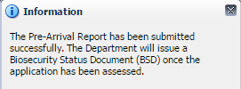 | This message is displayed if the PAR application was successfully submitted to MARS.

Livestock statement
The Livestock Statement tab is accessible on the PAR when the vessel type is ‘Livestock Carrier’. The Master must complete the sections to the Statement.
While the Livestock Statement questions are optional, incomplete information may delay the vessel’s biosecurity assessment and inspection.
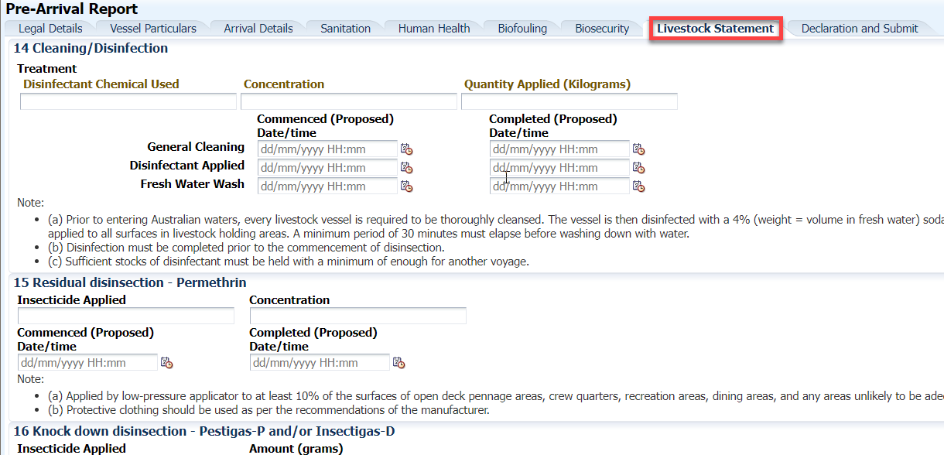
Field | Content
Disinfectant Chemical Used | After the vessel is thoroughly cleaned the vessel must be washed down with a Soda Ash Solution or equivalent chemical solution. Enter the product name in this field.
Concentration | The Soda ash applied must be in a 4% solution. This means 4 Kg of soda ash in every 100 Litres of water.
Quantity Applied | Enter the quantity of soda ash applied in kilograms. The amount of water used must also be recorded in the vessel’s logbook.
General Cleaning Dates and Times | Enter the dates and times when the general cleaning of the vessel commenced and was completed. Vessels must not be cleaned in Australian waters.
Fresh Water Wash Dates and Times | After the soda ash solution had been applied as directed all areas must be washed down with fresh water. This washing down must commence at least 30 minutes after the soda ash solution was applied to a surface. Enter the dates and times when the freshwater wash down commenced.
Disinfectant Applied Dates and Times | Enter the dates and times when the application of soda ash commenced and was completed.
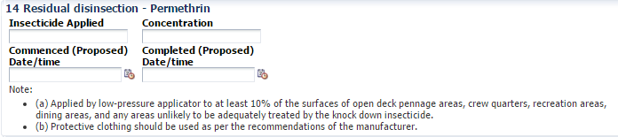
Insecticide Applied | Enter the brand name of the insecticide applied. The active ingredient must be Permethrin.
Concentration | Enter the concentration of residual insecticide used.
Residual Disinsection Dates and Times | Enter the dates and times the disinsection commenced and were completed.
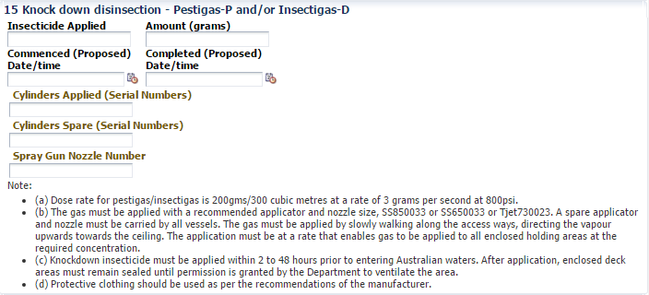
Insecticide Applied | Enter the name of the insecticide applied. Either Pestigas or Insectigas must be used.
Amount | Enter the amount of disinsectant used in grams.
Disinsection Dates and Times | Enter dates and times when knock down disinsection commenced and was completed.
Cylinders Applied (Serial Numbers) | Enter the serial numbers of all the insecticide cylinders used.
Cylinders Spare (Serial Numbers) | Enter the serial numbers of all the spare insecticide cylinders.
Spray Gun Nozzle Number | Enter the nozzle size used on the insecticide cylinders. The correct nozzle sizes are described in the Notes in section 15 on the Statement.
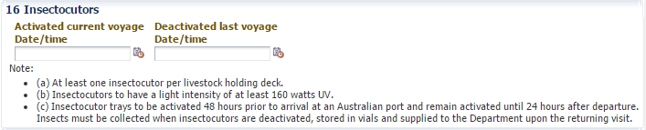
Activated Current Voyage | Enter the date and time the insectocutors were activated during the current voyage. The insectocutors must be activated 48 hours prior to arrival at an Australian port.
Deactivated Last Voyage | 24 Hours after departure from an Australian port the insectocutors must be de-activated. Enter the date and time the insectocutors were de-activated when the vessel last visited an Australian port.
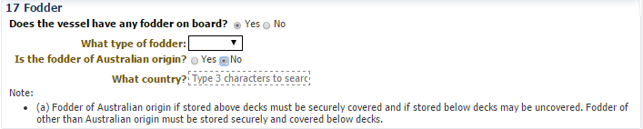
Does the vessel have fodder on board? | Answer ‘Yes’ if the vessel has any fodder on board.
What type of fodder? | If answered ‘Yes’ then select the type of fodder – Pellets or Hay.
Is the fodder of Australian origin? | Answer ‘Yes’ if the fodder is of Australian origin.
What Country? | If ‘No’ type the name of the country of origin.
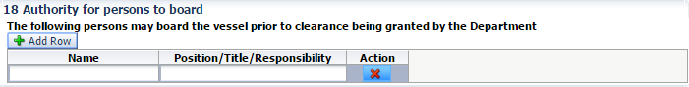
Name | Enter the name of any person requiring access to the vessel prior to biosecurity clearance being given.
Position/Title/Responsibility | Clearly enter the position or title or area of responsibility of the person requiring access to the vessel.
Australian or New Zealand Origin | Select ‘Yes’ if the vessel has only carried animals which originated in Australia or New Zealand during the previous voyage. For all other countries of origin enter ‘No’.
Country of origin | If ‘No’ was selected, then this field is displayed. Enter the name of the country where previous carried livestock originated.

Ballast Water Reporting
Ballast water must be managed in compliance with the Australian Ballast Water Requirements and International Maritime Organization (IMO) Regulations to ensure that exchange and discharge within Australian territory is managed in an approved manner.
Ballast water informs the biosecurity risk management of the vessel’s ballast water. Every tank must be reported. Where a tank or tanks have been exchanged after being reported (where the vessel ballast status has changed), a revised ballast report must be submitted.
Ballast water reports should be submitted no later than 12 hours before a vessel enters Australian territory.
The master must submit a Ballast Water Report if the master intends to discharge ballast water in Australian territory, or if it has already done so. The Ballast Water Report includes information about the vessel, arrival details, ballast water questions and the ballast tank information.
The BW Report can be accessed either from the Submit Applications drop down menu or by selecting the BW Report shortcut on the MARS Home screen. Reports must be completed manually in MARS by direct data entry or by uploading an XML Data file. Both options are described in the steps below.
Masters may elect to submit a BW Report directly to their port Agent using the department’s offline forms available on the department’s website www.agriculture.gov.au/biosecurity-trade/aircraft-vessels-military/vessels/mars/mars-offline-forms
Open the BW Report from the MARS home screen. To complete a report each tab must be completed in order of appearance.
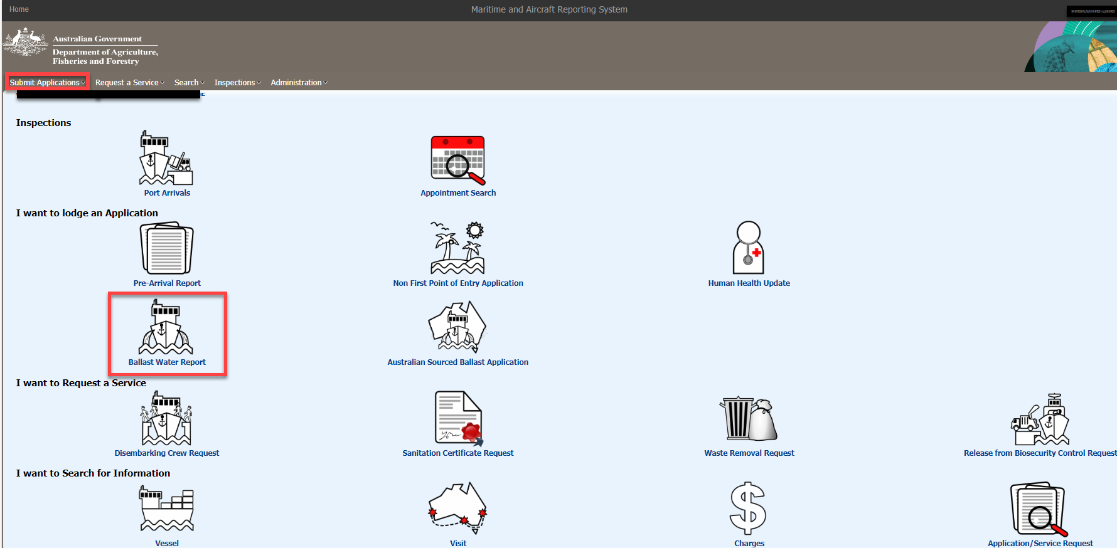
Upload File or Select Vessel
The ‘Upload File or Select Vessel’ tab provides the user with an option to complete a BW Report using data from a saved XML Data file. XML Data files are created by the BW Report Adobe PDF Offline Form.

Upload a Ballast Water Report from a MARS Offline Form, XML data file
- To complete a BW Report using data from an XML file answer ‘Yes’ to the question ‘Do you wish to complete this application with data from a file?’ Select the ‘Browse’ button and navigate to the location where the file is saved on the computer. Once the file is selected the data is automatically uploaded to MARS.
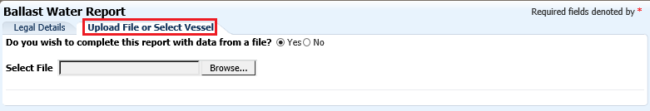
- Select and verify the details in each of the tabs, in sequential order, to ensure all mandatory fields are complete.

Completing a manual Ballast Water Report in MARS
If no XML data is available, select ‘No’ to the question ‘Do you wish to complete this application with data from a file?’ and complete a new BW Report.
If the vessel has Ballast tanks or cargo holds being used as ballast tanks, then select ‘Yes’ to the question ‘Does the vessel have Ballast/Heeling tanks or cargo holds being used as ballast tanks?’.
The Vessel Particulars tab is displayed and the vessel’s details as recorded in MARS are displayed. Complete all fields before continuing.
If ‘No’ is selected the user is informed that the BW Report does not need to be submitted. Select ‘Ok’ to close the BW Report.
The Master can only submit a BW Report for the vessel associated with their User ID. If the vessel displayed is not the vessel the Master wants to submit a BW Report for then the Master must refer to the MARS Vessel Registration section of this User Guide on how to register the vessel.
The BW Report must be completed in one session. If a timeout occurs the information is not saved and the user must start the application from the beginning.

Complete all the ballast water questions, noting they are mandatory. Some questions have additional fields to complete once answered.

Vessel Particulars
The vessel’s particulars screen establishes the vessel’s profile with ballast tank and pump configurations. The Vessel Particulars screen has three sections:
- Vessel Details – Contains the generic vessel profile details.
- Ballast Water Tank Details – This section must contain all the ballast water tanks on board the vessel. Tanks must be included even if they are not used on a regular basis to carry ballast. This includes ballast tanks that are filled with fresh water and empty tanks.
- Ballast Pump Details - This section must contain all the pumps that are used for ballast water management. This includes the fire pumps if they are used to manage the ballast water in certain tanks.

Arrival Details
Enter the information for all the fields in the Arrival Details screen. The voyage number must be the same as the voyage number used on all other reports or applications for the same voyage. This means that the Pre-Arrival Report (PAR) must have the same voyage number as the BW Report, which is essential for MARS to link the MARS reports.
NOTE: The Port Agency must be listed in MARS. If the nominated Port Agency does not appear in the drop-down box then the Master must contact the Port Agency and request the details of the Agency’s registration. The ballast water report cannot be submitted without a valid Port Agency.
Field |  | Content
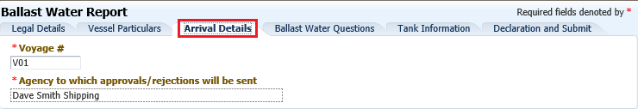
Voyage # | The voyage number is a unique identifier for each voyage a vessel undertakes to Australia. The voyage number must match the number on the PAR, Ballast Water, Human Health Update or NFP application for the current voyage. Alpha-numeric characters and dashes (-) are accepted. Spaces are not allowed.
Agency to which approvals/rejections are sent | Enter the name of the Agency that will represent the vessel at the first Australian port of call. The Biosecurity Status Document (BSD) with the approval status of the ballast tanks is sent to the Agency listed here.

Tank Information
Record and display all the ballast water management details of the ballast water tanks that were listed on the Vessel Particulars tab.
Enter information for all the tanks listed as they must have details recorded in this screen. This screen serves as a display grid, for each management method used. Use the separate pop-up screen to enter the appropriate ballast management data.

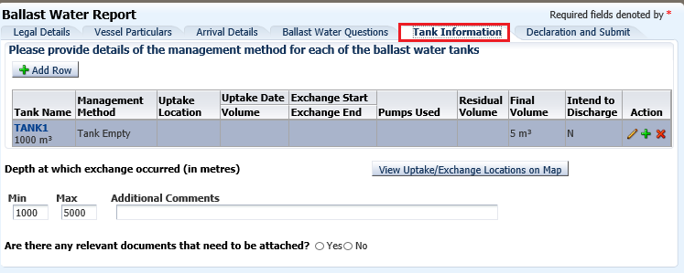
Field | Content
 | This button must only be used to add an additional row for tanks where the exchange method is either Empty/Refill or Flow Through. No other management method can be used for the same tank more than once. This is to cater for scenarios where the exchange must be recorded over two lines.
Actions | Use this function to edit and enter the tank ballast management details.  Use this function to add an additional tank row for tanks managed through the Flow Through or Empty/Refill method only.  Use this function to remove a row that was added manually.
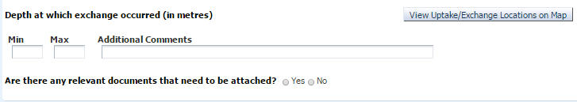
Min – MAX – The minimum and maximum depths the exchange of ballast water took place.
Additional Comments – Add any comments to clarify the ballast water management process if it cannot be clearly explained by the data entered only.
 | Once all the exchange coordinates have been entered the exchange locations for all tanks can be viewed on a map.
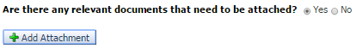
Answer ‘Yes’ to this question if any documents need to be attached to the Ballast Water report that may be used in assessing the application. Attach any files as necessary i.e. The Ballast Water Management System Certificate.
For each tank listed in the BW Report data must be entered to show how the ballast water was managed for that tank. Data can be entered by selecting the Tank Name hyperlink or by selecting the edit function
This opens a pop-up screen where the tank and the management method must be selected from a drop-down list. The management method selected will determine the data fields that need to be completed. Complete all mandatory fields marked with red asterisk (*).

Field | Content
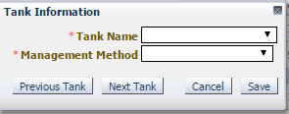 | Navigate between tanks by using the Previous Tank and Next Tank buttons. Details can be saved after each tank; however this will take the user back to the main tank grid.  The entered data will be lost if the session times out and the fields have not been saved.
Empty/Refill
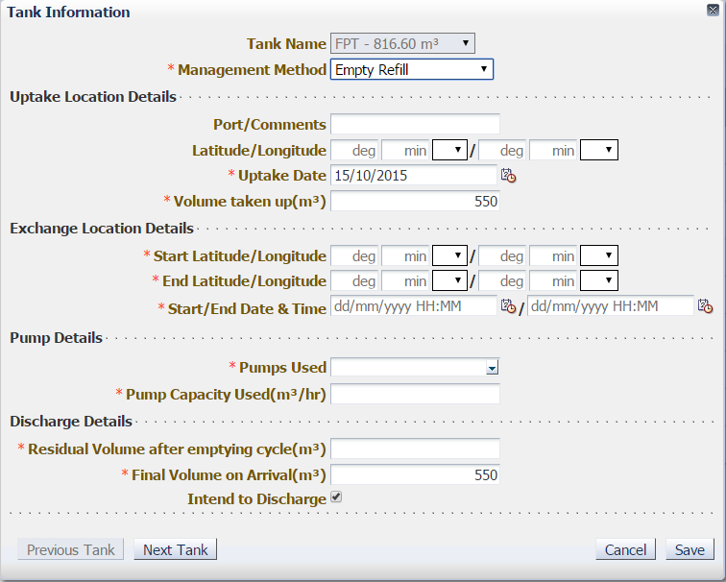 | Tank Information – Select the correct details from the drop-down lists. Details are taken from the Vessel Particulars tab and can be amended there.  Uptake Location Details – Enter the name or the coordinates of the place where ballast water was taken up, uptake date and volume of water.  Exchange Location Details – Enter all the information of the exchange details.  Pump Details – Pumps and pump capacity are taken from the Vessel Particulars tab, and can be amended there.  Discharge Details – Enter the residual volume left in the tank after the empty cycle of the exchange is completed. Enter the final volume of water in the tank on arrival in Australia and tick the box if there is any intention to discharge the ballast from this tank in Australian waters.
Flow Through/Dilution
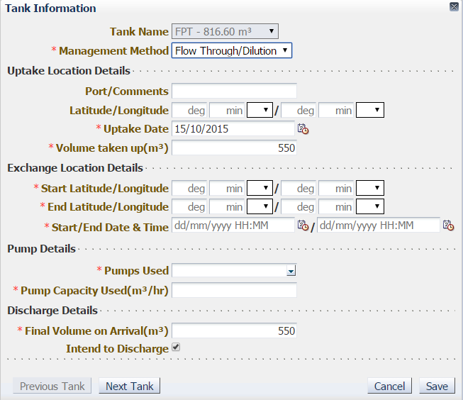 | Tank Information – Select the correct details from the drop-down lists. Details are taken from the Vessel Particulars tab and can be amended there.  Uptake Location Details – Enter the name or the coordinates of the place where ballast water was taken up.  Exchange Location Details – Enter all the information of the exchange details.  Pump Details – Pumps and pump capacity are taken from the Vessel Particulars tab, and can be amended there.  Discharge Details – Enter the final volume of water in the tank on arrival in Australia and tick the box if there is any intention to discharge the ballast from this tank in Australian waters.
Management System – Vessels using an IMO approved on-board ballast management system
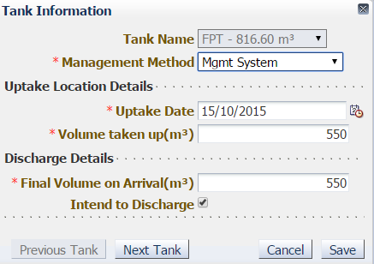 | Tank Information – Select the correct details from the drop-down lists. Details are taken from the Vessel Particulars tab and can be amended there.  Uptake Location Details – Enter the uptake date and the volume of ballast water that was taken up.  Discharge Details – Enter the final volume of water in the tank on arrival in Australia and tick the box if there is any intention to discharge the ballast from this tank in Australian waters.
Empty Tank
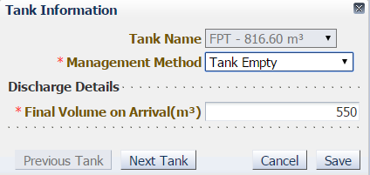 | Tank Information – Select the correct details from the drop-down lists. Details are taken from the Vessel Particulars tab and can be amended there.  Final Volume on Arrival – The soundings on the tank must be accurate and reflect the residual volume of water left in the tank. The Final Volume is the actual amount of water in the tank not the overall volume of the tank.
Mid Ocean Uptake
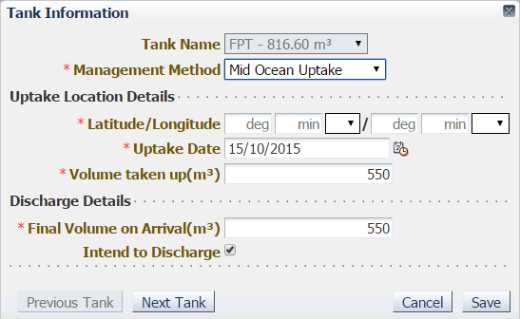 | Tank Information – Select the correct details from the drop-down lists. Details are taken from the Vessel Particulars tab and can be amended there.  Uptake Location Details – Enter the date, volume of water and the coordinates of the place where ballast water was taken up.  Discharge Details – Enter the final volume of water in the tank on arrival in Australia and tick the box if there is any intention to discharge the ballast from this tank in Australian waters.
Australian Water – Water taken up inside the Australian Territorial Sea
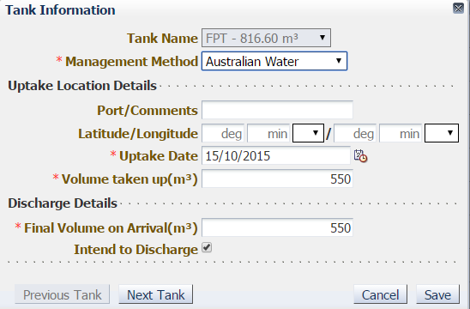 | Tank Information – Select the correct details from the drop-down lists. Details are taken from the Vessel Particulars tab and can be amended there.  Uptake Location Details – Enter the date, volume of water and the coordinates or the name of the place where ballast water was taken up.  Discharge Details – Enter the final volume of water in the tank on arrival in Australia and tick the box if there is any intention to discharge the ballast from this tank in Australian waters.
Fresh Potable Water – Clean fresh water
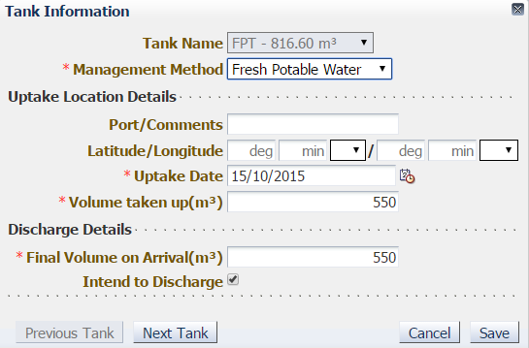 | Tank Information – Select the correct details from the drop-down lists. Details are taken from the Vessel Particulars tab and can be amended there.  Uptake Location Details – Enter the date, volume of water and the name or coordinates of the place where ballast water was taken up.  Discharge Details – Enter the final volume of water in the tank on arrival in Australia and tick the box if there is any intention to discharge the ballast from this tank in Australian waters.
Unmanaged
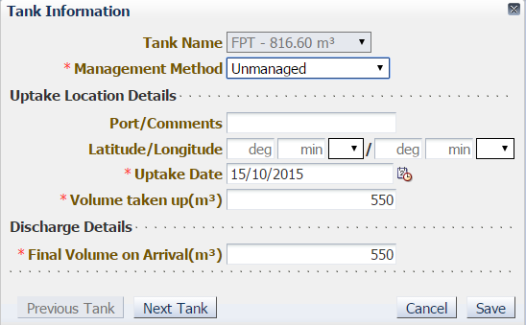 | Tank Information – Select the correct details from the drop-down lists. Details are taken from the Vessel Particulars tab and can be amended there.  Uptake Location Details – Enter the date, volume of water and the coordinates or the name of the place where ballast water was taken up.  Discharge Details – Enter the final volume of water in the tank. This tank will not receive permission to discharge ballast in Australian waters.
Other
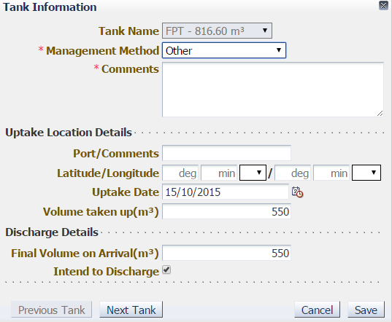 | Tank Information – Select the correct details from the drop-down lists. Details are taken from the Vessel Particulars tab and can be amended there.  Comments – Enter the details of why the management method is other and ballast water status. Comments are needed to manually assess the risk of this tank.  Uptake Location Details – Enter the date, volume of water and the coordinates or the name of the place where ballast water was taken up.  Discharge Details – Enter the final volume of water in the tank on arrival in Australia and tick the box if there is any intention to discharge the ballast from this tank in Australian waters.

Declaration and submission
The user must read the legal notice and acknowledge that the information supplied in the report is true and correct prior to submission. Breaches may apply for any omissions or miss-declarations in the BW Report.
Following successful submission, the BW Report submission date, time and the name of the person who submitted the application are displayed. All fields are read only, and no amendments can be made to the application.
If the vessel’s ballast status changes, a new BW Report must be submitted. Every tank must be reported on the new BW Report, not just the tank with the changed status. To minimise data entry, the MARS Ballast Water Clone function can be used. Refer to the section below ‘Clone a BW Report in MARS’ for a detailed explanation on how to use this feature. 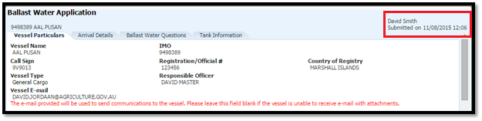

Cloning a ballast water report
A vessel master or nominated shipping agent may need to submit an updated BW Report for the current voyage. When MARS determines that a previous BW Report already exists for the voyage,a user may choose to pre-fill the new BW Report with the information from the previous report.
Select the Ballast Water Report icon. From the Upload File or Select Vessel tab select ‘No’ to the question ‘Do you wish to complete this application with data from a file?’.
Select ‘Yes’ to the question ‘Does the vessel have Ballast/Heeling tanks or cargo holds being used as ballast tanks?’. The Vessel Details screen is displayed with the details of the vessel the Master’s User ID is associated with. Enter the name of the Responsible Officer.
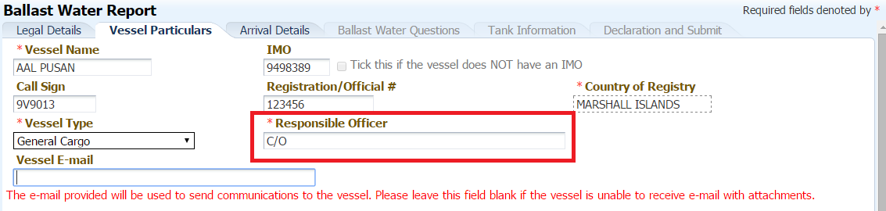
Select the Arrival Details tab and enter the same voyage number that was used in the BW Report that needs to be re-submitted. A Confirmation dialog box is displayed. Select ‘Yes’ to pre-fill the application with the previous BW Report’s details.
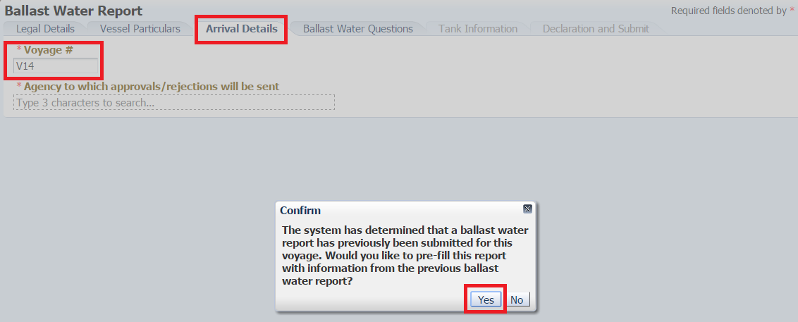
Verify that the Agency is correctly displayed on the Arrival Details tab.
Verify the answers to the questions on the Ballast Water Details tab are correct.
Update the Tank Information tab. Any changes to the BW exchange details must be made in this tab using the Edit function or by selecting the Tank Name hyperlink.
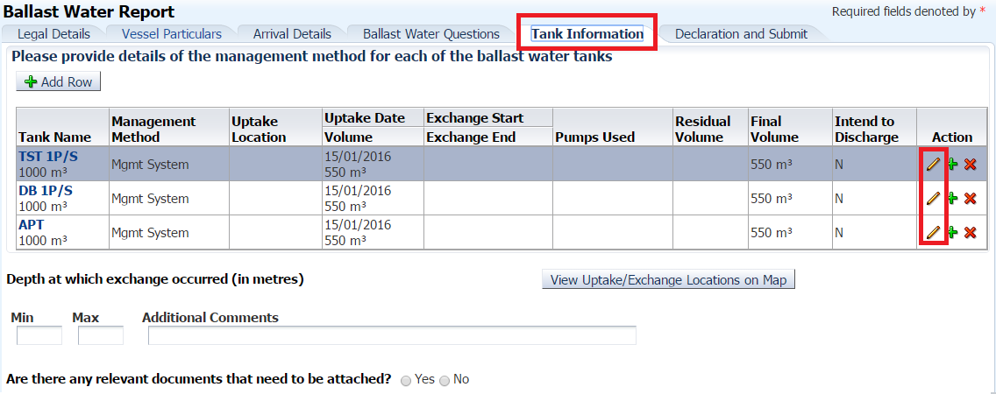
Complete the Declaration and Submit tab and Submit the ballast water report.

Australian sourced ballast water
Under section 208 of the Biosecurity Act 2015, vessels must manage all ballast water taken up and intended for discharge in Australian waters according to the latest version of the Australian Ballast Water Requirements.
Vessels may be eligible for exemptions from managing Australian sourced ballast water between specific ports, where the ballast transfer is determined to be low risk. This is known as a low-risk exemption.
To apply for a low-risk exemption, a vessel’s Responsible Officer must complete the Australian Sourced Ballast Application in MARS.
Apply for a low-risk exemption at any time prior to discharge including:
- when planning a voyage path that includes Australian ports
- at the time of arrival in the uptake port or
- prior to entering the intended discharge port.
As a Responsible Officer, users have the option of entering data directly into MARS or uploading it in PDF format from a computer. Both options are described in the steps below.
- Log into MARS.
- Select the MARS icon followed by the Australian Sourced Ballast Application icon on the MARS home screen.
- Review the Legal Details tab, and then go to the Upload File or Select Vessel tab.
- Select Yes to complete the application with data from a saved offline form (then go to Step 7), or select No for direct data entry (then go to Step 11).
- The offline form (MARS offline form domestic risk assessment application PDF) can be downloaded from agriculture.gov.au/mars-offline-forms. All fields on the form must be completed prior to submission.
- At the end of the form users are instructed to select the Send to Agency button. This attaches the form in XML format to an email. Then send the email to the nominated Agent.
- The Agent receives the email and must save the XML file to the computer.
- The Agent must select the Choose File button and navigate to the location where the file is saved on the computer. Once the file is selected, the data is automatically uploaded to MARS.
- The Agent should look at each of the tabs to check that all the fields are completed correctly.
- The Responsible Officer is prompted to either Search and select a Vessel already registered in MARS or Complete a DRA for a NEW Domestic Vessel.
- Selecting the vessel name from the search field opens the Vessel Particulars tab with pre-populated details of the vessel. You must include the vessel’s email address, so users receive a copy of the Domestic Risk Assessment Outcome (DRAO) report once the application is assessed by biosecurity officers.
- Selecting the Complete DRA for NEW Domestic Vessel button opens the Vessel Particulars tab without any pre-populated information. Complete the vessel details.
- Ensure the Vessel Email field is completed. The Domestic Risk Assessment Outcome (DRAO) report will be emailed following the application assessment. Users can add more than one email address where the DRAO should be sent to more than one recipient.
- Complete the details in the Domestic Ballast Water Details tab by selecting Add Row.
- In the Declaration and Submit tab, read the privacy notice, check the acknowledgement box, and submit the application.
A confirmation message is displayed if the ballast water report was submitted successfully. Biosecurity officers assess the application, and a DRAO is sent to the nominated email address. The DRAO indicates the risk rating of each ballast movement. The DRAO must be stored in the ballast water records to be a valid low risk exemption.

Non-First Point of Entry Port (NFP) Applications
Vessels must not arrive at an Australian Non-First Point of Entry without (prior) written permission from the department.
Applications for entering a NFP as either a first port or subsequent port of entry should be made at least 10 days prior to the vessel’s arrival at the port.
Use the NFP application for vessel arrivals and/or the discharge of cargo/goods/waste at a Non-First Point of Entry. Certain Determined First Ports of Entry also require an NFP to be submitted for the discharge of certain types of goods or waste. Refer to the department’s webpage for further details.
Masters or nominated shipping agents may elect to submit an NFP application directly to their port Agent using the MARS Offline Forms available on the department’s webpage, MARS offline forms.
The NFP application only lists the Non-First Points of Entry; the NFP application cannot be used to list the vessel’s complete itinerary. The vessel’s complete itinerary must be supplied on the PAR.
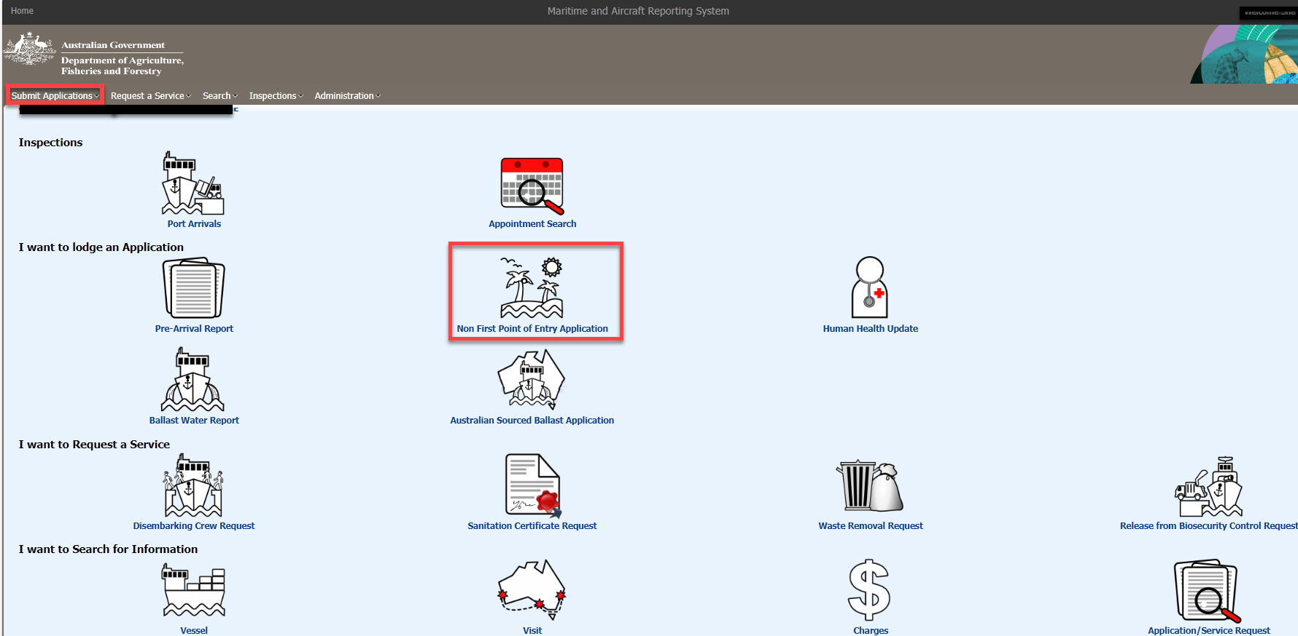
The NFP application must be completed in one session. If a timeout occurs the information is not saved and the user must start the application from the beginning.

NFP Activity Type

Field | Content
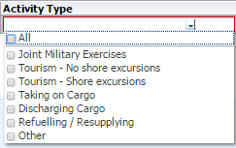 | Select the activity that will take place at the Non First Point of Entry. More than one activity can be selected.  Joint Military Exercises – Vessels taking part in joint military exercises with the Australian Navy must select this option.  Tourism – No shore excursions – If the main objective of the visit is for tourism and no crew nor passengers will go onshore this option must be selected.  Tourism – Shore excursions - If the main objective of the visit is for tourism and crew or passengers will go onshore this option must be selected.  Taking on Cargo – Select this option if the vessel is only taking on goods (cargo) at the nominated port.  Discharging Cargo – Select this option if the vessel is discharging cargo at the nominated port. This option must also be selected when cargo is to be discharged at a Proclaimed Port which is not Proclaimed for the discharge of certain goods or cargo.  Refuelling/Resupplying – Select this option if the vessel intends to refuel or take on supplies at the nominated port.  Other – Select this option if the reason for the visit to the Non First Point of Entry is not available from the options listed. Enter the details in the text box that is available when this option is selected.

Cargo Details
This tab only appears when the activity for the NFP includes the discharge of goods. All the fields are mandatory and must be completed before a user can navigate away from this tab. Waste requiring discharge at a First Point of Entry not proclaimed for the discharge of waste must be included in the Cargo Details.
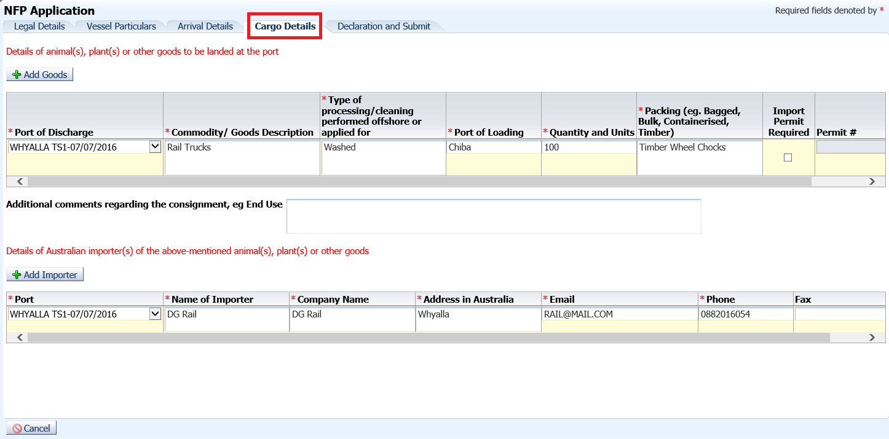

Details of animal(s), plant(s) or other goods to be landed at the port
All goods intended for discharge must be recorded here. If any dunnage or other packing material is to be discharged it must also be listed.
Field | Content
 | Use the Add Goods button to display the required fields. A separate row must be added for each type of good to be discharged.
Port of Discharge | Select the port where the goods are discharged from the list of available ports. Only the ports that were supplied in the Arrivals Details tab is listed.
Commodity/Goods description | Enter a description of the goods for example,.wooden pallets, stockfeed, mining equipment etc. Be as thorough as possible. A separate line must be used for each commodity.
Type of processing/cleaning performed offshore or applied for | Detailed description of the processing or cleaning of the goods to address any biosecurity concerns. For instance, goods were steam cleaned prior to loading and then covered in tarpaulins.
Port of Loading | Enter name of the port where the goods were loaded. Type the first three letters of the port name and then select the correct port from the list.
Quantity and units | Enter the quantity of goods and the number of units. For instance 5 Bags or 100 Kilograms etc.
Packing (eg. Bagged, Bulk, Containerised, Timber) | Describe how the goods have been packed for shipping. In bulk, bags, containers etc. Also include a description of any packing material used eg. Straw and wooden crates.
Import Permit Required | Tick this box if an import permit was required for the goods.
Permit # | Enter the import permit number. This field is only displayed if the Import permit Required box is checked.
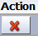 | Remove any lines added by mistake.
Additional Comments regarding the consignment, eg. Goods End Use | Use this field to record any additional information that will assist in the biosecurity risk assessment of the goods. For instance, End Use etc.

Details of Australian importer(s) of the above mentioned animal(s), plant(s) or other goods

Field | Content
 | Use the Add Importer button to display the required fields. A separate row must be added for each importer.
Port | Select the port where the importer of the goods is located from the list of available ports. Only the ports that were supplied in the Arrivals Details tab is listed.
Name of Importer | Enter the name of the importer.
Company Name | Enter the Importing Company name.
Address in Australia | Enter the importer’s address in Australia.
E-mail | Enter the importer’s e-mail address.
Phone | Enter the importer’s contact telephone number with all the relevant prefixes.
Fax | Enter the importer’s fax number. This is the only optional field in the grid.
 | Remove any lines added by mistake.

Declaration and submission
Once the Master is satisfied that the NFP Application is completed, submit. The Master must read the legal notice and acknowledge that the information supplied in the NFP application is true and correct.

Human Health Update
The Master or nominated shipping agent must complete this form to report any change in the health status to the department of passengers and crew originally reported on the PAR, prior to the vessel entering the next Australian port of call:
Where illness on board the vessel is reported, the vessel Master is required to answer additional questions to assess the public health risk associated with the vessel prior to arrival at the port.
In addition, Cruise and Naval Vessels must use the Human Health Update form to report any changes to the human health and status of crew and passengers prior to arriving at each port on their itinerary.
Open the Human Health Update application from the MARS home screen. To complete an application each tab must be completed in order of appearance.
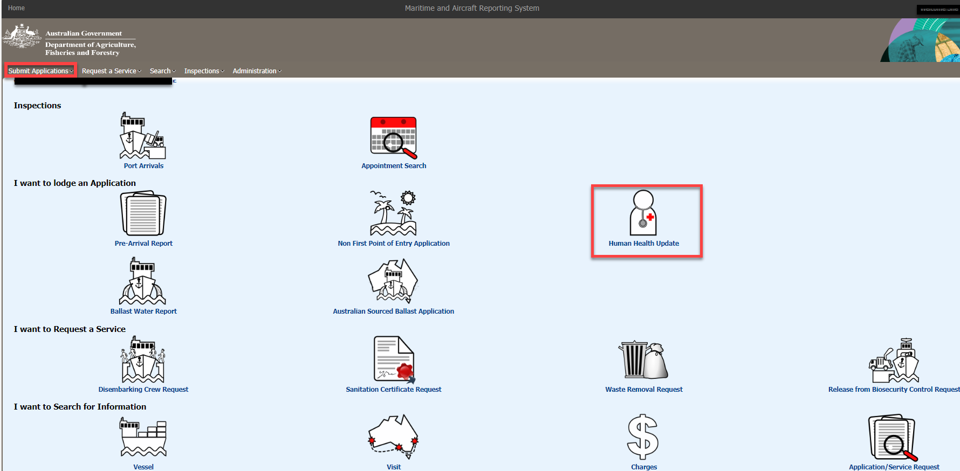

Declaration and submission
Once the Master is satisfied that the Human Health Update is complete, submit. The Master must read the legal notice and acknowledge that the information supplied in the NFP application is true and correct prior to submission.

MARS service requests

Disembarking Crew service requests
MARS must be used by commercial and cruise vessel masters and shipping agents to report on intended disembarkations. Reporting is mandatory for every crew member planning to disembark in Australian territory at a FPOE as well as subsequent Australian ports:
- in the MARS Pre-Arrival Report (PAR).
- as a Disembarking Crew MARS Service Request where disembarkation was not originally notified on the PAR
- as a Disembarking Crew MARS Service Request where any disembarkation information has changed.
Occasionally a commercial vessel (excluding cruise vessels) has a person travelling as a passenger e.g. a traveller. A disembarking crew service request must be completed by a master (or delegate) or ship’s agent for this person when disembarking in Australian territory, Section 48 (2) (g), Biosecurity Regulation 2016.
All vessel masters or agents are required by law to report any known crew that intend to disembark a vessel at the First Point of Entry (FPOE) or subsequent ports while in Australian territory and on an Australian voyage.
In late 2023, references to “crew change” were revised to “disembarking crew” and adjusted in MARS. In addition to the name change, biosecurity questions now include more detailed declarations for disembarking crew. Vessel operators or agents, along with crew members must declare the Yes/No answer to the following biosecurity questions, activities and complete the details of any goods declared prior to disembarking.
The ABF Form (B465) is for ABF use. Use of the ABF Form for biosecurity assessment became redundant with the rollout of disembarking crew reporting changes in December 2023. Biosecurity officers are to ensure masters and agents report all crew disembarkations using MARS.
The Master of a vessel must notify the department when crew need to disembark from the vessel. The notification must be submitted through the PAR when it is completed prior to arrival, or by submitting a service request through MARS. Service requests must be submitted through the Request a Service menu on the MARS home screen or by selecting the Crew Change Request icon.
A service request can only be submitted in MARS if a port visit exists for that voyage. A port visit is created when a PAR or NFP application is submitted.
Select the Disembarking Crew Service Request from the MARS home screen. To complete a service request each tab must be completed in order of appearance.
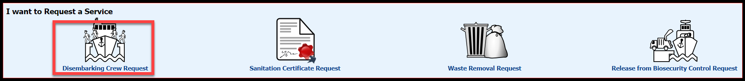
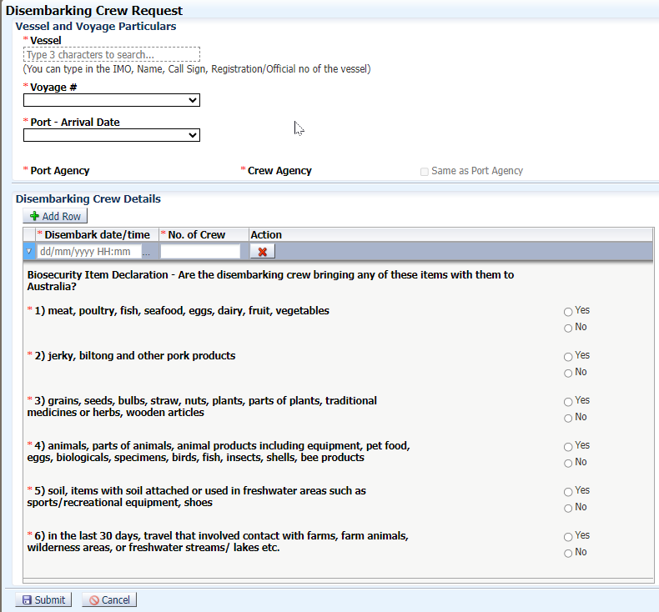
Once a PAR is submitted, the port, billing, and crew agencies each receive an automated email from MARS stating they have been nominated by the master as agents for a particular vessel’s voyage. This is an agent’s first opportunity to contact the NMC or a biosecurity officer and update details in MARS.
Important note: ABF requires crew declaration reporting, using Form 465 of the Customs Act 1901. This Form 465 is specifically for ABF use and is separate to DAFF’s reporting requirements under the Biosecurity Regulation 2016.
Shipping agents may provide Form 465’s as part of their crew disembarkation procedures and the Form may be saved into the MARS Attachments for the voyage. However, masters and agents must be advised that it is mandatory for all disembarking crew to be reported using MARS.

Ship Sanitation Certificate service requests
Ship Sanitation Control Exemption Certificates / Ship Sanitation Control Certificates are issued in compliance with Article 39 of the International Health Regulations (2005) (IHR). Ship Sanitation Certificates (SSC) may be required for all vessels on international voyages that call at a port of a State party. In Australia, Ship Sanitation Certificates can only be issued at declared ports for ship sanitation certificates. Ship Sanitation Certificates remain valid for a period of six months from the date of issue. This period may be extended by one month at a declared port if the inspection or control measures required cannot be accomplished at the port.
Renewal of a Ship Sanitation Certificate can be requested by the Master or Agent of a vessel when submitting the PAR or by submitting a Sanitation Certificate Request in MARS to arrange for an inspection. Ship Sanitation Certificate Inspections and the issuing of subsequent certificates can only be issued at declared ports.
Service Requests must be submitted through the Request a Service menu on the MARS home screen or by selecting the Sanitation Certificate Request icon.
A service request can only be submitted in MARS if a visit to a proclaimed port exists for that voyage. A port visit is created when a PAR or NFP application (for an SSC to be issued one of the ports must be a declared port on the NFP application) is submitted.
Select the Sanitation Certificate Request icon on the MARS home screen. Complete all the fields in the screen.
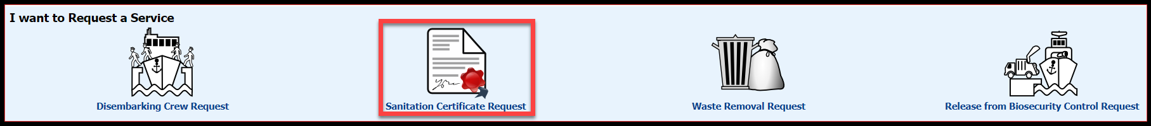

Waste removal requests
Biosecurity waste from international vessels poses a significant risk to Australia’s biodiversity. Strict control measures are imposed on the collection, storage, transportation, and treatment of biosecurity waste.
The Master or Agent must notify the department when Waste Removal is required. The notification may be submitted through the Biosecurity section of the PAR when it is completed prior to arrival or by submitting a service request through MARS. Service requests must be submitted through the Request a Service menu on the MARS home screen or by selecting the Waste Removal Request icon.
Some ports are not First Points of Entry for the removal of waste from vessels. The Master or Agent must refer to the department’s website for details about First Points of Entry ports. Waste cannot be discharged at a Non-First Point of Entry without the necessary approval from the department.
NOTE: A service request can only be submitted in MARS if a port visit exists for that voyage. A port visit is created when a PAR or NFP application is submitted.
Select the Waste Removal Request icon on the MARS home screen. To complete a service request each tab must be completed in order of appearance.
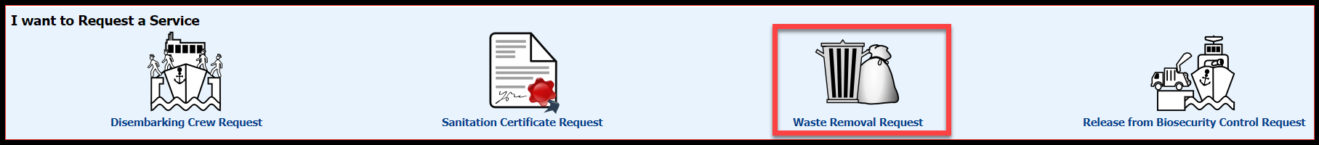
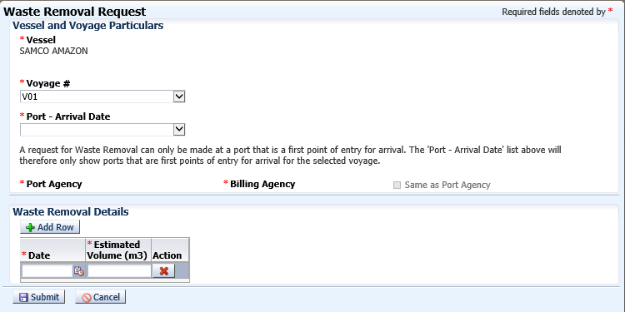
Biosecurity officers assess the Waste Removal Service Request. Where there are no identified, high-risk factors, masters receive a Biosecurity Status Document (BSD) by email which communicates the department’s biosecurity conditions. The BSD is emailed to the agent. The vessel’s email address must be included in the Vessel Details section for the vessel master to receive a copy of the BSD.
Masters and agents can search for and check the status of the service request in MARS through the Application Search Request function in MARS.

Release From Biosecurity Control service requests
International vessels intending to stay in Australian waters for an extended period may request a release from biosecurity control. However, the vessel may still be required to comply with relevant state or territory requirements.
Release from biosecurity control is granted after an inspection of the vessel is completed and all biosecurity risks have been managed in an approved manner.
Release from biosecurity control no longer applies if the vessel leaves Australian territory or interacts with another vessel subject to biosecurity control. The vessel returns to being subject to biosecurity control with mandatory pre-arrival reporting requirements in compliance with s193 of the Act.
The term “Release from biosecurity control” replaced “Coastal strip” and reference to “coastal status” throughout MARS, PAR, offline forms, and across the inspection process and department website in 2023. The release from biosecurity control terminology aligns with the Act and subordinate legislation.
A release from biosecurity control is granted after a vessel inspection is completed and all biosecurity risks have been managed in an approved manner.
International vessels intending to stay in Australian waters for an extended period of time may apply to the department to​​ be released from biosecurity. Being released from biosecurity control allows the vessel to carry goods between Australian ports without further intervention from the department. The vessel’s Agent or Master may submit a Release From Biosecurity Control Service Request to initiate this process. Usually, a release from biosecurity control is granted after an inspection of the vessel is completed and all biosecurity risks are managed in an approved manner.
The request must be submitted in MARS through the Request a Service menu on the MARS home screen or by selecting the Release From Biosecurity Control Service Request icon.
A service request can only be submitted in MARS if a visit exists for that voyage. A port visit is created when a PAR or NFP application is submitted.
Select the Release from Biosecurity Control Request icon on the MARS home screen. Complete all the fields.
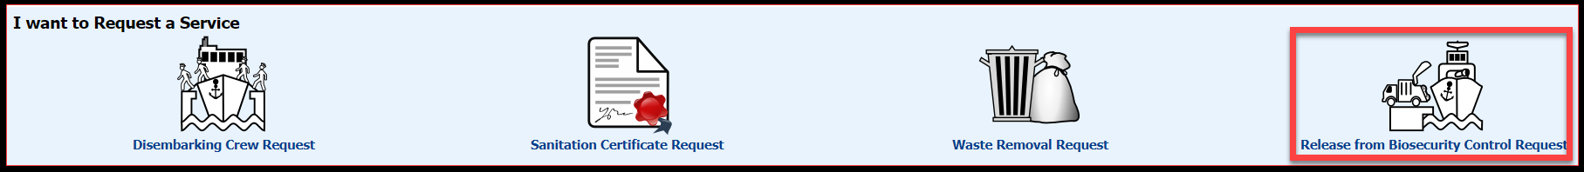
Biosecurity officers assess the Release from Biosecurity Control Service Request at the
nominated arrival port. A release from biosecurity control inspection, along with any other required inspections, is queued in MARS for biosecurity officers to assess and manage the biosecurity risk.
Vessel operators and the agency nominated for the voyage can search and check the status of the service request in MARS through the Search - Application/ Service Request function. Search by Application Type then Voyage number and review the Voyage Details Applications Received tab.
Release from biosecurity control will no longer apply if the vessel leaves Australian territory or interacts with another vessel subject to biosecurity control. The vessel will then return to being subject to biosecurity control and to pre-arrival reporting requirements. Refer to section 193 of the Biosecurity Act 2015.
Release from biosecurity control inspections is only completed at certain Australian ports. The master or agent should refer to the department’s website to learn how to prepare for a release from biosecurity control inspection: Release of biosecurity control of commercial vessels - DAFF (agriculture.gov.au)

MARS Search Information

Visit Search
Use this search to find details about the vessel’s current visit to an Australian port. The Agency name in this search screen defaults to the registered Agency of the user.

The vessel details default to the vessel associated with the Master’s User ID. Masters can search on the dates and port.
- Open the Visit icon on the MARS home screen.
- Enter the search criteria.
- Select the Search Visit button.
- The search details are displayed in the search results grid. Select the Port Name hyperlink to access the Visit Details screen.
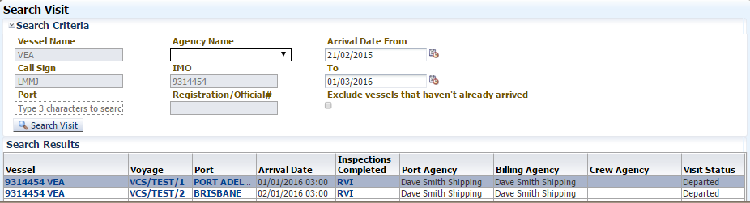
The Visit Details screen is displayed for the port that was selected.
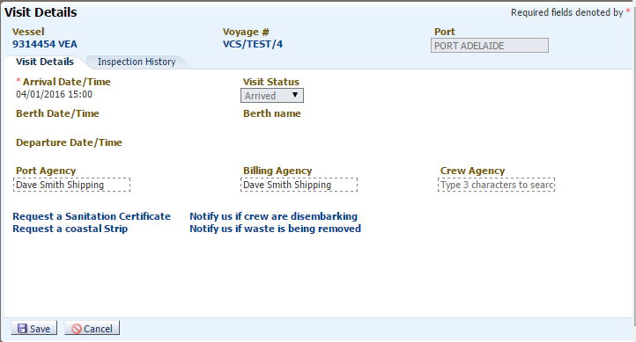
Field | Content
Visit Details | From this tab the visit details can be accessed for a particular port. The status of the visit is displayed along with the expected Arrival Date/Time; Berth Date/Time; Departure Date/Time in read only mode. These times are taken from the PAR or the NFP application.  The Billing Agency is mandatory if the vessel has requested a Release from Biosecurity Control or a Sanitation Certificate Request. Only an Agency with a department COM code can be identified as a Billing Agency. The Agency can be changed in this screen.  Service requests may be made from this screen. The port and arrival details are automatically pre-populated in the request. If any of the arrival details need amending, then the service request must be submitted using the appropriate Service Request application from the MARS home screen.
Changing Agency Names | The following rules apply for changes to Agency names in this screen:  - If the Agency field is blank a user can select their associated Agency name and save. This changes the Agency in the visit table.  - If the Agency field is blank a user can select an Agency not associated with them. An e-mail is sent to the selected Agency advising them that they have been nominated as the Agency.  - If the Agency field is 'Other', the user can choose their Agency. When the user tries to save this the following message is displayed - 'You have nominated yourself as the Agency where one already exists. User requests are received and biosecurity officers assess and makes changes if appropriate. Until the decision, MARS will not update the Agency to your Agency.'  - If the Agency field is 'Other' the user cannot 'blank out the Agency'.  - An Agency user can 'blank out the Agency' if the Agency field shows their Agency.
Inspection history | This tab contains a read only history of all the inspections this vessel has received at the selected port.

Report, application or service request search
Use this search to find applications and or service requests submitted for this vessel. The original application is displayed in read only mode. It also lists the date and time of submission as well as the name of the user who submitted the application.
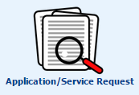
Enter the vessel’s IMO number in the search fields, adjust the date range and Select the Search Applications button. The vessel details and voyage number, the application type, status, and date submitted is displayed in the search results grid. Select the Type hyperlink to access the appropriate application or service request details.
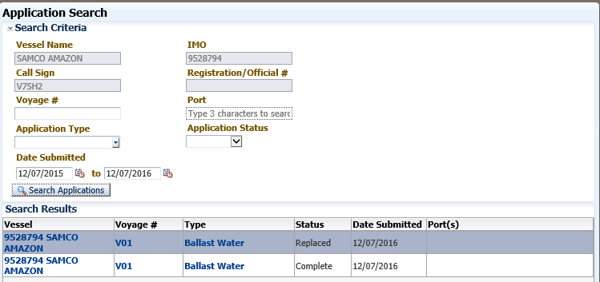
If the user wants to search on the Voyage number and the number is less than 3 characters a search wildcard must be used. For example, if the Voyage number is 1A then 1A% must be entered in the Voyage# search field.

The status of an application
Status | Description
Complete | The submission process is completed successfully; risk assessment is pending.
Withdrawn | The application is withdrawn from MARS.
Replaced | The application is replaced with another more current application.
Pending | NFP applications are undergoing assessment with approval to berth pending.

Accessing vessel information
Searching for vessel related information in MARS is available through the Visit and Application/Service Request search functions as discussed above. However, there are many other shortcuts in MARS to access specific information about the vessel, voyage, and visit. These shortcuts are always available as hyperlinks, which can be identified by the bold blue lettering.
This section details where in MARS the Master can get access to the vessel, voyage and visit information.
Access the vessel’s details by selecting any Vessel Name hyperlink in MARS. The table below lists the options available to the Master for accessing the vessel’s details:
Option | Details
1 | MARS Home Screen. The Vessel Name hyperlink on the MARS home screen gives access to the MARS Vessel Details screen. The Vessel Details screen in turn gives access to detailed vessel, voyage and visit information arranged in tabs. | 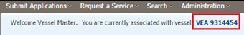
2 | Visit Search Results. The Visit search function on the MARS home screen also has a Vessel Name hyperlink when the search results are returned. Selecting the hyperlink displays the Vessel Details screen which in turn gives access to detailed vessel, voyage and visit information arranged in tabs. | 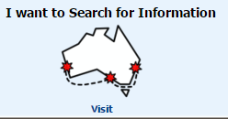  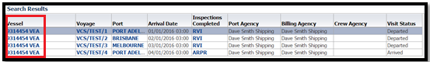
3 | Visit Details Screen. The Visit Details screen in MARS also has a Vessel Name hyperlink. Selecting the hyperlink displays the Vessel Details screen which in turn gives access to detailed vessel, voyage and visit information arranged in tabs. | 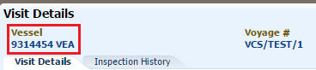
4 | Voyage Details Screen. The Voyage Details screen in MARS also has a Vessel Name hyperlink. Selecting the hyperlink displays the Vessel Details screen which in turn gives access to detailed vessel, voyage and visit information arranged in tabs. | 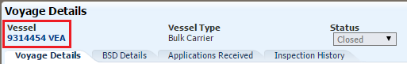
All the Vessel Name hyperlinks mentioned in Options 1 to 4 open the Vessel Details screen below

Field | Content
Vessel Particulars | This tab contains the read only particulars of the vessel. Changes to the vessel details are updated in MARS when an application is submitted with details that are different to the information contained on this tab. Alternatively the NMC may update details on this tab.
Ballast Details | This tab contains the read only details of the vessel’s ballast water tank and pump configuration. These details are updated when a new BW Report is submitted.
VCS Details | This tab contains read only information about the vessel’s complete Vessel Compliance Scheme (VCS) history. The demerit history is located here and the qualification criteria for the VCS. The Master can tell from this screen whether the vessel is currently on the VCS. VCS details are updated by MARS based on the vessel’s compliance history.
Voyage History | This tab contains the complete voyage history of the vessel. Each Voyage number is a hyperlink to the details for that voyage.
Vessel Identifiers | This tab is not used for commercial vessels. It displays the read only identifiers for non-commercial vessels such as Yachts.

Accessing voyage information
Access the voyage details by selecting any Voyage Number hyperlink in MARS. The table below lists the options available to the Master for accessing the voyage details:
Option | Details
1 | Visit Search Results. The Visit search function on the MARS home screen has a Voyage Number hyperlink when the search results are returned. Selecting the hyperlink displays the Voyage Details screen which in turn gives access to detailed vessel, voyage and visit information arranged in tabs. | 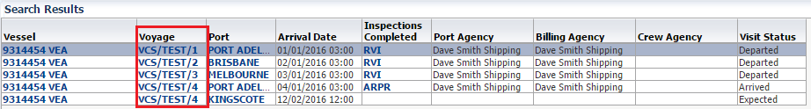
2 | Visit Details Screen. The Visit Details screen in MARS also has a Voyage Number hyperlink. Selecting the hyperlink displays the Voyage Details screen which in turn gives access to detailed vessel, voyage and visit information arranged in tabs. | 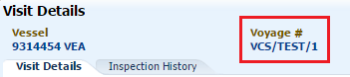
3 | Vessel Details Screen, Voyage History Tab. Selecting the hyperlink displays the Voyage Details screen which in turn gives access to detailed vessel, voyage and visit information arranged in tabs. | 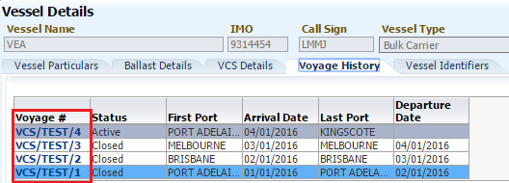
All the Voyage Number hyperlinks mentioned in Options 1 to 3 open the Voyage Details screen below

Field | Content
Vessel Hyperlink | The Vessel’s IMO and Name are hyperlinked to the Vessel Details screen. All the vessel’s particulars are available in read only mode in this screen.
Port (s) Hyperlink | The port names are hyperlinks to the Visit Details screen. This screen has details of the current visit and the inspection history at each port. Service requests may also be submitted from the Visit Details screen.
Inspections Completed Hyperlink | The hyperlink takes the user to the inspection detail information box. This lists the type of inspection completed, the port and the date the inspection was completed.
BSD Traffic Lights | This is a visual representation of the vessel’s current status as it relates to Approval to Berth; Non-First Point of Entry Approval; Biosecurity; Pratique and Ballast Water. The BSD contains the detailed explanation of each of these sections.
BSD Details Tab | This tab contains a link to the current BSD for the voyage. Previous versions of the BSD are replaced with the most current version. Always refer to this tab for the most up to date BSD for that voyage.
Applications Received Tab | This tab contains hyperlinks to all the applications submitted by this vessel for the current voyage. If the Master has successfully submitted an application, it is listed in this tab. Selecting the application hyperlink opens the original application that was submitted in read only mode.
Inspection History Tab | This tab contains a read only history of all the inspections this vessel has received. The appointment date, the port where the inspection was completed, the inspection date and the type of inspection.

MARS Documents and Certificates

Biosecurity Status Documents (BSD’s)
Biosecurity Status Documents (BSDs) are the source of information that communicate the department’s biosecurity conditions and directions during the period a vessel is on an Australian voyage.
Biosecurity Status Documents (BSDs) are documents that are auto generated in MARS and version controlled to reflect any reported changes to directions or status occurring throughout a vessel’s voyage.
BSDs use a traffic light system as a visual cue to alert the vessel operators and shipping agents regarding the vessel status and any associated directions or advice issued by the department. BSD documents are emailed to the vessel operators and agent and displayed and available in MARS for biosecurity officers.
The Biosecurity Status Document (BSD) is a single source of information for biosecurity directions and advice to vessel operator/master/shipping agent for each voyage.
Each BSD details the department's directions (at a point in time) for arrival including berthing conditions for first point of entry and non-first point of entry, pratique, vessel biosecurity and seasonal pest, ship sanitation, ballast water, biofouling and management and treatment directions.
A quick reference guide to Understanding the MARS Biosecurity Status Document (BSD) is published at: Quick Reference Guide: Understanding the BSD.
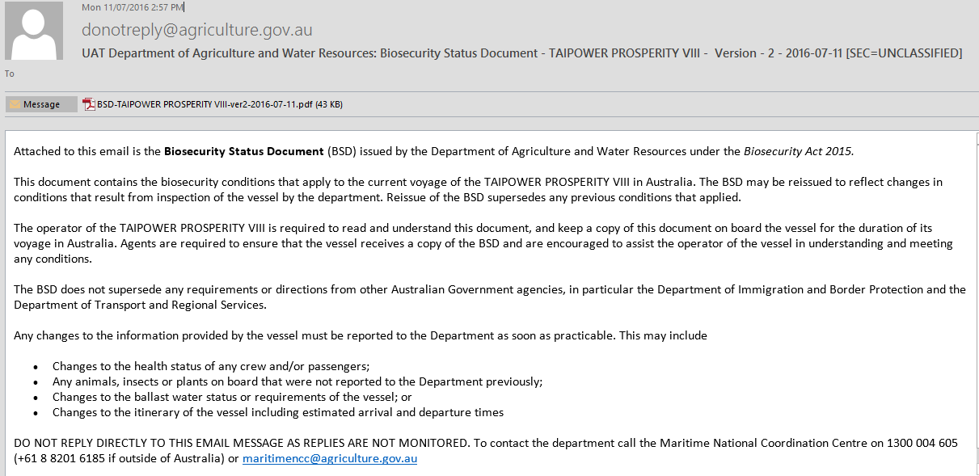

Where to find the BSD
To access the current BSD in MARS:
- On the MARS home screen Select the Vessel Name hyperlink.
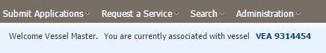
- The Vessel Details screen is displayed.
- Open the Voyage History tab and select the Voyage Number hyperlink.
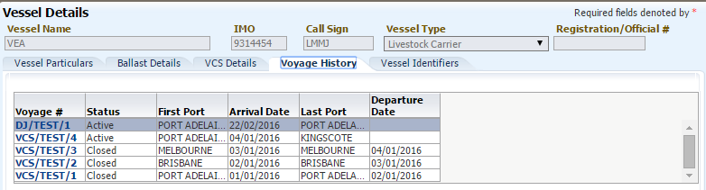
- The Voyage Details screen is displayed. Open the BSD Details tab and Select the View current BSD for voyage hyperlink. The BSD may be opened as a PDF file.
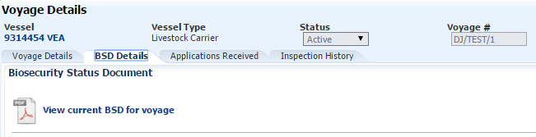

Ship Sanitation Certificates (SSC’s)
Ship Sanitation Certification (SSC) help control the international spread of human diseases by any vectors that potentially be carried on a vessel.
The department administers SSC requirements on behalf of the Department of Health. Ship Sanitation Certificates are issued in compliance with Article 39 of the International Health Regulations (2005) (IHR).
Current and valid Ship Sanitation Certificates are required for all vessels on international voyages that enter Australia.
In Australia, SSC inspections and the issuing or renewal of subsequent certificates are only conducted at ports that are declared by the Director of Human Biosecurity on behalf of the Department of Health. View a list of First Points of Entry www.agriculture.gov.au/biosecurity-trade/aircraft-vessels-military/vessels/first-point-entry-and-non-first-point-entry
The renewal of an SSC for a commercial vessel may be requested by the vessel master or agent when submitting the Pre-Arrival Report (PAR) prior to arrival, or by completing a Sanitation Certificate Service Request, post arrival. This guide covers the Sanitation Certificate Service Request.
MARS issues the Ship Sanitation Certificate electronically following a completed Ship Sanitation Inspection at a declared port.
MARS issues a Ship Sanitation Control Exemption Certificate when, at the time of inspection, biosecurity officers confirm there are no signs of vectors or reservoirs and subsequently no measures are required to control vectors and the relevant certification of vessel facilities is valid and/or in order.
The vessel must meet the following criteria:
- The vessel is inspected (the Areas Inspected section of the certificate) and evidence of rodents and mosquitos is not found on board (see Vector Indicators and Reservoirs for further details).
- The review of relevant documents (the Facility Review section of the certificate) has found all documents to be valid and in order and no control measures have been applied.
If satisfied that the vessel is free of vectors (rodents and mosquitos), there are no ill humans on board and pratique is granted, the biosecurity officer issues an electronic Ship Sanitation Control Exemption Certificate to the Master.
MARS issues a Ship Sanitation Control Certificate when, at the time of inspection, biosecurity officers report there are signs or evidence of vectors, and subsequent measures are applied to control vectors; or relevant certification of vessel facilities is invalid, out of date and/or out of order.
The vessel must meet the following criteria:
- The vessel is inspected (the Areas Inspected section of the certificate) and evidence of rodents and mosquitos is found on board.
- The review of relevant documents (the Facility Review section of the certificate) has found documents that are invalid, expired or otherwise out-of-order. Control measures are applied.
If a vessel has met any of the above criteria:
- The vessel is ordered to treat any infestation and
- MARS issues a Ship Sanitation Control Certificate to the Master by email.
Biosecurity officers review the vessel’s ballast water records, IMO and ISPP certificates during the SSC Inspection.
The Master and the vessel’s port Agent receive the SSC as a PDF attachment to an email after an inspection. Only the vessel’s Agent and the department have access to the electronically stored SSC in MARS.
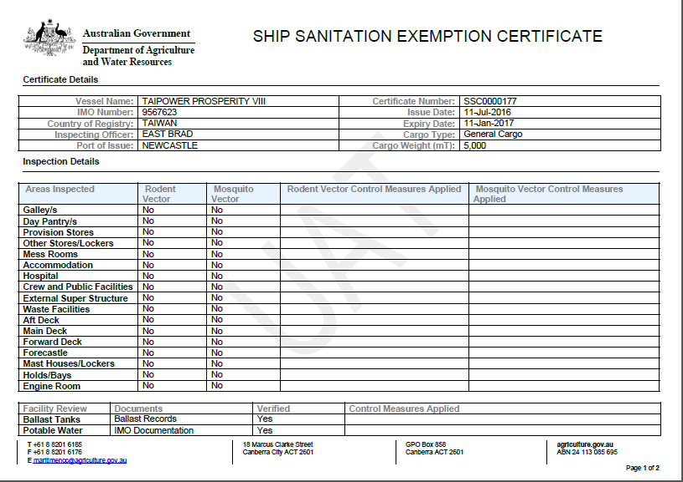
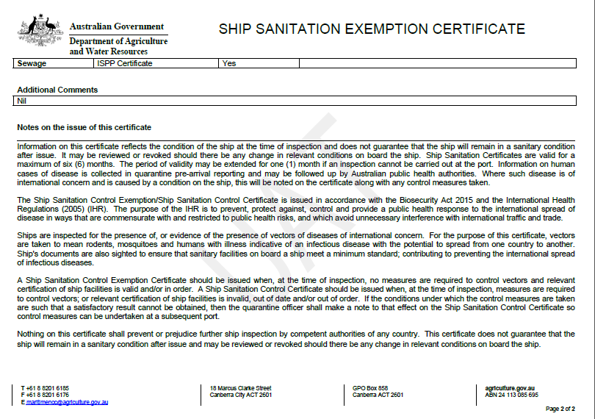

Seasonal Pest Questionnaires
The department conducts annual heightened vessel surveillance for managing risks posed seasonal pests such as Spongy Moths previously known as the Asian Gypsy Moth (AGM), Brown Marmorated Stink Bug (BMSB) and Burnt Pine Longicorn (BLP) beetle.
On submission of pre-arrival reporting by vessel masters or shipping agents, MARS may automatically email additional seasonal pest questionnaires to targeted vessels.
Once the master or agent has submitted the appropriate questionnaire, the NMC will conduct a biosecurity risk assessment of responses and advise.

Certificate of Freedom from Asian Gypsy Moth (AGM)
Under the Act, the department requires all vessels that have visited a far east Russian port between 40°N to 60°N, and west of 147°E anytime between 1 July and 30 September in the previous two calendar years must provide an AGM freedom certificate.
The certificate must be issued by the agriculture authorities in Australia, Canada, New Zealand, Russia, or the United States of America. If the certification is issued by the Russian agriculture authorities, the certificate must include the date and time of departure from the port where the vessel was inspected for AGM. If the Master of a vessel requests a Certificate of Freedom from Asian Gypsy Moth to be issued a full AGM inspection is conducted by biosecurity officers.
The Master and the vessel’s port Agent receive the Certificate as a PDF attachment to an email after an inspection. Only the vessel’s agent and the department have access to the electronically stored Certificate in MARS.
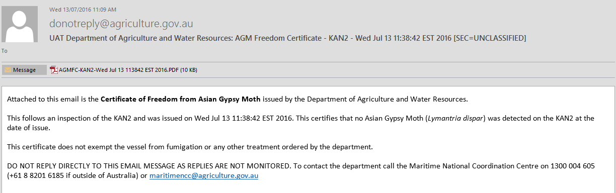
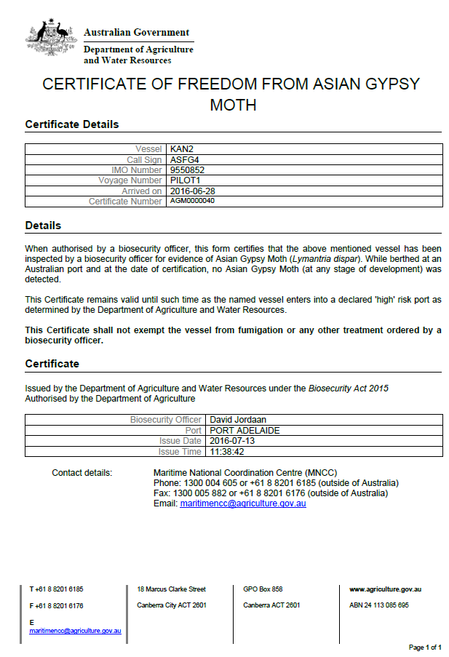

MARS Offline Forms
As an alternative to direct MARS access, offline reporting forms may be used by vessel operators where there is limited or unreliable internet connectivity to meet their pre-arrival reporting obligations.
Offline forms are ‘smart’ PDF documents of MARS questions available for vessel operators to download, complete and submit to their nominated shipping agent for upload into MARS.
Vessel operators with internet access should submit pre-arrival information by directly using the MARS online portal. Vessel operators with email but no internet access should download and complete offline forms that have been provided by their shipping agents or downloaded direct from the department’s webpage.
Once the form is completed, the form must be emailed as an xml data file (the Submit page of the form) to the shipping agent. The agent must then load this data file into MARS.
The offline forms are published on the web. The latest version must be downloaded regularly from the MARS offline forms webpage. This minimises delays and errors when uploading the information into MARS. Published offline forms are:
- PAR
- Non-First Point of Entry
- Ballast water
- Human health update
- Domestic risk assessment application
- Itinerary update form.
Once an offline form is completed, it must be submitted to the vessel’s Port Agent.
All reports completed using the Offline PDF Form must be submitted by selecting the Send to Agency button on the Submit tab. By selecting Send to Agency the Form is checked for any errors; alerting users to rectify any mistakes or complete any incomplete mandatory fields.
Responsible Officers must not select the Save XML Data button. If this option is selected the data in the file that is saved is not checked for errors. The saved XML file will not be sent to the Agent.
The Responsible Officer must check the following to ensure the PAR was sent to the Agent:
- Check the email to ensure it was sent successfully (Sent Items).
- Once the Agent has submitted the PAR into MARS the vessel receives a Biosecurity Status Document (BSD) via email if the vessel’s email address was provided in the Vessel Particulars tab of the Offline Form.
- Contact the Agent to confirm the Report was successfully received if unsure.
It remains the Responsible Officer’s responsibility to ensure Australian pre-arrival reporting requirements are met.
Field | Content
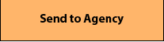 | By selecting the Send to Agency button, a report is sent to the vessel’s Agent as an attachment to an email. The Responsible Officer must select the email application to use and enter the Agency’s e-mail address in the email application To field.
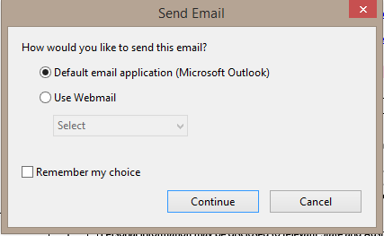 | The Send Email window appears when the Responsible Officer selects the Send to Agency button.  The Responsible Officer must select the appropriate email application for the vessel and select Continue.  An email is generated as shown below.
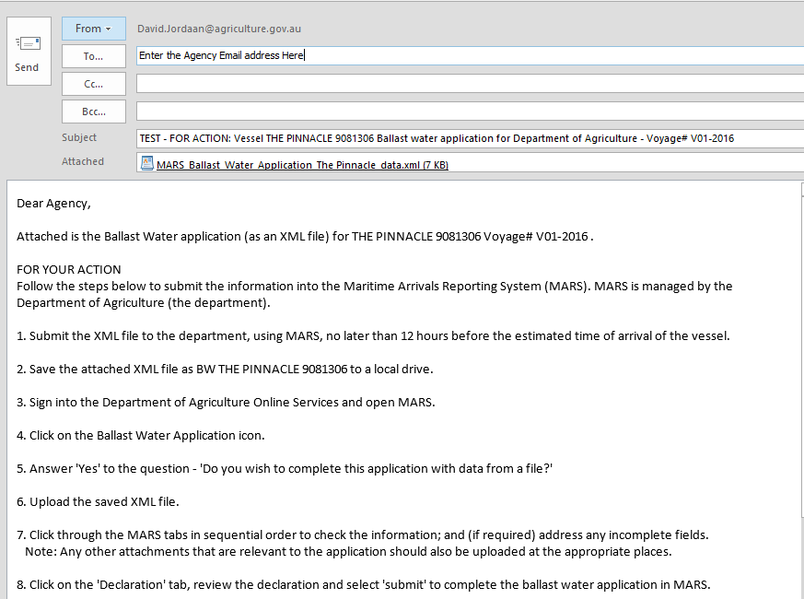

Pratique
Vessels are subject to either positive or negative pratique when entering Australian territorial waters, 12 nautical miles (nm) from the Australian coastline. The vessel type and the information provided in the PAR determines the pratique process used.
Once pratique is granted, it cannot be revoked.
Read all the details of pratique and vessel types at: Vessel Pratique - DAFF (agriculture.gov.au)

Positive pratique
A vessel subject to the positive pratique process under the Act is granted permission to embark or disembark Travellers (all passengers and crew), discharge or load goods and/or waste. These vessel arrivals are generally commercial, not cruise vessels.

Negative pratique
A vessel subject to the negative pratique process under the Act does not have permission to embark or disembark travellers (all passengers and crew), discharge or load waste or goods. Access to the vessel is restricted to personnel who are authorised under the Act, or another Australian law* until pratique is granted by a biosecurity officer.
These vessel arrivals are generally non-commercial vessels and cruise vessels.
*e.g., Vessel pilots, and other Government departments such as the Australian Maritime Safety Authority (AMSA), or Australian Border Force (ABF).

Determined Ports
After submitting a PAR and entering an Australian port, international vessels must comply with the Act and the First Point of Entry (FPOE) biosecurity determinations.
Each FPOE has its own determination which sets out what classes of vessels and goods are permitted to arrive at each port. Determinations also list the biosecurity entry points (BEPs) within the port at which certain classes of vessels and goods must arrive.
Each determination lists:
- permissions for particular classes of vessel that can berth
- goods that can be unloaded at the port
- biosecurity entry points (BEPs) within the port
- any conditions associated with the port as a first point of entry.
Applications for arrival and goods are two separate processes. FPOE approval to enter a port does not mean that goods are permitted. Goods and vessels are two separate permissions.

The Vessel Compliance Scheme
The Vessel Compliance Scheme (VCS) is a feature in MARS that provides transparency of Australia’s biosecurity requirements aimed at facilitating compliance by our maritime clients and stakeholders.
Under the VCS, commercial vessels who frequent Australian waters and demonstrate a history of compliance may be subject to a less rigorous inspection regime, which is a reduction in the number of physical inspections, with some voyages managed on documents and not a physical inspection.
Livestock vessels, cruise vessels and non-commercial vessels (yachts and super yachts) are not eligible for the VCS.
Learn more about the VSC at: The Maritime and Aircraft Reporting System (MARS) and the Vessel Compliance Scheme (VCS) - DAFF (agriculture.gov.au)

Offshore Installations
Offshore installations operating outside of Australian territory (12 Nm limit) are not subject to biosecurity control. However, any conveyance (such as support vessels and aircraft) that leaves Australian territory and interacts with an offshore installation (physical contact or in close proximity) becomes an exposed conveyance and is subject to biosecurity requirements when returning to Australia. For example, vessels that move between the offshore installation and an Australian port as part of provisioning operations.
During activities/interaction with the installation, vessels are subject to biosecurity control in compliance with the installation’s environmental management plan, such as ballast water, biofouling, and other biosecurity risks.
When returning to Australian territory, exposed conveyances become subject to biosecurity control and must undertake pre-arrival reporting and report where the vessel intends to arrive and unload goods.

Vessels exposed to offshore installations
A domestic vessel that leaves Australian territory and interacts with an installation or other vessels becomes an ‘exposed conveyance’ (exposed vessel) and is subject to biosecurity control when it returns to Australian territory in compliance with the Act, s193(1) (a) and (b); unless an
exception can be met. For the purposes of the Biosecurity Act 2015, exposure results from being in physical contact with, in close proximity to, or being contaminated by an installation.

Masters of domestic vessels entering Australia following exposure to an offshore installation must notify the department of their intention to enter either a First Point of Entry or Non-First Point of Entry (NFP).

The Pre-Arrival Reports (PAR) and the NFP application must be completed by the vessel master (or agent on their behalf) to notify the department of a vessels’ impending arrival. When completing the PAR and NFP application in MARS, the vessel master should select their port of origin as Administrative Port (Installations in International Waters). Exposed vessels are required to submit a PAR and notify the department of any intention to unload goods in Australia, unless an exception applies, as noted below.

The PAR must be submitted 96 to 12 hours prior to arrival for each voyage in Australia. Any change in circumstances must be reported to the department as soon as practicable through a new PAR. NFP applications, where required, should be submitted at least 10 working days prior to arrival.

When there are exceptions to lodging a PAR?
Where conditions are met under the Biosecurity (Exposed Conveyances – Exceptions from Biosecurity Control) Determination 2016, exposed conveyances can claim an exception from being subject to biosecurity control. This Determination can be found at More information relating to vessels exposed to offshore petroleum installations can be found in the Offshore Installation Biosecurity Guide.

Pre-Arrival Reporting for Australian External Territories
All international vessels planning to enter Australian territory must submit a Pre-Arrival Report (PAR).
All international vessels that are sailed, motored, or towed through the 12nM limit and enter Australian territory are subject to pre-arrival reporting, pratique, biosecurity assessment and inspection at a first point of entry on arrival. Vessels entering Australian territory must comply with their requirements under biosecurity legislation.

Australian External Territories are Christmas Island, Cocos (Keeling) Islands and Norfolk Island.

All vessel masters and agents representing commercial vessels, including cruise vessels, travelling between the Australian mainland and the Australian External territories, and between the external territories, are required to pre-arrival report.

MARS and biosecurity officers assess the PAR submission. Users receive notification communicating the department’s biosecurity conditions and expectations. This information may be emailed to a shipping agent (where an agency is nominated in the PAR).

Sovereign Immunity
​​​​​​Under international law, foreign governments are entitled to invoke sovereign immunity on state-owned or operated vessels arriving into Australian territory. Whenever the claim of sovereign immunity is invoked, biosecurity officers are not permitted to board sovereign immune vessels to conduct inspections or other official activities.
Biosecurity officers however will continue to carry out biosecurity functions under the Biosecurity Act 2015 without boarding the vessel.
While biosecurity officers are not to board a vessel that has invoked sovereign immunity, the vessel, its crew, passengers, and goods are still subject to biosecurity control and must still meet Australian biosecurity requirements. The process for managing them is set out below.
The claim of sovereign immunity does not exempt the vessel operator from meeting all Australian biosecurity requirements. The commanding officer (vessel master) of the vessel must ensure these requirements are met, including:
- submitting a pre-arrival report (PAR) in MARS between 96 to 12 hours prior to arrival
- submitting a Ballast Water Report and other appropriate vessel papers (for example, Certificate of Freedom from Gypsy Moth and Ship Sanitation Certificate) to a biosecurity officer on arrival at the port briefing.
Assessment of the biosecurity risk posed by the vessel is based on the information reported in the PAR. MARS and biosecurity officers determine any conditions and/or measures to be placed on the vessel (for example, whether or not the vessel has the department’s permission to discharge ballast water).
The vessel is issued a Biosecurity Status Document, informing the commanding officer (vessel master) of the department’s requirements regarding pratique, waste removal and biosecurity intervention of the crew and passengers that occur wharf side during the vessel’s stay in port.
The vessel’s agent should discuss the vessel’s sovereign immunity requirements with biosecurity officers prior to a vessel’s arrival.

Sovereign immunity declaration
The commanding officer (vessel master) of each vessel claiming sovereign immunity must declare to the department on arrival:
- whether the galley areas and dry stores are hygienic and free of infestations
- whether waste is stored appropriately (in bags/bins and not exposed)
- whether there are any dry stores on the vessel from the countries listed as being at risk from Trogoderma species (as per the department’s Biosecurity Import Conditions system (BICON) case for raw seed, or see Khapra beetle, and
- that crew are aware of the department’s requirements to not remove any food products, plant or animal material from the vessel and that targeted gangway watches of the vessel may occur.
The declaration must be in writing, and should be submitted by the commanding officer (vessel master) by email to the NMC.

Biosecurity waste bins used by vessels at all intended ports of call
Sovereign immune vessels, or their Australian agents, are required to provide adequate biosecurity waste bins at all Australian ports where the vessel intends to visit.
Biosecurity officers are not responsible for the collection and disposal of biosecurity risk material. It is the commanding officer’s (vessel master's) responsibility to ensure that the waste is disposed of by a service provider on an approved arrangement with the department.

Treatment of biosecurity waste coming off the vessel
As biosecurity officers cannot inspect the vessel to determine the disease/pest status of the galley and provision areas, all waste being removed from the vessel must be treated as a biosecurity risk, and managed in compliance with the department’s requirements, taking into account specific port capabilities and infrastructure.
Biosecurity officers must supervise the removal of all waste from the vessel to barge (if applicable), and to the wharf side collection point. In circumstances whereby a vessel is at anchor and a barge is used to transfer waste to shore and where front-loading lift bin type receptacles are used, receptacles must be lockable and be kept locked during transfer. All waste must be double bagged prior to being removed from the vessel.
If crew intend to remove waste, a biosecurity officer must supervise the removal of the waste.
Where the integrity of the receptacles are compromised or there is an identifiable risk such as:
- non-cosmopolitan insects or insects of an unknown species are sighted on or near waste
- waste not being double bagged
- bags containing waste are damaged
- the vessel having a history of insect related problems, for example Trogoderma.
The following treatments apply:
- The waste is sprayed with an insecticide aerosol spray. Spray is applied to the top of the waste and all external and internal surfaces of the receptacle. For very large volumes of waste the vessel’s master is directed to use industrial style spraying devices in lieu of a pressure pack spray and/or engage a pest controller to undertake required treatment.
- If a biosecurity pest is identified, biosecurity officers direct the vessel to cease the further removal of waste pending treatment of landed waste in an approved manner, such as fumigation.
All costs associated with the treatment and/or destruction of any biosecurity waste being removed from the vessel are at the expense of the vessel operator or its nominated agent.

Increased gangway watch of disembarking crew
While the vessel is in port, any baggage carried off the vessel by officers, crew and/or visitors to the vessel is subject to biosecurity intervention at the point of disembarkation from the gangway.
Any non-compliance with biosecurity requirements will result in increased mandatory gangway watches and monitoring by the department for the duration of the vessel’s stay in port.
All costs associated with the intervention of disembarking officers, crew and/or visitors are borne by the vessel or its Australian agent.

Changes to the health of crew, passengers, or visitors
The vessel’s commanding officer (vessel master) must report any change to the health status of persons on board the vessel, including crew, passengers, or visitors, for the duration of the vessel’s stay in port. The report can be made by contacting the NMC or the department’s local office where the vessel is in port.

What to expect during an inspection
Biosecurity officers in the field use mobile devices to conduct inspections and record outcomes.
As MARS is a paperless system, all directions, and relevant documents such as pratique and ship sanitation certificates are issued electronically. These documents are emailed to the nominated agent or vessel master.
Once an assessment or inspection activity is finalised, updated BSD’s will generally be emailed within minutes. During the inspection, biosecurity officers may request that a master demonstrate compliance with BSD directions and vessel documentation.

Home Screen - Menu Bar
Submit Applications – From this menu vessel operators can select the report or application they would like to submit. There are four reports/applications that can be completed from this menu.
- Pre-Arrival Report
- Ballast Water Report
- Non-First Point of Entry Application
- Human Health Update
Request a Service – From this menu vessel master’s can create service requests for an active voyage in MARS. Masters may select from the following services:
- Crew Change Request
- Sanitation Certificate Request
- Waste Removal Request
- Release from Biosecurity Control Request
Search – Here a Master can search for information regarding the current voyage of the vessel. Masters may search for:
- Visit details
- Reports, Applications and Service Requests that have been submitted
Administration – Here a Master can view the:
- User details submitted during the Security Account registration process, and
- User security details (Profile entitlements used for troubleshooting purposes).

Home Screen - Shortcuts
Shortcuts on the MARS home screen provide a master with direct access to the MARS applications required
for electronic reporting to the department. The shortcuts are alternatives to the drop-down menus
and list the same menu items. The welcome message identifies the user currently logged in and the
vessel with which they are associated. Select the [Vessel Name and IMO] hyperlink for the Vessel Details screen.

If the vessel name displayed on the MARS home screen is different to the vessel the Master
wants to submit reports/applications for then the Master must refer to the MARS Vessel Officer
Registration section in this User Guide on how to request access for the new vessel. A Master can only
submit electronic reports/applications for the vessel associated with their Security Account User ID.

Home Screen - Footer
The footer contains the department’s privacy policy and contact details. It also contains the MARS
version number which is important for troubleshooting purposes when contacting the department’s NMC for assistance.

Registration – Setting up billing, fees, and charges
MARS provides accurate and timely billing, and the ability to make changes throughout a voyage. The department’s Financial Management Information System (FMIS) issues invoices, not MARS. MARS is a record of service.
The choice of registration setup in MARS can be tailored to complement each agency business structure. This is largely based on the setup each agency has in the department’s FMIS, also known as a Unique Registration Number (URN), and the arrangements between agency port offices and head offices for billing purposes. This URN may be linked to bank account arrangements, noting where payments are made via Electronic Funds Transfer (EFT), the department provides one bank account per URN for payment.
Option 1 – When the agency organisation has multiple account numbers
This option is suitable for agencies where port agencies manage the verification of charges and use this information for their own cost recovery arrangements. An important consideration when choosing this option is that payments for each account are made into a single bank account.
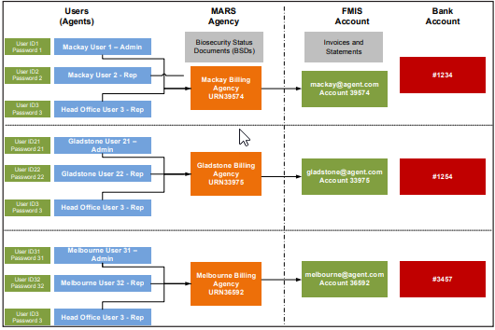
Option 2 – When the agency organisation has a single account number
This option is suitable for agencies where head office manages the verification and payment of charges. Port offices can still view charging information in MARS for verification purposes.
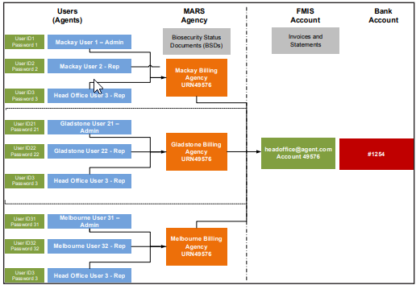
Additional Information about MARS and Billing
- Invoices are triggered by the departure date of a vessel and are issued within 24 hours of a vessel
- departing from a port.
- A single invoice is generated per port visit, per vessel (note: BPAY continues as one payment per invoice).
- The ability to view a summary of invoices, including un-invoiced charges and the payment status of each invoice is available in MARS.

Appendices

Glossary
Term | Definition
ALOP | Appropriate level of protection
Billing agency | The Agency nominated by the master of the vessel to manage the payment of accounts for a visit. The billing agency is mandatory in the PAR for first Australian port. Billing agencies must have valid COM numbers issued by the department. Any invoices for this visit (except crew disembarkation activities) which are billed to this agency. The billing agency can be different to Port and Crew Agency. It may also change from port to port.
Biosecurity | Managing risks to Australia’s economy, environment and community of pests and diseases entering, emerging, establishing or spreading in Australia.
Biosecurity Status Document (BSD) | The MARS Maritime single source of information of biosecurity directions and advice to the master and shipping agent for each voyage. BSDs are:  - auto generated in MARS.  - version controlled to reflect any reported changes to directions or status occurring during a voyage.  - issued by the department under Sections 193, 247(2) of the Act, and Section 48(6) Biosecurity Regulation.
Maritime and Aircraft Reporting System (MARS) | The department’s IT system for reporting and managing maritime and aircraft reporting for biosecurity purposes.
Non-First Point of Entry (NFP) application | The NFP application must be used by vessels intending to arrive at a Non-First Point of Entry.  A NFP is a landing place or port that has not been determined as a place where an aircraft, vessel or goods may arrive without (prior) permission to do so under s239, s247 or s146 respectively of the Act. These points might not have suitable facilities or infrastructure to meet biosecurity requirements.
Offline forms | As an alternative to direct MARS access, offline forms may be used by vessel masters or officers where there is limited or unreliable internet connectivity to meet pre-arrival reporting obligations.
Regulation | A rule or order, as for conduct, prescribed by authority; a governing direction or law.
XML data file upload | An XML data file is created when an offline form is created by a vessel master before selecting ‘Send to Agent’ on the offline form.XML data is emailed to the agent and the agent then uploads the data directly into MARS to assist vessel master’s with pre-arrival reporting. MARS only accepts applications from files saved as XML data files.

Common Buttons and Indicators
The following table lists common buttons and indicators that are used in MARS:

Icon | Description | Function
 | Cancel | Generally takes the user back to the previous screen.
 | Red asterisk | Indicates a mandatory field.
 | Calendar | Allows a user to select a date and time, if applicable.
 | Add Row | Select the Add Row button to enable data entry fields and add additional rows to grids.
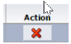 | Delete Row | Allows a user to remove any rows that were added.
 | Print Function | When using this print function in MARS a pdf document is created. This pdf can then either be sent to a printer or saved as a file.
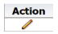 | Edit | Allows a user to edit the details of a table or grid.

Version history
Date | Details
March 2017 | Original publishing of the MARS Vessel Master user guide and MARS Vessel Agent user guide.
July 2026 | Consolidation of the master and shipping agent user guides into one, with additions of other users, Government, Port Authority, ABF Maritime Officer, updates to align with latest MARS changes.

References
MARS offline forms: Find the forms at: ww.agriculture.gov.au/biosecurity-trade/aircraft-vessels-military/vessels/mars/mars-offline-forms

