
Baseline analysis of mass balance rate of television and computer recycling in Australia

Prepared for:
The Australian Government Department of Sustainability, Environment, Water, Population and Communities for the National Television and Computer Product Stewardship Scheme

26 September 2011
The Tea House
Level 4, 28 Clarendon Street
Southbank Victoria 3006
Ph. +61 3 9690 8090
www.eqlomg.com
Table of Contents
1. Executive Summary 1
1.1 Recommendation and key findings 2
1.1.1 Recommendation 2
1.1.2 Key findings 2
2. Scope 4
2.1 Exclusions 5
3. Methodology 5
4. Detailed findings 6
4.1 Respondents 6
4.2 Materials recovery 8
4.2.1 Collection organisations 8
4.2.2 Findings 9
4.3 Processing organisations 9
4.3.1 Findings 10
4.4 Reporting and data quality 11
4.4.1 Mass balance 12
4.4.2 Findings 12
4.5 Risk management 13
4.5.1 Findings 13
4.6 Questions on bromenated flame retardants 13
5. Conclusion 14
Attachment 1 - Copy of questionnaire 15
Figures and Tables:
Figure 1: Scope of study…………………………………………………………………………..…….4
Figure 2: Reported volumes compared with current processing.............................................7
Figure 3: Collectors – Data Management and Quality.............................................................11
Figure 4: Processors – Data Management and Quality............................................................12
Table 1: Collectors – Televisions and computers reported by collectors................................8
Table 2: Processors - Total televisions and computers reported by processors.....................10

Disclaimer: The views and opinions expressed in this document are those of the authors and do not necessarily reflect those of the Australian Government or the Parliamentary Secretary for Sustainability and Urban Water.

Executive Summary
The National Television and Computer Product Stewardship Scheme (the Scheme) was agreed to in November 2009 by all Australian governments through the Environment Protection and Heritage Council (EPHC). The Scheme aims to increase the collection, material recovery and recycling of end-of-life televisions, computers and computer peripherals to 80% by 2020-21. To achieve this, the Scheme will be underpinned by Regulations that will set enforceable collection-for-recycling targets.
Following the decision by the EPHC to establish the Scheme, a joint government and industry Implementation Working Group (IWG) was established to facilitate arrangements for developing the Scheme, including key performance indicators (KPIs) which can be used to track progress toward achieving Scheme objectives. The draft KPIs include a measure for material recovery which would be the percentage and number of tonnes of collected material that is recovered.
This study incorporates a survey of existing collection and recovery practices to determine an appropriate success factor for the material recovery KPI for the Scheme and whether it would be appropriate to set an enforceable material recovery target in the Regulations. The study was commissioned by the Australian Government Department of Sustainability, Environment, Water, Population and Communities (DSEWPaC).
This study has taken information from 14 representative collection and processing organisations, which includes six processing organisations (being companies involved in sorting, dismantling and resource recovery, either solely or also conjunction with their own collection operations) and eight collection organisations including private companies and local government operations. In terms of being a representative sample, the processing organisations sampled handled more than 12,250 tonnes of end of life televisions and computers in the period 2009-2010. This is about 49% of current total annual processing in Australia. The collection organisations sampled handled 2600 tonnes of material in the period 2009-2010. The geographic spread of respondents covers all states and territories except the Northern Territory (an organisation that collects in the NT was invited to participate but failed to respond).
This study does not include televisions and computers collected and then reused as this is outside of the intent of the Scheme. It also does not include actual recycling – where the metals, plastics, glass and other materials are transformed into virgin replacement commodities or new actual products – as that material transformation is beyond the control of participants in the proposed Scheme.
This study has assessed current reported rates of material recovery, tested current reporting quality, reviewed current industry practices and examined related issues in order to determine the appropriateness of an enforceable resource recovery target for the Scheme. This information was also used to determine an appropriate rate for the proposed materials recovery KPI, if it was decided to adopt this approach. The study has applied a mass balance approach to determine actual recovery rates for the period examined. Mass balance is defined as a comparison of inputs and outputs for a particular process. Also called material balance, it examines material entering and leaving a given system to determine the gain or loss of material through that process.

Recommendation and key findings

Recommendation
The material recovery rate in Australia for the 2009-2010 period is estimated to be 91%. That is, of the end-of-life televisions and computers being presented for recycling, it is estimated that 91% of the material is actually recovered and sent to a recycling facility and the remaining 9% of material is going to landfill. On 2010 estimated total collection volumes this would be 22,750 tonnes of material recovered. However, given issues and discrepancies with current reporting standards, data quality and consistency, it is not appropriate for the proposed Scheme to have an enforceable recovery rate at commencement. It is recommended DSEWPaC give further consideration as to the most appropriate manner for a resource recovery rate to be incorporated into the proposed Scheme.

Key findings
Current recovery rates
- There is a 1% material loss at collection points due to breakage and unrecoverable matter (for example, broken glass, small pieces of plastic).
- There is an 8% material loss at processing due to contamination, unrecoverable, broken and damaged materials and general process loss.
- With adjustment for the rates achieved at the collection and processing points where the bulk volumes of materials are handled, there remains an overall system loss of 9%.
- Collectors report recovery rates ranging from 94% to 100% with reported rates determined by contamination (such as plastic film, foam, tape and CDs) and breakage and unrecoverable matter. Collectors do not currently track and report the different portion of losses between contamination and breakage and unrecoverable matter.
- For collectors, the raw aggregated recovery rate (that is, the reported recovery rate from each collection organisation when totalled together) for the period 2007-2010 is 98% and for the period 2009-2010 is 98%.
- When collectors are weighted to take into account recovery rates where larger volumes of materials are collected for the period 2009-2010, it produces a 99% recovery rate, and therefore a 1% system loss at collection points.
- Processors report recovery rates ranging from 74% to 99% with rates determined by contamination, unrecoverable, broken and damaged materials and general process loss. Recovery rates are lower the larger the volume a processor manages.
- For processors, the raw aggregated recovery rate (that is, the reported recovery rate from each processing point when totalled together) for the period 2007-2010 is 95% and for the period 2009-2010 it is 93%.
- When processors are weighted to take into account recovery rates where larger volumes are processed for the period 2009-2010, it produces a 92% recovery rate, and therefore an 8% system loss at processing points.
Reporting and data quality
- Overall reporting and data quality is average to poor.
- Seven out of eight collection organisations responded that they have tracking and reporting systems, but only two were able to provide evidence of their system and reporting and only one was able to provide evidence the system is audited.
- Six of the collection organisations track their own material but two rely on processors to track and report volumes and types of material.
- All six processing organisations responded that they have tracking and reporting systems, with three able to provide evidence of their system and reporting and two able to provide evidence the system is audited.
- The processing points where the majority of the volume of materials are handled have good to high quality data management and reporting, that is, they provided evidence of their system and that it is audited.
- All six processing organisations responded that they have developed proprietary software for tracking and reporting. Of the three that provided evidence able to be reviewed for this study, there are different definitions of materials used in their tracking and reporting.
Risk management
- Overall risk management is average to poor.
- At collection points there is limited planning and management for regulatory risk. Only two out of eight have ISO14000 certification (one has it in development), there is limited planning for business disruption or discontinuity and limited planning for managing a sudden influx of large volumes of material.
- At processing points there is generally good planning for regulatory risk (domestic and international), limited planning for discontinuity events to end customers, limited contingency planning for natural disasters and limited planning for managing bottle necks created by sudden influx of large volumes of material.

Comparison with other schemes
- It is difficult to compare recovery rates and targets between schemes because the nature of the schemes, materials targeted and operational standards vary.
- The European Union Waste Electrical and Electronic Equipment directive, for example, targets a recycling rate of 75% for IT equipment and consumer equipment (including TVs) but this is a broader range of products than is targeted in the proposed Scheme and also includes reuse.
- As the proposed Scheme develops and reporting and data quality improve, it may be valuable to document the scope, common areas and differences of it and other schemes to enable comparisons.
Enforceable targets
- It is not appropriate for the proposed Scheme to have an enforceable recovery rate at commencement given the range of current recovery rates, reporting and data quality and discrepancies between mass balance methodology currently used by recyclers.
- As the proposed Scheme develops and data and reporting quality improve it may be possible to set an enforceable recovery rate.
Material loss
- The bulk of the 9% material loss identified in this study is a mix of non-recyclables (such as foam, plastic film, strapping, tape) and unrecoverable recyclables (such as broken glass and plastic pieces) that is sent to landfill.
- No respondents could provide detailed material audits for this waste to landfill.
- A 2% process loss is reported by those respondents that capture this information. Process loss refers to material lost (usually in the form of dust) from pulverising.

Scope
The term “mass balance” is generally defined as a comparison of inputs and outputs for a particular process. Also called “material balance”, it seeks to examine material entering and leaving a given system to determine any gain or loss through that particular process.
This study assesses how much of the end-of-life televisions and computers collected and processed are sent for actual recycling, where the metals, plastics, glass and other materials are transformed into virgin replacement commodities or new actual products.
This study examines a range of collection practices (including events and permanent / semi permanent sites) and processing (sorting, dismantling and other resource recovery activities to prepare materials, whether as whole units, components or constituent commodities, for dispatch or on-sale to recyclers) to determine how much material is lost in these activities.
It does not include how much is lost through actual recycling (i.e. downstream processing) – where the metals, plastics, glass and other materials are transformed into virgin replacement commodities or new actual products. While there is further loss of material during actual recycling (down-cycling, contamination and residual waste), it is not in the scope of this study.
The following diagram presents the scope of the study, with the flows shown within the box being in the scope of this study.

Figure 1: Scope of study
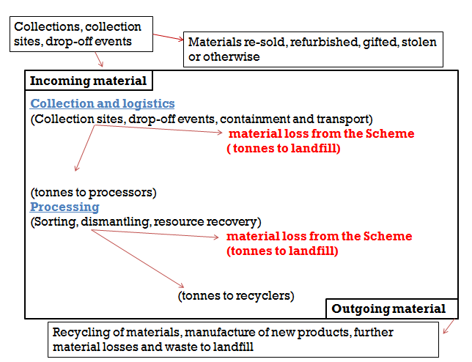

Exclusions
- Televisions and computers collected but refurbished, resold, gifted, stolen or otherwise being diverted away from recycling.
- Other e-waste (for example telecommunications equipment, appliances and commercial IT equipment such as servers).
- Actual material recycling, transformation or new product manufacture.
Televisions and computers collected and then reused and other e-waste are excluded as they are outside of the intent of the proposed Scheme. Actual material recycling is excluded as that material transformation is beyond the control of participants in the proposed Scheme.

Methodology
A list of e-waste collectors and processors was compiled from industry knowledge, reviewing current reports for the Scheme, discussions with stakeholders and an internet search. An assessment was made to ensure the organisations selected provided a comprehensive, adequate and representative sample of current e-waste collection and processing in Australia.
Stakeholders from the television and computer industry, state and local government, NGOs and the waste and recycling industries were consulted for input into the questionnaire to be provided to potential respondents. The draft questionnaire was discussed further with DSEWPaC before being finalised.
The questionnaire (see Attachment 1) sought not only quantitative responses on materials handled for the periods 2007-2008, 2008-2009 and 2009-2010, but details on length of time in operation, size of operation, investment in facilities, accreditations, regulatory compliance obligations, material tracking systems, accounting systems and supply chain reporting.
Further to the provision and follow-up of the questionnaire, responses that were unclear or incomplete were followed up. Three sites visits were also undertaken, two processors and one collector.
Respondents were assured that all responses provided would be confidential and the study would not enable the identification of any organisations response.
Responses were logged and recorded for quantitative and qualitative data. Raw quantitative data was checked against organisations public reports and other industry studies and reports to determine consistency and general accuracy. Qualitative data (such as accreditations and regulatory compliance obligations) was checked against organisations public reports and relevant public records.
Weighting and distribution of quantitative data was undertaken to account for outliers and for the different recovery rates being achieved by organisations handling different volumes of materials in order to ensure overall numbers properly reflect the current recovery rates.

Detailed findings

Respondents
Nineteen organisations were approached to participate in the questionnaire, including 13 collectors (those companies or local governments providing collection services and / or collection sites) and six processing companies (those involved in sorting, dismantling and resource recovery, either solely or in conjunction with their own collection operations).
Fourteen responses were received, eight from collectors and six from processors.
Responses cover operations in all states and territories except the Northern Territory. One company that collects material from the Northern Territory was asked to participate but did not provide any response.
Those identified and asked to participate were chosen in consultation with industry, environment group and government stakeholders and sought to be representative of a cross section of the location, size and type of operation, whether a collection or processing organisation. The participants were selected to provide a comprehensive, adequate and representative sample of current television and computer collection and processing in Australia.
With respect to processing organisations, A Study of Australia’s Current and Future E-Waste Recycling Infrastructure Capacity and Needs (Wright Corporate Strategy in collaboration with Ratwec) identified that there are 14 processing sites of significance in Australia processing about 25,000 tonnes of material in 2010. The six processors that participated operate 11 sites and processed a total of 12,250 tonnes of material in 2009-2010.
A greater number of collection organisations than processing organisations were approached to participate on the basis that there are more collection organisations than processing organisations and while processors are all private companies, collection organisations included private companies, local government and not-for-profit operators (although the not-for-profit groups did not respond to the questionnaire).
4.1.1 Collection
The eight collectors that responded undertake a range of collection activities. Four provide some form of collection service either as stand-alone on-call services or in conjunction with local government, and four operate drop-off points and / or collection days.
Of the eight collectors that responded, three provided data for three years (2007-2010), two for two years (2008-2010) and three for one year (2009-2010). The collectors reported sending an estimated total of 2,371 tonnes of televisions and computers to processors in 2009-10. For context, it is estimated that total annual processing in Australia was 25,000 tonnes in 2010.

4.1.2 Processors
The six processors that responded operate a total of 11 facilities in New South Wales, Victoria, Queensland and Western Australia.
Of respondents, four provided data for three years (2007-2010), one for two years (2008-2010) and one for one year (2009-2010).
Five of the respondents have ISO14001 environmental management system certification for at least one site under their operational control and one has certification pending. Three have ISO9001 safety management system certification and one has certification pending.
For the three year period studied, respondents reported a total of 28,150 tonnes of end-of-life televisions and computers collected and processed and a total of 26,250 tonnes of materials sent to recyclers.
For the period 2009-2010, the processing organisations sampled handled a total of than 12,250 tonnes of end of life televisions and computers. This represents approximately 49% of current total annual processing in Australia.

Figure 2: Reported volumes compared with current processing
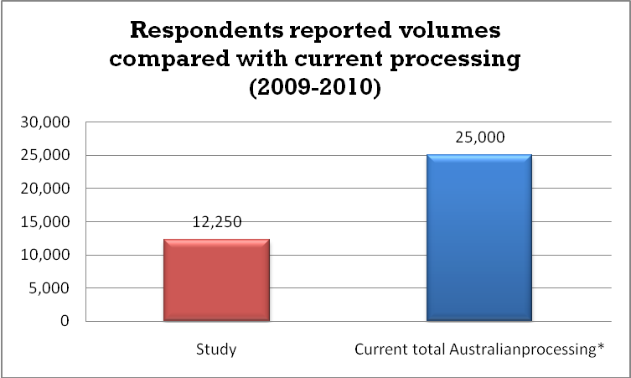
*A Study of Australia’s Current and Future E-Waste Recycling Infrastructure Capacity and Needs, Wright Corporate Strategy in collaboration with Ratwec, September 2010, indicated current processing at about 25,000 tonnes per year.

Materials recovery
Respondents were asked to provide details of the total volumes of televisions, computers and aggregated e-waste materials they collected and processed for the periods 2007-2008, 2008-2009 and 2009-2010.
Where an organisation did not track televisions and computers separately and / or collected and / or processed other forms of e-waste (such as appliances, audio visual equipment) they were asked to provide any material audits and estimates on the breakdown for televisions and computers.

Collection organisations
Individual collection organisations reported that between 94% and 100% of the matter they collect is sent to a processor or recycler. The matter that is not sent to a processor or recycler is a mixture of contamination (such as plastic film, foam, tape and CDs) and breakage and unrecoverable matter. Collectors do not currently track and report the different portion of losses between contamination and breakage and unrecoverable matter. The matter that is not sent to a processor or recycler is sent to landfill.
Aggregated reported data shows a 98% recovery rate.
Weighting to account for the recovery rate achieved by different collection organisations in accordance with the volumes collected produces a 99% recovery rate.
Of the eight collection organisations, four target televisions and computers only and four collect other e-waste such as mobile phones, audio visual equipment and appliances. None of those four were able to provide documented breakdowns between the television and computer collected and other e-waste but estimated other e-waste to be between 5% and 10% of total collected material by weight. An analysis of the actual tonnes reported by the four dedicated television and computer collectors combined with the estimates provided by the other four collectors was undertaken to produce the following table of the current collection of televisions and computers from these respondents.

Table 1: Collectors – Televisions and computers reported by collectors
 | Tonnes in | Tonnes out | Tonnes to landfill | Total recovery rate
2007-2008 | 184 | 182 | 2 | 99%
2008-2009 | 1,101 | 1,080 | 21 | 98%
2009-2010 | 2,411 | 2,371 | 40 | 98%
Total | 3,696 | 3,633 | 63 | 98%

Findings
- Losses at collection points are minimal. The matter that is not sent to a processor or recycler is sent to landfill and includes a mixture of contamination (such as plastic film, foam, tape and CDs) and breakage and unrecoverable matter (such as broken glass and small pieces of plastic). Collectors do not currently track and report the different portion of losses between contamination and breakage and unrecoverable matter.
- Material tracking, data management and reporting standards range from high quality to poor.
- Seven out of eight collection organisations responded that they have tracking and reporting systems, but only two were able to provide evidence of their system and reporting and only one was able to provide evidence the system is audited.
- Recovery rates are consistent at collection organisations regardless of volumes managed.

Processing organisations
Processing companies reported recovery rates between 74% and 99%. That is, between 74% and 99% of the total amount of e-waste received for processing was dispatched to a recycler.
While one company reported a 74% rate, the other five reported rates between 94% and 99%.
The respondent that reported a 74% recovery rate identified that the rate was impacted by processing during one particular year where equipment and general material handling problems caused large scale breakage and deterioration of matter rendering it unsuitable for sale to recyclers and therefore needing to be landfilled.
Of the six processing companies, all reported receiving some other e-waste along with end-of-life televisions and computers (such as appliances, audio-visual, gaming and / or telecommunications equipment).
Those able to track a breakdown of products report that between 80% and 95% of total e-waste received are end-of-life televisions and computers.
Those unable to provide a breakdown estimated that other e-waste was between 10% and 25% and, therefore end-of-life televisions and computers made up between 75% and 90% of e-waste received.
An analysis of the actual tonnes reported by these companies against their reported breakdowns or estimates was undertaken to produce an estimation of the current processing of end-of-life televisions and computers.
Aggregated reported data shows a 95% recovery rate for the period 2007-2010 and a 93% recovery rate in the period 2009-2010. Weighting to account for the recovery rate achieved by different processing organisations in accordance with the volumes collected produces a 92% recovery rate.
The processing respondents reported the following amounts of televisions and computers processed.
Table 2: Processors - Total televisions and computers reported by processors
 | Tonnes in | Tonnes out | Tonnes to landfill | Total recovery rate
2007-2008 | 6010 | 5730 | 280 | 95%
2008-2009 | 9240 | 8840 | 400 | 96%
2009-2010 | 12,250 | 11,450 | 800 | 93%
Total | 27,500 | 26,020 | 1480 | 95%

A number of anomalies were found in data being provided. For example, some processors included waste as part of their recovery rates based upon claims that general waste from their processes underwent further resource recovery by other operators. No evidence supported this claim and observations of the waste indicate it is not suitable for further resource recovery.
It is likely there is further waste to landfill due to the condition some commodities are in. It was observed at some processors that some sorted commodities presented as an ostensibly clean stream contained a variety of other materials. For example, sorted material presented for dispatch as plastics included metals (screws still in place, metal framework pieces) and material presented as glass contained plastics (broken pieces attached and floating).
While this contamination may be acceptable to end customers and may become a residual waste at the recycling point and therefore outside the scope of this study, it may also be recovered at or prior to recycling if operations enable such further resource recovery.
For the purpose of this study however it is indicative that the reported recovery of some commodities may not be accurate.

Findings
- The overall recovery rate from processors is 92%, with an 8% material loss, although this differs between processors, with one reporting a rate as low as 74%.
- The reported recovery rates do not accurately reflect actual recovery rates as some processors incorrectly report matter as sent to a recycler when it is actually sent to landfill.
- Aggregated reported recovery rates have fluctuated over the three year period of the study between 93% and 96%.
- Recovery rates are lower the larger volumes a processor manages.
- The material going to landfill is from broken and damaged products (such broken glass, small pieces of plastic) and contamination or unrecyclable materials incorrectly put into the system (such as foam, plastic film, strapping and tape).
- All six processing organisations responded that they have tracking and reporting systems, three were able to provide evidence of their system and reporting and two were able to provide evidence the system is audited.
- The processing points where the majority of the volume of materials are handled have good to high quality data management and reporting, that is, they provided evidence of their system and that it is audited.

Reporting and data quality
The issue of data management and data quality was assessed to inform the accuracy and reliability of current reporting. Respondents were asked to detail their data management systems, whether the systems are subjected to certification and / or audit, and to provide evidence to support the data and responses they provided.
Of the collectors, seven out of eight collection organisations responded that they have tracking and reporting systems, two were able to provide evidence of their system and reporting and one was able to provide evidence the system is audited.

Figure 3: Collectors – Data Management and Quality
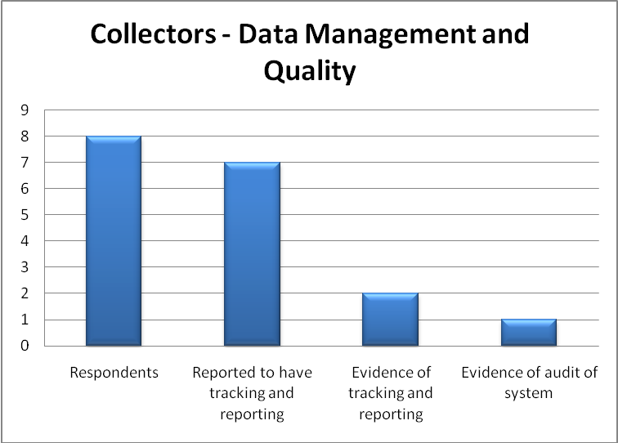

Of the processing organisations, all six processing organisations responded that they have tracking and reporting systems, three were able to provide evidence of their system and reporting and two were able to provide evidence the system is audited.

Figure 4: Processors – Data Management and Quality

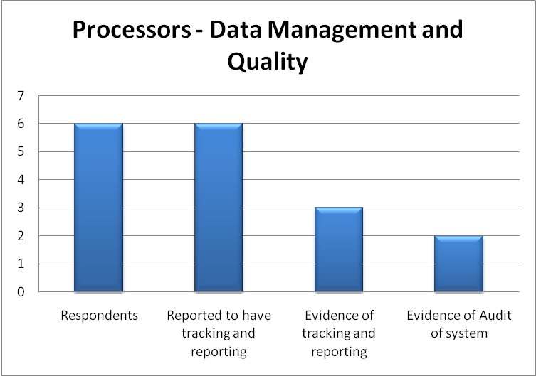

The processing organisations where the majority of the volume of materials is handled have good to high quality data management and reporting, that is, they provided evidence of their system and that it is audited.
All six processing organisations responded that they have developed proprietary software for tracking and reporting. Of the three that provided evidence able to be reviewed for this study, there are different definitions of materials used in their tracking and reporting.

Mass balance
Mass balance calculations are widely used by processors. The term “mass balance” is generally defined as a comparison of inputs and outputs for a particular process. Also called “material balance”, it seeks to examine material entering and leaving a given system to determine the gain or loss of material through that particular process.
To the limited extent the calculations could be examined and tested for this study, there is little consistency in calculations being used and there is evidence that some calculations are not robust. Some respondents included waste in their calculations as part of the material recovery.
Further, current data quality and transparency do not provide a high level of confidence that reported material rates are absolutely correct.

Findings
- Overall reporting and data quality is average to poor, although the processing points where the bulk of materials are handled have good to high quality data management and reporting.
- Different methodologies are used for monitoring reporting, which represents a data consistency issue.
- Of the collection organisations, 88% claim to have tracking and reporting systems, 25% provided evidence of such a system and 13% evidence that their system is audited.
- Of the processing organisations, 100% claim to have tracking and reporting systems, 50% provided evidence of such a system and 33% provided evidence that their system is audited.
- A number of processing organisations have proprietary material tracking and reporting systems using different definitions and methods.

Risk management
Current risk management practices do not provide a high level of confidence that unexpected circumstances that may interrupt processing capacity are being adequately assessed and managed.
At processing points there is generally good planning for regulatory risk (domestic and international) such as site environmental licensing, material tracking and reporting and international trade responsibilities. However there is limited planning for discontinuity events to end customers, limited contingency planning for natural disasters and limited planning for managing bottle necks created by sudden influx of large volumes of material.
Of note is that respondents reported there is adequate capacity in their operations, and the system as a whole, to adequately manage a sudden influx of large volumes of materials, however observations and anecdotal evidence does not support this claim. Sites have been observed with significant amounts of material stockpiled under current and reportedly business as usual conditions. Collectors report incidents of not being able to send materials to processors due to capacity constraints.
While it was neither observed nor reported that products have actually been sent to landfill due to this situation, processors could not provide any detailed or documented plan to manage this risk.

Findings
- There is a potential for recovery rates to be negatively impacted by unforeseen circumstances.
- Respondent claims that there is adequate capacity to handle a sudden influx of large amounts of material is not supported by evidence.

Questions on bromenated flame retardants
While not a focus of the mass balance assessment, respondents were asked to answer questions regarding their process identifying, handling and tracking any materials containing bromenated flame retardants (BFRs), see Attachment 1, question 4. This was undertaken to inform other work the DSEWPaC is doing on other waste policy matters.
Twelve responses to these questions were received and of those:
- Four were from processors (organisations that do some dismantling and sorting of the e-waste) and 8 from collectors or collection sites.
- None of the respondents currently check for BFRs.
- All respondents report any BFRs would go into a mixed plastics stream for recycling, either domestically or overseas.
- Only one collector is investigating equipment to identify and separate BFRs.
- Two processors are actively investigating.
- Two processors have investigated and have determined it is prohibitively costly.

Conclusion
This study has reviewed a large and representative sample of Australia’s existing collection and processing for end-of-life televisions and computers in order to determine the current recovery rate for recycling.
While a number of stakeholders in the proposed Scheme (some of who have participated in this study and questionnaire) claim that a 98% recovery rate of end-of-life televisions and computers is achievable, this is not supported on current available evidence and the analysis done for this report. This study estimates that the current material recovery rate in Australia in 2009-2010 is 91%, however, the poor quality of current data and reporting means setting an enforceable target for the commencement of the proposed Scheme is inappropriate.
As the proposed Scheme develops and reporting and data quality improve, it may be possible to set an enforceable recovery rate and also undertake other performance reviews to understand how much and what type of material is or is not being recovered under the proposed Scheme, and the reasons for such recovery.
Attachment 1 - Copy of questionnaire

March 2011
National Television and Computer Recycling
Product Stewardship Scheme
Questionnaire: material handling and processing

Introduction:
The Australian Government Department of Sustainability, Environment, Water, Population and Communities (DSEWPaC) has engaged Equilibrium and Nick Harford to analyse the current level of material recovery in Australia for television and computer waste. The outcome will be used to inform the key performance indicator for material recovery targets in the National Television and Computer Recycling Scheme (the Scheme).
All information gathered here is considered commercial-in-confidence. No information will be communicated to any third party nor used in any way that may identify the source of the information.
- General information:
Company / Organisation

Site(s) details

Period in operation

Number of employees

Approximate capital cost of facility
Person completing this form

Contact details

- Operational information:
Site environmental licence requirements (eg: EPA licence)
Regulatory reporting requirements (eg: waste tracking, EEO, NGERS)
Accreditation(s) (eg: ISO 14000)
Site activity (what is the primary activity of the site and what other activities are conducted)
Material tracking system

Software (accounting and / or material tracking)
Supply chain reporting upstream (what if any reporting is required upstream to points where material is received from)
Supply chain reporting downstream (what if any reporting is required downstream where material is sent or sold)
Material auditing schedule and system

- Material information:
(Responses to the following in accordance with the sites activity or activities, that is whether collection, sorting, dismantling, processing etc)
Televisions
Amount received (tonnes) | 09-10
Amount received (tonnes) | 08-09
Amount received (tonnes) | 07-08
Dispatched | 09-10
Dispatched | 08-09
Dispatched | 07-08
Waste to landfill | 09-10
Waste to landfill | 08-09
Waste to landfill | 07-08

Computers
Amount received (tonnes) | 09-10
Amount received (tonnes) | 08-09
Amount received (tonnes) | 07-08
Dispatched | 09-10
Dispatched | 08-09
Dispatched | 07-08
Waste to landfill | 09-10
Waste to landfill | 08-09
Waste to landfill | 07-08

Aggregated e-waste
Amount received (tonnes) | 09-10
Amount received (tonnes) | 08-09
Amount received (tonnes) | 07-08
Dispatched | 09-10
Dispatched | 08-09
Dispatched | 07-08
Waste to landfill | 09-10
Waste to landfill | 08-09
Waste to landfill | 07-08

- Bromenated flame retardant (BFRs)
DSEWPaC has also engaged Australian Environment Agency Pty Ltd to research factors associated with the identification and segregation of products containing brominated flame retardants (BFRs). The findings will inform DSEWPaC of Australia’s capacity to meet new requirements proposed by the Stockholm Convention on Persistant Organic Pollutants. More information about the changes to the Convention can be found at www.environment.gov.au/settlements/chemicals/international/index.html.
The two particular flame retardants which are the subject of international regulatory action are pentaBDE and octaBDE,. While use of these two flame retardants has largely ceased, they may still be found in a range of end use products or articles. PentaBDE is expected to have mainly been used in Australia in flexible polyurethane foam in domestic furniture some of which includes mattresses; in foam-based packaging; and in automotive seating. OctaBDE in Australia is expected to mainly have been used (including being imported) in ABS/SAN (acrylonitrile butadiene styrene/styrene acrylonitrile copolymenr) resins. Examples of final products using these resins include TV-sets, business machines, computer housings, household appliances (hair dryer, curler), automotive parts, electronics and telecommunications.
- Do you track the types and quantities of these products?

- If so, how much does your organisation handle per annum? Over the last three years?

- Is any such material recycled or sent to landfill?

- If recycled, what is the process and what products are made from the recycled material?

- If landfilled, where does disposal occur?

- Have you assessed and can you provide any information on the feasibility and cost of recycling infrastructure and / or processes to identify and separate BFR containing plastics?

A Study of Australia’s Current and Future E-Waste Recycling Infrastructure Capacity and Needs, Wright Corporate Strategy in collaboration with Rawtec, September 2010, indicated current processing at about 25,000 tonnes per year.
A Study of Australia’s Current and Future E-Waste Recycling Infrastructure Capacity and Needs, Wright Corporate Strategy in collaboration with Rawtec, September 2010, indicated current processing at about 25,000 tonnes per year.
A Study of Australia’s Current and Future E-Waste Recycling Infrastructure Capacity and Needs, Wright Corporate Strategy in collaboration with Ratwec, September 2010, indicated current processing at about 25,000 tonnes per year.

