

Department of Agriculture, Fisheries and Forestry

**Master Consolidator User Guide**

Version 2.0

1 August 2023

Contents

Lodging Master Consolidator Declarations for LCL/FAK containers 2

When do I need to lodge a BMSB Master Consolidator Declaration Form? 2

How do I complete the BMSB Master Consolidator Declaration Form? 2

How to reset a forgotten password 3

Accessing the Master Consolidator Declaration Portal 4

Entering the information on a Master Consolidator Declaration Form 5

Entering Vessel information 6

Entering Container and Treatment Certificate information 7

Select the declaration type: 7

Treated Offshore 8

Partial Treatment 11

Treatment Onshore 14

Nil Risk 16

Unknown Risk 19

What happens after the Master Consolidator Declaration Form is submitted? 21

What happens if I make a mistake? 22

Withdrawing a declaration 22

Amendments to existing draft declarations 23

Tips and troubleshooting 24

ICS holds and messages 24

FIXLOC direction 26

My container is still held in ICS after declaration lodgement 26

Changing container cargo type from LCL to FCL in ICS 26

FID lodgements 26

Unaccompanied Personal Effects (UPEs) 27

Changes to BMSB treatment rates to include timber 27

Payments against entries 27

Treatment certificates 27

Supporting documents 27

Useful Information 28

Contact Information 28

See. Secure. Report. 29

Further Information 29

# Lodging Master Consolidator Declarations for LCL/FAK containers

All Master Consolidators (MCs) handling LCL/FAK containers subject to BMSB measures ***must*** register with the department.

Registration forms can be found on the department website [here](https://www.agriculture.gov.au/biosecurity-trade/import/before/brown-marmorated-stink-bugs/lclcontainers" \l "how-do-i-register-as-a-master-consolidator). Please complete your form and email to SPP@aff.gov.au to register your company.

Please note that all individuals from your company that intend to lodge declarations, ***must*** register as a separate user under the Master Consolidator Identification (MC ID) for the company. Due to some MC IDs being shared accounts, it is important to distinguish who lodged the declaration for both the department and the Master Consolidator if follow up actions are required. Failure to do this could result in non-compliance action being taken against the individual or company.

**Note**: Once you are a registered user, your login will remain active. There is no requirement to re-register every year.

## When do I need to lodge a BMSB Master Consolidator Declaration Form?

LCL/FAK containers are managed for BMSB risk at the container level. This includes LCL consignments that are manufactured in and/or from a target risk country, between 1 September and 30 April (inclusive).

If your LCL/FAK container is subject to the measures when the cargo report is lodged, it will be referred for a Seasonal Pest hold (SPHOLD), and the cargo reporter will receive a message that an MC declaration is required to be submitted – see below. If you believe your cargo is not subject to the measures, a Nil Risk MC declaration will still be required to lift the hold.

**Note**: You will need to provide appropriate documentation that verifies your container is out of scope.

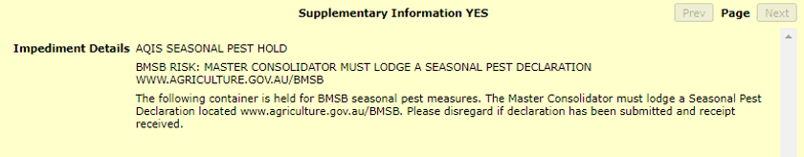

***Important****: If your LCL/FAK container does not have an SPHOLD at the container level and you do not receive this message in the ICS,* ***DO NOT SUBMIT AN MC DECLARATION*** *– your LCL/FAK container is not subject to BMSB seasonal measures and does not require a declaration to be lodged for clearance.*

## How do I complete the BMSB Master Consolidator Declaration Form?

Registered Master Consolidators must enter relevant details on their declaration form about the LCL/FAK container that is being imported. This information will include incoming vessel information along with a declaration against ***all*** goods in the container, this is not limited to only the target high risk goods.

Evidence to support the declaration type selected is also required to be provided. This includes but is not limited to:

* A container manifest that has HS codes and port of origins for all House Bills (HBOLs), and
* Bill of Lading (BOL) with a Shipped-on Board (SOB) date, and/or individual HBOLs that have HS codes and port of origin, and/or
* Any relevant sealing, 120 hour transhipment or NUFT [declarations](https://www.agriculture.gov.au/biosecurity-trade/import/before/brown-marmorated-stink-bugs/prepare-import" \l "templates-for-documentary-evidence), and/or
* Any offshore treatment certificate(s) that meet BMSB requirements. Visit here for up to date BMSB treatment information and requirements.

Master Consolidator declarations will be monitored throughout the season for non-compliance. Where continued non-compliance is found, the department may direct all future LCL/FAK containers for that MC ID for full documentation assessment, onshore treatment, or export.

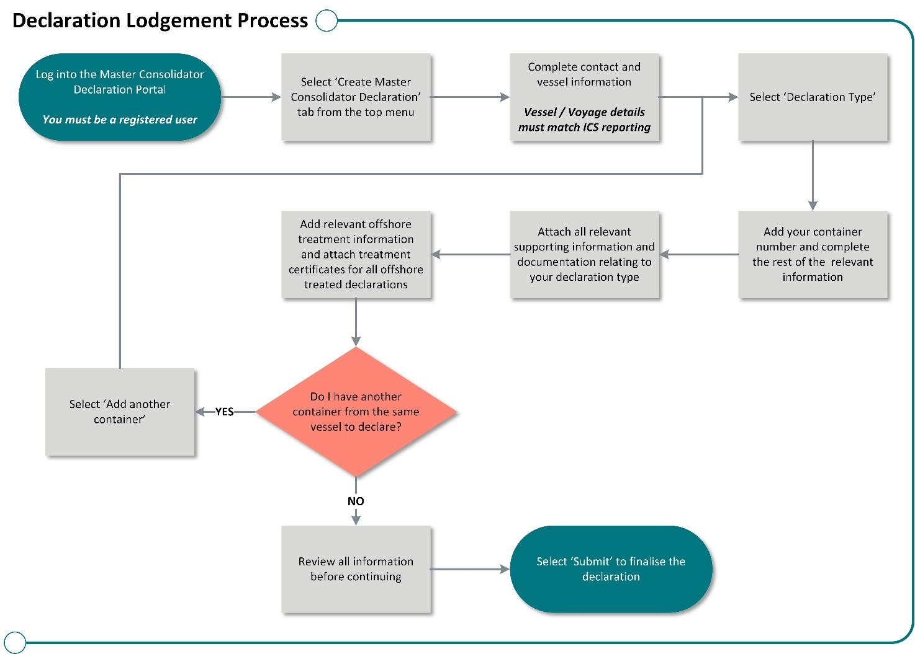

Figure 1: Flow chart showing lodgement of Master Consolidator Declarations

### How to reset a forgotten password

Any registered MC user that has forgotten their password, can reset it by using their accounts user email via the login screen, then clicking the ‘Forgot Password?’ link. See ‘**Accessing the Master Consolidator Declaration Form**’ for instructions on how to access the login screen.

### Accessing the Master Consolidator Declaration Portal

Once you have registered and have received your MC ID, log on to the departmental portal using your registered username, password and two factor authenticator code. The Master Consolidator Declaration form can be accessed through the department portal via here. Access to the form is only available to registered Master Consolidators.

* Once on the Forms Portal home page, select the ‘Create Master Consolidator Declaration.’

* This will open a new Master Consolidator Declaration form for you to complete.

### Entering the information on a Master Consolidator Declaration Form

* When a new form is generated, your 'Contact Name’ will be pre-populated with your registered details.

**Note:** Fields marked with an * are mandatory fields that must be completed; some fields have validated formats.

* The ‘Contact Name’ and ‘Contact Number’ must be added and are required to reflect the person lodging the declaration. Each person from your company lodging declarations, must use their individually registered account ID, sharing of IDs is not acceptable and could lead to non-compliance action. The phone number field must be provided with area code information and contain no spaces (i.e., 0212345678).

### Entering Vessel information

* Enter the relevant ‘Vessel Id,’ ‘Vessel Name’ and ‘Voyage Number.’ It is important to check that details entered match ***exactly*** what has been declared in ICS on the sea cargo report. If this information does not match, the system cannot release the hold on your container. If you find your container is still held after receiving your automated direction, please check the above information against ICS, then see the ‘**What happens if I have made a mistake**’section of this document.

* If you are making a declaration for multiple containers on the same vessel, click ‘Add Another Container’ once details for first container have been lodged. All containers must match their corresponding vessel details.

* If you wish to add additional information to aid assessment, please utilise the ‘Supporting Documentation Information’ field* to type a message.

*\*Please note that this function is just an aid to communicate any further information you may have for the department, it is* ***not*** *to be used as documentary evidence.*

### Entering Container and Treatment Certificate information

Each container can only be declared once using one of the declaration types below. Multiple declarations may result in multiple entries being created with differing directions. If this has occurred, please contact BMSBprocessing@aff.gov.au with ***all*** associated entry numbers that have been created for the container.

### Select the declaration type:

There are five risk status types* that can be declared:

1. **Treated offshore -** the entire container with target high risk goods has been treated offshore, or
2. **Partially treated -** all the target high risk goods inside the container have been treated offshore (partially treated), or
3. **Treatment onshore -** the entire container is nominated for onshore treatment, or
4. **Nil risk -** the entire container does not have any target high risk goods inside, or
5. **Unknown risk -** the contents of the container are unknown and nominated to be held at an approved arrangement (AA) site pending further information to be provided.

***\*****A brief description of acceptable scenarios has been included under each type below. Please ensure that all declarations accurately reflect the nature and/or treatments of the goods being imported.*

#### Treated Offshore

All goods within the container can be treated on the one certificate* as an FCL, or across multiple certificates* as LCLs, but ***ALL*** goods *must* have been treated offshore, not just the target high risk goods.

If ***ALL*** goods have *not* been treated, and only the target high risk goods have been treated, please select the “Partially Treated” declaration type, as the “Treated Offshore” option is ***not*** the correct declaration type to lodge for this scenario and may result in a non-compliance being issued.

*\*The container and seal or all goods and package quantities must be linked to the relevant treatment certificate(s) via an acceptable consignment link, failure to do so will result in the whole container requiring onshore treatment or export.*

1. Enter container number information. This must follow the standard format of 4 alpha - 7 numeric (i.e., ABCD1234567).

1. Enter the discharge and destination port information (i.e., SYD or MEL) and select from the drop box.

1. Nominate* an onshore AA verification facility. Based on the discharge and destination ports, a list of AA providers that can undertake this task in that location will be displayed.

*\*The nominated onshore AA verification facility information will only be used if the container is randomly selected for an onshore verification activity. Where containers are selected for an inspection, relevant directions will be generated and emailed to the Master Consolidator.*

1. Supporting documentation* for this type of declaration is required.

* Upload a copy of the container manifest via the ‘Attach Document’ button.
* Upload the rest of the supporting documentation via the ‘Add Supporting Documentation’ button.

Repeat this step for all additional documents you wish to submit.

* + Additional documentation should include at a minimum;
  + Bill of Lading with a Shipped-on Board date.
  + Any relevant House Bills with HS codes and port of origin.

**Note**: Each attachment has an 8 MB limit, however there is no limit on the number of documents able to be uploaded.

*\*Please see ‘****Tips and troubleshooting****’ section for tips and requirements for supporting documentation.*

1. Offshore treatment certificate information is required. This information must be added exactly as it is listed on the offshore treatment provider’s certificate*, to allow the department to match the information. Failure to match certificate information may cause delays for the container upon arrival.

1. Upload a copy of your treatment certificate via the ‘Attach Document’. All treatment certificates are required to be added separately. If required, please use the ‘Add Supporting Evidence’ functions for further supporting documents including sealing declarations.

1. To add additional certificates please use the ‘Add a Treatment Certificate’ option.

*\*Please see ‘****Tips and troubleshooting****’ section for tips and requirements for treatment certificates.*

1. You may add another container to this declaration at this stage. Follow steps in corresponding declaration type for new container declaration.

1. Once all the relevant information for this declaration type has been completed, select the ‘Yes’ radio button stating you agree with the terms and conditions of submitting the declaration and click ‘Submit’. Your declaration has now been submitted into the department for assessment. Once submitted, you will receive an automated direction via aims to the email address registered to the MC ID or an email verifying that your container does not require intervention and has been released from BMSB seasonal requirements. If you receive the latter, please do not email requesting a release direction. The processing and policy teams are unable to provide this, as an AIMs entry was never created. This automated email is your release from BMSB requirements, and your container is now only subject to import conditions relating to your goods and BICON.

#### Partial Treatment

Only part of the container has been treated i.e. all target high risk goods within the container. These goods can be treated on the one certificate* as consolidated cargo, or across multiple certificates* as LCLs, but ***ALL*** target high risk goods *must* have been treated offshore.

If all target high risk goods have *not* been treated offshore, then please use the “Treated Onshore” as the “Partial Treatment” option is *not* the correct declaration type to lodge for this scenario and may result in a non-compliance being issued.

*\*All risk goods must be linked to the relevant treatment certificate via an acceptable consignment link, failure to do so will result in the whole container requiring onshore treatment or export.*

1. Enter container number information. This must follow the standard format of 4 alpha-7 numeric (i.e., ABCD1234567).

1. Enter the discharge and destination port information (i.e., SYD or MEL) and select from the drop box.

1. Nominate* an onshore AA verification facility. Based on the discharge and destination ports, a list of AA providers that can undertake this task in that location will be displayed.

*\*The nominated onshore AA verification facility information will only be used if the container is randomly selected for an onshore verification activity. Where selected for an inspection, relevant directions will be generated and emailed to the Master Consolidator.*

1. Supporting documentation* for this type of declaration is required.

* Upload a copy of the container manifest via the ‘Attach Document’ button.
* Upload the rest of the supporting documentation via the ‘Add Supporting Documentation’ button.

Repeat this step for all additional documents you wish to submit.

* + Additional documentation should include at a minimum;
  + Bill of Lading with a Shipped-on Board date.
  + Any relevant House Bills with HS codes and port of origin.

**Note**: Each attachment has an 8 MB limit, however there is no limit on the number of documents able to be uploaded.

*\*Please see ‘****Tips and troubleshooting****’ section for tips and requirements for supporting documentation.*

1. Offshore treatment certificate information is required. This information must be added exactly as it is listed on the offshore treatment provider’s certificate*, to allow the department to match the information. Failure to match certificate information may cause delays for the container upon arrival.

1. Upload a copy of your treatment certificate via the ‘Attach Document’. All treatment certificates are required to be added separately. If required, please use the ‘Add Supporting Evidence’ functions for further supporting documents including sealing declarations.

1. To add additional certificates please use the ‘Add a Treatment Certificate’ option.

*\*Please see ‘****Tips and troubleshooting****’ section for tips and requirements for treatment certificates.*

1. You may add another container to this declaration at this stage. Follow steps in corresponding declaration type for new container declaration.

1. Once all the relevant information for this declaration type has been completed, select the ‘Yes’ radio button stating you agree with the terms and conditions of submitting the declaration and click ‘Submit’. Your declaration has now been submitted into the department for assessment. Once submitted, you will receive an automated direction via aims to the email address registered to the MC ID or an email verifying that your container does not require intervention and has been released from BMSB seasonal requirements.

If you receive the latter, please do not email requesting a release direction. The processing and policy teams are unable to provide this, as an AIMs entry was never created. This automated email is your release from BMSB requirements, and your container is now only subject to import conditions relating to your goods and BICON.

#### Treatment Onshore

Not all target high risk goods OR nil goods have been treated offshore and whole container will need to be treated onshore to mitigate the BMSB risk. It is the Master Consolidator’s responsibility to clear treatment of goods with all relevant importers/brokers, as this decision lies solely with the Master Consolidator. If any goods within the container cannot be treated* for any reason, export will be the only option available.

*\*Deconsolidation for part treatment is not permitted, if the whole container cannot be treated onshore, the container will be directed for export.*

1. Enter container number information. This must follow the standard format of 4 alpha-7 numeric (i.e., ABCD1234567).

1. Enter the discharge and destination port information (i.e., SYD or MEL) and select from the drop box.

1. Select the treatment type and from this a list of AA treatment providers that can undertake that type of treatment selected in that location will be displayed.

1. Where the individual goods are known to be valued at more than AUD $1 million, select ‘yes’.*

*\*DO NOT select ‘yes’ if your individual goods do not exceed AUD$1 million, as this will trigger a delay in assessment due to the approval process. If you have accidentally checked this option, please contact BMSBprocessing@aff.gov.au.*

1. Only a container manifest is required for this type of declaration.

* Upload a copy of the container manifest via the ‘Attach Document’ button.

**Note**: Each attachment has an 8 MB limit, however there is no limit on the number of documents able to be uploaded.

*\*Please see ‘****Tips and troubleshooting****’ section for tips and requirements for supporting documentation.*

1. You may add another container to this declaration at this stage. Follow steps in corresponding declaration type for new container declaration.

1. Once all the relevant information for this declaration type has been completed, select the ‘Yes’ radio button stating you agree with the terms and conditions of submitting the declaration and click ‘Submit’. Your declaration has now been submitted into the department for assessment. Once submitted, relevant directions will be generated by the system and emailed to the email address registered to the MC ID.

#### Nil Risk

All goods within the container are Nil risk and do not meet any of the criteria outlined in the BMSB seasonal measures by the department*.*

***DO NOT*** use this option unless ***everything*** within the container is out of scope for BMSB onshore intervention. If there are target high risk goods within the container that have been treated and the balance is Nil risk, you will have to use the “Partially Treated” option as the “Nil Risk” option is *not* the correct declaration type to lodge for this scenario and may result in a non-compliance being issued.

1. Enter container number information. This must follow the standard format of 4 alpha-7 numeric (i.e., ABCD1234567).

1. Enter the discharge and destination port information (i.e., SYD or MEL) and select from the drop box.

1. Nominate* an onshore AA verification facility. Based on the discharge and destination ports, a list of AA providers that can undertake this task in that location will be displayed.

*\*The nominated onshore AA verification facility information will only be used if the container is randomly selected for an onshore verification activity. Where selected for an inspection, relevant directions will be generated and emailed to the Master Consolidator.*

1. Supporting documentation* for this type of declaration is required.

* Upload a copy of the container manifest via the ‘Attach Document’ button.
* Upload the rest of the supporting documentation via the ‘Add Supporting Documentation’ button.

Repeat this step for all additional documents you wish to submit.

* + Additional documentation should include at a minimum;
  + Bill of Lading with a Shipped-on Board date.
  + Any relevant House Bills with HS codes and port of origin.

**Note**: Each attachment has an 8 MB limit, however there is no limit on the number of documents able to be uploaded.

*\*Please see ‘****Tips and troubleshooting****’ section for tips and requirements for supporting documentation.*

1. You may add another container to this declaration at this stage. Follow steps in corresponding declaration type for new container declaration.

1. Once all the relevant information for this declaration type has been completed, select the ‘Yes’ radio button stating you agree with the terms and conditions of submitting the declaration and click ‘Submit’. Your declaration has now been submitted into the department for assessment. Once submitted, you will receive an automated direction via aims to the email address registered to the MC ID or an email verifying that your container does not require intervention and has been released from BMSB seasonal requirements. If you receive the latter, please do not email requesting a release direction. The processing and policy teams are unable to provide this, as an AIMs entry was never created. This automated email is your release from BMSB requirements, and your container is now only subject to import conditions relating to your goods and BICON.

#### Unknown Risk

Any declaration lodged as Unknown will be subject to a Full Import Declaration (FID) assessment. Additional information will need to be sent to BMSBprocessing@aff.gov.au once the contents and risk has been identified, including but not limited to a manifest and bill of lading. The Master Consolidator is required to follow up on all containers lodged under this option and provide relevant information once all FIDs have been lodged in ICS.

1. Enter container number information. This must follow the standard format of 4 alpha-7 numeric (i.e., ABCD1234567).

1. Enter the discharge and destination port information (i.e., SYD or MEL) and select from the drop box.

1. Nominate* an onshore AA verification facility. Based on the discharge and destination ports, a list of AA providers that can undertake this task in that location will be displayed.

*\*The nominated onshore AA verification facility information will only be used if the container is randomly selected for an onshore verification activity. Where selected for an inspection, relevant directions will be generated and emailed to the Master Consolidator.*

1. Supporting documentation* for this type of declaration is required.

* Upload a copy of the container manifest via the ‘Attach Document’ button.
* Upload the rest of the supporting documentation via the ‘Add Supporting Documentation’ button.

Repeat this step for all additional documents you wish to submit.

* + Additional documentation should include at a minimum;
  + Bill of Lading with a Shipped-on Board date.
  + Any relevant House Bills with HS codes and port of origin.

**Note**: Each attachment has an 8 MB limit, however there is no limit on the number of documents able to be uploaded.

*\*Please see ‘****Tips and troubleshooting****’ section for tips and requirements for supporting documentation.*

1. You may add another container to this declaration at this stage. Follow steps in corresponding declaration type for new container declaration.

1. Once all the relevant information for this declaration type has been completed, select the ‘Yes’ radio button stating you agree with the terms and conditions of submitting the declaration and click ‘Submit’. Your declaration has now been submitted into the department for assessment. Once submitted, you will receive an automated direction via aims to the email address registered to the MC ID.

1. The container will be permitted to move from the wharf to the nominated onshore AA verification facility site pending further information being provided to the department. These containers will be held seals intact and may be held for up to 35 business days awaiting all FIDs to be lodged.
2. The Master Consolidator must advise the department when all FIDs have been lodged and additional information will need to be sent to BMSBprocessing@aff.gov.au once the contents and risk has been identified. This will need to include a manifest and any relevant treatment certificates or BOL or HBOLS with Shipped-on Board dates that were not lodged in the initial declaration. The Master Consolidator is required to follow up on all containers lodged under this option and provide relevant information once all FIDs have been lodged in ICS.

## What happens after the Master Consolidator Declaration Form is submitted?

Depending on the type of declaration made, and the details provided, declarations may be directed for officer assessment by the department.

* For declarations received prior to the arrival of the container, and assessed as not requiring further BMSB intervention, there will be no hold or AIMS entry generated. In this instance the department cannot provide you with a final release as no AIMS entry has been created, however you will receive an automated email informing you that your container is not subject to BMSB intervention. This email is your release from BMSB requirements only. These containers will be permitted to deconsolidate, and the consignments will be managed as per normal biosecurity processes.
* For declarations received prior to the arrival of the container, and assessed as requiring BMSB intervention, an AIMS entry will be generated, and an automated direction emailed to both the Master Consolidator (sent to the email registered to the MC ID and email added by the user that made the declaration), and the onshore approved arrangement site for further action.
* For declarations received after the arrival of the container, the container may be held at the wharf, until the declaration has been assessed and actioned by the department. It is important to lodge all declarations before the arrival of container to help reduce delays. The department does not have the ability to fast-track late lodgements of containers that have already arrived. All lodgements are assessed in the order in which they are received.
* Containers without a declaration and subject to BMSB measures will be held at the wharf until a declaration is provided to the department for assessment. Containers may be held at the wharf for up to 35 business days and directed for export if a declaration is not received. If you have a message in ICS that directs you to lodge an MC declaration, you ***must*** lodge one. This may include containers that are out of scope via season dates or country of origin. It is important to still lodge a declaration against these containers even if they are NIL risk, as this is the only way the system can clear the hold.



## What happens if I make a mistake?

If a declaration has been submitted and the container number, vessel ID and/or voyage ID is incorrect, the SCR lodgement in ICS has been amended to an FCL, or if the MC Declaration was not required, then the declaration must be withdrawn.

It is important to contact BMSBprocessing@aff.gov.au with all/any multiple entry numbers relating to the same container, or if a direction has been received prior to the withdrawal of the declaration so the department can manually withdraw the corresponding AIMs entry.

## Withdrawing a declaration

To withdraw an incorrectly lodged declaration:

1. Log into the Master Consolidator Declaration online portal.
2. Click the ‘Summary of Declarations’ tab, which will enable you to see all the declarations you have submitted, and those that are still in draft status. You can withdraw any declaration that has been submitted or is in draft status by clicking the ‘Withdraw’ button next to the appropriate declaration.

1. Select the most appropriate reason for the withdrawal from the drop-down menu. Then press ‘Submit’.

1. Once all the relevant information for this withdrawal has been completed, click ‘Submit.’ Your withdrawal has now been submitted to the department for assessment. Once submitted, please contact BMSBprocessing@aff.gov.au with any further supporting documentation relevant to the withdrawal (i.e., a BOL indicating that the container is an FCL not LCL/FAK container).

**Note**: For all withdrawals due to incorrect container number, vessel ID and/or voyage number, a new declaration will have to be submitted after the original has been withdrawn. If you receive a second entry number relating to the same container, you will have to contact BMSBprocessing@aff.gov.au with both entry numbers so duplicates can be manually withdrawn from the system.

## Amendments to existing draft declarations

All other amendments (i.e., declaration type, AA site etc.) must be amended prior to the submission of the declaration, or you will have to withdraw the submitted declaration and resubmit a new one with the correct details – see previous heading ‘**withdrawing a declaration**’.

Only declarations with a ‘Draft’ status can be amended. You can delete or withdraw declarations that are in draft status from the summary of declarations window, however, drafts can also be amended and/or changed to be utilised for other containers requiring declarations or deleted completely by removing all container information.

1. From the ‘Summary of Declarations’ window, find the draft you want to amend and click the corresponding declaration ID hyperlink.

1. You will now be able to change the 'Vessel Id’ and/or the ‘Voyage Number’ if required. You can also ‘Add a Container’, ‘Delete a Container’ and/or ‘Edit’ the existing container details.

## Tips and troubleshooting

### ICS holds and messages

* If you have a **AQIS SEASONAL PEST HOLD (SPHOLDM)** and you receive a message in ICS directing you to lodge an MC declaration, you will not be able to move your container until a declaration has been completed. There is no way to have this hold lifted without a MC declaration. If you have lodged an MC declaration and ICS is still showing this message, please check that your declaration has the correct vessel, voyage and container information as what has been declared in ICS. If this information differs, please see the ‘**what happens if I’ve made a mistake**’ section.



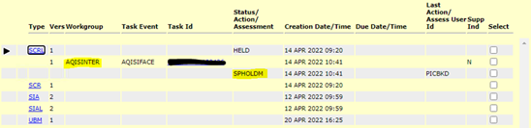

* If your House Bill (HBOL) is showing a **SEASONAL PEST REFERRAL (SPREF)** message, this is ***NOT*** a hold. It is a system reference recognising what has triggered the original SPHOLD. Do not contact the department requesting that the SPREF be lifted, it cannot be lifted as it is not a hold. Please check ICS to ensure that there are no other ABF or AQIS holds as this is usually what is holding your HBOL if your container has a CONDCLEAR or SUBUBMOV.

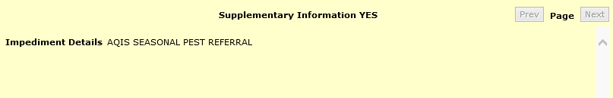

* If your FCL is showing a **CONDITIONAL RELEASE** message, your container is subject to department intervention outlined in the noted entry. Your conditional release will clear once you have completed all onshore interventions and receive a final release.

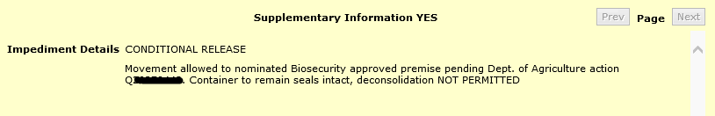

* If your FCL is showing a **AQIS** **GAS HOLD** message, your container is subject to Giant African Snail measures, this is not BMSB related. These holds cannot be lifted by the BMSB Processing Team, and your container will be held until the risk has been investigated and/or mitigated by the Container NCC team (containerncc@aff.gov.au).

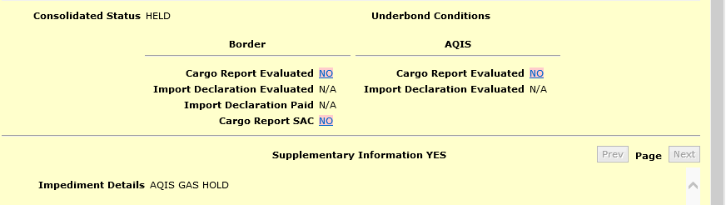

### FIXLOC direction

If you receive a FIXLOC direction for your container via AIMS, you will need to contact BMSBprocessing@aff.gov.au with the location you have nominated, and the entry number associated, noting that you may need to change your AA nomination to one that has been approved to carry out the required onshore intervention. This cannot be fixed via the online portal or by lodging amended or additional declarations.

### My container is still held in ICS after declaration lodgement

If you have lodged your declaration, please wait up to an hour for messaging to update in ICS. If you have waited and the hold still has not been lifted, please log back into the MC portal and review your declaration. In most cases, a hold not lifting is due to the Vessel ID and/or the Voyage ID not matching what has been reported in ICS. If this is the case, please see the ‘**what happens if I’ve made a mistake**’ section. If the details in your lodgement are correct and your container is still held, please contact BMSBprocessing@aff.gov.au to investigate further.

***Please note that this is the only team that can advise and /or have this removed. DO NOT contact multiple areas requesting a release, this only clogs up mailboxes, which in turn delays triaging and responses to other clients.***

### Changing container cargo type from LCL to FCL in ICS

Once a cargo type is reported in ICS as an LCL, an SPHOLD will be placed on the container. If the cargo type is amended to an FCL/FCX, the SPHOLD will remain at the container level even after the LCL report has been withdrawn. The system will not automatically lift the hold. If this occurs, please email BMSBprocessing@aff.gov.au with your OBOL verifying the FCL cargo type, to have the hold lifted.

### FID lodgements

If your container has been selected for a Full Import Declaration (FID) assessment or you have lodged an “unknown” declaration type, then your container will require assessment upon lodgement of all FIDs within the container via ICS. It is important to check that all import declarations have been lodged and all house bills (HBOLS) are linked to their parent bills (PBOLS) via ICS *before* contacting the department to progress with assessment. Assessment cannot be completed until all HBOLS and PBOLS have been accounted for via reporting. HBOLS that are out of scope due to being an Unaccompanied Personal Effects (UPE) or a Self-Assessed Clearance (SAC), will need to have the relevant indicators selected in ICS to be exempted from this requirement. If the entire container is out of scope due to being UPEs or has been shipped out of season and you have received a FID assessment direction, please contact BMSBprocessing@aff.gov.au with relevant supporting documents to verify exemption from FID assessment requirements.

### Unaccompanied Personal Effects (UPEs)

Household goods and personal effects imported as unaccompanied personal effects, and that are categorised as target high risk goods will not be subject to mandatory treatment requirements if they are imported under the B534 form and reported using customs tariff chapter 99. However, goods required to be reported under a Full Import Declaration (FID), for example, motor vehicles and / or goods that do not meet the customs criteria of UPEs and must be reported separately under a different tariff, will require mandatory BMSB treatment either offshore or onshore (if permitted).

### Changes to BMSB treatment rates to include timber

Occasionally goods being imported will require onshore treatment for BMSB *and* treatment to address commodity concerns, like timber. If this is the case, once you have lodged your declaration you will have to contact BMSBprocessing@aff.gov.au to amend the automated direction as this cannot be done via the portal. It is important that the rate gets changed to meet the higher requirements of the timber concern otherwise your goods will be subject to a second treatment as the BMSB rate does not meet the timber requirements.

### Payments against entries

If you or your company do not have an account with the department, you will be required to pay your outstanding assessment/inspection charges prior to release, treatment, or inspection. You will receive a pending payment direction with instruction on how to pay. Once payment has been made, please contact BMSBprocessing@aff.gov.au to finalise and/or receive your next direction, ensuring that the entry number you have paid is quoted in the subject field. Payments are processed by another department and the BMSB processing team cannot access this system, so it is important that you contact us to inform that payment has been made.

### Treatment certificates

It is important that when you lodge a treatment certificate with your declaration that it matches the information that the treatment provider has lodged. If this information does not match or the treatment provider has not lodged your treatment to the department, your container will be directed for an assessment by an officer. If this becomes an ongoing issue, the department suggests contacting your treatment provider for advice on how they are lodging their certificate information. Matching your lodgement to the treatment providers lodgement will enable system matching and alleviate delays due to officer intervention.

If you have received a direction stating that your certificate cannot be validated, and to contact your treatment provider to lodge the certificate with the department, it is important that you contact BMSBprocessing@aff.gov.au once you have confirmation that your certificate has been lodged. The processing team does not get notifications of certificate lodgements, it is important to follow up any outstanding certificate lodgements and inform the processing team when the assessment can be completed on the container.

### Supporting documents

At a minimum, a manifest is required to be submitted with your declaration. It is highly recommended a BOL with a Shipped on Board date and any or all relevant HBOLS be lodged with every declaration to enable timely assessment and alleviate the need for additional document requests. Please note that the more individual documents that are uploaded the more time it takes to assess. A good process to follow is to break documents up into categories and upload as combined documents i.e.,

**Attachment 1)** Manifest that includes HS codes and country of origin for all HBOLS,

**Attachment 2)** Bill of Lading with Shipped-on Board date,

**Attachment 3)** ALL relevant house bills with HS codes and/or country of origin (combined into the one document preferably in the order of the manifest) to support manifest,

**Attachment 4)** ALL sealing declarations (if relevant),

**Attachment 5)** ALL NUFT declarations (if relevant),

**Attachment 6)** Any other information that may be relevant to your container.

***DO NOT*** lodge treatment certificates anywhere other than the treatment section.

Whilst these document requirements are not compulsory, it will greatly aid the timely assessment and ultimate clearance of all containers lodged via the Master Consolidator Portal.

## **Useful Information**

**MC** – Master Consolidator **MC ID** – ID registered to MC

**MC DEC** – Master Consolidator Declaration **FID** – Full Import Declaration

**AIMS** – Agriculture Import Management System **SOB** – Shipped-on Board

**BOL** – Bill of Lading **OBOL** – Ocean Bill of Lading

**HBOL** – House Bill of Lading **FCL** – Full Container Load

**PBOL** – Parent Bill of Lading **LCL** – Less than a Container Load

**ICS** – Integrated Cargo System **FAK** – Freight of All Kinds

**GAS** – Giant African Snail **CAL** – Country Action List

**HPP** – Hitchhiker Pest Policy

## **Contact Information**

Queries relating to Master Consolidator Declarations for LCL and FAK consignments lodged via the Master Consolidator Online Declaration Form should be directed to bmsbprocessing@aff.gov.au. This includes, but is not limited to, additional documents, hold issues, payment notifications, duplicate and withdrawn entries.

Queries relating to BMSB seasonal measures can be directed to the Hitchhiker Pests Policy (HPP) Team via SPP@aff.gov.au.

Queries relating to **onshore** BMSB treatments and providers should be directed to treatments@aff.gov.au.

Queries relating to **offshore** BMSB treatments and providers should be directed to BMSBtreatments@aff.gov.au.

Queries relating to BMSB inspections should be directed to the inspection support mailbox or the post inspection support mailbox in the state of inspection. HPP, Treatments and the BMSB Processing teams ***cannot*** action these queries nor can they approve special arrangements. Please call **1800 900 090.**

Please ***do not*** email multiple departmental mailboxes with the same query or information as this only serves to clog our mailboxes leading to delays in triaging and responding to other clients.

Please ***do not*** email any departmental mailbox that is not relevant to your query. These emails will not be answered.

Please ***do not*** send multiple emails about the same issue/query without waiting for a response. Although these mailboxes are constantly monitored, they do become extremely busy, and a response may take time. We understand that your time and goods are important, but emailing multiple times only serves to clog our mailboxes, leading to delays in triaging and responding to you and other clients.

See. Secure. Report.

Seen something unusual? Report it, even if you are not sure.

Pests and diseases can spread quickly over large distances, so it is essential that you report what you find as soon as possible.

If you see something that could have entered Australia with imported goods, secure the goods and report it by phoning **1800 798 636** or completing the online form available on our webpage.

## **Further Information**

Visit agriculture.gov.au/BMSB to:

* [find seasonal measures for BMSB](https://www.agriculture.gov.au/biosecurity-trade/import/before/brown-marmorated-stink-bugs" \l "bmsb-measures-for-goods)
* [find and complete the BMSB Master Consolidator declaration form](https://www.agriculture.gov.au/biosecurity-trade/import/before/brown-marmorated-stink-bugs/lclcontainers" \l "lodging-bmsb-master-consolidator-declaration)
* [register for MC ID](https://www.agriculture.gov.au/biosecurity-trade/import/before/brown-marmorated-stink-bugs/lclcontainers" \l "master-consolidator-registrations)

Visit the Hitchhiker pest webinar series available at agriculture.gov.au (search for Australian Biosecurity series).

Visit agriculture.gov.au/subscribe to subscribe to the newsletter and Industry Advice Notices to keep up-to-date on the changes to import requirements, including updates to BMSB seasonal measures.

**Acknowledgement of Country**

We acknowledge the Traditional Custodians of Australia and their continuing connection to land and sea, waters, environment and community. We pay our respects to the Traditional Custodians of the lands we live and work on, their culture, and their Elders past and present.

© Commonwealth of Australia 2022

Unless otherwise noted, copyright (and any other intellectual property rights) in this publication is owned by the Commonwealth of Australia (referred to as the Commonwealth).

All material in this publication is licensed under a Creative Commons Attribution 4.0 International Licence except content supplied by third parties, logos and the Commonwealth Coat of Arms.

The Australian Government acting through the Department of Agriculture, Fisheries and Forestry has exercised due care and skill in preparing and compiling the information and data in this publication. Notwithstanding, the Department of Agriculture, Fisheries and Forestry, its employees and advisers disclaim all liability, including liability for negligence and for any loss, damage, injury, expense or cost incurred by any person as a result of accessing, using or relying on any of the information or data in this publication to the maximum extent permitted by law.