# Material Recovery Measurement and Reporting Methodology for the National Television and Computer Recycling Scheme

# Prepared by:

# Equilibrium OMG Pty Ltd

# June 2014

# Table of Contents

Level 2

33 Park Street

South Melbourne VIC 3205

(03) 8807 0139

info@eqlomg.com

www.eqlomg.com

Glossary ii

1. Introduction 1

2. Purpose 2

3. Methodology definitions and boundary 2

4. Principles 6

5. Methodology 6

5.1 Assessment batch processing 7

6. Material recovery rate calculation 7

7. Recycling and recovery record management 7

8. Methodology boundary 8

9. Traceability and downstream processing 10

10. Audit 10

Appendix A. Examples of how materials may be tracked 11

# Tables and Charts

Figure 1. Material flow and methodology boundary with examples 5

Figure 2. Material flow and methodology boundary 9

# Glossary

|  |  |
| --- | --- |
| Act | *Product Stewardship Act 2011* |
| AS/NZS 5377:2013 | The Australian Standard for the collection, storage, transport and treatment of end-of-life electrical and electronic equipment. |
| Batch/Batch processing | Manual or mechanical processing of a definite and well-defined amount of e-waste or fractions to determine the yields and comparisons of the resulting output fractions and treatment performance in material recovery and removal of hazardous waste (from AS/NZS 5377:2013). |
| Commodity | An unprocessed or partially processed good (as distinguished from a service) that is of use or value and is an article of trade or commerce. |
| Component | Element of an appliance with a distinct function that has been removed from the device as a unit. Note: Typical components of electrical and electronic equipment are batteries, capacitors, printed circuit boards, cathode ray tubes (CRTs), hard disk drives, transformers, power supplies and subassemblies (from AS/NZS 5377:2013). |
| End-user/Final end-user | The end user or the final end-user of the useable materials is a manufacturer or manufacturing process using the recovered material or commodity in a production process. See also final disposal/point of final disposition. |
| Energy recovery | Production of useful energy through direct and controlled combustion or other processing of waste (from AS/NZS5377:2013). |
| Established markets | Markets for useable materials that exist with proven technologies in use at commercial scale and generally operating at a scale commensurate with the types and volumes of materials arising from e-waste. |
| Final disposal/Point of final disposition | A point in the downstream flow of materials where the separated materials generated from the processing of end-of-life electrical and electronic equipment are physically altered from their original state and become commodities used to produce new products or become by-product waste for disposal.  A point of final disposition occurs when commodities are –   1. Used as raw material in the production processes of new products; 2. Used in the recovery of metal, energy or other resources; 3. Used in the pelletisation of plastics; 4. Disposed of to landfill or incinerated; 5. Processed in preparation for use as a raw material.   (From AS/NZS 5377:2013) |
| Fractions | Components which have been dismantled or treated mechanically (from AS/NZS 5377:2013). |
| Impurities/Contaminant | Material which is impure or unsuitable, a constituent part of a fraction which impairs the purity of the whole part or fraction. |
| Material processing | Operations including mechanical treatment, recycling feedstock (chemical) recycling and organic recovery but excluding energy recovery (from AS/NZS 5377:2013). |
| Material recovery | Separation or extraction of materials from end-of-life televisions or computers for processing into useable materials.  Any recovery operation excluding energy recovery and reprocessing into materials which are to be used for fuel (from AS/NZS 5377:2013). |
| Material recovery target | As per the Regulations, means the proportion of television or computer products to be sent after recycling for processing into useable materials in a particular financial year. |
| Products out of scope | E-waste products or other products collected or recycled but not defined as a television or computer product under Regulation 1.04(2) of the Product Stewardship (Televisions and Computers) Regulations 2011. |
| Processing into useable materials | The processing of separated fractions that is then able to be sold or otherwise provided in a form that is ready for final end-use, as an input into a manufacturing process, making a new product or put to another new use. |
| Recycling/Recycle | As per the Regulations, means the initial processing of the product for the purpose of recovering useable materials, and includes disassembly or shredding of the product.  For the purposes of the scheme, the outputs of the recycling process are waste for disposal to landfill, and fractions that are ready to be sent for processing into useable materials. The recycling process may involve multiple stages and may be performed by one or more entities at one or more recycling facilities. |
| Regulations | Product Stewardship (Televisions and Computers) Regulations 2011 |
| Re-market | Any action, including marketing activities, necessary to sell previously end-of-life electrical or electronic components assemblies or parts directly or indirectly to customers (from AS/NZS 5377:2013).  Where whole products are re-marketed these materials are not counted towards the material recovery target. |
| Re-use | Operation by which a product or a part having reached the end of one use-stage is used again for the same purpose for which it was conceived (from AS/NZS 5377:2013).  Where whole products are re-used, these materials are not counted towards the material recovery target. |
| The scheme | The National Television and Computer Recycling Scheme |
| Sending after recycling for processing into useable materials | Arranging for materials to be at a facility where they will undergo the final stage of processing into useable materials. The final stage of processing may occur at the same or a separate site to where the products were recycled. Where fractions contain 2% or more impurities by weight and the impurities will not be processed into useable materials, the weight of the impurities is excluded from the weight of materials sent for processing into useable materials. |
| Useable materials | The output of material recovery. Materials arising from the recycling of televisions and computers that have been separated into distinct streams and processed so as to be able to be sold or otherwise provided in a form that is ready for final end-use, as an input into a manufacturing process, making a new product or put to another new use. |

# 

# 1. Introduction

The aim of this methodology is to clarify how material recovery will be measured and reported for the purposes of the material recovery target under the National Television and Computer Recycling Scheme (the scheme). This will make it easier for co-regulatory arrangements to report on existing material recovery requirements.

The methodology is for use by co-regulatory arrangements and other stakeholders in tracking and reporting performance against the scheme material recovery target from 1 July 2014.

The specific requirements of the scheme are such that a tailored methodology is needed for the tracking and reporting of material recovery. This document is intended to provide clarification ensuring a consistent, efficient and accountable approach to tracking and reporting on material recovery.

The Australian Standard for the collection, storage, transport and treatment of end-of-life electrical and electronic equipment (AS/NZS 5377:2013) has, where practical, been adopted as is for the scheme material recovery methodology. The AS/NZS 5377:2013 principles and calculations have largely been adopted.

However, the AS/NZS 5377:2013 is for all e-waste and requires traceability of materials from receipt at the initial facility through to final disposition, which is more extensive than the requirements under the scheme. While many aspects of the AS/NZS 5377:2013 methodology for determining recycling and recovery rates are adopted, it is not practical to adopt the AS/NZS5377:2013 methodology as a whole for the scheme material recovery methodology.

This methodology for the material recovery target establishes the point up to which a co-regulatory arrangement has responsibility and needs to exercise control over the recycling of materials and therefore influence the material recovery rate.

Co-regulatory arrangements are required to track and report the total material recovery rate achieved, at the point where the material has been processed into useable materials.

In accordance with the scheme any re-use, refurbishment and/or re-marketing of televisions and computers is not considered material recovery and does not count towards the target.

A chain of custody approach is used with rates calculated and reported, annually from the 2014-2015 financial year, in accordance with paragraphs 5.14(10) (c) and (d) of the Regulations. Under Regulation 5.14(4) the co-regulatory arrangements must report recycling activities (which will include material recovery from 1 July 2014) and under Regulation 5.14(1) the administrator of a co-regulatory arrangement must provide an annual report by 30 October of the next financial year.

With respect to material recovery the reporting must include:

* The total weight of useable materials recovered from products in a class of products;
* The total weight of non-useable materials sent to landfill from products in a class of products by each of the following classes of facilities:
* Domestic processing facilities;
* Overseas processing facilities.

The material recovery rate can be reported using batch processing or assessment batch processing as set out in AS/NZS 5377:2013 Appendix D. This Standard establishes that a batch approach to reporting requires assessment of minimum amounts of input materials for different treatment categories (or classes of products, fractions or components) at least every two years or following changes to input quality or changes to treatment technology.

Co-regulatory arrangements must be able to provide evidence with respect to the material recovery rate. Regulation 5.01 sets out general requirements for record keeping and while evidence with respect to material recovery rates is not specified in the regulations, such evidence may include:

* Mass balance reports from recyclers and processors.
* Statutory declarations as to the veracity of recovery rates reported by recyclers and processors.
* Invoices.
* Weighbridge dockets.
* Audited reports.
* Batch assessment reports.

Products collected but not delivered to a recycler cannot be counted towards the material recovery target.

Products sent for refurbishment, re-use and/or re-marketing cannot be counted towards the material recovery target.

Products that are out of the scope of the scheme cannot be counted towards the material recovery target.

The measurement and reporting of material recovery is done on a weight basis and then presented also as a percentage of inputs and outputs.

# 2. Purpose

This methodology provides clarification for co‑regulatory arrangements and their service providers in measuring and reporting material recovery for the purpose of meeting scheme obligations. It is based on chain-of-custody tracking and tracing of materials through downstream processes into useable materials and materials sent as waste to landfill in a particular year.

# 3. Methodology definitions and boundary

Paragraph 3.01(1)(c) of the Regulations establishes that co-regulatory arrangements must achieve a material recovery target each financial year. Regulation 3.06 establishes that the material recovery target is 90% of television or computer products, based on weight. The Regulations also establish requirements for record keeping and auditing of the performance of a co‑regulatory arrangement in relation to the required outcomes and targets.

The Regulations define that recycle, “*in relation to a television or computer product, means initial processing of the product for the purpose of recovering useable materials, and includes disassembly or shredding of the product.”*

The Regulations define that the material recovery target *“means the proportion of television or computer products to be sent after recycling for processing into useable materials in a particular financial year, worked out under regulation 3.06.”*

As per the Regulations, recycling is the initial processing of the product for the purpose of recovering useable materials, and includes disassembly or shredding of the product. Recycling includes all processing steps prior to a final step in which the recycled materials are processed into useable materials. The recycling process may involve multiple stages, and may be performed by one or more entities at one or more recycling facilities. Products are not reported as recycled until all of these steps are completed and the fractions are ready to be sent for processing into useable materials and disposal of any remaining impurities.

For the purpose of this methodology, useable materials are defined as materials that are recovered from the recycling of television or computer products and:

* are immediately ready for final end-use as an input into a manufacturing process, making a new product or put to another new use, or
* where markets and end-uses for the materials are well established, have been recycled into fractions that are able to be sold or otherwise provided as commodities that are ready for further processing prior to final end-use of each constituent material.

Separated and processed fractions which have been dismantled or treated mechanically are *not* considered useable materials where they require further treatment to separate constituent fractions prior to final processing into useable materials (i.e. as the final output from the process).

Fractions sent for downstream processing may contain amounts of contaminant materials or impurities that will be removed during processing and may not be recovered.

Where contamination of fractions is less than 2% by weight, the fraction may be considered as a pure fraction of 100% of the recoverable material and therefore 100% of the fraction is considered to have been sent for processing into useable materials. This approach is an efficiency measure consistent with AS/NZS 5377:2013 which adopted the principle following industry consultation and review of international practices (see AS/NZS 5377:2013 Appendix D D2).

Where contamination is 2% or greater, by weight, the contaminant material is considered to have been sent for separation from the useable material, rather than to be processed into useable material. The weight of the contaminant material is therefore excluded from the weight of material sent for processing into useable materials.

For the purpose of this methodology, processing into useable materials is defined as the processing step following the completion of the recycling process, to prepare the materials for final end-use. That is, the processing of separated fractions that is then able to be sold or otherwise provided in a form that is ready for final end-use, as an input into a manufacturing process, making a new product or put to new use.

The methodology recognises that co-regulatory arrangements and their recycling service providers use a range of different systems for recycling and material recovery. They include:

* partial manual disassembly (where products are disassembled into smaller fractions but further recycling is required to separate materials before being sent for processing into useable materials)
* comprehensive manual disassembly (where products are fully disassembled to be sent for further processing into useable materials)
* automated disassembly (where products are in whole or part processed into a state where they are useable materials, or into a state where further processing is required to separate materials into useable materials).

Scheme materials may be handled by one or more recyclers as part of the recycling process before being ready to be sent for processing into useable materials.

Co-regulatory arrangements need to be able to track and report on the full recycling process that is undertaken before the materials are defined as useable materials as an output of the process, even where multiple recyclers are involved in the recycling process.

The following diagram depicts the material flow through the scheme and the methodology boundary. Figure 1 provides examples of recycling and processing into useable materials for illustrative purposes and a simplified material flow is provided at Figure 2.

Figure 1. Material flow and methodology boundary with examples

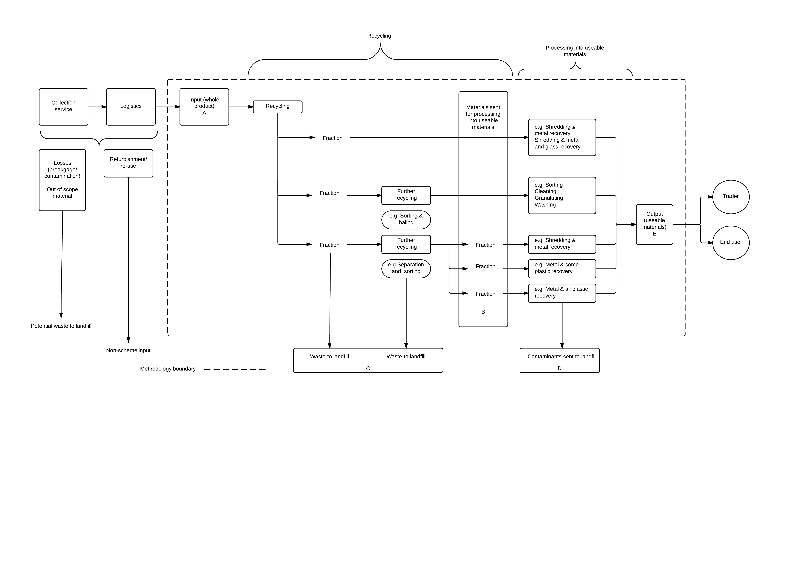

# 

# 4. Principles

The material recovery methodology is guided by the Regulations. A chain-of-custody approach is used for scheme materials where co-regulatory arrangements must be able to track and report in a consistent, accurate and accountable manner. The key principles of the methodology are:

* the material recovery rate will be based upon an input/output analysis
* inputs/outputs will be tracked, traced, documented and reported to enable administrators of co‑regulatory arrangements to meet the obligations specified in the Regulations
* assessment batch processing, where used, will be in accordance with AS/NZS 5377:2013 Appendix D
* for a given batch of products, the material recovery rate will be the weight of the output of useable materials as a proportion of the weight of input materials
* if recycling processes change in a manner that will alter the recovery rates achieved by a co‑regulatory arrangement or its service provider then future material recovery rates recorded will be updated.

Where a fraction to be sent for downstream processing has less than 2% by weight of contamination or impurity, the fraction may be considered 100% pure for the purposes of reporting the weight of material sent for processing into useable materials. Where the contamination is 2 % or greater by weight, the weight of the contaminant materials will be tracked and reported and is excluded from the weight of material sent for processing into useable materials.

# 5. Methodology

The process for determining the material recovery rate that is being achieved by a co-regulatory arrangement starts with the receipt of scheme waste at a recycling facility. Materials are then tracked through to sending for processing into useable materials, and then sending for final end-use. The process tracks the recovery of materials from collected scheme products and the disposal of waste to landfill.

The material recovery rate will be determined by an input/output analysis reporting the input of scheme material that has been received for processing and the output of processed materials. To determine the material recovery rate there needs to be an input/output analysis at different stages of the process namely:

1. Receipt of material (input).
2. Recycling (as defined by the Regulations).
3. Sending of material for processing into useable materials.
4. Waste to landfill from recycling and downstream processing.

In Figure 1, the input is at point A, the outputs of the recycling process are the materials at B to be sent for processing into useable materials and the waste to landfill at C. Once recycling is completed, (B + C) will be equal to A. The amount sent for processing into useable materials is the amount at B less the impurities removed and disposed of at D. The output of useable materials at E will be equal to (B – D).

Documentation of the input/output analysis will cover the following:

* Description of input material.
* Weight of input material.
* Recycling process, including all stages of multi-stage recycling process.
* Weight of output material.
* Classification by type of the output material.
* Further recycling of output material.
* Further processing of the output material.
* Weight of waste to landfill.
* Weight of output material.
* End-market and end-use for useable materials.

The material recovery rate will be calculated from the input/output analysis and to be reported as required under the Regulation.

## 5.1 Assessment batch processing

Where assessment batch processing is used to assess and report material recovery rates it will be done in accordance with AS/NZS 5377:2013 Appendix D.

Assessment batch processing is where a defined amount of materials or fractions thereof are processed in order to determine the composition and yields of the resulting outputs.

This Standard establishes that a batch approach to reporting requires assessment of minimum amounts of input materials for different treatment categories (or classes of products, fractions or components) at least every two years or following changes to input quality or changes to treatment technology.

# 6. Material recovery rate calculation

The material recovery rate is the total amount of output useable materials by weight as a percentage of the amount by weight of input materials.

In the flow chart at Figure 2, the input is at A and the output is at E. The calculation is E (weight of materials sent for processing into useable materials) divided by A (weight of products recycled) multiplied by 100, or

Material recovery rate (%) = E / A x 100.

In practice, for the purposes of co-regulatory arrangements’ annual reporting under the Regulations to demonstrate performance against the material recovery target, the calculation will be

Material recovery rate (%) = (B - D) / (B + C) x 100

# 7. Recycling and recovery record management

In accordance with AS/NZS 5377:2013 section 5.4, the input/output or mass balance approach requires appropriate records be maintained demonstrating that mass (inputs) equals mass (outputs) plus losses.

Regulation 5.01 establishes the record keeping obligations for co-regulatory arrangement administrators, while Regulation 5.14 lists the matters on which administrators must report annually.

Co-regulatory arrangements must be able to provide evidence with respect to the material recovery rate. Regulation 5.01 sets out general requirements for record keeping and while evidence with respect to material recovery rates is not specified in the regulations, such evidence may include:

* Mass balance reports from recyclers and processors.
* Statutory declarations as to the veracity of recovery rates reported by recyclers and processors.
* Invoices.
* Weighbridge dockets.
* Audited reports.
* Batch assessment reports.

# 8. Methodology boundary

The legislative obligations of co-regulatory arrangements and their administrators do not extend to the final end-use or final disposition of the useable materials. Therefore the methodology boundary does not extend to the end use of useable materials.

One or more recycling service providers may process the materials into a state where the fractions are suitable for sale or other provision to a downstream processor. The downstream processor may be a final end-user of all or part of the useable materials or a further processor undertaking activities to prepare the materials for final use. The downstream processor may also be a trader re-packaging or otherwise managing materials prior to sale or provision to a final end-user.

The methodology boundary will include all or part of the useable materials or a further processor undertaking activities to convert the materials into useable materials.

The downstream processor is not always the final-end user of the useable materials and may process/refine the useable materials further before they are in a state able to go to a further downstream process and be used in a manufacturing process or other new use.

The final end-user of the useable materials is a manufacturer or manufacturing process using the recovered material or commodity in a production process.

It is recognised that the co-regulatory arrangement will be limited in the extent to which it can ensure transparency and accountability on the actual final end-use of materials and the extent of any material losses in final use downstream processing activities, however will take all reasonable steps to collect necessary documentation.

The methodology boundary for the co-regulatory arrangement to track and report performance against is defined where materials enter and leave the recycling and processing phases in a state ready for final end-use.

Any materials collected but not delivered to a recycler cannot be counted towards the material recovery target.

Products collected and delivered to a recycler or otherwise sent for refurbishment, re-use and/or re-marketing cannot be counted towards the material recovery target.

Figure 2. Material flow and methodology boundary

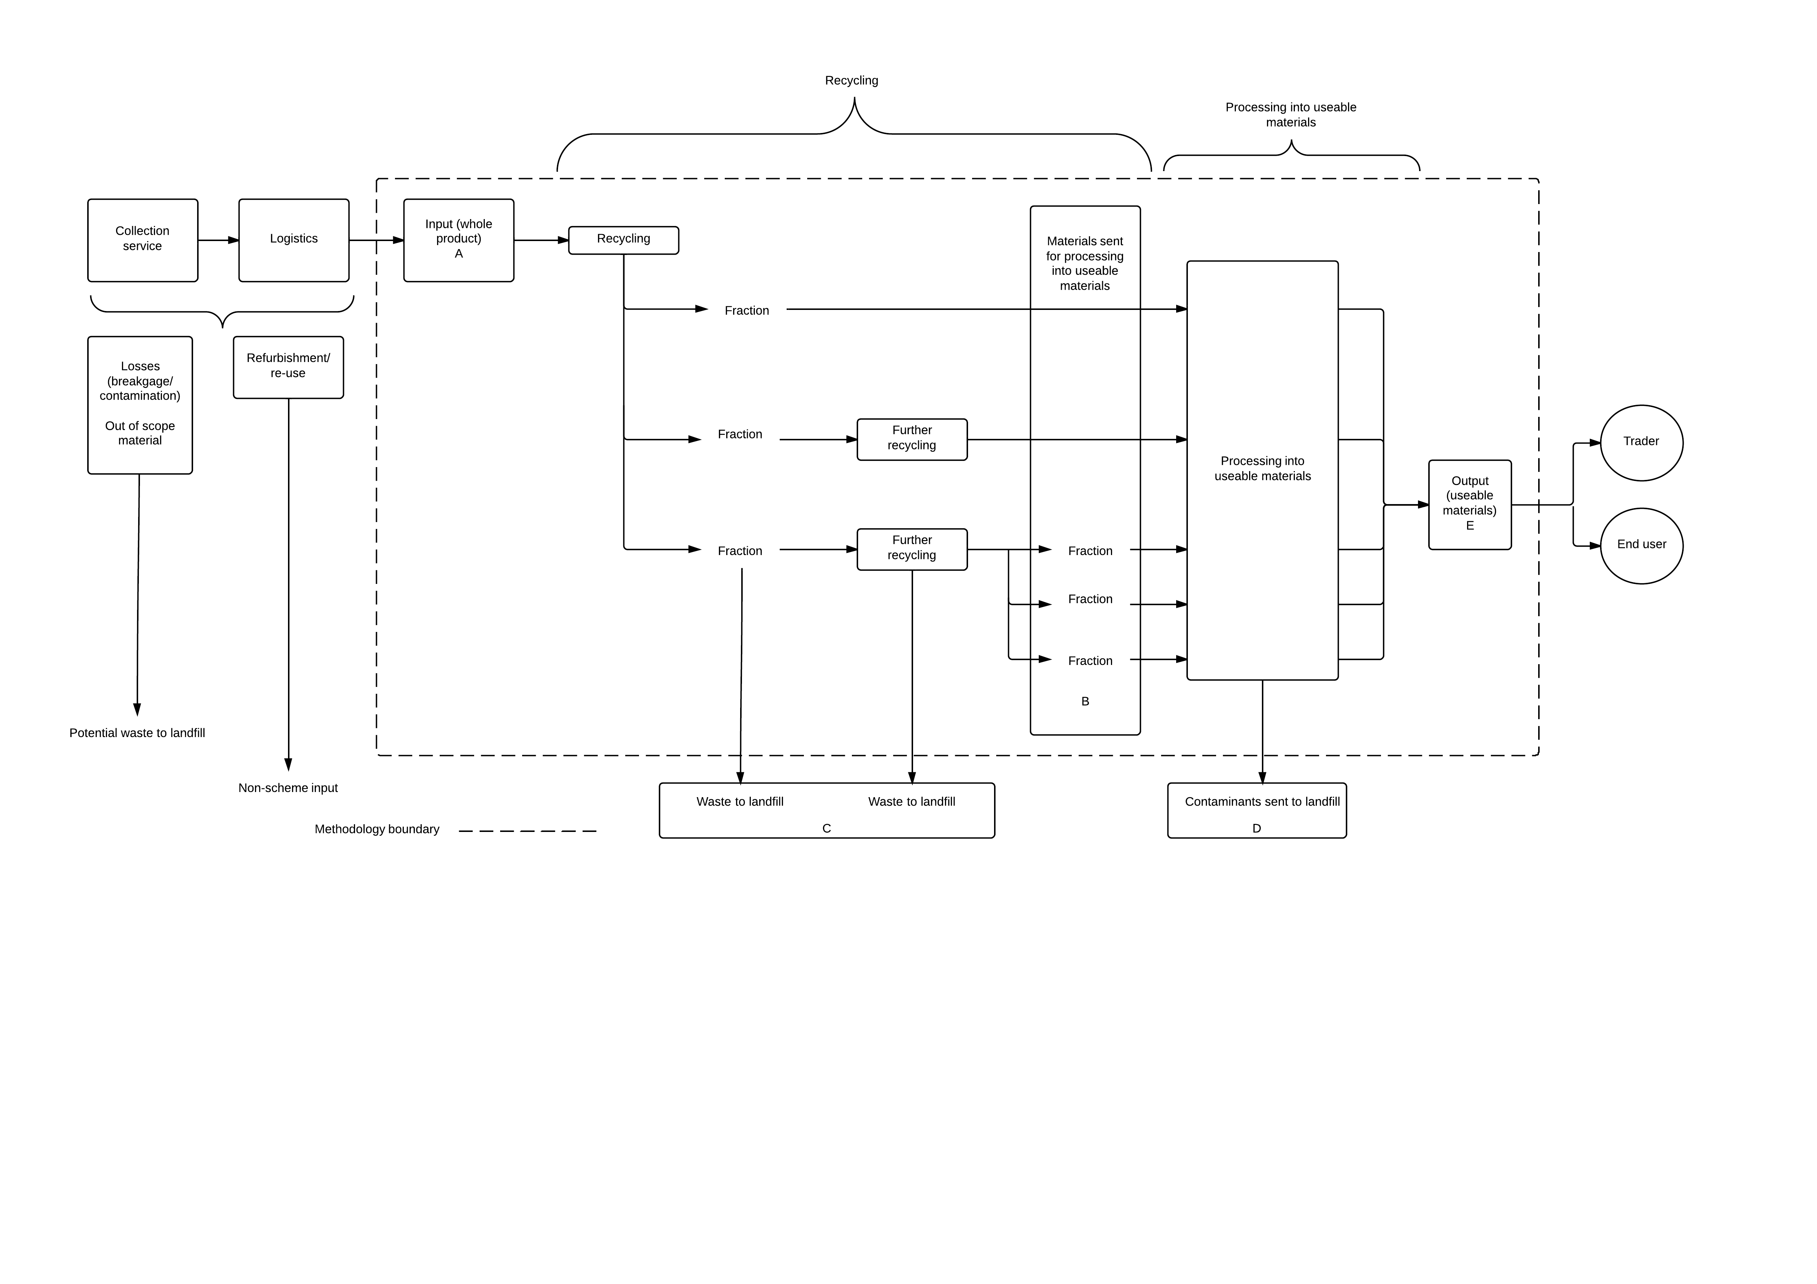

# 9. Traceability and downstream processing

Subregulations 5.14(4), (5) (6) (7) and (10) establish that the administrator of a co‑regulatory arrangement must report annually in respect to recycling, exporting and contracted service providers. This includes reporting the following:

* Details about recycling products.
* Details about exporting products.
* Details about contracted services (domestic and international).
* Details about total weight of useable materials recovered and total weight of non-useable materials sent to landfill.

This does not currently include traceability to final disposition or full downstream processing.

Where the material sent for processing into useable materials contains 2% or more contamination or impurity by weight that will need to be separated and disposed of to landfill, the weight of the impurity is not considered to have been sent for processing into useable materials and a measurement or estimate will need to be made of the impurities and waste to landfill.

The co-regulatory arrangement is limited in the extent to which it can monitor the downstream processing of materials. To ensure that the requirement of the Regulations are met, an arrangement administrator should take sufficient steps to provide assurance that the materials are actually being processed into useable materials, rather than being otherwise disposed of or stored indefinitely.

At a minimum this will include documentation of the disposition of the material to a market.

An example of how materials may be tracked in presented in Appendix A.

# 10. Audit

Section 5.15 of the Regulations establishes that a co-regulatory arrangement must submit an annual audit report on the operation of the co-regulatory arrangement for the financial year.

The report must be prepared by a registered auditor or authorised audit company.

The audit must include an audit of performance of the co-regulatory arrangement in relation to each outcome under Part 3 of the Regulations, including subregulation 3.06 which states that the material recovery target is 90% of the products in a class of products, based on weight.

Appendix A. Examples of how materials may be tracked

In response to stakeholder feedback, the following provides examples of how products and materials may be tracked through the different stages of recycling, processing into useable materials and then become outputs. It is provided for illustrative purposes only and not intended to be exhaustive or prescriptive.

| **Input** | **Recycling** | | | | **Processing into useable material** | | **End-market** |
| --- | --- | --- | --- | --- | --- | --- | --- |
| **Recycling activity** | **Output from recycling** | **Further recycling** | **Output from further recycling** | **Processing activity** | **Output – useable materials to further downstream processing** |
| Televisions and computers | Manual disassembly | Plastic fraction | * Sorting polymers * Remove contamination | * Plastics sorted by polymer | * Washing and flaking * Washing and granulating | * Plastics sorted and processed by polymer, in a manner meeting end-user specifications | * Plastic product manufacturer |
| CRT units | * Remove yoke | * CRT unit | * Remove screen/panel glass | * Screen/panel glass | * Other glass products |
| Steel | N/A | N/A | * Shredding | * Shredded metals | * Steel melting and remanufacture |
| N/A | N/A | N/A | * Sorted steel meeting end-user specifications and containing less than 2% contamination | * Metal trader |
| Automated / Shredding | Shredded metal fraction | * Auto sort. | * Sorted streams of metals | N/A | * Sorted streams of metals | * Metal smelter / recycler * Metal trader |
| Crushed glass | * Auto sort. | * Separated unleaded and leaded glass | N/A | * Unleaded glass | * Unleaded glass to glass aggregator / recycler. |
| * Leaded glass: lead removal | N/A | * Leaded glass | * Leaded glass to lead removal process. * Export to established markets. * Leaded glass to lead smelter (lead recovery and fluxing agent). |