Maximising Water Delivery for Regent Parrot Outcomes

Water for the Environment Program
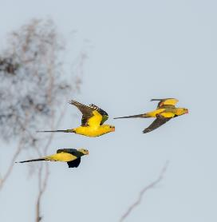
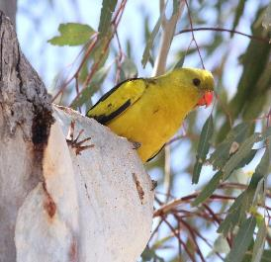

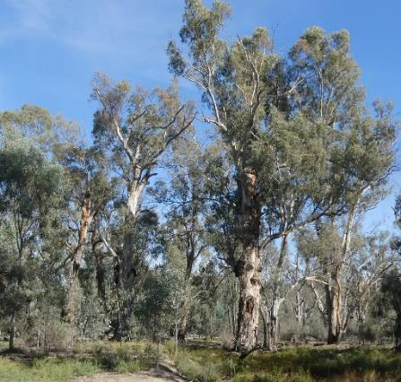

Maximising Water Delivery for Regent Parrot Outcomes
Water for the Environment Program

Reference ID: 2000008442
Document Title: Maximising Water Delivery for Regent Parrots
Date: March 2021
Author: Mike Harper (with assistance from Anna Harper, SA Regent Parrot Recovery Team and Project Steering Committee members)
South Australian Regent Parrot Recovery Team
C/o Riverland West Landcare Inc.
ABN 79 818 238 436
12a Peake Terrace
Waikerie SA. 5330
T +61 8 85412611
www.rwlandcare.org.au

This document has been produced by the South Australian Regent Parrot Recovery Team for the Commonwealth Environmental Water Office, Australian Department of Agriculture, Water and the Environment. It can be referenced as:

Reference:
Harper M.J., (2020) Maximising Water Delivery for Regent Parrot Outcomes – Water for the Environment Program. Prepared by the South Australian Regent Parrot Recovery Team for the Commonwealth Environmental Water Office, Australian Department of Department of Agriculture, Water and the Environment.

Acknowledgement for contribution
This document was produced with significant input from (as part of the Project Steering Committee): Karen Bishop, (Riverland West Landcare), Michelle Campbell, Lucy Carlile and Bill Matthews (Commonwealth Environmental Water Office), Chris Hedger (Department of Environment and Water [DEW]), Luke Ireland and Kate Mason (Murraylands and Riverland Landscape Board) and Kevin Smith (SA Regent Parrot Recovery Team[SA RPRT]). Additional SA RPRT members: Tim Field, Helga Kieskamp, Roger and Raelene Schmitke and Peter Waanders, Natalie Stalenburg (Nature Foundation), Peter Cale (Australian Landscape Trust), Myles Fauser (Renmark Paringa Council), Nathan Creeper, Tammie Edwards, Simon Frankel, Allison Stokes and Rebecca Turner (DEW), Justin Dixon (Mapping Services Australia) and Ben Harvey (Sturt Contractors Pty Ltd).
Front cover photographs (from top) by Helga Kieskamp, Mike Harper and Glenn Ehmke
Executive Summary

The Eastern Regent Parrot Polytelis anthopeplus monarchoides is currently listed as Vulnerable under the Australian Government Environment Protection and Biodiversity Conservation Act 1999 (EPBC Act). It is restricted to a single population occurring in inland south-eastern Australia in the Lower Murray-Darling Basin region of South Australia, New South Wales and Victoria. The Regent Parrot utilises a diverse semi-arid landscape consisting of Mallee Woodland, dryland agriculture and horticultural areas which are centred on their riverine breeding areas.

Over the last century the major threat to the Regent Parrot has been the clearing and degradation of its Mallee Woodland foraging habitats. However, since the early 1990s there has been a significant decline in breeding pairs within the South Australian distribution. Major threats include; altered River Murray hydrological regimes resulting in a significant reduction in floodplain vegetation health, Mallee Woodland wildfires, nesting colony disturbance and increased human caused mortality.

The Regent Parrot is a floodplain reliant species and water for the environment has been identified as a means that can be used to limit population decline and contribute to the long-term recovery of the species. However, this requires investigation of the most appropriate ways to maximise water for the environment delivery in order to achieve positive outcomes for both Regent Parrots and other flora and fauna species dependent on a healthy River Murray floodplain.
The Maximising Water Delivery for Regent Parrot Outcomes - Water for the Environment Program document was developed to assist water for the environment holders and delivery managers and is specific to South Australia but broadly applicable throughout the distribution of Regent Parrots in the Lower Murray Darling Basin.
The document includes several sections, which bring together the most up to date information on Regent Parrots and their requirements. The document identifies critical sites for environmental water management for Regent Parrot outcomes in SA. It includes relevant information that should be considered in the management of environmental water for Regent Parrot outcomes and identifies preliminary findings for management (including site management briefs, key threats and infrastructure assessments).
Forty-seven known Regent Parrot nesting colonies were surveyed along the South Australian Murray River corridor between Swan Reach and Lock 6. The survey focused on the long-term health vulnerability of nesting quality River Red Gum trees. Seven stressors were identified across the sites with 79% of sites exhibiting signs of vegetation stress due to the lack of inundation. Forty-three percent (sixteen) of the stressed sites were found to have potential for receiving water for the environment which will enhance the health of Regent Parrot River Red Gum nesting trees.
Thirty one existing water for the environment sites which contained Regent Parrot nesting colonies or which were in the vicinity to colonies were assessed for their potential to increase critical riparian vegetation services (nesting and/or foraging) to benefit Regent Parrots. Site hydrological parameters such as inundation area, watering frequency and timing and flow barriers were assessed against Regent Parrot utilisation of the site. The analysis indicated that at 19 sites hydrological management could be modified to increase outcomes for Regent Parrots.
Investigations concluded that between Swan Reach and Lock 6, 19 existing water for the environment sites could be modified, and, 24 new potential water for the environment sites could be implemented to increase outcomes for Regent Parrots. This combination of sites are grouped within known Regent Parrot nesting colony concentrations to form eight Regent Parrot Habitat Zones. Site management briefs for each water for the environment site have been developed. The briefs include site vegetation and hydrological description, ecological and community objectives, potential hydrological options and infrastructure required. These site briefs should be used as the basis for further work at these sites including cultural assessment and landholder consultation.
The following strategic observations on the Lower River Murray water for the environment program have been identified during development of the program to maximise water delivery for Regent Parrot outcomes;
- The water for the environment program has a number of water delivery partners with varying degrees of operational experience and resources. A management obligation to maintain water for the environment sites into the future is critical. Program continuity and oversight is needed to review yearly watering programs. This is especially important at sites with high-risk vegetation communities such as adult River Red Gum. Development of the annual program should be within an adaptive management framework utilising real time data which should be available to all levels within the decision-making process.
- To maintain ecological character over the long-term at each watering site, high risk areas within each site should be identified to ensure that when water and/or management resources are limited high risk areas receive appropriate water allocations.
- Due to predicted changes in climate resulting in significant reductions in Lower River Murray flows, managed hydrology of the floodplain will be needed well into the future to maintain and/or rehabilitate high value floodplain sites. To ensure current management actions are not squandered in the future it is essential that the Lower River Murray water for the environment program develops long-term strategies with realistic water delivery and site adaptive monitoring procedures which are adopted by all water delivery partners.
- The long-term sustainability of the small to medium water for the environment projects along the Lower River Murray are at a community and political crossroads. These floodplain sites require a long-term vision and social and political support. The development of a new Murray-Darling Basin restoration narrative will assist to achieve this. The water for the environment program has the opportunity to develop a community and landowner driven ecological recovery and management program.

This document describes critical actions for the long-term viability of the South Australian Regent Parrot population at key zones occurring within recorded Regent Parrot nesting colony concentrations. The document is the immediate “to do list” in the SA Murray Darling Basin.

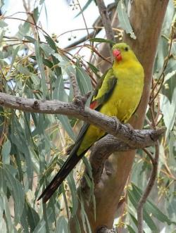
Sub-adult male Regent Parrot (Photo: H Kieskamp)

Table of Contents
1. Introduction 1
1.1 Background 1
1.2 Purpose and scope of the report 2
2. Current Knowledge of Regent Parrots 4
2.1 National description 4
2.2 South Australian Regent Parrot population 5
2.2.1 State distribution 5
2.2.2 Regent Parrot landscape usage 6
2.3 Regent Parrot breeding biology 9
2.4 Regent Parrot foraging resources 12
2.5 Regent Parrot threats 13
2.5.1 Clearing and degradation of Mallee Woodland 13
2.5.2 Altered River Murray hydrological regimes 14
2.5.3 Wild fires 14
2.5.4 Nesting colony disturbance 14
2.5.5 Human-caused mortality 15
2.6 Supporting Regent Parrots with Environmental Water 15
3. Regent Parrot Critical Habitat Vulnerability Assessments 16
3.1 Site identification and investigations 16
3.2 Vulnerability Assessment of Regent Parrot Nesting Colonies 17
3.2.1 Condition assessment of River Red Gum (Regent Parrot nesting class) 17
3.2.2 Identification and analysis of stressors 19
3.2.3 Vulnerability investigation results and conclusions 20
3.3 Vulnerability Assessment of Regent Parrot Critical Habitat 27
3.3.1 Floodplain Vegetation Community Health Assessment 27
3.3.2 Identification and analysis of stressors 28
3.3.3 Critical habitat vulnerability investigation conclusions 30
3.4 Summary of critical habitat sites investigated 38
4. Managing Environmental Water for Regent Parrot Outcomes 44
4.1 Context for Maximising Water Delivery for Regent Parrot Outcomes 44
4.1.1 Key threats and ecological objectives from other planning processes 44
4.1.2 Vegetation response to management 45
4.1.3 Key principles for management of floodplain vegetation 45
4.1.4 Landscape connectivity 46
4.1.5 Landowner engagement 46
4.1.6 Strategies to maximise water delivery for Regent Parrot outcomes 46
4.1.7 Principles of developing water for the environment projects to benefit Regent Parrots 47
4.2 Managing Environmental Water for Regent Parrot Outcomes 48
4.2.1 Prioritisation of water requirements 48
4.2.2 Potential environmental watering actions 49
4.2.3 Hydrological management to achieve Regent Parrot objectives 49
4.2.4 Potential risks associated with delivering environmental water 55
4.2.5 Water for the environment site establishment checklist 56
4.2.6 Hydrological infrastructure 57
4.2.7 Monitoring asset condition and impact of actions 61
4.2.8 Use results to adapt and manage into the future 62
5. Regent Parrot Water for the Environment Program – Preliminary Findings 65
5.1 Regent Parrot Floodplain Habitat Zones 65
5.1.1 Regent Parrot Floodplain Habitat Zone Key Issues 65
5.2 Water for the environment program description 70
5.3 Site objectives 79
5.4 Hydrological management to achieve site ecological outcomes 82
5.5 Potential watering site infrastructure requirements and estimated costs 84
5.6 Site Management Briefs 88
5.7 Conclusions and Strategic Observations on the Lower Murray Water for the Environment Program 88
5.7.1. Conclusions 88
5.7.2 Strategic observations 89
References 90
Appendix 1 Known Food Plants, Animals and Habitats of Regent Parrots 93
Appendix 2 Regent Parrot Nesting Colony Assessment 97
Appendix 3 Regent Parrot Nest Survey Methods 125
Appendix 4 Infrastructure Requirement Assumptions 128
Appendix 5 Plant List 133
Appendix 6 Management Briefs 135
1 Banrock Bend Management Brief 136
2 Gerard/Katarapko Lagoon Management Brief 141
3 Heron Bend Management Brief 145
4 Hogwash Bend Management Brief 149
5 Holder Lagoon Management Brief 158
6 Katarapko Creek Management Brief 165
7 Katarapko Island North Management Brief 174
8 Katarapko River Flood-out Management Brief 181
9 Little Schiller Lagoon Management Brief 184
10 Loveday 4 x 4 Lagoon Management Brief 188
11 Markaranka Flat Management Brief 192
12 Markaranka Management Brief 197
13 Markaranka Lagoon Management Brief 202
14 Molo Flat Management Brief 207
15 Morgan South Management Brief 211
16 Morgan North Management Brief 217
17 Murbpook Lagoon Management Brief 226
18 North West Bend Management Brief 231
19 Overland Corner Management Brief 236
20 Paschkes Flat Management Brief 243
21 Putjeda Creek Lagoons Management Brief 247
22 Pyap Bend Management Brief 254
23 Sugar Shack Upstream Lagoon Management Brief 259
24 Taylor Flat Management Brief 265
25 Westbrooks Management Brief 270
26 Weston Flat Lagoon Management Brief 274
27 Wiela Management Brief 279
28 Yabby Creek Management Brief 285
29 Yarra Creek Management Brief 290

Table of Figures
Figure 1.1: Regent Parrots utilise the Mallee, Floodplain, Dryland Agriculture and Horticulture Landscapes (Photo: M Harper). 3
Figure 2.1: Distribution of the eastern Regent Parrot (Baker-Gabb and Hurley, 2011). 4
Figure 2.2: Public Sightings of Regent Parrots from 2006 to June 2013, mapped by season. Breeding (Red), Juveniles fledged (Orange) and Non-breeding (Blue), (Ryan-Colton 2013). 5
Figure 2.3: Identifies the Regent Parrot nesting colonies along the River Murray in South Australia during the 2003 and 2010 whole of river surveys. 6
Figure 2.4: The GPS locations of all data loggers recorded during the study into the landscape use by Regent Parrots in the breeding season 2016 (Ireland 2020). 7
Figure 2.5: The GPS locations of satellite trackers recorded between Dec 2019 and Oct 2020 during a study into the landscape use of Regent Parrots along the River Murray in South Australia (Ireland pers. comm.). 8
Figure 2.6: The GPS locations of satellite trackers recorded during a five week period in October/November 2020 during a Regent Parrot landscape use study in the Chowilla / Murtho area in South Australia (Ireland pers. comm.). 9
Figure 2.7: Flight lines taken by breeding Regent Parrots from nest sites located at Hogwash and Markaranka Lagoon. 11
Figure 2.8: Female Regent Parrots at a (spout) nest site (Photo H Kieskamp). 11
Figure 2.9: Lesser Joyweed Alternanthera denticulata a common wetland Herbland plant the seeds of which Regent Parrots eat (Photos by SA Seed Conservation Centre). 13
Figure 2.10: Schiller Lagoon a Regent Parrot critical habitat existing watering site (Photo: M Harper 2020). 15
Figure 3.1: River Red Gum Canopy Condition Class. Top left: C1 Good %75 canopy cover, Top right: C2 Medium %75-40% canopy cover, Bottom left: C2 Poor <40% canopy cover, Bottom right: C4 Dead 0% canopy cover. 18
Figure 3.2: Examples of River Red Gum density class with photograph and aerial imagery. 19
Figure 3.3: Regent Parrot Nesting Colonies surveyed to assess their long-term health viability. 21
Figure 3.4: Example of an open woodland Regent Parrot nesting colony located at Hogwash Bend. (Photo M Harper). 21
Figure 3.5: View over Markaranka Lagoon - the centre of an important Regent Parrot nesting location which has regularly received Environmental Water since 2005/06. (Photo M. Harper). 21
Figure 3.6: During the 2003 whole of river Regent Parrot nest survey, six nests were found in the north east corner of Taylor Flat. At the time of the survey the above trees were alive. (Photo M. Harper 2020). 24
Figure 3.7: Draw down phase of water for the environment site East Morgan. Photo M. Harper. 24
Figure 3.8: Overland Corner a Regent Parrot critical habitat existing watering site (Photo: M Harper). 30
Figure 3.9: Fine line between salinized soils and healthy River Red Gums Yarra Creek. Photo M Harper. 33
Figure 4.1: Floodplain response to water management Model (adapted from AWE 2015) 45
Figure 4.2: Hogwash Bend Conservation Park a Regent Parrot breeding strong hold (Photo: M Harper). 47
Figure 4.3: A Temporary wetland with stressed River Red Gum desperate to receive water (Photo: M Fauser). 50
Figure 4.4: Regent Parrot feeding on Bladder Saltbush (Photo by H Kieskamp). 54
Figure 4.5: Sample of metal and fibreglass hinged flap gates (Photos: B Rampano and M Harper). 58
Figure 4.6: Penstock Vertical Winch (Photos: M Harper). 58
Figure 4.7: Wooden stop logs fitted to a drop board culvert (Photo: M Harper). 59
Figure 4.8: Segmented stop boards fitted to a box culvert road access structure (Photo: M Harper). 59
Figure 4.9: Metal Sheet Pilling structure fitted with segmented Stop boards. (Photo: M Harper). 60
Figure 4.10: Photographs taken by a drone over a stressed wetland site. All tree Canopy Condition Classes can be identified as well as the health variation within a patch of Lignum (left photo). (Photos: M Fauser). 62
Figure 4.11: Looking for Regent Parrot nests. 64
Figure 5.1: Male Regent Parrots at an (end of branch) nest site (Photo H Kieskamp). 66
Figure 5.2: Identifies the eight Regent Parrot Habitat Zones between Swan Reach and Lock 6. 67
Figure 5.3: Swan Reach Regent Parrot Floodplain Habitat Zone. 70
Figure 5.4: Murbko Regent Parrot Floodplain Habitat Zone. 70
Figure 5.5: Morgan Regent Parrot Floodplain Habitat Zone. 71
Figure 5.6: Hogwash Regent Parrot Floodplain Habitat Zone. 72
Figure 5.7: Lowbank Regent Parrot Floodplain Habitat Zone. 74
Figure 5.8 Overland Corner Regent Parrot Floodplain Habitat Zone. 75
Figure 5.9: Katarapko Regent Parrot Floodplain Habitat Zone. 76
Figure 5.10: Murtho Parrot Floodplain Habitat Zone. 78
Figure 5.11: KEEP THEM FLYING - Flock of male Regent Parrots. Photo: Glenn Ehmke. 89

Table of Tables
Table 2-1: Summary of Regent Parrot seasonal landscape use patterns 7
Table 2-2: Regent Parrot nesting colony details 10
Table 2-3: Other bird species observed utilising hollow at Regent Parrot nesting colonies. 12
Table 2-4: Known Riparian Food Plants of Regent Parrots 13
Table 3-1: River Red Gum Canopy Condition Class 17
Table 3-2: River Red Gum Density Class 18
Table 3-3: Rating Criteria for Stress/Direct Threats 20
Table 3-4: Regent Parrot Nesting Colony Stressor Irreversibility Rating Summary 22
Table 3-5: Stressor Irreversibility Rating for each Regent Parrot Nesting Colony 23
Table 3-6: Summary assessment of Regent Parrot Nesting Colonies as to their Suitability to Receive Water for the Environment 25
Table 3-7: Summary of key information from the site assessments for the 16 nesting colonies sites which have potential to be managed with water for the environment. 26
Table 3-8: River Red Gum Forest/Woodland Health Classification 27
Table 3-9: Black Box Woodland Health Classification (Cale 2019) 27
Table 3-10: Lignum Shrubland health classification 28
Table 3-11: Low Shrubland/Herbland Health Classification 28
Table 3-12: Example analysis table of existing water for the environment sites 29
Table 3-13: Example vulnerability analysis of viable Water for the Environment sites 29
Table 3-14: Analysis of current watering at 23 existing water for the environment sites to determine if modifications to the watering regime is required 31
Table 3-15: Historical watering of existing water for the environment sites (Department of Environment and Water, Banrock Station and Nature Foundation). 32
Table 3-16: Stressor Irreversibility Rating for existing and potential water for the environment sites 34
Table 3-17: Vulnerability analysis of existing and potential water for the environment sites 36
Table 3-18: Table of all critical habitat floodplain sites identified and summary of assessment outcomes in relation to sites that have potential to be managed with water for the environment for Regent Parrot outcomes 38
Table 4-1: Key directions from other planning processes 44
Table 4-2: Watering Actions under Different Water Availability Scenarios 48
Table 4-3: Principles to Assist in Determining Appropriate Hydrological Regimes at Water for the Environment sites for Regent Parrot Ecological Outcomes 51
Table 4-4: Reproduction Cycle of Key Riparian Food Plants of Regent Parrots 54
Table 4-5: Potential risks associated with water for the environment inundation events 55
Table 5-1: Regent Parrot Habitat Zone existing and potential water for the environment sites and issues impacting each zone 69
Table 5-2: Swan Reach & Murbko Regent Parrot Floodplain Habitat Zone water for the environment site description 70
Table 5-3: Morgan Regent Parrot Floodplain Habitat Zone water for the environment site description 71
Table 5-4: Hogwash Regent Parrot Floodplain Habitat Zone water for the environment site description 73
Table 5-5: Lowbank Regent Parrot Floodplain Habitat Zone water for the environment site description 74
Table 5-6: Overland Corner Regent Parrot Floodplain Habitat Zone water for the environment site description 75
Table 5-7: Katarapko Regent Parrot Floodplain Habitat Zone water for the environment site description 77
Table 5-8: Murtho Regent Parrot Floodplain Habitat Zone water for the environment site description 78
Table 5-9: Summary of ecological and community objectives for each potential water for the environment site. 80
Table 5-10: Hydrological management activities and options for potential water for the environment sites 82
Table 5-11: Design and project management assumptions 84
Table 5-12: Construction estimate assumptions 84
Table 5-13: Items excluded from the budget estimate assessment 85
Table 5-14: Potential water for the environment site infrastructure requirements and estimated costs 86

Introduction

Background
The Eastern Regent Parrot Polytelis anthopeplus monarchoides (herein referred to as the Regent Parrot) is currently listed as Vulnerable under the Australian Government Environment Protection and Biodiversity Conservation Act 1999 (EPBC Act). In South Australia, the Regent Parrot has been extensively studied since early 2000 under the guidance of the South Australian Regent Parrot Recovery Team (SARPRT). The Team has developed effective partnerships with the major stakeholders and undertaken monitoring, research and education on the conservation of this species. Local studies by the team have found that Regent Parrots are opportunistic when it comes to feeding behaviour and as food resources change from season to season and year to year, they utilise all the major landscape components in a region. Of particular importance are the following landscape components in South Australia; River Murray floodplain, Mallee (including extensive areas, remnant patches and roadside vegetation), irrigated horticulture (especially orchards and vineyards), and dryland farming crops. For Regent Parrots to survive the challenges of this semi-arid environment which has been significantly altered by human activities, access to healthy and productive natural landscape components is essential. The habitats on the River Murray floodplain are critical to the long-term survival of this species as they rely solely on hollow bearing River Red Gum trees to breed and floodplain vegetation habitats to feed throughout the year depending on regional climate conditions. Regent Parrots also use the river floodplain as a major conduit to the movement and access to other landscape components throughout a region.
The agriculture landscape presents many threats to the species, especially juvenile birds. Threats such as illegal shooting of birds in orchards and road kills present a major threat to the long-term survival of the species. The combination of the millennium drought, the major Mallee fire north of the River Murray in 2006, as well as the drying up of most water points in the South Australian Mallee pastoral areas forced Regent Parrots to forage closer to the Murray River where they came into greater conflict with fruit growers (Smith 2004 and Smith 2011). Having healthy floodplain vegetation will give the parrot, especially the vulnerable juvenile birds alternative food resources which could limit their exposure to the high-risk areas in the agriculture landscape.
The whole of River Murray, Regent Parrot nest surveys in South Australia during 2003/4 and 2010 indicated that Regent Parrot nesting colonies have moved away from long-term drowned and recently dead River Red Gums. A decline of 12% in the Regent Parrot breeding population was also identified during this period (Smith 2011). At the same time, the River Murray experienced historical low flows. Flow into South Australia did not exceed 10,000ML/d between July 2001 and June 2010 resulting in no floodplain inundation. With more reliance on healthy old growth River Red Gum sites for nesting and the decline in floodplain vegetation health the need to improve and maintain the health of the River Murray floodplain is critical to the long-term survival of Regent Parrots.
Regent Parrot nest surveys from 2003 to the present have indicated a significant correlation between floodplain watering resulting in increased vegetation health at nesting colonies and/or adjacent floodplain and parrot nesting effort. Observations indicate environmental watering in combination with natural flood events have a positive influence on the following Regent Parrot nesting habitat parameters; nest tree health, regeneration of dead or sparsely vegetated areas resulting in increased breeding sites, vegetation density and the promotion of food plant production (Smith 2011 and Smith 2014). Monitoring suggests that where the habitat is in good condition, new colonies were established, and colonies at existing colony sites increased in size. However, nesting colonies with poor vegetation health either had no nests or reduced numbers. This indicates riverine vegetation health is critical to Regent Parrot breeding attempts. The 2010 survey found that five of the nine largest colonies were at sites which received environmental water, three of which contained nearly 40% of the nest trees located during the survey.

The South Australian Murray River floodplain contains more than 14,000 wetlands which form an important part of the river system. These off-channel features provide crucial habitat for aquatic and terrestrial organisms including Regent Parrots, which are dependent on River Red Gum communities for the breeding phase of their life cycle. The parrot also utilise floodplain vegetation communities as a major foraging resource throughout the year.
Many of these wetlands are naturally connected by in-channel flows. However, river regulation and the construction of levees, blocking banks and road crossings haves reduced the frequency and duration of their inundation. This reduction in flood frequency, particularly during the millennium drought has resulted in the widespread dieback of River Red Gums and other floodplain vegetation communities. The loss of nesting and foraging habitat has contributed to a population decline of Regent Parrots.
The Regent Parrot is a floodplain reliant species and water for the environment has been identified as a means that can be used to limit population decline and contribute to the long-term recovery of the species. However, this requires investigation of the most appropriate ways to maximise water for the environment delivery in order to achieve positive outcomes for both Regent Parrots and other flora and fauna species dependent on a healthy River Murray floodplain.

Purpose and scope of the report
This report aims to provide guidance on the best way to deliver environmental water to maximise outcomes for Regent Parrots. The report identifies critical Regent Parrot habitat in South Australia that can be managed with environmental water and provides preliminary site assessments on how water can best be managed at these sites for optimal regent parrot outcomes. The report also provides general management considerations relevant to Regent Parrot outcomes.
  - Section 1 - Introduction: provides the background to why the project was initiated and sets out the scope and purpose of the report.
  - Section 2 - Current Knowledge of Regent Parrots: Brings together the most recent knowledge on Regent Parrots (from The National Recovery Plan for the Regent Parrot (eastern subspecies) Polytelis anthopeplus monarchoides and recent studies and monitoring) to present current understanding key requirements of Regent Parrots and how environmental water can be used to support them.
  - Section 3 - Regent Parrot Critical Habitat Vulnerability Assessments: Uses historical knowledge and site assessments (condition, threats and site manageability) to determine viable Regent Parrot sites that can/have potential to be managed with environmental water to support Regent Parrot requirements.
  - Section 4: Managing environmental water for Regent Parrot outcomes: Provides guidance on developing a management plan for Regent Parrots
  - Section 5: Regent Parrot Water for the Environment Program – Preliminary Findings: includes preliminary findings related to the management of sites, including habitat zones, key threats, site objectives and infrastructure preliminary assessment outcomes
It is intended that this report be used in planning and management of Regent Parrot habitat sites in South Australia particularly for use of environmental water. It is envisioned to help ensure future management of these sites consider the Regent Parrot objectives. While this report focuses on Regent Parrot habitat in South Australia, the general approach may also be applied to Regent Parrot habitat more broadly.

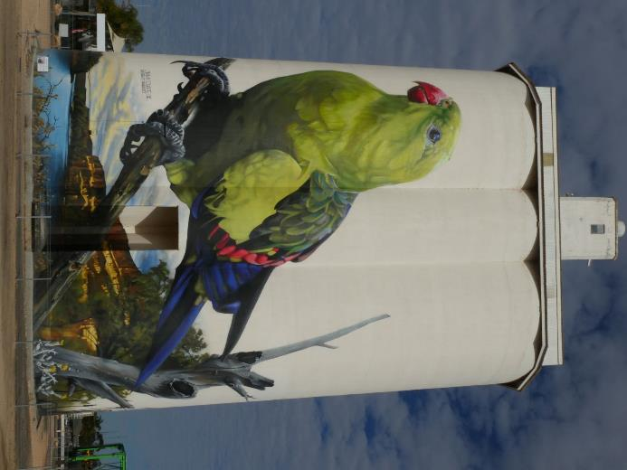
Figure 1.1: Regent Parrots utilise the Mallee, Floodplain, Dryland Agriculture and Horticulture Landscapes (Photo: M Harper).

Current Knowledge of Regent Parrots

This section draws together our understanding of Regent Parrot biology, behaviour, requirements and threats. Information has been collated from the national recovery plan, historical and recent South Australian nest surveys reports and recent studies into the species use of the landscape, particularly in South Australia. Even though the SARPRT has studied Regent Parrots for 20 years our knowledge on how the birds utilise their significantly modified landscape is still very limited. This is especially so over different seasons, periods of drought and above average rainfall years, as well as River Murray flood years.

National description
The Regent Parrot is currently listed as Vulnerable under the Australian Government Environment Protection and Biodiversity Conservation Act 1999 (EPBC Act). Within its range states, the Regent Parrot is listed as Vulnerable under the South Australian National Parks and Wildlife Act 1972, Threatened under the Victorian Flora and Fauna Guarantee Act 1988, and, is endangered under the NSW Threatened Species Conservation Act 1995. A national recovery team was established in 2009 which acts as a forum to share information between people working on this species. In 2011 a National Recovery Plan was published for the species (Baker-Gabb and Hurley, 2011).

The Regent Parrot is restricted to the south west corner of the Murray Darling Basin (Figure 2.1) and utilises the River floodplain, and adjacent Mallee woodland and agricultural habitats. This species breeds almost exclusively in River Red Gums along the River Murray between Swan Reach in South Australia upstream to the mouth of the Murrumbidgee River and within the Wyperfeld/Albacutya area of Victoria.
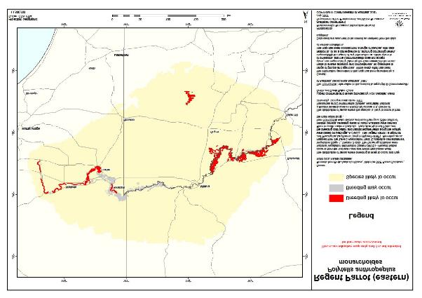
Figure 2.1: Distribution of the eastern Regent Parrot (Baker-Gabb and Hurley, 2011).

Due to a decline in population numbers, distribution, and ongoing threats to the species, the Eastern Regent Parrot is considered a nationally threatened species and is supported by the Victorian, New South Wales and South Australian Governments. Historically the breeding range of the Eastern Regent Parrot has declined over the past one hundred years (Burbidge, 1985). Regent Parrots were known to breed in areas such as the Avoca River just upstream from Kerang, Lake Boga district, Wakool River, on Pentel Island, opposite Swan Hill and the Darling River near Pooncarie during the 1960s (Baker-Gabb and Hurley, 2011).

South Australian Regent Parrot population

2.2.1 State distribution
The most comprehensive data set on the general distribution of Regent Parrots in South Australia is from the “citizen science” community sighting program, known as 1800 PARROT. It was initiated by the SA Regent Parrot Recovery Team (SARPRT) which commenced in July 2012 and continued for twelve months. During this time 416 public sightings of Regent Parrots were recorded. The project addressed the research gap on Regent Parrot movements across the landscape. The project identified patterns of habitat use including flight paths and improved the knowledge of Regent Parrot roosting and forage requirements and areas. An overview of all public sightings including sightings prior to the 1800 PARROT project are collated by season in Figure 2.2 (Ryan-Colton 2013).

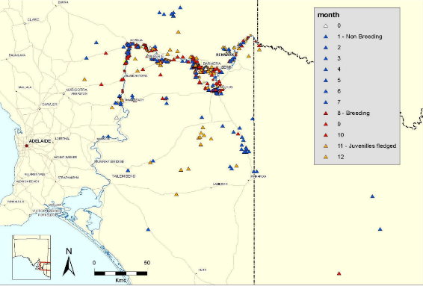
Figure 2.2: Public Sightings of Regent Parrots from 2006 to June 2013, mapped by season. Breeding (Red), Juveniles fledged (Orange) and Non-breeding (Blue), (Ryan-Colton 2013).

Surveys conducted throughout the last 30 years indicate that the number of breeding pairs in South Australia has declined, particularly in certain areas (Harper 1989, Smith 1992, 2001, 2004, 2011, 2014). In 2003 and 2010, the entire breeding area in South Australia was surveyed and provided an important baseline on population trends. In 2003, 50 colonies were recorded with approximately 400 nests (breeding pairs), compared to the 2010 survey when 41 colonies were recorded with approximately 350 nests (breeding pairs). During this seven year period, the Regent Parrot breeding population along the River Murray in South Australia declined by 12% (Smith,2011). Figure 2.3 identifies the Regent Parrot nesting colonies along the River Murray in South Australia during the 2003 and 2010 whole of river surveys.

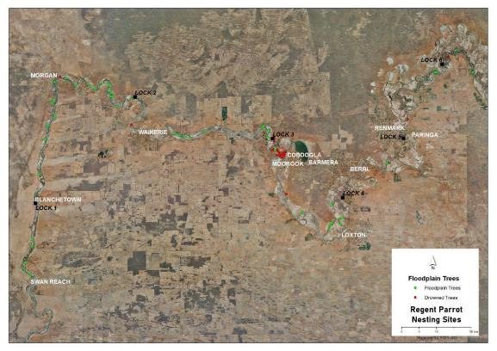
Figure 2.3: Identifies the Regent Parrot nesting colonies along the River Murray in South Australia during the 2003 and 2010 whole of river surveys.

2.2.2 Regent Parrot landscape usage
The Regent Parrot utilises a diverse semi-arid landscape which is centred on their riverine breeding areas. Due to the climate variation these birds are opportunistic in their foraging behaviour resulting in both roosting and foraging sites changing throughout the seasons and from year to year. Corridors of vegetation between nesting, foraging and roosting sites are essential for bird movement. Birds will use remnant woodlands along roadsides or in farm paddocks for movement and occasionally foraging, and rarely use more extensively cleared areas (Baker-Gabb and Hurley, 2011).
Sightings and tracking projects have helped build up patterns of landscape use by Regent Parrots however further knowledge is required. Use patterns described in Table 2-1 have been assembled from (Baker-Gabb and Hurley, 2011), (Smith 2011), (Ryan-Colton 2013) and (Ireland 2020).

Table 2-1: Summary of Regent Parrot seasonal landscape use patterns
Season | Date | Landscape Use patterns
Breeding Season | August–November | Groups of male birds flying together from nests to feeding areas, and to roost sites which are usually away from the nesting colonies. Often flying very fast, to get food to incubating females as soon as possible. Later in the breeding season, when young have hatched, females join males on these feeding flights to bring food back to the nest from the floodplain, Mallee, horticulture and dryland farming areas.
Juveniles Fledged | November-December | Juveniles have fledged and left the nest, and often fly around with adults and still beg for food. Larger mixed flocks are commonly seen on the floodplain and in Mallee, horticulture and dryland farming areas.
Non-Breeding Season | January-July | Birds can disperse into the Mallee, far from the nest sites, whilst some birds stay near the river and horticulture areas. ‘Crèche flocks’ have been observed as large flocks of predominantly young birds that move around the Mallee area during this time e.g. Gluepot Reserve. In some years mixed flocks spend most of the day feeding on the floodplain or in horticulture areas and return to nearby Mallee areas to roost. Breeding birds may be close to the river inspecting nest hollows during July.

Since 2016 the SA Regent Parrot Recovery Team has been involved in three studies investigating landscape use by Regent Parrots.

Study 1 - A study in the Waikerie area of South Australia placed GPS data loggers on eight Regent Parrots (five females and three males) aged between one+ and two+ years. The purpose of this study was to identify habitat gaps. The study was conducted for a three week period in 2016 and greatly enhanced the understanding of how Regent Parrots utilise the landscape during the breeding season. Ten land cover types were identified using South Australian GIS Land Cover Layer. The most frequently used habitat types were Mallee (45%), followed by dryland agriculture (19%), Eucalypt floodplain woodland (13%), Floodplain Chenopod Shrubland (9%) and orchards / vineyards (6%). Ireland (2020) identified that Woody Native Vegetation and Orchards / Vineyards are being used in a greater proportion than what is available in the landscape. Regent Parrots are using non-woody Native Vegetation slightly less than is available in the landscape and using dryland agriculture much less than is available to them (Ireland 2020). The GPS locations of all data loggers recorded during the study are presented in Figure 2.4.

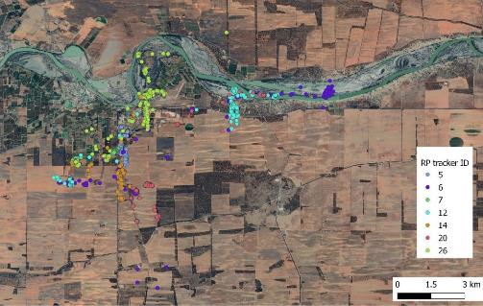
Figure 2.4: The GPS locations of all data loggers recorded during the study into the landscape use by Regent Parrots in the breeding season 2016 (Ireland 2020).
Study 2 - In December 2019, eight satellite trackers were placed on Regent Parrots caught and released at Gluepot Reserve 65 kms north of Waikerie, South Australia. The study was conducted to further understand how Regent Parrots utilise the landscape. The majority of trackers stopped working within the first month. One tracker continued for three months, while the last one was still working as at mid November 2020. Figure 2.5 identifies the GPS locations of the trackers during each monthly period between December 2019 and October 2020. The initial assessment of the data indicates the following landscape use trends by the Regent Parrots:
- The birds used the same area for roosting for a period time before moving onto another area.
- During extreme hot weather the birds loitered around the river and floodplain.
- Remnant patches of native vegetation were important.
- The birds utilised the floodplain during most months of the year.

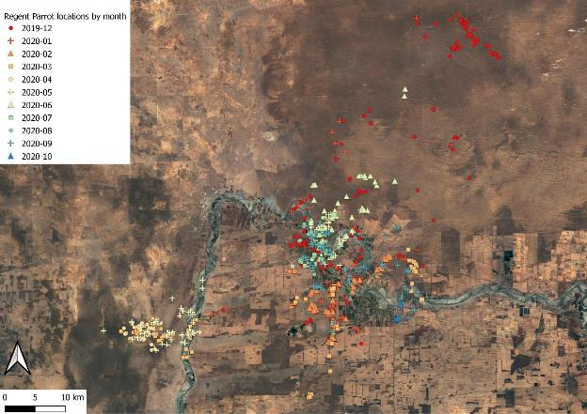
Figure 2.5: The GPS locations of satellite trackers recorded between Dec 2019 and Oct 2020 during a study into the landscape use of Regent Parrots along the River Murray in South Australia (Ireland pers. comm.).

Study 3 - In early October 2020 four satellite trackers were placed on male Regent Parrots caught and released 8 kms south of Lock 6 in the Chowilla / Murtho area South Australia. The study focused on the how the birds interact between the Chowilla area and the wider landscape. Prior to placing the trackers on the birds a number of Regent Parrot nests were recorded on the floodplain in the vicinity of Lock 6. Figure 2.6 identifies the GPS locations of the trackers during the first five weeks of records. After only this short period of tracking, data, together with the aid of tracking data site field surveys by volunteers, the following breeding season landscape use trends by Regent Parrots has been identified;
- A distinctive flight path between the foraging and breeding floodplain sites and the Mallee roosting sites. The birds travel through remnant patches of Mallee vegetation, open paddocks and an almond orchard.
- Night roosting can occur on both the floodplain and within Mallee vegetation well south of the river, and also within Mallee adjacent to the northern edge of the floodplain.
- Both adult, sub-adult and juvenile birds forage on Atriplex spp. (especially Eastern Flat-top Saltbush {Atriplex lindleyi}) for extended periods on the floodplain.

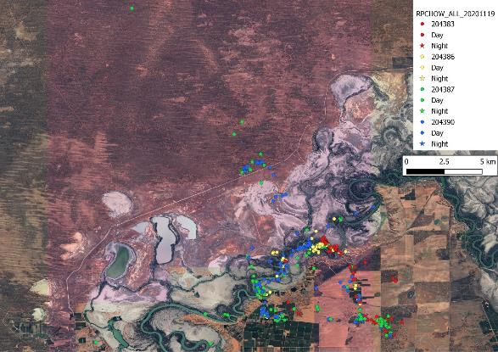
Figure 2.6: The GPS locations of satellite trackers recorded during a five week period in October/November 2020 during a Regent Parrot landscape use study in the Chowilla / Murtho area in South Australia (Ireland pers. comm.).

Regent Parrot breeding biology
Regent parrots are usually two years old before they start breeding. Nesting is restricted to stretches of mature riverine woodland and forest within 20 kms of suitable feeding habitat. This is because male Regent Parrots are limited by their need to make at least two to three return trips per day to feed nesting females (Forshaw and Cooper, 1981).
Regent Parrots usually nest in colonies which were found to fall into three different types (Smith 2006):
- Dead trees where the trees had been drowned when the locks and weirs were built on the river more than 70 years ago.
- Pockets of River Red Gum forests with suitable hollows.
- Large live trees that were more widely dispersed along the river edge and ephemeral creeks or permanent backwaters.
The area occupied by the nest trees in each colony can vary from four hectares up to 45 hectares. The smaller colonies (up to ten hectares) are were mainly located in drowned River Red Gums in backwaters. Table 2-2 presents a sample of colonies described by (Smith 2006) where he estimated area over which the nest trees were distributed and the estimated number of trees with suitable hollows.

Table 2-2: Regent Parrot nesting colony details
Site Name | Estimated area | Estimated nesting trees | Description of Site
Nil Nil | 8 ha | 90 | Drowned River Red Gums in 2 adjacent backwaters with a strip of land down the centre which is thickly wooded with River Red Gums.
Bankrock Bend | 30 ha | 400 | River Red Gum Forest and part woodland of live trees along the inside edge of a big bend in the river.
Island Reach | 45 ha | 100 | River Red Gum Woodland with live and recently dead trees located along the edge of the river and ephemeral backwaters.
Hogwash Bend | 20 ha | 500+ | Live River Red Gum Forest and woodland with a part understorey of Lignum.
Murbko Flat | 30 ha | 80 | Live and dead River Red Gums on the edge of a creek and lagoon.

Egg laying usually occurs in August and takes a few days. Incubation takes around three weeks and Chicks are present in the nest after about four weeks. The females do all the incubation and remain with the young for the next two weeks after hatching. This means that the males feed the female for a period of five to six weeks. At this point the females join the feeding flocks and both males and females feed the young birds until they fledge in about another four weeks (Higgins 1999). Not all pairs in a colony begin breeding at the same time and there can be up to two weeks between the individual pairs getting started (Smith 2004). During a good year however many more pairs will commence breeding at an earlier time (Smith 2014).
During the 2014 and 2016 breeding season cameras were placed on active nest hollows by South Australian Regent Parrot Recovery Team volunteers. The nest camera results suggest that two to three young are fledged from successful nests with an average over all nests filmed to be two young per nest. The cameras detected that some parent birds failed to return to the nests during the breeding season.
When nest brooding by the female begins the males form small flocks to travel back and forth from the feeding site. After feeding the female the males will sit quietly grooming themselves and occasionally call until other members of their feeding flock returned. The flock will sometimes rest and then as a group suddenly take off for the feeding ground. At other times the male bird would join the flock as it flies over. Flocks seem to take rather circuitous routes to ‘collect’ their members before heading off directly for the feeding grounds. As the young nestlings get older, the male and the female will fly off to the feeding grounds, quite often returning independently to feed the young in the hollow (Smith 1992). During the 1991 nesting survey at Loch Luna (Smith 1992) recorded feeding flocks of males flying out to the south east and returning during the day. However, after the late afternoon feed, they flew off in a northerly direction towards the Mallee. Banrock Station has four distinct breeding locations with birds from all four sites being part of the feeding flocks that leave the area together (Smith 2011). Figure 2.7 shows the flight lines taken by breeding birds from nest sites located at Hogwash and Markaranka Lagoon (Ireland, unpublished data). The previous three examples indicated that there are significant differences in Regent Parrot flight lines from nesting colonies over time and location.

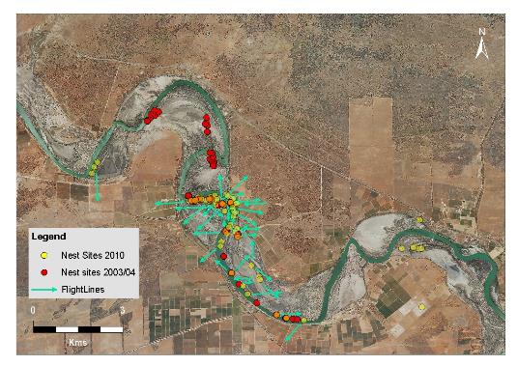
Figure 2.7: Flight lines taken by breeding Regent Parrots from nest sites located at Hogwash and Markaranka Lagoon.

A typical Regent Parrot nesting River Red Gum is a large very old tree (mature or senescent) usually with large limbs and branches missing with the majority of trees located within 100 metres of water. There are usually a number of hollows of varying sizes in the tree. During the South Australian 2010 Regent Parrot nesting survey, nests were found to occupy the following nest entrances: spouts 52%, end of branch 28% and lateral entry point 20% all with no particularly favoured orientation. Appendix 3 and Figure 2.8 and 5.1 demonstrate examples of Regent Parrot nest entrance types. Ninety two percent of nest hollows were located in separate trees.

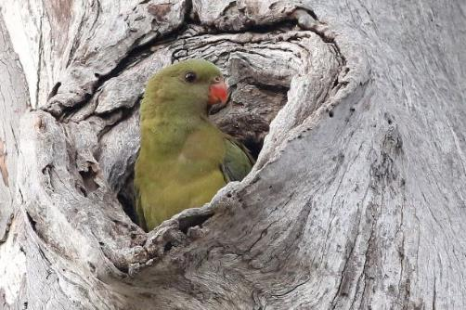
Figure 2.8: Female Regent Parrots at a (spout) nest site (Photo H Kieskamp).
The size of the hollow entrance was found to be more important with over 91% of nest entrances being small to medium range (Smith 2011). Australian Ravens Corvus coronoides and Lace Monitors Varanus varius have been observed removing Regent Parrot chicks from hollows where the entrances were large enough for these predators to access them (Smith 2014). Regent Parrot nesting colonies were observed to contain other bird species which were also utilising hollows for nesting. Twenty other bird species were observed utilising hollows at Regent Parrot nesting colonies that included three introduced species Table 2-3 (Smith 1992, Smith 2001, Smith 2011). Monitoring of South Australian Regent Parrot nesting sites between 2003-2013 found that nesting Sulphur-crested Cockatoos, Little Corellas, Galahs, Yellow Rosellas and Mallee Ringnecks were all found to be present at the majority of Regent Parrot nesting colonies (Smith 2014).

Table 2-3: Other bird species observed utilising hollow at Regent Parrot nesting colonies.
Peregrine Falcon Falco Peregrinus  Nankeen Kestrel Falco cenchroides  Sulphur-crested Cockatoo Cacatua galerita  Little Corella Cacatua sanguinea  Major Mitchell’s Cockatoo Cacatua leadbeateri  Galahs Cacatua roseicapilla  Yellow Rosellas Platycercus elegans flaveolus  Mallee Ringnecks Barnardius zonarius barnardi  Cockatiel Nymphicus hollandicus  Red-rumped Parrot Psephotus haemotonotus | Laughing Kookaburra Dacelo novaeguineae  Sacred Kingfisher Todiramphus sanctus  Brown Treecreeper Climacteris picumnus  Striated Pardalote Pardalotus striatus  White-breasted Woodswallow Artamus leucorynchus  Tree Martin Hirundo nigricans  Welcome Swallow Hirundo neoxena  *Feral Pigeon Columba livia  *Common Starling Sturnus vulgaris  *House Sparrow Passer domesticus
*Introduced species

The South Australian Murray River whole of river Regent Parrot nest surveys have revealed a fall in the numbers of drowned River Red Gums being used as nest trees from 32% in 2003/4 to 15% in 2010. The combined effects of the loss of available trees due to them falling over and the probable decline in the nature of the nest hollows due to decay and termite activity appears to have made these areas unattractive as nest sites. It is reasonable to assume that all of the remaining colonies in these drowned trees will disappear in the near future. The movement of nesting colonies away from drowned and recently dead River Red Gums shows the need to improve and maintain the health of those still surviving and to enhance recruitment of trees for the future (Smith 2011).

Regent Parrot foraging resources
Regent Parrots are generalist feeders and can take advantage of a range of food resources, both native and non-native with some variation between seasons Appendix 1. Ryan-Colton’s (2013) study indicates that this variation is related to when the required food source was available. For example, most local Acacia species generally seed in late spring and summer, and Regent Parrots were observed feeding on the seeds during this time. They were not observed feeding on Acacia seeds in the non-breeding season as seeds would no longer be available. Regent Parrots feed in pairs and small parties, occasionally in large flocks, usually on the ground, but also in trees (Beardsell 1985; Burbidge 1985).
Regent Parrots have been observed feeding on the temporary wetland bed herbland plants that have regenerated as a result of environmental watering. Table 2-4 identifies known Riparian food plants of Regent Parrots.
Table 2-4: Known Riparian Food Plants of Regent Parrots
Food column indicates which part of the plant was consumed. Abbreviations: B = berry, F = flowers, S = seeds, * = introduced species.
Common Name | Scientific Name | Food | Season
Capeweed | Arctotheca calendula*
Lesser Joyweed | Alternanthera denticulata | S | Breeding, Juveniles fledged
Box Mistletoe | Amyema miquelii | B
Eastern Flat-top Saltbush | Atriplex lindleyi | S | Breeding, Juveniles fledged
Old Man Saltbush | Atriplex nummularia |  | Breeding, Juveniles fledged
Creeping Saltbush | Atriplex semibaccata | S
Bladder Saltbush | Atriplex vesicaria | S | Breeding
Copperburr | Bassia spp. | S | Breeding, Juveniles fledged
Ruby Saltbush | Enchylaena tomentosa | B | Breeding
Heron's Bill | Erodium crinitum | S
River Red Gum | Eucalyptus camaldulensis | F, S,
Black Box | Eucalyptus largiflorens | F, S,
Cat's Ear | Hypochoeris spp.* | S
Bundled Peppercress | Lepidium fasciculatum | S
Lignum | Muehlenbeckia florulenta | F | Breeding, Non-breeding
Western Boobialla | Myoporum montanum |  | Non-breeding
Wild Mustard | Sisymbrium spp. | S
Common Sowthistle | Sonchus oleraceus* | S
Darling Pea | Swainsona greyana |  | Non-breeding
Twinleaf | Zygophyllum spp.
Floodplain Groundcover species |  |  | Breeding ,Juveniles fledged Non-breeding
Source: (Ireland and Ryan-Colton, 2016 modified 2020).

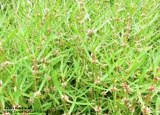 | 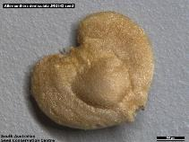
Figure 2.9: Lesser Joyweed Alternanthera denticulata a common wetland Herbland plant the seeds of which Regent Parrots eat (Photos by SA Seed Conservation Centre).

Regent Parrot threats
The National Recovery Plan for the Regent Parrot (eastern subspecies) Polytelis anthopeplus monarchoides (Baker-Gabb B. and Hurley V.H., 2011) identifies the key threats to this species across its interstate distribution. Summarized below are the key threats relevant to the South Australian Regent Parrot population.

Clearing and degradation of Mallee Woodland
One of the major threats to Regent Parrots is the decline and loss of Mallee woodland particularly within 20 kms of nesting colonies, both as feeding habitat and as flyways linking feeding habitat with breeding and non-breeding habitat. Further, during the non-breeding period of the year Regent Parrots forage considerable distances away from the floodplain and are dependent upon Mallee remnants and vegetated roadside corridors to access (Baker-Gabb and Hurley, 2011). In South Australia wide scale native vegetation clearing has been significantly reduced since the state Native Vegetation Act 1991 came into force.
Regent Parrots frequently forage on the ground, and heavy grazing by stock, feral and native herbivores are likely to reduce an areas value for these parrots (Baker-Gabb and Hurley, 2011). In South Australia large areas of Mallee are now not grazed by stock (e.g. Riverland Biosphere Reserve). However, grazing by Feral Goat Capra hircus, European Rabbit Oryctolagus cuniculus and high numbers of kangaroos if not kept at low numbers can severely degrade Regent Parrot foraging habitat. Decommissioning artificial water points in Mallee can help reduce overgrazing and have considerable biodiversity benefits. In South Australia this has probably occurred to the greatest extent in parks and reserves north of the River Murray (e.g. Riverland Biosphere Reserve). However, birds still need access to water, and (Smith 2001) noted that the removal of all water points over a large area could make it difficult for the species to forage effectively there. The recent drought dried up most water points in South Australian Mallee pastoral areas and Regent Parrots were forced to forage closer to the Murray River, where they came into greater conflict with fruit growers (Smith 2004).
A critical component of the Regent Parrot habitat is the vegetation between the Mallee woodland feeding and roosting areas and the River Red Gum nesting areas. Due to extensive clearing of land within 20 kms of the Murray River, this component now largely comprises vegetated corridors (or flyways) linking the other two habitats. These flyways are now often limited to one or two trees in width along roadsides and have been further degraded through road widening activities to accommodate larger machinery and infrastructure. There is considerable evidence to show Regent Parrots use these flyways to commute between the nest sites and feeding grounds several times a day during the breeding season and are reluctant to cross gaps or open areas greater than 200 meters (Baker-Gabb and Hurley, 2011).

2.5.2 Altered River Murray hydrological regimes
River Red Gum Woodlands throughout the range of the Regent Parrot are under great stress, and many nest trees have and are likely to die because of reduced flooding and ongoing drought (Smith 2004). An example in South Australia has been Taylor Flat where in 2003-4 seven nests were recorded in live trees. These trees were dead by the 2010 nest survey when no nests were found (K Smith pers. obs.). Since the millennium drought large areas of the floodplain which include Regent Parrot foraging sites have been severely stressed due to reduced river flooding and elevated saline groundwater impacts (M Harper, pers. obs.).

Wild fires
Extensive wildfires are considered a threat to Regent Parrots by reducing the availability of food over large areas of Mallee for many years after a fire (Baker-Gabb and Hurley, 2011). Fires have also caused the loss of nest trees in Victoria as well as nesting quality trees in South Australia and are considered a major threat in the future due to climate change.

2.5.4 Nesting colony disturbance
Human activities (particularly very noisy ones) in the vicinity of Regent Parrot breeding colonies can lead to the birds becoming very reluctant to enter their nest hollows and even abandoning previously occupied nest hollows (Smith 2001, Smith 2014). Historically, many riverine nest locations have been difficult to access due to land tenure and where on the floodplain a site is located. However, with the trend of increased recreation and tourism use of the River Murray floodplain both on private and public land, human impact on Regent Parrot breeding colonies is rapidly increasing.

Human-caused mortality
Human actions, both deliberate and inadvertent, have killed and continue to kill significant numbers of Regent Parrots. The birds are readily attracted to spilt grain and where this occurs along roadsides the birds may be struck and killed by passing vehicles especially juvenile birds. Regent Parrots are thought by some orchardists to damage nut and fruit crops, even though their impact is minor compared to several other species. Many birds have been deliberately killed and despite the birds now being fully protected in all range States, this persecution still persists. Major expansion of almond plantations in recent years has brought the species into conflict with more orchardists (Baker-Gabb and Hurley, 2011). Threats such as illegal shooting of birds in orchards and road kills cannot be quantified at this stage due to most evidence being anecdotal.

Supporting Regent Parrots with Environmental Water
As outlined above, riverine floodplain wetlands provide critical habitat for Regent Parrot breeding and foraging, essential for sustaining Regent Parrot populations. The condition of this habitat influences the level of utilisation with healthy vegetation supporting larger colonies of Regent Parrots. With the altered hydrologic regime of the River Murray due to river regulation and prolonged droughts much of the available habitat is in a stressed condition. Delivery of water for the environment to these habitats is one tool that can significantly improve the condition supporting improved outcomes for Regent Parrots.

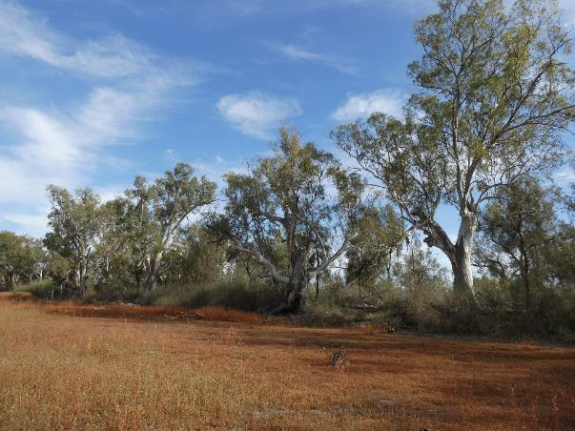
Figure 2.10: Schiller Lagoon a Regent Parrot critical habitat existing watering site (Photo: M Harper 2020).

Regent Parrot Critical Habitat Vulnerability Assessments
Based on current knowledge nesting colonies and surrounding foraging habitat have been identified as key Regent Parrot requirements that can be managed with environmental water. Providing these requirements will help support Regent Parrots to successfully nest and recruit.
This section outlines the methods and results of assessments undertaken in South Australia to identify priority Regent Parrot sites that can be managed with environmental water.
Nesting colonies and sites in the vicinity that are either known or have potential for nesting and foraging were identified as critical habitat. These sites were assessed in relation to their vulnerability (vegetation condition and stressors and threats). Nesting colony sites were determined to be the most urgent habitat to be considered in the conservation of the Regent Parrot and as such were identified and assessed, however the scope of the project was then broadened to include critical habitat (a combination of both foraging habitat and nesting habitat) to consider more holistic requirements for Regent Parrots when utilising floodplain and riverine environments. The following section outlines the approach used for identifying and assessing vulnerability for both types of sites.
The vulnerability assessment determines whether the site has stressors beyond the need for additional watering and whether other stressors will limit the success (achieving habitat outcomes) of delivering water for the environment at the site.
Sites were then assessed as to whether water for the environment can feasibly be delivered to the site and appropriate mechanism identified by which to deliver water.

3.1 Site identification and investigations
Prior to site visits the following geographical information data was gathered to assists in understanding the site parameters and issues:
- Historical nest colony sites plotted onto the latest aerial photo imagery.
- Land tenure and ownership category.
- Digital Terrain Model contours superimposed onto aerial photo imagery covering river zones of nesting colony concentrations and known or potential foraging sites (for critical habitat sites).
- Identify existing environmental watering sites and temporary wetlands which may influence areas of interest.
- Identify weir pool raising scenarios with potential to be operational in the short-term for areas of interest.
- Identify possible areas where hydrological management (water for the environment) could practically occur.

Once preliminary information was compiled and known and potential sites identified, site assessments were undertaken to determine the sites vulnerability and water delivery mechanisms. These included:
- Relevant condition assessments (refer methods below) plus reference photographs.
- Identify the known and potential Regent Parrot utilisation of the site.
- Stressor and threat description - Severity/Scope/Irreversibility assessment.
- Site management opportunities to reduce impacts of threats.
- Identify possible water for the environment delivery mechanisms and infrastructure requirements.
- Identify possible hydrological management unit if appropriate

While this project focused on completing a preliminary assessment to identify Regent Parrot sites that can be managed with environmental water. To complete this assessment, cultural assessments, landholder negotiations and further investigations into infrastructure will need to be undertaken.

3.2 Vulnerability Assessment of Regent Parrot Nesting Colonies
The vulnerability assessment of the River Red Gum nesting colonies is the key requirement for Regent Parrot conservation and the urgent need to protect nesting and potential nesting trees where possible. The vulnerability assessment focuses on;
- Current condition of a patch of both known and/or potential nesting River Red Gum.
- Identification of site stressors and threats.
- Current natural or managed site inundation capability, and,
- If water for the environment is required to sustain the site’s vegetation, identification of a potential watering method.

3.2.1 Condition assessment of River Red Gum (Regent Parrot nesting class)
A simple River Red Gum rapid condition assessment methodology was used and comprised of determining canopy condition and density classification as described below. As well as surveying the known nesting colony location, it is also beneficial to survey adjacent stands or patches of potential nesting trees. This is because Regent Parrots tend not to be very faithful to a particular area or tree hollows over extended periods (Smith 2011). A typical Regent Parrot nesting River Red Gum is a large, very old tree, (mature or senescent), usually with large limbs and branches missing (Smith 2011). Density classification is critical in determining potential water for the environment delivery mechanisms if required.
Canopy Condition Class
Canopy condition broadly means how stressed a tree is, without assigning the probable cause. In practice, almost all recent reports of River Red Gum condition have been in the context of acute water stress due to lack of flooding and compounded by falling water tables, saline groundwater, high temperatures and below average rainfall (Roberts and Marston 2011). Examples of each canopy condition class are shown below in Table 3-1 and Figure 3.1.

Table 3-1: River Red Gum Canopy Condition Class
Class | Visual Assessment | Recommended water management strategy
C1 - Good | >75% Canopy Cover, relatively non-stressed when compared to other River Red Gum. | No action may be taken, however if rainfall is well below average and river conditions predict a low flow period action should be considered to enhance tree resilience.
C2 - Medium | 75-40% Canopy Cover, made up of original canopy and or epicormic growth. | Regardless of canopy condition trajectory (improve or decline) trees are stressed, action recommended.
C3 - Poor | <40% Canopy Cover, made up of original canopy and or epicormic growth. | Stressed River Red Gum in poor or critical condition, priority action recommended.
C4 - Dead | 0% Canopy, tree is dead and will not recover. | If site has other values, action should be considered to enhance and/or promote River Red Gum regeneration.

C1 - Good | C2 - Medium
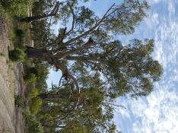 | 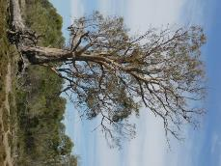
C3 - Poor | C - Dead
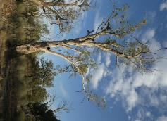 | 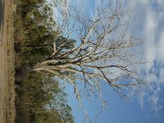
Figure 3.1: River Red Gum Canopy Condition Class. Top left: C1 Good %75 canopy cover, Top right: C2 Medium %75-40% canopy cover, Bottom left: C2 Poor <40% canopy cover, Bottom right: C4 Dead 0% canopy cover.

Density Classification
River Red Gum are the dominant tree species in frequently flooded floodplain forest and/or woodland. They are co-dominant in less frequently flooded areas such as higher parts of floodplains and along creek lines in semi-arid areas. Vegetation types with River Red Gum as the dominant or characteristic species show considerable diversity in structure and floristic diversity (Roberts and Marston, 2011). Examples of each density class are shown below in Table 3-2 and Figure 3.2

Table 3-2: River Red Gum Density Class
Density Class | Description
D1 – Forest | Forest consists of high numbers of trees with canopies touching to open canopy.
D2 – Open Woodland | Open Woodland consists of areas with fewer and more scattered trees than Closed Woodland.
D3 – Sparse Woodland | Sparse Woodland consist of areas with isolated trees.
D4 – Linear Woodland | Linear Woodland consist of a line of trees along the main river channel, creeks or the edge of a permanent or temporary wetland.

D1 – Forest
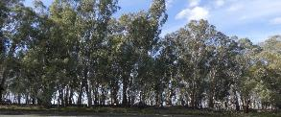 | 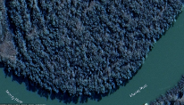
D2 – Open Woodland
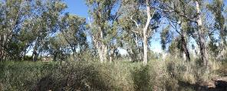 | 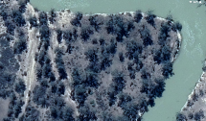
D3 – Sparse Woodland
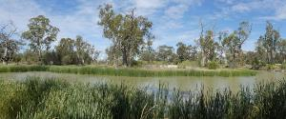 | 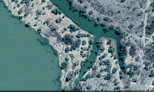
D4 – Linear Woodland
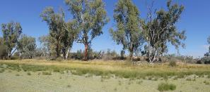 | 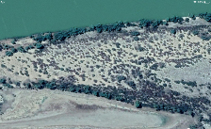
Figure 3.2: Examples of River Red Gum density class with photograph and aerial imagery.

3.2.2 Identification and analysis of stressors
The Regent Parrot nesting colony stressor identification and analysis focuses on the following:
- Long-term viability of both known and potential nesting trees within the colony determined by both the present River Red Gum and understory condition and natural or managed site inundation capability.
- Site evidence of recreational and tourism use type and density resulting in potential for human disturbance to the birds nesting outcomes.
- Site evidence of total grazing pressure from stock, feral and or native herbivores which have a major influence on tree regeneration success.

To determine the stressors which pose the greatest long-term threat to a site, the Nature Conservancy has developed a Rating Criteria for Stress/Direct Threats (TNC 2007). The criteria rates the contribution of the severity and scope of each stressor and the reversibility of each of the stressor sources Table 3-3.

Table 3-3: Rating Criteria for Stress/Direct Threats
Rating Criteria for Stress/Direct Threats (TNC 2007)
Severity – The level of damage to the conservation target that can reasonably be expected within 10 years under current circumstances (i.e., given the continuation of the existing situation).
- Very High: The stressor is likely to destroy or eliminate the conservation target over some portion of the target’s occurrence at the site.
- High: The stressor is likely to seriously degrade the conservation target over some portion of the target’s occurrence at the site.
- Medium: The stressor is likely to moderately degrade the conservation target over some portion of the target’s occurrence at the site.
- Low: the stressor is likely to only slightly impair the conservation target over some portion of the target’s occurrence at the site.
Scope – Most commonly defined spatially as the geographic scope of impact on the conservation target at the site that can reasonably be expected within 10 years under current circumstances (i.e. given the continuation of the existing situation).
- Very High: The stressor is likely to be very widespread or pervasive in its scope and affect the conservation target throughout the target’s occurrences at the site.
- High: The stressor is likely to be widespread in its scope and affect the conservation target at many of its locations at the site.
- Medium: The stressor is likely to be localized in its scope and affect the conservation target at some of the target’s locations at the site.
- Low: The stressor is likely to be much localized in its scope and affect the conservation target at a limited portion of the target’s location at the site.
Irreversibility – The degree to which the effects of a direct stressor can be restored.
- Very High: The effects of the stressor are not reversible (e.g. wetlands converted to a shopping centre).
- High: The effects of the stressor are reversible, but not practically affordable (e.g. wetland converted to agriculture).
- Medium: The effects of the stressor are reversible with a reasonable commitment of resources (e.g. ditching and draining of wetland).
- Low: The effects of the stressor are easily reversible at relatively low cost (e.g. off-road vehicles trespassing in wetland).

3.2.3 Vulnerability investigation results and conclusions
Forty-seven known Regent Parrot nesting colonies were surveyed along the South Australian Murray River corridor between Swan Reach and Lock 6 to assess the long-term viability of each site (Figure 3.3). The health viability of the nesting quality River Red Gum trees was the major focus of the survey. The description summary of each Regent Parrot nesting colony surveyed is presented in Appendix 2 and includes site geomorphic category, River Red Gum and understory description, condition and reference photograph and site stressor analysis for each site.

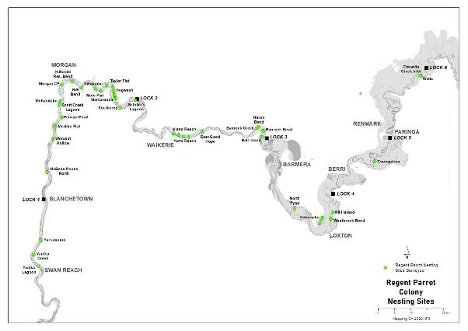
Figure 3.3: Regent Parrot Nesting Colonies surveyed to assess their long-term health viability.

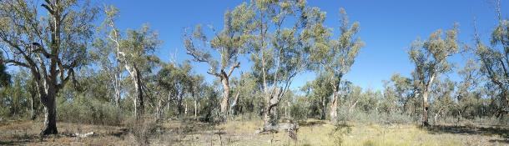
Figure 3.4: Example of an open woodland Regent Parrot nesting colony located at Hogwash Bend. (Photo M Harper).

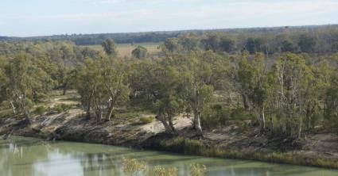
Figure 3.5: View over Markaranka Lagoon - the centre of an important Regent Parrot nesting location which has regularly received Environmental Water since 2005/06. (Photo M. Harper).

Identification and analysis of Regent Parrot nesting colony stressors
The Regent Parrot nesting colony threat analysis focused on the long-term viability of nesting trees and the potential for human disturbance to the bird’s nesting outcomes. During the colony investigations it was found that a significant number of Regent Parrot nesting colonies are degraded to some extent, or are facing a series of stressors or direct threats which need to be counteracted by conservation actions. To determine the stressors which pose the greatest long-term threat to a site, the Rating Criteria for Stress/Direct Threats developed by the Nature Conservancy was utilised (Table 3.3). The criteria rates the contribution of the severity and scope of each stressor and the reversibility of each of the stressor source for the Regent Parrot nesting colony survey. The analysis of site’s stressor is presented in each colony assessment description (Appendix 2).
A summary of each stressor irreversibility rating (the degree to which the impact can be restored) over the forty-seven sites assessed is presented in Table 3-4. Lack of inundation represents the major stressor (79%) to the long-term viability of the nesting quality River Red Gum trees at the sites surveyed. The threat to the health of these very old trees is exacerbated by the presence of saline groundwater which is impacting 40% of the sites. The third stressor to the continued nesting by Regent Parrots at these sites is not vegetation health related but human disturbance during the breeding season (August to November). Of particular concern is disturbance during the period when the birds are selecting a site to nest for the season. Depending on seasonal conditions this is usually during July and August but can be earlier. No stressors were identified at four of the sites. Table 3-5 presents the stressor irreversibility rating for each stressor impacting on each Regent Parrot colony. It is important to note that at sites where lack of inundation was identified as a stressor that was capable of being reversed (rating of medium or low), no other stressors were identified as being irreversible and as such means that environmental water management at these sites will likely result in positive outcomes for Regent Parrot habitat, however in some cases additional management actions may be required to achieve optimal habitat outcomes.

Table 3-4: Regent Parrot Nesting Colony Stressor Irreversibility Rating Summary
Irreversibility – The degree to which the impact can be restored. High: The effects of the stressor are reversible, but not practically affordable. Medium: The effects of the stressor are reversible with a reasonable commitment of resources. Low: The effects of the stressor are easily reversible at relatively low cost.
Stressors | High | Medium | Low | Total Sites | % of 47 sites
Lack of Inundation | 20 | 12 | 5 | 37 | 79%
Surface Soil Salinity | 2 |  |  | 2 | 4%
Saline Groundwater Depth | 10 | 4 | 5 | 19 | 40%
Flow Barrier |  | 3 | 1 | 4 | 9%
Bush Fire | 1 |  |  | 1 | 2%
Human Disturbance | 2 | 5 | 2 | 9 | 19%
Kangaroo and/or Sheep Grazing |  | 3 | 3 | 6 | 13%
Nil Stressors / Threats |  |  |  | 4 | 9%

Table 3-5: Stressor Irreversibility Rating for each Regent Parrot Nesting Colony
Irreversibility – The degree to which the impact can be restored. High: The effects of the stressor are reversible, but not practically affordable. Medium: The effects of the stressor are reversible with a reasonable commitment of resources. Low: The effects of the stressor are easily reversible at relatively low cost.
 | Stressor
Nesting Site | Lack of Inundation | Surface Soil Salinity | Saline Groundwater depth | Flow Barrier | Bush Fire Risk | Human Disturbance | Kangaroo and/or Sheep Grazing
Yatko Lagoon (Sugar Shack Creek d/s ) | High |  |  |  |  |  | Medium
Yatko Creek (Sugar Shack Creek u/s) |  |  |  |  |  |  | Medium
Yarramundi | High |  | High
McBean Pound North |  |  |  |  |  | High
Wombat Hollow | Medium
Murbko Flat | High |  |  |  |  | High
Pelican Point |  |  |  |  | High
Scott Creek (Brenda Park) | Nil Stressors or Direct Threats Identified
Mulyoulpko (Brenda Park) | High | High | High
Morgan South Lagoon | Medium |  |  |  |  | Low
Morgan Lagoon Flood-out | High |  |  |  |  | Low
Morgan North (East) | Medium |  |  | Medium
H Boord Reserve Bend | Nil Stressors or Direct Threats Identified
Nikalapko Lagoon | Nil Stressors or Direct Threats Identified
Molo Flat East Channels | Nil Stressors or Direct Threats Identified
Taylor Flat West | High |  | High
Taylor Flat Outlet Creek | Low |  | Low
Taylor Flat | High | High | High
Markaranka Flat | Medium |  | Medium
Markaranka Flat Channel | Low |  | Low
Hogwash Conservation Park | Medium |  |  |  |  | Medium
Hogwash Council Area | Medium |  |  |  |  | Medium
Markaranka Lagoon Outlet Channel | Low |  | Low
Markaranka River Flood-out | Medium |  |  | Low
Markaranka Lagoon Main River Channel | High
Markaranka Lagoon |  |  |  | Medium
Schiller Lagoon | Low |  | Low
Little Schiller Lagoon | Low |  | Low
Island Reach | High |  | High
Yarra Point | High
Yarra View | High
Yarra Reach | High
East Good Hope | High
Banrock Creek | High |  |  |  |  |  | Low
Heron Bend East & West | Medium |  | Medium |  |  |  | Low
Banrock Bend | Medium |  | Medium |  |  |  | Low
Ball Island | High |  | High
North Pyap | High |  | High
Katarapko Creek Campsite 47 |  |  |  |  |  | Medium
Katarapko Creek North and South |  |  |  | Medium |  |  | Medium
Katarapko Creek Campsite 45 | Medium |  |  |  |  | Medium
Katarapko Creek Campsite closed (previously campsite 25) | High |  | High
Westbrook Bend | Medium |  | Medium |  |  | Medium
Rilli Island | High |  | High
Coongalena | High |  | High
Chowilla Creek Inlet | High
Wiela | Medium

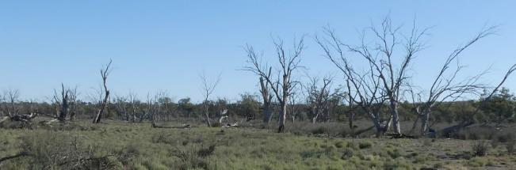
Figure 3.6: During the 2003 whole of river Regent Parrot nest survey, six nests were found in the north east corner of Taylor Flat. At the time of the survey the above trees were alive. (Photo M. Harper 2020).

Regent Parrot nesting colony water for the environment sites
Lack of inundation was identified as a stressor at 37 of the 47 Regent Parrot nesting colony sites assessed. These sites are where environmental water may potentially contribute to improving Regent Parrot nesting sites. While the other 10 sites are still important for Regent Parrots, environmental water is not an effective management option to deal with the stressors identified at these sites and other management actions should be explored. Of the 37 sites, five sites already receive water for the environment however, only a small percentage of known nesting trees receive water. Sixteen, (43%), sites have potential to receive or increase the present coverage of water for the environment to enhance the health of the Regent Parrot River Red Gum nesting trees. Table 3-6 summarises the parameters used to assess each Regent Parrot nesting colony for their need and suitability to receive water for the environment and identifies the reason the site is either not suitable or does not require water. Site topography was a major reason why sites were not suitable to receive water for the environment due to significant investment being required for a relatively small return. Consideration was also given to the use of sprinkler or dripper irrigation, however generally this is impractical due to thick understory or sparse density of trees.
Table 3-7 summarises key information from the site assessments for the 16 nesting colony sites identified as having potential to be managed with environmental water for Regent Parrot nesting colony outcomes.
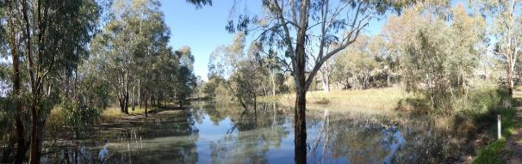
Figure 3.7: Draw down phase of water for the environment site East Morgan. Photo M. Harper.

Table 3-6: Summary assessment of Regent Parrot Nesting Colonies as to their Suitability to Receive Water for the Environment
Nesting Site | River Red Gum Density | River Red Gum Health Rating | Lack of Inundation” Threat Analysis |  |  | Potential  Watering | Reason for not being suitable  to receive  Water for the Environment
 |  |  | Severity | Scope | Irreversibility
Yatko Lagoon (Sugar Shack Creek D/S) | Linear & Open Woodland | Stressed - 3 | High | High | High | No | Site Topography/Thick understory
Yarramundi | Sparse Woodland | Healthy – 4 | Medium | Low | High | No | Site Topography/Thick understory
Wombat Hollow | Linear sparse Woodland | Healthy – 4 | Low | High | High | No | Site Topography/Thick understory
Murbko Flat | Sparse Woodland | Stressed - 3 | Low | Medium | High | No | Site Topography
Mulyoulpko (Brenda Park) | Sparse linear Woodland | Healthy - 4 | High | Medium | High | No | Site Topography/Thick understory
# Morgan South Lagoon | Open Woodland | Healthy – 4 | Medium | Medium | Medium | Yes
Morgan Lagoon Flood-out | Open Woodland | Stressed - 3 | High | High | Medium | Yes
Morgan North (East) | Linear Woodland | Healthy – 4 | Medium | Medium | Medium | Yes
Taylor Flat West | Sparse Woodland | Healthy – 4 | Low | Medium | High | No | Site Topography/Thick understory
Taylor Flat Outlet Creek | Open Woodland | Healthy – 4 | Low | Medium | Low | Yes
Taylor Flat | Open Woodland | Degraded – 0 | Very High | Very High | High | No | Site Topography/All trees dead
Markaranka Flat | Open Woodland | Stressed - 3 | Very High | High | Medium | Yes
Markaranka Flat Channel | Open Woodland | Stressed - 3 | Very High | High | Low | Yes
# Hogwash Conservation Park | Open Woodland | Stressed - 3 | Medium | Medium | Medium | Yes
Hogwash Council Area | Open Woodland | Healthy – 4 | High | High | Medium | Yes
Markaranka Lagoon Outlet Channel | Open Woodland | Stressed – 3 | Very High | High | Low | Yes
Markaranka River Flood-out | Open Woodland | Stressed - 3 | Very High | High | Medium | Yes
Markaranka Lagoon Main River Channel | Linear Woodland | Healthy – 4 | Low | Low | High | No | Site Topography/Thick understory
Schiller Lagoon | Open Woodland | Stressed - 3 | Medium | Medium | Low | Yes
Little Schiller Lagoon | Linear Woodland | Stressed - 3 | High | High | Low | Yes
Island Reach | Linear sparse Woodland | Stressed - 3 | Medium | Medium | High | No | Site Topography/Sparse Density
Yarra Point | Linear sparse Woodland | Healthy – 4 | Low | Low | High | No | Site Topography/Sparse Density
Yarra View | Linear Woodland | Healthy – 4 | Low | Low | High | No | Site Topography/Low risk site
Yarra Reach | Linear Woodland | Healthy – 4 | Low | Low | High | No | Site Topography/Low Risk Site
East Good Hope | Linear Woodland | Healthy – 4 | Low | Low | High | No | Site Topography/Low Risk Site
Banrock Creek | Linear Woodland | Healthy – 4 | Low | Low | High | No | Site Topography/Low Risk Site
Heron Bend East & West | Open Forest & Woodland | Stressed - 3 | Very High | High | Medium | Yes
# Banrock Bend | Open Forest & Woodland | Stressed - 3 | Very High | High | Medium | Yes
Ball Island | Open Woodland | Stressed - 3 | High | Medium | High | No | Site Topography/Thick understory
North Pyap | Linear Woodland | Healthy – 4 | High | Low | High | No | Site Topography/Small % effected
Katarapko Creek Campsite 45 | Open Woodland | Healthy – 4 | Medium | Medium | Medium | Yes
Katarapko Creek Campsite closed (previously Campsite 25) | Open Woodland | Degraded – 0 | Very High | Very High | High | No | Site Topography/All trees dead
Westbrook Bend | Open Woodland | Stressed - 3 | High | Medium | Medium | Yes
Table 3-6: Summary assessment of Regent Parrot Nesting Colonies as to their Suitability to Receive Water for the Environment (continued).
Nesting Site | River Red Gum Density | River Red Gum Health Rating | Lack of Inundation” Threat Analysis |  |  | Potential  Watering | Reason for not being suitable  to receive  Water for the Environment
 |  |  | Severity | Scope | Irreversibility
Rilli Island | Open Woodland | Stressed - 2 | High | Medium | High | No | Site Topography/Thick understory
Coongalena | Linear Woodland | Stressed - 3 | High | High | High | No | Site Topography/Thick understory /
Chowilla Creek Inlet | Forest | Healthy 4 | High | Low | High | No | Site Topography/Small % effected
# Wiela | Open Woodland | Healthy – 4 | Medium | Medium | Medium | Yes
# Existing Water for the Environment Sites
Table 3-7: Summary of key information from the site assessments for the 16 nesting colonies sites which have potential to be managed with water for the environment.
Nesting Site | River Red Gum Density | River Red Gum Health Rating | Lack of Inundation” Threat Analysis |  |  | Notes on other stressors identified at the site
 |  |  | Severity | Scope | Irreversibility
# Morgan South Lagoon | Open Woodland | Healthy – 4 | Medium | Medium | Medium | Human Disturbance (Low)
Morgan Lagoon Flood-out | Open Woodland | Stressed - 3 | High | High | Medium | Human Disturbance (Low)
Morgan North East | Linear Woodland | Healthy – 4 | Medium | Medium | Medium | Flow Barrier (Medium)
Taylor Flat West Outlet Creek | Open Woodland | Healthy – 4 | Low | Medium | Low | Saline Groundwater depth (Low)
Markaranka Flat | Open Woodland | Stressed - 3 | Very High | High | Medium | Saline Groundwater depth (Medium)
Markaranka Flat Channel | Open Woodland | Stressed - 3 | Very High | High | Low | Saline Groundwater depth (Low)
# Hogwash Conservation Park | Open Woodland | Stressed - 3 | Medium | Medium | Medium | Human Disturbance (Medium)
Hogwash Council Area | Open Woodland | Healthy – 4 | High | High | Medium | Human Disturbance (Medium)
Markaranka Lagoon Outlet Channel | Open Woodland | Stressed – 3 | Very High | High | Low | Saline Groundwater depth (Low)
Markaranka River Flood-out | Open Woodland | Stressed - 3 | Very High | High | Medium | Flow Barrier (Low)
Little Schiller Lagoon | Linear Woodland | Stressed - 3 | High | High | Low | Saline Groundwater depth (Low)
Heron Bend East & West | Open Forest and Woodland | Stressed - 3 | Very High | High | Medium | Saline Groundwater depth (Medium)  Kangaroo Grazing (Low)
# Banrock Bend | Open Forest and Woodland | Stressed - 3 | Very High | High | Medium | Saline Groundwater depth (Medium)  Kangaroo Grazing (Low)
Katarapko Creek Campsite 45 | Open Woodland | Healthy – 4 | Medium | Medium | Medium | Human Disturbance (Medium)
Westbrook Bend | Open Woodland | Stressed - 3 | High | Medium | Medium | Saline Groundwater depth (Medium), Human Disturbance (Medium)
# Wiela | Open Woodland | Healthy – 4 | Medium | Medium | Medium | Nil
# Existing Water for the Environment Sites

3.3 Vulnerability Assessment of Regent Parrot Critical Habitat
Site investigations of critical Regent Parrot habitat areas focused on vegetation condition assessment, and identification and analysis of stressors. Together, these components help determine whether managing sites for Regent Parrot outcomes is viable with the use of water for the environment. Existing water for the environment sites within the zones of interest were also assessed for their potential to provide critical riparian vegetation services (nesting and/or foraging) to benefit Regent Parrots. While the nesting sites provide critical information on key sites that need to be managed, these sites provide a more holistic approach to managing for Regent Parrot outcomes in riverine and floodplain environments. Thus, nesting colony sites that were identified in section 3.2 as suitable for targeted watering and where needs currently aren’t already met were incorporated.

3.3.1 Floodplain Vegetation Community Health Assessment
Across the Murray-Darling Basin a number of condition assessment survey methods for determining vegetation health classification are applied. To support the vulnerability assessment of Regent Parrot critical habitat areas, a rapid assessment of a “stand” or “patch” of a particular species or group of species was used. The majority of the present survey methods available would have also been appropriate however, due to time and funding constraints the follow methods were used.

River Red Gum Forest/Woodland
The health classification of woodland patch state used in the floodplain mapping of Black Box on Calperum floodplain (Cale 2019) has been modified to determine River Red Gum health classifications. The combination of the proportion of current live and dead trees (population state), and the current tree canopy condition defined the Forest/Woodland health classification Table 3-8 modified from (Cale 2019).

Table 3-8: River Red Gum Forest/Woodland Health Classification
 | ‘Degraded’ Forest/Woodland |  | ‘Stressed’ Forest/Woodland |  | ‘Healthy’ Forest/Woodland
 | 0 | 1 | 2 | 3 | 4 | 5
Population State | Trees dead | Most trees dead | Equal dead and live trees | Most trees Live | Odd tree dead | Odd tree dead
Current Canopy Condition | Nil | Live trees poor - good | Live trees poor–good | Live trees poor - good | Live trees medium -good | Live trees good

Black Box Woodland
The health classification of Black Box Woodland on Calperum floodplain (Cale 2019) has been adopted for this Framework. The combination of the proportion of current live and dead trees (population state) and the current tree canopy condition defined the woodland health classification Table 3-9.

Table 3-9: Black Box Woodland Health Classification (Cale 2019)
 | ‘Degraded’ Forest/Woodland |  | ‘Stressed’ Forest/Woodland |  | ‘Healthy’ Forest/Woodland
 | 0 | 1 | 2 | 3 | 4 | 5
Population State | Trees dead | Most trees dead | Equal dead and live trees | Equal dead and live trees | Most trees Live | Most trees Live
Current Canopy Condition | Nil | Live trees poor - good | Live trees poor–medium | Live trees medium-good | Live trees poor -medium | Live trees medium -good

Lignum Shrubland
The health classification of Lignum Shrubland (a Regent Parrot foraging habitat) combined the proportion of current live and dead shrubs (population state) and the current plant density described in Table 3-10 modified from (Cale 2019).

Table 3-10: Lignum Shrubland health classification
 | ‘Degraded’ Shrubland |  | ‘Stressed’ Shrubland |  | ‘Healthy’ Shrubland
 | 0 | 1 | 2 | 3 | 4 | 5
Population State | Shrubs dead | Most shrubs dead | Equal dead and live shrubs | Equal dead and live shrubs | Most shrubs  live | Most shrubs live
Plant Density | Nil | Dense - sparse distribution | Sparse distribution | Dense distribution | Sparse distribution | Dense distribution

Low Shrubland/Herbland
The health classification of Low Shrubland/Herbland (Regent Parrot foraging habitats) were defined by the population state which comprised of the proportion of soil salt scalding and salt and non-salt tolerant species described in Table 3-11.

Table 3-11: Low Shrubland/Herbland Health Classification
 | ‘Degraded’ Scrubland |  | ‘Stressed’ Shrubland |  | ‘Healthy’ Shrubland
 | 0 | 1 | 2 | 3 | 4 | 5
Population State | Areas of salt scalds | Dominated by samphire | Areas of bare soil and/or odd patches of samphire | Salt and non- salt tolerant species | > Five non-salt tolerant species | <Five non-salt tolerant species

3.3.2 Identification and analysis of stressors
Stressor identification and analysis of critical habitat areas for Regent Parrots focused on the following;
- Long-term viability of the four main floodplain vegetation types known to be utilised by Regent Parrots. They are River Red Gum Forest and Woodland, Black Box Woodland, Lignum Shrubland and low Shrubland/Herbland).
- Sites were assessed for evidence of stressors threatening both the long-term viability of floodplain vegetation and capacity for Regent Parrots to successfully nest. For example, inadequate flooding, saline groundwater depth, flow barriers, recreational and tourism use type and density, as well as total grazing pressure impacts.

The stressor analysis involved an assessment of existing water the environment sites as well as stressor assessment and vulnerability assessments for both existing and potential water for environment sites, refer below.
Existing water for the environment sites
The Lower River Murray has a significant number of existing water for the environment sites. The majority are located upstream of Morgan. Many of the sites were established during the River Red Gum Rescue program during the latter half of the Millennium Drought. Site management has varied significantly between sites and over time with inconsistent ecological outcomes. A review of these watering sites to determine if management can be modified to benefit both Regent Parrots and their original ecological objectives would improve landscape outcomes.
Existing water for the environment site analysis based on five environmental watering parameters has been modified from Cale 2019 (Table 3-12). Sites are assessed for their potential to provide critical riparian vegetation services (nesting and/or foraging) to benefit Regent Parrots if the scenario of “Status Quo” should continue thus indicating if a change in management would be beneficial.

Table 3-12: Example analysis table of existing water for the environment sites
Existing Environmental Watering Site | Regent Parrot Utilization | Environmental Watering Parameters |  |  |  |  | Status Quo
 |  | Inundation Extent | Frequency | Timing | Return Flows | Flow Barrier
 | Nesting | Adequate | Adequate | Adequate | No | Adequate | No Change
 | Foraging | Adequate | Increase | Change | Potential | Remove | Modify

Existing and potential water for the environment sites
Stressors at all sites were identified and analysed using the same method as the vulnerability assessment of Regent Parrot floodplain nesting colonies to determine if it would be feasible to ameliorate each stressor (Table 3-13).
A second vulnerability analysis of the potential and existing watering sites was done to determine the long-term vulnerability of vegetation communities critical to Regent Parrots. This included a “Do Nothing” scenario analysis modified from (Cale 2019) Table 5-6. The analysis compare present vegetation health classifications to three major floodplain stressors; inadequate flooding, elevated saline groundwater and surface soil salinity. These factors combine to limit the availability of suitable quality soil moisture for riparian vegetation. River regulation, and more recently, climate change have greatly modified the frequency, height and duration of River Murray high flow events. The use of water for the environment is one action that can significantly ameliorate these threats but will not replace all the floodplain hydrological and ecological processes of a natural flood event. However, the floodplain ecological parameters that are most critical to Regent Parrot survival relate to riparian vegetation health. Water for the environment is very effective at sustaining selected sites until the next natural flood event occurs.

Table 3-13: Example vulnerability analysis of viable Water for the Environment sites
Potential Environmental Watering Sites | Regent Parrot Utilisation | Present Health Classification |  |  |  |  | Stressors |  |  | Do-Nothing Scenario
 |  | River Red Gum Woodland | Black Box Woodland | Lignum Shrubland | Low Chenopod Shrubland | Herbland | Inadequate  Flooding | Saline Ground Water Depth | Surface Soil Salinity | Potential habitat outcome
 | Nesting | Degraded |  | Stressed | Healthy |  | Primary | Secondary | Present | Poor health
 | Foraging | Degraded | Degraded |  | Stressed |  | Primary |  |  | Potential Loss

3.3.3 Critical habitat vulnerability investigation conclusions
A total of 55 sites (31 existing watering sites and 24 sites not currently watered) were identified for critical habitat assessment. This included nesting sites identified in the above section as needing some or additional watering and had potential to receive it (noting some were absorbed into larger sites that were then assessed as critical habitat) as well as other nesting sites that were determined to not need further watering for nesting sites, but foraging parts of that site needed to be further assessed. In addition to the nesting sites other sites in the vicinity to nesting colonies that may have potential for nesting and or foraging, were identified for assessment.
Forty three critical habitat sites were identified for assessment in the desktop study (19 existing watering sites, and 24 potential watering sites). Condition of critical habitat was assessed at each of the identified sites and a summary of assessments are in Tables 3-14 to 3-17 while more detailed information is contained in the management briefs.

Analysis of existing water for the environment sites
Thirty one existing water for the environment sites which contained Regent Parrot nesting colonies, or, sites which were in the vicinity to colonies were assessed for their potential to increase critical riparian vegetation services (nesting and/or foraging) to benefit Regent Parrots. A desktop analysis found that inundation extent and frequency at 8 of the 31 sites were being met. From the limited hydrological assessment and knowledge of the sites by the author it was concluded that these sites are presently managed effectively for Regent Parrot outcomes. The sites are Sugar Shack Temporary Lagoon, Qualco Swamp, Riversleigh Lagoon, Wigley Flat, Parcoola West, Wigley Reach, Banrock Swamp and Murtho. The remaining twenty three sites were assessed in detail.

Table 3-14 describes the detailed assessment undertaken at the 23 sites. Four of these 23 sites are currently being watered effectively to meet Regent Parrot outcomes (Nikalapko Lagoon, Molo Flat (East Channels), Schiller Lagoon and Heron Bend South). Eighteen of the remaining 19 sites have the potential to increase inundation extent. All but two of these sites would also benefit by modifying other hydrological parameters while eight of these sites, plus the one remaining site have significant flow barriers. These barriers will prevent inundation during low to medium flood events.

Table 3-15 describes the available watering history for the majority of sites between 2005/06 and 2019/20. The historical watering data assisted in determining if the watering frequency at a site described in Table 3-14 was adequate to meet riparian vegetation health requirements to achieve Regent Parrot outcomes.

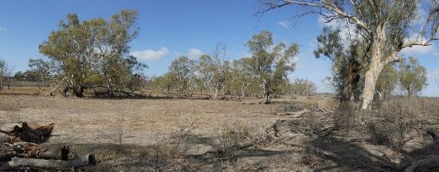
Figure 3.8: Overland Corner a Regent Parrot critical habitat existing watering site (Photo: M Harper).

Table 3-14: Analysis of current watering at 23 existing water for the environment sites to determine if modifications to the watering regime is required
Existing Water for the Environment  Sites | Regent Parrot Utilization | Environmental Watering Parameters |  |  |  |  |  |  | Status Quo
 |  | Inundation Extent |  |  | Frequency | Timing | Return /Reuse Flows | Flow Barriers
 |  | Existing Area | Potential Area | + /- hectares
Sugar Shack Upstream Lagoon | Nesting Adjacent & Foraging | 31.6 | 58.3 | +26.7 |  |  |  |  | Modify
Morgan South Lagoon | Nesting &Foraging | 15.1 | 23.7 | +8.6 |  |  |  | Yes | Modify
Morgan North (West) | Potential Foraging | 14.3 | 51.8 | +37.5 |  |  | Potential |  | Modify
Morgan North (East) | Potential Foraging | 19.5 | 32.6 | +13.1 |  |  | Potential | Yes | Modify
Nikalapko Lagoon | Nesting & Foraging | 46.2 | 46.2 | 0 |  |  |  |  | No Change
Molo Flat (East Channels) | Nesting Colony Adjacent & Foraging | 5.6 | 5.6 | 0 |  |  |  |  | No Change
Molo Flat | Nesting Adjacent & Potential Foraging | 36 | 76.4 | +40.4 |  |  | Potential | Yes | Modify
Hogwash Northern Flood-out | Nesting & Foraging | Unknown | 7 | +7 | Increase | Change |  | Yes | Restructure
Hogwash Bend Central Basin (West) | Nesting & Foraging | 1.8 | 8.2 | +6.4 | Increase | Change |  |  | Modify
Hogwash Bend Southern Basins | Potential Foraging | 33.3 | 37.5 | +4.2 |  |  |  |  | Modify
Markaranka Lagoon | Nesting & Foraging | 128 | 214 | +86 |  |  | Potential | Yes | Modify
Holder Lagoon | Foraging | 10.5 | 104.7 | +94.2 |  |  | Potential | Yes | Restructure
Schiller Lagoon | Nesting & Foraging | 92 | 92 | 0 |  |  |  |  | No Change
Yarra Creek | Foraging & Adjacent Nesting | Unknown | 123 | +? | Increase |  | Potential |  | Restructure
Heron Bend South | Foraging | 7.8 | 7.8 | 0 |  |  |  |  | No Change
Banrock Bend | Nesting &Foraging | 0.9 | 14.7 | +13.8 |  | Change |  |  | Restructure
Overland Corner including (Overland Corner Lignum Basin) | Adjacent Nesting & Foraging | 94 | 187.5 | +93.5 | Increase |  | Potential | Yes | Restructure
Gerard/Katarapko Lagoon | Potential Foraging | 8.6 | 41.1 | +32.5 |  |  | Potential |  | Modify
Katarapko Creek North and South | Nesting & Foraging | 2.6 | 2.6 | 0 |  | Change |  | Yes | Modify
Katarapko Island North | Potential Foraging | 23.7 | 463 | +439.3 | Increase |  | Potential |  | Restructure
Yabby Creek | Potential Foraging | 9 | 25.1 | +16.1 | Increase |  |  |  | Restructure
Westbrook Lagoon | Potential Foraging | 5.9 | 8.1 | +2.2 | Increase |  |  |  | Modify
Wiela | Nesting Adjacent & Foraging | 26.8 | 44.7 | +17.9 |  |  | Potential | Yes | Modify

Table 3-15: Historical watering of existing water for the environment sites (Department of Environment and Water, Banrock Station and Nature Foundation).
Existing Watering Site | 05/06 | 06/07 | 07/08 | 08/09 | 09/10 | 10/11 | 11/12 | 12/13 | 13/14 | 14/15 | 15/16 | 16/17 |  | 17/18 | 18/19 | 19/20
Morgan South Lagoon |  |  |  |  |  | 83,061 | 58,463 |  |  |  |  | 71,740
Bird and Meeting Lagoons (Morgan North West)
Morgan North East
Nikalapko
Molo Flat East Channels
Molo Flat
Hogwash Bend Southern Basins
Hogwash Bend Central Basin (West)
Hogwash Bend North (Hogwash Northern Flood-out)
Markaranka Lagoon
Holder Lagoon (Maize Island Lagoons )
Yarra Creek
Heron Bend (South)
Banrock Bend
Overland Corner
Overland Corner Lignum Basin
Gerard/Katarapko Lagoon
Katarapko Creek North and South
Katarapko Horseshoe Lagoons and Yabby Creek
Katarapko Island North
Westbrook Lagoon
Wiela
Natural Inundation | Pumping/Gravity

Identification and analysis of stressors
Stressors at 43 critical habitat sites including both existing (19 sites) and potential water for the environment sites (24 sites) were identified and analysed to determine the greatest long-term threats to a site. Two analysis were undertaken. The first, was to determine if it would be feasible to ameliorate the major stressor source. The second analysis was to predict what might occur if no action was taken.

Table 3.16 describes the feasibility to ameliorate the major stressor source which was determined by the contribution of the severity and scope of each stressor and the reversibility of each stressor source. The analysis of each site’s stressors is presented in the Management Briefs in Appendix 6. Six major stressors were identified across sites. A low to medium score for the lack of inundation stressor was identified at all sites. All sites are therefore likely to improve with environmental water management, however, some may require additional management interventions to address other stressors (eg: grazing pressure) to achieve maximum results.

An additional vulnerability analysis assessed for a “Do Nothing” management scenario. The reason for this analysis was to assist the site selection process for implementation. The analysis compares current lowest level vegetation health classification (presented in each Site Management Brief Appendix 6), to three major floodplain vegetation stressors (Table 3-17) and what the consequences would be if no changes to management of the site occurred.

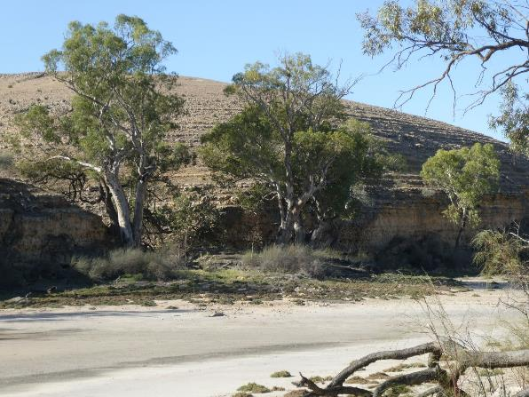
Figure 3.9: Fine line between salinized soils and healthy River Red Gums Yarra Creek. Photo M Harper.

Table 3-16: Stressor Irreversibility Rating for existing and potential water for the environment sites
Irreversibility – The degree to which the impact can be restored. High: The effects of the stressor are reversible, but not practically affordable. Medium: The effects of the stressor are reversible with a reasonable commitment of resources. Low: The effects of the stressor are easily reversible at relatively low cost
Existing & Potential Water for the Environment Sites | Stressor
 | Lack of Inundation |  | Saline Groundwater Depth |  | Surface Soil Salinity | Flow Barrier | * Human Disturbance | * High Total Grazing Pressure
# Sugar Shack Upstream Lagoon | Medium |  | Medium |  |  |  |  | Medium
# Morgan South Lagoon | Medium |  | Medium |  |  | Medium | Low
Morgan Lagoon Flood-out | Medium |  | Medium |  |  |  | Low
# Morgan North (West) | Medium
# Morgan North (East) | Medium |  | Medium |  |  | Medium
North West Bend | Medium |  | Medium
Weston Flat Lagoon | Medium |  | Medium |  |  |  |  | Medium
# Molo Flat | Medium
Taylor Flat Outlet Creek | Medium |  | Medium
Taylor Flat River Flood-out | Medium |  | Medium
Markaranka Flat | Medium |  | Medium
Markaranka Flat Channel | Low |  | Low
#Hogwash Northern Flood-out | Medium |  |  |  |  |  | Low
# Hogwash Central Basin West | Medium
Hogwash Central Basin East | Medium
#Hogwash Southern Basins | Medium
Markaranka Lagoon Outlet Creek | Low |  | Low
# Markaranka Lagoon | Medium |  | Medium |  |  | Medium
Markaranka River Flood-out | Medium |  |  |  |  | Low
Little Schiller Lagoon | Low | Medium | Low | Medium
# Existing Water for the environment sites * Refer to Site Management Briefs for details of the stressor (Appendix 6)

Table 3-16: Stressor Irreversibility Rating for existing and potential water for the environment sites (continued)
Existing & Potential Water for the Environment Sites | Stressor
 | Lack of Inundation | Saline Groundwater Depth | Surface Soil Salinity | Flow Barrier | * Human Disturbance | *High Total Grazing Pressure
# Holder Lagoon | Medium | Medium | Medium | Medium | Low | Low
Paschkes Flat | Medium |  | Medium
#Yarra Creek | Medium | Medium | Medium
Heron Bend West | Medium | Medium | Low |  |  | Low
Heron Bend East | Medium | Medium |  |  |  | Low
# Banrock Bend | Medium | Medium |  |  |  | Low
# Overland Corner | Medium | Medium | Medium | Low |  | Low
Loveday 4 x 4 Lagoon | Medium | Medium
Pyap Bend | Medium | Medium
Katarapko River Flood-out | Low | Low
# Gerard/Katarapko Lagoons | Medium
Putjeda Creek Lagoons | Medium | Medium |  |  |  | Low
Katarapko Creek Campsite 47 Watercourse | Medium | Medium
#Katarapko Creek North South | Medium |  |  |  | Low
Katarapko Creek East | Medium
Katarapko Creek Campsite 45 | Medium |  |  |  | Low
#Yabby Creek | Medium | Medium |  |  |  | Low
Yabby Creek Lagoon | Medium | Medium |  |  |  | Low
Westbrook Bend | Medium | Medium
# Westbrook Lagoon | Medium | Medium
# Katarapko Island North | Medium |  |  |  |  | Low
# Wiela | Medium
# Existing Water for the environment sites * Refer to Site Management Briefs for details of the stressor (Section 9)

Table 3-17: Vulnerability analysis of existing and potential water for the environment sites
Potential Water for the Environment Sites | Regent Parrot Utilisation | Vegetation Health Classification |  |  |  | Stressors |  |  | Do-Nothing Scenario
 |  | River Red Gum Woodland | Black Box Woodland | Lignum Shrubland | Low Shrubland/Herbland | Inadequate  Flooding | Saline Ground-water Depth | Surface Soil Salinity | Potential habitat outcome
# Sugar Shack Upstream Lagoon | Nesting and Foraging | Stressed L3 |  | Healthy L4 | Healthy L4 | Primary | Present |  | Potential Loss
Murbpook Lagoon | Adjacent Nesting and Potential Foraging | Stressed L3 |  |  | Stressed L3 | Primary | Secondary |  | Potential Loss
# Morgan South Lagoon | Nesting and Foraging | Stressed L3 |  | Healthy L4 | Stressed L3 | Primary | Present |  | Partial Loss
Morgan Lagoon Flood-out | Nesting and Foraging | Stressed L3 |  | Healthy L4 |  | Primary | Present |  | Potential Loss
# Morgan North (West) | Potential Foraging | Stressed L3 |  | Healthy L4 |  | Primary |  |  | Partial Loss
# Morgan North (East) | Nesting and Foraging | Stressed L3 |  | Healthy L4 | Stressed L3 | Primary | Present |  | Partial Loss
North West Bend | Potential Foraging | Stressed L3 | Healthy L5 |  | Stressed L3 | Primary | Present |  | Potential Loss
Weston Flat Lagoon | Potential Nesting and Foraging | Stressed L2 |  | Stressed L3 | Stressed L3 | Primary | Secondary |  | Loss
# Molo Flat | Adjacent Nesting and Foraging |  |  | Healthy L5 |  | Primary |  |  | Poor Health
Taylor Flat Outlet Creek | Nesting and Foraging | Healthy L4 |  |  |  | Primary | Present |  | Poor Health
Taylor Flat River Flood-out | Potential Nesting and Foraging | Healthy L4 |  |  |  | Primary | Present |  | Poor Health
Markaranka Flat | Nesting and Foraging | Stressed L3 |  |  |  | Primary | Secondary |  | Loss
Markaranka Flat Channel | Nesting and Foraging | Stressed L3 |  |  |  | Primary | Secondary |  | Loss
#Hogwash Northern Flood-out | Nesting and Foraging | Healthy L4 |  |  |  | Primary |  |  | Partial Loss
# Hogwash Central Basin West | Foraging and Nesting | Stressed L3 |  | Healthy L5 |  | Primary |  |  | Potential Loss
Hogwash Central Basin East | Foraging |  | Healthy L4 | Healthy L4 |  | Primary |  |  | Partial Loss
#Hogwash Southern Basins | Foraging | Degrade L1 |  | Healthy L4 | Stressed L3 | Primary |  |  | Partial Loss
Markaranka Lagoon Outlet Creek | Nesting and Foraging | Stressed L3 |  |  |  | Primary | Present |  | Potential Loss
# Markaranka Lagoon | Nesting and Foraging |  | Healthy L5 | Healthy L4 | Healthy L4 | Primary | Present |  | Partial Loss
Markaranka River Flood-out | Nesting and Foraging | Stressed L3 | Healthy L4 | Healthy L4 |  | Primary |  |  | Partial Loss
Little Schiller Lagoon | Nesting and Foraging | Stressed L3 |  |  | Healthy L4 | Primary | Secondary |  | Loss
# Existing Watering Sites (Vegetation Health Classification and potential habitat outcome is only related to additional area that could be added to the site)

Table 3-17: Vulnerability analysis of potential water for the environment sites (continued)
Potential Water for the Environment Sites | Regent Parrot Utilisation | Vegetation Health Classification |  |  |  | Stressors |  |  | Do-Nothing Scenario
 |  | River Red Gum Woodland | Black Box Woodland | Lignum Shrubland | Low Shrubland/Herbland | inadequate  Flooding | Saline Groundwater Depth | Surface Soil Salinity
# Holder Lagoon | Potential Nesting and Foraging | Stressed L3 | Healthy L4 | Healthy L4 | Stressed L3 | Primary | Secondary | Present | Potential Loss
Paschkes Flat | Foraging |  | Healthy L5 | Healthy L4 | D0 and S3 | Primary |  | Secondary | Potential Loss
#Yarra Creek | Foraging and Adjacent Nesting | Stressed L2 | Healthy L4 | Healthy L4 | Degraded L0 Stressed L3 | Primary | Secondary | Present | Loss
Heron Bend West | Nesting and Foraging | Stressed L3 |  |  | Stressed L3 | Primary | Secondary | Present | Loss
Heron Bend East | Nesting and Foraging | Stressed L3 |  | Healthy L4 | Stressed L3 | Primary | Secondary |  | Potential Loss
# Banrock Bend | Nesting and Foraging | Stressed L3 |  | Stressed L3 | Stressed L3 | Primary | Secondary |  | Loss
# Overland Corner | Adjacent Nesting and Foraging | Stressed L2 |  | Healthy L4 | Stressed L3 | Primary | Secondary | Present | Potential Loss
Loveday 4 x 4 Lagoon | Potential Nesting and Foraging | Stressed L3 | Healthy L4 |  | Stressed L2 | Primary | Secondary |  | Potential Loss
Pyap Bend | Potential Nesting and Foraging | Healthy L4 |  | Healthy L4 |  | Primary | Present |  | Partial Loss
Katarapko River Flood-out | Potential Nesting and Foraging | Stressed L3 |  | Healthy L4 |  | Primary | Secondary |  | Partial Loss
# Gerard/Katarapko Lagoons | Potential Foraging | Stressed L3 | Healthy L4 | Healthy L4 |  | Primary |  |  | Poor Health
Putjeda Creek Lagoons | Potential Foraging | Degraded L0 | Healthy L5 | Healthy L4 | Stressed L3 | Primary | Secondary |  | Potential Loss
Katarapko Creek Campsite 47 Watercourse | Potential Nesting and Foraging | Stressed L3 |  |  | Healthy L4 | Primary | Secondary |  | Partial Loss
#Katarapko Creek North South | Nesting and Foraging | Healthy L4 |  | Healthy L5 |  | Flow Barrier |  |  | Poor health
Katarapko Creek East | Nesting and Foraging | Stressed L3 |  |  | Stressed L3 | Primary |  |  | Partial Loss
Katarapko Creek Campsite 45 | Nesting and Foraging | Healthy L4 |  |  |  | Primary |  |  | Potential Loss
# Katarapko Island North | Potential Foraging | Stressed L3 | Healthy L4 | Healthy L4 | Stressed L3 | Primary | Present |  | Loss
#Yabby Creek | Potential Foraging | Stressed L3 |  |  | Stressed L3 | Secondary | Primary |  | Partial loss
Yabby Creek Lagoon | Potential Foraging | Stressed L3 |  | Healthy L4 | Stressed L3 | Primary | Secondary |  | Loss
Westbrook Bend | Nesting and Foraging | Stressed L3 |  |  |  | Secondary | Present |  | Partial Loss
# Westbrook Lagoon | Potential Foraging |  | Healthy L4 | Healthy L5 | Stressed L3 | Secondary | Present |  | Partial Loss
# Wiela | Nesting and Foraging | Stressed L3 |  | Healthy L4 | Stressed L3 | Secondary |  |  | Partial Loss
#Existing water for the environment Sites (Vegetation Health Classification is only related to additional area that could be added to the site)

3.4 Summary of critical habitat sites investigated
Nesting colonies and sites in the vicinity that are either known, or, have potential for nesting and foraging were identified as critical habitat. Investigations of over 80 sites focused on vegetation condition assessment, identification and analysis of stressors. Together, these components help determine whether managing sites for Regent Parrot outcomes is viable with the use of water for the environment. Table 3-18 lists all the critical habitat sites investigated and for each site identifies Regent Parrot utilization, potential to receive environmental water for Regent Parrot outcomes, and, if so, whether it is currently being achieved. Potential course of action is also provided.
Table 3-18: Table of all critical habitat floodplain sites identified and summary of assessment outcomes in relation to sites that have potential to be managed with water for the environment for Regent Parrot outcomes
Critical Habitat Sites investigated | Regent Parrot Utilization | Existing Watering for the Environment Sites | Potential Watering Parrot Outcomes | Regent Parrot outcomes currently achieved | Reason for not being suitable  to receive Water for the Environment for Regent Parrot Outcomes
Yatko Lagoon (Sugar Shack Creek d/s) | Nesting Colony |  | No | No | Not suitable for targeted watering: Site Topography/Thick understory
Yatko Creek (Sugar Shack Creek u/s) | Nesting Colony |  | No | Yes | Inundation is not required as lack of inundation was not identified as a stressor
Sugar Shack Upstream Lagoon | Nesting Adjacent & Foraging | Yes - Pool level | Yes | No | Greater extent of site could be inundated with site modifications to improve outcomes for Regent Parrots
Sugar Shack Temporary Lagoon | Potential Foraging | Yes | Yes | Yes | Watering requirements are currently being met: Continue with present management
Yarramundi | Nesting Colony |  | No | No | Not suitable for targeted watering: Site Topography/Thick understory
McBean Pound North | Nesting Colony |  | No | Yes | Inundation is not required as lack of inundation was not identified as a stressor
Murbpook Lagoon | Nesting Adjacent & Potential Foraging |  | Yes | No | Potential watering site requires site modifications.
Wombat Hollow | Nesting Colony |  | No | No | Not suitable for targeted watering: Site Topography/Thick understory
Murbko Flat | Nesting Colony |  | No | No | Not suitable for targeted watering: Site Topography
Pelican Point | Nesting Colony |  | No | Yes | Inundation is not required as lack of inundation was not identified as a stressor
Scott Creek (Brenda Park) | Nesting Colony |  | No | Yes | Regent Parrot outcomes are currently being met: No stressors were identified
Mulyoulpko (Brenda Park) | Nesting Colony |  | No | No | Not suitable for targeted watering: Site Topography/Thick understory
Table 3-18: Summary of all floodplain sites investigated and identification of potential critical habitat sites to receive water for the environment for Regent Parrot outcomes (continued)
Floodplain Sites investigated | Regent Parrot Utilization | Existing Watering for the Environment Sites | Potential Watering Parrot Outcomes | Regent Parrot outcomes currently achieved | Reason for not being suitable  to receive Water for the Environment for Regent Parrot Outcomes
Morgan South Lagoon | Nesting Colony & Foraging | Yes | Yes | No | Greater extent of site could be inundated with site modifications to improve outcomes for Regent Parrots
Morgan Lagoon flood-out | Nesting Colony |  | Yes | No | Potential watering site requires site modifications
Morgan North (West) | Potential Foraging | Yes | Yes | No | Greater extent of site could be inundated with site modifications to improve outcomes for Regent Parrots
Morgan North (East) | Nesting Colony | Yes | Yes | No | Greater extent of site could be inundated with site modifications to improve outcomes for Regent Parrots
North West Bend | Potential Foraging |  | Yes | No | Potential watering site requires site modifications
H Boord Reserve Bend | Nesting Colony |  | No | Yes | Regent Parrot outcomes are currently being met: No stressors were identified
Nikalapko Lagoon | Nesting Colony | Yes | Yes | Yes | Regent Parrot outcomes are currently being met: No stressors were identified
Molo Flat (East Channels) | Nesting Colony Adjacent & Foraging | Yes | Yes | Yes | Regent Parrot outcomes are currently being met: No stressors were identified
Molo Flat | Nesting Colony Adjacent & Foraging | Yes | Yes | No | Greater extent of site could be inundated with site modifications to improve outcomes for Regent Parrots
Weston Flat Lagoon | Potential Nesting & Foraging |  | Yes | No | Potential watering site requires site modifications
Taylor Flat West | Nesting Colony |  | No | No | Not suitable for targeted watering: Site Topography/Thick understory
Taylor Flat Outlet Creek | Nesting Colony & Foraging |  | Yes | No | Potential watering site requires site modifications
Taylor Flat River Flood-out | Potential Nesting & Foraging |  | Yes | No | Potential watering site requires site modifications
Taylor Flat | Nesting Colony |  | No | No | Not suitable for targeted watering: Site Topography/Nesting trees dead
Markaranka Flat | Nesting Colony |  | Yes | No | Potential watering site requires site modifications
Markaranka Flat Channel | Nesting Colony |  | Yes | No | Potential watering site requires site modifications
Hogwash Conservation Park | Nesting Colony | Yes | Yes | No | Included in Hogwash Northern Flood-out, Hogwash Central Basin (East & West) and Hogwash Bend Southern Basins
Table3-18: Summary of all floodplain sites investigated and identification of potential critical habitat sites to receive water for the environment for Regent Parrot outcomes (continued)
Floodplain Sites investigated | Regent Parrot Utilization | Existing Watering for the Environment Sites | Potential Watering Parrot Outcomes | Regent Parrot outcomes currently achieved | Reason for not being suitable  to receive Water for the Environment for Regent Parrot Outcomes
Hogwash Council Area | Nesting Colony |  | Yes | No | Included in Hogwash Northern Flood-out
Hogwash Northern Flood-out | Nesting Colony & Foraging | Yes | Yes | No | Regent Parrot outcomes could be improved by changing inundation frequency and timing and potentially increasing extent though site modifications
Hogwash Bend Central Basin (West) | Nesting Colony & Foraging | Yes | Yes | No | Regent Parrot outcomes could be improved by changing inundation frequency and timing and increasing extent though site modifications
Hogwash Bend Central Basin (East) | Foraging |  | Yes | No | Potential watering site requires site modifications
Hogwash Bend Southern Basins | Potential Foraging | Yes | Yes | No | Greater extent of site could be inundated, no site modifications required to improve outcomes for Regent Parrots
Markaranka Lagoon Outlet Channel | Nesting Colony & Foraging |  | Yes | No | Potential watering site requires site modifications
Markaranka River Flood-out | Nesting Colony & Foraging |  | Yes | No | Potential watering site requires site modifications
Markaranka Lagoon Main River Channel | Nesting Colony |  | No |  | Not suitable for targeted watering: Site Topography/Thick understory
Markaranka Lagoon | Nesting Colony & Foraging | Yes | Yes | No | Greater extent of site could be inundated, site modifications required to improve outcomes for Regent Parrots
Qualco Swamp | Potential Foraging | Yes | Yes | Yes | Watering requirements are currently being met: Continue with present management
Riversleigh Lagoon | Potential Foraging | Yes | Yes | Yes | Watering requirements are currently being met: Continue with present management
Schiller Lagoon | Nesting Colony & Foraging | Yes - Pool Level | Yes | Yes | Watering requirements are currently being met: Continue with present management
Little Schiller Lagoon | Nesting Colony & Foraging |  | Yes (Pool Level) | No | Potential watering site requires site modifications or increase inundation height of Schiller Lagoon
Holder Lagoon | Foraging & Potential Nesting | Yes | Yes | No | Greater extent of site could be inundated, site modifications required to improve outcomes for Regent Parrots
Paschkes Flat | Foraging |  | Yes | No | Potential watering site requires site modifications
Table 3-18: Summary of all floodplain sites investigated and identification of potential critical habitat sites to receive water for the environment for Regent Parrot outcomes (continued)
Floodplain Sites investigated | Regent Parrot Utilization | Existing Watering for the Environment Sites | Potential Watering Parrot Outcomes | Regent Parrot outcomes currently achieved | Reason for not being suitable  to receive Water for the Environment for Regent Parrot Outcomes
Island Reach | Nesting Colony |  | No | No | Not suitable for targeted watering: Site Topography/Sparse Density
Yarra Point | Nesting Colony |  | No | No | Not suitable for targeted watering: Site Topography/Sparse Density
Yarra View | Nesting Colony |  | No | No | Not suitable for targeted watering: Site Topography/Low risk site
Yarra Reach | Nesting Colony |  | No | No | Not suitable for targeted watering: Site Topography/Low Risk Site
Yarra Creek | Adjacent Nesting Colony & Foraging | Yes | Yes | No | Regent Parrot outcomes could be improved by changing inundation frequency and increasing extent though site modifications
East Good Hope | Nesting Colony |  | No | No | Not suitable for targeted watering: Site Topography/Low Risk Site
Wigley Flat | Potential Foraging | Yes | Yes | Yes | Watering requirements are currently being met: Continue with present management
Parcoola West | Potential Foraging | Yes | Yes | Yes | Watering requirements are currently being met: Continue with present management
Wigley Reach | Potential Nesting & Foraging | Yes | Yes | Yes | Watering requirements are currently being met: Continue with present management
Banrock Creek | Nesting Colony |  | No | No | Not suitable for targeted watering: Site Topography/Low Risk Site
Heron Bend West | Nesting Colony & Foraging |  | Yes | No | Potential watering site requires site modifications
Heron Bend East | Nesting Colony & Foraging |  | Yes | No | Potential watering site requires site modifications
Heron Bend South | Foraging | Yes | Yes | Yes | Watering requirements are currently being met: Continue with present management
Banrock Bend | Nesting Colony & Foraging | Yes | Yes | No | Regent Parrot outcomes could be improved by changing inundation timing and increasing extent though site modifications
Overland Corner | Adjacent Nesting Colony & Foraging | Yes | Yes | No | Regent Parrot outcomes could be improved by changing inundation frequency and increasing extent though site modifications
Banrock Swamp | Foraging | Yes | Yes | Yes | Watering requirements are currently being met: Continue with present management
Ball Island | Nesting Colony |  | No | No | Not suitable for targeted watering: Site Topography/Thick understory
North Pyap | Nesting Colony |  | No | No | Not suitable for targeted watering: Site Topography/Small % effected
Loveday 4X4 Lagoon | Potential Nesting & Foraging |  | Yes | No | Potential watering site requires site modifications
Table3-18: Summary of all floodplain sites investigated and identification of potential critical habitat sites to receive water for the environment for Regent Parrot outcomes (continued)
Floodplain Sites investigated | Regent Parrot Utilization | Existing Watering for the Environment Sites | Potential Watering Parrot Outcomes | Regent Parrot outcomes currently achieved | Reason for not being suitable  to receive Water for the Environment for Regent Parrot Outcomes
Pyap Bend | Potential Nesting & Foraging |  | Yes | No | Potential watering site requires site modifications
Katarapko River Flood-out | Potential Nesting & Foraging |  | Yes | No | Potential watering site. No site modifications required.
Gerard/Katarapko Lagoons | Potential Foraging | Yes | Yes | No | Greater extent of site could be inundated with site modifications to improve outcomes for Regent Parrots
Putjeda Creek Lagoons | Potential Foraging |  | Yes | No | Potential watering site requires site modifications
Katarapko Creek Campsite 47 | Nesting Colony |  | No | Yes | Inundation is not required as lack of inundation was not identified as a stressor
Katarapko Creek Campsite 47 Watercourse | Potential Nesting & Foraging |  | Yes | No | Potential watering site requires site modifications
Katarapko Creek North and South | Nesting Colony & Foraging | Yes | Yes | No | Regent Parrot outcomes could be improved by changing inundation timing and modifying the site.
Katarapko Creek East | Nesting Colony & Foraging |  | Yes | No | Potential watering site requires site modifications
Katarapko Creek Campsite 45 | Nesting Colony & Foraging |  | Yes | No | Potential watering site requires site modifications
Katarapko Creek Campsite closed (previously Campsite 25) | Nesting Colony |  | No | No | Not suitable for targeted watering: Site Topography/All trees dead
Katarapko Island North | Potential Foraging | Yes | Yes | No | Regent Parrot outcomes could be improved by changing inundation frequency and increasing extent though site modifications
Yabby Creek | Potential Foraging | Yes | Yes | No | Regent Parrot outcomes could be improved by changing inundation frequency and increasing extent though site modifications
Yabby Creek Lagoon | Potential Foraging |  | Yes | No | Potential watering site requires site modifications
Westbrook Bend | Nesting Colony |  | Yes | No | Potential watering site, works not appropriate require sprinkler
Westbrook Lagoon | Potential Foraging | Yes | Yes | No | Regent Parrot outcomes could be improved by changing inundation frequency and increasing extent though site modifications
Rilli Island | Nesting Colony |  | No | No | Not suitable for targeted watering: Site Topography/Thick understory
Coongalena | Nesting Colony |  | No | No | Not suitable for targeted watering: Site Topography/Thick understory
Table 3-18: Summary of all floodplain sites investigated and identification of potential critical habitat sites to receive water for the environment for Regent Parrot outcomes (continued)
Floodplain Sites investigated | Regent Parrot Utilization | Existing Watering for the Environment Sites | Potential Watering Parrot Outcomes | Regent Parrot outcomes currently achieved | Reason for not being suitable  to receive Water for the Environment for Regent Parrot Outcomes
Murtho | Potential Nesting & Foraging | Yes | Yes | Yes | Watering requirements are currently being met: Continue with present management
Chowilla Creek Inlet | Nesting Colony |  | No | No | Not suitable for targeted watering: Site Topography/Small % effected
Wiela | Nesting Colony & Foraging | Yes | Yes | No | Greater extent of site could be inundated with site modifications to improve outcomes for Regent Parrots

Managing Environmental Water for Regent Parrot Outcomes
This section of this report includes context and guidance covering a range of topics to be considered when designing an environmental watering program to achieve outcomes for Regent Parrots, both at a landscape scale and site scale.

Context for Maximising Water Delivery for Regent Parrot Outcomes
There are a number of key considerations which guide and give context to the approach taken to manage water for the environment sites to achieve the maximum ecological outcomes for Regent Parrots. They are;
- Key threats and ecological objectives from other planning processes.
- Vegetation response to management.
- Key principles for management of floodplain vegetation.
- Landscape connectivity.
- Landowner engagement.
- Strategies to maximise water delivery for Regent Parrot outcomes.
- Principles of developing water for the environment projects to benefit Regent Parrots.

4.1.1 Key threats and ecological objectives from other planning processes
Table 4-1 outlines important directions identified in other planning documents that operate at a similar spatial scale to that of this Framework. Not only will Regent Parrots benefit from the proposed floodplain habitat restoration activities but other biota will also be advantaged.

Table 4-1: Key directions from other planning processes
Murray-Darling Basin Authority (2019). Basin-wide Environmental Watering Strategy:
Outcomes that can be achieved beyond 2019
Vegetation Maintenance of the current extent of:
- River Red Gum, Black Box forest and woodland, and existing large communities of Lignum.
- Non-wood communities near or in wetlands, streams and on low-lying floodplains.
Maintain the current condition of lowland floodplain forests and woodlands: River Red Gum & Black Box.
Improved condition of: Southern River Red Gum.
Water birds Increase abundance and improved breeding.
Fish Improved distribution of key short and long-lived fish species across the Basin.
Improved breeding success for short-lived species (every 1-2 years).
Improved populations of short-lived species.
Baker-Gabb and Hurley (2011). National Recovery Plan for the Regent Parrot (eastern subspecies) Polytelis anthopeplus monarchoides. Department of Sustainability and Environment
Strategy for Recovery
- Locating and protecting actual and potential nesting colonies, flight paths to foraging areas, foraging habitat within 20km of nest sites and traditional watering points.
- Improving foraging habitat quality through reduction in total grazing pressure, timber harvesting and other degrading impacts.
- Controlling recreational impacts near nesting colonies.
- Increasing community involvement in the recovery program.
Birdlife Australia (2015). Conservation Action Planning: Threatened Mallee Birds Project.
Key actions to save the Regent Parrot
- The Threatened Mallee Birds CAP aims to secure and improve core habitat within 20km of breeding sites to increase populations of Regent Parrots by 2034. This includes the extent and quality of nesting colonies, Mallee Woodlands and vegetated corridors between nesting and foraging sites.
Cale and Treilibs (2008) Review of the Threatened River Corridor Fauna Recovery program.
Key findings from the review related to Regent Parrots
- Changes in nest tree health are a key concern.

Table 4-1: Key directions from other planning processes (continued)
- Restoration and threat mitigation in breeding habitat (i.e. Nest sites in River Red Gum Woodland) was considered higher priority than in foraging habitat (i.e. Mallee and agricultural areas).
- Suggests working with wetland managers to secure environmental flows to wetlands and maintain River Red Gum health could be one of the biggest benefits to Regent Parrot conservation.

4.1.2 Vegetation response to management
The Floodplain Response Model (Figure 4.1) provides diagrammatic representation of the key relationships between water management (groundwater and surface water management), groundwater processes, the movement of salt between the saturated zone (below the water table) and the unsaturated zone (zone above the water table), and tree health response. Unsaturated zone soil salinity is a function of groundwater depth, groundwater salinity, soil type and surface water management. The key premise behind this model is to deliver long-term improvements to the condition of floodplain vegetation. Interventions which improve groundwater salinity, and availability of appropriate soil water quality that can be accessed by floodplain vegetation should be identified. This model is therefore useful in guiding the assessment of management actions that may present a benefit or a risk to floodplain vegetation condition. Adapted from (Overton et al., 2018).

TREE CONDITION RESPONSE TO MANAGEMENT  A) Unsaturated zone soil water availability  B) River management to produce lateral recharge and lower salinity  C) Groundwater lowering to allow more space in the unsaturated zone for low salinity water (or raise groundwater in the case of freshwater areas)  D) Natural or managed surface watering to provide soil moisture and seed dispersal and germination  E) Surface watering potentially creating low salinity water lenses and reduces surface soil salinity | 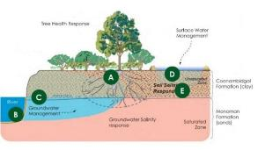
The Floodplain Response Conceptual Model illustrates the key relationships between groundwater and surface water management, soil and groundwater salinity, and tree health response.
Figure 4.1: Floodplain response to water management Model (adapted from AWE 2015)

4.1.3 Key principles for management of floodplain vegetation
The following principles have been adapted from Overton et al., (2018):
- Floodplain vegetation health is reliant on both groundwater and surface water management.
- Management at multiple scales; site, region and basin is required to combat the underlying causes of floodplain vegetation decline.
- Achieving sustainable outcomes for floodplain vegetation requires complementary land and water management interventions.
- As most floodplain trees and shrubs are long-lived and slow-growing they take several years to transition between states of condition. Multi-year commitments of sustained intervention are required to realise improvements.
- Due to the complex interdependencies of groundwater, surface water and salinity affecting floodplain vegetation condition, decisions to implement management options require a level of confidence in the stressors impacting a site to justify an effective use of resources.
- Vulnerability is a key factor when prioritising resources for floodplain vegetation management. Vulnerability is a combination of condition, stressors and the likelihood of decline and provides a means of setting objectives and outcomes that are realistic and achievable.

4.1.4 Landscape connectivity
Through Radio, GPS and recent satellite tracking of Regent Parrots by the SARPR Team, it has become increasingly apparent that these birds do not satisfy all their floodplain habitat needs on one floodplain site (Ireland and Ryan-Colton, 2016), (Ireland 2020). This is particularly true of the breeding period when specific requirements for floodplain nesting colonies exist in comparison to post-breeding activities. Thus, floodplain vegetation diversity and density may figure prominently in satisfying these needs and requires attention when selecting floodplain sites for management actions such as the use of water for the environment. Due to the variation in topography within a floodplain wetland complex or a group of sites in close proximity, a greater number of habitats are available and therefore are more likely to meet the needs of Regent Parrots throughout the year. It is also recognized that small isolated areas provide specialized habitat for Regent Parrots especially during the breeding season. The combination of a concentration of nesting sites and adjacent floodplain areas can be identified as a Regent Parrot floodplain habitat zone.

4.1.5 Landowner engagement
To assist water for the environment managers in developing a sustainable resilient ecosystem at watering sites it is critical to engage site landowner(s). The following principles may assist;
- To promote a long-term commitment to environmental watering and increase landowner engagement environmental water managers could consider entering into a voluntary partnership with site landowners.
- Engaging landowner(s) and/or their network in intervention monitoring activities creates an opportunity to foster local ownership of a watering site.
- Prior to planning the following years watering actions, an updated assessment of site condition in partnership with landowner(s) would ensure real time data is available to the adaptive management decision making process, and will greatly assist landowner communication and engagement.

4.1.6 Strategies to maximise water delivery for Regent Parrot outcomes
The following program strategies have been derived from:
- Current knowledge of Regent Parrots
- Issues identified by the viability assessment of Regent Parrot floodplain nesting and foraging sites.
- Ecological requirements and outcomes from existing environmental watering sites.

The first six are ecological strategies, while the final strategy has a focus on social outcomes.
- Maintain the health of mature hollow bearing River Red Gum to promote the nesting and/or use by native mammals, birds (especially Regent Parrot) and reptiles.
- Provide and improve floodplain and temporary wetland habitats favourable to supporting communities of native mammals, birds (especially Regent parrots), reptiles and frog species.
- Enhance floodplain landscape values to provide Regent Parrot connectivity along the river corridor and to adjacent highland habitats.
- Improve Regent Parrot foraging habitat values and tree and shrub recruitment survival through appropriate hydrological regimes and sustainable total grazing pressure.
- Reduce potential for horticulture conflict by increasing availability of high quality Regent Parrot floodplain food resources adjacent to horticulture areas.
- Reduce disturbance from human activities within or next to Regent Parrot nesting colonies during the breeding season.
- Provide opportunities to educate the community on the ecological values of environmental watering projects.

4.1.7 Principles of developing water for the environment projects to benefit Regent Parrots
The following principles were developed to guide the assessment and development of potential water for the environment projects to benefit Regent Parrot conservation along the Lower River Murray;
- Complement existing water for the environment sites across the landscape focusing on areas where there are a number of Regent Parrot nesting colonies or known foraging areas.
- Improve the ecological effectiveness of existing water for the environment actions by identifying Regent Parrot objectives.
- Develop water for the environment projects with a diverse floodplain topography to enhance landscape health.
- Enhance the ecological character within sections of the SA River Murray that are important to Regent Parrot survival.
- Promote water for the environment actions that have multiple ecological benefits and restore productive linkages between the floodplain and main channel habitats.

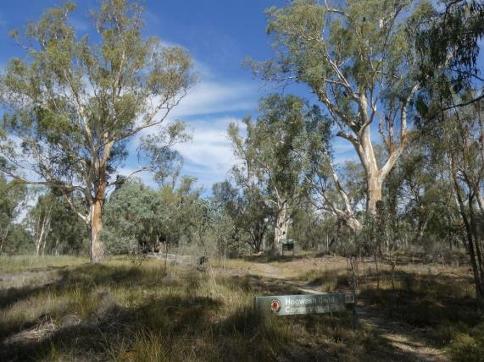
Figure 4.2: Hogwash Bend Conservation Park a Regent Parrot breeding strong hold (Photo: M Harper).

Managing Environmental Water for Regent Parrot Outcomes

4.2.1 Prioritisation of water requirements
Every year, water for the environment managers decide on what they aim to achieve depending on how much water is available and what the environment needs. Sites are chosen according to environmental outcomes achievable as well as water availability and the mangers ability to deliver and retain water at the site. Table 4-2 identifies watering actions under different water availability scenarios.

Table 4-2: Watering Actions under Different Water Availability Scenarios
Management Aims | Priority Actions
Very Dry: Protect  - Avoid catastrophic loss.  - Maintain capacity for potential recovery. | - Protect River Red Gum health at Regent Parrot nesting colonies.  - Protect sites with mature River Red Gum and Cooba or significant tree species regeneration.  - Continue to water targeted saline sites in floristic transition.
Dry: Maintain  - Improve capacity for recovery.  - Maintain key functions of high priority wetlands. | - Maintain sites with high biodiversity outcomes.  - Maintain features low in the landscape (e.g. wetlands and water courses) within a site with a diverse floodplain geography (low floodplain coverage).  - Continue to water targeted saline sites in floristic transition.
Moderate: Recovery  - Improve ecological health.  - Improve opportunities for plants and animals to breed, move and thrive. | - Conduct serial watering events in consecutive years to enhance biodiversity processes and outcomes.  - Completely inundate complex geographical floodplain sites (Maximum floodplain coverage).  - Restore productivity linkages between the floodplain and main channel habitats by returning flows to the river (Pulse flow).  - Extend site duration and area inundated by retaining weir pool raising water and/or applying water for the environment before the event recession starts (Maximum floodplain coverage).
Wet to very wet: Enhance  - Restore key floodplain and wetland linkages.  - Enhance opportunities for plants and animals to breed, move and thrive. | - Ensure sites are connected to the broader floodplain to enable site inundation by a natural flood event.  - Extend site duration and area inundated by retaining natural flood water and/or applying water for the environment at the peak of the event (Maximum floodplain coverage). Manage hydrograph recession.

4.2.2 Potential environmental watering actions
At sites where watering has been identified as an option, it is critical to determine watering actions required to achieve the ecological objectives of a site. The following identifies a range of hydrological management actions that could be implemented at a water for the environment site:
- Pump or gravitate water into individual floodplain sites
During periods of low water availability it may be prudent to water only a percentage of a site which are in a stressed condition e.g. depression(s) and connecting flow path(s) thus reducing the water required to avoid catastrophic loss.
- Use sprinklers to water individual sites
Although not a common method of watering, this delivery method should be considered when flooding is not an option and protection of the River Red Gum health at Regent Parrot nesting colonies is critical.
- Return or re-use flows
There is potential to return, or, re-use pumped/gravity fed water at sites with diverse topography, or, where it is inappropriate to have deep inundation for extended periods (e.g. lignum habitat). After achieving the required hydrological outcomes, excess pumped /gravity fed water could be released back to the river, or drained into an adjoining site. Varying AHD water levels at the site over time may maximise diversity outcomes.
- Weir pool enhancement
Sites that are partly inundated through a weir raising event could be supplemented by pumping additional water for the environment onto the site before the event recession, thus extending both inundation duration and coverage.
- Natural flood enhancement
At the peak of a natural flood event the following actions could extend inundation duration and coverage;
  - Retain the flood water to enhance inundation duration and manage the hydrological recession.
  - Retain flood water followed by pumping additional water for the environment onto the site to extend inundation coverage and duration and manage hydrological recession.

4.2.3 Hydrological management to achieve Regent Parrot objectives
A number of publications have been written on the environmental water requirements for the River Murray Floodplain in South Australia (Roberts and Marston, 2011, Newall, et al. 2008, Kilsby, et al. 2015 etc.). The authors have taken different approaches to this issue by either focusing on river flow bands into South Australia or ecological outcome inundation requirements or a combination of both. Parameters which describe the required hydrological regime usually involve at least the following; recurrence interval, duration, timing, magnitude and maximum time between events. The hydrological regime is usually focussed on the requirements of the floodplain landscape not an individual isolated site. Some authors describe different hydrological regimes for survival and recruitment.

Table 4-3 describes a set of principles that could assist water for the environment managers to determine appropriate hydrological regimes that will beneficial Regent Parrots and other floodplain biota. Table 4-4 describes the reproduction cycle of key riparian plant species that are an important Regent Parrot food source.

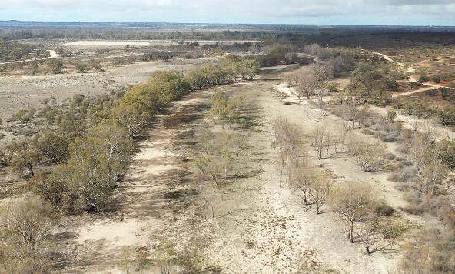
Figure 4.3: A Temporary wetland with stressed River Red Gum desperate to receive water (Photo: M Fauser).

Table 4-3: Principles to Assist in Determining Appropriate Hydrological Regimes at Water for the Environment sites for Regent Parrot Ecological Outcomes
Area of Influence | Hydrological Regime Principle
Mature hollow bearing River Red Gum | When tree health at a watering site transitions from good to medium, the site should be re-watered the following water year. If the health of an individual tree is allowed to fall below poor, there is a significant possibility the tree will die before the next watering event. The loss of a few trees at a site may not seem critical to the viability of the woodland in the short term, but, if repeated numerous times, the principle of ‘death by a thousand cuts’ will over time destroy the ecological character of the site.
Inundation Timing | The majority of River Red Gum Regent Parrot nesting trees are located within 100 metres of water. There is a correlation between increased vegetation health as a result of a watering event at nesting and/or adjacent floodplain sites and Regent Parrot nesting effort. Until recently there was little evidence to suggest that a freshly watered site is preferred to that of a site in draw down phase or recently dried. In May 2020, Katarapko Creek North South received pumped water for the environment for the first time since the 2016-17 flood event. This site and adjoining Campsite 45 are both Regent Parrot nesting locations. In 2003-04 and 2010, six Regent Parrot nests were recorded over the two sites during each survey period (SARPRT). The two sites were re-surveyed during September 2020 resulting in seven confirmed nests and five possible nests within or adjacent to the watering site (P Waanders, pers. comm.). During the nest surveys it was noted that the south arm of the site was dry, while the north arm and adjoining Wetland 1984 still retained water. If the ecological objective at a water for the environment site is to actively promote Regent Parrot nesting, consideration should be given to applying environmental water before pairs begin to select a nesting site, which is usually in July. Therefore, a late autumn to early winter watering event could be beneficial to Regent Parrot nesting outcomes.  Evaporation losses can be significantly reduced when sites are watered during autumn and/or winter which can increase the inundation period. If a watering event is followed by a natural flood event there is a potential risk of stressing woody vegetation from prolonged inundation, especially at low topography areas with a high sill level. To avoid this risk, consideration should be given to ensuring sites at risk can be drained or pumped out if inundation duration exceeds vegetation thresholds.
Inundation frequency | Patches of dense vegetation, or adult River Red Gum and Cooba within a site with the following attributes will most likely show signs of stress well before the remainder of the site:  - Low areas in the landscape with elevated saline groundwater.  - Areas on the floodplain edge exposed to an adjacent saline groundwater gradient.  Major indicators of stress are a decrease in tree health level and/or understory plant communities transitioning towards salt tolerant functional groups. Therefore, these sites can be an indicator to determine watering frequency, which can reduce vegetation monitoring effort.  Below average local rainfall will mostly likely reduce the period of time when watering events are required before damage occurs to woody vegetation such as adult River Red Gum, especially when located in high risk locations such as elevated saline groundwater areas. Above average rainfall may be the reverse but should not be assumed. Individual or groups of trees and shrubs (especially Black Box and Lignum) can benefit from high rainfall runoff events if located in localised depressions (Roberts and Marston, 2011, and J Seekamp pers. comm.).
Table 4-3: Principles to Assist in Determining Appropriate Hydrological Regimes at Water for the Environment sites for Regent Parrot Ecological Outcomes continued
Area of Influence | Hydrological Regime Principle
Inundation frequency continued | When developing hydrological requirements for water for the environment sites located low in the landscape in an area with elevated saline groundwater, e.g. (temporary wetland), caution should be taken when considering hydrological regimes which have been developed for general river floodplain ecological outcomes. Hydrological parameters to be cautious of include average recurrence intervals and the maximum time between flood events. The hydrological history of Carparks Lagoon at Katarapko, Katarapko Island North, and Overland Corner which all have elevated saline groundwater issues, were evaluated in view of present tree health (M Harper pers. coms.). The level of tree health stress at all the sites indicated that the maximum time between inundation events to maintain long-term health of adult River Red Gum communities exposed to elevated saline groundwater is no greater than two years. It was also found that a set of concurrent inundation events did not increase the resilience of a site with salinity in the landscape. The health of all growth classes of River Red Gum (adult, pole, sapling and seedlings) rapidly deteriorate during the third year after the last watering. This is regardless of how many inundations occurred whether from water for the environment and/or natural flood events prior to the last inundation year. However, the implementation of consecutive years of watering will enhance biodiversity processes and outcomes.  As every water for the environment site has different topography, vegetation composition and inundation history, all sites should have health condition assessments undertaken prior to planning the next watering years actions. By conducting yearly site assessments immediately before the planning phase, real time data will be available to ensure adaptive management decisions are appropriate to each site’s future needs.  When significant numbers of woody plant species germinate at a site during an inundation event, consideration should be given to watering the site the following year to ensure seedling establishment.  It would be appropriate at water for the environment sites with diverse floodplain topography to consider during low water availability years to only water areas in a stressed situation. For example depressions and connecting flow paths. This reduces the water required to avoid catastrophic loss.
Inundation duration | Consideration should be given to extend inundation duration and coverage during weir pool raising events and/or natural flood events by retaining the water and/or applying water for the environment at the peak of the event. The hydrological recession could also be managed during these events.  Extended inundation of River Red Gum in particular, can significantly impact some localities more than others. Roberts and Marston (2011) estimate from two to four years before site is impacted with the variation being attributed to differences in soil characteristics and distribution of roots through the soil profile. A local example is Lake Littra at Chowilla. Consecutive natural flood events in the early 1990s were held back in the lake. In less than 18 months of continuous inundation, the foliage on the River Red Gum trees started turning reddish followed by yellowing indicating stress (J Seekamp pers. comm.). An example of sites at risk of extended inundation are Bird and Meeting Lagoons (two temporary wetlands in Morgan West).  Shallow flooding over hot summer months can cause moisture stress and death of River Red Gums (Dexter 1986). Inundation periods before Black Box display signs of stress is about 12 months, and Lignum only three to five months with variations depending of site parameters (Roberts and Marston, 2011).
Table 4-3: Principles to Assist in Determining Appropriate Hydrological Regimes at Water for the Environment sites for Regent Parrot Ecological Outcomes continued
Area of Influence | Hydrological Regime Principle
Drawdown flows | Maximum rate of drawdown should be targeted at an average of 0.025m/day (average over three consecutive days, with a maximum of 0.05m in any one day (Kilsby and Steggles, 2015).
Fresh Groundwater Lens | The establishment and maintenance of a fresh groundwater lens under a temporary wetland is critical to the long-term survival of River Red Gum, Cooba and other non-saline dependant flora.
Soil Salinity | To prevent shifts in understory plant communities to salt tolerant functional groups across the elevation gradient, soil salinities should be kept below <5000 EC (Kilsby and Steggles, 2015).  A significant environmental watering commitment is required to reverse biodiversity loss at salinized temporary wetlands. The Johnson’s Waterhole Case Study (Harper 2020) found that it took five consecutive years of annual inundations before a floristic change transitioned away from salt tolerant functional groups.

Table 4-4: Reproduction Cycle of Key Riparian Food Plants of Regent Parrots
Species | Regent Parrot Food | Reproductive Cycle
River Red Gum | Flowers & Seeds | Flowering occurs in December-January and lasts about four to six weeks. Flowering varies in abundance or intensity from year to year. Seeds are stored temporarily in capsules. Trees in poor condition retain seeds longer. Seeds fall throughout the year but seed-fall peaks in September-November in the southern Murray-Darling Basin, coincident with spring floods (Roberts and Marston, 2011).
Black Box | Flowers & Seeds | Flowering timing and duration varies between regions. In South Australia, flowering occurs over an extended period of up to seven to eight months, from autumn to mid-summer. On the Chowilla floodplain, flowering intensity peaked in November-December but the number of trees in flower reached a maximum earlier than this, over winter. Flowering duration and timing for individual trees varies within this overall pattern. Capsules form after flowering, and this may take up to five months; the fully-formed capsules are retained on the tree for as much as 17 months (Roberts and Marston, 2011).
Lignum | Flowers | Flowering time is sometimes described as seasonal, notably in the southern parts of the Murray-Darling Basin however, is generally in response to inundation or rainfall. Fruits mature in autumn in the southern parts of the Murray-Darling Basin (Roberts and Marston, 2011).
Herbland/Chenopods  - Creeping Saltbush  - Bladder Saltbush  - Lagoon Saltbush  - Ruby Saltbush  - Lesser Joyweed | Berry  Seed  Seed  Berry  Seed | Prostrate perennial shrub. Flowering summer.  Perennial shrub. Flowering opportunistic mainly spring and summer.  Annual forb. Flowering spring-summer.  Variable perennial shrub. Flowering most of the year mainly spring-early summer  Annual forb. Flowering mostly spring-early summer but may occur throughout the year (Cunningham et.al. 1999)

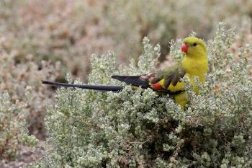
Figure 4.4: Regent Parrot feeding on Bladder Saltbush (Photo by H Kieskamp).

4.2.4 Potential risks associated with delivering environmental water
There are several risks associated with delivering water for the environment. It is essential to conduct a risk assessment during the site planning phase and prior to detail design phase of works if necessary. Targeted monitoring efforts should be identified around risks of the works and operations. The results from monitoring can be used to gauge the success of the works as well guide future adaptive management decisions. Table 4-5 identifies risks that could be relevant to water for the environment sites (site parameters may result in risks not identified below).

Table 4-5: Potential risks associated with water for the environment inundation events
Risk | Description
Not applying water for the environment | - Catastrophic risk to species or key habitat components or site value that would have a long recovery time or be lost to the site (hollow baring River Red Gum).  - High loss of previous watering investment (ecological, volume and $).
Land Owner / Manager | - Failure to communicate adequately with all site landowners/managers prior to a watering event.  - Private access routes affected during inundation event.  - Change in private land ownership.  - Landowner pressure to inundate site despite insufficient resources (water and/or staff).  - Reduced biological outcomes due to landowner inundation timing request.
Hydrology | - Original planning identifies an inadequate hydrological regime.  - Un-seasonal flooding resulting from timing of inundation either due to i) access to pumps ii) attempts to minimise the likelihood of triggering other hazards iii) landowner inundation timing request iv) managing for one particular group or individual species.  - Continuous inundation by a natural flood following a watering event could induce stress to woody tree and shrub species.  - Physical constraints which limit water coverage.  - Adaptive management decisions made separate of real time data due to lack of resources.
Grazing pressure | - High number of kangaroos and/or high stock grazing pressure reduces understory plant biodiversity and growth and tree and shrub regeneration.
Water Quality | - Changes to historical water regimes risks releasing salt and nutrients from the site and/or groundwater, resulting in decrease water quality in the water body.  - Other parameters that may affect water quality include suspended sediments loads and temperature.
Saline Groundwater | - Salt wash off from soil profile leads to increased surface water salinity.  - Groundwater discharge from floodplain aquifers leads to increased soil salinity followed by increased surface water salinity.
Pest vertebrate species | - Water management actions may benefit undesirable aquatic and terrestrial pest species through provision of habitat and food resources (e.g. Feral Pigs and European Carp).
Pest flora species | - Increase water on the floodplain may increase the occurrence of pest plant dispersal and colonisation (e.g. Noogoora Burr and Golden Dodder).
Cultural heritage | - On-ground works may potentially disturb or damage features of cultural significance during the construction phase.
Returning flows | - Concentrations of salt and nutrients and/or harmful/nuisance algal bloom from impounded water drains to the river.
Operation | - Infrastructure ownership and long-term maintenance and operation.  - Watering site infrastructure restricts a natural flood event inundation of a site.  - Noise from operating pump has the potential to disturb Regent Parrot nesting colonies and/or adjacent recreational users.  - Insufficient resources for monitoring.  - Unintended environmental damage and geomorphic impacts including erosion at pump sites and/or embankments.

4.2.5 Water for the environment site establishment checklist
This checklist is a reference guide for Water Delivery Partners and others involved in selecting, designing and implementing water for the environment projects which benefit Regent Parrot outcomes. It lists key issues to consider during the planning process and an overview of the South Australian operational and approval processes adopted from Sustainable Focus (2007) and Sturt Contractors Pty. Ltd. (2020).

Do you have a clear idea of what you want to achieve at the site?:
- An overlay of the contours from the River Murray digital terrain model on an aerial photograph of the potential site will assist in determining the site coverage and the most appropriate and sustainable water delivery method.
- Develop management objectives (ecological, social and culture) that consider Regent Parrot requirements (see section 5.3).
- What hydrological actions are required to achieve proposed ecological objectives?:
  - Delivering water by pump inundation or sprinkler during dry periods.
  - Returning pumped water to the river or reusing on an adjoining site.
  - Managing a natural flood recession.
  - Enhancing a natural flood duration and /or coverage.
- Does the landowner just give approval for the project or do they see themselves as a partner in maintaining the long-term health of the site?
- An Aboriginal Waterway Site Assessment can complement the development of an environmental watering project.
- Does the infrastructure need to;
  - Allow traffic to cross?
  - Assist fish passage during a natural flood event?

Issues to consider if constructing infrastructure:
- The following approvals and /or licences are required to undertake earth and/or construction works on the River Murray Floodplain in South Australia:
  - Landowner approval.
  - Environmental Protection and Biodiversity Conservation Act 1999. Areas that may fall within this Federal Act include:
    - Wetlands of International Importance (Ramsar wetlands).
    - Threatened species and ecological communities listed under the Act.
    - Migratory species listed under the Act.
  - SA Development Act 1993 approval to install a flow control structure and/or floodplain excavation and filling.
  - SA Native Vegetation Act 1991 vegetation clearance approval.
  - Native Title approval.
  - SA Aboriginal Heritage Act 1988 site clearance approval.
  - Cultural Heritage monitors are required during geotechnical investigation fieldwork.
  - Temporary Water licence for taking water for construction use.
- At a recognized Regent Parrot nesting site no construction works should occur during the birds breeding season (July to November).

Issues to consider when pumping water into a site:
- It is not advisable to pump environmental water into Regent Parrot nesting colony sites during the breeding season (July to November) unless the pump is positioned greater than 100 metres away from any nesting quality trees.
- Consideration should be given to reducing the level of pump noise disturbance if adjacent to a recreational area. Avoid pumping during peak holiday periods and/or relocate pumping site well away from the recreational use area.
- Establish erosion protection at pumped water delivery site by placing large to medium size rocks located on geotechnical fabric
- It is important to recognise that a decision not to pump water into the site during an annual watering year is a legitimate choice. Conditions under which this decision may be made include;
  - Ecological outcomes are presently met.
  - If trajectory related to the ecological outcomes is strong and/or stable.
  - Predicted ecological outcomes have not been achieved thus a management review is required.

4.2.6 Hydrological infrastructure

Infrastructure review
Nearly all sites identified in this report as having potential to be managed with environmental water for Regent Parrot outcomes require some infrastructure works. To ensure that water for the environment sites are not isolated during a natural flood event and the proposed hydrological management will achieve the ecological objectives, water control structures can be beneficial and/or critical. Due to variable site specific conditions and desired management outcomes, water control structures can be designed to provide solutions to a range of required hydrological parameters. The following review of water control structures which could be appropriate for small to medium size watering sites (modified from NSW Department of Industry and Investment 2009) is an insight into the various designs of structures, their functionality and some of the considerations necessary for implementation. These structures were considered in section 5.5 of the report ‘Potential watering site infrastructure requirements and estimated costs’ which identifies potential infrastructure for each Regent Parrot site identified for management with water for the environment.

Hinged Flap Gates
Flap gates only allow flow in one direction thus can retain water in a wetland while allowing the site to be refilled during a flood event without manual operation (Figure 4-5).
Advantages:
- Naturally automated.
- Simplistic construction and installation.
- Requires little maintenance.
- Long lifespan.
- Gates manufactured from non-metal materials, have no scrap value and will have no attraction to scrap metal thieves.
- Inexpensive cost of parts.
Disadvantages:
- Prevents flushing of upstream water bodies.
- Restricts fish passage and creates a flow barrier during natural flood events.
- Floating debris can jam the gate open or shut, and hence requires regular inspection.
- No provision for manual control of gates without installing additional infrastructure.
- Hinge/pin material may be subject to corrosion and damage impeding or prohibiting action of the gate.
Considerations:
The greater the weight of the gate the more energy (head pressure) required to open it and keep it open. This is could be a limitation during small to medium natural flood events.
Lighter or more buoyant construction materials can be used to increase the opening aperture of gates within systems operating under small hydraulic pressure. Adequate clearance is required for the gate to swing. Fibreglass gates with neoprene seal are a suitable design for River Murray environmental watering sites.

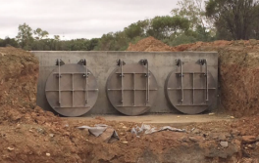 | 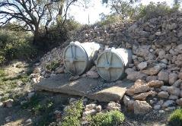
Figure 4.5: Sample of metal and fibreglass hinged flap gates (Photos: B Rampano and M Harper).

Penstock (Vertical Winch)
Penstocks are normally fitted to the structural framework of culverts and headwalls, or are constructed as self-contained units. Penstocks function by operation of a sluice gate placed on the landward side of a culvert. Designs can vary, with penstocks consisting of a single gate controlling flow through the culvert. The gate can be opened to a required height and will remain in position until it is reset (Figure 4-6).
Advantages:
- Provide excellent water level control and flood protection.
- Adjustable and reliable.
- Low maintenance.
- Manual actuation systems less expensive.
- Provide excellent sealing capacity.
Disadvantages:
- Can be expensive.
- Friction can develop in the tracks whilst opening or closing gates.
- Vertical winching mechanisms may result in the gate jamming open during outflow. This can be overcome by use of a worm drive mechanism.
- Vertical space required above culvert for actuation system.

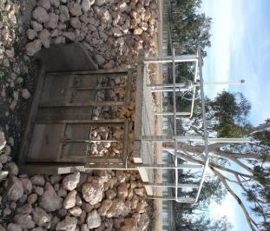
Figure 4.6: Penstock Vertical Winch (Photos: M Harper).

Stop Logs / Drop-board Culvert / Weirs (Overflow Escape)
These culverts function as per a weir to isolate flow or allow regulated flows via overshot level control. Stop logs can be made from a variety of materials (Figures 4-7 and 4-8).
Advantages:
- Provides excellent water control.
- Adjustable to desired water level.
- Construction can be retrofitted to existing culverts or head walls.
- Structures can be precast or set in place dependent upon design, scope of the project and site access.
- Designs can be manufactured inexpensively.
Disadvantages:
- Can result in some leakage but depends on design.
- Boards may be difficult to remove under significant head pressure
- Manually operated.
- Depending on design can be easily tampered with or vandalised which can result in the unauthorised lowering of the operational invert.
- May require additional OH&S infrastructure for safe working access.
- Fish passage is only possible when water level becomes high enough to overtop the stop logs / drop boards or when the boards have been removed. During all other events, a barrier to passage exists.

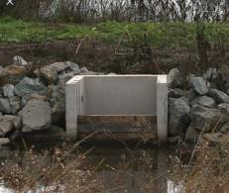 | 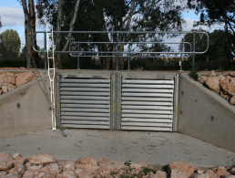
Figure 4.7: Wooden stop logs fitted to a drop board culvert (Photo: M Harper). | Figure 4.8: Segmented stop boards fitted to a box culvert road access structure (Photo: M Harper).
Sheet Piling Weir
The construction of pile weirs takes place by driving them into the waterway to the required height (Figure 4-9). This can be done by means of an excavator or similar device. Pilings can be manufactured from a range of materials to suit the requirements of the system including recycled plastics and vinyl for increased resistance against corrosion. Individual pilings can be cut to the required length.
Advantages:
- Guarantees minimum water level retention capacity providing excellent water level control.
- Structure can be constructed to any length as required by interlocking as many pilings as necessary.
- Pilings can be custom made to a required shape.
- Can incorporate water control gates.
- Flexibility provides resistance against impact and a tolerance of ground movement.
- Sheet piling installation may be linear or curved.
- Minimal disturbance to the system of implementation as piles are merely driven into the ground – no digging.
- Relatively easy to remove from a waterway with minimal disturbance. Once removed the structure may be reused at a similar site.
- Low cost as concreting, earthmoving and coffer-dam not required.
- Low maintenance.
Disadvantages:
- Not adjustable without modification of original installation.
- Depending on the material used to construct the sheet piling often results in some leakage.
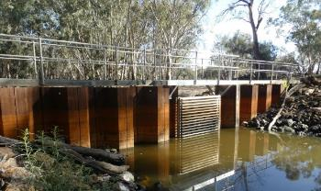
Figure 4.9: Metal Sheet Pilling structure fitted with segmented Stop boards. (Photo: M Harper).

Fish passage infrastructure review
With the placement of embankments and water control structures to achieve ecological objectives, fish passage onto floodplain sites may be inhibited during a natural flood. The following review into fish passage in off-channel habitats of the Lower River Murray (modified from Mallen-Cooper 2001) gives an overview of fish biology related to fish passage, and recommendations for providing fish passage at culverts.

Overview of fish biology and fish passage
Native fish use temporarily-inundated habitats opportunistically and the species involved are mostly ‘habitat generalists’, using the main channel of the river and re-colonising inundated wetlands when they are accessible. Re-colonising occurs by two main mechanisms: adult fish actively seeking or dispersing into off-channel habitats, and larvae drifting in from the river.

At low to moderate river flows the main large native species entering wetlands appears to be Bony Herring. Adult Bony Herring enter a range of off-channel habitats and may be an important component of temporary wetland ecosystems.

At high flows other large native species, such as Callop, Silver Perch and Murray Cod, use extensive floodplain habitats and anabranches, but rarely small floodplain habitats such as billabongs.

In restoring fish passage in the Lower River Murray the site priorities are, in order;
Very High Priority
- The main river channel.
- Major Anabranches.
High Priority
- Anabranch wetland systems.
These systems often have lake, floodplain and stream habitat that is excellent for native fish. Part of rehabilitating the ecology of these systems is restoring native fish populations, and fundamental to this is providing fish passage.
- Large floodplain habitats
Access for native fish needs to mainly be accommodated during large floods.
Moderate Priority
- Small billabongs and lakes.
Fish passage between the river and these habitats appears to be less important compared with the other off-channel habitats.
Improving Fish Passage
Implications for providing fish passage in culverts and regulators;
- Water velocity
Smaller native fish that are 30 to 80 mm long can negotiate water velocities between 0.1 and 0.3m/s. However, these small fish can often use boundary layers of lower water velocity near the edges of a culvert so they avoid the average maximum velocity in the culvert. To ensure fish passage in culverts, average water velocities should not exceed:
  - 0.15m/s for fish less than 80mm in length.
  - 0.30m/s for fish greater than 100mm.
  - 0.45m/s for fish greater than 150mm.
  - 0.75m/s for fish greater than 250mm.
- Water Depth
  - A depth of 1.0m will pass all native fish
  - A depth of 0.7m will pass most native fish, except Murray cod.
  - A depth of 0.4m may exclude some adult fish but enable passage of small and medium-sized fish.
  - A depth of less than 0.3m can only be considered suitable for small native fish.
  - Carp can negotiate depths that are less than their body height.
- Space
There is also an interaction between width and depth where fish may enter a shallow depth in a wide stream but not in a narrow culvert. If the culvert has a channel width that is greater than 1.5m it will pass almost all native fish except an adult Murray Cod which may need a culvert to be 2m wide with a minimum depth of 1m.
- Light
If light is absent from a culvert, such as a long narrow diameter pipe, then Bony Herring will be excluded, Silver Perch may be inhibited to enter, and it is possible some other native species may be prevented from using the culvert. However, Callop, some Silver Perch and some other native species will still pass through a dark culvert. If the culvert is short and has high, open entrances and exits allowing light to enter freely, most native fish will use the culvert.

4.2.7 Monitoring asset condition and impact of actions
In the present political and fiscal climate resources to undertake site monitoring is limited, thus site managers need to be creative as to what parameters to monitor and when. The following monitoring methods are critical to ensure a catastrophic event does not occur at a water for the environment site.

Compliance monitoring
Compliance Monitoring is simply a check of whether an intervention has been carried out as planned. It focuses on the outputs of an inundation event rather than the outcomes of the inundation event. Compliance monitoring keeps records of how the inundation event was performed, and can later be used in correlations with data obtained from condition and intervention monitoring. Essential compliance parameters are;
  - Duration of inundation (date commenced and total dry date).
  - Volumes of water used.
  - Area inundated.
  - Hazard issues.
  - Repairs/modifications to infrastructure.

Condition monitoring
Condition Monitoring measures how an asset (a species or group of species) changes over time, but its status is not specifically linked to a management action. Condition monitoring is crucial in determining water for the environment site inundation frequency
Intervention monitoring.
An important component of adaptive management is to monitor the results of management actions to determine whether they are achieving the desired results. This type of monitoring is termed intervention monitoring. To improve water for the environment site management and enhance ecological outcomes intervention monitoring investigates the links between environmental watering events and ecological outcomes.

Engaging land owners and managers and/or their networks in intervention and condition monitoring activities creates an opportunity to foster local ownership of a water for the environment site. There are a number of existing monitoring programs that foster volunteer involvement in monitoring local sites. Volunteer program examples are Birdlife Australia - Bird Atlas bird surveys and Aussie Backyard Bird Count, Frog Watch SA and the Murraylands and Riverland Landscape Board’s Citizen Science, Bird, Bat, and Water monitoring programs.

The SA Regent Parrot Recovery Team conducts two main methods to monitor Regent Parrot utilisation of the landscape. Monitoring nest colony sites has been the foundation of determining population trends. Identifying flight paths and important feeding and roosting areas using radio GPS and satellite tracking of birds has been deployed. Appendix 3 describes the Regent Parrot Nest Survey methods.
Drones have great potential to be a useful tool to monitor the health of floodplain vegetation especially woody vegetation with the use of limited resources (Figure 6.8). By establishing way points, a drone fight is repeatable, thus enabling long-term monitoring of precise locations. Real time aerial views of the site provides a quick overview of a site‘s vegetation health condition and can guide a person to a site at risk to conduct an on-ground site inspection.

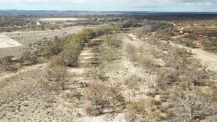 | 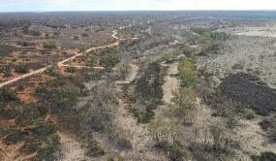
Figure 4.10: Photographs taken by a drone over a stressed wetland site. All tree Canopy Condition Classes can be identified as well as the health variation within a patch of Lignum (left photo). (Photos: M Fauser).

4.2.8 Use results to adapt and manage into the future
(Adapted from TNC 2007) Adaptive management recommends natural resource managers accept that they must move forward with insufficient knowledge. However, they do so in a way that enables them to set up their management as a set of testable ‘hypotheses’ based on their best understanding of the system. They must also monitor what happens in a systematic way so that they can ‘evaluate their hypotheses’, and learn what worked and what didn’t and adjust their practice accordingly. Objectives for success and actions are, in essence, a ‘hypothesis’ of what it will take to achieve the objective and secure the ecological viability of a site.
Good analysis is one of the most important aspects of adaptive management and the key to project team learning. It is the learning and adaptation that will enable the capitalization and replication of success and to avoid making the same mistakes over and over again.
Conservation is not a one-time action, but rather, a long-term endeavour, this is especially true for water for the environment sites. In almost all cases, conservation projects will need to last far longer than the involvement of any one person. Thus, it is critical that work is captured and shared and the knowledge gained so management teams and practitioners can benefit from what has been learned. Additionally, sharing work can improve the project visibility and credibility for future funding.
Analysing
Analysis is essentially converting the raw data into information that will provide feedback on progress towards project objectives and shed light on the following questions:
  - Are things moving in the right direction?
  - Are the actions taken having the effect hoped for?
  - Is the status of targets improving?
  - Are known threats being reversed?
Good Analysis Does Not Require Quantitative Data - Often teams don’t have quantitative data with which to conduct this analysis and review. Maybe it is too soon in the life of the project and the results are not yet available. Maybe the team doesn’t have resources to gather a lot of quantitative data. Maybe, some questions that they are asking don’t lend themselves to be answered to quantitative analysis. In these instances consider employing an After Action Review. This simple, systematic approach will work to generate information and insights with or without hard data. Questions answered in an After Action Review are;
  - What did we intend to accomplish through our actions?
  - What actually happened as a result of our actions?
  - What might have caused the actual results we observed?
- What actions should we continue to take: and/or how do we think we can improve our actions?
- What opportunities lie ahead in our project to test out our thinking about how to improve our actions, and can we test and review this thinking?
Adapting
Adapting is essentially using what has been learned from analysis to change and improve the project. This is a chance to acknowledge what is known and what the gaps are in knowledge, and to update project documents. In particular, strategic actions and monitoring plans should be re-visited and current status of monitoring indicators should be updated.

Sharing
Sharing involves documenting work and communicating it to others. It is important to share not just successes, but also the things that have not worked. Also, stories and anecdotes that illustrate what has been learned should be shared. Sometimes these can be the things people find most compelling.
Share With Project Team Members - Once analysis has been completed and documented, outputs should be shared with other team members, partners and stakeholders as appropriate to enable wider understanding of what is happening within the project and what changes need to happen and why. Doing this will help to ensure continued commitment to the project and buy-in for any changes.
Share Within Your Own Organisation - Most conservation organisations have their own newsletters, websites, magazines and other communication venues. Sharing a great story about what teams have done backed up by real data can be an inspiration to donors or management to further support not just this project but others like it.
Whatever is shared, the key to successfully having a significant impact is to:
- Distil the innovation.
- Identify the audience that would benefit from the finding.
- Identify the product most likely to actually reach that audience.
- Prepare the content in the form appropriate for that venue.

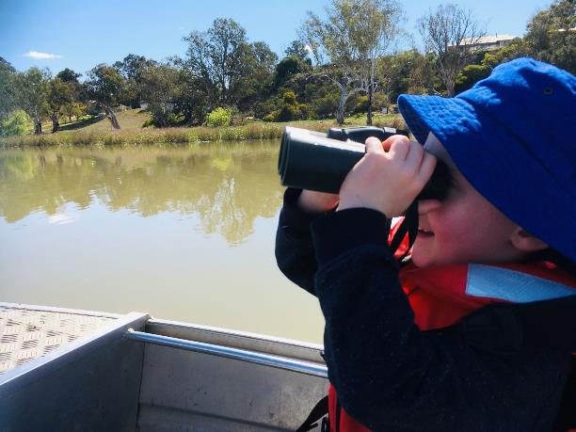
Figure 4.11: Looking for Regent Parrot nests.

Regent Parrot Water for the Environment Program – Preliminary Findings

This section (Section 5) of the report includes preliminary findings drawn from site assessments (Section 3) and from the guidance in Section 4 to provide Regent Parrot floodplain habitat zones and management issues, site management briefs and preliminary assessments of site infrastructure. These findings provide a basis for which land and water managers can use to undertake further assessments (e. g cultural assessments, broader ecological outcomes to manage for) and explore future management of these sites with landholders as to the most appropriate management of these sites for Regent Parrot outcomes.

5.1 Regent Parrot Floodplain Habitat Zones
The Regent Parrot Water for the Environment Program includes 19 sites which already receive environmental water and 24 new, potential sites between Swan Reach to Lock 6. A number of the existing and/or potential water for the environment sites have known Regent Parrot colonies within or adjacent to the site. This combination of sites is grouped within known Regent Parrot nesting colony concentrations to form eight Regent Parrot Habitat Zones (Figure 5-2). These zones are key areas for Regent Parrot management in South Australia and contain all sites identified through this project for potential management with water for the environment. The zones and the remaining floodplain between Swan Reach and the Border also include many other sites that were not identified as critical habitat but may support Regent Parrots. It is recognized these zones are also linked to the greater modified landscape. Recent South Australian studies using satellite trackers has increased our understanding of how Regent Parrots utilise the landscape. Indications are that these birds have adapted to the modified landscape and substitute horticultural tree plantings as flyway links between breeding and feeding sites (Figures 2-4 to 2-6). Historically the birds used Mallee Woodland as flyways.

5.1.1 Regent Parrot Floodplain Habitat Zone Key Issues
Six key issues have been identified which are impacting Regent Parrot populations within, and adjoining the eight Regent Parrot habitat zones. A brief description of the six key issues identified are presented below. The issues impacting the zones provide the context as to the relative importance of each zone and the necessity for the sites to be managed with water for the environment. Existing and potential watering site descriptions and issues impacting each Regent Parrot Habitat Zone are presented in Table 5-1. A vulnerability analysis of the potential water for the environment sites is presented in Table 3-17 and should also be considered during site implementation selection processes.

Nesting Colonies
Loss of hollows at historical nesting colonies - Historically, a significant number of Regent Parrot nesting colonies were located in dead, drowned River Red Gum with the remainder of the nests located in live adult River Red Gum. During a six year period between nest surveys (Smith 2011) recorded a major decline in numbers of nests located in drowned, dead River Red Gum from 32.3% in 2003-04 to 15% in 2010. It was noted that the combined effects of the loss in trees due to them falling over, and the decline in suitable nest hollows appears to have made these areas unattractive as nesting colonies. Smith (2001) previously recorded that between 1991 and 2000-01 out of 101 trees surveyed, 25% had significant damage to limbs or had broken off at water level or fallen over. The natural destruction of the drowned nesting trees now places more importance on the availability of healthy adult River Red Gum for nesting.

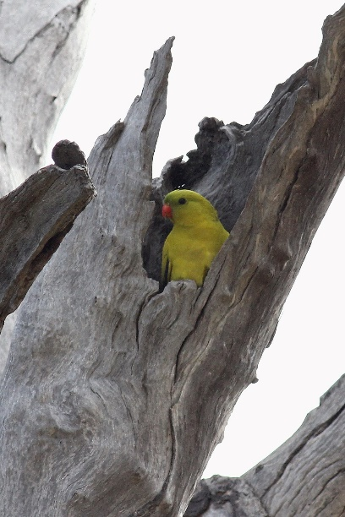
Figure 5.1: Male Regent Parrots at an (end of branch) nest site (Photo H Kieskamp).

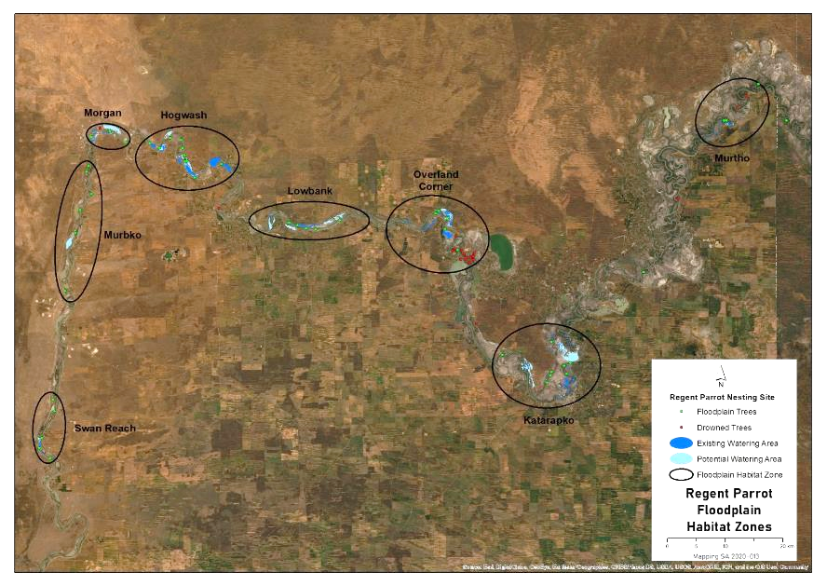
Figure 5.2: Identifies the eight Regent Parrot Habitat Zones between Swan Reach and Lock 6.

Decline in Regent Parrot nesting - Between 2003 and 2010, the entire breeding area in South Australia was surveyed and provided an important baseline on population trends. In 2003, 50 colonies were recorded with approximately 400 nests (breeding pairs), compared to the 2010 survey when 41 colonies were recorded with approximately 350 nests (breeding pairs). During this seven year period, the Regent Parrot breeding population along the River Murray in South Australia declined by 12% (Smith 2011). Since the 2010 survey a number of the large colony sites have been regularly surveyed such as Banrock Bend, Hogwash, Markaranka and Lock 6 with most sites recording a significant reduction in nest numbers.

Adult River Red Gum degradation
Lack of floodplain inundation - Between July 2001 and June 2010, flows into South Australia did not exceed 10,000ML/d resulting in no floodplain inundation. The millennium drought impacted vegetation communities across the floodplain. Populations of temporary wetland and old growth River Red Gum were significantly impacted. In areas with shallow saline groundwater, these trees were decimated and even populations of trees some distance from a permanent water source are now seriously degraded. Live adult River Red Gum are becoming more important as Regent Parrot nesting colonies due to the continued natural destruction of historical drowned nesting trees.

Irrigation induced saline water seepage - Drainage below district irrigation areas can build up on top of regional saline groundwater and increase the discharge of salt into the River Murray and floodplains. Adjacent to irrigation districts historical saline groundwater seepage has degraded adjoining floodplain vegetation communities, and in particular, River Red Gum. Irrigation districts which have large areas of floodplain between the irrigation properties and the river have significantly degraded large areas of floodplain. An example is the impact that the Pyap Irrigation Area has had on the Pyap Lagoon floodplain which is now a tree graveyard with Samphire flats reducing the area of suitable habitat for Regent Parrot breeding and foraging.

Creation of saline water disposal basins - To combat rising groundwater impacts to irrigation properties, saline water disposal basins were established adjacent to most irrigation districts. Due to the cost and ease of construction, wetlands located on the adjacent floodplain were converted to disposal basins. With the combination of saline groundwater and permanent inundation of mostly temporary wetlands, further degradation of the local floodplain occurred. As with the saline groundwater seepage, River Red Gum communities within the influence of the disposal basins were decimated. Examples of the degradation of significant temporary wetlands are Bulyong and Katarapko Island Saline Water Disposal Basins which had potential to be Regent Parrot nesting and foraging habitat.

Increased Regent Parrot horticulture conflicts
Historically local fruit orchard growers have considered Regent Parrots, as well as other local bird species, a pest when their fruit is about to ripen. This conflict, even though for only a short period each year, has resulted in the deliberate killing of Regent Parrots despite the birds being fully protected since the 1970s. Of particular concern is the major expansion of almond plantations in recent years which has brought the species into conflict with more orchardists for extended periods of the year. It seems that native bird species including Regent Parrots forage within almond orchards during a significant duration of the year. Possible reasons are that the birds are finding a number of food sources from ripe, partly ripe and mummified almonds to seeds and flowers of groundcover plant species.

Table 5-1: Regent Parrot Habitat Zone existing and potential water for the environment sites and issues impacting each zone
Regent Parrot Habitat Zones | Water for the Environment Sites |  |  |  | Regent Parrot Nesting Sites |  | Adult River Red Gum Degradation |  |  | Increased Horticulture Conflict
 | Existing Sites  Approximate Number | Existing Sites Modified | Potential New Sites | Additional Hectares | Loss of Historical Nesting Hollows | Large Nesting Colony Decline | Lack of Floodplain Inundation | Irrigation Saline Groundwater Seepage | Saline Water Disposal Basins
Swan Reach | 1 | 1 | 0 | 32
Murbko | 0 |  | 1 | 131
Morgan | 3 | 3 | 2 | 249
Hogwash | 8 | 4 | 10 | 243
Lowbank | 1 | 1 | 2 | 281
Overland Corner | 8 | 2 | 2 | 113
Katarapko | 13 | 3 | 11 | 694
Murtho | 3 | 1 | 0 | 18

5.2 Water for the environment program description
Listed below are each of the Regent Parrot Habitat Zone maps which identify the watering sites located within the zones. Accompanying each zone map is a table describing hydrological parameters, number of site landowners and watering options for each of the 43 potential Regent Parrot water for the environment sites.

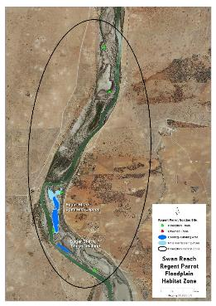 | 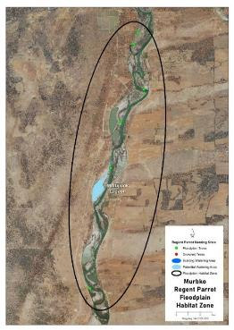
Figure 5.3: Swan Reach Regent Parrot Floodplain Habitat Zone. | Figure 5.4: Murbko Regent Parrot Floodplain Habitat Zone.
Table 5-2: Swan Reach & Murbko Regent Parrot Floodplain Habitat Zone water for the environment site description
 | Number of Temporary Wetlands | Maximum Water Height AHD  Option | Area of Inundation (ha) | Fill / Irrigation Volume ML | Commencement to Flow ML/d Band | Full Supply Flow ML/d Band | Number of Land  Owner(s) | Watering Option
Sugar Shack Upstream Lagoon | 1 | 1.6 | 58.3 | 523 | Pool level | 50-60,000 | 2 | Pumping
Murbpook Lagoon | 4 | 4.6 | 131 | 2737 | Pool Level | 100-110,000 | 3 | Pumping
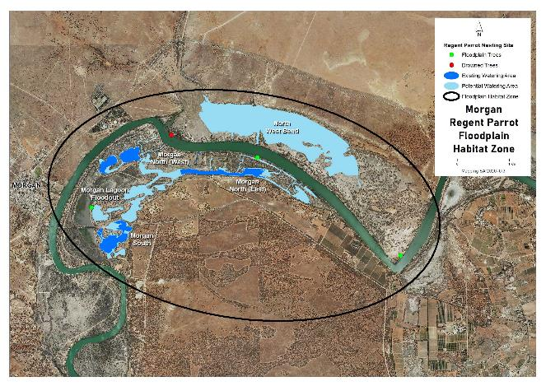
Figure 5.5: Morgan Regent Parrot Floodplain Habitat Zone.

Table 5-3: Morgan Regent Parrot Floodplain Habitat Zone water for the environment site description
Water for the Environment Sites  Morgan Zone | Number of Temporary Wetlands | Maximum Water Height AHD  Option | Area of Inundation (ha) | Fill / Irrigation Volume ML | Commencement to Flow ML/d Band | Full Supply Flow ML/d Band | Number of Land  Owner(s) | Watering Option
Morgan South Lagoon | 5 | 5.8 | 23.7 | 246.6 | 20-30,000 | 90-100,000 | 2 | Pumping
Morgan Lagoon Flood-out | 1 | 5.6 | 8.2 | 54.3 | 50-60,000 | 100-110,000 | 1 | Pumping
Morgan North (West) | 9 | 5.8 | 51.8 | 435 | 20-30,000 | 90-100,000 | 6 | Pumping
Morgan North (East) | 3 | 6.2 | 32.6 | 378 | 20-30,000 | 100-110,000 | 9 | Pumping
North West Bend | 2 | 5.6 | 182 | 2,197 | 60-70,000 | 70-80,000 | 10 | Pumping
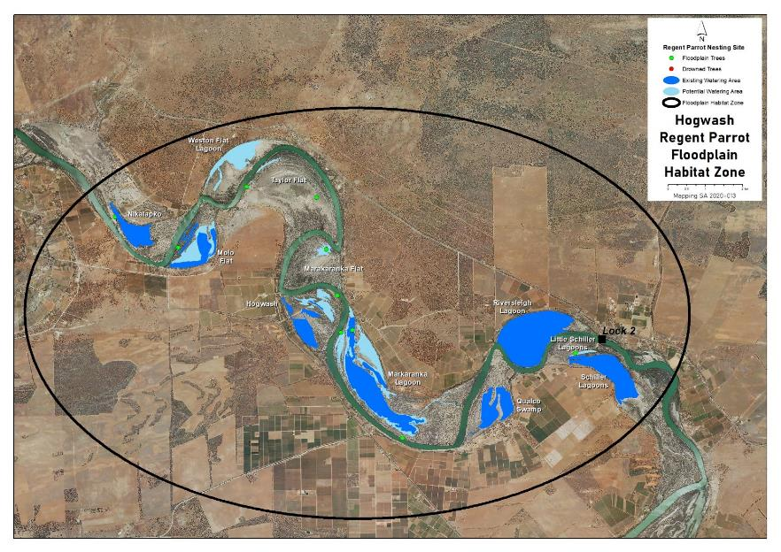
Figure 5.6: Hogwash Regent Parrot Floodplain Habitat Zone.

Table 5-4: Hogwash Regent Parrot Floodplain Habitat Zone water for the environment site description
Water for the Environment Sites  Hogwash Zone | Number of Temporary Wetlands | Maximum Water Height AHD  Option | Area of Inundation (ha) | Fill / Irrigation Volume ML | Commencement to Flow ML/d Band | Full Supply Flow ML/d Band | Number of Land  Owner(s) | Watering Option
Weston Flat Lagoon | 3 | 5 | 52.8 | 537 | 30-40,000 | 50-60,000 | 2 | Pumping
Molo Flat | 2 | 6 | 76.4 | 1,009 | 40-50,000 | 70-80,000 | 2 | Pumping
Taylor Flat Outlet Creek | 0 | 5 | 0.4 | 3 | 40-50,000 | 60-70,000 | 2 | Pumping
Taylor Flat River Flood-out | 0 | 5.4 | 3.6 | 12 | 40-50,000 | 80-90,000 | 2 | Pumping
Markaranka Flat | 0 | 5.6 | 8.4 | 29.4 | 40-50,000 | 50-60,000 | 3 | Pumping
Markaranka Flat Channel | 0 | 5.6 | 0.3 | 1.6 | 80-90,000 | 80-90,000 | 2 | Pumping
Hogwash Northern Flood-out | 0 | 7.2 | 7 | 32.4 | 60-70,000 | 90-100,000 | 3 | Pumping
Hogwash Central Basin West | 2 | 6.2 | 8.2 | 31 | 70-80,000 | 80-90,000 | 1 | Pumping
Hogwash Central Basin East | 1 | 7.2 | 13.7 | 76.6 | 70-80,000 | 90-100,000 | 2 | Pumping
Hogwash Southern Basins | 3 | 6.2 | 37.5 | 424 | 60-70,000 | 70-80,000 | 3 | Pumping
Markaranka Lagoon Outlet Creek | 0 | 5.6 | 2.1 | 15.8 | 30-40,000 | 60-70,000 | 2 | Pumping
Markaranka Lagoon | 4 | 7 | 214 | 3,558 | 40-50,000 | 90-100,000 | 2 | Pumping
Markaranka River Flood-out | 0 | 7.6 | 13.7 | 66.5 | 90-100,000 | 100-110,000 | 2 | Pumping
Little Schiller Lagoon | 1 | 6.4 | 4.2 | 44 | 40-50,000 | 70-80,000 | 1 | Pumping and Lock2 Weir Pool Raising

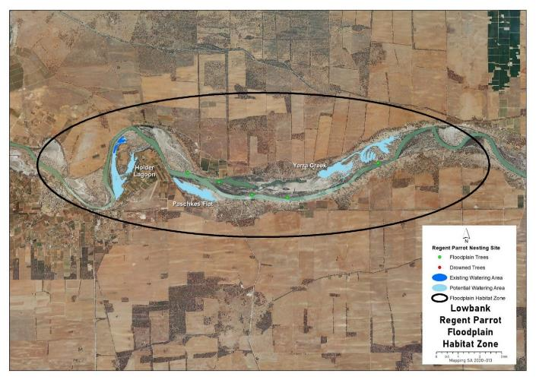
Figure 5.7: Lowbank Regent Parrot Floodplain Habitat Zone.

Table 5-5: Lowbank Regent Parrot Floodplain Habitat Zone water for the environment site description
Water for the Environment Sites  Lowbank Zone | Number of Temporary Wetlands | Maximum Water Height AHD  Option | Area of Inundation (ha) | Fill / Irrigation Volume ML | Commencement to Flow ML/d Band | Full Supply Flow ML/d Band | Number of Land  Owner(s) | Watering Option
Holder Lagoon | 8 | 8.8 | 104.7 | 1,486 | 10-20,000 | 100-110,000 | 4 | Pumping
Paschkes Flat | 1 | 8 | 63.4 | 605 | 20-30,000 | 70-80,000 | 5 | Pumping
Yarra Creek | 6 | 8.6 | 123 | 1,093 | 20-30,000 | 80-90,000 | 3 | Pumping
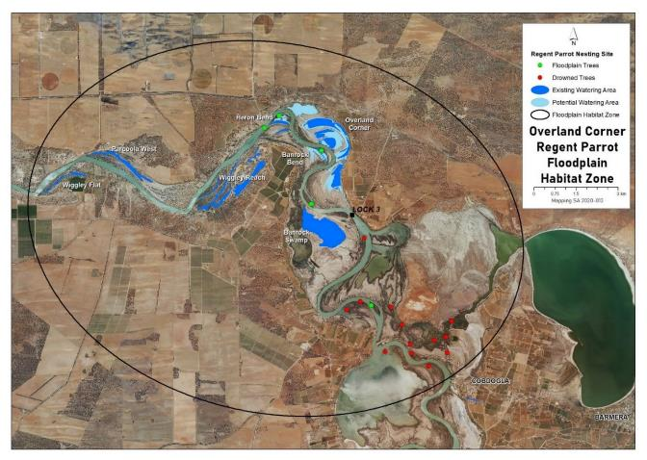
Figure 5.8 Overland Corner Regent Parrot Floodplain Habitat Zone.

Table 5-6: Overland Corner Regent Parrot Floodplain Habitat Zone water for the environment site description
Water for the Environment Sites  Overland Corner Zone | Number of Temporary Wetlands | Maximum Water Height AHD  Option | Area of Inundation (ha) | Fill / Irrigation Volume ML | Commencement to Flow ML/d Band | Full Supply Flow ML/d Band | Number of Land  Owner(s) | Watering Option
Heron Bend West | 0 | 8.2 | 2.6 | 13.3 | 50-60,000 | 60-70,000 | 2 | Pumping
Heron Bend East | 0 | 8.8 | 3.2 | 11.7 | 50-60,000 | 60-70,000 | 2 | Pumping
Banrock Bend | 1 | 8.8 | 14.7 | 77 | 40-50,000 | 50-60,000 | 2 | Pumping
Overland Corner | 10 | 9 | 187.5 | 1,751 | 40-50,000 | 50-60,00 | 2 | Gravity upper Lock3
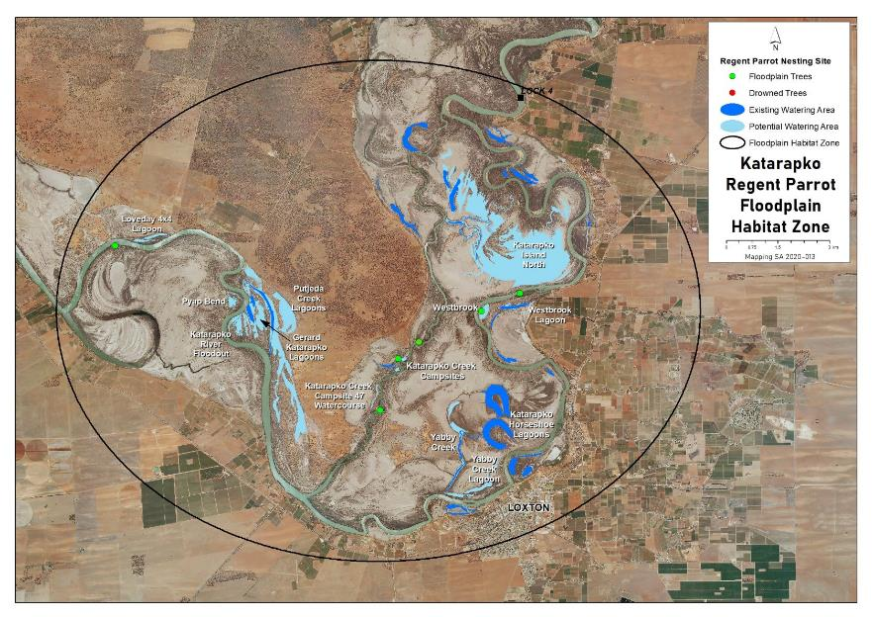
Figure 5.9: Katarapko Regent Parrot Floodplain Habitat Zone.
Table 5-7: Katarapko Regent Parrot Floodplain Habitat Zone water for the environment site description
Water for the Environment Sites  Katarapko Zone | Number of Temporary Wetlands | Maximum Water Height AHD  Option | Area of Inundation (ha) | Fill / Irrigation Volume ML | Commencement to Flow ML/d Band | Full Supply Flow ML/d Band | Number of Land  Owner(s) | Watering Option
Loveday 4x4 Lagoon | 1 | 11 | 7.4 | 42 | 40-50,000 | 60-70,000 | 2 | Pumping
Pyap Bend | 0 | 12 | 7.7 | 31.5 | 60-70,000 | 70-80,000 | 2 | Pumping
Gerard/Katarapko Lagoon | 2 | 11.8 | 41.1 | 237 | 40-50,000 | 70-80,000 | 2 | Pumping
Katarapko River Flood-out | 0 | 9.8 | 12 | 54 | 60,70,000 | 70-80,000 | 1 | Pumping
Putjeda Creek Lagoons | 5 | 11.8 | 149.3 | 1,145 | 5-10,000 | 70-80,000 | 2 | Pumping
Katarapko Creek Campsite 47 Watercourse | 0 | 12.4 | 2 | 10.4 | 60-70,000 | 70-80,000 | 1 | Pumping
Katarapko Creek North South | 1 | 12.2 | 2.6 | 19 | 60-70,000 | 70-80,000 | 1 | Pumping
Katarapko Creek East | 0 | 12.6 | 1 | 5 | 60-70,000 | 70-80,000 | 1 | Pumping
Katarapko Creek Campsite 45 | 0 | 12.6 | 1.5 | 7 | 60-70,000 | 70-80,000 | 1 | Pumping
Yabby Creek | 1 | 11.4 | 25.1 | 183.5 | 40-50,000 | 60-70,000 | 1 | Pumping
Yabby Creek Lagoon | 1 | 12 | 15.3 | 89 | 50-60,000 | 70-80,000 | 1 | Pumping
Westbrook Bend | 0 | N/A | 7.6 | 7.6 | 60-70,000 | 70-80,000 | 1 | Sprinklers
Westbrook Lagoon | 1 | 13 | 8.1 | 60.5 | 50-60,000 | 60-70,000 | 2 | Pumping
Katarapko Island North | 10 | 13 | 463 | 2934 | 40-50,000 | 50-60,000 | 1 | Pumping

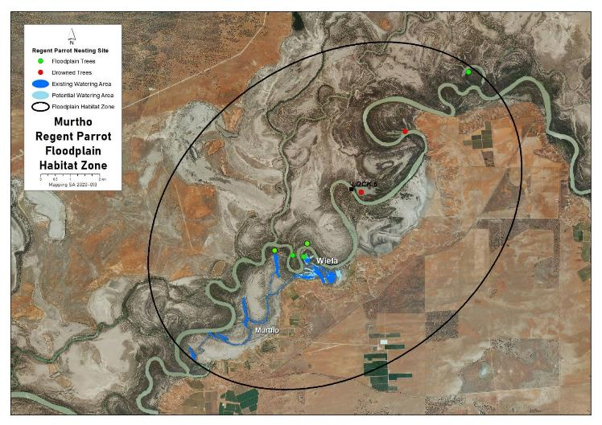
Figure 5.10: Murtho Parrot Floodplain Habitat Zone.

Table 5-8: Murtho Regent Parrot Floodplain Habitat Zone water for the environment site description
Water for the Environment Sites  Murtho Zone | Number of Temporary Wetlands | Maximum Water Height AHD  Option | Area of Inundation (ha) | Fill / Irrigation Volume ML | Commencement to Flow ML/d Band | Full Supply Flow ML/d Band | Number of Land  Owner(s) | Watering Option
Wiela | 4 | 18.8 and 19.6 | 44.7 | 648 | 40-50,000 | 70-80,000 | 2 | Pumping

5.3 Site objectives
The following objectives have been developed to guide the future ecological management of potential water for the environment sites and promote community participation and support for the conservation of Regent Parrots, and the water for the environment program. No Cultural objectives were identified during this project. However, if cultural issues are identified during further investigation of a site it may be appropriate to develop objectives in consultation with the First Peoples.
Ecological Objectives
- Halt the decline and improve the health condition of mature woody plant species e.g. (River Red Gum, Black Box, Cooba and Lignum).
- Maintain existing regeneration and provide opportunities for future regeneration events of woody plant species e.g. (River Red Gum, Black Box, Cooba and Lignum).
- Improve the abundance and diversity of flood dependant understory vegetation.
- Reduce soil salinity to disadvantage Samphire and promote regeneration of less salt tolerant floodplain and aquatic plant species.
- Improve floodplain habitat conditions to promote Regent Parrot breeding events.
- Provide floodplain and aquatic habitats suitable for waterbird and frog refuge and breeding.
- Provide fish passage through large floodplain habitats during natural flood events.
- Provide hydrological connectivity between watering sites and adjacent floodplain during natural flood events.
- Promote total grazing pressure within sustainable limits.
- Increase Regent Parrot potential breeding success by limiting disturbance from human activities such as recreational visitors and noise from water pumping at colony sites during July and August.

Community Objectives
- Through community educational programs and information promote water for the environment projects that contribute to Regent Parrot conservation.
- Engage landholder involvement in the sustainable management of their site(s).

A summary of the ecological and community objectives for each potential water for the environment site is presented in Table 5.9

Table 5-9: Summary of ecological and community objectives for each potential water for the environment site.
Potential Water for the Environment Sites | Ecological Objectives |  |  |  |  |  |  |  |  |  | Community Objectives
 | Improve health condition of woody plants | Maintain regen. of woody plants | Improve flood dependant understory vegetation | Promote regeneration of less salt tolerant plants | Promote Regent Parrot breeding events | Provide waterbird and frog refuge and breeding habitat | Provide fish passage during flood events | Provide hydrological connectivity between sites and floodplain | Promote sustainable total grazing pressure | Limit human disturbance to nest sites during July August | Community education | Engage landholder involvement
Swan Reach Regent Parrot Habitat Zone
Sugar Shack Upstream Lagoon
Murbko Regent Parrot Habitat Zone
Murbpook Lagoon
Morgan Regent Parrot Habitat Zone
Morgan South Lagoon
Morgan Lagoon Flood-out
Morgan North (West)
Morgan North (East)
North West Bend
Hogwash Regent Parrot Habitat Zone
Molo Flat
Weston Flat Lagoon
Taylor Flat Outlet Creek
Taylor Flat River Flood-out
Markaranka Flat
Markaranka Flat Channel
Hogwash Northern Flood-out
Hogwash Central Basin West
Hogwash Central Basin East
Hogwash Southern Basins
Markaranka Lagoon Outlet Creek
Markaranka Lagoon
Markaranka River Flood-out
Table 5-9: Summary of ecological and community objectives for each potential water for the environment site (continued).
Potential Water for the Environment Sites | Ecological Objectives |  |  |  |  |  |  |  |  |  | Community Objectives
 | Improve health condition woody plants | Maintain regeneration of woody plants | Improve flood dependant understory vegetation | Promote regeneration of less salt tolerant plants | Promote Regent Parrot breeding events | Provide waterbird and frog refuge and breeding habitat | Provide fish passage during flood events | Provide hydrological connectivity between sites and floodplain | Promote sustainable total grazing pressure | Limit human disturbance to nest sites during July August | Community education | Engage landholder involvement
Little Schiller Lagoon
Lowbank Regent Parrot Habitat Zone
Holder Lagoon
Paschkes Flat
Yarra Creek
Overland Corner Regent Parrot Habitat Zone
Heron Bend West
Heron Bend East
Banrock Bend
Overland Corner
Katarapko Regent Parrot Habitat Zone
Loveday 4x4 Lagoon
Pyap Bend
Gerard/Katarapko Lagoon
Katarapko River Flood-out
Putjeda Creek Lagoons
Katarapko Creek Campsite 47 Watercourse
Katarapko Creek North South
Katarapko Creek East
Katarapko Creek Campsite 45
Yabby Creek
Yabby Creek Lagoon
Westbrook Bend
Westbrook Lagoon
Katarapko Island North
Murtho Regent Parrot Habitat Zone
Wiela

5.4 Hydrological management to achieve site ecological outcomes
There are a number of hydrological management options to achieve the required ecological outcomes at water for the environment sites. Table 5-10 summarises the hydrological management activities and options that could be implemented at each of the 43 potential sites.

Table 5-10: Hydrological management activities and options for potential water for the environment sites
Potential Water for the Environment Sites | Hydrological Management Activities |  |  |  |  | Watering Timing | Full Supply Hydrological Option |  |  | Low Elevation Hydrological Option
 | Pump or Gravity to Full Supply | Pump or Gravity to Low  Elevation | Return / Reuse Flows | Manage Natural Flood Recession | Enhance Natural Flood Duration and Coverage |  | Water Height Level AHD | Inundation Hectares | Fill Volume ML | Water Height AHD Level | Inundation hectares | Fill Volume ML
Swan Reach Regent Parrot Habitat Zone
Sugar Shack Upstream Lagoon |  |  |  |  |  |  | 1.6 | 58.3 | 523 | Pool Level | 31.6 | 113.5
Murbko Regent Parrot Habitat Zone
Murbpook Lagoon |  |  |  |  |  |  | 4.6 | 131 | 2,737 | 3.4 | 111.5 | 1292
Morgan Regent Parrot Habitat Zone
Morgan South Lagoon |  |  |  |  |  |  | 5.8 | 23.7 | 246.6
Morgan Lagoon Flood-out |  |  |  |  |  |  | 5.6 | 8.2 | 54.3
Morgan North (West) |  |  |  |  |  |  | 5.8 | 51.8 | 435
Morgan North (East) |  |  |  |  |  |  | 6.2 | 32.6 | 378 | 5.6 | 19.5 | 221
North West Bend |  |  |  |  |  |  | 5.6 | 182 | 2,197 | 4.6 | 119 | 700.4
Hogwash Regent Parrot Habitat Zone
Weston Flat Lagoon |  |  |  |  |  |  | 5 | 52.8 | 537
Molo Flat |  |  |  |  |  |  | 6 | 76.4 | 1,009 | 4.8 | 37.2 | 301.4
Taylor Flat Outlet Creek |  |  |  |  |  |  | 5 | 0.4 | 3
Taylor Flat River Flood-out |  |  |  |  |  |  | 5.4 | 3.6 | 12
Markaranka Flat |  |  |  |  |  |  | 5.6 | 8.4 | 29.4
Markaranka Flat Channel |  |  |  |  |  |  | 5.6 | 0.3 | 1.6
Hogwash Northern Flood-out |  |  |  |  |  |  | 7.2 | 7 | 32.4
Hogwash Central Basin West |  |  |  |  |  |  | 6.2 | 8.2 | 31
Hogwash Central Basin East |  |  |  |  |  |  | 7.2 | 13.7 | 76.6
Hogwash Southern Basins |  |  |  |  |  |  | 6.2 | 37.5 | 424
Markaranka Lagoon Outlet Creek |  |  |  |  |  |  | 5.6 | 2.1 | 15.8
Markaranka Lagoon |  |  |  |  |  |  | 7 | 214 | 3,558 | 6.4 | 128 | 2267
Markaranka River Flood-out |  |  |  |  |  |  | 7.6 | 13.7 | 66.5
Little Schiller Lagoon |  |  |  |  |  |  | 6.4 | 4.2 | 44
# Watering Timing | Spring through to Autumn | Early Winter (June)
Table 5-10: Hydrological management activities and options for potential water for the environment sites (continued)
Potential Water for the Environment Sites | Hydrological Management Activities |  |  |  |  | Watering  Timing # | Full Supply Hydrological Option |  |  | Low Elevation Hydrological Option
 | Pump or Gravity to Full Supply | Pump or Gravity to Low  Elevation | Return / Reuse Flows | Manage Natural Flood Recession | Enhance Natural Flood Duration and Coverage |  | Water Height Level AHD | Inundation Hectares | Fill Volume ML | Water Height AHD Level | Inundation hectares | Fill Volume ML
Lowbank Regent Parrot Habitat Zone
Holder Lagoon |  |  |  |  |  |  | 8.8 | 104.7 | 1,486 | 7.6 | 53.8 | 524
Paschkes Flat |  |  |  |  |  |  | 8 | 63.4 | 605 | 6.8 | 16.9 | 132
Yarra Creek |  |  |  |  |  |  | 8.6 | 123 | 1093 | 7.2 | 30 | 270
Overland Corner Regent Parrot Habitat Zone
Heron Bend West |  |  |  |  |  |  | 8.2 | 2.6 | 13.3
Heron Bend East |  |  |  |  |  |  | 8.2 | 3.2 | 11.7
Banrock Bend |  |  |  |  |  |  | 8.8 | 14.7 | 77
Overland Corner |  |  |  |  |  |  | 9 | 187.5 | 1,751 | 8 | 71.3 | 505
Katarapko Regent Parrot Habitat Zone
Loveday 4x4 Lagoon |  |  |  |  |  |  | 11 | 7.4 | 42 | 10.4 | 3.3 | 12.6
Pyap Bend |  |  |  |  |  |  | 12 | 7.7 | 31.5
Gerard/Katarapko Lagoon |  |  |  |  |  |  | 11.8 | 41.1 | 237 | 11.4 | 21.6 | 112
Katarapko River Flood-out |  |  |  |  |  |  | 9.8 | 12 | 54
Putjeda Creek Lagoons |  |  |  |  |  |  | 11.8 | 149.3 | 1,145 | 11.4 | 93.4 | 658
Katarapko Creek Campsite 47 Watercourse |  |  |  |  |  |  | 12.4 | 2 | 10.4
Katarapko Creek North South |  |  |  |  |  |  | 12.2 | 2.6 | 19
Katarapko Creek East |  |  |  |  |  |  | 12.6 | 1 | 5
Katarapko Creek Campsite 45 |  |  |  |  |  |  | 12.6 | 1.5 | 7
Yabby Creek |  |  |  |  |  |  | 11.4 | 25.1 | 183.5
Yabby Creek Lagoon |  |  |  |  |  |  | 12 | 15.3 | 89
Westbrook Bend |  |  |  |  |  |  | N/A | 7.6 | 7.6
Westbrook Lagoon |  |  |  |  |  |  | 13 | 8.1 | 60.5
Katarapko Island North |  |  |  |  |  |  | 13 | 463 | 2,934 | 12.2 | 143 | 660
Murtho Regent Parrot Habitat Zone
Wiela |  |  |  |  |  |  | 19.6 | 44.7 | 648 | 18.4 | 26.8 | 181
# Watering Timing | Spring through to Autumn | Early Winter (June)

5.5 Potential watering site infrastructure requirements and estimated costs
Sturt Contractors were engaged to undertake a desktop analysis to establish a budget estimate for costs to design and construct potential infrastructure requirements at 40 of the 43 water for the environment sites identified (two sites require no hydrological infrastructure at this stage and sprinklers could be used to water the remaining site). The analysis was based on site information provided and a series of assumptions (Table 5-11 and 5-12 and Appendix 4). Sturt Contractors advise that there are limitations to the information provided in the development of the analysis and recommend the allocation of funding to projects that includes a contingency allowance. Table 5-13 describes the items excluded from the budget estimate assessment (Sturt Contractors Pty Ltd 2020). Table 5-14 describes the potential infrastructure requirements and estimated costs as per the identified assumptions and exclusions for the 41 water for the environment sites identified.

Table 5-11: Design and project management assumptions
- Development approval is obtainable without major constraints such as native vegetation clearance, cultural heritage requirements and landowner agreements.
- Projects will be let as small to medium contracts which will attract contractors with low commercial risk, therefore requiring less project management resources.
- The design team will not be required to participate in multiple workshops and “optioneering” multiple concept alternatives.
- The design team will not be required to assess watering site hydrology, structure hydraulics or fish attraction and fish passage.
- The design outputs will include 2D plans, elevations and standard cross sections. 3D design modelling has not been considered as it increases design costs and is unnecessary.
- Construction specifications would rely on applicable Australian Standards rather than bespoke technical specifications to avoid increased design costs and verification costs.
- Design concepts have been developed based on Riverland West Landcare descriptions and experience in construction of similar structures. The design concepts that the budget estimate is based on are summarised by the sketches below.

Table 5-12: Construction estimate assumptions
- Projects will be let as small to medium contracts which will attract contractors with relatively low onsite and offsite overheads, low mobilisation/demobilisation costs.
- Sites are accessible for construction equipment.
- Suitable clayey material is available within close proximity of each blocking bank (<5 kms).
- Embedment depths and lengths for sheetpiles are within the capacity of excavator mounted sheetpiling attachments (rather than requiring large cranes). On this basis, sheetpiles must not exceed 7m in length and are preferably 5m long and 600mm in unit width.
- Quarry and concrete materials will be sourced from local suppliers and material specifications do not require onerous testing requirements for approval and or quality assurance.
- Where road raising is required, the existing road is able to be narrower. If this is not acceptable, more details of the existing geometry is required.
- Sheetpiles can be driven by excavator to reduce plant requirements and construction costs. This is only achievable if the sheetpiles selected are not too long or too wide and the geotechnical conditions allow. The alternative is sheetpiling by crane which increases costs considerably.
- Vegetation clearance can be performed by an excavator/loader/grader in conjunction with preparatory earthworks (i.e.: specialist arborists are not required).

Table 5-13: Items excluded from the budget estimate assessment
Exclusions | Comment
Costs associated with obtaining development approvals. | Additional information required.
Surveys for cultural heritage, native title and native vegetation. | Additional information required.
Fish attraction/fish behaviour studies. | We have allowed for larger armour rock and angle baffles on the culvert structure as “good practice” but we have assumed that there is no formal requirement for the design of structures to consider fish behaviour.
Underground service locations. | It is assumed that these areas do not have services present.
Cultural heritage monitors for excavations. | Additional information required.
Arborists for tree trimming or removal. | It is assumed that any large trees are avoided in the design and that vegetation which does require removal can be done by excavator.
Licencing costs for dredging | Additional information required. Historically, there has been variability in how this has been managed.
Licencing costs for use of construction water. | Additional information required. Historically there has been variability in how this has been managed.
Embankments and road raising will not undergo road pavement design or Austroads design. | The existing local government roads impacted are unlikely to have been designed in the first place and any additional pavement material is expected to improve the existing road.
Costs for equipment to operate regulator infrastructure. | It is likely that these structures are operated manually and that this additional cost is negligible. It is also likely that one “set” of operational equipment will service multiple sites therefore we have not added the cost to each individual site.
Road safety barriers (“guard railing”), guide posts and hand railing. | We have allowed for handrail at the box culvert structure and sheetpiled structures but have not considered guardrail or guide posts. The cost for guide posts would be considered negligible if they are required. The need for guardrails would need site investigation.
Traffic Management during construction. | It is assumed that all sites are off public roads or are on public roads which can be closed because they are not required for thoroughfare.

Table 5-14: Potential water for the environment site infrastructure requirements and estimated costs
Potential Water for the Environment Sites | Earth Works |  |  |  |  | Structures |  |  |  |  |  |  | Estimated Cost  ($000)
 | Banks | Road Upgrades | Channel | Pipes Only | Pipes with Hinged Flap Valves |  | Vertical Winch Penstock | Pipe with chamber & stop-logs | Box Culvert with Stop Boards | Metal Sheet Pilling with Stop Boards | Pipeline & control value | Main Structures with Fish Passage
Sugar Shack Upstream Lagoon | 2 |  |  |  | 1 |  |  |  |  |  |  |  | [Redacted Detailed costings and personal information has been redacted from the original document to protect privacy and future tenders that will be undertaken to deliver this project]
Murbpook Lagoon | 2 |  |  |  | 1 |  |  |  |  | 1
Morgan South Lagoon | 1 | 1 |  |  | 1
Morgan Lagoon Flood-out | 1 |  |  |  | 1
Morgan North (West) | 5 | 2 |  | 2 | 1 |  |  |  |  | 2
Morgan North (East) | 5 |  |  |  | 3 |  |  | 1
North West Bend | 3 |  |  |  |  |  |  |  |  | 2
Molo Flat | 1 |  |  |  |  |  |  |  |  | 1
Weston Flat Lagoon | 3 |  |  |  | 1 |  |  |  |  | 1
Taylor Flat Outlet Creek | 2 |  |  |  | 2
Taylor Flat River Flood-out | 1 |  |  |  | 1
Markaranka Flat | 1 |  |  |  | 1
Markaranka Flat Channel | 2 |  |  |  | 1
Hogwash Northern Flood-out | 2 | 1 |  | 2 | 1
Hogwash Central Basin West | 2 |  |  | 1 | 3 |  | 1
Hogwash Central Basin East | 1 | 1
Hogwash Southern Basins | No works required
Markaranka Lagoon Outlet Channel | 1 |  |  |  | 1
Markaranka Lagoon | 4 |  |  |  | 1 |  |  |  |  | 2
Markaranka River Flood-out | 2 |  |  |  | 1
Little Schiller Lagoon | 1 |  |  |  | 1

Table 5-14: Potential water for the environment site infrastructure requirements and estimated costs (continued)
Potential Water for the Environment Sites | Earth Works |  |  |  |  | Structures
 | Banks | Road Upgrades | Channel | Pipes Only | Pipes with Hinged Flap Valves |  | Vertical Winch Penstock | Pipe with chamber & stop-log | Box Culvert with Stop Boards | Metal Sheet Pilling with Stop Boards | Pipeline & control value | Main Structures with Fish Passage | Estimated Costs  ($000)
Holder Lagoon | 2 | 1 |  | 2 |  |  |  |  |  | 2 |  |  | [Redacted. Detailed costings and personal information has been redacted from the original document to protect privacy and future tenders that will be undertaken to deliver this project]
Paschkes Flat | 1 |  |  |  |  |  |  |  |  | 1
Yarra Creek | 4 |  |  |  |  |  |  |  |  | 2 |  | 2
Heron Bend West | 2 |  |  |  | 2
Heron Bend East
Banrock Bend | 2 |  | 1 |  | 2 |  |  |  |  | 1
Overland Corner | 5 |  |  |  | 3 |  |  |  | 1 | 1 | 1 | 2
Loveday 4x4 Lagoon | 1 |  |  |  | 1
Pyap Bend | 5 |  |  |  | 2
Gerard/Katarapko Lagoon | 1 |  |  |  |  |  |  |  |  | 1
Katarapko River Flood-out | No works required. Monitor during and after initial event to assess need for any bank construction.
Putjeda Creek Lagoons | 5 |  |  |  | 3 |  |  |  |  | 2
Katarapko Creek Campsite 47 Watercourse | 2 |  |  |  | 2
Katarapko Creek North South | 2 |  | 1 |  | 1
Katarapko Creek East | 2 |  |  |  | 1
Katarapko Creek Campsite 45 | 1 |  |  |  | 1
Yabby Creek | 1 |  |  |  |  |  |  |  |  | 1
Yabby Creek Lagoon | 1 |  |  |  | 1
Westbrook Bend | No works required
Westbrook Lagoon | 1 |  |  |  | 1
Katarapko Island North | 10 |  |  |  | 2 |  |  |  |  | 2 |  | 2
Wiela | 5 |  |  |  | 1 |  |  |  |  | 2

5.6 Site Management Briefs
A Site Management Brief has been developed for each potential water for the environment site (Appendix 6). Each site brief provides a site description, potential hydrological management and associated infrastructure, including the following information;
- Vegetation description (see Appendix 5 for Plant List).
- Representative photographs of the site’s vegetation condition with accompanying GPS coordinates and photo direction.
- Stressor Analysis.
- Land Tenure issues.
- Regent Parrot Utilisation.
- Ecological and Community Objectives.
- A map identifying the existing and potential watering areas.
- Site hydrological parameters:
  - Existing inundation area and historical watering dates.
  - Maximum inundation-water height (AHD), inundation area and fill volume.
  - Commencement to flow ML/d band.
  - Full supply flow ML/d band.
  - Watering options.
  - Watering timing.
- Map features AHD heights across the site and identified potential infrastructure locations.
- Potential infrastructure requirements.

5.7 Conclusions and Strategic Observations on the Lower Murray Water for the Environment Program

5.7.1. Conclusions
Of the Regent Parrot habitat sites assessed in this project it was found that;
- 29 critical habitat sites were assessed as not having potential to be watered with environmental water either due to topography and practicability or that watering is unlikely to be an effective management tool.
- 12 critical habitat sites that are existing watering sites were assessed as currently having Regent Parrot outcomes met and management at these sites should continue as is.
- 43 sites (19 of which already receive some environmental water) were found to have potential for environmental watering to increase the area of regent parrot habitat that can be inundated.
It is estimated that with additional works at these 43 sites a total of approximately 2,217 Ha of regent parrot nesting and foraging habitat could be watered with water for the environment, an increase of approximately 1,761 Ha. Thirty-four of these sites (79%) exhibited signs of vegetation stress due to lack of inundation. Assessments of all 43 sites based on stressors and vegetation health indicate that if no action is taken to protect and improve the habitat at these sites 20% could be lost, 30% have potential to be lost, 37% are likely to experience partial loss and 12% are likely to experience poor health, likely to have a devastating effect on regent parrots.
The 43 sites are grouped within known Regent Parrot nesting colony concentrations to form 8 distinct Regent Parrot Habitat Zones which provide for management of sites at a landscape scale.
The results of this project indicate that much more can be done for Regent Parrots in South Australia and that environmental water can play a significant role in improving their habitat. Section 4 and 5 of the report provide guidance and preliminary findings (including management briefs for each site) that can be used to further develop and scope work in managing water for the environment for Regent Parrot outcomes.

5.7.2 Strategic observations
The following strategic observations on the Lower Murray Water for the environment program have been identified during development of the program to maximise water delivery for Regent Parrot outcomes;
- The water for the environment program has a number of water delivery partners with varying degrees of operational experience and resources. A management obligation to maintain water for the environment sites into the future is critical. Program continuity and oversight is needed to review yearly watering programs. This is especially important at sites with high risk vegetation communities such as adult River Red Gum. Development of the annual program should be within an adaptive management framework utilising real time data which should be available to all levels within the decision-making process.
- To maintain ecological character over the long-term at each watering site, high risk areas within each site should be identified to ensure that when water and/or management resources are limited high risk areas receive appropriate water allocations.
- Due to predicted changes in climate resulting in significant reductions in Lower River Murray flows, managed hydrology of the floodplain will be needed well into the future to maintain and/or rehabilitate high value floodplain sites. To ensure current management actions are not squandered in the future it is essential that the Lower River Murray water for the environment program develops long-term strategies with realistic water delivery and site adaptive monitoring procedures which are adopted by all water delivery partners.
- The long-term sustainability of the small to medium water for the environment projects along the Lower River Murray are at a community and political crossroads. These floodplain sites require a long-term vision and social and political support. The development of a new Murray Darling Basin restoration story will assist to achieve this. The water for the environment program has the opportunity to develop a community and landowner driven ecological recovery and management program.

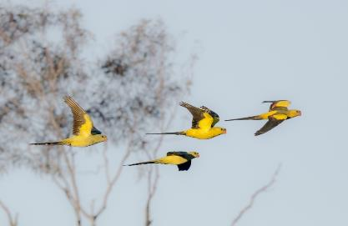
Figure 5.11: KEEP THEM FLYING - Flock of male Regent Parrots. Photo: Glenn Ehmke.

References

Australian Water Environments (AWE) (2015) Black Box Health and Management Options. Prepared for the Department of the Environment, Commonwealth Environmental Water Office. AWE Ref 1507
Baker-Gabb B. and Hurley V.H., 2011 National Recovery Plan for the Regent Parrot (eastern subspecies) Polytelis anthopeplus monarchoides
Beardsell, C. 1985. The Regent Parrot. A report on the nest site survey in south-east Australia. Australian National Parks and Wildlife Service, Report Series No. 1.
Burbidge, A.H. 1985. The Regent Parrot. A report on the breeding distribution and habitat requirements along the Murray River in south-eastern Australia. Australian National Parks and Wildlife Service, Report Series No. 4.
Cale P. (2019) Evidence-based Recovery Plan for Calperum Floodplain 2020 – 2025 BRAFT Australian Landscape Trust
Cale, P. and Treilibs, C. 2008. Review of the Threatened River Corridor Fauna Recovery program. Report for the SAMDB Natural Resources Management Board, Department for Environment and Heritage, Berri, SA.
Chowilla Floodplain Environmental Water Management Plan 2012
Commonwealth of Australia (2020). Healthy Rivers healthy communities a pocket guide to water for the environment.
Cunningham, G. M., Mulham. W. E., Milthorpe, P. L., and Leigh, J. H., Reprinted (1999). Plants of Western New South Wales, Inkata Press
Dexter, B.D. (1978) Silviculture of River Red Gum forest of Central Murray floodplain. Proceedings of the Royal Society of Victoria 90: 175-191
Forshaw, J.M. and Cooper, W.T. (1981). Australian Parrots second (revised) edition. Lansdowne Editions, Melbourne
Harper, A. and Harper, M. (2015) Katfish Reach Temporary Wetland Condition Report. A Report to
Department of Environment, Water and Natural Resources, SA Murray Darling Basin
Partnerships & Stewardship, Berri SA.

Harper, M.J. (1989) Regent Parrot Polytelis anthopeplus Breeding Sites in the Riverland, South Australia, 1989. Unpublished Report to South Australian NPWS, Adelaide.

Harper, M.J. (2020) Johnson’s Waterhole Case Study, Ral Ral Creek Floodplain, Renmark, South Australia.

Higgins, P.J. (Senior Ed.) (1999) Handbook of Australian, New Zealand and Antarctic Birds. Vol 4. (Oxford University Press, Melbourne)
Kilsby, NN and Steggles TA. Ecological objectives, targets and environmental water requirements for South Australian River Murray Floodplain environmental asset, DEWNR Technical Report 2015/15 Adelaide Government of South Australia.
Ireland, L. and Ryan-Colton, E. (2016). Regent Parrot Conservation in South Australia: Review of Projects to 2015
Ireland, L. (2020) Landscape Use of Regent Parrot in the Breeding Season. Report for the South Australian Regent Parrot Recovery Team
Mallen-Cooper, M. (2001) Fish passage in off-channel habitats of the Lower River Murray. Report for Wetland Care Australian
Murray-Darling Basin Authority (2019). Basin-wide environmental watering strategy: Second edition
Newall, P., Lloyd, L., Gell, P. and Walker, K. (2009) Riverland Ramsar Site Ecological Character Description.
NSW Department of Industry and Investment. (2009). Water Control Structures: Design Suitability for Natural Resource Management on Coastal Floodplains. Department of Industry and Investment (Aquatic Habitat Rehabilitation), Port Stephens.
Overton IC, Coff B, Mollison D, Barling R, Fels K and Boyd A (2018) Black Box Management Framework A Framework for Managing Floodplain and Wetland Black Box Eucalypts in the Murray-Darling Basin. Prepared by Jacobs Group (Australia) Pty Ltd for the Commonwealth Environmental Water Office, Australian Department of the Environment and Energy.
Roberts, J. and Marston, F. (2011). Water regime for wetland and floodplain plants. A source book for the Murray-Darling Basin, National Water Commission, Canberra.
Ryan-Colton, E. (2013), Important habitats for Regent Parrots at a landscape scale: use of citizen science, Natural Resources SA Murray-Darling Basin, Department of Environment, Water and Natural Resources, Be
Smith, K. (1992) The Regent Parrot in South Australia: Survey of Breeding Distribution. Unpublished Report.
Smith, K. (2001) A Report on Regent Parrot Nesting and Monitoring In the South Australian Riverland: September 2000 to January 2001. Unpublished Report for the South Australian National Parks and Wildlife Council.
Smith, K. (2004) Regent Parrot Nest Survey 2003 – 2004: A Report on Regent Parrot Nest Sites in the S.A. Section of the Murray-Darling Basin. Unpublished Report for the South Australian Threatened Species Network.
Smith, K. (2006) The Regent Parrot (Polytelis anthopeplus monarchoides) A survey of selected nesting colonies in South Australia in the 2006 breeding season. Report prepared for the Wildlife Advisory Committee South Australian national Parks and Wildlife Council
Smith, K.W. (2011). Regent Parrot nest Survey 2010, Results of the 2010 survey of Regent Parrot nests in the SA Murray Darling Basin, Department of Environment and Natural Resources, Berri, South Australia.
Smith, K.W. (2014). Monitoring the Regent Parrot population in South Australia 2003-2013, Department of Environment, Water and Natural Resources, Berri, South Australia.
Sturt Contractors Pty. Ltd., 2020. Budget Cost Estimate. Design and Construction of Various Wetland Sites on the River Murray between Swan Reach and the Border. Prepared for Riverland West Landcare
Sustainable Focus (2007). Your Wetland: On-ground Works, for the South Australian Murray River Basin Natural Resource Management Board, Berri, South Australia.
TNC (2007) Conservation Action Planning Handbook: Developing Strategies. Taking Action and Measuring Success at Any Scale. The Nature Conservancy, Arlington, VA.

Appendix 1 Known Food Plants, Animals and Habitats of Regent Parrots

Appendix 1 has been adopted from “Ireland, L. and Ryan-Colton, E. (2016). Regent Parrot Conservation in South Australia: Review of Projects to 2015”.
The ‘Food’ column indicates which part of the plant was consumed. Abbreviations: B = berry, BU = buds, C = culms, F = flowers, S = seeds, L = lerps, * = introduced species. The literature source for each species is listed in the table: Burbidge 1985, Webster 1993, Webster and Leslie 1997, Webster 2001, Hurley and Baker-Gabb 2011, Ryan-Colton 2013.

Family | Common name | Scientific name |  | Food | Season | Source
Amaranthaceae | Lesser Joyweed | Alternanthera denticulata |  | S | Breeding, Juveniles fledged | Harper 2017
Asteraceae | Capeweed | Arstotheca calendula* |  | S |  | Burbidge 1985
Asteraceae | Creeping Knapweed | Centauris repens* |  | S |  | Burbidge 1985
Asteraceae | Cat's Ear | Hypochoeris sp.* |  | S |  | Burbidge 1985
Asteraceae | Hawkweed Picris | Picris hieracioides* |  | S |  | Burbidge 1985
Asteraceae | Common Sowthistle | Sonchus oleraceus* |  | S |  | Burbidge 1985
Brassicaceae | Bundled Peppercress | Lepidium fasciculatum |  | S |  | Schmitke 2013
Brassicaceae | Wild Mustard | Sisymbrium sp. |  | S |  | Burbidge 1985
Casuarinaceae | Black Oak | Casuarina pauper |  | S | Non-breeding | Ryan-Colton 2013
Chenopodiaceae | Eastern Flat-top Saltbush | Atriplex lindleyi |  | S | Breeding, Juveniles fledged | Harper 2020
Chenopodiaceae | Creeping Saltbush | Atriplex semibaccata |  | S |  | Burbidge 1985
Chenopodiaceae | Bladder Saltbush | Atriplex vesicaria |  |  | Breeding | Wester 1993, Ryan-Colton 2013
Chenopodiaceae | Old Man Saltbush | Atriplex nummularia  ssp. nummularia |  |  | Breeding, Juveniles fledged | Ryan-Colton 2013
Chenopodiaceae | Fat Hen | Chenopodium album |  | S |  | Burbidge 1985
Chenopodiaceae | Mallee goosefot | Chenopodium desertorum |  | S |  | Burbidge 1985
Chenopodiaceae | Cannon-ball | Dissocarpus paradoxus |  | S |  | Burbidge 1985
Chenopodiaceae | Ruby Saltbush | Enchylaena tomentosa |  | B | Breeding | Burbidge 1985, Ryan-Colton 2013
Chenopodiaceae | Rosy bluebush | Marieana eriociada |  |  |  | Wester 2001
Chenopodiaceae | Erect Mallee bluebush | Marieana pentatropis |  |  |  | see Hurley and Baker-Gabb 2011
Chenopodiaceae | Black bluebush | Marieana pyramidata |  | S | Breeding | Burbidge 1985, Ryan-Colton 2013
Chenopodiaceae | Babaggia | Osteocarpum acropterum |  | S |  | Webster and Leslie 1997
Cucurbitaceae | Paddy Melon | Cucumis myriocarpus* |  | S |  | Burbidge 1985
Cucurbitaceae | Camel Melon | Citrullus lanatus* |  | S |  | Burbidge 1985
Cupressaceae | Native Pine | Callitris sp. |  |  |  | Ryan-Colton 2013
Dilleniacea | Guinea-flower | Hibbertia sp. |  | S |  | Burbidge 1985
Family | Common name | Scientific name |  | Food | Season | Source
Dilleniaceae | Guinea-flower | Hibbertia virgata |  | S |  | Burbidge 1985
Fabaceae | Flinders Ranges Wattle (garden) | Acacia iteaphylla |  |  |  | Ryan-Colton 2013
Fabaceae | Sandhill Wattle | Acacia ligulata or Acacia burkiitii |  |  | Ryan-Colton 2013
Fabaceae | Wattle | Acacia sp. |  | S |  | Burbidge 1985
Fabaceae | Golden Pea, Field Pea | Pisum sativum* |  | S |  | Burbidge 1985
Fabaceae | Darling Pea | Swainsona greyana |  |  | Non-breeding | Ryan-Colton 2013
Geraniaceae | Heron's Bill | Erodium crinitum |  | S |  | Burbidge 1985
Lauraceae | Dodder laurel | Cassytha sp. |  |  | Juveniles fledged | Ryan-Colton 2013
Loganiaceae | Olive | Olea europea* |  | B | Breeding, Juveniles fledged | Burbidge 1985, Ryan-Colton 2013
Loranthaceae | Box Mistletoe | Amyema miquelii |  | B |  | Burbidge 1985
Moraceae | Fig | Ficuscarica* |  | B |  | Burbidge 1985
Myrtaceae | Bottlebrush | Callistemon sp. |  | F (new flower tips) | Breeding | Ryan-Colton 2013
Myrtaceae | River Red Gum | Eucalyptus camaldulensis |  | S, F |  | Burbidge 1985, Ryan-Colton 2013
Myrtaceae | Silver Mallee | Eucalyptus cyanophylla |  | L |  | Burbidge 1985
Myrtaceae | Yorrell | Eucalyptus gracilis |  | S, BU | Juveniles fledged | Burbidge 1985
Myrtaceae | Black Box | Eucalyptus largiflorens |  | S, F |  | Burbidge 1985, Webster 2001
Myrtaceae | Oil Mallee | Eucalyptus oleosa |  | L |  | Burbidge 1985
Myrtaceae | Mallee | Eucalyptus sp. |  | F |  | Burbidge 1985
Myrtaceae | Ornamental Eucalypts (e.g. street trees, WA specis) | Eucalyptus sp. |  | F | Breeding, Non-breeding | Ryan-Colton 2013
Oxalidaceae | Soursob | Oxalis pescaprae* |  | C | Breeding | Burbidge 1985, Ryan-Colton 2013
Pinaceae | Pine | Pinus radiata* |  | S | Breeding, Non-breeding | Ryan-Colton 2013
Poaceae | Oats | Avena sativa* |  | S | Breeding, Juveniles fledged | Burbidge 1985, Ryan-Colton 2013
Poaceae | Spiny Burr-grass | Cenchrus pauciflorus* |  | S |  | Burbidge 1985
Family | Common name | Scientific name |  | Food | Season | Source
Poaceae | Barley-grass | Hordeum leporinum* |  | S |  | Burbidge 1985
Poaceae | Barley | Hordeum vulgare* |  | S |  | Burbidge 1985
Poaceae | Rye | Secale cereale* |  | S |  | Burbidge 1985
Poaceae | Sorgum | Sorgum sp. * |  |  | Breeding | Ryan-Colton 2013
Poaceae | Speargrass | Stipa spp. |  | S |  | Burbidge 1985
Poaceae | Sudax | Sudax sp.* |  | S |  | Burbidge 1985
Poaceae | Triticale | Triticale sp.* |  | S |  | Burbidge 1985
Poaceae | Wheat | Triticum aestivum* |  | S |  | Burbidge 1985
Polygonaceae | Lignum | Duma florulenta |  |  | Breeding, Non-breeding | Ryan-Colton 2013
Rosaceae | Loquat | Eriobotrya japonica* |  | B |  | Burbidge 1985
Rosaceae | Apple | Malus sylvestris* |  | B |  | Burbidge 1985
Rosaceae | Pear | Pirus communis* |  | B | Non-breeding | Burbidge 1985, Ryan-Colton 2013
Rosaceae | Almond | Prunus amygdalus* |  | B (including under ripe) |  | Burbidge 1985
Rosaceae | Apricot | Prunus armeniaca* |  | B (under ripe and over ripe), F |  | Burbidge 1985, Ryan-Colton 2013
Rosaceae | Peach | Prunus persica* |  | B under ripe | Breeding | Ryan-Colton 2013
Sapindaceae | Hopbush | Dodonaea vicosa ssp. angustissima |  | S | Juveniles fledged | Burbidge 1985, Ryan-Colton 2013
Scrophulariaceae | Berrigan | Eremophila longifolia |  | B |  | Burbidge 1985
Scrophulariaceae | Spotted Emu-bush | Eremophila maculata |  | F | Breeding | Ryan-Colton 2013
Scrophulariaceae | Boobialla | Myoporum montanum |  |  | Non-breeding | Ryan-Colton 2011
Solanaceae | Oondoroo | Solanum simile |  | S |  | Burbidge 1985
Vitaceae | Grape | Vitis vinifera* |  | S, B |  | Burbidge 1985
Zygophyllaceae | Climbing Twin Leaf | Zygophyllum eremaeum |  |  |  | Wester 2001
General Habitats | Groundcover in Mallee |  |  |  | All year | Ryan-Colton 2013
 | Groundcover in Vineyards and Oliveyards |  |  |  | Breeding, Non-breeding | Ryan-Colton 2013
 | Groundcover in Floodplain |  |  |  | Breeding, Non-breeding | Ryan-Colton 2013

Appendix 2 Regent Parrot Nesting Colony Assessment

Index

Ball Island 117
Banrock Bend 116
Banrock Creek 115
Chowilla Creek Inlet 122
Coongalena 121
East Good Hope 115
H. Boord Reserve Bend 105
Heron Bend 116
Hogwash Conservation Park 109
Hogwash Council Area 109
Island Reach 113
Katarapko Creek Campsite 45 119
Katarapko Creek Campsite 47 118
Katarapko Creek Campsite closed (previously campsite 25 119
Katarapko Creek North South 118
Little Schiller Lagoon 112
Markaranka Flat 108
Markaranka Flat Channel 108
Markaranka Lagoon 111
Markaranka Lagoon Main River Channel 110
Markaranka Lagoon Outlet Channel 110
Markaranka River Flood-out 110
McBean Pound North 100
Molo Flat 106
Morgan North East 104
Morgan North Lagoon Flood-out 104
Morgan South Lagoon 103
Mulyoulpko (Brenda Park) 103
Murbko Flat 101
Nikalapko Lagoon 105
North Pyap 117
Pelican Point 102
Rilli Island 120
Schiller Lagoon 112
Scott Creek Lagoon (Brenda Park) 102
Taylor Flat 107
Taylor Flat Outlet Creek 107
Taylor Flat West 106
Westbrook Bend 120
Wiela 121
Wombat Hollow (Murbpook) 100
Yarra Point 113
Yarra Reach 114
Yarra View 114
Yarramundi 99
Yatko Creek (Sugar Shack Creek Upstream) 99
Yatko Lagoon (Sugar Shack Creek Down Stream) 99

Presented below are the summary descriptions of 47 Regent Parrot nesting colony sites that were investigated along the SA River corridor between Swan Reach and Lock 6 to assess the long-term viability of each site. The Figure below identifies the location of each site or group of sites with the same locality name. Table at the end of this appendix identifies the coordinates and direction of each site’s reference photograph and Appendix 5 is the Plant List.

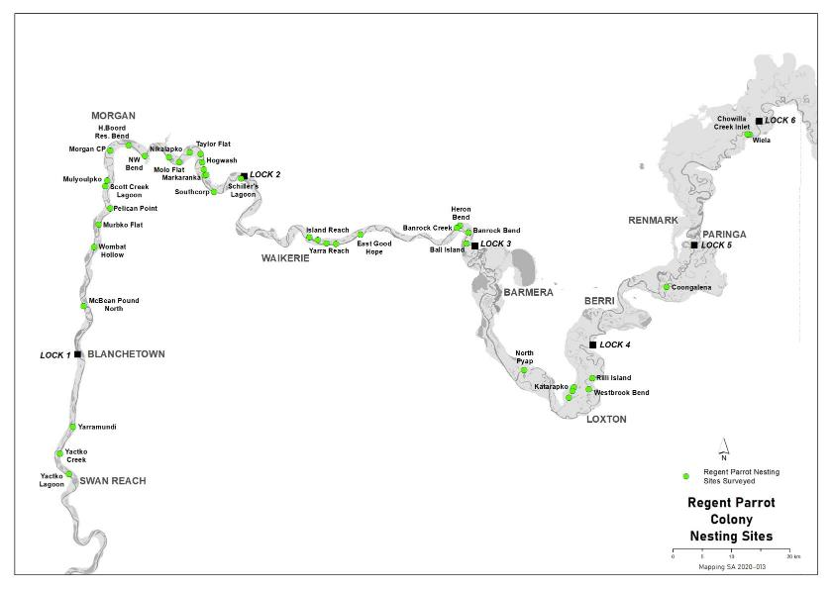

Location of Nesting Colonies and Groups of Colonies

Yatko Lagoon (Sugar Shack Creek Down Stream)

Geomorphic Category - Main Channel Edge

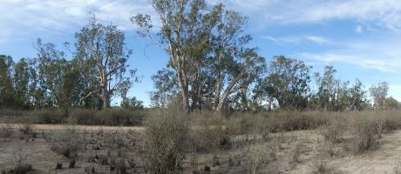

Regent Parrot Nesting Quality River Red Gum  River Red Gum Density - Linear and Open Woodland  River Red Gum Health Rating – Stressed (Level 3) | Understory Dominant Species and Health  Healthy Lignum, desiccated Tussock Grass

Stressor Analysis
Stressor | Severity | Scope | Irreversibility
Lack of Inundation | High | High | High
Kangaroo and Sheep Grazing | High | High | Medium

Yatko Creek (Sugar Shack Creek Upstream)

Geomorphic Category – Distribution Channel Edge and Main Channel Edge

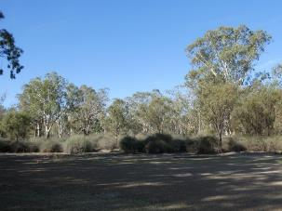 | Regent Parrot Nesting Quality River Red Gum  River Red Gum Density - Linear Woodland  River Red Gum Health Rating - Healthy (Level 5)  Understory Dominant Species and Health  Healthy Lignum, River Red Gum saplings. Cooba, adult and saplings. Spiny Sedge, Leafless Cherry.

Stressor Analysis
Stressor | Severity | Scope | Irreversibility
Kangaroo and Sheep Grazing | High | High | Medium
Yarramundi

Geomorphic Category – Interconnecting Depositional Basin Edge

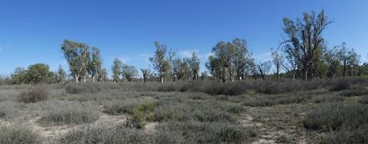

Regent Parrot Nesting Quality River Red Gum  River Red Gum Density – Sparse Woodland  River Red Gum Health Rating - Healthy (Level 4) | Understory Dominant Species and Health  Healthy dense Lignum, River Red Gum sapling, Saltbush spp., Creeping Saltbush, Pale Poverty Bush, Spiny Sedge, Grey Germander.

Stressor Analysis
Stressor | Severity | Scope | Irreversibility
Lack of Inundation | Medium | Low | High
Saline Groundwater Depth | Medium | Medium | High

McBean Pound North

Geomorphic Category – Main Channel Edge

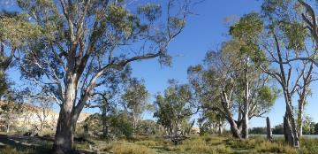

Regent Parrot Nesting Quality River Red Gum  River Red Gum Density – Linear Woodland  River Red Gum Health Rating - Healthy (Level 4) | Understory Dominant Species and Health  Healthy River Red Gum seedlings and poles /Smooth Heliotrope/Blue Rod/Spiny Sedge/Stinkwort/Star Thistle/odd Lignum/Yanga Bush

Stressor Analysis
Stressor | Severity | Scope | Irreversibility
Human Disturbance | High | Medium | High
Wombat Hollow (Murbpook)

Geomorphic Category – Main Channel Edge

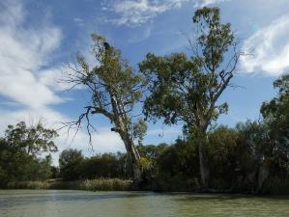 | Regent Parrot Nesting Quality River Red Gum  River Red Gum Density – Sparse Linear  River Red Gum Health Rating - Healthy (Level 4)  Understory Dominant Species and Health  Healthy Cooba/Prickly Bottlebrush /Western Boobialla/Floodplain Saltbush/Smooth Heliotrope/Ruby Saltbush/Yanga Bush

Stressor Analysis
Stressor | Severity | Scope | Irreversibility
Lack of Inundation | Low | High | Medium

Murbko Flat

Geomorphic Category – Distribution Channel Edge

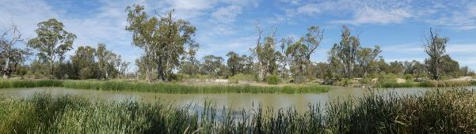

Regent Parrot Nesting Quality River Red Gum  River Red Gum Density – Sparse Woodland  River Red Gum Health Rating - Stressed (Level 3) | Understory Dominant Species and Health  Healthy Cooba/Western Boobialla/Lignum /River Red Gum seedlings /Spiny Sedge/Black Box seedlings/ Stinkwort/Smooth Heliotrope /Creeping Saltbush

Stressor Analysis
Stressor | Severity | Scope | Irreversibility
Lack of Inundation | Low | Medium | High
Human Disturbance | Low | Medium | High

Pelican Point

Geomorphic Category – Main Channel Edge

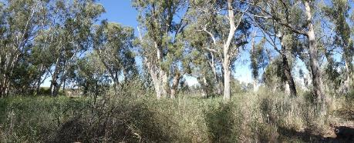

Regent Parrot Nesting Quality River Red Gum  River Red Gum Density – Forest  River Red Gum Health Rating - Healthy (Level 4) | Understory Dominant Species and Health  Healthy Phragmites/Lignum/Spiny Sedge/Smooth Heliotrope

Stressor Analysis
Direct Threat | Severity | Scope | Irreversibility
Bush Fire | Very High | Very High | High

Scott Creek Lagoon (Brenda Park)

Geomorphic Category – Deflation Basin Edge

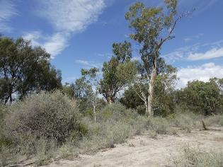 | Regent Parrot Nesting Quality River Red Gum  River Red Gum Density – Sparse Linear Woodland  River Red Gum Health Rating - Healthy (Level 5)  Understory Dominant Species and Health  Healthy Cooba, Lignum, Creeping Saltbush, Pale-Poverty Bush, Western Boobialla, Red Gum seedlings, Nitre Bush.

Stressor Analysis
Nil Stressors or Direct Threats Identified

Mulyoulpko (Brenda Park)

Geomorphic Category – Deflation Basin Edge

Regent Parrot Nesting Quality River Red Gum
River Red Gum Density – Sparse Linear Woodland
River Red Gum Health Rating - Healthy (Level 4)

Understory Dominant Species and Health
Healthy Cooba, Lignum, Red Gum saplings, Yanga Bush, Ruby Saltbush, Lagoon Saltbush

Stressor Analysis
Stressor | Severity | Scope | Irreversibility
Lack of Inundation | High | Medium | High
Saline Groundwater depth | High | Medium | High
Surface Soil Salinity | High | Medium | High

Morgan South Lagoon

Geomorphic Category – Deflation Basin Edge

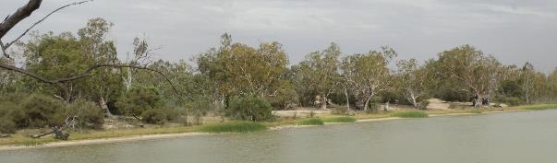

Regent Parrot Nesting Quality River Red Gum  River Red Gum Density – Open Woodland  River Red Gum Health Rating - Healthy (Level 4) | Understory Dominant Species and Health  Healthy River Red Gum seedlings and poles, Cooba adults and seedlings, Spiny Sedge, Purple Burr-daisy, Blue Rod, Smooth Heliotrope

Stressor Analysis
Stressor | Severity | Scope | Irreversibility
Lack of Inundation | High | High | Medium
Human Disturbance | Medium | Medium | Low

Morgan Lagoon Flood-out

Geomorphic Category – Deflation Basin Edge

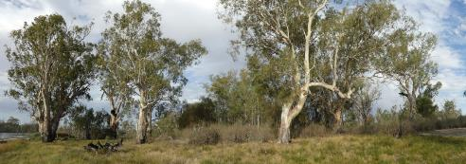

Regent Parrot Nesting Quality River Red Gum  River Red Gum Density – Open Woodland  River Red Gum Health Rating- Stressed (Level 3) | Understory Dominant Species and Health  Healthy River Red Gum seedlings and poles, Cooba adults and seedlings, Spiny Sedge, Native Liquorice, Purple Burr-daisy, Blue Rod, Smooth Heliotrope

Stressor Analysis
Stressor | Severity | Scope | Irreversibility
Lack of Inundation | Medium | Medium | Medium
Human Disturbance | Medium | Medium | Low

Morgan North East)

Geomorphic Category – Main Channel Edge

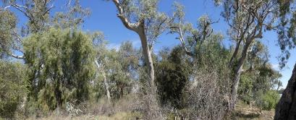

Regent Parrot Nesting Quality River Red Gum  River Red Gum Density – Linear Woodland  River Red Gum Health Rating-Healthy (Level 4) | Understory Dominant Species and Health  Heathy Lignum/Prickly Bottle Brush/Spiny Sedge/Ruby Saltbush/Cooba and saplings/River Red Gum saplings/Western Boobialla/Purple Burr-daisy/Native Willow

Stressor Analysis
Stressor | Severity | Scope | Irreversibility
Lack of Inundation | Medium | Medium | Medium
Flow Barrier | Medium | High | Medium

H Boord Reserve Bend

Geomorphic Category –Chute Channel and Main Channel Edge

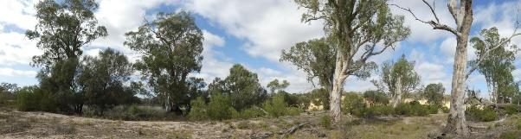

Regent Parrot Nesting Quality River Red Gum  River Red Gum Density – Sparely Linear Woodland  River Red Gum Health Rating - Healthy (Level 4) | Understory Dominant Species and Health  Heathy Spiny Sedge, Lignum, Native Liquorice, Creeping Saltbush, Smooth Heliotrope, Rat's-Tail Couch

Stressor Analysis
Nil Stressors or Direct Threats Identified

Nikalapko Lagoon

Geomorphic Category – Deflation Basin Edge

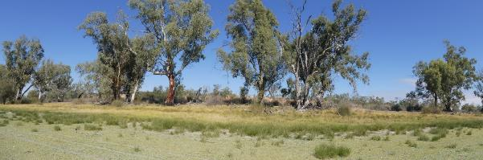

Regent Parrot Nesting Quality River Red Gum  River Red Gum Density – Linear Woodland  River Red Gum Health Rating - Healthy (Level 5) | Understory Dominant Species and Health  Heathy Spiny Sedge, Lignum, Native Liquorice, Creeping Saltbush, Smooth Heliotrope, Rat's-Tail Couch

Stressor Analysis
Nil Stressors or Direct Threats Identified

Molo Flat

Geomorphic Category – Flood-out and Main Channel Edge

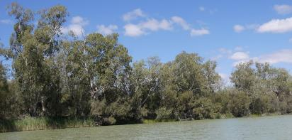

Regent Parrot Nesting Quality River Red Gum  River Red Gum Density – Linear Woodland  River Red Gum Health Rating - Healthy (Level 5) | Understory Dominant Species and Health  Healthy Cooba, Lignum, Red Gum Saplings, Common Sneezeweed, Hairy Carpet-weed, Lesser Joyweed

Stressor Analysis
Nil Stressors or Direct Threats Identified

Taylor Flat West

Geomorphic Category –Distribution Channel Delta

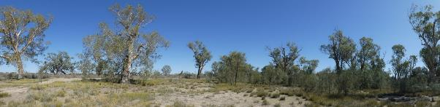

Regent Parrot Nesting Quality River Red Gum  River Red Gum Density – Sparse Woodland  River Red Gum Health Rating-Healthy (Level 4) | Understory Dominant Species and Health  Healthy Cooba (adults and saplings), River Red Gum seedlings, Lignum, Spiny Sedge, Rat's-Tail Couch, Native Liquorice, Lippia, Purple Burr-daisy, River Blue Bell, Swamp Daisy, Grey Germander, Blue Rod, Star Thistle, California Burr

Stressor Analysis
Stressor | Severity | Scope | Irreversibility
Lack of Inundation | Low | Medium | High
Saline Groundwater depth | Low | Medium | High

Taylor Flat Outlet Creek

Geomorphic Category – Distribution Channel

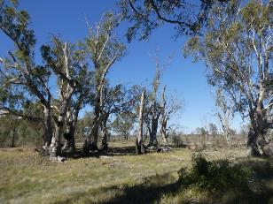 | Regent Parrot Nesting Quality River Red Gum  River Red Gum Density –Open Woodland  River Red Gum Health Rating-Healthy  (Level 4)  Understory Dominant Species and Health  Healthy Spiny Sedge, Red Gum saplings, Smooth Heliotrope, Western Boobialla, Blue Rod, California Burr, Creeping Saltbush, Grey Germander, odd Lignum

Stressor Analysis
Stressor | Severity | Scope | Irreversibility
Lack of Inundation | Low | Medium | Low
Saline Groundwater Depth | Low | Medium | Low

Taylor Flat

Geomorphic Category –Deflation Basin

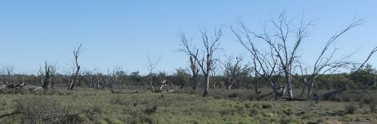

Regent Parrot Nesting Quality River Red Gum  River Red Gum Density – Open Woodland  River Red Gum Health Rating–Degraded (Level 0) | Understory Dominant Species and Health  Long lived species medium to poor. Cooba (adults and saplings), River Red Gum seedlings, Lignum, Spiny Sedge, Rat's-Tail Couch, Native Liquorice, Lippia, Purple Burr-daisy, Grey Germander, Blue Rod,

Stressor Analysis
Stressor | Severity | Scope | Irreversibility
Lack of Inundation | Very High | Very High | High
Saline Groundwater Depth | Very High | Very High | High
Surface Soil Salinity | High | High | High

Markaranka Flat

Geomorphic Category – Flood-out

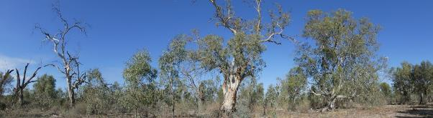

Regent Parrot Nesting Quality River Red Gum  River Red Gum Density – Open Woodland  River Red Gum Health Rating– Stressed (Level 3) | Understory Dominant Species and Health  Healthy River Red Gum saplings and poles, Cooba adults and saplings, Lignum, Spiny Sedge, Smooth Heliotrope, Native Liquorice, Creeping Saltbush, Lagoon Saltbush, Bladder Saltbush

Stressor Analysis
Stressor | Severity | Scope | Irreversibility
Lack of Inundation | Very High | High | Medium
Saline Groundwater Depth | Low | High | Medium

Markaranka Flat Channel

Geomorphic Category – Chute Channel

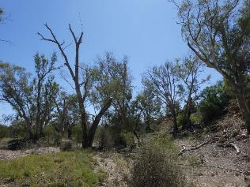 | Regent Parrot Nesting Quality River Red Gum  River Red Gum Density –Open Woodland  River Red Gum Health Rating- Stressed (Level 3)  Understory Dominant Species and Health  River Red Gum saplings, Lignum, Blue Rod, Spiny Sedge, Cooba adult saplings, Ruby Saltbush, Lagoon Saltbush, Yanga Bush

Stressor Analysis
Stressor | Severity | Scope | Irreversibility
Lack of Inundation | Very High | High | Low
Saline Groundwater Depth | Low | High | Low

Hogwash Conservation Park

Geomorphic Category – Bar Platform

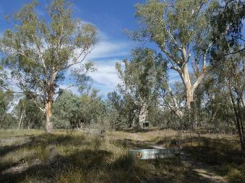 | Regent Parrot Nesting Quality River Red Gum  River Red Gum Density – Open Woodland  River Red Gum Health Rating- Stressed (Level 3)  Understory Dominant Species and Health  Healthy River Red Gum saplings, Lignum, odd Cooba, odd Black Box,, Creeping Saltbush, Spiny Sedge, Grey Germander, Native Liquorice, Lippia, Tussock Grass, Rat’s-Tail Couch

Stressor Analysis
Stressor | Severity | Scope | Irreversibility
Lack of Inundation | Medium | Medium | Medium
Human Disturbance | High | High | Medium

Hogwash Council Area

Geomorphic Category – Flood-out

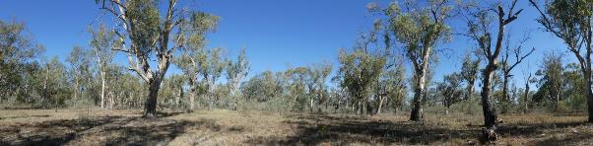

Regent Parrot Nesting Quality River Red Gum  River Red Gum Density – Open Woodland  River Red Gum Health Rating–Healthy (Level 4) | Understory Dominant Species and Health  Healthy River Red Gum saplings, Lignum, odd Cooba, Lagoon Saltbush, Creeping Saltbush, Spiny Sedge, Grey Germander, Native Liquorice, Lippia, Tussock Grass, Smooth Heliotrope, Rat’s-Tail Couch

Stressor Analysis
Stressor | Severity | Scope | Irreversibility
Lack of Inundation | High | High | Medium
Human Disturbance | High | High | Medium

Markaranka Lagoon Outlet Channel

Geomorphic Category – Distribution Channel and main Channel Edge

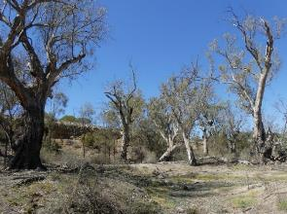 | Regent Parrot Nesting Quality River Red Gum  River Red Gum Density – Open Woodland  River Red Gum Health Rating-Stressed  (Level 3)  Understory Dominant Species and Health  Unhealthy River Red Gum saplings and poles (poles mostly dead), Cooba adult saplings, Lignum, Creeping Saltbush, Lagoon Saltbush, Ruby Saltbush, Smooth Heliotrope, Blue Rod, Native Liquorice, Bladder Saltbush, Pale Poverty Bush

Stressor Analysis
Stressor | Severity | Scope | Irreversibility
Lack of Inundation | Very High | High | Low
Saline Groundwater Depth | High | High | Low

Markaranka River Flood-out

Geomorphic Category – Flood-out

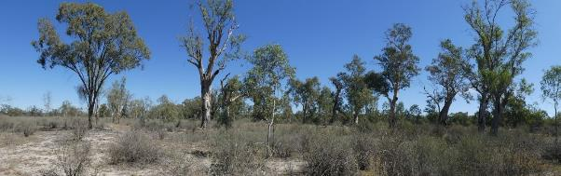

Regent Parrot Nesting Quality River Red Gum  River Red Gum Density – Open Woodland  River Red Gum Health Rating– Stressed (Level 3) | Understory Dominant Species and Health  Healthy River Red Gum saplings and poles, Black Box adults and saplings, odd Cooba, Lignum, Creeping Saltbush, Lagoon Saltbush, Ruby Saltbush, Native Liquorice (inland depression is dominated by Lignum with odd River Red Gum, Black Box and Cooba)

Stressor Analysis
Stressor | Severity | Scope | Irreversibility
Lack of Inundation | High | High | Medium
Flow Barrier | Medium | Medium | Low

Markaranka Lagoon Main River Channel

Geomorphic Category – Main Channel Edge

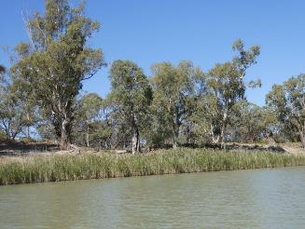 | Regent Parrot Nesting Quality River Red Gum  River Red Gum Density – Linear Woodland  River Red Gum Health Rating-Healthy  (Level 4)  Understory Dominant Species and Health  Healthy Lignum, Cooba, Ruby Saltbush, Lagoon Saltbush, Yanga Bush, Spiny Sedge

Stressor Analysis
Stressor | Severity | Scope | Irreversibility
Lack of Inundation | Low | Low | High

Markaranka Lagoon

Geomorphic Category – Distribution Channel Edge

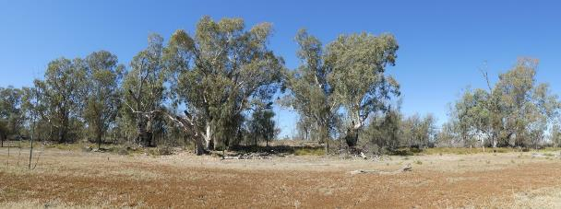

Regent Parrot Nesting Quality River Red Gum  River Red Gum Density – Linear Woodland  River Red Gum Health Rating–Healthy (Level 5) | Understory Dominant Species and Health  Healthy odd Lignum, Cooba, Lagoon, Spiny Sedge, Native Liquorice, Rat’s-Tail Couch

Stressor Analysis
Stressor / Direct Threat | Severity | Scope | Irreversibility
Flow Barrier | Medium | High | Medium

Schiller Lagoon

Geomorphic Category – Interconnecting Depositional Basins Edge

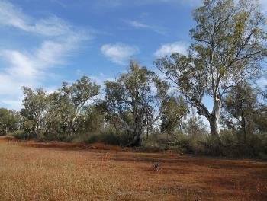 | Regent Parrot Nesting Quality River Red Gum  River Red Gum Density – Open Woodland  River Red Gum Health Rating-Healthy  (Level 4). Stressed on peninsular (Level 3)  Understory Dominant Species and Health  Healthy Cooba adults and saplings, River Red Gum saplings, Lignum, Spiny Sedge, Native Liquorice, Creeping Saltbush, Grey Germander, Spreading Emu Bush

Stressor Analysis
Stressor | Severity | Scope | Irreversibility
Lack of Inundation | Medium | Medium | Low
Saline Groundwater Depth | Medium | Medium | Low

Little Schiller Lagoon

Geomorphic Category – Interconnecting Depositional Basins Edge

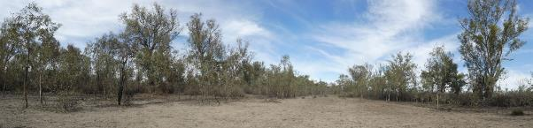

Regent Parrot Nesting Quality River Red Gum  River Red Gum Density – Linear Woodland  River Red Gum Health Rating– Stressed (Level 3) | Understory Dominant Species and Health  Healthy River Red Gum adults and saplings, odd Black Box, Cooba adults and saplings, Lignum, Spiny Sedge, Lagoon Saltbush

Stressor Analysis
Stressor | Severity | Scope | Irreversibility
Lack of Inundation | High | High | Low
Saline Groundwater depth | High | High | Low

Island Reach

Geomorphic Category – Distribution Channel and Main Channel Edge

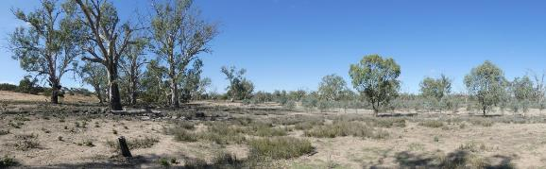

Regent Parrot Nesting Quality River Red Gum  River Red Gum Density – Linear and Sparse Woodland  River Red Gum Health Rating– Stressed (Level 3) Main Channel (Level 4) | Understory Dominant Species and Health  Healthy River Red Gum and Black Box saplings, Spiny Sedge, Rat's-Tail Couch, Lippia, Ruby Saltbush, odd Lignum, Tussock Grass

Stressor Analysis
Stressor / Direct Threat | Severity | Scope | Irreversibility
Lack of Inundation | High | High | High
Saline Groundwater Depth | High | High | High

Yarra Point

Geomorphic Category – Distribution Channel and Main Channel Edge

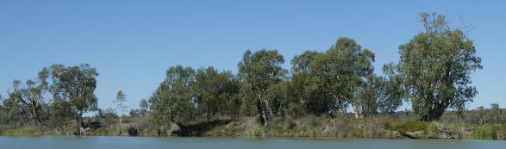

Regent Parrot Nesting Quality River Red Gum  River Red Gum Density – Linear and Sparse Woodland  River Red Gum Health Rating–Healthy (Level 4) | Understory Dominant Species and Health  Healthy River Red Gum Saplings, Lignum, Cooba, odd adult poles, saplings, Native Liquorice

Stressor Analysis
Stressor / Direct Threat | Severity | Scope | Irreversibility
Lack of Inundation | Low | Low | High

Yarra View

Geomorphic Category – Main Channel Edge

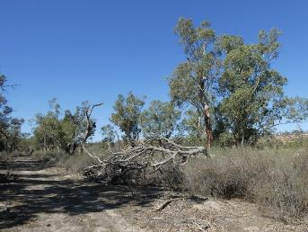 | Regent Parrot Nesting Quality River Red Gum  River Red Gum Density – Linear Woodland  River Red Gum Health Rating-Healthy  (Level 4)  Understory Dominant Species and Health  Healthy Lignum dominant, River Red Gum and Cooba saplings, Creeping Saltbush, Ruby Saltbush, Lagoon Saltbush, Pale Poverty Bush, Spiny Sedge, Blue Rod

Stressor Analysis
Stressor / Direct Threat | Severity | Scope | Irreversibility
Lack of Inundation | Low | Low | High

Yarra Reach

Geomorphic Category – Main Channel Edge

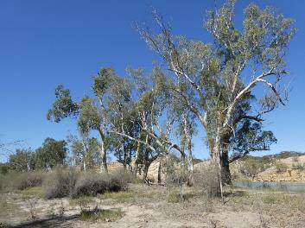 | Regent Parrot Nesting Quality River Red Gum  River Red Gum Density – Linear Woodland  River Red Gum Health Rating-Healthy  (Level 4)  Understory Dominant Species and Health  Healthy, Lignum, River Red Gum sapling, Spiny Sedge, Ruby Saltbush, Creeping Saltbush, Blue Rod, Native Liquorice, Pale Poverty Bush, Purple Burr-daisy

Stressor Analysis
Stressor / Direct Threat | Severity | Scope | Irreversibility
Lack of Inundation | Low | Low | High

East Good Hope

Geomorphic Category – Main Channel Edge

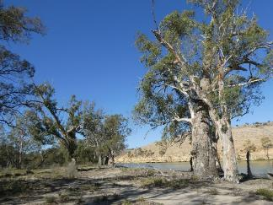 | Regent Parrot Nesting Quality River Red Gum  River Red Gum Density – Linear Woodland  River Red Gum Health Rating-Healthy  (Level 4)  Understory Dominant Species and Health  Healthy Odd lignum, Cooba adult and saplings, Spiny Sedge, Ruby Saltbush, Purple Burr-daisy

Stressor Analysis
Stressor / Direct Threat | Severity | Scope | Irreversibility
Lack of Inundation | Low | Low | High

Banrock Creek

Geomorphic Category – Distribution Channel and Main Channel Edge

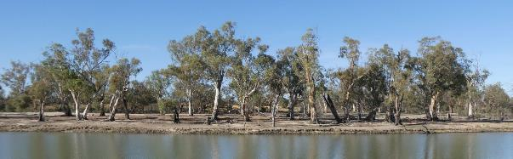

Regent Parrot Nesting Quality River Red Gum  River Red Gum Density – Linear Woodland  River Red Gum Health Rating–Healthy (Level 4) | Understory Dominant Species and Health  Healthy River Red Gum saplings, odd adult Cooba, Lignum outer edge, Smooth Heliotrope, Native Liquorice, Rat's-Tail Couch, Grey Germander

Stressor Analysis
Stressor | Severity | Scope | Irreversibility
Lack of Inundation | Medium | High | High
High Kangaroo Numbers | Medium | Medium | Low

Heron Bend

Geomorphic Category – Bar Platform

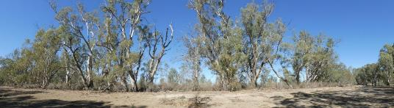

Regent Parrot Nesting Quality River Red Gum  River Red Gum Density – Open Forest and Woodland River Red Gum Health Rating– Stressed (Level 3) | Understory Dominant Species and Health  Healthy River Red Gum saplings, Lignum. Lagoon floor - Smooth Heliotrope, Lagoon Saltbush, Creeping Saltbush, Pale Poverty Bush

Stressor Analysis
Stressor | Severity | Scope | Irreversibility
Lack of Inundation | High | High | Medium
Saline Groundwater Depth | High | High | Medium
High Kangaroo Numbers | Medium | Medium | Low

Banrock Bend

Geomorphic Category – Bar Platform

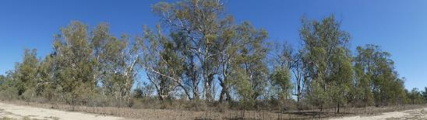

Regent Parrot Nesting Quality River Red Gum  River Red Gum Density – Open Forest and Woodland  River Red Gum Health Rating– Stressed (Level 3) | Understory Dominant Species and Health  Healthy dominated by Lignum. River Red Gum and saplings, Cooba adults and saplings, Smooth Heliotrope, Creeping Saltbush, Pale Poverty Bush

Stressor Analysis
Stressor | Severity | Scope | Irreversibility
Lack of Inundation | High | High | Medium
Saline Groundwater Depth | High | High | Medium
High Kangaroo Numbers | Medium | Medium | Low

Ball Island

Geomorphic Category – Main Channel Edge and Island
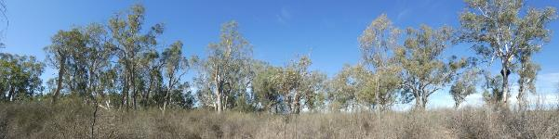

Regent Parrot Nesting Quality River Red Gum  River Red Gum Density – Open Woodland  River Red Gum Health Rating– Stressed (Level 3) | Understory Dominant Species and Health  Healthy Lignum, Spiny Sedge, Blue Rod, Smooth Heliotrope, Creeping Boobialla, Smooth Heliotrope, Pale Poverty Bush

Stressor Analysis
Stressor | Severity | Scope | Irreversibility
Lack of Inundation | High | Medium | High
Saline Groundwater Depth | High | Medium | High

North Pyap

Geomorphic Category – Main Channel Edge

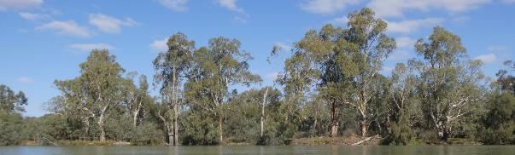

Regent Parrot Nesting Quality River Red Gum  River Red Gum Density – Linear Woodland  River Red Gum Health Rating–Healthy (Level 4) | Understory Dominant Species and Health  Healthy Lignum, River Red Gum sapling, Blue Rod, Creeping Boobialla, Native Liquorice, Creeping Saltbush, odd Smooth Heliotrope plant

Stressor Analysis
Stressor | Severity | Scope | Irreversibility
Lack of Inundation | High | Medium | High
Saline Groundwater Depth | High | Medium | High

Katarapko Creek Campsite 47 )

Geomorphic Category – Main Channel Edge

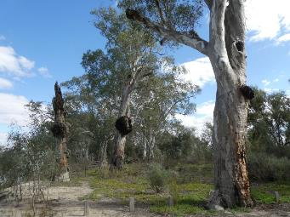 | Regent Parrot Nesting Quality River Red Gum  River Red Gum Density – Open Woodland  River Red Gum Health Rating–Healthy (Level 5)  Understory Dominant Species and Health  Healthy Patches River Red Gum saplings. Patches of Nitre Bush adults and seedlings. Odd Lignum. Creeping Boobialla, Blue Rod.

Stressor Analysis
Stressor | Severity | Scope | Irreversibility
Human Disturbance | High | Medium | Medium

Katarapko Creek North South

Geomorphic Category – Distribution Channel Edge

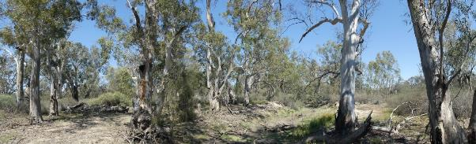

Regent Parrot Nesting Quality River Red Gum  River Red Gum Density – Open Woodland  River Red Gum Health Rating–Healthy (Level 4) | Understory Dominant Species and Health  Healthy Odd River Red Gum sapling, Cooba adults and saplings. Tall Groundsel. Lignum and patches Nitre Bush. Ruby Saltbush. Spreading Emu Bush. Atriplex spp.

Stressor Analysis
Stressor | Severity | Scope | Irreversibility
Flow Barriers | Medium | Medium | Medium
High Kangaroo Numbers | High | High | Medium

Katarapko Creek Campsite 45

Geomorphic Category – Main Channel Edge and Flood-out

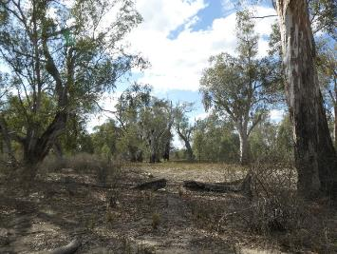 | Regent Parrot Nesting Quality River Red Gum  River Red Gum Density – Open Woodland  River Red Gum Health Rating–Healthy (Level 4)  Understory Dominant Species and Health  Healthy River Red Gum Saplings, Lignum, Blue Rod, Creeping Boobialla

Stressor Analysis
Stressor | Severity | Scope | Irreversibility
Lack of Inundation | Medium | Medium | Medium
Human Disturbance | High | Medium | Medium

Katarapko Creek Campsite closed (previously campsite 25)

Geomorphic Category – Flood-out

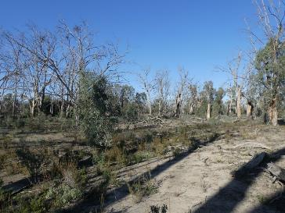 | Regent Parrot Nesting Quality River Red Gum  River Red Gum Density – Open Woodland  River Red Gum Health Rating–Degraded (Level 0)  Understory Dominant Species and Health  Healthy Odd River Red Gum poles and saplings. Bladder Saltbush, Nitre Bush adult and seedlings. Blue Rod. Creeping Saltbush, Smoot Heliotrope, Atriplex spp.

Stressor Analysis
Stressor | Severity | Scope | Irreversibility
Lack of Inundation | Very High | Very High | High
Saline Groundwater depth | Very High | Very High | High

Westbrook Bend

Geomorphic Category – Flood-out

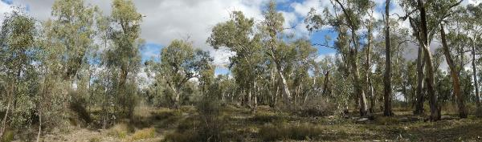

Regent Parrot Nesting Quality River Red Gum  River Red Gum Density – Open Woodland  River Red Gum Health Rating– Stressed (Level 3) | Understory Dominant Species and Health  Healthy Lignum patches, odd Spreading Emu Bush, Cooba adults and saplings, River Red Gum saplings, Creeping Saltbush, desiccated Tussock Grass, Smooth Heliotrope, Lagoon Saltbush, Atriplex spp. Creeping Saltbush

Stressor Analysis
Stressor | Severity | Scope | Irreversibility
Lack of Inundation | High | Medium | Medium
Saline Groundwater Depth | High | Medium | Medium
Human Disturbance | Medium | Low | Medium

Rilli Island

Geomorphic Category – Main Channel Edge and Island

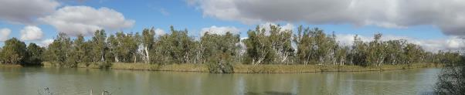

Regent Parrot Nesting Quality River Red Gum  River Red Gum Density – Open Woodland  River Red Gum Health Rating–Healthy –(Level 4) Centre of Island Stressed (Level 2) | Understory Dominant Species and Health  Healthy Lignum, Phragmites, River Red Gum poles and saplings. Cooba adults and saplings

Stressor Analysis
Stressor | Severity | Scope | Irreversibility
Lack of Inundation | High | Medium | High
Saline Groundwater Depth | High | Medium | High

Coongalena

Geomorphic Category – Main Channel Edge

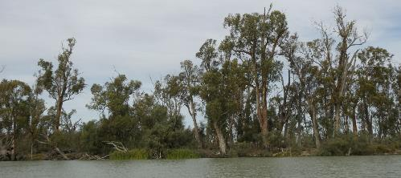

Regent Parrot Nesting Quality River Red Gum  River Red Gum Density – Linear Woodland  River Red Gum Health Rating– Stressed (Level 3) | Understory Dominant Species and Health  Healthy River Red Gum saplings, Blue Rod, Bushy Groundsel, Smooth Heliotrope

Stressor Analysis
Stressor | Severity | Scope | Irreversibility
Lack of Inundation | High | High | High
Saline Groundwater Depth | High | High | High

Wiela
Geomorphic Category – Main Channel Edge and Island

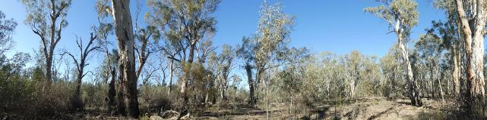

Regent Parrot Nesting Quality River Red Gum  River Red Gum Density – Open Woodland  River Red Gum Health Rating–Healthy –(Level 4) | Understory Dominant Species and Health  Healthy Scattered River Red Gum saplings, Tall Groundsel, Lignum on edges, odd Cooba adult, odd Spreading Emu Bush, odd Nitre Bush, Native Liquorice, Creeping Boobialla

Stressor Analysis
Stressor | Severity | Scope | Irreversibility
Lack of Inundation | Medium | Medium | Medium

Chowilla Creek Inlet

Geomorphic Category – Main Channel Edge

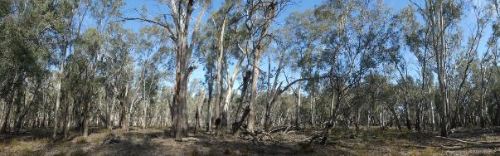
Downstream Site

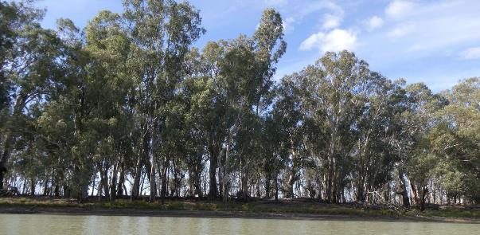
Upstream Site

Regent Parrot Nesting Quality River Red Gum  River Red Gum Density – Forest  River Red Gum Health Rating–Healthy  (Level 4) | Understory Dominant Species and Health  Healthy Bushy Groundsel, Blue Rod

Stressor Analysis
Stressor | Severity | Scope | Irreversibility
Lack of Inundation | Low | Low | High

Table of Coordinates and Direction of Each Site’s Reference Photograph
Nest Colonies | Latitude | Longitude | Direction
Ball Island | 3411087 | 14020538 | 130
Banrock Bend | 3410179 | 14020969 | 250
Banrock Creek | 3409946 | 14008292 | 156
Chowilla Creek Inlet (Upstream Site) | 3401079 | 14052478 | 50
Chowilla Creek Inlet (Downstream Site) | 3401070 | 14052004 | 180
Coongalena | 3415146 | 14042783 | 120
East Good Hope | 3410112 | 14008938 | 90
H. Boord Reserve Bend | 3402704 | 13944691 | 244
Heron Bend | 3409332 | 14019887 | 170
Hogwash Conservation Park | 3404000 | 13951167 | 170
Hogwash Council Area | 3403999 | 13951276 | 148
Island Reach | 3410210 | 14003130 | 160
Katarapko Creek Campsite Closed (previously 25) | 3424265 | 14032819 | 180
Katarapko Creek Campsite 45 (previously 30) | 3424620 | 14032339 | 64
Katarapko Creek North South (previously 30) | 3424791 | 14032162 | 220
Katarapko Creek Campsite 47 (previously campsite 31) | 3425444 | 14031870 | 264
Markaranka Flat | 3403282 | 13951152 | 190
Markaranka Flat B/W | 3403889 | 13951384 | 350
McBean Pound North | 3416431 | 13937657 | 340
Markaranka Lagoon (South Corp Flat) | 3404604 | 13951573 | 80
Markaranka Lagoon Outlet Channel (South Corp Flat) | 3404165 | 13951538 | 96
Markaranka Main River Channel (South Corp Flat) | 3405279 | 13951404 | 84
Markaranka River Flood-out (South Corp Flat) | 3404500 | 13951416 | 240
Molo Flat | Taken from boat
Morgan Conservation Park South Lagoon | 3402336 | 13940845 | 130
Morgan Conservation Park North Lagoon | 3402031 | 13940999 | 62
Mulyoulpko (Brenda Park) | 3404958 | 13940486 | 40
Murbko Flat | 3408871 | 13939517 | 208
Nikalapko Lagoon | 3402799 | 13947481 | 230
North Pyap | 3422766 | 14026846 | 148
North West Bend (Morgan East) | 3401616 | 13942911 | 240
Pelican Point | 3414414 | 14031989 | 180
Rilli Island | 3423513 | 14034693 | 160
Schiller Lagoon | 3404910 | 13955555 | 284
Schiller Lagoon (Little Schiller Lagoon) | 3404850 | 13955551 | 236
Scott Creek (Brenda Park) | 3405401 | 13940321 | 200
Taylor Flat | 3402619 | 13950958 | 340
Taylor Flat West | 3402473 | 13949724 | 192
Taylor Flat West Downstream Outlet Creek | 3402313 | 13949845 | 76
Westbrook Bend | 3423816 | 14033946 | 210
Wiela | 3401054 | 14052194 | 136
Wombat Hollow (Murbpook) | 3411606 | 13938822
Yatko Lagoon (Sugar Shack Creek Downstream) | 3432104 | 13935760 | 60
Yatko Creek (Sugar Shack Upstream) | 3430178 | 13934801 | 70
Yarra Reach | 3410997 | 14005967 | 98
Yarra View | 3410927 | 14004529 | 96
Yarramundi | 3427789 | 13936355 | 270

Appendix 3 Regent Parrot Nest Survey Methods
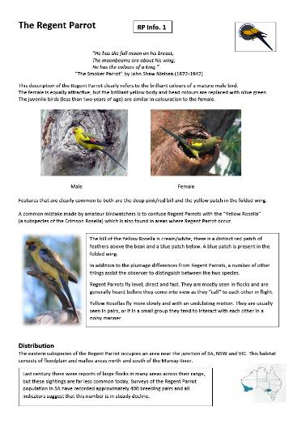 | 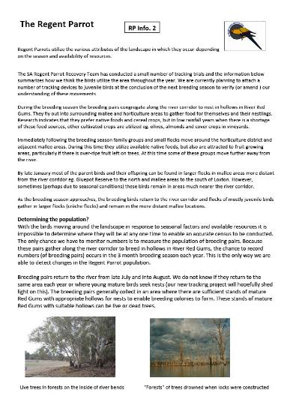

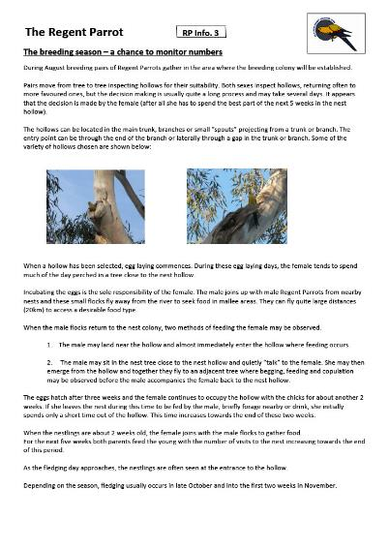 | 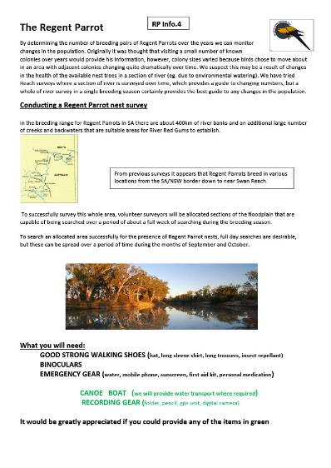

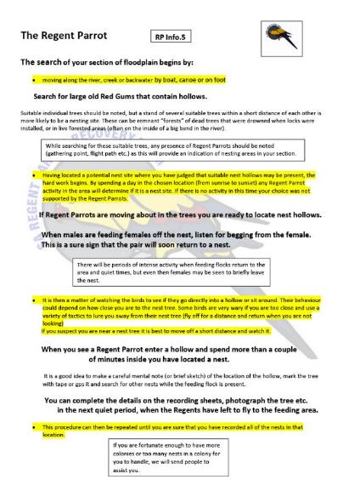 | 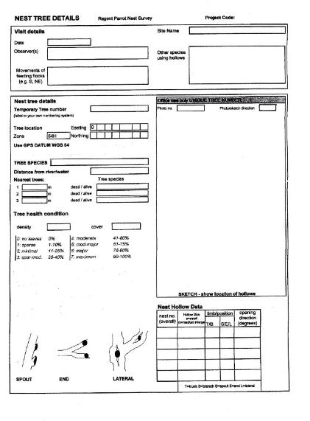

Appendix 4 Infrastructure Requirement Assumptions
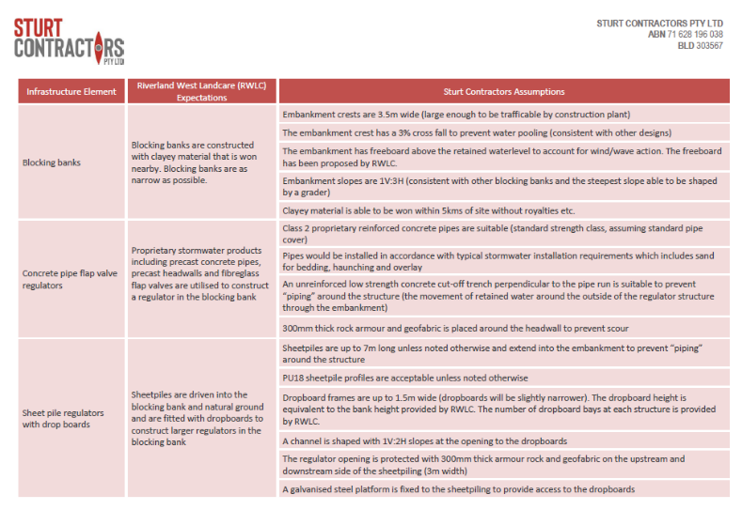
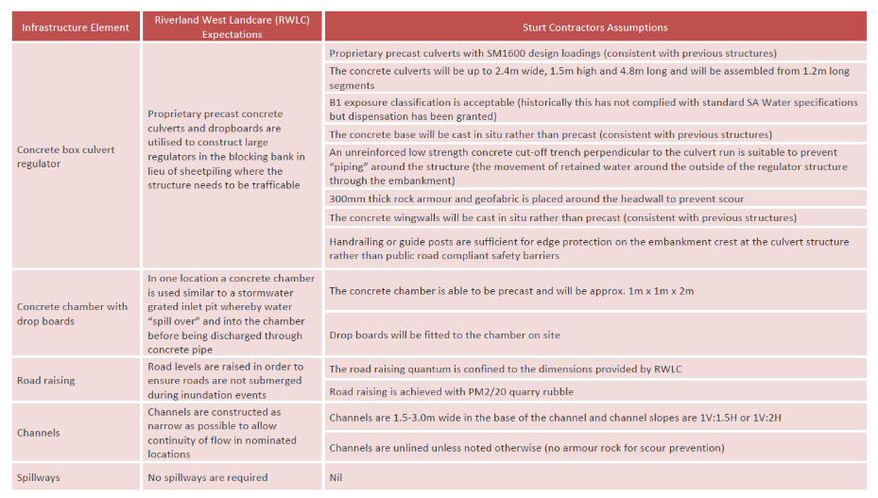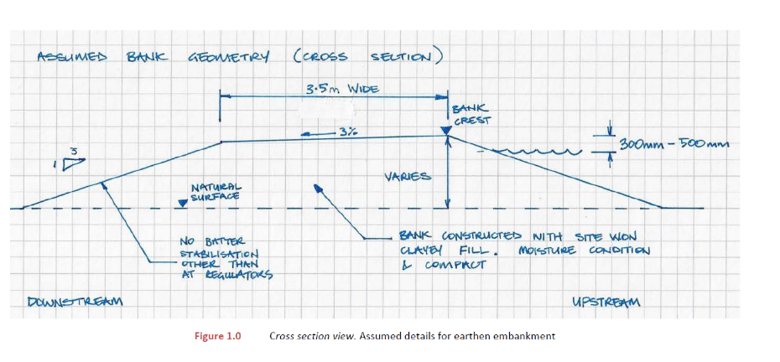

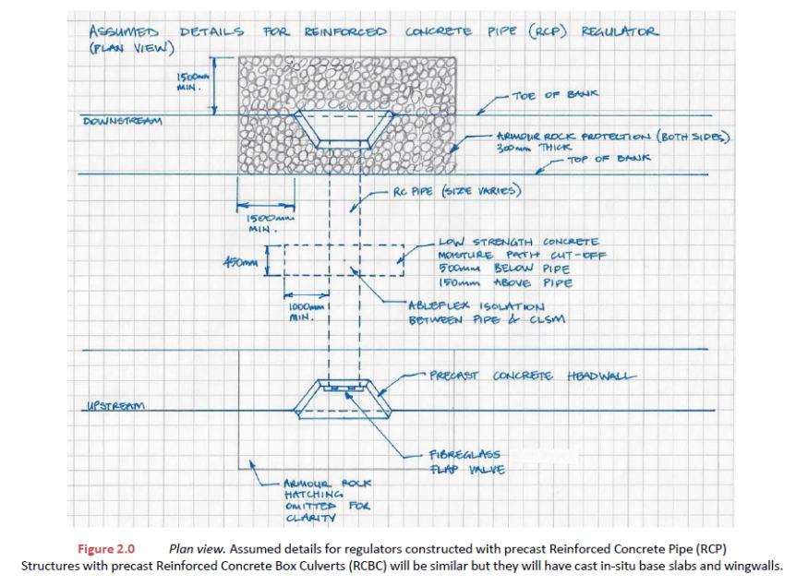

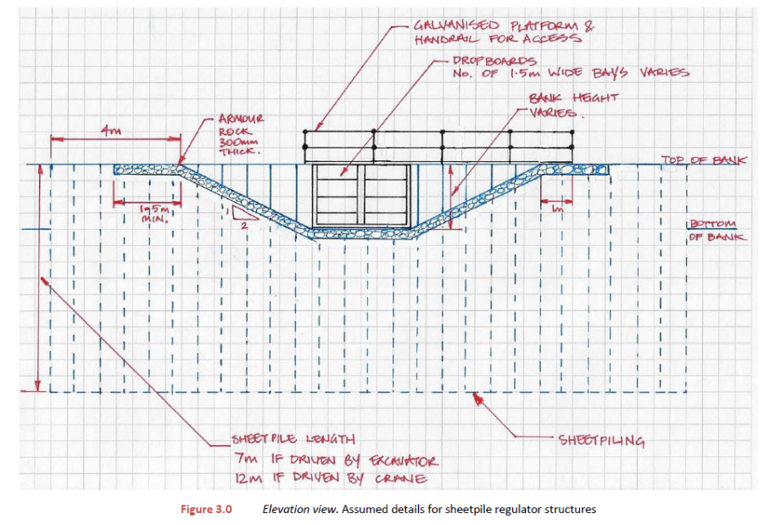

Appendix 5 Plant List

 | Common Name | Scientific Name
 | Atriplex spp. | Atriplex spp.
 | Bassia spp. | Bassia spp.
 | Bignonia Emu Bush | Eremophila bignoniflora
 | Black Box | Eucalyptus largiflorens
 | Black Roly Poly | Bassia quinquecuspis
 | Bladder Saltbush | Atriplex vesicaria
 | Blown Grass | Agrostis aemula
 | Blue Rod | Morgania floribunda
 | Bushy Groundsel | Senecio cunninghamii
* | California Burr | Xanthium orientale
* | Clover spp. | Medicago spp.
 | Common Joyweed | Alternanthera nodiflora
 | Common Reed | Phragmites australis
 | Common Sneezeweed | Centipeda cunninghamii
 | Common Spike-rush | Eleocharis acuta
 | Cooba | Acacia stenophylla
 | Creeping Boobialla | Myoporum parvifolium
 | Creeping Saltbush | Atriplex semibaccata
 | Cumbungi | Typha spp.
* | Curled Dock | Rumex crispus
 | Darling Pea | Swainsona greyana
 | Dirty Dora | Cyperus difformis
 | Giant Sedge | Cyperus exaltatus
 | Golden Dodder | Cuscuta campestris
 | Grey Germander | Teucrium racemosum
 | Hairy Carpet-weed | Glinus lotoides
* | Hexham Scent | Melilotu indica
 | Ice-plant spp | Mesembryanthemum spp.
 | Jersey Cudweed | Gnaphalium luteo-album
 | Lagoon Saltbush | Atriplex suberecta
 | Leafless Cherry | Exocarpos aphyllus
 | Lesser Joyweed | Alternanthera denticulata
 | Lignum | Muehlenbeckia florulentai
* | Lippia | Phyla nodiflora
 | Maireana spp. | Maireana spp.
 | Nardoo | Marsilea drummondii
 | Native Leek | Bulbinopsis bulbosa
* | Native Leek | Bulbinopsis alata
 | Native Liquorice | Glycyrrhiza acanthocarpa
 | Native Willow | Acacia salicina
 | Nitre Bush | Chenopodium nitrariaceum
 | Pale Knotweed | Polygonum lapathifolium
 | *Introduced
 | Common Name | Scientific Name
 | Pale Poverty Bush | Bassia divaricata
 | Pig Face | Disphyma spp.
 | Prickly Bottle Brush | Callistemon brachyandrus
 | Purple Burr-daisy | Calotis cuneifolia
 | Rat's-Tail Couch | Sporobolus mitchelli
 | Red Water Milfoil | Myriophyllum verrucosum
 | River Blue Bell | Wahlenbergia fluminalis
 | River Red Gum | Eucalyptus camaldulensis
 | Roly-Poly spp. | Brassia spp.
 | Ruby Saltbush | Enchylaena tomentosa
 | Salt Bush spp. | Atriplex spp.
 | Samphire | Arthrocnemum spp.
 | Short-winged Copperburr | Bassia brachyptera
 | Slender Knotweed | Polygonum decipiens
 | Small Monkey Flower | Mimulus prostatus
 | Smooth Heliotrope | Heliotropium curassavicum*
 | Spiny Sedge | Cyperus gymnocaulos
 | Spreading Emu Bush | Eremophila divaricata
* | Star Thistle | Centaurea calcitrapa
* | Stinkwort | Dittrichia graveolens
 | Swamp Daisy | Brachycome basaltica
 | Tall Groundsel | Senecio runcinifolius
 | Tussock Rush | Jucus spp.
 | Water Primrose | Ludwigia peploide
 | Western Boobialla | Myoporum montanum
 | Yanga Bush | Maireana brevifolia
* | Yellow-Flowered Devil's Claw | Ibicella lutea
 | *Introduced

Appendix 6 Management Briefs

A Site Management Brief has been developed for each of the 43 potential water for the environment sites. Only 29 Management Briefs have been developed because related sites are included in the same Brief, for example, Hogwash Bend includes four individual sites.

1 Banrock Bend Management Brief 136
2 Gerard/Katarapko Lagoon Management Brief 141
3 Heron Bend Management Brief 145
4 Hogwash Bend Management Brief 149
5 Holder Lagoon Management Brief 158
6 Katarapko Creek Management Brief 165
7 Katarapko Island North Management Brief 174
8 Katarapko River Flood-out Management Brief 181
9 Little Schiller Lagoon Management Brief 184
10 Loveday 4 x 4 Lagoon Management Brief 188
11 Markaranka Flat Management Brief 192
12 Markaranka Management Brief 197
13 Markaranka Lagoon Management Brief 202
14 Molo Flat Management Brief 207
15 Morgan South Management Brief 211
16 Morgan North Management Brief 217
17 Murbpook Lagoon Management Brief 226
18 North West Bend Management Brief 231
19 Overland Corner Management Brief 236
20 Paschkes Flat Management Brief 243
21 Putjeda Creek Lagoons Management Brief 247
22 Pyap Bend Management Brief 254
23 Sugar Shack Upstream Lagoon Management Brief 259
24 Taylor Flat Management Brief 265
25 Westbrooks Management Brief 270
26 Weston Flat Lagoon Management Brief 274
27 Wiela Management Brief 279
28 Yabby Creek Management Brief 285
29 Yarra Creek Management Brief 290

1 Banrock Bend Management Brief
Vegetation Description
River Red Gum Woodland  Stressed (level 3) | Adults and scattered poles and saplings centred on the inside of the sandbar are healthy (level 4) grading to stressed (level 3) further inland. Understory dominated by Lignum and scattered adult Cooba. Existing watering depression sites surrounded by healthy (level 5) poles and sapling with adult trees mostly dead (level1). Western section all adult trees dead with scattered patches of poles and saplings dead to healthy.
Lignum Shrubland  Stressed (level 3) | Lignum dominate understory on the inside of the sandbar healthy (level 5 and 4). Existing watering depression sites degraded (level 1). Western section low areas most Lignum dead with sparse healthy shrubs at higher elevations with scattered River Red Gum saplings.
Low Shrubland/Herbland  Stressed (level 3) | Existing watering depression sites dominated by scattered patches (areas) of California Burr, Nitre Bush, Common Sneezeweed, Smooth Heliotrope, Common Joyweed and Native Liquorice.  Downstream flood-outs and Wetland 616 dominated by Smooth Heliotrope, Lagoon Saltbush and Native Leek with Bladder, Creeping and Ruby Saltbush, Pale Poverty Bush and patches of desiccated Tussock Grass.

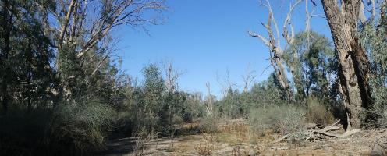
Existing watering site Latitude 34.10029 Longitude 140.20766 Direction 100

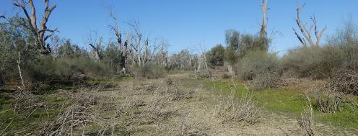
Existing watering site Latitude 34.10050 Longitude 140.20717 Direction 120

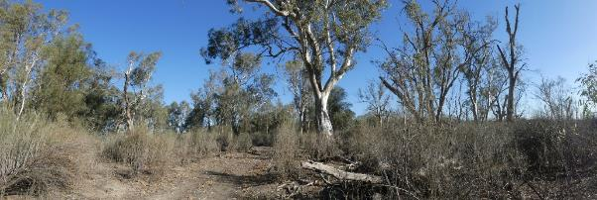Upstream area inside of the river sandbar Latitude 34.10231 Longitude 140.20927 Direction 220

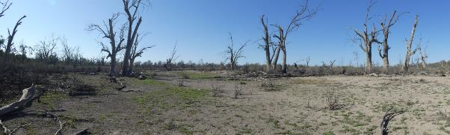
Downstream flood-out Latitude 34.10017 Longitude 140.20595 Direction 130

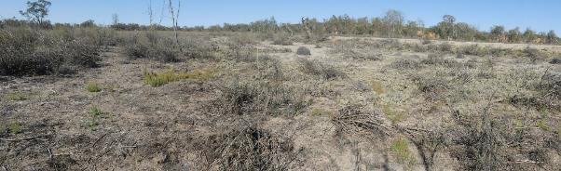
Wetland 616 Latitude 34.10097 Longitude 140.20516 Direction 210

Stressor Analysis
Stressor | Severity | Scope | Irreversibility
Lack of Inundation | Very High | High | Medium
Saline Groundwater Depth | High | High | Medium
High Kangaroo Numbers | Medium | Medium | Low

Land Tenure Issues
- The site is owned by one private land owner which is a company
- A strip of unalienated Crown land runs along the water’s edge and includes Bank one.

Regent Parrot Utilisation- Nesting and Foraging.

Ecological Objectives
Halt the decline and improve the health condition of mature woody plant species e.g. (River Red Gum, Black Box, Cooba and Lignum).

Maintain existing regeneration and provide opportunities for future regeneration events of woody plant species e. g: (River Red Gum, Black Box, Cooba and Lignum).

Improve the abundance and diversity of flood dependant understory vegetation.
Improve floodplain habitat conditions to promote Regent Parrot breeding events.
Provide hydrological connectivity between watering sites and adjacent floodplain during natural flood events.

Promote total grazing pressure within sustainable limits.
Increase Regent Parrot potential breeding success by limiting disturbance from human activities such as recreational visitors and noise from water pumping at colony sites during July and August.

Community Objectives
Engage landholder involvement in the sustainable management of their site(s).

Hydrological Parameters
Existing Area  - Inundation Area  - Historical Watering Dates | 0.9 ha  2015/16, 2017/18 and 2019/20
Maximum Inundation  - Water Height  - Inundation Area  - Fill Volume | 8.8 AHD  14.7 ha  77 ML
Commencement to Flow ML/d Band | 40-50,000
Full Supply Flow ML/d Band | 50-60,000
Watering Options | Pump to full supply  Possibility of return flows  Manage natural flood recession
Watering Timing | Late Autumn to Early Winter

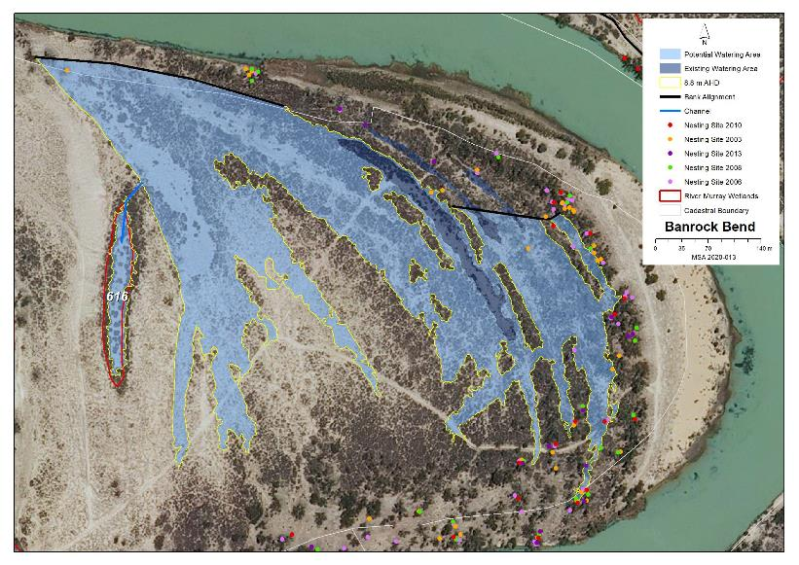
Map identifies the existing and potential watering areas

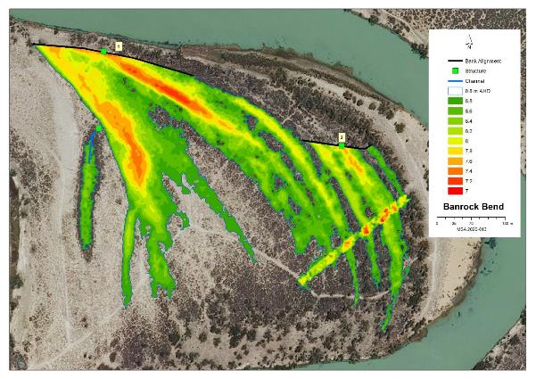
Map features AHD heights across the site and identified infrastructure locations

Potential Infrastructure Requirements
Bank or Channel Details
Location | ID | Length  (m) | Freeboard  (m) | Height with freeboard  (m) | Volume  (m3) | Regulator equipment and comments
Banrock Bend | Bank 1 | 337.5 | 0.50 | 1.90 | 4,088.9 | Sheetpile regulator with 1 bay of dropboards
 | Bank 2 | 148.8 | 0.30 | 1.50 | 911.3 | 1m concrete pipe with a flap valve
 | Channel 1 | 30 | N/A | N/A |  | Channel required between Bank 1 and the small lagoon to the west.  A 300mm concrete pipe, headwall and flap valve are required at the head of the channel.

2 Gerard/Katarapko Lagoon Management Brief
Vegetation Description
River Red Gum Woodland  Stressed (level 3) | River inlet lagoon (existing watering site) adult trees stressed (level 3) poles and saplings healthy (level 5) understory Cooba and Lignum. Most lagoons have scattered long-term dead adult and pole River Red Gum around the edges.
Black Box Woodland  Healthy (level 4 and5) | All Lagoons surrounded by adult and sapling Black Box understory dominated by Lignum and odd Cooba adult and sapling.
Lignum Shrubland  Healthy (level 4 and 5) | Lignum dominates the floor of all the lagoons except the inlet lagoon. Patches of Creeping Boobialla and Spiny Sedge plus Common Sneeze Weed, Lesser Joyweed, Blown Grass, Lagoon Saltbush, Smooth Heliotrope and Tussock Grass.

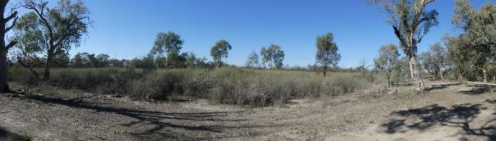
Wetland 903 northern end Latitude 34.23682 Longitude 140.29439 Direction 110

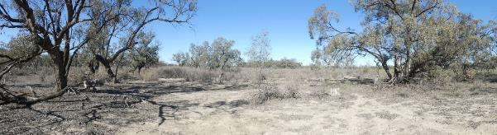
Eastern side of the complex Latitude 34.23695 Longitude 140.29578 Direction 170

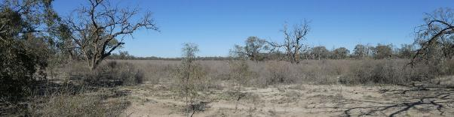
Southern extension of Wetland 909 Latitude 34.23775 Longitude 140.29658 Direction 190

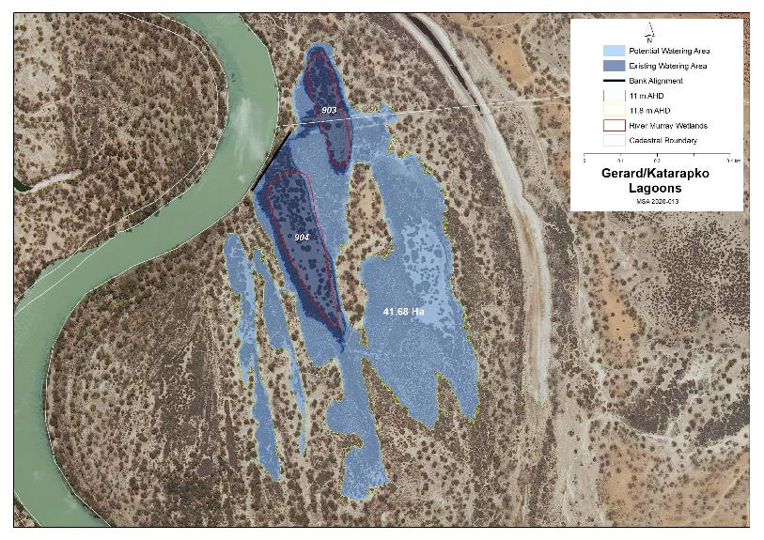
Map identifies the existing and potential watering areas

Stressor Analysis.
Stressor | Severity | Scope | Irreversibility
Lack of Inundation | Medium | High | Medium

Land Tenure Issues
- The site crosses the boundary between the Murray River National Park (Katarapko Section) and Gerard Aboriginal Reserve.

Regent Parrot Utilisation- Potential Foraging.

Ecological Objectives
Halt the decline and improve the health condition of mature woody plant species e.g. (River Red Gum, Black Box, Cooba and Lignum).
Maintain existing regeneration and provide opportunities for future regeneration events of woody plant species e.g. (River Red Gum, Black Box, Cooba and Lignum).
Improve the abundance and diversity of flood dependant understory vegetation.
Provide floodplain and aquatic habitats suitable for waterbird and frog refuge and breeding.
Provide hydrological connectivity between watering sites and adjacent floodplain during natural flood events.
Community Objectives
Engage landholder involvement in the sustainable management of their site(s).

Hydrological Parameters
Existing Area  - Inundation Area  - Historical Watering Dates | 8.6 ha  2015/16, 2018/19 and 2019/20
Maximum Inundation  - Water Height  - Inundation Area  - Fill Volume | 11.8 AHD  41.1 ha  237 ML
Low Inundation  - Water Height  - Inundation Area  - Fill Volume | 11.4 AHD  21.6 ha  112 ML
Commencement to Flow ML/d Band | 40-50,000
Full Supply Flow ML/d Band | 70-80,000
Watering Options | Pump to fully supply  Possibility of return flows  Manage natural flood recession
Watering Timing | Spring through to Autumn

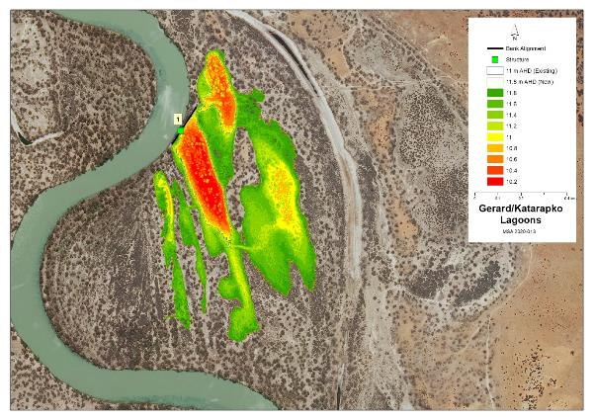
Map features AHD heights across the site and identified infrastructure locations

Potential Infrastructure Requirements
Bank or Channel Details
Location | ID | Length  (m) | Freeboard  (m) | Height with freeboard  (m) | Volume  (m3) | Regulator equipment and comments
Gerard Katarapko Lagoon | Bank 1 | 195.1 | 0.50 | 1.90 | 1,462.9 | Sheetpile regulator with 2 bays of dropboards

3 Heron Bend Management Brief
Vegetation Description - Heron Bend West
River Red Gum Woodland  Stressed (level 3) | Southern side of site adult long-term dead. Sandbar side - adult understory Lignum and River Red Gum saplings.
Low Shrubland/Herbland  Stressed (level 3) | Lagoon bed – Dominated by Smooth Heliotrope, Lagoon and Creeping Saltbush with scattered Pale Poverty Bush and a salt scald at the downstream end.

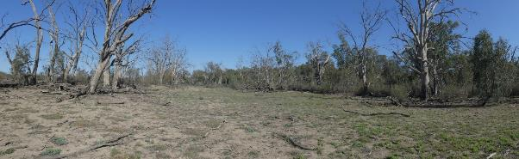
Lagoon bed looking downstream Latitude 34.09429 Longitude 140.19802 Direction 260

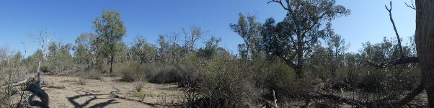
Back edge of river sandbar Latitude 34.09403 Longitude 140.19839 Direction 300

Vegetation Description - Heron Bend East
River Red Gum Woodland  Stressed (level 3 | Band of adult trees along back of the Sandbar.
Lignum Shrubland  Healthy (level 4) | Small patches and scattered bushes throughout the eastern two thirds of the site with scattered young adult River Red Gum.
Low Shrubland/Herbland  Stressed (level 3) | Scattered amongst small odd Lignum, Pale Poverty Bush, Creeping Saltbush, and Lagoon Saltbush and desiccated Tussock Grass.

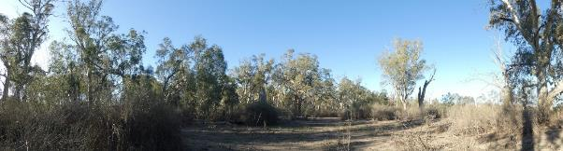
Back edge of river sandbar Latitude 34.09382 Longitude 140.19832.Direction 30
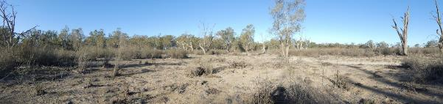
Downstream end Latitude 34.09455 Longitude 140.19927 Direction 90
Stressor Analysis.
Site | Stressor | Severity | Scope | Irreversibility
Heron Bend West | Lack of Inundation | Very High | High | Medium
 | Groundwater depth | High | Medium | Medium
 | Surface Soil Salinity | Low | Low | Low
 | High kangaroo numbers | Medium | High | Low
Heron Bend East | Lack of Inundation | Medium | High | Medium
 | Groundwater depth | Medium | Medium | Medium
 | High kangaroo numbers | Medium | High | Low

Land Tenure Issues
Heron Bend West | - The site is owned by one private land owner which is a company.  - A strip of unalienated Crown land runs along the water’s edge and includes a small section of Bank one.
Heron Bend East | - The site is owned by one private land owner which is a company.  - A strip of unalienated Crown land runs along the water’s edge.

Regent Parrot Utilisation
Heron Bend West | Nesting and Foraging
Heron Bend East | Nesting and Foraging

Ecological Objectives
Site Objectives | Heron Bend West | Heron Bend East
Ecological Objectives
Halt the decline and improve the health condition of mature woody plant species e.g. (River Red Gum, Black Box, Cooba and Lignum).
Maintain existing regeneration and provide opportunities for future regeneration events of woody plant species e.g. (River Red Gum, Black Box, Cooba and Lignum).
Improve the abundance and diversity of flood dependant understory vegetation.
Improve floodplain habitat conditions to promote Regent Parrot breeding events.
Provide hydrological connectivity between watering sites and adjacent floodplain during natural flood events.
Increase Regent Parrot potential breeding success by limiting disturbance from human activities such as recreational visitors and noise from water pumping at colony sites during July and August.
Community Objectives
Promote Water for the Environment projects through community educational information and programs.

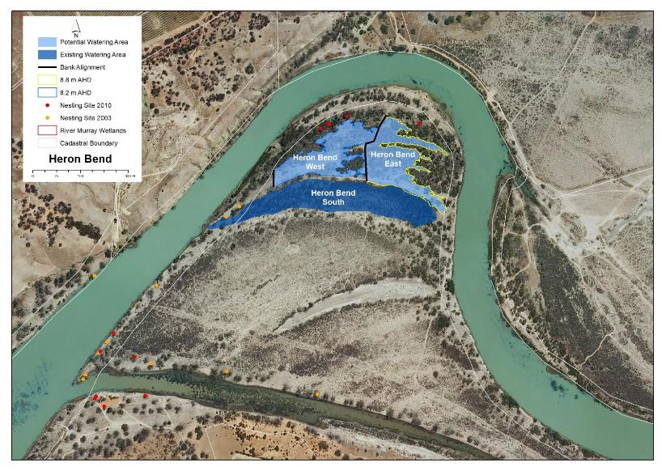
Map identifies the existing and potential watering areas

Hydrological Parameters
 | Heron Bend West | Heron Bend East
Maximum Inundation  - Water Height  - Inundation Area  - Fill Volume | 8.2 AHD  2.6 ha  13.3 ML | 8.8 AHD  3.2 ha  11.7 ML
Commencement to Flow ML/d Band | 50-60,000 | 50-60,000
Full Supply Flow ML/d Band | 60-70,000 | 60-70,000
Watering Options | Pump to full Supply  Manage natural flood recession | Pump to full Supply  Manage natural flood recession
Watering Timing | Late Autumn to Early Winter | Late Autumn to Early Winter

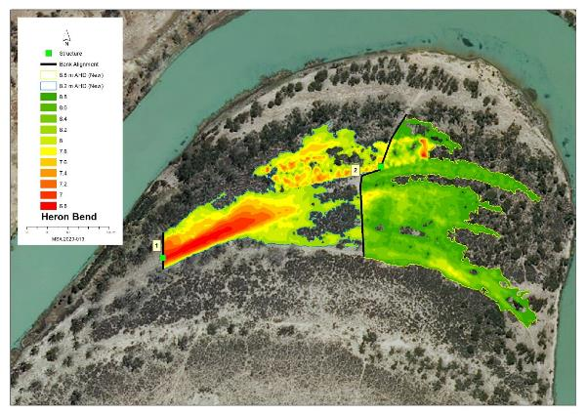Map features AHD heights across the site and identified infrastructure locations

Potential Infrastructure Requirements
Bank or Channel Details
Location | ID | Length  (m) | Freeboard  (m) | Height with freeboard  (m) | Volume  (m3) | Regulator equipment and comments
Heron Bend | Bank 1 | 54.5 | 0.50 | 1.90 | 612.4 | 800mm concrete pipe with flap valve
 | Bank 2 | 237.4 | 0.30 | 1.30 | 1,327.8 | 800mm concrete pipe with flap valve

4 Hogwash Bend Management Brief
Vegetation Description - Hogwash Northern Flood-out
River Red Gum Woodland  Healthy (level 4) | River Red Gum adults and saplings, odd Black Box and Cooba, with understory healthy comprising of sparse Lignum, Creeping Saltbush, Spiny Sedge, Lagoon Saltbush, Grey Germander, Lippia, and Native Liquorice

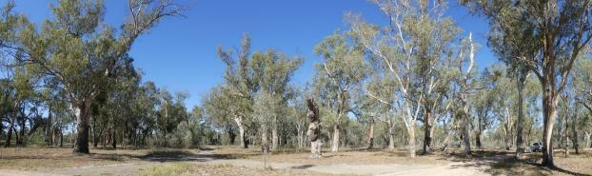
Mid Murray Council Reserve Latitude 34.03961 Longitude 140.29578 Direction 70

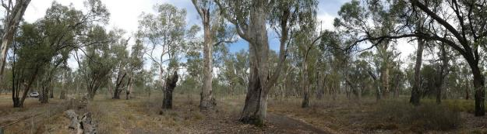
Western section within Hogwash Conservation Park Latitude 34.03919 Longitude 139.51105 Direction 246

Vegetation Description - Hogwash Central Basins West
River Red Gum Woodland  Stressed (level 3) | Majority patches of adult River Red Gum lining the bank of the western section of Wetland 1259. Odd adult dead River Red Gum and patches of saplings throughout the site. Understory dominated by Lignum with Creeping Saltbush and scattered Cooba
Lignum Shrubland  Healthy (level 5) | Lignum dominates the bed of Wetland 1259 and1258 and depression east of the road.

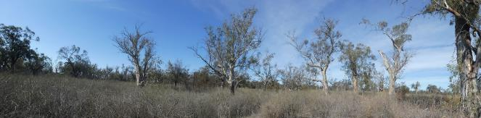
North eastern area of the site Latitude 34.04023 Longitude 139.50844 Direction 50
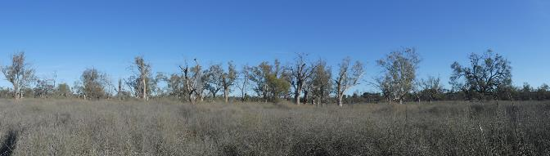
River Red Gum along the Southern shoreline of Wetland 125
Latitude 34.03988 Longitude 139.50744 Direction 150

Vegetation Description - Hogwash Central Basins East
Black Box Woodland  Healthy (level 4) | The site was once a mixed woodland but now the majority of River Red Gum are dead with a few still alive (in poor health) on the northern edge of the site. Healthy to poor adult Black Box dominate the site with patches of unhealthy Cooba adults and saplings. Understory dominated by patches of dense and sparse Lignum, Creeping Saltbush. Black Box sapling and seedlings in high density throughout the elevated areas of the site.
Lignum Shrubland  Healthy (level 4 and 5) | Lignum dominates the eastern extension of Wetland 1259 and throughout the Black Box Woodland.

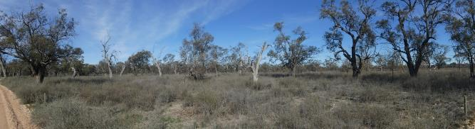
Western edge of Central Basin East Latitude 34.04061 Longitude 139.50983 Direction 130

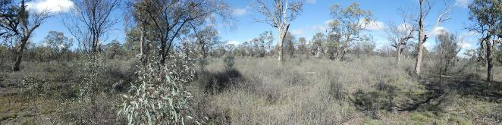
Eastern end of Central Basin East Latitude 34.04071 Longitude 139.57108 Direction 200

Vegetation Description - Hogwash Southern Basins
River Red Gum Woodland  Degraded (level 1) | Majority of adult River Red Gum dead around edge of Wetlands 1549 and 1550. Patches of healthy young adult trees around the edge of Wetland 1546 with understory dominated by Lignum and Common Spike-rush with patches of Blown Grass and Clover.
Lignum Shrubland  Healthy (level 4 and 5) | Wetland 1549 dominated by Lignum with open areas. Wetland 1546 large open areas with dense patches and scattered Lignum.
Low Shrubland/Herbland  Stressed (level 3) and possibly Healthy (level 4 or 5) | Wetlands 1546 and 1549 would have Herbland areas but are flooded at time of survey. Wetland 1550 bed dominated by Creeping, Lagoon and Bladder Saltbush with patches of Clover and odd Pale Poverty Bushes.

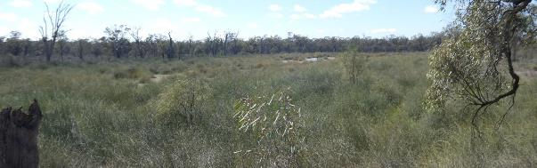
Wetland 1549 Latitude 34.04185 Longitude 139.50692 Direction 80

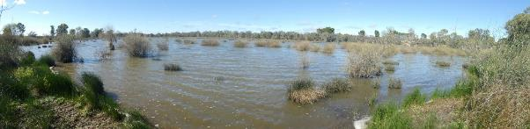
Wetland 1546 Latitude 34.04317 Longitude 139.50695 Direction 160

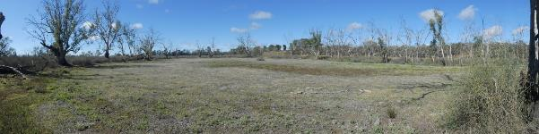
98 Wetland 1550 Latitude 34.04116 Longitude 139.50483 Direction 150

Stressor Analysis.
Site | Stressor | Severity | Scope | Irreversibility
Hogwash Northern Flood-out | Lack of Inundation | Medium | High | Medium
 | Human Disturbance | High | High | Low
Hogwash Central Basins West | Lack of Inundation | Very High | High | Medium
Hogwash Central Basins East | Lack of Inundation | High | High | Medium
Hogwash Southern Basins | Lack of Inundation | Medium | Medium | Medium

Land Tenure Issues
Hogwash Northern Flood-out | - The site includes Mid Murray Council Reserve and road reserve, Unalienated Crown Land and part of Hogwash Conservation Park.
Hogwash Central Basins West | - Unalienated Crown Land
Hogwash Central Basins East | - Hogwash Conservation Park and adjoining Mid Murray Council road reserve.
Hogwash Southern Basins | - Predominately Hogwash Conservation Park with two Company landowners.

Regent Parrot Utilisation
Hogwash Northern Flood-out | Nesting and Foraging
Hogwash Central Basins West | Nesting and Foraging
Hogwash Central Basins East | Foraging
Hogwash Southern Basins | Foraging

Ecological and Community Objectives
Site Objectives | Hogwash Northern Flood-out | Hogwash Central Basin West | Hogwash Central Basin East | Hogwash Southern Basins
Ecological Objectives
Halt the decline and improve the health condition of mature woody plant species e.g. (River Red Gum, Black Box, Cooba and Lignum).
Maintain existing regeneration and provide opportunities for future regeneration events of woody plant species e.g. (River Red Gum, Black Box, Cooba and Lignum).
Improve the abundance and diversity of flood dependant understory vegetation.
Improve floodplain habitat conditions to promote Regent Parrot breeding events.
Provide floodplain and aquatic habitats suitable for waterbird and frog refuge and breeding.
Provide hydrological connectivity between watering sites and adjacent floodplain during natural flood events.
Increase Regent Parrot potential breeding success by limiting disturbance from human activities such as recreational visitors and noise from water pumping at colony sites during July and August.
Community Objectives
Through community educational programs and information promote Water for the Environment projects that contribute to Regent Parrot conservation.
Engage landholder involvement in the sustainable management of their site(s).

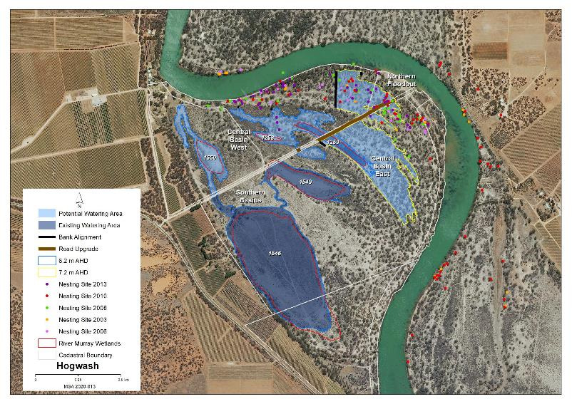
Map identifies the existing and potential watering areas

Hydrological Parameters
 | Hogwash Northern  Flood-out | Hogwash Central Basin West | Hogwash Central Basin East | Hogwash Southern Basins
Existing Area  - Inundation Area  - Historical Watering Dates | Irrigation Unknown  08/09, 09/10 & 18/19 | Temp Wetland 1259 (1.8 ha)  05/06, 09/10, 13/14, 15/16 & 18/19 | Nil | 33.3 ha  13/14, 15/16, 18/19 and 19/20
Maximum Inundation  - Water Height  - Inundation Area  - Fill Volume | 7.2 AHD  7 ha  32.4 ML | 6.2 AHD  6.7 ha (8.2 ha)  24.1 ML (31 ML) | 7.2 AHD  13.7 ha  76.6 ML | 6.2 AHD  37.5 ha  424 ML
Commencement to Flow ML/d Band | 60-70,000 | 70-80,000 | 70-80,000 | 60-70,000
Full Supply Flow ML/d Band | 90-100,000 | 80-90,000 | 90-100,000 | 70-80,000
Watering Options | Pump to full Supply  Manage natural flood recession  Enhance natural flood duration and Coverage | Pump to full Supply  Manage natural flood recession | Pump to full Supply  Enhance natural flood duration | Pump to full Supply
Watering Timing | Late Autumn to Early Winter | Late Autumn to Early Winter | Spring through to Autumn | Spring through to Autumn
# Hogwash Central Basin West – Figures in brackets include area and volume to filling both the western and eastern portion of Wetland 1259 at the same time.

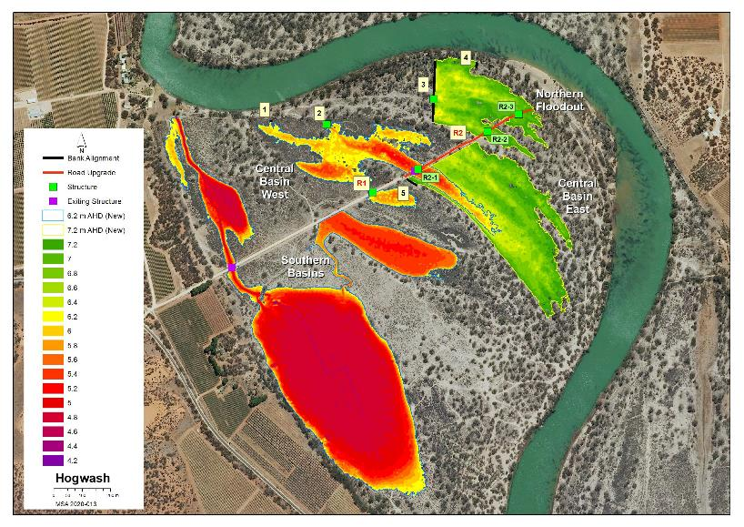
Map features AHD heights across the site and identified infrastructure locations
Potential Infrastructure Requirements
Bank or Channel Details
Location | ID | Length  (m) | Freeboard  (m) | Height with freeboard  (m) | Volume  (m3) | Regulator equipment and comments
Hogwash | Bank 1 | 8.7 | 0.30 | 0.40 | 35.4 | Nil
 | Bank 2 | 10.8 | 0.30 | 0.70 | 85.8 | 3x 300mm concrete pipe with flap valves
 | Bank 3 | 217.0 | 0.30 | 1.30 | 1,591.1 | 800mm concrete pipe with flap valve
 | Bank 4 | 22.5 | 0.30 | 0.70 | 97.2 | Nil
 | Bank 5 | 43.8 | 0.30 | 1.10 | 130.2 | Nil
 | Road 1 | 22.9 |  | 0.40 |  | 450mm concrete pipe with no flap valve  Raise existing road by 400mm
 | Road 2 | 509.0 |  |  |  | R2-1: Remove existing pipe and replace with 800mm concrete pipe with penstock  R2-2: 300mm concrete pipe with no flap valve  R2-3: 300mm concrete pipe with no flap valve  Raise existing 8.5m wide road by 500mm

5 Holder Lagoon Management Brief
Vegetation Description
River Red Gum Woodland  Stressed (level 3) | Long-term dead trees were scattered across the site in patches and odd trees. The greatest concentration of dead trees were around Wetland 1638 and upstream of the Holder Lagoon road crossing along the inlet channel. The majority of the floodplain edge and at times on the floodplain floor had strips, patches and odd trees with a range of ages from mature adult to saplings ranging in health from stressed to healthy. Areas of healthy trees were centred on the following areas; downstream end of Wetland 1665, between Wetland 1636 and the Holder Lagoon Road, Wetland 1675 and 1636 and the existing Watering sites.
Black Box Woodland  Healthy (level 5) | Most of the floodplain edge had strips of scattered trees with small patches of sapling throughout the site. The bay east of the upstream end of Wetland 1665 had a significant patch of saplings. The majority of areas were healthy except the lower areas surrounding Wetland 1638 which were stressed.
Lignum Shrubland  Healthy (Level 4 and 5) | Lignum was scattered throughout the site ranging from large dense patches to scattered bushes on the floor of Wetland 1638 and1675. Most of the floodplain edge had strips or scattered bushes. The majority of areas were healthy with some patches in Wetland 1638 stressed.
Low Shrubland/Herbland  Stressed (level 3) | Ranged from Wetland 1638 dominated by Samphire and bare damp patches of salt crystals and no soil structure. Wetland 1665 small scattered patches of Samphire and Smooth Heliotrope, Ice-plant spp., Creeping Boobialla and Spiny Sedge, Rat’s-Tail couch and Phragmites. Wetland 1675 Creeping Saltbush, Creeping Boobialla, Smooth Heliotrope, Spiny Sedge, Clover spp. and Ruby Saltbush. Health ranged between sites from degraded (level 0) to healthy.

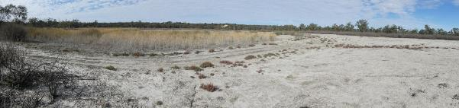
Wetland 1665 downstream end Latitude 34.10694 Longitude 140.000882.Direction 150

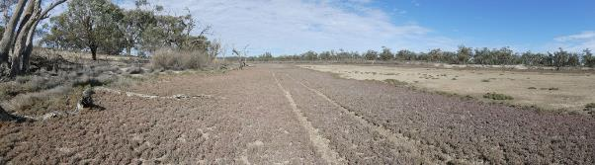
Wetland 1638 Latitude 34.10500 Longitude 140.00834.Direction 192

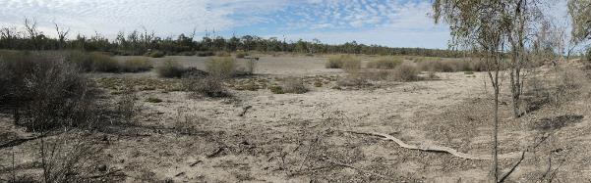
Wetland 1665 upstream end Latitude 34.10485 Longitude 140.00880.Direction 0

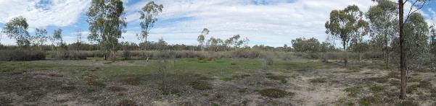
Wetland 1675 Latitude 34.10158 Longitude 140.01245.Direction 140

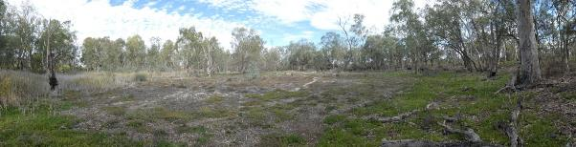
Wetland 1636 Latitude 34.09967 Longitude 140.01473.Direction 180

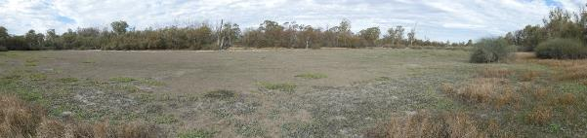
Wetland 1312 existing Watering site Latitude 34.09702 Longitude 140.00846.Direction 110

Stressor Analysis.
Stressor | Severity | Scope | Irreversibility
Lack of Inundation | Very High | High | Medium
Surface Soil Salinity | Very High | Low | Medium
Saline Groundwater Depth | High | Medium | Medium
Flow Barrier | Medium | Medium | Medium
High rabbit numbers | Medium | High | Low
Uncontrolled off road 4WD | Medium | Low | Low

Land Tenure Issues
- Northern area is within the Maize Island Conservation Park.
- A strip of Crown land along the water’s edge, both adjacent to the park and the privately held land.
- A large central portion is held by an incorporated sporting body.
- Another large parcel at the southern end is owned by a private land owner.

Regent Parrot Utilisation- Potential Nesting and Foraging.

Ecological Objectives
Halt the decline and improve the health condition of mature woody plant species e.g. (River Red Gum, Black Box, Cooba and Lignum).
Maintain existing regeneration and provide opportunities for future regeneration events of woody plant species e.g. (River Red Gum, Black Box, Cooba and Lignum).
Improve the abundance and diversity of flood dependant understory vegetation.
Reduce soil salinity to disadvantage Samphire and promote regeneration of less salt tolerant floodplain and aquatic plant species.
Improve floodplain habitat conditions to promote Regent Parrot breeding events.
Provide floodplain and aquatic habitats suitable for waterbird and frog refuge and breeding.
Provide hydrological connectivity between watering sites and adjacent floodplain during natural flood events.
Promote total grazing pressure within sustainable limits.
Community Objectives
Through community educational programs and information promote Water for the Environment projects that contribute to Regent Parrot conservation.
Engage landholder involvement in the sustainable management of their site(s).

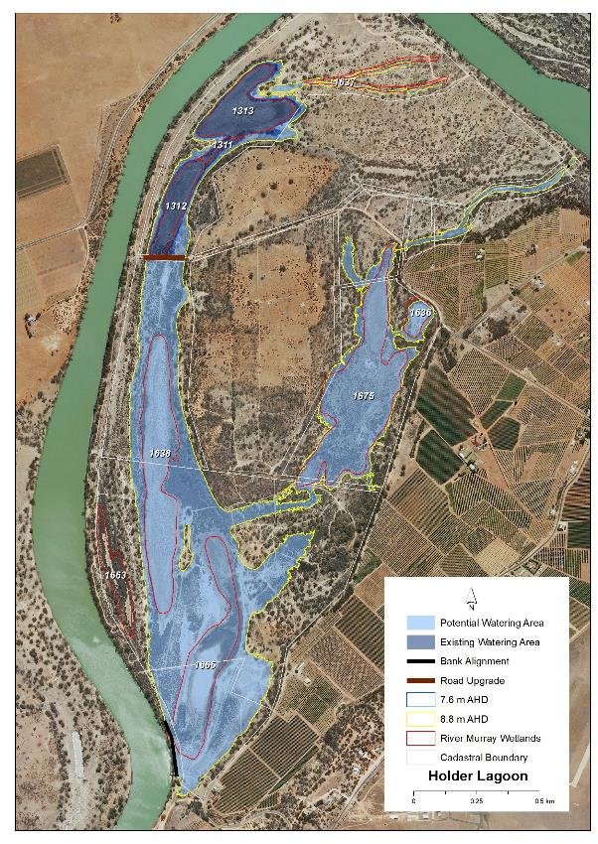
Map identifies the existing and potential watering areas

Hydrological Parameters
Existing Area  - Inundation Area  - Historical Watering Dates | 10.5 ha  05/06, 2013/14, 2015/16 and 2018/19
Maximum Inundation  - Water Height  - Inundation Area  - Fill Volume | 8.8 AHD  104.7 ha  1486 ML
Low Inundation  - Water Height  - Inundation Area  - Fill Volume | 7.6 AHD  53.8 ha  524 ML
Commencement to Flow ML/d Band | 10-20,000
Full Supply Flow ML/d Band | 100-110,000
Watering Options | Pump to full supply  Pump to low elevation  Possibility of return flows  Manage natural flood recession  Enhance natural flood duration and coverage
Watering Timing | Spring through to Autumn

Existing Public Road Crossing structures
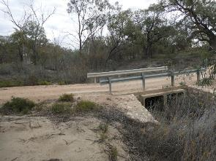 | 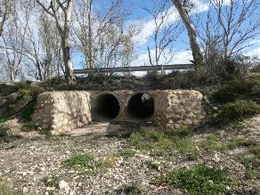
Inlet Creek upstream end | Holder Lagoon Road Crossing

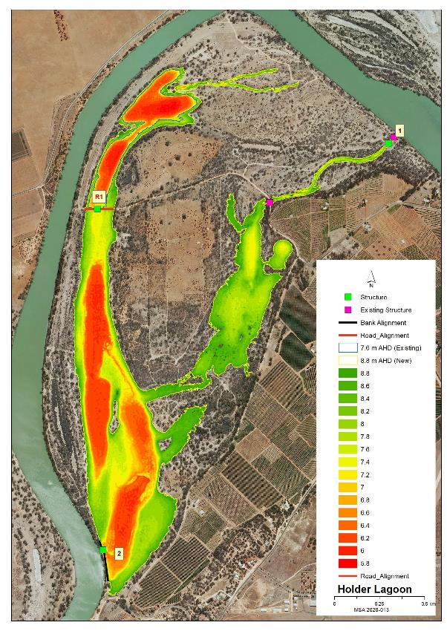
Map features AHD heights across the site and identified infrastructure locations

Potential Infrastructure Requirements
Bank or Channel Details
Location | ID | Length  (m) | Freeboard  (m) | Height with freeboard  (m) | Volume  (m3) | Regulator equipment and comments
Holder Lagoon | Bank 1 | 7.8 | 0.50 | 1.10 | 49.4 | Sheetpile regulator with 2 bays of dropboards  Existing box culvert just upstream of site (comment only)
 | Bank 2 | 231.9 | 0.50 | 2.90 | 2,972.6 | Sheetpile regulator with 2 bays of dropboards  Not a dry site for construction. Temporary cofferdam works required.
 | Road 1 | 65.0 | 0.50 | 2.30 |  | 2x 1m concrete pipe only  Raise existing 7.8m wide road by 600mm

6 Katarapko Creek Management Brief
Vegetation Description - Katarapko Creek Campsite 45
River Red Gum Woodland Healthy (level 4) | Majority adult trees understory scattered patches of River Red Gum Saplings and Lignum, with Blue Rod and Creeping Boobialla.

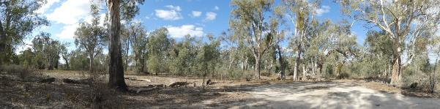
333 Campsite 45 Latitude 34.24620 Longitude 140.32339 Direction 160

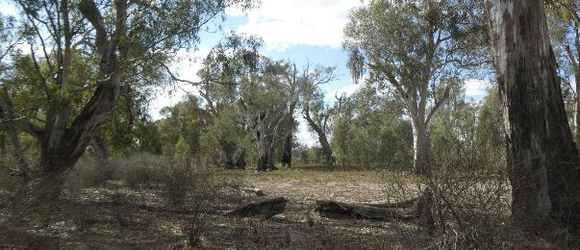
335 Upstream area of site Latitude 34.24620 Longitude 140.32339 Direction 64

Vegetation Description - Katarapko Creek North and South
River Red Gum Woodland  Healthy (level 5) | The majority of adult trees around Wetland 1984 are dead with the remainder healthy (level 5) as are the trees along the southern watercourse.
Lignum Shrubland  Healthy (level 5) | Healthy dense Lignum around the edge of Wetland 1984

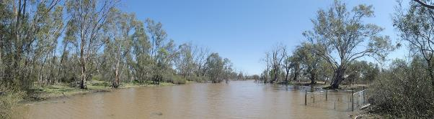
Katarapko Creek North Wetland 1984 Latitude 34.24735 Longitude 140.32122 Direction 250
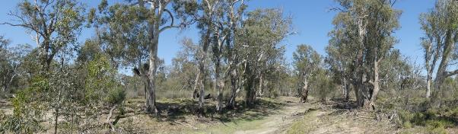
Katarapko Creek South eastern section of channel Latitude 34.24733 Longitude 140.32194 Direction 170

Vegetation Description - Katarapko Creek East
River Red Gum  Stressed (level 3) | Adults poor to good health with scattered patches of healthy saplings. Understory Blue Rod, Creeping Boobialla, desiccated Tussock Grass, Spiny Sedge, Nitre Bush seedlings and odd Lignum
Low Shrubland/Herbland  Stressed (level 3) | Northern depression dominated by Creeping and Bladder Saltbush and odd Smooth Heliotrope with Lignum, Cooba and Nitre Bush on northern edge.

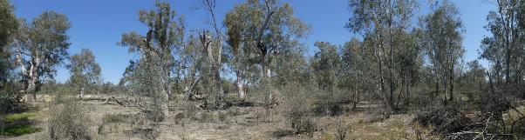
Katarapko Creek East creek edge Latitude 34.24806 Longitude 140.32267 Direction 230

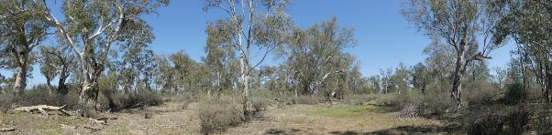
Katarapko Creek East inland section Latitude 34.24778 Longitude 140.32250 Direction 170

Vegetation Description - Katarapko Creek Campsite 47 Watercourse
River Red Gum Woodland  Stressed (level 3) | Both downstream and upstream ends adult River Red Gums healthy (level 4) with patches of sapling. Cooba adults and sapling scattered along the watercourse bank. Moving towards the centre of the watercourse tree health changes from stressed to dead.
Low Shrubland/Herbland  Healthy (level 4) | Watercourse floor Creeping Boobialla, Blue Rod, Rat’s-Tail Couch and odd Smooth Heliotrope. Healthy (level 4)

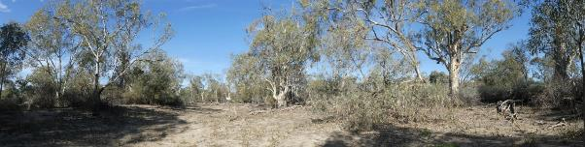
Upstream end of Creek Latitude 34.25065 Longitude 140.31844 Direction 190

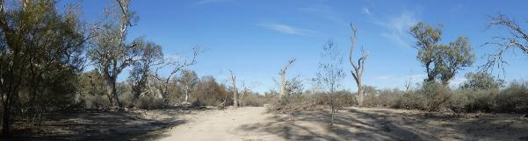
Centre area of Creek Latitude 34.25217 Longitude 140.31835 Direction 190

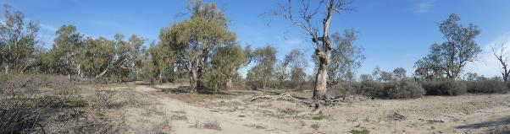
Downstream end of Creek Latitude 34.25365 Longitude 140.31761 Direction 224

Stressor Analysis.
Site | Stressor | Severity | Scope | Irreversibility
# Katarapko Creek Campsite 45 | Lack of Inundation | Medium | High | Medium
 | Human Disturbance | High | Medium | Low
Katarapko Creek North and South | Flow Barriers | High | High | Medium
 | High Kangaroo Numbers | High | High | Low
# Katarapko Creek East | Lack of Inundation | Medium | High | Medium
# Katarapko Creek Campsite 47 Watercourse | Lack of Inundation | High | High | Medium
 | Saline groundwater depth | Moderate | Low | Medium
# Due to the high impacts of kangaroo grazing at Katarapko Creek North and South the other three sites should be monitored for similar impacts.

Land Tenure Issues
- All sites are within the Murray River National Park (Katarapko Section).

Regent Parrot Utilisation
Katarapko Creek Campsite 45 | Nesting and Foraging
Katarapko Creek North and South | Nesting and Foraging
Katarapko Creek East | Nesting and Foraging
Katarapko Creek Campsite 47 Watercourse | Potential Nesting and Foraging

Site Objectives | Katarapko Creek Campsite 45 | Katarapko Creek North and South | Katarapko Creek East | Katarapko Creek Campsite 47 Watercourse
Ecological Objectives
Halt the decline and improve the health condition of mature woody plant species e.g. (River Red Gum, Black Box, Cooba and Lignum).
Maintain existing regeneration and provide opportunities for future regeneration events of woody plant species e.g. (River Red Gum, Black Box, Cooba and Lignum).
Improve the abundance and diversity of flood dependant understory vegetation.
Improve floodplain habitat conditions to promote Regent Parrot breeding events.
Provide hydrological connectivity between watering sites and adjacent floodplain during natural flood events.
Promote total grazing pressure within sustainable limits.
Increase Regent Parrot potential breeding success by limiting disturbance from human activities such as recreational visitors and noise from water pumping at colony sites during July and August..
Community Objectives
Engage landholder involvement in the sustainable management of their site(s).
Through community educational programs and information promote Water for the Environment projects that contribute to Regent Parrot conservation.

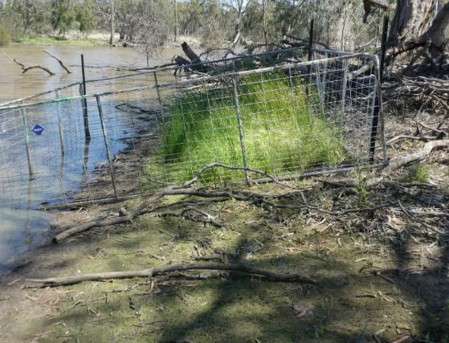
Kangaroo grazing impacts on the edge of Wetland 1984
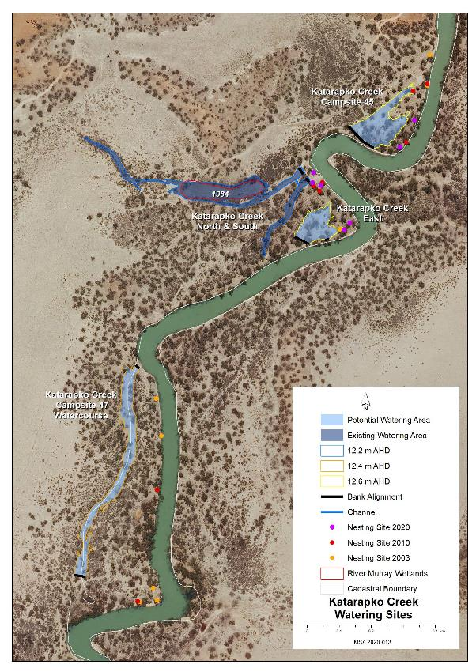
Map identifies the existing and potential watering areas

Hydrological Parameters
 | Katarapko Creek Campsite 45 | Katarapko Creek North and South | Katarapko Creek East | Katarapko Creek Campsite 47 Watercourse
Existing Area  - Inundation Area  - Historical Watering Dates | Nil | 2.6 ha  05/06, 09/10, 14/15 and 19/20 | Nil | Nil
Maximum Inundation  - Water Height  - Inundation Area  - Fill Volume | 12.6 AHD  1.5 ha  7 ML | 12.2 AHD  2.6 ha  19 ML | 12.6 AHD  1 ha  5 ML | 12.4 AHD  2 ha  10.4 ML
Commencement to Flow ML/d Band | 60-70,000 | 60-70,000 | 60-70,000 | 60-70,000
Full Supply Flow ML/d Band | 70-80,000 | 70-80,000 | 70-80,000 | 70-80,000
Watering Options | Pump to full Supply  Manage natural flood recession | Pump to full Supply  Manage natural flood recession | Pump to full Supply  Manage natural flood recession | Pump to full Supply  Manage natural flood recession
Watering Timing | Late Autumn to Early Winter | Late Autumn to Early Winter | Late Autumn to Early Winter | Late Autumn to Early Winter

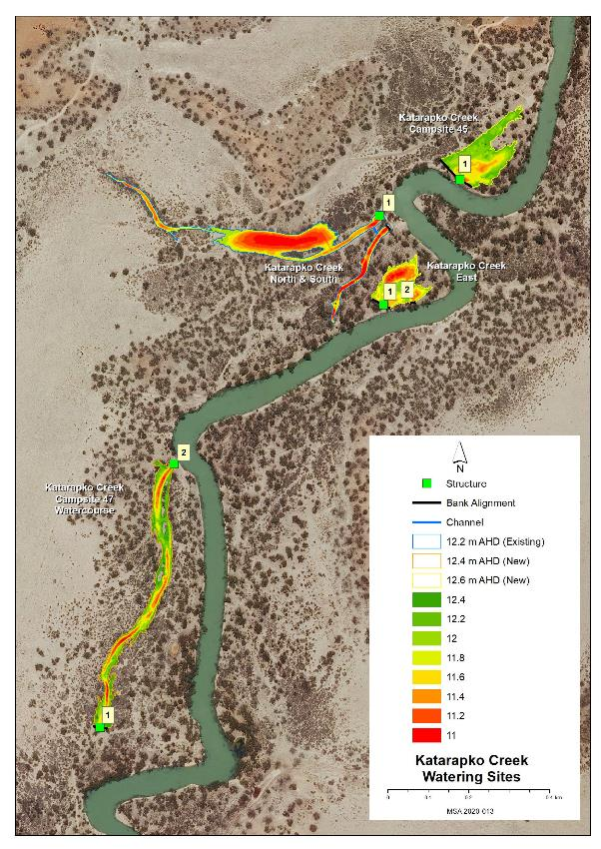
Map features AHD heights across the site and identified infrastructure locations

Potential Infrastructure Requirements
Bank or Channel Details
Location | ID | Length  (m) | Freeboard  (m) | Height with freeboard  (m) | Volume  (m3) | Regulator equipment and comments
Katarapko Creek Campsite 45 | Bank 1 | 106.0 | 0.30 | 1.90 | 841.1 | 800mm concrete pipe with flap valve
Katarapko Creek East | Bank 1 | 51.0 | 0.30 | 1.10 | 301.6 | 600mm concrete pipe with flap valve
 | Bank 2 | 15.0 | 0.30 | 0.70 | 93.5 | Nil
Katarapko Creek Campsite 47 Watercourse | Bank 1 | 35.8 | 0.30 | 0.90 | 172.1 | 600mm concrete pipe with flap valve
 | Bank 2 | 15.5 | 0.30 | 1.50 | 140.0 | 600mm concrete pipe with flap valve
Katarapko Creek North | Bank 1 | 25.0 | 0.30 | 1.30 | 135.1 | 800mm concrete pipe with flap valve  Reconstruct existing bank
Katarapko Creek North-South connecting channel | Channel 1 | 18.0 |  |  |  | Construct channel lined with armour rock. 1m wide at the channel invert, 1.2m deep,  1:1.5 batters
Katarapko Creek South | Bank 1 | 16.4 | 0.30 | 1.50 | 101.5 | Reconstruct existing bank

7 Katarapko Island North Management Brief
Vegetation Description
River Red Gum Woodland  Stressed (level 3) | In 2007 the majority of adult River Red Gum were dead at the following Wetland sites 1541, 1078, 437 and 149. At Wetland 779 the gums were mostly alive but by 2015 were dead (Harper and Harper 2015). In January 2014 a bush fire spread across the site burning out most of the dead trees. In early 2015 the majority of the Wetlands received pumped Water for the Environment which aided the regeneration of River Red Gum throughout the sites. This recent survey revealed that there are significant number of healthy saplings and poles throughout northern section of the site except Wetland 149 where the young trees range from dead to stressed.  The sandy elevated floodplain between the northern and southern sections of the site and along the eastern arms of Wetland 1541 and 1542 have scattered patches and individual healthy (level 4)and stressed (level 3) adult, poles and saplings River Red Gum with Cooba adults and saplings. Understory consists of Ruby Saltbush, Blue Rod, Rat’s-Tail Couch, Creeping Boobialla and patches and odd Nitre Bush and Lignum.
Black Box Woodland  Healthy (level 4 and 5) | Adult and sapling Black Box and Cooba are scattered along the banks of Wetland 1541 and 1542 and the sandy elevated floodplain between the northern and southern section. The eastern watercourse is dominated by healthy (level 5) adult Black Box with large patches of saplings.
Lignum Shrubland  Healthy (level 4) | The bush fire in January 2014 burnt most of the patches of Lignum especially in and around Wetland 1078 and 779 Stressed (level 3). Between Wetland 779 and the outlet of the eastern watercourse there are significant areas of Nitre Bush regrowth within the fire scar.
Low Shrubland/Herbland  Stressed (level 3) | Wetland 1541 channel floor Pale Poverty Bush, Ruby Saltbush, Maireana spp., Rat’s-Tail Couch, odd desiccated Tussock Grass and Smooth Heliotrope, scattered Roly-Poly, Native Leek, Nitre Bush seedlings. The South Eastern Flood-out is heavily grazed by kangaroos resulting in sparse vegetation with limited species. Desiccated Roly-Poly, Pale Poverty Bush and old small Lignum bushes remaining.

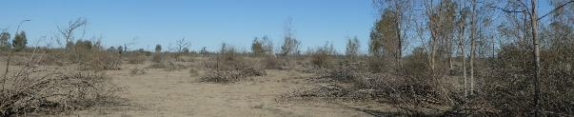
Stressed River Red Gum saplings at Wetland 149 Latitude 34.10029 Longitude 140.20766.Direction 100

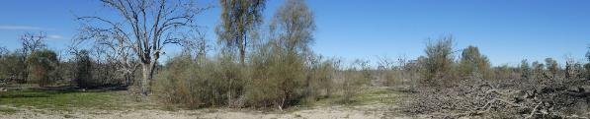
South east of Wetland 779 Latitude 34.10029 Longitude 140.20766.Direction 100
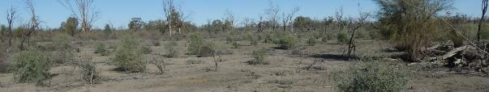
Nitre Bush regrowth within the fire scar between Wetland 779 and the eastern inlet watercourse.
Latitude 34.10029 Longitude 140.20766.Direction 100

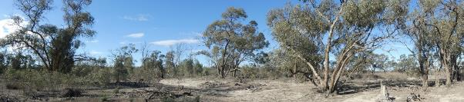
Eastern inlet watercourse Latitude 34.10029 Longitude 140.20766.Direction 100

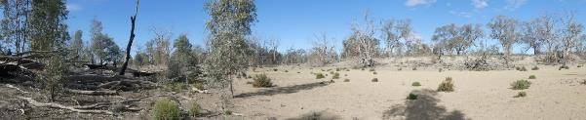
Northern arm of Wetland 1541 Latitude 34.10029 Longitude 140.20766.Direction 100

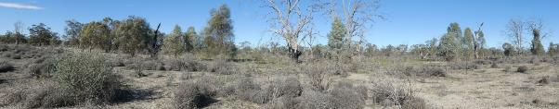
Northern edge of the sandy elevated floodplain Latitude 34.10029 Longitude 140.20766.Direction 100

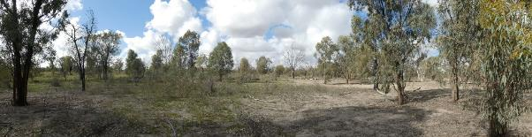
Central eastern edge of the sandy elevated floodplain Latitude 34.10029 Longitude 140.20766.Direction 100
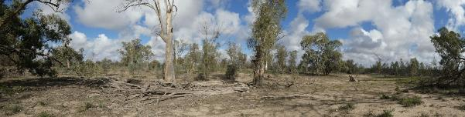
NE edge of sandy elevated floodplain adjacent to the southern section of the site
Latitude 34.10029 Longitude 140.20766.Direction 100

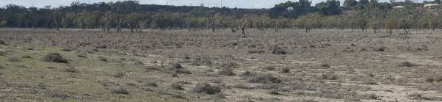
322 South-eastern section of the site Latitude 34.10029 Longitude 140.20766.Direction 100

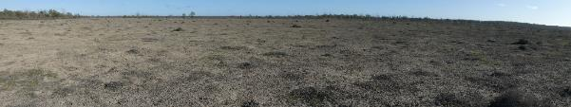
South-western section of the site Latitude 34.10029 Longitude 140.20766.Direction 100

Stressor Analysis.
Stressor | Severity | Scope | Irreversibility
Lack of Inundation | Very High | High | Medium
Saline Groundwater Depth | Medium | Low | Medium
High Kangaroo Numbers | Medium | High | Low

Land Tenure Issues
- All sites are within the Murray River National Park (Katarapko Section).
Regent Parrot Utilisation - Potential Foraging.

Ecological Objectives
Halt the decline and improve the health condition of mature woody plant species e.g. (River Red Gum, Black Box, Cooba and Lignum).
Maintain existing regeneration and provide opportunities for future regeneration events of woody plant species e.g. (River Red Gum, Black Box, Cooba and Lignum).
Improve the abundance and diversity of flood dependant understory vegetation.
Provide floodplain and aquatic habitats suitable for waterbird and frog refuge and breeding.
Provide fish passage through large floodplain habitats during natural flood events.
Provide hydrological connectivity between watering sites and adjacent floodplain during natural flood events.
Promote total grazing pressure within sustainable limits.
Community Objectives
Engage landholder involvement in the sustainable management of their site(s).

Hydrological Parameters
Existing Area  - Inundation Area  - Historical Watering Dates | 23.7 ha Wetlands 1541, 1542, 437 and 149  2014/15
Maximum Inundation  - Water Height  - Inundation Area  - Fill Volume | 13 AHD  463 ha  2934 ML
Low Inundation  - Water Height  - Inundation Area  - Fill Volume | 12.2 AHD  143 ha  660ML
Commencement to Flow ML/d Band | 40-50,000
Full Supply Flow ML/d Band | 50-60,000
Watering Options | Pump to full supply  Pump to low elevation  Possibility of return flows  Manage natural flood recession
Watering Timing | Spring through to Autumn

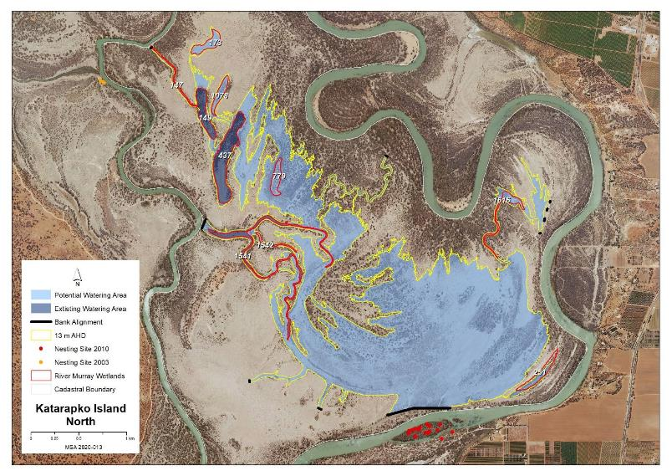
Map identifies the existing and potential watering areas
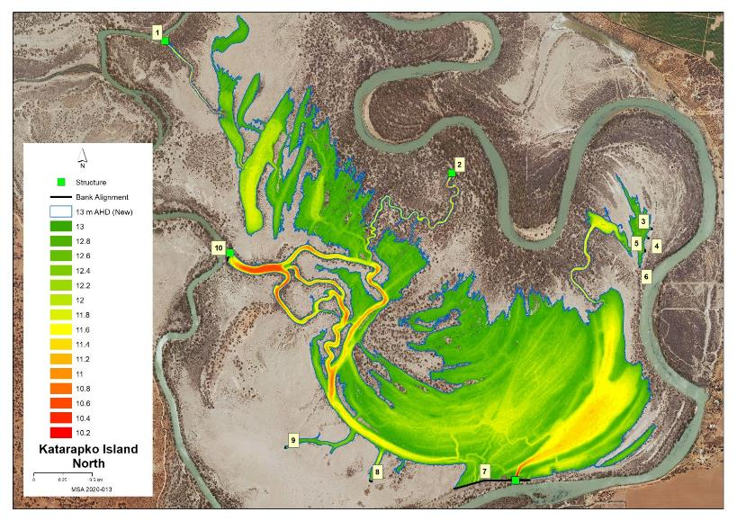
Map features AHD heights across the site and identified infrastructure locations

Potential Infrastructure Requirements
Bank or Channel Details
Location | ID | Length  (m) | Freeboard  (m) | Height with freeboard  (m) | Volume  (m3) | Regulator equipment and comments
Katarapko Island North  (Note: Barge access required) | Bank 1 | 13.5 | 0.30 | 1.50 | 126.0 | 1m concrete pipe with a flap valve
 | Bank 2 | 20.7 | 0.30 | 2.10 | 310.3 | 1m concrete pipe with a flap valve
 | Bank 3 | 15.4 | 0.30 | 0.50 | 75.6 | Nil
 | Bank 4 | 18.2 | 0.30 | 0.50 | 61.2 | Nil
 | Bank 5 | 27.2 | 0.30 | 0.50 | 96.1 | Nil
 | Bank 6 | 8.9 | 0.30 | 0.50 | 37.4 | Nil
 | Bank 7 | 664.2 | 0.50 | 1.70 | 3,919.4 | Sheetpile regulator with 4 bays of dropboards, plus large rocks for fish passage
 | Bank 8 | 32.0 | 0.30 | 0.70 | 125.2 | Nil
 | Bank 9 | 19.1 | 0.30 | 0.50 | 74.8 | Nil
 | Bank 10 | 104.2 | 0.30 | 2.30 | 890.5 | Sheetpile regulator with 2 bays of dropboards, plus large rocks for fish passage

8 Katarapko River Flood-out Management Brief
Vegetation Description
River Red Gum Woodland  Stressed (level 3) | Large healthy (level 4) adult trees with poles and sapling throughout the gutters inside the bend. Understory patches of Lignum, Spiny Sedge, Creeping Boobialla and odd Smooth Heliotrope. Eastern depression scattered with dead River Red Gum with healthy (level 4) adult and sapling River Red Gum and Cooba along the western edge.
Lignum Shrubland  healthy (level 5) | Eastern depression dominated by dense Lignum.

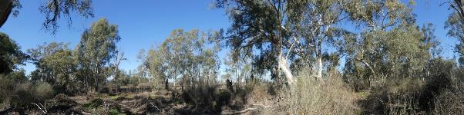
Downstream end Latitude 34.23956 Longitude 140.29183.Direction 200

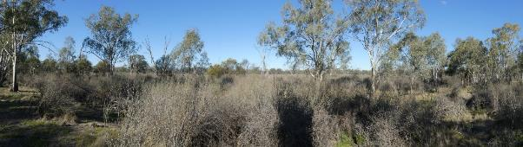
Overlooking the Eastern depression Latitude 34.23978 Longitude 140.29230 Direction 200

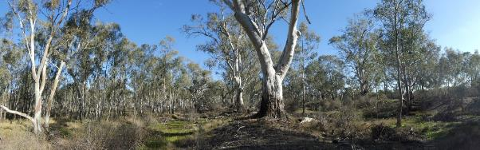Upstream end inside the bend Latitude 34.24042 Longitude 140.29160 Direction 210

Stressor Analysis.
Stressor | Severity | Scope | Irreversibility
Lack of Inundation | High | Medium | Low
Saline Groundwater Depth | Medium | Low | Low

Land Tenure Issues
- All sites are within the Murray River National Park (Katarapko Section).

Regent Parrot Utilisation - Potential Nesting and Foraging.

Ecological Objectives
Halt the decline and improve the health condition of mature woody plant species e.g. (River Red Gum, Black Box, Cooba and Lignum).
Maintain existing regeneration and provide opportunities for future regeneration events of woody plant species e.g. (River Red Gum, Black Box, Cooba and Lignum).
Improve the abundance and diversity of flood dependant understory vegetation.
Improve floodplain habitat conditions to promote Regent Parrot breeding events.
Community Objective
Engage landholder involvement in the sustainable management of their site(s).

Hydrological Parameters
Maximum Inundation  - Water Height  - Inundation Area  - Fill Volume | 9.8 AHD  12 ha  54 ML
Commencement to Flow ML/d Band | 60-70,000
Full Supply Flow ML/d Band | 70-80,000
Watering Options | Pumping to full supply
Watering Timing | Late Autumn to Early Winter

Potential Infrastructure Requirements and Estimated Costs
No infrastructure required at this stage.

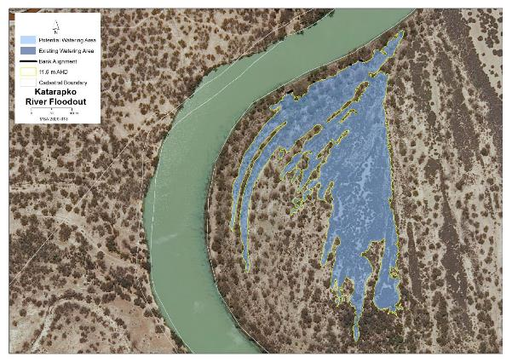
Map identifies the potential watering area

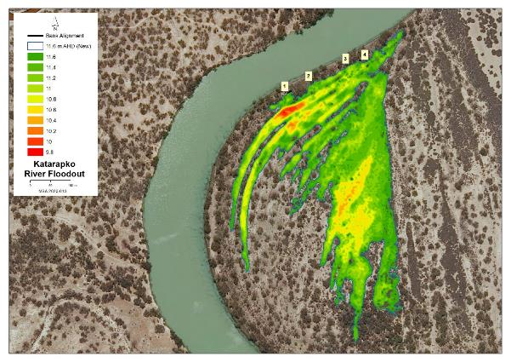
AHD heights across the site and identified infrastructure locations

9 Little Schiller Lagoon Management Brief
Vegetation Description
River Red Gum Woodland  Stressed (level 3) | River Red Gum adults and saplings, odd Black Box, Cooba adults and saplings. Understory Lignum and Spiny Sedge, Lagoon Saltbush.
Low Shrubland/Herbland  Healthy (level 4) | Lagoon bed dominated by River Red Gum saplings with Spiny Sedge and Lagoon Saltbush.

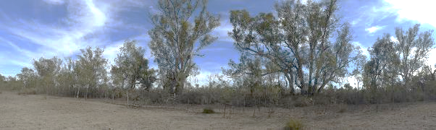
Northern bank of Little Schiller Lagoon Latitude 34.04850 Longitude 139.55551 Direction 312

View of Little Schiller Lagoon Latitude 34.04850 Longitude 139.55551 Direction 236

Stressor Analysis.
Stressor | Severity | Scope | Irreversibility
Lack of Inundation | High | High | Low | Medium
Saline Groundwater Depth | Medium | High | Low | Medium

Land Tenure Issues
- The site is owned by one private land owner.

Regent Parrot Utilisation- Nesting and Foraging.

Ecological Objectives
Halt the decline and improve the health condition of mature woody plant species e.g. (River Red Gum, Black Box, Cooba and Lignum).
Maintain existing regeneration and provide opportunities for future regeneration events of woody plant species e.g. (River Red Gum, Black Box, Cooba and Lignum).
Improve the abundance and diversity of flood dependant understory vegetation.
Improve floodplain habitat conditions to promote Regent Parrot breeding events.
Provide floodplain and aquatic habitats suitable for waterbird and frog refuge and breeding.
Provide hydrological connectivity between watering sites and adjacent floodplain during natural flood events.
Community Objectives
Engage landholder involvement in the sustainable management of their site(s).

Hydrological Parameters
Maximum Inundation  - Water Height  - Inundation Area  - Fill Volume | 6.4 AHD  4.2 ha  44 ML
Commencement to Flow ML/d Band | 40-50,000
Full Supply Flow ML/d Band | 70-80,000
Watering Options | Gravity from Upper Lock 2 Pool level maybe possible  Pump to full supply may be required  Lock 2 weir pool raising (frequency may not be adequate)  Manage natural flood recession
Watering Timing | Spring through to Autumn

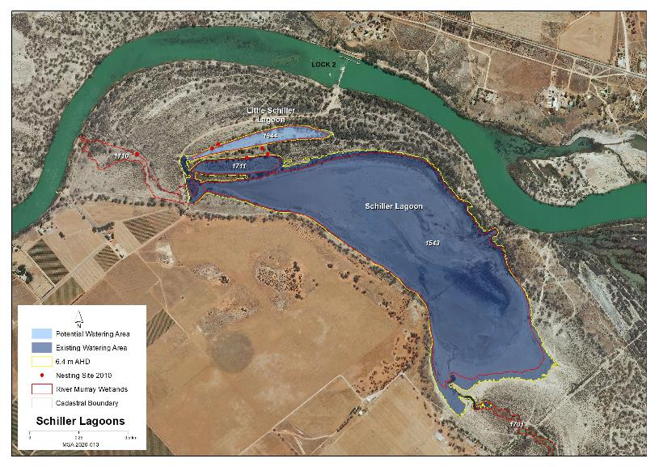
Map identifies the existing and potential watering areas

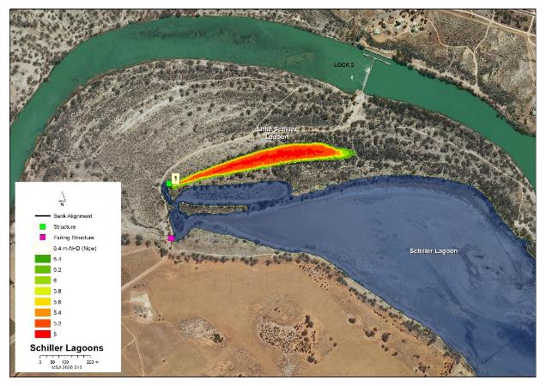
Map features AHD heights across the site and identified infrastructure locations

Potential Infrastructure Requirements
Bank or Channel Details
Location | ID | Length  (m) | Freeboard  (m) | Height with freeboard  (m) | Volume  (m3) | Regulator equipment and comments
Little Schiller Lagoon | Bank 1 | 24.3 | 0.30 | 1.30 | 184.1 | 1m concrete pipe with flap valve

10 Loveday 4 x 4 Lagoon Management Brief
Vegetation Description
River Red Gum Woodland  Stressed (level 3) | Floodplain dominated by adult hollow bearing River Red Gum with patches of saplings. Healthy (level 4). Understory Cooba adult and sapling small patches of Lignum, Spiny Sedge, Blue Rod, and Smooth Heliotrope. Edge of Lagoon River Red Gum predominately dead. Degraded (level 1).
Black Box Woodland Healthy (level 4) | Edge of Lagoon dominated by Black Box and Cooba adult and sapling with Lignum dominated understory.
Low Shrubland/Herbland  Stressed (level 2) | Wetland 519 Southern upper edge Smooth Heliotrope, Creeping Saltbush, Ruby Saltbush, Creeping Boobialla and Lagoon Saltbush. Lagoon floor and northern edge dominated by Samphire with patches of bare soil.

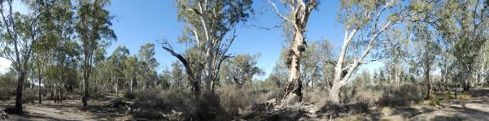
271 Western end of floodplain Latitude 34.22746 Longitude 140.27297 Direction 150

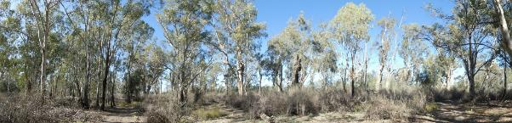
272 Central area of floodplain Latitude 34.22768 Longitude 140.27384 Direction 160

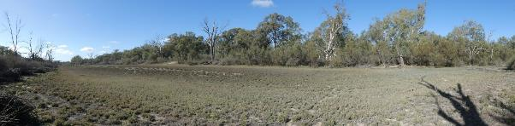
273 Bed of Wetland 519 Latitude 34.22710 Longitude 140.27482 Direction 124

Stressor Analysis.
Stressor | Severity | Scope | Irreversibility
Lack of Inundation | High | High | Medium
Saline Groundwater Depth | High | Medium | Medium

Land Tenure Issues
- The site is owned by one private land owner.
- A strip of unalienated Crown land runs along the water’s edge but does not influence the site.

Regent Parrot Utilisation- Potential Nesting and Foraging.

Ecological Objectives
Halt the decline and improve the health condition of mature woody plant species e.g. (River Red Gum, Black Box, Cooba and Lignum).
Maintain existing regeneration and provide opportunities for future regeneration events of woody plant species e.g. (River Red Gum, Black Box, Cooba and Lignum).
Improve the abundance and diversity of flood dependant understory vegetation.
Reduce soil salinity to disadvantage Samphire and promote regeneration of less salt tolerant floodplain and aquatic plant species.
Improve floodplain habitat conditions to promote Regent Parrot breeding events.
Provide floodplain and aquatic habitats suitable for waterbird and frog refuge and breeding.
Provide hydrological connectivity between watering sites and adjacent floodplain during natural flood events.
Community Objectives
Engage landholder involvement in the sustainable management of their site.

Hydrological Parameters
Maximum Inundation  - Water Height  - Inundation Area  - Fill Volume | 11 AHD  7.4 ha  42 ML
Low Inundation  - Water Height  - Inundation Area  - Fill Volume | 10.4 AHD  3.3 ha  12.6 ML
Commencement to Flow ML/d Band | 40-50,000
Full Supply Flow ML/d Band | 60-70,000
Watering Option | Pump to full supply  Pump to low elevation  Manage natural flood recession  Enhance natural flood duration and coverage
Watering Timing | Spring through to Autumn

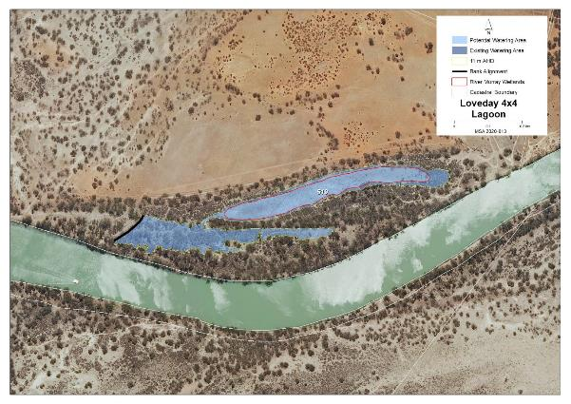
Map identifies the potential watering area

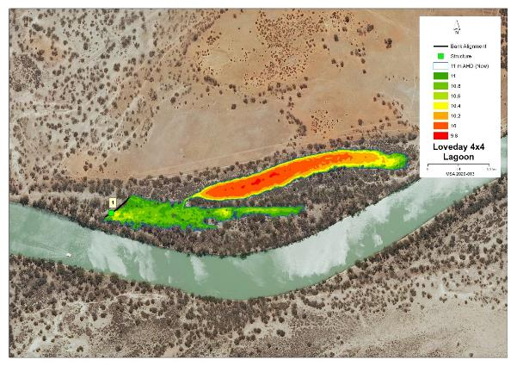Map features AHD heights across the site and identified infrastructure locations

Potential Infrastructure Requirements
Bank or Channel Details
Location | ID | Length  (m) | Freeboard  (m) | Height with freeboard  (m) | Volume  (m3) | Regulator equipment and comments
Loveday 4x4 | Bank 1 | 102.0 | 0.30 | 0.70 | 230.72 | 600mm concrete pipe with flap valve

11 Markaranka Flat Management Brief
Vegetation Description - Markaranka Flat
River Red Gum Woodland Stressed (level 3) | Stressed adult trees with patches of healthy poles and saplings. Understory Lignum, Spiny Sedge, Smooth Heliotrope, Native Liquorice, Creeping Saltbush, Lagoon Saltbush and Bladder Saltbush.

Latitude 34.03282 Longitude 139.51152 Direction 190

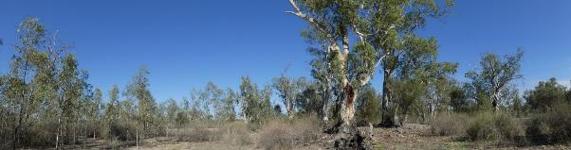
Latitude 34.03278 Longitude 139.51085 Direction 226

Vegetation Description - Markaranka Flat Channel
River Red Gum Woodland  Stressed (level 3) | Healthy and stressed adult trees with patches of healthy saplings. Understory Lignum, Blue Rod, Spiny Sedge, Cooba adults and saplings, Ruby Saltbush, Lagoon Saltbush and Yanga Bush.

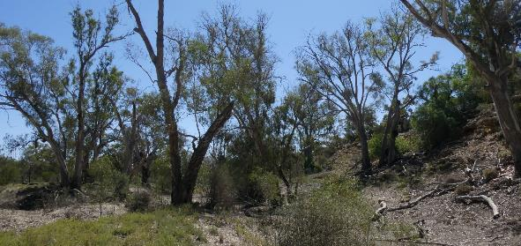
Latitude 34.03889 Longitude 139.51384 Direction 350

Stressor Analysis.
Site | Stressor | Severity | Scope | Irreversibility
Markaranka Flat | Lack of Inundation | Very High | High | Medium
 | Saline Groundwater Depth | Medium | High | Medium
Markaranka Flat Channel | Lack of Inundation | Very High | High | Low
 | Saline Groundwater Depth | Medium | High | Low

Land Tenure Issues
Markaranka Flat | - The greater portion of the site is located on the Hogwash Bend Conservation Park.  - The site will slightly impact on two private landowners.
Markaranka Flat Channel | - The greater portion of the site is located on the Hogwash Bend Conservation Park.  - The site will impact one private landowner with the small bank located on that land.

Regent Parrot Utilisation
Markaranka Flat | Nesting and Foraging
Markaranka Flat Channel | Nesting and Foraging

Ecological and Community Objectives
Site Objectives | Markaranka Flat | Markaranka Flat Channel
Ecological Objectives
Halt the decline and improve the health condition of mature woody plant species e.g. (River Red Gum, Black Box, Cooba and Lignum).
Maintain existing regeneration and provide opportunities for future regeneration events of woody plant species e.g. (River Red Gum, Black Box, Cooba and Lignum).
Improve the abundance and diversity of flood dependant understory vegetation.
Improve floodplain habitat conditions to promote Regent Parrot breeding events.
Provide hydrological connectivity between watering sites and adjacent floodplain during natural flood events.
Increase Regent Parrot potential breeding success by limiting disturbance from human activities such as recreational visitors and noise from water pumping at colony sites during July and August.
Community Objectives
Engage landholder involvement in the sustainable management of their site.
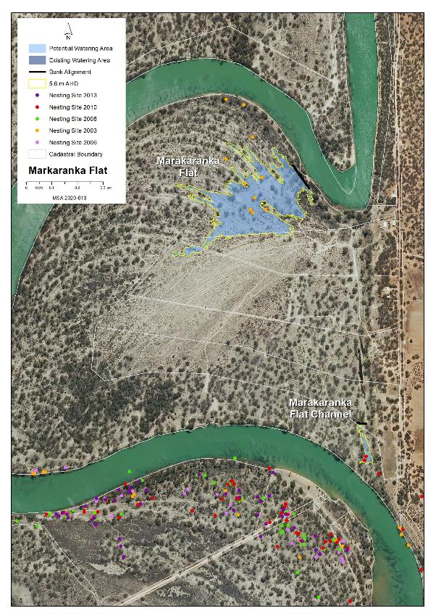
Map identifies the potential watering area

Hydrological Parameters
 | Markaranka Flat | Markaranka Flat Channel
New Area of Inundation  - Maximum Water Height Inundation Area  - Fill Volume | 5.6 AHD  8.4 ha  29.4 ML | 5.6 AHD  0.3 ha  1.6 ML
Commencement to Flow ML/d Band | 40-50,000 | 80-90,000
Full Supply Flow ML/d Band | 50-60,000 | 80-90,000
Watering Option | Pump to full Supply  Manage natural flood recession | Pump to full Supply  Manage natural flood recession
Watering Timing | Late Autumn to Early Winter | Late Autumn to Early Winter

Potential Infrastructure Requirements
Bank or Channel Details
Location | ID | Length  (m) | Freeboard  (m) | Height with freeboard  (m) | Volume  (m3) | Regulator equipment and comments
Markaranka Flat | Bank 1 | 84.3 | 0.30 | 1.50 | 515.9 | 1m concrete pipe with flap valve

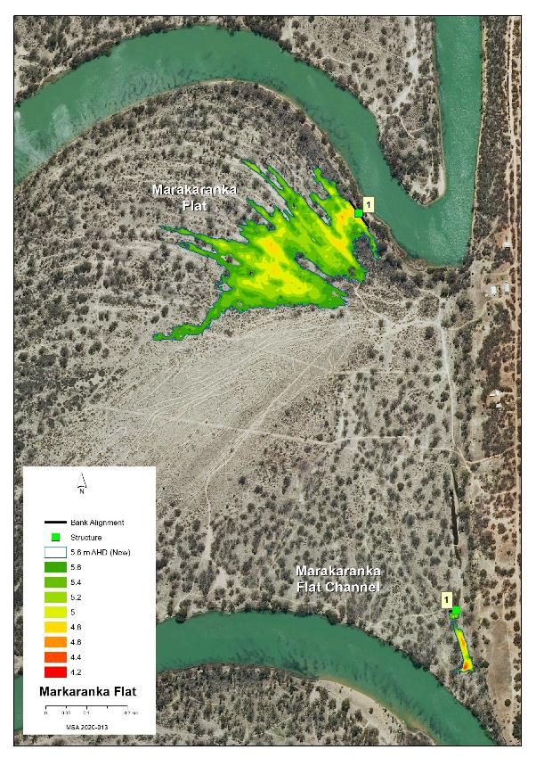
Map features AHD heights across the site and identified infrastructure locations

12 Markaranka Management Brief
Vegetation Description Markaranka Lagoon Outlet Creek
River Red Gum Woodland Stressed (level3) | River Red Gum adults and saplings (poles mostly dead). Understory Cooba adult and saplings, scattered Lignum patches, Creeping Saltbush, Lagoon Saltbush, Ruby Saltbush, Smooth Heliotrope, Blue Rod, Native Liquorice, Bladder Saltbush, Pale Poverty Bush.

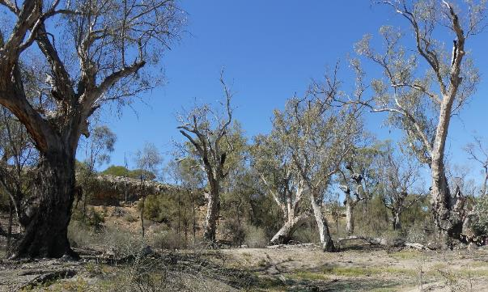
Existing Watering site Latitude 34.04165 Longitude 139.51538 Direction 96

Vegetation Description Markaranka River Flood-out
River Red Gum Woodland Stressed (level3) | River Red Gum adults, poles and saplings. Understory odd Cooba, scattered Lignum, Creeping Saltbush, Lagoon Saltbush, Ruby Saltbush and Native Liquorice.
Black Box Woodland Healthy (level 4) | Scattered adults and saplings across the eastern section of the site with Cooba and dense Lignum understory.
Lignum Shrubland  Healthy (level 4 and 5) | Continuous thick Lignum across the eastern section of site with odd Black Box and Cooba.

Western section of site Latitude 340.4500 Longitude 139.51416.Direction 240

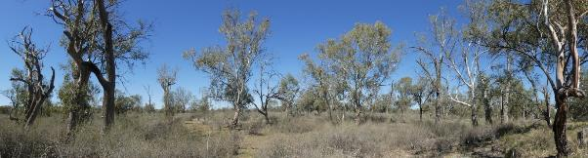
Western section of site Latitude 34.04622 Longitude 139.51305 Direction 110

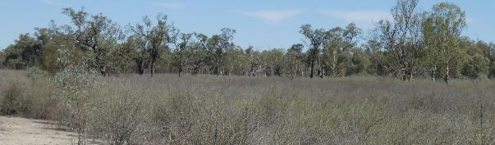
Eastern section of the site Latitude 34.04535 Longitude 139.51438 Direction 180

Stressor Analysis.
Site | Stressor | Severity | Scope | Irreversibility
Markaranka Lagoon Outlet Creek | Lack of Inundation | Very High | High | Low
 | Saline Groundwater Depth | Medium | High | Low
Markaranka River Flood-out | Lack of Inundation | High | High | Medium
 | Flow Barrier | Medium | Low | Low

Land Tenure Issues
Markaranka Lagoon Outlet Creek | - The site is owned by one private land owner which is a company.  - A strip of unalienated Crown land runs along the water’s edge and includes Bank one.
Markaranka River Flood-out | - The site is owned by one private land owner which is a company.  - A strip of unalienated Crown land runs along the water’s edge and includes Bank one.

Regent Parrot Utilisation
Markaranka Lagoon Outlet Creek | Nesting and Foraging
Markaranka River Flood-out | Nesting and Foraging

Ecological and Community Objectives
Site Objectives | Markaranka Lagoon Outlet Creek | Markaranka River Flood-out
Ecological Objectives
Halt the decline and improve the health condition of mature woody plant species e.g. (River Red Gum, Black Box, Cooba and Lignum).
Maintain existing regeneration and provide opportunities for future regeneration events of woody plant species e.g. (River Red Gum, Black Box, Cooba and Lignum).
Improve the abundance and diversity of flood dependant understory vegetation.
Provide floodplain and aquatic habitats suitable for waterbird and frog refuge and breeding.
Improve floodplain habitat conditions to promote Regent Parrot breeding events.
Provide hydrological connectivity between watering sites and adjacent floodplain during natural flood events.
Increase Regent Parrot potential breeding success by limiting disturbance from human activities such as recreational visitors and noise from water pumping at colony sites during July and August.
Community Objectives
Engage landholder involvement in the sustainable management of their site

Hydrological Parameters
 | Markaranka Lagoon Outlet Creek | Markaranka River Flood-out
New Area of Inundation  - Maximum Water Height Inundation Area  - Fill Volume | 5.6 AHD  2.1 ha  15.8 ML | 7.6 AHD  13.7 ha  66.5 ML
Commencement to Flow ML/d Band | 30-40,000 | 90-100,000
Full Supply Flow ML/d Band | 60-70,000 | 100-110,000
Watering Option | Pump to full Supply.  Manage natural flood recession | Pump to full Supply.  Manage natural flood recession
Watering Timing | Spring through to Autumn | Late Autumn to Early Winter

Potential Infrastructure Requirements
Bank or Channel Details
Location | ID | Length  (m) | Freeboard  (m) | Height with freeboard  (m) | Volume  (m3) | Regulator equipment and comments
Markaranka Lagoon Outlet Creek | Bank 1 | 13.50 | 0.50 | 1.30 | 105.7 | 600mm concrete pipe with flap valve
Markaranka River Flood-out | Bank 1 | 115.8 | 0.50 | 1.70 | 1,280.0 | 1m concrete pipe with flap valve
 | Bank 2 | 8.2 | 0.30 | 1.10 | 63.7 | Nil

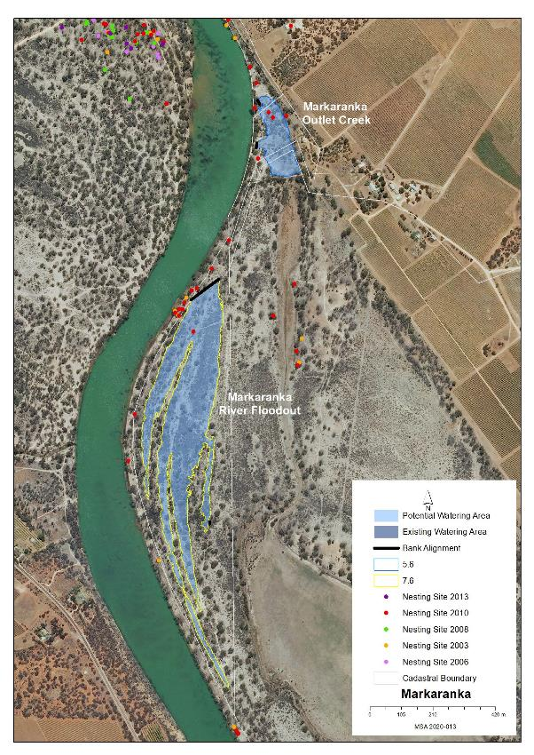
Map identifies the potential watering area

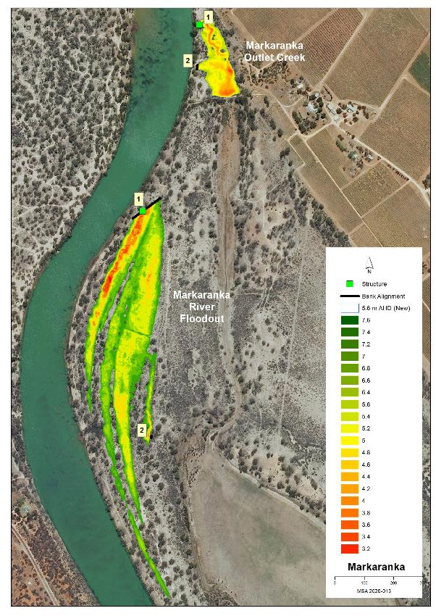
Map features AHD heights across the site and identified infrastructure locations

13 Markaranka Lagoon Management Brief
Vegetation Description
River Red Gum Woodland  Healthy (level 5) | Wetlands 1547 and 1705 healthy mature adult trees (level 5) with odd poles and saplings understory odd Lignum and Cooba with Spiny Sedge, Native Liquorice and Rat’s-Tail Couch. Dead adult trees scattered around the northern flat edge.
Black Box Woodland  Healthy (level 5) | Healthy (level 5) adult and sapling ring with Cooba around the outer edge of Wetlands 1708 and 1709 and the northern flat.
Lignum Shrubland  Healthy (level 4 and 5) | The northern depressions including Wetland 1709 and the south-western edge of Wetland 1705 area dominated by areas of dense and sparse Lignum with or without scattered patches and individual Cooba adults and saplings.
Low Shrubland/Herbland  Healthy (level 4) | Wetlands 1547 and 1705 bed dominated by patches of Spiny Sedge, Native Liquorice, Rat’s-Tail Couch.

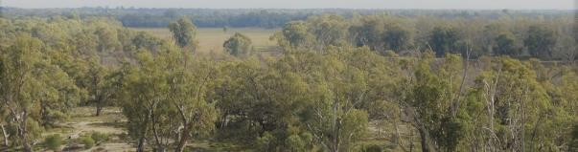
Southern end of Wetland 1705 Latitude 34.06242 Longitude 139.52723 Direction 316

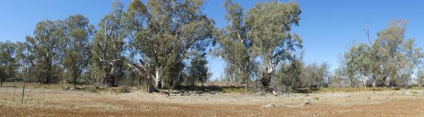
Edge of Wetland 1547 Latitude 33.404604 Longitude 139.51573 Direction 80

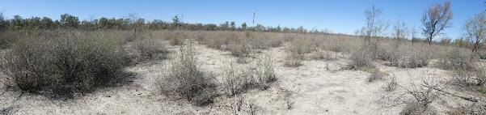
134 Northern Depression Latitude 34.04621 Longitude 139.51708 Direction 100

Regent Parrot Utilisation- Nesting and Foraging

Stressor Analysis.
Stressor | Severity | Scope | Irreversibility
Lack of Inundation | Medium | Medium | Medium
Saline Groundwater Depth | Medium | Medium | Medium
Flow Barrier | High | High | Medium

Land Tenure Issues
- The site is owned by one private land owner which is a company.
- A strip of unalienated Crown land runs along the water’s edge.

Ecological Objectives
Halt the decline and improve the health condition of mature woody plant species e.g. (River Red Gum, Black Box, Cooba and Lignum).
Maintain existing regeneration and provide opportunities for future regeneration events of woody plant species e.g. (River Red Gum, Black Box, Cooba and Lignum).
Improve the abundance and diversity of flood dependant understory vegetation.
Improve floodplain habitat conditions to promote Regent Parrot breeding events
Provide floodplain and aquatic habitats suitable for waterbird and frog refuge and breeding.
Provide hydrological connectivity between watering sites and adjacent floodplain during natural flood events.
Community Objectives
Engage landholder involvement in the sustainable management of their site(s).

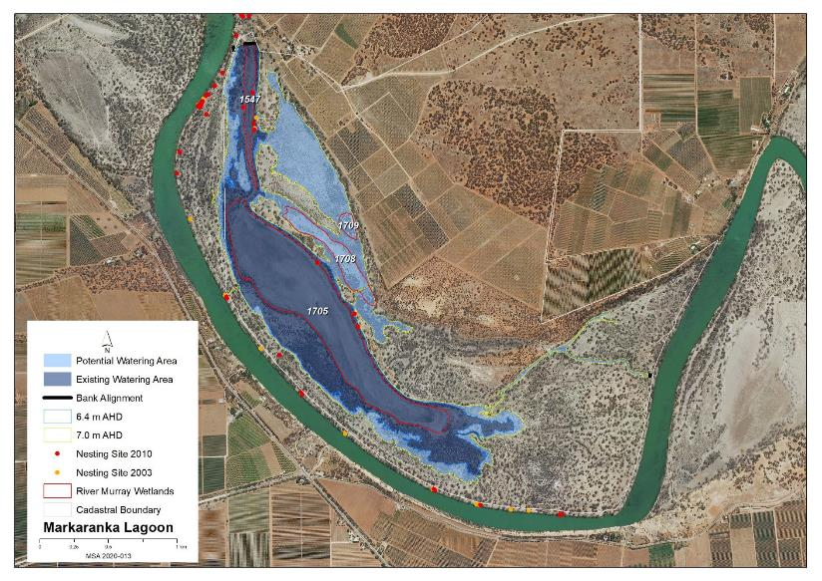
Map identifies the existing and potential watering areas

Hydrological Parameters
Existing Area of Inundation  - Inundation Area  - Historical Watering Dates | 128 ha  2005/06, 2008/08, 2009/10, 2014/16 and 2018/19
Maximum Inundation  - Water Height  - Inundation Area  - Fill Volume | 7 AHD  214 ha  3558 ML
Low Inundation  - Water Height  - Inundation Area  - Fill Volume | 6.4 AHD  128 hectares  2267 ML
Commencement to Flow ML/d Band | 40-50,000
Full Supply Flow ML/d Band | 90-100,000
Watering Option | Pump to full supply  Pump to low elevation  Possibility of return flows  Manage natural flood recession  Enhance natural flood duration and coverage
Watering Timing | Spring through to Autumn

Potential Infrastructure Requirements
Bank or Channel Details
Location | ID | Length  (m) | Freeboard  (m) | Height with freeboard  (m) | Volume  (m3) | Regulator equipment and comments
Markaranka Lagoon | Bank 1 | 22.8 | 0.30 | 0.50 | 59.2 | Nil
Markaranka Lagoon | Bank 2 | 77.2 | 0.50 | 3.70 | 1,487.5 | Sheetpile regulator with 3 bays dropboards  A crane is anticipated for sheetpiling due to the height of structure.
Markaranka Lagoon | Bank 3 | 14.0 | 0.50 | 1.50 | 131.4 | Sheetpile regulator with 3 bays dropboards
Markaranka Lagoon | Bank 4 | 8.0 | 0.50 | 1.30 | 32.4 | 800mm concrete pipe with flap valve

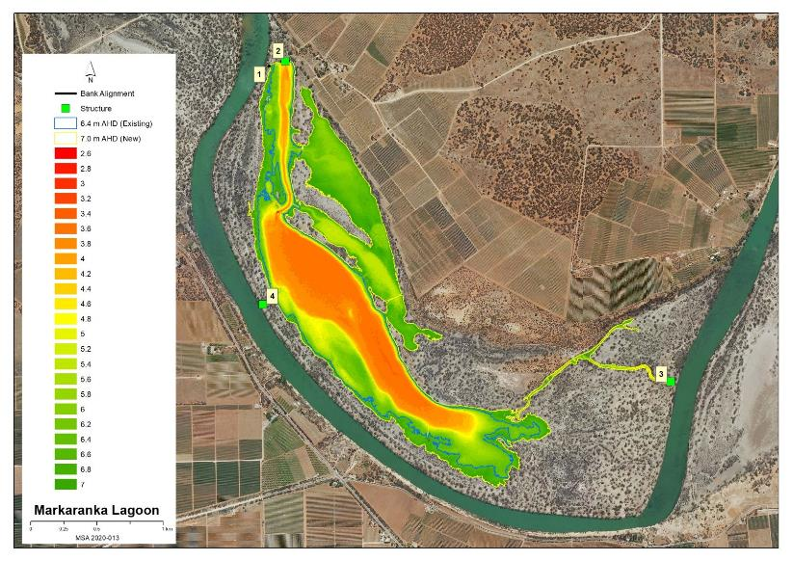
Map features AHD heights across the site and identified infrastructure locations

14 Molo Flat Management Brief
Vegetation Description
River Red Gum Woodland Stressed (level 2) | A strip of healthy and dead adult River Red Gum with patches of poles and saplings surround the two existing Watering lagoons. Understory Spiny Sedge and Native Liquorice.
Lignum Shrubland  healthy (level 5) | Open Lignum dominate the two Watering lagoons. Surrounding Wetland 1551 is dominated by Lignum with scattered Bladder and Creeping Saltbush. The northern area above Wetland 1712 is dominated by Lignum with scattered Black Box and Cooba saplings and odd Bladder Saltbush.

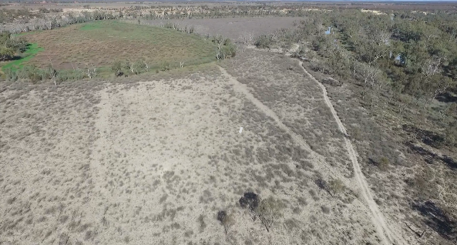
Wetland 1551 surrounded by Lignum (Drone image by L Morris)

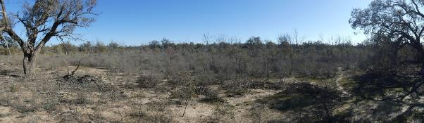
Area north of Wetland 1712 Latitude 3402920 Longitude 13949200 Direction 240

Stressor Analysis
Stressor | Severity | Scope | Irreversibility
Lack of Inundation | Medium | Medium | Medium

Land Tenure Issues
- The site is owned by one private land owner.
- A strip of unalienated Crown Land runs along the water’s edge and includes Bank one.
Regent Parrot Utilisation – Foraging and Adjacent Nesting.

Ecological Objectives
Halt the decline and improve the health condition of mature woody plant species e.g. (River Red Gum, Black Box, Cooba and Lignum).
Maintain existing regeneration and provide opportunities for future regeneration events of woody plant species e.g. (River Red Gum, Black Box, Cooba and Lignum).
Improve the abundance and diversity of flood dependant understory vegetation.
Improve floodplain habitat conditions to promote Regent Parrot breeding events.
Provide floodplain and aquatic habitats suitable for waterbird and frog refuge and breeding.
Provide hydrological connectivity between watering sites and adjacent floodplain during natural flood events.
Community Objectives
Engage landholder involvement in the sustainable management of their site(s).

Hydrological Parameters
Existing Area  - Inundation Area  - Historical Watering Dates | 36 ha  2005/06, 2009/10, 2014/15, 2015/16, 2018/19 and 2019/20
Maximum Inundation  - Water Height  - Inundation Area  - Fill Volume | 6 AHD  76.4 ha  1009 ML
Low Inundation  - Water Height  - Inundation Area  - Fill Volume | 4.8 AHD  37.2ha  301.4 ML
Commencement to Flow ML/d Band | 40-50,000
Full Supply Flow ML/d Band | 70-80,000
Watering Option | Pump to full supply  Pump to low elevation  Possibility of return flows  Manage natural flood recession
Watering Timing | Spring through to Autumn

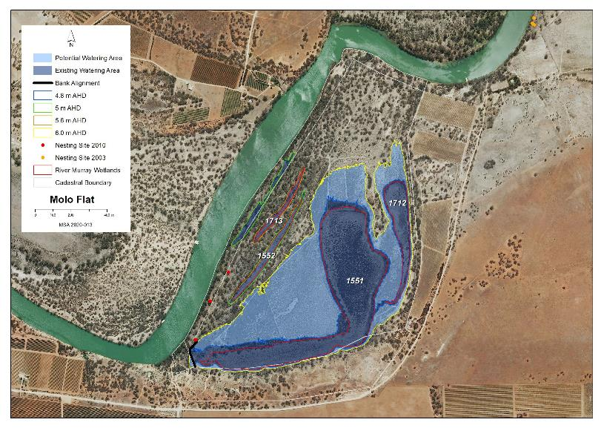
Map identifies the existing and potential watering areas

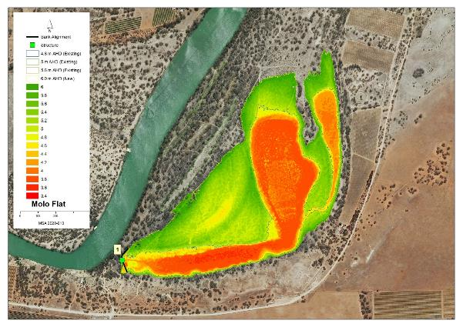
Map features AHD heights across the site and identified infrastructure locations

Potential Infrastructure Requirements
Bank or Channel Details
Location | ID | Length  (m) | Freeboard  (m) | Height with freeboard  (m) | Volume  (m3) | Regulator equipment and comments
Molo Flat | Bank 1 | 153.4 | 0.50 | 2.30 | 1,203.3 | Sheetpile regulator with 2 bays of dropboards

15 Morgan South Management Brief
Vegetation Description - Morgan South Lagoon
River Red Gum Woodland  Stressed (level 3) | Significant number of adult River Red Gum dead across the site. Within the current Water for the Environment influence and southern end of Wetland 2021 live trees in good health, outside of the Watering influence and including Wetland 1716 and west of Wetland 1720 most live trees range from medium to poor with a few good or healthy. Odd Black Box amongst the River Red Gum. Understory Lignum, Purple Burr-daisy, Spiny Sedge, Native Liquorice, Prickly Bottle Brush and small patches of River Red Gum saplings and poles and odd Cooba adults and saplings.
Lignum Shrubland  Healthy (Level 4 and 5) | Large areas of the site bed dominated with dense and sparse Lignum with Creeping Saltbush, Clover spp.and odd Bladder Saltbush.
Low Shrubland/Herbland  Stressed (level 3) | Wetland 1716 and other open areas dominated by Creeping Saltbush, Clover spp. and small patches of Smooth Heliotrope.

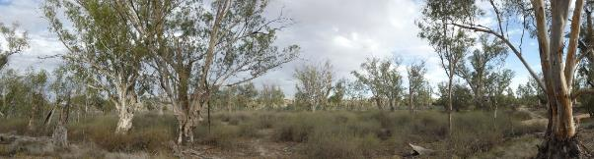
West of Wetland 1720 Latitude 34.04165 Longitude 139.51538 Direction 96

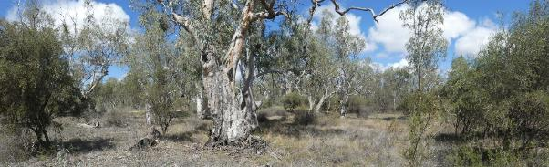
103 Southern end of Wetland 2021 Latitude 34.02633 Longitude 139.41103 Direction 200

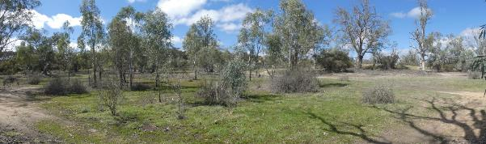
102 Wetland 1716 Latitude 34.02592 Longitude 139.41233 Direction 120

Vegetation Description Morgan Lagoon Flood-out
River Red Gum Woodland  Stressed (level 3) | Stressed (level 3) adult healthy poles and saplings. Understory scattered Cooba adults and saplings, scattered patches of Lignum and Prickly Bottle Brush, Spiny Sedge, Bladder Saltbush, Creeping Saltbush, Ruby Saltbush, Roly-Poly, Pale Poverty Bush, Native Liquorice and Blue Rod.
Lignum Shrubland  Healthy (Level 4) | Wetland 1721 scattered Lignum with Bladder Saltbush, Creeping Saltbush, Roly-Poly and Pale Poverty Bush.

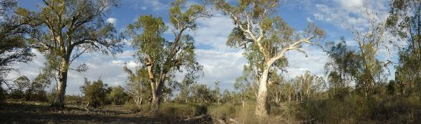
66 Existing watering site Latitude 34.04500 Longitude 139.51416 Direction 240

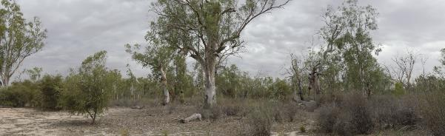
52 Existing watering site Latitude 34.04622 Longitude 139.51305 Direction 110

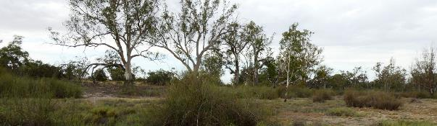
57 Wetland 1721 Latitude 34.04535 Longitude 139.51438 Direction 180

Stressor Analysis.
Site | Stressor | Severity | Scope | Irreversibility
Morgan South Lagoon | Lack of Inundation | High | Low | Medium
 | Saline Groundwater Depth | Medium | Low | Medium
 | Flow Barrier | Medium | High | Medium
 | Human Disturbance | High | Medium | Low
Morgan Lagoon Flood-out | Lack of Inundation | High | High | Medium
 | Saline Groundwater Depth | Medium | High | Medium
 | Human Disturbance | High | Medium | Low
Land Tenure Issues
- Both sites are within the Morgan Conservation Park.

Regent Parrot Utilisation
Morgan South Lagoon | Nesting and Foraging
Morgan Lagoon Flood-out | Nesting and Foraging

Ecological and Community Objectives
Site Objectives | Morgan South Lagoon | Morgan Lagoon Flood-out l
Ecological Objectives
Halt the decline and improve the health condition of mature woody plant species e.g. (River Red Gum, Black Box, Cooba and Lignum).
Maintain existing regeneration and provide opportunities for future regeneration events of woody plant species e.g. (River Red Gum, Black Box, Cooba and Lignum).
Improve the abundance and diversity of flood dependant understory vegetation.
Improve floodplain habitat conditions to promote Regent Parrot breeding events.
Provide floodplain and aquatic habitats suitable for waterbird and frog refuge and breeding.
Provide hydrological connectivity between watering sites and adjacent floodplain during natural flood events.
Increase Regent Parrot breeding success by limiting recreational visitor access to colony sites during July and August.
Increase Regent Parrot potential breeding success by limiting disturbance from human activities such as recreational visitors and noise from water pumping at colony sites during July and August.
Engage landholder involvement in the sustainable management of their site(s).
Community Objectives
Promote Water for the Environment projects through community educational information and programs.

Hydrological Parameters
 | Morgan South Lagoon | Morgan Lagoon Flood-out l
Existing Area  - Inundation Area  - Historical Watering Dates | 15.1 ha  2008/09, 2009/10, 2014/15, 2018/19 and 2019/20 | Nil
Maximum Inundation  - Water Height  - Inundation Area  - Fill Volume | 5.8 AHD  23.7 ha  246.6 ML | 5.6 AHD  8.2 ha  54.3 ML
Commencement to Flow ML/d Band | 20-30,000 | 50-60,000
Full Supply Flow ML/d Band | 90-100,000 | 100-110,000
Watering Option | Pump to full Supply  Possibility of return flows  Manage natural flood recession  Enhance natural flood duration and coverage | Pump to full Supply  Manage natural flood recession  Enhance natural flood duration and coverage
Watering Timing | Spring through to Autumn | Late Autumn to Early Winter

Potential Infrastructure Requirements
Bank or Channel Details
Location | ID | Length  (m) | Freeboard  (m) | Height with freeboard  (m) | Volume  (m3) | Regulator equipment and comments
Morgan South Lagoon | Bank 1 | 145.6 | 0.30 | 2.30 | 1,370.0 | 1m concrete pipe with flap valve
 | Road 1 | 43.10 | 0.50 | 0.50 | 318.5 | Raise existing road 500mm
Morgan Lagoon Flood-out | Bank 1 | 205.7 | 0.50 | 1.90 | 1,587.6 | 1m concrete pipe with flap valve.  Source of clay unknown at this location.

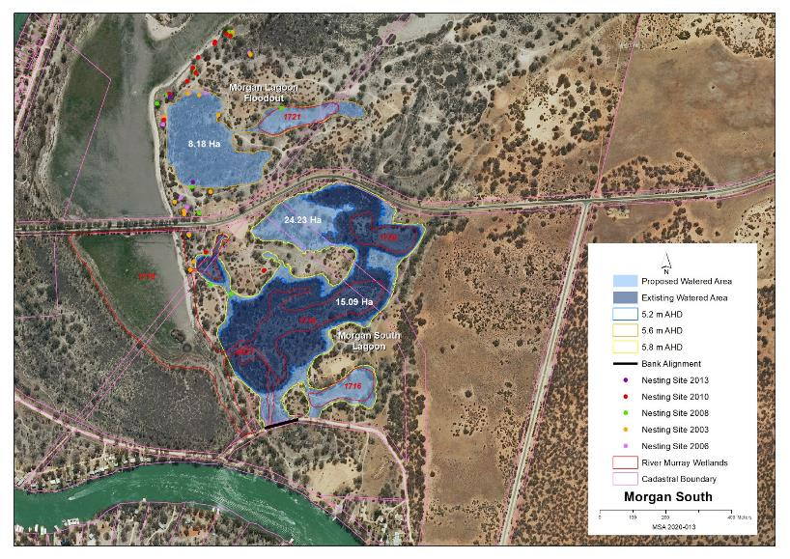
Map identifies the existing and potential watering areas
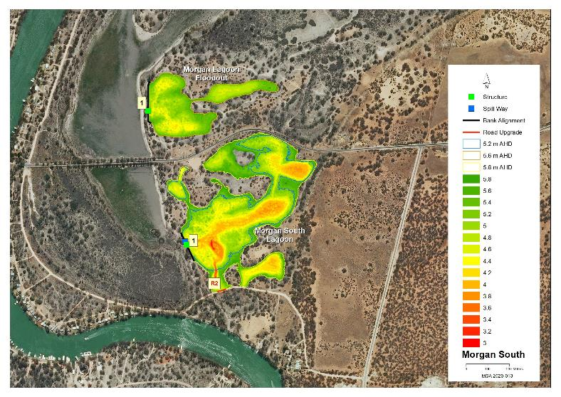

Map features AHD heights across the site and identified infrastructure location

16 Morgan North Management Brief
Vegetation Description Morgan West
River Red Gum Woodland  Stressed (level 3) | The majority of adults, poles and sapling were alive with a range of canopy condition. Wetlands 1463, 951, 351,973 and 974 had a population of River Red Gum to varying densities. Wetland 973 and 974 were a mixture of both River Red Gum and Black Box around the wetlands edge. Understory plant species and density varied considerably from site to site with the following species: Cooba, Prickly Bottle Brush, Creeping, Lagoon, Ruby and Bladder Saltbush, Spiny Sedge, Blue Rod and Native Liquorice.
Lignum Shrubland  Healthy (level 4 and5) | Wetland 967 dominated by dense Lignum with odd Black Box poles scattered across the wetland bed and ringed by adult Black Box. The flow paths between the wetlands had scattered River Red Gum adults, young adults and saplings, odd Black Box adults and saplings, Prickly Bottle Brush and patches of Lignum both dense and sparse.

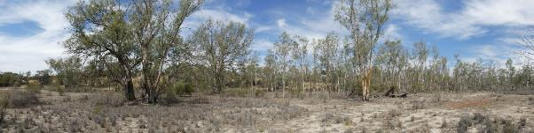
Wetland 1463 Latitude 34.02216 Longitude 139.41400 Direction 130

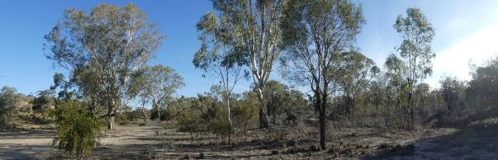
Wetland 951 Latitude 34.02049 Longitude 139.41593 Direction 200

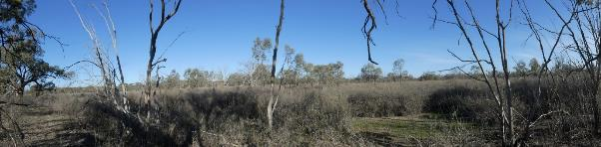
Wetland 967 Latitude 34.01918 Longitude 139.41432 Direction 160
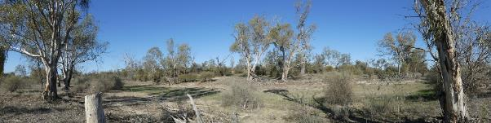
Flow path from East Morgan to West Morgan Latitude 34.01795Longitude 139.41797 Direction 150

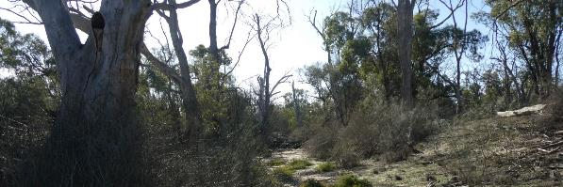
Main Inlet Creek Wetland 351 Latitude 34.01574 Longitude 139.41527 Direction 340

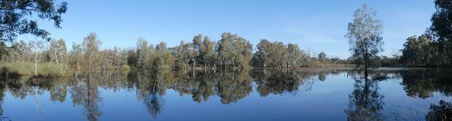
Wetland 973 an existing Water for the Environment Latitude 34.01603 Longitude 139.41177 Direction 210

Vegetation Description Morgan East
River Red Gum Woodland  Stressed (level 3) | Wetland 1111 is the focus of the existing Watering site with patches and strips of adult, pole and sapling River Red Gum ranging from dead to healthy. Along the river edge there are a number of lagoons and flood runners with healthy old and young adult trees. The north/south channels have a wide range of canopy condition with the downstream inlet creek having the most dead trees. Throughout the site there are a number of sites with a mix of River Red Gum and Black Box.
Lignum Shrubland  Healthy (level 4 and 5) | Large areas of dense and sparse Lignum occur throughout the flood-outs of Wetlands 1111, and 737.
Low Shrubland/Herbland  Stressed (level 3) | Within the existing Watering area Common Joy Weed, Common Nardoo, Common Sneeze Weed, Native Liquorice, Clover spp., Spiny Sedge, Pale Knotweed and Blown Grass. Outside the Watering influence Creeping, Bladder, Ruby and Lagoon Saltbush, Blue Rod, Pale Poverty Bush, Spiny Sedge, Purple Burr-daisy with Smooth Heliotrope and Ice-plant spp. within the centre north/south channels.

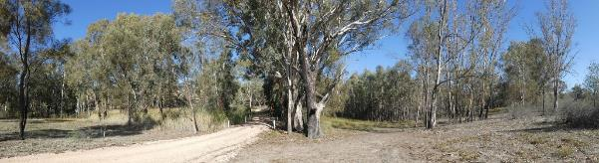
One of the many road embankments across Wetland 1111 the focus of the existing Watering site
Latitude 34.01758 Longitude 139.42533.Direction 200

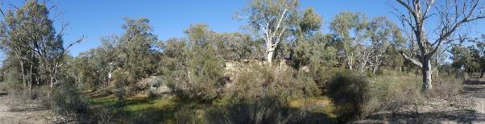
Wetland 736 part of the existing Water for the Environment site
Latitude 34.01887 Longitude 139.43180 Direction 220

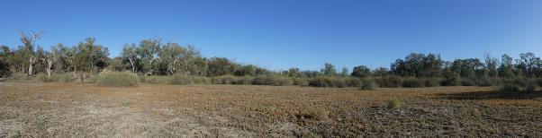
Looking west over Wetland 1111 eastern flood-out
Latitude 34.01793 Longitude 139.42979 Direction 260

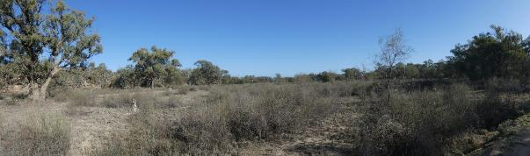
458 Area east of Wetland 1111 eastern flood-out
Latitude 34.01810 Longitude 139.43071 Direction 260
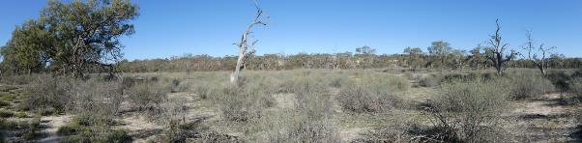
Looking towards Wetland 737 Latitude 34.01982 Longitude 139.43541 Direction 190

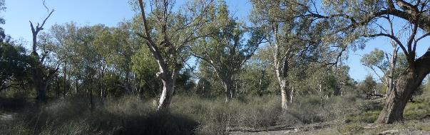
Upstream river edge lagoon Latitude 34.01949 Longitude 139.43518 Direction 90

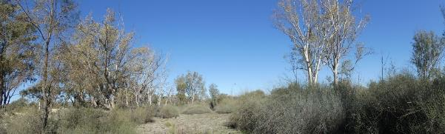
The central north south flow paths Latitude 34.01639 Longitude 139.42390 Direction 190

Stressor Analysis.
Site | Stressor | Severity | Scope | Irreversibility
Morgan West | Lack of Inundation | High | Medium | Medium
Morgan East | Lack of Inundation | High | High | Medium
 | Saline Ground Water Depth | Medium | Low | Medium
 | Flow Barriers | Medium | Medium | Medium

Regent Parrot Utilisation
Morgan West | Potential Foraging
Morgan East | Nesting and Foraging

Land Tenure Issues
Morgan West | - The greater portion of the site is located in the Morgan Conservation Park.  - The site will impact three private landowners (one only minimally).  - A strip of unalienated Crown land runs along the water’s edge adjacent to the private land.  - An un-made legal road runs north-south across the site and is invested in the Mid Murray Council.  - The site crosses the Old Cadell Morgan Rd.
Morgan East | - The site will impact eight private landowners.  - A strip of unalienated Crown land runs along the water’s edge.

Ecological and Community Objectives
Site Objectives | Morgan West | Morgan East
Ecological Objectives
Halt the decline and improve the health condition of mature woody plant species e.g. (River Red Gum, Black Box, Cooba and Lignum).
Maintain existing regeneration and provide opportunities for future regeneration events of woody plant species e.g. (River Red Gum, Black Box, Cooba and Lignum).
Improve the abundance and diversity of flood dependant understory vegetation.
Improve floodplain habitat conditions to promote Regent Parrot breeding events.
Provide floodplain and aquatic habitats suitable for waterbird and frog refuge and breeding.
Provide hydrological connectivity between watering sites and adjacent floodplain during natural flood events.
Increase Regent Parrot potential breeding success by limiting disturbance from human activities such as recreational visitors and noise from water pumping at colony sites during July and August
Community Objectives
Promote Water for the Environment projects through community educational information and programs.
Engage landholder involvement in the sustainable management of their site.

Hydrological Parameters
 | Morgan West | Morgan East
Existing Area  - Inundation Area  - Historical Watering Dates | 14.3 ha  2008/09, 2009/10, 2013/14, 2015/16, 2018/19 and 2019/20 | 19.5 ha  2006/07, 2009/10, 2014/15, 2015/16, 2018/19 and 2019/20
Maximum Inundation  - Water Height  - Inundation Area  - Fill Volume | 5.8 AHD  51.8 ha  435 ML | 6.2 AHD  32.6 ha  378 ML
Low Inundation  - Water Height  - Inundation Area  - Fill Volume |  | 5.6 AHD  19.5 ha  221 ML
Commencement to Flow ML/d Band | 20-30,000 | 20-30,000
Full Supply Flow ML/d Band | 90-100,000 | 100-110,000
Watering Option | Pump to full supply  Possibility of return flows  Manage natural flood recession  Enhance natural flood duration and coverage | Pump to full supply  Pump to low elevation  Possibility of return flows  Manage natural flood recession  Enhance natural flood duration and coverage
Watering Timing | Spring through to Autumn | Spring through to Autumn

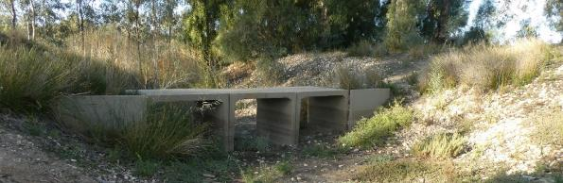
Morgan West Upstream Inlet Creek access crossing

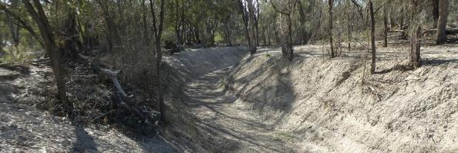
Morgan East upstream inlet creek channelized and deepened

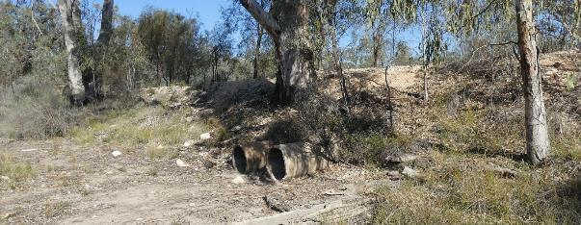
Morgan East downstream outlet pipes

Potential Infrastructure Requirements
Bank or Channel Details
Location | ID | Length  (m) | Freeboard  (m) | Height with freeboard  (m) | Volume  (m3) | Regulator equipment and comments
Morgan West | Bank 1 | 7.9 | 0.30 | 0.90 | 45.3 | Nil
 | Bank 2 | 232.6 | 0.30 | 1.70 | 954.0 | 1m concrete pipe with flap valve
 | Bank 3 | 18.1 | 0.50 | 2.30 | 269.0 | Sheetpile regulator with 2 bays of dropboards
 | Bank 4 | 4.2 | 0.30 | 0.40 | 21.7 | Nil
 | Bank 5 | 135.1 | 0.30 | 1.30 | 528.0 | Sheetpile regulator with 2 bays of dropboards
 | Road 1 | 56.8 | 0.50 | 1.10 |  | include one open pipe road crossing to suit the new road height  Raise existing 9m wide road 700mm
 | Road 2 | 38.0 | 0.50 | 0.70 |  | include one open pipe road crossing to suit the new road height  Raise existing 9m wide road 500mm
Morgan East | Bank 1 | 133.3 | 0.50 | 2.90 | 1,417.1 | Replace existing pipe with 1m concrete pipe. Install chamber with stoplogs to regulate flow
 | Bank 2 | 29.7 | 0.50 | 2.70 | 382.7 | 1m concrete pipe with flap valve
 | Bank 3 | 5.4 | 0.30 | 0.40 | 13.6 | Nil
 | Bank 4 | 12.1 | 0.50 | 1.30 | 93.4 | 600mm concrete pipe with flap valve
 | Bank 5 | 10.2 | 0.50 | 2.10 | 75.4 | 1m concrete pipe with flap valve

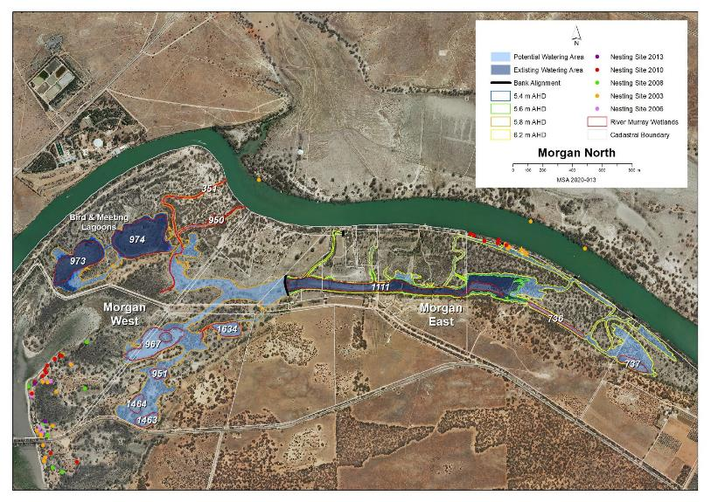
Map identifies the existing and potential watering areas
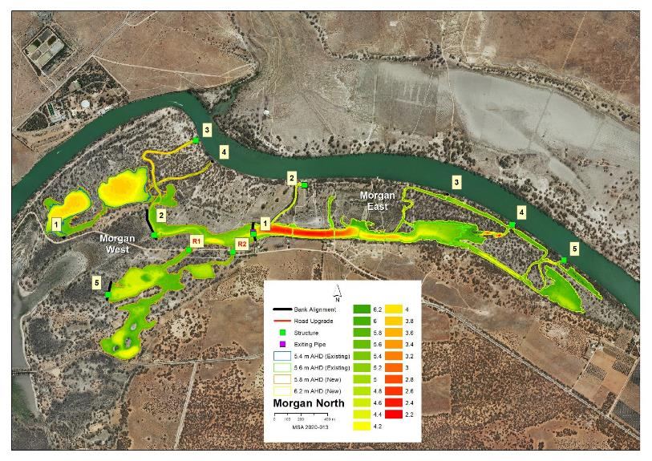
Map features AHD heights across the site and identified infrastructure locations

17 Murbpook Lagoon Management Brief
Vegetation Description
River Red Gum Woodland  Stressed (level 3) | Narrow band of healthy River Red Gum adults at the cliff base along the western edge of Wetland 1060 and the eastern edge of Wetland 1096, 1346 and 199. Understory Prickly Bottle Brush, Cooba, small patches of Western Boobialla and odd small patches of River Red Gum saplings. Along the opposite side of these wetlands the trees were dead with Samphire and bare soil.
Low Shrubland/Herbland  Stressed (level 2 and 3) | On the western portion of Wetland 1060 bed Stinkwort, Clover spp., Blue Rod, Smooth Heliotrope and Small Monkey Flower dominated stressed (level 3). On the eastern portion Samphire and bare soil dominated stressed (level 2. On the bed of Wetland 1096 bare soil dominated ringed by patches of Samphire and Smooth Heliotrope stressed (level 2). Wetland 1346 and 199 wetland bed had healthy Lignum with Samphire in the centre stressed (level 2).

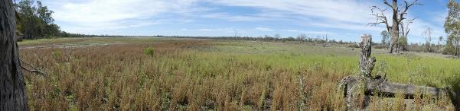
Southern End Wetland 1060 Latitude 34.12396Longitude 139.37940 Direction 20
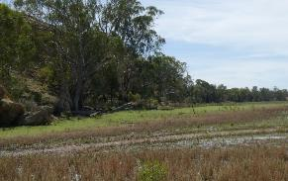 |  | 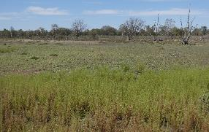
Wetland 1060 SW side |  | Wetland 1060SE side
Latitude 34.12396 Longitude 393.7940 Direction 346 |  | Latitude 34.12396 Longitude 139.37940 Direction 42
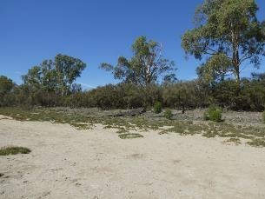 | 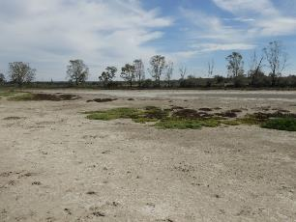
Wetland 1096 eastern edge | Wetland 1096 western edge
Latitude 34.11514 Longitude 139.38680 Direction 42 | Latitude 34.11514 Longitude 139.38680 Direction 220
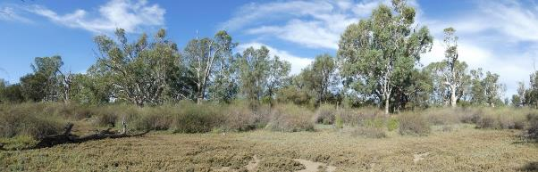
Wetland 1348 Latitude 34.11069 Longitude 139.38898 Direction 72

Stressor Analysis.
Stressor | Severity | Scope | Irreversibility
Lack of Inundation | High | High | Medium
Surface Soil Salinity | High | High | Medium

Land Tenure Issues
- Site activities will impact two private landowners.
- A strip of unalienated Crown land runs along the water’s edge adjacent to the private land.

Regent Parrot Utilisation - Adjacent Nesting and Potential Foraging.

Ecological Objectives
Halt the decline and improve the health condition of mature woody plant species e.g. (River Red Gum, Black Box, Cooba and Lignum).
Maintain existing regeneration and provide opportunities for future regeneration events of woody plant species e.g. (River Red Gum, Black Box, Cooba and Lignum).
Improve the abundance and diversity of flood dependant understory vegetation.
Reduce soil salinity to disadvantage Samphire and promote regeneration of less salt tolerant floodplain and aquatic plant species.
Improve floodplain habitat conditions to promote Regent Parrot breeding events.
Provide floodplain and aquatic habitats suitable for waterbird and frog refuge and breeding.
Provide hydrological connectivity between watering sites and adjacent floodplain during natural flood events.
Community Objectives
Engage landholder involvement in the sustainable management of their site(s).

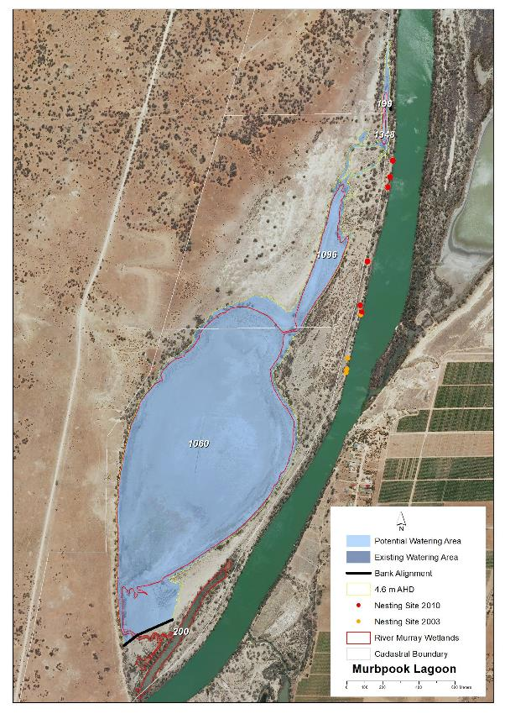
Map identifies the potential watering area

Hydrological Parameters
Maximum Inundation  - Water Height  - Inundation Area  - Fill Volume | 4.6 AHD  131 ha  2737 ML
Low Inundation  - Water Height  - Inundation Area  - Fill Volume | 3.4 AHD  111.5 ha  1292 ML
Commencement to Flow ML/d Band | Pool Level
Full Supply Flow ML/d Band | 100-110,000
Watering Options | Pump to full supply  Pump to low elevation  Possibility of return flows  Manage natural flood recession
Watering Timing | Spring through to Autumn

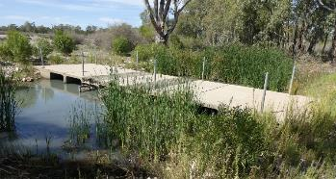
Existing Box Culvert inlet structure which does not hold water

Potential Infrastructure Requirements
Bank or Channel Details
Location | ID | Length  (m) | Freeboard  (m) | Height with freeboard  (m) | Volume  (m3) | Regulator equipment and comments
Murbpook Lagoon | Bank 1 | 307.8 | 0.50 | 2.10 | 2,636.0 | Sheetpile regulator with 2 bays of dropboards
 | Bank 2 | 7.7 | 0.50 | 0.90 | 43.4 | 450mm concrete pipe with flap valve

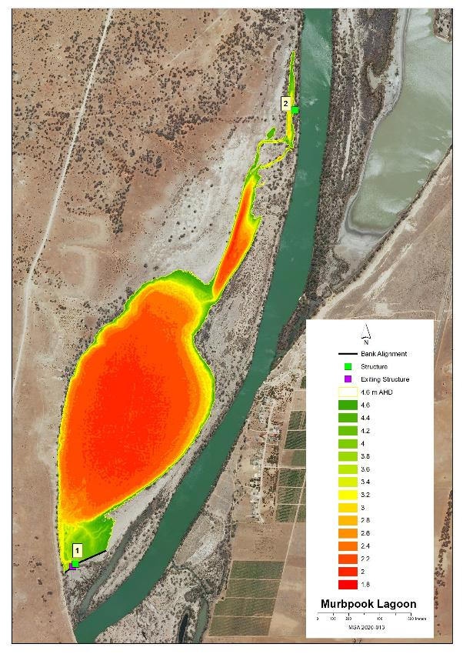
Map features AHD heights across the site and identified infrastructure locations

18 North West Bend Management Brief
Vegetation Description
River Red Gum Woodland  Stresses (level 3) | Southern edge of the floodplain dominated by patches of various aged adult River Red Gum with some patches of saplings. Health varies greatly from healthy to long-term dead.
Black Box Woodland  Healthy (level 5) | Healthy adult Black Box dominate the northern edge of the floodplain. The southern floodplain edge has odd mature Black Box with significant areas of Black Box saplings.
Low Shrubland/Herbland  Stresses (level 2 and 3) | Wetland 1112 lagoon bed dominated by Bladder, Creeping, Ruby, and Lagoon Saltbush, Pale-Poverty Bush, Yellow-Flowered Devil's Claw, Spiny Sedge and Rat’s-Tail Couch. Stressed (level 3). Wetland 1113 bed Pale-Poverty Bush, Black Roly-Poly, bare soil odd small Samphire Stressed (level 2).
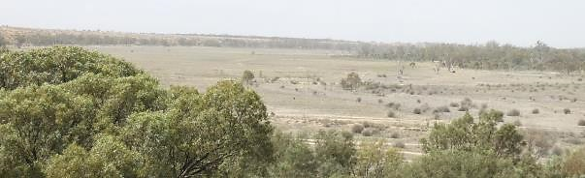
View over floodplain looking east

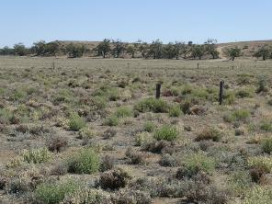 | 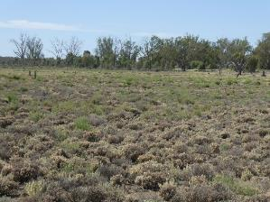
North western floodplain edge |  | Wetland 1112 south western edge
Latitude 34.01319 Longitude 139.42641 Direction 310 |  | Latitude 34.01319 Longitude 139.42641 Direction 100
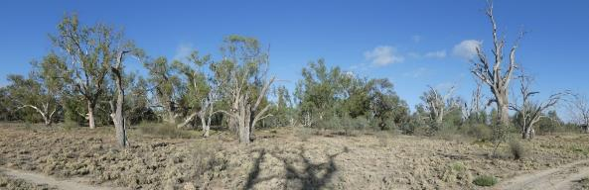
Southern edge of Wetland 1112 Latitude 34.01425 Longitude 139.43084.Direction 336
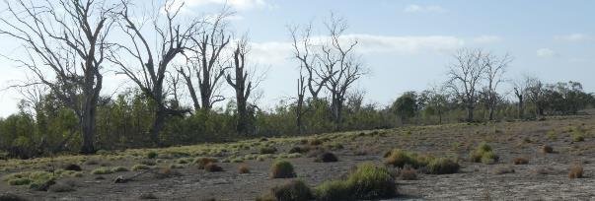
Northern edge of Wetland 1113 Latitude 34.01488 Longitude 139.43464.Direction 154

Stressor Analysis.
Stressor | Severity | Scope | Irreversibility
Lack of Inundation | Medium | High | Medium
Saline Ground Water Depth | Medium | High | Medium

Land Tenure Issues
- Site activities will impacted eight private landowner (2 of which are companies). One party owns multiple land parcels.
- At the water’s edge there is a strip of land owned by the Mid Murray Council which has created a number of shack allotments.
- A narrow strip of Crown land at the water’s edge exists in front of the private land.

Regent Parrot Utilisation - Potential Foraging.

Ecological Objectives
Halt the decline and improve the health condition of mature woody plant species e.g. (River Red Gum, Black Box, Cooba and Lignum).
Maintain existing regeneration and provide opportunities for future regeneration events of woody plant species e.g. (River Red Gum, Black Box, Cooba and Lignum).
Improve the abundance and diversity of flood dependant understory vegetation.
Reduce soil salinity to disadvantage Samphire and promote regeneration of less salt tolerant floodplain and aquatic plant species.
Provide floodplain and aquatic habitats suitable for waterbird and frog refuge and breeding.
Provide hydrological connectivity between watering sites and adjacent floodplain during natural flood events.
Community Objectives
Promote Water for the Environment projects through community educational information and programs.
Engage landholder involvement in the sustainable management of their site(s).

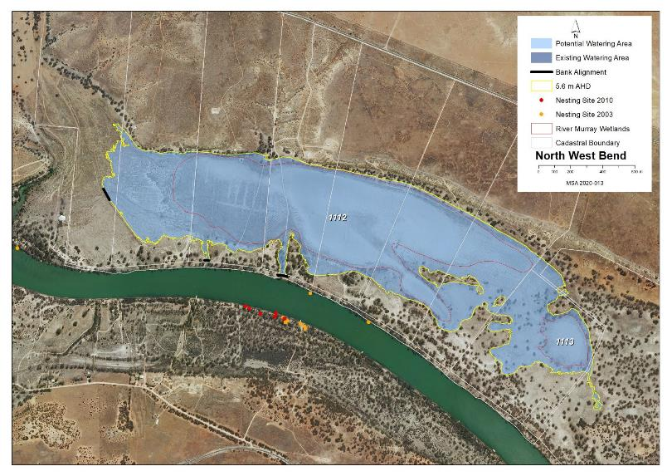
Map identifies the potential watering area

Hydrological Parameters
Maximum Inundation  - Water Height  - Inundation Area  - Fill Volume | 5.6 AHD  182 ha  2197 ML
Low Inundation  - Water Height  - Inundation Area  - Fill Volume | 4 6 AHD  119 ha  700.4 ML
Commencement to Flow ML/d Band | 60-70,000
Full Supply Flow ML/d Band | 70-80,000
Watering Options | Pump to full supply  Pump to low elevation  Possibility of return flows  Manage natural flood recession  Enhance natural flood duration and coverage
Watering Timing | Spring through to Autumn

Potential Infrastructure Requirements
Bank or Channel Details
Location | ID | Length  (m) | Freeboard  (m) | Height with freeboard  (m) | Volume  (m3) | Regulator equipment and comments
North West Bend | Bank 1 | 80.4 | 0.50 | 1.90 | 856.4 | Sheetpile regulator with 3 bays of dropboards  Large existing hole/breach to repair. Assume 1m deep, 10m wide, 20m long
 | Bank 2 | 25.2 | 0.50 | 1.10 | 142.7 | Nil
 | Bank 3 | 59.7 | 0.50 | 2.10 | 600.2 | Sheetpile regulator with 3 bays of dropboards

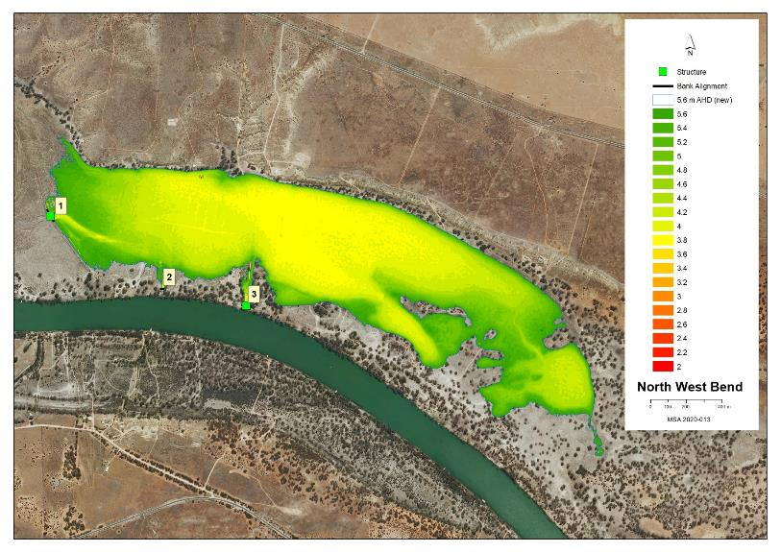
Map features AHD heights across the site and identified infrastructure locations

19 Overland Corner Management Brief
Vegetation Description
River Red Gum Woodland  Stressed (level 2) | Large stressed and odd dead adult River Red Gum throughout the edges of the western Wetland 96, 1988, 95, 1987 and 1316 with patches of poles and saplings stressed to healthy, healthy Cooba adults and saplings plus Lignum and Spiny Sedge. Eastern edge of upstream inlet channel, Wetland 1309 and 1683 and downstream flood-out all adult River Red Gum except odd trees are dead. Existing watering area Wetland 1683 small patches and individual healthy poles while Wetland 1309 has a significant dense patch of healthy poles.
Lignum Shrubland  Healthy (level 4 and 5) | Scattered patches of sparse to dense Lignum range across the site with significant areas occurring in Wetland 747 healthy and downstream flood-out stressed.
Low Shrubland/Herbland  Stressed (level 2 and 3) | Upstream inlet channel bed has salt scalds ringed by Samphire stressed (level 2). Wetland 1683 and 1309 recently watered had a diverse group of Herbland species; Common Nardoo, Slender Knotweed, Dirty Dora, Water Primrose, Common Sneezeweed, Lesser Joyweed, California Burr, Grey Germander, odd Cumbungi seedlings, Lagoon Saltbush, Clover spp., Native Liquorice, odd patches of Small Heliotrope, Creeping Saltbush ,and odd Lignum Healthy (level 5). The remaining Wetland wetlands not recently watered had a different group of species; Spiny Sedge, Lagoon, Bladder, Ruby and Creeping Saltbush, Pale Poverty Bush, Common Sneezeweed, Smooth Heliotrope, Grey Germander, Rat’s-Tail Couch, California Burr, Native Liquorice, Lignum and odd patches of desiccated Common Spike-rush and Giant Sedge stressed (level 3).

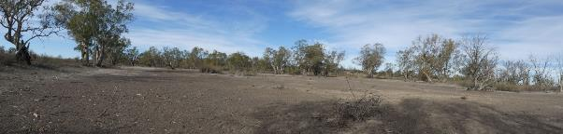 Wetland 96 Existing Watering site Latitude 34.10474 Longitude 140.21055 Direction 70

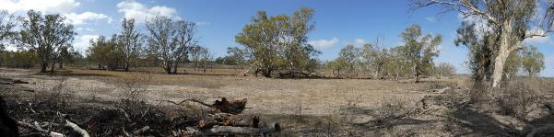
Wetland 1988 Existing Watering site Latitude 34.10371 Longitude 140.21142 Direction 126
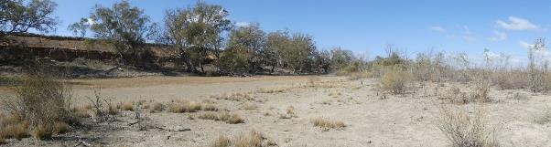 Wetland 1316 Existing Watering site Latitude 34.09665 Longitude 140.21288 Direction 120

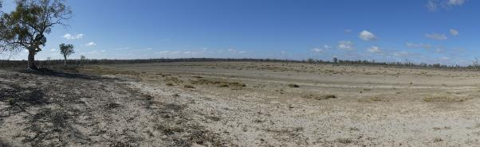
Wetland 1986 Latitude 34.09465 Longitude 140.20507 Direction 90

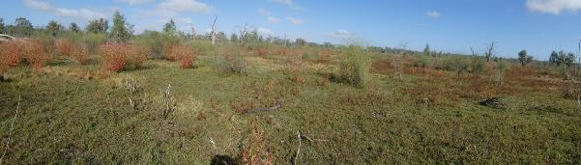 Wetland 1683 Existing watering site Latitude 34.09773 Longitude 140.20771 Direction 280

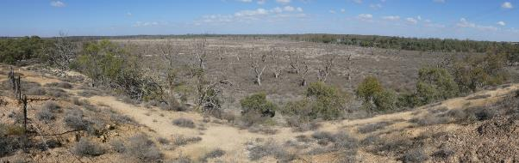
Downstream flood-out

Stressor Analysis.
Stressor | Severity | Scope | Irreversibility
Lack of Inundation | High | High | Medium
Saline Ground Water Depth | High | High | Medium
Surface Soil Salinity | High | Low | Medium
Flow Barrier | Medium | Medium | Low
Feral Goats and Pigs | Low | Medium | Low

Land Tenure Issues
- The northernmost area consists of two large land parcels held by the National Trust of SA. They also hold the two adjacent small land parcels near the site of the Historic Overland Corner Hotel.
- The remainder of the site is Crown land (Minister’s land) but there is an agreement in place for this land to be dedicated under the care, control and management of the River Murray and Mallee Aboriginal Corporation on behalf of the First Peoples of the River Murray and Mallee. The land is also subject to licensing for pump, pipeline and access.

Regent Parrot Utilisation- Adjacent Nesting and Foraging.

Ecological Objectives
Halt the decline and improve the health condition of mature woody plant species e.g. (River Red Gum, Black Box, Cooba and Lignum).
Maintain existing regeneration and provide opportunities for future regeneration events of woody plant species e.g. (River Red Gum, Black Box, Cooba and Lignum).
Improve the abundance and diversity of flood dependant understory vegetation.
Reduce soil salinity to disadvantage Samphire and promote regeneration of less salt tolerant floodplain and aquatic plant species.
Improve floodplain habitat conditions to promote Regent Parrot breeding events.
Provide floodplain and aquatic habitats suitable for waterbird and frog refuge and breeding.
Provide fish passage through large floodplain habitats during natural flood events.
Provide hydrological connectivity between watering sites and adjacent floodplain during natural flood events.
Increase Regent Parrot potential breeding success by limiting disturbance from human activities such as recreational visitors and noise from water pumping at colony sites during July and August
Community Objectives
Promote Water for the Environment projects through community educational information and programs.
Engage landholder involvement in the sustainable management of their site(s).

Hydrological Parameters
Existing Area of Inundation  - Inundation Area  - Historical Watering Dates | 94 ha  Overland Corner 2008/09, 2009/10, 2013/14 and 2014/15  Lignum Basins 2009/10, 2013/14 and 2014/15  2018/19 and 2019/20
Maximum Inundation  - Water Height  - Inundation Area  - Fill Volume | 9 AHD  187.5 ha  1751 ML
Low Inundation  - Water Height  - Inundation Area  - Fill Volume | 8 AHD  71.3 ha  505 ML
Commencement to Flow ML/d Band | 40-50,000
Full Supply Flow ML/d Band | 50-60,000
Watering Options | Gravity from Upper Lock 3 to full supply  Gravity from Upper Lock 3 to low elevation  Possibility of return flows  Manage natural flood recession  Enhance natural flood duration and coverage
Watering Timing | Spring through to Autumn
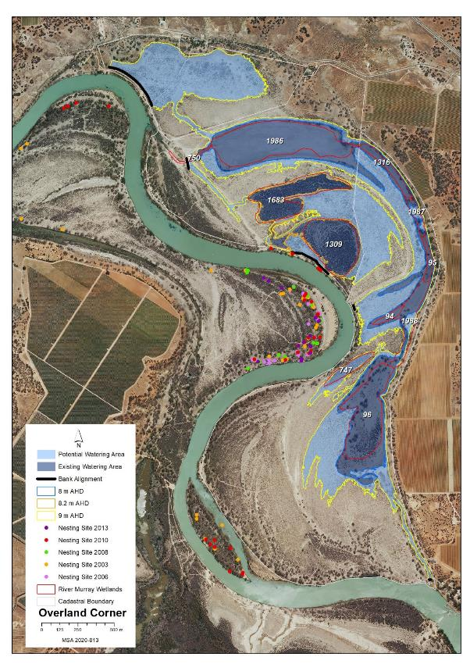
Map identifies the existing and potential watering areas
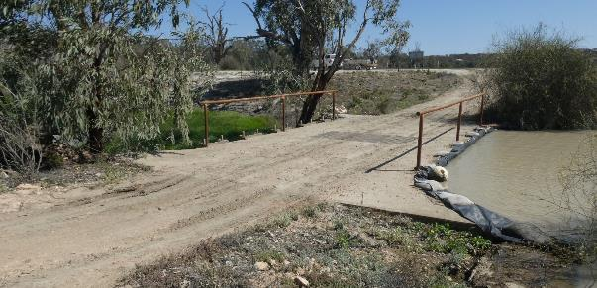
Overland Corner outlet structure - Note the plastic on the wetland side to hold back pumped water.
(Photo: by M Harper)

Potential Infrastructure Requirements
Bank or Channel Details
Location | ID | Length  (m) | Freeboard  (m) | Height with freeboard  (m) | Volume  (m3) | Regulator equipment and comments
Overland Corner | Pipeline 1 |  |  |  | N/A | 320m of pipe to siphon from upstream side of Lock 3.  Control valve and spindle or penstock required to control pipe at Lock 3 end. Flap valve required at downstream end.
 | Bank 1 | 418.3 | 0.30 | 0.90 | 2,305.1 | 2x 600mm concrete pipe with flap valve
 | Bank 2 | 73.8 | 0.50 | 3.30 | 1,439.1 | Box Culvert with large rocks and baffle angles for turbulence/fish passage
 | Bank 3 | 306.4 | 0.50 | 1.30 | 2,361.8 | 800mm concrete pipe with flap valve
 | Bank 4 | 31.7 | 0.30 | 0.50 | 43.0 | Nil
 | Bank 5 | 13.4 | 0.50 | 2.30 | 191.6 | Sheetpile regulator with 4 bays of dropboards and large rocks for fish passage

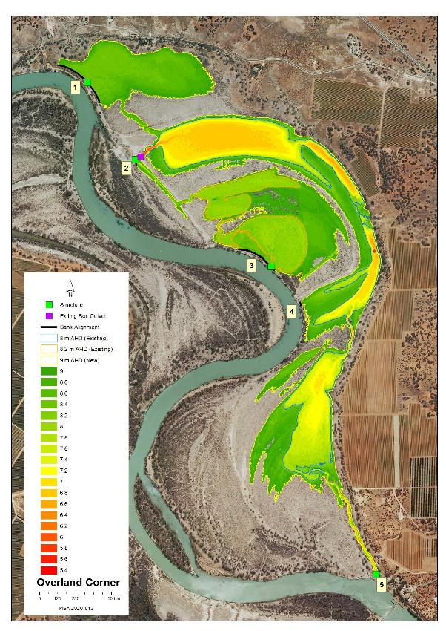
Map features AHD heights across the site and identified infrastructure locations

20 Paschkes Flat Management Brief
Vegetation Description
Black Box Woodland  Healthy (level 5) | Strip of adults and saplings along the southern edge of Wetland 1666.
Lignum Shrubland  Healthy (level 4 and 5) | Large area of thick to spare Lignum on the northern side of Wetland 1666 with scattered small patches to River Red Gum saplings, odd Cooba and Bladder Saltbush, Creeping Saltbush, Pale Poverty Bush.
Low Shrubland/Herbland  Degraded (level 0) and  Stressed (level 3) , | Wetland 1666 bed salt scald fringed by Samphire Degraded (level 0). The upstream half of the site is sparsely covered with Tussock Grass, Rat’s-Tail Couch, Lippia, Bladder Saltbush, Creeping Saltbush and Pale Poverty Bush. Stressed (level 3).

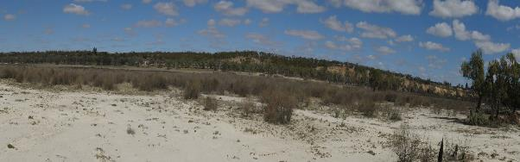
Upstream end Latitude 34.10673 Longitude 140.03194 Direction 180

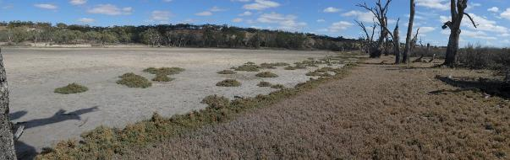
Wetland 1666 Latitude 34.10723 Longitude 140.03047 Direction 260

Regent Parrot Utilisation - Foraging

Stressor Analysis.
Stressor | Severity | Scope | Irreversibility
Lack of Inundation | High | High | Medium
Surface Soil Salinity | Very High | Medium | Medium

Land Tenure Issues
- There are 4 private landholders potentially impacted (1 party holds two of the large land parcels).
- A strip of unalienated Crown land runs along the water’s edge across all of these landholdings.
- South Australian Water should be consulted as there is infrastructure related to a salt interception scheme in this vicinity.

Ecological Objectives
Halt the decline and improve the health condition of mature woody plant species e.g. (River Red Gum, Black Box, Cooba and Lignum).
Maintain existing regeneration and provide opportunities for future regeneration events of woody plant species e.g. (River Red Gum, Black Box, Cooba and Lignum).
Improve the abundance and diversity of flood dependant understory vegetation.
Reduce soil salinity to disadvantage Samphire and promote regeneration of less salt tolerant floodplain and aquatic plant species.
Provide floodplain and aquatic habitats suitable for waterbird and frog refuge and breeding.
Provide hydrological connectivity between watering sites and adjacent floodplain during natural flood events.
Community Objectives
Engage landholder involvement in the sustainable management of their site(s).

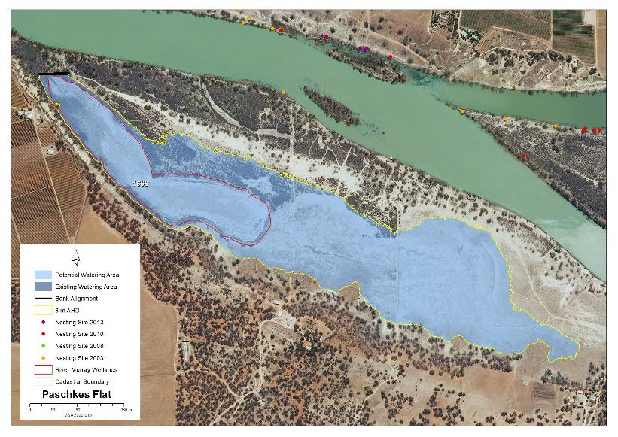
Map identifies the potential watering area

Hydrological Parameters
Maximum Inundation  - Water Height  - Inundation Area  - Fill Volume | 8 AHD  63.4 ha  605 ML
Low Inundation  - Water Height  - Inundation Area  - Fill Volume | 6.8 AHD  16.9 ha  132 ML
Commencement to Flow ML/d Band | 20-30,000
Full Supply Flow ML/d Band | 70-80,000
Watering Option | Pump to full supply  Pump to low elevation  Possibility of return flows  Manage natural flood recession  Enhance natural flood duration and coverage
Watering Timing | Spring through to Autumn

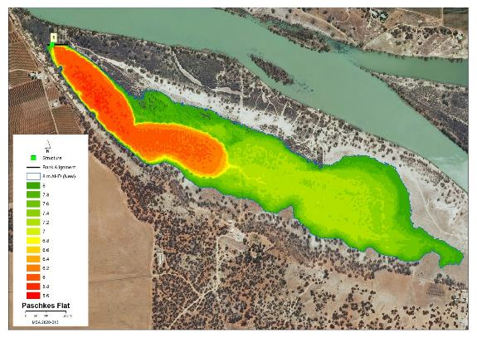
Map features AHD heights across the site and identified infrastructure locations

Potential Infrastructure Requirements
Bank or Channel Details
Location | ID | Length  (m) | Freeboard  (m) | Height with freeboard  (m) | Volume  (m3) | Regulator equipment and comments
Paschkes Flat | Bank 1 | 102.2 | 0.30 | 2.30 | 2,771.5 | Sheetpile regulator with 2 bays of dropboards

21 Putjeda Creek Lagoons Management Brief
Vegetation Description
River Red Gum Woodland  Degraded (level 0) | Adult River Red Gum 99.9% dead throughout the site. Healthy to dead, patches and individual poles and saplings scattered around the wetland edges and along the flow path between wetlands except Wetland 405. Within a similar AHD level Cooba adults and saplings scattered throughout the site.
Black Box Woodland  Healthy (level 5) | Adult Black Box line the outer edges of all wetland sites mostly healthy with odd trees dead. Healthy patches and individual saplings common across the site at most AHD levels.
Lignum Shrubland  Healthy (level 4 and 5) | Wetland 405 bed is dominated by scattered dead and stressed Lignum. Southern flood-outs of Wetland 901 and 900 dominated by thick healthy Lignum scattered with young adult Black Box. Small patches and strips of Lignum occur along the edges of most wetlands.
Low Shrubland/Herbland  Stressed (level 2 and 3) | Wetland 408 edge and 399 bed similar dominant strips of plants aligned with AHD levels high to low. Blue Rod and Creeping Boobialla / Bladder and Creeping Saltbush and Creeping Boobialla / Pig Face, Creeping Saltbush / Samphire and Smooth Heliotrope amongst salt scalded areas. The remaining wetland beds and flow paths between wetlands were dominated by Bladder, Ruby and Creeping Saltbush and Creeping Boobialla and Pig Face with areas of Cooba saplings, Nitre Bush seedlings, Bassia spp., Spiny Sedge, Pale-Poverty Bush and Smooth Heliotrope.

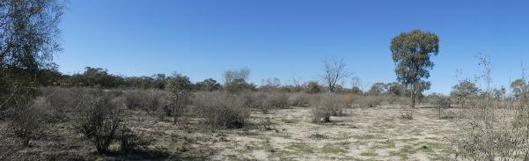
Gerard Flood-out Downstream End of Site Latitude 34.23343 Longitude 140.2951 Direction 100

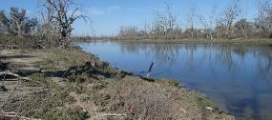 | 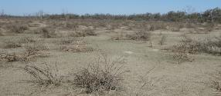
Downstream End Wetland 408 | Wetland 405
Latitude 34.23718 Longitude 140.29799 Direction 160 | Latitude 34.23695 Longitude 140.30096 Direction 210
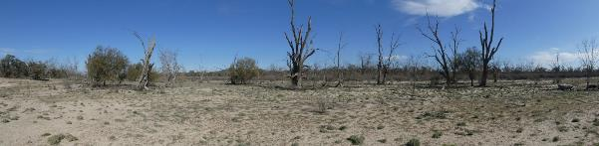
Flow Path between Wetlands 408 and 399 Latitude 34.24304 Longitude 140.25968 Direction 230
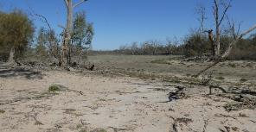 | 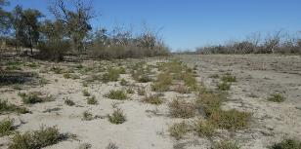
Wetland 399 | Wetland 900
Latitude 34.24565 Longitude 140.30101 Direction 188 | Latitude 34.25122 Longitude 140.30291 Direction 150
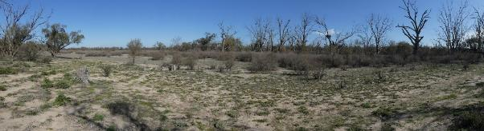
SE Flood-out of Wetland 399 Latitude 34.24655 Longitude 140.30156Direction 200
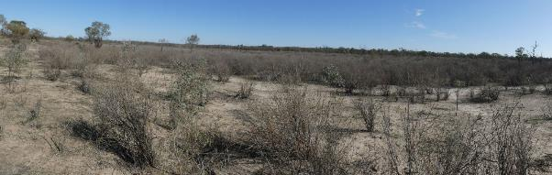
Southern Flood-out of Wetland 900 Latitude 34.25581 Longitude 140.30482 Direction 220

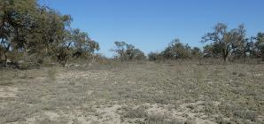 | 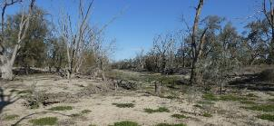
Flow Path Between Wetland 399 and 900 | Wetland 901
Latitude 34.24878 Longitude 140.30233 Direction 160 | Latitude 34.25073 Longitude 140.29918 Direction 170
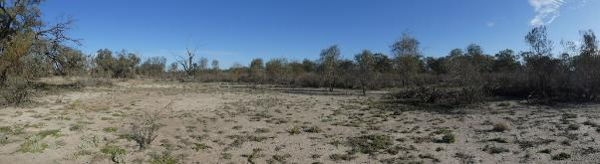Southern Flood-out of Wetland 901 Latitude 34.25294 Longitude 140.29929 Direction 176

Stressor Analysis.
Stressor | Severity | Scope | Irreversibility
Lack of Inundation | High | High | Medium
Saline Ground Water Depth | High | Medium | Medium
High Kangaroo Numbers | Medium | Medium | Low

Land Tenure Issues
- The site crosses the boundary between the Murray River National Park (Katarapko Section) and Gerard Aboriginal Reserve.

Regent Parrot Utilisation- Potential foraging.

Ecological Objectives
Halt the decline and improve the health condition of mature woody plant species e.g. (River Red Gum, Black Box, Cooba and Lignum).
Maintain existing regeneration and provide opportunities for future regeneration events of woody plant species e.g. (River Red Gum, Black Box, Cooba and Lignum).
Improve the abundance and diversity of flood dependant understory vegetation.
Reduce soil salinity to disadvantage Samphire and promote regeneration of less salt tolerant floodplain and aquatic plant species.
Provide floodplain and aquatic habitats suitable for waterbird and frog refuge and breeding.
Provide hydrological connectivity between watering sites and adjacent floodplain during natural flood events.
Promote total grazing pressure within sustainable limits.
Community Objectives
Engage landholder involvement in the sustainable management of their site(s).

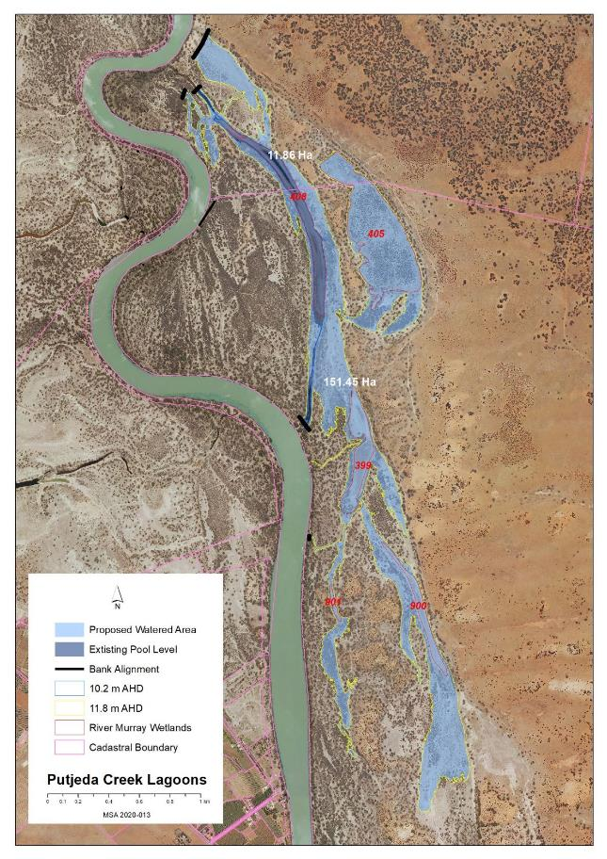
Map identifies the existing and potential watering areas
Hydrological Parameters
Maximum Inundation  - Water Height  - Inundation Area  - Fill Volume | 11.8 AHD  149.3 ha  1145 ML
Low Inundation  - Water Height  - Inundation Area  - Fill Volume | 11.4 AHD  93.4 ha  658 ML
Putjeda Creek Upper Bank Inundation  - Water Height  - Inundation Area  - Fill Volume | 11 AHD  20 ha  215 ML
Commencement to Flow ML/d Band | 5-10,000
Full Supply Flow ML/d Band | 70-80,000
Watering Options | Pump to full supply  Pump to low elevation  Possibility of return flows  Manage natural flood recession Enhance natural flood duration and coverage
Watering Timing | Spring through to Autumn

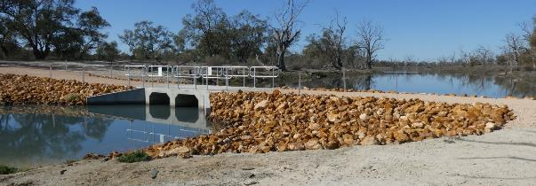
Putjeda Creek downstream Box Culvert
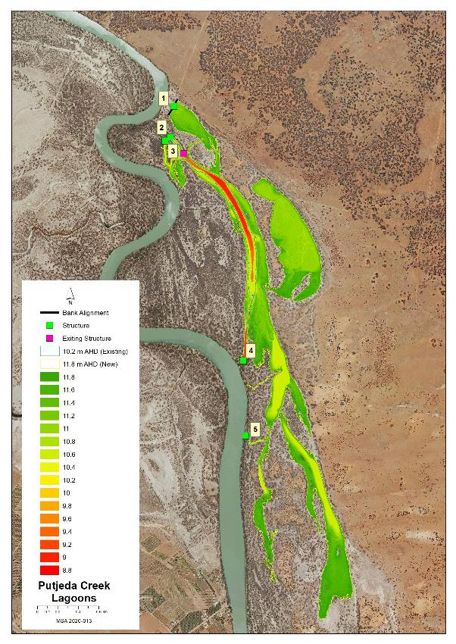
Map features AHD heights across the site and identified infrastructure locations
Potential Infrastructure Requirements
Bank or Channel Details
Location | ID | Length  (m) | Freeboard  (m) | Height with freeboard  (m) | Volume  (m3) | Regulator equipment and comments
Putjeda Creek Lagoon | Bank 1 | 184.8 | 0.30 | 1.10 | 1,115.3 | 800mm concrete pipe with flap valve
 | Bank 2 | 43.4 | 0.50 | 3.30 | 768.1 | Sheetpile regulator with 3 bays of dropboards.  Not a dry site for construction. Temporary cofferdam works required.
 | Bank 3 | 27.9 | 0.50 | 3.30 | 553.9 | 1m concrete pipe with flap valve.  Not a dry site for construction. Temporary cofferdam works required.
 | Bank 4 | 64.7 | 0.50 | 3.30 | 1,523.9 | Sheetpile regulator with 3 bays of dropboards.  Not a dry site for construction. Temporary cofferdam works required.
 | Bank 5 | 5.0 | 0.50 | 0.90 | 27.9 | 450mm concrete pipe with flap valve

22 Pyap Bend Management Brief
Vegetation Description
River Red Gum Woodland  Healthy (level 4) | Significant area of potential nesting quality River Red Gum scattered throughout the area. Some trees 1.5 metres in diameter. Scattered throughout the area are River Red Gum and Cooba adults, poles and saplings as well as patches of Lignum. Understory Blue Rod, Spiny Sedge, Nitre Bush, Native Liquorice, Creeping Boobialla, Creeping Saltbush, Bushy Groundsel with small patches of Smooth Heliotrope and Darling Pea.
Lignum Shrubland  Healthy (level 4 and5) | Patches of dense and sparse Lignum dispersed amongst the River Red Gums throughout the western half of the site.

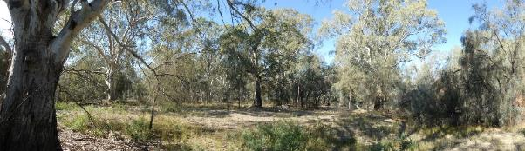
South eastern side of site Latitude 34.23809Longitude 140.29133 Direction 90

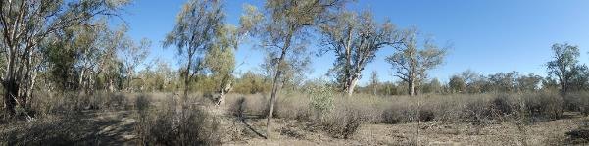
1.5m diameter gum in the centre of the site Latitude 34.23671 Longitude 140.29116 Direction 180

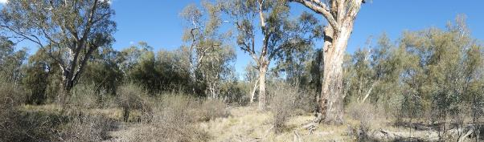Edge of one of the eastern gutters Latitude 34.23708 Longitude 140.29169 Direction 79
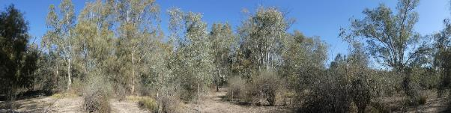
River Red Gum patch of poles Latitude 34.23751 Longitude 140.29141 Direction 190

Regent Parrot Utilisation- Potential Nesting and Foraging.

Stressor Analysis.
Stressor | Severity | Scope | Irreversibility
Lack of Inundation | Medium | Medium | Medium
Saline Ground Water Depth | Low | Medium | Medium

Land Tenure Issues
- The site is owned by one private land owner.
- A strip of unalienated Crown land runs along the water’s edge but is not impacted by the site.

Ecological Objectives
Halt the decline and improve the health condition of mature woody plant species e.g. (River Red Gum, Black Box, Cooba and Lignum).
Maintain existing regeneration and provide opportunities for future regeneration events of woody plant species e.g. (River Red Gum, Black Box, Cooba and Lignum).
Improve the abundance and diversity of flood dependant understory vegetation.
Improve floodplain habitat conditions to promote Regent Parrot breeding events.
Provide floodplain and aquatic habitats suitable for waterbird and frog refuge and breeding.
Provide hydrological connectivity between watering sites and adjacent floodplain during natural flood events.
Community Objectives
Engage landholder involvement in the sustainable management of their site(s).

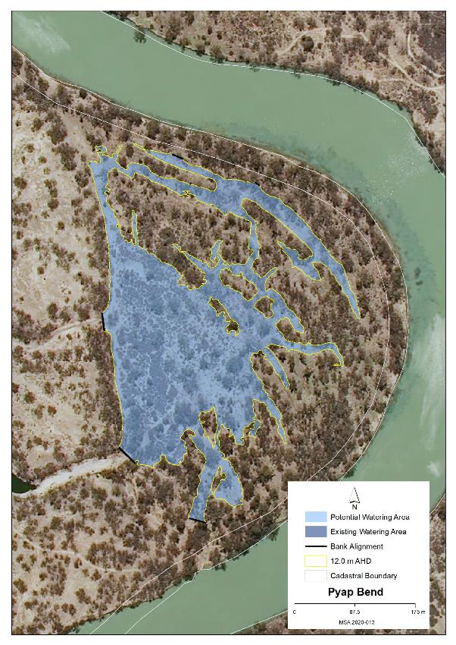
Map identifies the potential watering area
Hydrological Parameters
Maximum Inundation  - Water Height  - Inundation Area  - Fill Volume | 12 AHD  7.7 ha  31.5 ML
Commencement to Flow ML/d Band | 60-70,000
Full Supply Flow ML/d Band | 70-80,000
Watering Options | Pump to full supply  Manage natural flood recession
Watering Timing | Spring through to Autumn

Potential Infrastructure Requirements
Bank or Channel Details
Location | ID | Length  (m) | Freeboard  (m) | Height with freeboard  (m) | Volume  (m3) | Regulator equipment and comments
Pyap Bend | Bank 1 | 26.1 | 0.30 | 1.10 | 135.7 | 800mm concrete pipe with flap valve
 | Bank 2 | 17.3 | 0.30 | 0.70 | 69.7 | Nil
 | Bank 3 | 9.4 | 0.30 | 0.50 | 33.4 | Nil
 | Bank 4 | 25.9 | 0.50 | 2.30 | 248.8 | 1m concrete pipe with flap valve
 | Bank 5 | 33.8 | 0.50 | 3.10 | 844.3 | Nil

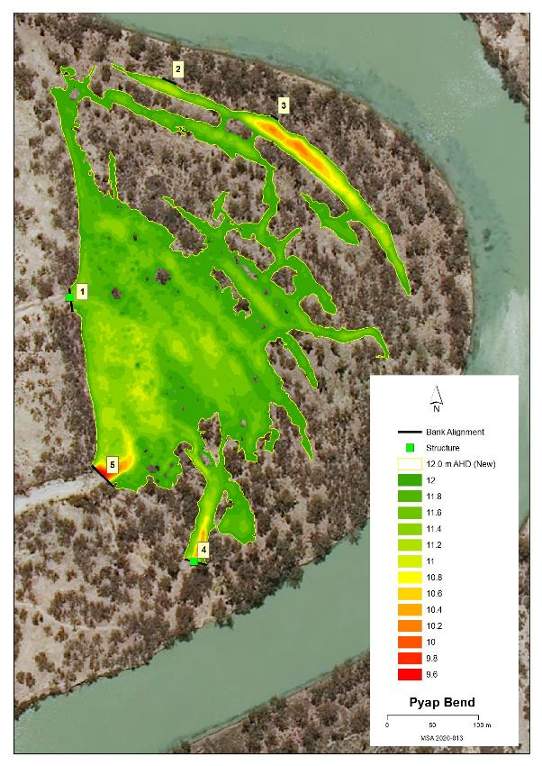
Map features AHD heights across the site and identified infrastructure locations

23 Sugar Shack Upstream Lagoon Management Brief
Vegetation Description
River Red Gum Woodland  Stressed (level 3) | Upstream flood-out River Red Gum adults, poles and saplings stressed (level 3). Understory Cooba adults and saplings, Lignum, desiccated Tussock Grass, Spiny Sedge and Rat’s-Tail Couch. Lagoon edge River Red Gum adults and saplings patches of long-term dead, majority healthy with areas of stressed trees away from water’s edge.
Lignum Shrubland  Healthy (level 4 and 5) | Lignum areas both scattered and dense patches along the lagoon edge and throughout the upstream flood-out.
Low Shrubland/Herbland  Healthy (level 4) | Wetland 554 bed Spiny Sedge, Rat’s-Tail Couch, Patches of Cumbungi and Clover spp. Upstream flood-out Herbland Spiny Sedge, Rat’s-Tail Couch and odd Lignum. All heavily grazed by stock and Kangaroos.

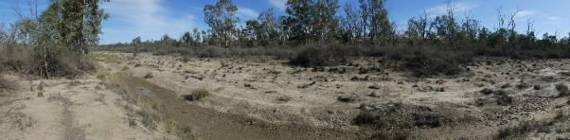
Western area of Northern Flood-out Latitude 34.30148 Longitude 139.34532.Direction 240

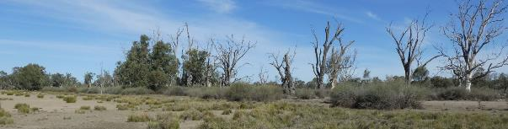
Western edge of the Lagoon’s Northern Section Latitude 34.30333 Longitude 139.34602 Direction 190

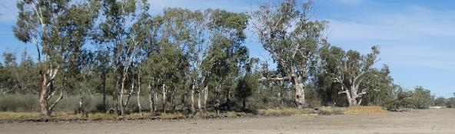
Eastern edge of the Lagoon’s Southern Section Latitude 34.30595 Longitude 139.34702 Direction 150
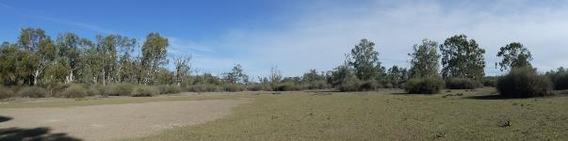
Eastern area of Northern Flood-out Latitude 34.30178 Longitude 139.34801 Direction 180

Regent Parrot Utilisation- Nesting and Foraging.

Stressor Analysis.
Stressor | Severity | Scope | Irreversibility
Lack of Inundation | Medium | Low | Medium
Saline Groundwater Depth | Medium | low | Medium
High Kangaroo and Sheep Grazing | High | High | Medium

Land Tenure Issues
- The site is owned by the Sugar Shack Aboriginal Corporation.
- A strip of unalienated Crown land runs along downstream portion of the site’s water’s edge.

Ecological Objectives
Halt the decline and improve the health condition of mature woody plant species e.g. (River Red Gum, Black Box, Cooba and Lignum).
Maintain existing regeneration and provide opportunities for future regeneration events of woody plant species e.g. (River Red Gum, Black Box, Cooba and Lignum).
Improve the abundance and diversity of flood dependant understory vegetation.
Improve floodplain habitat conditions to promote Regent Parrot breeding events.
Provide floodplain and aquatic habitats suitable for waterbird and frog refuge and breeding.
Provide hydrological connectivity between watering sites and adjacent floodplain during natural flood events.
Promote total grazing pressure within sustainable limits.
Community Objectives
Engage landholder involvement in the sustainable management of their site(s).

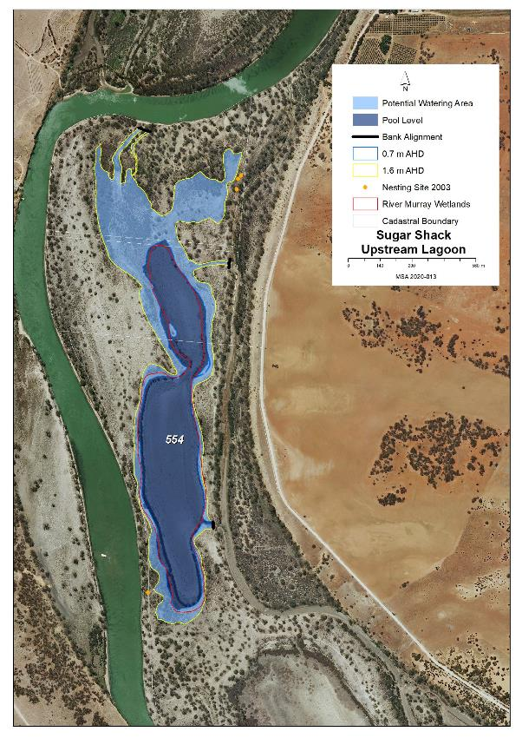
Map identifies the existing and potential watering areas

Hydrological Parameters
Existing Area of Inundation  - Pool Level Height  - Inundation Area  - Pool Level Volume | 0.7 AHD  31.6 ha  113.5 ML
Maximum Inundation  - Water Height  - Inundation Area  - Fill Volume | 1.6 AHD  58.3 ha  523 ML
Commencement to Flow ML/d Band | Pool Level
Full Supply Flow ML/d Band | 50-60,000
Watering Option | Pump to full supply  Manage natural flood recession
Watering Timing | Spring through to Autumn

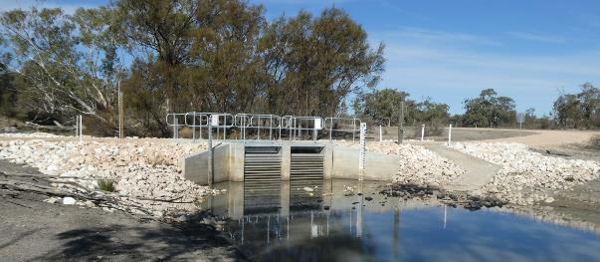
Existing Box Culvert located at Bank 3
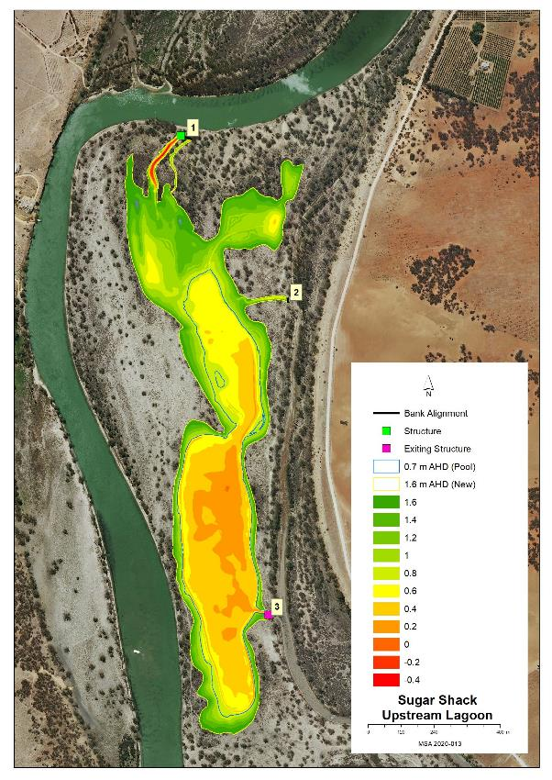
Map features AHD heights across the site and identified infrastructure locations

Potential Infrastructure Requirements
Bank or Channel Details
Location | ID | Length  (m) | Freeboard  (m) | Height with freeboard  (m) | Volume  (m3) | Regulator equipment and comments
Sugar Shack | Bank 1 | 53.4 | 0.50 | 2.10 | 426.0 | 1m concrete pipe with flap valve
 | Bank 2 | 17.9 | 0.30 | 0.50 | 60.0 | Nil
 | Bank 3 | 28.3 | 0.30 | 1.90 | 330.0 | Nil new (existing box culverts at this site)

24 Taylor Flat Management Brief

Vegetation Description - Taylor Flat Outlet Creek
River Red Gum Woodland  Healthy (Level 4) | Adult and saplings. Understory Spiny Sedge, Smooth Heliotrope, Western Boobialla, Blue Rod, California Burr, Creeping Saltbush, Grey Germander and odd Lignum.

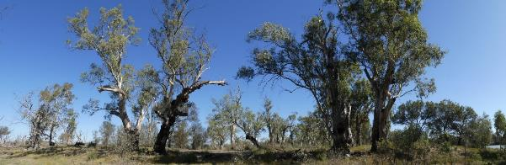
111 Southern Bank of Outlet Channel Latitude 34.02295 Longitude 139.49840.Direction 188

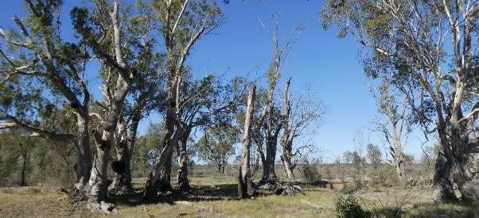
112 Northern Bank of Outlet Creek Latitude 34.02313 Longitude 139.49845 Direction 76

Vegetation Description - Taylor Flat River Flood-out
River Red Gum Woodland  Healthy (level 4) | Sparse River Red Gum adult and saplings, odd Black Box tree with Cooba adult and saplings, Lignum and Spiny Sedge. Less common Creeping Saltbush, Smooth Heliotrope, Western Boobialla, Rat’s-Tail Couch and Grey Germander.

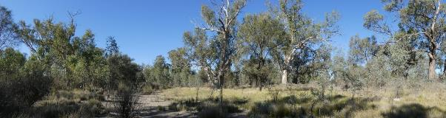
113 Taylor Flat River Flood-out Latitude 34.02124 Longitude 139.49983 Direction 30

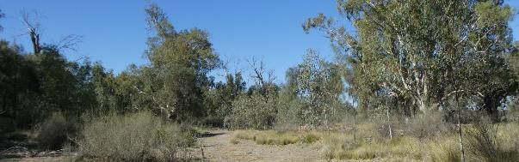
115 Taylor Flat River Flood-out Latitude 34.02084 Longitude 139.50054 Direction 42

Stressor Analysis.
Site | Stressor | Severity | Scope | Irreversibility
Taylor Flat Outlet Creek | Lack of Inundation | Medium | High | Medium
 | Saline Groundwater Depth | Medium | Medium | Medium
Taylor Flat River Flood-out | Lack of Inundation | Medium | High | Medium
 | Saline Groundwater Depth | Medium | Medium | Medium

Land Tenure Issues
Taylor Flat Outlet Creek | - The site is owned by one private land owner.  - A strip of unalienated Crown land runs along the water’s edge and includes Bank one.
Taylor Flat River Flood-out | - The site is owned by one private land owner.  - A strip of unalienated Crown land runs along the water’s edge and includes Bank one.

Regent Parrot Utilisation
Taylor Flat Outlet Creek | Nesting and Foraging
Taylor Flat River Flood-out | Potential Nesting and Foraging

Ecological and Community Objectives
Site Objectives | Taylor Flat Outlet Creek | Taylor Flat River Flood-out
Ecological Objectives
Halt the decline and improve the health condition of mature woody plant species e.g. (River Red Gum, Black Box, Cooba and Lignum).
Maintain existing regeneration and provide opportunities for future regeneration events of woody plant species e.g. (River Red Gum, Black Box, Cooba and Lignum).
Improve the abundance and diversity of flood dependant understory vegetation.
Improve floodplain habitat conditions to promote Regent Parrot breeding events.
Provide floodplain and aquatic habitats suitable for waterbird and frog refuge and breeding.
Provide hydrological connectivity between watering sites and adjacent floodplain during natural flood events.
Community Objectives
Engage landholder involvement in the sustainable management of their site.

Hydrological Parameters
 | Taylor Flat Outlet Creek | Taylor Flat River Flood-out
Maximum Inundation  - Water Height  - Inundation Area  - Fill Volume | 5 AHD  0.4 ha  3 ML | 5.4 AHD  3.6 ha  12 ML
Commencement to Flow ML/d Band | 40-50,000 | 40-50,000
Full Supply Flow ML/d Band | 60-70,000 | 80-90,000
Watering Option | Pump to full Supply  Manage natural flood recession | Pump to full Supply  Manage natural flood recession
Watering Timing | Late Autumn to Early Winter | Spring through to Autumn

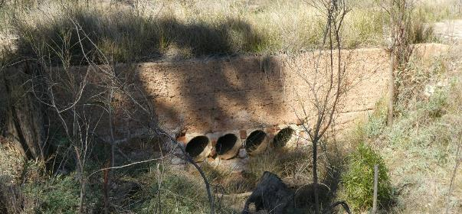
Taylor Flat Outlet Creek road crossing

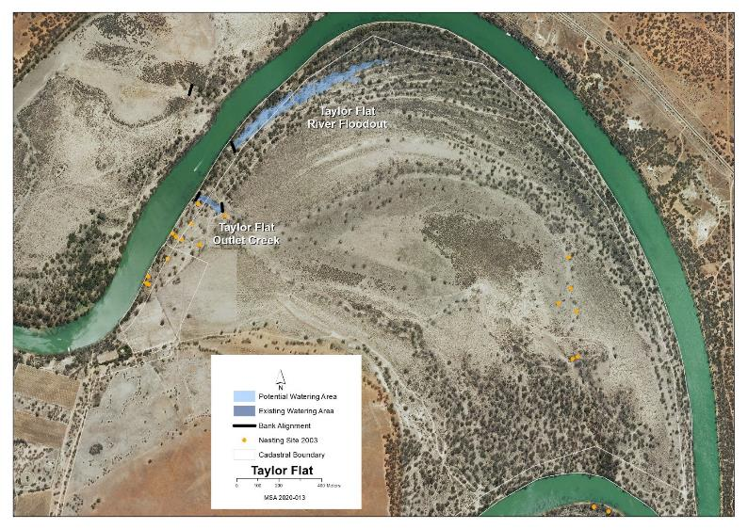
Map identifies the potential watering area

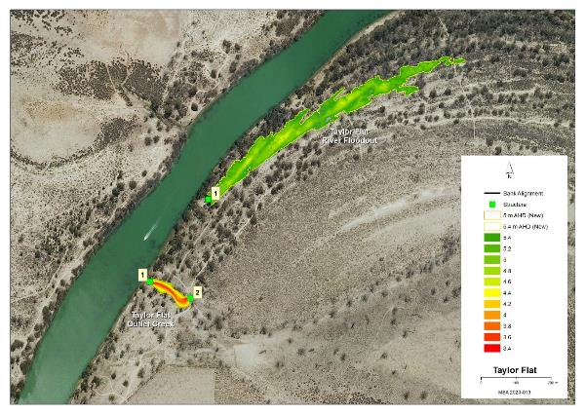
Map features AHD heights across the site and identified infrastructure locations

Potential Infrastructure Requirements
Bank or Channel Details
Location | ID | Length  (m) | Freeboard  (m) | Height with freeboard  (m) | Volume  (m3) | Regulator equipment and comments
Taylor Flat Outlet Creek | Bank 1 | 21.7 | 0.50 | 1.90 | 234.9 | 1m concrete pipe with flap valve
 | Bank 2 | 11.6 | 0.50 | 1.90 | 166.8 | 1m concrete pipe with flap valve.  4 no. existing steel pipes and a thick concrete headwall need to be removed.
Taylor Flat River Flood-out | Bank 1 | 32.6 | 0.30 | 0.70 | 119.3 | 600mm concrete pipe with flap valve

25 Westbrooks Management Brief
Vegetation Description – Westbrook Bend
River Red Gum Woodland Stressed (level 3) | River Red Gum and Cooba adults and patches of saplings. Understory Creeping and Lagoon Saltbush, desiccated Tussock Grass, Smooth Heliotrope and Atriplex spp.

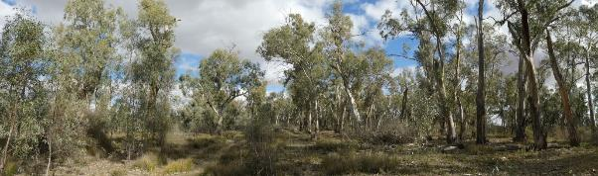
Westbrook Regent Parrot nesting colony site. 326 Latitude 3423816 Longitude 14033946.Direction 210

Vegetation Description – Westbrook Lagoon
Black Box Woodland  Healthy (level 4) | Lagoon ringed by Black Box adult and saplings with odd dead and live young adult River Red Gum
Lignum  Healthy (level 5) | Lignum dense distribution around the lagoon edge especially the northern side with odd Nitre Bush and Cooba saplings.
Low Shrubland/Herbland  Stressed (level 3) | Lagoon floor Bladder Saltbush, Creeping Saltbush and Atriplex spp.

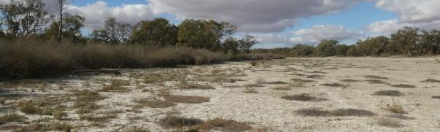
Westbrook Lagoon 328 Latitude 34.23822 Longitude 140.34382 Direction 70

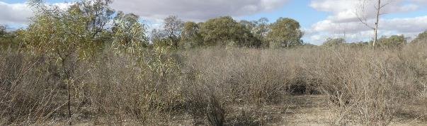
Northern Side of Westbrook Lagoon 329 Latitude 34.23805 Longitude 140.34381 Direction 60

Stressor Analysis
Site | Stressor | Severity | Scope | Irreversibility
Westbrook Bend | Saline Lack of Inundation | Medium | Medium | Medium
 | Groundwater Depth | Medium | Low | Medium
Westbrook Lagoon | Saline Lack of Inundation | High | Low | Medium
 | Groundwater Depth | Medium | Medium | Medium

Land Tenure Issues
Westbrook Bend | - The site is located on Crown Land vested in the Minister for Environment and Water.
Westbrook Lagoon | - The greater portion of the site is owned by one private landowner.  - Bank 1 is located on Crown land vested in the Minister for Environment and Water.

Regent Parrot Utilisation
Westbrook Bend | Nesting and Foraging
Westbrook Lagoon | Potential Foraging

Ecological and Community Objectives
Site Objectives | Westbrook Bend | Westbrook  Lagoon
Ecological Objectives
Halt the decline and improve the health condition of mature woody plant species e.g. (River Red Gum, Black Box, Cooba and Lignum).
Maintain existing regeneration and provide opportunities for future regeneration events of woody plant species e.g. (River Red Gum, Black Box, Cooba and Lignum).
Improve the abundance and diversity of flood dependant understory vegetation.
Improve floodplain habitat conditions to promote Regent Parrot breeding events.
Provide floodplain and aquatic habitats suitable for waterbird and frog refuge and breeding.
Provide hydrological connectivity between watering sites and adjacent floodplain during natural flood events.
Increase Regent Parrot potential breeding success by limiting disturbance from human activities such as recreational visitors and noise from water pumping at colony sites during July and August
Community Objectives
Engage landholder involvement in the sustainable management of their site.

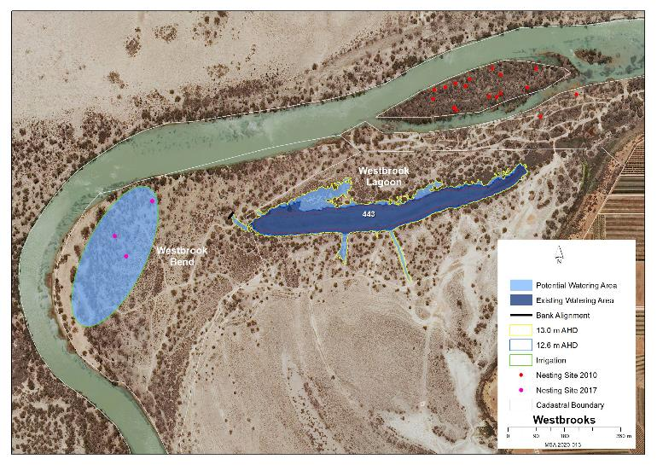
Map identifies the existing and potential watering areas

Hydrological Parameters
 | Westbrook Bend | Westbrook Lagoon
Existing Area of Inundation  - Inundation Area  - Historical Watering Dates |  | 5.9 ha  2016/17
Maximum Inundation  - Water Height  - Inundation Area  - Fill Volume | 7.6 ha  7.6 ML @ (100mm irrigation) | 13 AHD  8.1 ha  60.5 ML
Commencement to Flow ML/d Band | 60-70,000 | 50-60,000
Full Supply Flow ML/d Band | 70-80,000 | 60-70,000
Watering Option | Sprinkler Irrigation | Pump to full Supply  Manage natural flood recession  Enhance natural flood duration and coverage
Watering Timing | Spring through to Autumn | Spring through to Autumn

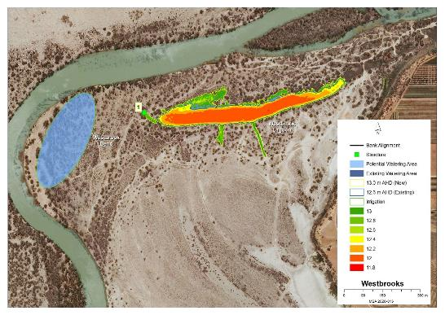
Map features AHD heights across the site and identified infrastructure locations

Potential Infrastructure Requirements
Bank or Channel Details
Location | ID | Length  (m) | Freeboard  (m) | Height with freeboard  (m) | Volume  (m3) | Regulator equipment and comments
Westbrook Lagoon | Bank 1 | 5.6 | 0.30 | 0.50 | 33.3 | 450mm concrete pipe with flap valve

26 Weston Flat Lagoon Management Brief
Vegetation Description
River Red Gum Woodland  Stressed (level 2) | Western edge of main lagoon dominated by healthy adult and sapling River Red Gum with odd adult Black Box. Understory Cooba adult and saplings Bladder and Creeping Saltbush, Spiny Sedge and Smooth Heliotrope. Northern and eastern edge Wetland 972 majority of River Red Gum dead and Cooba stressed.
Lignum Shrubland  Stressed (level 2 and 3) | Majority of Lignum on the lagoon bed Wetland 972 is dead with area of stressed Cooba. Above the wetland line the Lignum is healthy.
Low Shrubland/Herbland  Stressed (level 3) | Lagoon bed dominated with mixed species, patches of Lagoon, Creeping, Bladder and Ruby Saltbush, Yellow-Flowered Devil's Claw, Smooth Heliotrope, Pale-Poverty Bush, Yanga Bush, odd Samphire and dead Lignum.

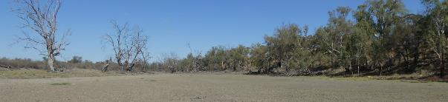
Wetland 972 south western arm Latitude 34.02088 Longitude 139.49213 Direction 210

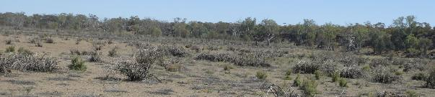
Central bed of lagoon Latitude 34.01938 Longitude 139.49668 Direction 230

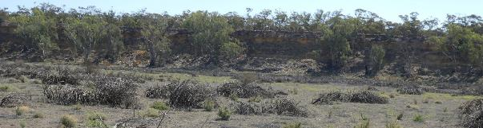
Western edge of lagoon Latitude 34.01938 Longitude 139.49668 Direction 310

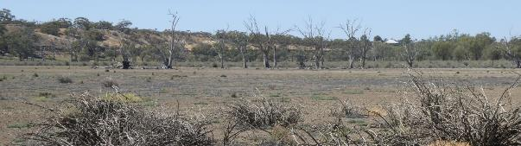
Northern end of Wetland 972 Latitude 34.01938 Longitude 139.49668 Direction 64

Regent Parrot Utilisation- Potential Nesting and Foraging

Stressor Analysis.
Stressor | Severity | Scope | Irreversibility
Lack of Inundation | High | High | Medium
Saline Groundwater Depth | High | Medium | Medium
High Sheep Grazing | Medium | Medium | Medium

Land Tenure Issues
- The site is owned by one private land owner.
- A strip of unalienated Crown land runs along the water’s edge

Ecological Objectives
Halt the decline and improve the health condition of mature woody plant species e.g. (River Red Gum, Black Box, Cooba and Lignum).
Maintain existing regeneration and provide opportunities for future regeneration events of woody plant species e.g. (River Red Gum, Black Box, Cooba and Lignum).
Improve the abundance and diversity of flood dependant understory vegetation.
Reduce soil salinity to disadvantage Samphire and promote regeneration of less salt tolerant floodplain and aquatic plant species.
Improve floodplain habitat conditions to promote Regent Parrot breeding events.
Provide floodplain and aquatic habitats suitable for waterbird and frog refuge and breeding.
Provide hydrological connectivity between watering sites and adjacent floodplain during natural flood events.
Promote total grazing pressure within sustainable limits.
Community Objectives
Engage landholder involvement in the sustainable management of their site(s).

Hydrological Parameters
Maximum Inundation  - Water Height  - Inundation Area  - Fill Volume | 5 AHD  52.8 ha  537 ML
Commencement to Flow ML/d Band | 30-40,000
Full Supply Flow ML/d Band | 50-60,000
Watering Option | Pump to full supply  Possibility of return flows  Enhance natural flood duration
Watering Timing | Spring through to Autumn

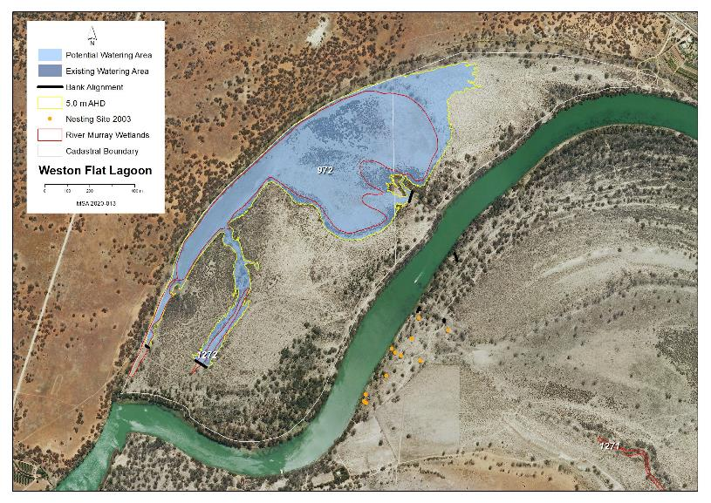
Map identifies the potential watering area

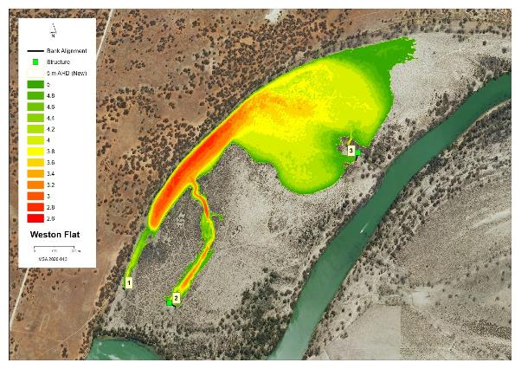
Map features AHD heights across the site and identified infrastructure locations

Potential Infrastructure Requirements
Bank or Channel Details
Location | ID | Length  (m) | Freeboard  (m) | Height with freeboard  (m) | Volume  (m3) | Regulator equipment and comments
Weston Flat Lagoon | Bank 1 | 14.8 | 0.30 | 0.50 | 44.7 | Nil
 | Bank 2 | 57.2 | 0.50 | 1.90 | 688.2 | Sheetpile regulator with 2 bays of dropboards
 | Bank 3 | 47.7 | 0.50 | 0.90 | 332.4 | 600mm concrete pipe with flap valve

27 Wiela Management Brief
Vegetation Description
River Red Gum Woodland  Stressed (level 3) | Central western depression and Wetlands W4 and W3 areas of dead adult River Red Gum. Wetland W1 and W2 within the existing watering site surrounded by healthy adult and sapling River Red Gums with patches of Black Box and Cooba adults and saplings. Understory Bignonia Emu Bush, Lignum, Nitre Bush and Spreading Emu Bush. The bed of these wetlands have patches of healthy to dead River Red Gum poles. Main Inlet Flow Path healthy to stressed adult and sapling River Red Gum understory Cooba adults and saplings, Tall Groundsel and Native Liquorice.
Lignum Shrubland  Healthy (level 4 and 5) | Dense Lignum and odd Nitre Bush dominates the upstream depression. Areas of sparse and dense Lignum across the western half of the site.
Low Shrubland/Herbland  Stressed (Level 3) | Area outside the existing Water for the Environment are Wetlands W2 and W3 dominated by Bladder, Creeping and Lagoon Saltbush, Pale-Poverty Bush, Rat’s-Tail Couch, few Nitre Bush seedlings and California Burr with Golden Dodder. Wetland W3 Spiny Sedge, Slender Knotweed, Lesser Joyweed, Common Sneeze Weed, Dirty Dora, Clover spp. and Curled Dock

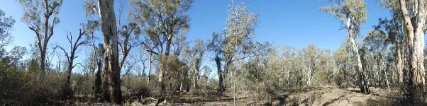
Existing Regent Parrot nesting site Latitude 34.01054 Longitude 140.52194 Direction 136

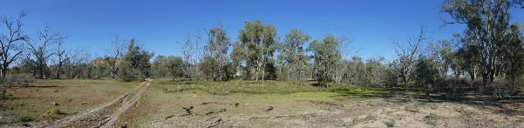
Downstream flow path east of Bank 1 Latitude 34.01379 Longitude 140.52055 Direction 180

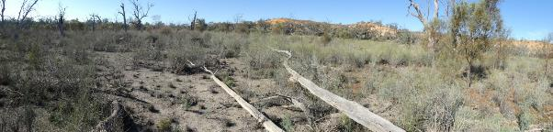
Flood-out east of Wetland W3Latitude 34.01382 Longitude 140.52274 Direction 120
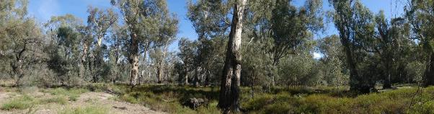
Main inlet flow path from River @ Bank 3 Latitude 34.01045 Longitude 140.52387 Direction 260

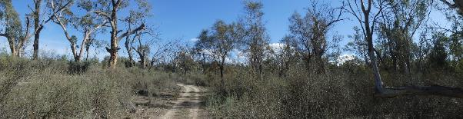
291 Flood-out west of Wetland W2 Latitude 34.01196 Longitude 140.52411 Direction 290

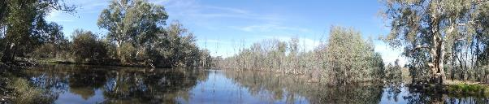
Existing watering site Wetland W2 Latitude 34.01226 Longitude 140.52397 Direction 140

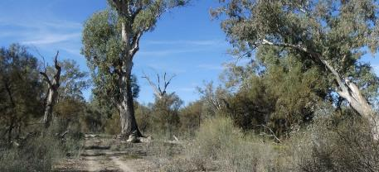
North Western Flood-out of Wetland W1 Latitude 34.01196 Longitude 140.52411 Direction 110

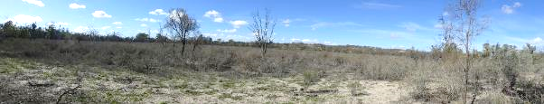
Upstream Lignum Depression Latitude 34.01363 Longitude 140.52881 Direction 94

Stressor Analysis.
Stressor | Severity | Scope | Irreversibility
Lack of Inundation | Medium | Medium | Medium

Land Tenure Issues
- The site is owned by one private land owner.
- A strip of unalienated Crown land runs along the water’s edge and includes most banks.

Regent Parrot Utilisation- Nesting and Foraging.

Ecological Objectives
Halt the decline and improve the health condition of mature woody plant species e.g. (River Red Gum, Black Box, Cooba and Lignum).
Maintain existing regeneration and provide opportunities for future regeneration events of woody plant species e.g. (River Red Gum, Black Box, Cooba and Lignum).
Improve the abundance and diversity of flood dependant understory vegetation.
Improve floodplain habitat conditions to promote Regent Parrot breeding events.
Provide floodplain and aquatic habitats suitable for waterbird and frog refuge and breeding.
Provide hydrological connectivity between watering sites and adjacent floodplain during natural flood events.
Increase Regent Parrot potential breeding success by limiting disturbance from human activities such as recreational visitors and noise from water pumping at colony sites during July and August
Community Objectives
Engage landholder involvement in the sustainable management of their site(s).

Hydrological Parameters
Existing Area of Inundation  - Inundation Area  - Historical Watering Dates | 26.8 ha  2005/06, 2009/10, 2013/14, 2014/15, 2015/16, 2018/19 and 2019/20
Maximum Inundation  - Water Height  - Inundation Area  - Fill Volume | 18.8 and 19.6AHD  44.7 ha  648 ML
Low Inundation  - Water Height  - Inundation Area  Fill Volume | 18.4 AHD  26.8 ha  181 ML
Commencement to Flow ML/d Band | 40-50,000
Full Supply Flow ML/d Band | 70-80,000
Watering Options | Pump to full supply  Pump to low elevation  Possibility of return flows  Manage natural flood recession  Enhance natural flood duration and coverage
Watering Timing | Spring through to Autumn

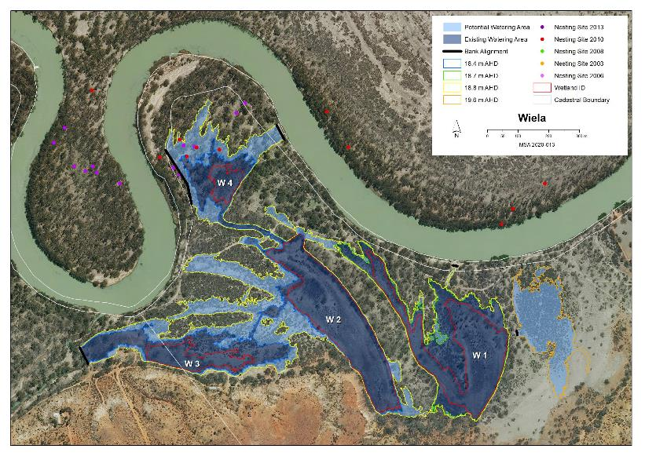
Map identifies the existing and potential watering areas
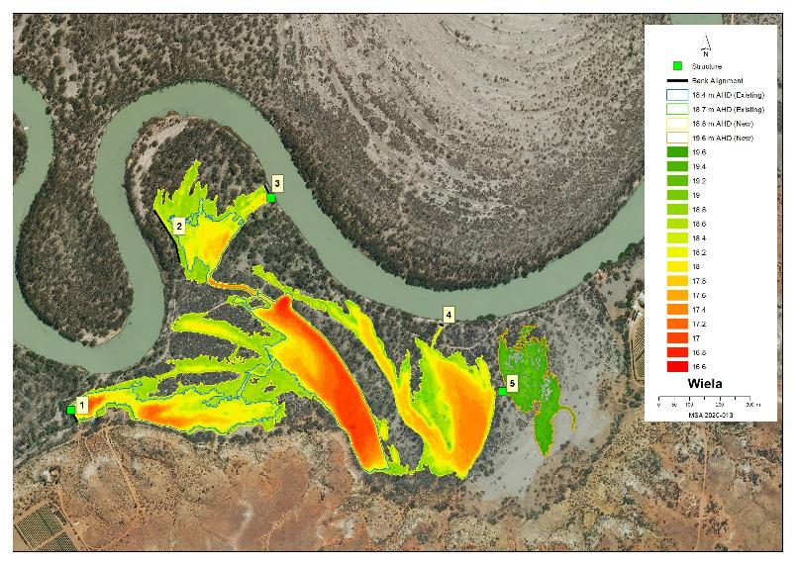
Map features AHD heights across the site and identified infrastructure locations

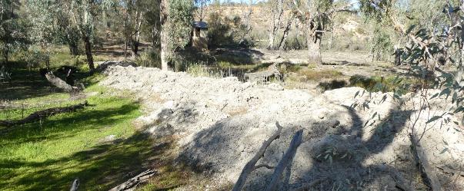
Existing Bank 1

Potential Infrastructure Requirements
Bank or Channel Details
Location | ID | Length  (m) | Freeboard  (m) | Height with freeboard  (m) | Volume  (m3) | Regulator equipment and comments
Weila | Bank 1 | 59.3 | 0.50 | 1.50 | 646.6 | Sheetpile regulator with 2 bays of dropboards
 | Bank 2 | 197.5 | 0.30 | 0.90 | 619.4 | Nil
 | Bank 3 | 54.1 | 0.50 | 1.70 | 341.0 | Sheetpile regulator with 2 bays of dropboards
 | Bank 4 | 13.5 | 0.30 | 0.50 | 36.9 | Nil
 | Bank 5 | 14.4 | 0.30 | 0.90 | 82.7 | 600mm concrete pipe with flap valve

28 Yabby Creek Management Brief
Vegetation Description – Yabby Creek
River Red Gum Woodland  Stressed (level 3) | Within the influence of the 2019/20 watering event, River Red Gum adults, young adults, poles and saplings healthy with significant numbers of long-term dead trees. Above the recent Watering event scattered and patches of medium to poor healthy River Red Gum with an odd healthy Black Box. Understory of Lignum and Cooba adults and saplings.
Low Shrubland/Herbland  Stressed (level 3) | Recent Watering area;  - Creek bed (dry) dominated by Common Sneezeweed with patches and individual plants of Bladder and Lagoon Saltbush, Rat’s-Tail Couch, Hexham Scent, Smooth Heliotrope, Pale Poverty Bush, Jersey Cudweed, Creeping Monkey Flower , Tall Groundsel and Lesser Joyweed  - Creek bed (mud) Red Water-milfoil and Common Sneezeweed with salt crystal amongst the plants.  Creek flood-out mostly bare soil with odd Pale Poverty Bush, Ruby Saltbush and healthy Lignum bush. Area covered with dead Lignum stumps

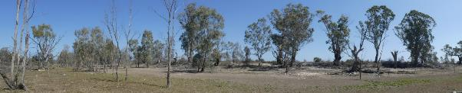
The 2019/20 watering event influenced tree high up the creek bank
Latitude 34.26421 Longitude 140.33364 Direction 270

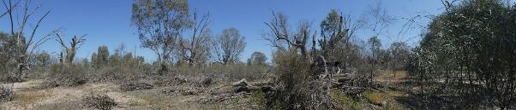
Above the influence of the 2019/20 watering event Latitude 34.26264 Longitude 140.33484 Direction 220

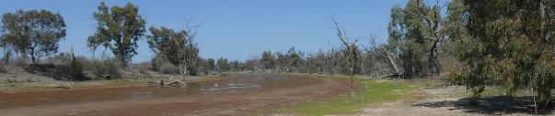
Remnants of the 2019/20 watering event Latitude 34.25998 Longitude 140.33384 Direction 170

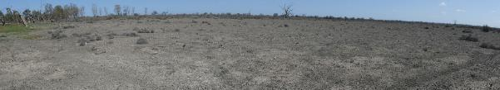
North western flood-out Latitude 34.25760 Longitude 140.33414 Direction 270

Vegetation Description – Yabby Creek Lagoon
River Red Gum Woodland  Stressed (level 3) | Ringed by healthy to stressed adults, poles and saplings with significant numbers dead with patches of poles and saplings on the elevated lagoon bed areas. Understory dominated by Lignum and Cooba adults with odd saplings.
Lignum Shrubland  Healthy (level 4 and5) | North eastern end of lagoon patches and dense healthy Lignum with scattered River Red Gum poles
Low Shrubland/Herbland  Stressed (level 3) | Lagoon bed dominated by Hexham Scent with patches and odd plants of California Burr, Lagoon, Bladder and Creeping Saltbush and Native Liquorice

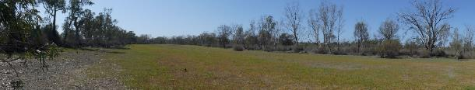
Bed of Central section of lagoon Latitude 34.26717 Longitude 140.33571 Direction 80

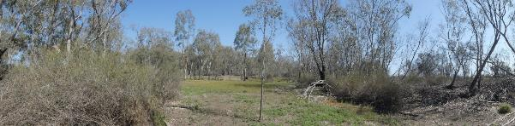
Elevated bed between the two open lagoon areas Latitude 34.26782 Longitude 140.33392 Direction 280

Stressor Analysis.
Site | Stressor | Severity | Scope | Irreversibility
Yabby Creek | Lack of Inundation | Medium | High | Medium
 | Saline Groundwater Depth | Medium | High | Medium
 | High Kangaroo Numbers | High | High | Low
Yabby Creek Lagoon | Lack of Inundation | Medium | High | Medium
 | Saline Groundwater Depth | Medium | Medium | Medium
 | High Kangaroo Numbers | High | High | Low

Land Tenure Issues
- Both sites are within the Murray River National Park (Katarapko Section)

Regent Parrot Utilisation
Yabby Creek | Foraging
Yabby Creek Lagoon | Potential Foraging

Ecological and Community Objectives
Site Objectives | Yabby Creek | Yabby Creek Lagoon
Ecological Objectives
Halt the decline and improve the health condition of mature woody plant species e.g. (River Red Gum, Black Box, Cooba and Lignum).
Maintain existing regeneration and provide opportunities for future regeneration events of woody plant species e.g. (River Red Gum, Black Box, Cooba and Lignum).
Improve the abundance and diversity of flood dependant understory vegetation.
Provide floodplain and aquatic habitats suitable for waterbird and frog refuge and breeding.
Provide hydrological connectivity between watering sites and adjacent floodplain during natural flood events.
Promote total grazing pressure within sustainable limits.
Community Objectives
Engage landholder involvement in the sustainable management of their site(s).

Hydrological Parameters
 | Yabby Creek | Yabby Creek Lagoon
Existing Area of Inundation  - Inundation Area  - Historical Watering Dates | 9 ha  2019/20
Maximum Inundation  - Water Height  - Inundation Area  - Fill Volume | 11.4 AHD  25.1 ha  183.5 ML | 12 AHD  15.3 ha  89 ML
Commencement to Flow ML/d Band | 40-50,000 | 50-60,000
Full Supply Flow ML/d Band | 60-70,000 | 70-80,000
Watering Option | Pump to full Supply  Manage natural flood recession | Pump to full Supply  Manage natural flood recession
Watering Timing | Spring through to Autumn | Spring through to Autumn

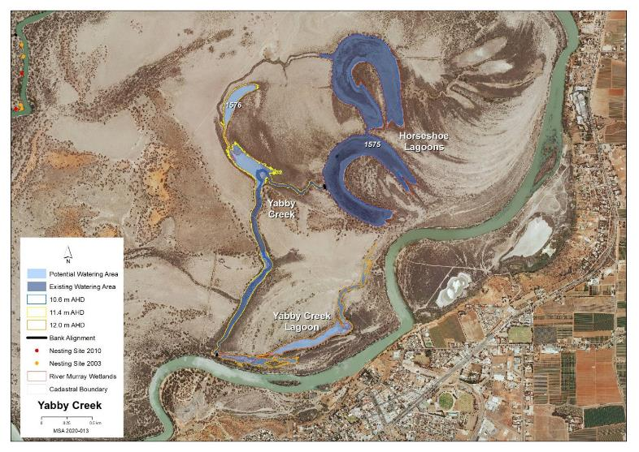
Map identifies the existing and potential watering areas

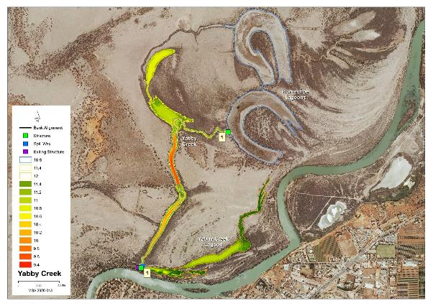
Map features AHD heights across the site and identified infrastructure locations

Potential Infrastructure Requirements
Bank or Channel Details
Location | ID | Length  (m) | Freeboard  (m) | Height with freeboard  (m) | Volume  (m3) | Regulator equipment and comments
Yabby Creek | Bank 1 | 26.3 | 0.50 | 1.70 | 254.5 | Sheetpile regulator with 3 bays of dropboards
Yabby Creek Lagoon | Bank 1 | 12.6 | 0.30 | 0.90 | 57.4 | 600mm concrete pipe with flap valve

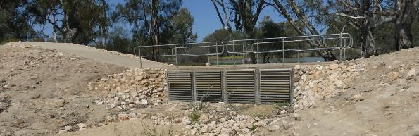Yabby Creek Outlet Structure

29 Yarra Creek Management Brief
Vegetation Description
River Red Gum Woodland  Stressed (level 2) | The four parallel floodplain features contained scattered stressed adult River Red Gum and patches of healthy sapling. A significant number of the adults were dead. Understory dominated by Lignum, Cooba adults and saplings and Black Box saplings with Black Box along the edges. The northern cliff edge of Wetland 306 supported a strip of stressed adult River Red Gum. Wetland 306 eastern finger flood-out; adult River Red Gum (stressed) and sapling, with a number of adult trees dead plus odd healthy Black Box. Understory dominated by dense Lignum with open areas with Creeping, Ruby and Lagoon Saltbush and Smooth Heliotrope. Wetlands 419, 559 and 1596 scattered dead adult trees around the edges
Black Box Woodland  Healthy (level 4) | Throughout the downstream section of the site which includes Wetlands 419, 559 and 1596 healthy adult Black Box occur around each wetland and are also scattered across the floodplain between the wetlands including patches of poles and saplings.
Lignum Shrubland  Healthy (level 4 and 5) | Across the downstream section of the site sparse Lignum dominates with areas of Creeping and Bladder Saltbush, Short-winged Copperburr and odd Pale Poverty Bush, Spreading Emubush seedlings and patches of desiccated Tussock Grass. Wetlands 559 and1596 beds were dominated by dense Lignum with scattered Creeping and Bladder Saltbush with odd Ruby Saltbush.
Low Shrubland/Herbland  Degraded (level 0 and 1)  Stressed (level 2 and 3) | Wetland 306 bed covered by salt scalds and Samphire. The high ledges of Wetland 306 dominated by Rat’s-Tail Couch, Spiny Sedge and Smooth Heliotrope with odd Samphire. Wetland 419 bed areas of bare soil between Creeping, Lagoon and Ruby Saltbush, Pale Poverty Bush and Smooth Heliotrope.

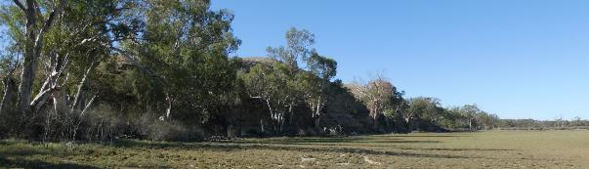
Eastern section of Wetland 306 Latitude 34.09663 Longitude 140.08788 Direction 30

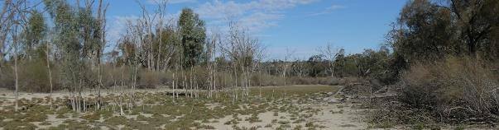
Wetland 306 eastern finger flood-out Latitude 34.09721 Longitude 140.08701 Direction 130
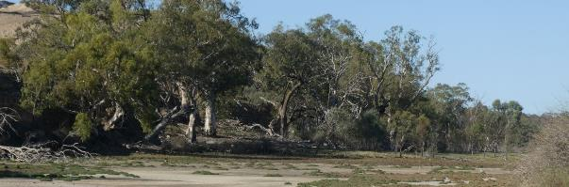
Northern cliff edge of Wetland 306

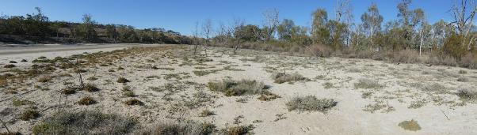
Central section Of Wetland 306 Latitude 34.09871 Longitude 140.08300 Direction 40

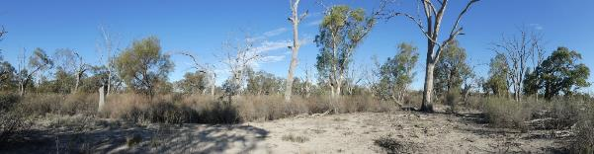
One of the four parallel floodplain features Latitude 34.09947 Longitude 140.08291 Direction 124

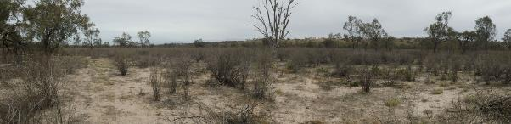
Wetland 559 Latitude 34.10260 Longitude 140.07927 Direction 300
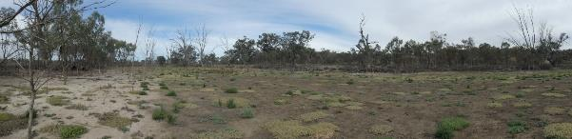
Wetland 419 Latitude 34.10306 Longitude 140.07236 Direction 260

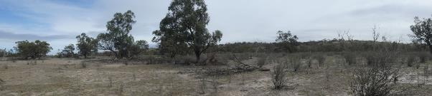
Flood-out between Wetland 419 and 421 Latitude 34.10340 Longitude 140.07410 Direction 250

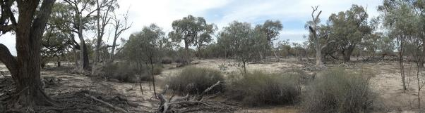
Wetland 421 (outlet watercourse) Latitude 34.10356 Longitude 140.07497 Direction 150

Regent Parrot Utilisation- Foraging and Adjacent Nesting.

Stressor Analysis.
Stressor | Severity | Scope | Irreversibility
Lack of Inundation | High | High | Medium
Saline Groundwater Depth | High | High | Medium
Surface Soil Salinization | High | Medium | Medium

Land Tenure Issues
- The site is owned by two private land owners.
- A strip of unalienated Crown land runs along the water’s edge.
- Minister for Environment and Water holds one land parcel that may have a lessee or licensee pursuant to the Crown Land Management Act 2009.

Ecological Objectives
Halt the decline and improve the health condition of mature woody plant species e.g. (River Red Gum, Black Box, Cooba and Lignum).
Maintain existing regeneration and provide opportunities for future regeneration events of woody plant species e.g. (River Red Gum, Black Box, Cooba and Lignum).
Improve the abundance and diversity of flood dependant understory vegetation.
Reduce soil salinity to disadvantage Samphire and promote regeneration of less salt tolerant floodplain and aquatic plant species.
Improve floodplain habitat conditions to promote Regent Parrot breeding events.
Provide floodplain and aquatic habitats suitable for waterbird and frog refuge and breeding.
Provide fish passage through large floodplain habitats during natural flood events.
Provide hydrological connectivity between watering sites and adjacent floodplain during natural flood events.
Community Objectives
Engage landholder involvement in the sustainable management of their site(s).

Hydrological Parameters
Existing Area of Inundation  - Inundation Area  - Historical Watering Dates | Unknown hectares (majority of wetland and the four parallel floodplain features)  2015/16
Maximum Inundation  - Water Height  - Inundation Area  - Fill Volume | 8.6 AHD  123 ha  1093 ML
Low Inundation  - Water Height  - Inundation Area  - Fill Volume | 7.2 AHD  30 ha  270 ML
Commencement to Flow ML/d Band | 20-30,000
Full Supply Flow ML/d Band | 80-90,000
Watering Option | Pump to full supply  Pump to low elevation  Possibility of return flows  Manage natural flood recession
Watering Timing | Spring through to Autumn

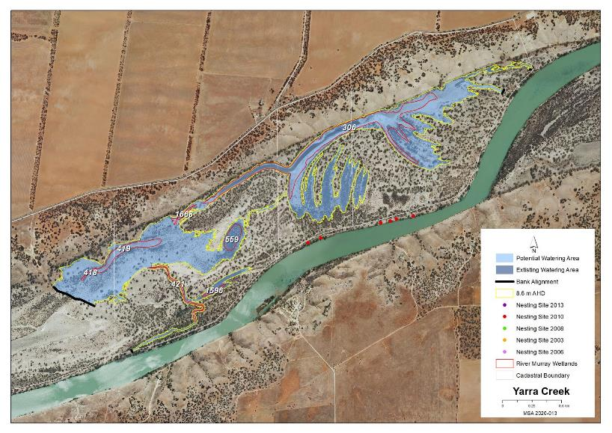
Map identifies the potential watering area

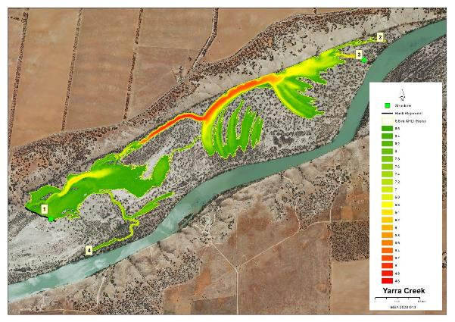Map features AHD heights across the site and identified infrastructure locations

Potential Infrastructure Requirements
Bank or Channel Details
Location | ID | Length  (m) | Freeboard  (m) | Height with freeboard  (m) | Volume  (m3) | Regulator equipment and comments
Yarra Creek | Bank 1 | 388.0 | 0.50 | 1.30 | 2,313.1 | Sheetpile regulator with 3 bays of dropboards, plus large rocks for fish passage
 | Bank 2 | 7.0 | 0.30 | 0.50 | 64.3 | Nil
 | Bank 3 | 36.3 | 0.50 | 2.70 | 702.7 | Sheetpile regulator with 3 bays of dropboards, plus large rocks for fish passage
 | Bank 4 | 14.2 | 0.30 | 0.70 | 52.7 | Nil

