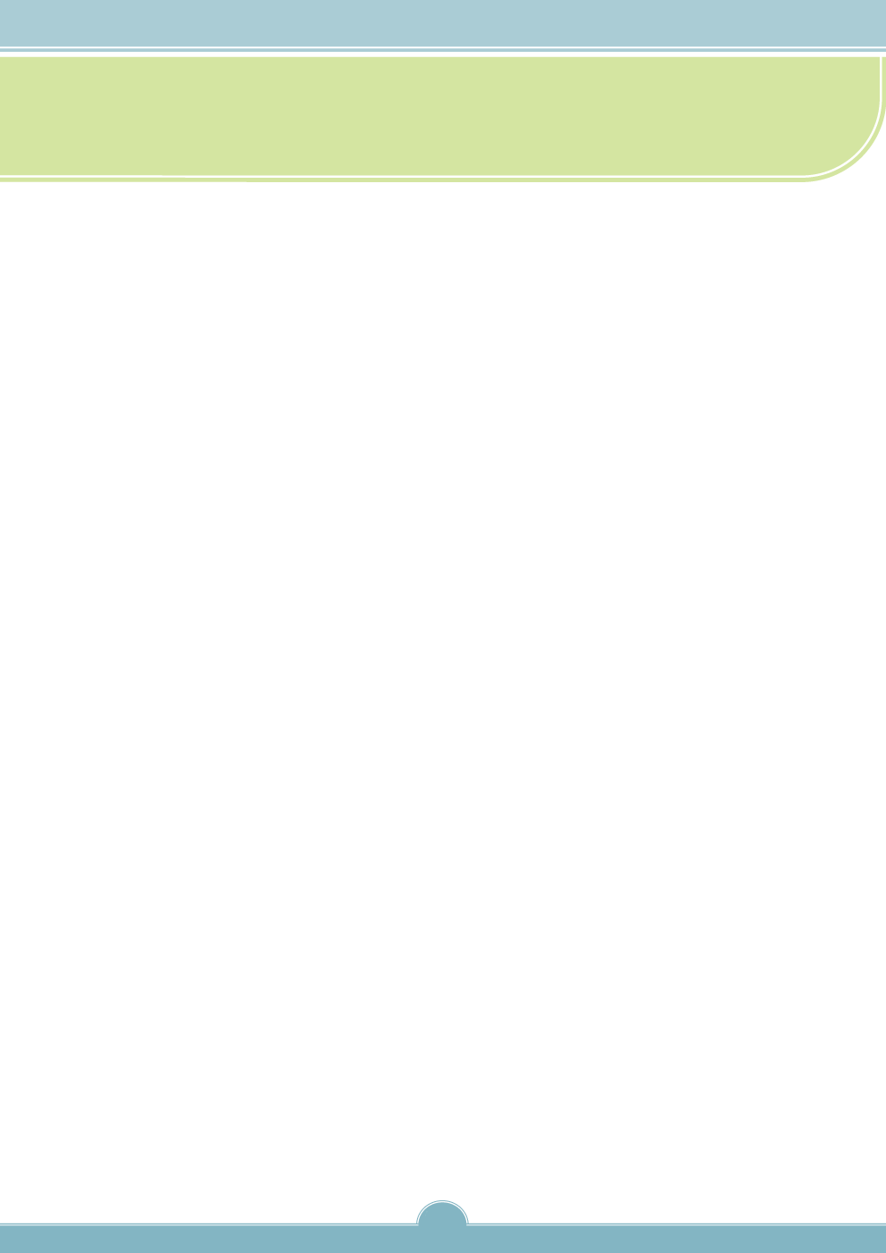

# MURRAY-DARLING BASIN ENVIRONMENTAL WATER HOLDERS REPORT JUNE 2012

# Introduction

The purpose of this report is to provide Ministerial Council members with information on the achievements, cooperative arrangements, challenges, and opportunities for improvement in the management of held environmental water in the Murray-Darling Basin.

State and Commonwealth governments are committed to sustainable water management in the Murray-Darling Basin to support healthy rivers, strong communities and a productive economy. Basin jurisdictions have participated in a significant program of reforms over the past twenty years to address over-allocation and return water to the environment.

The majority of the environmental water in the Basin is ‘rules-based’ water, including above Cap water, committed through the plans developed by Basin states to manage their water resources. The purpose of this ‘planned’ environmental water is to reinstate natural flow patterns to rivers and streams, taking into

***Estimate of planned and***

***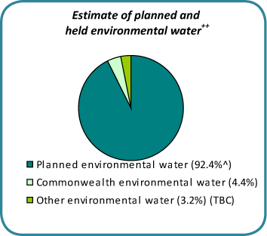held environmental water++***

Planned environmental water (92.4%^)

[Type a quote from the document or the summary of an interesting point. You can position the text box anywhere in the document. Use the Text Box Tools tab to change the formatting of the pull quote text box.]

Commonwealth environmental water (4.4%)

[Type a quote from the document or the summary of an interesting point. You can position the text box anywhere in the document. Use the Text Box Tools tab to change the formatting of the pull quote text box.]

Other environmental water (3.2%) (TBC)

[Type a quote from the document or the summary of an interesting point. You can position the text box anywhere in the document. Use the Text Box Tools tab to change the formatting of the pull quote text box.]

account the timing, frequency and variability of flows. In doing so, planned environmental water contributes to specific environmental outcomes. A much smaller, but increasing, subset of environmental water is the entitlements held by environmental water holders.

Holders of environmental water entitlements include the Murray Darling Basin Authority (on behalf of The Living Murray program\*), the New South Wales Office of Environment and Heritage, the Victorian Environmental Water Holder and Commonwealth Environmental Water. The benefit of held environmental water is that it can be actively managed to meet environmental objectives in a flexible and responsive way, often in conjunction with planned environmental water, to adapt to changing conditions and to help mitigate emerging risks. Held environmental water can be transferred between catchments where this is provided for, or it may be carried over or traded so that water is made available in different locations or in future years to enhance environmental outcomes.

# Outcomes achieved to date

# As of 31 March 2012, environmental water holders within the Murray-Darling Basin held water entitlements that combined are estimated to provide a long-term average annual yield of 1,504 GL per year. In addition, NSW manages substantial volumes of ‘discretionary’ planned environmental water, which requires a decision for release. The management of some discretionary water—the Barmah-Millewa Forest Environmental Water Allocation—also involves

1

\* The Living Murray program is a partnership of the Commonwealth, NSW, Victorian, South Australian and ACT governments.

++These figures are based on long-term average total volume secured. The figure for planned environmental water is derived from the proposed Basin Plan and MDBA estimates of environmental water recovery in the Murray-Darling Basin as at 31 December 2011. The figures for held environmental water here and in Attachment 1 were supplied by CEW, NSW OEH, VEWH and MDBA (for TLM) and were current as of 31 March 2012.

^ This includes both ‘discretionary’ planned environmental water (water that requires a decision for release) as well as all other water not extracted for consumptive use, noting that not all of this provides environmental benefit.

# Bg_page.jpgthe Victorian Environmental Water Holder. Since 2005-06, environmental water holders have delivered nearly 3,847 GL of both held and discretionary environmental water to achieve environmental benefits in the Basin. A breakdown of holdings and use by catchment, as well as a graph showing the change in the use of environmental water entitlements over time, are provided as Attachments 1 and 2.

## 2011 Murrumbidgee event

Wetlands along the Murrumbidgee River, from Gundagai through to the Murray River, benefited from the use of 161 GL of environmental water in June 2011. This included:

nearly 110 GL of Commonwealth held environmental water;

23 GL from The Living Murray program;

21 GL from the NSW environmental water allowance; and

8 GL from private donors.

This watering event built on the benefits of high river flows in spring 2010 which filled many wetlands for the first time in 10 years. The 2011 flows into the Murray system extended as far downstream as South Australia’s Lower Lakes and Coorong.

NSW State Water/ NSW Office of Environment and Heritage managed this action. Charles Sturt University is monitoring the ecological responses to the watering and local landholders are also assisting with monitoring.

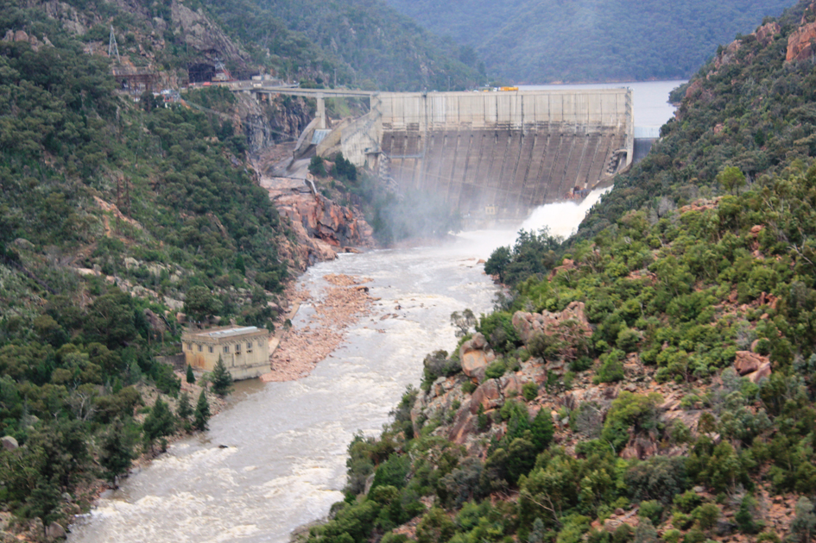

**Environmental water being released from Burrinjuck Dam (June 2011)**

Photo by Rebecca Gee, Commonwealth Environmental Water

1

During the recent extended drought, the focus of environmental water use was on using the limited volume of available water to mitigate damage to key environmen­tal assets (such as the ‘icon’ sites along the River Murray and significant floodplain wetlands throughout the Basin) and maintain the Basin’s capacity for ecological recovery. Although held environmental watering programs were generally at an early stage, monitoring programs detected positive outcomes that included improvements to vegetation health, decreasing salinity and benefits to populations of rare and endangered species.

For example, positive results were achieved through the use of 12.9 GL at Hattah Lakes in Victoria in 2009-10, which provided refuge for a range of species and helped prevent further decline in stressed river red gums following years of drought. Waterbirds flocked to the lakes in their thousands: more than 3,200 birds, including state listed threatened species, were observed at the site through surveys undertaken by The Living Murray program following the delivery of environmental water. This water was provided by Commonwealth Environmental Water, The Living Murray, the Victorian Government and public donations through the Australian Conservation Foundation.

With increasing volumes of water available following the breaking of the drought in 2010, environmental water holders shifted their focus to supporting the ecological recovery of riverine and floodplain wetland communities. While the full results will take some years to emerge, early monitoring indicates that by using environmental water to capitalise on the ecological benefits of high rainfall and increased river flows, environmental water managers have contributed to a range of ecological benefits including supporting:

* better health in river red gums;
* improved water quality through nutrient cycling and the export of salt from the Basin;
* hydrological connectivity between the rivers, wetlands and floodplains of various catchments; and
* the provision of habitat and breeding opportunities for waterbirds, frogs and native fish.

2

Specific examples of achievements since the breaking of the drought include the use of   
161 GL in the Murrumbidgee in June 2011 (see text box), which benefited fauna, flora and water quality within the filled wetlands and created conditions suitable for native fish, turtle, frog and waterbird breeding. Charles Sturt University has reported that the percentage cover of aquatic vegetation within wetlands that received environmental water increased significantly over time, compared to the control sites.

|  |  |
| --- | --- |
| **Environmental watering of Lakes Powell and Carpul (Victoria)**  During the floods in 2009-10 and 2010-11, river flows were not sufficient to inundate LakesPowell and Carpul. Absent development and regulation of this system, flows from equivalent rainevents would have seen these lakes filled, highlighting the need for works to ensure the long-termsurvival of these areas. The Mallee Catchment Management Authority (Mallee CMA) has developedan Environmental Water Management Plan with the local community which identifies the waterrequirement for the long term health of these lakes, including their environmental values andwater requirements. Through this plan it was identified that the Lakes critically need water. | |
| people.jpg  Community day at Lake Powell and Carpul celebrating the filling of the lakes Photo by Mallee CMA | Lake Carpul was identified through the Index of Wetland Condition assessment as the wetland in the best condition in the Mallee region.  The Mallee CMA has been working with the surrounding landholders, local community, indigenous groups, water corporations and state agencies to deliver water provided by the Victorian Environmental Water Holder to these sites in 2011-12. Watering has been highly successful with observed improvement in tree health, and waterbirds inhabiting the lakes. The community is highly engaged, as demonstrated by the canoeing day held to celebrate the watering, which was organised by the Mallee CMA and local residents. |

The use of 13 GL of Commonwealth environmental water in the Gwydir catchment in 2010-11, with the assistance of the Gwydir Environmental Water Advisory Group, provides a further example of benefits from the use of held environmental water. Prior to watering, ground cover vegetation in the area was dominated by exotic plant species. However, after environmental watering, 90 per cent of the area was covered by native meadows of couch and swamp buttercup. The subsequent delivery of 15 GL of environmental water allowance by the NSW Office of Environment and Heritage in early 2012, following extensive natural flooding of the Gwydir wetlands, has supported the largest waterbird breeding event in the Gwydir wetlands since the late 1990s.

Environmental water has also been used recently to maintain water quality along the main stem of the Murray River and in the Murrumbidgee and Edward-Wakool River systems. Approximately 191 GL of Commonwealth environmental water was delivered to these systems during April and May 2012 to reduce the impact of hypoxic blackwater on native fish by providing refuge habitat. NSW provided some additional environmental water, while both NSW and Victoria supported the release of the water from their storages.

Hypoxic blackwater occurs when oxygen is depleted from the water due to the breakdown of leaf litter and vegetation following inundation. It is a natural part of the ecology of lowland river systems, but can be extreme in areas impacted by drought where litter build up may be exacerbated. Monitoring undertaken by the

3

Murray Catchment Management Authority, NSW Department of Primary Industries and Charles Sturt University in the Edward-Wakool system over the past two years has shown that the delivery of the environmental water has improved water quality and reduced the impact of blackwater events on aquatic animals.

# Cooperation amongst environmental water holders and managers

The delivery of environmental water within the Basin is a cooperative effort involving multiple stakeholders, often represented through local advisory groups. Stakeholders typically include:

* state and Commonwealth government agencies
* catchment management authorities
* water user and community groups
* indigenous representatives
* landowners
* land managers and
* non-government organisations.

|  |  |
| --- | --- |
| **Barmah-Millewa environmental watering**  One of the key environmental watering actions to occur in 2011-12 was in the Barmah-Millewa Forest. In Aug-Sep 2011, a colonial bird breeding event commenced during a period of higher natural inflows. High flow levels for nearly five months are generally needed to ensure that bird breeding events are successfully completed. To meet that need, a significant volume of environmental water—totalling 428.1 GL—was delivered to the Barmah-Millewa Forest. This included 15 GL of entitlement held by NSW, 10 GL held by Victoria, 120 GL from The Living Murray and 283.1 GL from the Victorian and NSW Barmah-Millewa Environmental Water Account. | |
| The watering resulted in a significant breeding event for ibis, spoonbills, darters and cormorants. It also built on the watering provided in 2010-11, which resulted in the largest bird breeding event seen at the site in 60 years and provided opportunities for fish spawning (particularly silver and golden perch). Two consecutive years of flooding at Barmah-Millewa has also rejuvenated some sections of the forest and stimulated a positive response from flora and fauna.  **White ibis egg & chick**  Photo by Keith Ward Goulburn Broken Catchment Management Authority | 2011-12-09 (Top Island Barmah) 062 - White Ibis egg & chick (Keith Ward).jpg |

State and Commonwealth environmental water holders frequently conduct joint watering actions in the interest of maximising environmental outcomes from the available water. All Commonwealth environmental water delivered to date has been delivered in partnership with a state agency. Of all the watering actions involving the delivery of Commonwealth environmental water up to 31 March 2012,   
983 GL has been provided by Commonwealth Environmental Water while 602 GL has been contributed by delivery partners.

# Local engagement

Local and regional groups or individuals have substantial knowledge and experience which can support environmental water holders in a variety of ways. For example, local community groups, indigenous groups, and landowners and managers are often well placed to help identify potential watering sites and objectives. Catchment management authorities and other regional bodies often have the technical expertise to convert suggestions into watering options and help deliver the environmental

4

water. Non-government organisations and academic institutions often contribute by monitoring the environmental outcomes. Local input to watering actions will become increasingly important as environmental water holdings continue to grow in the coming years. In addition to their current contribution, the proposed Murray-Darling Basin Plan will require advice from local and regional groups to inform the development by the states of long-term environmental watering plans and annual watering priorities for each Basin catchment.

Local arrangements vary considerably across the Basin. There is an opportunity to strengthen the approach, including by formalising the role of these groups where appropriate and where this has not already occurred, and also by that consultation around local arrangements is targeted, involves all necessary stakeholders, and avoids any duplication.

**Challenges**

The active use of water entitlements to achieve environmental outcomes is a relatively new approach to water management in the Murray-Darling Basin. Current arrangements for the efficient operation of the river system have developed over a long period of time—primarily to meet the needs of consumptive water users—and environmental water holders must manage their water within the existing framework. Water held for environmental use is generally subject to the same operating rules, delivery constraints, state-based entitlement frameworks, fees and carryover rules as entitlements held for other purposes. However, these frameworks do not always support optimal environmental water delivery.

Recent trials of multi-site environmental watering actions, where water is used on successive assets as it flows downstream, have been conducted through The Living Murray program. These have highlighted the complex operational and accounting challenges involved in delivering environmental water in highly regulated river systems. Within this context, opportunities exist to work with river operators to facilitate the evolution of system operations and entitlement frameworks over time to better meet the needs of all water users.

5

State and Commonwealth governments are currently working together to find solutions to these challenges that will enhance the ability of environmental water holders to achieve improved environmental outcomes while avoiding any impacts that may diminish the rights of other users.

Specifically, opportunities to improve on current arrangements to enable the effective use of environmental water in the Basin may include:

* improving the ability to use water on successive downstream sites. For example, by reducing the risk of re-regulation of ‘return flows’ or by developing ‘shepherding’ arrangements (meaning to protect environmental water from extraction by consumptive users or water infrastructure operators in regulated and unregulated systems and/or to pass water through to downstream watercourses); and
* enabling environmental water holders to supplement flows under a range of scenarios (e.g. regulated and unregulated conditions).

Government agencies are also working on the identification of physical constraints that may need to be overcome in order to meet the environmental watering requirements of the Murray-Darling Basin. These include both constraints on the use of existing infrastructure (for example, limits on dam releases, the operation of regulators and channel capacity), as well as constraints that arise due to the potential for third party impacts (such as the flooding of private land or infrastructure).

In some cases, the solution to these physical constraints may include the development of new or improved infrastructure (works) to deliver environmental water. In other cases, particularly where the delivery of overbank flows is critical to the achievement of particular environmental outcomes, the best solution may include negotiating easements with landowners on key areas of the floodplain. The delivery of environmental water also needs to be undertaken in consideration of any ecological constraints, such as the potential for adverse environmental impacts on tributaries used to deliver water to downstream assets.Managing risks

Environmental water holders work very closely with their delivery partners, including state agencies, river operators and local advisory groups, to identify and manage risks associated with watering proposals. Decisions on watering are made only after a risk assessment is undertaken, based on the best available information at the time.

Watering actions are also actively managed to ensure flows can be reduced or stopped if conditions change, including by requesting river operators to halt the release of environmental water if certain triggers are met. For example, in specific instances environmental water holders have chosen not to proceed with or to modify particular actions when additional rains have led to flooding risks.

# Opportunities

The development of the Basin Plan, its environmental watering plan and the associated environmental management framework provides an opportunity to integrate planning for all environmental water. Environmental water holders and managers will need to contribute to the development of planning documents at the basin and catchment scale—covering both the long- and the short-term. When it comes into effect, the Basin Plan is intended to strengthen accountability for environmental water management by coordinating planning and reporting by all environmental water holders and managers on their outcomes.

The implementation of the Basin Plan will also provide an opportunity to develop long-term agreements or ‘environmental watering schedules’. These could enhance the efficiency of environmental water planning through multi-year ‘standing arrangements’ while still allowing flexibility for adaptive management in response to environmental and weather events.

With the increasing volumes of available environmental water, environmental water holders have been working collaboratively to implement larger scale multi-site watering actions. Such actions have sought to provide flows along the length of connected systems in order to support the in-stream and floodplain ecosystem functions that underpin a healthy working Basin.

Another key focus over the next few years will be to identify opportunities to achieve more water-efficient environmental outcomes, such as through environmental works and measures and changes to river operations. In addition, new knowledge generated through monitoring and evaluation will inform adaptive management, and in turn, improve the efficiency and effectiveness of environmental water use.

|  |  |
| --- | --- |
| David Parker Commonwealth Environmental Water Holder Commonwealth Environmental Water | Derek Rutherford Divisional Director, Waters, Wetlands and Coast Office of Environment and Heritage NSW Department of Premier and Cabinet |
| Jody Swirepik  Executive Director Environmental Management Division Murray-Darling Basin Authority | Denis Flett Chairperson Victorian Environmental Water Holder |
| **Photo-1---Yanga-wetlands_small.jpgYanga National Park after environmental watering (November 2010)** Photo by Tanya Doody, CSIRO – Land and Water | |

6

# Bg_page.jpgAttachment 1: Environmental water held Environmental water held by catchment (long-term average at 31 March 2012)\*

|  |  |  |  |  |
| --- | --- | --- | --- | --- |
| River system | Commonwealth Environmental Water (ML/year) | The Living Murray (ML/year) | Victorian Environmental Water Holder (ML/year) | NSW Office of Environment and Heritage (ML/year) |
| Queensland | | | | |
| Border Rivers | 3,917 |  |  |  |
| Lower Balonne | 4,180 |  |  |  |
| Moonie | 1,100 |  |  |  |
| Nebine | 1,000 |  |  |  |
| Warrego | 8,000 |  |  |  |
| Total QLD | 18,196 |  |  |  |
| New South Wales | | | | |
| Barwon-Darling | 14,603 |  |  |  |
| Border Rivers | 108 |  |  |  |
| Gwydir | 36,233 |  |  | 6,237 |
| Lachlan | 36,538 |  |  | 11,319 |
| Lower Darling | 399 | 70,616 |  |  |
| Macquarie/Cudgegong | 39,752 |  |  | 20,641 |
| Murray | 200,182 | 95,178 |  | 25,446 |
| Murrumbidgee | 94,666 | 52,144 |  | 18,508 |
| Namoi (upper) | 81 |  |  |  |
| Namoi (lower) | 4,695 |  |  |  |
| Total NSW | 427,256 | 217,938 |  | @ 82,150 |
| Victoria | | | | |
| Broken | 48 | 1,095 |  |  |
| Campaspe | 6,281 | 3,045 |  |  |
| Goulburn | 152,810 | 133,749 | # 23,386 |  |
| Loddon | 2,446 |  | 10,100 |  |
| Murray | 187,219 | 81,621 | # 31,936 |  |
| Ovens | 67 |  |  |  |
| Total Victoria | 348,871 | 219,510 | 65,422 |  |
| South Australia | | | | |
| Murray | 82,020 | 42,527 |  |  |
| Total SA | 82,020 | 42,527 |  |  |
| Total Murray-Darling Basin | 876,343 | 479,974 | 65,422 | 82,150 |

\* This includes only environmental water held as entitlements. NSW and Victoria also manage ‘discretionary’ planned environmental water, which requires a decision for release. NSW and Victoria jointly manage the Barmah-Millewa Forest Environmental Water Allocation, while NSW has the Gwydir Environmental Contingency Allowance and the Macquarie and Murrumbidgee Environmental Water Allocations. CEW figures are in long-term average annual yield. Other figures are in long-term averages as reported by NSW, Victoria and the MDBA (for TLM). Any discrepancies in totalled figures are due to rounding.

@ This includes NSW adaptive environmental water holdings adjusted for long-term average water accrual to those accounts.

# These figures include the long-term average of audited water savings already achieved from the Northern Victoria Irrigation Renewal Project, which will increase to 75,000 ML once the full saving is realised.

7

# Bg_page.jpgAttachment 2: Environmental water used from 2005-06#

# Note that in the case of NSW and Victoria, active management of environmental water can be traced back to the 1990s and, in certain areas, well before. Most, if not all, States have a history of environment water management.

\* No water had yet been listed on TLM’s Environmental Water Register at this time. This TLM environmental water was donated by South Australia.

^ These figures are use estimates up to 31 March 2012, which are subject to change.

~ Includes the Victorian component of the Barmah-Millewa Environmental Water Allocation, which was used in 2005-06 and 2010-11. Note that these figures do not show Wimmera releases. Delivery prior to the establishment of the Victorian Environmental Water Holder on 1 July 2011 was undertaken by the Department of Sustainability and Environment.

\* Includes NSW ‘discretionary’ planned environmental water: the Gwydir Environmental Contingency Allowance and the Macquarie, Murrumbidgee and Barmah-Millewa (NSW component) Environmental Water Allowances.

8