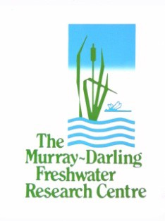**Murray–Darling Basin Environmental Water Knowledge and Research project:**

**Selection of priority research questions and research sites**

**Prepared by:** Ian Burns and Ben Gawne

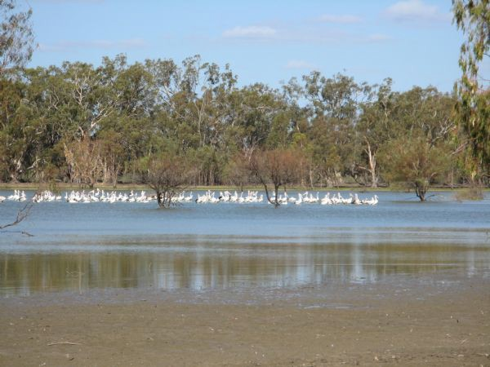

**Final Report**

#### MDFRC Publication 114

1



**Murray–Darling Basin Environmental Water Knowledge and Research project: Selection of priority research questions and research sites**

Final Report prepared for the Department of the Environment by The Murray–Darling Freshwater Research Centre.

Department of the Environment GPO Box 787

Canberra ACT 2601

Ph: (02) 6274 2710

This report was prepared by The Murray–Darling Freshwater Research Centre (MDFRC). The aim of the MDFRC is to provide the scientific knowledge necessary for the management and sustained utilisation of the Murray–Darling Basin water resources. The MDFRC is a joint venture between the Murray–Darling Basin Authority, La Trobe University and CSIRO.



For further information contact:

#### Jessica Davison

The Murray–Darling Freshwater Research Centre PO Box 991

Wodonga VIC 3689

Ph: (02) 6024 9645; Fax: (02) 6059 7531

Email: [j.davison@latrobe.edu.au](mailto:i.burns@latrobe.edu.au)

Web: [www.mdfrc.org.au](http://www.mdfrc.org.au/) Enquiries: [info@mdfrc.org.au](mailto:info@mdfrc.org.au)

**Report Citation:** Burns I, Gawne B (2014) Murray–Darling Basin Environmental Water Knowledge and Research project: Selection of priority research questions and research sites. Final Report prepared for the Department of the Environment by The Murray–Darling Freshwater Research Centre, MDFRC Publication 114/2014, June, 34pp.

**Cover Image:** Pelicans on Lake Cantala, Hattah Lakes, Victoria

**Photographer:** David Wood, MDFRC

Murray—Darling Basin Environmental Water Knowledge and Research project: Selection of priority research questions and research sites i

#### Disclaimer:

The material contained in this publication represents the opinion of the author only. Whilst every effort has been made to ensure that the information in this publication is accurate, the author and MDFRC do not accept any liability for any loss or damage howsoever arising whether in contract, tort or otherwise which may be incurred by any person as a result of any reliance or use of any statement in this publication. The author and MDFRC do not give any warranties in relation to the accuracy, completeness and up-to-date status of the information in this publication.

Where legislation implies any condition or warranty which cannot be excluded restricted or modified, such condition or warranty shall be deemed to be included provided that the author’s and MDFRC’s liability for a breach of such term condition or warranty is, at the option of MDFRC, limited to the supply of the services again or the cost of supplying the services again.

Copyright in this publication remains with the La Trobe University. No part may be reproduced or copied in any form or by any means without the prior permission of the La Trobe University.

#### Document history and status

|  |  |  |  |  |
| --- | --- | --- | --- | --- |
| **Version** | **Date Issued** | **Reviewed by** | **Approved by** | **Revision type** |
| Draft 1 | 26/11/14 | Ian Burns | Ben Gawne | Internal |
| Draft 2 | 28/11/14 | Ian Burns | Ben Gawne | Department of Environment |
| Draft 3 | 12/12/14 | Ian Burns | Ben Gawne | Jurisdictional Reference Group |

**Distribution of copies**

|  |  |  |
| --- | --- | --- |
| **Version** | **Quantity** | **Issued to** |
| Draft | 1 X Word | Department of Environment |
| Final | 1 x PDF | Department of Environment and Energy |

**Filename and path:** G:\SHE - Life Sciences\MDFRC\Projects\DSEWPC\465 MDB

EWKR\PROJECT MANAGEMENT\PHASE 1 FINAL DELIVERABLES

**Author(s):** Ian Burns and Ben Gawne

**Author affiliation(s):** Murray–Darling Freshwater Research Centre

**Project Manager:** Ian Burns

**Client:** Department of the Environment

**Project Title:** Murray–Darling Basin Environmental Water Knowledge and Research project

**Document Version:** Final

**Project Number:** M/BUS/465

#### Contract Number: N/A

Contents

1. Introduction 1
2. Priority Research Questions 2
   1. Stakeholder consultation 2
   2. Approach to identifying priorities 2
      1. Framework and principles 2
      2. Application of the framework and principles 6
   3. Vegetation theme 7
      1. High-level question and conceptual model 7
      2. Identifying priority research topics 7
      3. Proposed research approach 10
      4. Proposed threats to be considered in research 11
      5. Summary — proposed research questions for vegetation 11
   4. Native fish 12
      1. High-level question and conceptual model 12
      2. Identifying priority research topics 12
      3. Proposed research approach 15
      4. Proposed threats to be considered in research 16
      5. Summary — proposed research questions for native fish 16
   5. Waterbirds 17
      1. High-level question and conceptual model 17
      2. Identifying priority research topics 17
      3. Proposed research approach 19
      4. Proposed threats to be considered in research 19
      5. Summary — proposed research questions for waterbirds 20
   6. Additional theme — food webs 21
      1. Summary — proposed research questions for food webs 21
3. Research sites 22
   1. Identification of candidate sites 22
   2. Site selection criteria 23
   3. Proposed sites 25
   4. Relationship between sites and questions 26
4. Next steps 28

Appendices .......................................................................................................... Error! Bookmark not defined.

Appendix A Summary of research questions submitted by researchers 29

Appendix B Evaluation of research sites 31

# Figures

Figure 1. Conceptual diagram showing the influence of water management levers on physical conditions in aquatic ecosystems and the subsequent impacts on functional processes and biotic outcomes, together with the influence of pressures and stressors 3

Figure 2. Conceptual model of functional processes and their influence on outcomes for water-dependent vegetation 7

Figure 3. Conceptual model of functional processes and their influence on outcomes for native fish. 12

Figure 4. Conceptual model of functional processes and their influence on outcomes for waterbirds 17

Figure 5. Proposed process to select collaborators 28

# Tables

Table 1. Framework used to identify research priorities 4

Table 2. Water-dependent vegetation — evaluation of component parts against relevant prioritisation principles 8

Table 3. Proposed research approach — water-dependent vegetation 10

Table 4. Native fish — evaluation of component parts against relevant prioritisation principles 13

Table 5. Proposed research approach — native fish 15

Table 6. Waterbirds — evaluation of component parts against relevant prioritisation principles 18

Table 7. Proposed research approach — waterbirds 19

Table 8. Initial indication of sites proposed for fieldwork (subject to further consideration in project planning).

27

# Introduction

The Murray–Darling Basin (MDB) Environmental Water Knowledge and Research (EWKR) project is a 5 year, $10 million project to improve the science available to support environmental water management, and thereby contribute to achieving Basin Plan objectives. MDB EWKR will undertake research aimed at better understanding:

* the links between ecological responses to flow and medium and long-term changes in condition
* the impacts of threats (hydrological, aquatic and terrestrial) which may reduce or prevent the ecological improvement expected through environmental flow regimes.

In turn, this improved understanding will:

* enhance environmental water management and complementary natural resources management to improve environmental outcomes (predominantly biotic outcomes)
* build capacity to report against Basin Plan objectives and targets. The ability to explain ecological improvement within the context of multiple threats will be important in building and maintaining public confidence in the Basin Plan.

The project aims to collaborate with water managers, asset managers, water planners, scientists and relevant community groups to identify research priorities, and undertake research targeted at addressing those priorities. Phase 1, through to February 2015, is a planning phase to identify research priorities, develop research project plans and agree collaborative arrangements to undertake the work. Phase 2, delivery of the research, will commence in early 2015 and run through to 2018–19.

This report outlines the proposed research priorities and research sites for MDB EWKR. In accordance with MDB EWKR project objectives and guided by the environmental objectives of the Basin Plan, the priorities and sites have been identified by:

1. consulting with jurisdictional environmental water managers to identify their knowledge needs and research priorities
2. consulting with researchers in freshwater ecology to identify their suggested priority research questions
3. using analysis of the project objectives and the outcomes sought by the Basin Plan, together with feedback received in the consultation activities with water managers and researchers to inform potential research priorities
4. evaluating potential research sites against their capacity to support research into the proposed priorities.

Feedback received during the consultation activities is documented in detail in a separate report (*Preliminary Identification of Research Questions*).

# Priority Research Questions

## Stakeholder consultation

The priority research themes and topics set out in this report have been informed by stakeholder consultation activities undertaken in the early stages of MDB EWKR. These include:

Environmental water managers

* **Initial briefings with each basin jurisdiction** — to communicate the objectives of MDB EWKR and obtain input to the proposed process to undertake planning activities in Phase 1. These were undertaken between 28 July and 6 August 2014.
* **Research priority workshops with each basin jurisdiction** — to identify knowledge needs and potential research priorities for MDB EWKR. These were undertaken between 11 September and 2 October 2014.

Researchers

* **An initial briefing with senior researchers representing the main institutions involved in research in the MDB** — to communicate the objectives of MDB EWKR and obtain input to the proposed process to undertake planning activities in Phase 1. This briefing was held in Sydney on 21 August 2014.
* **Submissions on potential research questions for MDB EWKR** — research institutions were invited to submit potential research questions for MDB EWKR. The submission process opened on 2 September and closed on 26 September 2014.

Feedback received during these consultation activities is documented in detail in a separate report (Preliminary Identification of Research Questions). A high-level summary of the questions submitted by researchers is provided in Appendix A. There was much common ground in the research priorities proposed by environmental water managers and the research questions submitted by researchers, in terms of the biotic outcomes identified as priorities, the desire to better understand processes that underpin the achievement of biotic outcomes, and the need for applied research to support environmental water management. The feedback received informed the development of prioritisation principles set out in Section 2.2, as well as the selection of the proposed research priorities set out in later sections of this report.

MDFRC presented initial ideas and sought feedback on priority research questions and sites from the Jurisdictional Reference Group (meeting 5 November 2014) and Science Advisory Group (teleconference 7 November 2014). Comments and feedback from these groups has informed the development of this report.

## Approach to identifying priorities

### Framework and principles

The Basin Plan seeks to achieve a healthy working Murray–Darling Basin, predominantly through the recovery of water for the environment. Environmental works and measures (including SDL adjustment ‘supply measures’) and constraints management activities will also contribute to achieving a healthy working Basin.

These ‘water management levers’ influence the hydrology of the Basin’s rivers, wetlands and floodplains, which in turn influences physical and functional process, and which subsequently drive the biotic outcomes (Figure 1). These biotic outcomes are generally the outcomes sought by management actions. The biotic outcomes are also influenced directly or indirectly by the geology, geomorphology and climate across the Basin, together with the impact of other pressures and stressors (for example weeds, introduced species such as Carp).

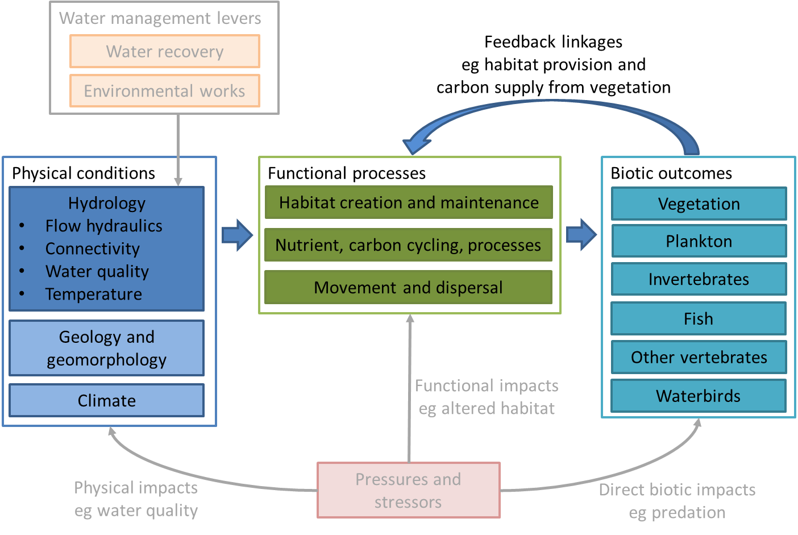

**Figure 1.** Conceptual diagram showing the influence of water management levers on physical conditions in aquatic ecosystems and the subsequent impacts on functional processes and biotic outcomes, together with the influence of pressures and stressors.

The proposed priority research areas for MDB EWKR have been identified by applying a framework that breaks down the biotic outcomes shown in Figure 1 into relevant component parts and supporting processes. The objectives for MDB EWKR have been expressed as prioritisation principles to guide the selection of priorities at each step in the framework. The prioritisation process has been strongly guided by the environmental objectives of the Basin Plan (as expressed in the environmental outcomes framework developed under the Commonwealth Environmental Water Office’s Long Term Intervention Monitoring (LTIM) project and the environmental outcomes described in the Murray–Darling Basin Authority’s (MDBA’s) Basin-wide Environmental Watering Strategy (BEWS).

This framework and the guiding principles at each step are summarised in Table 1 whilst the principles and their means of application are described thereafter.

**Table 1.** Framework used to identify research priorities.

|  |  |
| --- | --- |
| **Framework steps** | **Guided by** |
| Step 1: Research themes  The biotic responses (see Figure 1) proposed as the focus of research | Principle 1 |
| Step 2: High-level questions  Setting the strategic direction for research activity under the research themes | Principles 1 and 2 |
| Step 3: Conceptual models  Showing the key life-history stages or other relevant component parts, together with the physical and functional processes associated with the high-level questions | Principle 2 |
| Step 4: Priority research topics  Identifying which of the life history stages or other relevant component parts and processes identified in the conceptual models should be the focus of research in MDB EWKR | Principles 1, 3 and 4 |

#### Principle 1: Research is of management relevance now and into the future

MDB EWKR will deliver most of its research outcomes toward the end of the project in 2019. For MDB EWKR to deliver high-value outcomes, it is important that the project focus on strategic questions of enduring and basin-wide relevance, rather than questions of immediate, short-lived or localised priority.

This principle has been addressed by:

1. Focussing the research themes and priority research topics on the environmental outcomes identified in the BEWS.

The purpose of BEWS is to guide environmental watering at the Basin-scale and to meet the environmental objectives of the Basin Plan over the long term. The environmental outcomes described in the BEWS will be the Basin-scale focus for environmental water planning and delivery over the coming years. Focussing on the outcomes set out in the BEWS is likely to mean MDB EWKR achieves the maximum relevance over the life of the project.

This has been achieved by adopting:

* research themes aligned with the ecological components addressed in the BEWS — i.e. water- dependent vegetation, native fish and waterbirds
* within those research themes, priority research topics aligned with the specific expected outcomes described in the BEWS (further explanation in sections 2.3, 2.4 and 2.5, and associated tables).

1. Focussing research on the processes that drive the achievement of environmental outcomes, regardless of the intervention type.

The high-level questions proposed (and the application of these questions through the steps in the framework) seek to understand the core processes that drive the achievement of biotic

outcomes, rather than the effectiveness, limitations or risks associated with a specific intervention type. Interventions and works may be used as experiments to understand these processes, but the interventions will not be the focus of research *per se*. This approach is proposed to ensure the research outcomes are of basin-wide and broad management relevance, rather than limited to a particular intervention type or situation.

#### Principle 2: Research focuses on the links between ecological responses to individual flow events, and medium-to-long-term environmental outcomes from environmental watering

This principle represents one of the key objectives for MDB EWKR. It reflects that there are other projects and programs monitoring the outcomes of flow interventions, or alternatively ecological condition at a point in time. MDB EWKR has the ability to complement those programs by looking at the linkages between the outcomes of individual interventions, and the longer term environmental outcomes (changes in condition).

This principle also reflects that this is an area of science where knowledge is less developed. Whilst there may be knowledge about the impacts of flow on particular life-history stages of biotic groups (e.g. the influence of flows on fish spawning), often the processes that link this response to longer- term changes in condition (e.g. the factors that influence successful recruitment of fish larvae to increase the numbers of adult fish) are not as well understood.

This principle has been addressed by:

1. adopting high-level questions focussed on the drivers of the medium-to-long-term outcomes identified in the BEWS
2. using conceptual models underneath these high-level questions to identify the key life-history stages or other relevant component parts, together with the physical and functional processes that contribute to the medium-to-long-term outcomes
3. undertaking a process of prioritisation to identify which of these life-history stages, other component parts and processes should be priority research topics for MDB EWKR.

Note this principle has informed the development and application of the framework set out in Table 1, rather than prioritisation of component parts.

#### Principle 3: Research focusses on key knowledge gaps where further knowledge has the capacity to significantly enhance environmental watering

MDB EWKR aims to contribute new knowledge to support environmental watering — in terms of long-term planning, the development of annual watering priorities, and decision making around the delivery/design of actual watering events. It also has the capacity to enhance the reporting of environmental watering outcomes by improving the understanding of cause and effect.

This principle was used to inform the selection of priority research topics, by considering the priorities identified in workshops with environmental water managers, and the research questions submitted by researchers.

#### Principle 4: Research focusses on questions where it is feasible to develop or significantly improve predictive capacity in a 5 year timeframe

It is important that MDB EWKR achieves effective and efficient research outcomes. Undertaking speculative research into issues where there is currently little knowledge of the underlying cause-

and-effect relationships runs a high risk of not providing useful results over the life of MDB EWKR. Similarly, undertaking research into issues where there is already a high level of knowledge may not deliver the most value. Accordingly, it is considered appropriate that MDB EWKR focus on those issues where there is currently a robust conceptual understanding of the processes and a likelihood of significantly enhancing predictive capacity over the life of MDB EWKR.

A part of this principle is also considering the ecological response lag times. Focussing research on issues where the ecological response lag times are longer than the timeframe of MDB EWKR is unlikely to deliver useful research outputs.

This principle was used to inform the selection of priority research topics by undertaking an analysis of current knowledge and potential EWKR contribution over 5 years, including consideration of the ecological response lag times.

### Application of the framework and principles

The following sections describe the application of the framework set out in Table 1 for each of the selected research themes: water-dependent vegetation, native fish and waterbirds. The selection of priority research topics and the consideration of the related principles are mostly set out in Tables Tables 2,4, and 6.

It should also be noted that whilst the biotic outcomes are used as the framework for the research/project, the overarching priority is to understand the core processes that drive the achievement of those biotic outcomes.

Addressing some of the principles has required some initial exploration of the research approach that may be taken to address the identified priority research topics. The potential research approach is included in Tables 3, 5 and 7. This information also acts to give a more detailed understanding of the work that may be undertaken, which may be of value in determining priorities.

A key consideration in undertaking a prioritisation process such as this is an understanding of the feasibility of delivering the proposed activities with the available budget and time, and whether the resource split between activities represents value for money. The feasibility of delivering the potential package of work has been considered in selecting the proposed priority research topics. Without more detailed project planning, including research collaborators, it is not possible to identify the amount of resources required to address each of the priority resource topics. However, MDFRC believes that the portfolio of work associated with the priority research topics is potentially feasible and appropriate for MDB EWKR at this stage of the planning process. It is possible that with further planning, an additional prioritisation step may be required to ensure the portfolio of work is in line with the available budget and time.

## Vegetation theme

### High-level question and conceptual model

#### What are the drivers of sustainable populations and diverse communities of water-dependent vegetation?

This question seeks to explore the key functional processes that drive outcomes for water- dependent vegetation populations and communities, as well as the situations under which each of these processes become limiting.

The high-level question is broken down into its component parts in Figure 2. The figure shows the flow-related functional processes (e.g. habitat availability, connectivity) that contribute to short- term life-history responses (e.g. recruitment, survival) and longer-term condition outcomes (e.g. distribution, abundance, diversity) for water-dependent vegetation communities and populations.

The conceptual model draws on the Cause and Effect Diagrams prepared for the Commonwealth Environmental Water Office’s Long Term Intervention Monitoring Project (MDFRC 2013). It is a simplification of a more complicated set of interactions and responses and is presented to facilitate exploring research priorities for MDB EWKR, rather than describing all of the interactions and responses in detail. Please refer to MDFRC (2013) for further detail.

Guided by the environmental outcomes in the BEWS, the broad range of water-dependent vegetation communities and populations has been simplified to (1) understorey and wetland plant communities, and (2) populations of the main long-lived floodplain tree and shrub species.

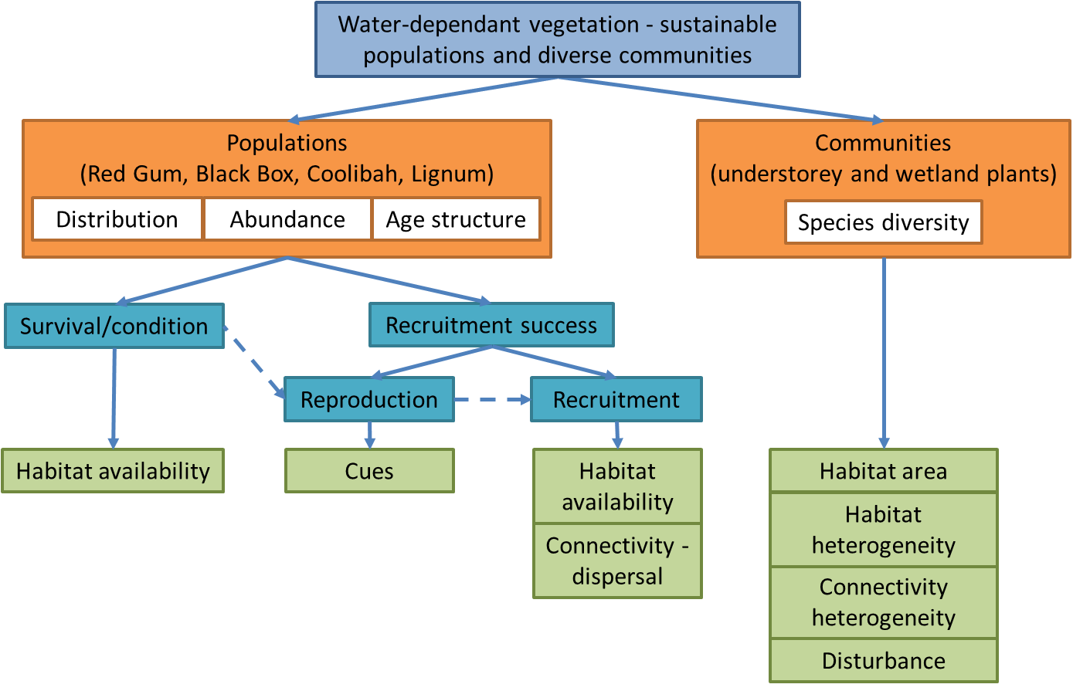

**Figure 2.** Conceptual model of functional processes and their influence on outcomes for water-dependent vegetation.

### Identifying priority research topics

Table 2 shows an evaluation of the component parts of the conceptual model (Figure 2) against the prioritisation principles set out in Section 2.2.1.

**Table 2.** Water-dependent vegetation — evaluation of component parts against relevant prioritisation principles.

|  |  |  |  |  |
| --- | --- | --- | --- | --- |
| **Component** | **Principle 1: Management relevance** Alignment with BEWS environmental outcomes | **Principle 3: Key knowledge gaps** Link to priorities identified by managers and questions from researchers | **Principle 4: Improve predictive capacity**  Current knowledge and potential EWKR contribution | **Proposed priority level and rationale** |
| Community — diversity (understorey and wetland plants) | Non woody vegetation communities are included in BEWS expected outcomes — maintain extent, increase growth.  Protect and restore representative communities of native biota is a Basin Plan objective (8.05(3)(b)).  Vegetation diversity is included as an LTIM Basin-scale evaluation matter.  Wetland and understorey plants provide important habitat to support other outcomes. | Not specifically identified in workshops with managers.  A small number of related questions submitted by researchers. | Understory and wetland plants are known to be highly sensitive to flow; however, capacity to predict diversity outcomes remains limited, particularly over multi-year timeframes. It is anticipated that EWKR could improve predictive capacity through a combination of analysis of existing data and new research to complement LTIM, | High priority  Whilst not an explicit BEWS priority, it has a strong link to Basin Plan objectives and is a common indicator included in environmental flow monitoring (e.g. LTIM, The Living Murray (TLM) and NSW Office of Environment and Heritage (OEH)). Ability to significantly improve predictive capacity. |
| Populations — survival/ condition (River Red Gum, Black Box, Coolibah and Lignum) | River Red gum, Black box, Coolabah and Lignum are included in BEWS expected outcomes — maintain extent, improve condition and recruitment. | Specifically identified as a priority in most workshops with managers.  Many related questions submitted by researchers. | Past research has focussed on long-term water requirements of these species, together with responses from individual watering events. EWKR could build on this to enhance understanding of how watering responses vary according to site characteristics, and how condition responds to watering over multi-year timeframes. | High priority  Whilst this is one of the better understood aspects of vegetation ecology and it is central to environmental watering decision making, some uncertainty remains, and there is capacity to analyse existing data sets to enhance predictive capacity at relatively low cost. |

|  |  |  |  |  |
| --- | --- | --- | --- | --- |
| **Component** | **Principle 1: Management relevance** Alignment with BEWS environmental outcomes | **Principle 3: Key knowledge gaps** Link to priorities identified by managers and questions from researchers | **Principle 4: Improve predictive capacity**  Current knowledge and potential EWKR contribution | **Proposed priority level and rationale** |
| Populations — reproduction  i.e. flowering and seed set (River Red Gum, Black Box, Coolibah and Lignum) | River Red Gum, Black Box, Coolabah and Lignum are included in BEWS expected outcomes — maintain extent, improve condition and recruitment.  Recruitment is dependent on reproduction — so reproduction is a relevant matter. | Not specifically identified in workshops with managers, but a critical link in achieving recruitment.  Not specifically identified in questions submitted by researchers. | Reproduction of these species is dependent on survival/condition and cues. Survival/condition is considered separately and cues are mostly understood. | Low priority  Not a major focus in BEWS, or from managers and researchers.  Processes relatively well understood. Capacity for research into survival/ condition to support reproduction. |
| Populations — recruitment (River Red Gum, Black Box, Coolibah and Lignum) | River Red Gum, Black Box, Coolabah and Lignum are included in BEWS expected outcomes — maintain extent, improve condition and recruitment. | Specifically identified as a priority issue in many workshops with managers.  Many related questions submitted by researchers. | Currently there is conceptual understanding of the processes supporting recruitment, but specific requirements have not been identified. EWKR could confirm and begin to quantify these relationships to give greater confidence to decision making. | High priority  Key issue identified by managers and researchers. Central to achieving BEWS outcomes and sustainable populations. Capacity to confirm and quantify existing conceptual understanding. |

The three priority research topics — community diversity, population survival/condition and population recruitment are all highly relevant to the achievement of management objectives and offer significant opportunities for the MDB EWKR project to value add to existing information and complement current monitoring activities.

### Proposed research approach

The MDB EWKR project seeks to add value to existing knowledge and complement other research and monitoring programs to improve capacity to predict the outcomes of environmental flows. In the case of water-dependent vegetation, data from intervention and condition monitoring programs provide a wealth of information. The analysis of some of these data sets will provide a foundation for the development of further research.

In the case of tree survival/condition, the meta-analysis will be combined with additional analysis of remote sensing data to improve predictive capacity across the Basin. As a desktop activity, this will involve less cost than the other priority research topics and provide potential early research outcomes. For community diversity, a meta-analysis will inform the development of a suite of field and laboratory activities designed to complement the work being undertaken in LTIM and The Living Murray (TLM). For tree recruitment, further analysis and planning is required to determine the most effective approach. A key limitation with field work will be the lag-times and reliance on flow events. Laboratory experiments may offer the best chance of understanding key drivers. Further details of the proposed approach are provided in Table 3.

**Table 3.** Proposed research approach — water-dependent vegetation.

|  |  |  |
| --- | --- | --- |
| **Component** | **Drivers of focus** | **Proposed research approach** |
| Community — diversity (understorey and wetland plants) | Habitat area  Habitat heterogeneity  Connectivity heterogeneity  Disturbance | **Data analysis and modelling**  Meta-analysis and modelling using existing data and new data being collected by LTIM, TLM and State monitoring programs (where relevant).  **Fieldwork**  Potential additional field data capture and analysis complementing LTIM and State monitoring programs (where relevant). |
| Populations — survival/condition (River Red Gum, Black Box, Coolibah, Lignum) | Habitat availability | **Data analysis and modelling**  Meta-analysis and modelling using existing data (including stand condition data), new data being collected by LTIM and remote sensing. |
| Populations — reproduction  (River Red Gum, Black Box, Coolibah, Lignum) | NA – not considered a priority for MDB EWKR | |
| Populations — recruitment  (River Red Gum, Black Box, Coolibah, Lignum) | Habitat availability Connectivity - dispersal | **Fieldwork**  Field data capture and analysis using existing infrastructure as treatments.  **Laboratory**  Possible mesocosm experiments. |

### Proposed threats to be considered in research

MDB EWKR will include research into the impacts of threats (hydrological, aquatic and terrestrial) which may reduce or prevent the ecological improvement expected through environmental flow regimes.

Threats are often specific to biotic outcomes, life-history stages, functional processes and geographic sites. For that reason, the identification of priority threats for research has been considered secondary to the identification of priority research topics and sites. Consultation activities identified the threats listed below as most significant in terms of their potential impact on vegetation outcomes across the Basin. These threats will be assessed in further detail during project planning to identify those considered most significant at the research sites, and for which further research under MDB EWKR can provide the most useful outputs to support environmental water and complimentary natural resource management, and Basin Plan reporting.

Flow independent threats

* Invasive species
* Grazing
* Habitat loss/land use

Flow related threats

* Climate change
* Groundwater/salinisation
* Water quality

### Summary — proposed research questions for vegetation

Diversity of understorey and wetland plant communities

* + - 1. What flow regimes best support the diversity of understorey and wetland plant communities?
         * How significant are the individual drivers (habitat area, habitat heterogeneity, connectivity heterogeneity, and disturbance) for diversity?
         * How do key drivers interact to influence outcomes?
         * How should flows be managed to enhance drivers and thereby diversity?
      2. How do threats impact on the drivers and diversity outcomes?

Survival and condition of long-lived floodplain vegetation (Red Gum, Black Box, Coolibah, Lignum)

1. What flow regimes (particularly frequency, period between follow up watering, event duration) best support the survival and condition of floodplain vegetation populations?

o How do site characteristics (soil type, climate, and groundwater) influence these flow requirements?

1. How do threats (increased temperature, changes in rainfall seasonality) influence flow requirements?

Recruitment of long-lived floodplain vegetation (Red Gum, Black Box, Coolibah, Lignum)

1. What flow regimes best support recruitment within populations of long-lived floodplain vegetation species?
   * How significant are the individual drivers (habitat availability, connectivity – dispersal) for recruitment?
   * How do key drivers interact to influence outcomes?
   * How should flows be managed to enhance drivers and thereby recruitment?
   * How do the characteristics of sites (soil type, climate etc.) influence these flow requirements?
2. How do threats impact on the drivers and recruitment outcomes?

## Native fish

### High-level question and conceptual model

#### What are the drivers of sustainable populations and diverse communities of native fish?

This question seeks to explore the key functional processes that drive outcomes for native fish populations and communities, as well as the situations under which each of these processes become limiting.

The high-level question is broken down into its component parts in Figure 3. The figure shows the flow-related functional processes (e.g. habitat availability, connectivity) that contribute to short- term life-history responses (e.g. recruitment, survival) and longer-term condition outcomes (e.g. distribution, abundance, diversity) for native fish communities and populations.

The conceptual model draws on the Cause and Effect Diagrams prepared for the Commonwealth Environmental Water Office’s Long Term Intervention Monitoring Project (MDFRC 2013). It is a simplification of a more complicated set of interactions and responses and is presented to facilitate exploring research priorities for MDB EWKR, rather than describing all of the interactions and responses in detail. Please refer to MDFRC (2013) for further detail.

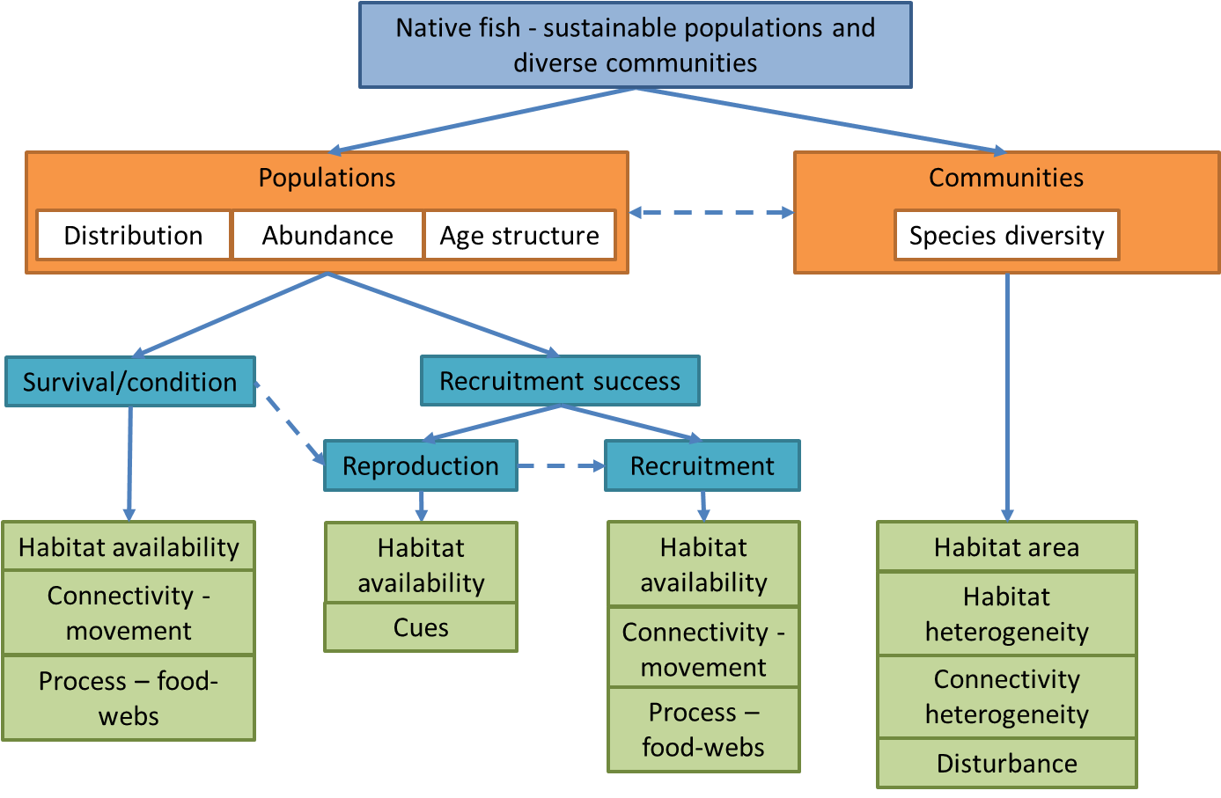

**Figure 3.** Conceptual model of functional processes and their influence on outcomes for native fish.

### Identifying priority research topics

Table 4 shows an evaluation of the component parts of the conceptual model (Figure 3) against the prioritisation principles set out in Section 2.2.1.

**Table 4.** Native fish — evaluation of component parts against relevant prioritisation principles.

|  |  |  |  |  |
| --- | --- | --- | --- | --- |
| **Component** | **Principle 1: Management relevance** Alignment with BEWS environmental outcomes | **Principle 3: Key knowledge gaps** Link to priorities identified by managers and questions from researchers | **Principle 4: Improve predictive capacity**  Current knowledge and potential EWKR contribution | **Proposed priority level and rationale** |
| Community — diversity | BEWS seeks to maintain current species diversity.  Approach to maintaining diversity (no loss of species) focuses on enhancing distribution of key species and supporting recruitment. | Not specifically identified in workshops with managers.  Not specifically identified in questions submitted by researchers. | Information about the life histories of common and charismatic species is now approaching the point where quantitative models can be developed. For many of the rarer species, there is considerable uncertainty concerning their habitat and movements, making identification of the water requirements difficult. | Low priority  Not a major focus in BEWS, or from managers and researchers. Low data availability to support research.  Capacity for research into population requirements to support species diversity outcomes. |
| Populations — survival/ condition | BEWS seeks to extend distributions and improve population numbers for key species.  Survival/condition is considered of direct relevance to BEWS. | Maintenance or recovery of fish populations specifically identified as a priority in most workshops with managers.  Many related questions submitted by researchers. | There is some information on the relationship between flow and fish abundance and condition, but the current view is that recruitment is a more important limitation. Very little specific information is available on the factors that influence fish distributions. | Moderate priority  Important to BEWS and a focus of researcher interest. Perceived as being of a lower priority in terms of its overall influence on fish population viability. |
| Populations — reproduction | BEWS seeks to extend distributions, improve breeding success and improve population numbers for key species.  Reproduction is therefore of direct relevance to BEWS. | Maintenance or recovery of fish populations specifically identified as a priority in most workshops with managers.  Many related questions submitted by researchers. | There are a number of long- term data sets concerning fish reproduction from across the Basin, although the methods used to collect the data vary. Advances in analytical techniques provide an opportunity to undertake a | High priority  Whilst this is one of the better understood aspects of fish ecology (for some species), there is capacity to analyse existing data sets to enhance predictive capacity at relatively low cost. |

|  |  |  |  |  |
| --- | --- | --- | --- | --- |
| **Component** | **Principle 1: Management relevance** Alignment with BEWS environmental outcomes | **Principle 3: Key knowledge gaps** Link to priorities identified by managers and questions from researchers | **Principle 4: Improve predictive capacity**  Current knowledge and potential EWKR contribution | **Proposed priority level and rationale** |
|  |  |  | meta-analysis and significantly improve our understanding of the role of flow in fish reproduction. |  |
| Populations — recruitment | BEWS seeks to extend distributions, improve breeding success and improve population numbers for key species.  Recruitment is therefore of direct relevance to BEWS. | Maintenance or recovery of fish populations specifically identified as a priority in most workshops with managers.  Many related questions submitted by researchers. | Recruitment of young fish to the adult population is one of the major long-term responses to environmental flows and yet our understanding of the links between flow and recruitment is limited. This is a major focus of the LTIM monitoring and so there are significant opportunities to complement the LTIM work to improve predictive capacity. | High priority  Drivers of successful recruitment are conceptualised, but the relative importance of influencing factors is not well understood. A key step in life- cycles to build abundance. Capacity to significantly enhance understanding through EWKR. |

The evaluation indicates fish survival/condition and recruitment are the priority research topics due to the importance in achieving management objectives, the focus for researchers and its alignment with the MDB EWKR’s objective of examining long-term responses to flow. Fish reproduction is also important from a management perspective and provides an opportunity for MDB EWKR to add value to existing data or complement current monitoring programs (e.g. LTIM).

Fish species to be addressed in research activities will be determined in subsequent MDB EWKR planning stages, taking into account:

* expected outcomes set out in the BEWS, and the associated key species
* Basin-wide relevance of the species
* species present at the research sites
* data availability to support research.

### Proposed research approach

In line with the principle of adding value to existing knowledge and complementing other research and monitoring programs, the fish reproduction activities will be focussed on analyses and modelling of existing data and new data generated by the LTIM project. As a desktop activity, this will involve less cost than the other priority research topics and provide potential early research outcomes. The activities on the survival/condition and recruitment will be a blend of fieldwork, mesocosm and laboratory research. Further details are provided in Table 5.

**Table 5.** Proposed research approach — native fish.

|  |  |  |
| --- | --- | --- |
| **Component** | **Drivers of focus** | **Proposed research approach** |
| Communities — diversity | NA — not considered a priority for MDB EWKR | |
| Populations — survival/condition | Habitat availability  Connectivity – movement  Process — food webs | **Fieldwork**  Field data capture and analysis complementing LTIM, TLM and State monitoring programs (where relevant). Potential to use infrastructure operations as experiments.  **Laboratory**  Potential for mesocosm and/or laboratory experiments. |
| Populations — reproduction | Habitat availability Cues | **Data analysis and modelling**  Modelling based on existing data and new data from LTIM and other programs. |
| Populations — recruitment | Habitat availability  Connectivity – movement  Process — food webs | *Food web component linked to waterbirds*  **Fieldwork**  Field data capture and analysis complementing LTIM, TLM and State monitoring programs (where relevant). Potential to use infrastructure operations as experiments.  **Laboratory**  Possible mesocosm experiments to explore food webs.  **Data analysis and modelling**  Modelling based on existing data and new data. |

### Proposed threats to be considered in research

MDB EWKR will include research into the impacts of threats (hydrological, aquatic and terrestrial) which may reduce or prevent the ecological improvement expected through environmental flow regimes.

Threats are often specific to biotic outcomes, life-history stages, functional processes and geographic sites. For that reason the identification of priority threats for research has been considered secondary to the identification of priority research topics and sites. Consultation activities identified the threats listed below as most significant in terms of their potential impact on native fish outcomes across the Basin. These threats will be assessed in further detail during project planning to identify those considered most significant at the research sites, and for which further research under MDB EWKR can provide the most useful outputs to support environmental water and complimentary natural resource management, and Basin Plan reporting.

Flow independent threats

* Invasive species
* Exploitation

Flow related threats

* Climate change
* Water quality — temperature and dissolved oxygen
* Season flow reversal, particularly through increases in inter-valley trade

### Summary — proposed research questions for native fish

Survival and condition of native fish populations

* + - 1. What flow regimes best support the survival and condition of native fish populations?
         * How significant are the individual drivers (habitat availability, connectivity- movement and processes/food webs) for survival and condition?
         * How do key drivers interact to influence outcomes?
         * How should flows be managed to enhance drivers and thereby survival and condition?
      2. How do threats impact on the drivers, and survival and condition outcomes? Reproduction of native fish populations

1. What flow regimes best support the reproduction of native fish populations?
   * How significant are the individual drivers (habitat availability, cues) for reproduction?
   * Under what conditions to these individual drivers influence outcomes?
   * How should flows be managed to enhance drivers and thereby reproduction?
2. How do threats impact on the drivers and reproduction outcomes? Recruitment of native fish populations
3. What flow regimes best support the recruitment of native fish populations?
   * How significant are the individual drivers (habitat availability, connectivity- movement and processes/food webs) for recruitment?
   * How do key drivers interact to influence outcomes?
   * How should flows be managed to enhance drivers and thereby recruitment?
4. How do threats impact on the drivers and recruitment outcomes?

## Waterbirds

### High-level question and conceptual model

#### What are the drivers of sustainable populations and diverse communities of waterbirds?

This question seeks to explore the key functional processes that drive outcomes for waterbird populations and communities, as well as the conditions under which each of these processes become limiting.

The high-level question is broken down into its component parts in Figure 4. The figure shows the flow-related functional processes (e.g. habitat availability, connectivity) that contribute to short- term life-history responses (e.g. recruitment, survival) and longer-term condition outcomes (e.g. distribution, abundance, diversity) for waterbird communities and populations.

The conceptual model draws on the Cause and Effect Diagrams prepared for the Commonwealth Environmental Water Office’s Long Term Intervention Monitoring Project (MDFRC 2013). It is a simplification of a more complicated set of interactions and responses and is presented to facilitate exploring research priorities for MDB EWKR, rather than describing all of the interactions and responses in detail. Please refer to MDFRC (2013) for further detail.

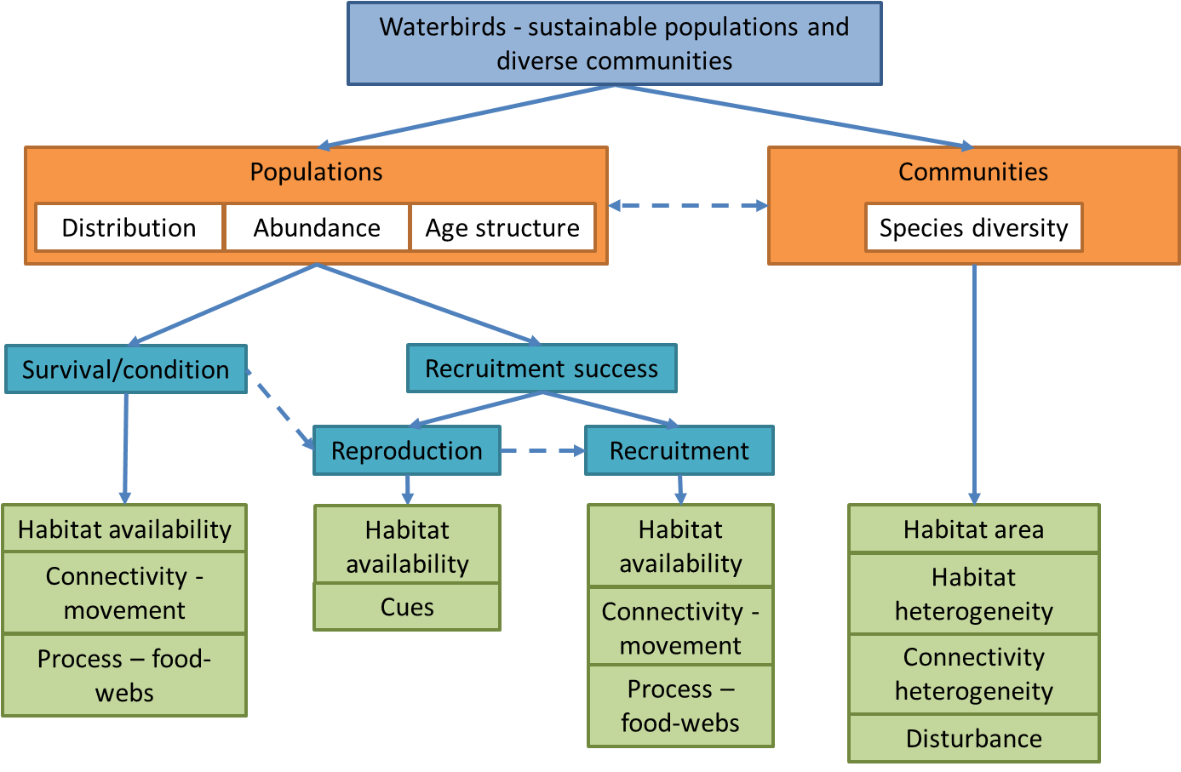

**Figure 4.** Conceptual model of functional processes and their influence on outcomes for waterbirds.

### Identifying priority research topics

Table 6 shows an evaluation of the component parts of the conceptual model (Figure 4) against the prioritisation principles set out in Section 2.2.1.

**Table 6.** Waterbirds — evaluation of component parts against relevant prioritisation principles.

|  |  |  |  |  |
| --- | --- | --- | --- | --- |
| **Component** | **Principle 1: Management relevance**  Alignment with BEWS environmental outcomes | **Principle 3: Key knowledge gaps** Link to priorities identified by managers and questions from researchers | **Principle 4: Improve predictive capacity**  Current knowledge and potential EWKR contribution | **Proposed priority level and rationale** |
| Community — diversity | BEWS seeks to maintain current species diversity, on the basis that observations indicate that species richness has not changed over the life of monitoring activities. | Not identified as a priority in workshops with managers.  Only a small number of relevant questions submitted by researchers. | As for many other biotic groups, there is very little known about the drivers of waterbird diversity and there are no current conceptual models. | Low priority  Not a major focus in BEWS, or from managers and researchers. Low data availability to support research. Research into recruitment may support species diversity. |
| Populations — survival/ condition | BEWS seeks to increase abundance. Abundance is strongly influenced by survival and condition. | Some related questions posed in workshops with managers.  Only a small number of relevant questions submitted by researchers. | While the water requirements of reproduction are reasonably well understood, there is little information available on the links between flow and survival/condition. In part this is due to the capacity of waterbirds to disperse across the continent. | Low priority  The location of key drought refuge habitats is largely known through surveys. Data availability to support research on processors/drivers for condition/survival is low. Research is likely to be expensive (tracking birds). |
| Populations — reproduction | BEWS seeks to increase abundance and increase breeding success. Both aspects relate to reproduction. | Some related questions posed in workshops with managers.  Only a small number of relevant questions submitted by researchers. | There is already considerable information available on the water requirements of waterbird breeding. The one major area of uncertainty is cues for which there is very little information available. | Low priority  Habitat requirements to support breeding events at key sites are mostly known. Cues are less well understood, but mostly outside management control (climate and continental scale processes). |
| Populations — recruitment | BEWS seeks to increase abundance and increase breeding success. Both aspects relate to recruitment. | Some related questions posed in workshops with managers.  Only a small number of relevant questions submitted by researchers. | Waterbird breeding success is known to vary widely and it seems likely that some of this variation is related to flow. This is an area in which new techniques offer significant opportunities to improve predictive capacity. | High priority  Drivers of successful recruitment are conceptualised, but the relative importance of influencing factors is not well understood. A key step in life-cycles to build abundance. Capacity to significantly enhance understanding through EWKR. |

The evaluation indicates that waterbird recruitment (breeding success) is the priority research topic due to its importance in achieving management objectives and the opportunity to improve predictive capacity. While the other components are also important, they offer lesser opportunities for improving predictive capacity due either to the amount (reproduction) or lack (breeding cues, diversity) of existing knowledge.

Bird species to be addressed in research activities will be determined in subsequent MDB EWKR planning stages, taking into account:

* expected outcomes set out in the BEWS, and the associated key species
* Basin-wide relevance of the species
* species present at the research sites
* data availability to support research.

### Proposed research approach

Waterbird breeding success requires field observations of breeding events. Where possible, the MDB EWKR project will seek to complement waterbird monitoring undertaken by TLM and LTIM. Further details are provided in Table 7.

**Table 7.** Proposed research approach — waterbirds.

|  |  |  |
| --- | --- | --- |
| **Component** | **Drivers of focus** | **Proposed research approach** |
| Communities — diversity | NA — not considered a priority for MDB EWKR | |
| Populations — survival/ condition | NA — not considered a priority for MDB EWKR | |
| Populations — reproduction | NA — not considered a priority for MDB EWKR | |
| Populations — recruitment | Habitat availability Process — food webs | *Food web component linked to fish*  **Fieldwork**  Field data capture and analysis complementing LTIM, TLM, MDBA and State monitoring programs (where relevant).  Potential to use infrastructure operations as experiments.  **Laboratory**  Possible mesocosm experiments to explore food webs. |

### Proposed threats to be considered in research

MDB EWKR will include research into the impacts of threats (hydrological, aquatic and terrestrial) which may reduce or prevent the ecological improvement expected through environmental flow regimes.

Threats are often specific to biotic outcomes, life-history stages, functional processes and geographic sites. For that reason, the identification of priority threats for research has been considered secondary to the identification of priority research topics and sites. Consultation activities identified the threats listed below as most significant in terms of their potential impact on

waterbird outcomes across the Basin. These threats will be assessed in further detail during project planning to identify those considered most significant at the research sites, and for which further research under MDB EWKR can provide the most useful outputs to support environmental water and complimentary natural resource management, and Basin Plan reporting.

Flow independent threats

* Invasive predators
* Habitat loss

Flow related threats

* Climate change

### Summary — proposed research questions for waterbirds

Recruitment of waterbird populations

1. What flow regimes best support the recruitment of waterbird populations?
   * How significant are the individual drivers (habitat availability, connectivity- movement and processes/food webs) for recruitment?
   * How do key drivers interact to influence outcomes?
   * How should flows be managed to enhance drivers and thereby recruitment?
2. How do threats impact on the drivers and recruitment outcomes?

## Additional theme — food webs

The themes of water-dependent vegetation, native fish and waterbirds provide a logical research/project framework for MDB EWKR noting that it will be essential for these themes to remain coordinated and connected (a ‘one project’ approach).

In undertaking the analysis described above, it became apparent that a key issue linking the themes of water-dependent vegetation, native fish and waterbirds (particularly the latter two themes) is food web processes. The role that floodplain connectivity plays in mobilising carbon and nutrients (from vegetation and soils), and the contribution that this carbon and nutrients provides to support aquatic food webs and ultimately outcomes for fish and waterbirds was a key question posed by both environmental water managers and researchers. Accordingly, it is proposed to establish a fourth research theme, being food webs.

The food webs theme will pick up relevant aspects of the research priorities identified in the native fish and waterbirds themes above. By grouping these related components under a separate theme, it will allow them to be explored more effectively using targeted resources and expertise. The linkages and boundaries between these themes (food webs and fish/waterbirds) will require detailed consideration in project planning to ensure activities remain coordinated.

### Summary — proposed research questions for food webs

1. What flow regimes best support food webs that contribute to outcomes for native fish and waterbirds?
   * How do food web processes and the dominant carbon-nutrient-energy pathways vary according to flow conditions?
   * How significant is floodplain inundation and the associated carbon-nutrient cycling to the achievement of biotic outcomes?
   * Under what conditions do food web processes drive outcomes, compared to other processes?
   * How should flows be managed to influence food webs to support native fish and waterbird outcomes?
2. How do threats impact on food web processes and the achievement of native fish and waterbirds outcomes?

# Research sites

The MDB EWKR project seeks to identify four sites that will be the focus of field-based research activities, noting that the project may also undertake laboratory experiments and data analysis activities that are not defined by the boundaries of the four sites.

The sites need to provide opportunities to address the priority research questions both at the area scale and also at the Basin scale through comparison of the findings at the four sites. To achieve the latter objective, it is considered appropriate that MDB EWKR undertake research at areas that span the Basin, with at least one northern, one central and one southern site.

Selection criteria have been used to support the evaluation of potential research sites for MDB EWKR. Sites have been evaluated qualitatively and whilst this evaluation aids the identification of appropriate sites, ultimately the choice of sites requires judgement to weigh up the relative significance of the criteria.

## Identification of candidate sites

The process of identifying research sites began with the identification of candidate sites. These are sites of a sufficient size and with some available baseline and inventory knowledge that would support research, and that are likely to receive environmental flows under the Basin Plan. It should be noted that the site names are used in a general sense, that each of the sites would include the full spectrum of adjacent riverine, wetland and floodplain components (e.g. Barmah–Millewa Forest would include the associated reaches of the River Murray and Edward River system), and that the exact boundary of the sites will be determined on the basis of requirements to facilitate research.

Potential candidate sites for MDB EWKR

1. Barmah–Millewa Forest
2. Booligal Wetlands
3. Lower Campaspe River
4. Edward–Wakool River system
5. Great Cumbung Swamp
6. Gunbower–Koondrook–Perricoota Forest
7. Gwydir wetlands
8. Hattah Lakes
9. Lachlan Swamp
10. Lindsay, Mulcra and Wallpolla islands
11. Lower Loddon River
12. Lower Balonne floodplain
13. Lower Darling River
14. Lower Goulburn River
15. Lower Murray (including Riverland Ramsar site and Chowilla)
16. Lower Murrumbidgee River and associated wetlands
17. Macquarie Marshes
18. Mid Murrumbidgee wetlands
19. Narran Lakes
20. Nimmie–Caira system
21. Warrego–Darling junction
22. Wimmera terminal wetlands

The following sites were also considered but not included as potential candidate sites for the reasons identified:

* Banrock Station wetland — Ramsar listed but small in size and therefore does not cover the full spectrum of riverine and floodplain components. Potential for inclusion as an extension to the Lower Murray site (if selected), but not considered a potential site in its own right.
* Ginini Flats — Ramsar listed, but as a sub-alpine bog it is not representative of priority environmental assets to receive water under the Basin Plan.
* Lower Ovens River — recognised for its high conservation values, but unlikely to receive significant environmental water under the Basin Plan. Potential for inclusion as an extension to the Barmah–Millewa Forest (if selected), but not considered a potential site in its own right.
* Paroo River and associated wetlands — Ramsar listed, but unlikely to receive environmental water under the Basin Plan.

## Site selection criteria

The following criteria are proposed as the basis for evaluating the candidate sites and informing the selection of research sites for MDB EWKR.

#### Criterion 1: Recognised environmental significance, including in relation to the priority questions

This criterion is relevant for two reasons. Firstly it ensures that the selected research sites are recognised as having the environmental characteristics and values associated with the proposed research themes and questions. For example, to facilitate answering questions associated with waterbird recruitment it is important that the site is recognised as a location that supports significant waterbird recruitment. Secondly, it ensures the research focusses on sites that are of significance to Basin governments and communities.

Indicators

1. Recognised values at the Basin scale
   1. Vegetation — contains large areas (greater than approximately 5000 ha) of multiple vegetation types including wetland, lignum and tree communities
   2. Fish — identified as an important Basin environmental asset for fish in the BEWS
   3. Waterbirds — identified as an important Basin environmental asset for waterbirds (particularly, recruitment of colonial nesting waterbirds) in the BEWS
2. Formal recognition of significance
   1. Ramsar listing
   2. The Living Murray icon site
3. Other indicators
   1. Likely achievement of criteria for identifying environmental assets (Schedule 8 of the Basin Plan) — using the assessments undertaken by the MDBA in developing the Basin Plan as a guide (noting this assessment and outcomes have no formal significance)

#### Criterion 2: Existing data and knowledge to support the proposed research questions and activities

This criterion recognises that MDB EWKR will achieve the best outcomes where there is a high level of existing data and knowledge available to support the proposed research questions and activities, rather than a ‘greenfield’ site where resources will need to be directed to collecting baseline knowledge and information. As examples:

* Floodplain inundation modelling or mapping will be useful to support research planning (i.e. selecting field sites targeting a particular flooding regime), understanding historical inundation patterns that may have contributed to existing characteristics, and supporting analysis of field data collected, including attribution of outcomes to watering actions or other influences.
* Historical monitoring data and baseline ‘inventory’ data will be useful in identifying current and historical characteristics of the site (e.g. does the site support a target species of plant, fish or bird).
* Past monitoring of responses to watering actions and research into the drivers of responses will provide an enhanced starting point from which further knowledge can be gained.

Indicators

1. Inundation modelling and mapping — categorised according to the type of modelling or mapping available
2. Past monitoring and research activities — summary descriptions of available information under the themes of vegetation, fish and waterbirds
3. Sustainable Rivers Audit — fish sites
4. State monitoring program sites — Victorian Environmental Flows Monitoring and Assessment Program (VEFMAP), Index of Stream Condition (ISC), NSW Integrated Monitoring and Environmental Flows (IMEF)
5. Number of references identified in Google Scholar and Web of Science search engines — as general indicators of past research activities
6. Basin Plan hydrologic indicator sites

#### Criterion 3: Alignment with current and future monitoring programs

This criterion recognises that MDB EWKR is likely to achieve enhanced research outcomes when it is aligned to other relevant monitoring and research programs, and that MDB EWKR may also provide enhanced outcomes for those aligned programs. For example, MDB EWKR may provide information to understand and explain the basis for outcomes reported under relevant monitoring programs.

There may also be efficiencies in the coordination of activities, reducing costs for one or multiple programs.

Indicators

1. Commonwealth Environmental Water Office (CEWO) Long Term Intervention Monitoring sites
2. MDBA Basin Plan fish and bird monitoring sites
3. Other — including state Basin Plan monitoring sites, where these are known

#### Criterion 4: Geographic spread of sites

This criterion recognises the objective of MDB EWKR to provide knowledge that is transferable across the Basin (noting that there will be some limitations on the extent to which knowledge will be transferable from site to site). A spread of sites across the Basin within different regions and bioregions will mean that it will be possible to identify if responses/drivers differ across the Basin, and the extent to which outcomes are representative and transferable.

This criterion has been used in a different context to the other criteria, to ensure there is a spread of sites geographically across the Basin, rather than a criterion guiding the selection of individual sites *per se*.

Indicators

1. Basin region — south (Murray and southern tributaries), central (Murrumbidgee, Lachlan, Macquarie) or north (Darling and northern tributaries)
2. Bioregion — IBRA7 bioregion name

## Proposed sites

Appendix B (Microsoft Excel spreadsheet) summarises the evaluation of candidate sites against the selection criteria. The evaluation process was qualitative. Within each region (criterion 4), sites are proposed that evaluated highest against criteria 1 to 3. Criterion 1 was considered of highest importance, with criteria 2 and 3 considered of equal importance thereafter.

The proposed sites are described below. In all cases, the sites would include adjacent river, wetland and floodplain components, notwithstanding that floodplain and wetland system names are used to identify some sites.

The exact boundaries of the research sites will be considered in further detail in planning the research projects to select the locations best able to support the research, and provide the most effective alignment with past and future monitoring and research activities. These considerations may result in the scale of the sites reducing, or alternatively it may be desirable to extend the boundaries of the sites upstream or downstream to enhance research opportunities.

#### Southern basin

The size, recognised environmental significance and scale of past investment in data collection, monitoring and research means that The Living Murray icon sites and adjacent river reaches evaluate strongly against the criteria. Added to this, the available environmental infrastructure at some sites enhances opportunities to explore some research questions.

The two sites proposed in the southern basin are:

* the Upper Murray, centred around Barmah–Millewa Forest and potentially including lower reaches of adjacent tributaries (Goulburn and Campaspe) and parts of the Edward–Wakool system
* the Lower Murray, centred around the Chowilla–Lindsay–Wallpolla floodplain and potentially including the Riverland Ramsar site and adjacent floodplain systems and river reaches.

Both sites evaluate well against the selection criteria. The distance between the sites and contrasting character of the sites would also allow a greater diversity of influences to be considered compared to similar sites situated closer together.

#### Central basin

Within the central basin, the Macquarie Marshes was evaluated most favourably against the criteria. The Macquarie Marshes is one of the largest semi-permanent freshwater wetlands in south-east Australia, covering about 200 000 hectares. The marshes are recognised as being internationally important because of their size, diversity of wetland types, extent of wetland communities and

large-scale colonial waterbird breeding events. The Macquarie Marshes Ramsar site has received an Article 3.2 notification under the Ramsar Convention, due to the decline in the health of wetland vegetation and waterbird breeding. The primary cause of this decline was identified as river regulation. An *Article 3.2 Response Strategy for the Macquarie Marshes Ramsar site* is being implemented.

The Lower Murrumbidgee, including the Nimmie-Caira system, was also evaluated highly; however, the site does not have the same depth of historical research activity as the Macquarie Marshes, and the more northern location of the Macquarie Marshes would provide a more diverse spread of sites across the Basin.

#### Northern basin

The Lower Balonne floodplain is identified as a research site for MDB EWKR in the project funding agreement to facilitate delivery of the Queensland Floodplain Vegetation Water Requirements Project. It is proposed that including Narran Lakes be considered in planning the research, given its recognised values in supporting waterbird breeding and recruitment, and available monitoring data and monitoring infrastructure.

## Relationship between sites and questions

Not all priority research topics would be explored at all four proposed sites. For some topics, the proposed research approach is one of laboratory experiments and/or data analysis activities that are not defined by the boundaries of the four sites. For the other topics, some sites may not contain the necessary environmental characteristics to support the research and/or may not have the necessary existing information to enable the proposed research. In addition, there is the issue of getting value for money and the potential value of focussing on a number of sites, rather than spreading resources thinly across all four sites.

Table 8 shows an initial indication of the sites proposed for fieldwork to address the priority research topics. This is only an initial indication, and the mix of sites and topics requires more detailed consideration in project planning.

**Table 8.** Initial indication of sites proposed for fieldwork (subject to further consideration in project planning).

|  |  |  |  |  |  |
| --- | --- | --- | --- | --- | --- |
| **Priority research topics** | | **Proposed sites for fieldwork** | | | |
| **Upper Murray** | **Lower Murray** | **Macquarie Marshes** | **Lower Balonne, including Narran Lakes** |
| **Vegetation** | Diversity1 (understorey, wetland) |  |  |  | Narran Lakes |
| Survival/condition (trees, lignum) | Desktop data analysis proposed | | | Queensland Floodplain Vegetation Water Requirements Project |
| Reproduction (trees, lignum) | Not recommended as a research priority | | | |
| Recruitment1 (trees, lignum) |  |  |  |  |
| **Native fish** | Diversity | Not recommended as a research priority | | | |
| Survival/condition |  |  | or Lower Balonne | or Macquarie Marshes |
| Reproduction | Desktop data analysis proposed | | | |
| Recruitment |  |  | or Lower Balonne | or Macquarie Marshes |
| **Waterbirds** | Diversity | Not recommended as a research priority | | | |
| Survival/condition |
| Reproduction |
| Recruitment1 |  | Not recognised as a significant breeding site at Basin scale |  | Narran Lakes |
| **Food webs** |  | To be determined | | | |

Notes:

= in-scope, subject to further consideration in project planning.

1 = unlikely that field work would be undertaken at all sites. Further consideration required in project planning. One option would be for research sites to be selected on the basis of flow events/climate conditions experienced.

# Next steps

The research priorities and research sites will govern and guide much of the future activity under MDB EWKR. The next immediate step in Phase 1 will be to run an expression of interest process to select research collaborators. The research priorities and research sites will be a component of the terms-of-reference for the expression of interest process.

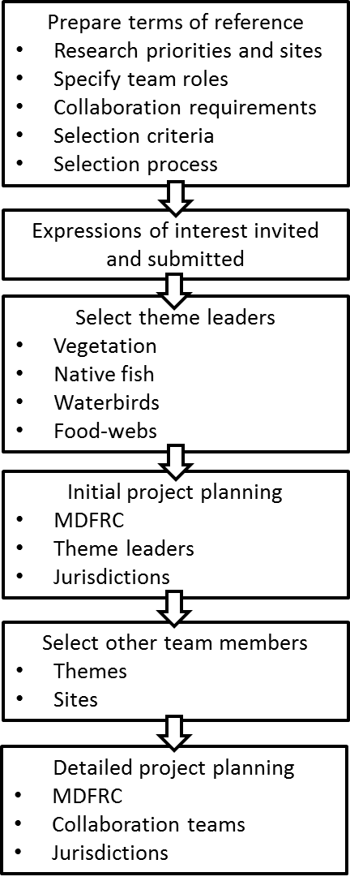

**Figure 5.** Proposed process to select collaborators.

# Appendix A Summary of research questions submitted by researchers

**Table A1.** Analysis of questions submitted by researchers — number of questions submitted against processes and taxonomic groups (shading indicates particular focal areas where multiple questions received).

|  |  |  |  |  |  |  |  |
| --- | --- | --- | --- | --- | --- | --- | --- |
| **Functional processes** | **Taxonomic group** | | | | | | **Sum** |
| **Vegetation** | **Macro- invertebrates** | **Fish** | **Birds** | **Other vertebrates** | **General questions not taxa specific** |
| **Habitat creation and maintenance** | 10 | 1 | 1 | 1 | 1 | 1 | 15 |
| **Movement and dispersal** |  |  | 5 | 4 | 1 | 1 | 11 |
| **Nutrient, carbon cycling, processes** |  | 1 | 5 | 3 | 3 | 9 | 21 |
| **General questions, not process specific** | 1 | 1 | 7 | 1 | 3 | 10 | 23 |
| **Sum** | 11 | 3 | 18 | 9 | 8 | 21 | 70 |

**Table A2.** Analysis of questions submitted by researchers — key words included in questions (bold indicates multiple questions) [RG – River Red Gum, BB – Black Box, FP – Floodplain].

|  |  |  |  |  |  |  |
| --- | --- | --- | --- | --- | --- | --- |
| **Functional processes** | **Taxonomic group** | | | | | |
| **Vegetation** | **Macro- invertebrates** | **Fish** | **Birds** | **Other vertebrates** | **General questions not taxa specific** |
| **Habitat creation and maintenance** | **RG, BB, FP vegetation resilience and recruitment** Macrophyte condition | Resilience | Recruitment | Recruitment | Platypus refugia | General |
| **Movement and dispersal** |  |  | General Resilience | **General** Recruitment Resilience | Resilience | General |
| **Nutrient, carbon cycling, processes** |  | Diversity | General Recruitment | Recruitment | Frog recruitment Mammal diversity Turtle recruitment | **General Primary production**  Carbon flow |
| **General questions, not process specific** | Works | General | **Works Recruitment** Abundance Distribution General | Diversity | Frogs Reptiles  Woodland birds | **General** Ecosystem diversity Ecosystem function Terrestrial subsidy |

## Appendix B Evaluation of research sites

**Evaluation of research sites**

High Medium Low/NA

Some key information sources used

|  |  |  |  |  |  |  |  |  |  |  |  |  |  |  |  |  |  |  |  |  |  |  |  |
| --- | --- | --- | --- | --- | --- | --- | --- | --- | --- | --- | --- | --- | --- | --- | --- | --- | --- | --- | --- | --- | --- | --- | --- |
| **Site** | | | | **Recognised environmental significance** | | | | | | | **Existing data and knowledge** | | | | | | | | | **Value adding (other programs)** | | | |
|  | | | | Recognised values at basin scale | | | Ramsar site | TLM icon site | KEA criteria | Other | Inundation modelling | Vegetation | Fish | Birds | SRA1/2  Fish | State monitoring | Google Scholar | Web of Science | HIS | CEWO LTIM | MDBA  monitoring | State monitoring | Other |
| Site | Valley | Region | Bioregion | Vegetation | Fish | Birds |
| Booligal Wetlands | Lachlan | Central | Riverina | L, W | M, B, O, H, T, R | AD, C |  |  | 1, 2, 3, 4, 5 |  | - | No mapping. Some wetland/understorey diversity and cover data - 2 IMEF sites. | No data in Booligal wetlands. IMEF samples sites upstream and downstream. | Historical records of breeding events (Reid et al. 2009). Model of ibis breeding (Chowhdury and Driver 2007). | N | NSW IMEF | 1 | 37 | Y | Y | Bird survey |  |  |
| Great Cumbung Swamp | Lachlan | Central | Riverina | RG, BB, L, W |  | AD, C |  |  | 1, 2, 3, 4, 5 |  | B | Mapping of vegetation communities (DECCW 2010). Some wetland/understorey diversity and cover data - 4 IMEF sites. | One IMEF sampling site in the Cumbung Swamp. IMEF sites upstream. NSW DPI datasets on fish communities collected since 2007 (Asmus et al.). | No systematic data sets identified. | N | NSW IMEF | 2 | 103 | Y |  | Bird survey |  |  |
| Lachlan Swamp | Lachlan | Central | Riverina | L, W |  |  |  |  | 1, 2, 3, 4, 5 |  | - | No mapping or tree condition data. Some wetland/understorey diversity and cover data - 1 IMEF site. | One IMEF sampling site in Lachlan River adjacent to the swamps. IMEF sites upstream and downstream. | No systematic data sets identified. | N | NSW IMEF | 2 | 24 | Y |  |  |  |  |
| Lowbidgee floodplain (Nimmie-Caira) | Murrumbidgee | Central | Riverina | BB, L, W | O | AD, R, C, S |  |  | 1, 2, 3, 4, 5 |  | B | Mapping of vegetation communities and condition (Bowen and Simpson). No IMEF sites. | No systematic datasets identified. | Limited data available (Reid et al. 2009). DSS has been developed for broader Lower Murrumbidgee system - includes Egret response (DECCW 2011). Wen et al. (2011) analysed abundance data from aerial and surveys and relationship to multiple variables including flow magnitude and volume. | N |  | 1 | 13 | Y |  | Bird survey |  |  |
| Lower Murrumbidgee River and associated wetlands | Murrumbidgee | Central | Riverina | RG, BB, L, W |  |  | Y (part) |  | 2, 3, 4, 5 |  | A - Yanga | Mapping of vegetation communities and condition (Bowen and Simpson). Only 1 IMEF site downstream of Balranald. | One IMEF site downstream of Maude and one downstream of Balranald. Multiple upstream of this site. Diversity, abundance, size. NSW Fisheries have data from several sites (back to 1996) and detailed community survey data from 1998-2002 between Balranald and Maude. Skye Wassens has 8 years of wetland data from the (No Suggestions) wetlands (Redbank - Maude). | Limited data available (Reid et al. 2009). DSS has been developed for broader Lower Murrumbidgee system - includes Egret response (DECCW 2011). Wen et al. (2011) analysed abundance data from aerial and surveys and relationship to multiple variables including flow magnitude and volume. | Y |  | 42 | 217 | Y | Y | Bird survey 1 fish site |  |  |
| Macquarie Marshes | Macquarie | Central | Darling Riverine Plains | RG, BB, C, L, W | M, T, R | AD, C, S | Y |  | 1, 2, 3, 4, 5 |  | A | Mapping of vegetation communities and condition (Bowen and Simpson 2009, DECCW 2010).  Wetland/understorey diversity and cover data - multiple IMEF sites across the marshes. | Two IMEF sites at upper end of Marshes, and two at lower end of Marshes. Multiple IMEF sites upstream of Marshes. Diversity, abundance, size. Detailed fish community data held by University of NSW. DPI has extensive community and migration data. | Historical records of breeding events. Quantitative model of colonial nesting waterbird breeding (Reid 2009, ANU 2011). Other analysis of breeding events by Bino et al., Kingsford and Auld etc. | Y | NSW IMEF | 42 | 597 | Y |  | Bird survey |  |  |
| Mid Murrumbidgee wetlands | Murrumbidgee | Central | Riverina | RG, BB, W | M, O, T | AD, S |  |  | 1, 2, 3, 4 |  | ? | Wetland/understorey diversity and cover data - multiple IMEF sites. | Multiple IMEF sites. Diversity, abundance, size. Skye Wassens (CSU). | Limited data available (Reid et al. 2009). | Y |  | 32 | 59 | Y | Y | 1 fish site |  |  |
| Gwydir wetlands | Gwydir | North | Darling Riverine Plains | RG, BB, W |  | AD, C | Y (all) |  | 1, 2, 3, 4, 5 |  | A | Mapping of vegetation communities and condition (Bowen and Simpson 2009, DECCW 2010).  Wetland/understorey diversity and cover data in response to flows - multiple IMEF sites across the marshes. Also Wilson et al. (2009). | No IMEF sites in Gwydir wetlands, but IMEF sites upstream and downstream. Wilson et al. (2009) data on abundance, diversity and size structure. NSW DPI has data on the main channel and some sites in Gingham watercourse. | Historical records of breeding events. Quantitative model of colonial nesting waterbird breeding (ANU iCAM 2011). | N | NSW IMEF | 12 | 183 | Y | Y | Bird survey 4 fish sites |  | National Cultural Flows Research Project case study site |
| Lower Balonne Floodplain | Condamine Balonne | North | Darling Riverine Plains | RG, C, L, W | M, B, T, R |  |  |  | 2, 3, 4 |  | C, F | Some mapping of tree species available. No condition monitoring. | Fish communities of waterholes study (Webb et al.). Smart rivers monitoring (Benson, SKM). | No systematic datasets identified. | Y |  | 10 | 251 | Y |  |  |  |  |
| Narran Lakes | Condamine Balonne | North | Brigalow Belt South/Darling Riverine Plains | L, W |  | AD, C, S | Y (part) |  | 1, 2, 3, 4, 5 |  | B | No systematic mapping or monitoring data identified. | No systematic datasets identified. | Historical records of breeding events. Quantitative model of colonial nesting waterbird breeding (ANU 2011, DECCW 2011). Monitoring infrastructure established by OEH and recent detailed records of bird breeding events. | N |  | 12 | 138 | Y |  | Bird survey 1 fish site |  | National Cultural Flows Research Project case study site |
| Warrego-Darling junction (Toorale) | Darling | North | Mulga Lands/Darling Riverine Plains |  | M, B, H, T, R |  |  |  | 1, 2, 3, 4, 5 |  | C, F | No systematic mapping or monitoring data identified. | No systematic datasets identified. NSW DPI has fish community data from the Warrego that dates back to 1996, but not all from the Toorale reach. | No systematic datasets identified. | Y |  | 8 | 4 |  | Y | Bird survey 1 fish site |  |  |
| Barmah-Millewa Forest | Murray | South | Riverina | RG, W | M, B, O, H, T, R | AD, C | Y (all) | Y | 1, 2, 3, 4, 5 |  | A | Mapping of tree populations. Tree condition monitoring. Wetland and understorey diversity and cover monitoring. Monitoring of responses to watering events (TLM monitoring inventory). | Extensive monitoring of fish population condition, recruitment and movement, impacts of hypoxia etc (TLM monitoring inventory). | Historical records of breeding events. Quantitative model of colonial nesting waterbird breeding (Reid et al. 2009). TLM condition monitoring. | Y |  | 25 | 541 | Y |  | Bird survey 2 fish sites |  |  |
| Edward-Wakool River system | Murray | South | Riverina | RG, BB, L, W | M, O, H, R |  | Y (part) |  | 1, 3, 4, 5 |  | C, F | No mapping or condition data identified. | River survey data since 1996 (annual sampling of four sites). Annual sampling of 30 sites throughout the system since 2009. Acoustic tracking data also available and also PIT data through Edward River fishways. | No systematic datasets identified. | Y |  | 3 | 77 | Y | Y |  |  |  |
| Gunbower-Koondrook- Perricoota Forest | Murray | South | Riverina | RG, W | M, B, O, H, T, R | C | Y (all) | Y | 1, 2, 3, 4, 5 |  | A | Mapping of tree populations. Tree condition monitoring. Wetland and understorey diversity and cover monitoring. Monitoring of responses to watering events (TLM monitoring inventory). | TLM condition monitoring. Some assessment of fish passage (TLM monitoring inventory). DPI commenced condition monitoring in 2012. Sampling to continue in conjunction with watering events. | Historical records of breeding events (Reid et al. 2009). TLM condition monitoring. | Y |  | 8 | 89 | Y |  | Bird survey |  |  |
| Hattah Lakes | Murray | South | Riverina | RG, BB, L, W | O, R | C | Y (all) | Y | 1, 3, 4, 5 |  | A | Mapping of tree populations. Tree, wetland and understorey condition monitoring. Monitoring of responses to watering events. (TLM condition and intervention monitoring) | TLM condition monitoring. Monitoring impacts of interventions (pumping) on fish passage and fish assemblages (TLM condition and intervention monitoring). | Anecdotal historical monitoring from watering sites (Reid 2009). Some intervention monitoring (TLM). | Y |  | 8 | 281 | Y |  | Bird survey 1 fish site |  |  |
| Lindsay, Mulcra and Wallpolla islands | Murray | South | Riverina | RG, BB, L, W | M, B, O, H, T, R | AD |  | Y | 1, 2, 3, 4, 5 |  | A | Mapping of tree populations. Tree condition monitoring. Wetland and understorey diversity and cover monitoring. Monitoring of responses to watering events (TLM monitoring inventory). | TLM condition monitoring. Some monitoring of fish movement and impacts of drought (TLM monitoring inventory). ARI have substantial fish community data on the Mullaroo system before, during and after the 2010 floods. Some data dating back to 2001-02. | Limited data available - some TLM condition monitoring data. | Y |  | 2 | 588 |  |  | Bird survey |  | National Cultural Flows Research Project case study site (Mulcra) |
| Lower Campaspe River | Campaspe | South | Riverina |  |  |  |  |  | 1, 2, 3, 4, 5 |  | C | Mapping of ecological vegetation classes. No tree condition data identified. ISC vegetation structure and cover data. | Fish population structure, abundance, size, larvae - VEFMAP. Fish abundance, composition, larvae data and responses to flow (Humphries et al.) | No systematic datasets identified. | Y | VEFMAP, ISC | 5 | 176 | N (but VIC FLOWS  assessment) |  |  |  |  |
| Lower Darling River | Darling | South | Darling Riverine Plains | RG, BB, L, W | M, B, O, H, T, R |  |  |  | 3, 4 |  | C, F | No mapping or condition data identified. | Abundance, biomass, diversity data from LMD CMA/NSW DPI (Gilligan et al. 2009). Clayton Sharpe has extensive datasets. Possibly also DAAMP? Sarah Commens has commissioned MDFRC to do annual larval sampling downstream of Menindee. | No systematic datasets identified. | Y |  | 6 | 478 | Y |  | 2 fish sites |  | MDBA annual larval sampling |
| Lower Goulburn River | Goulburn | South | Riverina | RG, W | M, B, O, H, T, R |  |  |  | 1, 2, 3, 4, 5 |  | A | Mapping of ecological vegetation classes. No condition data identified. ISC veg structure and cover data. | Fish population structure, abundance, size, larvae - VEFMAP. Lower Goulburn Fish Communities Project - distribution, abundance, population structure, larvae (Koster et al.). | No systematic datasets identified. | Y | VEFMAP, ISC | 33 | 183 | Y (+ VIC FLOWS  assessment) | Y | 3 fish sites |  |  |
| Lower Loddon River including Kerang wetlands | Loddon | South | Riverina |  | T | AD, C | Y (part) |  | 1, 3, 4, 5 |  | C | Mapping of ecological vegetation classes. No condition data identified. ISC vegetation structure and cover data. | Fish population structure, abundance, size, larvae - VEFMAP. ARI Database. | No systematic datasets identified. | Y | VEFMAP, ISC | 0 | 36 | N (but VIC FLOWS  assessment) |  | Bird survey |  |  |
| Lower Murray (Riverland Ramsar site and Chowilla) | Murray | South | Riverina | RG, BB, L, W | M, B, O, H, T, R | AD, R |  | Y (part) | 1, 2, 3, 4, 5 |  | A | Mapping of tree populations. Tree condition monitoring. Wetland and understorey diversity and cover monitoring. Monitoring of responses to watering events (TLM monitoring inventory). | Extensive monitoring of fish population condition, recruitment and movement, impacts of works/flows etc. (TLM monitoring inventory). Fishway monitoring. SARDI River Murray fish monitoring. Ten years of community data available at locks 1, 2 and 3 (MRFA project). | Some records of abundance, distribution and breeding events across Chowilla (Harper).  Quantitative model of colonial nesting waterbird breeding at Lake Merreti (Reid et al. 2009). | Y |  | 168* | 1420* | Y | Y | Bird survey 2 fish sites |  |  |
| Wimmera terminal wetlands | Wimmera | South | Murray-Darling Depression | W |  | AD | Y (part) |  | 1, 2, 3, 4, 5 |  | - | No systematic mapping or monitoring data identified. | No systematic datasets identified. | No systematic datasets identified. | N |  | 3 | 36 | Y |  | Bird survey |  |  |

Chessman (2003) IMEF summary report 1998-2000

Reid et al. (2009) Ecological outcomes of flow regimes - analysis of bird breeding data across MDB Chowhdury and Driver (2007) Ecohydrological model of waterbird nesting

RERP final report

Chessman (2003) IMEF summary report 1998-2000

Reid et al. (2009) Ecological outcomes of flow regimes - analysis of bird breeding data across MDB DECCW (2011) RERP final report

Chessman (2003) IMEF summary report 1998-2000

Reid et al. (2009) Ecological outcomes of flow regimes - analysis of bird breeding data across MDB DECCW (2011) RERP final report

Chessman (2003) IMEF summary report 1998-2000

Reid et al. (2009) Ecological outcomes of flow regimes - analysis of bird breeding data across MDB DECCW (2011) RERP final report

Chessman 2003 IMEF summary report 1998-2000

Reid et al 2009 Ecological outcomes of flow regimes - analysis of bird breeding data across MDB DECCW 2011 RERP final report

Chessman (2003) IMEF summary report 1998-2000

Reid et al. (2009) Ecological outcomes of flow regimes - analysis of bird breeding data across MDB DECCW (2011) RERP final report

Chessman (2003) IMEF summary report 1998-2000

Reid et al. (2009) Ecological outcomes of flow regimes - analysis of bird breeding data across MDB DECCW (2011) RERP final report

Wilson et al. (2009) Managing environmental flows - Gwydir wetlands Chessman (2003) IMEF summary report 1998-2000

Reid et al. (2009) Ecological outcomes of flow regimes - analysis of bird breeding data across MDB Ecosystem response modelling in the MDB (Merritt et al., Wilson et al.)

DECCW (2011) RERP final report

DECCW (2011) RERP final report MDBA EWR Report

Narran Lakes Ecosystem Project

MDBA inventory of monitoring projects (Microsoft Excel table)

Reid et al. (2009) Ecological outcomes of flow regimes - analysis of bird breeding data and models

MDBA EWR Report

MDBA inventory of monitoring projects (Microsoft Excel table)

Reid et al. (2009) Ecological outcomes of flow regimes - analysis of bird breeding data and models

MDBA inventory of monitoring projects (Microsoft Excel table)

Reid et al. (2009) Ecological outcomes of flow regimes - analysis of bird breeding data and models

MDBA inventory of monitoring projects (Microsoft Excel table)

Reid et al. (2009) Ecological outcomes of flow regimes - analysis of bird breeding data and models

ISC3 Report

Cottingham and SKM (2011) Ewater delivery report

Chessman (2003) IMEF summary report 1998-2000

Reid et al. (2009) Ecological outcomes of flow regimes - analysis of bird breeding data across MDB Gilligan (2009) LMD CMA CAP Fish report card

Cottingham and SKM (2011) Ewater delivery in the Goulburn River ISC3 report

Cottingham and SKM (2011) Ewater delivery in the Goulburn River ISC3 report

Kerang Lakes Ramsar site strategic management plan

MDBA inventory of monitoring projects (Microsoft Excel table)

Reid et al. (2009) Ecological outcomes of flow regimes - analysis of bird breeding data and models

MDBA EWR Report

Lake Albucutya Ramsar ECD

High RG - River Red Gum AD - abundance and diversity 1 - international agreements

Medium BB - Black Box R - drought refuge 2 - natural, near nature, rare, unique

Low/NA C - Coolabah C - colonial waterbird breeding 3 - vital habitat

L - Lignum S - shorebird abundance 4 - threatened species

W - wetland 5 - significant biodiversity

M - movement A - inundation modelling available

B - biodiversity B - inundation mapping available

O - site of other significance C - LIDAR available

H - hydrodynamic diversity F - future inundation modelling MDBA