# Murray–Darling Communities Investment Package

Third report into implementation February 2022

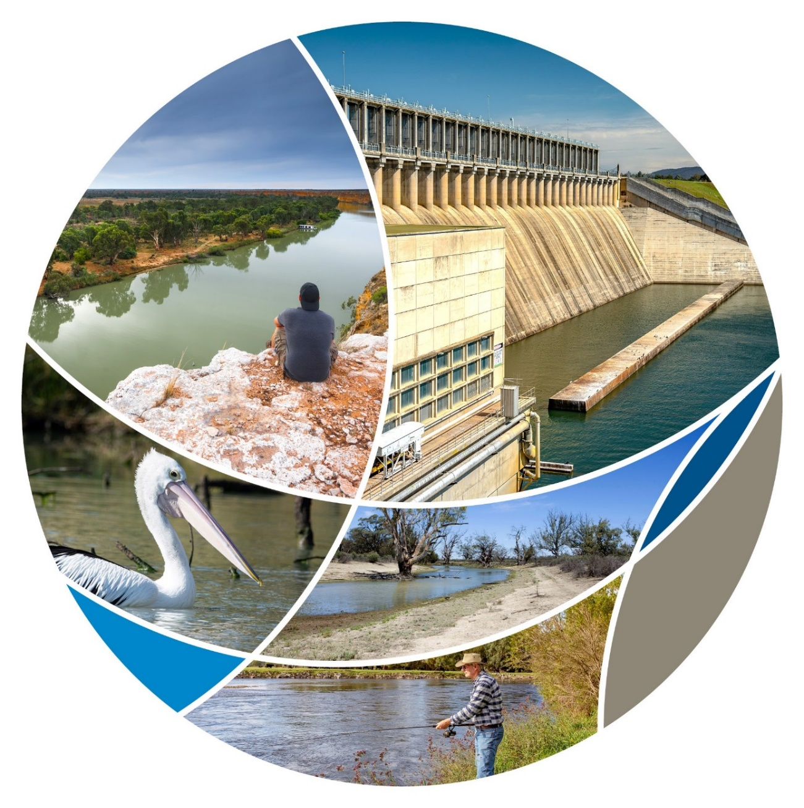

## Progressing Community Investment Package implementation report

The Australian Government’s $270 million Murray–Darling Communities Investment Package (investment package) is making a difference to communities as Murray–Darling Basin Plan implementation continues. Since the package was announced, on 4 September 2020, good progress has been made in delivering its 11 measures.

This is the third report from the Department of Agriculture, Water and the Environment detailing progress in rolling out the Investment Package which puts communities back at the centre of the Basin Plan.

The investment package responds to needs identified by the community, stakeholders and governments across 3 key themes:

* investing in community resilience and river health
* building trust, transparency and accountability in governments
* improving implementation of the Basin Plan.

The investment package delivers practical and realistic measures that supports Murray–Darling Basin (Basin) governments to deliver on their Basin Plan commitments by:

* ending water buybacks
* focusing on off-farm efficiency projects to return water to the environment while protecting communities and economies
* backing communities to design their own viable futures
* improving trust and confidence in Basin water management with a statutory and independent Inspector-General of Water Compliance on the job
* working to fast track a suite of projects that keep 605 GL of water in productive use while achieving the environmental outcomes of the Basin Plan.

The next report into implementation of the Murray–Darling Communities Investment Package is due later this year.

## Investing in community resilience and river health

The Healthy Rivers grants program awards grants to community groups for on-ground projects across a small grant stream and a large grant stream. These grants demonstrate the positive impact that local organisations and communities can make to their stretch of river. It gives communities practical tools to improve the health of rivers and wetlands, complementing other Basin Plan measures, like the more than 2,100 GL a year of water recovery achieved so far. Grants have been awarded for grazing exclusion fencing, riverbank and wetland revegetation, invasive species control and fish passage installation. In total, over 29 animal species, 13 plant species and 5 ecological communities listed under federal environmental legislation are being supported by projects.

The 3 rounds of the Murray–Darling Basin Economic Development Grants program have provided $72.7 million to 132 projects put forward and implemented by eligible Basin communities since 2020. Seventeen projects are complete and 112 projects are underway in communities most affected by historic water recovery. The 3rd and largest round of the program expands the number of local government areas eligible to apply for grants to 38 in response to the Sefton Report. The grants generate economic activity and additional jobs in those communities that are vulnerable and disadvantaged because of historic water recovery and also dealing with the economic impacts of COVID-19.

### Invest in community resilience and river health

| What we are doing | How we will do it | By when | Status | What have we done |
| --- | --- | --- | --- | --- |
| Maximising the benefits of the Basin Plan for communities | Deliver $34 million for economic assistance to communities struggling with the effects of water recovery by extending the successful competitive grants Murray–Darling Basin Economic Development Program. | Q1 2021 | COMPLETE | Round 3, funded through the Communities Investment Package, awarded 58 projects a total of $34 million in funding in June and July 2021. 105 grant applications were received between 3 March 2021 and 12 April 2021 following consultation on the guidelines, seeking over $85 million in funding. 57 projects are now underway providing economic stimulus and jobs on the ground.  The 17 projects funded in previous rounds and now complete generated 80 jobs during delivery and are expected to create a further 100 ongoing employment opportunities. |
| Improving river health for all users | Deliver $20 million to fund community-driven grants for on-ground projects that will improve the health of rivers and wetlands.  This builds on existing commitments to the environment of:   * $6 million for fish ways in the Lower Darling * $10 million to establish hatcheries at St George and Menindee * $15 million to fence Northern Basin riverbanks * $9.2 million to modify and decommission water infrastructure at Toorale. | Q1 2021 | Large grants  Small grants  COMPLETE | Large grants and small grants are currently being awarded to communities through the Healthy Rivers grants program. Practical on-ground projects that improve the ecological health and condition of rivers and wetlands are supporting economic development and jobs.  Round 1 of Healthy Rivers grants program awarded 74 grants valued at $285 million (GST exclusive) to community groups to improve their stretch of river and all funding agreements are in place. Round 1 projects aim to plant 84,000 native plants, install over 70 kms of fencing to protect nearly 800 hectares of riparian areas, and undertake 2,700 hectares of weed control. The new grants will add to that by aiming to plant 210,000 native plants, install 160 kms of fencing to protect over 1,200 hectares of riparian areas, and undertake approximately 25,000 hectares of weed control.  New South Wales is progressing planning for improved fish passage in the Lower Darling following the February 2021 announcement releasing $1.1 million in funding.  Work continues with the Menindee and St George communities on proposals for native fish hatcheries.  The rollout of the Fencing Northern Riverbanks Program in Queensland and New South Wales is underway. Program delivery in Queensland is ahead of schedule and NSW is working to recover from delays caused by COVID 19-related travel restrictions.  On-ground works to modify the Boera and Homestead dams at Toorale are underway and progressing to schedule. |
| Delivering environmental outcomes in the Riverland | Deliver $37.6 million in practical projects to sustain Riverland environments. We will work with the South Australian Government to deliver projects. This action recognises that there have been delays in progress towards securing an additional 450 GL of water to improve river health and habitats on the lower Murray. | Q2 2024 | ONGOING | South Australia continues to progress planning for restoring natural river patterns in the Lock 6 reach. Consultation with irrigators is expected to commence in early 2022.  Stakeholders in the Lock 3 reach are being engaged in planning a demonstration site to show the benefits of fish screening for native fish and the socio-economic benefits for irrigators.  Consultation continues with the Renmark community to finalise the design of the project to reinstate the natural habitat conditions in the Bookmark Creek complex. Key components of the project include:   * proposed infrastructure upgrades at Jane Eliza Estate and Nelwart Street as part of a project to reinstate natural habitat conditions for native species. The proposed works are expected to include a new inlet regulator including fishway and canoe passage, along with re-snagging for aquatic habitat and upgrades to the Nelwart St bridge to improve connectivity along the river for fish. * introduction of instream habitat for fish, realignment of a pedestrian access, and general landscaping and replanting native riparian plants either side of the new 560m section of track at Bookmark Ck, near Renmark. * an additional site is also proposed at Banrock Station, where 15-20 tree snag structures will be placed along the western bank of the River Murray for native fish habitat.   The overall program has been extended to June 2024 to allow additional time for community input into projects scope and design. |
| Recover the 450 GL of water for the environment in ways that support Basin communities. | Q2 2022 | ONGOING | Basin states can continue to nominate infrastructure projects through the $1.33 billion Off-farm Efficiency Program.  The NSW Murrumbidgee Irrigation Automation Finalisation Project will generate 7.4 GL of water savings to share between the water users, communities and the environment. The project enhances environmental outcomes, by upgrading 1,500 monitoring sites, automating 360 regulators, refurbishing 20 kilometres of open earth channels and constructing a new 5,000 ML surge reservoir.  This builds on the Goulburn Murray Water project that will generate 18.17 GL of water for the environment.  More applications have been received and are being assessed. |
| Supporting First Nations Australians to play an active role in river health | Deliver $3.1 million for 4 new First Nations River Rangers teams, creating around 20 jobs. | Q3 2021 | COMPLETE | The Murray-Darling Basin Indigenous Rivers Rangers Program has been extended until 2024-25 to deliver real jobs on the ground and support Indigenous people get more involved in river management and waterway health. The $12.2 million in extra funding provides greater opportunity for Indigenous people to continue to contribute to healthy waterways in the Basin and to plan and implement longer term plans to increase the impact on the ground. |
| Agree the framework for implementing the $40 million Aboriginal water entitlements program with Aboriginal communities. | Q1 2021 | ONGOING | The National Indigenous Australians Agency (NIAA) is working with Indigenous community stakeholders on the delivery arrangements for the $40 million program that aims to deliver on-ground water-related outcomes that generate cultural and economic results that respond to the objectives of Indigenous communities within the Murray–Darling Basin. |
| Appointment of an Indigenous board member to the Murray–Darling Basin Authority. | Q4 2020 | COMPLETE | Mr Rene Woods was appointed as the first dedicated Indigenous member of the board of the Murray-Darling Basin Authority by Minister Keith Pitt on 18 December 2020. |

## Build trust, transparency and accountability in government

Since the Hon. Troy Grant was appointed as Australia’s first Inspector General for Water Compliance on 5 August 2021, a number of assessments and audits have commenced. Mr Grant, supported by the Office of Water Compliance, is reviewing the planning and use of water for the environment held by the Commonwealth Environmental Water Holder with a particular focus on assessing community confidence in the transparency of water use and that good outcomes are being achieved. The Inspector General is also assessing the Basin states level of water compliance and performance of their enforcement systems. The final assessment underway is looking at the adequacy of the processes used to measure and account for water in the River Murray and the lower Darling, and how this informs decisions about river operations. These reviews will be published in the first half of 2022 – less than a year since the legislation to establish the role and the Office passed the Australian Parliament. As well as these reviews the Inspector General and his office oversee and monitor compliance with the Basin Plan and the Water Act. This function is core to the continued maturation of water management and water markets in Australia – and a model for others to adopt internationally. It delivers on the Australian Government’s commitment to increase trust and transparency with Basin communities by providing them with assurance that water is well managed in the Murray–Darling Basin.

Additional support has been provided for Regional Engagement Officers (REOs) across the Murray–Darling Basin to provide a stronger voice for Basin communities with government including a position in the Barwon-Darling. Regional Engagement Officers demonstrate excellent knowledge of their local community, have developed strong networks with government and non-government organisations and are equipped to provide on-ground local support to communities.

### Build trust, transparency and accountability in government

| What we are doing | How we will do it | By when | Status | What have we done |
| --- | --- | --- | --- | --- |
| Providing stronger leadership | Build a culture of genuine engagement and trust with communities and between governments. | Q4 2020 | ONGOING | The Regional Engagement Officer (REO) network has been expanded to provide a more holistic engagement opportunity for communities with the Australian Government on water management issues. REOs help facilitate engagement on key agency projects, support Chair and Ministers visits, connect people to Commonwealth programs and consistently provide advice on key community issues to agencies.  The Murray–Darling Basin Authority has established 6 Regional Community Forum groups and around 100 Basin community members with a range of backgrounds and interests are participating. These forums provide a platform for community members to inform the development of the MDBA science and monitoring program and hear from the MDBA and Australian Government partners on a range of locally specific programs, projects and initiatives.  The Basin Officials Committee will continue to take its meeting to regional centres in 2022 and will continue to publish meeting records publicly. |
| Maximising the benefits of the Basin Plan for all communities. |  | ONGOING | The Murray–Darling Basin Authority is planning its next River Reflections annual water conference, which will take place in Mildura from 1- 2 June 2022. This conference will be another opportunity for Basin communities and industries to share innovations in water management, knowledge and lessons learned and celebrate achievements in water reform.  The Murray–Darling Basin Economic Development Grants and the Healthy Rivers Grants are examples of programs designed to ensure Basin Plan benefits extend to all communities. |
| Lead the Murray-Darling Basin Ministerial Council in empowering communities to determine their own future and to keep governments accountable. |  | ONGOING | The Ministerial Council meets as needed and progresses matters out of session and through the Basin Official Committee. |
| Report 3 times a year on progress against the Package. |  | ONGOING | This is the third report. |
| Use the outcomes of the Sefton report to inform future work and decisions on implementing the Basin Plan. |  | COMPLETE | The Sefton report continues to inform policy and program design and implementation. |
| Appointed Air Chief Marshal Sir Angus Houston AK, AFC (Ret’d) to provide strong and strategic leadership as Chair of the Murray–Darling Basin Authority. |  | COMPLETE | While COVID restrictions impacted the number of face-to-face meetings in 2021 Sir Angus Houston continued to meet with a cross section of stakeholders virtually and in person. |
| Ensuring stronger compliance | Establish a statutory and independent Inspector-General of Water Compliance. This will bring together the water compliance role of the Murray–Darling Basin Authority with the assurance role of the Interim Inspector-General of Murray–Darling Basin Water Resources. | Q3 2021 | COMPLETE | The statutory Office of the Inspector General of Water Compliance was established on 5 August with offices located at 5 regional locations across the Murray-Darling Basin: Loxton (SA), Mildura (VIC), Albury (NSW Sth), Dubbo (NSW Nth) and Goondiwindi (QLD).  There are currently 7 investigations underway and 5 audits relating to compliance matters. The Inspector-General of Water Compliance, Mr Troy Grant, has continued meeting with stakeholders across the Basin, speaking with more than 200 people since his appointment to the interim role. |
| Deliver $38.7 million to improve Commonwealth water compliance functions. This builds on the Commonwealth’s existing commitment of $60 million for improvements in water metering and remote sensing. | Q3 2021 | COMPLETE | The Office of the Inspector General for Water Compliance reviews and audits water resource management compliance. Current reviews include:   * the use of water for the environment held by the Commonwealth Environmental Water Holder, including the transparency around how the water is used and the outcomes achieved * Basin states approach to water compliance and performance of their enforcement systems * the adequacy of the processes used to measure and account for water in the River Murray and the lower Darling, and how this informs decisions about river operations.   These will be published on the Office’s [website](https://www.igwc.gov.au/reviews-reports).  The existing $60 million Commonwealth commitment centres on the northern Basin with a $25 million metering program that is improving water information for users, providing metering and telemetry subsidies, and, in NSW, delivering Aboriginal metering traineeships. The $35 million hydrometrics and remote sensing program is improving public water information and delivering enhanced cross border measurement and compliance capabilities. |
| Providing better information | Bring together water information from across governments in a more accessible format for water users and communities.  The detailed platform will provide a one-stop shop for water storage, in-stream flows and trade information. This builds on the existing investment of $4.9 million to the Bureau of Meteorology to improve real-time reporting on water flows. | Q3 2021 | COMPLETE  ONGOING | The first version of the [Murray–Darling Basin Water Information Portal](https://mdbwip.bom.gov.au/) was released by the Bureau of Meteorology on 30 June 2021. Updates are planned over the next 3 years to further improve the information for users. The portal brings together the work with New South Wales and Queensland, to improve northern Basin water information through the Enhanced Water Monitoring and Information Program.  In addition, the Australian Government is investing $66 million to upgrade and integrate the Murray–Darling Basin’s 24 river models to help water managers make timelier, more reliable, and transparent water management decisions. Part of the investment will include developing a public-facing portal, giving water users access to future-scenario information. |
| Better monitoring and reporting of social, economic and environment conditions | Deliver $7.5 million to monitor social, economic and environmental conditions in the Basin. | Q3 2021 | ONGOING | The Murray–Darling Basin Authority has co-designed the work program in partnership with Basin communities through Regional Community Forums. Three rounds of forums were held throughout 2021around 5 themes: economic, social, cultural, environmental and hydrological. Sixteen projects are being developed for approval, with the final work program expected to be released in mid-2022. This collaborative approach has enabled community needs and feedback to be built directly into the monitoring program. |
| This action builds on a $20 million investment in Basin-specific research so river management can be based on the best available science. | Q3 2021 | ONGOING | The $20 million [Murray–Darling Water and Environment Research Program](https://www.mdba.gov.au/water-management/science-research/murray-darling-water-environment-research-program) is a four-year research program (2021–25) to improve scientific knowledge for water and environment management decisions and improve outcomes for the Basin and communities.  The MD-WERP Research Consortium was established during 2020–21, consisting of the lead agencies (CSIRO and La Trobe University) with supporting agencies (Deakin University, Ewater, Alluvium, Griffith University, Northern Basin Aboriginal Nations, Murray Lower Darling Indigenous Nations and IDEEA Group).  During the first half of 2021, the Consortium and Commonwealth partners co-designed research plans to set the research direction and investments for the next 4 years. MD-WERP incorporates both a long-term (i.e. 4-year) research program and shorter-term tactical projects based on immediate need.   * Long-term — the applied research program commenced in 2021. Findings from this research that will help inform ongoing Basin Plan implementation will be delivered from mid-2022 onwards. * Short-term tactical — two projects are underway: one using drone technology to study waterbirds and another looking at northern Basin inflows. A further 3 tactical research projects will begin soon examining waterbirds foraging habitat, riverbank stability along the River Murray, and blue green algae. |

## Improving implementation of the Basin Plan

Applications for the new $150 million Off-farm Efficiency Grants Program are currently open, making funding available over 3 years for smaller scale projects that can generate water savings for the environment while also making more usable water available to farmers. This complements the $1.33 billion that is available for state-led projects that improve irrigation network efficiency while also recovering water for the environment, that would otherwise be lost. The program invests in the future of regional communities by installing modern infrastructure that generate construction jobs and underpins economic activity and productivity in the long-term. The Australian Government has ruled out further water buybacks. Since the new Off-farm Efficiency Program was announced water recovery towards the 450 GL has increased from 2 GL in March 2021 to 18.59 GL under contract. The new program provides the best opportunity to recover as much of the 450 GL as possible.

The Australian Government continues to support New South Wales, Victoria and South Australia deliver the supply and constraints measures which collectively enable 605 GL of water to remain in productive use. As at 31 December 2021, the Australian Government had made available $582 million to New South Wales, Victoria and South Australia to deliver the measures. In 2021, a status assessment of the measures found that over 80% of projects could be delivered by the Basin Plan timeframe of 30 June 2024 delivering 74% of the offset. Basin Water Ministers are working together to manage project delivery risks and are making progress. This includes rescoping the Menindee Lakes and the Yanco Creek Offtake projects, acceleration of 5 projects in NSW and further investment to improve flows in Victoria to restore 9 key floodplains.

### Improving implementation of the Basin Plan

| What we are doing | How we will do it | By when | Status | What have we done |
| --- | --- | --- | --- | --- |
| Designing and delivering water programs in partnership with communities | More effectively seek community input and demonstrate how that feedback has been used in the design, delivery and evaluation of programs. | Q4 2020 | COMPLETE | The department has expanded the Regional Engagement Officer network to establish stronger lines of communication between community and government on Murray–Darling Basin water matters. For example, the Regional Engagement Officers promoted the guideline consultations undertaken for Healthy Rivers and the Economic Development Program to make sure they were workable for communities.  The Off-farm Efficiency Program grant component has made $150 million available to irrigation infrastructure organisations to improve infrastructure and return water to the environment. The department continues to work with irrigation infrastructure organisations to identify off-farm water efficiency projects with strong community support. The Basin Community Committee provided advice from a community perspective.  The department also sought community views on the intended outcomes and eligibility requirements of the Healthy Rivers Grants and the Economic Development Program’s third round. The feedback received was considered and publicly reported on to show how it was used to inform the design and delivery of the programs. Webinar sessions and other guidance material was developed to assist with applying for both grant programs. |
| Investing in off-farm water efficiency projects to increase water recovery | Shift the focus away from on-farm water efficiencies and buybacks.  Work with the states and irrigation networks to identify projects to generate water savings through off-farm infrastructure. | Q4 2020 | COMPLETE | The Off-farm Efficiency Program is broken has two main components: state-led projects and a $150 million grants program.  Through the State Led Off-farm stream of the Off-farm Efficiency Program, there is $1.33 billion available to fund projects that generate water savings off-farm. The NSW Murrumbidgee Irrigation Automation Finalisation Project has been approved and will generate 7.4 GL of water savings to be shared between water users, communities and the environment. This builds on the Goulburn Murray Water Efficiency Project that is modernising and upgrading ageing off-farm water infrastructure in the Goulburn-Murray Irrigation District generating 18.17 GL of water for the environment and hundreds of jobs.  On 24 November 2021 the Off-farm Efficiency Grants Program opened, making $150 million available to help make irrigation networks as efficient as possible, and to deliver commitments under the Basin Plan to enhance environmental outcomes.  The old Water Efficiency Program closed to new applications in March 2021. The assessment of all project proposals lodged before the program ceased were completed. A total of 28 projects valued at $9.8 million (GST exclusive) are now contracted to generate 758 ML of water savings for the environment. |
| Strengthening working relationships between the Australian Government, states, and local government to improve delivery of the Basin Plan | Work with Basin states to accelerate planning and delivery of supply and constraints projects that are at risk of not being delivered by 2024. We will partner with the National Water Grid Authority on these projects. | Q4 2020 | ONGOING | The Australian Government continues to work with New South Wales, Victoria and South Australia to progress the supply and constraints projects, including those at risk of not being delivered by 2024.  In September 2021, the Australian Government agreed funding of $331 million to enable New South Wales to accelerate delivery of 5 of its supply and constraints measures. This investment is expected to contribute 45 GL of the Sustainable Diversion Limit offset and could create up to 450 direct jobs in Murray and Murrumbidgee communities.  The NSW Government is proposing a range of initiatives to progress constraints projects and deliver acceptable community outcomes on the Murrumbidgee and the Murray. Similarly, the South Australian and Victorian governments are also progressing constraints projects in their states.  In 2021, the Government also agreed additional funding for Victoria making more than $99 million available to improve flows in the Goulburn and Murray Rivers and help restore 9 key floodplains along the Victorian Murray. |
| This action builds on the government’s existing commitment of $1.5 billion for these projects. | Q4 2020 | ONGOING | Through the Murray-Darling Ministerial Council the Australian Government has supported the New South Wales Government’s proposal to rescope the Murrumbidgee / Yanco Creek project and the Menindee Lakes project.  Quarterly dashboard reports showing progress with implementing the supply and constraints projects are being published on the MDBA website. |
| Develop a new National Partnership agreement between the Australian and Basin state governments to provide funding for new and ongoing activities required to implement the Basin Plan. | Q4 2020 | ONGOING | The Australian Government is negotiating with the Basin states and the ACT a new $60 million federation funding agreement until 2024 to support implementation of the Basin Plan and water reform. |