USER GUIDE

NEXDOC:
Create your NEXDOC Exporter Account

__________________________________________________________________________________
In this document
This document contains the following topics.
Purpose of this document 2
Register for Online Services portal 2
Apply to register as an exporter 6
Commodities 7
Company Details 8
Contact Details 10
My printer 11
Single electronic window (SEW) integration 13
Submit 13
Contact the NEXDOC help desk 14

Purpose of this document
The below information will guide you through how to create your NEXDOC exporter account.
Applying to be an exporter in the NEXDOC system is a two-step process.

Register for Online Services portal
If you’re not registered in the Agriculture Online Services Portal, you will need to create an account.
You can create an account two ways:
- with a Digital ID - an electronic authentication tool used by the Australian Government for organisations seeking to access a number of Government online services, or;
- Directly with the department.
To register directly with the department for the below.
Step 1  Log in to the Online services portal  Select Create Account | 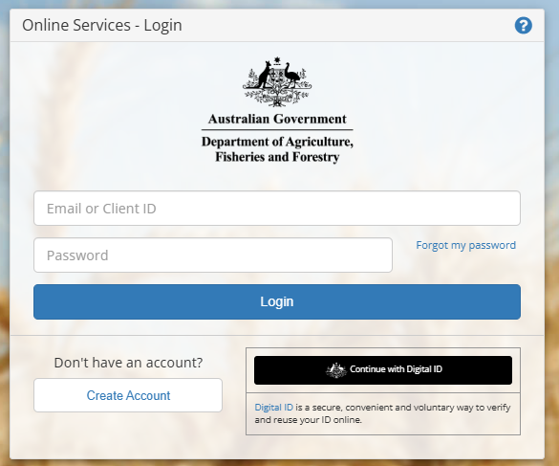
Step 2  Enter your email address | 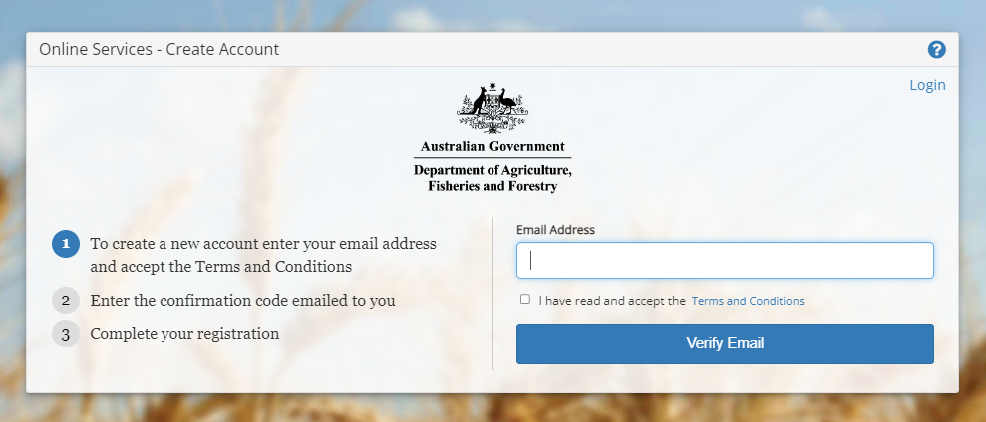
Step 3  Read the terms and conditions and if agreed, select the tick box.  Select Verify Email | 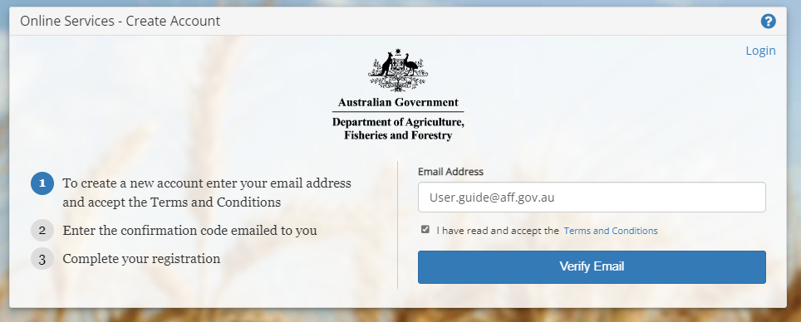
Step 4  A confirmation code has been sent to your email.  Type the confirmation code into the into the box. | 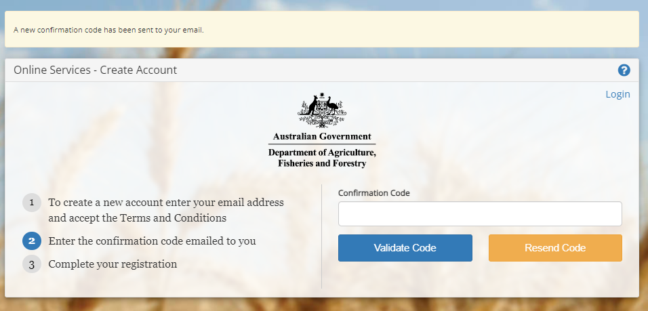
Step 5
Select Validate Code

Step 6  Type in your password. | 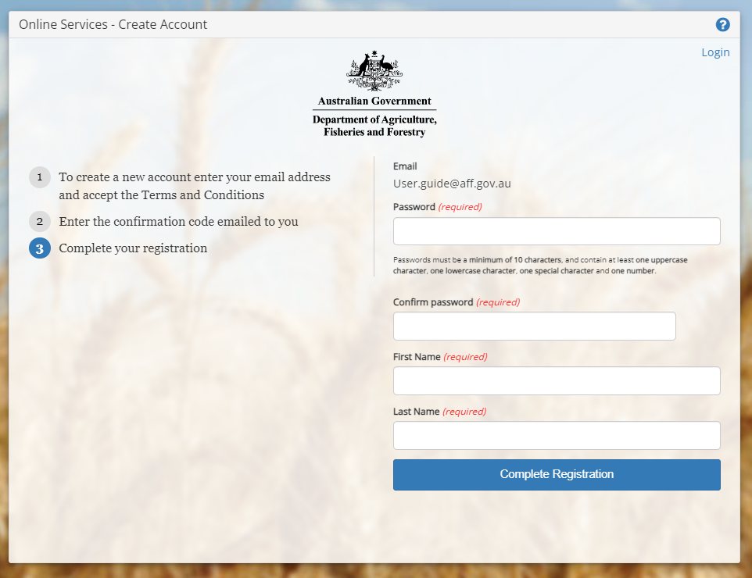
Step 7
Retype the same password in Step 6.

Step 8
Type your first name.

Step 9
Type your last name.

Step 10
Select Complete Registration
One your Online Service Account is created, you are eligible to be added to established client groups, and if applicable, receive the AEPD permission. Should you need to register an export company, please proceed with the below.

Apply to register as an exporter
Once you’ve logged into Online services, you will need to connect to NEXDOC.

Step 1  Select Connect to a service. | 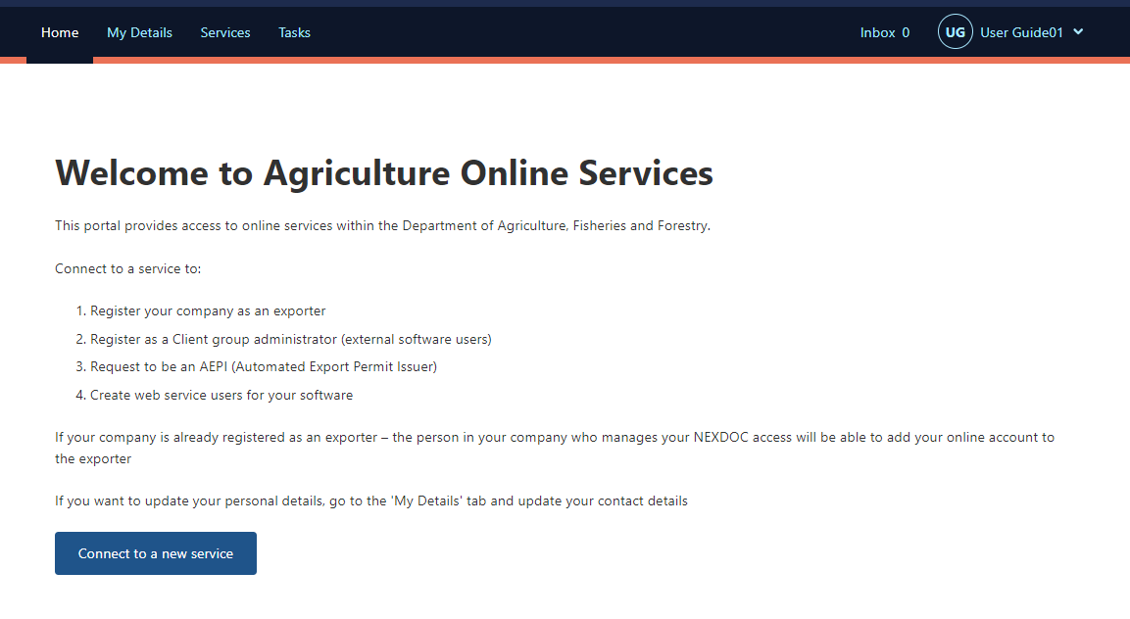
Step 2  Select Register as an Exporter. | 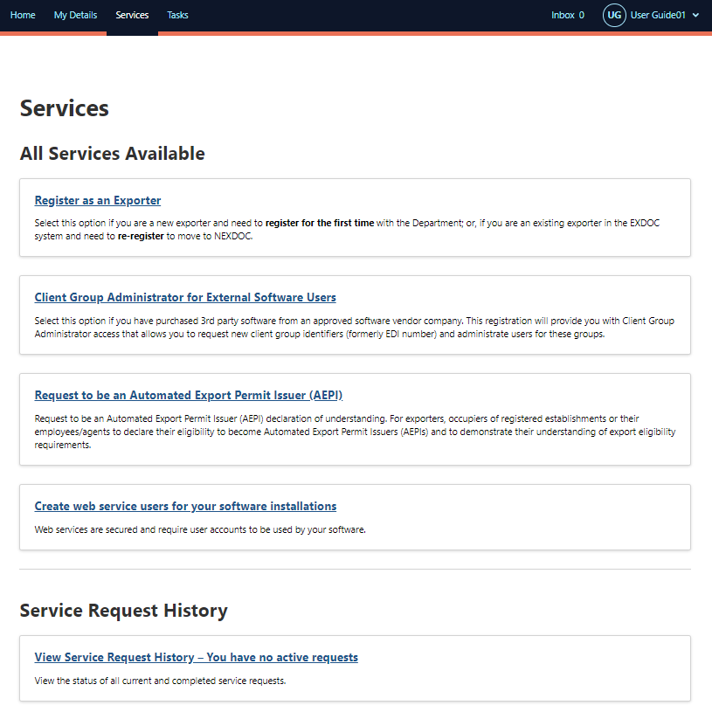

Commodities
Step 1  Select the Meat tick box and select Save and next. | 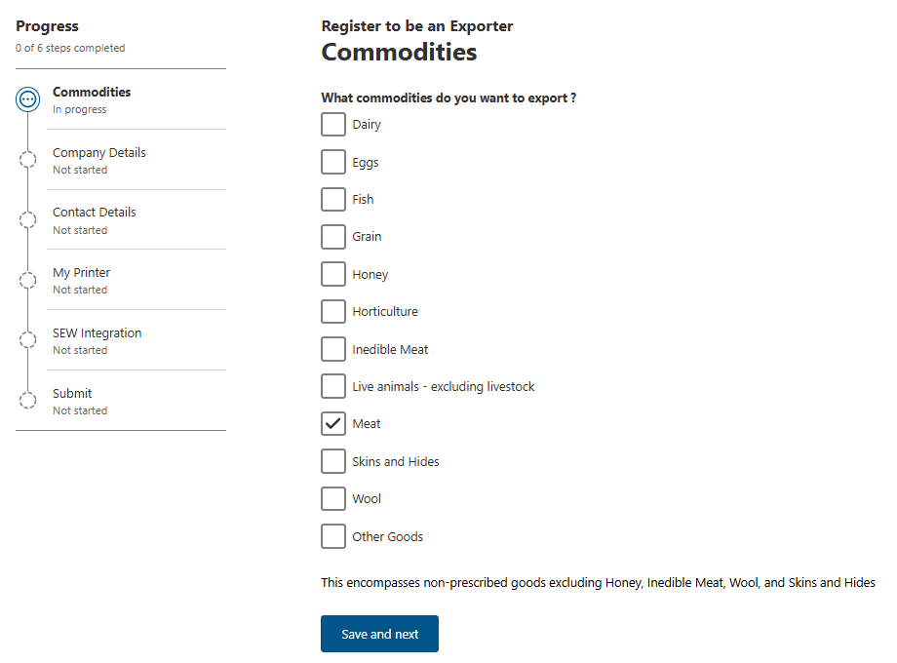

Company Details
Step 1  Enter the Exporter ABN. The system will automatically validate the ABN. It will provide a list of applicable business names, sourced directly from the ABN Lookup Register. Select the business name you wish to register as the export business.  If you wish to use a different name for the export business, you can type this into the field titled Company you wish to register. This field overrides the drop-down options. This is not a required field. Only use this if you have a valid reason to export under a different business name.  Please note that the ‘Company Name’ and/or ‘Business name’ is the name of the export business. The name you select or type in will appear on the export certificate.  Then, provide the following:  - Company email  - Company phone number  - Company physical address  - Exporter number (This is your current EXDOC ID and assists the department with aligning your EXDOC and NEXDOC profile)  - TRACES exporter number (Required if you export to the EU)  - Meat licence number (Required if you are exporting edible meat from sheep, cattle or goats)  - Postal address: tick box if it is the same as physical address  Relevant details will appear on documentation.  Select ‘Save and Next’. | 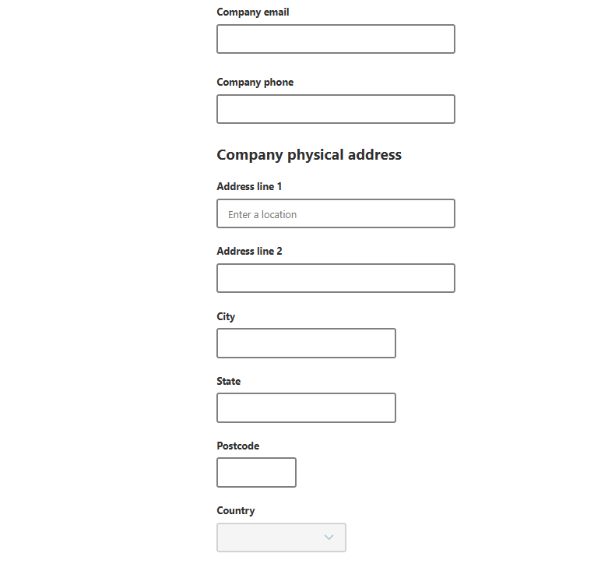  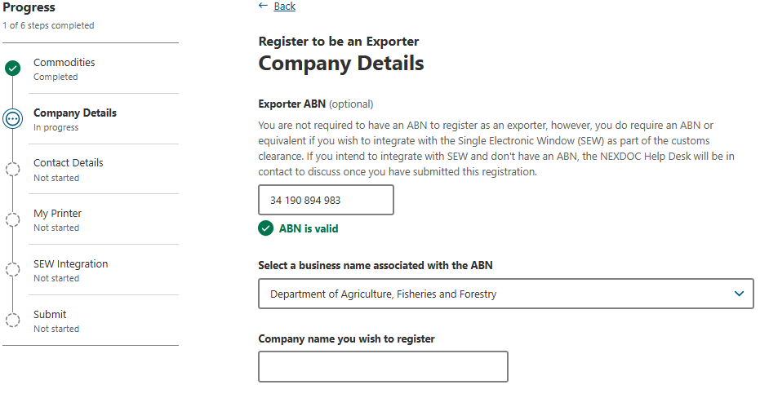  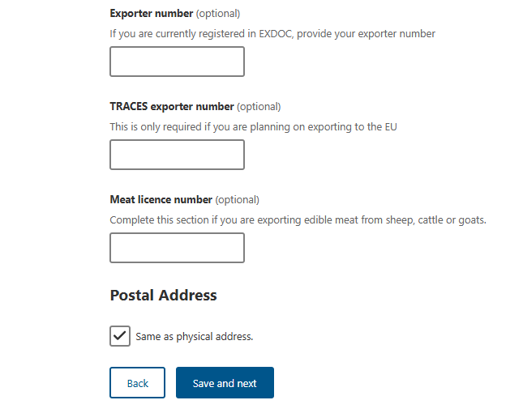

Contact Details
Step 1  The system will default for you to be the contact person.  If this is correct select Save and next.  Proceed to My Printer section. | 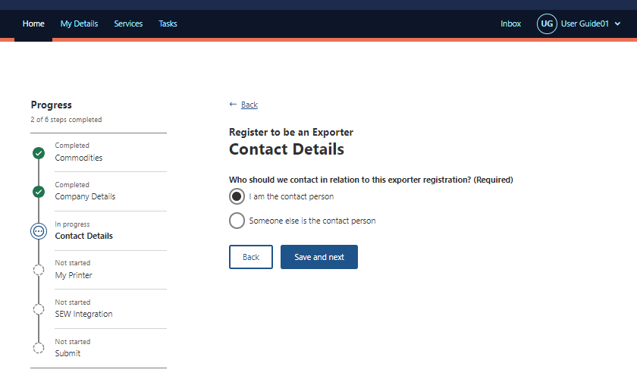
Step 2  If you are not the best contact, you will need to:  - enter the email or Online Services ID of the contact person  - select ‘Search for existing client’.  NEXDOC will search our records for an existing client record. | 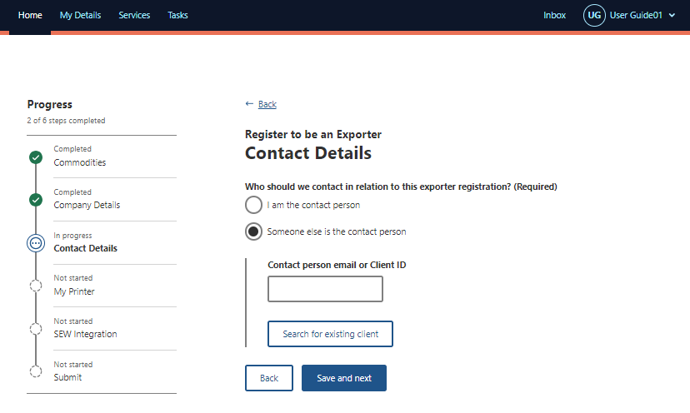
Step 3  If the client record is found, you can select from two options:  Use this existing client as the contact person. Selecting this option will use the contact details stored in NEXDOC for this person. Alternatively;  Don’t link the existing client, enter details manually. Select this option to manually insert the contact details.  When the contact is correct, select Save and next. | 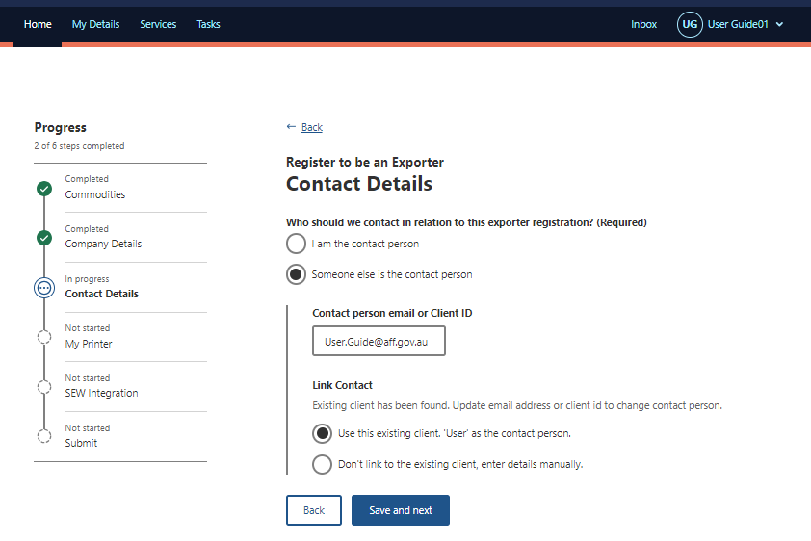  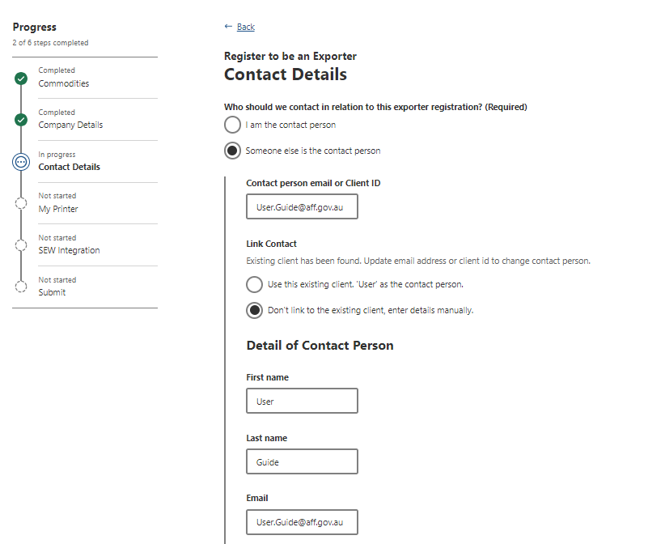  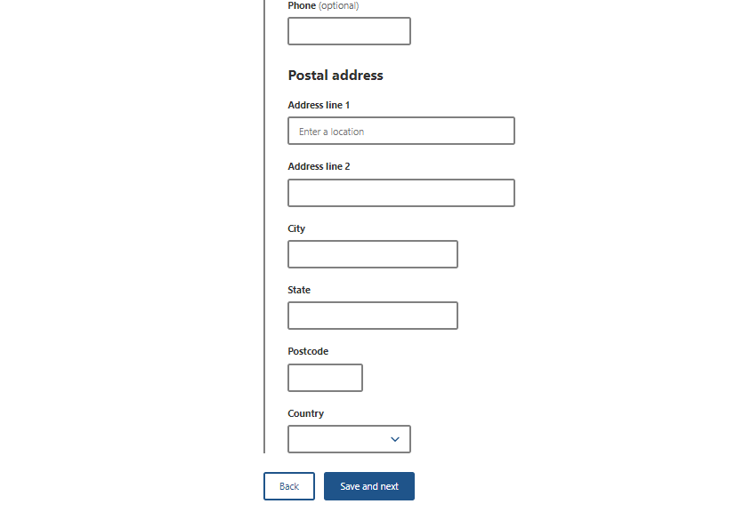

My printer
Step 1  You can request to use My Printer to print your certificates outside of the department’s offices.  To enable remote print in your office, select Yes and proceed to Step 2.  If you select No, then select Save and next. | 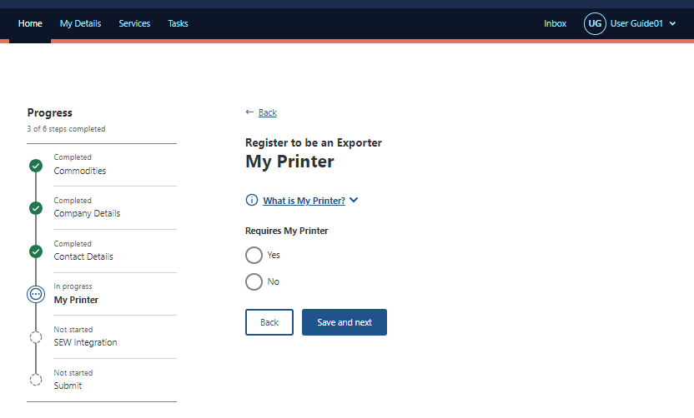
Step 2  Tick the box of which commodity/ies you would like to enable remote print for.  Select Save and next.  Your request for My Printer permissions will be sent to the department for decision as part of your registration application. | 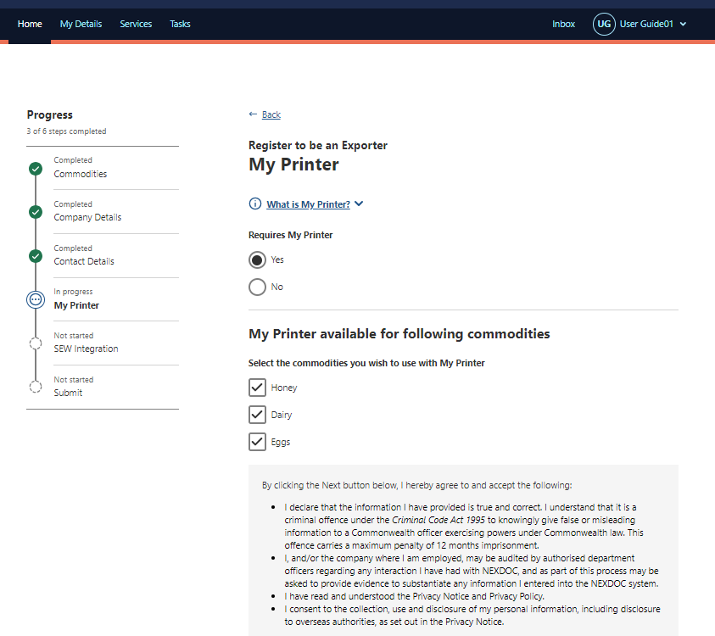  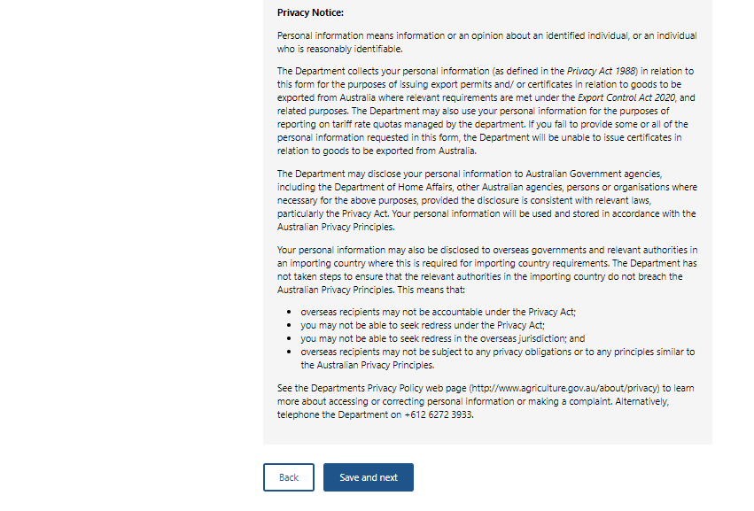

Single electronic window (SEW) integration
Step 1  If you intend to integrate NEXDOC with the single electronic window (SEW) select Yes.  If you currently obtain your EDN via EXDOC, the department will ensure that your details align with your current EXDOC profile details.  If you don’t intend to integrate NEXDOC with the single electronic window (SEW) select No.  Select Save and next. | 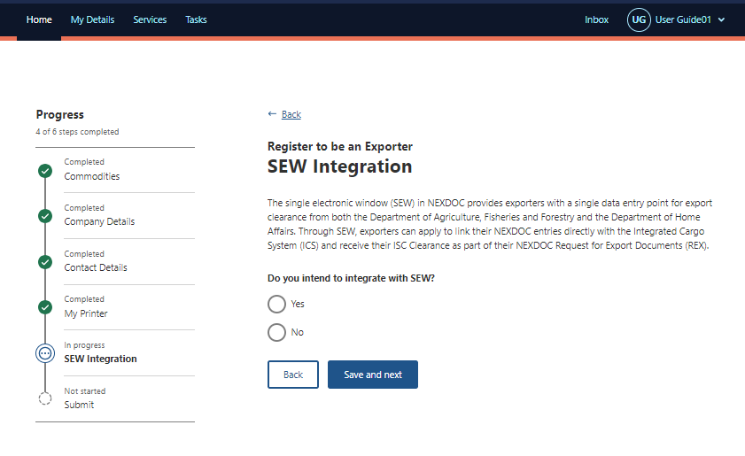

Submit
Step 1  Read the declaration and privacy notice.  If you agree, tick the box next to I agree.  Select Submit. | 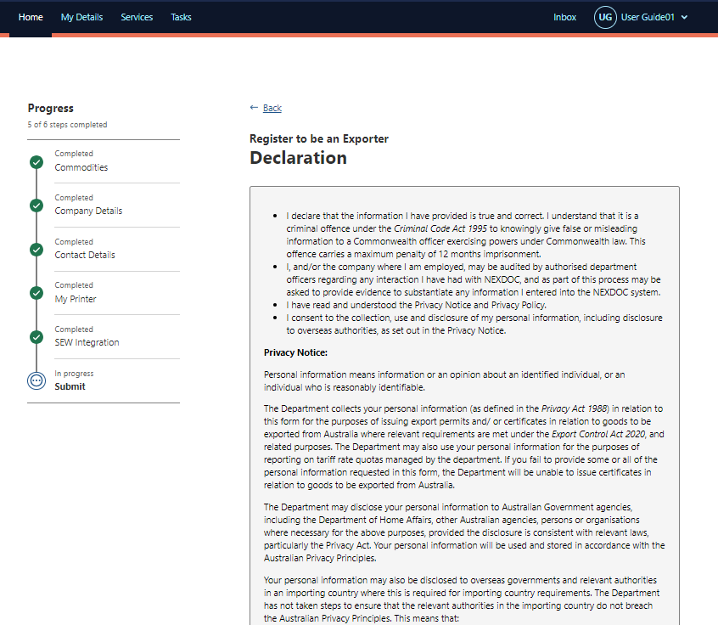  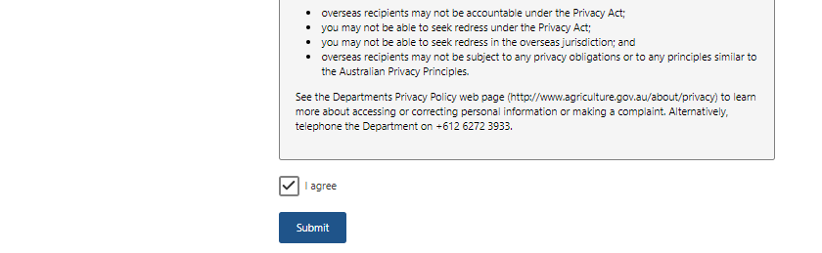
The department will review your application. Once your application has been assessed you will be notified of the decision through the NEXDOC inbox within the NEXDOC portal. | 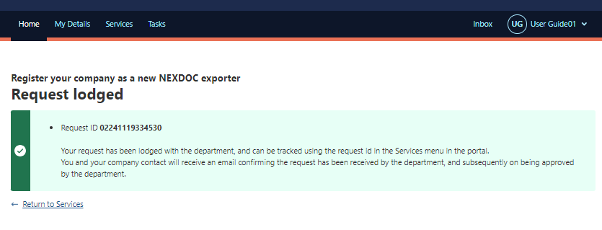

Contact the NEXDOC help desk
For more information or assistance, please contact NEXDOC@aff.gov.au

