The Menu of Measures

A framework for managing phytosanitary risks
© Commonwealth of Australia 2025
Ownership of intellectual property rights
Unless otherwise noted, copyright (and any other intellectual property rights) in this publication is owned by the Commonwealth of Australia (referred to as the Commonwealth).
Creative Commons licence
All material in this publication is licensed under a Creative Commons Attribution 4.0 International Licence except content supplied by third parties, logos and the Commonwealth Coat of Arms.

Cataloguing data
This publication (and any material sourced from it) should be attributed as: DAFF 2025, The Menu of Measures
A framework for managing phytosanitary risks, Department of Agriculture, Fisheries and Forestry, Canberra, December. CC BY 4.0.
This publication is available at https://www.agriculture.gov.au/biosecurity-trade/policy/menu-of-measures/about.
Department of Agriculture, Fisheries and Forestry
GPO Box 858 Canberra ACT 2601
Telephone 1800 900 090
Web agriculture.gov.au
Disclaimer
The Australian Government acting through the Department of Agriculture, Fisheries and Forestry has exercised due care and skill in preparing and compiling the information and data in this publication. Notwithstanding, the Department of Agriculture, Fisheries and Forestry, its employees and advisers disclaim all liability, including liability for negligence and for any loss, damage, injury, expense or cost incurred by any person as a result of accessing, using or relying on any of the information or data in this publication to the maximum extent permitted by law.
Acknowledgement of Country
We acknowledge the continuous connection of First Nations Traditional Owners and Custodians to the lands, seas and waters of Australia. We recognise their care for and cultivation of Country. We pay respect to Elders past and present, and recognise their knowledge and contribution to the productivity, innovation and sustainability of Australia’s agriculture, fisheries and forestry industries.

Introduction
The Menu of Measures is a resource developed by Australia’s Commonwealth Scientific and Industrial Research Organisation (CSIRO). The Menu classifies the 41 risk-reducing measures that are currently in use in Australia and internationally, based on how each contributes to reducing biosecurity risks (Figure 1).
The Menu is structured around the phytosanitary risk framework. This framework identifies the four ways (Risk Reduction Objectives) through which measures can mitigate plant biosecurity risks. It also identifies the consignment stages each measure can be applied to. Within each Risk Reduction Objective, the 41 individual measures are further grouped into 10 measure categories.
Figure 1 Overview of the Menu of Measures
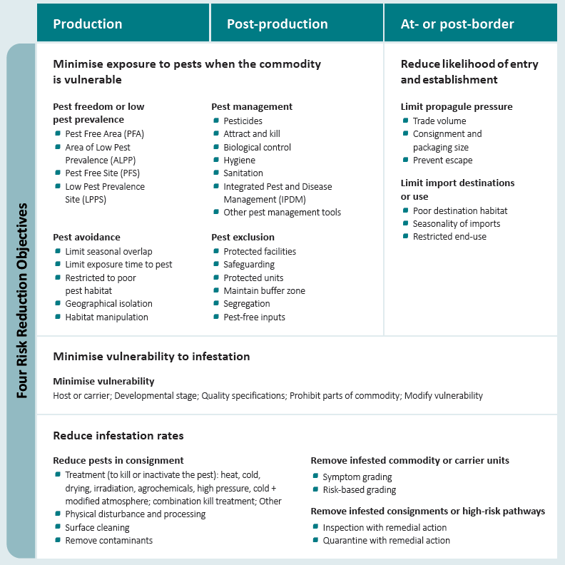
More detailed information on each measure is available here:
https://www.agriculture.gov.au/biosecurity-trade/policy/menu-of-measures
Contents
1 Introduction 3
2 Risk Reduction Objective 1: Minimise exposure to pests when the commodity is vulnerable 5
2.1 Pest freedom or low pest prevalence 5
2.2 Pest management 5
2.3 Pest avoidance 6
2.4 Pest exclusion 6
3 Risk Reduction Objective 2: Minimise vulnerability of the commodity or carrier to infestation 7
3.1 Minimise vulnerability 7
4 Risk Reduction Objective 3: Reduce infestation rates 8
4.1 Reduce pests in consignment 8
4.2 Remove infested commodity or carrier units 8
4.3 Remove infested consignments or high-risk pathways 8
5 Risk Reduction Objective 4. Reduce likelihood of pest entry and establishment 9
5.1 Limit propagule pressure 9
References 10
6 More information 11

Figures
Figure 1 Overview of the Menu of Measures 4

Risk Reduction Objective 1: Minimise exposure to pests when the commodity is vulnerable
Measures that provide confidence in pest freedom or low pest prevalence, or that reduce exposure to pests and the risk of infestation when the commodity is vulnerable.

Pest freedom or low pest prevalence
Measures that provide confidence in pest freedom or low pest prevalence in a designated area or registered site.
Pest free area: Provides the required confidence that a target pest does not occur within a designated area, thereby allowing trade to occur from within that area.
Area of low pest prevalence: Provides the required confidence in low pest prevalence within the designated area, thereby allowing trade to occur from within that area.
Pest free site: Provides confidence that there are no pests on the registered site when the commodity is vulnerable to infestation.
Low pest prevalence site: Provides the required confidence that pest prevalence

Pest management
Measures that supress pest populations at times when the commodity is vulnerable to infestation.
Pesticides: Pesticides kill the target pest, reducing pest abundance in the designated area or site.
Attract and kill: This measure reduces pest abundance in the designated area or site by attracting and killing the pest.
Biological control: Biological control kills or sterilises the target pest, thereby reducing its abundance within the designated site or area.
Hygiene: Hygiene measures reduce pest populations by controlling or removing sources of infestation risk.
Sanitation: Sanitation involves cleaning, washing, or disinfecting equipment and facilities to minimise the risk that pests could transfer onto the commodity.
Integrated Pest and Disease Management: Integrated pest and disease management (IPDM) involves coordinated application of multiple pest management options to sustainably manage pest populations.
Other pest management tools: A diverse range of other pest management tools are available to manage pest populations.

Pest avoidance
Measures that limit overlap in time or space between active pest populations and commodities vulnerable to infestation.
Limited seasonal overlap: Production and post-production of the commodity limited to seasonal periods when the target pest is rare or inactive.
Limit exposure time to pest: Risk is reduced by limiting the time that the commodity is exposed to the pest.
Restricted to poor pest habitat: Sites registered for trade must be located in areas where pest populations are naturally low because of unfavourable habitat conditions.
Geographical isolation: Exposure to the pest is reduced by ensuring that the commodity is geographically isolated from the pest.
Habitat manipulation: Exposure to the pest is reduced by manipulating the habitat and making it less suitable for pests.

Pest exclusion
Measures that apply physical, temporal or spatial barriers between the pest and the commodity when vulnerable to infestation.
Protected facilities: Production and post-production facilities are designed and managed to physically exclude pests.
Safeguarding: Physical barriers are used to exclude pests at the scale of the packed commodity or consignment.
Protected units: Physical barriers are used to exclude pests at the scale of individual commodity units.
Maintain buffer zone: Buffer zones around designated areas or sites reduce the likelihood of pest entry.
Segregation: Practices prevent infestation by preventing regulated and unregulated commodity from mixing.
Pest-free inputs: Ensuring inputs used in production, processing, and packaging are free from pests.

Risk Reduction Objective 2: Minimise vulnerability of the commodity or carrier to infestation
Measures that reduce the vulnerability or susceptibility of the commodity (host or carrier) to pest infestation.

Minimise vulnerability
Trade is restricted to commodities that are not hosts (or carriers), or that are modified to make them less vulnerable to infestation.
Host or carrier: Trade is restricted to commodities that are not hosts or carriers, or those hosts or carriers that are less vulnerable to infestation.
Developmental stage: Trade is restricted to specific stages of development or harvest maturity where the risk of infestation is low.
Quality specifications: Infestation risk is reduced through imposing quality specifications on the traded commodity.
Modify vulnerability: Requiring physical or chemical modifications to the commodity that make it less vulnerable to infestation.
Prohibit parts of commodity: Prohibiting parts of the commodity that may carry pests.

Risk Reduction Objective 3: Reduce infestation rates
Measures that reduce infestation rates, if there is a risk that pests are present in a consignment.

Reduce pests in consignment
Measures that kill, inactivate, or directly remove pests from the commodity in a consignment.
Treatment to kill or inactivate the pest: Chemical and physical phytosanitary treatments that kill or inactivate pests in the consignment.
Physical disturbance and processing: Physical processing or disturbance of the commodity that also kills or removes pests.
Surface cleaning: Physical or chemical cleaning to remove pests or sterilise the surface of the commodity.
Remove contaminants: Removing contaminants of biosecurity concern from the commodity or carrier.

Remove infested commodity or carrier units
Measures that inspect individual commodity units and remove any that show evidence of being infested.
Symptom grading: Inspection of the entire consignment, and remove commodity units that show evidence of being infested.
Risk-based grading: Inspect commodity units that are profiled as being at greater risk of being infested and remove or treat those with evidence of being infested.

Remove infested consignments or high-risk pathways
Measures that inspect a representative sample of a consignment, with remedial action applied to the consignment or pathway if pests are detected.
Inspection with remedial action: Inspection of a representative portion of the consignment, with remedial action applied to the consignment or pathway if a pest threshold is exceeded.
Quarantine with remedial action: Post-entry quarantine (PEQ) containment of consignments for further inspection, screening and remedial action if pest detection thresholds are exceeded.

Risk Reduction Objective 4. Reduce likelihood of pest entry and establishment
Factors that reduce the likelihood of pest entry and establishment. These can be considered when conducting a pest risk assessment, or in some cases be applied as measures.

Limit propagule pressure
Factors that limit the potential number or frequency of introductions of the pest and its distribution and transfer to a susceptible host within an area.
Trade volume: Predicted trade volume can be considered when assessing the likelihood of entry.
Consignment and packaging size: Smaller consignment and packaging sizes make it less likely that enough pests will enter the environment together to establish a new population.
Prevent escapes: The likelihood of entry is reduced by physically preventing the introduction and release of pests in the importing jurisdiction.

Limit import destinations or use
Factors that affect the ability of the pest to establish and survive within an area.
Poor destination habitat: Only approving imports to areas that are unfavourable for the establishment of the pest.
Poor time of year: Approved imports are limited to times of the year when conditions are unfavourable for pest establishment.
Restricted end-use: Imports are approved only for specific purposes that limit the likelihood of pest establishment.

References
Kaye, L., Muller, J., Gibbons, R., Calvert, B., Hull, C., van Klinken, R.D. (2024). A Menu of Measures Resource to manage trade-related plant pest risks. {https://www.agriculture.gov.au/biosecurity-trade/policy/menu-of-measures}. 29 October 2025.

More information
Learn more about The Menu of Measures Resource and Phytosanitary risk tools.
Web: https://www.agriculture.gov.au/biosecurity-trade/policy/menu-of-measures
https://research.csiro.au/prs/phytosanitary-risk-tools
Email: plantstakeholders@aff.gov.au

