# Murray–Darling Basin Economic Development Program

Monitoring, Evaluation, Reporting and Improvement Framework



© Commonwealth of Australia 2021

**Ownership of intellectual property rights**

Unless otherwise noted, copyright (and any other intellectual property rights) in this publication is owned by the Commonwealth of Australia (referred to as the Commonwealth).

**Creative Commons licence**

All material in this publication is licensed under a [Creative Commons Attribution 4.0 International Licence](https://creativecommons.org/licenses/by/4.0/legalcode) except content supplied by third parties, logos and the Commonwealth Coat of Arms.

Inquiries about the licence and any use of this document should be emailed to [copyright@awe.gov.au](mailto:copyright@awe.gov.au).



**Cataloguing data**

This publication (and any material sourced from it) should be attributed as: DAWE 2021, *Murray–Darling Basin Economic Development Program: Monitoring, Evaluation, Reporting and Improvement Framework*, Department of Agriculture, Water and the Environment, Canberra, November. CC BY 4.0.

ISBN 978-1-76003-509-9

This publication is available at [awe.gov.au/water/policy/mdb/programs/basin-wide/edpgrants](https://www.awe.gov.au/water/policy/mdb/programs/basin-wide/edpgrants).

Department of Agriculture, Water and the Environment

GPO Box 858 Canberra ACT 2601

Telephone 1800 900 090

Web [awe.gov.au](http://agriculture.gov.au/)

**Disclaimer**

The Australian Government acting through the Department of Agriculture, Water and the Environment has exercised due care and skill in preparing and compiling the information and data in this publication. Notwithstanding, the Department of Agriculture, Water and the Environment, its employees and advisers disclaim all liability, including liability for negligence and for any loss, damage, injury, expense or cost incurred by any person as a result of accessing, using or relying on any of the information or data in this publication to the maximum extent permitted by law.

**Acknowledgement of Country**

We acknowledge the Traditional Custodians of Australia and their continuing connection to land and sea, waters, environment and community. We pay our respects to the Traditional Custodians of the lands we live and work on, their culture, and their Elders past and present.

Contents

Introduction 1

1 Purpose 2

2 Program background 3

3 MERI Framework 6

4 Improvement 8

5 Compliance and risk management 10

Appendix A: Round 1 and 2 communities 11

Appendix B: Round 3 communities 12

Appendix C: Program logic 13

Appendix D: Evaluation framework 14

Version control 18

Figures

Figure 1 Murray–Darling Basin Plan alignment with departmental Corporate Plan and reporting framework 5

Figure 2 Improvement cycle for the program 9

Maps

Map A1 Murray–Darling Basin Economic Development Program round 1 and round 2 communities and local government area boundaries 11

Map B1 Murray–Darling Basin Economic Development Program round 3 communities and local government area boundaries 12

Tables

Table 1 Timeline of program reports 7

Table D1 Number of jobs created 14

Table D2 Impact on regional communities, organisations and businesses 15

Table D3 Efficient delivery of the program 16

## Introduction

This document outlines the Monitoring, Evaluation, Reporting and Improvement (MERI) Framework for the Murray–Darling Basin Economic Development Program. The MERI Framework used in this report has been adapted from the [Australian Government NRM MERI Framework](http://nrmonline.nrm.gov.au/catalog/mql:2338), published by the Department of the Environment, Water, Heritage and the Arts (DEWHA) in 2009.

The MERI Framework provides a conceptual framework for evaluating the program, with an emphasis on learning, improvement and accountability, as well as for guiding the development and implementation of the program. MERI activities support adaptive program management and good governance, assist in meeting stakeholder expectations and fulfil legislative requirements.

## Purpose

Monitoring, evaluation, reporting and improvement are integral components of programs, particularly natural resource management (NRM) programs. These activities are used to assess the impact, appropriateness, effectiveness, efficacy, efficiency and legacy of policies. They also promote accountability through the collection, analysis and use of information to assess the progress towards and achievement of program goals.

* This document sets out the Monitoring, Evaluation, Reporting and Improvement (MERI) Framework for the Murray-Darling Basin Economic Development Program rounds 1, 2 and 3. It describes the overarching program logic for the program.
* It provides the framework for the Department of Agriculture, Water and the Environment to
  + collect, generate and analyse data so that the program may be monitored and evaluated in a systematic manner
  + set and measure program performance against key performance indicators (KPIs)
  + report on program performance in a logical and consistent way
  + inform decisions to improve the program.

The framework described in this document and its appendixes aims to:

* support good program management, fulfil legislative requirements and help the program to meet stakeholder expectations
* answer questions about the program’s administration and impact in a reliable and systematic manner.

Lessons learned will also be used to inform our current and future program practice.

This MERI Framework is a dynamic tool. It is reviewed and updated regularly to ensure it remains consistent with changes to policy or program direction.

## Program background

The program was first announced by the then Minister for Agriculture and Water Resources, the Hon David Littleproud MP, on 7 May 2018, as part of the Basin Plan commitments package. The objective of the program is to assist eligible communities to undertake economic development projects to respond to the impact of water recovery activities under the Murray–Darling Basin Plan.

The intended outcomes of the program are to:

* increase opportunities for employment within eligible communities
* increase the capacity of eligible communities to diversify and strengthen local economies
* enhance the resilience of eligible communities to manage current and future economic challenges and changes.

Projects are proposed by not-for-profit community organisations to provide economic development and job opportunities specific to their local circumstances. Projects cover a range of sectors including tourism; construction; Indigenous health, welfare and culture; and leadership and capability training. Competitive grant rounds are administered primarily in‑house with mandatory assistance from the Department of Social Services Community Grants Hub. The program is funded under the Sustainable Rural Water Use and Infrastructure Program.

Round 1 will be implemented over four years from 2018–19 to 2021–22 in 15 eligible communities identified as being the most impacted by water recovery activities under the Basin Plan. Appendix A shows the map of eligible round 1 communities. A total of $24,362,662 was approved for 42 projects across all 15 eligible communities, providing funding over 3 years from 2019–20 to 2021–22.

Round 2 will be implemented over 4 years from 2019–20 to 2022–23 in 31 eligible communities, many of which were assessed as being moderately impacted by water recovery activities under the Basin Plan. Others are included due to the proposed acquisition of water entitlements in the Lower Darling and Barwon–Darling, including A Class licences. (This measure is part of the Australian Government’s response to the [Independent assessment of the 2018–19 fish deaths in the lower Darling final report](https://www.mdba.gov.au/publications/mdba-reports/response-fish-deaths-lower-darling), an independent review led by Professor Robert Vertessey.) Three projects with small impacts from water recovery under the Basin Plan are included due to election commitments made during the 2019 federal election. Appendix A shows the map of eligible round 2 communities. A total of $14,369,587 was approved under round 2 for 32 projects across 29 eligible communities, providing funding over three years from 2020–21 to 2022–23.

Round 3 will be implemented in communities across 34 out of 38 eligible local government areas over 2 years from 2020–21 to 2021–22. Appendix B shows the map of eligible local government areas for round 3. A total of $33,971,203 was approved under round 3 for 58 projects across 34 eligible communities.

### Portfolio budget statement

This program aligns with Outcome 5 of the 2021–22 Portfolio Budget Statement (PBS) for Agriculture, Water and Environment:

Improve the health of rivers and freshwater ecosystems and water use efficiency through implementing water reforms, and ensuring enhanced sustainability, efficiency and productivity in the management and use of water resources.

The Murray–Darling Basin Economic Development Program, which is a sub-program under the Sustainable Rural Water Use and Infrastructure Program linked to outcome 5, aligns to this outcome by improving outcomes for Indigenous people and addresses the social and economic impacts of the Basin Plan (Stream 3 of the Basin Plan commitments package). This is described in the program logic and is illustrated at Appendix C.

### Corporate plan

#### Objectives

This program most closely aligns with our objective to support the sustainable management and productive use of Australia’s water resources. It does so as described in section 3 of this framework and in the program logic, illustrated at Appendix C.

In discussing this objective, we note that:

The Murray–Darling Basin Economic Development Program is supporting economic development projects in identified communities impacted by water recovery under the Basin Plan.

Source: [Department of Agriculture, Water and the Environment](https://www.awe.gov.au/water/policy/mdb/programs/basin-wide/edpgrants)

#### Functions

This program is part of the Murray–Darling Communities Investment Package, with the objective of maximising the benefits of the Basin Plan for communities: Ensuring policy development and program/project delivery are informed by the views of stakeholders across the basin is essential for water resource management.

The measure against this criterion is that ‘Intended program outcomes are being achieved and the department implements improvements from lessons learned’. This MERI Framework seeks to monitor the achievement of the program’s outcomes. Lessons learned will be captured under our project management framework.

Additionally, our evaluation policy requires any new ‘significant activities’ to plan for and conduct evaluation. This MERI Framework aims to deliver on this requirement.

Figure 1 Murray–Darling Basin Plan alignment with departmental Corporate Plan and reporting framework

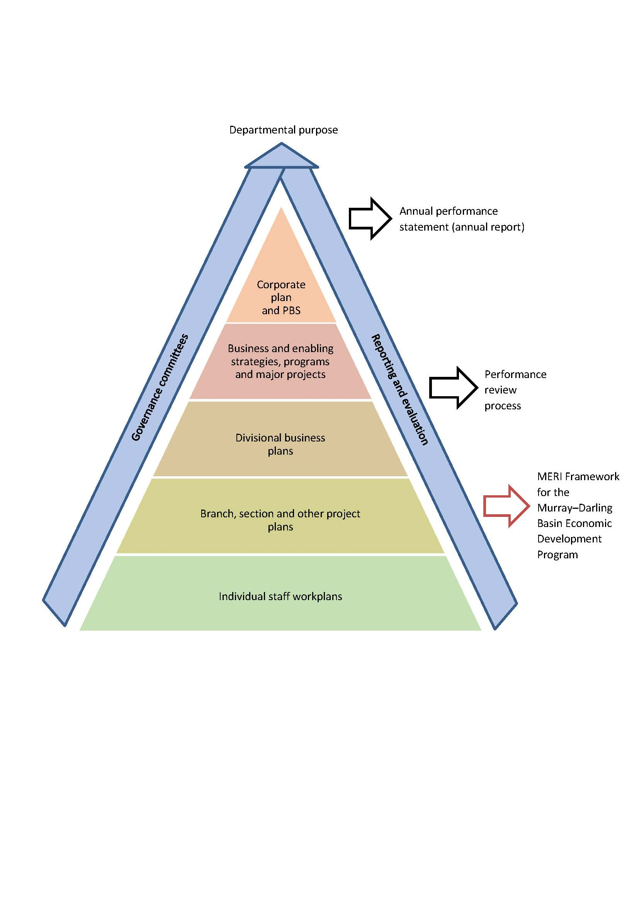

## MERI Framework

The MERI framework provides a strategic approach to monitoring, evaluating, reporting on and improving the program. The MERI framework was adapted from the [Australian Government NRM MERI Framework](http://nrmonline.nrm.gov.au/catalog/mql:2338), published by the Department of Environment, Water, Heritage and the Arts in 2009. The key components of the MERI Framework are:

* Monitoring – collection and analysis of information to assist timely decision-making, ensure accountability and provide the basis for evaluation and learning.
* Evaluation – periodic assessment of the program in terms of appropriateness, impact, effectiveness, efficiency and legacy.
* Reporting – specific reports that demonstrate progress towards targets and outcomes, highlight expected or unexpected impacts at different time intervals and serve to meet accountability requirements.
* Improvement – continuous review, learning and adaptation that leads to improvements in the efficacy of particular strategies, investments and activities.

The MERI Framework provides a model for assessing the program against planned immediate, intermediate and longer-term outcomes. It provides opportunities to improve program and project design and implementation, and to reorient investment at key decision points throughout the life of the investment strategy or policy.

MERI is viewed as a continuous cycle of participation and communication rather than as a single evaluation event. It promotes learning and adaptive management in response to progressive monitoring and evaluation, which enables improvement in program design and achievement of desired outcomes. The improvement cycle for the program at Figure 2 illustrates this continuous view of improving the program.

#### Program logic

The program logic at Appendix C shows the rationale behind the program and the cause-and-effect relationships between program activities, outputs and outcomes. Parameters of the program are defined in a 6-level hierarchy. The components of the program logic are supported by corresponding activities and reflect program design.

Chapter 13 of the [Murray–Darling Basin Plan 2012](https://www.legislation.gov.au/Details/F2018C00451) outlines principles to be applied to monitoring and evaluation. Specifically, principle 4 states that monitoring and evaluation should be undertaken within the conceptual framework of program logic.

#### Evaluation framework

The structure of the evaluation framework at Appendix D is informed by the program logic. The evaluation framework comprises the following elements:

* **Evaluation questions** – specified questions that relate to the impact, appropriateness, effectiveness, efficiency and legacy of the program.
* **Indicators** – qualitative and quantitative measures of program performance used to assess evaluation questions.
* **Method** – the way indicators are measured, and evaluation questions are assessed.
* **Data sources** – data collection through program-monitoring activities provides a primary source of information and is supported by other data sources external to the program. Privacy principles are applied to all elements of information collected and stored for the purposes of MERI.
* **Frequency** – evaluation of the program will occur at particular intervals, reflecting the varying timeframes for program outcomes, timeliness of stakeholder communication, complexity of evaluation, and reporting requirements.
* **Purpose** – the way evaluation results are used throughout the continuous MERI cycle.

#### Secondary questions

Secondary questions have been developed to assist in answering key evaluation questions.

#### Key performance indicators

KPIs are used to answer the key evaluation questions. Each KPI has a measure defined against it.

#### Means of evaluation

The means of evaluation has been developed to provide clarity around the type and source of information required to address each evaluation question and KPI. This information will both inform routine reporting and provide information on achieving progress towards desired outcomes as well as for final evaluation of the program.

#### Data sources and use

Information will be collected primarily from milestone and final reports submitted by grant recipients. This information may be supplemented by other means – for example, through Australian Bureau of Statistics employment data and evaluations of the Basin Plan, including analysis of social and economic data for communities, and reports or feedback from community members of groups.

Privacy principles are applied to all elements of information collected and stored for the purposes of this MERI Framework. Importantly, this information will not be released in a form which could identify program participants, and case studies will only be used where they are approved and agreed by the proponent through an agreed process.

#### Frequency and reporting timeline

The framework describes when we will evaluate a particular aspect of the program’s performance by seeking to answer an evaluation question and measure a KPI. The framework also indicates how the results may be used.

Table 1 Timeline of program reports

| Report | Date |
| --- | --- |
| MERI reports round 1 and round 2 for 2021–22 | October 2022 |
| Final MERI reports round 1 and round 3 for 2021–22 | December 2022 |
| Final MERI report round 2 and program closure report | December 2023 |

## Improvement

Improvement is an important aspect of monitoring and evaluation activities. The purpose of the continual monitoring, evaluation and reporting of the program is to inform improvements to the program – be they to capitalise on opportunities to improve program efficiency or impact or to address observed risks or failures. The results and reports of this framework will be drawn upon to identify and pursue improvements throughout the life of the program.

A review of the program will be undertaken by the department to inform potential future rounds and improvements that could be made. This review will focus on:

* the implementation of rounds 1, 2 and 3
* social and economic outcomes of the program across communities
* lessons learned from each of the 3 rounds.

The review will also take into consideration any new information on Basin communities from the implementation of the Basin Plan. Figure 2 illustrates the improvement cycle for the program. The department is responsible for each activity beginning by giving initial approval to evaluating a closing the program.

Figure 2 Improvement cycle for the program

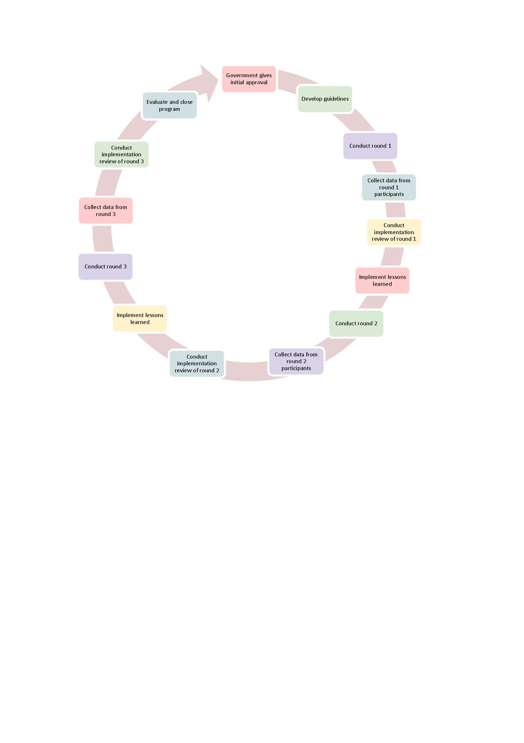

## Compliance and risk management

This framework does not include compliance functions, and a separate strategy will be developed to outline the program’s compliance approach. However, it should be noted that compliance activities may provide data useful for undertaking MERI activities.

Similar risk management is not explicitly covered in this framework. The Enterprise Risk Management Framework and Policy sets out the department’s approach to managing risk and meeting our obligations under the Commonwealth Risk Management Policy and Public Governance, Performance and Accountability (PGPA) Act. Planning Hub is our platform for undertaking most risk assessments, including those for new programs and projects and business plans at the division, branch and section level. Monthly program progress reports are provided to the Water Division’s Water Implementation Board for consideration through the Planning Hub.

This program is delivered by the Community Grants Hub, which provides a shared-services arrangement to deliver grant administration services on behalf of Australian Government client agencies to support their policy outcomes. Client agencies are responsible for grant policy and program development, while the Community Grants Hub is responsible for administering grant programs at the direction of policy owners and consistent with the requirements of the Commonwealth Grants Rules and Guidelines 2017.

## Appendix A: Round 1 and 2 communities

Map A1 Murray–Darling Basin Economic Development Program round 1 and round 2 communities and local government area boundaries

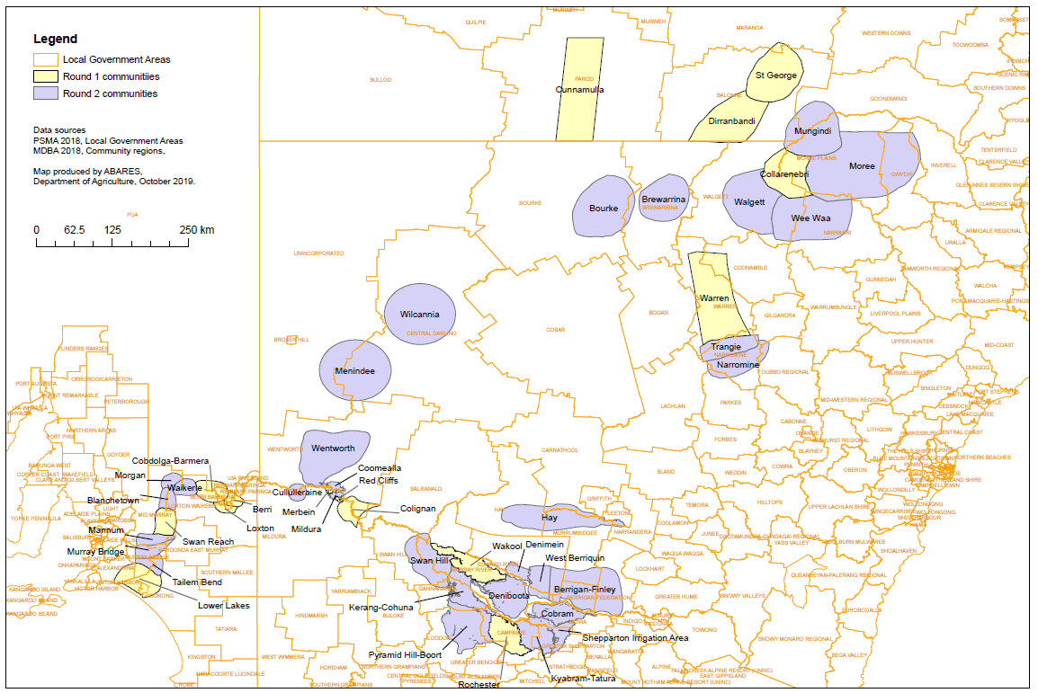

## Appendix B: Round 3 communities

Map B1 Murray–Darling Basin Economic Development Program round 3 communities and local government area boundaries

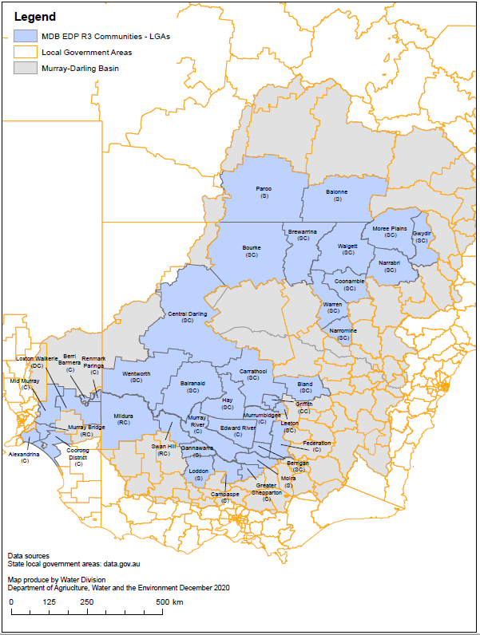

## Appendix C: Program logic

Diagram of Program Logic which describes the rationale behind the program and the cause-and-effect relationships between program activities, outputs and outcomes.

From top to bottom of diagram. The portfolio outcome is to improve the health of rivers and freshwater ecosystems and water use efficiency. This is done through implementing water reforms, and ensuring enhanced sustainability, efficiency and productivity in the management and use of water resources.

This program aligns with Outcome 5 of the 2021–22 Portfolio Budget Statement (PBS) for Agriculture, Water and Environment.

Parameters of the program are defined in a 6-level hierarchy to support outcomes of the Murray–Darling Basin Plan and maintain/create social licence for this reform within communities affected by water recovery.

Foundational activities support the program outputs using ICT Infrastructure. The Program outputs are grouped in categories which include economic, environmental, agricultural, social resilience, capacity building and Indigenous. These outputs support intermediate and long-term outcomes.

## Appendix D: Evaluation framework

Table D1 Number of jobs created

| Evaluation questions | Indicators | Means of evaluation | Data sources | Frequency of collection | Purpose |
| --- | --- | --- | --- | --- | --- |
| How many jobs have been created during project implementation and ongoing after completion of projects? | * Jobs created during project implementation. * Jobs created that are ongoing because of the program funding. * Indigenous jobs created during and after implementation of projects. | We will evaluate this after we review post-project data (collected on project completion) to determine whether employment outcomes have been realised. | * Milestone and final project reports * Participant surveys * Case studies * Follow-up visits * Compliance data | * End of participation survey | * Inform annual reports * Inform program reviews * Communication activities |
| What is the overall effect on regional/community employment and economic development? | * Projects are delivering the program’s anticipated economic and social benefits. | We will evaluate this through review of available information from Basin Reviews. | * Murray–Darling Basin Plan reviews * ABS census data * Murray-Darling Water and Environment Research Program Basin Plan Reporting project | * Annually, and as they become available | * Inform annual reports * Inform program reviews * Communication activities |

Table D2 Impact on regional communities, organisations and businesses

| Evaluation questions | Indicators | Means of evaluation | Data sources | Frequency of collection | Purpose |
| --- | --- | --- | --- | --- | --- |
| How many businesses report trade stimulation, increase in economic prosperity for local community and increased patronage? | * Participating organisations report increased trade and patronage. | We will evaluate this through final project reports and review of post-project data (collected on project completion). | * Final project reports * Participant surveys * Case studies * Follow-up visits * Compliance data | * End-of-participation survey | * Inform annual reports * Inform program reviews * Communication activities |
| How many communities report an increase in tourism to their community? | * Participating communities report increased tourism. | We will evaluate this through final project reports and review of post-project data (collected on project completion). | * Final project reports * Participant surveys * Case studies * Follow-up visits * Compliance data | * End-of-participation survey | * Inform annual reports * Inform program reviews * Communication activities |
| How many communities report improved education, Indigenous education and cultural awareness opportunities, business knowledge and health care services? | * The described socio-economic outcomes of approved projects have been realised at the project completion. | We will evaluate this through review of post-project data (collected on project completion) to determine other benefits. | * Final project reports * Participant surveys * Case studies * Follow-up visits * Compliance data | * End-of-participation survey | * Inform annual reports * Inform program reviews * Communication activities |
| How many communities report stronger and diversified economies, enhancing the resilience of the community? | * The described socio‑economic outcomes of approved projects have been realised at the project completion. | We will evaluate this through review of post-project data (collected on project completion) to determine other benefits. | * Final project reports * Participant surveys * Case studies * Follow-up visits * Compliance data | * End-of-participation survey | * Inform annual reports * Inform program reviews * Communication activities |
| How many community/public places have been improved/upgraded or promoted better? | * Participating communities report on community and stakeholder feedback received at completion of projects. | We will evaluate this through review of post-project data (collected on project completion) to determine other benefits. | * Final project reports * Participant surveys * Case studies * Follow-up visits * Compliance data | * End-of-participation survey | * Inform annual reports * Inform program reviews * Communication activities |
| Would communities/organisations participate in future economic development programs? | * Number of communities interested in participating in future rounds should the opportunity arise. | We will evaluate this through review of post-project data (collected on project completion) to determine other benefits. | * Participant surveys * Case studies * Follow-up visits * Compliance data | * End-of-participation survey | * Inform annual reports * Inform program reviews   Communication activities |

Table D3 Efficient delivery of the program

| Evaluation topic | Indicators | Means of evaluation | Evaluation Activities | Data sources | Frequency | Evaluation output |
| --- | --- | --- | --- | --- | --- | --- |
| Program management | To what extent is the program being managed consistent with applicable government and departmental policies and rules? | The program is being managed in a way that is consistent with the Water Program Governance Architecture Framework. | * Review program management activities. * Note: Policies and rules include but are not limited to our program and project management policies (administered by the P3O model of project certification) and the Commonwealth Public Governance, Performance and Accountability Act, Workplace Health and Safety Act; Commonwealth Procurement Rules; and Commonwealth Grant Rules. | * Program documents | Annually | * Program reports * Program reviews |
| Budget and financial management | Are funds being expended efficiently and effectively consistent with the use of public funds? | There is evidence of due diligence activities, using specified due diligence criteria:   * audit outcomes * value-for-money mechanisms * number of audits/inquiries/reviews. | * Review whether all recorded payments and transfers are attributed to projects. * Where available, refer to internal and external audits commissioned by the program or department. | * Financial management platform * Program documents * Audit reports | Annually | * Program reports * Program reviews * Departmental reporting * Water for the Environment Special Account reviews |
| Assurance and due diligence | What level of assurance does the program have that grants are being executed in a way that is consistent with contractual obligations? | Completed projects are subject to an independent financial audit report. | * Review technical assurance reports. | * Technical assurance reports | Annually | * Program reports * Program reviews |
| Assurance and due diligence | Does the MERI Framework cover all areas of interest? | The MERI Framework sufficiently addresses all aspects of the program. | * When undertaking evaluation activities, reflect on whether there are gaps in the evaluation framework. | * Technical assurance reports | Annually | * Program reports * Program reviews |
| Monitoring, evaluation, reporting and improvement | Is the program collecting and storing the data needed to make reliable evaluations? | Sufficient data are available to undertake all evaluations scheduled in this framework. | * When undertaking evaluation activities, reflect on whether there are gaps in the evaluation framework. | * Evaluations for all items * Program documents | Ongoing | * Program reports * Program reviews |
| Monitoring, evaluation, reporting and improvement | Are projects made public? | Relevant project information, project closure reports and technical assurance reports are all publicly available. | * When undertaking evaluation activities, reflect on whether there are gaps in the evaluation framework. * External consultant to assess the program’s capability for MERI. * Review the extent of published material. | * Evaluations for all items * Program documents | Ongoing | * Program reports * Program reviews |
| Monitoring, evaluation, reporting and improvement | Is this framework supporting program improvement? | Improvements to the program have been made as a result of evaluation activities. | * Review whether outputs from this framework are used as evidence when program changes are presented to the Project Board. | * Evaluations for all items * Program documents | Ongoing | * Program reports * Program reviews |

## Version control

| Version | Decision reference | Author | Approver | Date approved | Date of next review |
| --- | --- | --- | --- | --- | --- |
| 1.0 | draft | Economic Development Section | Fiona Wright  Assistant-Secretary – Industry, Community and Sciences | 21 April 2021 | – |
| 1.5 | endorsed | Economic Development Section | Water Implementation Board | 8 November 2021 | – |
| 2.0 | final | Economic Development Section | Fiona Wright  Assistant-Secretary – Industry, Community and Sciences | 21 December 2021 | 30 June 2022 |