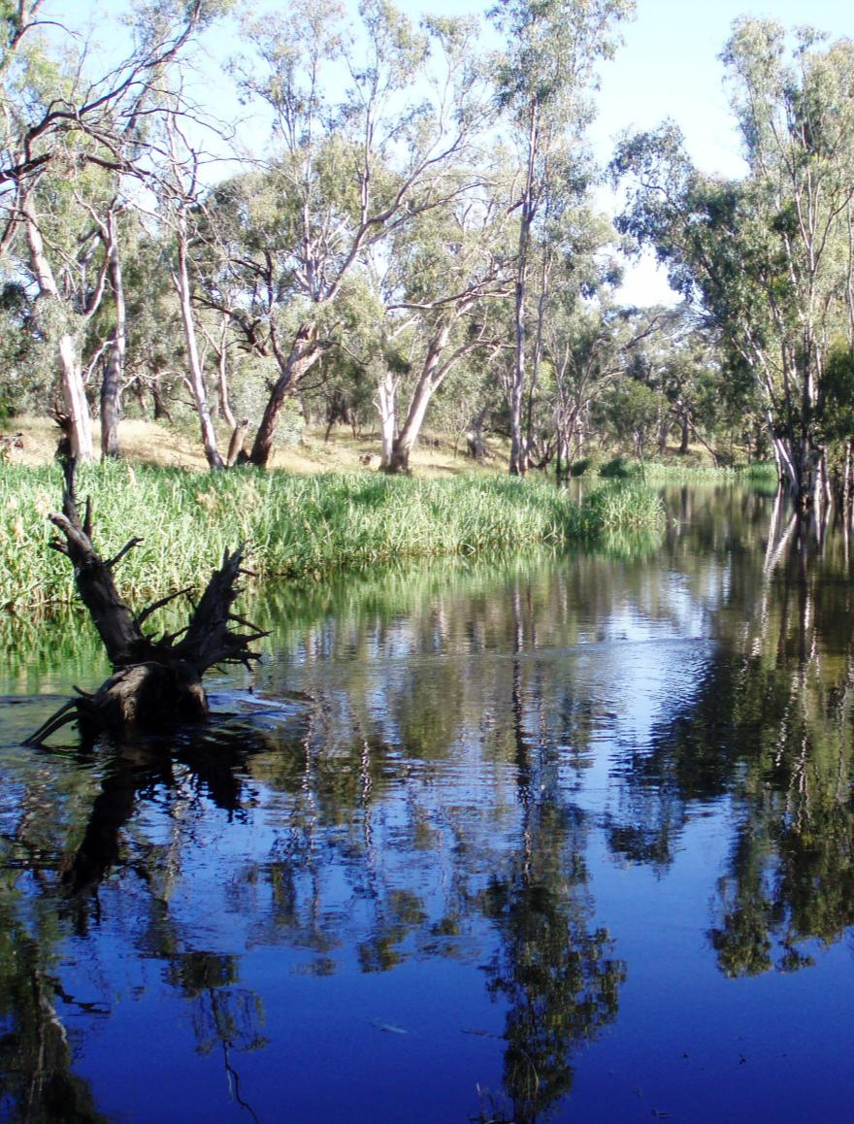

**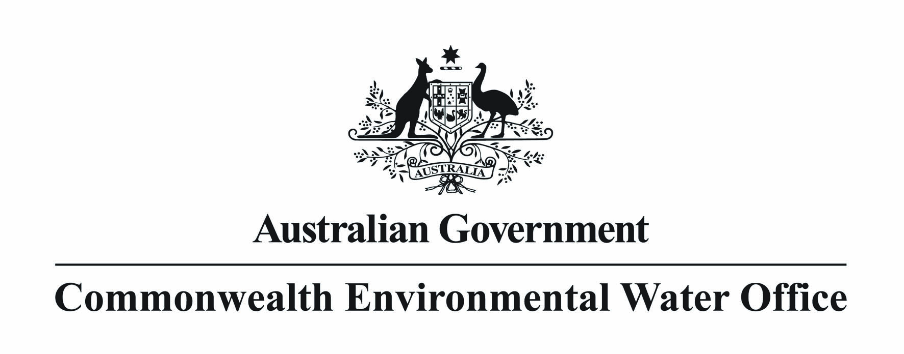 

**Monitoring, Evaluation, Reporting   
 and Improvement Framework**

June 2013 Version 2.0

**Image Credits**

Edward-Wakool River System   
© SEWPAC, Photographer: Rebecca Gee

This report should be cited as ‘*Commonwealth Environmental Water - Monitoring, Evaluation, Reporting and Improvement Framework*, Commonwealth Environmental Water, June 2013 V2.0’.

Published by the Commonwealth Environmental Water Holder for the Australian Government.

© Commonwealth of Australia 2013.

This work is copyright. Apart from any use as permitted under the Copyright Act 1968, no part may   
be reproduced by any process without prior written permission from the Commonwealth. Requests and

enquiries concerning reproduction and rights should be addressed to Department of Sustainability,

Environment, Water, Populations and Communities, Public Affairs, GPO Box 787 Canberra ACT 2601  
 or email [public.affairs@environment.gov.au](mailto:public.affairs@environment.gov.au)

Information presented in this document may be copied for personal use or published for education

purposes, provided that any extracts are fully acknowledged.

The views and opinions expressed in this publication are those of the authors and do not necessarily

reflect those of the Australian Government or the Minister for Sustainability, Environment, Water,

Population and Communities.

While reasonable efforts have been made to ensure that the contents of this publication are factually

correct, the Commonwealth does not accept responsibility for the accuracy or completeness of the

contents, and shall not be liable for any loss or damage that may be occasioned directly or indirectly

through the use of, or reliance on, the contents of this publication.

**Executive Summary**

* Monitoring, evaluation, reporting and improvement (MERI) is critical for supporting the efficient and effective use of Commonwealth environmental water, and demonstrating the achievement of environmental objectives.
* The framework is a high level document that provides overarching guidance for the development and implementation of MERI. As such, it is not intended to provide detail on particular MERI activities which will be the subject of more detailed scoping work. This framework is consistent with, and gives effect to, the relevant provisions of the Murray-Darling Basin Plan, as made in November 2012.
* This framework outlines an approach to MERI that will:
  + support accountability and good governance
  + support adaptive management
  + help build foundational knowledge.
* MERI activities will be implemented to align with the three levels of planning associated with the use of Commonwealth environmental water:
  + annual water use options planning
  + five year portfolio management planning
  + the ten year Basin Plan.
* **Monitoring:** The framework defines three types of monitoring relevant to Commonwealth environmental water: operational; intervention and program monitoring. Operational monitoring will be undertaken for all watering actions to ensure water is delivered as planned and to help manage risks. Intervention monitoring is the primary means for understanding the outcomes from the use of Commonwealth environmental water. This will be coordinated closely with program monitoring undertaken by the MDBA on the achievement of the environmental objectives of the Basin Plan.
* **Evaluation:** Evaluation will be undertaken at timescales that align with planning (<1 year, 1–5 years and >10 years), will be based on the program of monitoring outlined above, and be guided by the reporting requirements set out in Schedule 12 of the Basin Plan. The focus evaluation activity will be:
  + demonstrating the outcomes of the use of Commonwealth environmental water and contributions to the environmental objectives of the Basin Plan
  + supporting adaptive management and improvement in the management of Commonwealth environmental water
  + identify information gaps to help build new knowledge.
* **Reporting:** statutory and non-statutory reporting arrangements underpin a high level of commitment to transparency around the use of Commonwealth environmental water. Beyond statutory reporting obligations, there will be regular reporting of Commonwealth environmental water arrangements as part of broader public service obligations of accountability and good governance.
* **Improvement:** The improvement process for the use of Commonwealth environmental water will be based on evaluation of the environmental outcomes from the use of water, and the watering actions undertaken. Improvement will be given effect through refinement of:
  + future watering actions
  + annual and longer-term portfolio management plans
  + the Basin Plan.

**Table of Contents**

1 Introduction 5

2 Requirements and legislative obligations for the MERI framework 6

2.1 Accountability and good governance 6

2.2 Legislative obligations 6

3 Approach to MERI for the use of Commonwealth environmental water 8

3.1 Guiding principles 10

3.2 Scientific expertise 10

3.3 Working with others 11

4 Implementation of MERI for the use of Commonwealth environmental water 13

4.1 Planning using program logic 13

4.2 Monitoring 16

4.2.1 Operational monitoring 17

4.2.2 Intervention monitoring 18

4.2.3 Program monitoring 19

4.3 Evaluation 19

4.4 Reporting 20

4.5 Improvement 20

Attachment A 21

# Introduction

The Commonwealth Environmental Water Holder (CEWH) is an independent statutory position created by the Commonwealth *Water Act 2007* (the Water Act) to manage Commonwealth environmental water holdings. Commonwealth environmental water must be managed to meet the requirements of the Water Act:to protect or restore environmental assets within the Murray-Darling Basin (the Basin). The Commonwealth Environmental Water Office (CEWO) supports the Commonwealth Environmental Water Holder in performing its functions.

Monitoring, evaluation, reporting and improvement (MERI) are critical components of natural resource management programs, particularly in highly variable natural systems where the outcomes from actions can be uncertain. MERI activities support the efficient and effective use of resources, promote accountability support adaptive management.

The key components of a MERI framework are:

* monitoring - the measurement of indicators specifically selected to measure progress towards achieving program objectives
* evaluation - the assessment of the monitoring results against the objectives to determine whether progress is being made, and whether the selected indicators are appropriate measures
* reporting - communication of the results of the program
* improvement - a feedback loop to planning and decision making to ensure that outcomes from the evaluation are used to continuously improve program delivery.

Over the longer term, MERI will inform:

* the criteria and methods by which Commonwealth environmental water use is prioritised
* the development and refinement of the predictive models of ecosystem response against which environmental watering will be assessed
* the identification of areas where further scientific or other knowledge may be required to advance program planning and implementation.

This framework articulates the approach to MERI for the use of Commonwealth environmental water. It has been informed by the Australian Government’s best practice Natural Resource Management MERI Framework guidelines and has been improved to take into account the comments of stakeholders provided following the release of a discussion paper in June 2011. Version 1.0 of this framework was published in May 2012. This version (Version 2.0) is consistent with, and gives effect to, the relevant provisions of the Murray-Darling Basin Plan, as made in November 2012.

# Requirements and legislative obligations for the MERI framework

The implementation of MERI is critical for supporting the efficient and effective use of Commonwealth environmental water, and demonstrating the achievement of environmental objectives. This framework proposes an approach to MERI that will:

* support accountability and good governance
* support adaptive management
* help build foundational knowledge.

The MERI framework will support the CEWH in meeting a number of specific obligations as outlined below.

## Accountability and good governance

The CEWH must comply with the specific requirements and standards of Commonwealth legal and policy frameworks such as the *Financial Management and Accountability Act* *1997* and the *Public Service Act* *1999*. The MERI framework will contribute to the capacity of the CEWH to uphold high standards of public sector governance, including accountability, transparency, integrity, stewardship and efficiency. This will be demonstrated through transparent management of watering activities including publication of results.

## Legislative obligations

*Provisions under the Water Act and Basin Plan relating to MERI for Commonwealth environmental water are as follows:*

The Water Act requires an annual report on the management of Commonwealth environmental water be provided to the Commonwealth Water Minister, to be tabled in each House of Parliament and given to relevant State Ministers for each of the Basin States (section 114(1)). The report must include information on achievements against the objectives of the Basin Plan’s Environmental Watering Plan (section 114(2a)).

The Water Act also requires the CEWH to provide water information relating to the held entitlements and trade to the Commonwealth Bureau of Meteorology (Water Act s126).

The Basin Plan places a number of obligations on monitoring, evaluating and reporting on the use of Commonwealth environmental water. These are to:

* provide the Murray-Darling Basin Authority with a statement of reasons for any Commonwealth environmental watering that is not in accordance with the Basin annual environmental watering priorities. This statement must be provided as soon as practicable and within four months after the end of the water accounting period in which the environmental watering was undertaken (Basin Plan s8.44)
* apply the principles for monitoring and evaluating the effectiveness of the Basin Plan, as outlined in section 13.04 of the Basin Plan (Attachment A)
* report annually to the Murray-Darling Basin Authority on the following matters:
  + the extent to which local knowledge and solutions inform the implementation of the Basin Plan (Basin Plan Schedule 12, item 6)
  + the identification of environmental water and the monitoring of its use (Basin Plan Schedule 12, item 9)
  + the implementation of the environmental management framework (which includes the Basin-wide environmental watering strategy, the development of Basin annual environmental watering priorities, and the *Principles to be applied to environmental watering*) (Basin Plan Schedule 12, item 10)
  + the implementation of the water quality and salinity management plan, including the extent to which regard is had to the targets in Chapter 9 when making flow management decisions (Basin Plan Schedule 12, item 14)
* report every five years to the Murray-Darling Basin Authority on the achievement of environmental outcomes at a Basin scale, by reference to the targets to measure progress towards the environmental objectives in Schedule 7 (Basin Plan Schedule 12, item 7 ).

# Approach to MERI for the use of Commonwealth environmental water

MERI will be implemented in accordance with the Australian Government’s *Natural Resource Management MERI Framework* (the Australian Government’s MERI framework), and support the evaluation of progress towards achieving the objectives for the use of Commonwealth environmental water. A systematic approach, at the immediate, intermediate and long-term time scales will be applied.

The Australian Government MERI framework (sFigure 1) describes MERI as:

“*a continuous cycle of participation and communication rather than as a single evaluation event. MERI promotes learning and adaptive management in response to progressive monitoring and evaluation which enables improvement in program design and achievement of desired outcomes*”.

This framework is intended to support adaptive management around the use of Commonwealth environmental water. There are also a range of mechanisms under the Basin Plan that support adaptive management, including:

* Basin-wide environmental watering strategy and annual watering priorities to be prepared by the MDBA (Chapter 8, Division 2 and 5 respectively)
* long term watering plans to be prepared by states (Chapter 8, Division 3)
* the principles to be applied in environmental watering (Chapter 8, Division 6)
* the program for monitoring and evaluating the effectiveness of the Basin Plan (Chapter 13).

**REPORT** on  
outcomes and  
communicate  
learning

Adapt strategy accordingly and apply to next program phase for **IMPROVEMENT**

**START  
 Identify** priority assets, desired outcomes and program logic

**CONTINUOUS   
PARTICIPATION AND COMMUNICATION**

**Design**   
program   
including **MERI**   
Strategy

Implement program and **MONITOR**

* **EVALUATE** appropriateness  
   impact  
   effectiveness,   
  efficiency and   
  legacy

**Reflect**  
on what’s   
working,  
 what’s not   
and why

**Figure 1.** Conceptual diagram of MERI cycle (Australian Government, 2009).

The Australian Government’s MERI framework ( Table 1) sets out four key concepts, which are reflected in the approach taken here:

* an **integrated approach** to investment and program design, the planning process, evaluation and adaptive program management involving partners across jurisdictions
* an **asset-based approach** to evaluation that promotes target setting for the key asset classes that contribute to sustainable natural resource management
* monitoring **program performance** in addition to the state of and change over time in the condition of assets
* reporting with an emphasis on **outcomes and impacts**, including at an intermediate outcome stage.

**Table 1.** Key steps in developing MERI (adapted from Australian Government, 2009).

|  |  |
| --- | --- |
| **Key steps** | **Outputs** |
| Planning through program logic | * Desired changes, and the types and extent of changes expected  at different temporal and spatial scales * Key assumptions about how change will occur * Anticipated outputs and outcomes at each scale * Key evaluation questions and methods to enable demonstration of progress through time * Specified targets for outcomes * Indicators, both qualitative and quantitative to enable assessment of actual outcomes relative to expected outcomes. |
| Monitoring | * Relevant data * Reflection on results of monitoring * Strategies for program improvement |
| Evaluation and reporting | * Impact appropriateness, effectiveness, efficiency and legacy assessed at different stages of the program to determine immediate, intermediate and longer-term outcomes * Output reports * Financial reports * Outcome reports * Communications and reports on evaluation results as required  to internal stakeholders and key external stakeholders |
| Improvement and adaptive management | * Reflection on what is working and what is not working based  on monitoring data and evaluation reports * Changes to program direction or arrangements based on reflection on monitoring results and outcome reports |

## Guiding principles

The CEWO will apply the principles set out in Chapter 13 of the Basin Plan (Attachment A) in implementing monitoring and evaluation for Commonwealth environmental water. In addition, the following principles will be applied in working with states, the MDBA and others in working towards coherent and complementary MERI activities within the Basin.

**Principle 1**

Monitoring, evaluation and reporting activities for the use of Commonwealth environmental water will complement, not duplicate or replace, existing and planned monitoring, evaluation and reporting activities.

**Principle 2**

Monitoring, evaluation and reporting programs will be based on shared responsibility with partners in areas of common interest.

“Partners” means any group or individual who has a participatory interest in the monitoring and evaluation of Commonwealth environmental water. This includes other environmental water managers, local groups, landholders, catchment management authorities, state agencies, environmental water advisory groups, river operators and scientific organisations. Where there is common interest, cost sharing principles described in the Commonwealth Environmental Water Business Plan will guide negotiation of costs on a case-by-case basis.

**Principle 3**

Consistent monitoring, evaluation, reporting and improvement systems will be adopted in the management of Commonwealth environmental water, and progress towards consistent and comparable monitoring, evaluation and reporting across the Murray-Darling Basin will be encouraged and supported.

## Scientific expertise

Consistent with Principle 7 of Chapter 13 of the Basin Plan (Attachment A), the CEWO will draw on scientific advice in relation to MERI through our Environmental Water Scientific Advisory Panel (EWSAP). In addition, and where necessary, we will draw on external expertise, including from partners to design the approach to MERI implementation. This approach will extend from planning through to detailed MERI design, as well as evaluation and improvement.

## Working with others

The Basin Plan sets out reporting obligations and principles for undertaking monitoring and evaluation for state and Commonwealth agencies. When viewed together, these provisions broadly confer the following responsibilities:

* Murray-Darling Basin Authority is responsible for reporting on the achievement of the environmental objectives of the Basin Plan at a Basin scale
* Basin States are responsible for reporting on the achievement of environmental objectives of the Basin Plan at an asset scale (via long-term environmental watering plans)
* Commonwealth Environmental Water Holder is responsible for reporting on the contribution of Commonwealth environmental water to the environmental objectives of the Basin Plan.

The MDBA, Basin States, the scientific community, local groups and others have existing environmental water and aquatic health monitoring and evaluation programs and strategies in place. Of relevance to monitoring and evaluation under the Basin Plan, these include:

* Basin States are responsible for MERI activities associated with achieving the objectives set out in long-term watering plans. Together with regional natural resource management agencies the States have valuable on-ground knowledge and experience of particular ecosystem characteristics as well as the capacity to deliver, monitor and evaluate watering events efficiently and effectively.
* The Living Murray (TLM) program is administered by the MDBA and involves the delivery of TLM water, and associated monitoring and evaluation, to six sites in the southern Murray-Darling Basin. Monitoring and evaluation requirements for TLM are included under Items 7, 9, 10 and 14 of Schedule 12 of the Basin Plan.
* The Murray-Darling Basin Authority (MDBA) is responsible for monitoring and evaluating the effectiveness of the Basin Plan. As reflected in the Basin Plan principles at Attachment A, this means that the MDBA has a key role in coordinating MERI activities across the Basin.

There are clear benefits to working cooperatively on MERI and aligning the MERI activities at the Basin, regional and local levels. It will be important to ensure that the maximum value from existing monitoring and evaluation programs is maintained, and the historical results of these programs are used effectively. As the Basin Plan is implemented, there will be a need to integrate with broader jurisdictional frameworks for natural resource management.

As summarised in Figure 2, the CEWO will continue to work with the MDBA, research organisations, state agencies, regional organisations, local groups and others, such as landholders (monitoring and evaluation providers), to collect and collate relevant monitoring information that facilitates evaluation and reporting of the use of water.

We will seek to:

* refine common methods and processes for monitoring, evaluation and reporting activities to reduce the risk of duplication
* ensure that best placed organisations will be undertaking monitoring, evaluation and reporting to support the CEWO program
* coordinate the CEWO’s MERI activities to ensure the best possible information is collected in a cost-effective way
* establish standards for collecting, managing and using information
* establish methods for timely communication and reporting of all monitoring results.

**Figure 2.** The key relationships that support MERI activities. Monitoring and evaluation providers may include research organisations, state agencies, regional organisations, local groups and others, such as landholders.

# Implementation of MERI for the use of Commonwealth environmental water

## Planning using program logic

Consistent with the Australian Government MERI framework, planning using a program logic approach (as outlined in section 3) will be central to implementing this MERI framework. Program logic is a mechanism that helps to determine when and what to evaluate so that resources can be used efficiently and effectively. It is an approach to planning that provides a rationale for how Commonwealth environmental watering contributes to long-term outcomes under the Basin Plan. It will set out immediate and intermediate-term outcomes to define progress over time, and include the activities required to achieve them. A program logic approach:

* provides the basis for planning and decision-making
* promotes efficient and effective monitoring and evaluation of the ecological response to environmental water
* guides adaptive management of watering activities to better meet the environmental objectives set out in Basin Plan’s environmental watering plan
* promotes a shared understanding of the program both internally and externally.

The approach to Commonwealth environmental watering will be adapted and improved over time with experience and new knowledge. A program logic approach is being implemented through the relevant planning documents that guide use of Commonwealth environmental water. An outline of this approach is shown in Figure 3. It sets out how outcomes over the immediate, intermediate and long-terms will be established through planning, to contribute to the goal of protecting and restoring environmental assets of the Murray-Darling Basin. The program logic for Commonwealth environmental water is summarised as expected outcomes in the annual water use options at: www.environment.gov.au/ewater/publications/index.html

The relevant planning documents (annual watering options; long-term portfolio management strategies; and the Basin Plan’s environmental watering plan) will be developed and improved over time and will:

* identify immediate and intermediate-term outcomes to define progress over time, and include the activities required to achieve them
* define targets to enable monitoring and evaluation of progress over a range of timeframes and spatial scales
* identify knowledge gaps relating to Commonwealth environmental watering and consideration of foundational activities and processes to fill these.

The CEWO already develops, in conjunction with delivery partners, watering options for every catchment where water is held. These are considered in the context of wider portfolio management strategies. The alignment of the relevant planning documents and MERI activities with the immediate, intermediate and long term timeframes is summarised in Table 2.

**Goal**

To protect and restore the environmental assets of the Murray-Darling Basin.

**Longer-Term**

The outcomes over the long-term are contributions to the objectives of the Basin Plan - Environmental Watering Plan to:

* protect and restore water-dependent ecosystems of the Murray-Darling Basin
* protect and restore the ecosystem functions of water-dependent ecosystems
* ensure that water-dependent ecosystems are resilient to climate change and other risks and threats.

**Outcomes**

**(>10 years)**

**Intermediate**

The outcomes over the intermediate term define progressive achievement towards long term outcomes and are defined in annual water use options and wider portfolio management strategies.

**Outcomes**

**(1-5 years)**

**Immediate**

Immediate outcomes are defined in annual water use options, which have been developed for every catchment where water is held, and will be reviewed annually. Immediate outcomes are also reflected in water use decisions.

**Outcomes**

**(<1 year)**

**Activities**

Activities include:

* Manage the Commonwealth environmental water holdings, including agreeing use of available water
* Work with others to identify and assess watering proposals, deliver water and undertake monitoring and evaluation
* Advocate the objective of maximising the environmental benefits from the use of available environmental water
* Develop policy and decision frameworks to support the efficient and effective use of the Commonwealth environmental water holdings
* Collect new knowledge to improve watering activities
* Administer available funding

**Figure 3.** An outline of how a program logic approach will be implemented through planning for the use of Commonwealth environmental water.

**Table 2.** The alignment of planning and MERI activities with the timeframes set out under the program logic approach. Primary agencies responsible for these activities are also identified (MDBA – Murray-Darling Basin Authority).

|  |  |  |  |  |  |
| --- | --- | --- | --- | --- | --- |
| **Timeframe** | **Relevant planning document guiding the use of Commonwealth environmental water** | **Monitoring activities** | **Key issue to be addressed through evaluation and review** | **Key reporting activities** | **Key improvement activities** |
| Long-term  (Greater than 10 years) | **Basin Plan’s environmental watering plan (‘the EWP’)**  **(MDBA)** | **Program** monitoring of the effectiveness of the EWP (MDBA) | Environmental outcomes and effectiveness of the EWP | Basin Plan Schedule 12 (Item 7) | Refinement of Basin Plan’s EWP |
| Intermediate  (1–5 years) | **Long-term portfolio management strategies** | Long-term **intervention** monitoring of selected areas Commonwealth environmental water is delivered | Environmental outcomes of Commonwealth environmental watering | Basin Plan Schedule 12 (Item 7) | Refinement of long-term portfolio management strategies |
| Immediate  (Up to 1 year) | **Annual water use options**  **Watering decisions** | Targeted **intervention** monitoring of selected watering actions  **Operational** monitoringto ensure water is delivered as planned and without unintended consequences (delivery partners) | Environmental outcomes of Commonwealth environmental watering  Effectiveness of water delivery | Annual Report to Parliament  Annual Outcomes report  Published results from all monitoring  Basin Plan Schedule 12 (Items 6, 9, 10, 14) | Refinement of annual and future water use options |

## Monitoring

Three types of monitoring (Figure 4) will be undertaken across a range of spatial scales to align with the program logic hierarchy set out in Table 2:

* operational monitoring - measures whether water is being delivered in a manner consistent with the stated water action objectives and without unintended consequences
* intervention monitoring - measures ecological response to watering activities at an environmental asset scale level
* program monitoring - measures ecological condition at the Basin-scale and trends over the long term

Each type of monitoring needs to be designed to fit together to provide a coherent overall picture of the outcomes from environmental watering, and the contribution of environmental water to the objectives of the Basin Plan’s environmental watering plan.

**Figure 4.** A summary of the three types of monitoring relevant to Commonwealth environmental water (operational, intervention and program monitoring) and the alignment with planning.

### Operational monitoring

Operational monitoring will assess whether water has been delivered as planned and at a high level will monitor immediate environmental response. It will provide information to report annually (consistent with Item 9 of Schedule 12 of the Basin Plan) on the use of held environmental water to achieve environmental outcomes (including the volumes, timing (frequency and duration), location and flow rates of that water).

Operational monitoring will continue to be undertaken for every Commonwealth environmental watering action and will be a component of any arrangement for the use of Commonwealth environmental water. Standards for content and timelines for reporting will continue to be refined to support good governance in managing watering actions.

Details of operational monitoring will be agreed with delivery partners and may include:

* hydrologic monitoring of the primary components of the flow regime relevant to the expected ecological response (e.g. timing, frequency, duration, variability) to identify whether the water was delivered in the agreed volumes, at the agreed times and using the agreed delivery methods and guide improvements in delivery
* inundation extent and depth
* changes in connectivity among and between environmental assets
* monitoring indicators of operational risk, such as water quality (e.g. excessive nutrients and toxic algal blooms, fluctuations in dissolved oxygen and blackwater events, acid sulphate mobilisation, salinisation, turbidity and sedimentation) for the purpose of managing those risks
* monitoring indicators in relation to the Basin Plan’s water quality and salinity targets for managing flows
* observations about the immediate environmental responses to watering.

Tools to assist in this monitoring may include photo-point monitoring (before, during and after a watering event), gauging and remote sensing.

Like the delivery of Commonwealth environmental water itself, operational level monitoring is generally best implemented by local delivery partners. Whether these are local groups or state agencies, they will be well placed to undertake operational monitoring to adaptively manage watering actions.

### Intervention monitoring

Intervention monitoring will focus on understanding the ecological response to Commonwealth environmental water at the catchment and environmental asset scales. Two types of complementary intervention monitoring will be supported to assess outcomes associated with the use of Commonwealth environmental water.

*Targeted intervention monitoring of selected actions*

Targeted intervention monitoring will be undertaken for selected Commonwealth environmental watering actions. It will include detailed monitoring of key indicators and enable:

* environmental outcomes to be linked specifically to the delivery of water
* differentiation of Commonwealth environmental water outcomes relative to other water (and external influences)
* assessment of actions where there may be variance in outcomes.

The CEWO will arrange monitoring of this type in select cases. It will inform annual planning and long-term intervention monitoring of selected areas.

*Long-term intervention monitoring of selected areas*

Long-term intervention monitoring in selected areas will include detailed monitoring of indicators at a few representative sites across the Basin. It will enable:

* assessment of ecological responses to the use of environmental water over the intermediate to long-term
* development / refinement of predictive models relating flow regime to ecological response
* future cost effective monitoring across the Basin through extrapolation of results, with the aid of predictive models, to similar types of sites/species in other areas of the Basin not monitored intensively.

Long-term monitoring of selected areas will be guided by:

* representativeness of Commonwealth watering actions across different types of environmental assets of the Basin
* likelihood of receiving periodic application of Commonwealth environmental water in the future
* cost-effectiveness of hydrological, biological and physiochemical monitoring
* existence of appropriate management arrangements and assurance that the monitoring activities are sustainable.

Where needs overlap with The Living Murray Icon Sites or other sites that have adequate existing monitoring in place, the CEWO may invest to fill gaps.

Monitoring (and evaluation) of indicator sites will be at a frequency required to establish confidence in the achievement of objectives at each planning scale. The intention is to enter into longer term arrangements in most cases so that there is assurance about the availability of results into the future. The specific design of the long-term intervention monitoring program, including site selection and development of predictive models, will be developed following the program logic-based planning process, which will establish objectives and causal relationships.

Long-term intervention monitoring will allow assessment of sequences of watering events over a number of years relative to the objectives and enable reporting of progress towards achieving the environmental objectives of the environmental watering plan. Informed by the targeted monitoring, it is anticipated that long-term intervention monitoring will be the key input for reporting under the Basin Plan on the use and environmental outcomes of Commonwealth environmental water (Items 7 and 9 of Schedule 12 of the Basin Plan).

### Program monitoring

Program level monitoring will also be used to assess Basin-wide outcomes from the use of environmental water and will likely include:

* low intensity (broad scale) monitoring of key ecological indicators at randomly selected sites to validate intervention monitoring
* monitoring of larger scale responses associated with environmental watering such as broad scale longitudinal and lateral connectivity and broad-scale vegetative response

monitoring of mobile species (e.g. birds).

This broad scale monitoring will enable:

* monitoring of ecological response to environmental watering at the Basin scale
* assessment of the effects of environmental watering on mobile species.

It is anticipated that the MDBA will take the lead on the program level monitoring although input from environmental water managers will be an important contribution to this work. The CEWO will link our intervention monitoring activities with program level monitoring undertaken by the MDBA to contribute to assessing the environmental outcomes and effectiveness of the Environmental Watering Plan (Item 7of Schedule 12 of the Basin Plan).

## Evaluation

Evaluation is a systematic, evidence-based review of the efficiency and effectiveness of the use of Commonwealth environmental water. Evaluation should align with the program logic and seek to explain why a particular outcome has occurred, how well an activity was undertaken, whether it was a good thing to do, and what should be done in the future in light of the evaluation findings.

Evaluation will be undertaken at timescales that align with the program logic hierarchy (<1 year, 1–5 years and >10 years), will be based on the program of monitoring outlined above, and be guided by the reporting requirements set out in Schedule 12 of the Basin Plan.

The CEWO will aggregate the results of monitoring and, where appropriate, incorporate contextual information provided at a catchment and Basin scale to:

* demonstrate the outcomes of the use of Commonwealth environmental water and how it has contributed to achieving the environmental objectives (with reference to the targets for measuring progress) of the environmental watering plan (section 114 of the Water Act and items 7 and 9 of Schedule 12 of the Basin Plan)
* support adaptive management and improvement in the management of Commonwealth environmental water to meet environmental objectives
* identify information gaps to help build new knowledge.

The MDBA will be responsible for aggregating the results of monitoring undertaken by all jurisdictions to evaluate the environmental outcomes and effectiveness of the environmental watering plan (Items 7–10 of Schedule 12 of the Basin Plan).

## Reporting

The CEWO is committed to having a high level of transparency about its operations and this is underpinned by statutory and non-statutory reporting arrangements. Beyond statutory reporting obligations set out in section 2 of this document, there will be regular reporting of Commonwealth environmental water arrangements as part of broader public service obligations of accountability and good governance. The CEWO will:

* publish results from all monitoring and evaluation work that we commission
* continue to produce an annual environmental water outcomes report, which will summarise overall environmental outcomes.

## Improvement

Adaptive management based on the monitoring and evaluation process is critical to improvement in the management of Commonwealth environmental water. This will be based on the results of monitoring and evaluation undertaken by the CEWO and other groups including research institutions. The improvement process for the use of Commonwealth environmental water will be based on evaluation of the environmental outcomes from the use of water, and the watering actions undertaken. Improvement will be given effect through refinement of:

* future watering actions
* annual and longer-term portfolio management plans
* the Basin Plan (to be undertaken by the MDBA through reviews including under section 50 of the Water Act and Chapter 13 of the Basin Plan).

The improvement process will include:

* mechanisms for incorporating learning and new knowledge into planning, management and decision making
* selection of management activities that are specifically designed to test hypotheses (predictive models) through ecosystem-scale experiments
* review of mechanisms for multi-disciplinary and multi-stakeholder involvement, with a focus on collaborative and participatory learning.

A detailed approach to adaptive management will be the subject of future work in developing the plans noted above.

# Attachment A

**13.03    Principles of responsibility for monitoring and evaluating the effectiveness of the Basin Plan**

**Principle 1**

(1)     The Authority is responsible for leading monitoring at the Basin scale, having regard to the desirability of:

(a)     collecting information in an efficient way; and

(b)     providing open access to information collected or used in, or generated by, monitoring; and

(c)     harnessing existing monitoring capabilities where possible, rather than creating new monitoring capabilities; and

(d)     building upon existing information and data supply arrangements where possible, rather than establishing new arrangements; and

(e)     using an adaptive approach to test and improve monitoring capabilities; and

(f)      eliminating duplication and fragmentation of monitoring processes where possible; and

(g)     there being no net reduction in existing monitoring efforts.

**Principle 2**

(2)     The Authority is responsible for leading all evaluations of the effectiveness of the Basin Plan, with Basin States, the Commonwealth Environmental Water Holder and the Department enabling evaluations by collecting, analysing and reporting information (including data) in a fit for purpose manner.

**13.04    Other principles to be applied in monitoring and evaluating the effectiveness of the Basin Plan**

(1)     The principles in this section must be applied by:

(a)     the Authority, when monitoring the effectiveness of the Basin Plan and conducting evaluations and reviews under Part 3; and

(b)     the Basin States, the **Commonwealth Environmental Water Holder** and the Department, when monitoring and evaluating for the purpose of meeting the reporting requirements in Part 4.

**Principle 3**

(2)     Commonwealth agencies and Basin States should report against matters in a manner which reflects the degree to which they are responsible for those matters.

Note:      For example, the Commonwealth Environmental Water Holder is responsible for reporting on matters only to the extent that the matters relate to its responsibilities.

**Principle 4**

(3)     Monitoring and evaluation should be undertaken within the conceptual framework of program logic.

Note:      Program logic is a mechanism that helps to determine when and what to evaluate so that resources can be used effectively and efficiently: see the Australian Government’s *NRM MERI Framework*.

**Principle 5**

(4)     Monitoring and evaluation findings, including in respect of progress towards meeting targets and trends in the condition and availability of the Basin water resources, should enable decision-makers to use adaptive management.

**Principle 6**

(5)     Monitoring and evaluation should harness the monitoring capabilities of existing Basin State and Commonwealth programs (including jointly funded programs), provided that the programs are consistent with the principles in this Part, with a view to aligning and improving these programs over time.

Note:      For example, water information provided by Basin States to the Bureau of Meteorology under Part 7 of the Act may be used, where possible, for monitoring and evaluation under this Chapter to avoid duplication in the sourcing of that information.

**Principle 7**

(6)     The best available knowledge (including scientific, local and cultural knowledge), evidence and analysis should be used where practicable to ensure credibility, transparency and usefulness of monitoring and evaluation findings.

**Principle 8**

(7)     Basin States and the Commonwealth should collaborate on the technical and operational elements of monitoring and evaluation in order to build engagement and ownership.

**Principle 9**

(8)     A risk-based approach should be used for investment in monitoring and evaluation.

**Principle 10**

(9)     Monitoring and reporting should be timely, efficient, cost-effective and consistent, and should supply the information needed for evaluation.

**Principle 11**

(10)   To the extent possible, there should be open access to information collected or used in, or generated by, monitoring and evaluation.