| This Quick Reference Guide provides a brief overview of MERIT. For more detailed guidance, refer to the MERIT User Guides available on the [MERIT Homepage](https://fieldcapture.ala.org.au/) or [NLP website](http://www.nrm.gov.au/my-project/monitoring-evaluation-reporting-and-improvement-tool-merit/user-guides).  MERIT Process    ➀ If an approved plan requires amending, contact the Grant Manager to enable modification of the MERI Plan. Edit the plan and resubmit for approval.  ➁ If a submitted report is rejected because the plan requires editing (e.g. an activity form has been omitted), the Grant Manager will enable modification of the MERI Plan. Edit the plan and resubmit for approval. Once the plan is approved, add/amend activity data and resubmit the report for approval. |
| --- |

Getting Started

MERIT User Guide Reference: [Getting Started](http://www.nrm.gov.au/system/files/resources/ecd6d287-56b3-4ea6-a39c-e0f86264369c/files/merit-info-1.pdf)

[Add User/s](http://www.nrm.gov.au/system/files/resources/ecd6d287-56b3-4ea6-a39c-e0f86264369c/files/merit-info-3.pdf)

1. All users must register with Atlas of Living Australia (ALA) in order to use MERIT.

1. Go to <https://fieldcapture.ala.org.au/>
2. Click .
3. Click the link under the heading ‘Register’.
4. Fill out the information requested.
5. Click .
6. An email will be automatically forwarded to you. Check your junk email folder if it doesn’t arrive within 24 hours.
7. Open the email and click the link to complete the registration process.

2. Grant Managers please send an email to [MERIT@ala.org.au](mailto:MERIT@ala.org.au) advising you have registered and require departmental Grant Manager permission.

3. All registered users must be added to the list of project members in order to access a project.

1. *Grant Manager access*: Grant Managers can assign themselves to project (provided you have completed Step 2).
2. *Administrator access*: contact the project’s Grant Manager.
3. *Editor access*: contact the project’s Administrator (within your organisation) or Grant Manager.

You are now registered and ready to use MERIT.

Search for a Project

MERIT User Guide Reference: [Search for a project](http://www.nrm.gov.au/system/files/resources/ecd6d287-56b3-4ea6-a39c-e0f86264369c/files/merit-info-2.pdf)

There are **3** ways to search. Start on the MERIT Homepage.

1. **Search function**: type search term into tool. Click search.

**OR**

2. **Filter Results function**: click relevant filters in filter results box. Click .

**OR**

3. **Projects of which you are a member**: click  Choose a link from the list.

Add a Site or Point of Interest to a Project

MERIT User Guide Reference: [Add a site to a project](http://www.nrm.gov.au/system/files/resources/ecd6d287-56b3-4ea6-a39c-e0f86264369c/files/merit-info-7.pdf)

[Add points of interest to a site](http://www.nrm.gov.au/system/files/resources/ecd6d287-56b3-4ea6-a39c-e0f86264369c/files/merit-info-8.pdf)

[Project](http://www.nrm.gov.au/system/files/resources/ecd6d287-56b3-4ea6-a39c-e0f86264369c/files/merit-info-2.pdf) Reporting – Add data

Access Level: Editor, Administrator, Grant Manager

Usually completed by the funding recipient (Administrator or Editor).

Project can be in any phase:







Start from the Project homepage.

1. To create a new site

1. Click the **Sites** tab.
2. Click 
3. Fill in the fields and define the extent.
4. Add point/s of interest (POI) (note: POIs are required if you wish to add photo point images to activities as part of your reporting).
5. Click .
6. The site will now appear on the project’s list of sites.

2. To add an existing site:

1. Click the **Sites** tab.
2. Click 
3. Refine the list of existing sites using the search tool.
4. Click  to tag a site to be added. You can tag more than one site at a time. Click  to un-tag a site.
5. Click . Tagged sites will now appear on the project’s list of sites.

3. To upload sites generated by other GIS software:

1. Click the **Sites** tab.
2. Click .
3. Click  and navigate to the file location. **Note**: the complete shapefile (including all component files) must be zipped into a single file.
4. Select the zipped file, then click **Open.**
5. Click **.**
6. Refer to the user guide for further guidance on uploading shapefiles.

4. To add a point of interest to an existing site:

1. Click the **Sites** tab.
2. Click  for the site you wish to add the POI to.
3. Click 
4. Complete the free text boxes and choose ‘**photopoint’** from the drop down list. Click and drag the yellow locator icon or enter the latitude/longitude.
5. You can add more POIs by completing Steps 3 & 4 again.
6. Click .

5. You can also add a photo point point of interest via an activity form, providing your plan has been approved and a site has been added to the activity. Refer to the *Project Reporting* section below.

You have now added sites and/or POIs to your project.

Create/edit a Project Plan

MERIT User Guide Reference: [Create / edit a project plan](http://www.nrm.gov.au/system/files/resources/ecd6d287-56b3-4ea6-a39c-e0f86264369c/files/merit-info-5.pdf)

Access Level: Editor, Administrator, Grant Manager

A project plan consists of up to five components:

* Programme Logic (optional)
* MERI Plan
* Planned Activities
* Output Targets
* Project Risks & Threats

Some components may be optional for some programmes (e.g. BioFund, Green Army). Refer to the programme’s guidelines.

Phase = 

The project plan is usually completed by the funding recipient (Administrator or Editor).

1. Start from the Project homepage.

1. Click the **Admin** tab, then the **MERI Plan** sub-tab on the left (Administrators only). Complete the template.
   1. In the budget table, provide 3 rows per objective:
      1. $ toward engaging the community,
      2. $ toward indigenous engagement,
      3. $ toward all other expenditure
   2. Refer to [Completing a Project MERI Plan](http://www.nrm.gov.au/system/files/pages/71b6ae5d-51be-47c6-9f0c-11ecb28f6969/files/project-meri-plan.pdf) for further guidance.
2. Click  as you go and before navigating away from the **Admin/MERI Plan** page.
3. Click the **Activities** tab. Complete the Planned Activities, Total Project Outputs and Project Risks & Threats sections. You can add a site to an activity now or after the plan is approved. The relevant output targets must be entered for the dashboard to function correctly.
   1. To add an activity, click .
   2. Complete the template.
   3. Ensure the start and end dates fall within stage boundaries for the programme (eg Jan-Jun, Jul-Dec). Multiple activities of the same type will be needed if an activity is undertaken across more than one stage, (eg 18 month revegetation program, will need 3 *Revegetation* activity forms, 1 for each reporting period).
   4. Click .
4. Optional: to add a Programme Logic, go to the **Admin** tab then the **Documents** sub-tab. Click . Complete the template, choosing ‘Programme Logic’ as the Document type. Click  (Administrators only).

You have now created (or edited) a Project Plan.

Submit a Project Plan for approval

MERIT User Guide Reference: [Submit a project plan for approval](http://www.nrm.gov.au/system/files/resources/ecd6d287-56b3-4ea6-a39c-e0f86264369c/files/merit-info-6.pdf)

Access Level: ~~Editor~~, Administrator, Grant Manager

Usually completed by the funding recipient (Administrator).

Phase = 

Start from the Project homepage.

1. Click the **Admin** tab, then the **MERI Plan** sub-tab on the left.
2. Scroll to the bottom of the page and click .
3. An email is automatically sent to the project’s Grant Manager advising the plan is ready to be assessed. The plan is locked and no further edits can be made.

The phase is now:

You have now submitted your plan for approval.

Approve/Reject a Project Plan

Access Level: ~~Editor~~, ~~Administrator~~, Grant Manager

Can only be completed by a Grant Manager appearing on the list of project members.

Phase = 

Start from the Project homepage.

1. Click the **Admin** tab, then the **MERI Plan** sub-tab on the left.
2. Click  or .
3. An email is automatically sent to the project’s Administrator/s advising of the decision.
4. If you clicked **Approve**: The plan remains locked and reporting data can now be added to activity forms.

The phase is now:



1. If you clicked **Reject**: the plan is unlocked to enable further editing.

The phase is now:



Refer to the MERIT Process diagram.

Modify (unlock) an approved Project Plan

Access Level: ~~Editor~~, ~~Administrator~~, Grant Manager

Unlocking an approved plan can only be completed by a Grant Manager appearing on the list of project members.

Phase = 

Start from the Project homepage.

1. Unlock the plan

1. Click the **Admin** tab, then the **MERI Plan** sub-tab on the left.
2. Click .
3. The plan is now unlocked ready for editing.
4. The phase is now:



2. The process of editing the plan and submitting for approval will need to be followed again. Refer to the MERIT Process diagram.

Project Reporting

MERIT User Guide Reference: [Project](http://www.nrm.gov.au/system/files/resources/ecd6d287-56b3-4ea6-a39c-e0f86264369c/files/merit-info-2.pdf) Reporting – Add data

[Project Reporting – Defer or Cancel activity](http://www.nrm.gov.au/system/files/resources/ecd6d287-56b3-4ea6-a39c-e0f86264369c/files/merit-info-10.pdf)

[Project Reporting – Upload document](http://www.nrm.gov.au/system/files/resources/ecd6d287-56b3-4ea6-a39c-e0f86264369c/files/merit-info-11.pdf)

[Add a site to a project](http://www.nrm.gov.au/system/files/resources/ecd6d287-56b3-4ea6-a39c-e0f86264369c/files/merit-info-7.pdf)

[Add points of interest to a site](http://www.nrm.gov.au/system/files/resources/ecd6d287-56b3-4ea6-a39c-e0f86264369c/files/merit-info-8.pdf)

Access Level: Editor, Administrator, Grant Manager

Usually completed by the funding recipient (Administrator or Editor)

Phase = 

1. Start from the Project homepage.

1. Click the **Activities** tab and scroll to the Planned Activities section. The current reporting period will be indicated by the  icon in the ‘Stage’ column.
2. Click  (Edit) for the activity you want to report on.
3. Complete the template. You can add or change a site to the activity now, provided it has been added to the project.
4. Mandatory fields are marked with a red asteriskasterisk. You can only proceed to Step 8 once all mandatory fields have been completed.
5. To add a Photo Point point of interest, scroll to the **Photo Points** section. Click . Complete the template.
6. To add a Photo Point photo, click . Navigate to where the photo is stored. Click **Open**.
7. If all the data you want to report has been added, tick the check-box at the bottom of the page..
8. Click .

2. Repeat the process for the remaining activities you are reporting on.

3. If an activity was partially completed during the stage:

1. Report on the work completed so far and note in the comments why the work wasn’t completed and which stage the remaining work will be completed in.
2. You will need to add new activity to the plan to capture the work outstanding. Contact your Grant Manager to ‘unlock’ the plan so the activity may be added.

4. If an activity was not undertaken at all during the stage, but will be undertaken at a later stage:

1. Click the **Activities** tab and scroll to the Planned Activities section.
2. Change the status for the activity from  to .
3. Type in the reason for deferring and which stage the activity will now be completed in the pop-up window.
4. Click .
5. You will need to add a new activity to the plan to capture the deferred work. Contact your Grant Manager to ‘unlock’ the plan so the activity may be added.

5. If an activity was not undertaken at all during the stage, and will not be undertaken at a later stage:

1. Click the **Activities** tab and scroll to the Planned Activities section.
2. Change the status for the activity from  to .
3. Type in the reason for cancelling the activity in the pop-up window.
4. Click .
5. Please discuss cancelled activities with your Grant Manager as soon as possible. A variation to your funding agreement may also be required.

6. If supporting documentation forms part of the report (Administrators only)

1. Click the **Admin** tab, then the **Documents** sub-tab on the left.
2. Click 
3. Complete the template.
4. Click . Navigate to where the document is stored. Click **Open**.
5. Click 
6. Note that if you ticked the ‘make this document public on the project documents tab’ checkbox and the file you are uploading has a graphic file format (e.g. .jpeg) a privacy declaration statement appears in a pop-up window. This declaration must be agreed (ticked) in order to save/upload the file.

Once every activity in the  is ,  or  , and supporting documentation is attached, you are ready to submit the report for approval.

Submit a report for approval

MERIT User Guide Reference: [Project](http://www.nrm.gov.au/system/files/resources/ecd6d287-56b3-4ea6-a39c-e0f86264369c/files/merit-info-2.pdf) Reporting – Submit report for approval

Access Level: ~~Editor~~, Administrator, Grant Manager

Usually completed by the funding recipient (Administrator only)

Phase = 

The 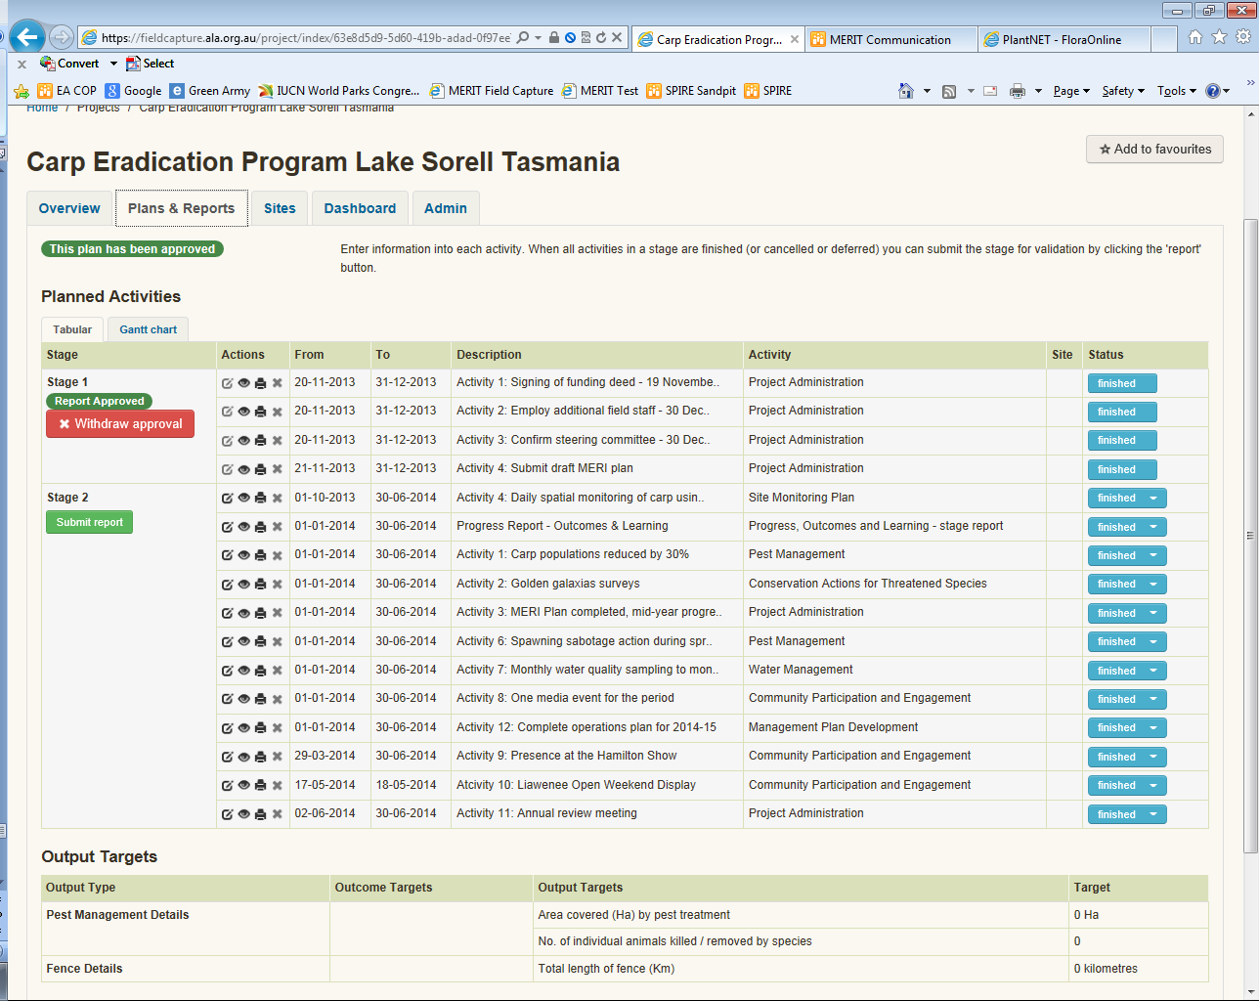button appears in the Stage column of the project’s activities list the day after the last day of the current stage. For most programmes, this is 1 July and 1 January.

1. Start from the Project homepage.

1. Click the **Activities** tab.
2. Scroll to the stage in the activities list you want to report on. The current stage will now be indicated by a 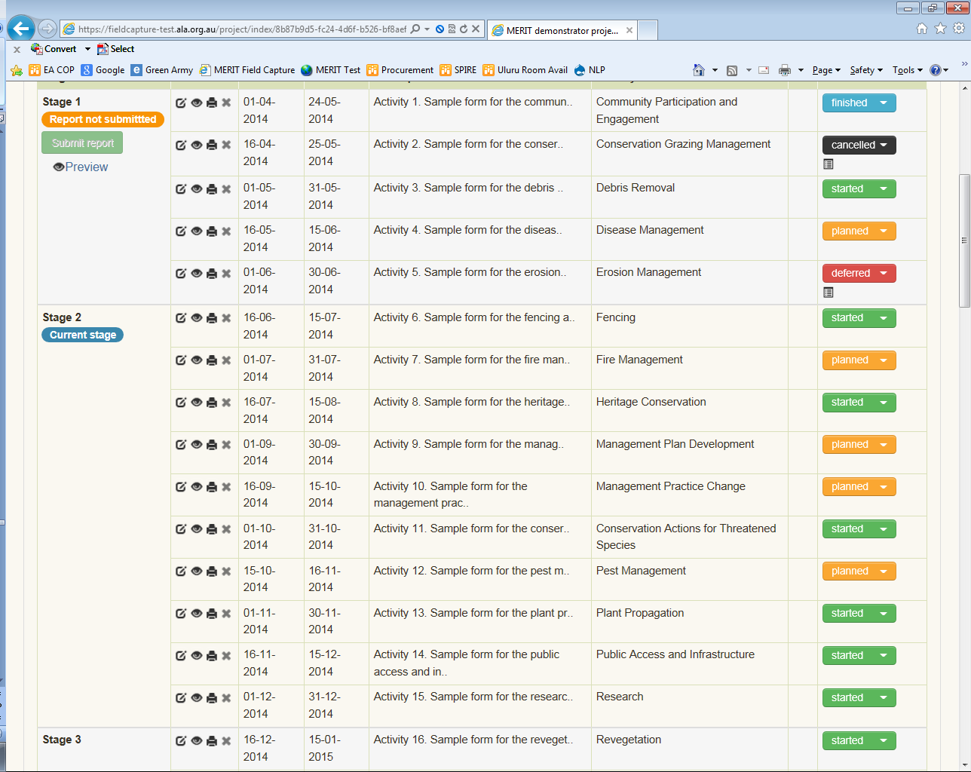 tag.
3. Click 
4. An email is automatically sent to the project’s Grant Manager advising the report is ready to be assessed. The report is locked and no further reporting for that stage can be made.

You have now submitted a report for approval.

Approve/Reject a Project Report

Access Level: ~~Editor~~, ~~Administrator~~, Grant Manager

Can only be completed by a Grant Manager appearing on the list of project members

Phase = 

Start from the Project homepage.

1. Review the report:

1. Click the **Activities** tab.
2. Click  (View) for each activity appearing in the current reporting stage.
3. Click the **Documents** tab. Review any supporting documentation.

2. Record your assessment decision:

1. Click the **Admin** tab, then the **MERI Plan** sub-tab on the left.
2. Click  or .
3. An email is automatically sent to the project’s Administrator/s advising of the decision.
4. If you clicked **Approve**: The report remains locked so no changes can be made.
5. If you clicked **Reject**: the report is unlocked to enable editing.

3. If you clicked **Reject** because an activity is missing, you will also need to ‘unlock’ the project plan so the activity can be added.

1. Click the **Admin** tab, then the **MERI Plan** sub-tab on the left.
2. Click .
3. The plan is now unlocked and the activity can be added to the project plan.

The phase is now:



The process of editing the plan and submitting the plan and report for approval will need to be followed again. Refer to the MERIT Process diagram.

Create/Edit News & Events and Project Stories

MERIT User Guide Reference: [Create/Edit News & Events and Project Stories](http://www.nrm.gov.au/system/files/resources/ecd6d287-56b3-4ea6-a39c-e0f86264369c/files/merit-info-13.pdf)

Access Level: ~~Editor~~, Administrator, Grant Manager

Usually completed by the funding recipient (Administrator only)

1. Start from the Project homepage.

1. Click the **Admin** tab, then either the **News & Events** or **Project Stories** sub-tab on the left.
2. Type your text into the editor (white window). The Preview will show how your text will be displayed on the Overview tab.
3. Click .

Your text will now appear on the Overview tab. **Note**: attach videos to the project homepage via the **Admin**/**Documents** tab.