

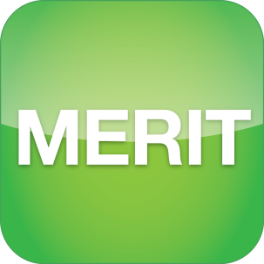

Monitoring, Evaluation, Reporting and Improvement Tool

USER GUIDE

FOR NRM FUNDING RECIPIENTS

AND THE PUBLIC

June 2020

Acknowledgement of Traditional Owners and Country

The Department acknowledges the traditional owners of country throughout Australia and their continuing connection to land, sea and community. We pay our respects to them and their cultures and to their elders both past and present.

© Copyright Commonwealth of Australia, 2016.



The *Monitoring, Evaluation, Reporting and Improvement Tool user guide for NRM funding recipients and the public* is licensed by the Commonwealth of Australia for use under a Creative Commons Attribution 4.0 International licence with the exception of the Coat of Arms of the Commonwealth of Australia, the logo of the agency responsible for publishing the report, content supplied by third parties, and any images depicting people. For licence conditions see: <https://creativecommons.org/licenses/by/4.0/>

This document should be attributed as ‘Monitoring, Evaluation, Reporting and Improvement Tool user guide for NRM funding recipients and the public, version 3, Commonwealth of Australia 2020’.

The Commonwealth of Australia is aware of applying details to identify any content supplied by third parties, using the following format ‘© Copyright’. No third-party material has been used in this guide.

Contents

Introduction 1

ABOUT this Guide 2

MERIT user roles - GENERIC 3

Tools to Help 4

PART A – AN INTRODUCTION TO THE MERIT SYSTEM 5

1. MERIT BASICS 5

1.1 Opening MERIT 5

1.2 Project explorer: Overview 5

1.3 Finding information using ‘Project Explorer’ 6

1.4 Finding information using the ‘Search’ tool 8

2. VIEWING A PROJECT 9

2.1 Opening Project 9

2.2 Viewing Project Details 9

3. VIEWING THE DASHBOARD 11

3.1 Viewing the Program Dashboard 11

PART B – getting started 12

4. NEW USERS: REGISTER AND LOG IN 12

4.1 Register with ALA 12

4.2 Edit your ALA profile 13

4.3 Forgotten password 15

5. LOG IN AND OPEN PROJECTS 16

5.1 Access projects assigned to you 16

6. ADMIN TAB: USER ROLES 17

6.1 Edit the Overview Tab 17

6.2 Edit Project Blog 17

6.3 Edit the MERI Plan Tab 18

6.4 Edit Risks and threats table 18

6.5 Project Access 19

6.5a Add a user to a Project 19

6.5b Add user to the Organisation’s list of projects 20

6.5c Change User Roles 20

6.6 Edit the Documents Tab 21

6.6a Upload a document to MERIT 21

7. Organisation page – Admin Access 23

7.1 Create an organisation 23

7.2 Edit an organisation 23

7.2a Edit organisation details and content 23

7.2b Edit announcements in bulk 24

PART C – EDITING GENERIC SCREENS 25

8. Organisation page 25

8.1 View an organisation 25

9. Overview Screen 27

9.1 Overview tab: edit or add a new blog 27

9.2 Embed a video on the Overview page 28

10. Documents Screen 30

11. Sites Tab: Adding Project Sites 31

11.1 Create a site 31

11.2 Add a new site 32

11.2a Define extent: draw a shape 33

11.2b Define extent: known shape 34

11.2c Define extent: point 34

11.3 Upload sites from shapefile 34

11.3a Download sites as shapefiles. 36

11.4 Add Points of Interest 37

11.5 Manage your sites 38

11.6 Edit a site 38

11.7 View a site 39

11.8 Delete a site from a project 39

12. MERI Plans and Reporting 40

Want more information? 41

Glossary of terms 42

APPENDIX A: MERIT Workflow 44

APPENDIX B: Drawing Tools in the Sites Tab 45

APPENDIX C: Guidelines for taking photographs 47

# Introduction

Organisations and individuals who receive funding from Australian Government Natural Resource Management (NRM) programs are required to report regularly to the Department on the progress of their projects. Reports are submitted using the Monitoring, Evaluation, Reporting and Improvement Tool (MERIT). MERIT is an online reporting system that simplifies and streamlines reporting across Australian Government NRM programs. A workflow of a Project that reports into MERIT is available in APPENDIX A: MERIT Workflow.

MERIT was developed in collaboration with the Atlas of Living Australia (ALA) and aims to provide consistent reporting across all Australian Government NRM programs. The data collected in MERIT is linked to Australia’s biodiversity conservation work and aggregated data is available in publicly accessible dashboards. MERIT also allows increased information sharing within the NRM community and broader public.

For the Australian Government, MERIT allows greater transparency, increased efficiencies and the ability to use project data to directly report on programs and high-level strategies such as Australia’s Biodiversity Conservation Strategy and the State of the Environment Report.

MERIT also aligns with the Australian Government Declaration of Open Government by better enabling public access to government held data on NRM investments. MERIT information available to the public includes:

* MERIT homepage
* Project Explorer page, including the **Map**, **Projects** and **Dashboard** tabs
* **Overview** and **Documents** tabs for individual projects

# ABOUT this Guide

This guide is designed to help NRM funding recipients with the day-to-day use of MERIT while helping members of the public wanting to view the progress of NRM program/s or project/s. The layout of this guide will cover the generic features of MERIT that are applicable across all programs, such as how to create a blog or enter site details. It will work alongside other Parts that are specific to various NRM programs.

* Part A includes an introduction for all users and the public wanting to visit the web tool. Members of the public may refer to this part for instructions on searching for projects and finding data (see 1.3 Finding information using ‘Project Explorer’).
* Part B is designed for registered users who need to log in and get started. It also covers functions that only an Administrator user can perform (in the generic sense).
* Part C will explain generic functions that all registered MERIT users can perform across NRM programs.
* Part D outlines program specific requirements such as for MERI Plans and reports. The image below will highlight which program guides are available in yellow.

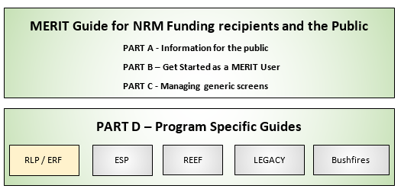

If no extension Guide exists for any of the programs above refer to the LEGACY Guide or contact the [MERIT Team](mailto:MERIT@awe.gov.au).

This guide and chapters, available as individual information sheets, can be found here: <http://www.nrm.gov.au/my-project/monitoring-evaluation-reporting-and-improvement-tool-merit/user-guides>. These documents will be updated as required.

Chapter 6 onwards, of this guide, will assume that you are logged in and have navigated to your project (see chapter 4 NEW USERS: REGISTER AND LOG IN).

# MERIT user roles - GENERIC

There are 4 user roles in MERIT: Administrator, Editor, Grant Manager (departmental officers) and public. Each role determines which functions of MERIT are available to the user.

The table below identifies MERIT functions, covered in this guide, and explains which of them are available to each user role (including the public).

|  |  |  |  |  |  |  |
| --- | --- | --- | --- | --- | --- | --- |
|  | View project overview information | Viewing documents | Dashboard | Sites Tab | Access Admin tab | Assign / edit user roles |
| Public | ✓ | Only documents marked for public view | Via the Project Explorer |  |  |  |
| Editor | ✓ | ✓ | ✓ | ✓ |  |  |
| Administrator | ✓ | ✓ | ✓ | ✓ | ✓ | ✓ |
| **Grant Manager** (departmental officers only) | ✓ | ✓ | ✓ | ✓ | ✓ | ✓ |

Further user roles (such as MERI Plans and Reports) will be listed in program specific guides as they refer to users that manage projects in MERIT (Editors and Administrators).

A table at the start of each chapter indicates the user role required for the functions outlined in the chapter.

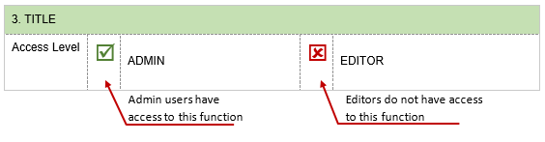

# Tools to Help

|  |  |  |
| --- | --- | --- |
| Resource | Description | Location |
| MERIT Demonstrator Project | This project has been set up in the test environment so that registered users can explore the range of activity forms currently available. Special log in details for this project are noted on the demonstrator project overview page. | <https://fieldcapture-test.ala.org.au>  Copy and paste this link into a Google Chrome browser. This address is deliberately not a link as it directs users to Internet Explorer whereas MERIT operates best in Google Chrome. |
| MERIT Schema | Word document that contains every field description, data use and type for each activity form. It also lists the outputs that are currently used for reporting. | MERIT Help menu  [MERIT resources](http://www.nrm.gov.au/my-project/monitoring-evaluation-reporting-and-improvement-tool-merit/user-guides) on the National Landcare Programme (NLP) website: [www.nrm.gov.au](http://www.nrm.gov.au) |
| Application Programming Interface (API) | The API is for those interested in the technical details behind MERIT, or those wishing to interoperate their local systems with MERIT. | <http://ecodata.ala.org.au/documentation/index> |
| MERIT Ready Reckoner | This ready reckoner is a general version. Please bear in mind that some programs have their own ready reckoners which will supersede this version. | MERIT Help menu  [MERIT resources](http://www.nrm.gov.au/my-project/monitoring-evaluation-reporting-and-improvement-tool-merit/user-guides) on the NLP website: [www.nrm.gov.au](http://www.nrm.gov.au) |
| Activity family tree | A table demonstrating the temporal relationship between activities. | MERIT Help menu  [MERIT resources](http://www.nrm.gov.au/my-project/monitoring-evaluation-reporting-and-improvement-tool-merit/user-guides) on the NLP website. [www.nrm.gov.au](http://www.nrm.gov.au) |
| MERIT FAQs and User Guides | Comprehensive guidance on how to use MERIT. | MERIT Help menu  [MERIT resources](http://www.nrm.gov.au/my-project/monitoring-evaluation-reporting-and-improvement-tool-merit/user-guides) on the NLP website: [www.nrm.gov.au](http://www.nrm.gov.au) |
| MERIT Inbox | Funding recipients should contact their departmental grant manager in the first instance. Contact the MERIT team for further technical support or to provide feedback on MERIT. | [MERIT@awe.gov.au](mailto:merit@environment.gov.au) |

# PART A – AN INTRODUCTION TO THE MERIT SYSTEM

|  |  |  |  |  |  |  |
| --- | --- | --- | --- | --- | --- | --- |
| MERIT BASICS | | | | | | |
| Access Level | ☑ | PUBLIC | ☑ | EDITOR | ☑ | ADMIN |

|  |  |
| --- | --- |
|  | **BROWSER:** MERIT achieves best performance with recent versions of web browsers such as [Google Chrome](http://www.google.com/chrome/). Internet Explorer and older versions of web browsers do not support efficient use of MERIT. |

### Opening MERIT

To open MERIT

1. Open the Google Chrome Browser.

Google Chrome is free to download and is a supported browser of the Department.

1. Copy and paste **https://fieldcapture.ala.org.au/** into the Google Chrome Browser.

|  |  |
| --- | --- |
|  | *This address is deliberately not a link as it directs users to Internet Explorer whereas MERIT operates best in Google Chrome. Please follow the instruction above.* |

1. 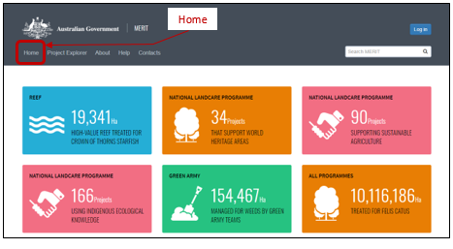This will open the home page of MERIT.

The home page contains summary details and statistics on various MERIT projects. This screen shares information on program statistics.

### Project explorer: Overview

The MERIT Project Explorer contains three topics; **map**, **projects** and **dashboard**. These topics will assist you to filter/find information on your program/project. You don’t have to be a MERIT user to view and search this information. Refer to the next few section ‘Finding information’ below for guidance on searching.

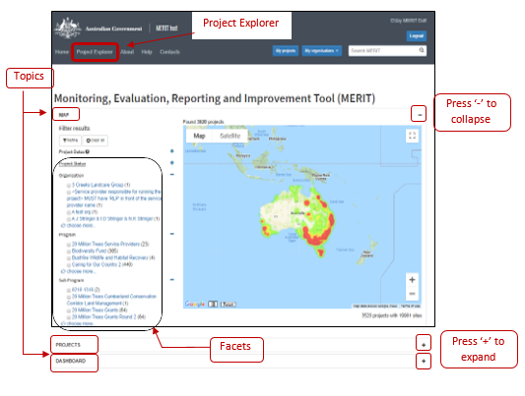

Topics:

|  |  |
| --- | --- |
| Map | Displays the location of projects across Australia or the area you have zoomed in to. You may select a point on the map to open and view project information. |
| Projects | Displays a list projects by name (with latest updated project at the top). Clicking on the project title will display a summary about the project. Click the ‘View Project Page’ to open the project details (see below for Finding Projects in the Project Explorer). |
| Dashboard | Provides a progress summary of project activities based on the filter you choose. |

Facets:

When opening a Topic, Facets appear on the left of the screen to identify filters (e.g. Organisation, Program, Sub-Program, etc). The Facet list displays each heading, followed by a few options. These are used to filter or refine your search.

### Finding information using ‘Project Explorer’

1. Click the ProjectExplorer link. Choose a **Topic** from the list by clicking .
2. To view the full list of options for each facet’s heading, select the  button, below the relevant list, to expand it.

The following options will be available to assist you in choosing the filter you need.



1. Once you are ready, you may select:
2. an individual name to directly refine your filter, or
3. multiple tick boxes and click the refine button to filter the options.
4. Your search results will display in the relevant topic. Below is an example of search results in Project Explorer.

|  |
| --- |
| Sample search results in project explorer.  You wish to look up Projects funded under Regional Land Partnership program and delivered by Port Philip Westernport Catchment Management Authority.   * + - * 1. Open the ‘Projects’ filter.         2. Scroll to the ‘Program’ filter and click the ‘National Landcare Programme’ link.         3. Scroll to the ‘Sub Program’ filter and click the ‘Regional Land Partnerships’ link.         4. Scroll to the ‘Organisation’ filter and click ‘Port Phillip and Westernport CMA’. You will need to click the ‘choose more’ button to open the full list of organisations. The list can be sorted alphabetically.   Your search results in Project Explorer will display the following: |
|  |

### Finding information using the ‘Search’ tool

1. Type your search term into the search bar.  Hint: add double quotation marks to narrow your search to an exact phrase, e.g. “Recovery Plan”.
2. Click  button or press the enter key to activate the search. Your results for the relevant topic will display. These results will display any project that has mentioned the search term in their activities, project titles, descriptions or organisations.

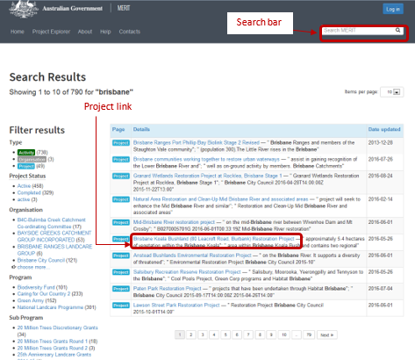

1. Click on the project link to go to the project page.

|  |  |  |  |  |  |  |
| --- | --- | --- | --- | --- | --- | --- |
| VIEWING A PROJECT | | | | | | |
| Access Level | ☑ | PUBLIC | ☑ | EDITOR | ☑ | ADMIN |

### Opening Project

The following information will appear if you are searching for a project via Project Explorer or MERIT’s main Search Bar. Once you’re able to locate your project

1. Click on the Project link to open a summary containing the project name, organisation name & description.

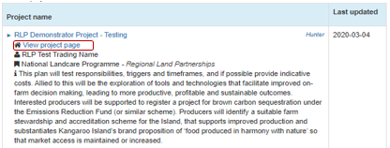

1. Click ‘View project page’ to open the project.

### Viewing Project Details

When you click to ‘View project page’ MERIT will open the project details and direct you to the project’s overview page. Some programs may also allow you to view information relating to the Management Unit. These program guides are explained in ‘ABOUT this Guide’. Use the [NRM MERIT Website](http://www.nrm.gov.au/my-project/monitoring-and-reporting-plan/merit) to choose the relevant Program Specific Guide (listed on the right hand side – Under ‘Find MERIT Guidance for:’).

The screens below are available to all users or visitors of MERIT:

1. 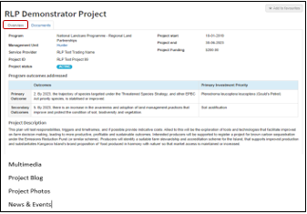Overview Tab: contains the following subject matter.
2. 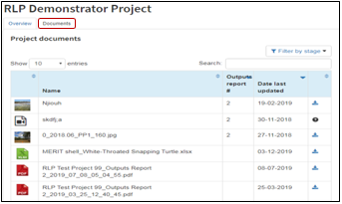Documents Tab: contains documents the Service Provider has added to this public view.

|  |  |  |  |  |  |  |
| --- | --- | --- | --- | --- | --- | --- |
| VIEWING THE DASHBOARD | | | | | | |
| Access Level | ☑ | PUBLIC | ☑ | EDITOR | ☑ | ADMIN |

### Viewing the Program Dashboard

This chapter looks at viewing aggregated information based on programs or outputs in MERIT. The dashboard extracts information from progress reports approved by the Department of Agriculture, Water and the Environment. While efforts are made to ensure the accuracy of the ecological information contained in MERIT, please contact the Department at [merit@awe.gov.au](mailto:merit@awe.gov.au) for confirmation of authoritative data.

1. 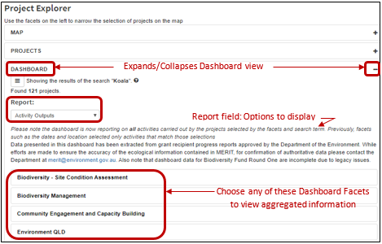In the **Project Explorer** link, expand the ‘Dashboard’ from the list of Topics by clicking . The following will be displayed.
2. The ‘Report’ field works as its own facet and will display aggregated information below it by the following options when clicking the dropdown arrow.

|  |  |
| --- | --- |
| Report Options | Displays |
| Activity Outputs | Activities and programs. Before picking an option below this dropdown, you may enter a term in the Search bar to show relevant data. |
| Announcements | A table of announcement, similar to the Projects Topic (where Project ID’s and names reside). |
| Outputs Targets by Programme | A table of Output target measures for the Biodiversity Fund rounds. |
| Reef 2050 Plan Dashboard | Progress on Reef 2050 Plan for the selected period.  This report ignores any other facet selection you may have made. |

# PART B – getting started

|  |  |  |  |  |  |  |  |  |
| --- | --- | --- | --- | --- | --- | --- | --- | --- |
| NEW USERS: REGISTER AND LOG IN | | | | | | | | |
| Access Level | ☒ | Public | ☑ | Editor | ☑ | Admin | ☑ | Grant Manager |

IMPORTANT: Information from here-on will only advise users who manage project/s in MERIT.

|  |  |
| --- | --- |
|  | **BROWSER:** MERIT achieves best performance with recent versions of web browsers such as [Google Chrome](http://www.google.com/chrome/). Internet Explorer and older versions of web browsers do not support efficient use of MERIT. |

### Register with ALA

People who are required to use MERIT must first register with the ALA.

1. Copy and paste **https://**[**fieldcapture.ala.org.au**](https://fieldcapture.ala.org.au/) into the Google Chrome browser.

|  |  |
| --- | --- |
|  | *This address is deliberately not a link as it directs users to Internet Explorer whereas MERIT operates best in Google Chrome. Please follow the instruction above.* |

This will open the MERIT log in page.

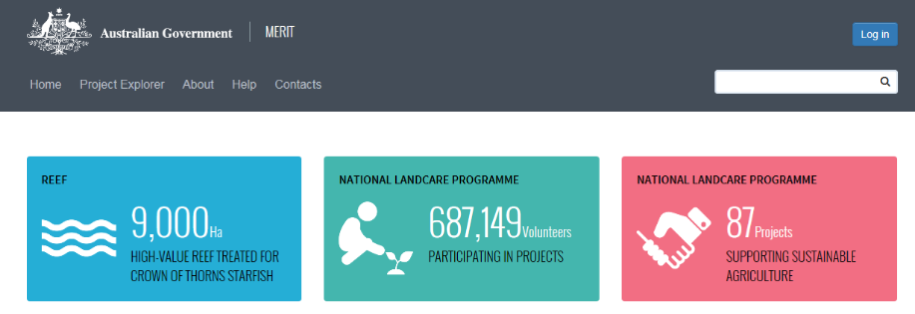

Click **Log in**. This will redirect you to the ALA webpage ([www.ala.org.au](http://www.ala.org.au)) where you are able to register and update details previously entered.

1. 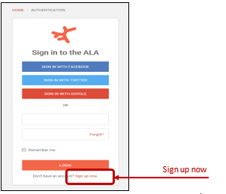Click **Sign up now** at the bottom of the screen. The *Create your account* page opens.

Complete the information requested. Your password must be at least 8 characters.

1. Click the **Create account** button at the bottom of the page. An email will be sent to your email inbox from the ALA.

|  |  |
| --- | --- |
|  | **Tip:** Check your junk email folder if you haven’t received an email within 24 hours. Contact the MERIT team at [MERIT@awe.gov.au](mailto:merit@environment.gov.au) if you are having difficulties. |

1. To activate your account, click on the link in the email and follow the instructions provided. You are now registered with ALA.
2. Advise the relevant contact (see below) that you have registered with ALA and they will add you to the project in MERIT:

If you require Admin access, contact another person in your organisation who already has Admin access to the project or your departmental Project Manager.

If you require Editor access, you may contact someone in your own organisation who currently is an Administrator for the project.

### Edit your ALA profile

Follow these instructions to update your ALA profile (e.g. username, password, email).

1. Copy and paste **https://**[**fieldcapture.ala.org.au**](https://fieldcapture.ala.org.au/) into the Google Chrome browser. This will open the MERIT log in page.

|  |  |
| --- | --- |
|  | *This address is deliberately not a link as it directs users to Internet Explorer whereas MERIT operates best in Google Chrome. Please follow the instruction above.* |

1. Click **Log in** button (in the top right-hand corner). This action will open the ALA login page where you are able to register, and update details previously entered.
2. 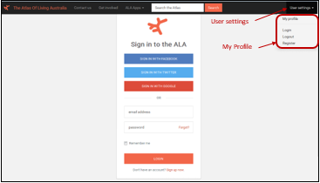Click **User settings** then **My profile** located at the top right-hand corner of the page.
3. Enter the email address and password you used to register with ALA.
4. Click **Log in**. Your ALA Profile Home Page will open.
5. Click the **Update your profile** link. This page displays the information you used to register with ALA.

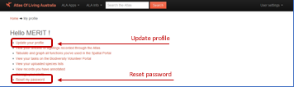

1. Edit the information as necessary and click **Update account**.
2. Click **Reset my password** if you wish to change your password.

### Forgotten password

If you have forgotten your ALA password:

1. 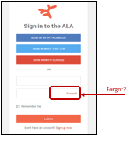Click the **Forgot?** link on the ALA login page (refer to 4.1 Register with ALA).
2. Follow the instructions provided. A password reset email will be sent to your email inbox. Remember to check your junk email folder if necessary.

|  |  |
| --- | --- |
|  | If you have issues logging in, please contact your departmental grant manager or [MERIT@awe.gov.au](mailto:merit@environment.gov.au). |

|  |  |  |  |  |  |  |
| --- | --- | --- | --- | --- | --- | --- |
| LOG IN AND OPEN PROJECTS | | | | | | |
| Access Level | ☑ | Editor | ☑ | Admin | ☑ | Grant Manager |

Once you have registered and have access to your project/s, you can log in and start using MERIT. There are three ways to access MERIT:

1. Copy and paste https://fieldcapture.ala.org.au/ into Google Chrome.

|  |  |
| --- | --- |
|  | *This address is deliberately not a link as it directs users to Internet Explorer whereas MERIT operates best in Google Chrome. Please follow the instruction above.* |

1. Via ‘ALA **Apps’** on the ALA website <https://ala.org.au>
2. Click on **the** link to the MERIT home page via the NLP website <http://www.nrm.gov.au/my-project/monitoring-and-reporting-plan/merit>.
3. 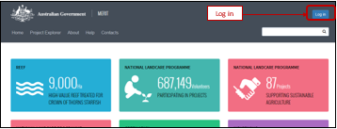Click **Log in** on the MERIT home page. The ALA login page will open.
4. Enter the email address and password registered with ALA. Click **Log in**.

### Access projects assigned to you

1. 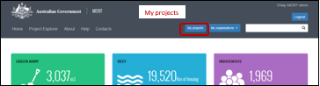After logging in, click **My projects** to view projects you have access to.
2. Select the Project Link you wish to view.

If you can’t see your project/s on the ‘**My Projects**’ list, it means you have not been added to the project/s. Contact your project administrator or departmental grant manager as outlined in 4.1 Register with ALA (step 7). Refer to 6.5a Add a user to a Project for further instructions.

|  |  |  |  |  |  |  |
| --- | --- | --- | --- | --- | --- | --- |
| ADMIN TAB: USER ROLES | | | | | | |
| Access Level | ☒ | Editor | ☑ | Admin | ☑ | Grant Manager |

This section refers to a few extra functions that only Administrators and Grant Managers (see MERIT user roles - GENERIC) have access to and can perform. Editors cannot see this tab.

The screens available in the **Admin** tab include:

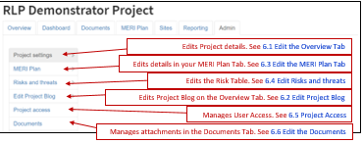

### Edit the Overview Tab

Project information in the **Overview** tab (as displayed in image below) can only be edited by the MERIT Team. Administrator users must forward an email to their Departmental Grant Manager to manage the update of these details.

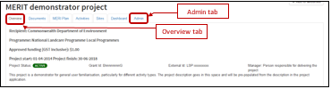

### Edit Project Blog

|  |  |  |  |  |  |  |
| --- | --- | --- | --- | --- | --- | --- |
| Access Level | ☑ | EDITOR (partial) | ☑ | ADMIN | ☑ | Grant Manager |

The Project Blog feature enables funding recipients to publish news and events, project stories and photos that they want to share with the general public. Project stories may include summaries of progress reports and project outcomes to date. There are two ways to access the blogs screen:

1. **Overview** Tab - Available to editors (See 9.1 Overview tab: edit or add a new blog). It will allow them to add or edit only.
2. **Admin** Tab - is only available to Admin Users or Grant Managers (See
3. MERIT user roles). It enables them to add/edit/delete any blogs.
4. 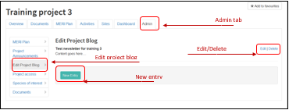Click the **Admin** tab then ‘Edit Project Blog’ button. Click ‘New Entry’ or ‘Edit/Delete’.
5. Add the blog entry as per section 9.1 Overview tab: edit or add a new blog
6. Click the Edit/Delete button on a row to update or delete those details.

No confirmations appear when this action is performed so please be careful.

### Edit the MERI Plan Tab

MERI Plans can differ across NRM programs. This information is briefly covered in Chapter 12 MERI Plans and Reporting of this guide. For program specific details please see ‘ABOUT this Guide’. Use the [NRM MERIT Website](http://www.nrm.gov.au/my-project/monitoring-and-reporting-plan/merit) to choose the relevant Program Specific Guide (listed on the right hand side – Under ‘Find MERIT Guidance for:’).

### Edit Risks and threats table

|  |  |  |  |  |  |  |
| --- | --- | --- | --- | --- | --- | --- |
| Access Level | ☒ | EDITOR (partial) | ☑ | ADMIN | ☑ | Grant Manager |

This table details the risks and threats specific to the project and the mitigation strategies being used to address them. Risks identified should be those that the Service Provider considers to be within their remit to anticipate and manage. This screen may be updated at any time and should be reviewed prior to submitting your reports (at least every six months).

Please discuss any changes to project risks and threats with your Departmental Grant Manager as part of ongoing project management conversations.

1. Ensure you are logged in and navigate to the ‘Admin’ Tab
2. Choose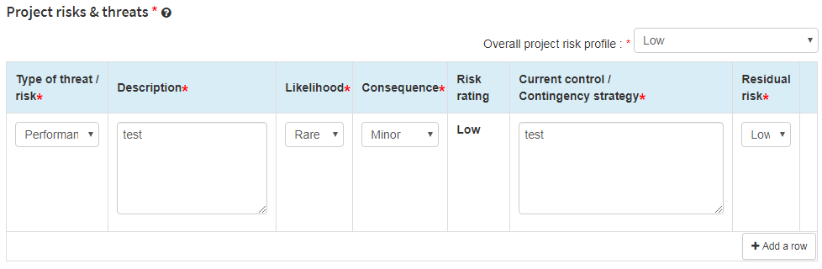 Project risks & threats from menu (left side of screen).
3. Fill out the fields as required.
4. To add a type of threat/risk, click the  button.
5. To edit a type of threat/risk, users may edit the field and save.
6. To delete a type of threat/risk, click the ‘x’ at the end of the row.
7. Review the project risks and threats table and update the overall project risk profile, if required.

|  |  |
| --- | --- |
|  | Press the ‘Save changes’ button as you fill out the form to avoid losing information. |

### Project Access

Admin users can provide colleagues with access (either Administrator or Editor roles) to projects in MERIT. See below for instructions on adding an individual user projects, or refer to 6.5b Add user to the Organisation’s list of project to add users to all of an organisation’s projects.

|  |  |
| --- | --- |
|  | Editor and Administrator user roles in MERIT have different levels of access, as shown below: |

People who are required to use MERIT must first register with the ALA before they can access projects (refer to 4 NEW USERS: REGISTER AND LOG IN).

#### Add a user to a Project

1. Click the **Admin** tab on your project page.
2. 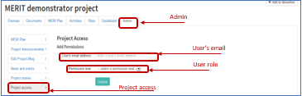Click the **Project Access** sub-tab on the left of the screen. A list of MERIT users who already have access to the project will be displayed.
3. Enter the user’s email address (that they used to registered in MERIT).
4. From the dropdown menu, choose the user role you wish to give them (editor or administrator).
5. Click **Submit**. The user will be added to the bottom of the list of project members.

|  |  |
| --- | --- |
|  | If you receive a message that the email address did not match a registered user, follow the prompts to either correct the email address entered or ask your colleague to register to use MERIT (refer to 4 NEW USERS: REGISTER AND LOG IN.) |

Advise the user they have access to the project. The project will appear on the list when they click **My Projects** on the MERIT home page.

#### Add user to the Organisation’s list of projects

Organisation administrators can add, remove or edit MERIT users for all projects managed by their organisation.

1. Click the organisation’s ‘Admin’ tab.
2. Enter the MERIT user’s email address and the required permission level then click Submit. Edit user roles or delete users as necessary.
3. Advise the MERIT user that they have been added or had their user role changed or deleted.

#### Change User Roles

|  |  |  |  |  |  |  |
| --- | --- | --- | --- | --- | --- | --- |
| Access Level | ☒ | Editor | ☑ | Admin | ☑ | Grant Manager |

As the administrator, you can change or revoke the user roles of people with access to your project/s in MERIT.

1. Click the **Admin** tab on your project’s home page.
2. 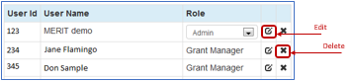Click the **Project Access** sub-tab on the left of the screen. A list of users with access to the project in MERIT will be displayed.
3. To change the user role for an existing user, click the edit button  next to their name. This displays a dropdown menu under the ‘Role’ column.
4. From the dropdown menu, choose the user role you wish to give them (editor or admin). Refer to for different functions available to each role.
5. Advise the person that you have changed their user role. When they next log in to MERIT, their access to the project will reflect the role you have assigned them.
6. To delete a project member, click the **X** in the last column.

|  |  |
| --- | --- |
|  | If your changes are not displaying straight away, refresh your browser (e.g. F5 key for Google Chrome). |

### Edit the Documents Tab

|  |  |
| --- | --- |
|  | All document formats are accepted for uploading into MERIT. |

#### Upload a document to MERIT

The documents screen can only be uploaded/edited via the ‘Documents’ button in the Admin Tab.

1. Click the ‘Admin’ tab on the Project home page.
2. Click the ‘Documents’ sub-tab on the left of the screen.

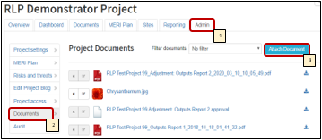This will generate a list of documents that are available in the Project Blog, Documents Tab, and some programs may also have information attached in their reports. Refer to the relevant Program Specific Guide to check whether they attach any other types of documents (see ABOUT this Guide). Use the [NRM MERIT Website](http://www.nrm.gov.au/my-project/monitoring-and-reporting-plan/merit) to choose the relevant Program Specific Guide (listed on the right hand side – Under ‘Find MERIT Guidance for:’).

1. 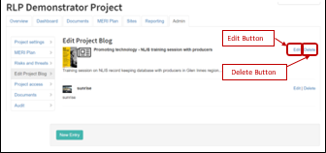Click the ‘Attach Document’ button to add information, images & Videos to the ‘Documents’ Tab. Most information on attaching documents will be identical to Section 9.1 Overview tab: edit or add a new blog. Further information on adding videos is available below in 9.2 Embed a video on the Overview page.
2. Click over the Edit word in ‘Edit/Delete’ to change details. The following dialog box will appear to allow the user to update details. Press the ‘Save’ button once it is ready.

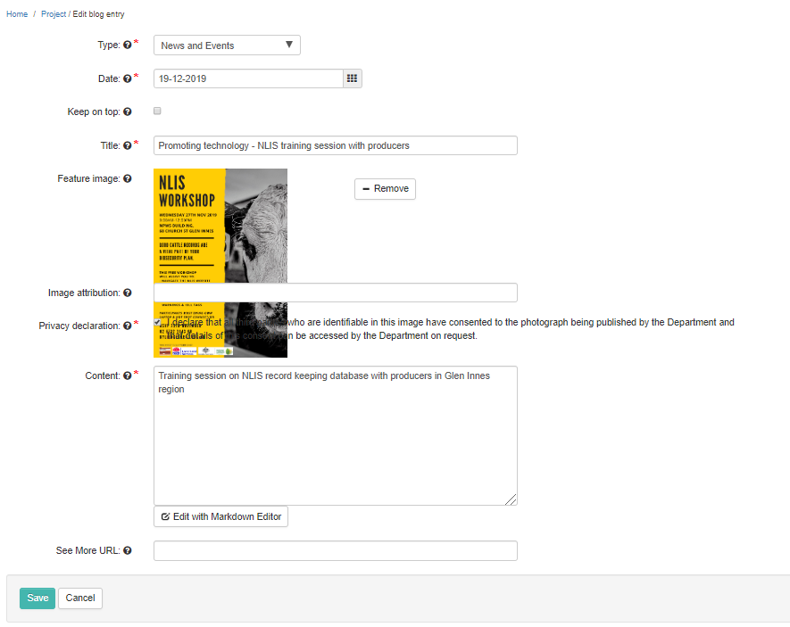

1. Click over the Delete word in ‘Edit/Delete’ to delete any attachment.

*No confirmations appear when this action is performed so please be careful.*

|  |  |  |  |  |  |  |
| --- | --- | --- | --- | --- | --- | --- |
| Organisation page – Admin Access | | | | | | |
| Access Level | ☒ | Editor | ☑ | Admin | ☑ | Grant Manager |

Organisations page sits outside of project information and allows organisation members to view all Commonwealth funded NRM projects, sites and a dashboard associated with the organisation. Through this page, administrators can also edit organisation details, create bulk announcements for all projects and manage user roles across all their projects.

This section will cover Functions that only an Admin user can perform. Further details (that may be carried out at any MERIT User level) about the organisation page will be explained in Section 8 Organisation page.

|  |  |
| --- | --- |
|  | The Department will add an ‘organisation administrator’ when an organisation page is created. The organisation administrator will be able to view and edit the organisation page. The organisation administrator can also nominate other project members to view and/or edit the organisation’s projects. See section 6.5b Add user to the Organisation’s list of project for additional information. |

### Create an organisation

Project administrators can request the creation of an organisation page. Please send the request to the MERIT inbox: [MERIT@awe.gov.au](mailto:merit@environment.gov.au). The Department will add an organisation administrator to the newly created organisation page.

### Edit an organisation

Only organisation administrators can edit their organisation’s page.

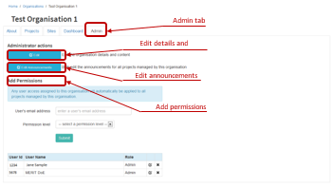

#### Edit organisation details and content

1. Click the organisation **Admin** tab.
2. Under Administrator actions, click the **Edit** button.
3. Enter information about your organisation as required.

#### Edit announcements in bulk

Use this function to view, add or edit announcements in bulk for your organisation’s projects. Project announcements can only be made if a MERI Plan has been approved by the grant manager.

1. Click on the organisation’s admin tab.
2. Click the **Edit announcements** button.
3. Edit existing announcements by selecting a table cell.
4. To add a new announcement for a project, use the **+** button in the last column.
5. 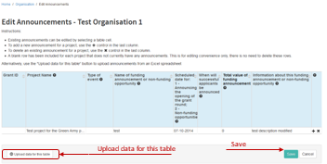To delete an existing announcement for a project, use the **X** button in the last column.

|  |  |
| --- | --- |
|  | A blank row has been included for each project that does not currently have announcements. This is for editing convenience only. There is no need to delete the blank row. |

1. To upload announcements from an Excel spreadsheet, click **Upload data for this table**.
2. Click **Step 1 -** **Download template**. Excel is opened in another window.
3. Complete the table, entering one announcement per row.
4. Save the template as you normally would for an Excel document.
5. Navigate back to MERIT.
6. Click Step 2 - Upload populated template. Navigate to the template document you saved in Step C and click open.
7. The table within MERIT should now be populated with the data entered into the Excel template.
8. **C**lick **save**.

All project announcements will appear on the organisation dashboard tab, under the ‘report’ dropdown list. Project announcements will also appear on the **Admin** tab of the relevant projects (refer to the [legacy program Guide](http://www.nrm.gov.au/my-project/monitoring-and-reporting-plan/merit) for more information on announcements at the project level).

# PART C – EDITING GENERIC SCREENS

|  |  |  |  |  |  |  |
| --- | --- | --- | --- | --- | --- | --- |
| Organisation page | | | | | | |
| Access Level | ☑ | Editor | ☑ | Admin | ☑ | Grant Manager |

The Organisations page sits outside of project information and allows organisation members to view all Commonwealth funded NRM projects, sites and a dashboard associated with the organisation. The editing functions are only available to Administrators.

The organisation page can be found in the Black banner.

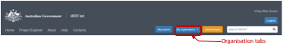

### View an organisation

1. Click  at the top of the screen.
2. If you have admin or editor access for an organisation page, your organisation will appear on the dropdown list. Select your organisation to continue.
3. If your dropdown list is empty, click the **find an organisation here** link to open the full list of organisations currently available.
4. Search for an organisation by entering its name in the organisation search tool 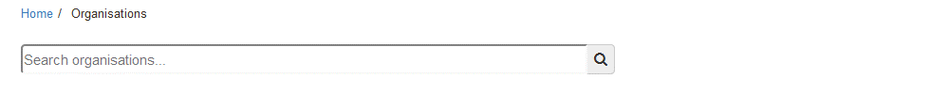

Alternatively, scroll to the bottom of the page and click the arrow buttons to search through the full list.

1. Open the organisation page. The following tabs will be displayed: **About**, **Reporting, Projects**, **Sites**, **Dashboard** and **Admin**. Only ‘organisation admin’ users will be able to see the Admintab.

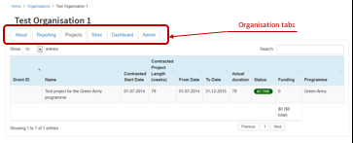

|  |  |
| --- | --- |
| Tab | Description |
| About | Information about the organisation. Minimum information required is organisation name and description. Can also include an acronym, website URL, link to social media, organisation logo and feature graphic. |
| Reporting | Only NRM regions have this tab. Performance management framework and self-assessments are completed via this tab. |
| Projects | A list of all projects the organisation is responsible for in MERIT. Also includes a total funding amount for the organisation. |
| Sites | Displays all project sites on a map. |
| Dashboard | Displays data from project reports submitted by the organisation and approved by the Department. Also displays announcements (viewable by organisation administrators only). The dashboard will only display if more than one project exists for the organisation. |
| Admin | Only visible to organisation administrators. Organisation administrators can edit the organisation details, create bulk announcements for all projects managed by the organisation, add MERIT users to all projects managed by the organisation (and change user role). |

|  |  |  |  |  |  |  |
| --- | --- | --- | --- | --- | --- | --- |
| Overview Screen | | | | | | |
| Access Level | ☑ | Editor (partial) | ☑ | Admin | ☑ | Grant Manager |

The overview screen is mainly a viewing screen. This enables the user to see the Project Title, recipient or organisation name and other details. Information contained at the top of this screen can only be edited by the Department’s MERIT Team (See 6.1 Edit the Overview Tab).

### Overview tab: edit or add a new blog

The Project Blog is the only item that can be edited, directly from the Overview page, by any of the three user levels above. It enables funding recipients to publish news and events, project stories and photos that they want to share with the general public. Project stories may include summaries of progress reports and project outcomes to date.

There are two ways to add blogs:

1. **Overview** Tab - Available to editors. It will allow them to add / edit only.
2. **Admin** Tab - is only available to Admin users or Grant Managers users (See). It enables them add/edit/delete any blogs (These users should refer to 6.2 Edit Project Blog).
3. 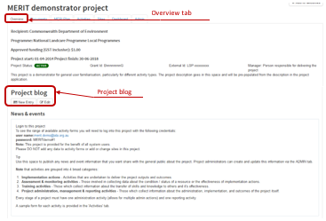On the project **Overview** tab, scroll to the **Project Blog** section and click either **New Entry** or **Edit**.

The following dialog box will appear.

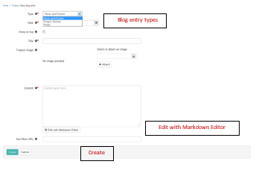

1. Select the type of blog entry you wish to create (News and Events, Project Stories or Photos) and complete the required information.
2. You can format your text in the ‘Content’ box by clicking ‘Edit with Markdown Editor’. A pop‑­up box will appear.Type your text into the blog content box and click ‘done’.

|  |  |
| --- | --- |
|  | MERIT uses Markdown Syntax for formatting plain text. It is a simple HTML text editor for basic formatting and is different to Microsoft Word. Rather than typing out a passage then adding formatting afterwards with mouse clicks and formatting tools like buttons and dropdowns, Markdown allows a writer to use a very simple set of symbols to denote the desired format of the text. Click the  for examples or search for further Markdown Syntax guidance online. |

1. Click the Attach’ button to add information, images & Videos. Further information on adding videos is available below in 9.2 Embed a video on the Overview page.
2. Click **Create** when you have entered the blog. Your entry will appear on the **Overview** tab.

### Embed a video on the Overview page

Videos relevant to your project that are hosted on YouTube, Vimeo, TED and Wistia can be embedded on the **Overview** tab of your project.

1. Follow steps 1-4 in section ‘9.1 Overview tab: edit or add a new blog’ above, choose ‘Embedded video’ from the ‘Document type’ dropdown list, and paste in the code for the video.
2. Navigate to the website hosting the video you wish to embed on the overview tab.
3. Obtain Video Code.

|  |  |
| --- | --- |
|  | This step ‘obtain the video code’ may have various methods (depending on the source of the video). If these instructions do not find a video CODE, please contact the [MERIT Team](mailto:MERIT@awe.gov.au). |

The code for the MERIT workflow video should be similar to this:

<iframe width="560" height="315" src="https://www.youtube.com/embed/LB2mtec7Uwo" frameborder="0" allowfullscreen></iframe>

**OPTION A**

Open the video.

Pause the video.

Click the ‘share’ or ‘embed’ button and copy the CODE associated with the video.

**OPTION B**

Open your video.

Pause the video.

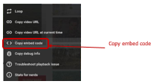Right clicked anywhere on the screen. It will bring up a menu:

Click on “Copy embed code”.

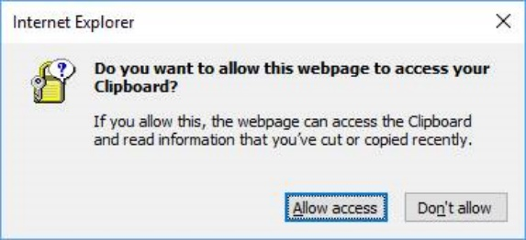The message below appears:

1. Click allow access and then open a BLANK WORD document.
2. Paste the address into word (for safe holding until you navigate into MERIT).

<iframe width="640" height="360" src="https://www.youtube.com/embed/zcSUQeF3qIs" frameborder="0" allow="accelerometer; autoplay; encrypted-media; gyroscope; picture-in-picture" allowfullscreen></iframe>

1. Return to MERIT to paste your video CODE into the ‘Embed video’ field and fill out the rest of the dialog box.

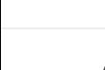

1. Click **Save**.
2. The video may take a few seconds to appear as a thumbnail on the **Documents** tab and will appear on the **Overview** tab if you selected the ‘make this document public’ option from the pop-up window.

|  |  |  |  |  |  |  |
| --- | --- | --- | --- | --- | --- | --- |
| Documents Screen | | | | | | |
| Access Level | ☒ | Editor | ☑ | Admin | ☑ | Grant Manager |

MERIT Users may submit attachments to demonstrate the delivery of their Project.

This Document Tab is only a viewing screen. It will display document links that, if chosen to, can be made available to the public. Examples include (but are not limited to) Program logics, plans, surveys, flyers, photos, videos and sound bites. These types of attachments are added at the project level via the Admin Tab and may only be edited by someone with Administrator access (See Section

Edit the Documents).

|  |  |  |  |  |  |  |
| --- | --- | --- | --- | --- | --- | --- |
| Sites Tab: Adding Project Sites | | | | | | |
| Access Level | ☑ | Editor | ☑ | Admin | ☑ | Grant Manager |

Adding site information to a project gives spatial reference to the data contained in MERIT. Spatially accurate data is more useful for analysis and informing both management and investment decisions.

It is important to create Sites and points of interest (POIs) in the Sites Tab. Sites can be created under this Tab at any time. For information on Drawing Tools see APPENDIX B: Drawing Tools in the Sites Tab.

In some programs, such as Regional Land Partnerships (RLP) & Environment Restoration Fund (ERF), Sites, that are created in the Sites tab, will transport to the reporting screens and enable users to select and/or edit their sites directly in the **Reporting** Tab for that period. For more information on using sites in reports/activities please see extension guides for those programs (see ‘ABOUT this Guide’). Use the [NRM MERIT Website](http://www.nrm.gov.au/my-project/monitoring-and-reporting-plan/merit) to choose the relevant Program Specific Guide (listed on the right hand side – Under ‘Find MERIT Guidance for:’).

|  |  |
| --- | --- |
|  | Sites created with the mapping tool in your NRM funding application form are automatically imported into MERIT. Use the instructions in this section to add new or modify your existing sites in MERIT. |

### Create a site

Currently, only one site can be assigned to an activity form.

1. 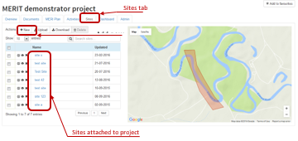Click the **Sites** tab on your project page. Sites already added to the project are on the left of the screen. They are also indicated on the map.

There are three ways you can add a site to a project:

1. 11.2 Add a new site: use MERIT’s GIS tool to create a new site.
2. 11.3 Upload sites from shapefile: upload a shapefile created in other GIS software.
3. directly enter a point. Mainly used for structures of photo-points.

### Add a new site

1. Click the **+New** button.
2. Complete the free text fields and dropdown lists. There are three ways to define the extent of the site:
3. draw a shape,
4. known shape,
5. or point.

#### Define extent: draw a shape

1. 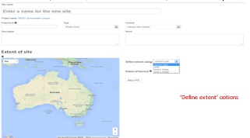On the map of Australia, zoom in to the area where your site is located.

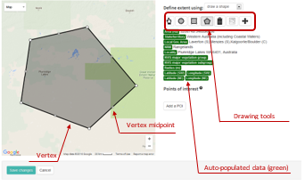Choose a tool and draw your shape. See ‘APPENDIX B: Drawing Tools in the Sites Tab’ for assistance with using the drawing tools.

|  |  |
| --- | --- |
|  | If you have an activity form that aggregates data across multiple field sites, draw one polygon that encompasses all of the sites. Add points of interest (POIs) to represent the location of each field site (see 11.4 Add Points of Interest) |

1. Click **Save changes**. The site will be added to the project’s list of sites and the map.

#### Define extent: known shape

Try to avoid using ‘known shapes’ as sites. Choosing an entire NRM region as a site, for example, does not allow a precise indication of activity location.

1. Choose a layer from the dropdown list: NRM, IBRA 7 Region, IBRA 7 Subregion, Australian State or Local Government Area.
2. Choose a shape from the dropdown list.
3. The data highlighted in green will be automatically populated according to the layer and shape chosen. The map will zoom to show the extent of the shape.
4. Click Save changes.
5. The site will be added to the project’s list of sites and map.

#### Define extent: point

**1.** If you know the latitude and longitude of your site (in decimal degrees), enter them into the respective text boxes. Don’t forget to include the minus (-) with the latitude. If you don’t know the latitude and longitude, enter -35 latitude and 150. This will add a point to your map.

**2.** Click on the map. The data highlighted in green will be automatically populated according to the location of the point. The map will zoom to show the point, which is indicated with a red locator icon.

**3.** Use the zoom function (bottom right of map) and click/drag the locator icon to refine the position of the point. Your mouse cursor will change to a hand symbol, allowing you to click and drag.

**4.**  Click **Save changes**. The site will be added to the project’s list of sites and the map.

### Upload sites from shapefile

You can add a site to a project by uploading a shapefile generated with GIS software. A site may have multiple polygons or POIs if these are uploaded as a shapefile document. Note that MERIT only recognises points or polygons, not lines.

|  |  |
| --- | --- |
|  | Shapefiles  MERIT recognises shapefiles in a range of formats (coordinate reference systems).  A complete shapefile consists of a .shp file and a set of component files (e.g. .sbx, .pjr, .dbf etc). The software used to create the shapefile determines the number and type of component files.  MERIT requires the complete shapefile, including all component files, to be uploaded in order for it to display properly. To do this, zip the complete shapefile (the .shp plus all of the component files) into a single file and upload into MERIT.  A site shapefile can comprise multiple polygons or points, each representing a site in the field. This may be useful if your activity form aggregates data across multiple field sites. Select the appropriate saving method in your GIS software depending on whether you want the upload to MERIT to consist of one site comprising many polygons (Option A in the diagram below) or multiple unique sites (Option B).    It is a good idea to name (label) each feature prior to uploading into MERIT. Otherwise, MERIT will display the shapefile as multiple unidentified polygons/points. |

1. Click the **Sites** tab on your project page.
2. Click the **Upload** button.
3. Click the **Browse** button and navigate to the file location.
4. Select the zipped shapefile, then click **Open** (all component files in zip format – see above).
5. Click Upload Shapefile.

If your shapefile consists of single or multiple polygons representing one site (Option A in the diagram on the previous page), it will be added to the project’s list of sites and map.

If your shapefile consists of multiple polygons that are to be uploaded as multiple unique sites (Option B in the diagram on the previous page), the following screen will be opened.

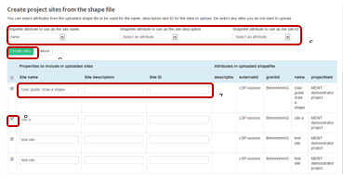

Steps 6 to 9 are indicated in the above diagram.

1. Choose the attribute you wish to use as the site name, site description and site ID from the relevant dropdown lists (if already defined when the shapefile was created in your GIS software).
2. Alternatively, type a site name, description and ID into the text boxes for each site.
3. De-select any sites you do not wish to upload by un-ticking the box next to the relevant site.
4. Click Create sites. The shapefile you chose will be added as multiple unique sites to the project’s list of sites and map.

#### Download sites as shapefiles.

You can download all your sites from MERIT as a shapefile to use with your GIS software.

1. Click the **Sites** tab on your project page.
2. Click the **Download** button.
3. The shapefile downloads as a zip file and can be saved and opened on your computer as required.

### Add Points of Interest

|  |  |  |  |  |  |  |
| --- | --- | --- | --- | --- | --- | --- |
| Access Level | ☑ | Editor | ☑ | Admin | ☑ | Grant Manager |

Points of Interest (POIs) can be added to sites and are most commonly used to record the location of photo-points. Photo-points can provide a visual representation of vegetation change over time.

|  |  |
| --- | --- |
|  | POIs cannot be uploaded from an existing shapefile or spreadsheet. |

Refer to **Error! Reference source not found.** for more information on photo-point photos.

1. Click the **Sites** tab on your project page.

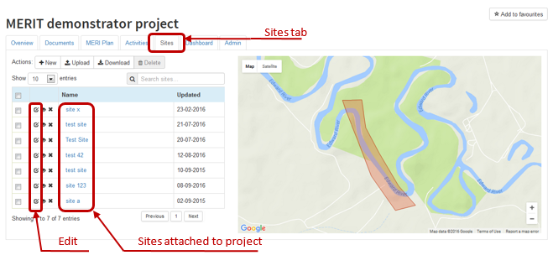

1. Either click **Edit**  for an existing site or **+New** for a new site (refer to 11.2 Add a new site).
2. Scroll to the bottom of the page and click **Add a POI** in the Points of Interest box.
3. Fill in the free text boxes and choose **photo-point** from the point type dropdown list.
4. Enter the latitude and longitude for the photo-point (in decimal degrees).
5. Enter the bearing (degrees) for the direction the photo is taken.
6. Click **Add a POI** again if you have more than one POI to add. Delete POIs by clicking ‘remove’.
7. Click **Save changes** at the bottom of the page.

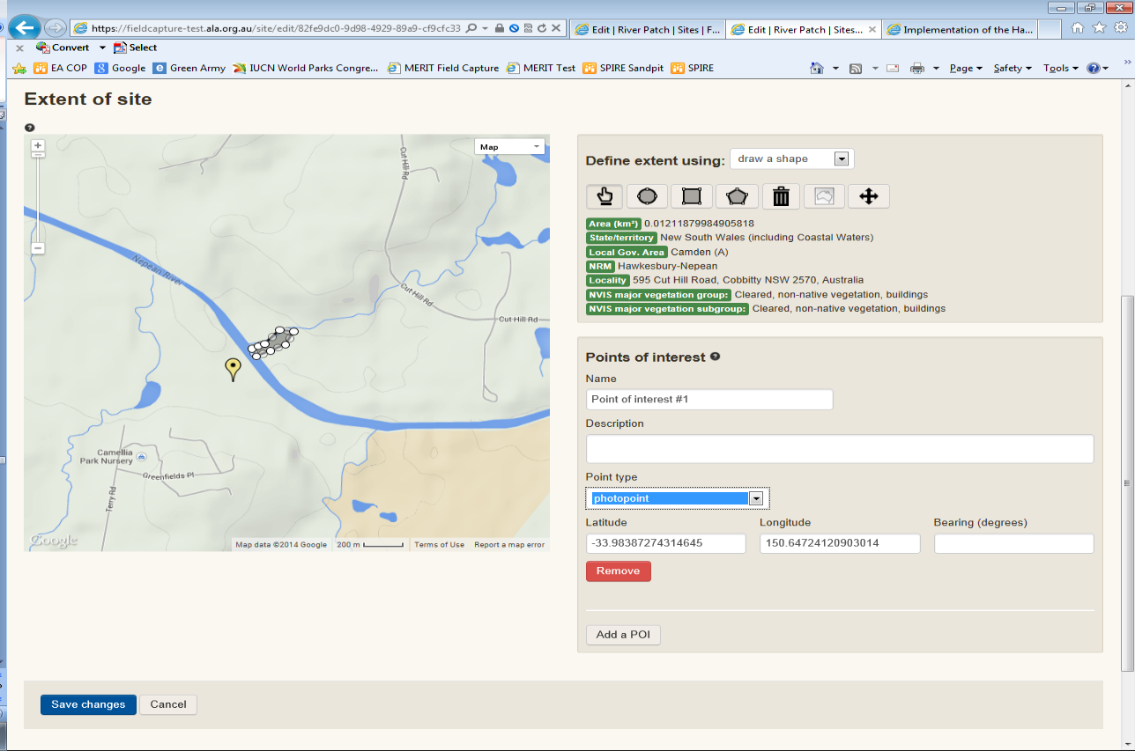

Add POI

Save changes

POI box

Dropdown list

Locator icon

### Manage your sites

Sites can be viewed, edited or deleted from a project during any phase.

1. Click the relevant action icon next to the site you wish to edit, view or delete.

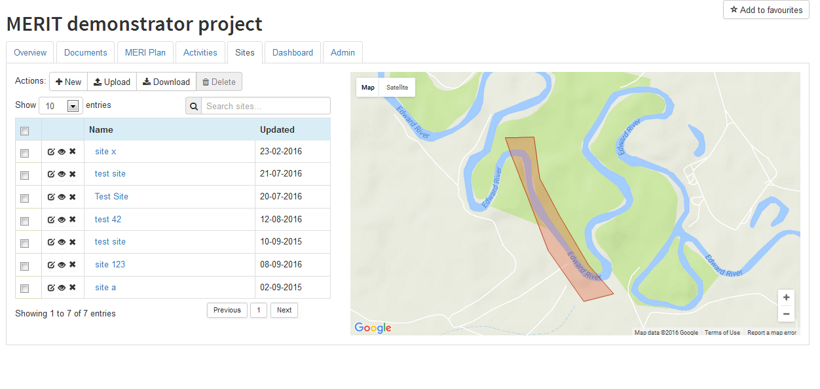

Sites tab

Actions

|  |  |
| --- | --- |
|  | There are 3 actions for a site attached to a project:  Edit  View  Delete |

### Edit a site

1. To edit a site associated with a project, click Edit .
2. Make the necessary changes and click **Save changes**. Refer to 11.2 Add a new site for instructions on how to refine the location or shape of your site.

### View a site

1. To explore a site associated with a project, click **View.** 

This displays the site information, plus the projects, points of interest (POIs) and activities associated with the site. See 11.4 Add Points of Interest for more information on POIs.

Location data for the site can be downloaded as a shapefile by clicking **Download Shapefile** under the map and following the instructions.

The shapefile can also be viewed using the ALA’s spatial portal by clicking **View in Spatial Portal** under the map. This feature enables users to consider the site in relation to hundreds of different spatial layers contained in the ALA portal.

1. 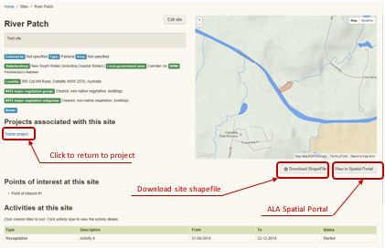To return to your project page, click the project’s name in the list under **Projects associated with this site**.

### Delete a site from a project

|  |  |
| --- | --- |
|  | Deleting a site from a project breaks the association between it and any activities to which it is attached. The site, **and any associated photo-point data/images**, will be removed from the relevant activity/ies. |

1. To delete a site associated with a project, click **Delete** .
2. To delete multiple sites, tick the boxes for the sites you wish to remove and click **Delete**.

|  |  |  |  |  |  |  |
| --- | --- | --- | --- | --- | --- | --- |
| MERI Plans and Reporting | | | | | | |
| Phase |  | | | | | |
| Access Level | ☑ | Editor | ☑ | Admin | ☑ | Grant Manager |

As explained at the beginning of this document, (See ‘ABOUT this Guide’), Part A refers to information available to all users (including the public). Part B and C are designed for MERIT users who have Editor/Administrator access and need to perform functions that are the same across all programs.

MERI Plans and Reporting requirements differ across NRM programs (maintained in the tool). Therefore, these functions will be provided in the extensions to this guide, alongside other information that is specific to those NRM programs. Use the [NRM MERIT Website](http://www.nrm.gov.au/my-project/monitoring-and-reporting-plan/merit) to choose the relevant Program Specific Guide (listed on the right hand side – Under ‘Find MERIT Guidance for:’).



# Want more information?

Click the **Help** link on the MERIT menu bar to read answers to frequently asked questions.

Click the **About** link on the MERIT menu bar to read recent news and information on enhancements and fixes.

Important news is also sometimes included in a pop-up box that appears when you log in to MERIT.

Use the [NRM MERIT Website](http://www.nrm.gov.au/my-project/monitoring-and-reporting-plan/merit) and choose from the relevant Program (listed on the right hand side) to find the Program Specific Guide.

# Glossary of terms

|  |  |
| --- | --- |
| **Administrator**: | A level of access in MERIT. It enables you to view all information for your project, input, edit and submit project data and reports to the Department; and assign user roles to other people (e.g. project managers, sub-contractors). |
| **Department** | The Australian Government Department administering the NRM funding |
| **Description (project)** | The description of your project, which you provided in your project application. The project description appears on the **Overview** tab of a project page in MERIT. This is the field visible in the public domain. |
| **Editor** | A level of access in MERIT. It enables you to view all information for a project, as well as input and edit activity data. It does not allow you to submit reports to the Department or assign user roles to other people. |
| **Funding recipient** | an individual or organisation that has received funding for a project through an Australian Government NRM program e.g. Grant recipient: |
| **Grant manager (Project Manager)** | Departmental Grant Manager (officer) who manages projects funded by Australian Government NRM programmes in cooperation with the funding recipient. Also known as Project Manager. |
| **MERI** | Simple concepts that, when applied, help us understand what is being achieved and help identify possible improvements, for projects and programmes:   * **Monitoring:** the collection of data and information. * **Evaluation:** analysing the monitoring data and assessing what it means. Based on this, informed judgements can be made about the success of a project or programme and improvements can be identified. * **Reporting:** communicating what we have found out through monitoring and evaluation. It is about sharing information, including about achievements and lessons learnt. * **Improvement:** using this information to improve the way things are done. |
| **NRM program** | Australian Government funded NRM programs, such as National Landcare Programme. |
| **Outcomes** | The tangible and measurable changes resulting from maintenance of and/or improvement in NRM assets (e.g. vegetation condition change, recovery of threatened species). These may be immediate, intermediate or longer-term outcomes. |
| **Outputs** | The tangible (measurable and practical), immediate and intended results to be produced through NRM investment (e.g. area (ha) of revegetation completed). |
| **Output Targets** | The total project outputs that a project has committed to achieve. These are captured from your MERI plan and displayed at the bottom of the **Activities** tab of a project page in MERIT. |
| **Phase**: | There are three phases for project MERI plans (displayed on the Admin/MERI plan sub-tab): not yet approved, submitted but not approved, and approved. The phase determines the actions that can be undertaken:   |  |  |  | | --- | --- | --- | | Phase | Edit Project Plan? | Record Activity Data? | |  | Yes | No | | The project plan has been submitted but not yet approved by the Departmental grant manager | No | No | |  | No | Yes | |
| **Point of Interest** | This is a marker for a specific geographic location which can be added through the **Sites** tab of a project page in MERIT or via an activity form (for photo-points). Funding recipients can use this to mark a range of features which will be useful to them such as the location of specific plantings within a larger site or the location of threatened species. |
| **Project member** | A MERIT user (editor, admin or grant manager) who has been given access to a project in MERIT |
| **Project MERI plan** | This is a document prepared by funding recipients to clearly set out the project activities to be undertaken, and the intended outputs and outcomes of the project. |
| **Site** | A defined geographic location relevant to a project. Sites can be defined using the mapping tools available in the **Sites** tab of a project page in MERIT. Funding recipients can create sites at their discretion which allow them to represent their project. In some instances, it may be preferable to identify a site as a whole project area, or alternatively as several more specific smaller areas. |
|  |  |

Acronyms

**ALA**: Atlas of Living Australia

**MERI**: Monitoring, Evaluation, Reporting and Improvement

**MERIT**: online Monitoring, Evaluation, Reporting and Improvement tool

**NRM**: Natural Resource Management

# APPENDIX A: MERIT Workflow

There are two main phases for reporting in MERIT: **planning** and **reporting**. The diagram below demonstrates the MERIT workflow from creation of a project shell to final approval. The steps relevant to funding recipients are covered in these guidelines. 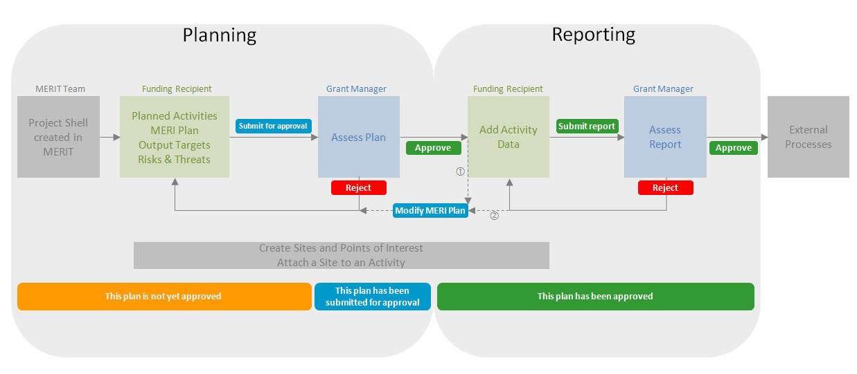□ If an approved project MERI plan requires amending, contact the Grant Manager to enable modification of the project MERI Plan. Edit the plan and resubmit for approval.   
□ If a submitted report is rejected because the project MERI plan requires editing (e.g. an activity form has been omitted), the Grant Manager will enable modification of the MERI Plan. Edit the plan and resubmit for approval. Once the plan is approved, add/amend activity data and resubmit the report for approval.

# APPENDIX B: Drawing Tools in the Sites Tab

The table below contains a legend of the drawing tools available in the ‘**Sites**’ tab. These differ to the drawing options in the Reporting forms (for projects under the RLP Services Agreement; See Part D). If you are after options available in other extension guides, please visit the [NRM MERIT Website](http://www.nrm.gov.au/my-project/monitoring-and-reporting-plan/merit) to choose the relevant Program Specific Guide (listed on the right hand side – Under ‘Find MERIT Guidance for:’).

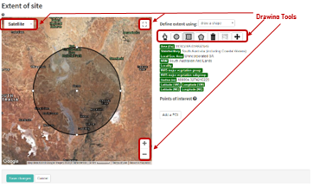A [Ready Reckoner](http://www.nrm.gov.au/system/files/resources/b351b394-f041-4625-94cf-46f8dc67a9b1/files/merit-ready-reckoner-rlp-project-services.pdf) and ‘[On‑ground Investment Location Data Capture, Management and Sharing Standards’](https://www.environment.gov.au/system/files/resources/13813cd1-84e6-4a73-8816-ee21187f6a4d/files/ground-investment-location-data-capture-mgt-sharing-standards-v1.pdf) both provide guidance on RLP mapping requirements.

The drawing tools above are available in the Sites Tab only allow one map per site. However, multiple sites may be uploaded. The mapped areas cannot be edited (only redrawn). The drawing tools include:

|  |  |
| --- | --- |
|  | Top left corner of Map. The user may choose a viewing preference:  - **Map**: displays google map view. Click on the down arrow again to choose whether to include ‘**Terrain**’ information.  - **Satellite**: displays google satellite view. Click on the down arrow again to choose whether to include ‘**labelled**’ information. |
|  | **Toggle view.** Top right corner of Map. Enables full screen view of Map.  Note: Full screen view doesn’t provide drawing tool options. |
|  | **Zoom in** (standard mapping function). Bottom right corner. You may either; click this button and move the screen to find your location; or double click your mouse to zoom in on the area you want. The screen will zoom into |
|  | **Zoom out** (standard mapping function). Bottom right corner. Click this button to zoom out and include a larger area on your screen. |
|  | **Drag**. Allows user to drag the screen to get a better view of the location they are seeking. |
|  | **Circle**. These may be used for an uncertain planned area. Click this button. Move your cursor to the location where you would like to start the radius point. Drag the circle to the size required. |
|  | **Square**. This shape cannot be edited into rectangles or rotated. Click on this button and move your cursor to the location where you would like to start. Click the mouse to start and then drag the square in the direction to cover your project. |
|  | **Polygon**. Allows users to map one area. Click on this button. Move your cursor to the location where you would like to start. Click the mouse to start and at each time you want to change direction. Double click on the last point and the system will link that point to the 1st point you clicked. Any further polygons created here will replace the previous drawing. |
|  | **Delete**. Deletes the shape/s created on the screen. Click this button and all shapes will disappear. Once you are happy with the changes click the **Save changes** button (below the map). Beware of pressing the cancel button. It will undo your deletion and force you to leave the screen. This will return you to the MERIT Home page (where you will need to find your project again. |
|  | **Edit**. Edits any shape that contains a dashed line. Click this button and move to the handles (major points) or markers (minor points) and drag to edit a feature. Once you are happy with the changes return to the edit button and click Save pop-up feature. The cancel button will undo your changes to the original shape/s before you pressed edit. |
|  | **Australia**. This button resets your map view to centre on the whole of Australia. |
|  | **Zoom to location**. Line of drawing tools. This button will only be valid if a shape has been drawn on the map. Click this button to zoom directly to the area on your screen. |

# APPENDIX C: Guidelines for taking photographs

Photo-point

Setting up and using a photo-point to obtain a time-series of photographs of the same feature is an effective way of keeping a photographic record of change. A photo-point is a fixed point on the ground from which photographs are taken along a fixed bearing. In this case the photo-point is located 5 metres from the start of the transect, and is the only fixed position from which plot images will be taken. The reference marker (located at the start of the transect) and the alignment marker (located 20 m along the transect) will act as ‘sighter’ posts for taking the fixed image (see below image). These posts should be in the centre of the frame so the image captures equal areas of the left and right sectors of the plot (i.e. the photo is aligned directly along the transect bearing).

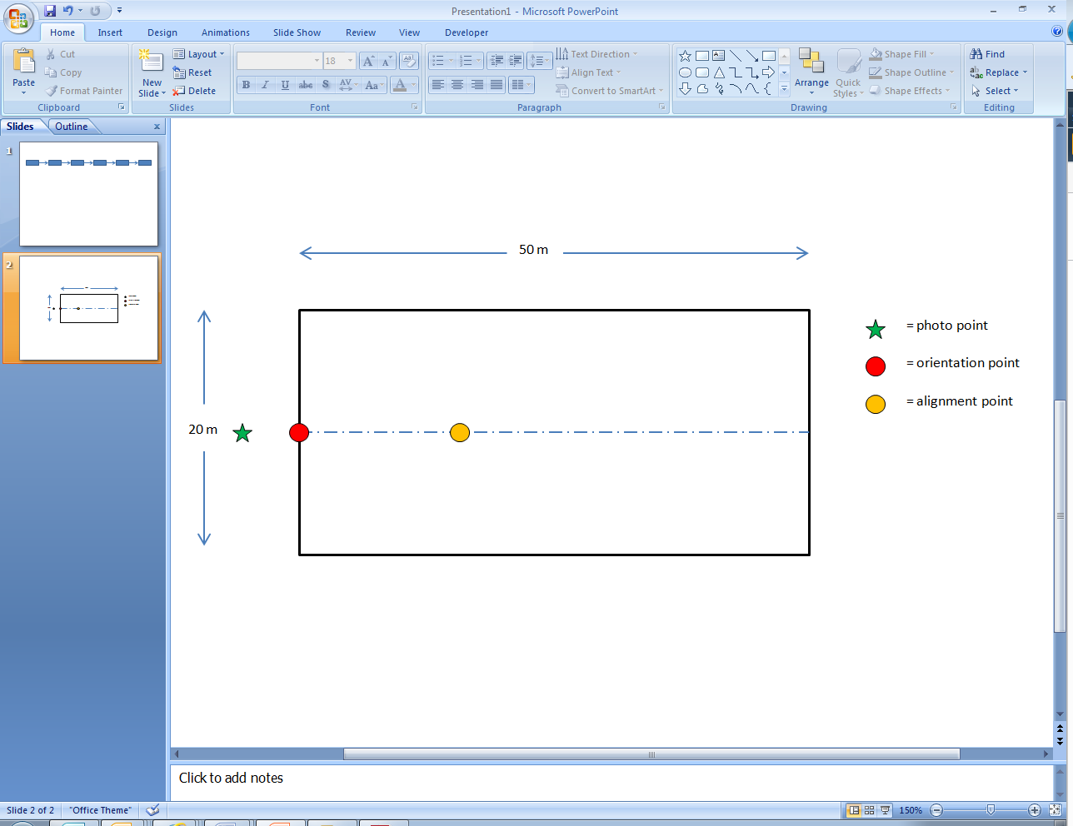

The fixed photo can be oriented in landscape or portrait. A rule of thumb is to use landscape where you can adequately capture the overstorey canopy, otherwise use portrait (normally for taller forest and woodland types). Future photos taken from the photo-point will always use the same orientation as the initial photo. Orientation and transect bearing will be recorded on the pro forma in the Standard and Abridged Field Guides. Always stand (do not sit) when taking the plot photo, so that images are always taken at eye level.

If a shrub or some other feature is obstructing the line of site along the transect, then ignore it and take the image anyway. Obstructions come and go over time. The important thing is that photographs provide a visual record of vegetation change.

Disturbance to the site should be minimised for taking photographs. For example, do not physically remove objects to create a better line of sight, and minimise the level of trampling between the photo-point and the sighter posts. It is best to record the fixed image immediately after delineating the plot, rather than after completion of field survey.

Opportunistic photographs

Taking field images of interest in addition to the fixed photograph is encouraged. These may include photographs of:

- native plants and animals,

- habitat features (e.g. hollow-bearing trees, bird nests, coarse woody debris),

- weed infestation before and after intervention,

- disturbance incidents (e.g. wind throw, floods),

- ‘typical’ stands of the vegetation type in and around the plot, and

- the surrounding landscape.

The position of the photographer in relation to the transect (i.e. transect distance and perpendicular distance right or left) and the photo bearing should be recorded on the pro forma so that the feature can be revisited updated images possible recorded during future monitoring.

Image nomenclature

The image taken at the photo-point should be named after the Project and Plot ID, with a prefix for the year in which it was undertaken, and a ‘P’ to indicate it is the standard plot photo.

For example: CFOC0208_Plot01_2012_P

Additional images taken at other points in the plot, or perpendicular to the plot transect, should use the same nomenclature, but with a trailing number to show that it is an opportunistic rather than the standard image.

For example: CFOC0208_Plot01_2012_1; CFOC0208_Plot01_2012_2; CFOC0208_Plot01_2012_3 etc.

Intervention-specific images taken at other photo-points should use a similar naming convention so that images can be conveniently associated with the project ID, the intervention, and the year of sampling.