
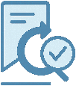


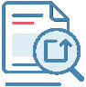





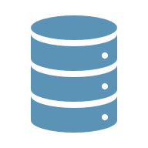
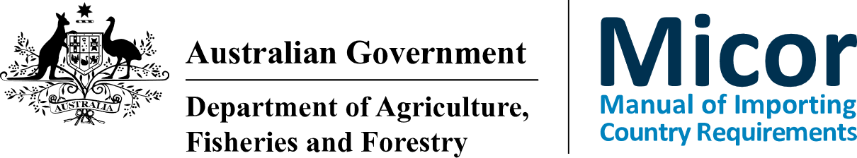


Micor GovCMS Platform Go-Live Date: Thursday, 16 July 2026
Email Micor Project Team
Simpler Show Changes
New URLs for content pages
Minor changes to Search and Filtering
Like-for-Like migration
No changes to content
Navigation
Search & Filtering
Re-create bookmarks for specific country or case pages
Two-Factor Authentication (TFA) requirement to access password-protected content
Commodity landing page tiles
User interface
https://micor.agriculture.gov.au
Familiar design
Show changes
Layout
What remains familiar?
What’s new?
What do I need to do post go-live?
Micor Re-Platforming Project
Information Session Summary
If you currently access password-protected content, you will need to reset your Micor password and set up Two-Factor Authentication (TFA) to continue to access the content on the new Micor platform
Where can I get help post go-live?
User guides and instructional videos available on
Micor help page https://micor.agriculture.gov.au/help
TFA help through the support form available when enrolling for TFA
micorproject@aff.gov.au
https://micor.agriculture.gov.au
Micor GovCMS Platform Go-Live: Thursday, 16 July 2026
Micor Re-Platforming Project
FAQs
https://micor.agriculture.gov.au
micorproject@aff.gov.au
Micor Re-Platforming Project
FAQs
Micor GovCMS Platform Go-Live: Thursday, 16 July 2026

Frequently Asked Questions (FAQs)
Question
When will the new Micor platform be available?
Response
The platform migration will begin at 8 pm AEST on Thursday, 16 July 2026, and the new platform is expected to be available from 6 am AEST on Friday, 17 July 2026. Once the new platform is online, if you access publicly available content on Micor, you can continue to do so as usual. If you access password-protected content on Micor, you will need to reset your password and set up TFA to continue accessing secure content on the new Micor platform.
Question
I access publicly available Micor content without a username or password. Do I need to create an account and set up TFA on the new platform?
Response
No. Two-Factor Authentication (TFA) only applies to users who access password-protected content using a username and password. TFA is required for Meat, Plants Workplans and Protocols, and Livestock content. If you only access publicly available content, you do not need to create a Micor account or set up TFA on the new platform.
Question
I currently access Micor with a username and password. Do I need to reset my password on the new platform to set up TFA?
Response
Yes. If you currently access Micor with a username and password, your existing password will not work on the new platform. You will need to reset your password before setting up TFA.
Question
Is there a time limit by which I need to set up TFA?
Response
No. However, you can skip the TFA setup up to three times. After the third attempt, your account will be locked, and you will need to contact the Micor team for assistance. We recommend setting up TFA as soon as possible once the new platform becomes available.
Question
I currently access Micor with a username and password. Will my account permissions be migrated to the new platform?
Response
Yes. As part of the migration to the new platform, your account permissions will be migrated. Please note that you will need to reset your password on the new platform before you are able to access the password-protected content on the new Micor platform.
Question
When will I need to re-create my bookmarks for individual country or case pages on the new platform?
Response
If you have any bookmarks to any specific country or case pages, you will need to re-create them after go-live. The new Micor platform is expected to be available from 6 am AEST on Friday, 17 July 2026.
Question
Do I need to re-subscribe to the weekly newsletter?
Response
No, if you are currently subscribed to Micor weekly newsletters, they will carry forward to the new platform.
Question
Where can I find help resources such as user guides and instructional videos?
Response
User guides and instructional videos will be available on the new Micor platform’s help page from 6 am AEST on Friday, 17 July 2026.
The help page is available at https://micor.agriculture.gov.au/help.
Alternatively, the Micor team can be contacted via micorproject@aff.gov.au for assistance.

https://micor.agriculture.gov.au
micorproject@aff.gov.au

